A history of the chemical composition and manufacturing refinery processes of aviation gasoline (Avgas) from 1903 to 2003.

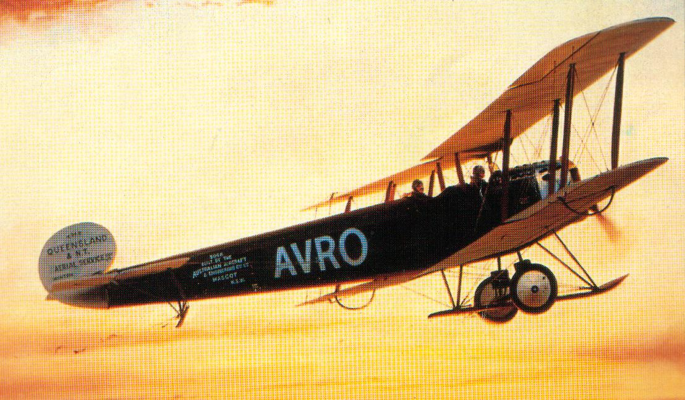

History of Aviation Gasoline

Chapter

1

‘Man conquers powered flight’

The Beginning 1901-1913

Photo 1. Standard Oil Company of California - Richmond Refinery 1902.

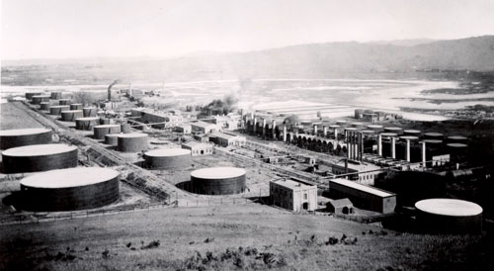

© Petroch Services

Noel H Tresider AM

PO Box 1273

Hawksburn 3142

AUSTRALIA

Phone +61 (3) 9529-3188

Copyright All rights reserved.

**Disclaimer**

Considerable effort has been made to assure the accuracy and reliability of the information contained in this presentation. However, neither Petroch Services nor the author can accept liability for any loss, damage or injury whatsoever resulting from the use of this information. The views and opinions expressed are those of the author and do not necessarily represent the views or opinions of the companies mentioned in this publication. No copyright is claimed on photos or material from secondary sources.

Table of Contents

Summary 4

Technical Information 5

Abbreviations And Interpretations 6

The Overview Of Production 7

The Process And Chemistry Overview 9

Avgas Components 9

Avgas Performance Characteristics 10

Avgas Manufacturing Process 18

1903 Gasoline Takes To The Air With The Wright Brothers. 19

The Fuel Volatility Factor 20

Gasoline Composition 1910 21

Avgas Specifications And Test Methods Before 1914 27

Manufacturing Process Before 1914 27

Oil Companies And Refineries 30

Australian Beginnings 32

“The Race Is On” – Airspeed Records 33

Epilogue For 1914 34

Acknowledgments 35

Research Sources 36

Index 38

References 40

# Summary

A retrospective review of the chemical composition of Aviation Gasoline (Avgas) used in Australia from 1903 to 2003. The review has been done using modern analytical laboratory techniques, assessment of the refining process or data from published literature. Because Australia imported Avgas, the review also includes overseas production methods used and the chemical composition during this period.

Figure 1. Wright Flyer 1903

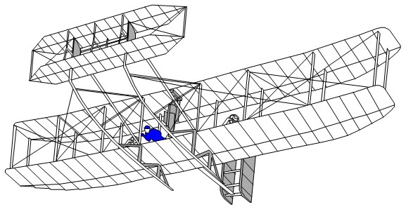

The first sustained powered flight by the Wright Brothers captured the world’s imagination for the flying machine; however, the fuel that made that flight possible was of little interest. During World War I, the fuel of interest was fuel oil that powered the grand navies of the world, for it was naval power that was the mark of a country’s military might. The potential of these new flying machines was still to emerge.

The 1920-29 period saw the emergence of commercial aviation, while on the military side there was stagnation. People were sick of the horrors of war after “the war to end all wars” - This was the era of jazz and prohibition in the US, recovery and rebuilding in Europe, and return to normality and expansion for Australia, Communism in Russia, oil exploration in the Middle East, feudalism in China, and development in Japan.

In 1921, Colonel Billy Mitchell demonstrated the military power of aircraft over the ship by the destruction of a captured German battleship “Ostfriesland”, off the Virginia coast USA - a lesson not lost on the Japanese.

The later 1920’s and early 1930’s saw the world in a global recession, but the aeroplane was still there to capture the public interest with events such as Charles Lindbergh’s crossing of the Atlantic in 1929, the London (England) to Melbourne (Australia) Air Race of 1934, the crossing of the Pacific Ocean by Sir Charles Kingsford Smith in 1928.

In 1936 during the Spanish Civil War, the German Air Force Condor Unit demonstrated the essential role of aircraft in land battles. This was later to be exploited as part of the German “Blitzkrieg” in the early stages of World War II.

By now the air forces had achieved the same status symbol as navies. The 1930’s saw a number of “goodwill” long distance flights by the air forces of Germany, Italy, America, and the pursuit of air speed records. Aviation fuel (Aviation Gasoline) was now becoming important in these events.

At the start of World War II aviation gasoline (avgas) was now recognised as an essential war materiel. It was events such as the ‘Battle of Britain’ July-October of 1940, and the Japanese Naval Air Service attack on Pearl Harbour, December 7, 1941, which saw the emergence of air power and redefined the role of Aviation Gasoline (Avgas) as the fuel of this era.

This was the fuel that powered the aircraft of the bomber raids over Europe into Germany, the dropping of the atomic bomb on Hiroshima and Nagasaki, the delivery of vital supplies to China. At the end of the war, this was the fuel for the delivery of supplies to Berlin in the 1948 ‘Berlin Airlift’.

However, with the invention of the jet engine, a new form of propulsion had captured the world's imagination, with speeds approaching the ‘sound barrier’ now a reality. Avgas was still in use, but it was becoming ‘yesterday’s fuel’.

This document seeks to identify the chemical composition of Aviation Gasoline from the earliest days, through the mid-20th Century, and up to the end of the 20th Century. While it is not possible to analyses the fuels of yesteryear, it is possible to estimate the chemical composition from the manufacturing methods used.

The main focus is on the specifications which were developed for Aviation Gasolines (Avgas) and the manufacturing processes used. Where possible, the analyses of aviation gasolines from a variety of sources are reproduced to illustrate the changes that occurred in this important fuel.

# Technical information

Since the information comes from a wide range of sources, there is a need to standardise on measurement units. The following approach has been adopted.

All units have been converted to metric format; where the units are not clear, for example Imperial gallon or US Gallon, these are noted with (?). The following conversion factors have been used:

1 Imperial Gallon (IG) = 4.546 Litres (L)

1 US Gallon (USG) = 3.785 Litres (L)

1 Barrel (BBL) = 159 Litres (L)

ML = Millions of Litres

KL = Thousands of Litres

Specifically, with regard to ‘octane’ numbers and aviation, there are at least three different octane numbers: Motor Octane Number (MON), Research Octane Number (RON), Performance Number (PN) often quoted as an ‘octane number’. A separate section is included to briefly explain the various octane engine tests and the Octane scale.

With regard to octane numbers[1]

F1 Research Octane Number (RON) relates to automotive service – as to knocking that occurs when accelerating from slow engine speeds. It has no importance in aero engines.

F2 Motor Octane Number (MON) and F3 Aviation Octane Number are closely related.

F4 Performance Number – rich mixture supercharged. F2 and F4 ratings are sufficient to define the knock characteristics of aviation fuels.

Where possible additional technical reference information has been provided from CRC Handbook 75th Edition.

# Abbreviations and Interpretations

AIP = Australian Institute of Petroleum

API = American Institute of Petroleum

Avgas = Aviation Gasoline

Aviation Spirit = Aviation Gasoline

Benzene = the chemical compound Benzene CAS No. 71-43-2

Benzine = gasoline (European). This term will be avoided where possible. It is the term occasionally used for the petroleum fraction of distillation rage 120 to 150oC, and also the term used by the Germans to describe gasoline. It should not to be confused with Benzene.

Benzol = a mixture of Benzene, Toluene, Xylenes obtained from coke or town gas production.

CAS No. = Chemical Abstract Services Number which is used to uniquely describe a chemical compound

Chevron = formerly Standard Oil Company of California (SOCAL)

Exxon = Esso (formerly Standard Oil Company of New Jersey)

IP = Institute of Petroleum (United Kingdom)

Mobil = Mobil Oil (formerly Standard Vacuum Oil Company of New York)

Petrol = Gasoline

RAAF = Royal Australian Air Force

RAE = Royal Aircraft Establishment (located in the U.K.)

RAF = Royal Air Force

TCD method = Temp. Critique Dissolution method

TEL = Tetra Ethyl Lead (the alkyl lead used to improve anti-knock properties of gasolines).

US = United States of America

# The Overview of Production

Firstly, let me start with an overall worldwide view of avgas production from 1926-1970 and illustrate where Australia was placed in this production. Throughout where possible, I have standardised on metric units for consistency.

Graph 1. Avgas production 1926-1970 showing the importance of US production[2]. (Data sourced from Milestones in Aviation Fuels by Dukek, Winan, & Ogston; AIP, Australian National Archives)

The main points to draw from this graph (Graph 1) are:

* Australia was a small player in the production of Avgas.
* During World War II, German production of Avgas was a fraction of that produced by the Allies (US).

Immediately after World War II, Avgas production dropped markedly as motor gasoline restrictions were lifted and the majority of gasoline production shifted from avgas to motor gasoline. The increase in 1948 onwards was due to the Berlin Air-Lift and the Korean War.

Graph 2. Australian Avgas and Jet Fuel Usage, also showing Avgas production and exports

The main points to draw from this graph (Graph 2.) are:

* As a general statement, up until 1955 in Australia, all Avgas was imported, and it was not until 1980 that Australia produced more Avgas than it used. In the 1980’s, the number of refineries making Avgas increased from one to three. [As of 2003, there were only 2 Australian refineries producing avgas].
* In Australia by 1959 Jet fuel (Avtur) usage exceeded Avgas - The ‘Jet Age’, as far as fuel usage was concerned, had arrived.

# The Process and Chemistry Overview

To assist in understanding the Avgas story, some chemical keys to gasoline are required. A further detailed explanation of the manufacturing processes will be detailed later.

## Avgas components

### Gasoline components:

All petroleum products are composed of hydrocarbons, and these are characterised by four types, described as PONA.

* Paraffins: Octane range from zero to over 100. Chemically stable, burn clean. Main component in crude oil. Paraffinic Crudes produce poor gasoline, but good lubricating oils.
* Olefins: Octane better than paraffins, chemical reactive tend to form gum deposits, generally produced in refinery cracking process.
* Naphthenes: Fair octane, chemically stable, gasoline, and good lubricating oils.
* Aromatics: High octane, higher freezing point than paraffins, burn smokey, present in some crude oils, can attack some rubber components. Crude not suitable for lubricating oils.

### Additives:

Lead, or more correctly Tetra Ethyl Lead (TEL) - discovered in 1921 and accepted in aviation gasolines in 1931; improves octane significantly, but to different degrees. - known as ‘lead susceptibility’. Small amounts are better than large amounts.

### Other Additives:

Amines such as Methanolamine, Xylidene usually up to 3%, were used during the Second World War to boost the performance of high powered military aircraft. Alcohols such as Methanol were used to boost performance during take-off, or racing where fuel economy was not of interest.

### Blendstocks from other sources:

Benzol, a by-product from the coking of coal in coke ovens in steel manufacture. These are 100% aromatic, pungent odour, high octane, strong solvent attack on rubber components and paint. Benzol contains 70-75% Benzene, 25-30% Toluene and Xylene.

### Other Chemical additives:

Alcohol, aromatic amines, Isopropyl ether, Cumene (iso-Propyl Benzene).

# Avgas Performance Characteristics[3]

There is a great difference between aviation fuels and the motor spirits used in motor car engines. The remarkable improvement in aircraft engines that took place during the years after World War I could not have been achieved without a correspondingly rapid improvement in the technology of fuel production. During this period the power of the aircraft engine increased by 150% without any increase in cylinder capacity. The brake mean effective pressure (B.M.E.P.) increased by 100% and the engine speed by 21%, whilst the fuel consumption at cruising was reduced by 30%.

Although much of the credit for this remarkable performance was due to the skills of the engine designers and metallurgists, the oil industry also met the challenge by producing fuels to meet the demands of the new engine designs.

By this time, it was generally recognised that an aviation petrol usually had a higher knock-rating than the average motor spirit, but there are very many important characteristics of an aviation gasoline that vary markedly from those gasolines ordinarily used in road transport vehicles. In the previous decade (1920’s) “aviation petrol” was ordinary motor spirit with a small proportion of Benzol (10 to 25%) added to increase the resistance to detonation, but the aviation gasoline marketed in the 1930’s was a highly developed fuel with special characteristics.

These characteristic properties of aviation fuels have a direct influence upon the efficiency and reliability of aircraft engine operation. The most important of these are listed in Table 1.

Table 1. Aviation Gasoline Properties (1930’s)

|  |  |
| --- | --- |
| Property | Performance |
| Octane Number | Controls resistance to detonation. Maximum power and fuel economy |
| Distillation Range | Controls starting characteristics and distribution of the mixture to the individual cylinders. Also affects tendency to vapour lock (in conjunction with vapour pressure). |
| Vapour Pressure | Controls tendency to vapour lock in the fuel lines and fuel pump. |
| Specific Gravity & Calorific Value | Controls the maximum range of the aircraft. |
| Sulphur Content | Reduced to insignificant percentage to limit any corrosive action of fuel. |
| Gum Content (Actual & Potential) | Controlled to a minimum to prevent gum deposition in fuel lines, manifolds, and valves. |

Octane Number

The octane number of fuel is a measure of its resistance to detonation. This resistance to detonation is usually called the ‘knock-rating’ or ‘anti-knock value’ of a fuel. This is one of the most important characteristics of an aviation gasoline. The higher the knock-rating the greater is the power that can be obtained from an engine of given dimensions provided that the engine is designed to take full advantage of the higher octane number.

The anti-knock value or knock rating of an aviation gasoline is determined usually in the laboratory by comparing its resistance to detonation with that of reference fuels of known octane number in a standard engine running under carefully controlled and standardised conditions. This engine is known as the Co-operative Research Fuel Research (C.F.R.) engine.

Photo 2. C.F.R. Engine Test

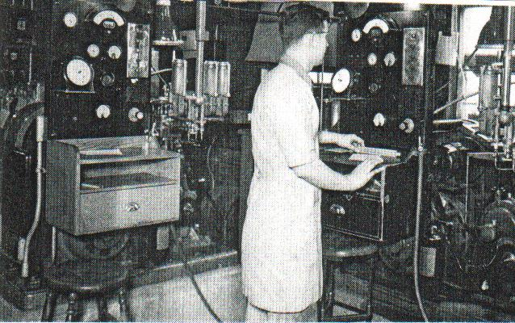

This method gives a very good indication as to how the gasoline will behave in an engine under service conditions, but with certain types of fuel the octane number, as determined by the C.F.R. engine, varies from that obtained in a full scale engine. Some cracked gasolines (gasolines from the catalytic process) show a lower anti-knock value in a full scale engine than would be expected from their octane number as determined by the C.F.R. method, whilst others, particularly highly aromatic fuels, are abnormally sensitive to mixture strengths. When operated in a full-scale engine with a rich mixture these gasolines show a higher resistance to detonation than might be anticipated from the C.F.R. engine test.

Detonation in automobile engines is usually not accompanied by engine failure unless detonation is unusually severe. Such engines are usually water-cooled and the local heating which ensues from detonation can usually be controlled by the water-cooling system. When detonation occurs in air-cooled aircraft engines, however, it is usually quite disastrous.

The temperature of the cylinder head and the top of the cylinder barrel usually rises rapidly and piston ring sticking usually follows. If the detonation is very severe the piston may seize in the cylinder barrel, or local over-heating occur to such an extent that a hole may appear in the piston head. It is therefore imperative that aviation gasolines must be carefully chosen with regard to their resistance to detonation.

The subject of Octane and C.F.R. engines is covered in more detail in Chapter 37 ‘Octane Testing’.

High Octane Fuels and Engine Performance

No gain in economy or power output can be achieved by using a high octane aviation gasoline in an engine designed to give maximum power at sea level on a lower knock-rating fuel. By changing the compression ratio or the super-charge ratio, or both, gasolines of high knock-rating can be used to advantage.

The performance characteristics of aircraft engines may vary according to the service use. In the days before jet aircraft, certain military aircraft operating on avgas, where economy was not of primary importance, were highly super-charged to give greatly increases power output at high altitudes. On the other hand, commercial aircraft and to some extent the long range bombers of the 1930’s & 40’s required good take-off power and economy at cruising speeds and altitudes. Certain engines, especially those fitted to civil aircraft in the late 1930’s were ‘altitude rated’. Such engines were guaranteed to develop maximum power output at some specified altitude on a given type of fuel, such as 87 octane number. If 100 octane fuel was used it was possible to obtain more power at sea level by opening the throttle wider, without the risk of detonation. This meant that a larger load could be taken off the ground or alternatively a reduction in take-off run could be used, than would be the case with 87 octane fuel. In some cases commercial aircraft in the 1930’s operated on two fuels: -

1. A gasoline of high octane number for take-off purposes, and
2. A fuel of lower knock-rating (and therefore lower price) for cruising purposes, when the desired flying altitude was reached.

In the case of one particular engine, the normal take-off power was increased from 1,050 to 1,200 horsepower by the substitution of 100 octane fuel for 87 octane fuel, while the rated cruising power was increased from 650 to 700 horsepower. This increase in rated cruising power by using a higher octane fuel, naturally meant that a reduced fuel consumption could be obtained cruising at 650 horsepower with a higher octane fuel, but in commercial practice at that time this was often more than off-set by the extra cost of the higher octane fuel. In military aircraft, the fuel cost was not of primary importance.

Octane: Another important parameter often confused is ‘Octane rating’. This will be discussed later, but it is suffice to say, that even today there are at least two octane ratings. Research Octane which is used for motor gasoline, and this is the familiar 91 RON for unleaded petrol or 96 RON for premium unleaded petrol. The Motor Octane or MON, which is now used for motor and aviation gasolines, and this is the octane rating quoted throughout this document. Unleaded petrol is about 84 MON and premium unleaded petrol about 87 MON.

For values above 100, the term “performance number” is used.

Distillation

Another important parameter for the petroleum chemist is distillation, simply put, over what temperature range does the product boil, e.g. water boils at a constant 100 Deg. C, while gasoline which is a mixture, boils over a range from about 35 to 215 Deg. C, (kerosene is 200 to 300 Deg. C). Distillation characterizes the petroleum fraction into the product type gasoline, kerosene, heating oil, diesel, fuel oil, even bitumen, etc.

Figure 2. A.S.T.M Distillation Apparatus

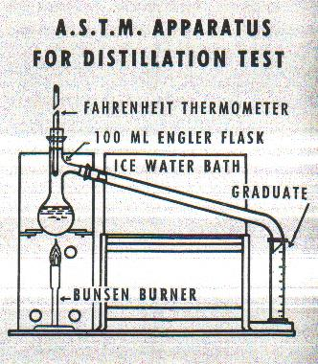

The distillation range of an aviation gasoline is very important as it controls the ease of starting, especially at low temperatures and, in conjunction with the vapour pressure limits, determines freedom from vapour lock. It controls proper distribution of the fuel to the cylinders and has a large bearing on fuel economy.

A fuel which has a high initial boiling point will make starting the aircraft engine harder. The ease of starting is governed by the temperature at which 10% of the fuel is distilled off.

Aircraft engines are more difficult to start than automobile engines; owing to their size it is more difficult to turn them quickly and consequently, the temperature of the compressed mixture when the piston is at the top of its stroke is less than would be the case in automobile engine where the cranking speed is higher.

Under starting conditions quite an appreciable part of the vapourisation of the mixture of the fuel takes place actually in cylinders on the compression stroke and, consequently this is not as satisfactory in aircraft engines, which crank at lower speeds than automobile engines. It was found however, that if 10% of the aviation gasoline was distilled below 165 deg F (74 deg C) satisfactory starting could be obtained under normal conditions.

It is very difficult to ensure that every cylinder of a multi-cylinder aircraft engine receives the same amount of fuel, although no difficulty is experienced in ensuring that all cylinders get similar amounts of air. This is one of the reasons for the trend to fuel injection (as favoured by German aircraft engine manufacturers). In the carburettor fuel system if a wet mixture is present in the carburettor, bad distribution usually ensues.

It is necessary, therefore, to see that the distillation end point or specifically, the temperature at which all the petrol is turned into vapour, is not excessively high, otherwise an incomplete liquid/vapour (wet) mixture will be obtained and distribution will be poor. The reason for correct uniform distribution is that if certain cylinders are fed with a mixture which is too weak, detonation will occur with its resultant problems, if the carburettor mixture is enriched to avoid this weak mixture in certain cylinders, the remaining cylinders will receive a mixture which is too rich. This condition, while not as bad as a mixture which is too lean, is detrimental to the performance of the engine and, at the same time increases the fuel consumption.

Vapour Pressure

The vapour pressure of a liquid is really an indication of its inherent tendency to form a gas or vapour. High vapour pressure indicates that the liquid will readily turn into gas/vapour, while at a low vapour pressure indicates that gas/vapour will not be formed quite so readily.

Photo 3. Laboratory technician performs Reid Vapour Pressure (RVP) test.

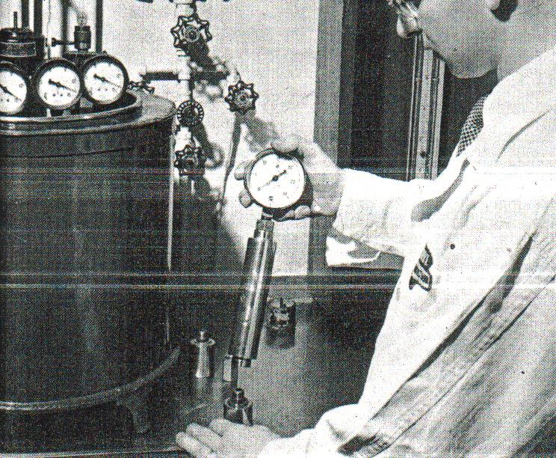

Under conditions of low atmospheric pressure or high temperature there is a tendency for petrol to vapourise. The greater the altitude at which an aircraft is flying, the lower is the atmospheric pressure. Consequently, the greater is the tendency of the petrol to vapourise in the fuel lines. In extreme cases vapour bubbles may form in the fuel line, or vapour may be formed in the float chamber of the carburettor to a greater extent than can be adequately handled by the vent holes. In these circumstances the mixture may be very materially altered, or the flow of petrol to the carburettor jets may be stopped entirely. The formation of vapour in this way is known as ‘vapour lock” and the importance of low vapour pressure for aviation gasolines can be critical.

Vapour lock is associated not only with the vapour pressure of the fuel but also with the volatility of the fuel. Excessively volatile fuels have a greater tendency towards vapour lock than those with higher distillation ranges.

Specific Gravity & Calorific Value

The specific gravity of a liquid is its weight compared to that of an equal volume of water at 4 deg C. The calorific value of fuel is the number of heat units in a given weight (pound or kilogram) of fuel (calories, BTU, joules). It is desirable for aviation fuels to have a high calorific value per pound (or kilogram) whilst a low specific gravity is of great advantage in obtaining maximum range of operation for the aircraft.

Photo 4. Laboratory technician performs specific gravity test using a hydrometer.

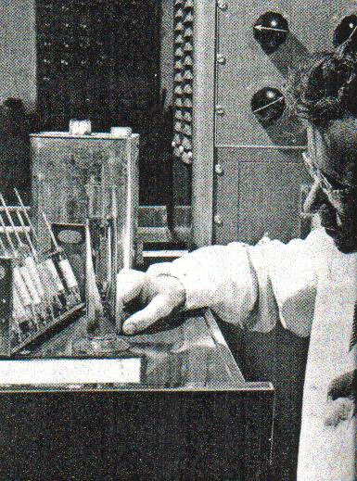

In general, fuels of high specific gravity contain a greater number of heat units per unit volume than those of low specific gravity, while the latter contain a greater number of heat units per unit weight. In the case of long-range aircraft, it is obviously advantageous therefore to use a low specific gravity fuel, since it has a higher number of heat units per unit weight than a high specific gravity fuel.

Where a heavy load of fuel is carried it is obvious that the use of a low specific gravity fuel will result in savings in weight which represents an increase in payload or, alternatively in take-off characteristics. On the other hand, for a given payload the amount of fuel carried may be increased resulting in a greater range.

The use of alcohols has been mentioned as a boost to anti-knock rating. The great disadvantage of ethyl alcohol as a fuel is that it has a high specific gravity (0.792) as compared with an aviation gasolines typically 0.74. Further the calorific value of ethyl alcohol is only about 12,700 BTU per pound (29.5 MJ/kg) while a good quality aviation gasoline has a calorific value of about 20,000 BTU per pound (46.5 MJ/kg). There is less available energy in ethyl alcohol.

Sulphur

All petroleum fuels contain some sulphur compounds. These sulphur compounds when burnt form oxides and in the presence of water, form corrosive acids which will attack metal, especially copper alloys such as those used in aircraft fuel systems and filters. In the manufacture of aviation fuels, it is necessary to minimize the total sulphur content. Usually the aviation gasoline specifications or those of the engine manufacturer, limit the amount of sulphur to 0.1% by weight.

Photo 5. Laboratory technician prepares a number of copper strip corrosion tests.

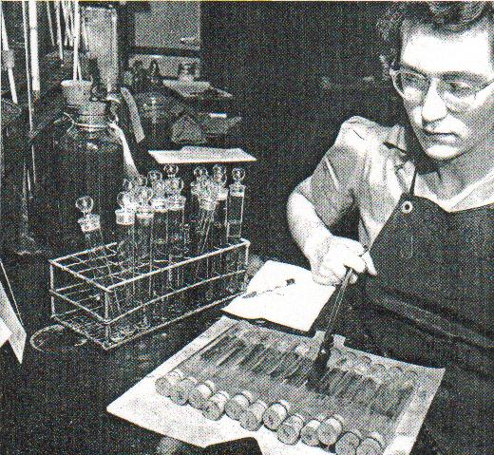

To ensure that there are no other corrosive compounds it is specified that the fuel should not cause any corrosion (as evidenced by discolouration) of a polished strip of pure copper.

Gum

During storage, gummy material develops in certain types of gasoline, and this of course has the effect of blocking filters, and in some instances forming undesirable deposits on the inlet valves and rings of the engine pistons. Certain types of gasoline and particularly those which have been obtained from cracking processes, are apt to contain unstable compounds which tend to develop into gummy substances when subjected to the action of light, air, or heat.

‘Cracked petrols’ as they come from the refining process contain very little gum, but the unstable compounds tend to form gum during storage. Gum formation is essentially an oxidation process and the gum itself contains a high percentage of oxygen. It is necessary to appreciate the difference between the gum actually present in the fuel, and the ease with which gum may be formed on storage.

The ‘actual’ gum content is the amount of gum present in the fuel at the moment of test, whereas, the ‘potential gum’ content is the amount of gum formed, or liable to be formed on further storage. (This achieved by subjecting the fuel to heat and oxygen for 16 hours).

Photo 6. Laboratory technician inspect beaker from gum test.

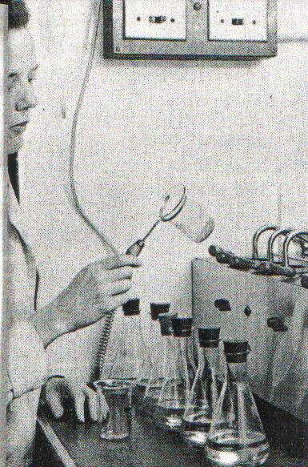

Photo 7. Laboratory technician prepares Induction Test apparatus for accelerated gum or potential gum test.

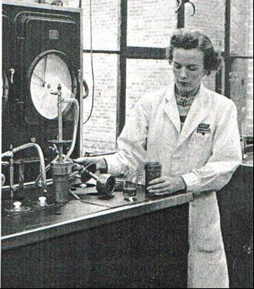

# Avgas Manufacturing Process

The production of aviation gasoline can contain up to six different refining processes. These developed with time and the demand for better quality aviation gasoline.

1. Straight distillation started in the 1800’s and produced gasoline of octane low to fair. [Straight Run Gasoline]
2. Cracking or Pressure distillation of gas oils commenced in the early 1900’s. - octane good. Later to become Catalytic Cracking.
3. Re-forming (same as cracking) of petrol (gasoline) commenced in the 1920’s - octane good.
4. Polymerization (then hydrogenation) commenced in the 1930’s - octane excellent.
5. Hydrogenation commenced in the 1930’s - octane excellent.
6. Alkylation invented 1937 and developed in the 1940’s - Octane excellent. (A major process for all Avgas from 1940 onwards).

In general terms:

* The period 1930 to about 1945 was the period of most development in Avgas.
* From 1944 with the advent of Avgas 115/145, there has been virtually no new development and no new grades except a low lead version of Avgas 100 LL in the 1980’s.

The beginning 1901

# 1903 Gasoline takes to the air with the Wright Brothers.

The First Avgas (1901)

Despite the success of the automobile engine by Daimler, the outlook for a light weight internal combustion engine was not promising, however as a result of the Spanish American war the US Congress appropriated money for a manned aircraft. Charles Manly constructed a 52-horsepower radial engine and a quarter scale version was tested in 1901 in a flying model and this was the first time gasoline took to the air.

The petroleum industry started in the mid-19th. Century, and by the time the internal combustion engine was built, coal-oil and kerosene (used for illumination) were available fuels. It was soon found that a more volatile distillate was required for successful atomization of the fuel in the carburettor. When the first aircraft was built, gasoline was a well-established fuel for thousands of automobiles.

The Wright Brothers had been enthusiastic aviation engineers well before 1903, and for the airplane they built a four-cylinder water cooled (201 cu. in.) 12 hp engine. (180 lbs/82 Kg). They fuelled this engine with several cans of Standard Oil motor gasoline bought from a nearby boatyard, probably supplied from Standard Oil Company of New Jersey (Baltimore Refinery) using Pennsylvania crude (octane about 38). And the rest is history.

Photo 8. Wright Flyer 1909

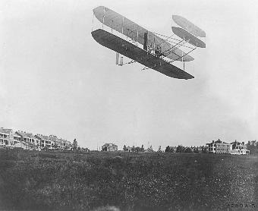

While this flight took the imagination of the world, very little attention was paid to the part that fuel played in both the automobile and aircraft propulsion. Gasoline was taken for granted mainly because the light fraction distilled from the crude oil when manufacturing kerosene contained natural properties better than any engines of the time.

The first decade of flight brought to the fore the importance of fuel volatility and gravity, but it took World War I and its demand on aircraft engines to focus attention on what proved to be the most significant property of all gasolines - the ability to burn in an internal combustion engine without detonating. This property was not well understood until much later, and even in 1911 the British were experimenting with using gunpowder and other explosive chemicals (such as Picric acid) as an additive to gasoline to get a better detonation.

The petroleum chemists were there at the start –

Photo 9. Chevron Laboratory 1904. (possibly Port Arthur Refinery, Texas)

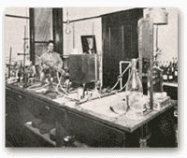

# The Fuel Volatility Factor

1903-1910

Aircraft engines of the period 1903 to 1910 operated on the lightest and most volatile fuel available. The vapourising tendency made up for the imperfect carburettor design. It was noticed that heavy fuels were responsible for hot running engines and so called "pinking". This was the first observation of engine knock. To ensure satisfactory operation, the aviation pioneers insisted upon high test gasoline, which implied fuels of light gravity (or density), their reasoning being that light gravity meant high volatility.

1900-1914

There were no specific requirements for aviation gasoline, and so motor gasoline of varying quality was used. The process used to manufacture this gasoline would have been primary distillation, and so the fuel would have been straight run naphtha (SRN) from most likely American crude oils of that region. Poor in octane, and somewhat uncertain properties with regard to distillation.[4] During this period the quality of aviation gasoline was generally the same as that of the regular motor gasolines used for automobiles, and in many cases inferior and a material of widely varying characteristics. Almost anything was used in the aeroplane engine that would enable it to operate. The principal specification was that of gravity (degrees Baumé), and the gravity of the fuel was supposed to indicate quality.

# Gasoline Composition 1910[5]

This story is about the foresight of New Zealand scientists, which has allowed us to go back 70 years into the past with modern analytical techniques.

In my time as the Chief Chemist of Mobil’s Altona Refinery (Melbourne, Australia) I had a conversation with Roy Freeman, a chemist with the RAAF. In a conversation several years later he told me that he had the compositional analysis (Gas Chromatography/Mass Spectrometry) of gasoline from 1910. This seemed impossible since these analytical techniques were not invented until the 1960’s. He sent me a copy of the information, (which was limited in detail), but it did allow me to track down the source, and find out the full story of the “1910 Gasoline”.

In 1983, the New Zealand Government sent a scientific expedition to Captain Scott’s Antarctic Base. (The base is in the area under New Zealand’s protection).

*“On the slopes of Cape Evans, Ross Island, there is a fuel dump above the hut erected as a base for Captain Scott’s 1910 Antarctic Expedition. The dump had 13 cases labelled ‘Captain Scott’s Antarctic Expedition 1910. Shell Motor Spirit’, which contain large brass drums, many of which contain the original fuel. This fuel was used for his motor tractors, which proved to be an unsuccessful experiment; one fell through the sea ice when it was unloaded from the ship and the other two were abandoned after mechanical failures on the route to the South Pole.*

*The fuel in this dump is historically significant as it is probably the last remaining example of the type of fuel which was used in the early days of motoring and aviation. It predates the first development of fuel refining (the cracking process for increasing the yield of petrol from crude oil was invented in 1913) and nothing was known about anti-knock requirements for engines and the knocking characteristics of petrol until the early 1920’s. The composition of this fuel would therefore be markedly different from modern fuels.*

*A sample of motor spirit from one of these drums was taken in December 1982 during a visit I (Gavin Dougherty) made to Ross Island when I was seconded to the historic huts restoration programme of the New Zealand Antarctic Research Programme. A portion of this sample was sent to the Fuels and Lubricants Laboratory of the National Research Council of Canada for a detailed compositional analysis, and their Technical Report TR-FL-1 “Analysis of Captain Scott’s Antarctic Expedition 1910 Shell Motor Spirit” details the results of this examination”* – from the report by Gavin Dougherty (formerly of the Department of Scientific Research (DSIR) New Zealand).

Scott required the motor spirit for snow tractors that he had brought to explore the region. The source of this Shell Motor Spirit was most likely the East Indies refineries of Sumatra or Borneo, which Shell had operated since the 1890’s. It would have been straight run naphtha from crude sources in the East Indies. At this time motor spirit was also used for aviation purposes, so it is reasonable to assume that this would the composition of avgas in 1910.

So, the foresight of these New Zealand scientists in 1983 has given us the following information:

Table 2. Composition of 1910 Shell Motor Spirit (Gasoline).

|  |  |  |  |  |  |  |
| --- | --- | --- | --- | --- | --- | --- |
| Shell Motor Spirit 1910 | GC | CRC Handbook | | | | |
| Component | %Wt. | Structure No. | Other names | CAS No. | MW | Formula |
| **Paraffins** |  | | | | | |
| n-Butane | 0.92 | 3229 |  | 106-97-8 | 58.12 | C 4H10 |
| iso-Butane | 0.32 | 10073 | 2-Methyl Propane | 75-28-5 | 58.12 | C 4H10 |
| 2,2-Dimethyl Propane | 0.02 | 9910 | Neopentane | 463-82-1 | 72.15 | C 5H12 |
| Iso-Pentane | 5.17 | 3397 | 2-Methyl Butane | 78-78-4 | 72.15 | C 5H12 |
| n-Pentane | 4.96 | 8709 |  | 109-66-0 | 72.15 | C 5H12 |
| 2-Methyl Pentane | 5.62 | 8823 | Isohexane | 107-83-5 | 86.18 | C 6H14 |
| 2,2-Dimethyl Butane | 0.72 | 3289 | Neohexane | 75-83-2 | 86.18 | C 6H14 |
| 2,3-Dimethyl Butane | 1.17 | 3290 |  | 79-29-8 | 86.18 | C 6H14 |
| 3-Methyl Pentane | 3.77 | 8824 |  | 96-14-0 | 86.18 | C 6H14 |
| n-Hexane | 6.69 | 6731 |  | 110-54-3 | 86.18 | C 6H14 |
| 2-Methyl Hexane | 3.52 | 6834 | Isoheptane | 591-76-4 | 100.20 | C 7H16 |
| 2,2-Dimethyl Pentane | 0.50 | 8760 |  | 590-35-2 | 100.20 | C 7H16 |
| 2,2,3-Trimethyl Butane | 0.14 | 3457 | Triptane | 464-06-2 | 100.20 | C 7H16 |
| 2,3-Dimethyl Pentane | 0.85 | 8761 |  | 565-59-3 | 100.20 | C 7H16 |
| 2,4-Dimethyl Pentane | 0.62 | 8762 |  | 108-08-7 | 100.20 | C 7H16 |
| 3-Methyl Hexane | 3.55 | 6835 | (+)- | 6131-24-4 | 100.20 | C 7H16 |
| 3,3-Dimethyl Pentane | 0.30 | 8763 |  | 562-49-2 | 100.20 | C 7H16 |
| n-Heptane | 5.96 | 6355 |  | 142-82-5 | 100.20 | C 7H16 |
| 2-Methyl 3-Ethyl Pentane | 0.05 | 8813 |  | 609-26-7 | 114.23 | C 8H18 |
| 2-Methyl Heptane | 2.06 | 6422 |  | 592-27-8 | 114.23 | C 8H18 |
| 2,2-Dimethyl Hexane | 1.17 | 6771 |  | 590-73-8 | 114.23 | C 8H18 |
| 2,2,3-Trimethyl pentane |  | 8847 | 2-tert-Butyl butane | 564-02-3 | 114.23 | C 8H18 |
| 2,2,4-Trimethyl Pentane | 0.02 | 8848 | Isooctane | 540-84-1 | 114.23 | C 8H18 |
| 2,3,3-Trimethyl Pentane | 0.05 | 8849 |  | 560-21-4 | 114.23 | C 8H18 |
| 2,3,4-Trimethyl Pentane | 0.24 | 8850 | est. | 565-75-3 | 114.23 | C 8H18 |
| 2,5-Dimethyl Hexane | 0.45 | 6774 |  | 592-13-2 | 114.23 | C 8H18 |
| 3-Methyl Heptane | 3.71 | 6423 |  | 6131-25-5 | 114.23 | C 8H18 |
| 3,4-Dimethyl Hexane | 0.13 | 6773 |  | 589-43-5 | 114.23 | C 8H18 |
| 4-Methyl Heptane | 0.60 | 6424 |  | 589-53-7 | 114.23 | C 8H18 |
| n-Octane | 3.03 | 8355 |  | 111-65-9 | 114.23 | C 8H18 |
| 2-Methyl Octane | 0.24 | 8408 |  | 3221-61-2 | 128.26 | C 9H20 |
| 2,2,4-Trimethyl Hexane | 0.03 | 6860 |  | 16747-26-5 | 128.26 | C 9H20 |
| 2,2,5-Trimethyl Hexane | 0.06 | 6861 |  | 3522-94-9 | 128.26 | C 9H20 |
| 2,3-Dimethyl Heptane | 0.63 | 6384 |  | 3074-71-3 | 128.26 | C 9H20 |
| 2,3,3-Trimethyl Hexane | 0.02 | 6862 |  | 16747-28-7 | 128.26 | C 9H20 |
| 2,3,5-Trimethyl Hexane | 0.16 | 6864 |  | 1069-53-0 | 128.26 | C 9H20 |
| 2,4-Dimethyl Heptane | 0.05 | 6385 |  | 2213-23-2 | 128.26 | C 9H20 |
| 2,4,4-Trimethyl Hexane | 0.02 | 6865 |  | 16747-30-1 | 128.26 | C 9H20 |
| 2,5-Dimethyl Heptane | 0.28 | 6386 | 3,6-Dimethyl heptane | 2216-30-0 | 128.26 | C 9H20 |
| 3-Methyl Ethyl Hexane | 0.05 | 6826 |  | 3074-76-8 | 128.26 | C 9H20 |
| 3-Methyl Octane | 0.18 | 8409 |  | 2216-33-3 | 128.26 | C 9H20 |
| 3,3-Dimethyl Heptane | 0.05 | 6388 |  | 4032-86-4 | 128.26 | C 9H20 |
| 3,3,4-Trimethyl Hexane | 0.02 | 6866 |  | 16747-31-2 | 128.26 | C 9H20 |
| 3,4-Dimethyl Heptane | 0.16 | 6389 |  | 922-28-1 | 128.26 | C 9H20 |
| C9-Paraffin | 0.04 |  |  |  | 128.26 | C 9H20 |
| C9-Paraffin | 0.02 |  |  |  | 128.26 | C 9H20 |
| n-Nonane | 0.58 | 8120 |  | 111-84-2 | 128.26 | C 9H20 |
| 2,2-Dimethyl Octane | 0.01 | 8373 |  | 15869-87-1 | 142.28 | C10H22 |
| 2,2,6-Trimethyl Heptane | 0.03 | 6440 |  | 1190-83-6 | 142.28 | C10H22 |
| 3-Methyl Nonane | 0.03 | 8141 |  | 5911-04-6 | 142.28 | C10H22 |
| 3,6-Dimethyl Octane | 0.07 | 8382 |  | 15869-94-0 | 142.28 | C10H22 |
| C10 Paraffin | 0.15 |  |  |  | 142.28 | C10H22 |
| C10 Paraffin | 0.01 |  |  |  | 142.28 | C10H22 |
| C10 Paraffin | 0.03 |  |  |  | 142.28 | C10H22 |
| C10 Paraffin | 0.01 |  |  |  | 142.28 | C10H22 |
| C10 Paraffin | 0.04 |  |  |  | 142.28 | C10H22 |
| C10 Paraffin | 0.04 |  |  |  | 142.28 | C10H22 |
| C10 Paraffin | 0.02 |  |  |  | 142.28 | C10H22 |
| n-Decane | 0.10 | 5033 |  | 124-18-5 | 142.28 | C10H22 |
| 5-Methyl Decane | 0.01 | 8143 |  | 15869-85-9 | 142.28 | C10H22 |
| C11 Paraffin | 0.00 |  |  |  | 156.31 | C11H24 |
| C11 Paraffin | 0.01 |  |  |  | 156.31 | C11H24 |
| n-Undecane | 0.04 | 11938 |  | 1120-21-4 | 156.31 | C11H24 |
| **Naphthenes** |  | | | | | |
| Cyclopentane | 0.87 | 4774 |  | 287-92-3 | 70.13 | C 5H10 |
| Methyl Cyclopentane | 5.74 | 4826 |  | 96-37-7 | 84.16 | C 6H12 |
| Cyclohexane | 3.89 | 4305 |  | 110-82-7 | 84.16 | C 6H12 |
| Methyl Cyclohexane | 10.41 | 4426 |  | 108-87-2 | 98.19 | C 7H14 |
| 1,1-Dimethyl Cyclopentane | 1.25 | 4800 |  | 1638-26-2 | 98.19 | C 7H14 |
| 1,3-Dimethyl Cyclopentane (cis) | 1.54 | 4803 |  | 2532-58-3 | 98.19 | C 7H14 |
| 1,3-Dimethyl Cyclopentane (trans) | 1.70 | 4804 |  | 1759-58-6 | 98.19 | C 7H14 |
| Ethyl Cyclopentane | 0.44 | 4812 |  | 1640-89-7 | 98.19 | C 7H14 |
| 1-Ethyl 1-Methyl Cyclopentane | 0.05 | 4814 |  | 16747-50-5 | 112.22 | C 8H16 |
| 1-Methyl 3-Ethyl Cyclopentane (trans) | 0.24 | 4818 |  | 2613-65-2 | 112.22 | C 8H16 |
| 1,1-Dimethyl Cyclohexane | 0.62 | 4364 |  | 590-66-9 | 112.22 | C 8H16 |
| 1,3-Dimethyl Cyclohexane (cis) | 0.04 | 4367 |  | 638-04-0 | 112.22 | C 8H16 |
| 1,3-Dimethyl Cyclohexane (trans) | 0.74 | 4370 |  | 2207-03-6 | 112.22 | C 8H16 |
| 1,4-Dimethyl Cyclohexane (trans) | 0.88 | 4371 |  | 2207-04-7 | 112.22 | C 8H16 |
| 1,1,4-Trimethyl Cyclopentane | 0.37 | 4856 |  | 4516-69-2 | 112.22 | C 8H16 |
| CCT 1,2,4-Trimethyl Cyclopentane | 0.10 | 4862 |  | 4850-28-6 | 112.22 | C 8H16 |
| CTC 1,2,3-Trimethyl Cyclopentane | 0.74 | 4857 |  | 19374-46-0 | 112.22 | C 8H16 |
| CTC 1,2,4-Trimethyl Cyclopentane | 0.81 | 4860 |  | 16883-48-0 | 112.22 | C 8H16 |
| Ethyl Cyclohexane | 0.41 | 4390 |  | 1678-91-7 | 112.22 | C 8H16 |
| Isopropyl Cyclopentane | 0.06 | 4828 |  | 3875-51-2 | 112.22 | C 8H16 |
| n-Propyl Cyclopentane | 0.57 | 4849 |  | 2040-96-2 | 112.22 | C 8H16 |
| 1-Ethyl 2-Methyl Cyclohexane (cis) | 0.15 | 4395 |  | 4923-77-7 | 126.24 | C 9H18 |
| 1-Ethyl 3-Methyl Cyclohexane (cis) | 0.13 | 4397 |  | 19489-10-2 | 126.24 | C 9H18 |
| 1-Ethyl 4-Methyl Cyclohexane (cis) | 0.18 | 4399 |  | 4926-78-7 | 126.24 | C 9H18 |
| 1-Ethyl 4-Methyl Cyclohexane (trans) | 0.20 | 4400 |  | 6236-88-0 | 126.24 | C 9H18 |
| 1-Methyl 1-Ethyl Cyclohexane | 0.11 | 4394 |  | 4926-90-3 | 126.24 | C 9H18 |
| 1-Methyl 2-Ethyl Cyclohexane (trans) | 0.03 | 4396 |  | 4923-78-8 | 126.24 | C 9H18 |
| 1-Methyl 2-Propyl Cyclopentane | 0.03 | 4834 |  | 932-43-4 | 126.24 | C 9H18 |
| 1,1,3-Trimethyl Cyclohexane | 0.82 | 4486 |  | 3073-66-3 | 126.24 | C 9H18 |
| CCC 1,2,3-Trimethyl Cyclohexane | 0.15 | 4490 |  | 1839-88-9 | 126.24 | C 9H18 |
| CCC 1,3,5-Trimethyl Cyclohexane | 0.01 | 4496 |  | 1795-27-3 | 126.24 | C 9H18 |
| CTC 1,2,4-Trimethyl Cyclohexane | 0.03 | 4493 |  | 7667-59-6 | 126.24 | C 9H18 |
| CTT 1,2,4-Trimethyl Cyclohexane | 0.04 | 4495 |  | 7667-60-9 | 126.24 | C 9H18 |
| iso-Butyl Cyclopentane | 0.04 | 4833 | iso Butyl Cyclopentane | 16631-63-3 | 126.24 | C 9H18 |
| n-Butyl Cyclopentane | 0.07 | 4778 |  | 2040-95-1 | 126.24 | C 9H18 |
| tert-Butyl Cyclopentane | 0.08 | 4805 | tert-Butyl Cyclopentane | 3875-52-3 | 126.24 | C 9H18 |
| 1-Ethyl 2,3-Dimethyl Cyclohexane | 0.01 |  |  |  | 140.27 | C10H20 |
| iso-Butyl Cyclohexane | 0.01 | 4369 | iso-Butyl Cyclohexane | 3178-22-1 | 140.27 | C10H20 |
| sec-Butyl Cyclohexane | 0.01 | 4448 | sec-Butyl Cyclohexane | 7058-01-7 | 140.27 | C10H20 |
| **Aromatics** |  |  |  |  |  |  |
| Benzene | 0.90 | 867 |  | 71-43-2 | 78.11 | C 6H6 |
| Toluene | 3.62 | 1947 |  | 108-88-3 | 92.14 | C 7H8 |
| Ethyl Benzene | 0.26 | 1668 |  | 100-41-4 | 106.17 | C 8H10 |
| m-Xylene | 1.44 | 1453 |  | 108-38-3 | 106.17 | C 8H10 |
| p-Xylene |  | 1452 |  | 95-47-6 | 106.17 | C 8H10 |
| o-Xylene | 0.32 | 1454 |  | 106-42-3 | 106.17 | C 8H10 |
| iso-Propyl Benzene | 0.02 | 1975 | Cumene | 98-82-8 | 120.19 | C 9H12 |
| n-Propyl Benzene |  | 2169 |  | 103-65-1 | 120.19 | C 9H12 |
| 1,3,5-Trimethyl Benzene | 0.11 | 2359 | Mesitylene | 108-67-8 | 120.19 | C 9H12 |
| 1,2,4-Trimethyl Benzene | 0.09 | 2358 | Psuedocumene | 95-63-6 | 120.19 | C 9H12 |
| o-Ethyl Toluene | 0.04 | 1685 |  | 611-14-3 | 120.19 | C 9H12 |
| m/p-Ethyl Toluenes | 0.04 | 1686 |  | 620-14-4 | 120.19 | C 9H12 |
| m/p-Ethyl Toluenes | 0.04 | 1687 |  | 622-96-8 | 120.19 | C 9H12 |
| tert Butyl Benzene | 0.02 | 1459 | 1,1-Dimethyl ethyl benzene | 98-06-6 | 134.22 | C10H14 |
| 1-Methyl 3-iso Propyl Benzene | 0.03 | 1989 |  | 535-77-3 | 134.22 | C10H14 |
| 1-Methyl 4-iso Propyl Benzene | 0.00 | 1990 |  | 99-87-6 | 134.22 | C10H14 |
| 1-Methyl 2-iso Propyl Benzene | 0.02 | 1988 |  | 527-84-4 | 134.22 | C10H14 |
| n-Butyl Benzene | 0.01 | 1118 |  | 104-51-8 | 134.22 | C10H14 |
| Diethyl Benzene | 0.01 | 1414 |  | 141-93-5 | 134.22 | C10H14 |
| 1,2-Diethyl Benzene | 0.01 | 1413 |  | 135-01-3 | 134.22 | C10H14 |
| 1,4-Diethyl Benzene | 0.01 | 1415 |  | 105-05-5 | 134.22 | C10H14 |
| 1-Methyl 2-n-Propyl Benzene | 0.01 | 2036 |  | 1074-17-5 | 134.22 | C10H14 |
| C10 Aromatic | 0.01 |  |  |  | 134.22 | C10H14 |
| Pentyl Benzene | 0.01 | 2107 | Pentyl Benzene | 538-68-1 | 148.25 | C11H16 |
| Total | 99.99 |  | | | | |

Data source: Technical Report 1984/03, TR-FL-1, NRC No. 23408

Analysis of “Captain Scott’s Antarctic Expedition 1910 Shell Motor Spirit” by L. Gardiner, B. Glavincevski, G. Moon and D. McDill. Division of Mechanical Engineering, National Research Council Canada.

The authors noted (in 1983), that the chromatographic data showed in excess of 140 components. Of these 124 were assigned an identification by the PNA program based solely on the basis of retention time. The accuracy of the identification in a complex hydrocarbon mixture such as gasoline, where a large number of components with retention times in close proximity exist, has not yet been established.

The following data (Table 3.) was derived from the above table to illustrate the hydrocarbon group types. This can be used for comparison with other gasolines analysed in the First World War years.

Table 3. Shell Motor Spirit 1910 - Hydrocarbon Group Types by Carbon Number

|  |  |  |  |  |  |  |  |  |  |
| --- | --- | --- | --- | --- | --- | --- | --- | --- | --- |
| Hydrocarbon Type | Total % Wt. | C4 | C5 | C6 | C7 | C8 | C9 | C10 | C11 |
| n-Alkanes | 22.26 | 0.92 | 4.96 | 6.69 | 5.96 | 3.03 | 0.58 | 0.10 | 0.04 |
| Iso-alkanes | 37.20 | 0.32 | 5.19 | 11.28 | 9.47 | 8.47 | 2.02 | 0.44 | 0.03 |
| Cyclo-alkanes | 33.55 |  | 0.87 | 9.63 | 15.33 | 5.28 | 2.42 | 0.02 |  |
| Aromatics | 6.98 | - | - | 0.90 | 3.60 | 2.02 | 0.34 | 0.11 | 0.01 |

Carbon Number Distribution

From the above table of hydrocarbon types it can be seen that there is a substantial amounts of cyclo-Alkanes (Naphthenes) and Iso-Alkanes (Iso-paraffins) which are greater than the n-Alkanes (normal paraffins). This is important because the former components have much higher octane ratings than normal paraffins. For example, normal Hexane (a normal paraffin) has an RON of 24, while Isohexane (an iso-paraffin) is 74 RON, and Cyclohexane (a naphthene) is 83 RON.

Graph 3. Carbon Number Distribution for Shell Gasoline 1910

The octane ratings of individual hydrocarbons and groups will be discussed later.

Predicted Octane Ratings

From the detailed composition of this 1910 gasoline, the Research Octane Number and Motor Octane Number have been calculated using the linear blending method and American Petroleum Institute blending octane numbers (Source API Project 45, 1958). It is estimated that the Research Octane Number (RON) of this 1910 gasoline was 70 RON, and the Motor Octane Number was 67 MON.

Given that this was at a time well before the discovery and addition of antiknock additives, this is a moderately good octane rating for a straight run gasoline from probably the East Indies. This would have significant ramifications in the forthcoming World War – The ‘Great War’.

PONA

One of the techniques used by the oil industry to describe the general nature of a hydrocarbon mixture (or product) is to analyse the mixture into broad hydrocarbon groups – specifically Paraffins, Olefins, Naphthenes and Aromatics, commonly called ‘PONA’ Analysis. This allows the oil industry chemist to predict some of the properties of the mixture. For example, Paraffins CnH2n+2 where n = the number of Carbon atoms C, H is the hydrogen atom.

In the gasoline range (C5 to C12) paraffins are generally poor in octane rating (except for highly branched paraffins), but higher paraffins are excellent for kerosene and jet fuels and satisfactory for lube oils. Indeed, the paraffin (C7H16) normal Heptane has an octane of zero.

Olefins (CnH2n) are usually present only in low concentrations in crude oils, but can be present in catalytically cracked gasolines, and as Propylene and Butenes (and Pentenes) are the essential feed stock for the Alkylation process; (which is a major process essential for higher octane aviation gasolines. This will be discussed in detail later).

Naphthenes (CnH2n) are satisfactory in gasoline and jet fuels, and excellent in lube oils.

Finally, Aromatics (CnH2n-6) in the gasoline range are excellent for octane rating, and poor in jet fuels because they cause excessive smoking and built up of carbon deposits; and as ‘fused aromatics’ Poly Aromatic Hydrocarbons (PAH) are bad in lube oils because they cause sticky resins to form.

Graph 4. PONA Distribution for Shell Gasoline 1910

As can be seen from the above figure the significant level of naphthenes and small amount of aromatics, are the major components contributing to the reasonable octane rating of this gasoline.

# Avgas Specifications and Test Methods before 1914

The first US government specification for the purchase of gasoline appeared in 1907 as US Navy Specification Number 24G.5;[6] which called for ‘high grade’ refined gasoline free from all impurities, having a gravity of particular number 70o Be *(Baumé Gravity) (0.70 Specific Gravity)*, and requiring that no residue be left in a platinum dish after one hour in boiling water. It can be seen that there was no appreciation of chemical qualities of the fuel, and only a test to assure the absence of kerosene or lube oil contamination.

Specific gravity (or density) and a rough distillation appeared to be the only requirement, together with an ability to distinguish between gasoline and other petroleum products of the time such as kerosene.

# Manufacturing Process before 1914

The primary refinery process from the discovery of crude oil in the 1859, up until the introduction of thermal cracking in 1913, was primary atmospheric distillation initially in batch process operations; essentially loading a large vessel (a still) with crude oil and heating the crude to drive off the various broad range of products - naphtha, illuminating kerosene, furnace oils, and the residue used as a rough and ready lubricant or grease. Later this would be developed into a continuous process where the heated crude oil would enter the distillation tower and the desired products would be drawn off from the various side draws. These are known as “straight run” products.

Prior to the introduction of the automobile, the prime purpose of distilling crude oil was to produce illumination kerosene. It should also be recognised that this was the period of naval power, where the status of a nation was measured by the size of its navy, and to power that navy required fuel oil or bunker fuel. Naphtha or gasoline was of minor importance. The quality of these products depended solely on the crude oil from which they came. Thus the performance of the gasoline depended on two important factors, the distillation range (or ‘cut’ from the distillation) and type of crude oil from which it was derived. Both these factors would become significant in aircraft engine performance in the looming World War of 1914 -19.

Table 4. Oil Refining Processes 1862-1913

|  |  |  |  |
| --- | --- | --- | --- |
| Year | Process name | Process purpose | Process by-products |
| 1862 | Atmospheric distillation | Produce kerosene | Naphtha, tar, etc. |
| 1870 | Vacuum distillation | Lubricants | Gas oil |
| 1913 | Thermal cracking | Increased gasoline yield | Residual, bunker fuel |

Atmospheric Distillation (or Primary Distillation)

Atmospheric Distillation (or Primary Distillation) is the first major operation performed on crude oil in petroleum refining. One of the limiting factors is the temperature to which the crude oil is heated, if the temperature is too high degradation and formation of coke may occur in the heating furnace. One way to overcome this problem is to use a secondary process – Vacuum distillation. The primary distillation process produced naphtha which was used as gasoline for internal combustion engines whether they be in motor cars, motorcycles, motor boats or aircraft. It is still known today as ‘Straight Run Naphtha’ (SRN); it can also be known as Light Virgin Naphtha (LVN) or Heavy Virgin Naphtha (HVN) depending on its distillation range.

Vacuum Distillation

This follows the primary distillation and uses the residue from the primary distillation as its feedstock. It is used to distil material in the crude oil which, due to high boiling point or heat sensitivity, cannot be distilled at the atmospheric conditions of the primary distillation. This process does not produce any gasoline components, only lubricating oils (usually of poor quality).

Case Head Gasoline or Natural Gasoline

Crude oil is obtained from wells sunken into oil fields, and in many cases there can be associated gas fields there too. Some of these gas fields will also produce a gasoline type product, which is extracted directly from the ground and separated from the gases. The gasoline product is known as ‘natural gasoline’ or sometimes ‘case head gasoline’. These are usually light gasolines and containing Butanes and Pentanes. These were also used as a gasoline component where they were available (that is from gas fields).

Thermal Cracking[7]

From 1909-1913, Dr. William M. Burton, was General Manager of Standard Oil of Indiana, Whiting Refinery in Indiana, USA, and Dr. Robert E. Humphreys was the Chief Chemist and head of the refinery’s laboratory, they devised an economically practical way to increase gasoline yields using heat and pressure. The Whiting Refinery was the world’s largest at the time. Burton and Humphreys had tried and failed to extract more gasoline from crude by adding chemical catalysts, but then Burton had an idea and directed Humphreys to add pressure to the standard heating process used in distillation. If the residues from the primary distillation are further heated under pressure, the molecules of the heavier oil fractions are broken up (or cracked) into lighter fractions (smaller molecules). This is known as ‘Thermal Cracking’. From this process a ‘cracked’ gasoline component can be produced. Under both heat and pressure, it turned out that heavier molecules of kerosene, with up to 16 carbon atoms per molecule, "cracked" into lighter molecules such as those of gasoline, with 4 to 12 carbons per molecule. However, this cracked gasoline usually has a foul odour (due to Sulphur compounds); when sulphur is present in the charge stocks, the sulphur content of the cracked product is high. Also the cracked product is susceptible to oxygen and gum formation (due to olefinic compounds, mono- and diolefins) which can leave deposits on fuel filters, tanks and carburettors. Thermal cracking, as the process came to be called, doubled the efficiency of refining, yielding 40 percent gasoline.

Dr. William Burton and Dr. Robert E Humphreys developed and patented Thermal Cracking in 1913, perhaps the most important patent in the history of petroleum refining. Cracking units were soon put into commercial operation. Within a few decades, improved cracking processes more than doubled the yield of gasoline from crude. Equally important, cracking produced a product (cracked naphtha) far superior in octane to the straight run gasoline produced from atmospheric distillation. This permitted the development of higher compression ratio engines. Thermal cracking also yields a product (cracked naphtha) containing large amounts of unsaturated hydrocarbons (olefinic compounds) both mono- and diolefins, and. As engines increased in performance, thermally cracked naphthas were found to be unsuitable for aviation gasoline blendstocks; indeed, the new avgas specifications in the 1920’s would limit the use of these cracked naphthas.

These properties make for an undesirable product for aviation use, as will be seen later.

Photo 10. Dr. William M Burton (circa 1913)

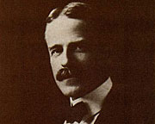

Photo 11. Dr. William Burton and the Burton Distillation Unit.

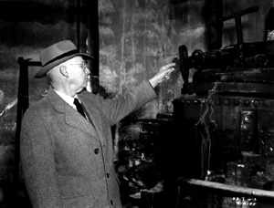

Dr. Robert E. Humphreys stands next to the Burton distillation unit, one of the great inventions of modern times. The still now resides in the Smithsonian Institute.

# Oil Companies and Refineries

Some of the oil companies and refineries of this period were:

**Middle East**

Anglo-Persian Oil Company (later BP) – Abadan Refinery, Persia (later Iran).

Photo 12. Abadan Refinery circa 1913

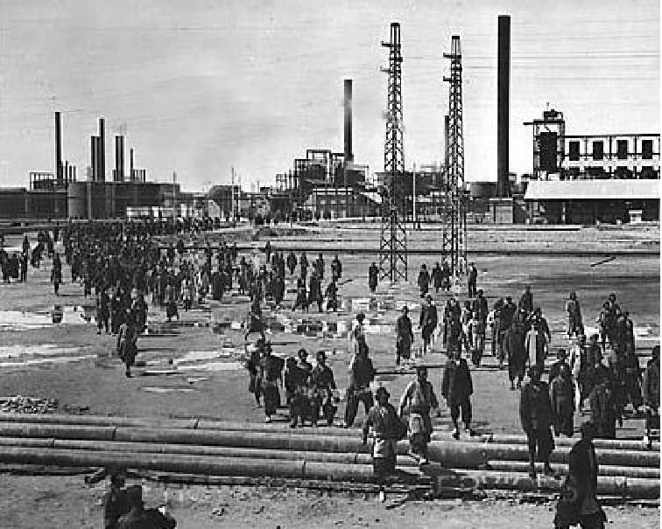

**South East Europe & South West Asia**

This region covered the oil fields of Rumania and Azerbaijan. The Petroleum Production Company Nobel Brothers, Limited, or Branobel was an oil company set up by Ludvig Nobel and Baron Peter von Bilderling, mainly in Baku, Azerbaijan, but also in Cheleken, Turkmenistan and producing mainly kerosene. These oil fields and refineries would feature greatly in WWI and WWII.

Photo 13. The Nobels' oil facilities in Baku between 1876 and 1920

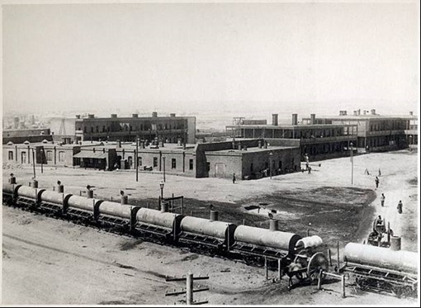

**Netherlands East Indies**

In 1883, Dutch engineers proved the existence of oil in Sumatra and Java. In 1885, the first oil well was drilled. By 1890, Langkot, North West Sumatra was established as an oil producing region. Two companies were in operation, both had Royal Dutch Shell involvement.

Anglo-Saxon Petroleum Co.

Bataafsche Petroleum Maatschappij

Before 1914, Standard Oil Company of New Jersey had concessions in Netherlands East Indies. These would be developed in the 1920’s. A more detailed explanation of the oil fields of Netherlands East Indies and their place in this history is presented in Chapter 15.

**US Refineries**

The US refineries of the early part of the 20th century were primarily crude distillation (by batch process) followed by vacuum distillation. Thermal cracking was just making a start. The SOCAL Richmond Refinery 1903 shows the rows of crude oil stills on the right-centre.

Photo 14. Standard Oil Company of California – Richmond Refinery 1903

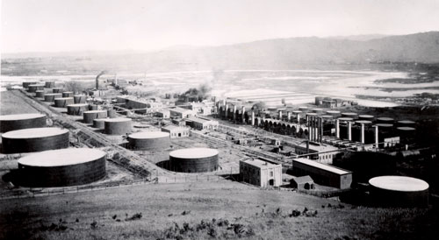

The next photo shows a horse drawn tanker, perhaps a paradox in that the horse would be taken over by the motor car as a result of gasoline.

Photo 15. Gulf Refining Co. horse drawn tanker circa 1907

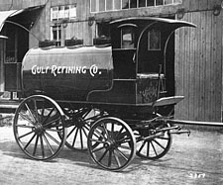

# Australian Beginnings

What was happening in Australia at this time? - This is still an area which requires further research, but I would suggest that normal motor gasoline was used for aviation and later all aviation gasoline was imported from the Dutch East Indies.

1. No aviation gasoline was made in Australia because the first oil refineries built were in 1928 at Clyde in NSW, and the COR Refinery at Laverton in 1926 (processing Persian Crude). Also prior to the Second World War local gasoline production was less than 10% of consumption, with the balance being imported.
2. The major oil companies imported and marketed most petroleum products. Standard -Vacuum (Mobil), Atlantic (Esso), COR (BP), and Shell. These products most likely came from the large refineries in the Dutch East Indies (nine refineries of which seven were run by Royal Dutch Shell) and one by Standard Oil NJ (Esso). The other two Shell refineries were in Borneo and Sarawak.
3. Australia was still very much part of the British Empire, so all technical information was from the British War Office for the fledgling aviation industry. In WWII, the R.A.F. east of Suez was supplied by Shell’s refineries in Balik Papan, Pladju and Palembang Brandan. These refineries also supplied Australia and New Zealand.

Australia’s First Flights[8][9]

July 16th, 1910 was the day the very first Australian built aircraft successfully lifted off the ground in central Victoria. The flight was the fruit of a collaborative effort by two farmers and brothers, John and Reg Dugan.

Photo 16. John Duigan and the biplane, circa 1910

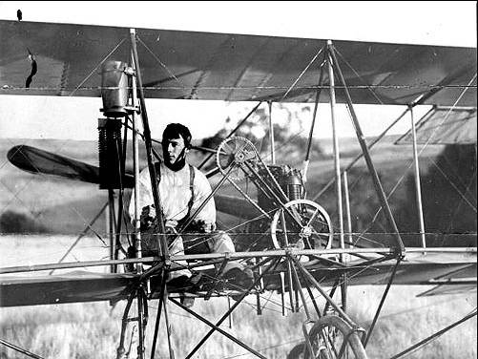

Whilst the first controlled flight in Australia appears to have been made by Fred Custance on 17 March 1910 at Bolivar, South Australia, followed next day by the famous Harry Houdini near Melbourne, it is to John Robertson Duigan of Victoria that belongs the honour of being the first Australian to fly in a locally designed powered aircraft. Contrary to the legend that he was a self-taught lad from the boy, Duigan was a graduate engineer. He designed and made his own aircraft operating in almost complete isolation from contemporary European and Australian pioneers. The power plant he used was produced by J. E. Tilley, also to Duigan's design. Duigan, in his professional way, conducted many structural tests on components and then practiced, in an extended series of short hops, before he was confident that his machine was controllable. His first 'flight' of some 24 ft. (7.3 m) took place on 16 July 1910. At that stage, Duigan realised he needed more power from his engine and undertook modifications to his power plant. From 7 October 1910, he was in a position to fly longer distances, extending to some 200 yards (183 m) in length. His maximum distance, in 1911 was some 1,000 yards (914 m).

When John Duigan wrote to the then Industrial and Technological Museum in 1920, offering to donate an aircraft he had built ‘many years ago about 1910’, the curator, R.H. Walcott, immediately recognised a unique piece of Australian aviation heritage; it was the ‘first Australian-made aircraft to fly’. His flimsy aircraft is now in the care of the Melbourne Museum and a replica is on display.

# “The Race Is On” – Airspeed Records

The thirst and passion for speed, and man’s (and woman’s) desire for faster and faster machines to achieve it, has led to a variety of record-breaking adventures – aircraft speed included, if not at the forefront. The following table lists some of these pioneer achievements. Within the space of one decade since the first manned flight, aircraft speed had increased four-fold.

Table 5. World Air Speed Records 1903-1913[10]

|  |  |  |  |  |  |
| --- | --- | --- | --- | --- | --- |
| Date | Location | Pilot | Aircraft | Achieved km/hr | Official km/hr |
| 17 Dec 1903 | USA – Kill Devil Hill,  North Carolina | Wilbur Wright | Wright Flyer 1 | 50 |  |
| 12 Nov 1906 | France – Bagtelle | Alberto Santos-Dumont | Santos-Dumont 14bis (mod) |  | 41.292 |
| 26 Oct 1907 | France – Issy-les Moulineaux | Henry Farman | Voison-Farman 1 | 52.768 |  |
| 28 Aug 1909 | France –Reims | Louis Blériot | Blériot XII | 76.956 |  |
| 10 July 1910 | France –Reims | Léon Morane | Blériot XI (Mod) | 106.509 |  |
| 29 Sept 1913 | France –Reims | Maurice Prévost | Deperdussin Monocoque Gordon Bennett (F-1) |  | 203.800 |

Photo 17. Louis Blériot about to depart on his epic crossing of the English Channel on 25 July 1909.

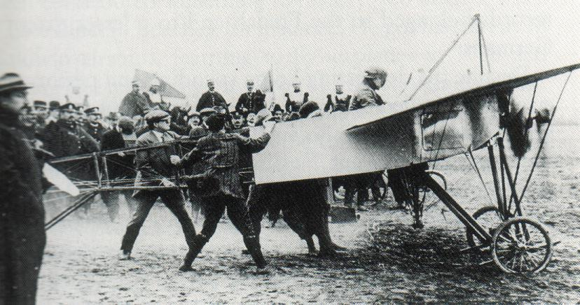

Shell had a long history of selling gasoline for aircraft use overseas, beginning in 1909 when Shell gasoline had fuelled Louis Blériot’s cross-channel flight.

This flight was of major significance for no longer could any island nation such as Britain, be protected by its navy defending its seas.

The fascination with flight would result in a wide variety of air races, exhibitions, displays which would extend into the 1920’s and beyond.

# Epilogue for 1914

In this period 1901 to 1914, the internal combustion engines of the day were simple, heavy, of low compression ratios, and in particular, the aspiration of the fuel was a crude affair. The gasolines of the day were more than suitable for fledgling aircraft engines and designs.

This would be the start of the complex relationship between engine manufacturer and designers on one side, and petroleum chemists and refiners on the other. Where at one time the gasoline fuel available would be far superior to any engine in use at the time; with the situation to be reversed where the engine manufacturers would demand better fuels to meet the potential of their new engines. Then back again, when new fuels were developed which exceeded the requirements of the available engines.

Air races and speed were to become a feature of aircraft interest from this time forward.

Photo 18. Standard Oil of California tanker truck circa 1914

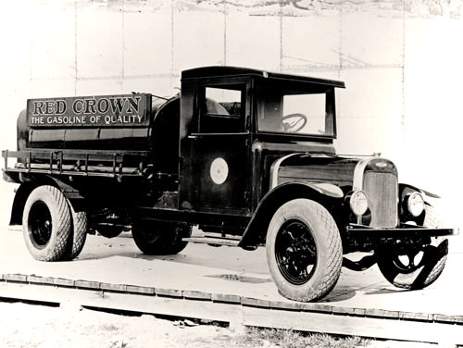

# Acknowledgments

I am indebted to the many colleagues and friends who have assisted me with their recollections, knowledge and review of this publication, in particular the late Mr. Frank Provera who reviewed many of the early chapters, and late Mr. Warren Hicks who has also reviewed many of the chapters.

I am particularly indebted to the many librarians around the world with whom I posed the questions on: “What did they have on aviation gasoline?” and received considerable help and access to the collections under their charge.

I am also indebted to those with vision, who have kept, and continue to keep the archives of their nation, so that others may learn from the work of years gone by. In this regard, I am reminded of but two of countless examples:

G.H. Lines who diligently produced the “Weekly Return Stocks And Issues To Consumption Of Aviations Fuel And A/C Lubricating and Also TEL” [11]from 1941 to 1945 which described the aviation petroleum usage by the British Royal Air Force in the dark days of World War II and the Battle of Britain against the German Luftwaffe, and the subsequence victory over the Nazis.

The historian of the Historian, Historical Sub-Section, Office of Intelligence Officer, Headquarters, Army Air Force Service Command, Mediterranean Theater of Operations who described in detail the operations in providing aviation gasoline to the Allied forces in the Mediterranean[12]

I am sure that these people and many others like them would never have thought that over more than half a century later their efforts, during a period of great stress, would be of interest and value to the next generations. – My heartfelt thanks.

# Research Sources

The information contain in this publication has been drawn from air museums and their libraries, public libraries, oil company libraries, private communications and chemical analyses of Australian Aviation gasolines (1999).

Considerable assistance was obtained from the various librarians, and I am indebted to their patience and assistance while I trawled through their collections. These museums and libraries were:

**Museums**

* San Diego Aerospace Museum – San Diego, California, USA
* Chino “Planes of Fame” Air Museum & Yankee Air Corps Museum – Chino, California, USA
* PIMA Air & Space Museum – Tucson, Arizona, USA (Excellent collection of US jet aircraft from late 1940’s.)
* Confederate Air Force Museum & The American Airpower Heritage Museum – Midland, Texas, USA
* Petroleum Museum – Midland, Texas, USA
* History & Tradition Museum of US Air Force - Lackland Air Force Base (Basic Training for US Air Force) - San Antonio, Texas, USA
* Admiral Nimitz State Historic Park - Fredericksburg, Texas, USA
* USS Lexington Museum On The Bay - Corpus Christi, Texas, USA
* US Air Force Museum - Wright Patterson Airforce Base – Dayton, Ohio, USA
* National Air and Space Museum - Washington DC, USA
* US Naval Aviation Museum – Pensacola, Florida, USA (Excellent collection of US naval/carrier based aircraft)
* Cradle of Aviation – New York, USA
* National Air Museum – Ottawa, Canada
* Canadian War Museum – Ottawa, Canada
* Imperial War Museum – Duxford, Cambridgeshire, UK
* RAF Museum – Hendon, London, UK
* RAF Cosford Museum – Cosford, Shropshire, UK (Experimental jet aircraft)
* Fleet Air Arm Museum – Yeovilton, Somerset, UK
* Yorkshire Air Museum – UK
* Tangmere Military Museum - UK (Neville Duke’s record breaking Hawker Hunter, replica of the first Spitfire prototype)
* Manchester Air & Space Museum - UK
* D-Day Museum – Portsmouth, UK
* British Science Museum - London, UK
* Australian Air Force Museum - Pt. Cook, Melbourne, Australia
* Musee de L’Air – Paris, France
* Musee L’Armee – Brussels, Belgium
* Aviodrome, Nationaal Luchtvaart-Themapark – Lelystad, Netherlands

**Libraries**

* Australian War Memorial Research Centre - Canberra, Australia
* Australian National Archives - Canberra & Melbourne, Australia
* Australian Institute of Petroleum - Melbourne, Australia
* Australian Defence Forces Central Library - Melbourne, Australia
* Australian Air Force Museum - Pt. Cook, Melbourne, Australia
* Shell Centre Library - London, UK
* Institute of Petroleum - London, UK
* Imperial War Museum - London, UK
* UK Public Records Office - Kew, London, UK
* Leicester Reference Library - Leicester, UK
* Sheffield Library - Sheffield, UK
* US Library of Congress - Washington DC, USA
* American Petroleum Institute - Washington DC, USA
* Smithsonian National Air and Space Museum Archives - Washington DC, USA
* Mobil Corporation Research Library - Paulsboro, New Jersey, USA
* Chevron Technical Library - San Ramon, California, USA
* San Francisco Public Library - San Francisco, California, USA
* San Diego Aerospace Museum - San Diego, California, USA
* National Air Museum – Ottawa, Canada

**Company Visits**

* Octel - Ellesmere Port. (Liverpool), UK (Manufacturer of Alky Lead Compounds)
* Shell Stanlow Refinery - (Liverpool) UK

# Index

A

accelerated gum 16

AIP 5, 6

Alcohols 8

alkyl lead 5

Alkylation 17, 25

Altona Refinery 20

American Institute of Petroleum 5

anti-knock 5, 9, 10, 14, 20

API 5, 24

aromatic 8, 10

Aromatics 8, 22, 23, 24, 25

Atmospheric Distillation 26

Australian Institute of Petroleum 5, 36

Avgas 100 LL 17

Avgas 115/145 17

Avtur 7

Azerbaijan 29

B

Baku 29

Balik Papan 31

Baltimore Refinery 18

Battle of Britain 4

*Baumé* 26

Benzene 5, 8, 22, 23

Benzine 5

Benzol 5, 8, 9

Berlin 4, 7

Borneo 20

brake mean effective pressure 9

Branobel 29

Burton 27

Butanes 27

Butenes 25

C

C.F.R. 10

C.F.R. engine 10

calorific value 13, 14

carburettor 12, 13, 18, 19

case head gasoline 27

Catalytic Cracking 17

Cheleken 29

Chevron 5, 19, 36

coal-oil 18

Co-operative Research Fuel Research 9

copper strip corrosion 15

Cumene 8, 22

cyclo-Alkanes 23

Cyclo-alkanes 23

Cyclohexane 23

D

degrees Baumé 19

density 19, 26

Distillation 11, 27

Distillation Range 9

Dougherty 20

Duigan. 31

E

engine knock 19

Esso 5, 31

ethyl alcohol 14

Exxon 5

F

Freeman 20

fuel injection 12

G

Gas Chromatography 20

gum 8, 9, 15, 27

gunpowder 19

H

Heavy Virgin Naphtha 26

Hexane 23

high test gasoline 19

Hiroshima 4

Humphreys 27

Hydrogenation 17

I

Imperial War Museum 35

Induction Test 16

Institute of Petroleum 5, 36

IP 5

Iso propyl ether 8

Iso-alkanes 23

Iso-Alkanes 23

Isohexane 23

iso-Propyl Benzene 8

J

Java 30

Jet fuel 7

K

kerosene 11, 18, 25, 26

knock-rating 9, 11, 14

Korean War 7

L

Light Virgin Naphtha 26

Lindberg 3

Louis Blériot 32, 33

M

Mass Spectrometry 20

Methanol 8

Methanolamine 8

Mitchell 3

Mobil 5, 20, 31, 36

Motor Octane Number 4, 24

N

Nagasaki 4

n-Alkanes 23

naphtha 26

Naphthenes 8, 22, 23, 24, 25

natural gasoline 27

Netherlands East Indies 30

Nobel Brothers 29

O

Octane Number 9, 24

Olefins 8, 24

Ostfriesland 3

P

Palembang 31

Paraffins 8, 21, 24

Pearl Harbour 4

Pennsylvania 18, 39

Pentanes 27

Pentenes 25

Performance Number 4

Picric acid 19

pinking 19

Pladju 31

Polymerization 17

PONA 8, 24, 25

Port Arthur Refinery 19

potential gum 16

Primary Distillation 26

Propylene 25

R

RAAF 5, 20

RAE 5

RAF 5, 35

Re-forming 17

Reid Vapour Pressure 13

Research Octane Number 4, 24

Richmond Refinery 1, 30

Royal Dutch Shell 31

Rumania 29

RVP 13

S

Scott 20, 23

Shell 20, 21, 23, 24, 25, 30, 31, 33, 36

specific gravity 13, 14

Specific Gravity 9

Standard Oil 31

Standard Oil Company of California 5, 30

Standard Oil Company of New Jersey 5, 18, 30

straight run 24, 26

Straight Run Gasoline 17

straight run naphtha 19, 20

Straight Run Naphtha 26

sulphur 14

Sulphur 27

Sumatra 20, 30

T

TEL 5, 8

Tetra Ethyl Lead 5, 8

Thermal cracking 26

Thermal Cracking 27

Toluene 5, 8, 23

Turkmenistan 29

V

Vacuum distillation 26

vapour lock 9, 12, 13

Vapour Pressure 9, 12

W

Wright Brothers 3, 18

X

Xylene 8

Xylidene 8

# References

1. Communications Warren R Hicks October 2007
2. “Milestones in Aviation Fuels” by Dukek, Winan, & Ogston
3. “Aviation Fuels- Lubricants and Special Petroleum Products” – Vacuum Oil Company Pty. Ltd – Melbourne Australia. Complimentary Booklet circa 1938
4. Aviation Gasoline Manufacture – Matthew Van Winkle, Pennsylvania State College, McGraw-Hill 1944
5. National Research Council of Canada, Fuels and Lubricants Laboratory, Technical Report TR-FL-1 “Analysis of Captain Scott’s Antarctic Expedition 1910 Shell Motor Spirit”
6. History of Aviation Fuel Development In The United States - AFRL/PSRF sourced from the Internet
7. From API Facts about Oil (circa 1981)
8. Website <http://www.austehc.unimelb.edu.au/tia/497.html> Accessed 11 August 2007
9. Website: <http://www.museum.vic.gov.au/treasures/collDetails.aspx?ID=15> Accessed Aug 11, 2007
10. “World Speed Record Aircraft” by Ferdinand Kasman F.C.W. -Cologne - June 1990. Leicestershire Library (UK) Call No. 639.1334
11. UK Public Records Office London.
12. UK Public Records Office London, Ref: WO 204/6560