Chapter

2

First World War 1914-1919

The Great War – The Biplane Triumphs

Photo . Spad XIII circa 1917

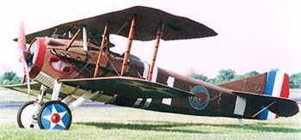

Table of Contents

Summary 3

Combat Fuel And High Altitude Performance 1914-1918 5

German Supplies 5

US Refiners Becomes The Allies Major Supplier 6

Delivery Of Gasoline 8

Supplies For The Battlefield 14

US Avgas Grades 15

US Bureau Of Mines Investigates 16

British R.A.E. Investigates 18

Avgas Specifications And Test Methods 1914-1919 18

US, British, French Aviation Gasoline Specifications 1917-1919 19

Gasoline Composition 1914-1919 20

Analyses Of Aviation Gasolines 1918 22

Abadan Aviation Spirit 1918 28

The Perils Of A Pilot’s Lot 31

Aviation And The Chemist 33

The Long Distance Flights Of 1919 34

Manufacturing Process 1914-1919 38

Oil Companies And Refineries 39

“The Race Is On” – Airspeed Records 42

Epilogue For 1919 43

Index 44

References 45

# Summary

Chronology – Australian Aviation Time lines[1]

**1914** March 1st - Lts. Harrison and Petre test fly Australia's first military aircraft, a Boxkite (CFS 3) and Deperdussin (CFS 4) at Point Cook, Victoria. The first Australian-built non-rigid airship is flown in Sydney, NSW, on July 4 by A.L. Roberts. Twelve days later, on July 16, Australia's first air mail consisting of 1,785 letters left Melbourne, Vic. in Maurice Gillaux's Blériot monoplane. It reached Sydney, NSW 2½ days later on July 18th. Actual flying time - including 1 hr. 13 mins. of demonstration flying - was 9 hrs. and 15 mins.

August 4, 1914 WORLD WAR I begins.

World War 1

**1915** The first Central Flying School course at Point Cook, Vic., finishes on 12th November 1914. In less than three weeks Australia's first aviation unit to be sent overseas on active duty sailed from Sydney on Nov. 30th, 1914 for German New Guinea. It returned in April, 1915. Lt. Merz, of the first Point Cook course, became the first Australian military pilot killed in action on 30 April, when his Caudron was forced down with engine trouble and he was killed by hostile Arabs.

On Aug. 10th, the first military aircraft built in Australia, a Bristol Boxkite, entered service at Point Cook as CFS 10.

**1916** The New South Wales Government Aviation School opened at Richmond, initially with two Curtiss Jenny aircraft. Two more were ordered, and were in still use by the end of WW2. Four Caudrons were also ordered.

**1917** On March 20, Lt. F.H. McNamara of 1 Sqn ., AFC became Australia's only air Victoria Cross winner of World War 1. On 22 November, Lt. F.G. Huxley of 2 Sqn. AFC achieved the first Australian air victory on the Western Front, flying a DH-5, when he shot down a German Albatross scout.

**1918** Capt. Lawrence Wackett, of 3 Sqn., AFC perfects an ammunition supply dropping technique which was adopted by the RAF.

November 11, 1918 WORLD WAR I ends.

Inter-War

**1919** Australia signs the Convention for Regulation of Aerial Navigation on 13th October. Australian aircraft would carry registration letters of G-AU plus two other letters. These were to be replaced by the prefix letters VH- plus three letters in 1929.

On Dec. 10th, 1919 Vickers Vimy G-EAOU reaches Darwin, Northern Territory, having left England on Nov. 12th, winning its crew - Ross and Keith Smith, W.H. Shiers and J.M. Bennett - the Australian Government's first prize of ten thousand pounds for a flight from England to Australia within 30 consecutive days. Two other men hoping to enter the event could not, because their intended financier died, so they took work preparing the Australian leg of the race. The two - P.J. McGinness and W. Hudson Fysh - would start QANTAS airline. Two days after the Vimy reached Darwin, a BE.2c flown by Capt. H. Wrigley & Sgt. A. Murphy arrived, having departed from Point Cook on Nov. 16th. This was the first Australian transcontinental flight.

Photo . Aircraft launches from HMAS Australia 1918.

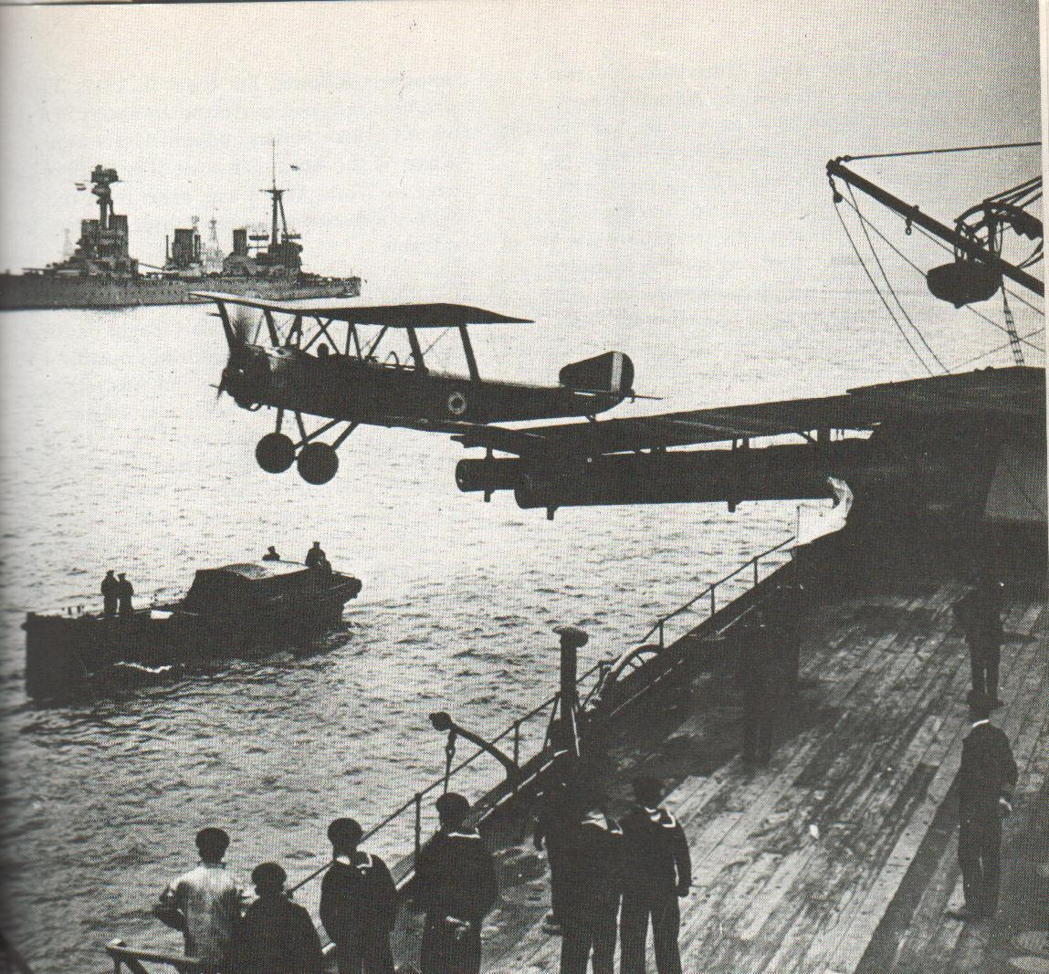

An aircraft leaves the turret platform of HMAS Australia for a flight from Rosyth, Scotland 1918. [Source Pictorial History of Australia at War].

The Great War – The Biplane Triumphs

The First World War years and the development of specifications and initial understanding of “engine knock”.

# Combat Fuel and High Altitude Performance 1914-1918

Once the utility of the aeroplane in observation and combat was demonstrated in war, great efforts were made to develop more powerful engines and better airframes to increase speed and altitude. To get more power out of the aircraft engines required increasing the compression ratio and the capacity to intake more air for combustion. The recognition that air density decreased with altitude led to the British experiments with superchargers in 1915.

Increasing the compression ratio required better fuel quality, but fortunately the British and French were obtaining much of their aviation gasoline from aromatic crudes of the Dutch East Indies (Indonesia) and British Borneo which contained 30% aromatics and displayed high anti detonation value in engines, and did not limit the development of the more powerful engines.

The French also drew from the same sources, but went one step further by re-running (redistilling) the stocks in French refineries. French authorities claimed this step was necessary to obtain the quality necessary for their planes. Others were suggested that the purpose was to make work for the French refining interests.

Shell Aviation Spirit up to the mid 1917 was the only fuel supplied to the Allied Flying Corps. It was refined in Sumatra and Borneo, transported to storage, then to the UK. In the UK, it was transported by rail tank cars to inland bulk depots and filled into the famous 2-gallon cans.[2]. By 1917-1918 tanker filling into aircraft commenced.

Competition with demand for explosives

One of the key components in aviation gasolines, which gave it high anti-detonation properties were the aromatics, specifically Toluene (or Toluol). However, Toluene is the chemical building block for Tri-Nitro Toluene (the explosive more commonly known as TNT). This competing demand for aviation gasoline or explosives would always appear in times of war. For the explosive demand, Toluol was extracted from straight run gasoline obtained from Shell Oil in Borneo. The distillation was done in Rotterdam, Netherlands to extract the Toluol because there was no distillation operation in England.

# German Supplies

Germany's pre-war crude supplies had come from Mexico and Rumania (Romania). As the British blockade effectively shut off tanker shipments from overseas, Romania became the principal source of supply. Oil supplies for the German forces in Western Europe were limited and forced Germany to resort to substitute fuels with inferior properties. Blends of kerosene, benzol, and potato alcohol were often used in heavy bombers, while remaining petroleum fuels were reserved for fighter aircraft.

In 1918 the standard Avgas was a Borneo or Romanian fuel of about 70 Octane.

Photo . German Fokker DVII aircraft 1918.

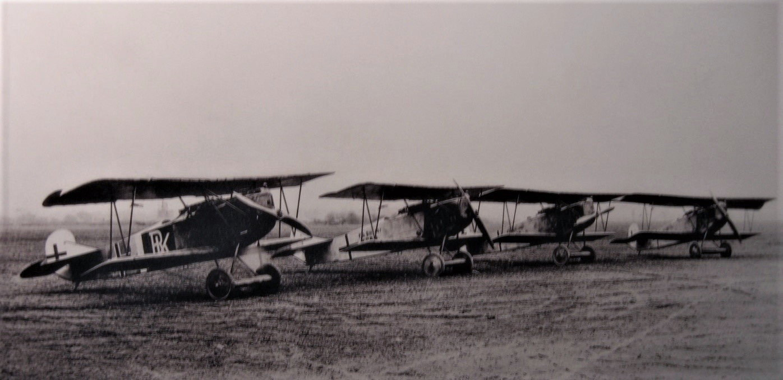

This aircraft was considered such an important German armament that is was specifically named in the Versailles Peace Treaty when the Great War was over.

# US refiners becomes the Allies major supplier

The US refineries began to become the major supplier of oil products to the British and French in World War I.

In 1917, as a result of heavy Allied shipping losses, and in part to meet the mounting requirements, the British reluctantly turned to American sources of aviation gasoline. In October 1917, F. W. Black of the British War Mission in the United States wrote that because European supplies were “dangerously low” he was authorised to place an order for “aviation naphtha” with American refineries. The initial order was for 36,000 tons (approximately 250,000 barrels (42 USG) (or 40 million Litres), which according to British specifications was to be “straight run” gasoline from high quality (no Sulphur), American (no Mexican) crudes. The gasoline should be within 65 to 67.8 Baumé (Specific Gravity 0.708 - 0.718), with a distillation range of 65% recovered below 100 deg. C., and 100% recovered at 150 deg. C. These requirements effectively limited potential American suppliers to refiners who were prepared to run Pennsylvania (paraffin) crudes through an initial distillation, followed by a rerun (redistillation) in a distillation tower or fractionating steam stills to obtain the exact cuts specified. Thus, of the dozen companies asked to bid on the contract, only two, Standard Oil Company of New Jersey (later Esso) and the Atlantic Refining Company responded, and the order was divided equally between them.[3]

At the end of 1917 (late December) the Petroleum Committee (US) was advised the future requirements of aviation naphtha for the United States and Allied Governments for shipment from New York, starting January 1st, 1918 would be 10,000 tons per month (11 million Litres per month). In attempting to allocate this quota among the large Atlantic Coast refiners the Petroleum Committee encountered some resistance, which stemmed from several considerations. Firstly, the demanding requirements of skilled personnel and equipment to meet the exacting standards of aviation gasoline, which also tended to reduce the total output of gasoline slightly (by 2%). Secondly, the production of aviation gasoline took a considerable portion of the low-boiling fractions or highly volatile components of crude oil, with a consequent reduction in the quality of regular automobile fuels. Finally, the companies were eager to maintain or increase their share of the domestic gasoline market, which was expanding rapidly in 1917 and 1918.

This competition between the wartime demand for aviation gasoline and the demand for petrol by the domestic motorist would reappear again in the next World War.

In an effort to ensure continued and increasing supply of aviation gasoline, the Petroleum Committee in February 1918 asked refiners to produce aviation gasoline volumes equivalent to between 4% and 6% of their crude throughput. Those refiners who did not meet this request would receive a letter questioning why they could not meet this demand when other refiners could. This led to refiners in Pennsylvania and the Mid-Continent (US) becoming aviation gasoline suppliers.

The Petroleum Committee met the challenge of increased demand for aviation gasoline by firstly calling on California refiners to contribute to the aviation gasoline output, and secondly by getting the large Mid-Continent refineries to re-run gasoline from smaller refineries not equipped to produce aviation fuel. By October 1918, the total output from US refineries was 39,000 tons per month (44 million Litres/month) of which some 21,000 tons (54%) came from the seaboard refineries, and about 6,000 tons each from California, Oklahoma and Pennsylvania. Actual production in 1918 was in excess of overseas shipments and did not reach 20,000 tons per month until October 1918, however these shipments were more than sufficient to supply the needs of the combined Allied air forces at the front which totalled some 6,784 aircraft as of November 11, 1918.

Figure . Exported Avgas from US 1918

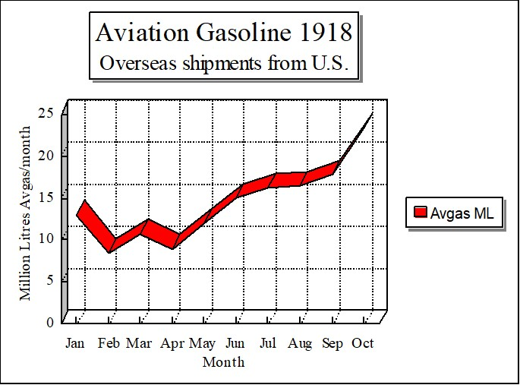

# Delivery of Gasoline

The delivery of gasoline of the fledgling air forces and their flying machines was also developing – the easiest way was in 2- or 4-gallon drums on horse drawn wagons. As the war progressed refuelling became better organised, but fuel cleanliness and quality would always be a matter of concern.

In order to keep these flyers in the air required a ground crew and also included refuelling equipment, and while the 2- and 4-gallon drums were commonly used, for larger facilities a refuelling wagon (285 US Gallon) would carry enough gasoline to fuel nine Sopwith Camels. The following is an example of such a refuelling trailer. This unit has been restored and is located at the US Air Force Museum at Dayton, Ohio.

Photo . Restored Refuelling Wagon (circa 1918) on display at US Air Force Museum (Petroch Services 1999).

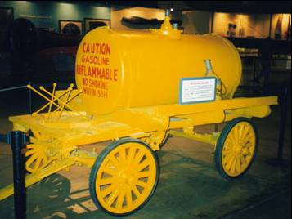

Avgas delivery during the First World War was also in drums on horse drawn carts.

Photo . Typical delivery wagon for aviation gasoline in World War I (1914-1918).

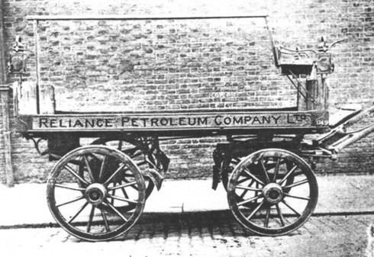

Photo . Nieuport N.28C-1 fighter (restored) typical of World War I aircraft (US Air Force Museum (1999).

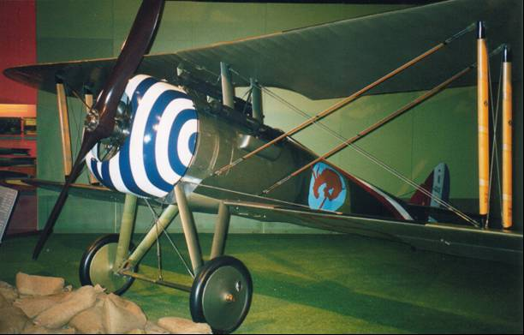

Photo . Refuelling a French aircraft (pusher type) with cans typical of 1914-1918 (Musée de l’Air et de l’Espace 1999).

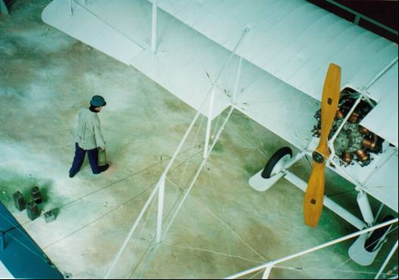

Photo . Gasoline cans typical of 1914-1918 (Musée de l’Air et de l’Espace 1999).

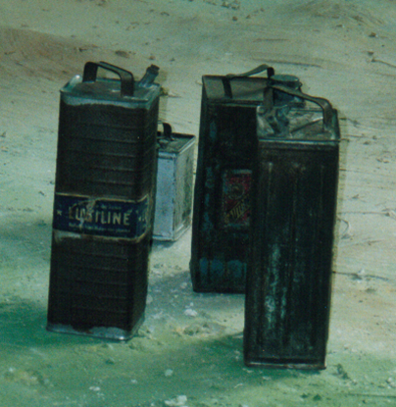

Photo . US Army Pilots refuelling a “Jenny” in Mexico 1917 (US Air Force Museum).

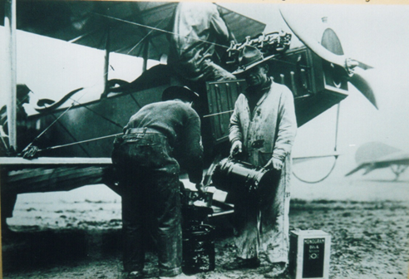

The above photo has a number of interesting points. The drum in the forefront is “Monogram Oils & Petrol”. Corporal Ira D. Biffle seen pouring the gasoline, graduated from the US Army Signal Corps Aviation School at North Island, San Diego, California in January 1916. He enlisted in 1917 and was commissioned during 1917. Later as a civilian, he gave flight instruction to a young Charles Lindbergh who would achieve fame with his solo flight of the Atlantic Ocean.

Photo . Refuelling a ‘Jenny’ - (San Diego Aerospace Museum, USA 1999).

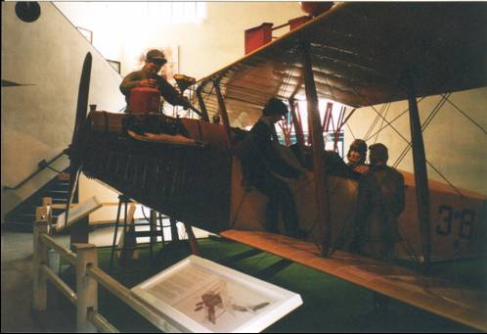

Note the chamois filter to remove water and other particulate impurities such as sand, dirt etc.

Photo . BP refueller truck circa 1919.



Note that the fuel supplied was ‘motor spirit’ for aviation service.

Photo . Refuelling hand operated equipment, aviation gasoline pump (red) and lube oil pump (Cradle of Aviation Museum, New York 2006).

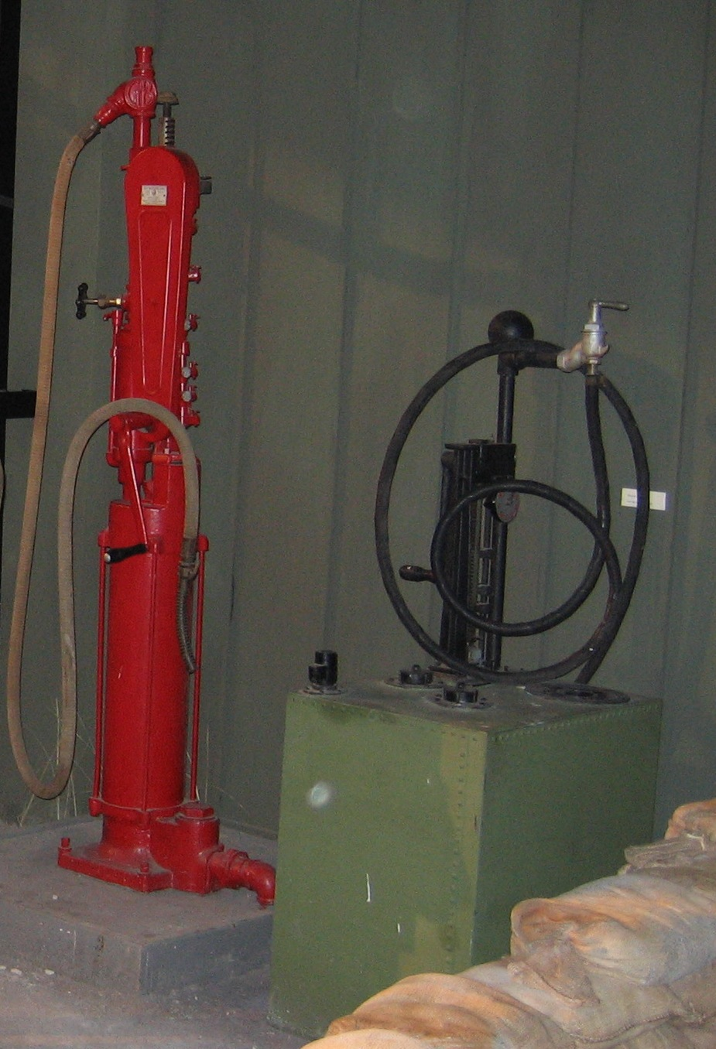

Photo . Dutch Farman aircraft being transported by trailers, note the gasoline drums in the foreground 1918 (Aviodrome, Nationaal Luchtvaart-Themapark – Lelystad, Netherlands 2006)

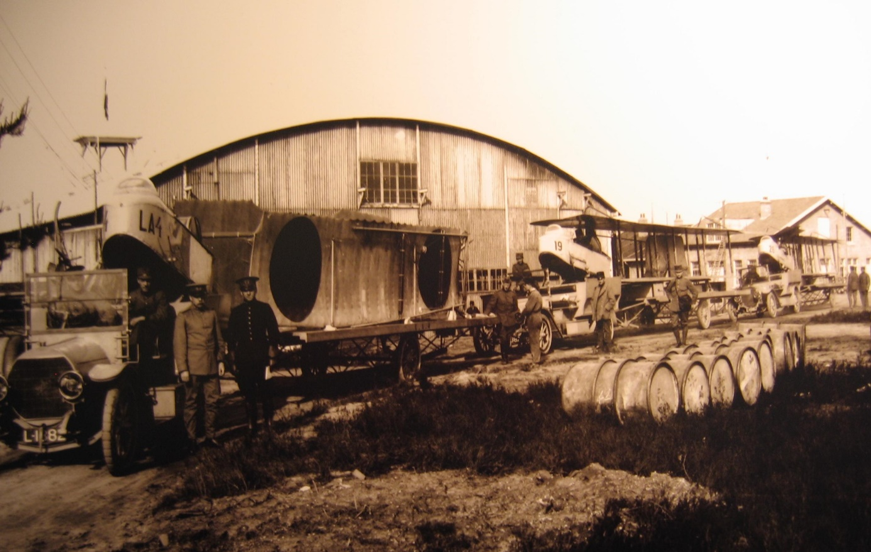

Photo . Standard Oil Company road tanker circa 1914.

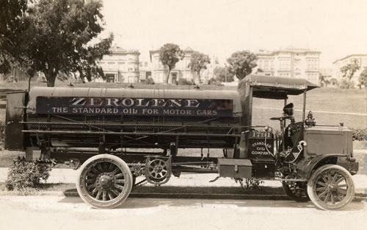

# Supplies for the battlefield

While the necessity to maintain supplies of aircraft, spare parts, motor transport and supplies was always paramount for the continued operations of these flying corps, equally the supply of gasoline and oil was also critical. With the US First Army flyers the arrangements were as follows [4]

An extract from Headquarters Air Service (US) First Army August 30, 1918 Memorandum to Colonel Mitchell. Subject: Method of Supply of 1st Army Squadron

“1. The 1st Air Depot at Colombey les Belles will supply all American Squadrons east of St. Mihiel. Vinets Depot will supply all American Squadrons west of St. Mihiel. The French Army and Group Parks will supply all French Squadrons. Details of the Supply Methods are as follows:

2. West of St. Mihiel

(C ) Gasoline and Oil. Squadrons will requisition for gas and oil through the Group Supply Officer on the mobile parks of their groups. The Mobile Parks at Souilly and Rembercourt will keep on hand 30 days’ reserve supply of airplane oil and gasoline for all squadrons west of St. Mihiel. This supply is already on hand. An automatic supply of 4,500 gallons of airplane gasoline and 1,200 gallons of castor oil per day has been ordered sent to the Gasoline Supply Station of the Quartermaster Department at Souilly, beginning September 10th. The Mobile Park will keep on hand one week’s supply of motor transport gasoline and oil for their groups, requisitioning these supplies from the Quartermaster station at Souilly.”

2. East of St. Mihiel

(C ) Gasoline and Oil. The squadrons will requisition for gas and oil through the Group Supply Officer on the Mobile park, if there is a Park. Each Group or Park should keep on hand one week’s supply of airplane oil and gasoline for squadrons under it. The present automatic supplies to Groups directly form the Quartermaster Corps will be continued. Where there is no such automatic supply, or in case the supply is insufficient, Groups or Parks will requisition on First Air Depot for airplane gasoline and oil. The First Air Depot will have in reserve three week’s supply for all squadrons served by it. Gasoline and oil for motor transport will be requisitioned by the Groups, or by the Mobile Parks when such parks are operating, directly on the Gasoline Section, Quartermaster Corps, at Neufchateau. Emergency supplies of gasoline and oil for motor transport may be obtained from the First Air Depot.”

To keep track of these arrangements, of course the necessary reports on consumption and stocks were required.

The following is an example of the daily report from the Equipment Department Airplane Gas and Oil Report

Table Airplane Gas and Oil Report, Air Service First Army Date Sept 12, 1918

|  |  |  |  |  |  |
| --- | --- | --- | --- | --- | --- |
| Station | Kind | Gallons on Hand yesterday | Gallons delivered | Gallons Received | Gallons on Hand today |
| First Air Depot | Fighting Spirits | 471 |  | 3,679 | 4,150 |
| Gasoline | 58,723 | 6,133 | 5,334 | 57,924 |
| Castor Oil | 24,781 |  |  | 24,781 |
| BB Oil | 18,353 | 1, | 2,000 | 20,352 |
| Rembercourt | Fighting Spirits | 3,721 |  |  | 3,721 |
| Gasoline | 50,402 |  |  | 50,402 |
| Castor Oil | 7,733 |  |  | 7,733 |
| BB Oil | 36 |  |  | 36 |
| Souilly | Gasoline | 6,000 |  |  | 6,000 |
| Castor Oil | 9,000 |  |  | 9,000 |
| Toul | Gasoline | 11,627 | 346 | 2,030 | 13,310 |
| Castor Oil | 30 |  |  | 30 |
| Fighting Spirits | 747 |  |  | 747 |
| Mobile Park No. 1 | Fighting Spirits | 5,386 |  |  | 5,386 |
| Gasoline | 16,905 |  |  | 16,905 |
| Castor Oil | 4,550 |  |  | 4,550 |

The problems of quality control were also noted [5]

“Aviation Gas. This squadron received at certain times during its operations, quantities of bad gasoline, or gas that did not test high enough to successfully operate a Liberty engine. Some of the gas received by the 50th Squadron on actual test fell as low as 60 [assumed to be Baumé density], while the test should be at least 70 to insure the successful performance of a Liberty airplane mission. It is believed that sufficient care was not taken in grading this gas, as it has come to the writer’s knowledge in at least one instance that motor gas was delivered in drums stencilled “Aviation of Fighting Gas”

# US Avgas Grades

In the US, there were three grades (Domestic, Export & Fighting) - Export grade with an end point of 160 and 190 deg. C., and in the Eastern states of the US this was refined from Pennsylvania crudes. When the export Grade X began to reach the Western Front in Europe, it was found to be totally unacceptable for combat use. The British and French were used to fuels from the East Indies or Borneo crudes, and they began to report serious engine problems when they used the US fuel.

It would be sometime before this fuel’s mysterious overheating was understood. The British and French aviation fuels by modern standards had an octane of 65-70 while the US fuels refined principally from Pennsylvania and Oklahoma crudes had an octane of only 45-55. American gasolines of the time were Pennsylvania Gasoline 30 PN (Performance Number), California 50-55 PN (similar to Dutch East Indies).

This lower anti-knock quality was reflected in a number of piston failures due to pre-ignition caused by hot-running engines. The only remedy was to follow the British practice of adding 20% Benzol.

# US Bureau of Mines Investigates

On August 2, 1917, the US Bureau of Mines arranged to study fuels for aircraft engines in cooperation with the Aviation Section of the US Army Signals Corps. (The US Army Signals Corps was the branch of the US Army which initially interested in aviation after the Wright Brothers flight). After a general survey, it was found that no reliable data was available on the most suitable fuel. Various tests were conducted at Langley , McCook and Wright airfields in actual flight tests, and an altitude chamber was erected by the US Bureau of Standards was used to study performance at conditions encountered at high altitudes. In addition, laboratory examinations, particularly of distillation characteristics, were conducted by both bureaus.

Several interesting results were found from these investigations. In certain types of aircraft, motor gasoline gave just as satisfactory performance as Pennsylvania ‘high test’ gasoline. In others, the pilots reported hot-running with the use of this type of fuel. An experimental fuel composed of 70% Cyclohexane and 30% Benzene seemed to be the most satisfactory for use in fighting aircraft. This fuel showed suitable operating characteristics in motors having a compression ratio as high as 7.5 to 1, and in some cases allowed a 10% increase in power and a 1,000 ft increase in ceiling. Other fuels distilled from selected crudes were also satisfactory. These gasolines were of aromatic or naphthenic types and had relatively high octane numbers.

Ernst W. Dean and Clarence Netzer at the US Bureau of Mines began to investigate suitable fuels for aircraft engines. In the paper by Dean[6], the requirements for motor gasoline at that time were given as follows:

1. The gasoline should contain enough volatile material to ensure easy starting, but not enough to cause excessive evaporation losses and danger in handling and storage.
2. It should not contain heavy materials that would not vapourise or burn.
3. It should not form a residue in the motor.
4. It should be free of corrosive substances.
5. It should not have, and its combustion products should not have a disagreeable odour.
6. It should be free of non-combustible material such as water and acid.

As a result of this study a specification was set up for motor and aviation gasolines as follows:

Table 2. Specification for Motor Gasoline 1917.

|  |  |
| --- | --- |
| Property | Specification |
| Acidity | Neutral |
| Colour | Water white |
| Volatility | |
| 20% evaporated, deg. F, minimum | 158 deg. F (70 deg. C) |
| 50% evaporated, deg. F, maximum | ½ (20% point +90% point) |
| 90% evaporated, deg. F., minimum | Reported |
| End Point, deg. F, maximum | 99 deg. F + 90% point |
| Water & Sediment | None |

These specifications were obviously not very strict and were merely an attempt to stabilise the gasoline boiling range within certain wide limits. No consideration was given to stability, vapour pressure, or hydrocarbon type content. Although it was generally recognised that specific gravity was no indication of quality, it was still to be reported. The presence of ‘unsaturates’ (olefins) due to addition of cracked gasolines to straight run gasolines was detected by means of the acid heat test, iodine number, or solubility in Sulphuric acid. No specification was established for this purpose, because it was believed that cracked gasoline had no harmful properties.

Dean and Netzer concluded that high volatility and a relatively low distillation end point were all that were required for suitable aviation fuels.

As a result, three grades of fuel were supplied to the military thereafter.

"Domestic Aviation Grade" had the lowest volatility and was used primarily for low-powered engines in training aircraft.

"Export Grade X" still enjoyed the highest availability, and

"Fighting Grade", with the highest volatility was available in limited quantities.

To improve fighting grade fuel, the Bureau of Mines, in May 1918 asked the Atlantic Refining Company to furnish for comparative testing, 11 grades of gasoline covering a range from ordinary motor fuel of relatively low volatility to a special close-cut grade of high volatility. Each of the fuels was run in a combat type aircraft engine at the Langley Field laboratories of the Bureau of Standards.

The results of the engine tests proved disappointing in that the differences found among the fuels, as to developed power, economy, high altitude performance, etc. were only + or - 5%.

The problem with these tests was the fact that they were run at a single, rather modest, engine compression ratio. Real differences, especially in anti-knock qualities, would have become apparent if higher compression ratios had been examined.

A second series of tests were conducted with the same engine in order to compare fuels from East Indies crudes against Export Aviation Gasoline. Again, the test showed no significant difference in power development, even though the East Indies fuels were recognized to be superior in service. It was correctly concluded, and subsequent experience was to show conclusively, that the volatility has very little to do with the power potential of a fuel.

Knocking or detonation, was observed in motor vehicle engines early in their use. In early aircraft engines, knocking was thought to be a result of inadequate engine cooling.

The understanding of the knock mechanism and the crucial role played by the fuel itself was to have a profound effect on both the aviation and petroleum industries. World War I accentuated the knock problem because every program to develop more powerful engines was ultimately limited by the detonation characteristics of the fuel.

# British R.A.E. Investigates

By 1918, the three grades of US aviation fuel were being supplied to the armed forces. Domestic grade was used for low powered engines such as training, the Export X grade was shipped overseas and rejected by the British (and the French), the ‘Fighting grade’ or famous pink gasoline was used in France.

The problems of engine failures lead to much research in Britain by the Royal Aircraft Establishment (R.A.E.) where various aviation gasolines were analysed in an effort to define the problem.

As early as 1915 the Royal Aircraft Factory had discovered that Benzol reduced knocking. At this time, the standard gasoline from Dutch East Indies about 50 Performance Number.

Cracked gasoline was tested but due to instability (and odour) lost anti-knock properties and was not used as aviation gasoline.

British engineers had determined that in order of engine performance: Aromatics were the best, Naphthenes – intermediate performance, Paraffins were the worst performers. This led to the preference of 38% aromatics content by British and use of PONA analysis to determine quality.

In 1918 Lorriane Dietrich (France) redistilled American gasoline to reduce end point. [The ‘end point’ is the temperature at which the last drop is distilled, actually in the ASTM D86 Distillation Test, it is the highest temperature indicated at the completion of the distillation test]. The British opposed redistillation and developed thermal cracking. However, this fuel was inferior in air cooled engines – also there was an odour problem with cracked gasolines.

# Avgas Specifications and Test Methods 1914-1919

The first US government specification for the purchase of gasoline appeared in 1907 as US Navy Specification Number 24G.5;[7] which called for “high grade refined gasoline free from all impurities, having a gravity of particular number 70o Be (Baumé Gravity) (0.70 Specific Gravity), and requiring that no residue be left in a platinum dish after one hour in boiling water”. It can be seen that there was no appreciation of chemical qualities of the fuel and only a test to assure the absence of kerosene or lube oil contamination.

Specific gravity (or density) and a rough distillation appeared to be the only requirement, together with an ability to distinguish between gasoline and other petroleum products of the time such as kerosene.

# US, British, French Aviation Gasoline Specifications 1917-1919[8]

These specifications were based solely on distillation. Of note is the French “Special” specification which reflected their view that re-distillation achieved an aviation gasoline of superior performance. In reality, this was not true – it was the presence of aromatics and certain naphthenes that would produce better aviation gasolines.

Table 3. US Navy, British & French Aviation Gasoline Specification 1917

|  |  |  |  |  |
| --- | --- | --- | --- | --- |
| Country | US Navy Dept. | British | French | |
| Grade Designation | 8Glb* |  | Average | Special |
| Specification Date. | 9 Jan 1917 |  |  |  |
| Distillation | | | | |
| Initial (deg. C) Max. | 49 |  |  |  |
| Temp 5% Rec. (deg. C) Min. |  |  |  |  |
| Temp 5% Rec. (deg. C) Max. |  |  | 60 | 60 |
| Temp 10% Rec. (deg. C) Max. |  | 74 |  |  |
| Temp 50% Rec. (deg. C) Max. | 105 |  |  | 95 |
| Temp 55% Rec. (deg. C) Max. |  |  | 105 |  |
| Temp 80% Rec. (deg. C) Max. | 125 |  |  |  |
| Temp 90% Rec. (deg. C) Max. |  |  |  |  |
| Temp 95% Rec. (deg. C) Max. |  |  | 146 | 117 |
| Temp 96% Rec. (deg. C) Max. |  |  |  |  |
| End Point (deg. C) Max | 177 | 150 |  |  |
| Recovery % min | 95 |  |  |  |
| Loss % Max. |  |  |  |  |
| Specific Gravity |  |  |  |  |

* Quality: to be high-grade, refined and free from water, adulterants and impurities and shall show a neutral reaction. No natural-gas gasoline shall be accepted nor shall they be mixed with any gasoline submitted for acceptance. (This was the standard for US Navy and Army during World War I).

# Gasoline Composition 1914-1919

Avgas Research Begins

These engine failure problems led to the first aviation fuels research in 1917-1918. The focus of this research was two-fold. Firstly, to analyse the gasolines in order to determine what chemical factors were present which would explain good and poor performance. Secondly to identify the causes of the engine overheating using test engines. The story of test engines is a fascinating one of determination and is dealt with as a separate chapters (Octane Testing).

Initially the focus was still on high volatility with a relatively low end point 160 deg. C. (endpoint is the temperature at which the last drop is distilled). [9]

What was not recognised at the time was that too much volatility can cause vapour lock and carburettor icing which would become apparent with higher fighting altitudes reached during late 1918.

Five samples taken from 2,000 Imp Gallon consignments supplied by the Asiatic Petroleum Company[10]. [The Asiatic Petroleum Company (a Royal Dutch/Shell Co.) would play an important role in the next World War with its plants in Curaçao West Indies and Venezuela]. The (1918) samples were from Sumatra, Borneo and American sources, plus two blends which included Benzol. The results of these samples were presented in the [11]RAE Report on Analysis of Petrols Report H818, 4 July 1918.

The analytical methods of the day included the following tests to determine composition:

* Sulphuric Acid Absorption was used to determine aromatics contents.
* % Vol. Olefins were determined by Bromine absorption. (Bromine reacts with the unsaturated double bond in the chemical molecular structure of olefin hydrocarbons). This test was used to detect the presence of “cracked gasolines”- gasolines produced from thermal cracking of crude oil.
* % Vol. Aromatics were determined using the TCD method.
* % Vol. Naphthenes were also determined using this TCD method.
* % Vol. Paraffins was determined by difference after subtraction of percentage of Aromatics, Naphthenes and Olefins.

In addition, a number of tests were conducted to characterise the fuels – these included a standard distillation (typically 100 ml of fuel slowly heated and the temperature recorded for a particular percentage of product distilled off).

As with all petroleum products appearance, marketable odour and specific gravity were assessed.

In order to obtain more information about the composition of the fuel, a technique known as fraction distillation was used. With knowledge of the boiling points of various hydrocarbon components it was possible to determine the content of some of the more important components – in particular Butanes, Pentanes, Hexanes, Benzene, and Toluene.

The concept of ‘octane numbers’ would not be invented for another 15 years, however armed with that concept it is easy to understand now why some fuels performed better than others.

Shell “A” Aviation Spirit is the benchmark

The most common aviation gasoline at this time was Shell “A” Aviation Spirit. This was often used as the standard with which to compare new aviation gasoline blends. Shell Aviation Spirit up to summer of 1917 was the only fuel supplied to the Allied Flying Corps. The crude oil source was from Sumatra and Borneo. It was refined then transported to storage, then shipped to the UK. In the UK, it was transported by rail tank cars to inland bulk depots and filled into the famous 2-gallon cans.

It would not be until 1917-1918 that tanker filling into aircraft commenced.

Photo . Typical British airfield WWI circa 1917-18. (Note the gasoline cans in the foreground).

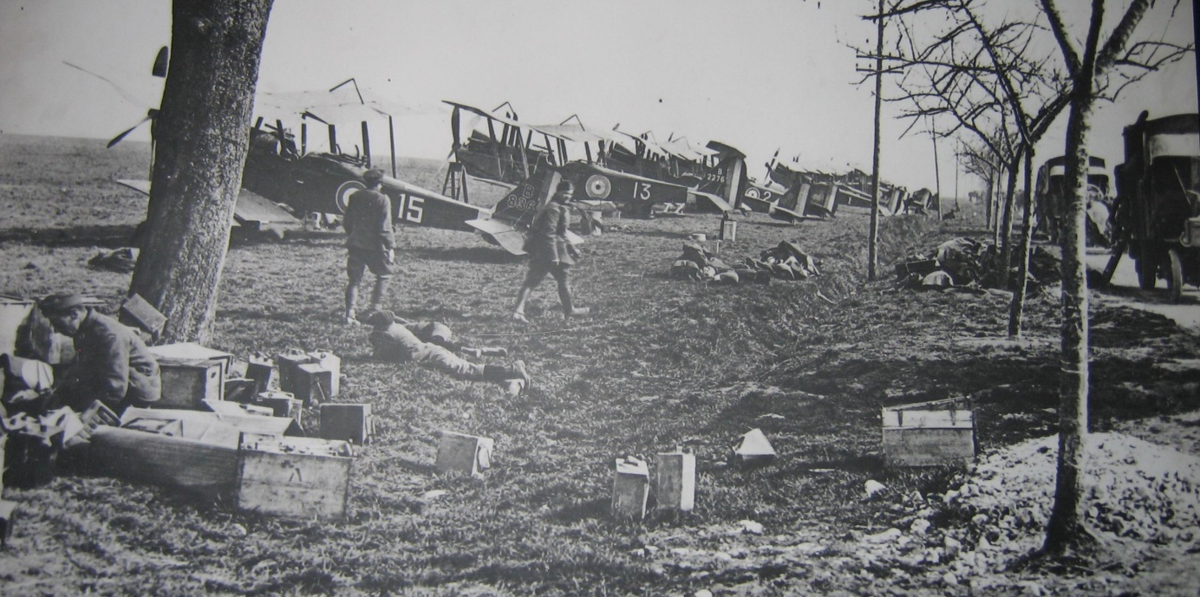

# Analyses of Aviation Gasolines 1918

Table 4. Analyses of various aviation gasolines in 1918 with a comparison to Shell “A” Aviation Spirit

|  |  |  |  |  |  |  |
| --- | --- | --- | --- | --- | --- | --- |
| Samples | A | B | C | D | E | For Comparison |
| Source (Report HC 796) | Borneo | American | Sumatra | 15% Benzol & American | 15% Benzol, 20% Borneo, 65% American | Shell "A" Source Report 1311 |
| Marked | P.A. 11.4.18 | B.I.F. 23.4.18 | P.A. 8.4.18 | B.I.F. 27.4.18 | B.I.F. 1.5.18 |  |
| Appearance |  |  |  |  |  |  |
| Odour | no objectionable odour | no objectionable odour | no objectionable odour | Slight smell Benzol | Slight smell Benzol |  |
| Specific Gravity @15 deg. C. | 0.740 | 0.707 | 0.731 | 0.739 | 0.746 | 0.721 |
| Specific Gravity @25 deg. C. | 0.732 | 0.699 | 0.722 | 0.731 | 0.737 | 0.713 |
| Residue not volatile in 1 hour in gms/100ml | 0.002 | 0.003 | 0.002 | 0.003 | 0.001 | .00? |
| Sulphuric Acid Absorption % (indicates Aromatics) | 18.3% | 7.8% | 14.5% | 18.3% | 20.8% | 8.4% |
|  |  |  |  |  |  | Report H797 |
| Analysis (Report H816) | Borneo | American | Sumatra |  |  | Shell 'A' |
| % Vol. Olefins (Bromine absorption) | Trace | 1.3% | Trace |  |  | Trace |
| % Vol. Aromatics (TCD method) | 23% | 3.5% | 15.5% |  |  | 6.5% |
| % Vol. Naphthenes (TCD method) | 27% +/- 3% | 17% +/- 2% | 25.5% +/-3% |  |  | 35% +/- 3% |
| % Vol. Paraffins (by difference) | 50% +/- 3% | 78% +/- 2% | 59% +/-3% |  |  | 58% +/- 3% |

TCD method = Temp. Critique Dissolution method

Standard Distillation

Table 5. Standard Distillation of Aviation Gasolines 1918 (various British supply sources)

|  |  |  |  |  |  |  |
| --- | --- | --- | --- | --- | --- | --- |
| Source | Borneo | American | Sumatra | 15% Benzol & American | 15% Benzol, 20% Borneo, 65% American | Shell "A" |
| Standard Distillation | Deg. C | Deg. C | Deg. C | Deg. C | Deg. C | Deg. C |
| 0% | 50 | 45.5 | 49 | 58 | 60 | 50 |
| 2.0% | 61 | 55.5 | 59.2 | 66.5 | 70.1 | 59.5 |
| 5% | 66.5 | 63 | 66.1 | 71 | 73.5 | 64.9 |
| 10% | 72 | 69 | 71.3 | 74.2 | 76 | 71 |
| 20% | 79.2 | 77.6 | 78.2 | 78.2 | 79.4 | 80.5 |
| 30% | 85 | 84.8 | 83.4 | 81.5 | 82.2 | 87.5 |
| 40% | 90.1 | 91.3 | 88 | 84.6 | 85 | 93.4 |
| 50% | 95 | 97.1 | 92.5 | 87.3 | 87.3 | 98.7 |
| 60% | 99.5 | 102 | 97 | 90.7 | 90.2 | 104 |
| 70% | 104.1 | 107 | 102.5 | 95.8 | 94 | 111 |
| 80% | 109.6 | 112 | 109.5 | 102 | 99.5 | 119 |
| 85% | 113 | 115.5 | 114 | 106 | 102.8 | 124 |
| 90% | 117 | 119 | 123.2 | 113.6 | 109.5 | 132.6 |
| 92.5% | 121 | 121.5 | 128 | 121 | 115 | 139 |
| 95% | 126.1 | 124.8 | 135.5 | 127 | 121.8 | 150 |
| 98% | 135 | 141 | 146 | 137 | 137 |  |

Graph . Distillation curves for Aviation Gasolines 1918.

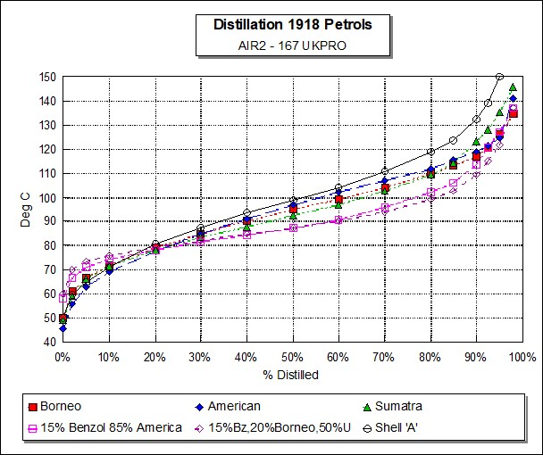

Table 6. Fractional Distillation of Aviation Gasolines 1918 (used to determine approximate composition.)

|  |  |  |  |  |  |  |  |
| --- | --- | --- | --- | --- | --- | --- | --- |
| **Fractionation Data** | | | | | Specific Gravity of fraction | | |
| %Vol. | Borneo | American | Sumatra | Shell 'A' | Borneo | American | Sumatra |
| 0-20OC Gases & Butane | 4.5% | 4.5% | 5.5% | 4.0% |  |  |  |
| 20-40OC Pentanes (nC5, iC5) | 7.5% | 12.0% | 8.5% | 10.0% | 0.628 | 0.629 | 0.618 |
| 40-57OC (No components) | - | - | - | - | - | - | - |
| 57-75OC Hexane Isohexane | 20.0% | 20.0% | 20.0% | 22.0% | 0.72 | 0.68 | 0.701 |
| 75-87OC mainly Benzene, Cyclohexane | 7.5% | 2.0% | 7.0% | N/A | 0.77 | 0.733 | 0.766 |
| 87-104OC Heptanes, Methyl Cyclohexane | 31.0% | 27.0% | 32.0% | N/A | 0.762 | 0.728 | 0.734 |
| 104-115OC mainly Toluene | 7.0% | 6.0% | 4.5% | N/A | 0.77 | 0.746 | 0.763 |
| 115-125OC Octane fraction | 19.0% | 20.0% | 6.5% | N/A | 0.755 | 0.735 | 0.746 |
| 125-140OC Xylenes | 3.0% | 6.0% | 8.5% | N/A |  |  | 0.786 |
| Above 140OC | - | 2.0% | 7.0% | N/A |  |  |  |
| **Total** | 99.5% | 99.5% | 99.5% |  |  |  |  |

PONA Analysis

PONA Analysis is a valuable indicator for the petroleum chemist to characterise a petroleum product such as gasoline. As explained earlier ‘PONA’ stands for Paraffins, Olefins, Naphthenes and Aromatics.

**Paraffins:** Octane range from zero to over 100. Chemically stable, burns clean. Main component in crude oil. Paraffinic crudes produce gasolines with poor anti-knock performance. Some paraffinic crudes are the source of good lubricating oils.

**Olefins:** Octane better than paraffins, chemical reactive tend to form gum deposits, generally produced in refinery cracking process.

**Naphthenes**: Fair octane, chemically stable gasoline, and good lubricating oils.

**Aromatics:** High octane, higher freezing point than paraffins, burns smokey, present in some crude oils, can attack some rubber components. Crude not suitable for lubricating oils.

In general, for gasolines it is desirable to have a blend of paraffins with a high content of naphthenes or aromatics (or both) and very little olefins. When the aromatic content is low the (octane) performance can be improved by the addition of Benzol, as the British had discovered in the early years of the war.

From the data in table 6. above, it can be seen that the favoured East Indies gasolines of Sumatra and Borneo were higher in Aromatics than the poor American gasolines. This is illustrated in the following graphs of PONA Analysis.

Graph . Shell ‘A’ Aviation Spirit 1918 PONA Analysis

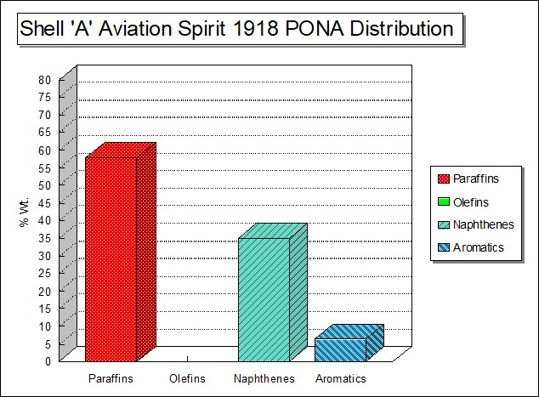

Graph . Borneo Aviation Spirit 1918 PONA Analysis

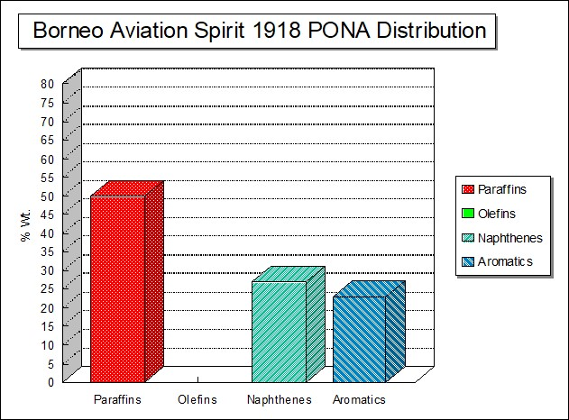

Graph . American Aviation Spirit 1918 PONA Analysis

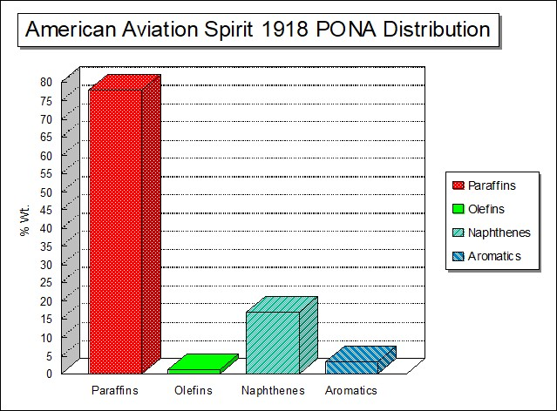

Graph . Sumatra Aviation Spirit 1918 PONA Analysis

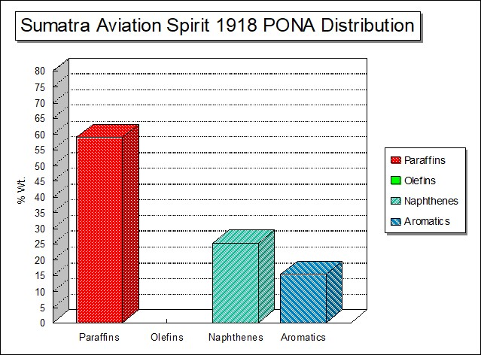

As can be seen from the above PONA analyses the American aviation spirit was highest in paraffins content, lowest in aromatics and naphthenes, in addition it contained a small amount of olefins. This American gasoline would be poor in storage and gum formation could be expected, octane performance would be considerably lower than Borneo, Sumatra and Shell ‘A’ Aviation Spirit. A fact born out in the operation of aircraft under combat conditions.

# Abadan Aviation Spirit 1918

Search for Alternate Supplies – Abadan Aviation Spirit - disappointing

The search for alternate supplies other than US in particular, the quest for a better aviation spirit than US was continued by the British. It is ironic that the great oil fields of the Middle East, such as Abadan which were to become critical in supplying the USSR during World War II, were to be so disappointing in these earlier days; further testing would occur and new refining techniques of the 1930’s which would change all this. The Abadan Refinery was operated by the Anglo Persian Oil Company which was later to become the Anglo-Iranian Oil Company, and then British Petroleum (BP).

Testing of Abadan Aviation Spirit 1918

British forces already had a presence in Persia and so in order to investigate the suitability of Abadan gasoline samples were sent to India for testing of Persian Aviation Spirit. Some 100 cans were shipped from Persia on the “SS Beechleaf” (1,200 Imp. gallons) from the Anglo Persian Oil Co. Abadan were sent in June 1918.

Ref: 3493 Government of India, Army Department, Delhi 12 March 1919

20 cases of petrol from Anglo-Persian Oil Co. for test. (secured by Mesopotamian Expeditionary Force, Basrah). Tests by: Chief Inspector Indian Ordnance Department Naini Tal Embarkation Chemical Analyst, Bombay, and Officer Commanding No. 31 Squadron RAF, Risalpur

Lab Testing – Abadan Aviation Spirit

The laboratory testing of the Abadan Aviation Spirit was conducted in 1918 at Naini Tal, India and the results were listed in the British Government report. Report August 2, 1918 - Ref: No. 36589/35 (Q.M.G.6) -8 July 1918. Naini Tal is at 6000 ft, so distillation was corrected for altitude.

Table 7. Initial testing of Abadan Petrol

|  |  |
| --- | --- |
| Test | “APOC” |
| Specific Gravity @ 60OF | 0.713 |
| Dist. below 100 deg. C | 74% |
| Dist. below 130 deg. C | 99% |

Further samples tested 29 July 1918 Chemical Analyst to Government, Bombay.

Table 8. Testing of Abadan Petrol at Bombay India

|  |  |  |
| --- | --- | --- |
| Test | “APOC” – “1” | “APOC” – “2” |
| Specific Gravity @ 60OF | 0.7140 | 0.7148 |
| Dist. below 100 deg. C | 65% | 66% |
| Dist. below 130 deg. C | 98.8% | 98.8% |

Evaporation Test: 50 cc evaporated completely in 24 hours, both samples.

The report further stated: Opinion: Both samples pass the S&T specification for spirit for special aircraft.

Field Testing

While the laboratory report indicated that the Abadan petrol met the current specification, the real test would be how this gasoline performed in full scale aircraft engine tests. These tests would be undertaken by Royal Air Force No. 31 Squadron, using Aircraft BE.2C #4157 with 90 H.P. R.A.E. engine.

Photo 16. British BE.2C on display at Imperial War Museum, London (2005)

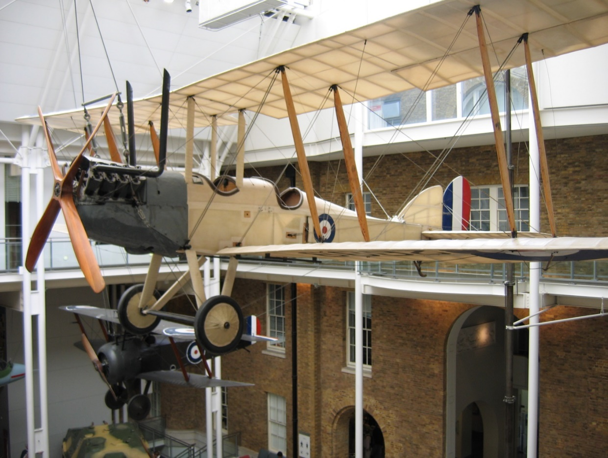

Their report was summarised as follows:

“Found unsatisfactory. Engine overheated and required top overhaul and one of the pistons had nearly seized.”

In a further report the Officer Commanding “A” Flight No. 63 Squadron RAF wrote:

“Memo 22 Aug 1918 to C.G. Staff Simla from Force “D” Baghdad.

New Abadan Petrol

“the engine ran smoothly but there were decided variations in revolutions. Overheating is intense and although at this time of the year the main trouble we experience with the 140 H.P. RAF’s using Shell spirit is overheating, the Abadan Spirit markedly increases this difficulty.

The fumes from the unusually large percentage of Sulphur contained in Abadan are injurious to the engine and also very unpleasant for the occupants of the machine.”

Central Laboratory reports that the sample passes test Air Board Specification with regard to aircraft and Sulphur content. Specific Gravity @15 deg. C was 0.718.

No distillation.

Engine – Flying Test RE8 Unsatisfactory overheating

Engine lubricant Vacuum BB

* Unfavourable –
* Overheating of engine
* Undue carbonisation of cylinder
* Evil smell

Special peculiarities in the chemical composition of Abadan petrol due to the presence of Naphthenes and Sulphur compounds.”

It is evident from the above report that the limited tests available at this time - distillation and specific gravity could not predict the suitability of a gasoline for aircraft engine use. These were little more than screening tests to determine if the petroleum product was in fact a ‘gasoline’. Thus, the reliance of field testing was an expensive method of assessing the merit of a gasoline for aviation use. This problem was to spur efforts to develop laboratory test engines and better aviation specifications.

However, the story does not end there. By 1920 the Abadan Petrol had been retested and this time - Persian Spirit Report No. E 23768 is in all respects satisfactory for aviation as long as steps are taken to ensure the spirit is not contaminated.

Further, Persian Aviation Spirit was bench tested on a Liberty and Maybach engines and appears to have been satisfactory. The Liberty engine was the main US aircraft engine, while the Maybach engine was used in airships.

# The Perils Of A Pilot’s Lot

‘Death awaits the inexperienced and reckless’

The pilot of an aeroplane faced many hazards, flimsy, unstable flying machines subject to mechanical failure, variable fuel quality, poor landing strips – mortality was high, one report was that in 1913 at US Army Air Training base at North Island, San Diego, California[12], pilot mortality during training was a high as 18%.

This perilous occupation would continue into World War I, where the fatalities would increase when aircraft fought aircraft over the skies of France.[13]

24 August 1918

A report on the deaths and injuries from flying in the Royal Flying Corps (R.F.C.) between 1916 and 1918 highlighted the risks.

There were many deaths as novice pilots explored the vagaries of flying flimsy, unpredictable aircraft. This report listed the limited statistics of flying at that time. Given the carnage on the ground in the trenches, these numbers must have seemed insignificant, however a death of a person whatever the circumstances however, is still the death of a human being. The matter was a concern to the fledgling Royal Flying Corp where many of the best officers and men had cast their fate.

For example, during training in July 1918, the total hours flown were 81,442 while the fatalities were 132; this was described as a ratio;

Hours flown/Fatal casualties = 617

For action on the Western Front (France Only) the hours flown were 53,600 with fatalities of 234 including killed by accident and missing, this ratio dramatically and tragically became

Hours flown/fatalities = 229

For training 6 months Average June 1917 to December 1917, the Hours flown/death was 942, there was a deterioration over the next six months when the average December 1917 to June 1918 (Hours flown/death) was 791.

For those in action over French skies the dangers were even greater. Average (6 months) Hours flown/death in December 1916 was 206; it decreased to 172 by December 1917, but by June 1918 this ratio was 222, or expressed in another way for every 1,000 hours flown by a squadron, 4 to 6 pilots would lose their lives.

While these seem just statistics, to provide some perspective, imagine a modern jumbo Boeing 747 flying from Melbourne to Sydney and return (approximately 1,000 total passenger flying hours), then between 4 to 6 passengers would arrive at their destination dead – Every Time.

This was a time of no parachutes and some pilots in a flaming aircraft plummeting toward the ground facing a fiery death chose to shoot themselves.

One of the solutions to this high rate of pilot attrition was to improve the average training flying hours before overseas posting. In December 1916, this training was only 30 hours, by July 1918 this was increased to an average of 71.5 hours, but by now so many of the best young flyers had lost their lives.

Other Hazards

Perhaps one of the lesser known hazards was that of inhalation of noxious fumes. Anecdotes of the time reported that the pilots were ill and vomited from the inhalation of fumes particularly from the thermally cracked fuel. The inhalation problem was most likely due to the presence of volatile Sulphur compounds such as Hydrogen Sulphide and pungent mercaptans (similar to a skunk-like odour). This was not the only inhalation hazard to be faced by these early pilots.

Since, for most single engine aircraft, the pilot was seated behind the engine and usually in the slipstream of the engine exhaust. One of the early engine lubricants used in aircraft was Castor Oil. When the engine was operating the castor oil would become hot, partly burnt and vapourised, and be expended with other contaminants in the engine exhaust gases - which may be potentially inhaled by the pilot. Castor Oil is a potent laxative, and a peril to be faced by a pilot may have been to return from a mission in a less that comfortable state following an unavoidable dose of Castor Oil (vapour).

The typical oil consumption of engines in this period was between 4 and 9 litres (oil) per hour.

Photo 17. Captain Eddie Rickenbacker- American ‘Ace of Aces’ 94th Aero Squadron 1918. He would later control the US airline company Eastern Airlines.

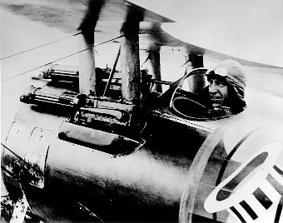

# Aviation and the Chemist

The following article from the Journal of Industrial Engineering and Chemistry in 1917 conveys the sentiment of the times and the challenges for the chemists of the day in regard to aviation. [14]

“Like a flash this nation (USA) became convinced that it could deal an effective blow in the war against Germany by an overwhelming production of men and machines for aeronautic service on the battlefields of Europe. Engineers and manufacturers are cooperating to bring America’s unique talent for standardized manufacture to its very highest efficiency for unlimited aeroplane output. Certainly, at the close of the war the world will face a new era in transportation. The advent of the aeroplane in every-day life will be at hand. Here then lies a field of research in which chemists must play a great part.”

From an interview with Mr. Leon Cammen, Vice-President of the American Aeronautical Society. “Without hesitation, he affirmed that in the future development of the aeroplane the research chemist will be the greatest factor, some of the problems he discussed are here presented.

In general, the materials entering into aeroplane construction are subjected to two unusual conditions: first, extreme vibration, a condition which will become more and more accentuated as greater possibilities of speed are realized; second, sudden and extreme changes of temperature due to rapid ascent or descent.

As to particulars, there is needed an ideal “dope” for impregnation of the fabric, Irish linen. To be ideal, this material should make the fabric water-proof, air-proof, fire-proof, or at least slow-burning, should give low visibility, prevent deterioration and be non-poisonous; some now in use are poisonous and the drippings seriously affect the aviators.

Another problem is the drying of all wood used in construction. Air-drying requires at least nine months; kiln-drying is not successful as the wood is thus injured by the outside being drier than the inside. Vacuum drying has been attempted, but so far without much success. An ideal impregnating medium for the wood is needed, not to prevent rotting but the disintegration resulting from rapid changes of temperature, whereby the juices of the wood freeze, expand and weaken the cells.

An ideal means is needed to prevent rusting, one which can be applied after the machine is built. Nickel-plating has not proved successful; the varnish makers have had before them heretofore no such conditions of vibration and sudden changes of temperature. Indeed, the whole subject of rusting has never been systematically studied from the standpoint of these conditions.

Much study is needed in the field of light alloys. Those with aluminium as a base disintegrate under the intense vibration and stresses in high altitudes. Why? We should know.

A more thorough knowledge of magnesium alloys is desirable, both those with aluminium and those with other metals, while interesting possibilities might be developed through a thorough study of beryllium alloys. Are the properties of aluminium alloys affected by occluded gases? For such studies more refined methods are needed for the determination of the presence and amount of occluded gases.

As to lubricants, the behaviour of such types as castor oil under the temperature conditions in question, calls for investigation. What is the best method for testing and what should be the standard specifications for so important a factor in aeronautics?

In connection with the ignition system a wide field of research is open for the study of spark discharge from the chemical standpoint. Better insulating material for spark plugs should be developed; at present mica and porcelain are used. This is considered the weakest feature of present-day motors.

Much of the advance in aeronautics has been empirical. Further progress can be best assured by the application of the strictest methods of scientific research. It is through this medium that such wonderful advances have been made in the steam turbine during the past decade. For the fuller grasp of the many problems here awaiting solution, chemists must become familiar with the principles of aviation. Success in the solution of these problems carries with it the promise of rich reward and is now invested with the halo of patriotic service.”

# The Long-Distance Flights of 1919

The First World War had identified aviation as a new frontier for man to exploit and what better way than to fly further and faster than ever before. The skills developed in the Great War were put to use to conquer distance.

America to England Non-Stop

After Blériot’s feat in crossing the English Channel, the Trans-Atlantic route held the same fascination for aviators to be the first to fly across the Atlantic Ocean. In 1913, Lord Northcliffe, proprietor of the Daily Mail, offered a prize of £10,000 to the first aviators to cross the North Atlantic.

The outbreak of the First World War intervened but attempts on the prize resumed in 1919. This was claimed by John Alcock and Arthur Whitten Brown in a modified World War I bomber Vickers Vimy with their 14-15 June 1919 flight from St. John, Newfoundland to Clifden, Ireland where they crash landed in an Irish bog. They were not hurt. This was to be the start of many developments in trans-Atlantic flight.

Photo 18. Vickers Vimy bomber[15]

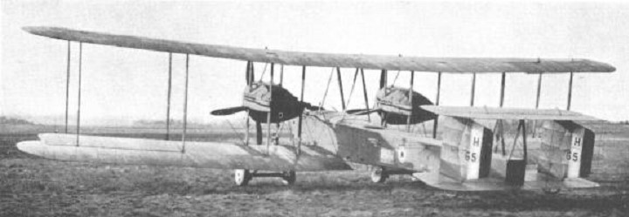

**Vickers Vimy** 1919

The Vimy had been designed in 1917 as a heavy bomber. Its great asset for the Atlantic attempt was its two Roll Royce Eagle engines – probably the most reliable aero engines then made. [Actually, BMW engines were recognised as the most reliable engines at that time, but it was impolitic to use these.]

The aircraft was shipped to Newfoundland and assembled in the open in a field at St. John’s. A wall was taken down and some trees felled in order to obtain a take-off run of 475 metres (500 yards). The aircraft took off at 1:41 pm on 14 June (1919), without any prior test flight, and set course for Ireland.

At one point during the flight Alcock became disoriented in dense cloud and spiralled down out of control. He was just able to recover close to the water. Later, in a storm, snow and ice began to obscure the fuel–flow gauge above the cockpit. Several times Brown climbed out of the cockpit, kneeling on the fuselage to reach up and clear the glass. After sixteen hours, they crossed the Irish coast near the Marconi radio station at Clifden and decided to land in a large field. In fact, it was a bog and the aircraft made an undignified landing with considerable damage.

Photo 19. The end of the epic flight by Alcock & Brown - Clifden, Ireland 1919.

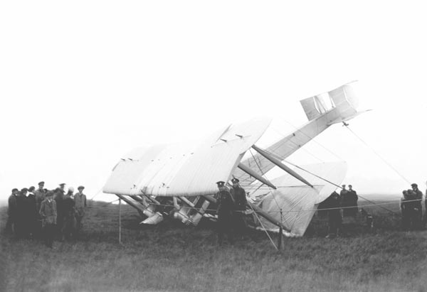

The aircraft was rebuilt by Vickers at Brookside and presented to the British Museum by the Vickers and Rolls-Royce companies in December 1919. It now stands proudly on display in the British Science Museum, London, U.K.

Wing span: 20.47 m (67 ft. 2in.)

Length: 13.27 m (43 ft. 6.5in.)

Weight empty: 3,175 kg (7,000 lbs)

Fuel Capacity: 3,932 litres (865 Imp. gallons)

Power plant: Two Rolls-Royce Eagle VIII V-12 engines of 360 hp (269 kw) each

Crossing speed: 144 km/h (90 mph)

Photo 20. Alcock & Brown’s Vickers Vimy (on display at British Science Museum 2004)

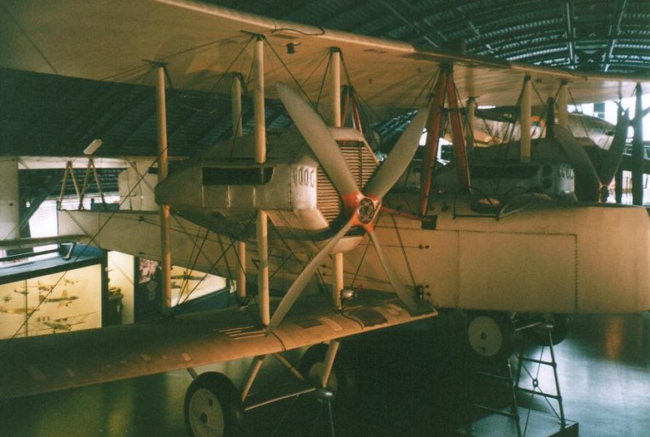

England to Australia in 28 days – An Epic Race

In 1919, the Australian Government under the flamboyant Prime Minister, W.M. "Billy" Hughes, offered a first prize of £10,000, the equivalent of nearly half a million dollars today, for a flight from England to Australia within 30 consecutive days. But the race had a greater impact on the history of aviation, demonstrating the feasibility of long-distance air travel. At least one major airline, QANTAS, traces its origins directly to this 1919 race.

This challenge was met by Ross and Keith Smith who flew a WWI Vickers Vimy Bomber from England to Darwin Australia in 28 days. Flights were to commence after September 8, 1919 with the arrival before midnight on December 31, 1920.

The Smith Brothers accompanied by mechanics Walter Shiers and James Bennett flew a Vickers Vimy G-EAOU (affectionately known as "God 'Elp All Of Us"), they left Hounslow, England on 12 November 1919. Keith was assistant pilot and navigator. They arrived in Darwin on 10 December 1919 having made the flight in just under 28 days, with the actual flying time of 135 hours 55 minutes, and winning for its crew - Ross and Keith Smith, W.H. Shiers and J.M. Bennett, the Australian Government’s prize and world-wide acclaim. The Smith Brothers were immediately knighted and the ₤10,000 prize money was divided into four equal parts.

The key to this success was the preparation in establishing refuelling depots along the route. This would be the precursor to the establishment of fuel depots along the trans-continental air routes. The fuel used on this flight was supplied by the Shell Company.

Photo 21. Vickers Vimy G-EAOU arrival at Mascot, Sydney 1919[16]

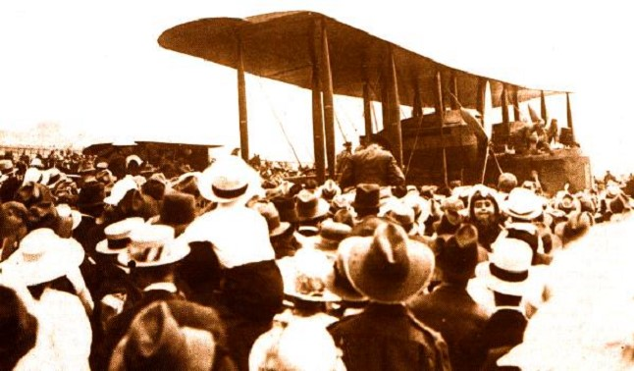

Photo 22. Ross & Keith Smith, with W.H. Shiers and J.M. Bennett

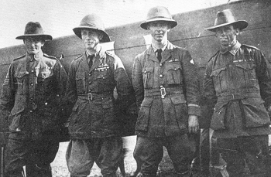

### Ross & Keith Smith

South Australian brothers Ross and Keith Smith[17] both served as flyers in World War I where Ross was twice awarded the Military Cross and three times the Distinguished Flying Cross.

Flying was a perilous adventure and fame short-lived; on April 13, 1922 Sir Ross Smith and Lt. J.M. Bennett were killed at Brooklands, England, whilst testing a Vickers Viking aircraft for a world flight.

The original Vickers Vimy of Ross and Keith Smith's England to Australia flight, G-EAOU, is on display at Adelaide's West Beach Airport, South Australia.

### Other Contenders

Two other men hoping to enter the England to Australia event were disappointed when fate went against them and their intended financier died. So they took work preparing the Australian leg of the race, an effort which would prove most beneficial within several years. The two were P.J. McGinness and W. Hudson Fysh, who would later establish the Queensland & N.T. Aerial Services which would become the famous QANTAS airline.

Photo 23. Hudson Fysh in 1920’s

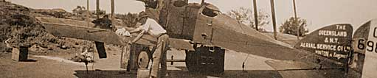

Everyone had their job to do, even Hudson Fysh, future Knight of the Realm, seen here washing the BE.2E (Photo: QANTAS Historical Collection)

Two days after the Vimy reached Darwin, a BE.2c flown by Capt. H. Wrigley and Sgt. A. Murphy arrived in Darwin, having departed from Point Cook, Melbourne on Nov. 16th. This was the first Australian transcontinental flight; it took in 26 days.

# Manufacturing Processes 1914-1919

The primary refinery process during the First World War years did not change. The only new process development was the redistilling of naphtha to achieve the new demands and emerging aviation gasoline specifications.

It was also evident that gasoline produced from selected crude oils, which experience in operations and tests by the governments’ bureaus had indicated to be satisfactory, were demanded for use in combat aircraft. So, the source of the crude oil for gasoline was perhaps more important than the manufacturing process.

During the First World War, the manufacture of aviation fuel[18] consisted of the following methods:

1. Distilling a straight run gasoline from a suitable crude oil source and adjusting the distillations range to the loosely specified limits.
2. Distilling a straight run gasoline and adding ‘casing-head’ or natural gasoline (or adding natural gasoline to kerosene distillate).
3. Blending cracked gasoline to straight run gasoline with or without the addition of natural gasoline.

At the end of the war the following methods were in an experimental stage and were not extensively used:

1. Blending straight run gasoline with benzol and alcohol.
2. Through close fractionation of a naphtha cut from selected crude oils (California and Venezuela) producing a 10-degree boiling range fraction to be used unblended as a fuel.
3. Manufacturing Cyclohexane synthetically and blending with Benzene.

It is interesting to note that Cyclohexane (octane number 83 RON, but blends as if its octane is 110 RON), Benzene (octane number 100+ RON, has a blending octane number 99 RON), and straight run gasolines from naphthenic and aromatic crude oils (60 to 80 octane) were found from experience to give satisfactory performance.

From 1903, aviation’s first year, until 1918 there was no manufacture of aviation fuel as such. Although gasolines from certain crude oils were more desirable from the user’s standpoint, the manufacture of both motor and aviation gasolines was the same, with the process and product being identical. During the First World War a greater portion of the aviation gasoline used was regular motor gasoline ranging from 40 to 60 octane number and having a boiling range between 38 and 232 Degree Centigrade (100 to 450 Deg. F). The ‘Fighting Grade’ was probably 50 to 65 octane number with a boiling range of 38 to 177 Deg. C. (100 to 350 Deg. F.).

# Oil Companies and Refineries

US Refineries

While the oil industry was expanding even in the time of war, perhaps the greatest growth in this period occurred in the United States, by 1919 there were some 359 refineries with a total daily capacity of 1.265 million barrels (200 million litres) and placed the estimated investment at $US 600 million (1919 value). By far California was the leading refining state, followed by the other ‘oil states’ – Oklahoma, Texas, Louisiana and, of course the birth place of US refining, Pennsylvania.

Typically, the refineries were very small, up to 500 barrels per day (80 K.Litres/day) [a typical refinery in the 1990’s was over 100,000 barrels per day (16 M.Litres/day), and by the year 2000 over 200,000 barrels per day (32 M.Litres/day). The largest refinery in 2020 is the Jamnagar Refinery in India at a massive 1,240,000 barrels per day (198.4 M/Litres/day)].

Table 9. Refineries in the United States 1919[19]

|  |  |  |
| --- | --- | --- |
| State | No. of Refineries | Barrels crude per day |
| California | 79 (Standard Oil Co. – Bakersfield, Richmond, El Segundo, Associated Oil Co. – Martinez, Shell- Martinez, Vacuum Oil Co. – Torrance, Union Oil Co. Wilmington | 210,000 |
| Wyoming | 5 | 48,500 |
| Utah | 1 | 500 |
| New Mexico | 1 | 150 |
| Colorado | 4 | 5,600 |
| Texas | 26 | 225,000 |
| Louisiana | 16 | 62,500 |
| Arkansas | 1 | 300 |
| Oklahoma | 66 | 177,300 |
| Kansas | 31 | 75,575 |
| Missouri | 6 | 27,300 |
| Minnesota | 1 | 300 |
| Illinois | 12 | 43,400 |
| Indiana | 1 (Standard Oil Whiting Refinery) | 60,000 |
| Kentucky | 3 | 3,500 |
| Tennessee | 1 | 400 |
| Massachusetts | 1 | 300 |
| West Virginia | 6 | 6,100 |
| Ohio | 11 | 28,000 |
| Pennsylvania | 60 | 85,000 |
| New York | 9 | 36,000 |
| New Jersey | 12 | 146,100 |
| Maryland | 6 | 22,500 |
| Total | 359 | 1,264,325 |

Some of the US oil companies and refineries of this period were:

Gulf Oil Corporation

Magnolia Petroleum Co.

Ohio Cities Gas Co. (Pure Oil)

Producers and Refiners Corporation

Sinclair Oil Corporation

Standard Oil Co. of California

Standard Oil Co. of Louisiana

Sun Company

Texas Company

Tidewater Oil Co.

Transcontinental Oil Co.

Union Oil Co. of California

Some of these would merge over the next decades.

Changes in World Oil

Other world events which would shift the dependence and access to oil were the Bolshevik Revolution in 1917. The Anglo-American oil rivalry in Iran. [20]

The Bolshevik revolution in 1917 caused fundamental changes in power politics involving Iran. By reversing the rigid tactics of Imperial Russia, the Soviet Union facilitated a more aggressive role for American diplomacy in Iran and prompted the United States to act more assertively in order to control the oil reserves of Northern Iran.

The Anglo-Persian Agreement of 1919 initiated by Lord Curzon would also serve the interests of the British crown by giving full financial and military control to the British Government over Iran. This measure would further enhance the ability of the British government to resist American participation in oil development in the region. In Iran, Great Britain had followed a policy which had been adopted in many of the colonies many years ago, that is, of excluding Americans, or placing heavy burdens upon such Americans or other foreigners in any British oil field.

# “The Race Is On” – Airspeed Records[21]

During the war years, these pastimes would have to wait; only opportunity and the pursuit of aircraft performance would allow such matters to be recorded.

Table 10. Airspeed Records

|  |  |  |  |  |
| --- | --- | --- | --- | --- |
| Date | Location | Pilot | Aircraft | Achieved km/hr (mph) |
| June 1914 | UK - Farnborough | Norman Sprat | Royal Aircraft Factory SE4 (628) | 217 (135) |
| April 1918 | UK | Harry Hawker | Sopwith 7 F.1 Snipe (B9967) | 251 (156) |

Photo 24. Australian H.G. Hawker – test pilot for Sopwith Aircraft Company

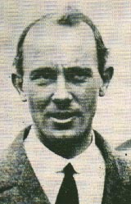

Photo 25. Sopwith Snipe –1918 (RAF service aircraft shown)

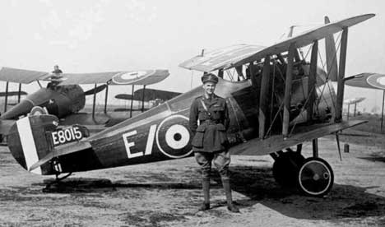

# Epilogue for 1919

In this period 1914 to 1919, the biplane triumphed. Major developments were made in aircraft design and performance. The ‘golden years of aviation’ were just over the horizon. Air travel was to become a reality preceded by the England to Australia flight in 1919 by Ross and Keith Smith, and the Trans-Atlantic non-stop flight by Alcock and Brown in 1919 in Vickers Vimy WWI bombers. Air races and speed were to become a feature of aircraft interest from this time forward.

Photo 26. Vickers Vimy (replica) approaches Clifden, Ireland in July 2005[22]

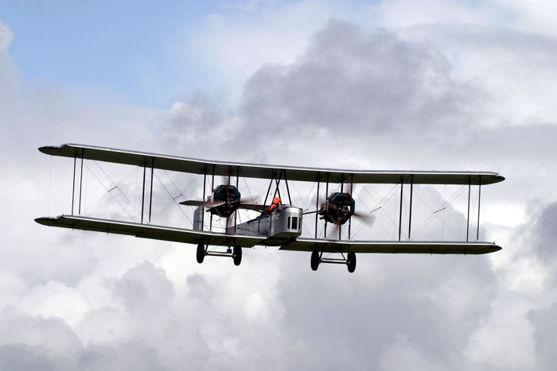

# Index

1

1 Sqn 3

1st Air Depot 14

1st Army Squadron 14

2

2 Sqn 3

3

3 Sqn 3

31 Squadron 28, 29

5

50th Squadron 15

6

63 Squadron 30

7

70 Octane 5

A

Abadan 28, 29

Abadan Aviation Spirit 28

Abadan gasoline 28

Abadan petrol 29, 30

Abadan Refinery 28

acid heat test 17

Acidity 17

Air Board Specification 30

Air-drying 33

Albatross 3

Alcock 34, 35, 36, 43

alcohol 38

altitude chamber 16

aluminium 33

American Aeronautical Society 33

Anglo Persian Oil Company 28

Anglo-Iranian Oil Company 28

Anglo-Persian Agreement 41

anti-knock 16, 17

APOC 29

Arkansas 40

aromatic 5,16, 18, 19, 20, 22, 25, 27, 39

Asiatic Petroleum Company 20

Atlantic Coast refiners 6

Atlantic Ocean 10

Atlantic Refining Company 6, 17

Australian Government 36

automobile fuels 7

Avgas 5

aviation fuel 7, 15, 18, 38, 39

aviation gasoline 5, 6, 7, 8, 12, 16, 18, 19, 21, 24 38, 39

Aviation Gasoline Specification 19

aviation naphtha 6

Aviation Spirit 27

B

Baghdad 30

Baumé 6, 18

BB Oil 15

BE.2C 29

Bennett 3, 36, 37

Benzene 16, 20, 25, 39

Benzol 5, 16, 18, 20, 22, 23, 25, 38

beryllium 33

Biffle 10

Black 6

Blériot 3, 34

BMW engines 35

Boeing 747 31

Bolshevik Revolution 41

Borneo 5, 15, 20, 21, 22, 23, 25, 26, 27

Boxkite 3

British Petroleum 28

British Science Museum 35

British War Mission 6

Bromine absorption 20

Brooklands 37

Brown 34, 35, 36, 43

Bureau of Mines 16, 17, 50

Bureau of Standards 17

Butane 20, 25

C

California 7, 16, 38, 39, 40, 50

California refiners 7

Cammen 33

carburettor icing 20

casing-head 38

castor oil 14, 15, 32, 33

Caudron 3

Central Flying School 3

Central Laboratory 30

chamois 11

Clifden 34, 35

Colombey les Belles 14

Colorado 40

Colour 17

Convention for Regulation of Aerial Navigation 3

cracked gasoline 17, 18, 20, 38

cracking process 25

crude oil 7, 38

Curaçao West Indies 20

Curtiss 3

Cyclohexane 16, 25, 39

D

Daily Mail 34

Darwin 3, 36, 38

Dean 16, 17, 50

Deperdussin 3

detonation 18

distillation 19, 23

distillation range 6

distillation tower 6

Domestic Aviation Grade 17

dope 33

Dutch East Indies 5, 16, 18

E

East Indies 15, 17, 25

Eastern Airlines 32

end point 17, 18, 19, 20

English Channel 34

Esso 6

Evaporation Test 29

Export Aviation Gasoline 17

Export X grade 18

F

Farman 13

Farnborough 42

Fighting Grade 17, 39

Fighting Spirits 15

First Air Depot 14, 15

Fokker DVII 6

Fractional Distillation 25

fractionating steam stills 6

freezing point 25

French 19

French Army 14

G

gasoline 6, 14, 15, 16, 18, 25, 38

Gasoline Supply Station 14

German New Guinea 3

Germany 5, 33

Grade X 15, 17

Great Britain 41

Gulf Oil Corporation 41

gum deposits 25

gum formation 27

H

Harrison 3

Hawker 42

Headquarters Air Service 14

Heptanes 25

Hexane 20, 25

high altitude 17

high test gasoline 16

HMAS Australia 4

Hounslow 36

Hudson Fysh 3, 38

Hughes 36

Huxley 3

Hydrogen Sulphide 32

I

Illinois 40

Imperial War Museum 29

India 28, 39

Indian Ordnance Department 28

Indiana 40

Indonesia 5

inland bulk depots 21

iodine number 17

Iran 41

Ireland 35

Irish linen 33

Isohexane 25

J

Jamnagar Refinery 39

Jenny 3, 10, 11

K

Kansas 40

Kentucky 40

kerosene 5, 18, 38

kiln-drying 33

L

Langley 16

Langley Field laboratories 17

Lelystad 13

Liberty engine 15, 30

Lindbergh 10

Lord Curzon 41

Lorriane Dietrich 18

Louisiana 39, 40

lube oil 18

lubricants 33

lubricating oils 25

M

magnesium 33

Magnolia Petroleum Co. 41

Marconi radio station 35

Maryland 40

Mascot 37

Massachusetts 40

Maybach engines 30

McCook 16

McGinness 3, 38

McNamara 3

mercaptans 32

Merz 3

Mesopotamian Expeditionary Force, Basrah 28

Mexican 6

Mexico 5, 10

mica 34

Mid-Continent 7

Middle East 28

Minnesota 40

Missouri 40

Mitchell 14

Mobile Park 14, 15

Monogram Oils 10

motor gasoline 16, 17, 39

Murphy 3, 38

N

Naini Tal 28

naphtha 38

Naphthenes 18, 19, 20, 22, 25, 27, 30

naphthenic 16, 39

natural gasoline 38

natural-gas gasoline 19

Netzer 16, 17

Neufchateau 14

New Jersey 40

New Mexico 40

New York 40

Newfoundland 34, 35

nickel-plating 33

Nieuport N.28C-1 9

North Island, San Diego 10, 31

Northcliffe 34

Northern Territory 3

noxious fumes 32

O

octane 15, 25

octane numbers 20

odour 18, 22, 32

Ohio 40

Ohio Cities Gas Co. 41

Oklahoma 7, 15, 39, 40

Olefins 17, 20, 22, 25, 27

P

Paraffins 6, 18, 20, 22, 25, 27

Pennsylvania 6, 7, 15, 16, 39, 40

Pennsylvania crudes 15

Pentanes 20, 25

Performance Number 16, 18

Persia 28

Persian Aviation Spirit 28, 30

Petre 3

petrol 7, 28

Petroleum Committee 6, 7

Point Cook 3, 38

PONA Analysis 18, 25, 27

porcelain 34

potato alcohol 5

Pure Oil 41

Q

QANTAS 3, 36, 38

Quartermaster Corps 14

Quartermaster Department 14

R

rail tank cars 21

RE8 30

redistillation 6, 18

refineries 5, 6, 39, 40, 41

refiners 6, 7

Rembercourt 14, 15

re-run gasoline 7

Richmond 3

Rickenbacker 32

Risalpur 28

Roberts 3

Roll Royce Eagle engines 35

Rolls-Royce 35

Romania 5

Rotterdam 5

Royal Air Force 29

Royal Aircraft Establishment 18

Royal Aircraft Factory 18

Royal Dutch/Shell Co. 20

Royal Flying Corps 31

S

SE4 42

Shell 21, 22

Shell ‘A’ Aviation Spirit 26, 27

Shell Aviation Spirit 5, 21

Shell Company 36

Shell Oil 5

Shell spirit 30

Shiers 3, 36, 37

Simla 30

Sinclair Oil Corporation 41

Smith 3, 36, 37, 43, 50

Sopwith 7 F.1 Snipe 42

Sopwith Camels 8

Souilly 14, 15

Soviet Union 41

Spad XIII 1

spark plugs 34

Specific Gravity 6, 18, 19, 22, 28, 29, 30

specification 5, 6, 17, 19, 29, 30, 33, 38

Sprat 42

SS Beechleaf 28

St. Mihiel. Vinets Depot 14

stability 17

Standard Oil Co. of California 41

Standard Oil Co. of Louisiana 41

Standard Oil Company 13

Standard Oil Company of New Jersey 6

straight run gasoline 5, 6, 17, 38, 39

Sulphur 6, 30, 32

Sulphuric acid 17

Sulphuric Acid Absorption 20, 22

Sumatra 5, 20, 21, 22, 23, 25, 27

Sun Company 41

T

TCD method 20, 22

Tennessee 40

Texas 39, 40

Texas Company 41

thermal cracking 18, 20

thermally cracked fuel 32

Tidewater Oil Co. 41

Toluene 5, 20, 25

Toul 15

Trans-Atlantic route 34

Transcontinental Oil Co. 41

Tri-Nitro Toluene 5

U

U.S. Army Signals Corps 10, 16

U.S. Bureau of Mines 16

U.S. Bureau of Standards 16

Union Oil Co. of California 41

U.S. First Army 14

U.S. Navy Dept. 19

USSR 28

Utah 40

V

Vacuum BB 30

vacuum drying 33

vapour lock 20

vapour pressure 17

Venezuela 20, 38

Versailles Peace Treaty 6

Vickers 35

Vickers Viking 37

Vickers Vimy 3, 34, 35, 36, 37, 43

Victoria Cross 3

volatility 17

W

Wackett 3

West Beach Airport 37

West Virginia 40

Western Front 3, 15, 31

Wright airfields 16

Wright Brothers 16

Wrigley 3, 38

Wyoming 40

X

Xylenes 25

# References

1. Australian Aviation History Time Lines - Website accessed June 1, 2002 - <http://users.chariot.net.au/~theburfs/aahistpage1.html#preww1>
2. Shell Oil Company - Title: “The "shell" that hit Germany hardest” by P.G.A. Smith. 1919. Publisher - Melbourne British Imperial Oil. Sourced Shell Oil Company, London & Australian War Memorial
3. The American Petroleum Industry – The Age of Energy 1889-1959 by Harold F. Williamson et.al. Northwest University Press. Sourced from Chevron Park – San Ramon Technical Library. California, U.S.A
4. The US Air Service in World War I, Volume III The Battle of St Mihiel. The Office of Air Force History Headquarters USAF Washington to 1979 US Library of Congress 75-42296
5. The US Air Service in World War I, Volume IV. The Office of Air Force History Headquarters USAF Washington to 1979 US Library of Congress
6. Dean: Bureau of Mines Technical Paper 305 (1917)
7. History of Aviation Fuel Development In The United States – AFRL/PSRF sourced from the Internet
8. Military Aviation Fuel Characteristics 1917-1945 by Robert Kerley SAE Publication SP-1008 (ISBN 1-56091-454-8)
9. UK Public Records Office AIR 2, 167 Royal Aircraft Establishment Report No. H.C.796 of 28 May 1918, Royal Aircraft Establishment Report No. H.816 of 4 July 1918.
10. UK Public Records Office Preliminary Report of Laboratory Tests on Sample of Petrol from the Asiatic Petroleum Company, Ref: A.M. 471396/23 Report HC 796 Lab Ref: X.3.A. A.P.T/51618/1918, 16.5.18.
11. UK Public Records Office RAE Report on Analysis of Petrols Report H818 4 July 1918
12. “Master of Airpower – General Carl A. Spatz” by Dr. David R. Mets (1997) Published by Presidio Press, Novato, California USA (ISBN 0-89141-639-0)
13. UK Public Records Office AIR2/91 B3563 Morbidity of Flying 24 Aug 1918
14. The Journal of Industrial Engineering and Chemistry, September 1917, Ind. Eng. Chem.; 1917; 9(9); 826-827
15. Web site <http://users.chariot.net.au/~theburfs/index_mil.html> Accessed Sept 10, 2003
16. Web site <http://users.chariot.net.au/~theburfs/history/vimy_mascot.jpg>, Accessed Sept 10, 2003.
17. Australian Stamp Bulletin No. 226 Aug –Sept 1994
18. Aviation Gasoline Manufacture – Matthew Van Winkle, Pennsylvania State College, McGraw-Hill 1944.
19. “Analytical Survey of the Oil Industry and Statistical Handbook” circa 1919. Sourced from American Petroleum Institute Library (1998)
20. Web site <http://www.khazar.org/jas/text/politics.html> accessed Jan 24, 2004 “THE ANGLO-AMERICAN OIL CONTROVERSY IN IRAN 1919-1924”
21. “World Speed Record Aircraft” by Ferdinand Kasman F.C.W. -Cologne - June 1990. Leicestershire Library (UK) Call No. 639.1334
22. Web site [http://www.vimy.org/vimyatlantic/photogallery/Clifden%20Arrival/pages/clifden-070305-15.htm accessed Sept 30](http://www.vimy.org/vimyatlantic/photogallery/Clifden%20Arrival/pages/clifden-070305-15.htm%20accessed%20Sept%2030), 2006