Chapter

3

1920-1930 “Roaring Twenties”

Part 1 - The Adventurers

Photo 1. Douglas Cruiser ‘Round the World Flight’ US Army Air Service - 1924

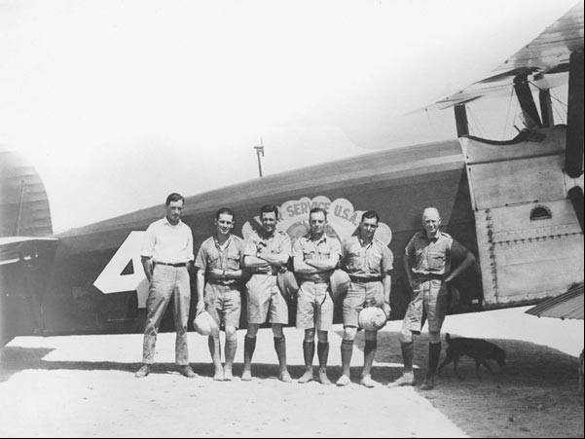

Table of Contents

The Roaring Twenties - Barn Storming & Adventure Years 3

Air Power Versus Sea Power 4

Air Routes 5

Pioneering Flights 8

Round The World Flights 12

Solo Trans-Atlantic Flight 1927 Lindbergh Triumphs 15

Australian Aviation Feats 17

Oil Companies & Their Aviation Departments 23

“The Race Is On” – More Airspeed Records 30

Schneider Trophy – The Ultimate Prize For Seaplanes 31

Epilogue For 1929 41

Index 42

References 44

Summary

# The Roaring Twenties - Barn Storming & Adventure Years

The Roaring Twenties - a period of development of specifications and fuel research.

After the horrors of the First World War, the world wanted to forget the dreadful carnage, and sought escapism from this dreariness. This was the era of jazz, flappers, movies, alcohol and good times; and the fascination with aircraft continued.

There were air displays, shows and races which initially featured the surplus biplanes from the Great War, but then started new developments in aircraft to meet the demand for greater speed and endurance.

Typical of the day were air displays featuring dare-devil feats such as standing on the upper wing, hanging from wing struts or the aircraft undercarriage.

Photo 2. Daredevil flying circa 1930’s[1]

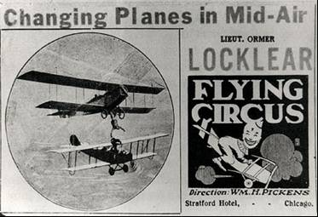

This decade was the era of many great pioneering flights and new heroes – people such as Charles Lindbergh, Bert Hinkler, Smithy & Ulm became household names.

It was also the development of air mail routes, and the emergence and display of a nation’s ‘Air Power’, which would challenge naval power.

Another key development was the involvement of the oil companies with aviation, and the creation of new marketing units - their “Aviation Departments”. This would later lead to the creation of major global marketing organisations supplying aviation fuels, lubricants and special products.

Photo 3. Chevron aviation poster of 1928

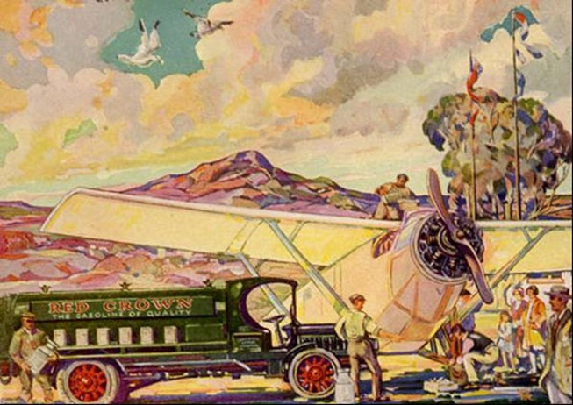

Before the decade was out the major oil companies would have ‘aviation departments’ across the globe to assist the fledgling aviation industry and ensure that they would be key players in any new developments in this new industry.

# Air Power versus Sea Power

While the horrors of war were to be forgotten, the changes in warfare tactics were not to be lost on some of the aviation visionaries such as William ‘Billy’ Mitchell of the US Army - this was the emergence of a new weapon of war – the Aeroplane. To demonstrate the capabilities of this ‘air power’, in July 1921 off Virginia on the east coast of the United States, the outspoken Billy Mitchell used bombers in an attempt to sink a number of the captured German naval vessels including the battleship “Ostfriesland”. US President Harding was among the gallery of observers and promised the creation of a powerful and independent Air Force if the airplanes could sink the warships. [It would be 26 years and four Presidents later before the US Air Force was created.]

It was to be Air Power versus Sea Power.

General Pershing (Chief of the US Army) watched grimly as US Army and Navy pilots quickly dispatched a submarine, a destroyer and even the cruiser “Frankfurt”. But the real test was the battleship “Ostfriesland”-so heavily armour plated that it was considered unsinkable by many naval experts, and the “Ostfriesland” was tough; in the first attack she took six direct hits and stayed afloat. Bombing was stopped for an inspection. After the inspection, she took six more direct hits-four by 1,000-pound bombs and, though damaged, she still stayed afloat. Before the next day’s attack, Mitchell told his pilots - ‘All we have done will be forgotten if we fail to kill and bury the Ostfriesland”.

Photo 4. Captured German battleship “Ostfriesland” under attack from US bombers July 1921

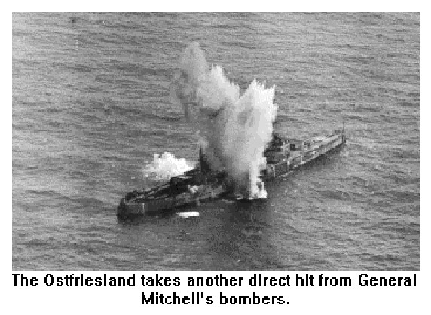

The next day, his boys did the job for him. Eleven direct hits with 1,000-pound and 2,000-pound bombs sent the “Ostfriesland” to the bottom of the Atlantic Ocean.[2]

The first time that aircraft had sunk a capital war ship. This demonstration was to highlight the attack role of aircraft in a naval battle – an event that would occur many times over in the Second World War, and foreshadowed a new naval vessel – the aircraft carrier which would eventually replace the battleship. And new aircraft types such as the torpedo bomber would play a key role in the next World War (WWII).

# Air Routes

During the same period, airmail routes were becoming established and commercial aviation started to emerge. The airmail routes were to provide the impetus for the development of commercial aviation’s routes of the 1930’s in the US, Australia and other nations in the British Empire, and from Europe to the East and West Indies. Routes such as London (U.K.) to Bombay (India), London (U.K.) to Cape Town (South Africa), Amsterdam to Batavia (Netherlands East Indies), and the start of the famous “Clippers” from the USA to South America.

Photo 5. Early US Air Mail flight preparation

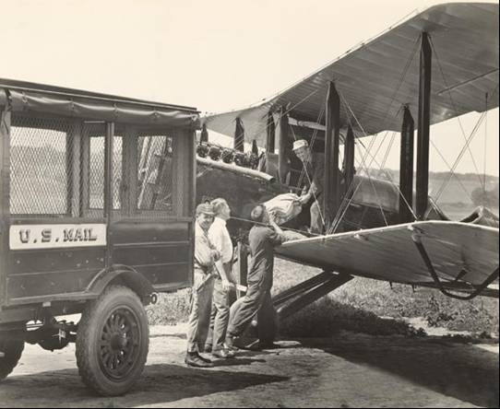

The development of these air mail routes and later the commercial aviation routes would see the establishment of the necessary refuelling depots at key locations along the route, together with other aviation services provided by the oil companies at new aerodromes.

Figure 1. British BOAC air route 1929 London to Karachi with a comparison to the route in 1972.

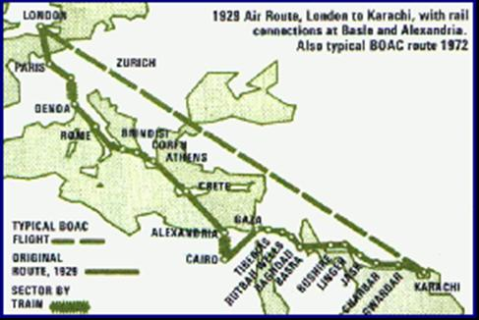

Figure 2. Pan American air routes from USA to South America, circa 1930

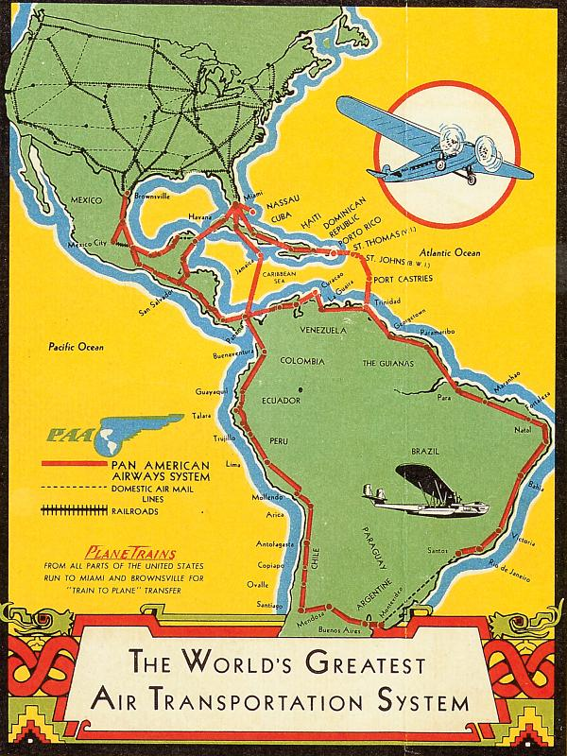

# Pioneering Flights

US Non-stop Coast to Coast

In 1922, the US Army Air Services flew non-stop from coast to coast New York to Los Angeles using a Fokker F IV monoplane to demonstrate the feasibility of moving troops quickly across the country in time of emergencies.

Photo 6. US Army Air Services A.S. 64233 Fokker F IV Serial No. 1800 Reg. A

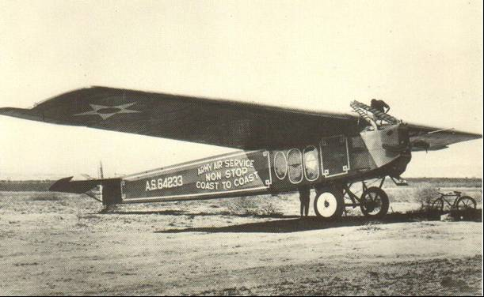

Photo 7. Fuel and oil used in the record non-stop coast to coast flight, 1922

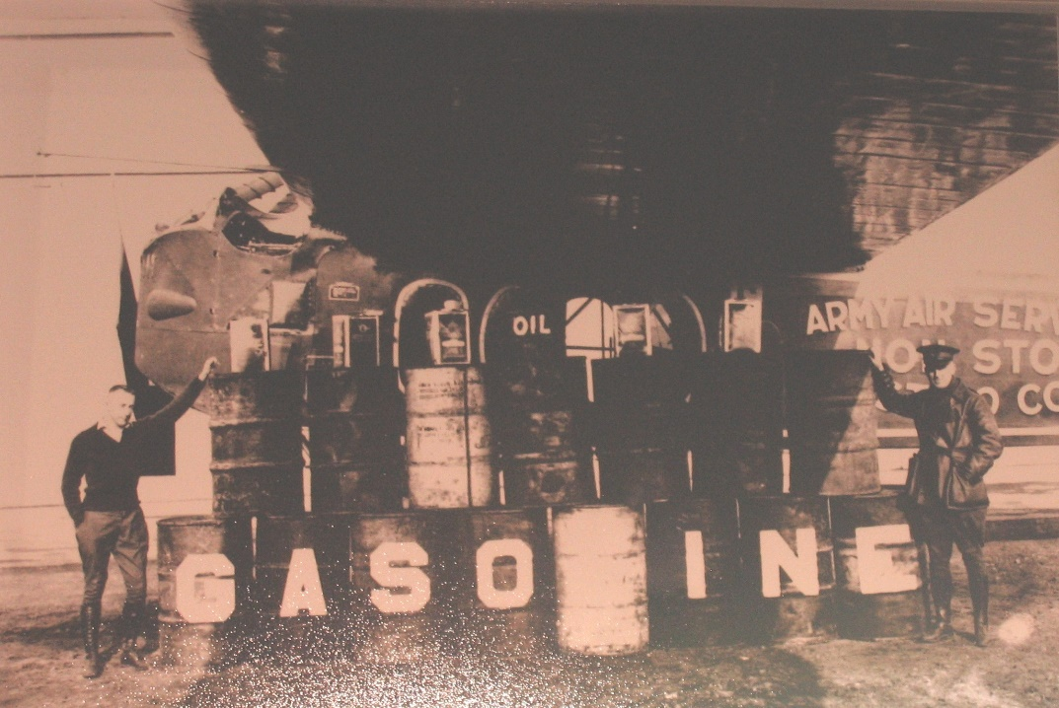

Fuel used 14 drums (approx. 2,800 litres) of aviation gasoline, and 6 cans (approx. 60 litres) of oil.

Dutch Air Route to East Indies

The Dutch colonies were as far flung as the British, and with their early involvement in aviation primarily through the brilliant engineer Anthony Fokker, it was inevitable that the Netherlands would also establish an airline, Koninklijke Luchtvaart Maatschappij (KLM) with air routes from Amsterdam to the East Indies (now Indonesia). The obvious partner to supply the fuel for this airline would be the Royal Dutch Shell Company, and on 24 November 1924 a KLM Fokker F7A (Reg. No. H-NACC) left Batavia (now Jakarta, Indonesia) for Amsterdam, arriving after a flight of 127 hours and 16 minutes.

Photo 8. KLM Fokker F7A arrives in Batavia (Netherland East Indies) 1924.

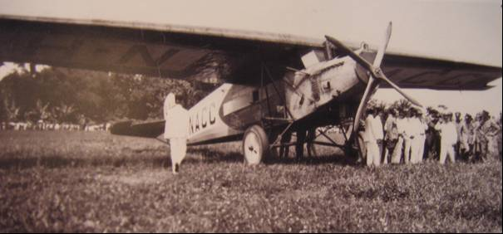

To maintain the operation of such long-distance flights required fuel depots at strategic locations along the route. These were established by the oil companies, in the case of the Netherlands, by the Royal Dutch Shell Company.

Photo 9. Fuel depot at an airport circa 1924

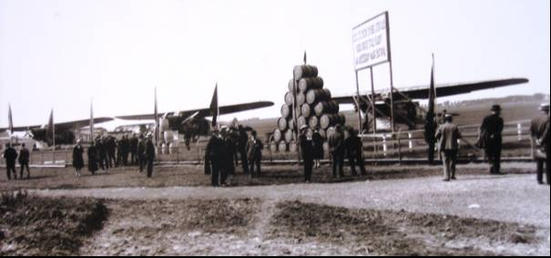

In June 1927, a KLM Fokker F7A (Reg. No. H-NADP) flew the first passenger flight from Batavia to Amsterdam on Shell ‘Benzine’ (aviation gasoline).

Photo 10. Shell postcard celebrating the first KLM passenger flight from the Netherlands East Indies 1927.

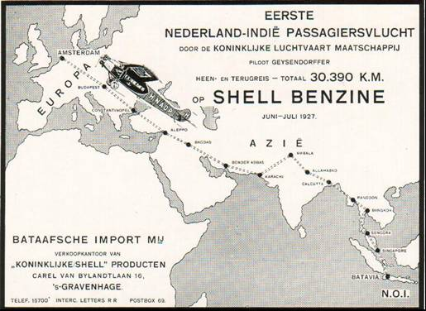

Photo 11. KLM European Air Routes 1927-1929 (on display at Aviodrome Museum – Lelystad, Netherlands 2006).

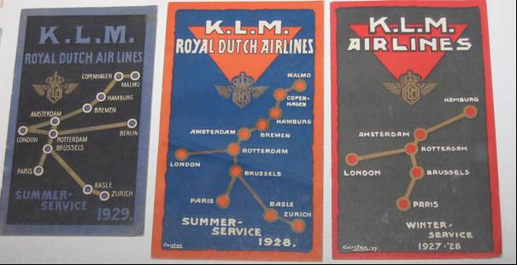

RAF Far East Flight 1927[3]

On 17 October 1927, four Supermarine Southampton seaplanes (RAF serials S1149, S1150, S1151 and S1152,) - backed by a reserve aircraft, S1127 - took off from England, led by Group Captain H.M. Cave-Brown-Cave, DSO, DFC. In fourteen months, they flew from England to Calcutta, Rangoon, Penang, Singapore, Australia, around Australia, back to Singapore, around the China Sea and back to Singapore again. The flight landed at Broome, WA on 1 June 1928. They then proceeded south to Albany, before turning eastwards. There they faced a long, empty stretch of Australian coastline backed by desert, but found the water at tiny Israelite Bay dead calm, with fuel on the jetty as arranged. They moved on to Melbourne and up the east coast, around to Port Darwin, and on through the Dutch East Indies to conclude with a tour of south-east Asia.

Much later, the formation leader, Group Captain G.E. Livock, DFC, AFC, RAF (Ret'd) commented that it was curious that such a long cruise should have so few highlights, but everything proceeded smoothly. This flight typifies the detailed planning required to ensure that fuel and other supplies were available at these remote locations.

The Southampton's place in Australian aviation history was established by the RAF Far East Flight in 1927-28. These aircraft were later to become RAF Squadron 205 based at Singapore - the first RAF squadron in the Far East.

Two Southampton Mk. Is were ordered by the R.A.A.F. in June 1927 for the Coastal Reconnaissance flight at Point Cook, Victoria, arriving in Australia by ship in January 1928. They continued to fly with RAF serials S1158 and S1159 until RAAF serials A11-1 and A11-2 were applied. A11-1 was sold in 1937. A11-2 served until 1939, with platforms fitted to its outer wings for parachute training. It was scrapped in 1940.

Photo 12. RAAF Supermarine Southampton (Serial No A11-2) flies over Melbourne.

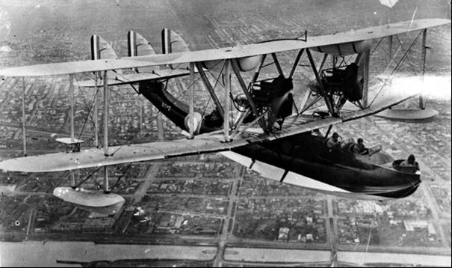

Supermarine Southampton, serial A11-2. Date and location unknown, but the parachute training platforms on the outer wings were fitted late in its career. Melbourne, looking west over Footscray, has been suggested as the location. (Commonwealth of Australia - Department of Defence).

# Round the World Flights

Douglas World Cruiser “Chicago” 1924[4]

In 1924 the US Army Air Services undertook a ‘Round The World Flight’ – the first time any such feat had been attempted. The US Army Air Service requested a strong airplane that could endure the harsh conditions of a world flight. The Air Service chose a modified Douglas DT-2 Navy torpedo bomber. Because the flight would take place over land and water, the airplanes had to have interchangeable floats and wheels. To increase range, fuel tanks were added to the upper wing section, the lower wing roots, behind the fire wall, and under the pilot’s seat. These tanks increased the fuel capacity from 435 Litres (115 US Gallons) to 2,438 Litres (644 US Gallons). Other modifications included a larger radiator, strengthened bracing, increased rudder surface, a cut-out in the upper wing for increased visibility, and moving the observer’s cockpit closer to the pilot.

In preparation for this flight a questionnaire for information along flight route for seaplane facilities was prepared - “War Department - Office of the Chief of Air Services - Washington W-949 A.S.” and “U.S. Army Air Service W-1091.A.S.” Two of the questions referred to fuel type and supply:

“22. Is high test gasoline and high grade oil available in quantity?”

“32. Names and addresses of dealers handling high test gasoline and high grade oil.”

At the start of this flight “Red Crown” Aviation Gasoline was used by the three US Army planes which undertook this feat.

Photo 13. Douglas Cruiser being loaded with gasoline from 4-gallon tins, 1924.

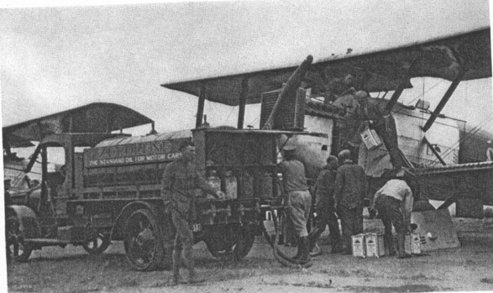

Pursuant to US War Department orders[5], the following named officers were ordered to report to Langley Field and begin temporary duty on January 2, 1924 for the purpose of instruction in meteorology and aerial navigation and familiarizing themselves with the handling in flight of the experimental type of Douglas Cruiser to be used in the Round-the-World Flight:

Major F.L. Martin, Air Service, - Pilot

1st Lieut. Lowell H. Smith, Air Service, - Pilot

1st Lieut. Leigh Wade, Air Service, - Pilot

1st Lieut. L.D. Schulze, Air Service, - Alternate Pilot

1st Lieut. Leslie P. Arnold, Air Service, - Alternate Pilot

1st Lieut. Erik H. Nelson, Air Service, - Pilot, being on duty at the Douglas Company, Santa Monica, California, as a representative of the Engineering Division Office, Chief of Air Service, in connection with the fabrication of the four Douglas World Cruisers to be used for the World Flight, reported on January 7th.

The commissioned personnel assigned to the flight were detailed to duty as follows:

Major F.L. Martin - Commanding

1st Lieut. Lowell H. Smith - Adjutant

1st Lieut. Leigh Wade - Supply Officer

1st Lieut. Erik H. Nelson - Engineering Officer

1st Lieut. L.D. Schulze - Alternate Pilot

1st Lieut. Leslie P. Arnold - Alternate Pilot

(In 1923, 1st Lieut. Lowell H. Smith had been one of the team to set the Flight Endurance record).

The planes flew from Santa Monica, California to start from Seattle, Washington. They then proceeded in stages to conquer the world by air.

Stage 1 - Seattle, Washington to Attu, Aleutian Islands - 6 April to 14 May 1924

Photo 14. Refuelling in the Aleutian Islands 1924 [6]

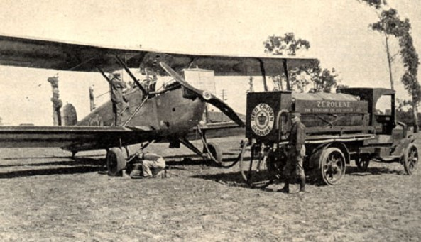

A US Army Air Service Douglas Cruiser airplane (in land-based configuration) stopped in the Aleutian Islands (Stage 1) to be refuelled with Red Crown Gasoline during the first around-the-world flight in 1924. The markings on the tanker wagon are “Zerolene” which was the Standard Oil Company of California brand of lubricating oils.

Stage 2 - Attu, Aleutian Islands to Kagoshima, Japan - 15 May to 3 June 1924

Stage 3 - Kagoshima, Japan to Calcutta, India - 4 June to 30 June 1924

Stage 4 - Calcutta, India to Constantinople, Turkey - 1 July to 11 July 1924

Stage 5 - Constantinople, Turkey to London, England - 12 July to 16 July 1924

Stage 6 - London, England to Boston Massachusetts - 17 July to 7 September 1924

One of the airplanes from this epic flight - Douglas Cruiser “Chicago” is now housed at the US National Air & Space Museum Washington D.C. (2002)

Photo 15. Douglas Cruiser “Chicago” on display at US National Air & Space Museum (1999)

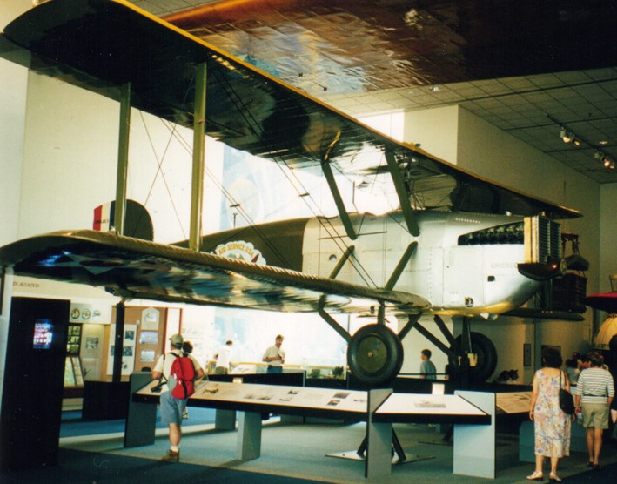

# Solo Trans-Atlantic Flight 1927 Lindbergh Triumphs

Perhaps the greatest flight that caught public imagination and admiration of the period was the solo flight of Charles Lindbergh from New York to Paris in 1927 in his Ryan NYP (‘New York - Paris’) monoplane “Spirit of St. Louis”. In 1927 the Raymond Orteig prize of $25,000 was offered for the first non-stop flight from New York to Paris. Two days before Lindbergh's scheduled May 10, 1927 departure from San Diego, news broke that Frenchmen Charles Nungesser and Francois Coli had taken off from Paris bound for New York. It appeared as if all of Lindbergh's and Ryan Airlines' efforts had been in vain. However, despite a radio report claiming that Nungesser and Coli had been spotted over the Atlantic, the two were never seen again. Lindbergh's chance for glory was still within reach. "Lucky Lindy" and his "Spirit of St. Louis" landed at Curtiss Field on Long Island, New York, on May 12, 1927. En route, pilot and plane had already broken the existing record for the fastest transcontinental flight. Eight days later, Lindbergh and his silver plane were poised to set new records as they took off from Roosevelt Field. Fighting fog, icing, and sleep deprivation, Lindbergh landed safely at Le Bourget Field in Paris at 10:22 pm on May 20, 1927. "The Spirit of St. Louis" had carried him over 3,600 miles in 33.5 hours. A new aviation hero was born, and the "Spirit of St. Louis" attained legendary status.

Much has been written about this famous flight, but there has been little information on the fuel that made this flight possible. From sources obtained from Chevron (Standard Oil Bulletin June 1927) the following reveals the choice of fuel was not made lightly.

“Capt. Lindbergh devoted much attention to the selection of the gasoline that he was to use. He was at first in doubt as to the advisability of using a western product (US West Coast), for he had learned that this gasoline weighed more than eastern gasoline (US East Coast); but when it was explained that this extra weight mean more heat units per pound, he chose “Red Crown” Aviation Gasoline, manufactured by the Standard Oil Company of California (at its Richmond Refinery on San Francisco Bay - San Francisco, California, USA). This choice was made without any sentiment being attached to it, or the pressure of salesmanship. One factor that did carry weight with Capt. Lindbergh was the unequivocal recommendation of the Ryan (Aircraft) Company which had tried out upon its flying field many different gasolines, with the result that “Red Crown” Aviation Gasoline was used exclusively, the opinion being that it was the best fuel available.”

On Monday May 16, 1927, the marketing men in the San Francisco office of Standard Oil Company of California received a cable with an unusual request:

“Can you supply Red Crown Aviation Gasoline in New York in three days for Lindbergh’s proposed transatlantic flight?”

A reply was quickly prepared and sent off: “Who is Lindbergh?”

On May 16, 1927, they were not alone in their ignorance of a young man named Lindbergh. However, with the order placed there was another problem – there was no transportation available which could get the needed gasoline to New York in time. Fortunately, fate intervened. In New York at that time was Commander Richard E Byrd and his crew preparing for another transatlantic hop. He too had chosen “Red Crown” and had a supply on hand. In his final test flight, he had had an accident and his plane was damaged. The time required for repairs would permit replenishing his supply of “Red Crown”, so Byrd’s gasoline was diverted to Lindbergh. The history making flight of 3600 miles to Paris was thus completed and Standard Oil Company of California had another envious event to add to its record. (Source “The Standard Oiler” – August 1954).

Photo 16. “Spirit of St. Louis” refuelling by hand using 4-gallon tins 1927. Charles Lindbergh, Donald Hall, designer of the Spirit of St. Louis, and sales manager Edwards.

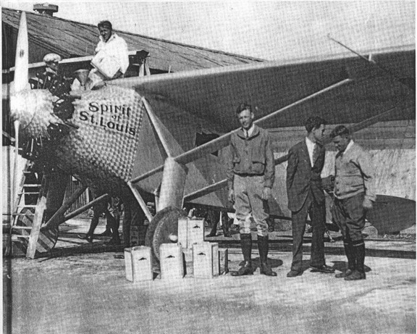

Photo 17. Refuelling “Spirit of St. Louis” with Standard Oil’s “Red Crown” – “The Gasoline of Quality”

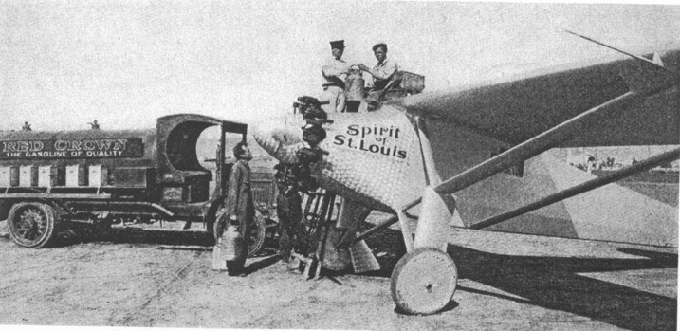

Engine Wright J5 “Whirlwind”, Fuel Capacity 425 US Gallons.Australian Aviation Feats[7]

The fascination with the aircraft and flying extended all over the world, and even more so in a vast country like Australia which was the continent most distant from Europe and America. In 1920, the first single-engined aircraft flight from England to Australia left Hounslow, England. The DH-9, flown by R.J. Parer and J.C. McIntosh, reached Darwin, Australia on 2nd August, 1920.

Also in August 1920, P.J. McGinness and W. Hudson Fysh set up their airline business; with an order for two Avro aircraft, at Mascot Aerodrome, Sydney, New South Wales, the name Queensland and Northern Territory Air Services Ltd. (QANTAS) was registered that November.

Between November 30 and December 2, 1920 F.S. Briggs, C.J. deGaris and J. Howard completed the first east-west transcontinental crossing of Australia by air, in a DH-9 aircraft flying from Glenroy, Victoria to Perth, Western Australia. They made the return trip December 14-16, 1920.

In December 1921, Australia had nine government aerodromes and five emergency landing grounds in operation. In 1923 the first airport in Canberra (Australian Capital Territory) opened in April. It saw limited use, and closed in 1926 when it was replaced by an aerodrome at the present location.[8]

Flying Doctor Service - Australia

On May 15, 1928, the Flying Doctor Service came into being. Dr. K. H. Vincent Welsh using a De Havilland DH-50A (fitted for two stretchers) commenced operating from Cloncurry, Queensland, Australia. Its pilot was Arthur Affleck. It would become an Australian institution and national icon. The supplier of aviation products including aviation fuel was most likely the Shell Company of Australia, as they had a depot in Cloncurry.

Photo 18. An example of a De Havilland DH-50A for the era, circa 1924

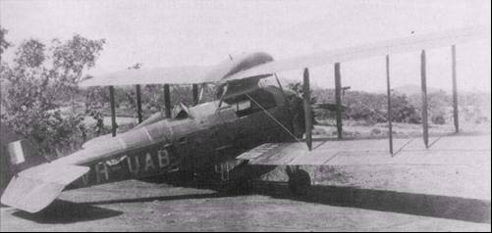

Royal Australia Air Force is born - 1921

In January 1920, the AFC (Australian Flying Corps) was replaced by the Australian Air Corps under Lt.-Col. R. Williams. The Australian Air Force was created on March 31, 1921, and Williams became Wing Commander. It became the Royal Australian Air Force (RAAF) on Aug. 31, 1921.

**First flight around Australia’s coast 1924**

The first aerial circumnavigation of Australia was an initiative of the RAAF. Wing Commander Stanley J. Goble and Flight Lieutenant Ivor E. McIntyre left the RAAF Base at Point Cook, Victoria on 6 April 1924 in a modified Fairey IIID Seaplane A10-3. The purpose of the trip was to conduct a reconnaissance of the route to Thursday Island in the far north of tropical Australia and to test the performance of the plane in the tropics. McIntyre was the pilot and Goble the navigator. They returned to Point Cook on May 19, 1924; some 44 days had elapsed of which 20 had been flying days. They had flown 13,599 kilometres in 93 hours. The Commonwealth Government awarded Goble ₤500 and McIntyre ₤250, and in April 1924 they received the Britannia Trophy for the best flight in 1924.

Photo 19. Fairey IIID Seaplane A8-1 (similar to the A10-3)

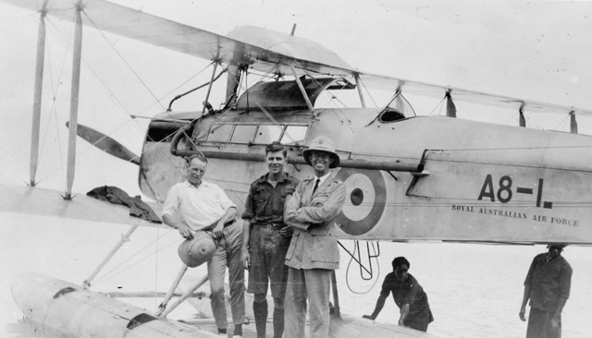

The beginnings of the Australian Government’s aircraft industry were started during this period with the establishment of the RAAF's Experimental Section in January, 1924 at Randwick, NSW, under Squadron. Leader. R.J. Wackett. He was later to be a major driving force for the development of the Australia’s fledgling aircraft industry, essential for Australia’s defence during World War II. Between 1924 and 1930 this experimental section produced the Wackett Warbler, Wackett Widgeon and Wackett Warrigal.

RAN launches its first aircraft -1928

In 1928, on February. 21st, the Royal Australian Navy's seaplane carrier HMAS Albatross was launched, and commissioned the following year. She carried the designation of 101 Fleet Cooperation Flight of the RAAF, and was made up of Seagull III amphibians. However the Australian Navy would consider the aeroplane as a mere supplement to a reconnaissance role and would not utilize aircraft in an attack role until after the Second World War with the addition of the HMAS Sydney (Australia’s first aircraft carrier which served in the Korean War, and later to become a troop transport during the Vietnam War). In 1933 the RAN seaplane carrier HMAS Albatross was paid off into reserve. The RAN's naval aviation was limited, until after World War 2, to aircraft operating from cruisers and armed merchant cruisers.

Bert Hinkler –First solo flight from England to Australia

In February 1928, Bert Hinkler made the first solo flight from England to Australia in his Avro Avian G-EBOV, taking just over fifteen days to complete this amazing feat. However, as with many aviators, fame was to be short-lived for on January 7, 1933 pioneering aviator Bert Hinkler was killed when his De Havilland DH-80A Puss Moth crashed in the Tuscan Mountains, Italy, en route from England to Australia.

‘Smithy’ – an Australian Icon

No story on Australian aviation can be complete without mention of Charles Kingsford-Smith, known affectionately to the Australian public as ‘Smithy’. The exploits of Smithy and his crew, and the “Southern Cross” would become part of Australia’s history, and he would become a national icon. In 1927, Smithy and Ulm set a new record for a flight around Australia; in 1928 they conquered the Pacific air route, and in 1929 set a new flight record for England to Australia.

Smithy & Ulm conquer the Pacific

On 31 May 1928 Charles Kingsford-Smith (“Smithy”) together with Charles Ulm (co-pilot), with two Americans Harry Lyon (navigator) and James Warner (radio operator) took off from Oakland, California in the “Southern Cross” [9] across the Pacific bound for Australia.

Photo 20. Charles Kingsford-Smith (left) and Charles Ulm (circa 1928)[10]

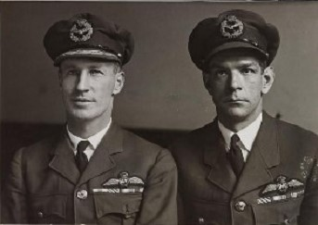

The “Southern Cross”, a Fokker trimotor F VIIb, had to lift a total of seven tons of men, fuel and gear into the air. Smithy and Ulm sat in the two pilot’s seats near the front of the long fuselage. Behind them was an 800-gallon tank full of petrol. Behind that Lyon and Warner, both ex-US Navy men, worked the instruments.

Smithy and the crew landed “Southern Cross” first in Hawaii before setting off for Fiji. This leg set a record 34 ½ hours flight across open seas before gliding past the Grand Pacific Hotel where a large and enthusiastic crowd saw it touch down at Albert Park. The Fokker was the first aircraft to land in Fiji. Eight and a half days after leaving Oakland, including over 83 hours in the air to travel almost 12,000 kilometres, they landed in Brisbane, where they were welcomed by over 15,000 people. The “Southern Cross” is now on permanent display at Brisbane’s Eagle Farm Airport.

While Charles Kingsford-Smith has gone down in history as one of our greatest aviators, little attention has been paid to his, and Charles Ulm's outstanding marketing skills.

Smithy uses Vacuum Oil Products[11]

Prior to 1928, the two, Smithy and Ulm used only Vacuum Oil (later Mobil) products in their plane. Here are excerpts from an unsolicited letter they wrote to the Vacuum Oil Company's managing director in Australia on July 4, 1927:

"We wish to place on record our appreciation of the excellent quality of your products, Plume Motor Spirit and Gargoyle Mobiloil BB used by us on our Record-Breaking Flight Around Australia.

That our choice of Plume and Mobiloil was wise, has been demonstrated by the fact that in no single instance did we have the slightest trouble, due either to fuel or lubricating oil - on the contrary, easy starting, smooth running and low consumption was evident."

Smithy changes to Atlantic Union

However, a year later they switched to the then new Atlantic Union (later Esso) for their historic Pacific and Tasman crossings [Australia to New Zealand] and their non-stop Australian flight from Sydney (New South Wales) to Perth (Western Australia) [an equivalent in the USA of flying non-stop from Washington to San Francisco]. Here’s an excerpt from a telegram they sent to the company after their Pacific crossing.

"Atlantic Extra Heavy Oil used. Pressure on three motors never varied throughout extreme rise and fall in temperature… Union Motor Spirit only fuel used ... three motors never missed a beat ... Atlantic Lubrication Grease was never changed and is as good as when we left America ... we cannot speak too highly of your products and without your cooperation and service on the route we would have been unable to maintain schedule. Many thanks”

A little over a year later they were back using Vacuum products.

If nothing else this episode shows, that these pioneering aviators, had the confidence to put their lives and fortunes in the products of two of the companies that later formed Exxon-Mobil. [12]

The relationship between oil companies and famous aviators was beneficial to both parties, the companies got publicity and the aviator was indirectly supported by access to aviation fuel and lubricants.

1929 June 25-July 10; Kingsford-Smith, Ulm, Litchfield and McWilliam set a new record for an England-Australia flight, again in the “Southern Cross”.

Smithy and his crew’s journey in an act of extraordinary human endeavour and courage signalled the opening of international air travel across the Pacific and the boost to trade and tourism enjoyed today.

Smithy was to be lost in 1935 in yet another attempt to conquer the skies.

Photo 21. Refuelling the ‘Southern Cross Junior”

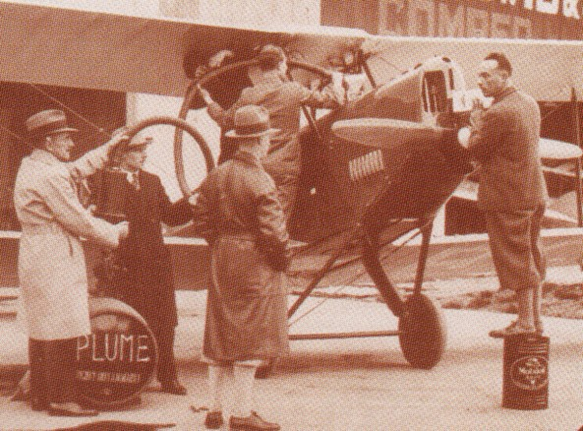

Vacuum Aviation Manager Fred Haig (left) and Charles Kingsford-Smith supervise the refuelling of the Avro Avian "Southern Cross Junior" with Plume. The promotional endorsement claimed: *“Easy starting, smooth running and low consumption was evident”.*

Photo 22. The Southern Cross is refuelled with Union Motor Spirit “three motors never missed a beat.”

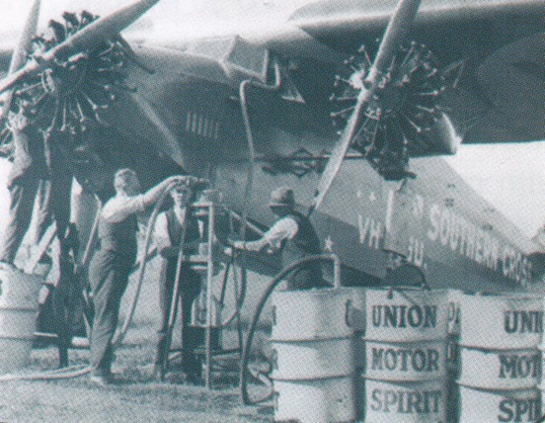

Photo 23. Vacuum Oil poster circa 1929

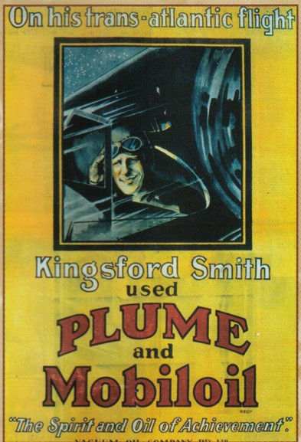

Photo 24. Smithy’s ‘Southern Cross’ – Fokker F VIIb-3M Serial No. 4954 is refuelled in Netherland East Indies.

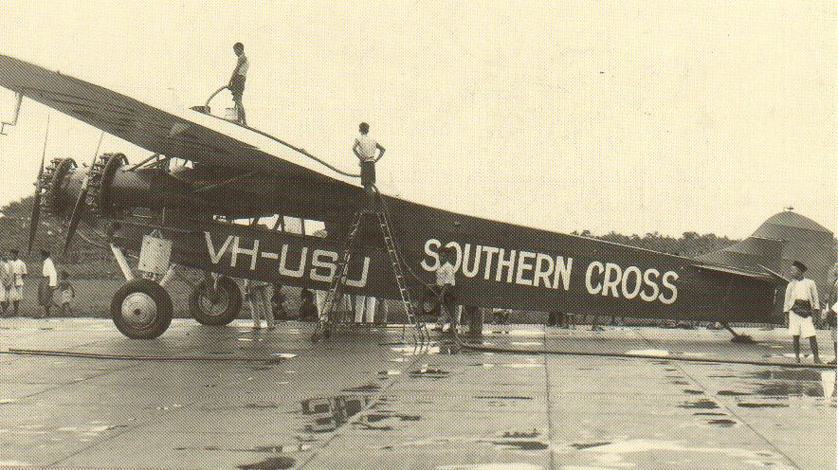

# Oil Companies & their Aviation Departments

The invention of the four stoke cycle internal combustion engine by Nicolaus Otto led to the development of aviation engines; oil companies provided the fuel. However shaky the beginning of air transport, its future seemed certain. The advertising value of backing aviation feats such as long-distance flights was a factor that they could not afford to ignore – it was the only profit they could expect from the support they gave to these trail-blazing pilots. But there was much more to it than that; more even that the oil company “service” they had been trained to provide. There was a fraternity interest that has perhaps no parallel in other industrial fields.

The oil companies sponsored this relationship as a matter of deliberate policy. Initially, in Australia, Shell and Vacuum were the main competitors in the aviation field. They would be the key suppliers prior to, and during World War II.

Commonwealth Oil Refineries (which later became part of BP Australia Ltd.), Caltex and H. C. Sleigh followed Shell and Vacuum into Australia in the oil business, however they would never achieve the aviation market domination of Shell and Vacuum (later Mobil Oil), and except for BP, the others were not involved in aviation gasoline.

When the first aviation departments were set up, the men who were put in charge were themselves flying men, well chosen for the job. They were men of character and administrative ability as well as possessing aviation technical knowledge and experience. In the United States, one of these men was James Doolittle (winner of the Schneider Trophy in 1925) who joined Shell as their Aviation Manager and later was a key player in the development of 100 Octane aviation gasoline. As Doolittle recalls “All of the ‘name’ oil companies were hiring well-known pilots at that time to represent their products at air races, by setting records and otherwise getting their respective companies in the news in a favourable way. Among them was Jimmy Mattern at Pure Oil, Frank Hawkes at Texaco, Eddie Aldrin (father of the US astronaut Buzz Aldrin) at Standard Oil, Billy Parker at Phillips, Al Williams at Gulf and Roscoe Turner” . The flamboyant Turner was from movie world of Hollywood and worked for Gilmore Oil Company and later with Chevron (he was the Winner of the Thompson Trophy at the 1938 Cleveland National Air Races).

Photo 25. James Doolittle circa 1929

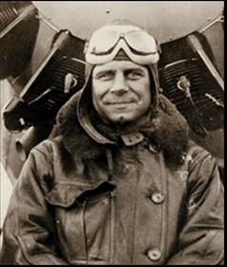

Photo 26. Texaco Company plane of Frank Hawkes on display at Chicago Science & Technology Museum (2006).

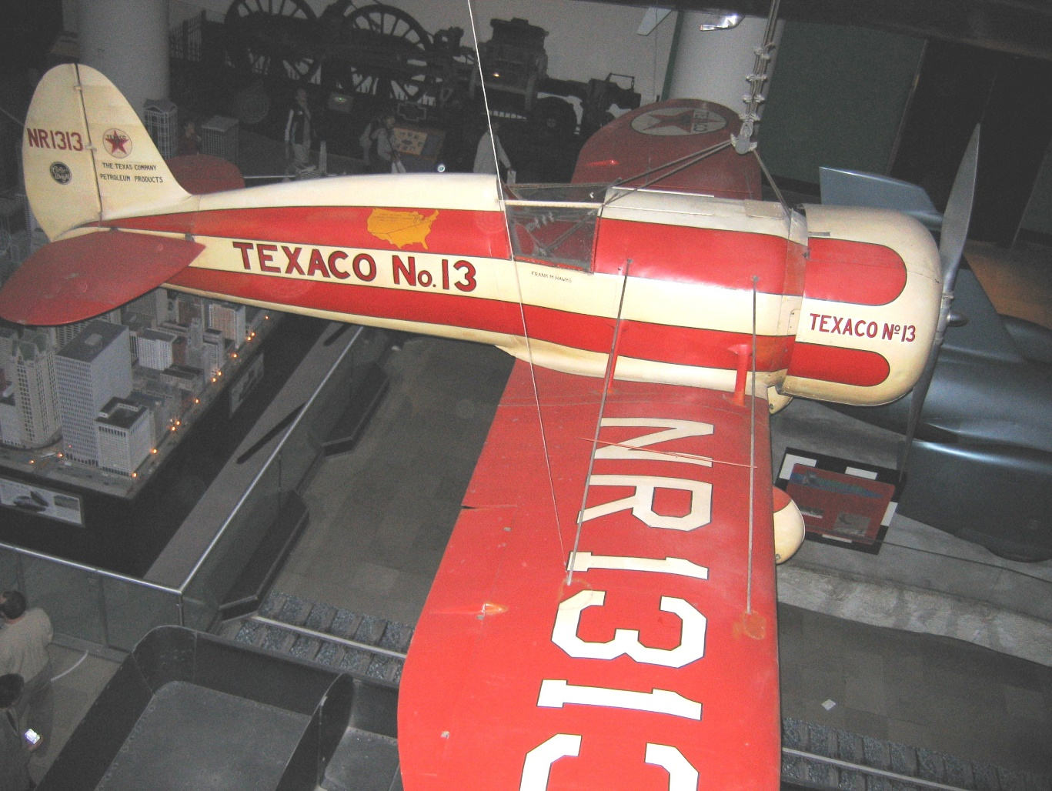

Photo 27. Will D. Parker – Phillips Petroleum circa 1929

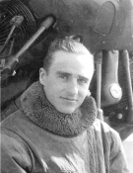Photo 28. Al Williams and US Navy Curtiss Racer circa 1923

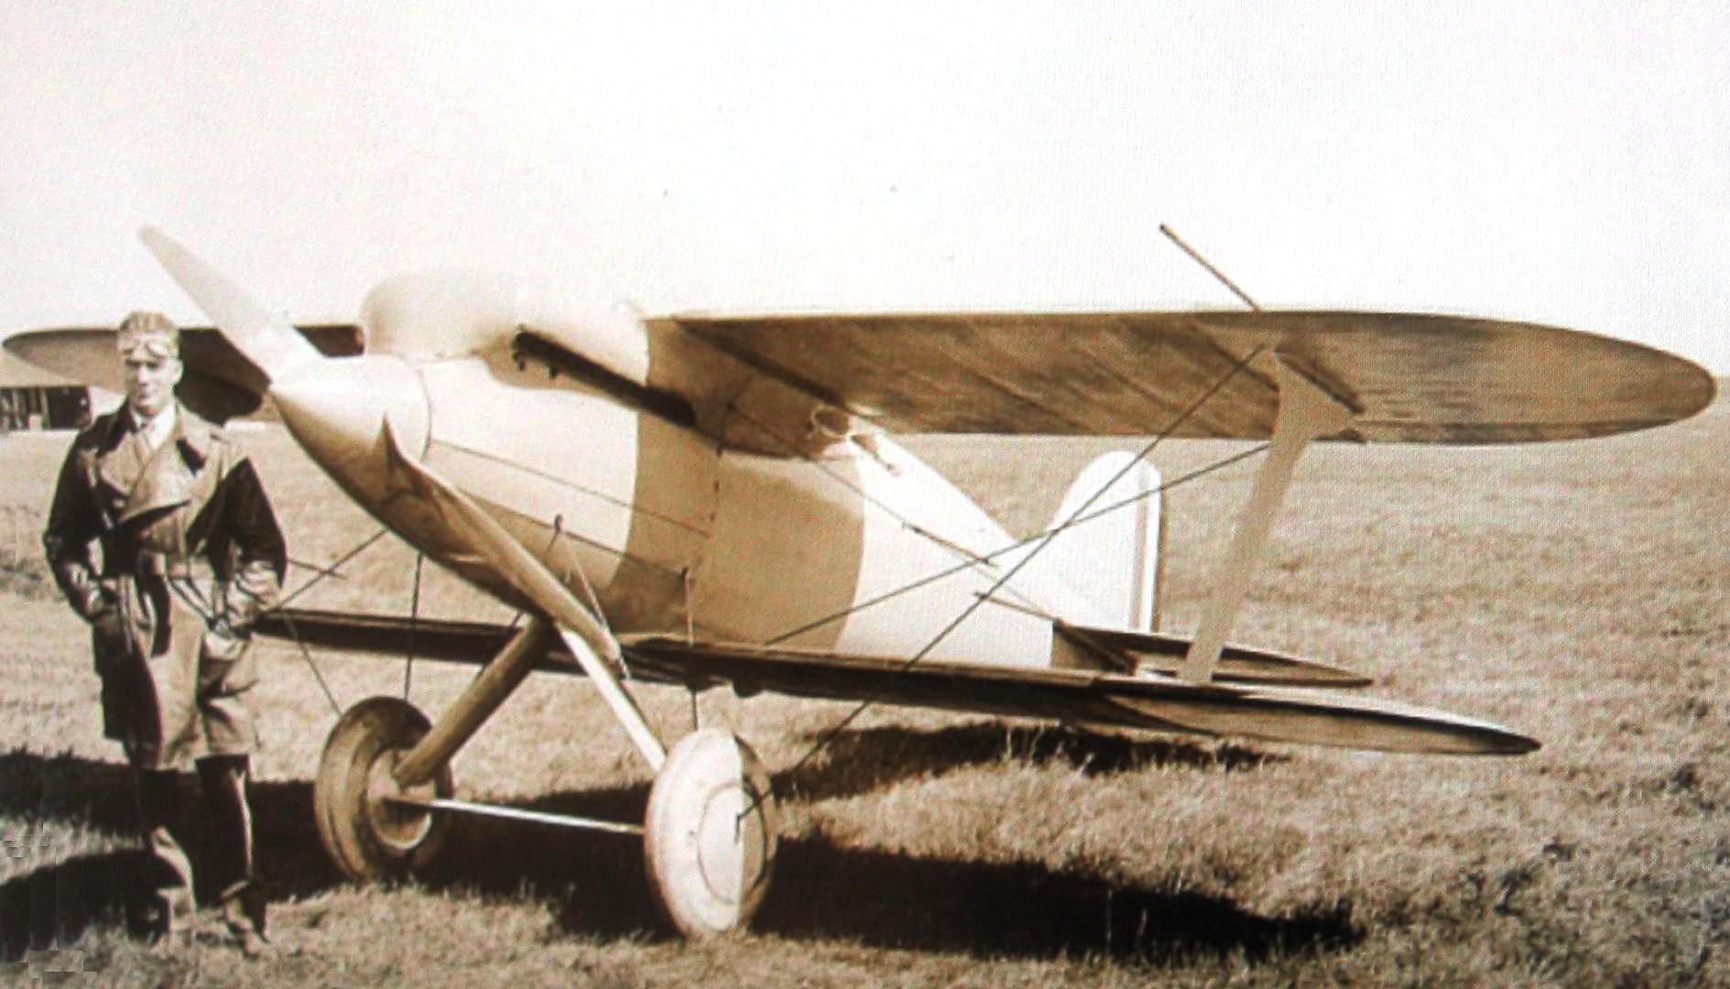

Photo 29. Al Williams with his Gulf Hawk circa 1936

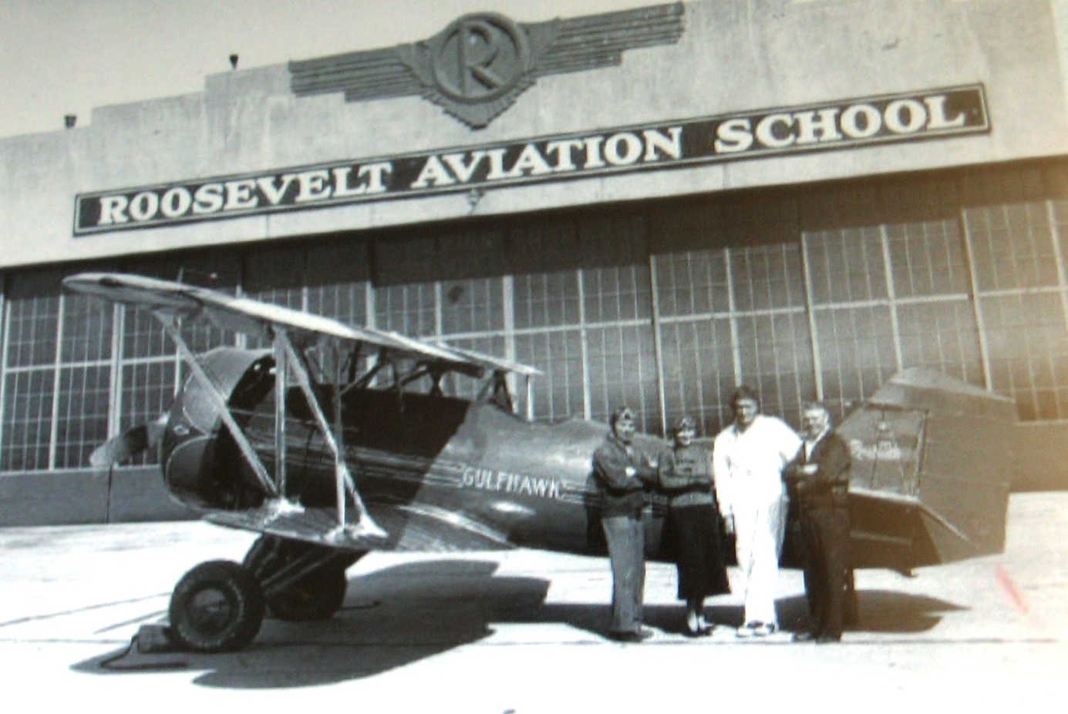

Photo 30. Col. Roscoe Turner and pet lion cub “Gilmore” circa 1930.

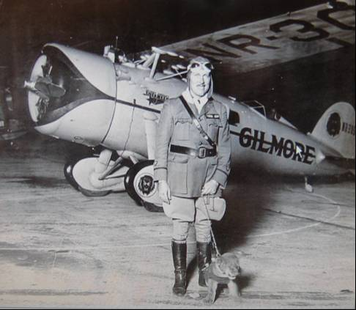

“Gilmore’ would accompany Turner in his plane advertising Gilmore Red Lion gasoline. The Gilmore Oil Company in California was to be taken over by Socony-Vacuum in 1940.

**Airborne sales force[13]** - Promoting the business of flying Standard Oil Company of California (later to become Chevron) further demonstrated its commitment to the young aviation industry by developing its own fleet. The reason was two-fold: to meet business requirements and to make the public aware of the utility of aircraft in business.

In 1928, Standard purchased its first plane, a TriMotor Ford, christened ‘Standard of California No. 1’, the plane eventually logged 200,000 miles and carried about 30,000 civic officials, business executives, farmers and Standard employees.

Photo 31. Standard Oil Company of California (Chevron) Trimotor Ford company plane

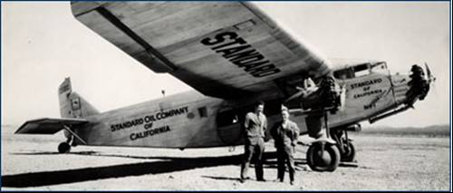

That same year, Standard coordinated its growing involvement in the aircraft industry by establishing an Aviation Division, which was responsible for activities such as new product development and support for air demonstrations.

As a company with a glowing list of endorsements by daredevil aviators, Standard Oil Company of California chose the 1929 Cleveland Air Show as the venue to publicly test the new Stanavo Aviation Engine Oil. A year after its successful "solo" at the show, the company introduced the product as the "custom-built flyer's oil."

Standard quickly added Stanavo Aviation Gasoline and Stanavo Rocker Arm Grease to its new product list, which was promoted by establishing a flying corps of salesmen. Within two years, more than 80 percent of all Western and Hawaiian air-transport companies became regular users of the company's gasoline.

Photo 32. Standard Oil of California (Chevron) aircraft No. 2, one of the fleet to promote Stanavo products circa 1930.

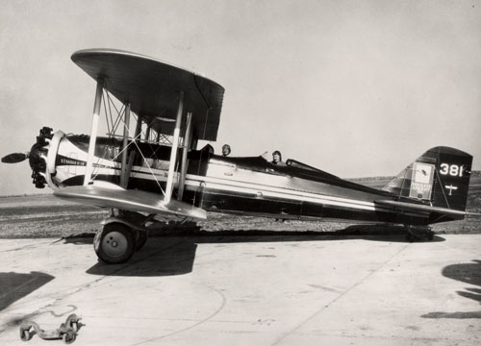

In Australia, there were men like Captain E. J. Jones MC, DFC, who was Deputy Controller of Civil Aviation before he joined Shell in 1929 as Chief Aviation Officer. Squadron Leader Frank C. Penny, who went to Shell in 1924 direct from a most notable wartime (WWI) and post-war career in the Royal Flying Corps (RFC) and RAF.

Vacuum Oil also had their aviation men like Captain Fred Haig, who was with the Flying Corps, had been a Qantas pilot and had aero club instructional experience. He was appointed to Vacuum’s aviation department. It was their jobs to foster aviation, and it was partly their job to sort out those among the flying pioneers who had the ability and stability to make aviation more than a ‘fly-by-night’ career.

Representation was more important than immediate sales; the oil companies had the services and where it was worthwhile, they could provide the organisational help, advice on approaches to governments and local bodies. Most of the aviation pioneers were working on a shoestring budget financially, and the oil companies in providing and laying down their fuel supplies had to carry many risks. Every major and minor pioneering flight in or out of Australia was preceded by long conferences between the pilot-organisers and the oil company representatives. Routes were planned, maps prepared, supply dumps of fuel laid down at appropriate intervals, with careful timing and allowance for emergencies (of which there would be many). It was all part of the service – months of organisation that, if all went well, paid off with a brief mention or two in the newspaper columns that hailed another milestone in aviation progress.

It was not always without misadventure, either. In Australia, when the big East-West Race of 1929 was in progress, with 60 or more aircraft entered for the race from Brisbane, via Sydney, Melbourne, Adelaide and many other points between, to finally Perth. Frank Penny (Shell Company) was stationed at Rawlinna (a landing field just east of the West Australian gold mining town of Kalgoorlie). He had thousands of four-gallon tins of aviation gasoline stacked in the field. The flyers came and went on their way refuelled, but it was hot 49 deg C (120 F) in the shade – and the tins were bursting all over the place from expansion of the gases in fuel. “Heaven only knows how much was spilled that day,” said Penny.

Each of the major companies had its own aircraft. In Australia, Vacuum had the first all-metal De Havilland made in Australia, named “Kingfisher”, while Shell had the “Golden Shell” De Havilland Dragon Rapide. They were flown by company pilots and aviation officers on a wide variety of jobs – inspection of airfields and collection of data for inclusion in information booklets and strip maps which were distributed among pilots and sent overseas to aid incoming pilots. Shell painted the word “SHELL” in large white or silver letters on the roofs of its buildings at aerodromes to aid pilots in locating airfields.

Photo 33. De Havilland Dragon Rapide – typical of the period (on show at Duxford UK 2005)

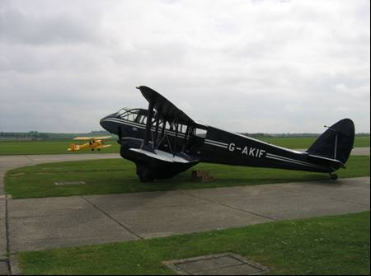

The oil companies supported the industry with competitions, for example in the UK the 1923 Lympne light aircraft fuel economy contest won by an English Electric Wren with a fuel consumption of 87.5 mpg (31 km/L) – it used an ABC two-cylinder motorcycle engine.

Photo 34. English Electric Wren 1923

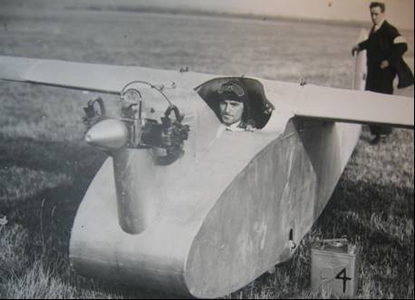

Note the Shell Aviation Spirit 2-gallon tin marked for the ‘4’ for the trial.[14]

Photo 35. Aviation refuelling at Gloucester, England by BP Aviation Services, 1928.

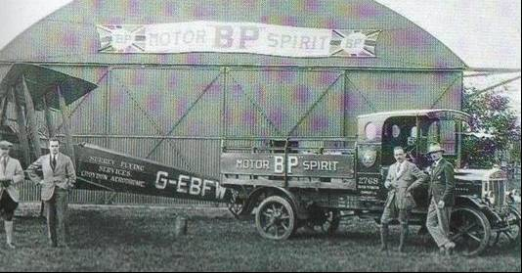

# “The Race Is On” – More Airspeed Records[15]

The pursuit of more speed was occurring on land, sea and air, and the development of machines continued at a heady pace. One significant event, which attracted international interest, was the Schneider Trophy that commenced in 1913. Meanwhile the land-based aircraft were still setting records in speed, duration and height.

Air Speed Records

The thrill of speed continued from the war years. The focus initially was on aircraft engines and aircraft design, but later special aviation fuels would play an important part in the attainment of new speed records. In this period the (land-based) aircraft achieved the following:

Table 1. Air Speed Records

|  |  |  |  |  |
| --- | --- | --- | --- | --- |
| Date | Location | Pilot | Aircraft | Achieved km/hr |
| 4 Nov 1920 | France –Buc | Bernard de Romanet | Spad Herbemont S.29 bis 6 | 309.013  Official |
| 18 Nov 1922 | USA – Selfridge Field, Michigan | William Mitchell | Curtiss 32 R-6 (AS 68563/68564) | 358.923  Official |
| 2 Nov 1923 | USA – Curtiss Field, New York | Harold J Brow | Curtiss 32 R2C-1 (A-6691) | 417.590 |

In the US, according to Jimmy Doolittle “Those of us who were flying during the 1920’s knew that if we wanted to try for a record flight, we’d better have the gasoline shipped all the way from California to Ohio, rather than get it from Pennsylvania, right next door.”

Records in 1928

In 1928 the following records were established and the objectives were as always to fly faster, higher, longer and further than before.

Speed (Land based aircraft): In France with aircraft Bernard 450 Hispana-Suiza, a speed of 448.125 km/hr (278.452 mph) was reached.

Altitude: USA Wright “Apache” 425 Pratt & Whitney Wasp in 1927 reached 11,710 m. (38,419 ft)

Duration: France 65 hours 25 minutes was set in a Junkers W33.

Seaplane: Italy Macchi 52bis reached a speed of 512.766 km/hr (381.618 mph). [Comment: this was most likely during flight trials for the Schneider Trophy Race in the next year, and of interest is that this was faster than the land-based aircraft despite the aerodynamic drag of floats on the seaplane.]

# Schneider Trophy – The ultimate prize for seaplanes

The Schneider prize for seaplanes was first announced by Jacques Schneider, the French Under-Secretary for Air, in 1911, with a prize of the then huge amount of £1,000. It was meant to encourage progress in civil aviation, but it became a contest primarily about speed and national pride.

Photo 36. The Schneider Trophy

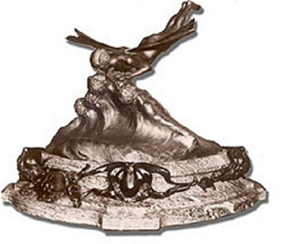

In the twenties, it was a spur to aircraft development and in the end was seen as a test of a nation’s strengths in aviation technology. It was largely due to the Schneider Trophy that aircraft speeds rose from 150 mph (241 km/hr) at the end of the First World War, to over 400 mph (644 km/hr) in 1931. The race gave birth to the Spitfire and the Italian Macchi fighters and established the low drag liquid cooled engine as the fast fighter designers’ principal choice for power. A fashion that only died with the success of the German Focke-Wulf FW 190, and the American F4U Corsair and Republic Thunderbolt, but this however may have been due to other design considerations.

Britain won the trophy in 1914. After the war the first contest, in 1919, was declared void by the judges. In 1920 and 1921 the contest was won by the Italians. The rules said that any nation that won the trophy three years in succession could keep it. So, it was a close run thing when the Britain’s Supermarine ‘Sea Lion’ snatched victory by tactical flying in the 1922 race with a speed of 145 mph (233 km/hr).

The next year 1923, saw a technical revolution in the shape of the American Curtiss floatplanes with their in-line liquid cooled engines. The Curtiss won with a speed of 177 mph (285 km/hr). Mr. C.R. Fairey of the Fairey Aircraft Company was so impressed with the new engines, he purchased some and fitted them to a new light bomber, the Fairey Fox. The Fox was so fast that no RAF fighter could catch it. An example of how the race was prompting aircraft development.

The 1924 contest was declared void since no other nation turned up to challenge the Americans. In 1925, R.J. Mitchell’s Supermarine S4 was entered but crashed before the race, the pilot was saved. The Americans won in an aircraft piloted by James Doolittle, who later went on to win fame with his audacious raid on Tokyo during World War II and was a key figure in the development of aviation fuels during his employment with the Shell Company. The winning speed was 232 mph (373 km/hr).

Photo 37. Jimmy Doolittle with his Curtiss Racer 1923.

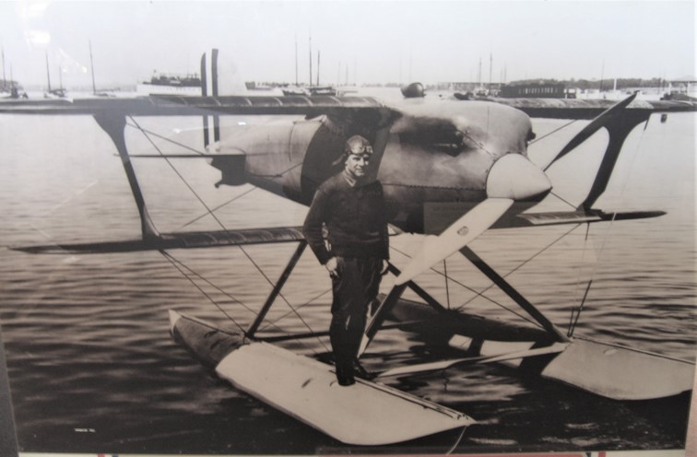

This aircraft is now located at the US National Air and Space Museum in Washington. (2002).

Photo 38. Curtiss Racer on display at US National Air & Space Museum Washington (2002)

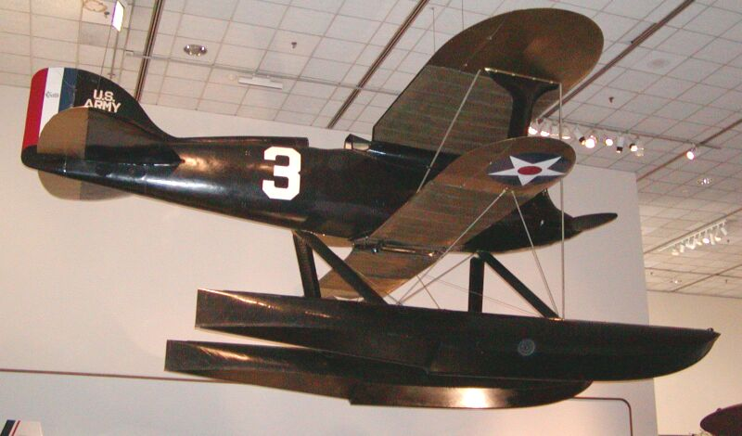

The Italians came back forcefully in 1926 with their new sleek Macchi M39 winning at 246 mph (396 km/hr). The British were not ready to compete that year. In 1927 Mitchell’s new aircraft, the Supermarine S5, was ready, in fact the British aircraft industry was there in strength with entries from the Gloster and Shorts companies as well. The effort was only made possible by the backing of the British Government, which also allowed the RAF to participate in the form of serving pilots in the "high speed flight". Two S5s took first and second place and the winning speed was 281 mph (452 km/hr).

Photo 39. British entrants Gloster IVB biplane (foreground) and the sleek Supermarine S5 monoplane in preparation for the 1927 contest in Venice.

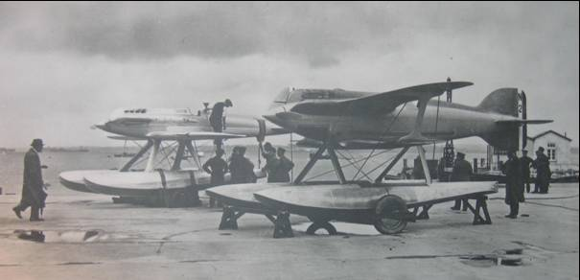

Photo 40. Schneider Trophy Race 1929 seafront at Calshot U.K. – the crowd watches the Italian competitor.

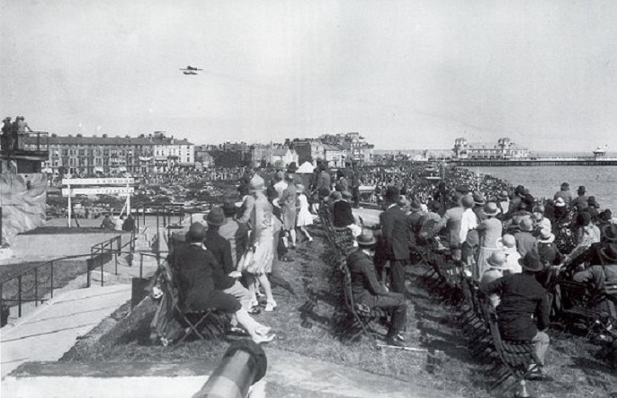

After that all nations agreed that a two year gap was needed between races. Aircraft and engines (and fuels) were getting more complex and two years was needed to introduce innovations. So, the next contest was held in 1929. However, there was a crash of a Supermarine S5 in which Flight Lieutenant Kinkead of the High Speed Flight was killed in 1928.

In 1929, Supermarine had the new S6 ready. This was powered by a new engine from Rolls-Royce called the "R" that was capable of producing the then staggering power of 1,900 horsepower. The Italians were determined to win the trophy that year, they had an engine of similar power but it weighed a lot more than the Rolls-Royce creation. The Supermarine S6 won with a speed of 328 mph (528 km/hr). However, not long afterwards, the British Government withdrew financial support and the British prospect for 1931 looked bleak. The extreme patriot, Lady Houston stepped in however and gave £100,000 towards the costs. (She also supported the flight over Mount Everest in 1931).

The “R” engine was boosted to 2,000 horsepower. When Flight Lieutenant John Boothman achieved an average speed of 340.3 mph (547.63 km/h) over the triangular Schneider Trophy course in the Supermarine S6B seaplane on 13 September 1931, this was to make Great Britain the outright winner with three successive victories. This was a new World speed record. It did not last for long however since the S6B broke it again two weeks later, raising it to a staggering 407 mph (655 km/hr).

Photo 41. The Schneider Trophy 1929 winner – Supermarine S6B N247[16]

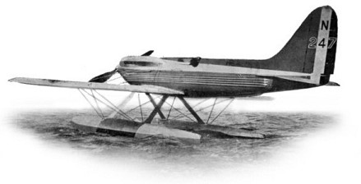

Photo 42. Refuelling Supermarine S6 Number 1495 in 1929[17]

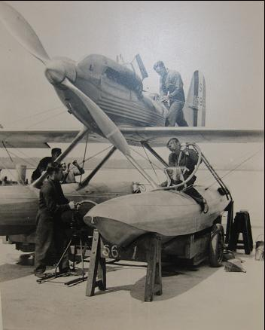

(Note the fuel is delivered by hand pumping from drums, typical of such specialized requirements. The chamois filter cloth to remove any water and particulate matter).

With three successive victories, the Schneider Trophy was therefore won outright by Britain, and the competition which had been instituted nearly nineteen years earlier came to an end. In the process many advances had been made in aircraft design and construction, in engine design, and also in fuel technology.

Table 2. The Schneider Trophy Winners

|  |  |  |  |  |  |
| --- | --- | --- | --- | --- | --- |
| Year | Location | Pilot | Country | Aircraft | Average speed (km/h) |
| 1913 | Monaco | M. Prévost | France | Deperdussin Monocoque | 72.600 |
| 1914 | Monaco | C.H. Pixton | Great Britain | Sopwith 'Tabloid' | 139.660 |
| 1919 | Bournemouth | Cancelled |  |  |  |
| 1920 | Venezia | L. Bologna | Italy | SIAI S.12 | 172.561 |
| 1921 | Venezia | G.De Briganti | Italy | Macchi M-7bis | 189.677 |
| 1922 | Napoli | H.C. Baird | Great Britain | Supermarine Sea Lion II | 234.516 |
| 1923 | Cowes | D. Rittenhouse | USA | Curtiss C.R.3 | 285.457 |
| 1925 | Baltimore | J. Doolittle | USA | Curtiss R3C-2 | 374.247 |
| 1926 | Hampton Roads | M.de Bernardi | Italy | Macchi M-39 | 396.612 |
| 1927 | Venezia | S.N. Webster | Great Britain | Supermarine S5 | 453.282 |
| 1929 | Calshot | H.R.D. Waghorn | Great Britain | Supermarine S6 | 528.867 |
| 1931 | Calshot | J.N. Boothman | Great Britain | Supermarine S6B | 547.633 |

Racing Fuels for Schneider Trophy

Interest in what could be accomplished by use of special fuels of very high anti-knock value, was also stimulated by the experience of Rolls-Royce in developing the V-12 liquid cooled engine which had enabled Britain to win the Schneider Trophy was races in 1929 and 1931. One of the key players in the success of the British victories in the Schneider Trophy was F.R. Banks who worked for the Ethyl Gasoline Corporation in the UK (the world wide makers of “Ethyl Fluid” – Tetra Ethyl Lead - the anti-knock agent essential to achieve high octane performance). In his autobiography “I Kept No Diaries” and other publications - The INTAVA World (after June 1939) “Aviation Fuels and Engines by F.R. Banks; he explains some of the details of the fuels used in these races. [This paper was also given at the Society of Automotive Engineers on June 7, 1939 at San Francisco, California USA]

In 1928, the Rolls-Royce H or Buzzard engine prototype developed 925 HP on a fuel of “80:20” (probably 87 Octane). This was most likely 80% domestic aviation gasoline with 20% Benzol. Within a year, now designated ‘R’ (for Racing), an enlarged supercharger and a blend formulated by F.R. Banks of 78% Benzol and 22% light gasoline (Rumanian naphthenic base gasoline) with 4cc TEL/IG, the engine was able to achieve 2,320 hp from an octane of 96. [Fuel No. 1] and subsequently won the 1929 Schneider Trophy with a speed of 329 mph.

For the 1931, race the engine was run at full throttle developing 2,360 hp at 3,200 rpm. In this case, the fuel [Fuel No. 2] was a blend of 70% Benzol, 10% Methanol and 20% light gasoline and 4cc TEL/IG with a reported Octane of 95, however the cooling effect of methanol had a greater effect on suppressing detonation in the highly supercharged ‘R’ engine. Again, the team was successful with a speed of 340 mph.

After winning the 1931 Schneider Trophy, the same aircraft made an attempt on the world speed record in an effort to break the ‘magic’ 400 mph (664 km/hr). Due to considerations of policy, the engine could not be modified except in minor details in order to obtain the extra power required to exceed 400 mph. Therefore, it was decided to speed up the engine by 200 rpm and alter the fuel to give this power increase. The attempt was successful. The fuel [Fuel No. 3] was markedly different and comprised mostly of Methanol. The engine achieved nearly 2,600 hp at 3,400 rpm. This is illustrated in the distillation curves for these racing fuels.

Graph 1. Distillation curves for Racing Fuels Schneider Trophy 1929 & 1931

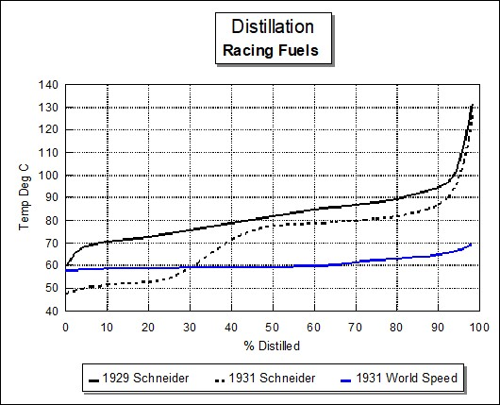

The above graph illustrates the marked differences in the fuels developed by Banks to achieve these records. Of interest is the narrow boiling range of the fuel used for the 1931 World Record, and the low distorted front-end distillation of the 1931 fuel as a result of the Methanol.

This was a period of great interest in speed not only in the air, but also on land and across water. The above Fuel No. 2 was used by Campbell and Eyston in their successful attempt on the World Land Speed record, and Malcolm Campbell would also use the same fuel for his water speed record.

Table 3. shows the fuel properties used in the races.

It is interesting to note that these ‘stunt’ fuels, containing high aromatic and alcohol content, cannot be evaluated properly based on the A.S.T.M. - CFR Motor Method. Such fuels were not practical for any purpose other than that for which they were originally intended. Also, of note is the significant increase in fuel consumption, perhaps not a consideration in an attempt on a speed record.

Table 3. Racing Fuels for Schneider Trophy 1929 &1931

|  |  |  |  |
| --- | --- | --- | --- |
| Fuel | 1 | 2 | 3 |
| Race | 1929 Schneider Trophy | 1931 Schneider Trophy | ~1931 World Speed Attempt |
| Benzole | 78% | 70% | 30% |
| Methanol | - | 10% | 60% |
| C.P. Acetone | - | - | 10% |
| Light Spirit (SG 0.680) | 22% | 20% | - |
| cc TEL/Imp. Gallon | 4 | 4 | 5 |
| cc TEL/USG | 3.3 | 3.3 | 4.1 |
| Specific Gravity @60OF (24.6OC) | 0.8330 | 0.8295 | 0.8245 |
| Water Tolerance | Nil | 0.5% | 14.3% |
| ASTM Octane Motor | 96 | 95 | 92 |
| ASTM Octane Motor (Clear) | 91.5 | 92.5 | 92 |
| Calorific Value | | | |
| BTU/Imp. Gallon | 154,472 | 146,750 | 104,580 |
| BTU/pound | 18,550 | 17,710 | 12,685 |
| Latent Heat | | | |
| BTU/Imp. Gallon | 1,377 | 1,615 | 2,887 |
| BTU/pound | 166 | 195 | 350 |
| Brake Horse Power (Max) | 2,320 | 2,360 | 2,590 |
| @ RPM | 3,200 | 3,200 | 3,400 |
| Fuel Consumption lb/BHP/hr | 0.64 | 0.63 | 0.85 |

Figure 3. Composition of fuel used by 1929 Schneider Trophy Winner



Figure 4. Composition of fuel used by 1931 Schneider Trophy Winner



These analyses are distinctly different to that of a typical PONA analysis of aviation gasoline.

Figure 5. Composition of fuel used by 1931 World Record attempt.



Again, this exotic aviation racing fuel bears little resemblance to the typical aviation fuels. The following table illustrates some of the other racing fuels that Banks developed at this time, of note is the use of Ethanol and lower aromatic content, but higher lead content with Fuel No. 4, and variations of the Methanol, Light Spirit, Benzole and lead content for Fuels No.s 5, 6 & 7. Lead contents significantly above 4cc TEL/Imp Gallon would start to present problems with spark plug fouling, however for the short-term requirement of these fuels, this was perhaps not an important consideration when striving for records.

Table 4. Other racing fuels developed by Banks circa 1931

|  |  |  |  |  |  |
| --- | --- | --- | --- | --- | --- |
| Fuel | 2 | 4 | 5 | 6 | 7 |
| Race | 1931 Schneider Trophy | 1931 World Speed Attempt | Racing fuel | Racing fuel | Racing fuel |
| Engine | Rolls Royce 'R' | Fiat | other developments of Fuel 2 | | |
| Use | Campbell & Eyston Land, Campbell water | Racing |
| SRN Aviation gasoline 74 MON | - | 55% | - | - | - |
| Light Spirit (25-65 Deg C) | - | - | 20% | 20% | - |
| Benzole | 70% | 22% | 60% | 60% | 70% |
| Methanol | 10% | - | 20% | 20% | 10% |
| Ethanol | - | 23% | - | - | - |
| Light Spirit (SG 0.680) | 20% | - | - | - | 20% |
| cc TEL/Imp. Gallon | 4 | 7 | 10 | 4 | 7 |
| cc TEL/USG | 3.3 | 5.8 | 8.3 | 3.3 | 5.8 |
| Specific Gravity @60OF (24.6OC) | 0.8295 | 0.7705 | 0.8135 | 0.8135 | 0.8285 |
| Water Tolerance | 0.5% | 1.7% | 1.1% | 1.1% | 0.5% |
| ASTM Octane Motor | 95 | 90.5 | 96 | 95 | 96 |
| ASTM Octane Motor (Clear) | 92.5 | 88 | 93 | 93 | 92.5 |
| Calorific Value | | | | | |
| BTU/Imp. Gallon | 146,750 | 139,777 | 137,120 | 137,120 | 146,750 |
| BTU/pound | 17,710 | 18,140 | 16,860 | 16,860 | 17,710 |
| Latent Heat | | | | | |
| BTU/Imp. Gallon | 1,615 | 1,522 | 1,678 | 1,678 | 1,615 |
| BTU/pound | 195 | 198 | 206 | 206 | 195 |

# Epilogue for 1929

In this period 1920 to 1929, the sleek monoplane emerged and triumphed. Major developments were made in aircraft design and performance. The “golden years of aviation” had started and the public’s imagination on aviation was fired. On the technical front, the complexities and vagaries of “engine knock” were now being understood. The word “Octane” and “Leaded Gasoline” were now in the aviation fuel lexicon.

Air races and speed were a feature of this era and would continue for some decades.

In the 1920’s, it was quoted that aviation was the third most interesting thing to the press after murder and divorce, because it was about accidents and daring men.

In the succeeding years the United States developed trans-continental mail services. Canada developed air survey and forest patrols. Germany developed municipal aerodromes and passenger carrying aircraft, as did France. England developed the outlines of the Imperial Airways from England to Australia with a branch to South Africa. The Netherlands established air routes to the East Indies.

But, perhaps the last word for this period is best left to Janes “All the Aircraft of the World – 1928”[18]

‘To be killed in an aeroplane during the Great War was a glorious death in which honour was attached to the victim. To be killed in an accident to a civil aircraft after the War came to be regarded as a slightly elaborate form of suicide, and so air transport did not leap into popularity.’

Photo 43. Daredevil Ormer Locklear walks on the wing of a Curtiss Jenny, circa 1920 (NASM)

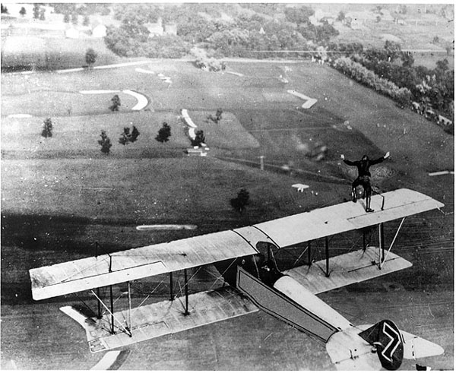

# Index

A

Aldrin 23

Atlantic Extra Heavy Oil 20

Atlantic Lubrication Grease 20

Atlantic Union 20

Australian Flying Corps 17

Avro 17, 19, 21

B

Banks 35

Benzol 35

Boothman 34

BP Australia 23

Briggs 17

Byrd 15

C

Caltex 23

Campbell 36

Cave-Brown-Cave 11

CFR Motor Method 36

Chevron 15, 23, 26

Cleveland Air Show 27

Coli 15

Commonwealth Oil Refineries 23

Curtiss 15, 30, 31, 32

Curtiss Field 15, 30

D

Darwin 11, 17

De Havilland Dragon Rapide 28

deGaris 17

Doolittle 23, 30, 31, 32

Douglas Cruiser 1, 12, 13, 14

E

Eagle Farm Airport 20

engine knock 41

Esso 20

Ethyl Fluid 35

Ethyl Gasoline Corporation 35

Eyston 36

F

F4U Corsair 31

Fairey Aircraft Company 31

Focke-Wulf FW 190 31

Frankfurt 4

G

Gargoyle Mobiloil BB 20

Gilmore Oil Company 23

Goble 18

Gulf 23

H

H. C. Sleigh 23

Haig 21, 27

Hawkes 23

Hinkler 19

HMAS Albatross 18

HMAS Sydney 18

Houston 34

Howard 17

Hudson Fysh 17

I

INTAVA 35

J

Jones 27

K

Kingsford-Smith 19, 20, 21, 44

Kinkead 34

L

Langley Field 12

Le Bourget Field 15

Leaded Gasoline 41

Lindbergh 15

Livock 11

Lyon 19

M

Macchi 31

Macchi M39 33

Mascot Aerodrome 17

Mattern 23

McGinness 17

McIntosh 17

McIntyre 18

Methanol 35, 36

Mitchell 4, 30, 31, 33

Mobil Oil 23

N

Nungesser 15

O

Octane 41

Orteig 15

Ostfriesland 4

P

Parer 17

Penny 27

Pershing 4

Phillips 23

Plume Motor Spirit 20

Point Cook 11, 18

Pure Oil 23

R

Randwick 18

Red Crown 12, 13, 15, 16

Republic Thunderbolt 31

Richmond Refinery 15

Rolls-Royce 34

Round The World Flight 12

Royal Australian Air Force (RAAF) 17

Royal Australian Navy 18

Royal Flying Corps 27

Rumanian naphthenic base gasoline 35

Ryan (Aircraft) Company 15

Ryan Airlines 15

S

Schneider Trophy 23, 30, 31, 33, 34, 35, 36, 37

Shell 23, 27, 28, 32

Southern Cross 19, 20, 21, 44

Southern Cross Junior 21

Spirit of St. Louis 15, 16

Spitfire 31

Stanavo 27

Standard Oil 23

Standard Oil Company of California 15, 26

Supermarine S4 31

Supermarine S5 33, 34

Supermarine S6 34

Supermarine S6B 34

Supermarine Southampton 11

T

TEL 35

Tetra Ethyl Lead 35

Texaco 23

Thompson Trophy 23

Turner 23

U

U.S. Army Air Services 12

Ulm 19, 20

Union Motor Spirit 20

V

Vacuum 23

Vacuum Oil 20

Vacuum Oil Company 20

W

Wackett 18

Warner 19

Williams 17, 23

# References

1. Ormer Locklear was known for a stunt called "the transfer," in which he switched from one plane to another while in mid-air. Credits - © 2002 National Air and Space Museum, Smithsonian Institution (SI Neg 85-12327)
2. Web site: <http://www.nationalaviation.org/museum_enshrinee.asp?eraid=2&enshrineeid=275> , Accessed Sept 4, 2003
3. Web site <http://users.chariot.net.au/~theburfs/index_mil.html> Accessed Dec 30, 2003
4. US National Air and Space Museum Washington D.C. USA – Display ‘First World Flight’
5. Official Report of the US Army Air Service Around the World Flight - ©USAF Academy Library Special Collections - Maj. Gen. Leigh Wade collection.
6. Web Site: <http://www.chevron.com/learning_center/history/topic/aviation/> Accessed Sept. 11, 2003
7. Australian Aviation History Time Lines Web site <http://users.chariot.net.au/~theburfs/aahistpage1.html#preww1> Accessed April 8, 2003
8. Australian Aviation History Time Lines - Website accessed June 1, 2002 - http://users.chariot.net.au/~theburfs/aahistpage1.html#preww1
9. Web Site <http://www.austhighcomm.org.fj/media/2003/smith_landing.htm> Accessed Sept 11, 2003
10. Web Site <http://www.curbe.com/QVA/qva/smithy.htm> Accessed Sept 11, 2003 (Kingsford-Smith & Southern Cross)
11. Exxon-Mobil (in-house magazine) “Connection” June 2003 Issue 37.
12. Exxon-Mobil Connection June 2003
13. Web site <http://www.chevron.com/learning_center/history/topic/aviation/> Accessed Sept 11, 2003
14. Science Museum, London display May 2006.
15. “World Speed Record Aircraft” by Ferdinand Kasman F.C.W. -Cologne - June 1990. Leicestershire Library (UK) Call No. 639.1334.
16. Web Site: <http://www.supermarine-spitfire.co.uk/schneider_trophy.htm> , Accessed Sept 11, 2003
17. Source: RAF Cosford Museum display April 2005
18. Janes “All the Aircraft of the World 1928” Leicester City Library Shelf 629.13 Leicestershire Library (UK)