Chapter

4

1920-1930 “Roaring Twenties”

Part 2 - The Researchers

Photo . Dr. Frederick D. Rossini who led the work on API Project No. 6

Table of Contents

The Roaring Twenties – The Research Developments 3

Oil Chemists Search For The Composition Of Petroleum – API Project No. 6. 3

Oil Chemists Search For Better Fuels 4

Developments At Dayton, Ohio 1929 10

US Avgas Specifications & Test Methods 1920-1929 17

Volatility Question Is Raised Again 22

British Research Continues In Uk At Rae 26

British Aviation Spirit Specification 28

Gasoline Composition 1920-1929 33

Index 35

References 36

Summary

# The Roaring Twenties – The research developments

The Roaring Twenties - a period of development of specifications and fuel research.

This was a period that saw the development of the close association of the oil industry with this emerging form of transport in both the fledgling civil aviation field and the military at a technical level.

In spite of the large volume of chemical research which had been done on petroleum, the chemical composition of petroleum was virtually unknown. Obviously, without such knowledge, chemical research was handicapped.

Before detonation and octane numbers were known, aviation companies used the distillation curve in order to select and evaluate fuels. Systematic trials of fuels in engines showed that those with low distillation ranges were the most useful; the choice of distillation range was a guarantee of a certain volatility of the fuel. The distillation curve, therefore, was a measure of the homogeneity and of the volatility of the fuel. The latter could be limited, so the danger of vapour lock could be avoided.

There were major technical breakthroughs in this decade:

* Development of the Octane scale and a standardized means to measure it (refer Chapter 37 Octane Testing).
* Discovery of Tetra Ethyl Lead (refer Chapter 36 Lead) and increased octane numbers of aviation fuels.
* Development of more quality control tests and improved, specific tests for aviation fuel only, thus leading to improved Aviation Fuel specifications.

# Oil Chemists search for the composition of Petroleum – API Project No. 6[1].

In 1926 the US National Bureau of Standards, realizing the lack of established information on the composition of petroleum and anticipating the need for such information for the rapidly expanding industry, undertook the task of developing methods for finding out what compounds were present in petroleum. In January 1927, this work attracted the interest and financial support of the American Petroleum Institute, and it became API Project 6.

In determining the program for API Project 6, two important points were considered; firstly, the study would be completed on only one crude petroleum, so that both qualitative and quantitative data could be obtained. Secondly the work would be on such a scale that after exhaustive fractionation of the crude the individual components could be obtained in sufficient quantity to permit their purification and positive identification. The crude petroleum selected was a (US) Mid Continent mixed base crude, chosen with the thought that it contained a large proportion of paraffinic hydrocarbons which predominated Pennsylvania crudes and also naphthenic hydrocarbons which predominated in US Gulf Coast or California crudes. A well was chosen from which uncontaminated crude of known history could be obtained. Specifically, this was well No. 6 of the South Ponca Field, Kay County, Oklahoma, USA and supplied by the Marland Oil Company.

This project developed new methods of fractionating using specifically designed stills which included:

1. Control of the atmosphere in the still (usually carbon dioxide gas).
2. Automatic control of the pressure within the still at any desired value between 0.0001 (vacuum) and 760 mm of mercury (atmospheric), thereby permitting controlled fractionation with the exclusion of thermal decomposition.
3. Inclusion of a Cottrell boiler for the accurate (+/- 0.01 deg. C) and continuous determination of the true boiling point of the distillate as it collected.

The final results of the systematic fractionation by distillation were then subjected to further analyses such as (a) fractionation by crystallisation, (b) extraction with aniline or liquid sulphur dioxide, (c) redistillation with added substances such as alcohol or acetic acid, (d) distillation as low pressure, and (e) chemical methods such as nitration or sulphonation.

The API Project No. 6 would continue for the next 25 years and produce valuable information on the composition of petroleum and in particular, the composition of aviation gasoline blendstocks during World War II.

The story of API Project No. 6 continues throughout other chapters.

# Oil Chemists search for better fuels

The initial understanding of anti-knock properties led the chemists and researchers to experiment with fuels in search of better performance. One such experiment was that of “Hector Fuel”, which was one of the first adaptations of relatively chemically pure components to be used as an aviation fuel. Another experiment was to determine the effect of alcohols as an aviation fuel component.

Alcohol Fuels

One of the leading groups investigating these fuels was the US Bureau of Standards who in 1919 were experimenting with alcohol fuels for the US Navy and “Export Grade” or “X” Grade Aviation Fuel was used as the yardstick for comparison.

Report No. 89 “Comparison of Alcogas Aviation Fuel with Export Aviation Gasoline” by V.R. Gage, S.W. Sparrow & D.R. Harper. – US Bureau of Standards. November 25, 1919[2]

“Alcogas” prepared by Industrial Alcohol Co., Baltimore, Maryland, U.S.A. for testing by Navy Department and later submitted for US Bureau of Standards for testing was:

Table . Composition of “Alcogas” fuel - 1919

|  |  |
| --- | --- |
| Component | Content |
| Alcohol | 40% |
| Gasoline | 35% |
| Benzol | 17% |
| Other Ingredients (Toluol, Ether, etc.) | 8% |

The physical properties of the two fuels used in these tests are given in Table 2 (below). The distillation figures were determined by the Bureau of Mines method as described in Technical Paper No. 214 (Motor Gasoline, Properties, Laboratory Method for testing, and Practical Specifications).

The gasoline was the standard reference fuel of this lab (“X” Grade) prepared for the US Bureau of Standards by the Atlantic Refining Company from Pennsylvania crude oil. It complies with Specification No. 3512 of the Bureau of Aircraft Production for export aviation gasoline for the use of the American Expeditionary Forces 1918.

Table . Comparison between Alcogas an “X” Export Grade (1917 Specification)

|  |  |  |
| --- | --- | --- |
| Test | **Alcogas** | **Export Grade** |
| Heat Value total BTU/lb. | 15,910 | 20,340 |
| Heat Value Cal/gm | 8,840 | 11,300 |
| Appearance | Clean lavender | Clear - Water white |
| Odour | Alcohol & Ether | Gasoline |
| Specific Gravity @ 15.6 deg. C | 0.799 | 0.710 |
| Distillation Initial Boiling Point deg. C | 60 | 59 |
| 10% | 65 | 72 |
| 20% | 67 | 77 |
| 30% | 69 | 82 |
| 40% | 71 | 87 |
| 50% | 73 | 92 |
| 60% | 74 | 97 |
| 70% | 76 | 103 |
| 80% | 78 | 111 |
| 90% | 145 | 127 |
| 95% | 177 | 150 |
| Dry point | 184 (97%) | 153 (96%) |
| Residue % | 1 | 1.5 |
| Loss % | 2 | 2.5 |
| Reaction to Litmus | slightly acid | no data |
| Corrosion | black deposit | no data |
| Gum % | 0.02 | no data |

Alcogas is a mixture somewhat similar to the “Taylor Fuel” of 33% Alcohol, 40% gasoline, 27% Benzol tested by the Bureau of Mines in experimental aviation engines and found capable of withstanding compression ratio of 8.2 to 1 without knock. It is this characteristic which makes the mixtures worthy of special study as engine fuels.

Since commercial alcohol and gasoline are not readily miscible it is required to add ingredients such as benzol to secure homogeneity, and another (Toluol, Ether, etc.) must be added to lower the freezing point. The conclusion from these tests were:

* Alcogas has better maximum power than the “X” grade gasoline.
* Alcogas Fuel consumption was higher by 10-15%.
* Alcogas Thermal Efficiency was 15% higher.
* Comparison of Alcogas and “X” grade by volume, Alcogas was 12% more dense.
* Compression ratio of 5.6 using a Liberty 12-cylinder engine was too high for “X” grade gasoline.

“Hecter Fuel”

A little later, the same chemists at the US Bureau of Standards in 1920 published their report on “Comparison of Hecter Fuel with Export Aviation Gasoline”. A mixture of 20% Benzol and 80% Cyclohexane was patented by General Motors Company, and the fuel called “Hecter”.

Report No. 90 **-** Comparison of “Hecter Fuel” with Export Aviation Gasoline by H.C. Dickinson, V.R. Gage, S.W. Sparrow – US Bureau of Standards. Jan 20, 1920[3]

[The Report No. 90 uses the term ‘Hecter fuel’ and ‘Hector fuel’ to describe the same product.]

Table . Hector Fuel

|  |  |  |  |
| --- | --- | --- | --- |
| Components | Freezing point Deg. C | Density | Boiling point Deg. C |
| Benzol 30% | 5.5 | 0.8765 | 80 |
| Cyclohexane 70% | 6.6 | 0.7785 | 80.7 |

The freezing points of Benzene and Cyclohexane are between 5 and 6 degrees C.; however, “Hecter Fuel” forms an approximate eutectic mixture, which depresses the freezing point to minus 40 deg. C.

Tests were conducted using Liberty 12-cylinder Engine Manufacture No. 586 Aircraft Production No. 30641. Mobil “B” oil was used for lubricant, Compression ratio 7.2, operated at 1,400-1,800 rpm.

The power developed by Hecter fuel was the same as “X” aviation gasoline fuel at 1,800 rpm all altitudes (25,000 ft. - altitude chamber at Bureau of Standards).

Export “X” aviation fuel was from Atlantic Refining Company using Pennsylvania crude and complied with Specification No. 3512 of the Bureau of Aircraft Production for export gasoline for the use of the A.E.F. 1918. [American Expeditionary Forces]

Heating Value 11,300 cal/gm (20,300 BTU/lb).

Hector fuel as supplied 30% vol. Benzol (C6H6) and 70% vol. Cyclohexane.

Freezing point: minus 32 deg. C.

Heat of combustion 10,800 cal/gm (19,440 BTU/lb) about 4.5% less than Export Grade gasoline.

The Cyclohexane was obtained by hydrogenation of Benzol (actually Benzene, refer to distillation range).

Table Comparison of Hector Fuel and Export Grade Aviation Fuel

|  |  |  |
| --- | --- | --- |
| **Test** | **Hector Fuel** | **Export Grade** |
| Heat Value total BTU/lb. | 19,440 | 20,340 |
| Heat Value Cal/gm | 10,800 | 11,300 |
| Distillation | | |
| Initial Boiling Point deg. C | 76 | 59 |
| 10% | 77 | 72 |
| 20% | 77 | 77 |
| 30% | 77 | 82 |
| 40% | 78 | 87 |
| 50% | 78 | 92 |
| 60% | 78 | 97 |
| 70% | 78 | 103 |
| 80% | 78 | 111 |
| 90% | 78 | 127 |
| 95% | 79 | 150 |
| Dry point | 82 (98%) | 153 (96%) |

These investigations did not lead to the development of new aviation fuels probably due to the costs involved in the manufacture of such compounds. Also, the demand was not sufficient to warrant extensive development at that time – interest turned again to motor fuels and its quality where the market was booming.

Graph . Distillation curves for Hector Fuel and Export Grade Aviation Fuel 1920



Aviation Gasoline from Coal

Across the Atlantic in the United Kingdom, the Royal Aircraft Establishment undertook testing of aviation gasoline produced from coal. In their report[4], RAE Report No. H.C. 907 on May 4, 1925 “Report on the Chemical Examination of a Sample of “COALITE” Aviation Spirit” by Dr. E.W.J. Mardles, the properties of ‘Coalite Aviation Spirit’ produced by the Low Temperature Carbonisation Company Ltd. were examined for its suitability as an aircraft fuel. The general conclusion was that this fuel would be suitable. Again, this did not lead to the development of a new source of aviation fuel probably due to costs involved.

The composition of the ‘Coalite” was determined as a mixture of hydrocarbons (paraffin series 37% volume, aromatic and hydro-aromatic 53-54%, olefins 9-10%) of suitable volatility for aircraft work. No Sulphur was present and the mixture had no corrosive action on sand blasted mild steel, tinned iron or duralumin. It was found that no polymerisation into resinous material occurred when the fuel was kept in contact with a strong caustic soda solution for 3 weeks. [This was probably not a suitable method for determining polymerisation, and given the Olefins content of 9-10% it could be expected that this fuel would present problems with gum deposits and most certainly fail the oxidation bomb tests later used.]

Table . Estimated PONA Distribution of ‘COALITE’ Aviation Spirit 1925

|  |  |
| --- | --- |
| Hydrocarbon | Content |
| Paraffins | 37% |
| Olefins | 9-10% |
| Naphthenes (estimated) | 17% |
| Aromatics (estimated) | 36% |

Figure . PONA Analysis of Coalite Aviation Fuel 1925



The values for naphthenes (‘Hydro-aromatics’) and aromatics content have been estimated from the fractional distillation data.

The distillation data for this fuel is listed in the following table.

Table . Experimental Data “COALITE aviation Spirit 1925

|  |  |
| --- | --- |
| Test | Coalite |
| Appearance | Clear colourless |
| Odour | Cracked spirit |
| Specific Gravity @ 15 deg. C | 0.783 |
| Distillation Initial Boiling Point deg. C | 67 |
| 2.5% | 75.5 |
| 5% | 77 |
| 10% | 77.3 |
| 20% | 81 |
| 30% | 84.5 |
| 40% | 86.8 |
| 50% | 90 |
| 60% | 93 |
| 70% | 98 |
| 80% | 105 |
| 90% | 114 |
| 95% | 127 |
| Dry point | Not listed |
| Freezing Point (deg. C) | -53 |

Graph . Coalite Aviation Spirit 1925 - Distillation Curve

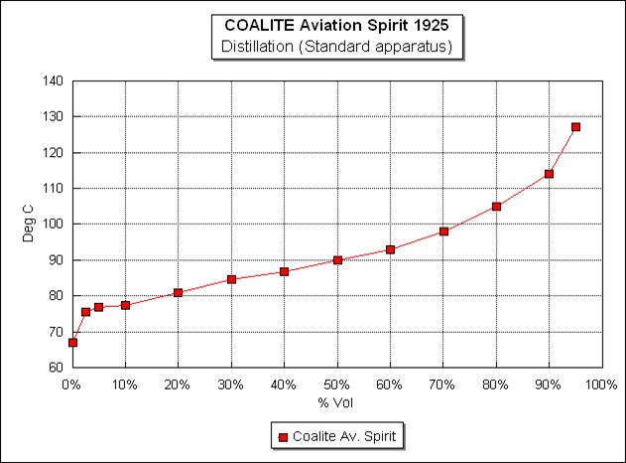

# Developments at Dayton, Ohio 1929[5][6]

McCook Field – Dayton Ohio

One of the significant US research centres into aero propulsion and fuels was to have its start as the (Engine Design Section at McCook Field (located near downtown Dayton, Ohio, USA). Formed in 1917 shortly after the US entered World War I, the organization - known throughout most of its history as a "laboratory" - pioneered many of the early propulsion advances. These ranged from cylinder design to superchargers, from engine coolants to metal propellers. The early laboratory built close partnerships with industry, academia, and the other services, to efficiently move this important technology into the service of the United States.

In 1927, the Laboratory moved to its present location on Wright Field (now called Wright-Patterson Air Force Base), on land donated by the people of Dayton. It was later to become the Aero Propulsion and Power Directorate. It would be at this location where Midgely brought the first samples of the anti-knock additive Tetra Ethyl Lead for test in a full-scale aircraft engine in 1922.

Photo 2. Air-Cooled Radial Engine on Test. Circa 1920[7]

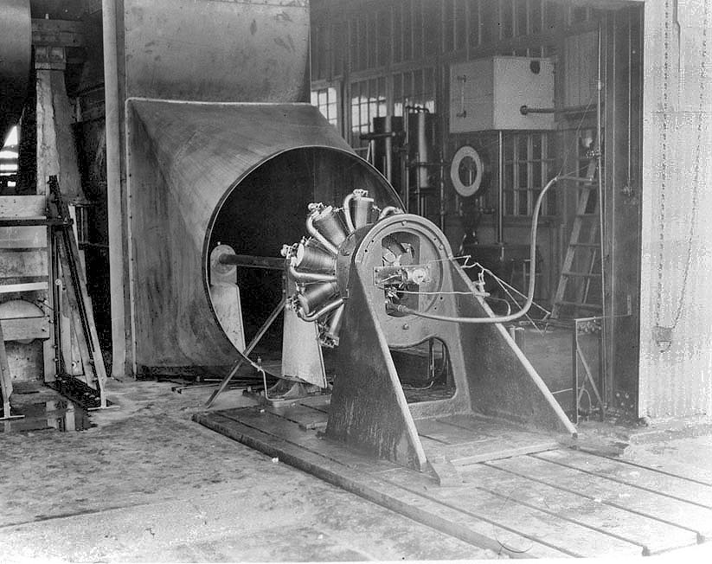

Air-Cooled Radial Engine on Test. - Sodium cooled valves, higher octane fuels, and other improvements led directly to reliable radial engines for the military and the first commercial airliners.

As early as 1922 McCook Field (US Army Air Corps) were making limited use of aromatic amines (ortho-toluidine and Xylidene) which were discovered by Midgely prior to his discovery of TEL. The US Navy started to use TEL in air cooled engines in 1926, the Air Corps started to use TEL in 1928. The Octane scale had not been established at this time (1927 Edgar was working on synthesizing pure hydrocarbons.)

Sam Heron

One of its noted pioneers was Samuel Dalziel Heron who together with others would make a significant contribution to aircraft engine design and fuel research. Sam D. Heron had worked at the Royal Aircraft Factory in England from 1915-1916 with Professor A. H. Gibson on the first systematic scientific study of air-cooled cylinder construction. Here, the characteristics of modern cylinders were developed. Heron came to the United States in 1921 to work at McCook Field where he used his considerable knowledge to enhance the air-cooled cylinder in the US. Perhaps his most valuable contributions were the invention of the sodium-cooled exhaust valve and contributions to the use of high-octane aviation gasoline, which together with improvements led directly to reliable radial engines for the military and the first commercial airliners.

Photo 3. Sam Heron[8] - Sam Heron -famous inventor, pioneer, fuels expert.

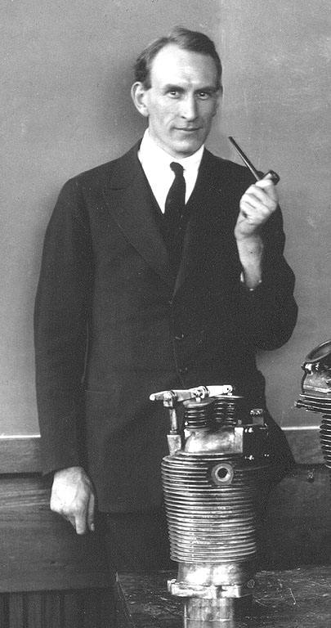

Heron assisted Charles Lawrance in the development of the J series of engines while at McCook Field and eventually came to Wright Aeronautical Corporation. This company developed the famous Wright J-5 ‘Whirlwind” radial engine.

The J-5 introduced a completely new cylinder designed by Sam Heron. This cylinder featured fins machined on the steel barrel, with only the upper 1.75 inch screwed and shrunk into the aluminium head. The valves were placed at a greater angle to the cylinder axis, inclined at angles of 35 degrees versus the 8.5 degrees of the previous cylinders. The valves were of the tulip type, and were machined from tungsten steel. The hollow exhaust valve stem was partially filled with a sodium/potassium salt mixture to assist in cooling.

Each valve was held to its aluminium-bronze shrunk-in seat by three concentric helical springs. The combustion chamber was domed, with spark plugs located at the front and rear. These cylinder changes provided much better cooling (particularly of the exhaust valve) and much better breathing, resulting in improved fuel consumption.

Rocker arms and push rods were completely enclosed, a first for any air-cooled engine made in the US. Casting technology still did not allow the rocker arm chambers to be cast with the head. Rocker arm lubrication was accomplished using grease fittings. The Lindbergh engine had specially built spring-loaded grease reservoirs that allowed around forty hours of continuous running without manual greasing of the fittings. A new three-barrel carburettor solved mixture-distribution problems that had plagued earlier models. It is said that Heron personally inspected all components used in Lindbergh's transatlantic engine.

By 1927, the J-5 had become the engine of choice for world explorers such as Chamberlin, Byrd, Maitland, Smith, Goebel, Jensen, and Brock. It was also widely used in three-engine passenger planes built by Fokker and Ford.

Heron investigates Benzol

Investigations[9] started about 1929 by the Power Plant Laboratory at Wright Field under the direction of Samuel D. Heron showed that use of benzol as a means to increase the anti-knock value of gasoline was largely ineffective in air cooled radial engines. This was especially the case with the models which were then being introduced with more efficient superchargers to increase take-off horsepower and altitude performance. The higher the temperature of the fuel/air charge, especially at lean mixture conditions, the less effective benzol became. The Wright Field tests showed, however, that TEL was a highly effective anti-detonate in air-cooled engines. The outcome of these investigations was that in 1930 the U S Army Air Corps specified a minimum octane requirement of 87 (by the US Army Method), the first US specification for aviation gasoline to include an octane number requirement. The octane requirement of 87 necessitated the use of TEL; a maximum of 3 cc/US gallon being permitted. The introduction of 87 octane fuel encouraged the development of improvements in aircraft engines that could be realized by the use of fuels of higher anti-knock value. The 1930's witnessed a rapid advance in the development of gear driven superchargers.

In the US, between 1928-29, the choice of aviation fuel components were Benzol, Straight Run gasoline 35-55 PN, cracked (olefinic) gasolines up to 50 PN and Lead (TEL). Benzol was limited to 20% due to freezing in cold weather and also availability. In the end California straight run gasoline plus lead was best answer to fuel problems.

Important Developments in 1929

On July 22, 1929 a significant conference on “Fuel and Aircraft Engine Development” was held at Wright Field, Dayton, Ohio. This conference gathered representatives from the aircraft engine manufacturers, the oil companies supplying petroleum products to the US, and from both the US Army Air Corps and the US Navy including the technical expertise of these armed services. Sam Heron prepared a paper titled ‘Part 1 Engine Development’.

Some of the key points were as follows:

US Air Corps lays down the challenge for better fuel

‘Future engine development of the (US) Air Corps shall as primary requirement take full advantage of modern available ant-knock fuels.

The policy (for the US Air Corps) will be to specify a very high anti-knock value, obtained by the use of high quality base gasoline or one peculiarly susceptible to the effect of anti-knock compounds and of a type of which the supply available is such as to be sufficient for any emergency. To this base (gasoline) will be added the maximum usable quantity of available dopes. Engines for Air Corps use will be required to take the fullest advantage from the fuel specified, but will not be acceptable if requiring a superior fuel. Engine development should be such as to secure the maximum of output, fuel economy and specific engine weight with due emphasis on parasitic drag involved in cooling in the airplane. It would seem certain that the use of the high compression ratios and supercharging at ground level will be necessary to secure the required standard of performance.

No available un-doped (unleaded) fuel will give the required anti-knock properties, and the use of dope is thus essential. The anti-knock standard of the fuel will have an anti-knock value in hot running engines similar to that secured by a blend of approximately 60% Benzol with 40% of average Mid-Continental domestic aviation gasoline meeting Air Corps Specification 2-40-F.’ [An interesting comparison to the work of Ricardo a decade earlier with the use Toluene Rating System].

At the time of this meeting, General Benjamin Foulais, who attended the meeting had been Chief of the Air Corps Materiel Division for about two weeks. [General Benjamin Foulais, while new to this position did however have considerable practical experience in the operation of aircraft dating as far back as the American-Mexico conflict in 1916 when he was in charge of the 1st Aero Squadron under General Pershing, then in 1918 in France he was Chief of Air Service of the American Expeditionary Force]. Major Howard acted as chairman and introduced the subject for discussion with the following provocative opening:

‘The start of this meeting was caused by our belief that other first-class powers are getting greater performance out of similar engine displacements than we are able to obtain. The results of our analysis show that this is due to the use of decidedly higher grade fuel than is in general use by the Air Corps. We see no reason why, with probably the best natural facilities in the world for high-grade fuel, we should not standardise on such a product…. As you probably know, we have gone to Ethyl Gasoline for the last six months of the present calendar year [1929], the Ethyl Gasoline used being gasoline meeting Air Corps Specification 2-40-F with 3 cc of Tetra Ethyl Lead added. This is the first step towards the goal which we visualized, and is more or less of a service test…..’

He went further to say: ‘After this series of tests is over, we propose to radically increase the anti-knock value of the fuel in use by the adoption of a base fuel much superior to our present domestic aviation grade. To this improved base we propose to add lead to secure a fixed anti-knock value. We would like to go to a high–grade California gasoline for our base. We desire to adopt the equivalent of the best California Fighting Grade gasolines we have tested and to this add 3 cc of lead. Then within 18 months we hope to go to a similar fighting grade gasoline with 5 cc of lead….. Our plan of attack is to immediately start the use of California Fighting Grade with 3 cc of lead at this Field (Wright), and as fast as the manufacturers can bring out engines that can use this fuel to advantage, we will put them in service here. We will later expand our use of such equipment and put it in service at other stations, probably Selfridge Field (Michigan) first and other later, and we are in hopes the problem will unfold in such a manner that within 18 months we can have the ideal in fuels and engines’

Clearly the challenge had been laid down by the US Air Corps to the engine manufacturers and aviation gasoline suppliers.

This historic meeting was attended by representatives of five fuel suppliers –

Richfield

Standard Oil Company of California (late Chevron)

The Texas Corporation (Texaco)

Standard Oil Development (the Research arm of Standard Oil of New Jersey – later Exxon)

Standard Oil Company of Indiana,

and by aircraft engine manufacturers –

Wright Aeronautical

Curtiss Aero & Motor Company Inc.

Pratt & Whitney

also, other interested parties at this meeting were –

US Navy

US Bureau of Standards

Ethyl Gasoline Corporation (manufacturers of Tetra Ethyl Lead)

During the course of the meeting, Major Howard deftly explored the problems involved and guided the discussion to his desired conclusions.

‘Present day fuel consumptions [1929] of American engines are largely a result of the policy of endeavouring to build, mechanically, the best engines in the world and having done so, running them on the worst or almost the worst fuel in the world…average fuel to Air Corps Specification 2-40-F needs over 30% Benzol added to it before it equals the anti-knock value of automobile anti-knock gasolines of wide availability. Under the Federal specifications for aviation gasoline, which do not specify a maximum critical temperature of solution with aniline after nitration as does Specification 2-40-F, fuel considerably inferior to the worst obtained under the latter is often supplied.’

“Red Crown” Gasoline is the Standard

‘The California gasolines would appear to have the highest anti-knock of any largely available gasolines in the world, the average California gasoline being about equal to the best of the much vaunted Sumatra and Borneo products….The California gasolines possess the further marked advantage of a remarkable susceptibility to the only generally available dope, namely Tetra Ethyl Lead.’

‘To date, California gasolines, some stabilized casing-head and fuels from South American crudes have shown excellent lead response and with additions up to 5 cc of lead per gallon (US gallon), will give approximately the anti-knock value required by the Air Corps. This anti-knock value has been increased since Part I of this was issued as a result of further work, and cannot be expressed in terms of benzol in average mid-continent D.A.G. (Domestic Aviation Gasoline), but rather as 3 cc of lead in a highly naphthenic gasoline which requires ¾ cc of lead to equal 80 octane 20 heptane, inferior gasolines to be allowed lead additions up to 6 cc per gallon. The Materiel Division has had experience in endurance running with the use of 6 cc of lead per gallon and with one theory of bromine has reason to believe that the problems involved are anything but insuperable’.

‘The Air Corps contemplates the standardisation within the next year or two of gasoline having a volatility substantially equal to that required by the present Federal specification for Fighting Grade. Even with Fighting Grade it has been found that in engines having excellent manifolding, extensive jacketing of the manifolding with liquid circulating 300oF is necessary to secure the most efficient fuel consumption.’

‘The Materiel Division is satisfied that the best method of measurement of anti-knock value of fuels for aircraft engines has yet to be arrived at.

The measurement of anti-knock value would appear to be a very complex problem and any specified method of test can at the best but require a test procedure which strikes a fair average of the conditions met in service by a given type of fuel…

The knock test method proposed by Heron was not in a final form, but the principles outlined were considered sound. The comparative standard was to be Standard Oil Company of California “Red Crown Fighting Grade” to which 3.0 cc Tetraethyl Lead/US Gallon had been added. It was agreed that this unleaded base was slightly better than the then Ethyl standard for automotive gasoline. (This unleaded base fuel would be about 73 octane number by current standards, and the leaded product would rate about 87 to 91 octane number by the various knock test methods to be specified as later dates by the US Air Corps.) It was stated that other gasolines would be permitted to add up to 5.0 cc Tetraethyl Lead/US Gallon to meet this standard.’

[Author’s note: Again, Standard Oil Company of California’s “Red Crown Gasoline” was favoured as the best quality; this may be partly due to the US Air Corps’ and Lindbergh’s experience with this fuel.]

Predictions which would come true in the next decade

The question of fuel volatility was discussed, specifically whether Domestic Aviation Gasoline or the more volatile Fighting Grade should apply. Sam Heron indicated that the volatility requirements would approach the Fighting Grade requirements – he reasoned that tests, which the Air Corps had conducted, indicated that better economy was obtained with the more volatile fuel. Heron did state “Any specification we decide on would have to apply in the case of emergency. It is no use building up our specification on a gasoline that is not generally available in time of war. That would be living in a “Fool’s Paradise”. [Indeed, prophetic words, some 10 years before the onset of World War II, and it would become a major challenge in the first years of America entering the war].

No specific values for volatility were set. [It would be some way off before acceptance that volatility did not equate to anti-knock performance].

‘Mr. Fliedner, US Navy Department, raised the age-old military problem of the necessity of living off the land, [we know this today as ‘over stretched supply lines’, a factor which would be critical in the Second World War]. “In the next war, your forces will so far out run your source of supply, that you will have to rely on the supply in the occupied territory. If the gasoline available in that territory cannot be used in our engines, we are out of luck. In expeditionary forces your supply couldn’t keep up with the demand (for Fighting Grade Gasoline) unless you expect your planes to return to the base all the time.”

The incisive Major Howard suggested that instead of building only aircraft carriers, that carriers and tankers could be built. Mr. Fliedner suggested that a submarine would eliminate the tanker. Major Howard replied: “It would be unfortunate if the (US) Army were to strive for a higher grade of gasoline and the (US) Navy should stand on the present domestic aviation grade. It would put the engine manufacturers in a somewhat difficult position of providing two types of engines.”

[This exchange of views highlighted some of the problems that had to be addressed between the fledgling US Army Air Corps, and the strong and dominant US Navy. These would be overcome in the Second World War, where initially supply of one grade would be by tanker upon which an entire US naval strategy would be based.

The German Navy would use submarine refuellers to supply its ‘Wolf packs’ with diesel fuel.

The Japanese would capture as much aviation fuel supplies and manufacturing facilities as possible - ‘living off the land’].

Ethyl Fluid causes problems for the Navy

A number of engine problems had been experienced due to the use of Tetraethyl Lead – the problems were the detrimental effects of valve stem rusting and sticking, valve seat pounding, valve seat recessing, piston ring and cylinder rusting. The problems were of greater magnitude for the US Navy (sea water conditions) than those encountered by the land-based Army. Suggested cures were to change from Ethyl 3J Fluid which contained 1.5 theories of Bromine to 1.0 theory of Bromine (Theoretical equivalents of Bromine that would react with the Alkyl Lead to produce Lead Bromide as the scavenged by-product) - this resulted in decrease in rusting and valve seat recessing, while better valve steels were available and aluminium-bronze valve seat inserts were being replaced by austenitic nickel-chrome steel inserts.

The outcome of these discussions was that the US Army Air Corps were going to persist with this ‘experimental project’ (leaded gasoline) with the view to switching to leaded gasoline at the end of 18 months. [From the Air Corps position it appeared the US Navy could please themselves as to what they did].

“Ethyl Gasoline” is not without its problems

In mid-May of 1930 Heron delivered a paper on “High Performance Gasoline Aircraft Engines to the ASME in Dayton. Much of the information dealt with the items in the 1929 conference. It was a long paper and detailed the use of leaded gasolines in engines not yet metallurgically designed for it. It does however provide some insight into the problems – ‘Shortly after a general adoption of Ethyl gasoline (leaded gasolines) in service by the (US) Air Corps, numerous cases of airplanes being set on fire by hot particles blown from the exhaust pipes occurred while idling, taxiing, warming up or shutting down the engine. [This was still the period of the biplane with fabric covered wings]. In no case did these fires occur in the air, being confined to conditions when the air blast over the wings was sufficiently low to allow the hot particles to settle on the wing surfaces. Investigations showed that the particles causing the fires were flakes of iron oxide, mainly the magnetic oxide, (thus proving that the scale was formed at high temperature). The question of relative attack of exhaust piping by doped (leaded) and undoped (unleaded) gasoline and of the relative resistance of a variety of materials to such attack was investigated by the Ethyl Gasoline Corporation.

During this period Dr. Graham Edgar (the inventor of the ‘Octane Number scale’) made frequent visits to Wright Field, sometimes at Major Howard’s request; at one of these meeting it was reported that in response to Howard’s concern about the airplane fires, Edgar supposedly replied that the Air Corps should be grateful that they were finally getting rid of some of their obsolete aircraft.”

Heron gets support from British success

The papers prepared by Heron after the meeting had adjourned also included an interesting reference to the British success in the Schneider Trophy of 1929, which Heron used to support the case for the US Air Corps. In part it stated: “The Air Corps demand for greatly improved engine performance has received additional backing since the conference by the results obtained in the Schneider Trophy race with highly supercharged engines”.

# US Avgas Specifications & Test Methods 1920-1929

1920 US Army Aviation Gasoline Specification

The US Army Aviation Gasoline specification and methods of testing were published in 1920. It covered the three grades which had continued from World War I. These were Domestic Aviation Gasoline, Export Gasoline and Fighting Gasoline. The significant changes were the introduction of test for controlling corrosion and gum tendencies. These tests were the “Doctor Test” where a sample is tested to ascertain the presence of sulphur compounds (which may include smelly Hydrogen Sulphide or Mercaptan compounds). The Copper Dish test was to find if the fuel had the potential to corrode copper components such as fuel lines and fuel tanks, and/or the potential to form gum deposits which may block fuel lines.

Table . US Army Aviation Gasoline Specification 1920 (US War Department)[10]

|  |  |  |  |
| --- | --- | --- | --- |
| Grade Designation | Domestic | Export | Fighting |
| Date. | July 1920 | July 1920 | July 1920 |
| Specification | No. 3511-B | No. 3512 | No. 3513-AB |
| Distillation (Method 100.1) | | | |
| Initial (deg. C) Max. |  |  |  |
| Temp 5% Rec. (deg. C) Min. |  | 50 | 60 |
| Temp 5% Rec. (deg. C) Max. | 75 | 65 | 70 |
| Temp 10% Rec. (deg. C) Max. |  |  |  |
| Temp 50% Rec. (deg. C) Max. | 105 | 95 | 95 |
| Temp 55% Rec. (deg. C) Max. |  |  |  |
| Temp 80% Rec. (deg. C) Max. |  |  |  |
| Temp 90% Rec. (deg. C) Max. | 155 | 125 | 113 |
| Temp 95% Rec. (deg. C) Max. |  |  |  |
| Temp 96% Rec. (deg. C) Max. | 175 | 150 | 125 |
| End Point (deg. C) Max. | 190 | 165 | 140 |
| Recovery % min. | 98 | 98 | 98 |
| Loss % Max. | 2 | 2 | 2 |
| Colour (Method 10.1) | Water white | Water-white | Water-white* |
| Appearance (free acid test, foreign matter) | Pass | Pass | Pass |
| Doctor test (Method 520.3) | Negative | Negative | Negative |
| Corrosion & Gumming Test (Copper Dish) (Method 530.1) | Pass - no discoloration and no weighable amount of gum | Pass | Pass |

Additions to aviation gasoline specifications made in December 1920.

|  |  |  |  |
| --- | --- | --- | --- |
| Unsaturated Hydrocarbons (soluble in conc. Sulphuric Acid)[11] (Method 550.1) | Not more than 2% | - | - |
| Acid Heat Test | Gasoline shall not increase in temperature by more than 10 deg. F. | - | - |

* The United States War Department required that the Fighting Grade be coloured red after inspection and acceptance.

The test methods were published in Technical Paper 298, US Bureau of Mines; and Technical Paper 305 which listed the details of authority, personnel and specifications of petroleum products other than gasolines was published in 1922.[12]

Of interest in the above specification was the absence of specific gravity (or density) which was common to many other specifications.

The typical US Mid-Continental Aviation Gasoline of 1920 had a specific gravity of 0.726 and distillation properties as shown in Graph No. 1

Graph . US Mid Continental Aviation Gasoline Distillation 1920

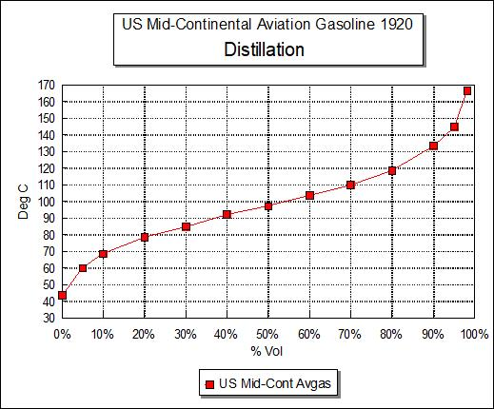

In the US in 1917 to 1919 many states had established specifications for gasolines (including motor). No two of these specifications agreed and all were unsatisfactory from one standpoint or another. The gasolines varied with the manufacturing company, crude source, locality and occasionally the season of the year. Refining companies, particularly the larger ones, had begun to include in their shipping specifications, tests such as colour, odour, unsaturation (per cent soluble in Sulphuric Acid), Doctor test (for presence of Sulphur compounds), gravity and distillation range. Since the unsaturation test was included, it is evident that the refiners were recognizing the fact that unsaturated (or cracked) materials caused gum formation in storage and in use, and that some control on the amount of such material included (from cracked gasoline) was necessary.

1922 US Gasoline Specifications

In 1922 the US government specification were published which covered two aviation grades, Domestic and Fighting grade and one motor gasoline. The aviation specification included tests for controlling corrosion and gum tendencies. These specifications in the United States were developed by the Interdepartmental Petroleum Specification Committee. The specifications and test methods from this committee were adopted by various departments and independent establishments of the US Government on January 23, 1922, amended March 1, 1922 and revised October 31, 1922.

Table . US Government Gasoline Specification 1922 [13]

|  |  |  |  |
| --- | --- | --- | --- |
| Grade Designation | Aviation Fighting Grade | Aviation Domestic | Motor Gasoline |
| Colour, Saybolt (min) | 25 | 25 | 16 |
| Distillation | | | |
| Initial (deg. C) Max. |  |  | 55 |
| Temp 5% Rec. (deg. C) Min. | 50 | 50 |  |
| Temp 5% Rec. (deg. C) Max. | 65 | 75 |  |
| Temp 20% Rec. (deg. C) Max. |  |  | 105 |
| Temp 50% Rec. (deg. C) Max. | 95 | 105 | 140 |
| Temp 90% Rec. (deg. C) Max. | 125 | 155 | 200 |
| Temp 95% Rec. (deg. C) Max. | 150 | 175 |  |
| Temp 96% Rec. (deg. C) Max. | 165 | 175 |  |
| End Point (deg. C) Max. | 165 | 190 | 225 |
| Recovery % min. | 96.0 | 96.0 | 95.0 |
| Loss % Max. | 2 | 2 |  |
| Doctor test | Negative | Negative | - |
| Corrosion (Copper Dish) | None (1) | None | - |
| Gum (Copper Dish) mg/100 ml, max. | 3.0 | 3.0 | - |
| Corrosion (Copper Strip) | - | - | None |
| Unsaturated Hydrocarbons (soluble in 95% Sulphuric Acid) % max. | 1% | 2% | - |
| Acidity of Residue | None | None | - |
| Water & Sediment, max. | None | None | - |

Note 1. None is assumed to be ‘Pass - no discoloration’.

In this set of specifications, the qualities controlled were colour, corrosiveness, and mercaptans Sulphur content, volatility, stability, and suspended matter. The volatility range (distillation) of the aviation gasolines, both Fighting and Domestic grades, was narrower than that of motor gasoline. The volatility of the Fighting grade was greater than that of the Domestic grade. This was still the period when it was considered that the greater the volatility (lower distillation range), the better the performance – by the end of this decade the Octane scale and Knock engine would be used to measure performance.

Sulphur was a problem because (a) before combustion Sulphur compounds such as mercaptans, sulphides and free Sulphur could corrode parts of the fuel system such as tanks, fuel lines, pumps, etc.; and (b) after combustion, Sulphur and its compounds when burnt in air formed Sulphur Dioxide which when combined with water formed Sulphurous acid which corroded the exhaust system.

1926 US Aviation Gasoline Specifications

This specification saw the introduction of new tests designed specifically to determine the presence of adverse components, in particular Sulphur components, which when burnt would produce detrimental corrosive combustion products. There was also a rudimentary test to determine the presence of aromatic compounds by use of the Critical temperature of Solution Aniline after nitration. This specification also saw the introduction of the Saybolt Colour test – this is essentially a long glass tube which is filled with the test gasoline and viewed along its long axis, and compared against standard colour discs. A value of 25 is close to water-white in colour.

Thus, the specifications had moved away from the World War I theories of “volatility factor” and low density gasolines, to begin to look at the quality of gasolines, in particular impurities which would cause corrosion of the aircraft engine and fuel system.

Table . US Government & US Army Department 1926-1927[14] [15]

|  |  |  |  |
| --- | --- | --- | --- |
|  | US Fed. Spec. Board | | US Army |
| Grade Designation | Domestic | Fighting | 2-40-E |
| Specification Date. | Oct 21, 1927 | Oct 21, 1927 | March 20, 1926 |
| Distillation | | | |
| Initial (deg. C) Max. |  |  |  |
| Temp 5% Rec. (deg. C) Min. | 50 | 50 | 50 |
| Temp 5% Rec. (deg. C) Max. | 75 | 65 | 75 |
| Temp 50% Rec. (deg. C) Max. | 105 | 90 | 105 |
| Temp 80% Rec. (deg. C) Max. |  |  |  |
| Temp 90% Rec. (deg. C) Max. | 155 | 125 | 155 |
| Temp 96% Rec. (deg. C) Max. | 175 | 150 | 175 |
| End Point (deg. C) Max | 190 | 165 | 190 |
| Recovery % min | 96 | 96 | 96 |
| Loss % Max. | 2 | 2 | 2 |
| Acidity of residue in flask | Neg. | Neg. | Neg. |
| Doctor Test 520-3 | Neg. | Neg. | Neg. |
| Specific Gravity |  |  | Not Required. Information:  California 0.730-0.750  Mid-Cont. 0.700-0.720 |
| Sulphur Max. % | 0.10 | 0.10 | 0.10 |
| Colour Saybolt Max. | 25 | 25 | 25 |
| Copper Dish Corrosion No Grey or Black with Max deposit 3.0 mg/100 ml. | Incl.  Incl. | Incl.  Incl. | Incl.  Incl. |
| Crit. Temp of Solution. Aniline after Nitration deg. C. |  |  | 63.0 |

Comments on Methods

Doctor Test = A test intended primarily for the detection of mercaptans in petroleum products by use of Sodium Plumbite solution.

Meanwhile across the Atlantic, the British were well advanced with a new aviation gasoline specification in 1923.

Photo 4. US Army Air Corp front line aircraft of the era - Curtiss P-12 Pursuit aircraft circa 1929.

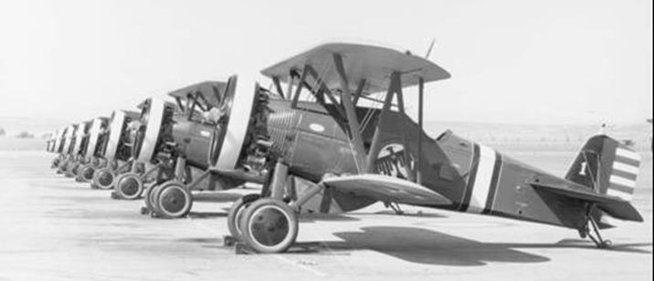

Note this biplane aircraft is powered by a radial engine favoured by the US Army and US Navy.

Photo 5. US Army Air Corps Curtiss P-12E Serial No. 31-559 Wheeler Field (on display at US Air Force Museum 2008)

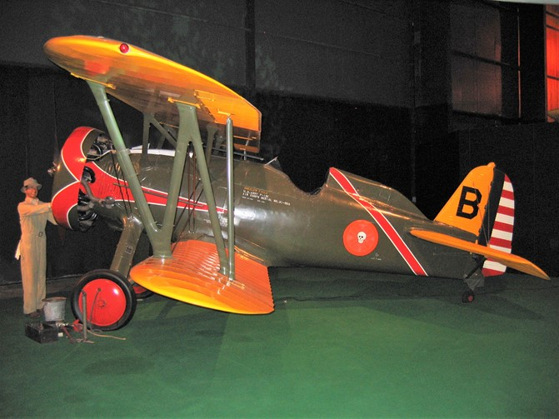

# Volatility question is raised again

One of the questions raised by Sam Heron was on the volatility requirements in the US Government Specification and why a 10% Evaporated temperature was specified in lieu of the 5% Evaporated requirement previously included in the Specification 2-40F. This question received a response from Mr. H.H. Cummings – “Unfortunately no direct attention has been given to the problem of the possible revision of the aviation specification, except insofar as a study of the vapour lock problem has a bearing on the present minimum 5% point in the distillation. The general conclusion of the motor gasoline work, that the 90% point is fully as significant as any other point in the upper part of the distillation range, holds absolutely for the aviation gasolines. The indications are that the 10% point is quite as valuable a guide to initial volatility and vapour lock as is the 5% point in the aviation gasolines. In our revised specifications for motor gasolines, we have substituted the 10% point for the initial and 20% points.”

In 1930, Heron stated that some vapour lock trouble was experienced with the present military fuel systems and average gasoline obtained to Air Corps Specification 2-40F. This was largely due to the fuel pumps having to lift the gasoline from the tanks rather than being drowned (from overhead fuel tanks in biplanes), although some trouble was experienced even with gravity systems.

‘The US Bureau of Standards has found that the ‘corrected’ ASTM 10% point is very closely related to the gasoline temperature at which vapour locking will occur at sea-level pressure. Examination by the Materiel Division of a large number of samples of gasoline giving reasonably satisfactory service in the Air Corps and meeting Specification 2-40F showed the average corrected 10% point was 65OC (149OF). Therefore, the Air Corps, in its recently issued specification for Aviation Fighting Grade Anti-Knock Gasoline, has eliminated the 5% point specified in Federal Specifications and has substituted a corrected 10% point with temperature limits of 62 OC (143.6 OF) to 72 OC (161.6 OF).’

Origins of US Government Aviation Gasoline Specifications

In Robert Kerley’s book “Military Aviation Fuel Characteristics 1917-1945 he cites an interesting discussion with Sam Heron in 1958 on the origins of the US Government specifications for aviation gasolines. Today it provides us with insight to the reasons for some of the specifications which still exist today. The recollections are listed here:

‘Prior to about 1930, US Federal Specifications Board specifications for aviation gasoline were considered mandatory by the Air Services of the US Army and US Navy. Both accepted the volatility requirements of Domestic Aviation Gasoline (DAG) which had a 90% point of 311OF (155OC). While both Services accepted the volatility requirements of DAG as the holy word, both cheated in respect to anti-knock requirements. Both Navy and Army had begun in 1928 to make considerable use of air-cooled engines, and these were in considerable difficulty in regard to the knock rating of the gasoline supplied to the specifications. The Navy attempted to control knock rating by an engine test. The Army instituted a requirement for a maximum temperature of solution with aniline after the gasoline had been nitrated with nitric-sulfuric acid. The Army test was completely useless as a control of knock rating (critical temperature of solution in aniline of n-Heptane (zero Octane) is lower than that of iso-octane (100 Octane).’

Federal Specification Board

‘The Federal Specification Board aviation gasoline specification included one for Fighting Grade (FG) with a 90% point of 257OF (125OC) as well as DAG. – in 1929 the FG specification was not in use. Both the DAG and FG specifications dated back to World War I. They both lacked any anti-knock control, and as applied in World War I resulted in Pennsylvania gasoline being considered the best type. When in 1918 the US took over the supply of aviation gasoline to England and France, the anti-knock value of FG and DAG (both were supplied) caused much difficulty since the British engines, at least, had largely been developed on the highly aromatic Borneo gasolines. Up to 1929 Federal Specification Board (FSB) specifications for petroleum products for aviation use were regarded by the Navy and Army as (US) Supreme Court rulings which could not be flouted. The specifications included aviation engine oils of which it was rudely said that a piece of paper saying “Any Damned Thing Will Do”, would have been as effective as the specifications. It was the air-cooled engine which showed up the weakness of the oil specifications, as it had that of DAG. Finally, both Services decided that the FSB gasoline specifications must be disregarded as they severely handicapped the advanced aircraft coming into or then in service. The Army flouted the FSB requirements by issue of US Army Specification Y-3557, dated March 13, 1930 for 87 Octane Number FG gasoline, which however substituted a 10% point for the current 5% point. Y-3557-A, dated August 1, 1930, also specified a Reid vapour pressure of 6½ psi. Neither octane number nor vapour pressure had previously been required in any American aviation gasoline specification. [This same revision changed the 10% point from 143.6OF (62OC) to not less than 167OF (75OC)]. The Navy heresy was not so marked since they kept DAG volatility requirements, but specified an H.U.C.R. (highest useful compression ratio) of 5.8 in the NACA single cylinder engine. This was a base gasoline to which lead was added in the aircraft tanks when additional anti-knock value was needed. The final blow to FSB aviation specifications came about 1932. At this time, the Army has specifications for lubricating oils of about 95 Viscosity Index. Viscosity Index has proved to be the best then available method of securing suitable oils for air-cooled engines. [the higher the Viscosity Index VI, the better the lubricating oil with regard to viscosity stability]. After the Army had successfully used the oils for about two years, the FSB blandly submitted specifications for aviation oils of about 85 Viscosity Index. The Army rudely retorted that so far from reducing the Viscosity Index, they hoped to increase it in the future (this was only an Army hope which was exaggerated for the benefit of the FSB).’

Distillation 10% Point

‘The Army had been in considerable difficulty with engines cutting out in flight and this was thought to be due to vapour lock. The matter was discussed with Dr. Oscar Bridgeman, who was then conducting an investigation of vapour pressure and volatility at the US National Bureau of Standards for the CFR (Co-operative Fuel Research Committee). Bridgeman suggested a vapour pressure of 6 to 7 psi (pounds per square inch) (41.3 to 48.2 kPa), and pointed out that in many cases there was a relationship between the 10% point and the Reid vapour pressure. He regarded a 10% requirement of 167OF (75OC) maximum as compatible with 5 to 7 psi Reid vapour pressure (RVP). While the Army was afraid of the vapour locking problem, they at the same time considered that the front-end volatility should be fairly high on account of engine staring difficulties.

(Both Y-3557, Tentative and Y-3557-A state that the corrected 10% point was substituted on advice of the Bureau of Standards.)

At this time engine starting in cold weather was quite a problem, and the Army felt that the front-end volatility should be fairly high to minimise such difficulties. Much of the starting difficulties was later shown to be due to inadequate ignition systems and faulty method of priming. Also, the Army later found out that the engine cutting trouble, which was blamed on vapour lock, was really due to carburettor icing. However, it was also found that 7 psi Reid vapour pressure was as much as the then current fuel systems would stand (some of them would not even stand 7 psi). (The 7.0 psi limit was adopted in Y-3557-G, dated April 10, 1933.) The use of Reid vapour pressure in aviation gasoline originated from a suggestion made by Professor George Granger Brown.

Reid Vapour Pressure

About 1930 a considerable number of US Army aircraft were flying over the city of Chicago at fairly low altitude in an air show and suffered repeated engine cut out over the roof tops. Needless to say, this was decidedly unpopular both with the pilots and residents. A sample of the gasoline was obtained and found to have a 90% point of only 200 deg. F (93 deg. C) clearly too volatile for an aircraft engine (given that even in 1920 the US specification for the 90% point was between 113 and 155 deg. C maximum depending on the grade and most refineries would target for the maximum, this gasoline was too volatile).

This experience resulted in adding a requirement of 6.5 psi Reid Vapour Pressure to the specification. This led to vigorous protest from the oil industry – a not unexpected response. In reply to the protests the experts at Wright Field admitted that the requirement was due to bad engineering of the fuel system and that the vapour pressure would be increased when the fuel systems were modified.

In one case a twin engine bomber which had suffered a catastrophic vapour lock trouble was found to have an absolute pressure of 8.3 psi at the fuel pump intake at sea level. A fuel of only 2 psi vapour pressure was supplied and the vapour lock problems were still encountered; it was then decided that the fuel would never remedy the problem of bad engineering design. A major source of the vapour lock was due to mounting the fuel pump on the engine accessory case where the temperature reached at least 250 deg. F (121 deg. C) in flight.

The specification of 6.5 psi Reid Vapour Pressure was shortly increased to 7.0 psi in the US Specification Y-3557-G in April 1930.

[This specification still exists some 70 years later despite marked improvements in fuel system engineering, for example fuel injection]

Volatility Control for Carburettor Icing (Sum of 10%+50%+90% points)

The US Army Specification Y-3557-A on August 1, 1930 Fighting Grade included 6.5 psi Reid Vapour Pressure, 87 Octane number, 50% point of 203 deg. F and 90% point of 257 deg. F maximum. When the fuel first went into service, the fuel supplied for the first six months or so had a 90% point of between 240 and 257 deg. F. (116 to 125 deg. C). It was reported that this fuel was quite satisfactory in service, but a Mid- Continent (US) supplier then provided a fuel with a 90% point of only 205 deg. F (96 deg. C). This fuel came into service in winter so there was no problem, but when summer arrived, the problem of engine cut out started to occur, and it was quite obvious that vapour pressure was not the cause of the problem. Further investigation showed that the problem was due to carburettor icing, and this seemed to indicate that this may have been the problem with the aircraft in Chicago. The same fuel also had a problem with the fuel-air mixture becoming lean in the carburettor due to the lower density of the fuel. The engine manufacturers had adjusted the carburettor settings for fuel with a 90% point of around 250 deg. F, not 205 deg. F.

According to Kerley, the story related by Sam Heron was as follows:

‘When the icing trouble reached catastrophic proportions, bids for fuel for the next six months had already been received with the same (US Mid Continent) supplier being the low bidder for a very large portion of the country, including California [California was then a significant market for the US Army Air Corps because of the many flying schools and aircraft manufacturers]. Sam Heron was called in late one afternoon by the Chief Engineer, Major C.W. Howard, and told to fix the specification that day so that the icing difficulty would be avoided. Heron pleaded to be given at least until 10 am the next morning to come up with an answer. Heron discussed the matter that night with Dr. Graham Edgar, who had been at Wright Field that day, they concluded the excessive volatility was the cause of the trouble, and that reasonable control would be obtained by the sum of 10%, 50% and 90% points. This was duly embodied in the specification and the figure was set at 564 deg. F (260 deg. C). The specification was dated June 3, 1932 and became Y-3557-E.

Heron was criticized for this requirement and particularly so when it became apparent that the 90% point was not significant in respect to icing. His response was – “would you do any better in 18 hours and without any experimental data?”

The revised specification with the 10%+50%+90% requirement went into force immediately, and the bids, which had been received under the old specification, were rejected, and new bids obtained to the revised specification. Fuel to the new specification virtually eliminated icing difficulty in service.

Subsequent to the issuance of this revised specification, there was much justified criticism of inclusion of the 90% point by the petroleum industry and others. Investigations of the relative icing tendencies of gasolines of varied volatility were carried out by the US National Bureau of Standards, Standard Oil Company of Indiana, the British (presumably the Royal Aircraft Establishment), and US Army Wright Field.

All these investigations showed that the 90% point had no influence upon the tendency to form carburettor ice.

Distillation 90% Point

When the US Army Specification Y-3557-A was issued, it required a 90% point of 257 deg. F maximum (125 deg. C.) as discussed previously. At the same time the Domestic Aviation Gasoline (DAG) had a 90% point requirement of 311 deg. F (155 deg. C), and the US Navy continued to use the DAG volatility requirement although it included an anti-knock requirement for the clear gasoline. About 1932 Heron was sent to Detroit to attend the January meeting of the Society of Automotive Engineers (SAE). While in Detroit he received a telegram from his superiors at Wright Field stating that the US Navy were sending Mr. C.S. Fliedner to Detroit and that we should endeavour to reach agreement on a 90% point temperature which would be used by both Services.

According to Heron – “these were the deep days of prohibition in the US, and a friend had presented Heron with a bottle of genuine Three Start Hennessey. When Heron and Fliedner met, Heron said, “Fliedner, you know the Army and Navy will never agree on a 90% requirement. (Dr.) Bridgeman (then National Bureau of Standards) is here, and I suggest that the three of us assemble in my room, each take a drink of my Three Star Hennessey and that Bridgeman then set the 90% requirement.” The three experts assembled, took the drink, and Bridgeman set a value of 275 deg. F (135 deg. C) which still exists today in the aviation gasoline specifications.

Specification Y-3557-D dated September 18, 1931 changed the 50% point from 203 to 212 deg. F (95 to 100 deg. C), the 90% point from 257 to 275 deg. F (125 to 135 deg. C), the 96% requirement was dropped and raised the 96% recovery to 98%. It also changed the fuel colour from purple to blue, raised the 2-hour oxygen bomb test to 4 hours, and dropped the gum maximum at the end of ageing from 15 milligrams to 10 milligrams.

“The Three Star Hennessey was remarkable stuff”.

Dr. Oscar C. Bridgeman, research associate at the Bureau of Standards for the Society of Automotive Engineers. – 1929

C.S. Fliedner, Bureau of Aeronautics, USN - 1929

# British Research continues in UK at RAE

While considerable research was occurring in the US with regard to anti-detonation additives such as Tetra Ethyl Lead (Refer to Chapter 36. Alkyl Lead) the researchers at the Royal Aircraft Establishment were not idle, and they too were experimenting with similar compounds. Some of this work is described in the following reports. The experiments were performed on aircraft engines, both in-line liquid cooled engines and air-cooled radial engines, and again the British preference for high aromatic content was evident.

Shell Aviation Spirit was still considered to be the reference by which comparisons would be made.

Ref: DSIR 23/2387 Royal Aircraft Establishment Report No. E 1694, July 11, 1925

“Test of Napier Lion Engine using Lead Tetra Ethide as an anti-knock detonation in Aviation Spirit” - Air Ministry Reference 571211/25/R.D.2.A. Test Case 1314

Aviation spirit and doped with 5½. cc/(Imp) gallon of fuel. Standard 20% Benzol mixture. The report dealt mostly with information on engine and oil conditions.

Photo 6. Napier Lion engine 1924 (on display at London Science Museum 2004).

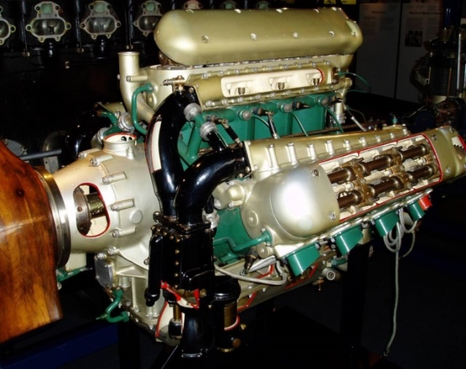

The Lion was a 12-cylinder W-block inline liquid cooled aircraft engine built by Napier & Son starting in 1917, and ending in the 1930’s. A number of advanced features made it the most powerful engine of its day, and kept it in production long after contemporary designs had stopped production. It is particularly well known for its use on a number of racing designs, in aircraft, boats and cars. It was the engine used by the British for their Schneider Trophy entrants in 1922 and 1927.

Ref: DSIR 23/8441 Royal Aircraft Establishment Report No. E 1694A, July 5, 1926

“Test of Jupiter IV Engine using Lead Tetra Ethide as an anti-knock detonation in Aviation Spirit” - Air Ministry Reference 571211/25 Test Case 1314

Shell Aviation Spirit and doped with 5½. cc “Ethyl Fluid” (consisting of 3 parts volume Tetra Ethyl Lead and 2.5 parts Dibromo Ethylene).

Comparative power curves on doped fuel and Standard Service 20% Benzole mixture were taken. The Jupiter IV is an air-cooled engine.

Conclusion: Variation in engine deposit (water-cooled – none) and also fuel source had an influence.

Fuel: 5½.cc (3cc TEL, 2½.cc Ethylene Dibromide) per Imp. Gallon of Shell Aviation Spirit.

Lubricant: Pure Castor Oil.

Photo 7. Bristol Jupiter engine circa 1924

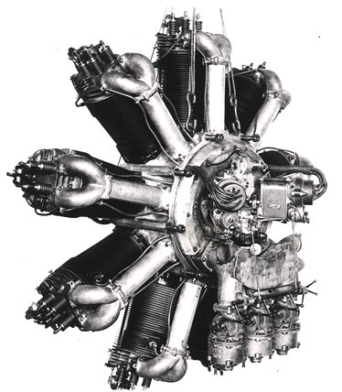

The Bristol Jupiter IV was a British 9-cylinder air cooled one-row piston radial engine and was one of the most reliable aircraft engines on the market. Production started in 1918 and ceased in 1930. It was built under license in France as the Gnome-Rhone Jupiter and in the Soviet Union as the M-22.

# British Aviation Spirit Specification

1923 British Specification No. 121

In 1923, the British specification No. 121[16] which covered two grades “Aviation Spirit Grade 720” and “Aviation Spirit Grade 760” was introduced; these numbers in fact referred to the specific gravity of each grade. This specification was to be possibly the first and most advanced in the aviation world, because it introduced:

* A test requirement related to a test engine ‘rating’ titled “Toluene equivalent”. This was clearly influenced by the work of Harry Ricardo and his test engine for ‘rating’ aviation gasolines (refer to Chapter 36. Alkyl Lead & Chapter 37. Octane Testing.).
* Freezing point test to assess the fuel for high altitude use.
* Specified aromatic hydrocarbon content together with a ‘Method of Determination of Total Aromatic Hydrocarbons’. An aromatic content of between 12-20 % with a “Toluene equivalent” of 10% minimum for Grade 720, and up to 35% with a “Toluene equivalent” of 28% minimum for Grade 760. A requirement that the British adopted from their experiences with aviation gasolines in World War I.

For completeness, the entire British Specification is listed here even though it included motor spirit not used in aircraft.

As will be seen this specification was well in advance of any others of the time and introduced new concepts and test methods.

British Standard Specification No. 121 (1923)

British Engineering Standards Association – April 1923 - Adopted 7 March 1923, Approved by Main Committee (Institute of Petroleum Technologists) 18 April 1923.

Definition:

Motor Spirit fulfilling the requirements of Specification A

Aviation Spirit fulfilling requirements of Specification B (Aviation 720) or Specification C (Aviation 760)

Specification A Motor Spirit

General: Consist of hydrocarbons and be free from visible impurities.

Distillation: Standard Method (IP)

First drop Less than, or equal to 55 deg. C. (see Appendix I)

20% Less than, or equal to 105 deg. C (see Appendix I)

Final Boiling Point Less than, or equal to 225 deg. C

Acidity: Free from mineral acid.

Specification B Aviation 720

Appearance: Same as Spec. 760

Specific Gravity at 15 deg. C: not less than 0.720, not more than 0.740

Distillation: 100 cc distilled in Standard Distillation apparatus (BS Spec 2 D15) at a rate of 2 drops per second at 760 mm pressure.

Below 75 deg. C not less than 10 cc

Below 100 deg. C not less than 60 cc

Below 140 deg. C not less than 95 cc

Residue on Evaporation: When 50 cc is heated on a bath of boiling water for one hour, the residue shall not exceed 0.01% by weight and shall be oily in nature.

Aromatic Hydrocarbons: The total content of aromatic hydrocarbons shall be determined as described in Appendix II shall be not less than 12% and not more than 20% by volume.

Toluene Equivalent of the Aromatics: The Toluene equivalent of the aromatic hydrocarbons determined in Appendix III shall not be less than 10% by volume.

Acidity: The aviation Spirit shall be free from mineral acid.

Sulphur: Sulphur content shall not exceed 0.05 % by weight.

Specification C Aviation 760

Appearance: The aviation spirit shall be clear, water white and free from all visible impurities. It shall contain not more than traces of olefine hydrocarbons (cracked spirit).

Specific Gravity at 15 deg. C not less than 0.760, not more than 0.790

Distillation: 100 cc distilled in Standard Distillation apparatus (BS Spec 2 D15) at a rate of 2 drops per second at 760 mm pressure.

Below 75 deg. C not less than 10 cc

Below 100 deg. C not less than 50 cc

Below 150 deg. C not less than 90 cc

Residue on Evaporation: When 50 cc is heated on a bath of boiling water for one hour, the residue shall not exceed 0.01% by weight and shall be oily in nature.

Clause 18. Aromatic Hydrocarbons: The total content of aromatic hydrocarbons shall be determined as described in Appendix II, and shall be not less than 35% by volume. (see Clause 19).

Clause 19. Critical Solution Temperature: The critical solution temperature in aniline of the residue remaining after the removal of aromatics (see Appendix II) shall not exceed 55 deg. C or, in the event of its exceeding 55 deg. C, the minimum content of aromatics given in clause 18 shall be increased by 1% per 1 deg. C in excess of 55 deg. C. Thus, if the critical solution temperature after sulphonation be 61 deg. C, then the minimum content of total aromatics must be increased from 35% to 35 + (61-55) = 41%

Toluene Equivalent of the Aromatics: The Toluene equivalent of the aromatic hydrocarbons as described in Appendix III shall not be less than 22% by volume.

Acidity: The aviation spirit shall be free from mineral acid.

Sulphur: Sulphur content shall not exceed 0.05 % by weight.

Freezing Point: The freezing point of the aviation spirit shall be below –60 deg. C.

Appendix I

Non-applicability of certain clauses (in the specification) when Motor Spirit consists mainly of Benzol or Toluol.

When the Motor Spirit consists mainly of Benzol or Toluol, the clause relating to the Initial Boiling Point (IBP) in the case of Benzol and the clauses relating to IBP and distillate up to 105 deg. C in the case of Toluol shall not apply.

Appendix II

Method of Determination of Total Aromatic Hydrocarbons

20 cc of the spirit shall be shaken with 70 cc Sulphuric Acid (98%) for 15 minutes. The acid layer shall then be run off, a further 20 cc of fresh acid added to the remaining spirit and the mixture again shaken for 15 minutes. The acid shall again be run off and the remaining spirit washed with water and dried over calcium chloride. These operations are best carried out in a stoppered separating funnel in order that evaporation losses may as far as possible be avoided.

The critical solution temperature in aniline shall be determined of

* the untreated spirit
* the spirit from which the aromatics have been removed as above.

The difference between the two temperatures obtained multiplied by 1.9 gives the total aromatic content by weight.

The percentage by volume shall then be calculated as follows:

Let X = percentage of aromatics by weight.

S1 = Specific Gravity of the original spirit.

S2 = Specific Gravity after the removal of aromatics.

Y = percentage of aromatics by volume.

Then Y = 100 – (100-X) S1/S2.

Appendix III

Method of Determination of Toluene Equivalents of the Aromatics.

500 cc of the spirit shall be fractionated using an efficient column e.g. a Darier or a Dufton Column, at a rate of one drop per second.

Cuts shall be taken at 95 deg. C and 122 deg. C.

The volumes of the three fractions shall be recorded, care being taken to allow in the final fraction for the amount of spirit retained in the column.

The specific gravity and critical solution temperature in aniline of each fraction shall be determined. Each fraction shall then be treated with Sulphuric Acid as described in Appendix II, and its specific gravity and critical solution temperature again determined.

The percentage of aromatic hydrocarbons by weight in each fraction shall then be calculated as in Appendix II, using the following factors.

1st. Fraction – Benzene 1.15

2nd. Fraction – Toluene 1.20

3rd. Fraction – Xylenes 1.23

and from the results thus obtained and the specific gravities of the fractions, the percentages by volume shall be deduced as in Appendix II.

The Toluene Equivalent shall be calculated on the assumption that 150 parts of Benzene and 120 parts of Toluene are each equivalent to 100 parts of Xylene.

For example, if the spirit is found to contain:

X% Benzene

Y% Toluene

Z% Xylene

then the Toluene Equivalent is: X/1.5 + Y + Z/1.2

Footnote:

The Standard Methods of test now being prepared by the Committees of the Institution of Petroleum Technologists will be published as British Standard Methods of Test as soon as they have been adopted by the B.E.S.A. (British Engineering Standards Assoc.).

Since many countries around the world were part of the British Empire, their military services looked to Britain for purchase of military aircraft, technical developments and in particular, aviation gasoline specifications. In Australia, the RAAF also adopted the British Specification especially since nearly all aviation fuel was supplied from the Dutch East Indies or British Borneo who also supplied the RAF to this new specification.

Comments on Methods

Aniline Point = The lowest temperature at which an oil is completely miscible with an equal volume of Aniline. The change of Aniline Point after the oil has been treated with concentrated Sulphuric acid is an indication of its aromatic content (I.P. Method 3/42).

British Specification for “Benzol”

Given the confusion in terminology between Benzene, Benzine and Benzol(e), it is perhaps appropriate to include a specification for ‘Benzol’ to clarify the situation While Benzene in this publication refers to the pure chemical compound (CAS No. 71-43-2 and Molecular weight 78.11), the term ‘Benzine’ is the name occasionally used for the petroleum fraction (gasoline) with a distillation range of 120oC to 150oC and common in Europe to mean gasoline – it has been avoided in this publication.

However, the blending component ‘Benzol’ can be of variable composition depending on the reference source. Therefore, the following will assist in understanding the differences. The use of ‘Benzol’ as a blend component in aviation fuels led to the need ensure the quality of this component met certain criteria. The Auto Journal (Vol. 26) 1921 published the British Engineering Standards Association specification for ‘Benzol’. This specification is presented here in a similar format to other specifications listed above.

Definition: – The term ‘benzole’ shall denote denotes a liquid consisting essentially of a mixture of benzene, and not more than 30% by volume of toluene and xylenes.

Description: – The liquid shall be a clear ‘water-white’ liquid, free from undissolved water and other visible impurities.

Specific Gravity: – The specific gravity at 15.5 deg. C. shall be not less than 0.870 and not more than 0.885.

Distillation: - 100 cc distilled in Standard Distillation apparatus (BS Spec 2 D15) at a rate of 7cc per minute at 760 mm pressure.

At or below 90 deg. C not less than 60 cc

At or below 100 deg. C not less than 75 cc

At or below 120 deg. C not less than 90 cc

The flask shall be dry at a temperature not exceeding 125 deg. C (Dry Point).

Residue on Evaporation: - The amount of non-volatile residue remaining when 20 cc is heated on a bath of boiling water at 100 deg. C for two hours, (the residue) shall not exceed 0.01% by weight.

Colouration with Sulphuric Acid: - The colouration imparted to pure Sulphuric Acid (90%), free from Nitric Acid, when 90 cc of the material are shaken with 10 cc of the acid for 5 minutes at ordinary temperature, shall be not more than a light brown.

Sulphur Content: - The total Sulphur content shall not exceed 0.4 % by weight.

Freedom from alkali and acid: - The material shall give no reaction for free acid or free alkali, when tested by the method described in the appendix.

Freedom from Hydrogen Sulphide: - The material shall give no reaction for H2S when tested by the method described in the appendix.

Freezing Point: - The freezing point shall not be higher than -14 deg. C when determined by the method described in the appendix.

The appendices gave details of the test methods.

Photo 8. British aircraft of the era - Imperial Airways de Havilland DH-66 Hercules circa 1929 – refuelling operation

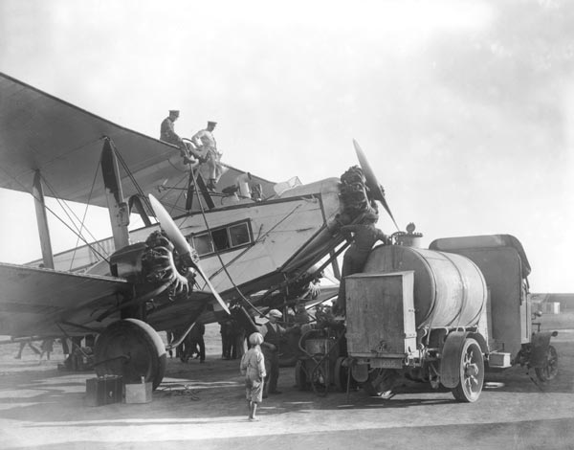

# Gasoline Composition 1920-1929

The following are some of the experimental grades of the time

SHELL-MEX Aviation Spirits 1923

Analyses of Shell-Mex Aviation Gasolines 1923 as tested by the Royal Aircraft Establishment, which was part of the British Air Ministry. These were probably experimental blends submitted by SHELL-MEX, which was the marketing company conglomerate of the Shell Company and the British Petroleum Company.

Source: Royal Aircraft Establishment Report No. H.C. 820 of 11 Feb 1924.

Ref: UKPRO AVIA 6/3617, Ref: A.M. 471396/23.

Table 10. Report on the chemical examination of Shell-Mex Aviation Spirit 'X' and 'Y'.

|  |  |  |
| --- | --- | --- |
| Test | Aviation Spirit 'X' | Aviation Spirit 'Y' |
| Specific Gravity 15C/4C | 0.7744 | 0.7715 |
| Distillation (Std. Apparatus) | | |
| 0% | 65 | 64 |
| 5% | 82 | 81 |
| 10% | 85.5 | 84.5 |
| 20% | 89 | 88 |
| 30% | 95 | 93 |
| 40% | 98 | 96 |
| 50% | 101 | 100 |
| 60% | 105 | 103 |
| 70% | 110 | 109 |
| 80% | 119 | 117 |
| 90% | 124 | 124 |
| 95% | 134 | 133 |
| Aromatic Hydrocarbons %Vol. | 33 | 31.5 |
| CST in aniline. deg. C | 54.5 | 52.5 |
| Toluene Equivalent (engine rating) | 26.5 | 27 |
| Benzene % Vol. | 7.5 | 6.5 |
| Toluene % Vol. | 11.5 | 12.5 |
| Xylenes % Vol. | 11.5 | 11.5 |
| Sum | 30.5 | 30.5 |
| Freezing Point deg. C | <-60 | <-60 |
| Effect on P.R. Tubing | Satisfactory after 6 days | Satisfactory after 6 days |
| Effect on benzol resistant tubing | Satisfactory after 6 days | Satisfactory after 6 days |

Compare with US Spec (10+50+90%) 310.5 & 308.5 deg. C - spec 260 deg. C

Graph . Distillation – Shell-Mex Aviation Spirits ‘X and ‘Y’ 1923.

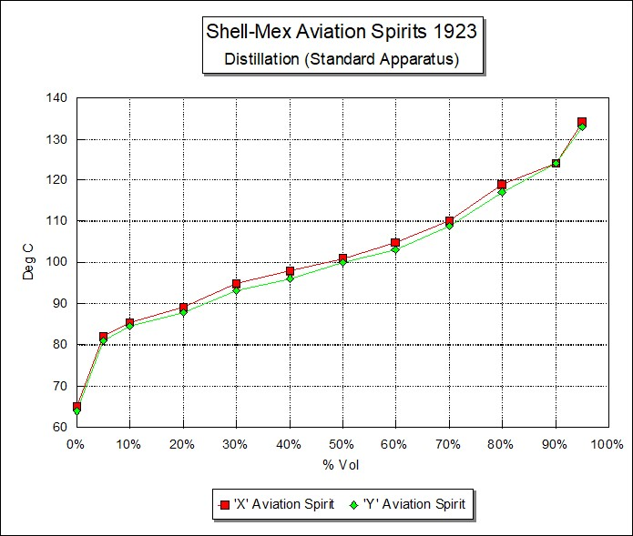

# Index

1

100 Octane 22

1st Aero Squadron 13

5

50 PN 12

8

80 octane 20 heptane 14

87 Octane 12, 23, 24

A

acetic acid 4

Acid Heat Test 18

Acidity 19, 20, 28, 29

Aero Propulsion and Power Directorate 10

Air Corps Materiel Division 13

Air Corps Specification 2-40-F 13, 14, 22

aircraft carriers 15

aircraft engine manufacturers 12, 14

aircraft engines 14, 26

aircraft manufacturers 24

Alcogas 4, 5

alcohol 4, 5

alkali 32

Alkyl Lead 16

altitude chamber 6

aluminium 11

aluminium-bronze 12, 16

American Expeditionary Force 5, 13

American Petroleum Institute, 3

American-Mexico conflict 13

aniline 4, 14, 22, 20, 30, 33

Aniline Point 31

anti-detonation additives 26

anti-knock …4, 10, 12, 13, 14, 15, 22, 23, 25, 26, 27

API Project No. 6 1, 2, 3, 4, 39

aromatic 8, 20, 23, 26, 28, 29, 30, 33

aromatic amines 10

ASTM 22

Atlantic Refining Company 4, 6

automobile anti-knock gasolines 14

automotive gasoline 15

Aviation 720 28

Aviation 760 28, 29

aviation engine oils 23

aviation fuel supplies 15

aviation gasoline 4, 5, 6, 8, 11, 12, 14, 19, 21, 22, 23, 28

aviation gasoline specification 22, 23, 31

aviation spirit 28, 29

Aviation Spirit Grade 720 28

Aviation Spirit Grade 760 28

B

base fuel 13

base gasoline 13, 23

Benzene 6, 30, 31, 33

Benzine 31

Benzol 4, 5, 6, 12, 13, 14, 26, 30, 31,33

benzole 27, 31

Borneo 14, 23, 31

Bridgeman 23, 25

British Air Ministry 33

British Engineering Standards Association 28, 31

British Petroleum Company 33

British Standard Specification No. 121 28

bromine 14, 16

BS Spec 2 D15 29

Bureau of Aeronautics 25

Bureau of Aircraft Production 5, 6

Bureau of Mines 4, 5

Byrd 12

C

calcium chloride 30

California 12, 24

California crude 3

California Fighting Grade gasolines 13

California gasoline 13, 14

carbon dioxide 4

carburettor 12, 24

carriers 15

casing-head 14

Castor Oil. 27

caustic soda 8

Chevron 13

Chicago 24

coal 8

Coalite 8, 9, 39

compression ratio 13, 23

Co-operative Fuel Research Committee 23

Copper Dish 17, 19, 20

corrosion 5, 17, 19, 20

Cottrell boiler 4

cracked (olefinic) gasoline 12

cracked gasoline 19

Critical Solution Temperature 29

crystallisation 4

Cummings 22

Curtiss Aero & Motor Company Inc. 14

Curtiss P-12 Pursuit 21

Curtiss P-12E 21

Cyclohexane 6

cylinder rusting 16

D

Darier 30

de Havilland DH-66 32

Detroit 25

Dibromo Ethylene 27

Dickinson 6

diesel fuel 15

Doctor Test 17, 19, 20, 21

Domestic Aviation Gasoline 14, 15, 17, 22, 25

domestic aviation grade 13, 15

Domestic grades 19

dope 13, 14, 16, 26, 27

Dry point 5, 7, 9

Dufton Column 30

duralumin 8

Dutch East Indies 31

E

Edgar 10, 16, 24

End Point 17

engine manufacturers 13, 15, 24

Ether 4, 5

Ethyl 3J Fluid 16

Ethyl Fluid 27

Ethyl Gasoline 13, 14, 16

Ethyl Gasoline Corporation 16

Export Gasoline 6, 17

Export Grade 4, 5, 6, 7

extraction 4

Exxon 14

F

Federal Specification Board 22, 23

Fighting Grade 14, 15, 18, 19, 22

Fighting Grade Gasoline 15, 17

Final Boiling Point 28

Fliedner 15, 25

Fokker 12

Ford 12

Foulais 13

fractionation 4

freezing point 5, 6, 9, 28, 29, 32, 33

G

Gage 4, 6

gasoline 5

General Motors Company 6

German Navy 15

Gibson 11

Gnome-Rhone Jupiter 27

Gulf Coast 3

gum 5, 17, 19, 25

gum deposits 8, 17

gum formation 19

H

Harper 4

Heat Value 5, 7

Hecter Fuel 6

Hector Fuel 4, 6, 7

Heron 11, 12, 15, 16, 22, 24, 25

Howard 13, 14, 15, 16, 24

hydro-aromatic 8

Hydrogen Sulphide 17, 32

hydrogenation 6

I

Imperial Airways 32

Industrial Alcohol Co. 4

Initial Boiling Point 30

Institute of Petroleum Technologists 28, 31

Interdepartmental Petroleum Specification Committee 19

iron 8

iron oxide 16

iso-octane 22

J

Japanese 15

Jupiter IV Engine 27

K

Kerley 22, 24

L

Lawrance 11

lead 12, 13, 23

Lead Bromide 16

Lead Tetra Ethide 26, 27

leaded gasoline 16

Liberty 5, 6

Lindbergh 12, 15

Low Temperature Carbonisation Company Ltd. 8

lubricating oils 23

M

Mardles 8

Marland Oil Company 3

Materiel Division 14, 22

McCook Field 10, 11, 39

mercaptan 17, 20, 21

Method 10.1 17

Method 100.1 17

Method 520.3 17

Method 530.1 17

Method 550.1 18

Mid Continent mixed base crude 3

Mid-Continental Aviation Gasoline 13, 18

Midgely 10

mineral acid 28, 29

Mobil 6

motor gasoline 4, 19, 22

motor spirit 28, 30

N

naphthenes 8

naphthenic 3, 14

Napier Lion Engine 26

National Bureau of Standards 25

Navy Department 4

n-Heptane 22

nickel-chrome steel 16

nitration 4, 14, 20

Nitric Acid 32

nitric-sulfuric acid 22

O

Octane 22

octane number 12, 15, 23

Octane scale 3, 10, 16, 20

Odour 5, 9

oil companies 12

olefine 29

olefins 8

ortho-toluidine 10

oxidation bomb test 8

oxygen bomb test 25

P

paraffin 8

paraffinic 3

Pennsylvania crude 3, 4, 6

Pennsylvania gasoline 23

Pershing 13

polymerisation 8

PONA Distribution 8

Power Plant Laboratory 12

Pratt & Whitney 14

R

radial engine 10, 11, 12, 26, 27

Red Crown Fighting Grade 15

Red Crown Gasoline 15

redistillation 4

refineries 24

refiners 19

Reid vapour pressure 23, 24

resinous material 8

Ricardo 13, 28

Richfield 13

Rossini 1

Royal Aircraft Establishment 8, 25, 26, 27, 33, 39

Royal Aircraft Factory 11

S

Saybolt 19, 20

Schneider Trophy 16, 26

Selfridge Field 13

Shell Aviation Spirit 26, 27

Shell Company 33

Shell-Mex 33, 34

Society of Automotive Engineers 25

sodium 10, 11

Sodium Plumbite 21

sodium/potassium salt 12

South American crudes 14

South Ponca Field 3

Soviet Union 27

Sparrow 4, 6

specific gravity 5, 9, 18, 20, 28, 29, 30, 31, 33

Specification B 28

Specification C 28, 29

Specification Y-3557-D 25

Standard Oil Company of California 13, 15

Standard Oil Company of Indiana 14, 25

Standard Oil Development 14

Standard Oil of New Jersey 14

steel 8

straight run gasoline 12

submarine 15

sulphides 20

sulphonation 4, 29

Sulphur 8, 17, 19, 20, 29, 32

sulphur dioxide 4, 20

Sulphuric Acid 18, 19, 30, 32

Sumatra 14

superchargers 10, 12

supercharging 13

suppliers 13

T

tanker 15

Taylor Fuel 5

TEL 10, 12, 27

Tetra Ethyl Lead 3, 10, 13, 14, 26, 27

Tetraethyl Lead 15, 16

Texaco 14

The Texas Corporation 14

thermal decomposition 4

Toluene 30, 31, 33

Toluene Equivalent 28, 29, 31, 33

Toluene Rating System 13

Toluol 4, 5, 30

tungsten steel 12

U

U.S. National Bureau of Standards 3, 25

United States War Department 18

unleaded 13

unleaded base 15

unsaturated 19

Unsaturated Hydrocarbons 19

US Air Corps 13, 15, 16

US Army 21, 22

US Army Air Corps 10, 12, 15, 16, 21, 24

US Army Aviation Gasoline specification 17

US Army Method 12

US Army Specification Y-3557-A 23, 24, 25

US Bureau of Mines 18

US Bureau of Standards 4, 6, 14, 22, 23

US Federal Specifications Board 22

US Government Specification 22

US Navy 4, 10, 12, 14, 15, 16, 21, 22, 25

V

valve seat pounding 16

valve seat recessing 16

valve stem rusting 16

vapour lock 22, 23, 24

vapour pressure 23

Viscosity Index 23

volatility 3, 8, 14, 15, 19, 20, 22, 23, 24, 25

W

Wheeler Field 21

Whirlwind 11

Wolf packs 15

Wright Aeronautical 11, 14

Wright Field 10, 12, 16, 24, 25

Wright-Patterson Air Force Base 10

X

Xylene 30, 31, 33

Xylidene 10

Y

Y-3557 23, 24, 25

# References

1. American Petroleum Institute 14th Annual Meeting October 23-26, 1933 “Chemical Composition of Petroleum” API Project 6 by Edward W. Washburn
2. U.S. Library of Congress. Call Number: TL521. A33 No. 89. Main Title: Comparison of alcogas aviation fuel with export aviation gasoline. By Published/Created: Washington, Govt. print. off., 1920. Personal Name: [Gage, Victor Raymond], 1882- Description: cover-title, 14 p. diagrs. 30 cm.
3. U.S. Library of Congress. Call Number: TL521. A33 No. 90. Main Title: Comparison of Hecter fuel with export aviation gasoline. Personal Name: [Dickinson, Hobart Cutler], 1875- Published/Created: Washington, Govt. print. off., 1920 Description: cover-title, 10 p. diagrs. 29 cm.
4. UK Public Records Office- London Ref: UK PRO AVIA 6/3673 “Royal Aircraft Establishment Report No. H.C.907 “Report on the Chemical Examination of a Sample of “COALITE” Aviation Spirit” 4 May 1925
5. Military Aviation Fuel Characteristics 1917-1945 by Robert Kerley SAE Publication SP-1008 (ISBN 1-56091-454-8)
6. Wright Patterson Air Force Base Website. <http://www.pr.afrl.af.mil/history_wpafb.html> Accessed Jan 11, 2004
7. Wright Patterson Air Force Base Website. <http://www.pr.afrl.af.mil/history_wpafb.html> Accessed Jan 11, 2004
8. Wright Patterson Air Force Base Website. <http://www.pr.afrl.af.mil/history_wpafb.html> Accessed Jan 11, 2004
9. Website ?? Accessed ? HISTORY OF AVIATION FUEL DEVELOPMENT IN THE UNITED STATES - AFRL/PRSF
10. U.S. Air Service Information Circular Vol. 1 August 30, 1920 No. 46 prepared by Materials Section, Engineering Division, Air Service, McCook Field, July, 1920. (NASM B4 292100-21).
11. Committee on Standardization of Petroleum Specifications Bulletin 5 effective December 29, 1920. Sourced from “A Handbook of the Petroleum Industry” – Dr. David T Day Volume II. Published by Chapman & Hall Ltd. London 1922 Sourced from Institute of Petroleum – London.
12. Motor Fuels – Their Production and Technology by Dr. Eugene H Leslie published by The Chemical Catalogue Company Inc. New York 1923
13. Aviation Gasoline Manufacture by Matthew Van Winkle - Mineral Industries Series 1944 McGraw-Hill Book Company New York.
14. Military Aviation Fuel Characteristics 1917-1945 by Robert Kerley SAE Publication SP-1008 (ISBN 1-56091-454-8)
15. Federal Specifications Board Specification No. 2 d Revised October 21, 1927.
16. British Standard Specifications for Motor and Aviation Spirit **-** Published for the British Engineering Standards Association by C. Lockwood & Son, 1923 London**.** Sourced from: **U.S.** Library of Congress Call Number: TP343 B7. Type of Material: Book. Subjects: Gasoline. Fuel. Description: 7 p. 22 cm.