Chapter

5

1920-1930 “Roaring Twenties”

Part 3 - The Refiners & Oil Companies

Photo . Construction of SOCONY Paulsboro Refinery, New Jersey, USA circa 1917

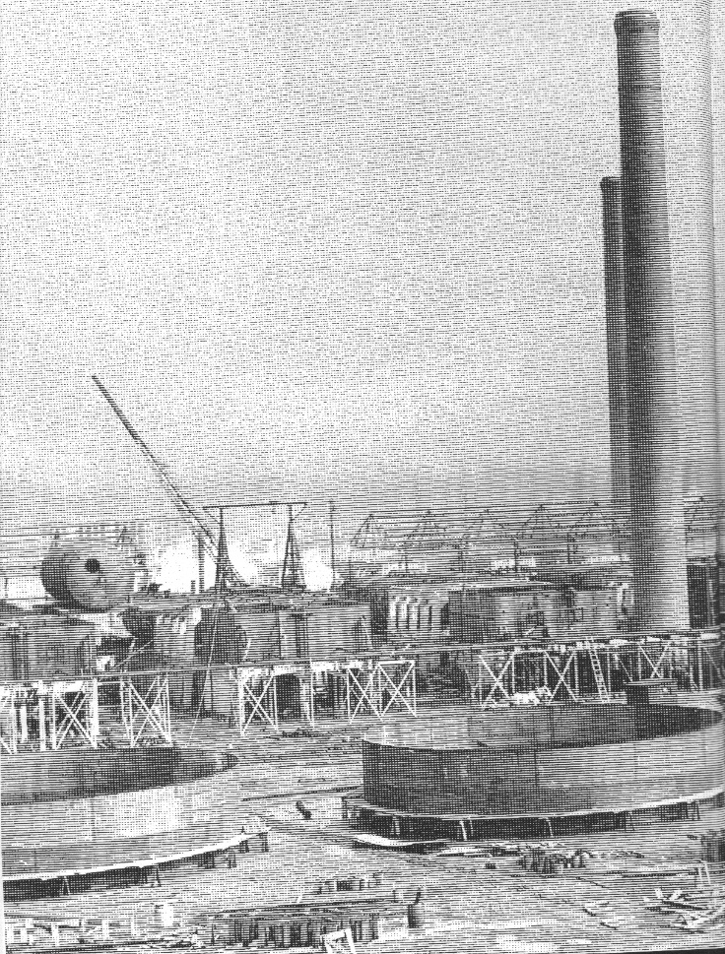

Table of Contents

Summary 3

The Roaring Twenties – The Refinery Growth Starts 3

Avgas Consumption Growth 3

Manufacturing Process 1920-1929 5

Thermal Cracking Unit 6

Alchlor Process 7

Oil Companies And Refineries 8

1928 American Oil Companies 10

US Refineries 11

World-Wide Refineries 1927 16

European Refineries 1927 18

North America (Excluding US) 21

South America & West Indies 22

Australia 23

References 29

# Summary

# The Roaring Twenties – The refinery growth starts

The Roaring Twenties - a period of development of specifications and fuel research, but also the expansion of the refining operations around the world.

This was a period in which the growth of the refining industry was needed to support the world demand for petroleum products.

# Avgas Consumption Growth

Aviation consumption in the US essentially doubled each year from 1926 to 1930, both in scheduled air transport and miscellaneous operations (until 1930 for the latter). Miscellaneous operations included such activities as experimental, exhibition, industrial, student instruction and pleasure flying. The data for the year 1930 is estimated from Jan-June 1930 data.

Graph . US Aviation Gasoline Consumption 1926-1930

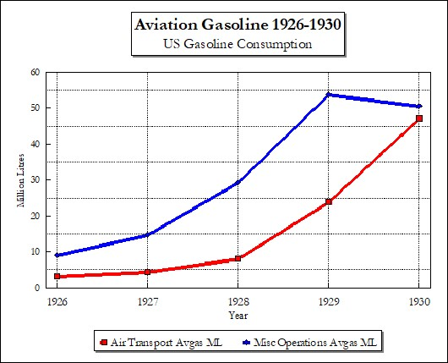

This graph illustrates the development and acceptance of scheduled air transport as a practical mode of transport, and also shows the increasing interest by the public in the aviation both in air shows and other pursuits. The decline in 1930 of miscellaneous aviation consumption may have been due to the start of the Great Depression of the 1930’s following the US Wall St. stock market crash of October 1929.

Photo . Phillips Petroleum Co. Air Service fuel truck operating in Wichita, Kansas. Walter Beech is standing next to the plane Travel Air 4000. (1928)[1]

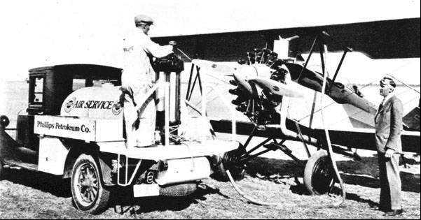

Photo . The Texas Company (Texaco) delivery wagon 1927.

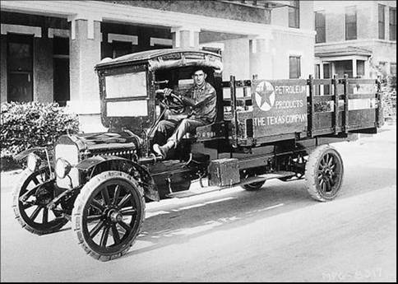

# Manufacturing Process 1920-1930

The primary refinery processes did not change significantly after the war years (First World War). Cracking and other processes were used to produce cracked gasolines which were also used for motor gasoline. The only new process development was the redistilling of naphtha to achieve the new demands and emerging aviation gasoline specifications. This was often done using steam stills to produce the desired gravity (and distillation end point).

While the aviation gasolines were straight run naphtha which had been redistilled (or ‘stripped’) using steam, by contrast the motor gasolines of the day were higher in density 0.747 to 0.763 and distillation end points of 225 to 232 degrees C. These motor gasolines were a mixture of casing-head or absorption condensate, refined ‘cracked’ gasoline and straight run gasolines.

During the period 1918 to 1929, aviation fuel manufacture was relatively simple for the refiner. Several similar methods were followed and consisted of:

1. Fractionation of a suitable boiling range naphtha from crude oil.
2. Fractionation or stabilisation of natural gasoline to correct the boiling range.
3. Fractionation of cracked gasoline to correct the boiling range, and blending it with straight run gasoline or natural gasoline.
4. Addition of benzol to suitably fractionated straight run gasoline.

During this time the cracking capacity of the refining industry increased enormously and most gasoline, whether aviation or motor, contained some cracked components. Those companies having natural gasoline plants also included as much natural gasoline as possible.

Since the principal qualification in the US was to meet the distillation range, almost any hydrocarbon mixture having the correct boiling range was suitable for aviation fuel. Gasolines from aromatic and naphthenic crude oils such as California, South Texas, or Venezuela, were premium fuels (as well as benzol blends) because their use apparently resulted in smoother running engines. This was especially true in the liquid (water) cooled engines. The British were still using their preferred East Indies production which contained high aromatic content aided by the addition of benzol.

During this period, studies on stability indicated that cracked gasoline blends contained components which formed gums and polymers during storage. They also imparted a peculiar “cracked odour” – probably from aldehydes components. (This stability problem was due to the unsaturated hydrocarbons such as Butenes, Pentenes and Hexenes which combine with each other and also with oxygen to form gums, polymers and other “sticky” components. Ironically, it would be these Butenes (and Propylene) which would become the chemical building blocks for Avgas 100 and synthetic Butyl rubber (SBR) during World War II.

In 1922 the US limited the use of cracked gasoline in aviation fuel by establishing a stability test (Copper dish gum limit) and an unsaturation percentage of 1 to 2 % maximum (percentage soluble in concentrated Sulphuric Acid). This almost eliminated cracked gasoline as a blending component for aviation fuels since almost all the unsaturated hydrocarbons in cracked naphthas are soluble in concentrated Sulphuric Acid. Thus, the manufacture of aviation gasoline reverted to fractionating straight run naphthas or blending straight run and highly treated cracked naphthas. This situation continued until 1929.

The best ‘pressure’ cracked gasoline tested required the addition of 5½ cc of Tetraethyl Lead per (US) gallon to equal California Fighting Grade (with 3 cc TEL/USG), and a vapour phase cracked gasoline needed 10 cc TEL/USG to equal the same standard. These cracked gasolines were considered satisfactory in stability when properly inhibited. Gum tests were conducted before and after ageing for two hours in an oxygen bomb with a steam bath at 100 deg. C (210 deg. F). This method was developed by the Standard Oil Company of New Jersey (Esso). It has been found that, in general, the straight run gasolines used by the US Air Corps was unaffected by the two-hour ageing test. Any gasoline which is apparently gum stable in storage will stand the two-hour oxygen bomb ageing test.

In the US although most of the large commercial users followed the US Government specifications, this was not universal and probably much of the aviation gasoline sold in 1928 and 1929 was material that would not pass the generally accepted specifications. This allowed for quite a variation in the quality of gasoline sold as aviation fuel.

# Thermal Cracking Unit

In the 1920’s there were a number of thermal cracking processes:

* Cross process
* Burton Process - developed in 1913 (refer to Chapter 1) by 1936 they had been superseded
* Tube and Tank Process
* Holmes Manley Process – in use at SOCAL Port Arthur Refinery
* Dubbs Process

Photo 4. Port Arthur Refinery Holmes-Manley Thermal Cracking Tanks 1920 - (Standard Oil Company of California refinery)

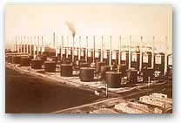

Dubbs Process

Universal Oil Products (UOP) was founded on June 17, 1914 as the National Hydrocarbon Company. At the time, the company’s only offering was the Dubbs Process for thermal cracking of heavy hydrocarbons to gasoline. The Dubbs process proved highly successful, and in the 1920’s-30’s was soon employed in more than 250 units operating in the United States and 18 foreign countries. These units helped provide gasoline to fuel the ever-increasing number of automobiles being built in the early 20th century. Some were still in operation in the 1940’s, however it would soon be superseded by the new cracker designs - TCC and FCC.

Photo 5. Dubbs Thermal Reforming unit (UOP).

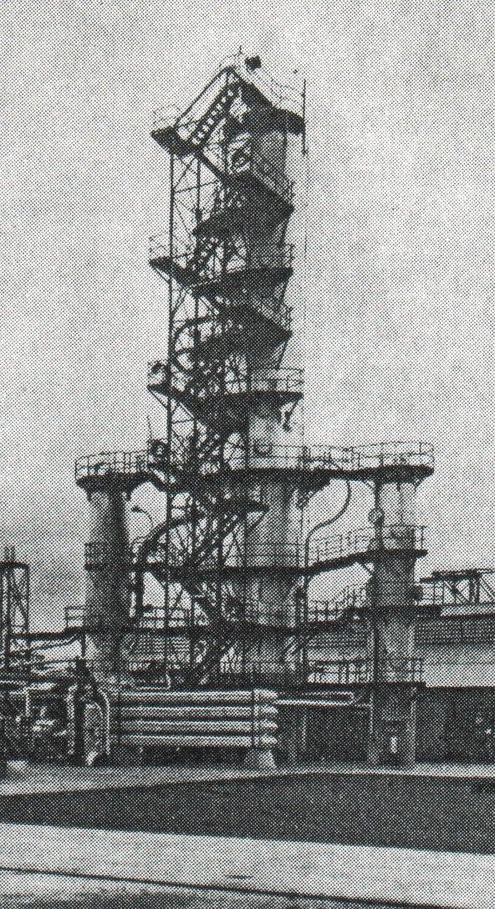

In 1930, the US the total cracking capacity was 1,720,000 barrels/day which comprised Burton Process (6.4%), Dubbs Process (13.1%), Tube and Tank Process (28.0%), Holmes-Manley Process (13.9%), Cross Process (15.7%); other thermal processes (22.9%).

# Alchlor Process[2]

In the 1920’s Dr. Almer McDuffie McAfee of Gulf Oil developed process for manufacture of cheap aluminium chloride. Bauxite (Aluminium ore) was mixed with refinery coke and cooked in a revolving tubular oven at 1,800 deg. F (982 deg. C). The resultant powder is poured into another oven (vertical) where oxygen and chlorine are infused into it and cooked again at 1,600 deg. F (871 deg. C). Under these conditions the bauxite is chlorinated and passes off as vapour like fog, as it cools it becomes an orange–yellow powder – Aluminium Chloride.

Gulf spent $1 million on these experiments. At the beginning aluminium chloride cost US$1.50/pound ($3.30/kg), when Gulf had finished it could make it at less than US$0.05/pound ($0.11/kg). This cheap aluminium chloride was to be used in the development of a new catalytic cracking process for the manufacture of gasoline.

“No-Nox Gasoline”

During the 1920’s Gulf had built at their Port Arthur Refinery some twenty-seven 1,000 barrel stills and three at Fort Worth (Texas) for the purpose of cracking high boiling oils with Aluminium Chloride into gasoline, which was marketed as “No-Nox Gasoline”. (In those days the term ‘octane’ number rating was not yet known and the antiknock properties of TEL had not been recognised).

Gasoline made by the aluminium chloride process was water-white, sweet smelling and had superior antiknock properties. Gulf was thus the first by many years to produce and sell gasoline made by catalytic cracking.

During the 1920’s, however there was steady improvement in the methods of thermally cracking oils into gasoline, and a constant expansion of this process in the whole petroleum industry. By 1929 the costs involved with the use of thermally cracked gasoline had been so reduced that Aluminium Chloride gasoline could not compete, particularly in view of the fact that the use of tetra-ethyl lead as an anti-knock agent had developed.

The other use to which Gulf put aluminium chloride in 1929 was in the manufacture of premium grade lubricating oils. By 1927 automobile engines had been so improved in respect to high compression and high speed that superior lubrication oils were required and Gulf started making Gulfpride oils by the Alchlor process. By 1929, when aluminium chloride had ceased in the gasoline manufacture, the quantity required for Gulfpride oils comparatively small, hence Gulf had excess aluminium chloride on hand – this was sold.

By 1929 aluminium chloride appeared to have passed its peak of petroleum usefulness, however when World War II made unprecedented demands on 100-octane gasoline, it demanded quantities of isobutane for the manufacture of high octane blending components. Isobutane was in short supply, but not n-Butane. Aluminium chloride was used to convert n-Butane into Isobutane.

# Oil Companies and Refineries

At this time Aviation Gasoline was intermingled with motor gasoline particularly at the start of the decade, so in order to provide more background unless specifically identified, the following information relates to gasoline in general.

One of the major developments in this period was the direct involvement of the oil companies with aviation. This was illustrated by many of the companies employing former aviators in variety of jobs and also purchasing their own company plane. One of those leading the drive was the Standard Oil Company of California (later to be Chevron) as noted in their company magazines of the time. In 1926, when Chevron was The Standard Oil Company of California, the company cooperated with the Army Air Service to help mark the airways of the Pacific Coast.

Photo 6. Cover of Standard Oil Bulletin January 1926

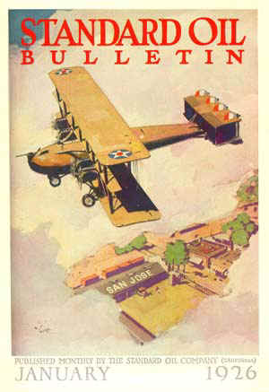

This picture shows a Standard Oil bulk-storage distribution centre in San Jose, California, with a sign on the roof to help pilots navigate. The company painted block letters, a minimum of twelve feet tall, on roofs in over 100 cities from Seattle to San Diego, visible from 3,000 feet up in good weather.

Signs like this were an important help to early aviators, who navigated with nothing but a crude map, a compass, and a good memory for landmarks. Standard Oil received so many thanks for the signs -- from the Navy, the Postmaster General, and numerous flying clubs and air transport businesses -- that the company decided to paint more.

"As aviation develops and flying becomes general -- which experts say is a day not far off - there will be still more air-signs, until it is likely that in the future all of the Company's 650 stations will be marked." (Standard Oil Bulletin, January, 1926)

"Today, for the first time, the population of the United States stands squarely behind aviation, and is watching with keen interest and unbounded enthusiasm its every forward move and turn. And there is a great deal to watch. So fast is aviation news being made that a chronicle of current events in the Pacific West states, if set down here, would in all likelihood be largely ancient history by the time it reached its audience." (Standard Oil Bulletin, August, 1927)

The role of the oil companies is discussed in previous chapters.

Some of the other US oil companies and refineries of this period were listed in the Aircraft Year Book 1928[3] which stated:

Fuels & Lubricants - Commercial aviation owes a debt to the big oil companies of the century for the very practical support that they are giving to commercial aviation.

Gulf Refining Company of Philadelphia

Kendal Refining Company of Bedford Pennsylvania

Standard Oil Company of Indiana

Standard Oil Company of New Jersey

Texas Company of New York

Vacuum Oil Company of New York

Wolverine Lubricants Company of New York,

All heavy producers of aviation fuels and lubricating products, are among the companies rendering excellent service in an educational and practical way for the advancement of flying.

1928 - Richfield Oil Company of California set out to develop a market for its aviation fuels and lubricants and commenced using planes for transportation and demonstration purposes.

# 1928 American Oil Companies[4]

The Wall Street Journal of 1929 listed comments on the US Oil companies of the day; perhaps surprising was that in fact a non-US oil company, Royal Dutch Shell was the world’s biggest producer of crude oil in 1929. It produced 54.4 million barrels compared with 51.7 million barrels produced by the Standard Oil Company of New Jersey. The Wall Street Journal assessment of the oil companies was as follows:

**Standard Oil Company of New Jersey** (later to be Exxon Corporation) - “The Leader in Oil”

**Royal Dutch Shell Group** - “Operations extend all over the world”

**The Texas Corporation** - “The Leading (US) Independent” (17 refineries), (later to be known as Texaco)

**Standard Oil Company of California** (later to be Chevron Corporation) - “A self-contained unit”

**Standard Oil Company of New York** (later SOCONY would merge with Vacuum to become the Mobil Corporation) - “Socony - A household word”

Standard Oil Company of Indiana - “one of the highly profitable units”

**Sinclair Consolidated Oil** - “Extension of markets at home (US) and aboard” (8 refineries).

**Humble Oil & Refining Company** - “huge new investment in past 10 years (1918-1928)”

**Shell Union Oil Corporation** - “Big strides in 7 years (1921-1928)”

**Vacuum Oil Company** - “Earnings gain constant”

**Gulf Oil Corporation** - “Mellon family leading factor”

In 1928 the American Petroleum Institute, Division of Public Relations published “Petroleum Facts and Figures” – this publication listed the status of the oil industry around the world. The following is presented as a brief summary of the situation then (1928) with particular reference to refineries and aviation gasoline usage in the US. The information highlights the large number of companies and governments involved in refining. Additional information has been drawn from The Independent Petroleum Association of America, Tulsa Oklahoma – Bulletin No. 13 “Dutch-Shell, Anglo-Persian, Burmah Oil” by Charles E Bowles - circa 1929.

There were a number of American companies operating abroad in exploration and development. Refining operations of American companies abroad were largely confined to Mexico, Columbia and Peru, although several American controlled refineries in Europe and one in Dutch East Indies. (Standard Oil Company of New Jersey).

Standard Oil Company of New Jersey (Esso later Exxon)

Standard Oil Company of Indiana (Amoco)

Gulf Oil Corporation

The Texas Company (Texaco)

Standard Oil Company of California (Chevron)

Standard Oil Company of New York (later to become part of Mobil)

Sinclair Consolidated Oil Corporation

Pure Oil Company

Atlantic Refining Company

Union Oil Company of California

Marland Oil Company

Pan-American Petroleum & Transport Company

Lago Oil & Transport Corporation

Tide Water Associated Oil Company

Sun Oil Company

Transcontinental Oil Company

Vacuum Oil Company (later to become part of Mobil)

Beacon Oil Company

California Petroleum Corporation

Amerada Petroleum Corporation

# US Refineries

While the US oil industry had its beginnings in Pennsylvania, it would be the states of Texas, Oklahoma and California where the major development would occur.

The Texas Company had some 17 refineries mostly in California (3), Texas (6) and the rest located in Wyoming, Montana, Colorado and Oklahoma.

Sinclair had 8 refineries located in Kansas (2), Oklahoma, Texas, Indiana, New Jersey and Louisiana.

Royal Dutch Shell had some 8 refineries totalling 228,000 Barrels per day with 113,500 barrels per day cracking capacity mostly in California and Mississippi Valley.

Table . Royal Dutch Shell US Refineries 1929[5]

|  |  |  |  |
| --- | --- | --- | --- |
| State | Location | Crude Capacity  Barrels per day | Cracking Capacity  Barrels per day |
| California | Martinez | 100,000  (Total California) | 54,000  (Total California) |
| California | Watson |
| California | Coalinga |
| Kansas | Arkansas City | 20,000 | 9,000 |
| Illinois | Wood River | 46,000 | 20,500 |
| Indiana | East Chicago | 27,000 | 10,000 |
| Texas | Houston | 20,000 | 10,000 |
| Louisiana | Sellers | 15,000 | 10,000 |

The refinery capacities were now (1929) around 15-65,000 barrels per day, compared with the small throughputs <1,000 Barrels per day, some ten years earlier.

The Rockefeller Empire of Standard Oil Companies, which had been broken up by the US anti-trust laws, were also part of this expansion. One of these was Standard Oil Company of California (later Chevron) which built its Richmond Refinery, San Francisco in 1901 processing San Joaquin crude; by 1921 it was operating at 65,000 barrels per day [6]. The process comprised a number of batch stills.

Other Standard Oil Company of California (Chevron) refineries were El Segundo Refinery and Bakersfield Refinery - all used Californian crudes and produced kerosene and lubes.

In California, San Diego was the general supply and repair base for all Air Service activities west of the Rocky Mountains including the Philippines and Hawaii and (Panama) Canal Zone.

Photo 7. Standard Oil of California – Richmond Refinery September 1920

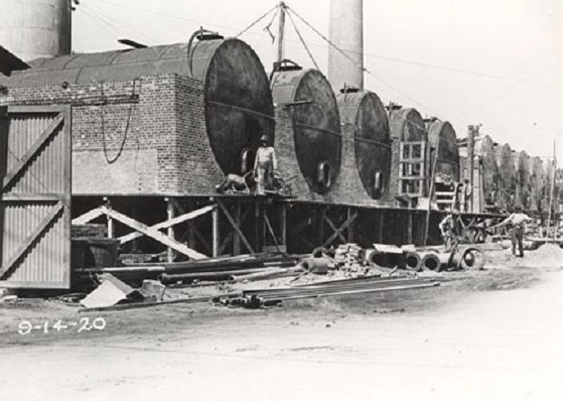

Photo 8. Standard Oil of California El Segundo Refinery circa 1913.

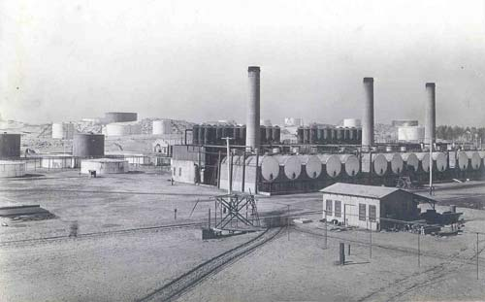

Union Oil Company of California

“The fabulous life and times of Union Company of California, and The Pure Oil Company” details the history of these two companies.

Union Oil Refineries

Unocal[7] was founded on October 17, 1890, when it was incorporated in Santa Paula, California, as the Union Oil Company of California. The company was formed by the merger of co-founders Lyman Stewart, Thomas Bard, and Wallace Hardison's holdings. Union Oil moved its headquarters to Los Angeles in 1901. The company expanded to national status in 1965, when Union Oil merged with the Pure Oil Company of Illinois. Over the next two decades, Union became the major oil producer in southern Alaska and a major natural gas producer in the Gulf of Mexico. The company was reorganized in 1983 and the Union Oil Company of California became an operating subsidiary of a new holding company, Unocal Corporation.

In 1928 Union Oil refineries were:

Oleum Refinery, San Francisco 48 MBSD

Los Angeles Refinery, Los Angeles, California opened in 1917, by 1996 this was 106.5 MBSD refinery.

Smith’s Bluff Refinery, Nederland, Texas 88.5 MBSD

Santa Maria Refinery (near Avila), California

Union Ethyl gasoline entered the marketplace April 1927.

Rocky Mountain Refinery 1904 Cut Bank Montana (old refinery)

Pure Oil Company

In 1927 Pure Oil Company of Illinois introduced Pure Gasoline “Detonox”. In 1925 Pure Oil had been associated with aviation when “Purol” and “Tiolene” was supplied to most contestants on the Pulitzer Air Race at Mitchell Field, Long Island, New York. “Woco-Pep” was a blend of gasoline and benzol from Woffard Oil Company Georgia and Alabama.

“Purol” aviation fuel was supplied to US Army Air Force as well as “Tiolene” Motor Oil.

Phillips Petroleum[8]

Phillips Petroleum was founded in 1917, first gas liquids plant opened. In 1920 they began research on gas processing plant techniques. In 1923 the Company won the first patent on process for recovering natural gasoline from natural gas, and by 1925 their Research and Development Group was formed under George Obefell. This group would be responsible for a number of significant contributions to aviation gasoline manufacture and petroleum testing - Frederick Frey - inventor of alkylation process, and Walter J. Podbielniak - POD Apparatus. [Standardization of Low-Temperature Fractionation-Analysis Apparatus and Method Using Automatic Recording and Control – this apparatus would be used by every refinery laboratory].

Phillips Petroleum would become one of the major aviation gasoline producers and innovators.

In August 1927 a new lighter, more efficient Phillips aviation fuel was used to power the first flight between the US mainland and Hawaii. The flight was from Bartlesville, Oklahoma, USA to Hawaii using Phillips “Nu-Aviation” Gasoline (and Mobiloil B); it flown by Art Goebel (Hollywood stunt pilot) in a Fokker C2 “Bird of Paradise”.

By 1928 Phillips had developed the first aviation refuelling trucks.

In 1930 Phillips introduced its Phillips 77 Aviation fuel which was detailed as:

Page 41 Poster October 1930 Oil & Gas Journal No. 7

Petroleum Age November Advert No. 789

“Phillips 77 Aviation used for (1) Aviation Gasoline (2) A Premium Motor Fuel (3) Blending.

Gravity 75-79 API

Distillation -Initial boiling point 95-100 deg. F (35-38 deg. C)

83% or more at 212 deg. F (100 deg. C)

End point 350 deg. F, or lower (<177 deg. C)

Recovery 98%

Natural gasoline for controlled volatility

Phillips Petroleum Company - Bartlesville Oklahoma Minneapolis, Minnesota”

Some of the lesser known oil companies would merge to become brands in the US such as Conoco.

Willie Cry Refinery - Conoco

The refinery was started in 1918 by E. W. Marland as a small skimming plant designed to produce gasoline and kerosene after Marland discovered oil on the Willie Cry lease southwest of Ponca City. In 1920, lubricating oil was added to the product slate, and other process units were installed to help refine heavy oils. The 1929 merger of Marland Oil Company and Continental Oil Company brought a gradual replacement or enlargement of most of the original buildings and units.

Photo 9. Marland Oil Company Refinery

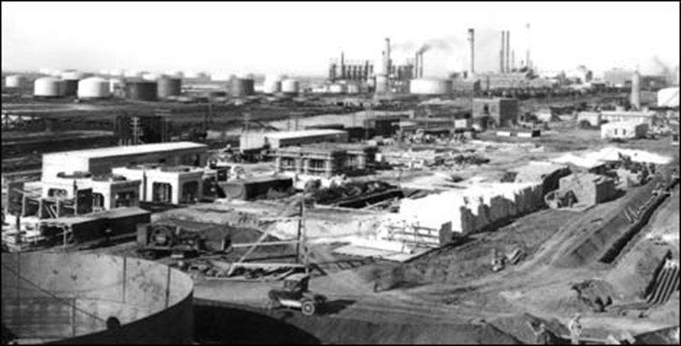

1928 Foreign (Non-US) Oil Companies[9]

The two principal foreign oil (non-US) companies of the time were the Royal Dutch Shell and Anglo-Persian Oil Company (later to become British Petroleum - BP). Royal Dutch Shell produced oil in Dutch East Indies, Sarawak (British Borneo), Rumania, Egypt, Venezuela, Trinidad, Mexico, Argentina, and the US. In 1925, 5.5% total US output from Royal Dutch Shell Refining and marketing operations was world-wide.

Anglo-Persian Oil Company - the principal oil source (1926) was Persia. By 1929 this company had refineries in Persia, England, Scotland, Roumania, France and Australia (C.O.R. Laverton). It marketed petroleum products in throughout Europe, Near East, and Australia.

Background on Non-US Oil Companies

The significant oil companies outside the United States were Royal Dutch Shell and Anglo-Persian and to a lesser extent Burmah Oil Company. In 1929 there was interlocking stock ownership through interlocking directorships, thus these three companies can be considered a “Triumvirate of Non-US Oil Power”. In order to understand the complex nature of the oil industry the following is a very brief outline of the origins of each (as described in 1929)

* Burmah Oil Company, organised in 1886, reconstructed in 1902. With Concessions Syndicate Ltd. and Lord Strathcona, was the original holder of Persian oil concessions granted May 28, 1901. Principal operations in 1929 were in Burmah (British India).
* Anglo-Persian Oil Company organised April 14, 1909 to acquire from Burmah Oil, Concessions Syndicate Ltd. and Lord Strathcona the Persian concession granted May 28, 1901.
* Royal Dutch Company organised in Holland in 1890 to operate oil interests in Dutch East Indies.
* Shell Transport and Trading organised in England in 1897 to operate in oil between the Dutch East Indies and Great Britain.

Royal Dutch Company and Shell Transport & Trading merged in 1907 as Royal Dutch Shell, and two new companies were formed: the “Bataafsche Petroleum Maatschappij” in Holland and the “Asiatic Petroleum Company” in England. Bataafsche Petroleum Maatschappij was the operating company and Asiatic Petroleum was the marketing company - the two parent companies became the holding companies, Royal Dutch Company held 60% of both Bataafsche Petroleum Maatschappij and Asiatic Petroleum, while Shell Transport & Trading held the remaining 40%.

The Consolidated Petroleum Company was formed October 17, 1928, to take over the entire distributing organisations of both the Asiatic Petroleum Company and the Anglo-Persian Oil Company in South and East Africa, Egypt, Sudan, Palestine, Syria and the Red Sea and Ceylon (Sri Lanka) territories. This company was formed by the Asiatic Petroleum Company and equal shares were held by Anglo-Persian and Asiatic Petroleum.

The British Government owned 55.9% of the common stock of Anglo-Persian Oil Company and had the controlling interest.

Burmah Oil Company was also a shareholder in Anglo-Persian, Shell Transport and Trading and also the United British Oilfields of Trinidad, and an interest in a syndicate in Hungary.

World-wide Refineries 1927[10]

The refineries around the world in 1927 were in some cases small and usually located close to crude sources, some were government controlled as in Egypt, and others had part government ownership or involvement as in the Dutch East Indies (now Indonesia).

Each refinery in the general vicinity of the crude oil concession and producing wells, was operated by the same controlling interest. The other feature was the involvement of a number of US, Canadian, British and Dutch oil companies in the refining activities around the world at this time – 1928.

However, the two major non-US players were Royal Dutch Shell and Anglo-Persian (British Petroleum). Worldwide the Shell Company had 43 refineries with a total capacity of 808,024 barrels per day and 113,500 barrels per day cracking capacity (plus 2 Cross and 38 Dubbs Cracking Units); while Anglo-Persian had only 12 with a total capacity of 191,400 barrels per day and 19,600 barrels per day cracking capacity (plus 6 Cross, 4 Dubbs and 2 Gray Cracking Units). These two companies controlled some 58% of the total refining capacity outside the United States – Royal Dutch Shell alone controlled nearly 47% of this refining capacity, clearly there were in a dominant position.

Egypt

Egyptian Government Refinery had a capacity of 11,400 tons/year.

Shell Refinery at Suez had a capacity of 16,000 barrels per day.

East Indies – Refineries: Sumatra (5), Java (4)

Topping plant Boela Bay on the Island of Ceram (1)

* Bataafsche Petroleum Maatschappij (a subsidiary of Royal Dutch Shell) either operated or controlled (7 refineries) - Sumatra (4), Java (2) with Balikpapan (Dutch East Borneo) the largest refinery in East Indies. Capacity of Shell operated refineries in Sumatra was 43,000 barrels per day, in Java they were only 8,000 barrels per day, and even less at Ceram 800 barrels per day.
* Nederlande Koloniale Petroleum Maatschappij (The Dutch Colonial Company) (with interests by Standard Oil Company of New Jersey) operated:

Soenei-Gerong, near Palembang - Southern Sumatra;

Kapoean - Samarang district in east central Java - Small refinery.

* Algemeene Petroleum Company, Klantoeng, near Klantoeng-Sodjomerto concession in Java.

**Sumatra Crudes**: Nearly all the Sumatra crudes are especially rich in light products and generally have little or no paraffin.

**Java Crudes**: Yielded little ‘benzine’, (probably this is meant to be gasoline). Some crude oils do not contain kerosene; others are of a strong paraffin base.

The factories at Java and Borneo put a large quantity of paraffin wax on the market. High melting point Borneo paraffin.

**Borneo & Sarawak**

Refineries: Borneo (1) Sarawak (1) were controlled by Royal Dutch Shell, total capacity was 50,000 barrels per day.

**Borneo Crudes**: vary considerably in composition, even in the same field. The product range at this time (1928) was Gasoline, Kerosene, Terpene, Fuel Oil, Asphalt, Lubricating Oils, Greases, as well as paraffin.

Figure . Refineries in Dutch East Indies 1922.

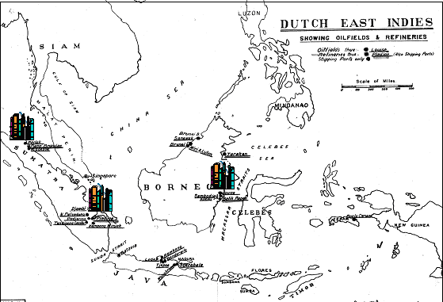

India (& Burma)

There were 9 refineries in the then British India region with a total capacity of 28,850 barrels per day, of which three were operated by the London based Burmah Oil which operated in the region and enjoyed a monopoly in Burma – the only oil producing region in India. The largest was 16,500 barrels per day refinery at Syriam, Burma while at Digboi, India there was a 5,000 barrel per day refinery; and at Badarpur a refinery of only 275 barrels per day.

Burmah Oil only had one Dubbs Cracking Unit. The two larger refineries would play an important role in supplying the R.A.F. east of Suez when the Japanese invaded the Dutch East Indies in 1942.

Persia (Later Iran)

* Abadan Refinery operated by Anglo-Persian Oil Company (later BP) is located on Persian Gulf. The crude source is in the district around Masjid-I-Sulaiman in the south-west of Persia (Iran). Products - Output of refined products 2,950,000 tons (year ending March 1926). The product range was Kerosene, Benzine (Gasoline), Fuel Oils. By 1929 the capacity was listed as 100,000 barrels per day which made it one of the larger refinery operations in the world at that time.
* A small refinery at Khanikin, close to Persian-Iraq border, was operated by Khanaqin Oil Company (subsidiary of Anglo-Persian Oil Company), there were no other details. This was possibly the Anglo-Persian Refinery at Alwand Iraq which had a capacity of 2,000 barrels per day.

Photo 10. RAF Fairey IIID of No. 47 Squadron in Baghdad 1930

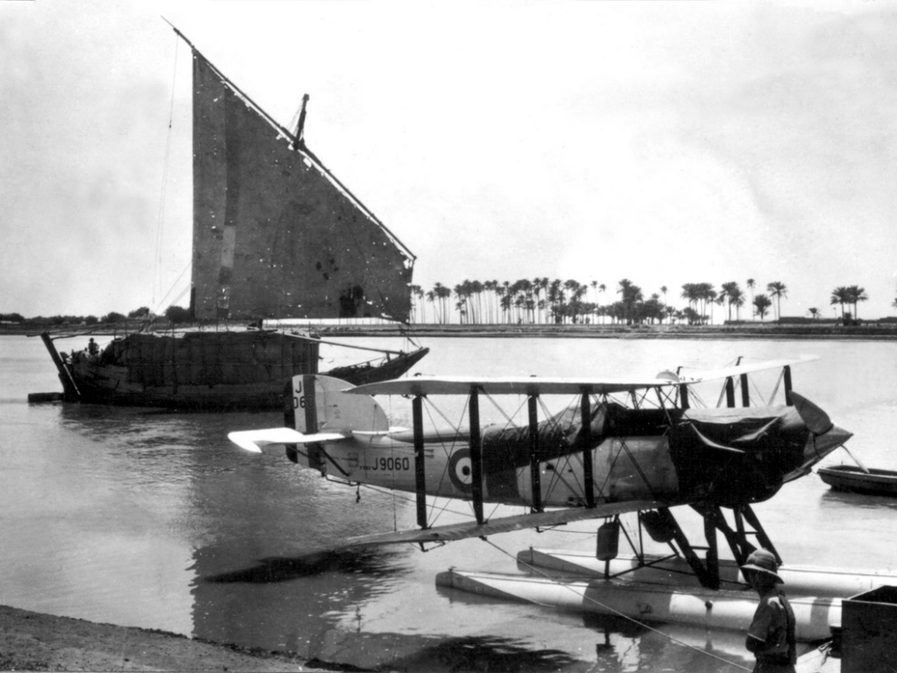

European Refineries 1927[11]

The information on refineries in Europe was limited in this 1928 survey and identified refineries as follows: Austria (3), Belgium (1), Czecho-Slovakia (11), France (10 - limited information), Germany (approximately 18), Italy (1), Norway (1), Latvia (1), and some information on the major producers in Rumania and Poland. However there was considerable detail on Great Britain.

Great Britain

The petroleum refining industry in Great Britain, with the exception of shale oil refining, was almost entirely a post-war (WWI) development, having grown with rapidity and success. It was already a comparatively large industry, an important factor in national trade, and was growing. Some idea of the growth of petroleum refining in Great Britain may be gained by a comparison of the statistics of crude oil imports, there being practically no domestic output of crude oil aside from that obtained by the distillation of shale oil. In 1913 only 31,700 barrels of crude oil were imported, while in 1925 the total receipts amounted to 16,046,300 barrels, or more than five hundred times the 1913 figure, and imports during 1926 were about the same as in 1925. The principal growth had taken place in the last six years, the first large increase in refining having been in 1921.

The growth of the industry may also be shown by the size of the domestic market for petroleum products, which had been supplied by the local refineries. In 1921, the first year of refining on a comparatively large scale, less than 10% of the total domestic consumption of petroleum products (including bunker oil), was supplied by domestic refineries. In 1925, with the increase in total consumption of about 45%, imports of refined petroleum products had actually declined, and the domestic industry was supplying 28% of the total demand. The principal products manufactured had been gasoline and fuel oil, with a fair output of kerosene and some other products. The local manufacture of lubricating oils was still small, but an increase in the domestic supply of these products was to be expected in the near future. [In this post World War I period the British Navy was perhaps the most powerful navy in the world and therefore defending the British Empire around the world required substantial fuel oil supplies].

Petroleum refining in the United Kingdom at this time was an outstanding example of the development of the industry in a country having no commercial production of crude petroleum of its own. The United Kingdom (in 1928) was the world’s second largest petroleum consuming country. In the British industry, long distance transportation of crude oil had been necessary. The bulk of the raw material had come from foreign countries, although chiefly from production under control of British companies.

Information from the petroleum department of the (UK) Board of Trade provided by the oil companies showed the total output from UK refineries including cracking plants was:

Table . UK Petroleum Production 1925 & 1926

|  |  |  |  |  |
| --- | --- | --- | --- | --- |
| **Throughput** | **1926** | **1925** | **1926** | **1925** |
|  | KL/day | KL/day | BSD | BSD |
| Crude | 7,179 | 7,449 | 45,153 | 46,851 |
| Shale Oil | 496 | 625 | 3,122 | 3,933 |
| **Output** | | | | |
| Motor Spirit | 2,159 | 2,226 | 13,578 | 14,001 |
| Other Spirit | 177 | 95 | 1,116 | 595 |
| Kerosene | 793 | 946 | 4,984 | 5,950 |
| Gas Oil | 359 | 364 | 2,255 | 2,287 |
| Lubricating Oil | 102 | 79 | 638 | 496 |
| Fuel Oil | 3,315 | 3,834 | 20,849 | 24,112 |
| Other Liquid products | 2 | 0 | 10 | 1 |
| **Total Liquid products** | **6,906** | **7,543** | **43,432** | **47,440** |

The major refineries were:

* Llandarcy Refinery (Wales) (near Swansea) 15,000,000 Bbls/year (Anglo-Persian Oil Company) – nominal capacity 40,000 barrels per day.
* Grangemouth Refinery (Scotland) 3,000,000 Bbls/year (Anglo-Persian Oil Company) – nominal capacity 20,000 barrels per day. There were other smaller refineries operated by Anglo-Persian Oil Company in Scotland – Uphall 2,500 barrels per day, Pumpherston and Oakbank 3,000 barrels per day.
* Frawley Refinery 2,000,000 Bbls/year (Agwi Petroleum Corporation, later to become an Esso Refinery).
* Shell Haven Refinery (near London) nominal capacity 7,000 barrels per day, or 2,000,000 Bbls/year (Shell-Mex).
* Shell Stanlow Refinery (near Chester) nominal capacity 4,000 barrels per day, or 500,000 Bbls/year (Shell-Mex). [This refinery would play a significant part in UK avgas production in the Second World War.]
* Shell Ardrossen Scotland Refinery nominal capacity 2,000 barrels per day.
* Thames Haven Refinery 5,000,000 Bbls/year (London & Thames Haven Oil Wharves Ltd.).

France

There were some 10 refineries in France. Shell had a refinery at near Rouen of 7,700 barrels per day, while Anglo-Persian has a 40,000 barrel per day refinery near Paris.

Not to be left out, in 1929 Vacuum Oil Company crossed the Atlantic to France to build a new refinery for Vacuum’s French affiliate, Raffineries de la Vacuum Oil Company, at Port Jerome, near Gravenchon on the Seine River midway between Le Havre and Rouen. The plant was intended to provide high grade lubricants to France and neighbouring countries, and was also expected to produce a considerable amount of light products such as gasoline and fuel oil from its daily throughput of 5,000 barrels. It was brought on stream in 1934 in the middle years of the Depression and gave employment to 600 people.

Hungary

There were six refineries - Combined capacity 162,000 tons/year. Shell had a refinery at Budapest of 1,700 barrels per day.

Poland

In Poland there were 35 refineries with capacities ranging from 240,000 metric tonnes/year at the Polmin (Government) refinery at Drohobycz, to small refineries of 4,800 Tonnes/year. The Nobel Bros. Refinery of 62,000 metric tonnes/year was part of Standard Oil Company of New Jersey, and Vacuum Oil Company had a 100,000 tonnes/year refinery at Czechowice.

Rumania

Even since the discovery of oil in the region, Rumania had been an important supplier of petroleum products with some 33 leading refineries with a total capacity 4,685,900 tons/year, and together with 20 smaller refineries of total combined capacity 15,000 tons/year.

One of the major locations was at Ploësti where there were 9 refineries (including the two largest were Vega 648,000 tons/year, and Astra Romana 540,000 tons/year). Shell Ploësti Refinery had a capacity of 16,000 barrels per day. Anglo-Persian Oil Company had refineries at Campina (20,000 barrels per day), Moinesta (1,200 barrels per day), and Arbanasi (400 barrels per day). Some 20 years later (in 1944) these refineries would come under constant air attack from the RAF and US Army Air Force.

Russia

With Russia now under the Communist rule following the Revolution ten years earlier, there was little information available to rest of the world. It was known that there were four principal trusts to operate the petroleum industry and that the gross output of oil and gasoline was 7,081,600 tons/year (1925).

# North America (excluding US)

Outside of the United States the other significant refinery production in North America was in the regions of Canada and Mexico.

Canada

There were 15 refineries however the refinery capacity in Canada was dominated (some 81%) by Imperial Oil Ltd, which was a subsidiary of the Standard Oil Company of New Jersey (Esso, later Exxon).

Table . Canadian Refineries 1928

|  |  |  |  |
| --- | --- | --- | --- |
| Company | Location | Province | BSD |
| Imperial Oil Ltd. (Esso) | Calgary | Alberta | 5,000 |
| Imperial Oil Ltd. (Esso) | Ioco | British Columbia | 8,000 |
| Imperial Oil Ltd. (Esso) | Sarnia | Ontario | 10,600 |
| Imperial Oil Ltd. (Esso) | Montreal East | Quebec | 17,000 |
| Imperial Oil Ltd. (Esso) | Regina | Saskatchewan | 5,500 |
| Imperial Oil Ltd. (Esso) | Dartmouth | Nova Scotia | 8,000 |
| British American Oil Company Ltd. | Toronto | Ontario | 3,000 |
| Canadian Oil Cos. Ltd. | Petrolia | Ontario | 1,170 |
| McColl Bros. | Toronto | Ontario | 1,500 |
| North Star Oil & Refining Company Ltd. | Winnipeg | Manitoba | 250 |
| Alberta Refineries Ltd. | Edmonton | Alberta | 300 |
| Invincible Oil Ltd. | Wainwright | Alberta | 100 |
| Standard Refining Company Ltd. | Lethbridge | Alberta | 50 |
| Union Oil Company of Canada | Port Moodie | British Columbia | 500 |
| Frontenac Oil Refineries Ltd. | Montreal East | Quebec | 5,500 |

Mexico

In Mexico there were 19 refineries of which 8 are topping refineries - the total capacity 268,042 barrels per day, and 6 complete refineries were producing by-products such as lubricants, paraffin, gasoline, etc. with a total capacity of these 192,285 barrels per day. Total capacity of all 19 plants was 461,390 barrels per day.

The largest refinery was Compañía Mexicana de Petróleo El Águila at Dona Cecilia in the state of Tamaulipas with a capacity of 113,220 Barrels per day. The other major operations were the topping and gasoline plant 139,927 and 149,922 barrels per day at Huasteca Petroleum Company, Pueblo Viejo in the state of Vera Cruz.

Dutch-Shell has several plants with an estimated total capacity of 120,000 barrels per day.

# South America & West Indies[12]

There were a number of state-owned refining companies throughout South America and the West Indies, together with some owned by the major oil companies of the day. The most important by far was the Dutch West Indies which was later to play a significant role in maintaining supplies of British aviation gasoline and other petroleum products during World War II.

Argentina

Refineries (6) – the largest was the government operated National Refinery at La Plata 2000 metric tons/day (10,000 Barrels per day).

Columbia

There is one refinery operated by the Tropical Oil Company (International Petroleum Company of Canada) located in Barranca Bermeja, which had a capacity of 6,000 Barrels per day.

Ecuador **-** Four small refineries

Peru

The refinery of the International Petroleum Company Ltd. of Canada at Talara had a capacity of 15,000 barrels per day. The locally refinery at Zorritos had a capacity of 1,000 barrels per day.

Cuba

The refinery of the West India Oil Company located at Havana had a capacity of 2,000 barrels per day.

Venezuela (and Dutch West Indies)

At San Lorenzo, on the east shore of Lake Maracaibo, Venezuela, the Royal Dutch Shell Company had a 20,000 barrel per day refinery, and since there were only about 20,000 motor vehicles in all of Venezuela, the refinery had a substantial export surplus of refined products.

On the Island of Aruba just off the Venezuela coast was the Shell Refinery at Druif with a capacity of 17,500 barrel per day of which all the refined product was for export.

On the Island of Curacao at Willemstad was the refinery operated by Curacaosche Petroleum Industrie Maatschappij (Royal Dutch Shell subsidiary). It operated on Venezuelan crude and had a capacity of up to 250,000 Barrels per day – by far the largest refinery in the world at this time. The total capacity from Shell operated refineries in this area was 287,500 barrels per day with 6 Dubbs Cracking Units installed and a further 8 Dubbs Cracking Units being installed, and 2 Cross Cracking units installed. In 1929 Royal Dutch Shell imported 3-500,000 barrels of gasoline into the United States; about 626,000 barrels came in at New Orleans, and the remaining 2,871,000 barrels at different ports along the American Atlantic seaboard. These refineries were to become a major supply of aviation gasoline for the British during the Second World War.

Trinidad

Dutch-Shell had a refinery at Point Fortin with a capacity of 5,000 barrels per day.

# **Australia**

It is unlikely that either of these refineries produced aviation spirit in the 1920’s because Australia was part of the British Empire and therefore followed the British Air Ministry specifications; and the Royal Dutch Shell and Standard Vacuum refineries of Borneo and Dutch East Indies were producing aviation spirit for the British RAF and exporting this product. The suppliers of aviation gasoline in Australia were Shell and Vacuum.

* Commonwealth Oil Refinery - Laverton, Victoria (Ownership Commonwealth Government & Anglo-Persian Oil Company (later BP), 90% of crude oil was from Persia (nominal capacity 2,700 barrels per day).

Table . C.O.R. Laverton Refinery Annual output 1928

|  |  |
| --- | --- |
| Product | Imp. Gallons/year |
| Gasoline | 6-6,500,000 |
| Kerosene | 12,500,000 |
| Fuel Oil | 15,000,000 |

This refinery operated from 1925 and was closed down in 1955.

* Clyde Refinery - John Fell & Company – Clyde, Sydney, New South Wales, Australia. The Clyde Refinery was originally established by John Fell and Company producing motor spirit, kerosene, tractor distillate and coke.

The throughput was 900,000 Imp. Gallons/month (4.1 M Litres/month, or 846 barrels/day). However after a disastrous fire in August 1927, the refinery was shut down; in 1928, it was bought by the Shell Company of Australia. The main unit then was a Dubbs thermal cracker, the first cracking plant in Australia; other units had been brought from shale oil refineries at Newnes and Torbane in New South Wales. Feedstock for the refinery was Tarakan (North Borneo) crude enriched with gasoline from the Pladju Refinery in Sumatra. The Dubbs unit was converted to a topping plant in 1928 when the refinery came on stream and by 1929 the capacity was 2,300 barrels per day. Throughout the 1930’s both production and the product range increased. In 1938 a new crude distillation unit was started up and the Dubbs topping plant closed down. Supplies of crude oil were cut off in January 1942, and refining virtually ceased until March 1946 when the Clyde Refinery was officially re-opened.

Photo 11. Vacuum Oil (Mobil) Yarraville Terminal garage– tradesmen repaint a wagon (circa 1930).

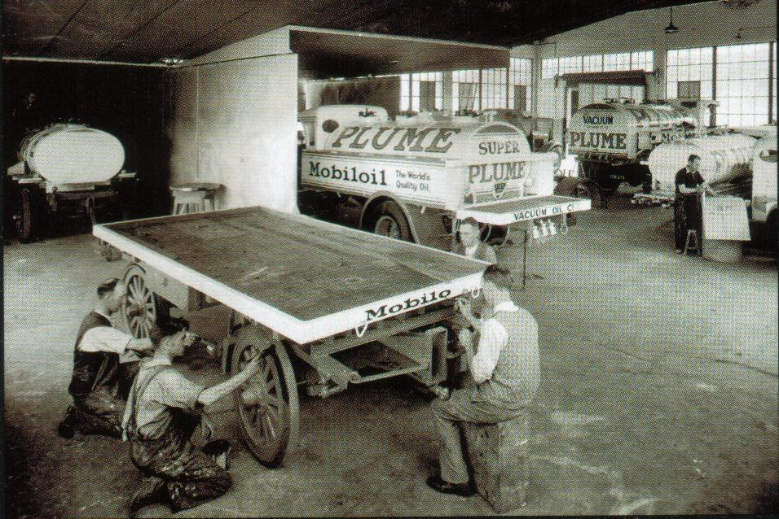

Photo 12. Shell ‘Chariot’ portable fill stand for motor spirit (circa 1924) on display at Shell Newport Terminal (2003).

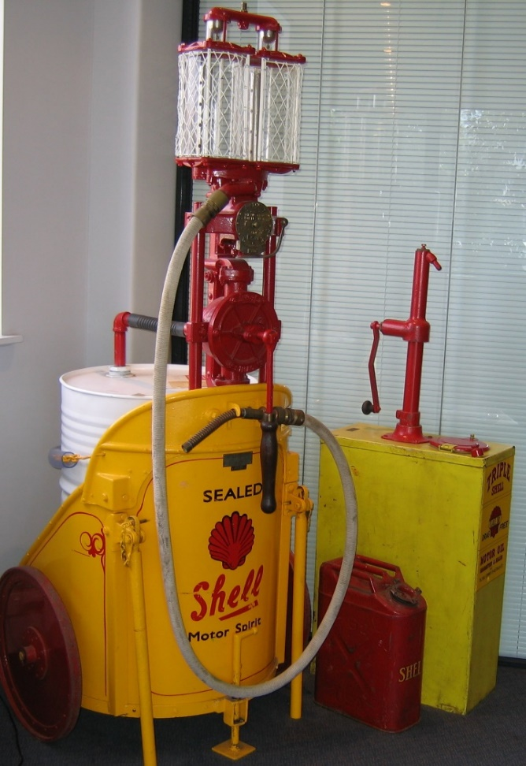

Index

1

100-octane gasoline 8

A

Abadan Refinery 18

Agwi Petroleum Corporation 20

Alabama 13

Alaska 13

Alberta Refineries Ltd. 21

Alchlor process 7, 8

aldehydes 5

Algemeene Petroleum Company 17

alkylation 14

aluminium chloride 7, 8

Aluminium ore 7

Alwand 18

Amerada Petroleum Corporation 11

American Petroleum Institute 10, 30

Amoco 11

Anglo-Persian 10, 15, 16, 18, 20, 21, 23, 30

anti-knock 8

Aqulia, Cia Mexicana de Petroleo 22

Arbanasi 21

Argentina 15, 22

Arkansas City 12

Army Air Service 8

aromatic 5

Aruba 22

Asiatic Petroleum 16

Asphalt 17

Astra Romana 20

Atlantic Refining Company 11

Australia 15, 23

Austria 18

Avgas 100 5

aviation fuel 5, 10

aviation gasoline 5, 6, 14, 23

aviation refueling trucks 14

B

Badarpur 18

Bakersfield Refinery 12

Balikpapan 16

Bard 13

Barranca Bermeja 22

Bartlesville 14

Bataafsche Petroleum Maatschappij 16

bauxite 7

Beacon Oil Company 11

Beech 4

Belgium 18

Benzine (Gasoline) 18

benzol 5, 13

Bird of Paradise 14

Board of Trade (UK) 19

Boela Bay 16

Borneo 15, 16, 17, 23

Bowles 10

British American Oil Company Ltd. 21

British Navy 19

British Petroleum - BP 15

Bruif 22

Budapest 20

bunker oil 19

Burma 17

Burmah 15

Burmah Oil 10, 15, 16, 17, 18, 30

Burton Process 6, 7

Butenes 5

Butyl rubber 5

C

C.O.R. Laverton 15

Calgary 21

California 5, 11, 13, 30

California Petroleum Corporation 11

Californian crudes 12

Campina 21

Canada 21

Canadian Oil Cos. Ltd. 21

casing-head 5

catalytic cracking 8

catalytic cracking process 8

Ceram 16

Ceylon 16

Chevron 8, 10, 11, 12, 30

chlorine 7

Clyde Refinery 23

Coalinga 12

coke 23

Colorado 11

Columbia 11, 22

Commonwealth Oil Refinery 23

Concessions Syndicate Ltd 15

condensate 5

Conoco 14

Consolidated Petroleum Company 16

Continental Oil Company 14

Copper dish 5

cracked gasoline 5, 8

cracked naphthas 5

cracked odour 5

Cross 16, 22

Cross process 6, 7

Cuba 22

Curacao 22

Curacaosche Petroleum Industrie Maatschappij 22

Czecho-Slovakia 18

Czechowice 20

D

Dartmouth 21

Detonox 13

Digboi 18

Dona Cecilia 22

Drohobycz 20

Dubbs 16, 18, 23

Dubbs Cracking Units 22

Dubbs Process 6, 7

Dubbs Thermal Reforming unit 7

Dutch East Indies 11, 15, 16, 18, 23

Dutch West Indies 22

E

East Chicago 12

East Indies 5

Ecuador 22

Edmonton 21

Egypt 15, 16

El Segundo Refinery 12, 13

end point 5, 14

England 15, 16

Esso 6, 11, 20, 21

Europe 11

Exxon 10, 11, 21

F

FCC 6

Fell & Company 23

Fighting Grade 5

Fort Worth 8

France 15, 18, 20

Frawley Refinery 20

Frey 14

Frontenac Oil Refineries Ltd. 21

fuel oil 17, 18, 19, 20

G

Gas Oil 19

gasoline 19, 20, 21, 22

Georgia 13

Germany 18

Goebel 14

Grangemouth Refinery 20

Gravenchon 20

Gray Cracking 16

Great Britain 18

Gulf of Mexico 13

Gulf Oil 7, 8, 10, 11

Gulf Refining 10

Gulfpride 8

Gum tests 6

gums 5

H

Hardison 13

Havana 22

Hawaii 12, 14

Hexenes 5

High melting point Borneo paraffin 17

Holland 15

Holmes Manley Process 6, 15

Houston 12

Huasteca Petroleum Company 22

Humble Oil & Refining Company 10

Hungary 16, 20

I

Illinois 13

Imperial Oil Ltd. (Esso) 21

India 17

Indiana 11

International Petroleum Company of Canada 22

Invincible Oil Ltd 21

Ioco 21

Isobutane 8

Italy 18

J

Japanese 18

Java 16, 17

Java Crudes 17

K

Kansas 11

Kapoean 17

Kendal Refining 10

kerosene 12, 17, 18, 19, 23

Khanaqin Oil Company 18

Khanikin 18

Klantoeng 17

L

La Plata 22

Lago Oil & Transport Corporation 11

Lake Maracaibo, Venezuela 22

Latvia 18

Laverton 23

Lethbridge 21

Llandarcy Refinery 20

London & Thames Haven Oil Wharves Ltd 20

Los Angeles Refinery 13

Louisiana 11

lubricants 8, 10, 14, 19

M

Marland Oil Company 11, 14

Martinez 12

Masjid-I-Sulaiman 18

McAfee 7

McColl Bros 21

Mexico 11, 15, 21, 22

Minneapolis 14

Mississippi Valley 11

Mobil 10, 11

Mobiloil B 14

Moinesta 21

Montana 11

Montreal 21

motor gasoline 5, 8

Motor Spirit 19

N

naphtha 5

National Hydrocarbon Company 6

National Refinery 22

natural gasoline 5, 14

n-Butane 8

Nederlande Koloniale Petroleum Maatschappij 16

New Jersey 11

New Orleans 22

Newnes 23

Newport Terminal 24

Nobel Bros. Refinery 20

No-Nox Gasoline 8

North Star Oil & Refining Company Ltd 21

Norway 18

Nu-Aviation 14

O

Oakbank 20

Obefell 14

Oklahoma 11, 14

Oleum Refinery 13

oxygen 7

oxygen bomb 6

P

Pacific Coast 8

Palembang 17

Palestine 16

Panama Canal Zone 12

Pan-American Petroleum & Transport Company 11

Paulsboro Refinery 1

Pentenes 5

Persia 15, 18, 23

Persian oil 15

Peru 11, 22

Petrolia 21

Philippines 12

Phillips 14

Phillips 77 Aviation fuel 14

Phillips Petroleum 4, 14

Pladju Refinery 23

Ploësti 20

Podbielniak 14

Point Fortin 23

Poland 18, 20

Polmin 20

polymers 5

Ponca City 14

Port Arthur Refinery 6, 8

Port Jerome 20

Port Moodie 21

Propylene 5

Pueblo Viejo 22

Pulitzer Air Race 13

Pumpherston 20

Pure Oil Company 11, 13

Purol 13

R

Raffineries de la Vacuum Oil Company 20

redistilling 5

refinery coke 7

Regina 21

Richfield Oil Company 10

Richmond Refinery 12

Rockefeller 12

Rocky Mountain Refinery 13

Rocky Mountains 12

Rouen 20

Roumania 15

Royal Dutch Company 15

Royal Dutch Shell 10, 11, 12, 15, 16, 17, 22, 23

Rumania 15, 18, 20

Russia 21

S

Samarang 17

San Diego 9, 12

San Joaquin crude 12

San Jose 9

San Lorenzo 22

Santa Maria Refinery 13

Santa Paula 13

Sarawak 15, 17

Sarnia 21

Scotland 15, 20

Seattle 9

Sellers 12

shale oil 18, 19, 23

Shell Ardrossen 20

Shell Company of Australia 23

Shell Haven Refinery 20

Shell Ploësti Refinery 20

Shell Stanlow Refinery 20

Shell Transport & Trading 16

Shell Transport and Trading 15, 16

Shell Union Oil 10

Shell-Mex 20

Sinclair 11

Sinclair Consolidated Oil 10, 11

Smiths Bluff Refinery 13

SOCONY 1, 10

Soenei-Gerong 17

South America 22

South Texas 5

Standard Oil 9, 12, 21, 30

Standard Oil Company of California 6, 8, 10, 11, 12

Standard Oil Company of Indiana 10, 11

Standard Oil Company of New Jersey 6, 10, 11, 16, 20, 21

Standard Oil Company of New York 10, 11

Standard Refining Company Ltd. 21

Standard Vacuum 23

steam stills 5

Stewart 13

straight run gasoline 5

straight run naphtha 5

straight run naphthas 5

Strathcona 15

Sudan 16

Suez 16

Sulphuric Acid 5

Sumatra 16

Sumatra Crudes 17

Sun Oil Company 11

Syria 16

Syriam 18

T

Talara 22

Tamaulipas 22

Tarakan 23

TCC 6

Terpene 17

tetra-ethyl lead 8

Tetraethyl Lead 5

Texaco 4, 10, 11

Texas 11

Texas Company 10, 11

**Texas Corporation** 10

Texas, 11

Thames Haven Refinery 20

thermal cracking 6

Thermal Cracking Unit 6

Tide Water Associated Oil Company 11

Tiolene 13

topping plant 23

topping refineries 22

Torbane 23

Toronto 21

tractor distillate 23

Transcontinental Oil Company 11

Trinidad 15, 23

Triumvirate of Non-US Oil Power 15

Tropical Oil Company 22

Tube and Tank Process 6, 7

U

Union Company of California 13

Union Ethyl gasoline 13

Union Oil 13

Union Oil Company 11, 13, 21

Union Oil Company of California 13

United British Oilfields of Trinidad 16

Universal Oil Products 6

Unocal Corporation 13

unsaturated hydrocarbons 5

Uphall 20

US Air Corps 6

US Army Air Force 13

V

Vacuum Oil Company 10, 11, 20

Vega 20

Venezuela 5, 15, 22

Vera Cruz 22

W

Wainwright 21

Watson 12

West India Oil Company 22

West Indies 22

Willenstad 22

Willie Cry Refinery 14

Winnipeg 21

Woco-Pep 13

Woffard Oil Company 13

Wolverine Lubricants Company 10

Wood River 12

Wyoming 11

Y

Yarraville Terminal 24

Z

Zorritos 22

# References

1. Wichita Public Library Local History Section, Identifier: wpl_wpl651
2. “Since Spindletop – A human story of Gulf’s first half century” by Craig Thompson. Accessed from Chevron Park San Ramon Technical Library, California (2000)
3. Aircraft Year Book 1928 (NAM Call No. TL501.A56 1928) U.S. Naval Aviation Museum, Pensacola, Florida, USA
4. “Petroleum Facts & Figures”-1930 prepared by the Division of Public Relations - American Petroleum Institute. Sourced from American Petroleum Institute Library, Washington DC.
5. The Independent Petroleum Association of America, Tulsa Oklahoma – Bulletin No.13 “Dutch-Shell, Anglo-Persian, Burmah Oil” by Charles E Bowles - circa 1929. Sourced from American Petroleum Institute Library, Washington DC.
6. Standard Oil Bulletin” Vol. VIII, No. 11, 1921. Accessed from Chevron Park Library, San Ramon, California.
7. Website: <http://en.wikipedia.org/wiki/Union_Oil_Company> accessed Sept 3, 2005.
8. “Phillips - the First 66 Years” PIMA Call No. HD9569 P53 p49 1983 Phillips. Sourced PIMA Air & Space Museum, Tucson, Arizona, USA
9. “Petroleum Facts & Figures”-1930 prepared by the Division of Public Relations - American Petroleum Institute. Sourced from American Petroleum Institute Library, Washington DC.
10. “Petroleum Facts & Figures”-1930 prepared by the Division of Public Relations - American Petroleum Institute. Sourced from American Petroleum Institute Library, Washington DC.
11. “Petroleum Facts & Figures”-1930 prepared by the Division of Public Relations - American Petroleum Institute. Sourced from American Petroleum Institute Library, Washington DC.
12. “Petroleum Facts & Figures”-1930 prepared by the Division of Public Relations - American Petroleum Institute. Sourced from American Petroleum Institute Library, Washington DC.