Chapter

6

The Golden Years 1930-1938

Part 1 - Oil Industry & Aviation

Photo 1. Refuelling Smithy’s ‘Southern Cross’ with Plume Gasoline in the 1930’s.

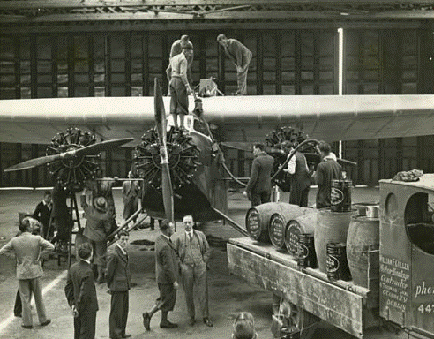

Table of Contents

Summary - World Events 4

The Golden Years Of Aviation, Great Advances & Prelude To War 5

“Good-Will” Flights & Aviation Pioneers 6

England To Australia 1934 Macrobertson International Air Race 9

Flying Boats Span The World 16

Oil Companies and Aviation 20

British Petroleum (Anglo - Iranian) 20

Shell Company 21

Stanavo 22

INTAVA 23

INVATA Aviation Gasolines 30

INTAVA Aviation Oils 32

INTAVA Special Products 32

Refuelling Services 35

INTAVA Refuelling Services 35

Shell Aviation – Refuelling Services 41

Safety Fuels 50

Prelude To World War – Spain, North Africa & China 52

The Air Race Is On” – Airspeed Records 54

Index 58

References 60

# Summary - World Events

**1931** Sept. 18, Japanese begin conquest of Manchuria.

**1932**  March 1, Manchuria becomes Japanese puppet state of Manchukuo

**1933**  Jan. 30, Adolf Hitler becomes chancellor of Germany.

March 27, Japan leaves League of Nations.

July 1-15, some 24 Italian Savoia-Marchetti S55X flying boats, under the command of General Italo Balbo, make the first transatlantic formation flight. The flight between Italy and Chicago, Illinois is to take part in the Century of Progress Exposition.

Oct. 14, Germany leaves League of Nations.

**1934** Feb. 3, The first scheduled trans-ocean airmail service is established between Europe and South America by Deutche Lufthansa. Flying from Stuttgart to Buenos Aires via Seville, Bathurst and Natal. The delivery time is four days.

**1935** March 9, Germany announces that the Luftwaffe has been established.

March 16, Hitler reintroduces compulsory military service.

Oct. 3, Benito Mussolini invades Ethiopia.

**1936** March 7, Hitler remilitarizes the Rhineland.

May 5, Italians capture Addis Ababa, ending major operations in Ethiopia.

June 6, Socony-Vacuum Oil Company at Paulsboro in New Jersey begins production of 100 octane aviation fuel.

July 17-18, Spanish Civil War begins.

Oct. 25, Germany and Italy form Rome-Berlin Axis.

Nov. 25, Germany and Japan sign Anti-Comintern Pact.

**1937** July 7, Marco Polo Bridge incident near Peiping sets off Sino-Japanese War.

Dec. 12, Japanese planes sink United States gunboat Panay in Yangtze River.

Dec. 13, Japanese sack Nanking.

December 26, Pan American World Airways (Pan-Am) flying-boat 'Samoa Clipper' inaugurates the first air mail and freight service between the USA and New Zealand.

**1938** March 13, Hitler annexes Austria.

Sept. 29-30, Munich Conference approves German acquisition of the Sudetenland.

# The Golden Years of Aviation, great advances & prelude to War

The Thirties were the period of new fuels and the development of new processes and fuel research and development.

At the end of roaring twenties, the fledgling commercial aviation industry was beginning to establish commercial air route for airmail and passenger transport. The Thirties was to be a period of great development in commercial aircraft and routes. These would need to be supplied with aviation fuel, lubricants and special aviation products around the world, often in new and exotic locations.

New aviation marketing companies and services would be created to meet this need. INTAVA, STANAVO and Shell Aviation Service would become familiar names to the pilots and airlines, and to the air forces of the world.

This period also captured the imagination of the public, and the interest of military. Air races, good-will flights, air displays such as the Hendon 1932 Air Pageant would occur in this period. These were the forerunners to the great aviation exhibitions such as Farnborough Air Display and Paris Air Show.

Photo 2. Hendon 1932 Air Pageant showing both RAF and British civil aircraft.

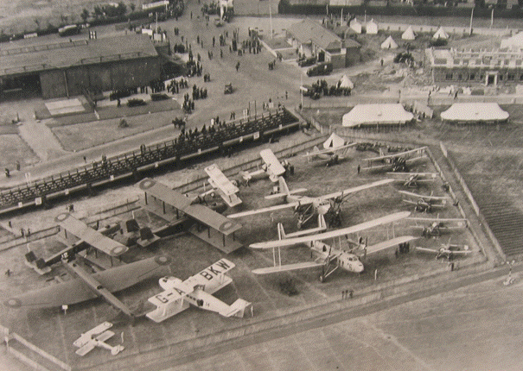

# “Good-Will” Flights & Aviation Pioneers

The military “Good-will” flights

During the 1930’s the measure of a nation’s status and prestige was its aviation prowess. The period saw a number of good-will flights - across the Atlantic Ocean to the Americas by the Italian Air Force; across the African and Indian sub-continent to the Far East by the British Royal Air Force (RAF); and round the world flights by the US Army Air Services.

On July 1, 1933, General Italo Balbo, the Air Minister of Italy, led a maritime bomber armada of 24 Savoia-Marchetti S.55 twin-hull catamaran flying boats from Orbetello, Italy, to the Century of Progress Exposition in Chicago, Illinois (USA), landing at Lake Michigan in just over 48 hours. Earlier in 1931 he led another flight across the South Atlantic from in Portuguese Guinea to Brazil.

Photo 3. General Italo Balbo

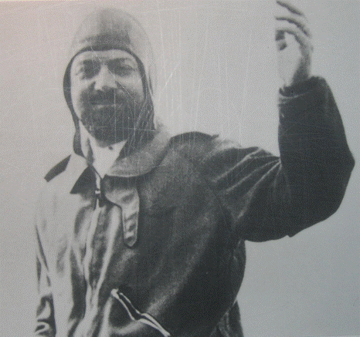

Photo 4. The flight of Italian Savoia-Marchetti S.55 Flying Boat, 1931.

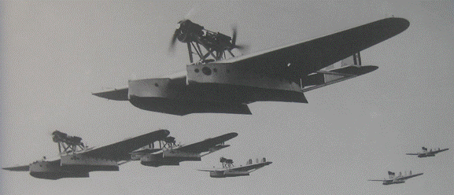

Other nations were not to be outdone and also sought the prestige of achieving fame and national pride. The RAF also flew a group of Southampton Seaplanes from UK to Australia in 1927. In addition, a number of aviation heroes and heroines were attempting new aviation feats.

Aviation Pioneers

The enthusiasm of the public for aviation continued in this period with both men and women attempting new long distance flights, sometimes at their peril. These historic flights were the forerunners of the new commercial passenger aviation routes. These heroes and heroines achieved movie star like fame. Some of these aviation pioneers would be the founders of commercial airlines of this period – people like Lindbergh who help found Transcontinental & Western Air (T&WA), later to become Trans World Airlines; Kingsford-Smith with his Australian National Airways, and Hudson-Fysh with QANTAS.

Charles Kingsford-Smith (Australia) had conquered the Pacific Ocean, and thereby setting the world on another path for commercial aviation.

1930

Charles Kingsford-Smith and C.T.P. Ulm, having founded Australian National Airways (A.N.A.), began a Sydney to Brisbane air service on 1st January. On July 1, A.N.A. began its Melbourne-Sydney service. The following January (1931) a Melbourne-Hobart service was inaugurated. Smithy, meanwhile, continued his epic flights.

In February, the Shell Company of Australia adopted a system of painting roof signs on all Shell depots, consisting of the name of the town, an arrow pointing to the nearest aerodrome, and the distance in miles. It was expected to assist aerial navigation in a country with large expanses of featureless landscape.

Amy Johnson reached Darwin, Northern Territory, Australia on May 24, in a DH-60G Moth, to become the first woman to fly solo from England to Australia.

1931

On May 21, Australian National Airways' Avro Ten, Southern Cloud, with six passengers on board, vanished on a flight from Sydney to Melbourne. The wreck was not found until October 25th, 1958, in the Toolong Range of the Snowy Mountains. By June 1931, the Great Depression of the thirties caused A.N.A. to suspend interstate operations.

On July 29, J. Mollison took off from Wyndham, W.A. in a DH-60G and established a new record, reaching England in 8 days, 19 hrs. and 25 mins.

1932

Kingsford-Smith's ‘Southern Cross’ was used for commemorative flights during the opening of Sydney Harbour Bridge, but was badly damaged in a night landing and had to be rebuilt. The work was done at Cockatoo Docks, under Wing Commander Lawrence Wackett.

In August-September, aviatrix Lores Bonney flew around the coast of Australia in a Gipsy Moth.

1933

On Jan. 7th, pioneering aviator Bert Hinkler was killed when his DH-80A Puss Moth crashed in the Tuscan Mountains, Italy, en route from England to Australia.

1934

On Jan. 18th QANTAS became QANTAS Empire Airways, connecting with the Empire Airways air route from England at Singapore.

C.T. Ulm, G. Littlejohn and L. Skilling were lost at sea on Dec. 4th, off Hawaii, in an Airspeed AS6 on a flight from the USA to Australia.

Jean Batten reached Darwin in a DH-60M Moth, creating a new women's record of 14 days, 23 hours, 25 mins. from England to Australia.

Photo 5. DH-60 Moth of the 1930’s, this one appears to be French.

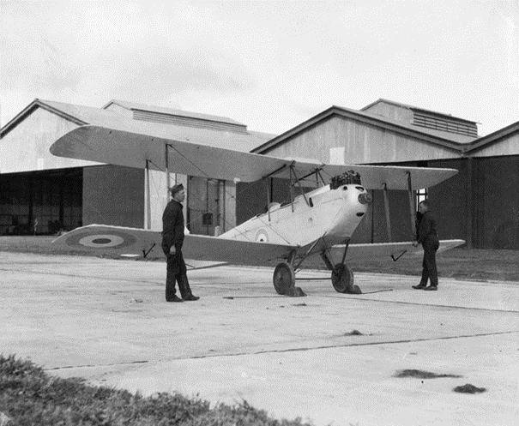

1935

'Smithy' lost - On 6 Nov. "Smithy" - Sir Charles Kingsford-Smith - took off in his Lockheed Altair ‘Lady Southern Cross’ with navigator Tommy Pethybridge, intending to break the England-Australia record set by the DH-88 Comet in the 1934 Centenary air race. At 2.30 am on 8th November, pilot Jimmy Melrose, who had also set off from Croydon aerodrome, England, was last to sight ‘Lady Southern Cross’ when he saw the glow of the Altair's twin exhausts above him, 200 miles south of Rangoon. "Smithy" and his crewman disappeared near Aye Island, off Burma.

1936

In April, the (Australian) Civil Aviation Board was established. In 1936 the first air navigation radio station was set up 1.6 km south of Mascot Airport, Sydney.

Dec. 16-18. A Brisbane-Adelaide air race commemorated the centenary of South Australia. Jean Batten again arrived in Darwin, on Oct 11, to establish a new England-Australia record, in a Percival Gull, Jean, after a flight of 5 days, 21 hrs. 3 mins. Five days later she flew on to New Zealand. Her aircraft is now located at Auckland Airport. The following year she flew Australia to England in two hours less.

1938

On Feb. 6, Air Vice-Marshal R. Williams left Laverton for Singapore in a Tugan Gannet of the RAAF - the first flight by an Australian-built RAAF aircraft to an overseas country. In July of that year flying boat services began between Australia and England.

# England to Australia 1934 MacRobertson International Air Race[1][2]

But perhaps the most publicised aviation event for Australia was the 1934 MacRobertson International Air Race from London, England to Melbourne, Australia.

In 1930, the question as to how the Australian state of Victoria, and its capital city Melbourne, might celebrate its coming centenary produced a suggestion from Melbourne's Lord Mayor, Harold Smith, that an air race linking England with Australia be organised. A sponsor was sought, and found in the person of wealthy confectionary manufacturer, Sir Macpherson Robertson, of MacRobertson's Chocolates.

In June 1933, Sir Macpherson Robertson as his personal Centenary gesture, placed the sum of £100,000 at the disposal of the State of Victoria, to be used in utilitarian and employment-giving projects associated with the Victorian-Melbourne Centenary Celebrations of 1934-1935. In addition, an amount of £15,000, including a Gold Cup valued at £650, was set aside to form prizes in connection with the Air Races from England to Australia commencing in October 1934.

Photo 6. Sir Macpherson Robertson with the trophy 1934.

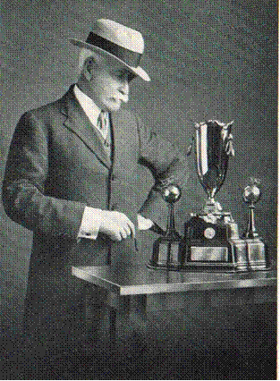

The Royal Aero Club of England was to oversee the event. It was divided into a speed division – the winner being the first aircraft to reach Melbourne; and a handicap division, which allowed 16 days to finish, the winner having the lowest flying time based on a formula.

Pioneering pilot Jim Mollison flew a route in 1931 between England and Australia, which was adopted as the basis of the race's course. It covered 11,300 miles, and would include five compulsory stops. Pilots could choose their own course between those stops, and a further 22 optional stops or "checking points" were included.

The Royal Aero Club set to work convincing various countries along the way to upgrade airports chosen for compulsory stops and checking points, and the Shell Oil and Stanavo companies provided supplies of fuel and lubricants at all points. If required, entrants could also enjoy overnight accommodation at the stops.

Photo 7. The route part – London, Bagdad, Allahabad.

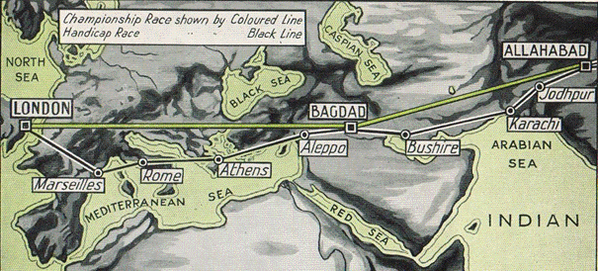

Photo 8. The route part – Allahabad, Singapore, Darwin, Melbourne.

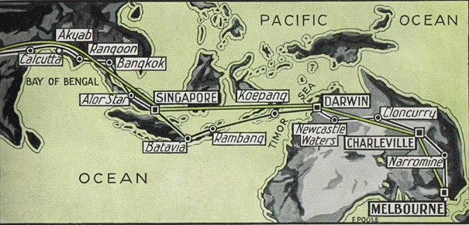

On October 20th, 1934 the England to Australia Air Race began.

It was won by de Havilland DH-88 Comet Reg. No. G-ACSS “Grosvenor House”, crewed by C.W.A. Scott and T. Campbell Black when they arrived in Melbourne in just under three days. It was described in The Herald newspaper thus,

"Flashing out of the sky like a fiery particle with the roar of its engines merging into a tumult of cheers that rose from a vast waiting crowd, the Comet flew over the finishing line at Flemington racecourse."

Photo 9. de Havilland DH-88 Comet “Grosvenor House” - England to Australia 1934 in 3 days.

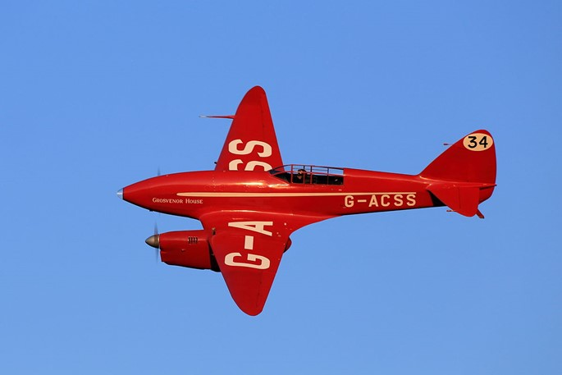

The winners in the speed section were:

**First**  Britain, C.W.A. Scott, T. Campbell Black in a DH-88 Comet "Grosvenor House" Reg. No. G-ACSS (Racing No. 34). Arrived 23 Oct. 1934, Elapsed time 71:0:18

**Second** United States, Roscoe Turner, Clyde Pangborn in a Boeing 247-D "Warner Bros. Comet" Reg. No. NR257Y. Arrived 24 Oct. 1934, elapsed time 92:55:38 (The same famous Roscoe Turner from Chevron Oil Company and Hollywood).

**Third** Britain, O. Cathcart Jones, K.F. Waller in a DH-88 Comet Reg. No. G-ACSR. Arrived 25 Oct. 1934, Elapsed time 108:13:45

The winners in the handicap section were:

**First** Netherlands, K.D. Parmentier, J.J. Moll, B. Prins, C. Van Brugge in a Douglas DC-2 “Uiver” Reg. No. PH-AJU (Racing No. 44). Arrived in Melbourne on 24 Oct. 1934, actual flying time 81:10:36, elapsed time 90:13:36

The “Uiver” (Stork) had an emergency landing at Albury, Victoria and became bogged. The towns people rallied to free the aircraft and send it on its way to complete the race.

**Second** Australia, C.J. Melrose in a DH 80 Puss Moth "My Hildegarde" Reg. No. VH-UQO. He flew solo and arrived in Melbourne on 31 Oct. 1934, actual flying time 120:13:59, elapsed time 10 days 16:23

This race was to establish the feasibility of long distance air travel and many of the stops used along this race would become familiar place names of the new airline routes around the world. Indeed, the aircraft used would become the backbone of the new airlines. The Douglas DC-2 would be redeveloped into the famous Douglas DC-3, still flying today. It would also establish the necessary aviation gasoline depots and refuelling operations.

Photo 10. The proud crew of the KLM “Uiver” DC-2, 1934[3]

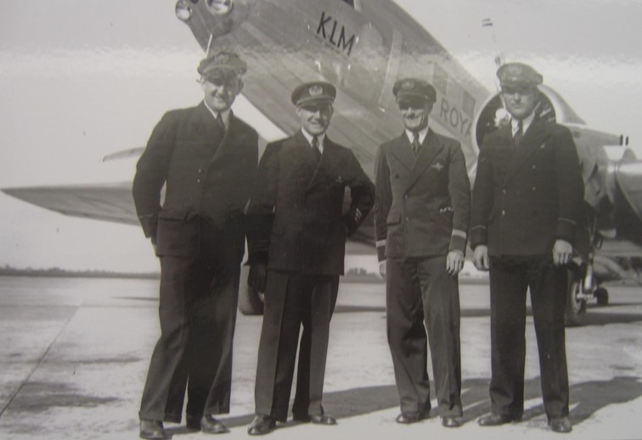

Photo 11. Refuelling of “Uiver’ at Cloncurry, Queensland 1934

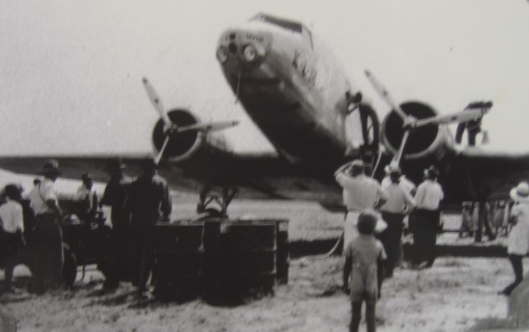

Photo 12. The people of Albury come to the aid of the stricken (bogged) “Uiver”, 1934.

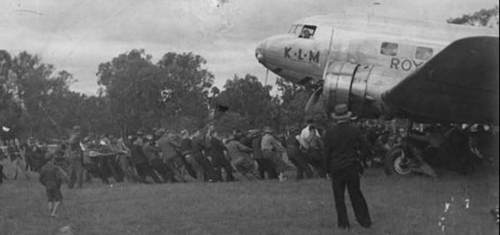

The Uiver made several goodwill flights in Australia before departing for Holland on 20 November 1934. Sadly, its days ended on 20 December 1934 when it crashed in a fatal accident during a sandstorm near Rutbah Wells in Iraq.[4] Late in 1983, with the 50th anniversary of the MacRobertson Race approaching, Rob Swaneborg of the Netherlands Broadcasting Corporation conceived the idea of making a documentary film on the role played by KLM’s ‘Uiver’. Douglas DC-2 c/n 1404 NC39165 ex U.S. Navy transport aircraft was used for the filming and it was later purchased by the Aviodrome of Schipol (now National Luchtvaart-Themapark Aviodrome at Lelystad Aerodrome.

Photo 13. KLM Douglas DC-2 ‘Uiver’ (replica) at Lelystad airfield in 2004. [5]

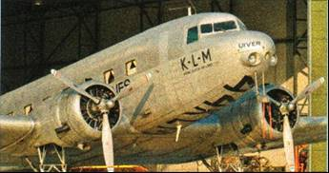

By 2006 this once famous aircraft (replica) had been relegated to a remote hangar at Lelystad aerodrome, and now (in 2006) lays there dismantled – wings, engines, tailplane removed.

Photo 14. Lelystad Hangar No. T2 - the “Uiver’ (replica) lays dismantled (2006). [6]

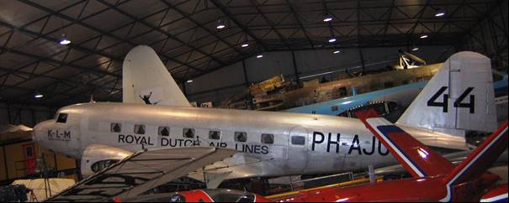

Photo 15. The “Uiver” soars over Amsterdam circa 1934.

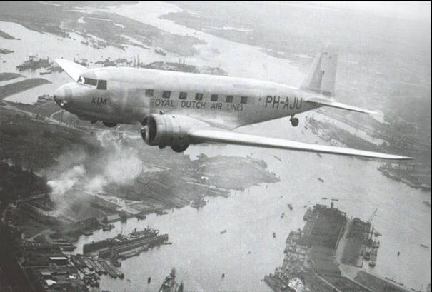

Photo 16. The route of the “Uiver” in the 1934 race from London to Melbourne.

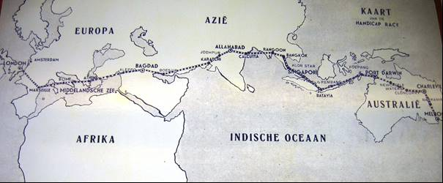

Fuels and lubricants for the race

The Shell Oil and Stanavo companies were given the task to provide supplies of fuel and lubricants at all (25) points. In many cases these were at remote locations. The handicap route was London, Marseilles, Rome, Athens, Aleppo, Baghdad, Bushire, Karachi, Jodhpur, Allahabad, Calcutta, Akyab, Rangoon, Bangkok, Alor Star, Singapore, Batavia, Rambang, Koepang, Darwin, Newcastle Waters, Cloncurry, Charleville, Narromine, and Melbourne.

To achieve the supply of fuels and lubricants required great planning and organisation, however these companies could see the potential for increased sales of aviation products and service by participating in such an event and rose to the challenge.

Photo 17. The Shell - Stanavo refuelling point at Batavia 1934.

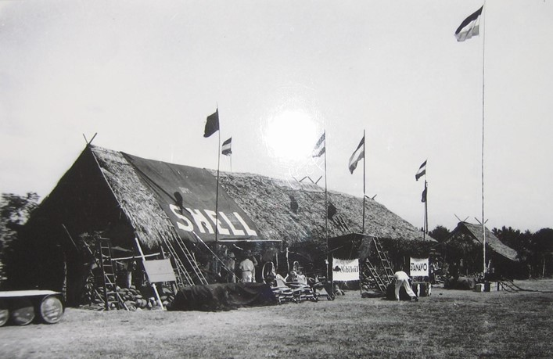

Note the Shell Aviation Spirit drums (left), the refuelling hand-pump trolleys (centre), the Stanavo gasoline drums (right), the “SHELL’ logo boldly displayed on the roof of the hut (to indicate to the aircraft that this was a refuelling stop), the Mobiloil and STANAVO banners in the front of the hut, and although Stanavo and Shell were rivals in the market place, jointly supporting the competitors in this epic air race, finally the Dutch flag flies proudly over the refuelling depot.

Photo 18. Aeroshell refuel trolley circa 1926 (on display at Aviodrome Museum Lelystad 2006).

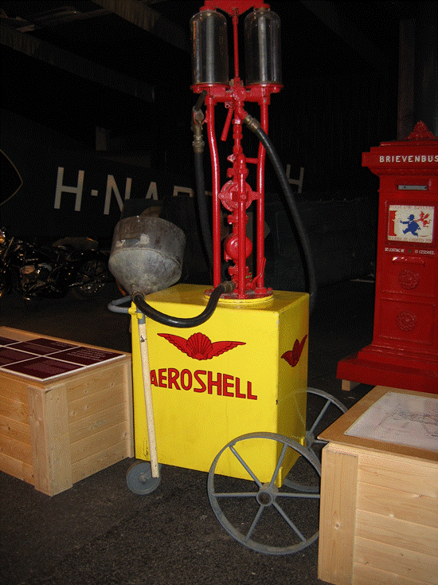

This refuelling unit is fitted with a 5-litre glass metering bowl; the fuel is hand pumped into the aircraft using the large funnel, which was usually lined with a chamois filter to remove water and particulate matter during refuelling.

# Flying Boats span the World[7]

In the 1920’s and 30’s, the problem not only lay with the design of the aeroplanes, it was also a question of finding suitable runway sites. Everywhere the airlines looked there were oceans, rivers and lakes, served by lucrative ports and docks. The airlines therefore decided to make use of the existing infrastructures and create planes that could land on water. The flying boats were born.

New names such as Pan American World Airways and Imperial Airways Limited would be associated with the romantic era of the flying boat. Movies would be made about these flights - Humphrey Bogart and Pat O'Brian starred in a film called ‘China Clipper’ - released in 1936.

The attraction of the flying boat was that it did not require a landing field, and there already existed some logistical support and fuel depots for the ‘Senior Service’ – the Royal Navy, and the sea transport and cargo routes were already established. The Americans had a vast network of naval bases in the Pacific starting with Pearl Harbour in Hawaii. The British Empire had an even bigger network extending to South Africa, India, Ceylon, Singapore, Hong Kong and Australia. The Dutch had the Netherlands East Indies, and the West Indies. Docking facilities already existed, all that was required was fuel and lubricants, and provisions to continue their journey. These would become part of the airmail routes.

The basic principle was of a ship-shaped fuselage that could land on water and carry mail. Although mail contracts dominated the flying boats' trade, larger planes meant that passenger services would soon be possible. For the elite few, this would be the pinnacle of luxurious travel.

As Pan Am began to expand into South America, Imperial Airways gained a foothold in India and South Africa. However, the Atlantic remained their ultimate goal. In the meantime though, Pan Am turned its attention to the Pacific Ocean. On 12 November 1938, it conquered that ocean with the ‘China Clipper’, a new Martin M-130 plane, named after the fast 19th century clipper ships.

Imperial Airways retaliated with a new Empire class, built by the leading manufacturer, Short Brothers. However, 9 of the first 28 planes crashed, or were damaged in accidents.

Then, in 1938, under contract from Pan Am, Boeing built the largest commercial flying boat yet – the B314. The pioneering B314, ‘Yankee Clipper’, was launched by Eleanor Roosevelt in March 1939. Meanwhile, the British continued work on their new flying boat, the ‘Golden Hind’. It was launched in June 1939.

On 28 June 1939, Pan Am's ‘Dixie Clipper’ left Newfoundland and arrived in Southampton 18 hours, 42 minutes later. The Golden Hind would never make the journey – the world was now consumed by the Second World War and both Pan Am's and Imperial's fleet were requisitioned by the military, protecting convoys, hunting U-boats and rescuing pilots.

At the end of the war, the world had moved on – bomber technology meant that greater non-stop distances were possible; new runways had been built, and jet technology was just around the corner. The days of the flying boat were over.

Imperial Airways British Empire Routes

Following the achievements of aviation explorers of the 1920’s and the early 1930’s, the later 1930’s saw the development of flying boat routes across the world. In particular, the British Empire could be linked by these new routes, and thus the Imperial Airways Limited would expand to all corners of the British Empire of the 1930’s. – South across the Mediterranean into Africa, east across the Middle East and into the subcontinent of India, and to the Far East, Singapore, and Australia.

Photo 19. Shell Aviation Service refuels an Imperial Airways flying boat “Cooee” circa 1938.[8]

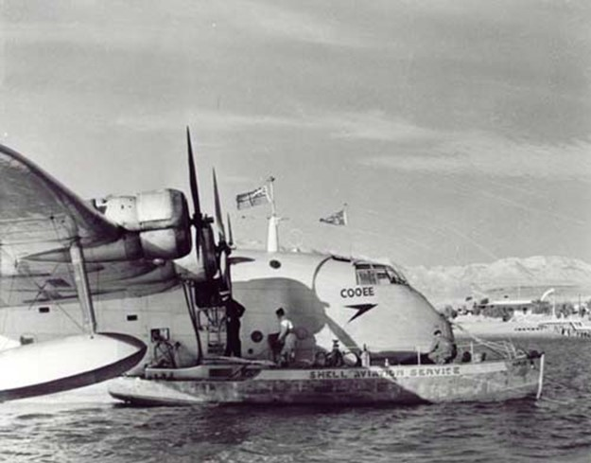

Even in the 1930’s, the airline business had become very competitive and the decision was made to merge Imperial Airways and British Airways into a new state-owned national airline and so British Overseas Airways Corporation (B.O.A.C.) was formed on 24 November 1939, and Imperial Airways ceased to exist.

In Australia, names like Rose Bay, Darwin, Cairns and Lord Howe Island would become synonymous with the fabled flying boats.

US Pan American Clipper Routes

The Americans would also establish flying boat routes particularly into Central and South America, and later into the Pacific after the Kingsford-Smith’s flight. This would become the new exciting romantic alternative to the ocean liner voyage.

Photo 20. Pan Am South American route 1930.

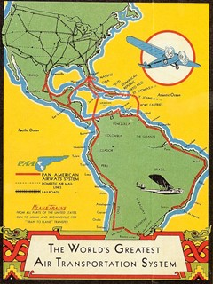

Photo 21. "China Clipper," (Martin M-130) passes over the San Francisco waterfront at the start of the inaugural commercial flight across the Pacific Ocean, to Manila.[9]

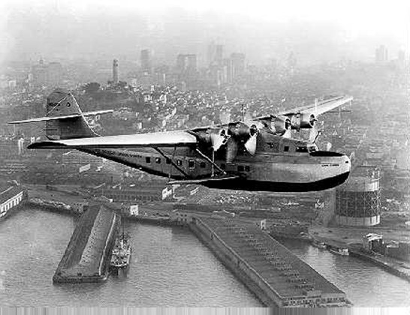

Pan American World Airways fabled China Clipper (Martin M-130 Flying Boat) left Alameda Marina on November 22, 1935. Under the command of Captain Edwin C. Musick, the flight would reach Manila via Honolulu, Midway, Wake, and Guam. The inauguration of ocean airmail service and commercial air flight across the Pacific was a significant event for both California, and the world. The aircraft completed the trip in six days, with a flying time of 59 hours, 48 minutes. Overnight stops included Honolulu, Midway, Wake Island, and Guam.[10]

Photo 22. Pan Am ‘Dixie Clipper’ aircraft could carry more fuel for longer journeys by using the sponsons as fuel tanks, circa 1939. [11]

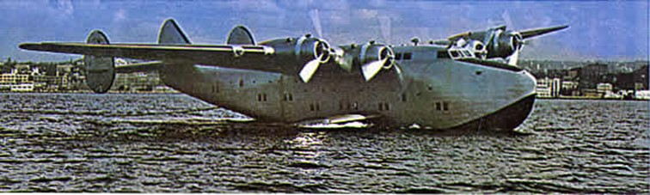

The Dixie Clipper employed the same engine as the B-15 experimental heavy bomber. The four GR2600 Wright twin cyclone engines were truly outstanding. With each 14-cylinder, air-cooled radial motor pushed to the limit the pilot could draw on 6,400 horsepower. Also, as the first machine to use the new ‘super powerful 100 octane fuel’; there really was no other way to cross the Atlantic. On 28 June 1939, Pan Am, with their Dixie Clipper, became the first to inaugurate a transatlantic passenger service.

These developments would lead to global networks for the supply of petroleum products and refuelling services to the aviation industry as discussed later.

# Oil Companies and Aviation

# British Petroleum (Anglo - Iranian)

The following is an extract from the “The History of the British Petroleum Company Volume 2. The Anglo-Iranian Years 1928-1954” by J.H. Bamberg*[12]* which describes the BP’s situation regarding the development of aviation spirit.

Photo 23. BP refuelling a Bristol fighter 1936

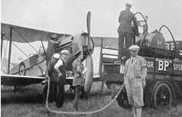

“While the demand for higher octane spirit for motor cars was expanding, a still greater technical challenge was posed by the increasingly exacting standards to be met in the production of aviation spirit. The growth of aviation provided a strong incentive for the Company (BP) to pay increase attention to aviation fuel in the 1930’s. BP did not have a product to satisfy British Air Ministry, which in May 1928 complained about the quality of BP’s aviation fuel, which was based on Iranian straight run spirit of low octane number.

BP Research labs at Sunbury after much work recommended in August 1930 a blend based on Romanian light benzene with solvent naphtha (a coal tar product) and benzene. This was of much higher quality and arrangements were in hand by September for its manufacture in the hope of regaining the share formerly held of Air Ministry business. Meanwhile in February 1930 Fraser chaired a Company meeting at which it was laid down that efforts should be made to take a better standing in the Aviation Spirit Trade both in this country (Britain) and on the continent. The Company was not starting from scratch for it already supplied aviation fuel to Imperial Airways for its route to India via Iraq and Iran, met 90 per cent of Lufthansa’s requirements in Germany and elsewhere, and supplied Bristol Aeroplane Company and the Dutch airline KLM. It was however apparent that there was considerably more scope for expansion in the fast growing, but technically demanding aviation fuel business.

In October 1933, the (British) Air Ministry updated its specification for aviation spirit to permit the addition of tetraethyl lead. The Company imported spirit made from Miri (Dutch Borneo) crude oil, added tetraethyl lead, and by February 1934 was making 87- octane aviation spirit, an octane rating which met the Royal Air Force’s requirements at the time. The Company was able to obtain publicity for its aviation products by providing special fuels for record attempts or races, such as the England to Australia Air Race in the autumn on 1934.”

In fact, the main suppliers of aviation gasoline for the England to Australia Air Race were Mobiloil (Stanavo) and Shell.

# Shell Company

The direct involvement of the oil companies with aviation continued throughout the 1930’s. This was illustrated by many of the companies employing former aviators in variety of jobs for example James Doolittle was employed by the Shell Company.

In addition, there were alliances formed to service the growing aviation industry. The expanding aviation market meant the aviation petroleum products would be required worldwide, and the oil companies understood that an internationally recognised brand name would be advantageous in promoting their products over their competitors. Shell because of its international standing both in the US through people like Doolittle, and its long established history in Europe and the East and West Indies was marketed as ‘Shell Aviation Products’. Other oil companies such as the family of Standard Oil Companies formed new marketing and distribution organisations such as ‘STANAVO’, with the Vacuum Oil Companies forming ‘INTAVA’ for the same purpose.

In Australia, the two principal marketing and distribution organisations for aviation products were Shell and INTAVA. These and other companies would provide essential information to the pilot on such matters as fuel supply depots, general metrological information of foreign locations.

In 1934 the first port of call on the air route to Australia was Darwin, Shell Aviation News[13] which was an international publication advised:

“Sydney may also be reached from Charleville via Cunnamulla, Bourke and Narromine.

Melbourne may also be reached from Bourke via Hillston and Hay or via Narromine and Cootamundra.

Good aerodromes were available between Perth and Adelaide at Kalgoorlie, Rawlinna, Forrest, Cook, Ceduna, and Kimba.

There were no recognised seaplane stations, except the Royal Australian Air Force station at Point Cook (Victoria), but good alighting areas for seaplanes was available at practically every important seaport in the Commonwealth.

Large areas of country in the north and centre of Australia were devoid of well-defined physical features which could assist an aviator to fix his position in the air. These areas were, generally speaking, poorly mapped, and centres of settlement shown on available maps consisted in many cases only of few small galvanized iron buildings which may be difficult to locate from the air, even from a point only a few miles away.

Detailed instructions regarding the difficulties attached to flying in the northern areas of Australia had been prepared by the Shell Company, and were available from its branch offices or from its agents at Darwin and Wyndham.

Availability of Shell Supplies.

Supplies of Aeroshell lubricating oil and Shell motor oils, as well as Shell aviation gasolines and Shell motor gasolines could be made available at short notice at all of the aerodromes mentioned in the schedule headed ‘3’, but pilots intending to follow the central route from Darwin to Melbourne via Alice Springs, or the western route from Darwin Wyndham or Derby to Perth, should give adequate notice of their intentions.”

The aerodromes in this schedule for Shell products were:

Darwin

Katherine

Daly Waters

Newcastle Waters

Anthony’s Lagoon

Brunette Downs

Alexandria

Camooweal

Mt. Isa

Cloncurry

Winton

Longreach

Blackall

Charleville

Roma

Brisbane

Coff’s Harbour

Sydney

Cootamundra

Melbourne

Many of these aerodromes would become a vital part of Australia’s air defences during World War II.

Around 1939 both Shell and INTAVA produced technical booklets to promote their products and service to the aviation industry. The Shell booklet was “Aircraft Fuels and Lubricants” from the Technical Department of the Shell Company of Australia Limited, while the INTAVA booklet was “Aviation Fuels- Lubricants and Special Petroleum Products” – Vacuum Oil Company Pty. Ltd – Melbourne Australia. The latter is detailed below.

# STANAVO

One of the largest aviation petroleum product marketing and distribution concerns was ‘STANAVO’, which became operational in 1932. It was a consortium of oil companies for the distribution of aviation products both in the US and overseas, and comprised the following companies.

STANAVO Distributors 1932 in US**[14]**

Colonial Beacon Oil Co. Inc. Boston, Mass.

Humble Oil & Refining Co., Houston, Texas

Pasotex Oil Co., El Paso, Texas

Standard Oil Co. (Ohio), Cleveland, Ohio

Standard Oil Co. of California, San Francisco, California. (Chevron)

Standard Oil Co. (Indiana), Chicago, Ill.

Standard Oil Co. (Kentucky), Louisville, Ky.

Standard Oil Co. of Louisiana, New Orleans, La.

Standard Oil Co. of Nebraska, Omaha, Nebr.

Standard Oil Co. of New Jersey, New York, N.Y. Cable Stanavo, New York. (Later to be known as Esso, then Exxon).

Standard Oil Co. of Pennsylvania, Philadelphia, Pa.

STANAVO Distributors 1932 in foreign countries

There were a variety of companies and these were located in the following countries (Specific company names are listed in the reference source.)

Algeria, Austria, Belgium, Brazil, Canada (Imperial Oil Co. Ltd.), Colombia, Cuba, Czecho-Slovakia, Denmark, England (Anglo American Oil Co. Ltd.), Finland, France, Germany, Holland, Hungary, Italy, Malta, Norway, Peru & Bolivia, Baltic Provinces, Roumania, Sweden, Switzerland, Tunisia, West Indies (except Cuba), Latin America (except Brazil, Colombia, Peru, & Bolivia), Mexico.

There was no listing for Australia in the STANAVO foreign distributor list.

# INTAVA

'INTAVA' was the world-wide marketing organisation used by Vacuum Oil Company and other Standard Oil Companies to market and distribute aviation products particularly outside the United States (which was generally covered by STANAVO). The following is a listing of various locations of the INTAVA marketers throughout the world in 1938. It shows the domination of Vacuum Oil Company and its affiliates in various countries. [The country names of 1938 have been retained, many were still under colonial rule from European powers such as Belgium, France, Britain and others].

Europe

### Azores

Vacuum Oil Company

### Belgium, Luxembourg

American Petroleum Co. S.A.B.

Vacuum Oil Company S.A.B.

### Bulgaria

Socony-Vacuum Oil Co. Inc.

### France & Corsica

Standard Française Des Petroles

Vacuum Oil Company S.A.F.

### Czechoslovakia

Standard Oil of Czechoslovakia

Vacuum Oil Company A.S.

### Denmark, Greenland, Iceland

Det Danske Petroleum A/S

Vacuum Oil Company A/S

### Finland

Osakeyhtio Nobel-Standard Aktie-Bolag

O/Y Vacuum Oil Company A/B

### Germany

Deutsch-Amerikanische Petroleum Gesellschaft

Deutsche Vacuum Oel A.G.

### Gibraltar

Gibraltar Vacuum Oil Company Limited

### Great Britain (excluding Irish Free State)

Anglo-American Oil Company Ltd.

Intava Limited

Vacuum Oil Company Limited

### Greece

Socony-Vacuum Oil Co. Inc.

### Holland

American Petroleum Company N.V

Vacuum Olie Maatschappij N.V.

### Hungary

Vacuum Oil Company R.T.

### Irish Free State (Ireland)

Irish American Oil Co. Ltd.

Vacuum Oil Company (Ireland) Limited

### Italy, Albania, Sardinia, Sicily

Societa Italo-Americana Pel Petrolio

Vacuum Oil Company S.A.I.

### Jugoslavia (Yugoslavia)

Standard-Vacuum Oil Company of Jugoslavia, Inc.

### Latvia, Lithuania, Esthonia

Vacuum Oil Company A/S

### Malta

St. Pauls Petroleum Tanks

Vacuum Oil Company Limited

### Norway

Ostlandske Petroleumscompagni

Norsk Vacuum Oil Company A/S

### Poland

Vacuum Oil Company S.A.

### Portugal

Vacuum Oil Company

### Roumania

Agentia Americana S.A.

Vacuum Oil Co. S.A.D.R

### Spain

Vacuum Oil Company S.A.E.

### Sweden

Svenska Petroleum Aktiebolaget Standard

Vacuum Oil Company A.B.

### Switzerland

Standard Mineraloelprodukte A.G. (Intava Produkte)

Vacuum Oil Company

### Turkey (including Turkey in Asia)

Socony-Vacuum Oil Co. Inc.

Asia

### Aden Protectorate

Aden Coal Co. Ltd

### Afghanistan, Baluchistan

Standard-Vacuum Oil Company

### Burma

Standard-Vacuum Oil Company

### Ceylon (later to become Sri Lanka)

Standard-Vacuum Oil Company

China (North of Foochow)

Standard-Vacuum Oil Company

China (South of Foochow)

Standard-Vacuum Oil Company

### Federated Malay States

Standard-Vacuum Oil Company

### French Indo-China (later to become Vietnam)

Standard-Vacuum Oil Company

### India

Standard-Vacuum Oil Company

### Iran, Iraq

K. & E.M. Lawee

### Japan

Standard-Vacuum Oil Company

### Netherlands East Indie

N.V. Koloniale Petroleum Verkoop Mij

### Palestine & Trans-Jordan

Standard-Vacuum Oil Company Inc.

### Philippine Islands

Standard-Vacuum Oil Company

### Siam (later to become Thailand)

Standard-Vacuum Oil Company

### Syria

Socony-Vacuum Oil Co. Inc.

### Turkey, Kurdistan

Socony-Vacuum Oil Co. Inc.

Africa

### Algeria

Cie Algerienne Des Petroles Standard

Vacuum Oil Company S.A.F.

### Angola

Vacuum Oil Company

### Bechuanaland

Vacuum Oil Co. of South Africa Ltd.

### Belgian Congo, French Congo, Ubangi-Shari

Vacuum Oil Company

### Cameroons (British), Dahomey (French), Niger Colony, Nigeria, Tchad

Vacuum Oil Company

### Cameroons (French), Fernando Po, Gaboon, Guinea (Spanish)

Vacuum Oil Company

### Canary Islands, Rio De Oro

Vacuum Oil Company of Canary Islands S.A.E.

### Cape Verde Islands

Serras & Souza Ltda

Lopes & Medeira Ltda (lubricants)

Manuel Gomes Madeira & Fa (fuels)

### Egypt

Socony-Vacuum Oil Co. Inc.

### Gambia, Guinea (French), Guinea (French), Mauretania, Senegal, Sudan (French)

Vacuum Oil Company

### Gold Coast, Liberia, Sierre Leone, Togoland

Vacuum Oil Company

### Italian East Africa

G.G. Cassuto, C. Scapellato

### Ivory Coast

Vacuum Oil Company

### Kenya, Tanganyika, Uganda, Zanzibar

Vacuum Oil Co. of South Africa Ltd.

### Libya

Societa Italo-Americana Pel Petrolio

### Madagascar, Mauritius, Reunion, Union of South Africa

Vacuum Oil Co. of South Africa Ltd.

### Madeira Islands

Vacuum Oil Company

### Morocco, Tangiers

Socony-Vacuum Oil Co. Inc.

### Nyasaland

African Lakes Corporation

### Portuguese East Africa

Vacuum Oil Company

Rhodesia (Northern & Southern)

Vacuum Oil Co. of South Africa Ltd.

Vacuum Oil Company

### South West Africa

Vacuum Oil Co. of South Africa Ltd

Somaliland (British)

Arabian Trading Co. Ltd.

Somaliland (French)

Sharqieh Ltd.

Sudan (Anglo-Egyptian)

Contomichalos, Dark & Co. Ltd.

### Tunisia

Société Tunisienne Des Petroles

Americas and the West Indies

### Argentina

West India Oil Company, S.A.P.A.

Ultramar S.A.P.A.

### Bahamas

West India Oil Company, S.A.

### Bermuda

West India Oil Co. S.A.

### Bolivia

International Petroleum Co. Ltd.

Socony-Vacuum Oil Co. Inc.

### Brazil

Standard Oil Co. of Brazil

Socony-Vacuum Oil Co. Inc.

### British Honduras, Costa Rica, Guadeloupe, Leeward Isles, Martinique, Panama, Guiana (French)

West India Oil Co. S.A.

### Canada

Imperial Oil Co. Ltd.

### Chile

West India Oil Co. Chile S.A. Commercial

Socony-Vacuum Oil Co. Inc.

### Colombia

Tropical Oil Co. Ltd

West India Oil Co. S.A.

### Cuba

Standard Oil Company of Cuba

### Dominican Republic

West India Oil Co. S.A.

### Ecuador

International Petroleum Co. Ltd.

Socony-Vacuum Oil Co. Inc.

### Guatemala

West India Oil Co. S.A.

### Guiana (Dutch)

West India Oil Co. S.A.

Socony-Vacuum Oil Co. Inc.

### Haiti

West India Oil Co. S.A.

### Jamaica

West India Oil Co. S.A.

### Nicaragua

West India Oil Co. S.A.

### Paraguay

West India Oil Company, S.A.P.A.

Socony-Vacuum Oil Co. Inc.

### Peru

International Petroleum Co. Ltd.

### Puerto Rico, Virgin Isles

West India Oil Co. (P.R)

### Salvador

West India Oil Co. S.A.

### Trinidad

Trinidad Oil Fields Operating Co. Ltd.

### Uruguay

West India Oil Co. S.A. Urugauya

Socony-Vacuum Oil Co. Inc.

### Venezuela

Compania De Petroleo Lago

### Windward Isles

West India Oil Co. S.A.

Australasia

### Australia

Vacuum Oil Co. Pty. Ltd.

### British New Guinea, Papua, South Sea Islands

Vacuum Oil Co. Pty. Ltd.

### Fiji

Vacuum Oil Co. Pty. Ltd.

### New Zealand

Vacuum Oil Co. Pty. Ltd

Promoting INTAVA

As part of its promotion, Vacuum Oil Company in Australia produced a small complimentary booklet[15] which was presented as a useful guide and reference to the many products (Vacuum Oil Co.) required in the operation and maintenance of the ‘modern aircraft (in 1939).

Photo 24. Cover of Vacuum Oil booklet (circa 1939)

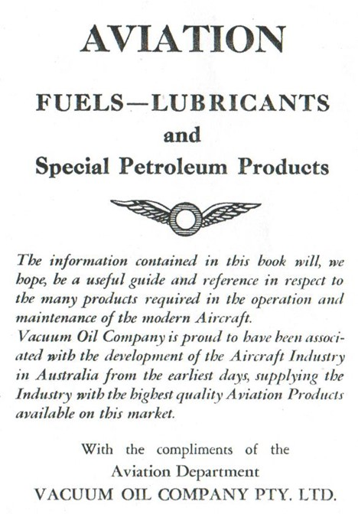

The booklet described in layman terms:

* Origin of Petrol
* Production of Aviation Fuel and refinery processes (which comprised straight distillation, cracking gasoline, reforming process (thermal cracking), polymerisation, hydrogenation, what is ‘Octane’, alkylation)
* Anti-detonants and blending agents (Tetra-Ethyl Lead, Benzol, Alcohol, Iso-Octane, Iso-Pentane, Iso-Propyl Ether)
* Characteristics of Aviation Fuels (Octane Number, High Octane fuels and engine performance, Distillation, Vapour Pressure, Specific Gravity and Calorific value, Sulphur, Gum)
* Intava Aviation Gasolines, Intava Special Products, Safety Fuels – and a range of other topics which included Intava Aviation Oils.
* Conversion tables and useful data.
* Vocabulary (English, French, Germans, Italian, Spanish)

Much of the material is covered in more detail elsewhere in this book, however there are a few items which are unique, and illustrate to type of material offered in this booklet. For example:

Benzol

‘Benzol is the name usually applied in the chemical industry to a mixture of hydrocarbons of the benzene series, in which benzene itself predominates in association with certain of its homologues and various impurities. The benzene series is the most important group of substances in the class of aromatic hydrocarbons.

Benzol is a by-product of the manufacture of coke employed in steel works and gas works practice and, as can be well imagined, the quality of the benzol derived from different sources may vary quite widely. It is necessary, therefore, when using benzol in conjunction with petrol as a fuel to select the benzol with care. It is necessary to refine benzol before it can be used in an internal combustion engine, since in an unrefined state it often contains unsaturated compounds which have an objectionable tendency to form gummy material which causes trouble in the engine. The chief difficulties experienced are the choking of jets and the formation of gum deposits on the induction manifold and on the inlet valve stems causing them to stick in their guides. In addition to the unsaturates, sulphur compounds are also present, the removal of which is also necessary.

When suitably refined, however, benzol owing to its high knock rating may be added to petrol to raise its octane rating without any troubles ensuing from these causes. However, the use of benzol tends to increase cylinder head and plug temperatures, while its knock rating decreases with increase in temperature.

Consequently, a blend of petrol and benzol will not have as high an octane number in actual practice as would be expected arithmetically by taking its estimated anti-knock value into account and assessing the contributory value of the proportion added.

A leaded fuel in comparison with a benzol blend retains its anti-knock value to a high degree when subjected to conditions of high temperatures such as those pertaining to air-cooled aircraft engines.

Benzol has also a lower calorific value per lb. [pound] than petrol which has an adverse effect upon the cruising range of an aircraft carrying a specified weight of fuel.

In addition, it has a comparatively high freezing point in the vicinity of 5oC to 10oC and hence, apart from other factors, there is a limit to the amount of benzol which can be added to an aviation fuel owing to the danger of freezing at high altitudes.’

Alcohol

‘Anhydrous or water free alcohol is sometimes added to increase the knock-rating. It is considerably more effective than benzol, but nowhere as effective as tetra-ethyl-lead. Originally ethyl-alcohol derived from natural sources was widely used, but latterly synthetic ethyl-alcohol is used more and more.

Ethyl-alcohol may be obtained synthetically from coke, or oven gas, but the most recent source of large quantities is the gases produced in the refining of petroleum. Alcohol has a very low calorific value, hence the consumption of ethyl-alcohol petrol blends is greater than that of straight petrols or petrols containing tetra-ethyl-lead or benzol.’

Solubility of Alcohol in Petrols and Other Fuels

‘Alcohol mixes in all proportions with water. The presence of water within certain limits does not render the alcohol unsuitable as a fuel although it naturally reduces the power output of the engine by the amount of energy absorbed in vapourising the water. While alcohol, methylated spirits and water are miscible in all proportions, and mixtures of petrol or benzol with pure ethyl-alcohol free from water are also quite stable, these latter mixtures separate into two liquids of different compositions if more than a certain proportion of water be present. The point at which separation commences depends on the percentage of water in the alcohol, the percentage of alcohol in the blend, the composition of petrol, the nature and amounts of substances added to increase the solubility and the amount of water which gets into the blend by condensation from the air.

Anhydrous ethyl-alcohol is completely miscible with petrol at all temperatures likely to be encountered in service. If the alcohol contains more than a small amount of water it may still be completely miscible with petrol at summer temperatures, but may not be at winter temperatures. However, even though the alcohol used is completely miscible at all operating temperatures, precautions must be taken to prevent absorption of sufficient water from the air to cause separation.

The sensitivity of alcohol-petrol mixtures to added water has been the subject of many investigations in which the variations caused by temperature composition of the mixture and character of the petrol have been separately studied.

Alcohol fuels intended for use in aircraft engines must, therefore, have a high ‘water tolerance’, i.e. they must be capable of dissolving large amounts of water without separating in to two immiscible layers. Defining ‘water tolerance’ in this way, it follows that the amount of water which can be added to an alcohol blend before separation occurs depends upon the following factors: -

1. The nature of the alcohol or alcohols present.
2. Temperature
3. Alcohol content of the blend
4. Excess of blending agent present

The greatest value of alcohol as a constituent of internal combustion engine fuels is its pronounced anti-detonation characteristics and were it not for this desirable property alcohol fuels would not possess a single redeeming feature in comparison with petrols, with the possible exception of their high latent heat which, in certain circumstances has a beneficial effect upon the volumetric efficiency and power output. The high latent heat of alcohol reduces the temperature of the induction manifold and in this way increases the volumetric efficiency.’

# INVATA Aviation Gasolines[16]

While our interest here is on aviation gasolines of the time, it should be remembered that other aviation petroleum products were available from these companies – SHELL, STANAVO and INTAVA. These products were promoted in the respective booklets – those of INTAVA in Australia (1939) were quoted as follows:

“Intava Aviation Gasolines are produced from specially selected crudes containing hydrocarbons of the type and relative proportions necessary hydrocarbons of the type and relative proportions necessary to give optimum performance in modern aircraft engines. Since the varying features of engine design and output require diverse fuel characteristics. Intava offers to the world market aviation fuels to fulfil all requirements. Rigid manufacturing specifications control the production of Intava Aviation Gasolines, assuring products of uniform quality to operators of aircraft throughout the world.” [This was the early years of international air travel with airlines such as Empire Airways and Pan American; reliability of supply and quality were critical].

“A complete range of grades was available (1939) from which the most suitable quality for a particular engine or a particular government specification may be selected. Freedom from gum, both existent and potential, complete absence of impurities and corrosive constituents, together with a carefully balanced distillation range, assure maximum power and economy, freedom from vapour lock, quick starting, and trouble-free operation. The various grades of Intava Aviation Gasolines are classified (1939) by antiknock rating or octane number, according to the standards of the American Society of Testing Materials and the Co-operative Fuel Research Committee.” [A.S.T.M. – C.F.R. engine test]

Intava Aviation Gasoline

“A non-lead aviation gasoline suitable for engines of comparatively low specific horsepower output. Intava Aviation Gasoline conforms to British Air Ministry Specification D.T.D. 224. This gasoline meets the requirements of engine builders in Australia, Great Britain and USA.” [This was produced from straight run gasolines]. The ‘INTAVA World’ magazine of July 1938 listed this as: “a non-leaded gasoline of 74 octane number with approvals from the French Air Ministry, Italian Air Ministry, U.S. Army, U.S. Navy, Pratt & Whitney Aircraft, Wright Aeronautical Corporation, Lycoming and other leading engine manufacturers.”

INTAVA World also listed: “Intava Aviation Gasoline 77 – A non-leaded gasoline of 77 octane number for use in engines of moderate specific horsepower output in which the use of leaded fuel is not permissible due to characteristics of the valve and valve-seat material. This grade meets the specifications of leading European engine manufacturers, the British Air Ministry, Belgium Ministry of National Defence, Imperial Airways Limited, British Airways and Air France.”

Intava Ethyl Aviation Gasoline 87

“An aviation gasoline containing Ethyl Fluid, for general use in military and commercial aircraft engines when a fuel of 87 octane is required. Conforms to British Air Ministry Specification D.T.D. 230. This gasoline meets the requirements of engine builders in Australia, United Kingdom and USA.” [This was essentially straight-run gasoline from suitable crudes and cracked treated gasolines].

Intava Ethyl Aviation Gasoline 90

Intava Ethyl Aviation Gasoline 95

These high-grade aviation fuels are marketed (in late 1930’s) to meet the requirements of certain types of aircraft engines which call for the use of 90 and 95 octane aviation gasoline and fully conform to the specification requirements.

Intava Ethyl Aviation Gasoline 100

In 1939, this was quoted as: “A fuel containing tetra-ethyl lead and a considerable percentage of blending agent specifically developed to increase the anti-knock value. Its knock rating matches that of chemically pure iso-octane which is by definition 100 octane number. It meets the tentative specifications of the British Air Ministry and has an anti-knock value above that specified by the U.S. Army Air Corps and the U.S. Navy for 100 Octane. This fuel is used by military services in the latest types of high compression, high powered engines and also by certain commercial airlines on routes where maximum take-off power and minimum fuel consumption are essential requirements.”

INTAVA was a worldwide marketing operation and while Aviation Diesel fuel was probably not used in Australia; it was however used elsewhere in the world. ‘INTAVA World’ July 1938 listed the following description of this aviation fuel.

Intava Aviation Diesel Fuel

“A fuel refined from specially selected crudes to give optimum performance in modern high-speed compression engines. The excellent ignition qualities of this product result in rapid even flame propagation and ensure the take-off power guaranteed by the engine builder under normal operating conditions. Its balanced distillation range provides maximum power and economy, and guards against the ring-sticking which in diesel engines is often caused by incomplete combustion of the fuel. The low pour point and cloud point permit trouble-free operation at high altitudes and under winter conditions; freedom from ash, sediment, and sulphur assures long life for pump plungers and injection nozzles. This fuel meets the requirements of the two largest operators of diesel-engined aircraft. (Deutsche Lufthansa and the German Air Ministry), for whom it has proved eminently satisfactory.”

# INTAVA Aviation Oils

While our focus has been on aviation gasolines, it should be remembered that the other key petroleum aviation products are engine oils. Engine aviation oils undergo extensive laboratory testing which include engine tests by both the oil companies and the engine builders. The result is an aviation engine oil which is acceptable to the oil company and approved by the engine manufacturer. In the 1930’s the various Intava Aviation Oils were distinguished by ‘colour-band’ for differing viscosity grades.

Table 1. Intava Aviation Oils 1938.[17]

|  |  |  |
| --- | --- | --- |
| Product | Seconds Saybolt Universal @ 210oF | Centistokes @100oC |
| Intava Aviation Oil White Band 60 | 60 | 10 |
| Intava Aviation Oil White Band 80 | 80 | 14 |
| Intava Aviation Oil White Band 100 | 100 | 19.5 |
| Intava Aviation Oil White Band 120 | 120 | 24 |
| Intava Aviation Oil White Band 140 | 140 | 29 |

The booklet [1939] described these aviation oils thus:

“These oils meet the majority of government specifications for their respective viscosity categories. They are approved for use in all models of Bristol, de Havilland, Pratt & Whitney, Rolls Royce and Wright engines, as well as other makes. Service results to date have confirmed the attainment of the research engineers’ objective, namely, the production of an oil cleaner than the former Intava oils, superior in the prevention of ring sticking or gumming, and one which not corrode cadmium alloy, silver-lead, or any other bearing materials in current use.”

# INTAVA Special Products

Besides aviation gasolines and engine oils there were also a wide range of petroleum products available for use in particular and special applications. This section is of interest because it was in a period of great aircraft engine development; it also highlights the many items of an aircraft which required lubrication or use of specialised petroleum products to function – this was in an era well before the avionics of today. The booklet also promoted the company’s products with reference to Government specifications and also those of the aircraft component manufacturers, as illustrated below.

Intava Utility Oil

“A non-gumming, non-corrosive petroleum product with excellent low temperature characteristics. It is recommended for hydraulic flaps and retractable landing gear struts (except where natural rubber washers are used), control hinge pins and other control mechanisms. When used as the medium in aircraft shock absorbers, it cushions and renders smooth action of the oleo units without foaming or congealing at low temperatures. Intava Utility Oil will not affect synthetic rubber. Intava Utility Oil is approved for use in Smith Automatic Pilots and in Aircraft Components (Dowry) hydraulic mechanisms, and is also approved for use in the hydraulic mechanisms of aircraft manufactured by the Bristol Aeroplane Co. Ltd. and other manufacturers. Conforms to [British Air Ministry] Specification D.T.D. 44B&C.” [Several Bristol military aircraft types were in service with R.A.A.F. and R.A.F.]

Intava Servo Fluid

“A product of excellent viscosity temperature characteristics. It is non-gumming and non-corrosive and is used as the hydraulic medium in Sperry Servo units (automatic pilots). It provides instantaneous action of the aircraft controls in response to the movements of the gyro instruments of the automatic pilot. This product is often used in place of Intava Utility Oil where a fluid of higher viscosity is desired. It is approved by the Sperry Gyroscope Company under their specification P-69555-E for use in their automatic pilots. It conforms to Specification D.T.D. 44B. It is also approved as a hydraulic oil for Aircraft Components (Dowry) landing gear, for Aerol oleo struts and for certain models of Goodyear, Goodrich and Bendix brakes.”

Intava Compass Fluid

“This is a highly refined close-cut colourless petroleum fluid free of water and sediment, which is recommended for use in aircraft compass bowls to dampen the oscillations of the compass card. This product is non-corrosive and free from gum; it has a high chemical and colour stability, a low freezing point and will not attack the luminous readings on the compass card. Intava Compass Fluid is approved by the manufacturers for all Pioneer Compasses. Certain compasses still require non-mineral fluids, such as glycerine, alcohol and distilled water, and care should be taken not to use Intava Compass fluid in such compasses.”

Intava Instrument Oil

“A product of excellent fluidity at extremely low temperatures, being non-corrosive and free from gum forming characteristics. It is recommended for gyro and other aircraft instruments assuring dependable operation of these delicate mechanisms. This product is approved by the Sperry Gyroscope Company and other leading aircraft instrument manufacturers.”

Intava Special Shock Absorber Fluid

“A non-mineral hydraulic fluid recommended for use in hydraulic systems of certain aircraft, including shock struts, undercarriage, flap gear, etc. where a high percentage of natural rubber parts is used.”

Intava Controls Lubricating Oil 663

“A low cold test oil for aircraft control mechanisms. It meets British Air Ministry Specification D.T.D. 201.”

Vacuum Gun Turret Oil

“Specially manufactured product to meet the requirements of hydraulically operated gun turrets.” [R.A.F. Lancaster, Stirling, and Wellington bombers were equipped with Frazer-Nash hydraulically operated gun turrets.]

Intava Anti-Corrosion Oil

“Intava Anti-Corrosion Oil is a light non-drying corrosion preventing oil for that protection of ferrous and light alloy parts. It is particularly developed for the protection of aircraft engines and engine parts while in storage, as well as for the protection of surfaces requiring a thin film against corrosion.”

Intava Cold Corrosion Inhibitor (EG.174)

“A product to protect engines in storage, to prevent cold corrosion on cylinder walls. This product can be used in place of Intava Anti-Corrosion Oil. It conforms to British Air Ministry Specification D.T.D. 427.”

Intava De-Icing Fluid

“This product conforms to British Air Ministry Specification D.T.D. 406A.” [The material had the following approximate composition: - 85% by volume of ethylene glycol, 5% by volume of ethyl alcohol or iso-propyl alcohol, 10% by volume of water.] This product was used for windscreen de-icing in the famous R.A.F. Hawker Hurricane.

Intava Grease “A”

“This is a semi-fluid grease developed for the lubrication of enclosed rocker and valve mechanisms and is an approved lubricant for Hamilton Standard Controllable Propellers. It is also used for general lubrication by means of Tecalemit, Alemite or Zerk fittings. Widely used for grease-lubricated rocker boxes, except where very high temperature conditions prevail.”

Intava Grease “B”

“A soft grease of higher consistency than Intava Grease “A”. It is intended for use in enclosed rocker and valve mechanisms under high temperature conditions where a heavier grease then Intava Grease “A” is required.”

Intava Grease “C”

“Intava Grease “C” is a product of slightly different character and of higher consistency than either Intava Grease “A” or “B”. It is recommended for use on open rocker arm mechanisms and also for use in enclosed rocker boxes under extremely under high temperature conditions. This grease is approved for the valve rocker gear of Bristol Mercury and Pegasus engines.” [These radial engine types were in use in British frontline military aircraft of this time such as the Gloster Gauntlet, Gloster Gladiator, Bristol Blenheim, and commercial aircraft such as the Short Sandringham and Sunderland Flying Boats].

Intava Grease “D”

“A non-fluid general purpose grease for use in wheel bearings and similar places requiring a high melting point grease capable of resisting high pressures.”

Intava Grease “E”

“A soft grease specifically developed to comply with British Air Ministry Specification D.T.D. 143C. This product permits satisfactory lubrication of aircraft controls at extremely low temperatures encountered in high altitude operation.”

Intava Coolant Pump Grease 651

“A coolant pump grease resistant to glycol approved by Messrs Rolls Royce.” [The Rolls Royce Merlin engine as used in the Spitfire was a liquid cooled in-line engine and used this type of coolant].

Vacuum Product No. 31

“This product is for use as a thread lubricant and is insoluble in petrol. It is recommended for lubricating the various types of cocks, etc., employed in mobile aircraft filling equipment [refuellers] and for the cocks and glands employed in bulk petrol installations.”

Vacuum Product No. 32

“A soft grease-like substance, soluble in petrol, containing a non-corrosive anti-welding ingredient to prevent seizure of threaded joints.”

Vacuum Product No. 33

“A soft grease-like substance, soluble in petrol, containing a non-corrosive anti-welding ingredient to prevent seizure of threaded joints. This product is somewhat similar to Vacuum Product No. 32, but possesses slightly more ‘set’ and resembles some of the earlier types of anti-welding greases. It is manufactured with a bituminous residual oil and therefore has better shock resisting properties.”

# Refuelling Services

Not only were organisations such as Shell Aviation, STANAVO and INTAVA marketing aviation products, but as part of their distribution network they also provided refuelling services[18] around the world.

# INTAVA Refuelling Services

Refuelling by Truck

When introducing the Intava brands, one of the primary aims was to develop refuelling equipment to meet the current and future requirements of airline operators. To improve efficiency of the airline business it was necessary to reduce flying time; the stops for passengers and cargo landings, and for refuelling operations at intermediate places which were becoming an increasing percentage of the total schedule time. Frequently inadequate fuel delivery speeds or poor refuelling equipment (hoses, controls, meters, etc.) were directly responsible for delays in the scheduled operations.

The Intava engineers made a thorough study of the refuelling equipment and airline operations, together with the aircraft manufacturers. As a result, specifications were developed for Intava refueller trucks which began to be introduced in the late 1930’s at major airports around the world. While the trucks differed in minor respects due to local fire and insurance regulations and to local preference for chassis, the major points of the specification were met and became the Intava standard around the aviation world.

A number of identical trucks designed by INTAVA and built by Werkspoor N.V. of Amsterdam were in service at European airports. For this type a standard Ford V8 truck chassis with a 157-inch wheel base was selected because of the familiarity by local personnel with Ford. The chassis was fitted with a Timken trailing third axle which was supplied as a standard accessory by the Ford assembly plant in Holland. Dual heavy duty ground grip tyres 32 x 6” were fitted to permit traction on the soft surfaces of turfed airports.

Photo 25. Typical Intava Refueller Truck used in Europe 1938 for larger airports.

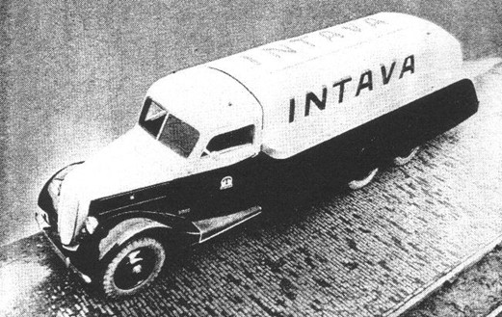

*Photo 26. Intava refuelling truck for Central American airline showing the delivery system, for use at smaller airports 1938.*

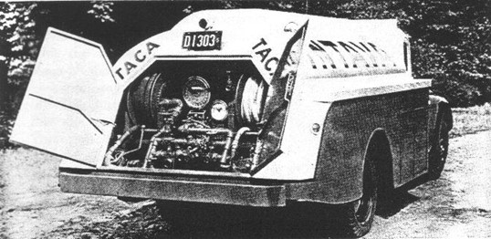

Photo 27. Refueller pumping system

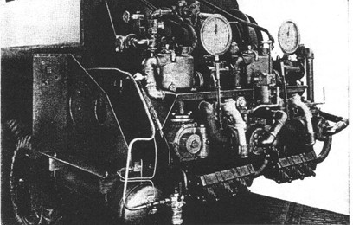

A single power take-off was fitted to the transmission with a drive-shaft extending by a series of universal joints to the rear of the chassis. There was an air cleaner and backfire trap on the carburettor and the exhaust discharges on the right of the chassis beneath the cab well ahead of the tank and pumping equipment. The steel tank was divided into three compartments of 220, 330, 550 US Gallons, or approximately 800, 1200 and 2000 Litres. These trucks were designed with two complete gasoline pump systems, thus permitting simultaneous discharge of two grades of gasoline as required by so many transport aeroplanes of the day. Each piping system could draw fuel from any of the three tanks and deliver it to the aircraft at a rate of at least 80 US gallons or 300 Litres per minute.

There were two Carbon Dioxide fire extinguishers accessible in the right rear skirting, as well as two small supplementary Carbon Tetrachloride, one on the rear compartment door, the other in the driver’s cabin. [Carbon Tetrachloride CCl4 fire extinguishers would be banned in the 1970’s due to the toxicity of Carbon Tetrachloride].

The truck was equipped for night service, besides the usual running lights, four red obstruction lights outlining the general shape of the truck. Of course, to promote Intava brand these trucks were painted with a common colour scheme – the tank and cabin were silver, the side and mudguards were red, the colour change separated by a narrow black band.

For smaller airports, Intava engineers designed a truck similar to the large truck but containing a single pumping system, and a two compartment tank of 550 US gallons or 2,000 Litres capacity, mounted on the regular Ford V8 four wheel 157-inch chassis. The typical operation at the established airports was by tanker truck which would be driven to the aircraft to carry out the refuelling operation. The following was typical of similar operations around the world.

Photo 28. Fleet of Intava tank trucks destined for airports in the East 1940.

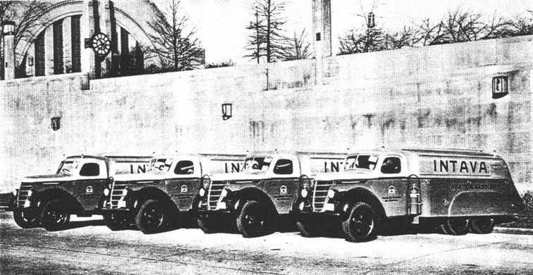

These tank trucks were built for service on the aerodromes at Jodhpur, Allahabad, Calcutta and Rangoon – March 1940[19]

Photo 29. Refuelling de Havilland DH 86B Airliner ‘Carinthia”- VH-UYW at Mascot Sydney, Australia 1940.

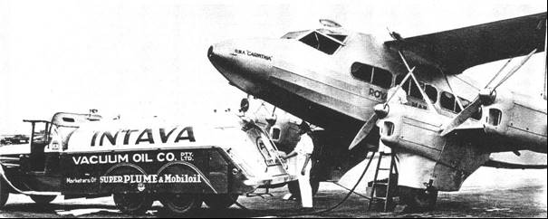

The tank truck was operated by Vacuum Oil Co. Pty. Ltd. who was the INTAVA agent in Australia, the gasoline was Super Plume, and the oils were Mobiloil.

The aircraft above was owned by W.R.C. Airlines which was part of W.R. Carpenter & Co. of Sydney, and they operated the weekly mail service from Sydney, Australia to Rabaul, New Guinea from 1937.

Photo 30. Refuelling a de Havilland Dragon of Misr Airlines in Egypt 1939.

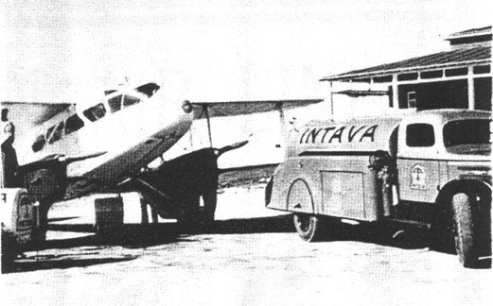

For the more remote locations refuelling would be done from a small trailer or a small underground tank.

Photo 31. Refuelling Vacuum Oil Co. Stinson in outback Australia 1939 from an underground tank.

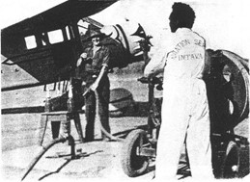

This particular aircraft is a Stinson SR8C Reliant was and owned by the Vacuum Oil Company. On August 14, 1936, it was imported by the Vacuum Oil Co. Pty. Ltd. for their own use and delivered to Port Melbourne on October 5th 1936 on the S.S. “Ardenvohr”.

It was transported to Essendon Aerodrome Vic. and after assembly it was flown on October 13th 1936 by F.W. Haig, Vacuum’s chief pilot and Aviation Manager; it was registered as VH-UXI on the same date. After three years with Vacuum, it was registered to W.J. Smith of Point Piper NSW in whose hands it operated until it was impressed into the RAAF. On February 24th 1941 it was allotted No. A38-1 and was issued to No. 2 Communications Flight at Mascot Aerodrome NSW, who operated it until early 1944.

This aircraft was on display at Wangaratta Air World (as at 2000), together with a Vacuum Aviation Services refueller of the same era. Sadly, the museum and the collection has been closed and sold off.

Photo 32. Vacuum Stinson Reliant on display at Wangaratta Air World (2000)

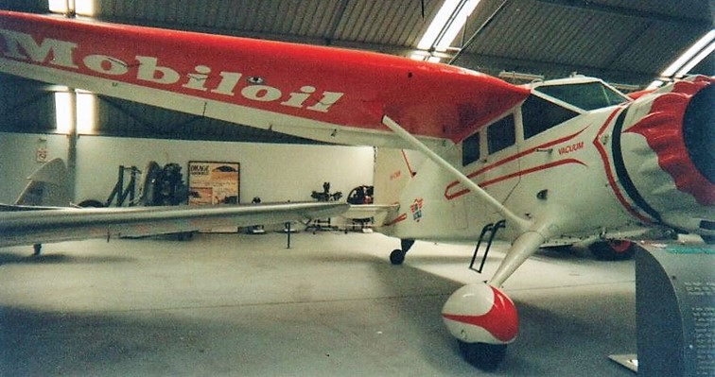

Photo 33. Vacuum Aviation Services 1935 International aviation refueller operated in Perth W.A.

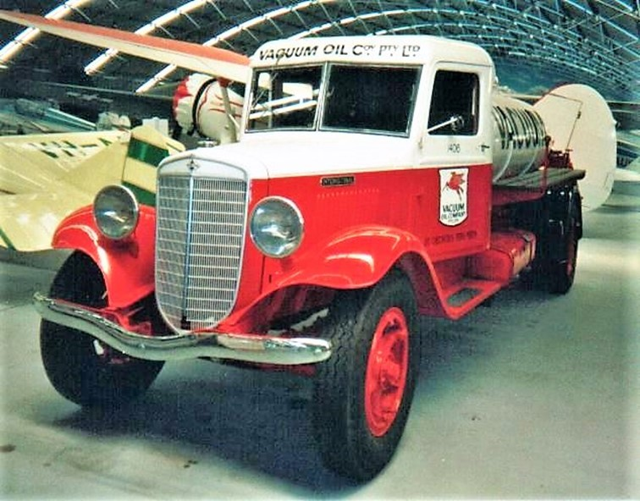

Photo 34. Vacuum Aviation Services 1935 International aviation refueller

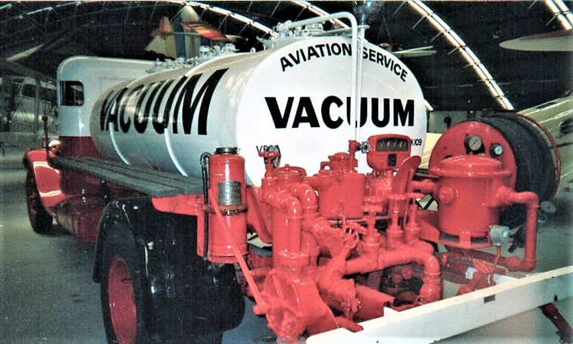

The refueller was restored by the Western Australian agent.

# Shell Aviation – Refuelling Services

In 1919, Alcock and Brown made the first non-stop flight across the Atlantic - powered by Shell fuel. Shell Aviation Services was established that same year.

Photo 35. Refuelling an Italian Savoia-Marchetti flying boat using 2-gallon tine. Note the chamois leather filter. 1925.

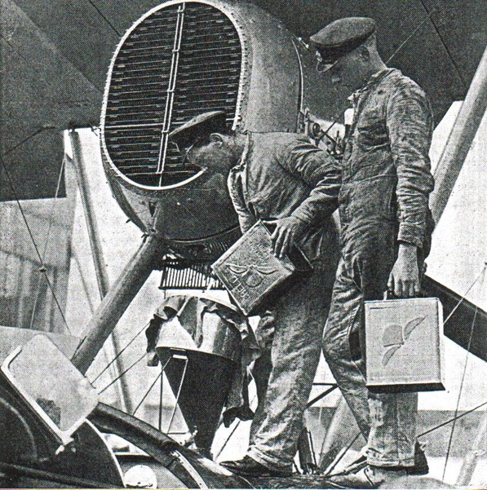

While much of the information above is about Intava, the other oil companies such as Shell Aviation Service were also active in these operations, particularly in Europe. These operations were described in the Shell Aviation News of September 1934 as follows:

‘Aviation being essentially international in its scope, supplies of aviation gasoline and lubricants have to be distributed to approximately 2,500 aerodromes and seaplane stations throughout the world (as at 1934). In most cases, the gasoline is imported in the refined state, but a certain amount of crude petroleum is imported in tankers and refined at strategic points. In either case, the first stage of distribution process is to bring the gasoline and discharge it at an ocean installation by pumping it from the tanker into large storage tanks situated at various main ports. In these tanks, it is stored and maybe blended into the correct specification to make the grade of gasoline universally known as Shell aviation gasoline. From these ocean installations supplies are transferred either by railway, by means of rail tank cars, or, in the case of places near at hand, by road tank wagons to aerodrome storage tanks, which are usually placed underground. In some cases, the amount of business done at the aerodrome does not justify the provision of storage tanks. The aerodromes are therefore usually supplier with aviation gasoline packed in drums, usually of 42 gallons (200 litres) capacity.’

The initial arrangements in the 1920’s for long range flight was to provide strategically located fuel ‘dump’s at designated locations along the ‘planned’ route. The necessary number (estimated) of 2-gallon tins was prepared, filled, sealed and stencilled with the pilot’s name for whom they were reserved. All means of transport were used to get the fuel to the location – sea, rail, road, camel or native porter.

*Photo 36. A pilot refuelling his aircraft in the 1920’s – note the funnel with a chamois to remove water and sediment.*

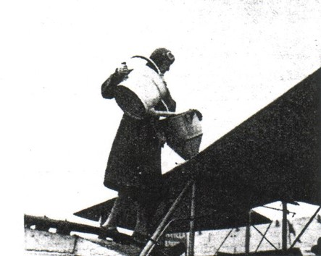

Development of aircraft refuelling ground organisation – From the old can or drum-funnel method came the had operated pump fixed to a large 200 L drum, and then the adaptation of the familiar roadside gasoline pump, raised on a platform and fitted with a long swing arm to carry the hose to the aircraft fuel tanks. This had disadvantages in that pump was an obstruction or had to be placed at the edge of the aerodrome where it was difficult for aircraft to access. The next step was to place the necessary refuelling equipment in underground pits situated at strategic points on the aerodrome with covers flush to avoid obstruction to taxi-ing aircraft, with the electric pumps located at the edge of the field. [A variant of this method is in use today at modern airports.]

With advancements in refuelling operations, the chamois filter gave way to filters in the refuel nozzles and the introduction of static lead bonding via the delivery hose between the aircraft and the refuelling equipment.

Shell believed in the future of civil aviation and to this end at many of the principal aerodromes, Shell Aviation Service Stations were erected which served as offices, stores for aviation supplies, ladders, funnels, chamois leather, chocks, etc. In some cases, these building facilities were provided to the pilots to rest, writing log books, flight planning, etc. In India, there was even sleeping accommodation and bathrooms for the pilots. All Shell Aviation Service Stations were permanently attended by a representative during the aerodrome operating hours. They were also in direct contact with head office, providing daily stock information and conducting regular testing to ensure no product fell below Shell standards. [These tests would be appearance, density, and perhaps distillation].

Photo 37. Refuelling a passenger aircraft circa 1930’s

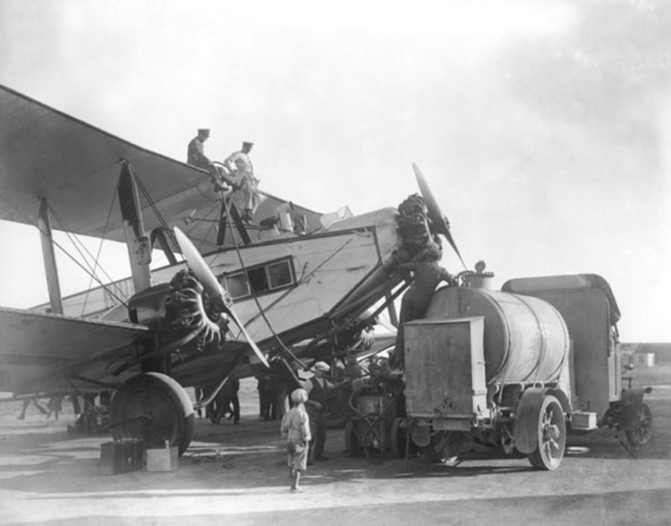

In addition to ground service, the Shell Company made available considerable information on aerodromes, routes, flying and meteorological conditions, etc. Plans of every important aerodrome were available; many had been prepared from aerial photography taken from the Shell Company’s aircraft.

When the first flights to Cape Town (South Africa) and Australia were made, information was required about aerodromes on these routes, but it was not available. The Shell Company undertook the task of collecting, compiling and circulating details in a form readily available to the pilots. Engineers and technicians were at the disposal of pilots to discuss any intricate problem arising from the refuelling or lubrication of their aircraft before undertaking a flight.

Photo 38. Shell Aviation Service refuels a Ford Tri-motor at Croydon Aerodrome (U.K.) using underground facilities, circa 1930’s.

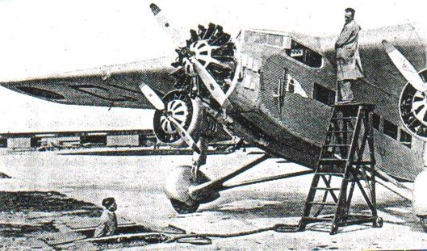

Another service was the introduction of the ‘Shell Carnet’ – perhaps one of the first ‘company credit cards’. In effect it was a worldwide letter of credit, enabling the holder to take supplies of Shell product from any Shell agent without the necessity of carrying large amounts of cash in a variety of currencies to pay for fuel and lubricants. The accounts were settled monthly at holder’s home town in his local currency – a deposit was obtained prior to departure. Any pilot armed with a Shell Carnet could leave on a long distance flight, knowing that he could find Shell Aviation products available at every major and most of minor aerodromes where he may land.

Photo 39. Shell Aviation Services refuel an Imperial Airways Handley Page HP-42 ‘Hanno’ October 1931, at Semakh located at the southern end of Lake Tiberias (the Sea of Galilee). Note the use of fuel carts on each side.

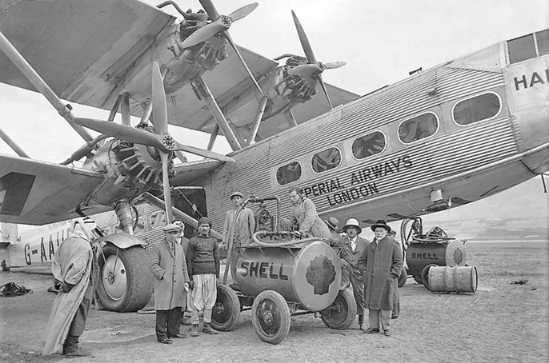

Photo 40. Underground facilities in India, circa 1934.

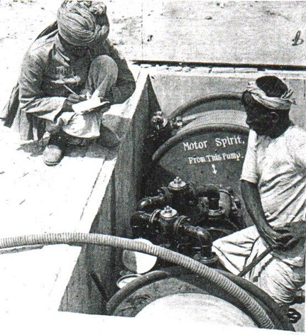

While the underground pit system proved satisfactory at terminal aerodromes, a speedier method was necessary at the intermediate aerodromes where the delays in taxi-ing an aircraft to a pump or pit meant a waste of valuable time. To avoid these delays, the Shell Company introduced an electrically operated refuelling truck capable of delivering 28 Imp. Gallons per minute (128 L/min), up to a total of 330 Imp. gallons (1,500 litres). The principle of using mobile equipment proved so successful in Europe that it was extended to Africa and Asia, however difficulties in obtaining electrical power resulted in the conversion to hand operated trucks and a refuelling rate of 15 Imp. Gallons per minute (68 L/min) was achievable.

However, the need for faster refuelling led to the development of the refueller with a 700 Imp. Gal. (3,200 litre) tank, with delivery rates of 70 Imp. Gallons per minute (320 L/min).

At this time, it was generally not realized by the customer that the ground transport in some of these remote locations was a difficult affair and to ensure adequate aviation gasoline supplies could cost as much as 80% of the cost of the fuel delivered to the aircraft’s tanks.

1934 Shell 77 Octane Fuel

In order to promote their marketing position, Shell announced in February 1934, that a new quality of Shell Gasoline would be available in every territory in which Shell Company markets throughout Europe, Africa and the East. This Shell aviation gasoline was a straight run petroleum product containing no benzol or ‘dope’ (TEL), and it met the new British Air Ministry Specification No. DTD 224 for 77 octane fuel (MON). If a higher octane fuel was required, arrangements could be made to deliver Shell aviation gasoline with the addition of tetra ethyl lead.

Photo 41. Shell Aviation Services refueller 1934.

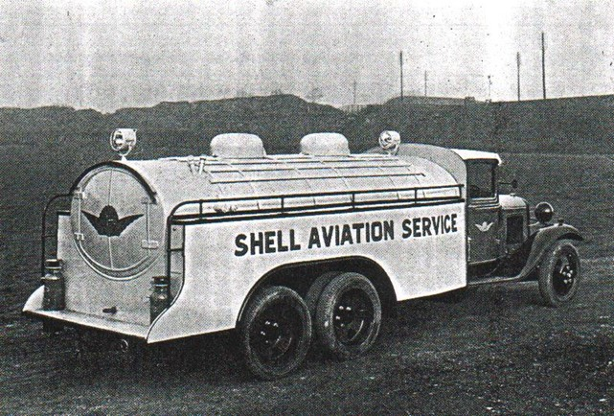

Photo 42. Shell tanker refuelling K.L.M. Fokker.

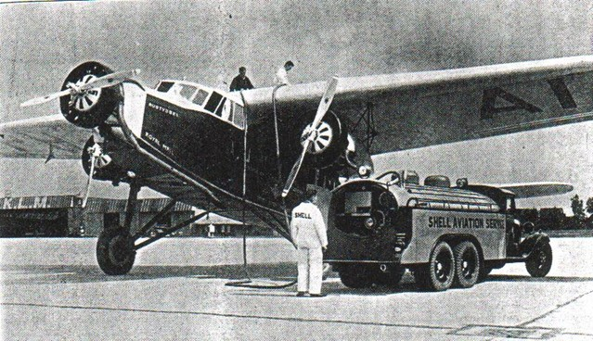

Refuelling by Launch[20]

In the early days, flying boats and seaplanes were hauled from the water after each flight. The aircraft resting on its beaching gear, was carefully washed with fresh water and kept ashore in a hangar until the next flight. This was done because wooden hulls and floats soaked up water which materially increased the weight of the aircraft, also the older types of aluminium-alloy hull was apt to corrode. By 1939, wooden hulls were becoming obsolete, and improved aluminium alloys and better methods of protection made it possible and economical to keep flying boats or seaplanes in the water for long periods. Thus, instead of refuelling the aircraft while ashore from underground tanks (pits) or tanker trucks, methods of refuelling these aircraft while afloat had to be developed. This was the ‘Golden Age’ of the flying boat – the Pan American Clippers and Empire Flying Boats.

It was sometimes possible to bring seaplanes to floating barges close to shore and refuel them from tanks on these moored barges, but often the aircraft was moored some distance from shore and so the fuel had to be brought to the aircraft – this was done by launch.

Intava engineers in cooperation with a specialised refuelling equipment manufacturer H.W. de Voogt developed the most modern launches of the day, which were of all-welded steel construction, with tanks built into the hulls. It was a streamlined craft powered by a Scripps V8, 55 hp engine (the well-known Ford V8 motor converted for marine service). The launch was extremely manoeuvrable since there was often very little margin for error, and exceptional care was required to avoid damage to the seaplanes. The launch was equipped with suction hoses, filters, funnels, handling and mooring lines, and other marine gear including an 83-gallon (380 litres) water tank.

Photo 43. Intava Refuel Launch 1939.

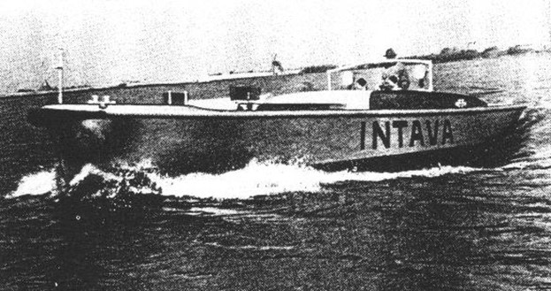

The vessel cockpit contained two fuel hoses, each 100 ft. (30.5m) of neoprene-line bonded refuelling hose (1½ in. (37.9 mm) diameter mounted on hose reels; a 100 ft. length of 1¼ in (31.7 mm) oil hose also fitted to a hose reel. All hoses were fitted with quick acting trigger nozzles.

The delivery system was configured so that two grades of fuel commonly required could be delivered simultaneously at flow rate of 66 gallons (273 Litres) per minute.

The tank compartment was divided into four separate tanks, two of 396 gallons (1,800 Litres) each, and two of 262 gallons (1,200 Litres) each. These tanks were coated with a special anti-corrosive synthetic lacquer which proved most satisfactory in service. The tank compartment was just ahead of the centre of gravity and centre of buoyancy of the boat, thus there was little difference in the trim of the boat whether loaded or empty.

There were two 38½ gallon (175 Litre) fuel tanks for the launch’s engine located under the side decks of the cockpit. The vessel was fitted with ‘Minimax’ fire extinguishers with four lines, one to the hose reel compartment, one to the four fuel tanks, one to the pump cockpit, and one to the engine compartment and engine fuel tank. By a turn of the valve ‘Minimaxin’, a fire-extinguishing gas was forced under pressure to the source of the fire. An extra portable fire extinguisher was within reach of the helmsman, and another portable extinguisher was kept in the hose reel compartment.

The steel deck was covered with a non-skid tread and fitted with mooring bollards and cleats.

Photo 44. Intava launch being filled from a trailer Haifa Harbour (a British battleship in the background) 1939.

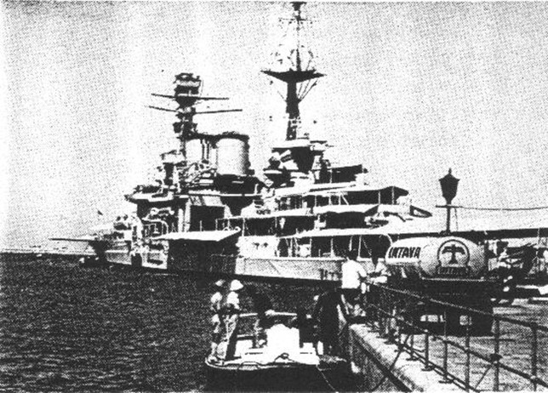

Photo 45. Launch refuelling Ala Littoria’s Savoia-Marchetti in Haifa Harbour 1939.

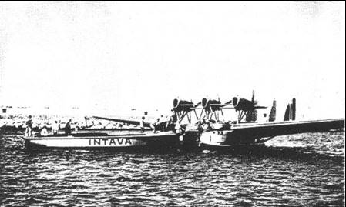

Extensive experience was obtained with these launches, and it was found to have a maximum speed of just over 8 knots. They have proved satisfactory in all conditions that might be expected in service, both loaded and light in smooth, rough, fresh and salt water. Refuelling by launch was not limited to Intava, other companies such as Shell had similar equipment and carried out similar operations.

Photo 46. Shell Aviation Service[21] refuels a Hermes flying boat in Phaleron Bay Athens 1934.

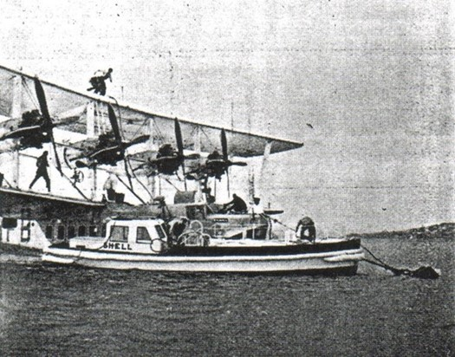

Refuelling in Remote Locations

While the major airports and military bases had refuelling operations generally supplied by the major oil companies such as Shell, Standard Vacuum, Texaco and others, there were many more remote locations where aircraft, particularly military, were refuelled from drums usually the 2- or 4-gallon (20 litre) tin, and later the famous ‘jerry-can’. The following picture shows the typical refuelling of RAF aircraft in India 1937 with the classic 2-gallon Shell tin.

Photo 47. Refuelling a RAF Westland Wapiti in service in India 1938.

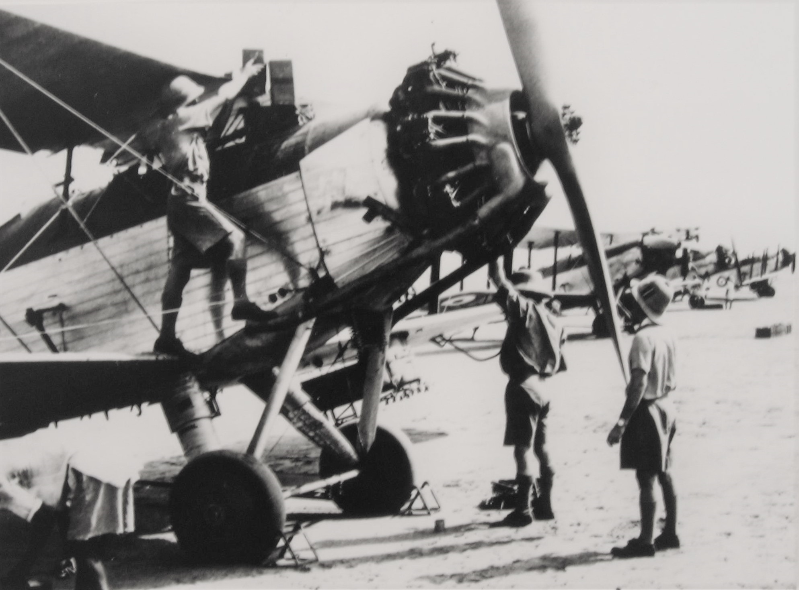

Refuelling in the air

The problem of refuelling aircraft during flight had long occupied the minds of technicians, transport operators and economists of flight. If perfect atmospheric conditions could always be guaranteed, the problem would be reduced to one of skilful piloting and installation of the necessary tanks, pipes and hailing gear. In the United States, when endurance flights were fashionable, the aircraft was refuelled by this dangerous and unreliable method in which a crew member caught the end of a pipe trailed from the supplying aircraft.

The topic of in-flight refuelling will be discussed in a separate chapter.

# Safety Fuels

One of the interesting developments in the 1930’s was that of 'Safety Fuels', probably prompted by the tragic consequences that followed a fire from the not infrequent aircraft crashes in the 1920’s and 30’s in this rapidly growing industry.

The Intava booklet devoted a brief chapter on this subject that succinctly described the status in 1938.

Considerable development work has been carried out on the use of safety fuels. Safety Fuels are relatively non-volatile fuels of high octane number for use in aircraft. They can have either an aromatic or paraffinic base, and are usually produced by some form of hydrogenation or synthesis. Aromatic type safety fuels at present available have octane numbers of 85–95 clear (unleaded). Lead susceptibility is not particularly good, but 100 octane has been reached with 3 cc of lead. Paraffinic type safety fuels of 85 to 100 octane number can be produced, and since they have good lead susceptibility this can be increased by the addition of Tetra Ethyl Lead.

The original idea behind the introduction of safety fuels was, as their name indicates, to increase safety of aircraft by reducing the fire hazard of the fuel used. A lighted flame or an electrical spark will not ignite safety fuel under ordinary conditions, since a lighted match can be plunged into it without fear of a fire occurring. On the other hand, if safety fuel comes in contact with highly heated parts such as exhaust pipes it would be more likely to catch fire than the ordinary lighter grades of aviation gasolines. This is because the lighter and more volatile petrol has a cooling effect as it evaporates (this is known as the Joules– Thompson effect), and consequently it is not easy to bring it to its spontaneous ignition temperature (auto-ignition temperature). Safety Fuel, however, with its lower volatility does not evaporate so easily, and is more readily brought to its ignition temperature. The question of how ‘safe’ safety fuel really is in a fire is a question which required further research and practical experience, but in all probability, it should prove at least as safe in actual service as Diesel Fuel.

Apart from the question of fire risk, safety fuels have a great advantage over ordinary aircraft fuels owing to their comparative freedom from vapour lock, and also in the reduction in the loss by evaporation of the light, high octane number fractions of the fuel. Owing to their low volatility it is not easy to start a cold engine directly on safety fuels, and in many instances, it is necessary to inject a small amount of normal aviation gasoline into the intake manifold while the engine is being turned over so that the actual starting is made on normal fuel. Another factor is that normal carburettor equipment cannot be used without serious loss of efficiency and it is usually necessary to inject safety fuels directly into the cylinder. [Fuel injection was common in German aircraft engines, but not British or American engines].

In 1934 Shell Company[22] made the following comments:

The fuel requirements of the direct injection engine introduce new problems to the fuel suppliers. Apart from the manufacture of a close boiling range product of the required flashpoint, it is essential that the antiknock value of the fuel be high enough to enable compression ratios and supercharge pressures to be used which are comparable to carburetted engines.

Hydrogenation has been discussed as a means of producing safety fuels of the desired knock rating and while satisfactory fuels have been produced, there may be other processes available. The Shell Group has examined this problem with the view of being able to meet any demand for safety fuels which may arise in the future. As a result, Shell High Flash Aviation Gasoline, meeting all the requirements of flash point, volatility and anti-knock value can be offered commercially as soon as the demand arises. For experimental purposes small quantities can be obtained upon request.

The following is an average analysis of Shell High Flash Gasoline.

Specific Gravity at 15 deg. C. 0.863

Colour water white

Flashpoint 106 deg. F (41 deg. C)

Boiling Range (A.S.T.M.)

Initial boiling point 150 deg. C

20% 160 deg. C

50% 166 deg. C

70% 171 deg. C

90% 179 deg. C

Final boiling point 194 deg. C

Distils up to 175 deg. C 84%

Octane Number C.F.R. Motor method 91

[This high flash gasoline was narrow cut boiling range 150-194 deg. C and higher density than the typical aviation gasolines of the time, which were distillation range was 50-160 deg. C, densities around 0.72- 0.75 and a significantly lower flashpoint of -25 deg. F (-32 deg. C)].

Safety Fuels will be discussed in later chapters.

# Prelude to World War – Spain, North Africa & China

The rapid development of military aircraft was driven by the ambitions of Adolf Hitler and other militarists, and also the desire of the colonial powers to maintain control over their empires, and respond to the growing military strength of the Axis powers. A number of conflicts occurred which provided the aggressors with a rehearsal for the next major conflict – World War II.

This resulted in not only the development of faster and more deadly aircraft, but also the fuels and the supply planning, production and distribution which would be needed to fight the next war. These topics will be discussed in later chapters.

Spanish Civil War

In 1937, the Spanish Civil War between the Fascists and Communists provided a unique opportunity for the German Luftwaffe to develop their air power and blitzkrieg tactics. The Luftwaffe formed a special unit to fight under General Franco’s pro-fascist forces. This unit was known as the Condor Unit. They were also joined by the Italian Air force.

Photo 48. German Heinkel 111 from the Condor Unit attacks a Spanish target (circa 1937)

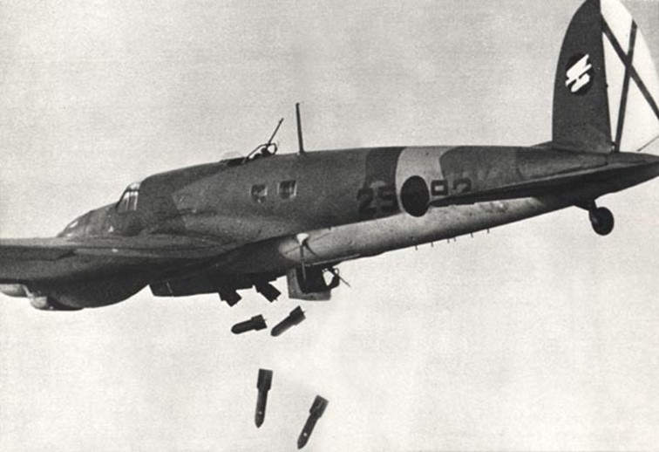

Photo 49. Italian Savoia-Marchetti SM-81 bomber and Fiat CR32 fighters with Spanish Fascist markings circa 1937.

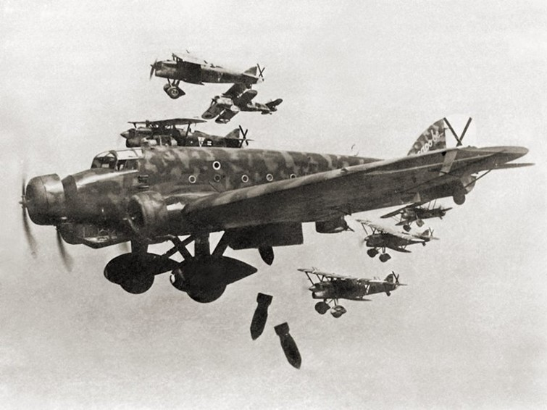

A Savoia-Marchetti SM-81 during a bombing raid in the Spanish Civil War (1936-39). The black crosses distinctive on the aircraft rudder are Saint Andrew's Cross, the insignia of the Spanish Nationalist Air Force (of General Franco). The small biplanes are FIAT CR.32 of the Italian XVI Gruppo Autonomo Cucaracha.

The Republicans (Communists) were backed by Soviet Russia and provided a limited number of aircraft including Polikarpov I-15 and I-16 fighters. (Refer to Russian Chapter)

North Africa

The Italian fascist dictator Benito Mussolini had ambitions to emulate the heroic conquests of the Roman Empire. On October 3, 1935 the modern Italian forces supported by air power invaded Ethiopia; by May 5, 1936 they had captured Addis Ababa, ending major military operations in Ethiopia. This is discussed in later chapters.

Photo 50. Refuelling an Italian Ca 101. This light bomber for 'colonial' warfare was used in the invasion of Ethiopia. (circa 1937)

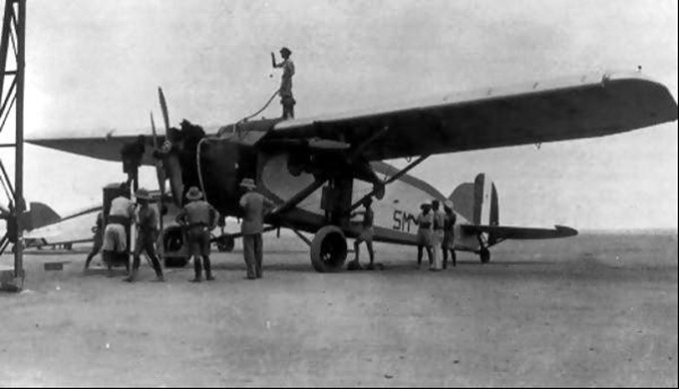

Sino-Japanese War

On September 18, 1931 the militarist government of Japan began its conquest of Manchuria, and by March 1932 Manchuria had become a Japanese puppet state of Manchukuo. On July 7, 1937 an incident at the Marco Polo Bridge near Peiping sets off Sino-Japanese War. In the same year on December 12, Japanese planes sank United States gunboat ‘Panay’ in Yangtze River creating an international incident. This was quickly followed on December 13 by the sacking of Nanking in which the civilian population were bombed. This outrage became known as the “Rape of Nanking”. Again, the use of aircraft and the development of tactics was a prelude to future Japanese attacks.

Photo 51. Japanese Mitsubishi G3M bomber ‘Nell’ (circa 1937)[23].

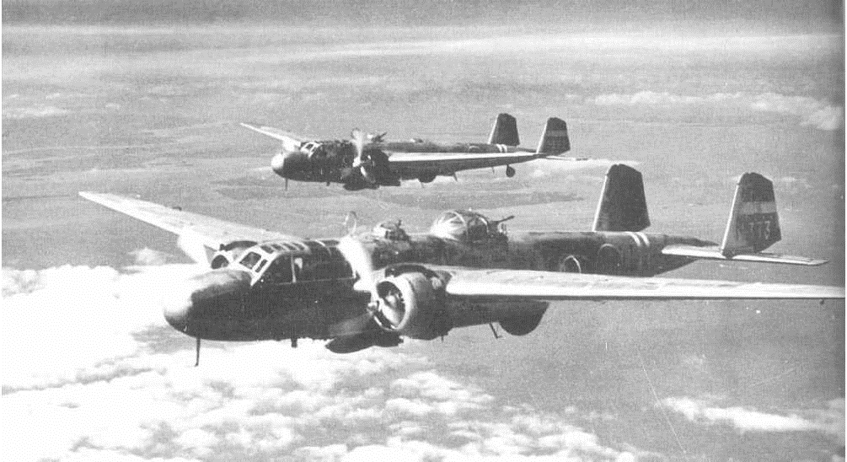

# The Air Race is On” – Airspeed Records[24]

More Speed and Air Races

The 1930’s saw great public enthusiasm and interest in air races. There were a number of races, which attracted international interest; new aviation heroes and heroines were created and their popularity rivalled that of the film stars of the day. Air races such as the Bendix Trophy, Schneider Trophy, Powder-Puff Derby (trans American race for lady pilots), Cleveland Air Race, and the MacRobertson International Air Race - London to Australia in 1934 were all part of the public’s enchantment with the exciting world of aviation.

In this period the (land-based) aircraft achieved the following air speed records:

Table 2. Airspeed Records 1930-1938.

|  |  |  |  |  |
| --- | --- | --- | --- | --- |
| Date | Location | Pilot | Aircraft | Official km/hr |
| 31 Aug 1932 | USA - Cleveland, Ohio | James R Doolittle | Granville Brothers “Gee Bee” R-1 (NR2100) | 473.820 |
| 25 Dec 1934 | France - Istres | Raymond Delmonte | Caudron C.460 (6907) | 505.848 Achieved - Unofficial |
| 12 Sept 1935 | USA - Santa Anna, California | Howard Hughes | Hughes Special 1B (H-1) (NR258Y) | 567.115 |
| 11 Nov 1937 | Germany - Augsburg | Herman Wurster | Messerschmitt Bf-109 V13 (Bf 113) (D-IPKY) | 610.950 |
| 5 June 1938 | Germany - Wurstow | Ernst Udet | Heinkel He 100 V2 (He 112U)  (D-IUOS) | 634.473 |

Perhaps one of the more unusual aircraft was the Granville Brothers “Gee-Bee”. They simply streamlined a Pratt & Whitney Wasp Sr. engine and added just enough wing and tail control surface area to barely keep it airborne and moving at a record speed of almost 300 mph.

Photo 52. Granville Bros. “Gee-Bee” Racer R-1 of 1932.

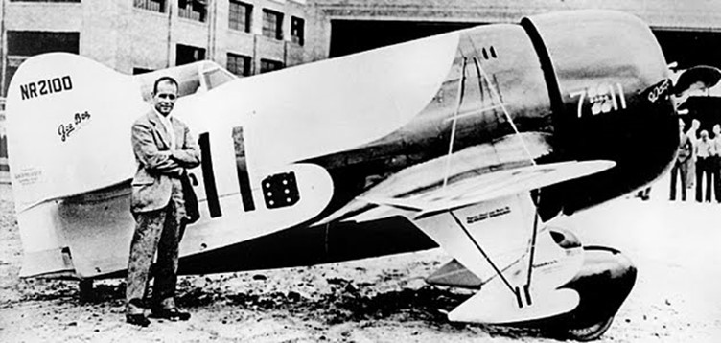

In the hands of Jimmy Doolittle, the R-1 won the 1932 Thompson Trophy race. At that time Doolittle also set a new world landplane speed record of 296 mph in the Shell Speed Dash, a straight-line course.

After a series of crashes of this little unstable aircraft, the Granville Brothers Aircraft, Inc. was liquidated in the late 1933. They had built a total of only 22 aircraft - including 9 biplanes, 8 Sportsters, 2 Senior Sportsters, 3 Super Sportsters, and one long-tailed racer.

In the years between 1935, when Germany first revealed formation of the Luftwaffe, and the outbreak of World War II, Adolf Hitler was most anxious to impress upon the world the capability of the fighter aircraft that equipped his new air force. This was apparent with German efforts in 1937 – 1938 using their military aircraft to secure the air speed records - this would continue into 1939 and beyond.

Special Aviation Fuels[25]

Aviation gasolines are designed to give the best result for a variety of flying conditions and engines – to combine good power output with good fuel consumption and economy, easy starting and good distribution to the cylinders. The cost must not be prohibitive and supplies widely available. For special stunt flights some of these characteristics are less important, and special aviation fuels can be tailored for the specific record attempt.

Speed - Sprint

An aircraft designed solely for speed records will use an engine which is highly supercharged and high compression ratio. Fuel consumption is relatively unimportant. The properties of importance are good latent heat so as to provide the best possible volumetric efficiency and good anti-knock properties in order to withstand the severe pressures and temperatures imposed by supercharging. The fuel components most commonly used to obtain high latent heat are methanol and ethanol. Of these, methanol has the higher latent heat and is often used. In order to provide the necessary volatility, gasoline (of a narrow range) or acetone is added. An example of these fuels is illustrated by the fuels formulated by Banks for the Schneider Trophy races.

Speed – Racing

For comparatively long distance races, fuel consumption becomes a major consideration; in addition, the volatility must be improved to give good acceleration when the engine throttle is opened quickly. In racing fuels the calorific value and volatility are more important than the latent heat. In racing fuels, benzol is generally added to the alcohol to give improved consumption (owing to a higher calorific value), and in a benzol-alcohol mixture, gasoline is generally used to supply the necessary volatility for acceleration. Gasoline has a higher calorific value than acetone and can mix more readily with a benzol-alcohol blend than straight alcohol. Here again a special distillation cut of gasoline is required.

Altitude

Photo 53. Bristol Type 138 set a new altitude record of 53,937 ft. (16,440 metres) in November 1937.

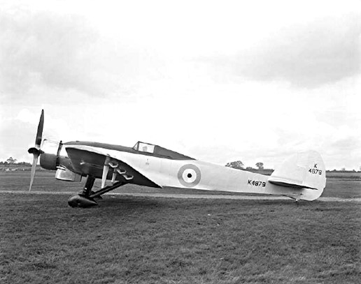

The key requirement of an engine for this type of work is a high degree of supercharge to maintain power at high altitude where oxygen levels are lower. A good anti-knock fuel is required and therefore must be ‘ethylized’ or leaded. It must have a very low freezing point as discussed earlier. Volatility is important and must be careful controlled to maintain good distribution at extremely high altitude. Fuels rich in alcohol are ruled out due to high consumption and the danger of phase separation at low temperatures. Benzol cannot be used due to its relatively high freezing point. Toluol can be used provided it is dehydrated to eliminate the presence of water. Generally, the fuel requirements can be met by special grades on leaded gasolines.

Duration

The principal requirement of an aircraft engine for a long-distance non-stop flight is economy. Therefore, the engine will probably be of a high compression un-supercharged type in order to obtain the best thermal efficiency; further the carburettor will be set to run on a weaker mixture than usual. Fuel requirements are good calorific value to give minimum consumption, and good anti-knock value to enable high compression ratio to be used. The high calorific value requirement by weight or volume, means the specific gravity must be fairly low, about 0.720. Since these flights may entail night or high altitude flying where low temperature conditions prevail, then a low freezing point fuel is required. Benzol has a good calorific value, but has a high specific gravity (0.878) and high freezing point (-10 deg. C) and so it should not be used in large proportions as a blended component for a duration flight. Therefore, leaded gasolines are usually the most suitable fuels for duration flights.

# Index

1

100 octane fuel 18

A

A.N.A. 6

Addis Ababa 52

Airspeed AS6 6

Alcohol 27, 28, 29

alkylation 27

Anglo-American Oil Company 22

Australian National Airways 6

B

B.O.A.C. 17

Balbo 5

Batten 6, 7

Bendix Trophy 53

Benzol 27, 28, 56

benzol-alcohol blend 55

Bristol 31, 32, 33

Bristol Type 138 55

British Air Ministry 30, 32, 33

British Overseas Airways Corporation 17

C

Ca 101 52

Campbell Black 9, 10

Carbon Dioxide 36

Carbon Tetrachloride 36

Chevron 21

Chevron Oil Company 10

China Clipper 16, 18

Cleveland Air Race 53

Colonial Beacon Oil Co. 21

Condor 51

cracked treated gasolines 30

D

de Havilland 9, 10, 31, 37, 38

DH 88 Comet 9, 10

Diesel 31, 49

Dixie Clipper 16, 18

Doolittle 20, 54

Douglas DC-2 "Uiver" 10

E

Empire Airways 6, 30

Empire Flying Boats 45

Esso 21

ethanol 55

Ethyl Aviation 30

Exxon 21

F

FIAT CR.32 52

Ford V8 34, 36, 46

Franco 52

G

Gee-Bee 54

German Air Ministry 31

Golden Hind 16

good-will flights 4, 5

Granville Brothers 54

H

Hendon 4

Hermes flying boat 48

High Flash Aviation Gasoline 50

Hitler 51

Hudson-Fysh 6

Hughes 54

Humble Oil & Refining Co. 21

hydrogenation 27, 49

I

Imperial Airways 16, 17, 30

Imperial Oil Co. 21, 25

Intava 22, 23, 27, 29, 30, 31, 32, 33, 34, 35, 36, 37, 46, 47, 49

INTAVA 4, 20, 29

Iso-Octane 27

Iso-Pentane 27

Iso-Propyl Ether 27

Italian Air Force 5

J

Johnson 6

K

Kingsford-Smith 6, 7

L

Lindbergh 6

Littlejohn 6

Lufthansa 31

Luftwaffe 51, 54

M

MacRobertson International Air Race 8, 53

Manchukuo 53

Manchuria 53

Marco Polo Bridge 53

Martin M-130 16, 18

Mascot Airport 7

Melrose 7, 10

Merlin 34

methanol 55

Minimax 46

Minimaxin 46

Mitsubishi G3M 53

Mollison 6, 8

Musick 18

Mussolini 52

N

Nanking 53

P

Pan Am 16, 17, 18

Pan American Clippers 45

Pan American World Airways 16, 18

Panay 53

Pasotex Oil Co. 21

Peiping 53

Plume 37

polymerisation 27

Powder-Puff Derby 53

Pratt & Whitney 30, 31, 54

Q

QANTAS 6

R

R.A.A.F. 32

R.A.F. 32

RAAF 7

RAF 5

reforming 27

Robertson 8, 60

Rolls Royce 31, 34

Royal Aero Club 8

S

Safety Fuels 27, 49

Savoia-Marchetti 5, 47

Savoia-Marchetti SM-81 52

Schneider Trophy 53, 55

Scott 9, 10

Scripps V8 46

Shell 8, 14, 20

Shell Aviation Service 4, 17, 40

Shell Carnet 43

Shell Company 20

Shell Company of Australia 6, 21

Shell High Flash Gasoline 50

Skilling 6

Smith 8

Socony-Vacuum 22, 23, 24, 25

Southern Cross 6

Spanish Civil War 3, 51

Spanish Nationalist Air Force 52

Special Aviation Fuels 54

Specification D.T.D. 30, 32, 33

Spitfire 34

Stanavo 8, 14, 21

STANAVO 4, 20, 21, 29

Standard Oil 22

Standard Oil Co. 21, 25

Standard Oil Co. (Indiana) 21

Standard Oil Co. (Kentucky) 21

Standard Oil Co. (Ohio) 21

Standard Oil Co. of California 21

Standard Oil Co. of Louisiana 21

Standard Oil Co. of Nebraska 21

Standard Oil Co. of New Jersey 21

Standard Oil Co. of Pennsylvania 21

Standard Oil Company 25

Standard-Vacuum Oil Company 22, 23

Stinson 38

straight-run gasoline 30

T

Tetra-Ethyl Lead 27

Texaco 48

thermal cracking 27

Thompson Trophy 54

Timken 34

Toluol 55

Turner 10

U

Udet 54

Ulm 6

US Army Air Services 5

V

Vacuum Oil Co. 23, 24, 26, 27, 37, 38

Vacuum Oil Company 21, 22, 23, 24, 27, 60

Vacuum Product No. 31 34

Vacuum Product No. 32 34

Vacuum Product No. 33 34

W

Wackett 6

Werkspoor N.V. 34

West India Oil 25

Westland Wapiti 48

Williams 7

*Wright* 18, 30, 31

Y

Yankee Clipper 16

# References

1. “The Mac Robertson Centenary Gestures” published by The Specialty Press Pty. Ltd. Art Printers 174-176 Little Collins St. Melbourne C1. Circa 1934-1935
2. Website <http://www.dc3airways.com/1934-1.html> Accessed Sept 10, 2005
3. Aviodrome, Nationaal Luchtvaart-Themapark – Lelystad, Netherlands, display Sept 2006.
4. Flightpath Volume 26 Number 2, page 60 “The Many Fuselages of ‘Uiver’” – Neil Follett
5. Aviodrome, Nationaal Luchtvaart-Themapark – Lelystad, Netherlands, display Sept 2006.
6. Aviodrome, Nationaal Luchtvaart-Themapark – Lelystad, Netherlands, display Sept 2006.
7. Website <http://www.panam.org/default.asp> PanAm Heritage Accessed Sept 10, 2005.
8. Website [http://www.channel4.com/science/microsites/S/speedmachines/flyingboats.html.](http://www.channel4.com/science/microsites/S/speedmachines/flyingboats.html.%20) Accessed Sept 10, 2005. Source British Airways Museum
9. Website <http://www.panam.org/default.asp> PanAm Heritage Accessed Sept 10, 2005.
10. Website [http://www.zpub.com/sf/history/sfh-cc.html](http://www.zpub.com/sf/history/sfh-cc.html.%20) Accessed Sept 10, 2005.
11. Website <http://www.channel4.com/science/microsites/S/speedmachines/flyingboats_technology.html> Accessed Sept 10, 2005. Source Vinmag Archive
12. “The History of the British Petroleum Company Volume 2 The Anglo-Iranian Years 1928-1954” by J H Bamberg, Cambridge University Press ISBN 0 521 259509
13. Shell Aviation News, September 1934
14. Source: NASM B4 292100-01
15. “Aviation Fuels- Lubricants and Special Petroleum Products” – Vacuum Oil Company Pty. Ltd – Melbourne Australia. Complimentary Booklet circa 1939
16. “Aviation Fuels- Lubricants and Special Petroleum Products” – Vacuum Oil Company Pty. Ltd – Melbourne Australia. Complimentary Booklet circa 1939
17. ‘The INTAVA World’ July 1938
18. ‘The INTAVA World’ December 1938
19. ‘The INTAVA World’ March 1940
20. ‘The INTAVA World’ April 1939
21. Shell Aviation News, December 1934
22. Shell Aviation News, September 1934
23. Public Domain, https://commons.wikimedia.org/w/index.php?curid=844086
24. “World Speed Record Aircraft” by Ferdinand Kasman F.C.W. -Cologne - June 1990. Leicestershire Library (UK) Call No. 639.1334.
25. Shell Aviation News, June 1934