Chapter

17

Rumanian Oil 1940-1945

Photo . Ploesti Refineries 1943 during bombing attacks by USAAF 380th Bomb Group[1].

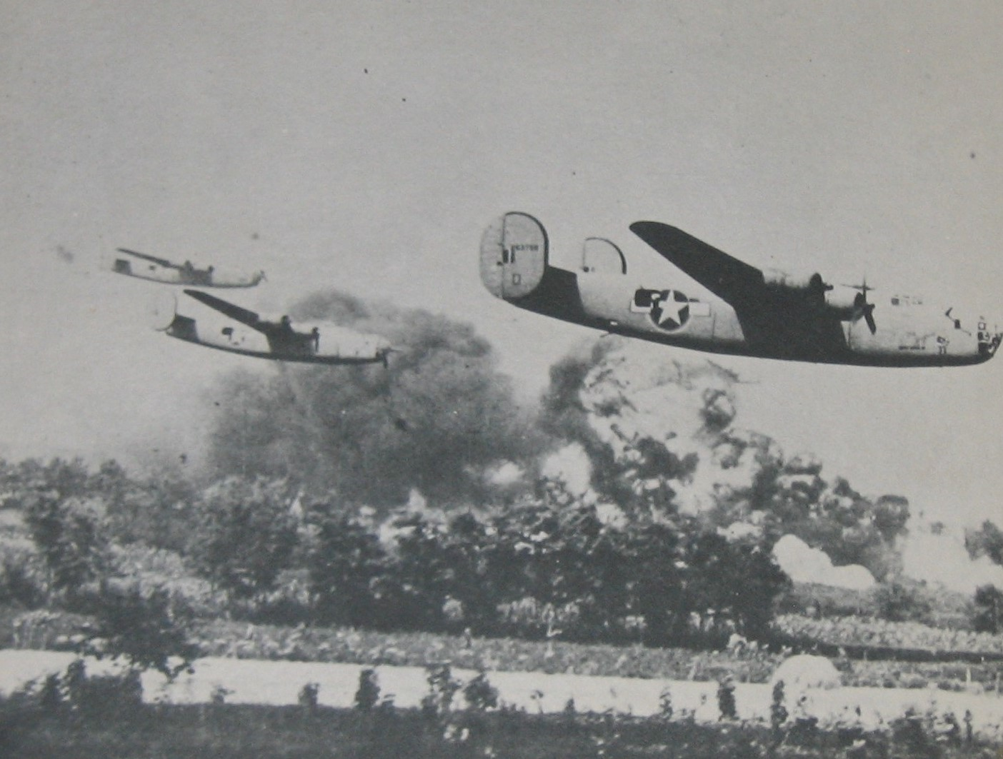

Table of Contents

Summary 3

The Importance Of Ploesti 4

“Target – Destroy Germany’s Oil Industry” 5

Oil Supplies, Refineries And Plants 5

Rumanian Naphtha 6

Spoils Of War – Captured Oil Supplies And Facilities 8

Romania During World War II 8

British Plan Attacks On Rumanian Oil 8

Roumanian Refineries 9

The Raids Begin – Soviet Red Air Force 12

US Army Air Force – Prepares 1942 12

The Ploesti Oil Fields 17

Epilogue For The Rumanian Oil 18

Index 22

Research Sources 25

Photo 2. USAAF B-24 Liberator bomber attach Ploesti refineries. 1944s

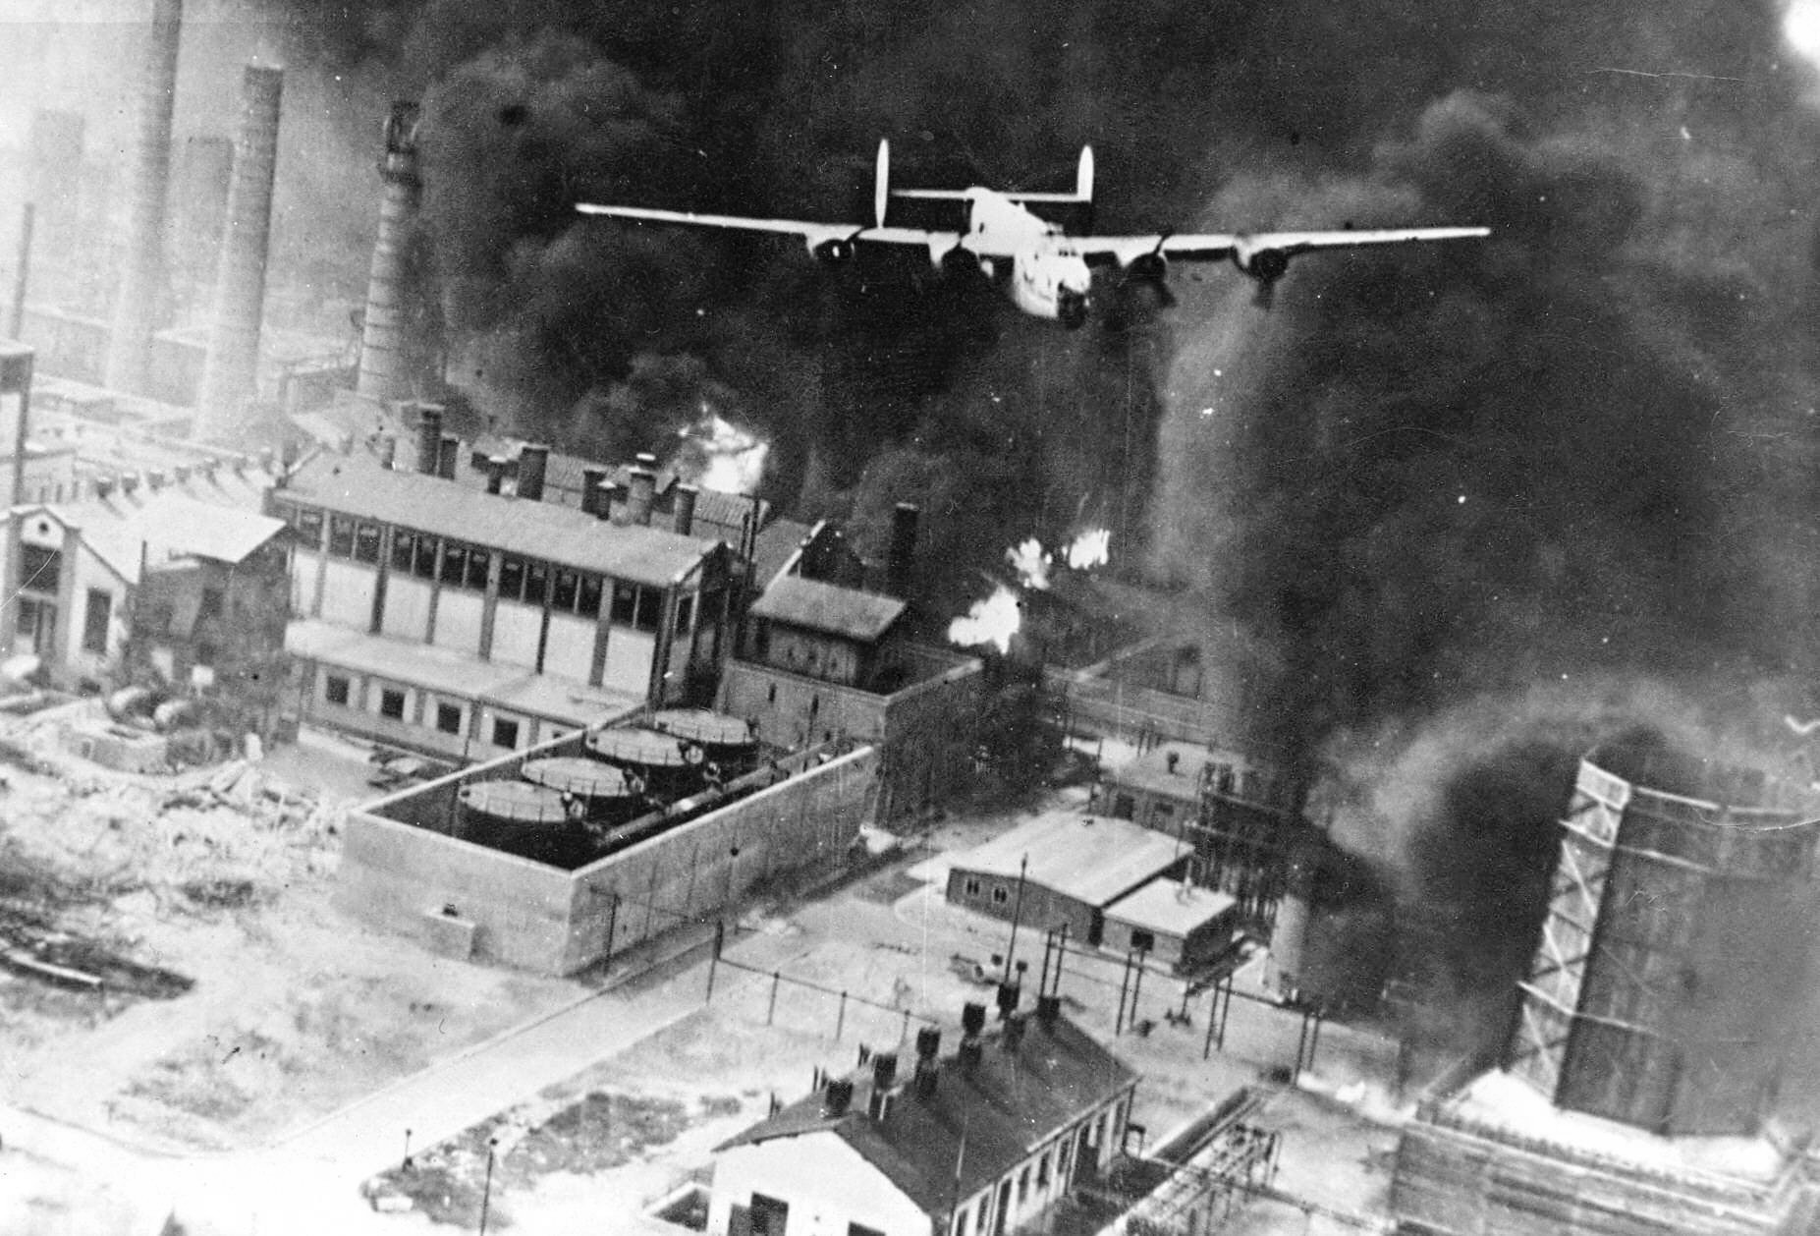

Summary

For the German Reich to maintain the German juggernaut across Europe and North Africa oil was essential; what better place to get that precious cargo than the rich oil fields of the Balkans – Rumania!

Chronology

September 27, 1940 Germany, Italy, and Japan form the Axis coalition, sign the Tripartite Pact in Berlin.

November 20, 1940. Hungary signs the Tripartite Pact (Axis)

November 23, 1940 Romania signs the Tripartite Pact (Axis)

March 1, 1941 Bulgaria signs the Tripartite Pact (Axis).

July 13, 1941 Red Air Force attack Ploesti refineries.

June 12, 1942 USAAF B-24 Liberator bombers from Egypt attack Ploesti refineries.

August 1, 1943 ‘Operation Tidal Wave’ USAAF bombers from 8th and 9th Air Forces attack Ploesti refineries.

April 5-May 5, 1944 USAAF 15th Air Force bombers attack Ploesti refineries.

May 16, 1944 RAF Halifax and Wellington bombers attack Ploesti refineries.

August 1, 1944 USAAF 15th Air Force bombers attack Ploesti refineries.

Aug.-Sept 1944 Axis supplies from Rumanian refineries and captured territories are lost.

1945 Rumania oil industry in Russian hands.

Photo 3 Ploesti refinery after RAF bomber attack 1944.

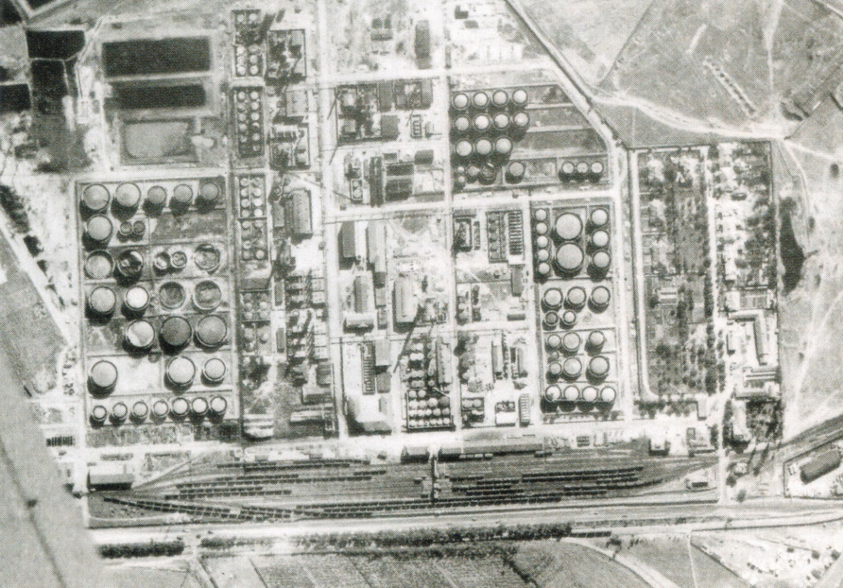

# Rumanian Oil - A constant Allied target

The oil fields and refineries of Rumania became a constant target for Allied bombers., indeed, it was recognised as a vital war resource in the Great War (1914-1918). Places such as Ploësti would be on the list of targets of nearly every raid, equally they would be defended by the Axis, because this was the life blood of the German war machine.

# The Importance of Ploesti

To understand the importance of Ploesti , one must go back to the Great Warwhen the sabotage of the principal producing wells were considered; and then in 1939 the pre-emptive actions by the British government started as early including clandestine commercial activity, sabotage, attempts to block the Danube. [2]

With regard to the pre-emptive actions –

As soon as the policy of purchase of Rumanian oil was decided upon in September 1939 by the British Government, the Mines Department (Petroleum Division) concerted preliminary arrangements with the oil companies with British capital in Roumania. The companies were the Astra Romana, a subsidiary of the Shell Group, Unirea, a subsidiary of Phoenix Oil and Transport Co., Ltd., Dacia Romana, and Steaua Romana, of which 49 per cent, of the capital was held by British and French interests.

A committee under the British War Cabinet was set up, under the chairmanship of Lord Hankey, to devise and co-ordinate means to frustrate German plans and promote the policy of the War Cabinet.

Clandestine commercial activity included the purchase or charter means of oil transport such as barges, tugs and rail tank cars so as to deny the use of vessels was first put into practice in the spring of 1939. The enforcement of a strict blockade of Germany's ocean-born imports at the outset of the war left open only the Baltic, and the Black Sea and Danube waterways for its imports. The oil, food and mineral resources of the Black Sea and Danube areas made the Danube route of vital importance. To achieve this a company, Goeland Transport and Trading Company, Limited, totally British Government-owned and was formed with a view to furthering the Government's plans for denying the use of craft on the Danube to the enemy by means of purchase, charter, laying up or hindering river traffic. The main activity of the company was to charter or purchase vessels in order to reduce the tonnage of shipping on the Danube, not only to prevent them trading with the enemy, but to manipulate their use in trade with neutral countries.

Sabotage

Plans to deny Roumanian oil to Germany; it was decided in 1939 that in the event of war, which by then appeared inevitable, the oil resources of Roumania must not be allowed to fall intact into the hands of the enemy. The proposal that the oil-fields should be "scorched" was first put forward by the Admiralty and a representative was sent to Roumania in June 1939 to discuss with the Roumanian General Staff the possibility of British help in the work of destruction should the Germans invade. At the same time the War Office sent an intelligence officer to reconnoitre the vulnerable points in the Roumanian communication system. However, this plan was scrapped with the assassination of Armand Călinescu (4 June 1893 – 21 September 1939) who served as 39th Prime Minister of Rumania.

On the 3rd July, 1940, without warning and obviously acting under German orders, the Roumanian police expelled from the country about twenty-five British employees of the oil companies, giving them twenty-four hours in which to leave. They were replaced by Roumanian commissars. This meant the end of the oilfields plan, since the services of the local British residents were essential to the scheme. At the same time, the placing of strong forces of Roumanian troops around the oil installations put an end to any possibility of large-scale sabotage.

Attempts to Block the Danube

An important part of these plans had been the blockage of the Danube at the narrows formed by the Iron Gates. During the winter of 1939 British representatives in Yugoslavia had arranged for the cliffs above the river at the Iron Gates to be prepared for explosive charges which were to blow the rock into the stream and so block the narrow passage. In April 1940, a small fleet of merchant vessels entered the Danube. The crews were personnel of the Royal Navy, attired inappropriate disguises, and the cargoes included the explosives required for the task. However, their plan was discovered and the Roumanian Government insisted upon the immediate withdrawal of these ships from the Danube. One more attempt was made to block the Iron Gates. In April 1941 an endeavour was made to sink a number of barges laden with stones in the narrows. Although some barges were sunk in the positions intended, the channel was not effectively blocked.

On the 15th February, 1941, the British Legation party left Bucharest and with their departure there ended any chance of effective action against the Roumanian oil industry from within the country. The Petroleum Adviser to the Legation proceeded to Cairo where, at a conference with the Foreign Secretary and Chief of Staff, it was decided to press for a policy decision to bomb Roumanian oil targets without delay. Roumanian targets were, however, out of range to the then available bombers from Middle East bases, and permission to use Greek airfields was not forthcoming. When, after the invasion of Greece, these became available for use, there were no bombers which could be spared for these operations.

All of the above leads us to the conclusion that the target of Ploesti must now be a bombing target for the Allied Air Forces.

# “Target – Destroy Germany’s Oil Industry”

As the war in the world progressed, it was apparent that this could be more properly termed “Air War I”. In Europe, after the fall of France and the evacuation of the British from Dunkirk, it was essentially the ‘War in the Air’ on the Western front. In the Pacific, great naval battles would be fought using aircraft flown from aircraft carriers where the opposing ships never sighted each other. In North Africa, armies would advance, stall, or retreat depending on fuel supplies. Therefore, all those involved knew the importance of maintaining and securing supplies of petroleum products. For the Allies, a major part of their strategy was to destroy the Axis oil industry, and this would be demonstrated by the strategic targeting by the bomber forces of both U.S. Army Air Forces and British RAF Bomber Command. Their targets were the refineries, chemical plants, oil depots and supply routes. One of the most important areas was that of Rumania

# Oil Supplies, Refineries and Plants

At the start of the war 1939 Germany had only 0.3% of the world’s crude oil supplies, its allies Rumania had 2%, while the USA had 60%, Venezuela 11%, Russia 10%. This lack of crude oils was the drive to (a) gain access to crude supplies by conquest and (b) utilize coal as a fuel source for gasoline. In addition, Germany’s Axis partners Italy, Hungary and Rumania would be called upon to support the war effort with petroleum products, of these Rumania was the most important.

Graph 1. German aviation gasoline position 1940-1945

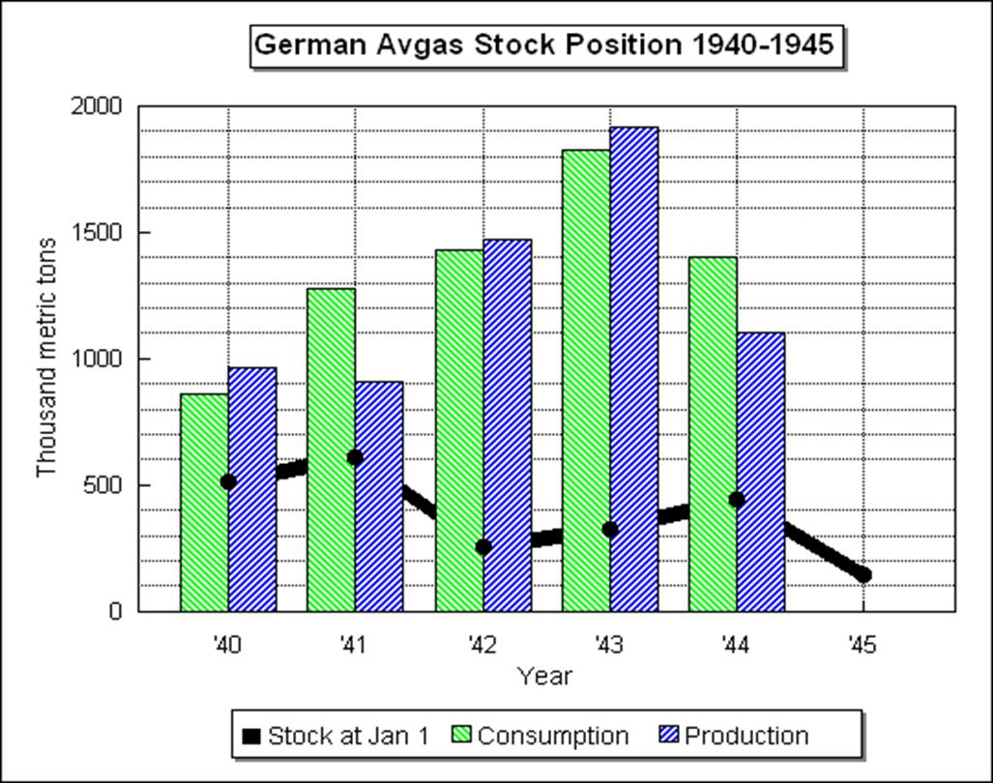

The rich oil fields of the Balkans became a target for the Allies. The impact of the bombing raids in Germany and Roumania can be seen in the decreases in 1944.

# Rumanian Naphtha

The Rumanian oil fields of Merisor, Bucsani and Gura-Ocnitsei produced crude oil from which naphtha could be refined. This naphtha, depending on its quality (composition of Paraffins, Olefins, Naphthenes and Aromatics known as PONA), could be used as a component of motor gasoline or aviation gasoline. The naphtha from these crudes was rich in aromatics and naphthenes and therefore suitable for aviation gasoline blend stocks.

Theoretical calculation of the Motor Octane Number (MON), assuming no synergism, has Merisor naphtha MON = 60.2, Bucsani naphtha MON = 49.9 and Gura-Ocnitsei (aromatic free) naphtha MON = 67.7, so clearly Merisor and Gura-Ocnitsei (aromatic free) naphthas would be preferred for aviation gasoline.

The following are the compositions[3] of these naphthas in 1939. The naphthas appears to be stabilised, that is, the light gases such as Methane, Ethane, Propane and Butane have been removed. The naphtha cuts are 50 to 150 deg C.

Table 1. Composition of Naphthas from Rumanian crude oils 1939.

|  |  |  |  |  |
| --- | --- | --- | --- | --- |
| Component | Synonyms | Merisor | Bucsani | Gura-Ocnitsei (aromatic free) |
| 50-150OC | 50-150OC | 50-150OC |
| %wt. | %wt. | %wt. |
| Cyclopentane |  | 0.4 | 0.1 | 0.2 |
| Isohexanes | 2-Methyl pentane | 5.4 | 5.1 | 9.4 |
| n-Hexane |  | 5.4 | 5.3 | 3 |
| Methyl cyclopentane |  | 3.7 | 2 | 7.1 |
| Benzene |  | 1.7 | 2 |  |
| Cyclohexane |  | 3.5 | 2.7 | 9.1 |
| Dimethyl Cyclopentanes |  | 6 | 2.7 | 10.8 |
| Isoheptanes | Incl. 2,3, Di Methyl Pentane | 6.9 | 7.7 | 10.9 |
| n-Heptane |  | 4.8 | 8.3 | 3.1 |
| Iso-Octanes |  | 6.4 | 9.1 | 9.6 |
| Methyl Cyclohexane |  | 9.3 | 7.3 | 20.3 |
| Naphthalene fraction 104-113C |  | 3.6 | 1.2 | 4.9 |
| Toluene |  | 2.1 | 3.6 |  |
| n-Octane & heavier |  | 3.2 | 7.5 |  |
| p-Xylene (or Xylenes) |  | 4.1 | 6.5 |  |
| Iso-Nonanes |  | 5.2 | 8.4 |  |
| n-Nonane |  | 1.2 | 5.5 |  |
| Dimethyl Cyclohexanes |  | 11 | 5.7 | 11.6 |
| Naphthalene fraction 126-150OC |  | 16.1 | 8.4 |  |
| PONA |  |  |  |  |
| Paraffins |  | 14.6 | 26.6 | 6.1 |
| Iso-Paraffins |  | 23.9 | 30.3 | 29.9 |
| Olefins |  | 0 | 0 | 0 |
| Naphthenes |  | 53.6 | 30.1 | 64.0 |
| Aromatics |  | 7.9 | 12.1 |  |

# 

# Spoils of War – Captured Oil supplies and facilities

With the German Blitzkrieg advances in the west came the capture of enemy (French) aviation gasoline stored supplies and oil plants. In the east came the Balkan oil resources, and since Rumania was soon to be an ally of Germany, then these oil supplies of product and crude continued.

The Rumanian oil fields and particularly the refineries are an important part of the avgas story for throughout the war they provided the Axis air forces with the precious aviation fuel, and therefore would be a constant Allied target.

# Romania during World War II

When war erupted in Europe in 1939, Romania was pro-British and was allied to Poland. However, following the invasion of Poland by Germany and the Soviet Union, and the German conquest of France and the low countries, Romania found itself increasingly isolated. Pro-German and pro-fascist elements began to grow.

The August 1939 Molotov-Ribbentrop Pact between Germany and the Soviet Union contained a secret protocol ceding Bessarabia, part of northern Romania, to the Soviet Union. On June 28, 1940, the Soviet Union occupied and annexed Bessarabia, as well as Northern Bukovina and the Hertza region. On August 30, 1940, Germany forced Romania to cede Northern Transylvania to Hungary as a result of the second Vienna Award. Southern Dobruja was also ceded to Bulgaria in September 1940. In an effort to appease the Fascist elements with the country and obtain German protection, King Carol II appointed the General Ion Antonescu as Prime Minister on September 6, 1940.

Two days later, Antonescu forced the king to abdicate and installed the king's young son Michael (Mihai) on the throne, then declared himself Conducător (Leader) with dictatorial powers. Under King Michael I and the military government of Antonescu, Romania signed the Tripartite Pact on November 23, 1940. German troops entered the country in 1941 and used the country as platform for invasions of both Yugoslavia and the Soviet Union. Romania was also a key supplier of resources, especially oil and grain.

Romania joined the German led invasion of the Soviet Union on June 22, 1941. Nearly 800,000 Romanian troops fought on the Eastern front. Areas that were annexed by the Soviets were reincorporated into Romania. By 1943, the tide began to turn and the Soviets pushed further west closer to Romania. Foreseeing the fall of Nazi Germany, Romania switched sides during King Michael's Coup on 23 August 1944. Romanian troops then fought alongside the Soviet Army until the end of war, reaching as far as Czechoslovakia and Austria.

# British plan attacks on Rumanian Oil

As early as 1940, the British had identified the Rumanian oil fields and associated installations were possible targets. Even questions were received from British parliamentarians.

Memos from the British Air Ministry (Department of Information) noted [4]

Air Ministry - Received AMCS 23 July 1940 from Air Vice Marshall Drummond

Greater Danube collecting stations at Regensburg, Passau, Vienna and Bratislava

This identified part of the transport route for petroleum products along the Greater Danube River which were to be used by the Germans together with the expected increase in output.

Air Ministry D o I (AI 3C) - Received AMCS 25 July 1940 from Paynter

Report from Air Attaché Bucharest on Roumanian oil fields indicated that exports to Germany were now (July 1940) 30,000 tons per month by rail and 70,000 tons via Danube River. After nationalisation the Air Attaché estimates that the Germans can obtain up to 90,000 tons per month by rail and 100,000 tons by barge along the Danube River.

By November 1940 with the political situation deteriorating in the Balkan region with Hungary and Rumania about to join the Axis, the RAF planners were busy again.

RAF Intelligence on Rumanian Oil Fields March 1940

The British RAF had undertaken a review of possible targets and in March of 1940 had prepared a paper titled ‘Most Secret – Roumanian Oil Fields and Refineries’ - this document contained general remarks, information on Roumanian oil fields, Roumanian refineries in order of importance, a list showing the most important oil fields, and a division of the productive wells from the 8 largest oil fields as of January 1, 1940. Of particular interest was their assessment on the best way to inflict damage to the enemy’s oil operations.

The following is a list of the installations together with their assigned RAF target numbers.

# Roumanian Refineries

Figure 1. Ploesti Refinery Complex and the locations of the refineries

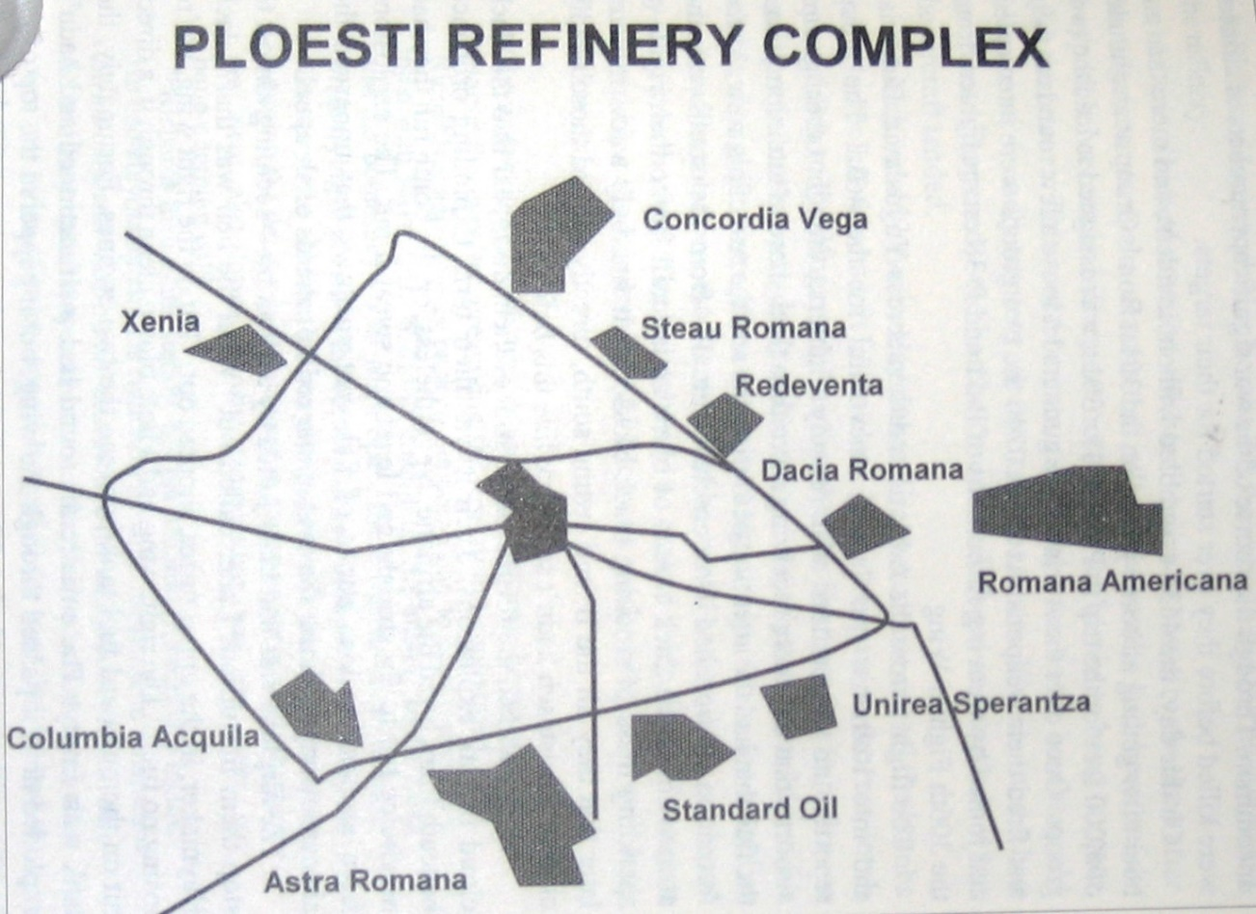

In order of importance – representing over 90% of the capacity of Roumania

Table 2. Roumanian Refineries (circa 1939)

|  |  |  |  |  |  |  |
| --- | --- | --- | --- | --- | --- | --- |
| Cracking Refineries | | | | | Tons of Crude treated |  |
|  | Name and Location | | Potential throughput T/year Crude | | Actual output Jan-Sept 1939 extrapolated for 1 year | Monthly Capacity |
| BR1 | Astra Romana, Ploesti | | 2,000,000 | | 1,460,000 | 165,000 |
| BR2 | Concordia Vega, Ploesti | | 1,470,000 | | 1,000,000 | 110,000 |
| BR4 | Romana Americana Ploesti (Teleajen) | | 1,400,000 | | 800,000 | 115,000 |
| BR3 | Steaua Roman, Campina | | 1,240,000 | | 580,000 | 100,000 |
| BR5 BR10 | Unirea Orion, Ploesti  Unirea Sperantia, Ploesti | | 1,161,000 | | 600,000 | 50,000  40,000 |
| BR7 | Creditul Minier, Brazii | | 540,000 | | 387,000 | 50,000 |
| BR6 | Columbia (Vega) Ploesti | | 540,000 | | 391,000 | 40,000 |
| BR8 | Standard Petrol (Petrol Block) Ploesti | | 504,000 | | 20,000 | 40,000 |
|  | | | | |  |  |
| Non-Cracking Refineries | | | | | Tons of Crude treated |  |
|  | | Name and Location | | Potential throughput T/year Crude | Actual output Jan-Sept 1939 extrapolated for 1 year | Monthly Capacity |
| BR9 | | Redeventza (Xenia), Ploesti | | 292,000 | 143,000 | 23,000 |
| BR12 | | Dacia Romana, Ploesti | | 240,000 | 142,000 | 15,000 |
|  | | Petrol-Bucharesti, Bucharesti | | 210,000 | 190,000 |  |
| BR13 | | Lumina (Petrolmina), Ploesti | | 150,000 | - | 12,000 |
|  | | Steaua Romana, Moinesti | | 60,000 | 35,000 |  |
|  | | Roman Belgiana, R-Sarat | | 50,000 | 4,300 |  |
|  | | Photogen, Brasov | | 34,000 | 13,000 |  |
| BR14 | | Fratia, Ploesti | |  |  | Small |
| BR18 | | Redeventza, Ploesti | |  |  | 16,000 |
| Other refineries | | | |  |  | 50,000 |
| **Total** | | | | **9,891,000** |  | **826,000** |

Since our focus is on avgas and refineries, the information from this source has been limited to those interests, however the source also contains details on specific oil wells and fields.

It was clear that the RAF considered the Rumanian oil fields a prime objective having identified specific targets and a strategy to inflict the greatest potential disruption to the German oil supplies.

Renewed Plans to Attack Rumanian Oil

By November 1940, Rumania was part of the Axis Tripartite Pact and therefore a legitimate and prime target. In March 1941, the RAF were assessing the Rumanian oil targets again and planning their attacks. There would, of course, be political considerations – this time it would be the interests in the American companies operating in Rumania, for America was still neutral at this time.

Cable received AMCS 11 March 1941[5]

RAF Oil Targets Roumania

Background of study:

Present oil stocks now Roumania amount over 1,400,00 tons of which 1,000,000 finished products (including oil) main reason these exceptional large stocks (1) normal (?winter) excess production over consumption and export. (2) Present German insistence on increased production on the grounds they will soon be able take away over period of time both maximum current production and accumulated stocks. New double 10 inch pipeline from Ploesti to Giurgiu ready April 1941, new river tankers, improvements railways will it is estimated enable Germany to take away for use in greater Germany and Italy 400,000 tons product per month from May 1941 onwards. Limiting factor therefore now changing from transport to production. Germans not yet made much progress with program protective measures at refineries and storage tanks but pressing on with these. Germans now dispersing products for example, benzene stock moved Constanza proportion of which possibly destined military use in Bulgaria.

Recommendations are:

(A) If attacks possible during next 2 months objectives should be bulk stocks refined products. Tanks, refineries, railway sidings in immediate proximity most instances thereby constituting profitable area targets. Storage tanks primary target. General principle attacks directed simultaneously on as many objectives as possible in same locality, main reason being (1) Fires likely spread causing further damage without need additional bombing effort. (2) Special German fire-fighting appliances now organized, would be dispersed and be less effective in consequence. (3) Increased effect morale of workmen in plant areas and other personnel in neighbourhood and encouragement and cover given sabotage friendly Roumanians.

(B) Present order of priority target areas for A.

1. Ploesti

2. Constanza

3. Campina

4. Bucharest

5. Giurgiu

6. Corsova

(C) After initial bombing in A, priority objectives to be reviewed light of experience and results based on information all sources. Decision then to be taken whether refineries, communications, oil fields or power plants best objectives. Special study latter aspects now being made.

Agree that Romana Americana Group (Target S.104) being American owned should not be attacked, at least in initial stages.

# The Raids Begin – Soviet Red Air Force

Red Air Force attack Ploesti July 1941[6]

The Soviets also recognised Ploesti’s importance as well, and the Red Air Force was first to bomb the refineries. Within a month of the Nazi invasion of the Soviet Union, the Red Air Force sent aircraft against Ploesti on July 13, 1941. The hope was that the German Luftwaffe would be forced to shift their fighter units from the front to Rumania to defend the oil fields. A small force of six bombers attacked the Astra Romana, Orion, and Unirea refineries on the southern outskirts of the city causing significant damage. More than 9,000 tons of oil were set ablaze and a number of storage tanks and railway tank cars were damaged. However, the results of these attacks were negligible owing to the smallness of the forces employed and to inadequate navigational aids.

# US Army Air Force – Prepares 1942

The US Army Air Force prepared a folder titled “Air Objective Folder No. 69.1 Rumania”[7]. This folder covered the targets with the Ploesti Objective Area, Rumania (69.1). It was primarily for the use of group and squadron commanders and intelligence officers in the planning of operations and briefing of crews. It included a tabulation of target information which contained a description of each refinery in the Ploesti complex. (Refer Table 2).

Summary and Evaluation of Area - Description

The city of Ploesti and its suburbs constitute and area of approximately 19 square miles with an estimated population of 100,000. The city was situated in the Wallachian Plain 30 miles north of Bucharest; to the north of the city rises the foothills of the Transylvanian Alps and 5 miles to the east of the town the Teleajen River flows in a south-easterly direction. The northern region of the area contains numerous oil fields, particularly in the sector around Campina. Ploesti was almost the geographical centre of the area as a whole and was the hub of rail and highway routes converging from all directions. Approaching the area from the south, attacking bombers would fly near the large city of Bucharest and its environs.

Importance

The Ploesti Objective Area (69.1) was determined by far the most important area in Rumania, as it was the centre of the Rumanian oil refining industry, which supplied Germany with approximately 35% of her petroleum products. This was an important objective in the war against the Axis.

There were twelve large oil refineries in this objective area which produced approximately 86% of the refined petroleum products of Rumania and represented 96% of the total cracking capacity. These refineries had a capacity of 189,000 barrels per day and were now producing an average of 170,000 barrels daily. Ten of these refineries were located in the city of Ploesti. One of the remaining two was situated to the south of Ploesti, in the small town of Brazii and the other one 20 miles to the north-west in Campina. The remaining 14% of refined petroleum products was produced in some 39 refineries throughout Rumania. Most of these plants were small and obsolete, and their production would have to be used for local consumption in the event that the major refineries were destroyed. The Rumanian petroleum production (crude or refined) was of assistance to the Axis only if the oil can be effectively transported from the Ploesti area. Although the pipelines move a considerable amount of oil from Ploesti to Giurgiu, yet 89% of the oil leaving the area moves by rail. Continuous and effective operations against refineries and transportation objectives in Rumania would result in a serious blow to the German war effort.

This Air Objective Folder Rumania (69.1) also included a tabulation of target information which contained a description of each refinery. (Refer Table 3.)

Defences and Vulnerability

The defences of the Ploesti area were quite strong and active. Local defences exist for the various groups of refineries and possible for certain of the vital transportation points. The Germans have carefully protected the vital parts of the refineries by the construction of protective walls around them. The storage tanks were camouflaged with paint or by wooden sheds built over them. Included in the various protective defences has been the construction of “dummy towns” to deceive attacking bombers. A dummy Ploesti was erected on the site of an encampment at Albesti about 7 miles east of Ploesti in June 1941 and during the Russian attack this “dummy town” was purposely set on fire. The fighter aircraft defences of Ploesti were taken over by the German Air Force during the Balkan invasion in the spring of 1941 and since that time they have shared equally with the Rumanians.

Photo 4. German Bf 109 E together with two Romanian Messerschmitt's guarding Ploesti oilfields, Romania. July 1940.

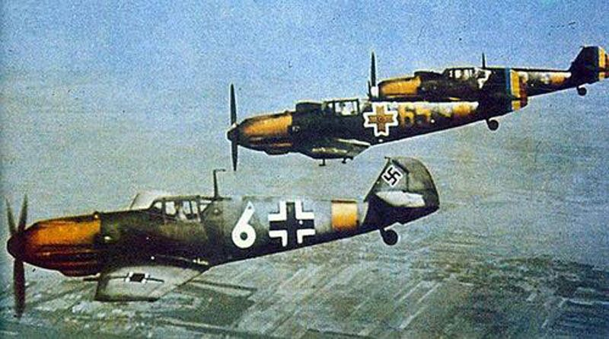

Photo 5. German anti-aircraft gun emplacement around a Ploësti refinery.

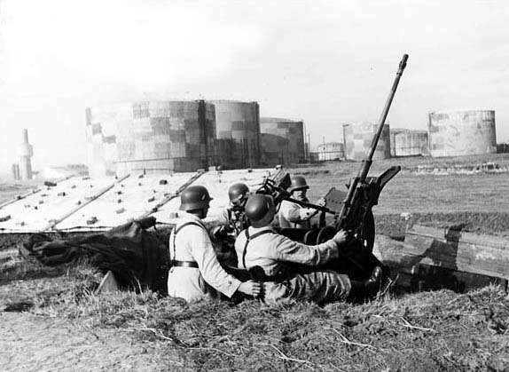

Table. 3. Tabulation of target Information

|  |  |  |
| --- | --- | --- |
| Target No. | Target Name | Description and Significance |
| 83 | Astra Romana Refinery (Ploesti) | Capacity 2,000,000 tons/year or 18% of Rumanian total; cracking capacity 650,000 tons/year or 32% of Rumanian total. Largest refinery in Europe. Possesses important modern cracking units. Most southern located refinery in Ploesti; identified by 4 large tanks as approached from south. Giurgiu pumping station is within target |
| 39 | Romano-Americana Refinery (Ploesti) | Capacity 1,250,000 tons/year or 11% of Rumanian total; cracking capacity 400,000 tons/year or 17% of Rumanian total. Third most important Rumanian refinery with second largest cracking installation in Rumania. 3 miles east of Ploesti near Teleajen Station and 600 yards north of Brazii railway. Includes 2 boiler pump houses, power plant for Constanza pumping station, cracking, distillation plants |
| 40 | Concordia Vega Refinery (Ploesti) | Capacity 1,300,000 tons/year or 13% of Rumanian total; cracking capacity 210,000 tons/year or 9% of Rumanian total. Important cracking equipment. Refinery installation, 3 boiler houses, distillation plant |
| 41 | Phoenix Unirea Refinery (Ploesti) | Capacity 700,000 tons/year or 6% of Rumanian total; cracking capacity 83,000 tons/year or 4% of Rumanian total. Cracking plant prime objective, adjoining Standard Petrol Block (Target 45) |
| 42 | Dacia (Dacia-Romana) Refinery (Ploesti) | Capacity 375,000 tons/year or 3% of Rumanian total. Small, Non-cracking, older equipment. Compact with refining units installed between tank farms |
| 43 | Phoenix Orion Refinery (Ploesti) | Capacity 460,000 tons/year or 4% of Rumanian total; cracking capacity 85,000 or 4% of Rumanian total. Small, but contains modern cracking units. Equipment concentrated. Includes a lubricating oil plant one of few in Rumania. |
| 44 | Colombia (Colombia Aquila) Refinery (Ploesti) | Capacity 300,000 tons/year or 3% of Rumanian total; cracking capacity 150,000 or 5% of Rumanian total. Production of high proportion of benzene. Cracking equipment prime objectives. Other units include refinery installation, distillation plant and boiler houses are compact. |
| 45 | Standard Petrol Block Refinery (Ploesti) | Capacity 600,000 tons/year or 5% of Rumanian total; cracking capacity 150,000 or 5% of Rumanian total. Modern cracking installation and lubricating oil plant. Vulnerable points include distillation plants, boiler houses |
| 46 | Redeventza Refinery (Ploesti) | Capacity 260,000 tons/year or 2% of Rumanian total. No cracking, old equipment. |
| 47 | Xenia (Xenia Redeventza) Refinery (Ploesti) | Capacity 300,000 tons/year or 3% of Rumanian total. No cracking, older, less important than others. Prime objective within refinery is distillation unit |
| 48 | Constanza Pumping Station (Ploesti) | Pumping station for oil to Constanza. Station has numerous pipelines from Ploesti refineries. Pumps old but large. |
| 49 | Creditul Minier Refinery (Brazii) | Capacity 600,000 tons/year or 5% of Rumanian total; cracking capacity 175,000 or 7% of Rumanian total. Equipped with large cracking units. Modern refinery, including only high-octane gasoline plant in Rumania. Other vital points are boiler, power house, distillation plant |
| 50 | Steaua Romana Refinery (Campina) | Capacity 1,750,000 tons/year or 13% of Rumanian total; cracking capacity 400,000 or 17% of Rumanian total. Third largest European refinery. Large cracking installations, modern distillation units, and only important paraffin plant in Rumania |

Figure 2. Map of Rumania circa 1943 showing location of major oil locations

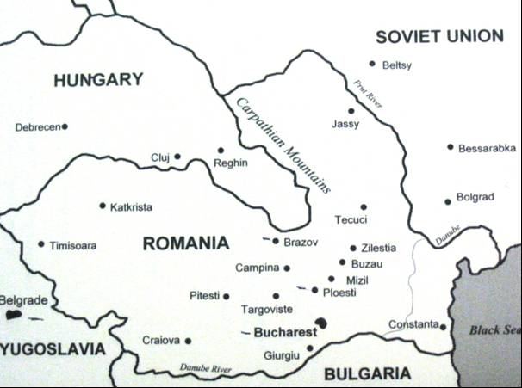

Photo 6. Astra Romana Refinery after 1944 bombing raid

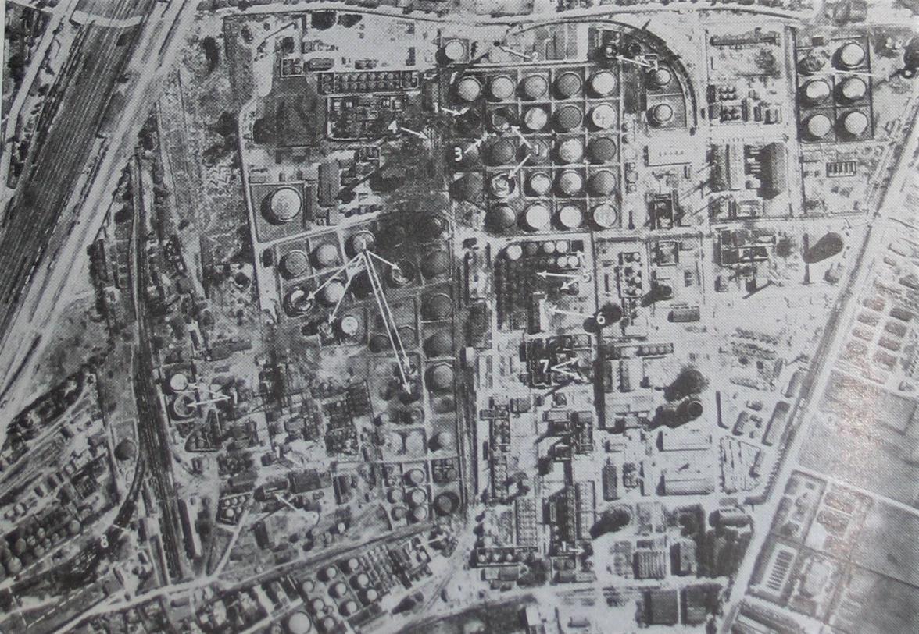

Reconnaissance photo shows damage (1) large and small tanks destroyed, (2) craters on rail tracks, (3) pipes damaged by blast, (4) booster pump house destroyed, (5) lube oil tanks destroyed, (6) Lubricating oil refining plant severely damaged, (7) McKee furnace destroyed, (8) Phoenix Orion Refinery (left) – siding damaged, including 20 tank cars, (9) & (10) power station and boiler house damaged or destroyed.

# The Ploesti Oil Fields

Located 35 miles north of Bucharest, the capital of Rumania, Ploesti was a massive complex consisting of seven major refineries, storage tanks and related structures covering 19 square miles. The importance of Ploesti can be judged by the fact that it supplied Germany with 1/3rd of its entire fuel oil needs. It's not too surprising then, that it was also the first target in Europe to be bombed by American aircraft.

First USAAF Strike June 12, 1942: B-24 Liberator bombers took off from Egypt June 11th, arriving over the target at dawn the following day. Ten bombers hit the Astra refinery at Ploesti, one B-24 attacked the port area of Constanta, and the remaining two B-24s struck unidentified targets. Three ended up interned in Turkey, the rest manage to reach friendly bases in Iraq. Damage turned out to be minimal, but the mission was considered a success.

August 1, 1943: The USAAF launched ‘Operation Tidal Wave’ against the Ploesti oil installations It was to prove costly for both sides. The 177 B-24 Liberator bombers set off from North Africa from the 376th, 98th Bomber Groups of the US Ninth Air Force, and 93rd, 44th, 389th Bomber Groups of the US Eighth Air Force. The targets were the following refineries: Romana Americana, Concordia Vega, Standard Petrol Block Unirea Speranta, Astra Romana Unirea Orion, Columbia Aquila, Creditul Minier (Brazii), and Steaua Romana (Campina).

After attacking the target German fighters pursued the bombers as they left bringing down more than a few damaged aircraft. Of the 177 bombers that took part in the mission 54 were lost, a further 53 planes were heavily damaged. It was a costly victory by any measure. The damage to Ploesti was significant, but offset by its spare refining capacity and the fact that a raid like this could not be mounted again for quite some time.

Photo 7. Ploesti refineries burns – ground level photograph taken by German Corporal Ewald Wagener August 1, 1943.

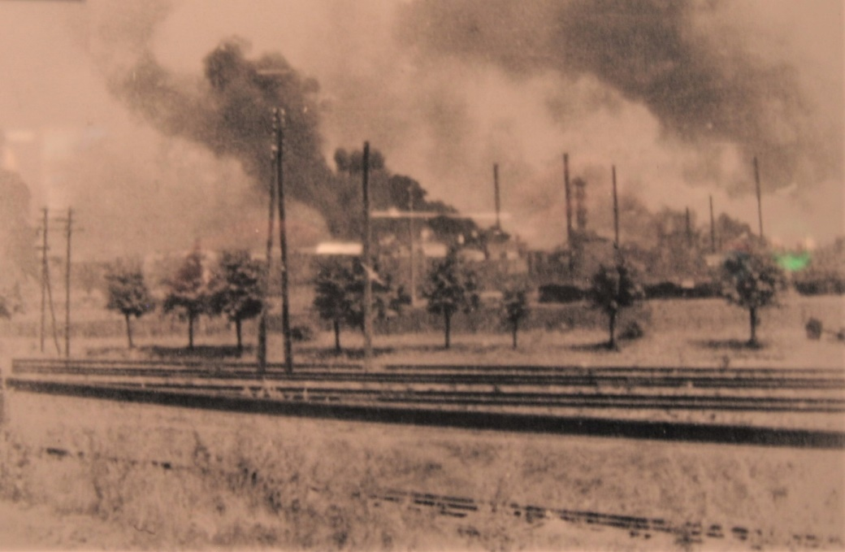

Photo 8. Ploesti Refineries burn after attack by B-24 Liberators – view from B-24 tail gunner.

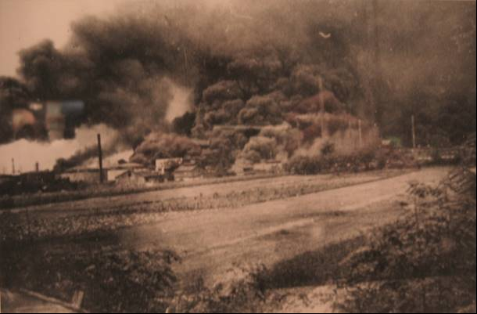

Between April 5 and May 5, 1944, the 15th US Army Air Force attacked the marshalling yards at Ploesti four times, losing 43 heavy bombers shot down and a dozen more in crash landings. May 18, 1944 - the 15th Army Air Force made its first direct attack on the refineries.

Between April 5 and May 5, 1944, the 15th US Air Force attacked the marshalling yards at Ploesti four times, losing 43 heavy bombers shot down and a dozen more in crash landings. May 18, 1944 - the 15th Air Force made its first direct attack on the refineries.

*Photo 9. British bombers attack on Axis controlled Ploesti Refinery, Rumania 1944.*

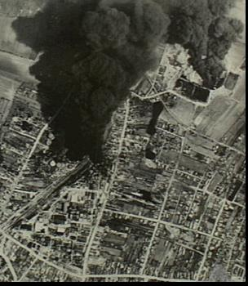

Campina near Ploesti, Rumania. 16 May 1944. Aerial view from a South African Air Force Mosquito aircraft shows the burning oil storage tanks at Campina, twenty miles northwest of Ploesti, a few hours after RAF Handley-Page Halifax and Vickers-Armstrong Wellington bomber aircraft had bombed the refinery and marshalling yards. Half an hour after this, 15th US Army Air Force Consolidated B-24 Liberator bomber aircraft also attacked Campina rail yards, hits being scored on a refinery, rolling stock and tank cars. Productive capacity of Ploesti refining system has been reduced to less than twenty-five per cent of its normal output as a result of day and night attacks by Strategic Air Force.

In August 1944, the US 15th Army Air Force B-24 Liberator bombers returned to attack the Ploesti refineries once again, this time causing their complete destruction. The following photos depict the destruction of the Ploesti facilities. [8]

*Photo 10. Railway yards following the bombings in 1944 Ploesti*

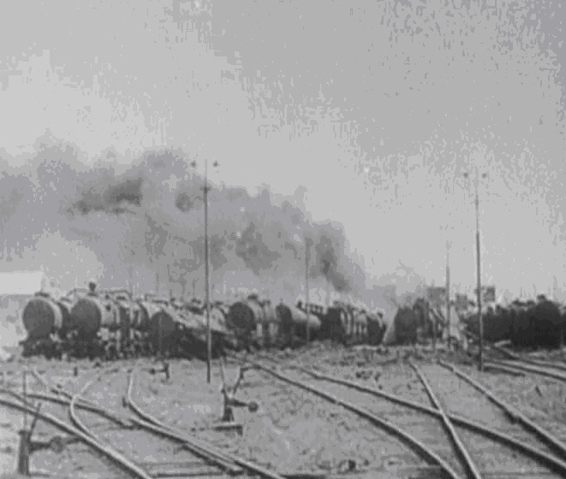

*Photo 11. German firefighters battle the oil fires at the Ploesti refineries August 1994*

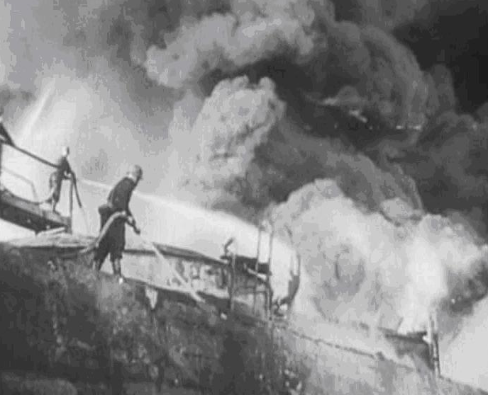Photo 12. Damaged refinery still at Ploesti Refineries August 1944.

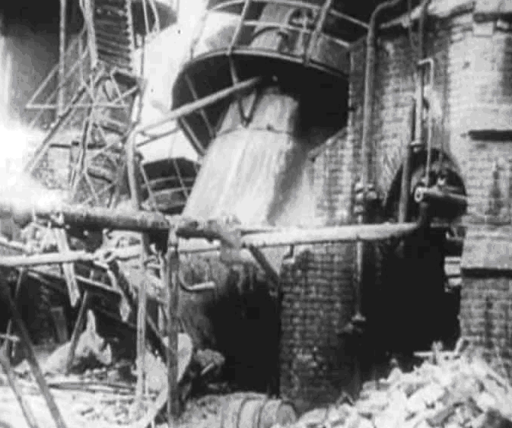

*Photo 13. Damaged refinery still at Ploesti August 1944.*

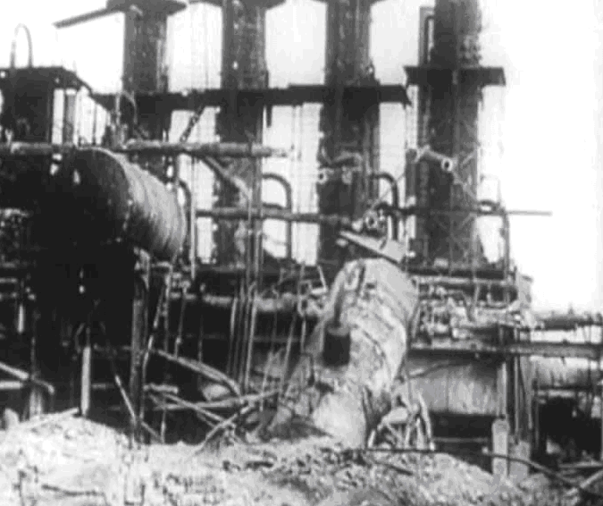

Photo 14. Damaged refinery still at Ploesti August 1944.

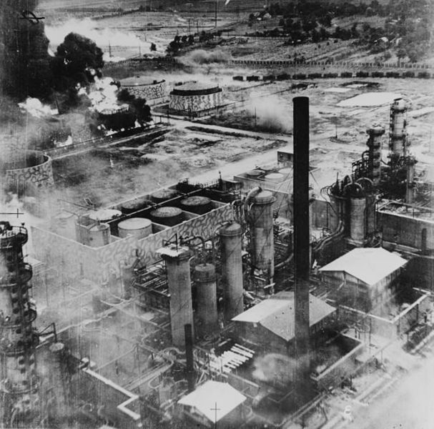

# Epilogue for the Rumanian Oil

The raids on the Rumanian oil facilities were costly in both US, British and German lives, and greatly impacted on the German oil supplies. But it would be the Soviet Union who eventually gained control of these oil fields and this rich resource, and it would remain under communist control for a further 50 years.

Photo 15. USAAF B-24 Liberator bomber stricken by flak on a raid against Ploesti refineries.

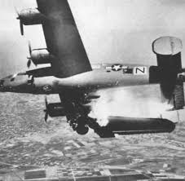

# Index

1

15th US Army Air Force 18

2

2,3, Di Methyl Pentane 7

2-Methyl pentane 7

3

376th 17

380th Bomb Group 1

389th Bomber Group 17

4

44th 17

9

93rd 17

98th Bomber Group 17

A

Admiralty 4

Air Vice Marshall Drummond 8

Albesti 13

American aircraft 17

American companies 11

Antonescu 8

Armand Călinescu 4

Aromatics 6, 7

Astra refinery 17

Astra Romana 4, 10, 12, 14, 16

Austria 8

avgas 10

aviation fuel 8

aviation gasoline 6, 8

B

B-24 Liberator bombers 17

Balkan 3, 6, 8, 9, 13

Baltic 4

benzene 7, 11, 14

Bessarabia 8

Black Sea 4

blend stocks 6

Blitzkrieg 8

boiler 14, 17

Brasov 10

Bratislava 8

Brazii 10, 12, 14, 17

British Air Ministry 8

British Government 4

British Legation 5

British War Cabinet 4

Bucharest 5, 9, 10, 11, 12, 17

Bucsani 6, 7

Bulgaria 3, 8, 11

Butane 6

C

Cairo 5

Campina 10, 11, 12, 15, 17

Chief of Staff 5

coal 5

Colombia Aquila 14, 17

Concordia Vega 10, 14, 17

Conducător 8

Constanza 11, 14, 15, 17

Corporal Ewald Wagener 17

Corsova 11

cracking 14

cracking capacity 12, 14

Cracking Refineries 10

Creditul Minier 10, 15, 17

crude 6

Cyclohexane 7

Cyclopentane 7

Czechoslovakia 8

D

Dacia (Dacia-Romana) 14

Dacia Romana 4, 10

Danube 4, 5, 9

Dimethyl Cyclohexanes 7

Dimethyl Cyclopentanes 7

distillation plants 14

dummy towns 13

Dunkirk 5

E

Eastern front 8

Egypt 17

Ethane 6

F

fire-fighting 11

Foreign Secretary 5

France 5, 8

Fratia 10

French 4

G

General Ion Antonescu 8

German 4

German Air Force 13

German fighters 17

German Luftwaffe 12

Germany 3, 6, 8, 11, 12

Giurgiu 11, 12, 14

Goeland 4

Great War 4

Greater Danube River 8

Greece 5

Greek 5

Gura-Ocnitsei 6, 7

H

Hertza 8

Hungary 3, 5, 8, 9

I

Iraq 17

Iron Gates 5

Iso-heptanes 7

Iso-hexanes 7

Iso-nonanes 7

Iso-nctanes 7

Iso-paraffins 7

Italy 3, 5, 11

J

Japan 3

K

King Carol II 8

King Michael I 8

King Michael's Coup 8

L

Lord Hankey 4

low countries 8

lube oil tanks 17

lubricating oil plant 14, 17

Lumina (Petrolmina) 10

M

marshalling yards 18

McKee furnace 17

Merisor 6, 7

Methane 6

Methyl Cyclohexane 7

Methyl cyclopentane 7

Middle East 5

Mines Department 4

Moinesti 10

Molotov-Ribbentrop Pact 8

motor gasoline 6

N

naphtha 6

naphthenes 6, 7

Nazi invasion 12

n-Heptane 7

n-Hexane 7

n-Nonane 7

n-Octane 7

Non-cracking 10, 14

North Africa 5, 17

Northern Bukovina 8

Northern Transylvania 8

O

oil fields 11

Olefins 6, 7

Operation Tidal Wave 17

Orion 12

P

Pacific 5

Paraffins 6, 7

Passau 8

Paynter 9

Petrol-Bucharesti 10

Petroleum Adviser 5

Petroleum Division 4

Phoenix Oil and Transport Co 4

Phoenix Orion 14, 17

Phoenix Unirea 14

Photogen 10

pipeline 11, 12

pipes 17

Ploesti 1, 4, 5, 10, 11, 12, 13, 14, 17, 18, 25

Ploesti Objective Area 12

Ploesti refineries 9. 17

Poland 8

PONA 6, 7

power plant 11, 14

power station 17

Prime Minister 4

pro-British 8

Propane 6

pump house 14, 17

pumping station 14

p-Xylene 7

R

RAF 9, 10, 11

RAF Bomber Command 5

rail 12

rail tracks 17

railway 14

railways 11

Red Air Force 12

Redeventza 10, 14

refineries 11, 12, 17

refining capacity 17

Regensburg 8

river tankrs 11

Roman Belgiana 10

Romana Americana 10, 11, 17

Romania 3, 6, 8

Romanian troops 8

Romano-Americana 14

Roumanian General Staff 4

Roumanian Government 5

Roumanian oil 5

Roumanian Oil Fields 9

Roumanian refineries 9, 10

Royal Navy 5

R-Sarat 10

Rumania 5, 8, 9, 12, 15, 17, 18, 19

Rumanian crude oils 7

Rumanian oil 4, 10

Russia 5

Russian 3, 13

S

Shell 4

Southern Dobruja 8

Soviet Army 8

Soviet Union 8, 12, 21

Soviets 8, 12

Standard Petrol 10

Standard Petrol Block 14, 17

Steaua Romana 4, 10, 15, 17

storage tanks 11, 12, 13, 17

T

tank cars 17

tank farms 14

tanks 17

Teleajen 10, 12, 14

Toluene 7

Transylvanian Alps 12

Tripartite Pact 3, 8, 11

Turkey 17

U

U.S. Army Air Forces 5

Unirea Orion 10, 17

Unirea refineries 12

Unirea Sperantia 10, 17

US Eighth Air Force 17

US Ninth Air Force 17

USA 5

USAAF 17

V

Venezuela 5

Vienna 8

Vienna Award 8

W

Wallachian Plain 12

War Office 4

X

Xenia 10

Xenia Redeventza 14

Xylenes 7

Y

Yugoslavia 5, 8

# Research Sources

1. The History of the 380th Bomb Group (H) AF – “The Flying Circus” November 1943 – September 1945 at 8th Air Force Heritage Museum, Savannah, Georgia, U.S.A.
2. Oil As A Factor In The War Effort, 1933 -1945, Offices of the Cabinet and Minister of Defence, 8th March, 1946, U.K.
3. Chemical Constituents of Petroleum by Dr. A N Sachanen - R&D Division, Socony-Vacuum Oil Co., Reinhold Published 1945
4. UK Public Records Office AIR 2/7291
5. UK Public Records Office AIR 2/7291
6. “Fortress Ploesti – The Campaign to Destroy Hitler’s Oil” by Jay A Stout
7. Target Ploesti “View for A Bombsight” by Leroy W. Newby 1983 – Appendix B
8. Wings of Glory – The Air Force Story Vol. 1 ,2, 3 CD RBC Entertainment.