Chapter

20

Italian Aviation Gasoline 1935-1944

Photo 1. Italian Fiat CR-42 fighter on display at RAF Hendon, London 2005.

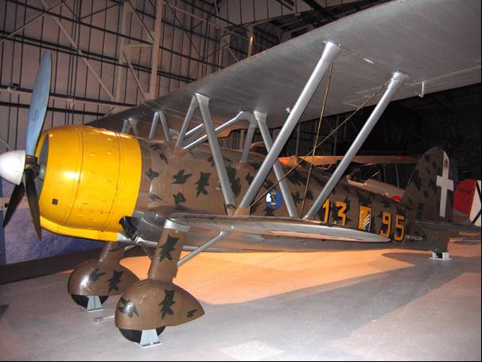

Table of Contents

Summary 3

New Roman Empire 4

Brief History Of Règia Aeronautica 6

North African Campaigns – Western Desert 10

Italian Aviation Gasoline 19

Specifications 23

Epilogue For The Fascist Italy 25

Index 26

Research Sources 29

Photo 2. Italian Fiat GR-42 refuelling.

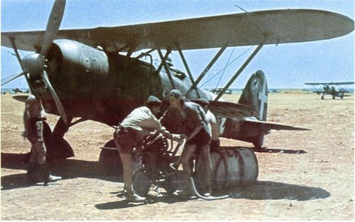

# Summary

The rise of Fascism in Italy led to an expansion in Italian military air power - Règia Aeronautica, which would be used against a weak and defenceless Ethiopia. But when faced with a formidable well- equipped foe, the now obsolescent forces paid the price with a humiliating defeat and eventual invasion of their beloved Italy by American and British armies.

Photo 3. Italian Macchi C.200 in North Africa circa 1941.

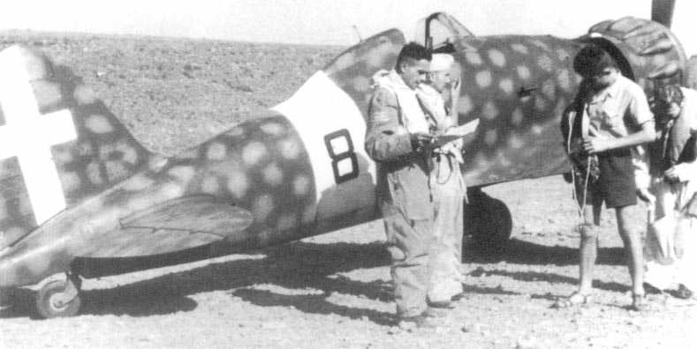

Photo 4. Italian Caproni Ca.101 refuelling 1937.

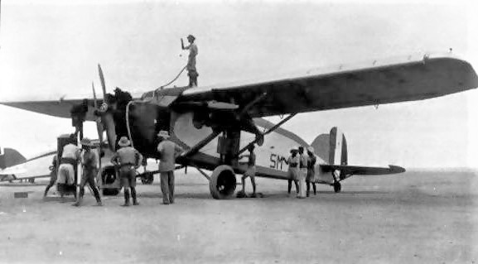

# New Roman Empire

The six and one-half years after Adolf Hitler became chancellor of the German Reich in January 1933 were a period of mounting tension in the Mediterranean and nearby areas as in other regions. In October 1935, Italy, under the fascist leadership of Benito Mussolini correctly judging the impotence of the League of Nations, decided to extend its already considerable empire in Africa by invading Abyssinia (now Ethiopia), and by May 1936 had completed the annexation of the country.

As World War II approached, Mussolini announced his intention of annexing Malta, Corsica, and Tunis. He spoke of creating a "New Roman Empire" that would stretch east to Palestine and south through Libya and Egypt to Kenya.

In April 1939, after a brief war, he annexed Albania. Mussolini decided to remain 'non-belligerent' in the larger conflict until he was quite certain which side would win.

On June 10, 1940 Mussolini finally declared war on Britain and France and on October 28, 1940 Mussolini attacked Greece. But after initial success, the Italians were repelled by a relentless Greek counter attack which resulted in the loss of a quarter of Albania, until Hitler was forced to assist him by attacking Greece as well. In June 1941, Mussolini declared war on the Soviet Union and in December 1941 also declared war on the United States.

Photo 5. Poster of “His Excellency Benito Mussolini, Head of Government, Leader of Fascism, and Founder of the Empire".

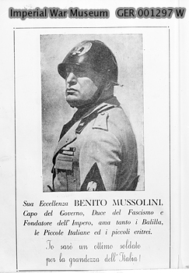

One of the military forces that Mussolini would use in his conquest was the Règia Aeronautica.

Photo 6. Mussolini inspects the Italian Air Force circa 1937.



Photo 7. Fascist leaders ‘Il Duce’ Benito Mussolini and the Fuhrer Adolf Hitler.

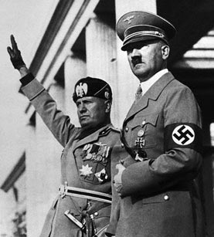

Brief History of Règia Aeronautica [1]

The Italian air force became an independent service - the Règia Aeronautica - on March 28, 1923. The Fascist regime of Mussolini turned it into an impressive propaganda machine, with its aircraft, featuring red-and-buff "rising sun" livery on the wings, making numerous record-breaking flights. It reached its zenith when two fleets of flying boats, led by General Italo Balbo, crossed the Atlantic Ocean in 1931 and 1933 respectively (refer to Chapter 6).

Photo 8. Italian Savoia-Marchetti S55X flying boat in 1933.

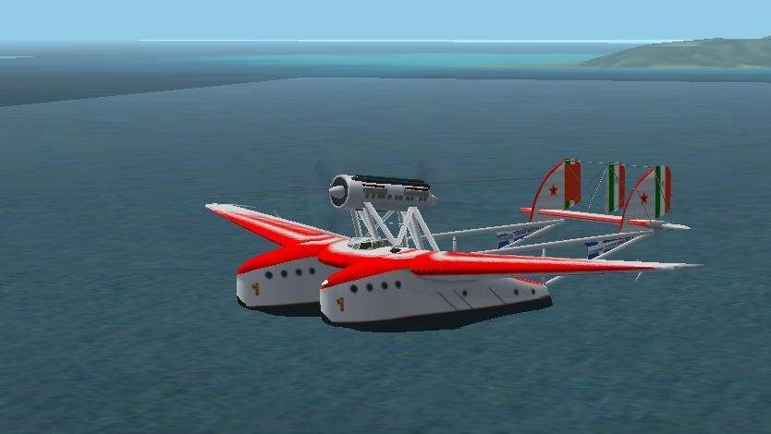

During the latter half of the 1930s, the Règia Aeronautica participated in the Spanish Civil War, as well as the invasion of Abyssinia (now Ethiopia).

When World War II began in 1939, Italy had the smallest air force among the three major Axis powers. With a paper strength of 3,296 machines, only 2,000 were fit for operations, of which just 166 were modern fighters, the Macchi C. 200 and Fiat G.50 were still slower than their potential Allied opponents. While numerically still a force to be reckoned with, it was hampered by an inadequate local aircraft industry; technical assistance by its German ally did little to improve the situation.

Ethiopian Campaign 1935-1937

The Second Italo-Ethiopian War, also referred to as the Second Italo-Abyssinian War, was a war of aggression which was fought between Italy and Ethiopia from October 1935 to February 1937. It is seen as an example of the expansionist policy that characterized the Axis powers and the ineffectiveness of the League of Nations before the outbreak of Second World War.

During the Ethiopian campaign, the Règia Aeronautica became the living proof of Mussolini's authoritarian regime, showing no respect or concern for the international point of view. The Règia Aeronautica performed massive poison gas bombings over the Ethiopian soldiers, most of them only armed with spears and wooden shields. Despite being inadequately equipped, they managed to decimate Ethiopian forces and undertook massive bombings of Ethiopian cities (particularly Addis Ababa). Although controversial, the support of the Règia Aeronautica was invaluable for the Règio Esercito (Italian army) and it was enhanced by the total lack of Ethiopian air forces. This was yet another example of air supremacy deciding the outcome of land battles.

The Règia Aeronautica order of battle comprised:[2]

Bombardment, Reconnaissance, and Fighter Aviation Command A. O. – Gen. Aimone Cat

3rd Air Brigade – Brig.Gen. Ferruccio Ranza Eritrea (145 aircraft)

HQ Flight (4 × Caproni Ca.101 light bomber/transport aircraft)

Reconnaissance Squadron (un-numbered):

34th Reconnaissance Flight (8 × Romeo Ro.1 reconnaissance and ground attack aircraft) attached to Eritrean Corps

38th Reconnaissance Flight (10 × Ro.1)

41st Reconnaissance Flight (10 × Ro.1)

103rd Reconnaissance Flight (9 × IMAM Ro.37)

116th Reconnaissance Flight (10 × Ro.1)

118th Reconnaissance Flight (10 × Ro.1) attached to 2nd Corps

131st Reconnaissance Flight (10 × Ro.1)

Libyan Reconnaissance Flight (11 × Ro.1) attached to 1st Corps

106th Fighter Flight (7 × CR.20)

4th Bombers Squadron – Brig.Gen. Attilio Matricardi

14th Bomber Flight "Hic Sunt Leones" – (10 × Caproni Ca.101 D/2)

15th Bomber Flight "La Disperata" – (10 × Ca.101 D/2)

27th Bomber Squadron

17th Bomber Flight (5 × Caproni Ca.111 light bombers)

18th Bomber Flight (5 × Ca.111)

Hydroplanes Detachments (4 × Marinens Flyvebaatfabrikk M.F.4 floatplane and 2 × CANT 25 flying boat fighter)

7th Bomber Wing detached to Somalia with 38 aircraft – Brig.Gen. Ferruccio Ranza

Photo 9. Italian Romeo Ro.1 reconnaissance ground attack aircraft 1935.

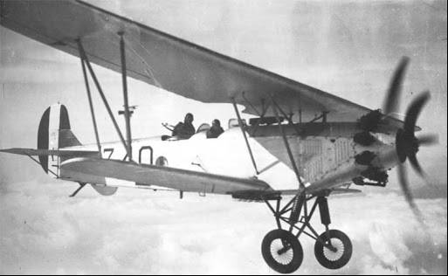

Photo 10. Italian bombers attack the people of Ethiopia 1935.

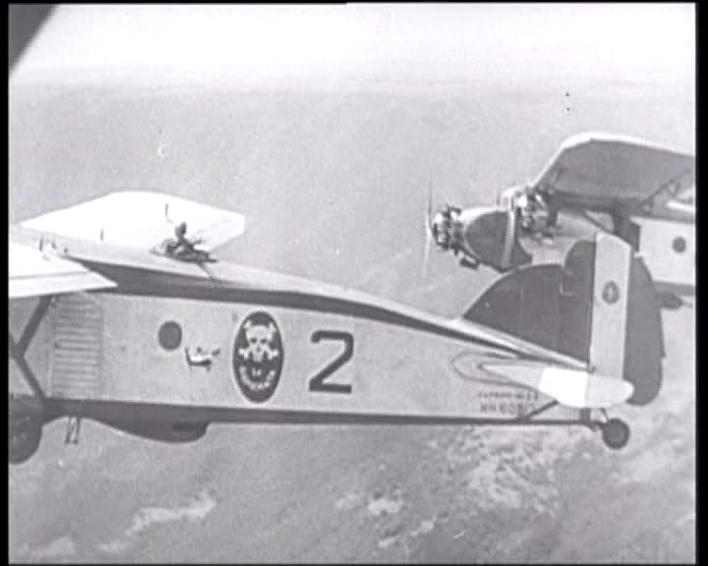

Spanish Civil War 1936-1939

The Legionary Air Force (Italian: Aviazione Legionaria, Spanish: Aviación Legionaria) was an expeditionary corps from the Italian Royal Air Force. It was set up in 1936 and sent to provide logistical and tactical support to the Nationalist faction under General Francisco Franco after the Spanish coup of July 1936 marked the onset of the Spanish Civil War.

The corps and its Nazi German allies—the Condor Legion—fought against the Spanish Republic and provided support for the Italian ground troops of the Corpo Truppe Volontarie. They served from August 1936 to the end of the conflict in March 1939. Their main base of operations was on Mallorca in the Balearic Islands.

Photo 11. Italian Savoia-Marchetti SM-79 in action during the Spanish Civil War circa 1936.

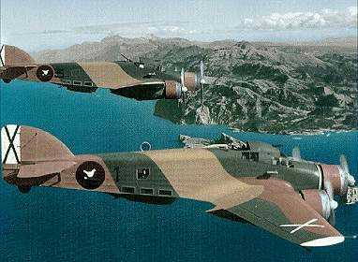

Photo 12. Italian Savoia-Marchetti S.73 bomber and Fiat CR-32 fighters in action during the Spanish Civil War circa 1936.

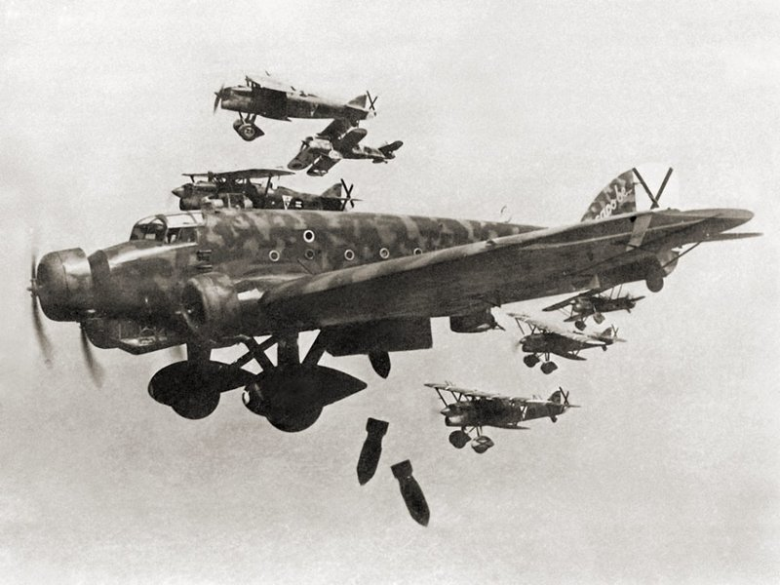

Battle of France

During the Battle of France the Règia Aeronautica carried out 716 bombing missions in support of the Italian invasion, dropping a total of 276 tons of bombs.

Photo 13. Fiat G-50 Freccia RA 20G352SA 352 12 being refilled with oxygen Ursel Belgium 1940-41.

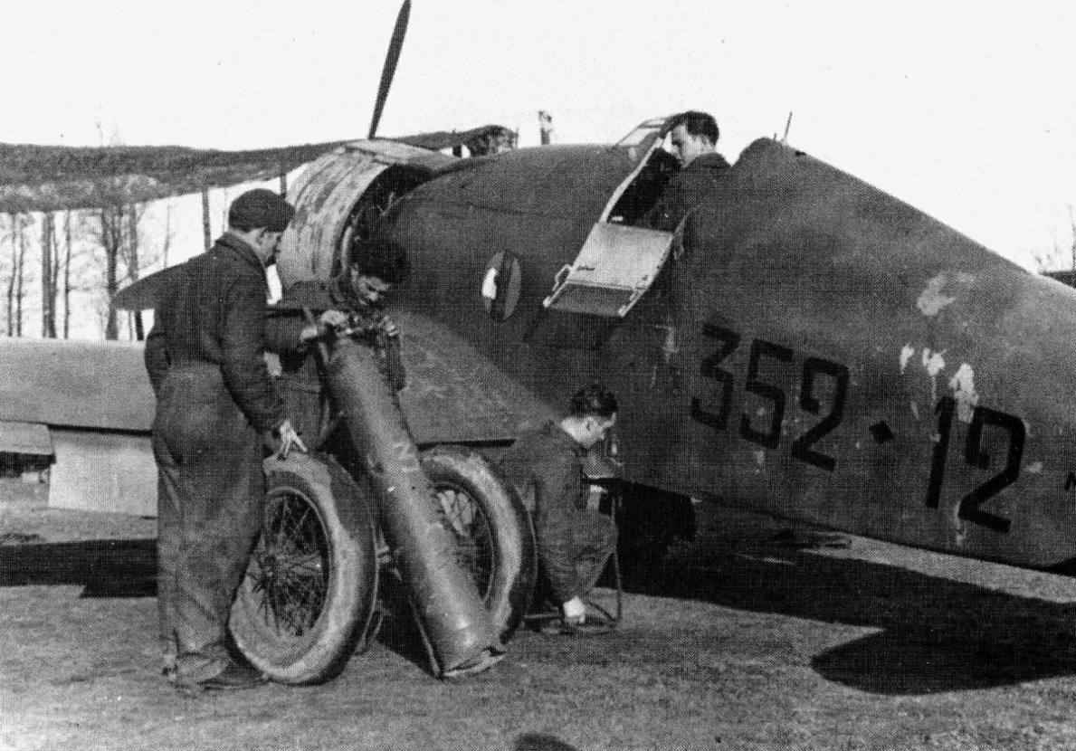

Battle of Britain

From October 25, 1940, some 170 Italian planes (including 73 Fiat Br.20 bombers) were sent to occupied Belgium formed the Corpo Aero Italiano (CAI) to participate in the Battle of Britain. They fared poorly against the British defenders; about a quarter of the Fiat Br.20 were lost in 2 months of operations. The Corps was withdrawn to Greece in December 1940.

Photo 14. Fiat Br.20 Cicogna (‘Stork”).

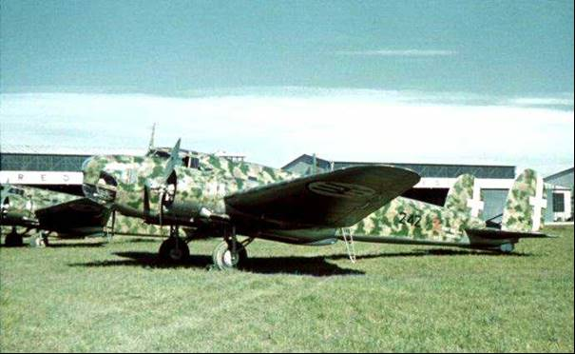

# North African Campaigns – Western Desert

Italian Libya was a colony of the Kingdom of Italy. It was formed from the Italian colonies of Cyrenaica and Tripolitania that were taken by Italy from the Ottoman Empire in the Italo-Turkish War of 1911 to 1912. They were unified in 1934 by governor Italo Balbo, with Tripoli as the capital. General Italo Balbo, Governor-General of Italian Libya from 1 January 1934 – 28 June 1940, who was previously the Minister of the Air Force from 12 September 1929 – 6 November 1933; and in July 1933 led a flight of some 24 Italian Savoia-Marchetti S55X flying boats to make the first Good Will transatlantic formation flight between Italy and Chicago, Illinois to take part in the Century of Progress Exposition. (Refer Chapter 6.)

The war in North Africa started well for the Italian forces in 1940, but it was to change dramatically for the worse. The Italians would be supported by the Germans, in particular General Erwin Rommel (‘The Desert Fox’) and his dedicated Afrika Korps.

12 September 1940, Italian Army HQ. Orders from Il Duce to General Graziani indicate that Sidi Barrani must be captured by 15 October or else!*[3]*

Sidi Barrani is in Egypt on the Mediterranean coast and was an important supply port, it was held by a Commonwealth garrison. The Italian Air Force Règia Aeronautica opened the attack. The first shots were fired as two squadrons of Fiat CR-42’s engaged the British fighters at Sidi Barrani. Both sides took substantial losses. After the British fighters were knocked down, two squadrons of Savoia Marchetti SM-79’s barraged the airfield, but failed to damage any of the British aircraft.

15-18 September 1940, it is reported that the Commonwealth was pulling out of Sidi Barrani. British aircraft had been seen interdicting around Buqbuq and had been somewhat successful in hindering the advance of 1st Raggruppamento. A squadron of CR-42s eventually chased them away. The British attempted to damage the airstrip with a mission of Wellingtons, but this failed. General Maletti and 63rd MG battalion captured Sidi Barrani. Cirene Division also captured the abandoned airstrip at Maktila.

Libyan Operations Group HQ arrived at Sidi Barrani and set up camp with the 28th Blackshirt Division. Several divisions, MG battalions and Light Mechanized units flowed into Egypt.

However, by early January 1941, the Italian forces had been repulsed and the British, Indian and Australian forces had recaptured Sidi Barrani and were pushing the Italians out of Egypt back to Tobruk. By 25 March 1941, Australian units occupied the airstrip and port at Gazala.

Although the Libyan campaign was seriously limited because of desert conditions, the Règia Aeronautica managed to retain a force of nearly four hundred aircraft, most of them obsolete biplanes such as the Fiat CR-32 and Fiat CR-42. During the first offensive towards Sidi Barrani, the Règia Aeronautica performed poorly, despite minimal enemy resistance. During the first British counter-offensive, the Règia Aeronautica suffered heavy losses (over 400 aircraft) until the German attack on Greece, when British forces had to divert a major part of their land and air forces thus giving the Italian forces enough time to deploy more units and strengthen their air forces. These were supplemented by the arrival of Rommel's Afrika Korps, and the attached Luftwaffe forces deployed almost 200 airplanes in Libya and another 600 in Sicily.

Next to the Luftwaffe, the Italian air force performed better due to exchange of tactical doctrine between services and the arrival of more modern aircraft. During Rommel's first offensive they managed to keep the RAF fighters away from Rommel's forces, and covered Rommel's retreat during the British ‘Operation Crusader’ while inflicting heavy losses on the RAF bombing aircraft.

During Rommel's second offensive the Règia Aeronautica and the Luftwaffe suffered considerable losses due to stronger Allied resistance, with almost their entire destruction during the air battles over El Alamein and the bombing raids over Alexandria and Cairo.

The Règia Aeronautica were almost destroyed in Egypt, and the remnants of this Italian force were quickly retired to Tobruk, Benghazi, Tripoli and eventually Tunisia.

The Règia Aeronautica also participated in the air offensive on the British controlled island of Malta in an attempt to gain control of the sea routes from Sicily and Italy to North Africa from its bases in Sicily, Italy and Sardinia. Although on the edge of starvation and suffering heavy losses, Malta managed to withstand the attacks from the Italian and German air force, and inflicted losses of almost 1500 planes. The battle cost the British 800 planes and considerable amounts of transport ships, but the price was worth it: 60% of Axis supplies intended for North Africa were sunk thanks to Malta's aircraft, submarines and destroyers.

The Italians had always been at forefront of aviation, from aircraft design in World War I, through to the speedy sleek Macchi sea planes competing in the Schneider Trophy in the 1920’s. However, the Italian Air Force was supplied with aircraft designs based on the early to mid-1930’s, and they were more style, than performance. By the time war had started, they were part of the Axis war machine and its supply system. Therefore aviation gasoline was essentially that required by the German Air Force particularly from 1941.

Fuels obtained from captured sources were tested to determine the quality; in the UK it was from crashed German aircraft, in the Italian case it was from captured fuel supplies of the Axis in North Africa as the Allied and Axis armies and their air forces battled across Egypt and Libya. The Allies tested capture fuels to the British specification test methods in order to make comparisons to the fuels supplied to the Allies in particular the British, since at this stage America had not be drawn into the European and African theatres of conflict.

Figure 1. Map of Libya.

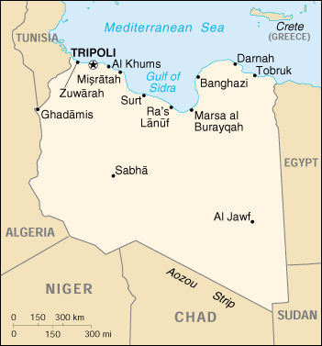

29-31 March 1941, the British used a battalion of captured tanks to overrun the airstrip at Tmini. The Fiat fighters [CR-42] fled to El Mechili. The capture of the airstrip fulfilled Churchill’s demand for action! A squadron of British aircraft performed interdiction raids near Tmini.

Rommel and the DAK HQ (Deutsches Afrikakorps) [German Afrika Korps] arrived together at Benghazi. [Insignia of the German Afrika Korps].

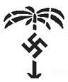

During the North African campaigns Commonwealth forces comprising RAF (to attack supply convoys, troops, tanks and aircraft), Royal Navy (to attack the ports with off shore bombardments) and land forces of British Army, which included Free French, Polish, Indian, New Zealand and Australian troops) successfully attacked the Italian land and air forces. These advances resulted in the capture of Axis fuel dumps at air strips at Sidi-el Tmimi (Damah), Gazala, and Bomba (some 40 miles west of Tobruk).

By April 1941, the German Luftwaffe with Messerschmitt Bf-109’s, Bf-110’s, and Junkers Ju-87 Stuka and Ju-88 had joined the battle in North Africa, shifting the balance of air superiority in the Axis favour. The air conflicts had moved from the biplane battles between Italian Fiat CR-42 and the British Gloster Gladiator, to the struggle between sleek monoplanes of the German Messerschmitt Bf-109, the Italian Macchi C.202, and British Hawker Hurricane and the American built Curtiss Kittyhawks on Lend-Lease to the RAF and RAAF.

Photo 15. General Erwin Rommel (the ‘Desert Fox’) in Africa 1941.

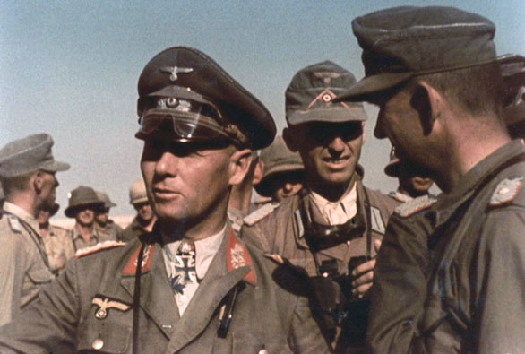

The presence of the Desert Fox and his famed Afrika Korps soon made an impact on the tide of the Western Desert campaigns in North Africa. His goal was the defeat of the British Army, control of the Suez and get to the rich oil fields of Persia.

The Battle of Gazala was an important battle of the World War II Western Desert Campaign, fought around the port of Tobruk in Libya from May 26 to June 21, 1942. The combatants on the Axis side were the Panzer Army Afrika, consisting of German and Italian units and commanded by the ‘Desert Fox’ Colonel-General Erwin Rommel; the Allied forces were the Eighth Army, commanded by Major General Neil Ritchie under the close supervision of the Commander-in-Chief Middle East, General Sir Claude Auchinleck. Following Rommel's attack (second offensive) in January 1942, the Allies had retreated across Libya to a strong position on a line between the fortified port of Tobruk on the Mediterranean coast and the town of Bir Hakeim to the south.

From these battles would be born the legends of the Australian ‘Rats of Tobruk’.

But the Commonwealth forces were to be pushed back even further, and by July 1942 the Afrika Korps and Italians had crossed Egypt again and were at El Alamein.

However, the lifeblood of any army, navy or air force is its supply lines, and with the Axis supply lines with its motorized divisions and its aircraft extended from Tripoli to Egypt, and under constant aerial attack from the (Allies) Desert Air Force, it was inevitable that the side with the best supply lines would be victorious.

Figure 2. Map of Rommel’s second offensive January to July 1942.

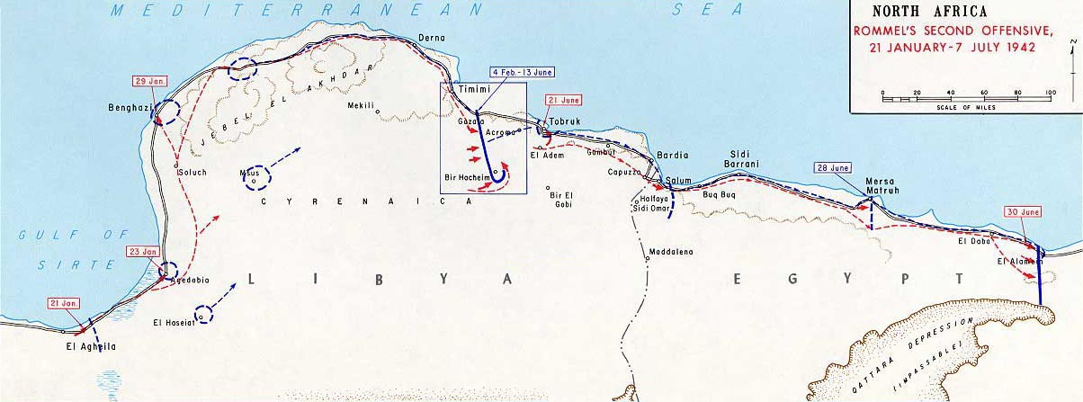

The German Luftwaffe and Italian Règia Aeronautica also operated their bombers Ju-88 and SM-79 from Crete air bases to attack the Commonwealth forces and their supply lines. The main Axis supply port was Tripoli in Libya, however the Axis supply lines were continually harassed by the Royal Navy in the Mediterranean, and by RAF air strikes from Malta which accounted for significant Axis supply losses.

Photo 16. Italian Savoia Marchetti SM-79.

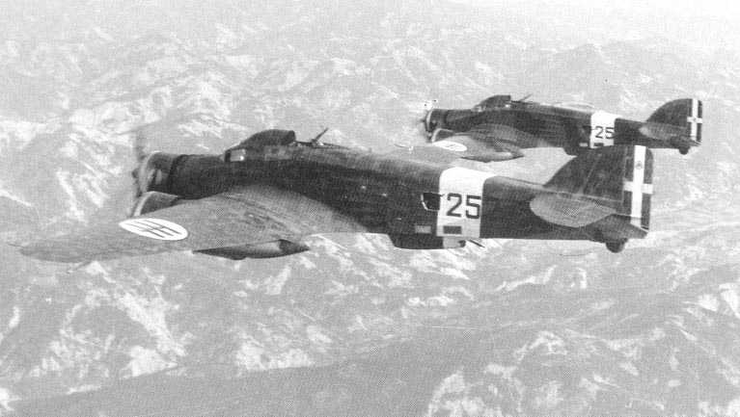

Biplane Battles

The air battles in the Western Desert were initially between the Italian front line fighters of the late 1930’s, the Fiat CR-42, and the last of the British biplane fighters - the Gloster Gladiator. The Gloster Gladiator would win immortality in the dark days over Malta when the last three aircraft nicknamed ‘Faith, Hope and Charity’, took to the skies to defend the tiny island of Malta against the onslaught of Axis bombers.

Photo 17. Italian Fiat CR-52 is fitted with 50lb. bombs, circa 1941.

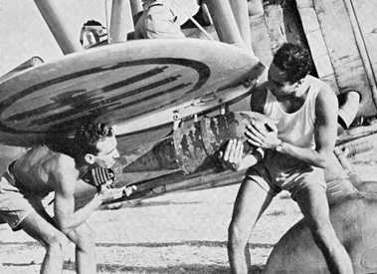

Photo 18. RAF Gloster Gladiator – the last of the British fighter biplanes.

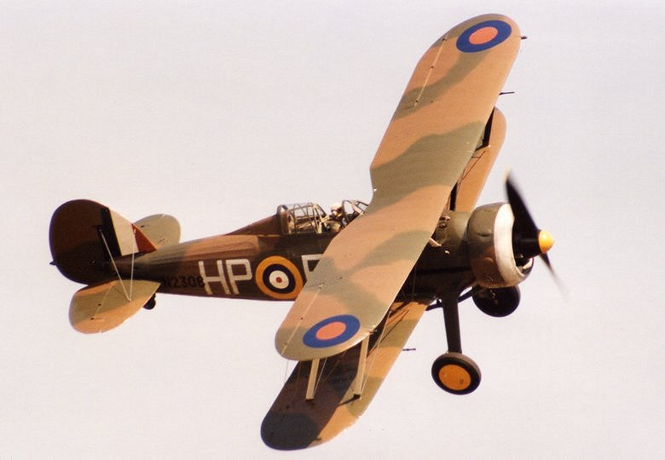

8-11 September 1942, To General Alexander: From the Commanding officer of the Eighth Army, General Montgomery: *Give me a fortnight and I can resist the German attack. Give me three weeks, and I can defeat the Boche. Give me a month and I can chase him out of Africa.* End of transmission.

The final outcome would be decided in the Second Battle of El Alamein under the leadership of General Bernard Montgomery (‘Monty’) in October/November 1942, when the Afrika Korps and Italian forces would be halted and pushed back through Egypt, then Libya to Tunisia.

Photo 19. A captured Italian Fiat CR-52 undergoes change of insignia by British troops.

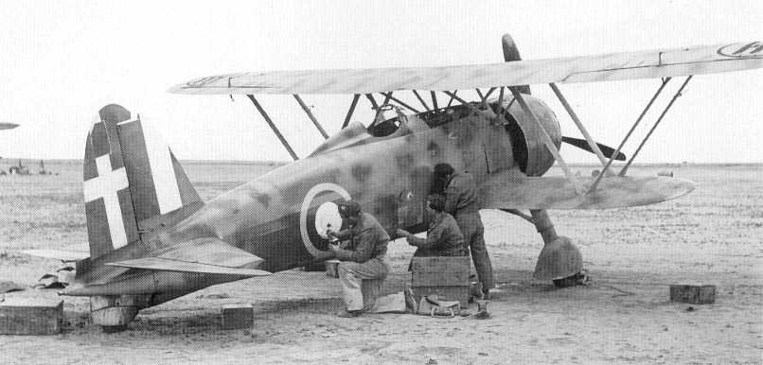

Photo 20. Australian troops pose next to a crashed Italian Fiat CR-42 in the Western Desert, circa 1942.

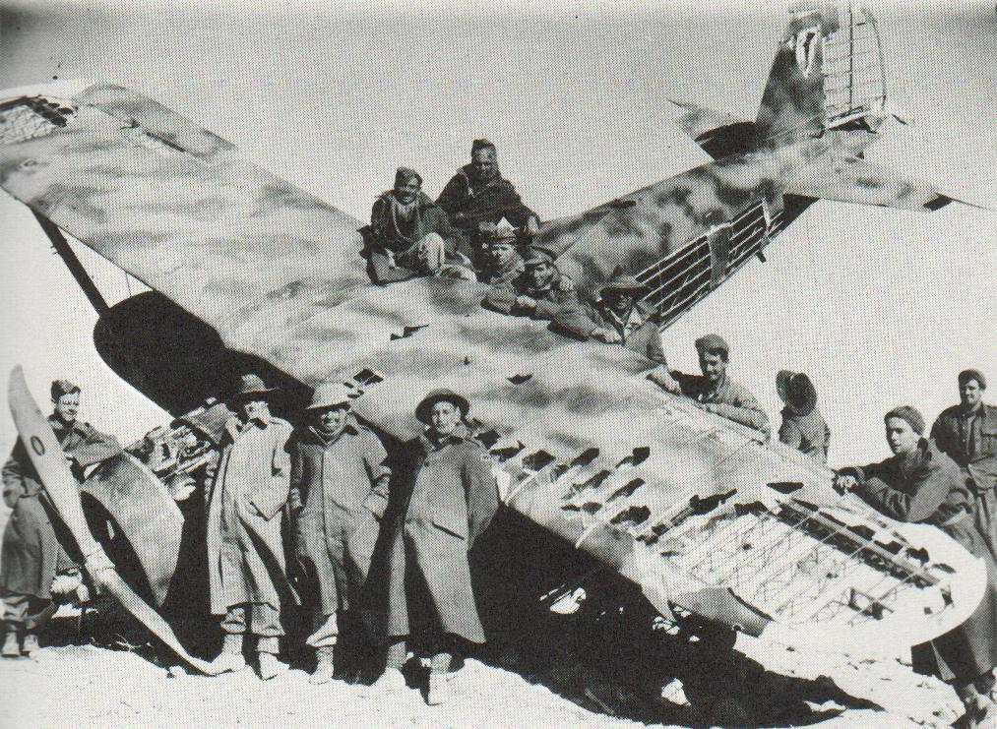

Malta Campaign

The close proximity of Malta to Italy made it a prime target for Axis air attacks, not only to take control of the British island fortress, but also to disrupt Allied supplies to North Africa. Malta would be subjected to continued air attacks. The Règia Aeronautica participated in the air offensive on the British controlled island of Malta along with the German Air Force in an attempt to gain control of the Axis sea routes from Sicily, Sardinia, and Italy to North Africa. Up to the end of 1940, the Règia Aeronautica carried out 7,410 sorties against the island, dropping 550 tons of bombs, losing 35 aircraft. The Italian airmen started to fear RAF fighters from Malta and AA artillery, so much so that the flight to the besieged island became known as the rotta della morte, the "route of death". In 1942, for its operations against Malta, between 1 January and 8 November, Règia Aeronautica had to write off 100 more aircraft lost in action.

Malta suffered heavy loss of equipment, ship and vehicles and was at the edge of starvation. However, the besieged island managed to withstand the attacks from the Italian and German air forces, and up to November 1942, Luftwaffe admitted to losing 357 aircraft and Règia Aeronautica 210. But, during the siege, the RAF's losses were even heavier, amounting to 547 in the air (including some 300 fighters) and 160 on the ground, plus 504 aircraft damaged in the air and 231 on the ground.

Gibraltar 1940-1943

The Règia Aeronautica had begun its attacks on the British crown colony of Gibraltar and its important naval base since July 1940. In 1942, Italian Piaggio P.108 bombers attacked Gibraltar from Sardinia, flying a number of long-range night raids. Up to October 1942, Règia Aeronautica carried out 14 raids with a total of 32 bombers.

Photo 21. Italian long-range bomber, the Piaggio P.108, ready to attack Gibraltar in 1942.

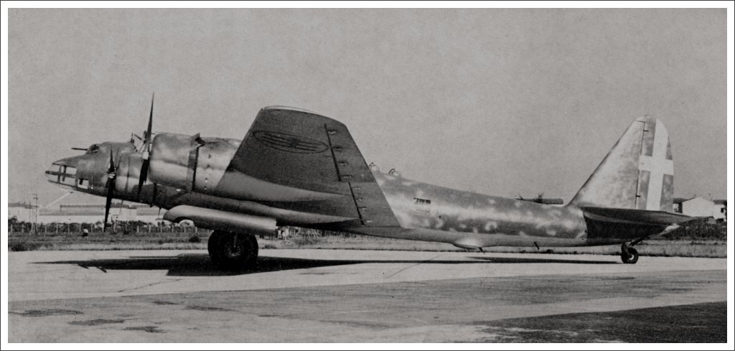

The last raids on Gibraltar were done during the 1943 Allied landing in Algeria, when those bombers also made a successful strike on the port of Oran. The only unit of the Règia Aeronautica to fly the Piaggio P.108 was the "274th Long-Range Bombardment Group" which became operational in June 1942.

Greece and Yugoslavia

When, on 28 October 1940, the Greco-Italian War started, Règia Aeronautica fielded 193 combat aircraft which initially failed to achieve air superiority against the Royal Hellenic Air Force, RHAF, that had 128 operational aircraft out of a total of 158. The poor infrastructure in Albania air bases, hindered communications and movements between the Italian flying units. Only two airfields – Tirana and Valona – had asphalt runways, so operations from other airfields in autumn and winter weather made operations more difficult. There was also the usual lack of co-operation with the Italian Navy and Army. Finally, just few days after the start of the war, Italian pilots were confronted by the RAF with No. 80 Squadron equipped with Gloster Gladiators, by Bristol Blenheims of No. 30 Squadron, No. 211 Squadron and No. 84 Squadron, and No. 70 Squadron with Vickers Wellingtons. Gradually, Italian air power grew to over 400 aircraft against the dwindling numbers of the Greeks. However, this advantage did not stop the Hellenic Army from forcing the Règia Esercito onto the defensive and back into Albania. In early 1941, the tide was turned as the German Wehrmacht launched its simultaneous invasion of Yugoslavia and of Greece.

For the 11 days campaign against Yugoslavia, Règia Aeronautica deployed 600 aircraft, claiming five air victories (plus 100 planes destroyed on the ground) and suffering five losses. However, from that point on, the role of the Règia Aeronautica in the Balkans Campaign was primarily that of support to the Luftwaffe. This support role continued during the occupation of Greece and the occupation of Yugoslavia that followed.

Actually, the air war against Greece cost the Italians just 65 losses (but 495 damaged), while RAF losses in the Greek campaign were 209 aircraft, 72 in the air, 55 on the ground and 82 destroyed or abandoned during the evacuation.

Eastern Front 1941-1945

In August 1941 the Règia Aeronautica sent an Air Corps of 1,900 personnel to the Eastern Front as an attachment to the "Italian Expeditionary Corps in Russia" (Corpo di Spedizione Italiano in Russia, or CSIR) and then the "Italian Army in Russia" (Armata Italiana in Russia, or ARMIR) were known as the "Italian Air Force Expeditionary Corps in Russia" (Corpo Aereo Spedizione in Russia). These squadrons, initially consisting of 22° Gruppo CT with 51 Macchi C.200 fighters and 61° Gruppo with the Caproni Ca.311 bomber, supported the Italian armed forces from 1941 to 1943. They were initially based in the Ukraine and ultimately supported operations in the Stalingrad area. In mid-1942 the more modern Macchi C. 202 was introduced to operations in Russia. The CSIR was subsumed by the ARMIR in 1942 and the ARMIR was disbanded in early 1943 after disaster during the Battle of Stalingrad. The Air Corps pulled out of operations in January 1943, transferring to Odessa.

From 1944 to 1945, Italian personnel operated from the Baltic area and in the northern part of the Eastern Front under the direct command of the Luftwaffe under the name Air Transport Group 1 (Italian: 1° Gruppo Aerotrasporti "Terracciano" , German: 1° Staffel Transportfliegergruppe 10 (Ital)). This group was part of the National Republican Air Force of the Italian Social Republic.

Sicilian Campaign

The Règia Aeronautica was put in a defensive role in Sicily, constantly fighting against allied efforts to sink the Règia Marina (Italian Navy). Just before the allied invasion of Sicily, a huge allied bomber offensive struck the airfields in Sicily in an effort to gain further air superiority. This left the Règia Aeronautica very weak, but still alive as planes continued to come out of Sardinia, southern Italy, and southern France. The last mission of Italian Règia Aeronautica was the defence of USAF bombing on Frascati - Rome in September 8th 1943.

The Armistice of Cassibile was an armistice signed on 3rd September 1943 by US General Walter Bedell Smith and Giuseppe Castellano and made public on 8th September between the Kingdom of Italy and the Allies during World War II. It was signed at a conference of generals from both sides in an Allied military camp at Cassibile, in Sicily, which had recently been occupied by the Allies. The armistice was approved by both King Victor Emmanuel III and Italian Prime Minister Pietro Badoglio. The armistice stipulated the surrender of Italy to the Allies.

Germany moved rapidly, freeing Benito Mussolini and attacking Italian forces in Italy, southern France and the Balkans. Italian forces were quickly defeated, and most of Italy was occupied by German troops, who established a puppet state, the Italian Social Republic.

The Règia Aeronautica officially ceased to exist when Italy became a republic on June 2, 1946, succeeded by the Aeronautica Militare.

However, our interest here is aviation gasoline, and the following are examples of the analysis of captured Italian aviation gasoline supplies.

# Italian Aviation Gasoline

The following are some examples of the analysis of aviation gasolines obtained from captured airstrips in the Western Desert campaigns.

Table 1. Italian Aviation Gasolines from captured stocks in North Africa during World War II circa 1940-41. [4]

|  |  |  |  |  |
| --- | --- | --- | --- | --- |
| Source | Gazala-Bomba ex dump | Sidi-el Tmimi (no markings) | Sidi-el Tmimi marked "Shell Ethyle 87 CFR" | "Intava Benzine Aviazione" |
| Colour | Water white | Blue | Blue | Pink Tinge |
| Specific Gravity | 0.715 | 0.716 | 0.716 | 0.733 |
| Octane No. | | | | |
| ASTM (Motor Method) | 72.5 |  |  | 61 |
| F3 (Aviation Method) |  | 88.5 | 88.5 |  |
| Initial Boiling Point deg. C |  | 45 | 47 | 43 |
| % Recovered to 75OC |  | 28 | 29.5 | 13 |
| % Recovered to 100OC |  | 64 | 65 | 34 |
| % Recovered to 150OC |  | 97 | 97 | 81 |
| Final Boiling Point deg. C |  | 154 | 152 | 190 |
| Reid Vapour Pressure psi |  | 6 | 6 | 6.5 |
| cc TEL/IG | Nil | 3.6 | 3.5 | Nil |
| Alcohol content | Nil | Nil | Nil | Nil |
| Bromine Value |  | Nil | Nil | 14 |
| Sulphur % |  | 0.017 | 0.017 | 0.06 |

The above table indicates that the fuel from Sidi-el Tmimi was typical of the German aviation grade B4. The gasoline marked “Shell Ethyle 87 CFR” also suggests that this may have been Shell product manufactured in Europe before the war, and it contained “Ethyl Fluid” and was tested to Shell specifications, which included CFR engine test methods. Similarly, the gasoline marked “Intava Benzine Aviazione” was Standard Oil product manufactured before the war - INTAVA was the international division of STANAVO. (Refer to earlier chapters for a detail on this aviation distribution network in Chapter 6).

There were, however differences in some Italian aviation gasolines as shown by the oil stocks captured in Libya. These showed that alcohol blend aviation gasolines were in use. (Refer Table 2.) The blends were water-white in colour, octane of 87 MON and unleaded, higher density, narrower boiling range (final boiling point 134 deg. C compared to 164 deg. C for Grade B-3). It was certainly inferior to 100 Avgas used by the opposing Allied air forces.

Table 2. Italian Aviation Gasoline (containing Alcohol) 1941.

|  |  |  |  |
| --- | --- | --- | --- |
| Source | Avaizione Tara K Italian plain drum | Italian red drum | Italian Aviation Benzine ex dump Capuzzo Rd. |
| Date | 27 Jan 1941 | 22 Jan 1941 | 5 June 1941 |
| Markings | Plain | Red Band |  |
| Colour | Water White | Water White | Blue |
| Specific Gravity | 0.773 | 0.77 | 0.721 |
| Reid Vapour Pressure psi |  | 6.5 | 5.5 |
| Alcohol content | 20% Methyl Alcohol | 20% Methyl Alcohol |  |
| Bromine Value |  |  | 2 |
| Sulphur % | 0.04 | 0.02 | 0.01% |
| cc TEL/IG | Nil | Nil | 3.91 |
| Octane CFR MON |  |  | 87 |
| F3 (Aviation Method) | 86 | 86 | 87 |
| Base |  |  | 73 |
| @ 1.855 cc TEL/IG |  |  | 84.2 |
| @ 3.91 cc TEL/IG |  |  | 87.4 |
| Lead Susceptibility |  |  | 1.55 |
| Aromatics |  |  | 8% |
| Paraffins |  |  | 61% |
| Naphthenes |  |  | 31% |
| Unsaturates |  |  | Nil |
| Initial Boiling Point (deg. C) | 51 | 51 | 50 |
| 5% (deg. C) | 59 | 59 |  |
| 10% (deg. C) | 60 | 61 |  |
| 20% (deg. C) | 63 | 63.5 |  |
| 30% (deg. C) | 65 | 66 |  |
| 40% (deg. C) | 67 | 68 |  |
| 50% (deg. C) | 68 | 69.5 |  |
| 60% (deg. C) | 69 | 70 |  |
| 70% (deg. C) | 71.5 | 74 |  |
| 80% (deg. C) | 93 | 100 |  |
| 90% (deg. C) | 106 | 112 |  |
| 95% (deg. C) | 121 | 122 | 150 |
| 98% (deg. C) | 134 | 134 | 164 |
| % Recovered to 75OC | 75 | 71 | 23.5% |
| % Recovered to 100OC | 85 | 80 | 61% |
| % Recovered to 150OC | - | - | 95% |
| Water tolerance | 1.5% add water completely soluble% add water slight alcohol separation |  |  |
| Comments | Strong smell Benzol. No evidence of cracked spirit |  |  |

The composition of the Italian aviation gasoline [Italian Aviation Benzine ex dump Capuzzo Rd.] can be illustrated by the PONA distribution which is similar to the Allies aviation gasoline, most likely due to the use of straight run gasoline with a high TEL content. This particular fuel did not have any alcohol content.

Graph 1. Italian Avgas 87 MON Grade 1941- PONA Distribution.



Another feature of the Italian aviation fuels (87 MON grade) was the use of Alcohol in particular Methanol (Methyl Alcohol). This may have been a carry-over from the halcyon days of the Schneider Trophy in the 1930’s when alcohol fuels were popular racing fuels and the Italians with their sleek Macchi seaplanes were fierce competitors (refer Chapter 3). The presence of Methanol is evident in the distillation curve of the gasoline from Avaizione Tara K Italian (plain drum) in early 1941.

Graph 2. Distillation Curve of Italian (Water-white) 87 MON aviation gasoline (circa 1941).



Note the flatness of the curve between 10% and 70% distilled, this is due to the 20% Methanol which has a boiling point of 64.6 deg. C. These gasolines with high percentages evaporated in the 60-70 deg. range would have been liable to vapour lock troubles in the hot desert weather.

Photo 22. Italian mechanics service a Macchi C.202 in the desert, circa 1941.

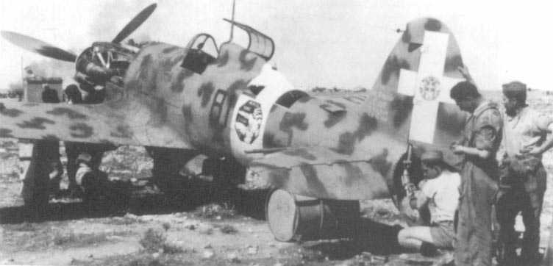

# Specifications

The following is the Aviation Gasoline for Italy as listed by STANAVO in 1935.

Table 3. STANAVO Aviation Gasoline specification for Italy 1935.[5]

|  |  |
| --- | --- |
| Grade Designation | Aviation Gasoline |
| Specification No. | None listed |
| General requirements | Non opalescent or fluorescent |
| Colour | Equal volumes of H2SO4 (sulfuric acid) added must assume colour more intense than a solution of Bichromate at 1 per 100 parts. |
| Specific Gravity | None listed |
| Doctor Test | None listed |
| Corrosion | No visible sign of corrosion |
| Existent Gum (mg/100 ml) Max. | None listed |
| Potential Gum (16 hr aging mg/100 ml) Max. | None listed |
| Sulfur (wt.%) Max. | 0.15% |
| Freezing Point (deg. C) Max | -50 |
| Reid Vapour Pressure (@37.8 deg. C) psi Max | None listed |
| Knock Rating | None listed |
| Acidity | Comparatively neutral reaction |
| Distillation % Recovered at 50 deg. C  % Recovered at 100 deg. C  % Recovered at 120 deg. C  % Recovered at 150 deg. C  End Point (deg. C) | Max. 5%  Min 57% +/-1%  Min. 80%  Min. 90%  165 |
| Residue | Max 2 gm. |
| Tetra Ethyl Lead Content | None listed |
| Benzol, Alcohol | None listed |
| Unsaturates | Bromine Index Max. 3 |
| Remarks | 100cc evaporated and dried out at 100 to 105 deg. C, residue max 0.005 gm. |

This specification is surprising in its obsolescence. It is reminiscent of the early aviation gasoline 1917 specifications before the understanding of knock ratings. It has no specification for knock rating, lead content, vapour pressure, existing or potential gum, Doctor Test. The colour test is most curious! This specification is clearly reliant on the old notion of specifying the quality by distillation and residue on evaporation at 100 deg. C.

Allies Gain Air Superiority

As the war continued in the deserts of North Africa, the Italian Air Force was being outclassed by the more robust Allied aircraft such as the American Curtiss Tomahawks and Kittyhawks, and the British Spitfires and Hurricanes. The Luftwaffe’s Messerschmitt Bf-109s could still match the Allied aircraft, but uncertain fuel supplies and constant attack on their air fields and supply lines was a constant threat.

Photo 23. Italian Macchi C.202 on display at NASM Washington D.C. (1999).

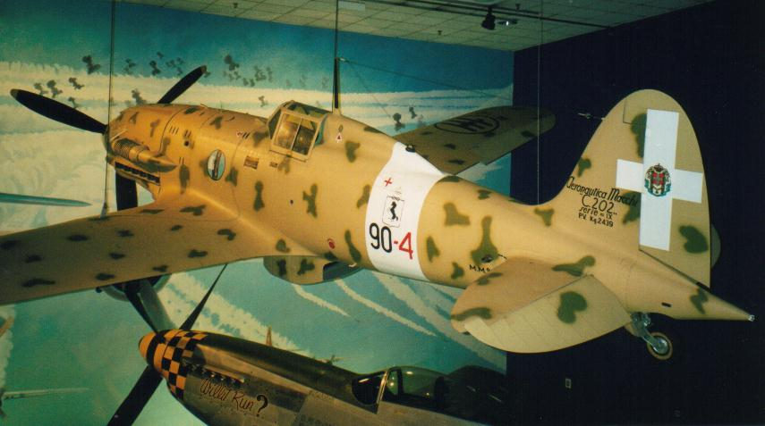

While camouflage was important in warfare, there was also the need to ensure that the aircraft was serviced correctly and therefore standard markings were used on key service points. The photo below shows the characteristic triangle indicating the fuel required for this aircraft.

Photo 24. Macchi C.202 showing the fuel tank triangle marking behind the cockpit, (the red cross is the first aid kit). (This aircraft was on display at NASM 1999).

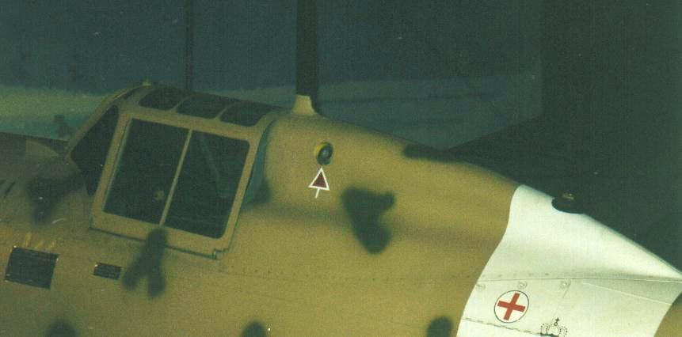

Photo 25.. Macchi C.202 showing the fuel tank marking behind the cockpit circa 1942.

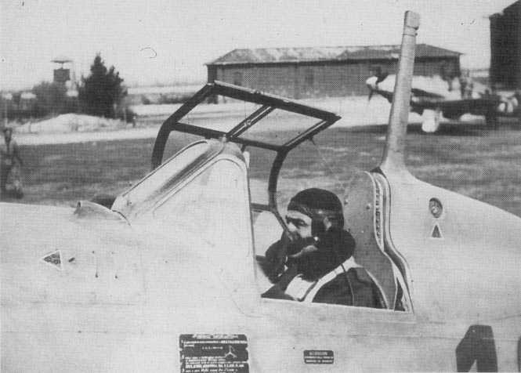

# Epilogue for the Fascist Italy

When he came to power in 1926, Il Duce dreamed of the resurrection of a glorious new Roman empire. After some initial conquests in Ethiopia, Albania, Libya and Greece the dream was never to be fulfilled. In 1940, Mussolini took his country into World War II on the side of Nazi Germany, but soon was met with military failure. By the autumn of 1943, he was reduced to being the leader of a German puppet state in northern and central Italy, and was faced with the Allied advance from the south and an increasingly violent internal conflict with the partisans. By 1943 the fascist regime had collapsed and Mussolini was to be captured and later in 12th September 1943, was rescued by Colonel Skorzeny and 16 SS troopers in a high-risk glider mission. In April 1945, with the Allies breaking through the last German defences in northern Italy, and a general uprising of the partisans taking hold in the cities, Mussolini's situation became untenable. On 25th April he fled Milan, where he had been based, and tried to escape to the Swiss border. He and his mistress, Claretta Petacci, were captured on 27th April by local Italian Communist partisans near the village of Dongo on Lake Como. Mussolini and Petacci were executed the following afternoon, two days before Adolf Hitler's suicide. Their bodies were hung upside down in the city of Mezzegra, in the province of Como.

Italy became a republic on June 2, 1946.

Règia Aeronautica was always dependent on aviation gasoline supplies from their Axis ally Germany. In many operations the Italian Air Force was always subservient to the German Luftwaffe.

# Index

1

1° Gruppo Aerotrasporti "Terracciano" 18

1° Staffel Transportfliegergruppe 10 (Ital) 18

100 Avgas 19

106th Fighter Flight 7

116th Reconnaissance Flight 7

118th Reconnaissance Flight 7

131st Reconnaissance Flight 7

14th Bomber Flight 7

15th Bomber Flight 7

17th Bomber Flight 7

18th Bomber Flight 7

1st Raggruppamento 11

2

22° Gruppo CT 18

274th Long-Range Bombardment Group 17

27th Bomber Squadron 7

28th Blackshirt Division 11

3

34th Reconnaissance Flight 7

38th Reconnaissance Flight 7

3rd Air Brigade 7

4

41st Reconnaissance Flight 7

4th Bombers Squadron 7

6

61° Gruppo 18

7

7th Bomber Wing 7

8

87 MON 19, 21, 22

A

Abyssinia 4, 6

Acidity 23

Addis Ababa 6

Aeronautica Militare 18

Afrika Korps 10, 11, 12, 13, 14, 16

Air Transport Group 1 18

Albania 4, 17, 25

alcohol 19, 20, 21, 23

Alexander 16

Alexandria 11

Algeria 17

Allied 24

Armata Italiana in Russia 18

ARMIR 18

Armistice of Cassibile 18

Aromatics 20

Atlantic Ocean 6

Auchinleck 13

Australian 11, 13, 16

Avaizione Tara K 20, 21

Avgas 87 21

Aviación Legionaria 8

aviation gasoline 18, 19, 20, 21, 22, 23, 25

aviation grade B4 19

Aviation Method 19, 20

Aviazione Legionaria 8

Axis 11, 13, 14, 15, 16, 17, 25

B

Badoglio 18

Balbo 6, 10

Balearic Islands 8

Balkans 18

Baltic 18

Battle of Britain 10

Battle of France 9

Bedell Smith 18

Belgium 9, 10

Benghazi 11, 12

Benzol 23

Bir Hakeim 13

Bomba 13

Bristol Blenheim 17

Britain 4

British 10, 11, 12, 15, 16, 17, 24

British Army 13

Bromine Index 23

Bromine Value 19, 20

Buqbuq 11

C

Cairo 11

CANT 25 7

Caproni Ca.101 3, 7

Caproni Ca.111 7

Caproni Ca.311 18

Capuzzo 20, 21

Castellano 18

Cat 7

Century of Progress Exposition 10

CFR engine 19

CFR MON 20

Chicago 10

Churchill 12

Cirene Division 11

colour 19, 20, 23

Commonwealth 10, 11, 13, 14

Communist partisan 25

Condor Legion 8

Corpo Aereo Spedizione in Russia 18

Corpo Aero Italiano 10

Corpo di Spedizione Italiano in Russia 18

Corpo Truppe Volontarie 8

Corrosion 23

Corsica 4

Crete 14

CSIR 18

Curtiss Kittyhawk 13

Curtiss Tomahawk 24

Cyrenaica 10

D

Damah 13

Desert Air Force 14

Desert Fox 10, 13

destroyers 11

Deutsches Afrikakorps 12

Distillation 23

Doctor Test 23

Dongo 25

E

Eastern Front 18

Egypt 4, 10, 11, 12, 14, 16

Eighth Army 13, 16

El Alamein 11, 14, 16

El Mechili 12

Emmanuel III 18

Ethiopia 3, 4, 6, 8, 25

Ethyl Fluid 19

Existent Gum 23

F

F3 19, 20

Faith, Hope and Charity 15

Fiat Br.20 10

Fiat CR-32 9, 11

Fiat CR-42 1, 10, 11, 13, 15, 16

Fiat CR-52 15, 16

Fiat G-50 6, 9

Fiat GR-42 2

France 4, 18

Franco 8

Frascati - Rome 18

Free French 13

Freezing Point 23

fuel dumps 13

fuel tank 24

G

gasoline 19

Gazala 11, 13, 19, 30

German 6, 8, 10, 11, 13, 16, 17, 19

Germany 18, 25

Gibraltar 17

Gloster Gladiator 13, 15, 17

Grade B3 19

Graziani 10

Greco-Italian War 17

Greece 4, 10, 11, 17, 18, 25

H

Hawker Hurricane 13

Hellenic Army 17

Hitler 4, 5, 25

Hurricane 24

I

Il Duce 10, 25

IMAM Ro.37 7

Indian 11, 13

INTAVA 19

Intava Benzine Aviazione 19

Italian 11, 13, 14, 15, 16, 17

Italian Air Force 11, 24, 25

Italian Air Force Expeditionary Corps in Russia 18

Italian Aviation Benzine 20, 21

Italian Navy 17, 18

Italian Royal Air Force 8

Italian Social Republic 18

Italo-Turkish War 10

Italy 6, 10, 11, 16, 17, 18, 23, 25

J

Junkers Ju-87 13

K

Kenya 4

Kingdom of Italy 18

knock ratings 23

L

lead content 23

League of Nations 4, 6

Legionary Air Force 8

Lend-Lease 13

Libya 4, 10, 11, 12, 13, 14, 16, 19

Libyan Reconnaissance Flight 7

Luftwaffe 11, 13, 14, 17, 18, 24, 25

M

Macchi C.202 3, 6, 13, 18, 22, 24

Macchi seaplanes 21

Maktila 11

Maletti 11

Mallorca 8

Malta 4, 11, 14, 15, 16

Marinens Flyvebaatfabrikk M.F.4 floatplane 7

Matricardi 7

Mediterranean 10, 13, 14

Messerschmitt Bf-109 13, 24

Methanol 21, 22

Methyl Alcohol 20, 21

Mezzegra 25

Milan 25

Montgomery 16

Motor Method 19

Mussolini 4, 5, 6, 18, 25

N

Naphthenes 20

National Republican Air Force 18

New Roman Empire 4

New Zealand 13

No. 211 Squadron 17

No. 30 Squadron 17

No. 70 Squadron 17

No. 80 Squadron 17

No. 84 Squadron 17

North Africa 10, 11, 13, 17, 19, 24

O

Odessa 18

oil fields 13

Operation Crusader 11

Oran 17

Ottoman Empire 10

P

Palestine 4

Panzer Army Afrika 13

Paraffins 20

Persia 13

Petacci 25

Piaggio P.108 17

Polish 13

PONA distribution 21

potential gum 23

R

RAAF 13

RAF 11, 13, 14, 17, 18

Ranza 7

Rats of Tobruk 13

Règia Aeronautica 3, 4, 6, 9, 10, 11, 14, 16, 17, 18, 25

Règia Esercito 17

Règia Marina 18

Règio Esercito 6

Reid Vapour Pressure 19, 20, 23

Residue 23

RHAF 17

Ritchie 13

Romeo Ro.1 7

Rommel 10, 11, 12, 13, 14

rotta della morte 17

Royal Hellenic Air Force 17

Royal Navy 13, 14

S

Sardinia 11, 17, 18

Savoia-Marchetti S.73 9

Savoia-Marchetti S55X 6, 10

Savoia-Marchetti SM-79 8, 11, 14

Schneider Trophy 11, 21

Second Italo-Abyssinian War 6

Second Italo-Ethiopian War 6

Shell Ethyle 87 CFR 19

Sicily 11, 17, 18

Sidi Barrani 10, 11

Sidi-el Tmimi 13, 19

Skorzeny 25

Somalia 7

Soviet Union 4

Spanish Civil War 6, 8, 9

Spanish Republic 8

Specific Gravity 19, 20, 23

specification 12, 19, 23

Spitfire 24

Stalingrad 18

STANAVO 19, 23

Standard Oil 19

straight run gasoline 21

Stuka 13

submarines 11

Suez 13

Sulfur 23

Sulphur 19, 20

surrender 18

Swiss 25

T

TEL 19, 20, 21

Tetra Ethyl Lead 23

Tirana 17

Tmini 12

Tobruk 11, 13

Tripoli 10, 11, 14

Tripolitania 10

Tunis 4

Tunisia 11, 16

U

Ukraine 18

United States 4

unleaded 19

Unsaturates 20, 23

Ursel 9

USAF 18

V

Valona 17

vapour lock 22

vapour pressure 23

Vickers Wellington 17

W

Water tolerance 21

Wehrmacht 17

Wellington 11

Western Desert 13, 15, 16, 19

Y

Yugoslavia 17, 18

# Research Sources

1. Source Website: <http://en.wikipedia.org/wiki/Regia_Aeronautica> Accessed November 28, 2006
2. Source Website <https://en.wikipedia.org/wiki/Italian_order_of_battle_for_the_Second_Italo-Ethiopian_War> Accessed November 11, 2020
3. Source Website: <http://72.14.235.104/search?q=cache:fsUiacKAi_EJ:grognard.com/reviews1/dak.doc+Gazala-Bomba&hl=en&gl=au&ct=clnk&cd=1> Accessed November 22, 2006
4. UK Public Records Office- London Ref: UK PRO POWE 33/1470
5. ‘Aviation Gasoline Specifications – Year 1935’ STANAVO