Chapter

21

Japanese Aviation Gasoline – The ‘Japanese way’ - Copy, Modify, Improve, Create.

Photo 1. Replica of a Japanese Val-D3A dive bomber (Mid Atlantic Air Museum, Reading PA, USA, June 2007).

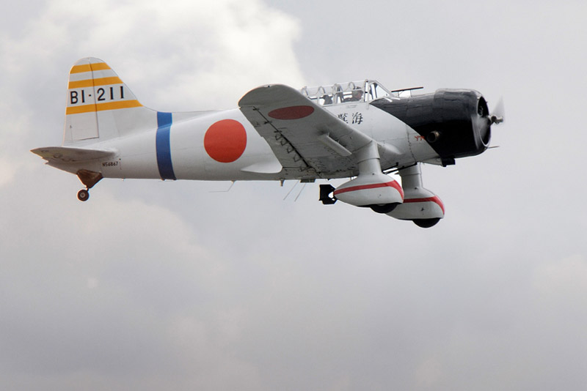

Table of Contents

Summary 3

Japan - Aviation Gasolines 6

The Expansion Of Japan 1868-1941 6

Japan And Oil Before The War 1893-1925 6

Japanese Denied Access To Oil 8

Japan Starts To Stockpile 8

Japan's World War Ii Business Practices 14

Conquest For Oil 21

Oil Fields, Refineries And Storage Centres Under Imperial Japanese Army Control 22

The Origins Of The Imperial Japanese Navy Air Force 24

Japanese Oil Refineries 1936 32

Oil Companies And Refineries 32

Japanese Gasoline Composition 1941-43 33

Avgas Specifications & Test Methods 1942 34

Japanese Army Aviation Gasoline 1943 35

Manufacturing Process 1941-1945 53

Japan – Tel Production 56

Japanese Petroleum Position In 1944 61

Some Experiments – Aviation Fuels & Lubricants In World War Ii 69

Avgas From Pine-Root Tar 76

Lubricants Of Aircraft Engines 79

“Target – Destroy Japan’s Oil Industry” 80

“Airspeed Records Japan Takes The Record 1943” 80

Epilogue For The Japanese Years – Desperate Measures. 81

Index 82

Research Sources 88

# Summary

Chronology

1895-1923 Japanese oil production peaked in 1916 then decreased

1925 Japan denied access to vast East Indies oil reserves

The Rise of Japanese Imperialism.

1937 War with China. Preparations for war against America.

July 1940 United States placed embargo on export of oil, scrap metal and all aviation gasoline to Japan

Dec 1941 Japanese attack US base at Pearl Harbour “Day of Infamy’, Japanese Imperial Forces sweep down Malay Peninsula and attack British possessions.

Photo 2. Japanese carrier-based aircraft launch their attack 1941

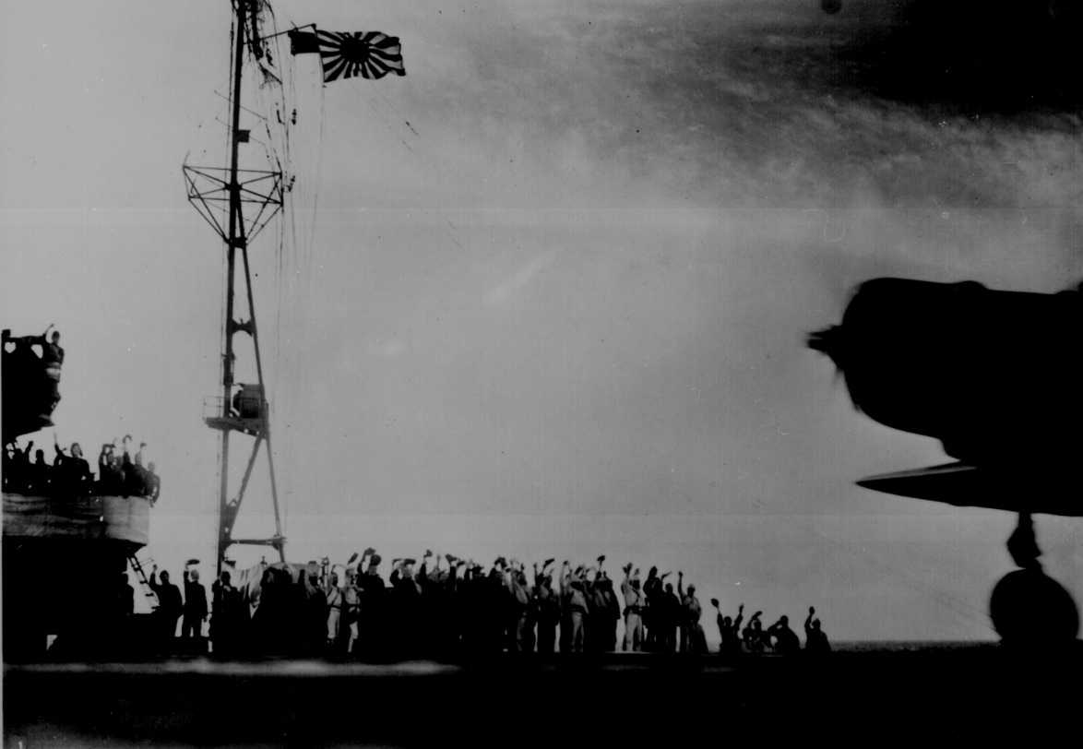

Photo 3. Hickam Field Pearl Harbour December 7, 1941.

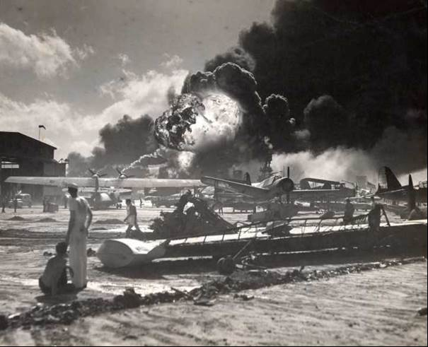

Jan 1942 Japanese capture the ‘prize’ - East Indies Oil fields

1942-1943 Japanese exploit captured oil fields; export crude oil back to Japan.

1943-1944 Desperation sets in as fortunes of war change.

Aug 1945 World War concludes with the defeat of Japan and its industry

Figure 1. The Japanese advances in 1942

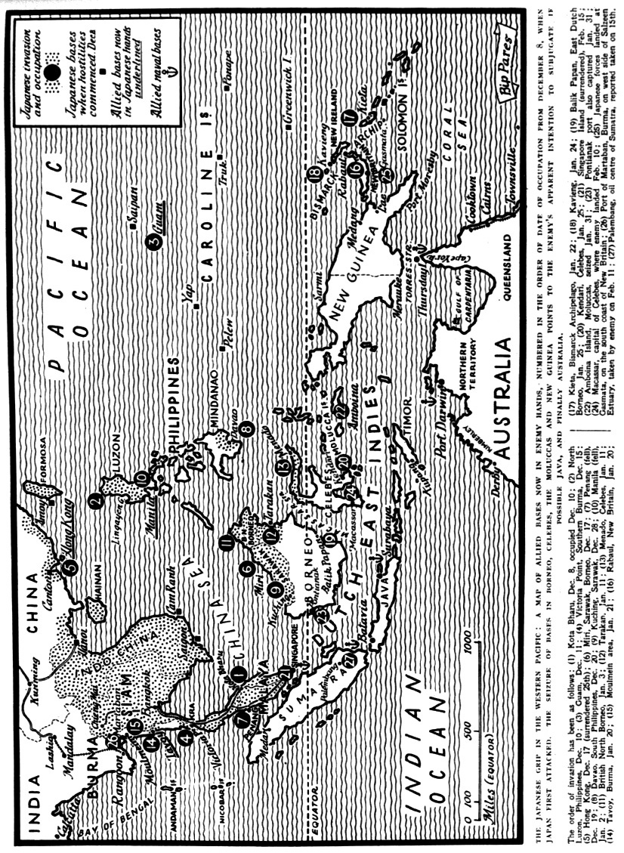

# Japan - Aviation Gasolines

Always limited supply.

The Imperial Japanese Army and Imperial Japanese Navy had fundamentally only two fuel requirements - fuel oil for their ships and industry, and aviation gasoline for the naval aircraft and army aircraft. Japan had very little natural resources, and so relied on importing essentially all of its oil needs – a situation which still exists today. One of the driving forces for Japan declaring war was the denial of oil supplies from U.S. controlled refineries, and British and Dutch interests in the East Indies and Borneo. The swift attack by the Imperial Japanese Army and Navy down the Malay Peninsula was directly toward the oil rich regions of Borneo and Sumatra.

But first we must go back to before the War.

# The Expansion of Japan 1868-1941[1]

In the Military Atlas of World War II by Bishop, he outlines the Japanese expansion as follows:

The creation of the modern state of Japan was rapid after the Meiji Restoration of 1868. In less than 40 years, the Japanese Empire had changed from a feudal state into a country with a modern army and navy. These were tested in a war with China, fought over control of Korea, and were proved in a stunning triumph over the Russians in 1905. Both wars were settled by international treaty, and the Japanese felt that they had been cheated of their just rewards by the interference of the Great Powers. The outbreak of the Great War (WWI) in 1914 was seen by Japan as an opportunity to expand its power into the Chinese mainland. Declaring war on the side of the Allies, the Japanese seized German holdings in China and the Pacific. In just three decades, Japan had won control of Korea, the German treaty ports in China, and in 1931, the fiercely nationalist Japanese Army seized Manchuria without reference to the Tokyo government. Colonial ambitions and the rise of Japanese militarism in the 1930’s now saw the Japanese cynically manipulating China into war.

# Japan and Oil before the War 1893-1925[2]

Petroleum deposits have been worked in Japan for several hundred years and the yield of oil obtained from seepage, hand dug pits and from shallow wells supplied their needs.

Contact with western civilisation in the 19th Century brought about an increasing demand for petroleum products, especially kerosene, and the importation of American methods and outfits led to increased production. By 1893 output was 106,000 Bbls (1 barrel = 159 Litres) and every year saw an increase with the peak of 2,963,000 Bbls reached in 1916. Since then the decline in local production due to higher costs of drilling, cheaper imported mineral oils and crude for refining, and with shallow deposits exhausted, there was a greater dependence on overseas supplies.

Practically Japan’s entire yield of 200,000 Bbls (1923) came from western coast of Honshu. Smaller fields are being worked in various parts of this island and oil is also produced in variable quantities in Formosa, Hok-kaido and Saghalien Islands.

Formosan fields were first developed

1908 7,000 Bbls

1916 20,000 Bbls

1924 10,000 Bbls

Although there has been active interest in oil searches, no success as yet (by 1925).

Figure 2. Japanese local Oil Production for years 1893 –1923

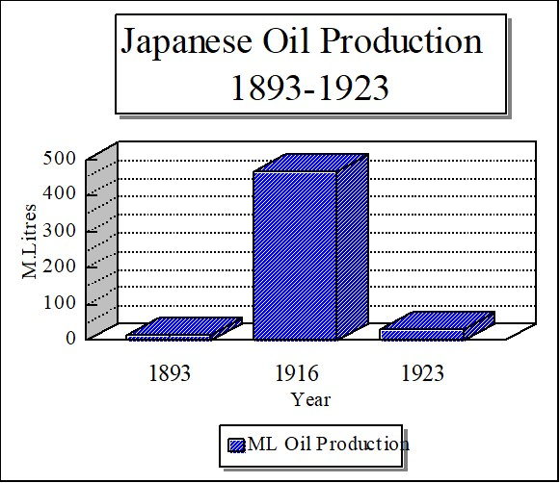

(For comparison, in 1916 the US production of gasoline alone was 7,793 million litres, by 1926 it was 41,269 million litres, while Japan’s was only 91 million litres).

In 1890 Nippon Oil Co., and Hoden Oil Co. undertook oil exploitation, however by 1921 Nippon has absorbed Hoden to be the largest oil company in the Orient. American oil companies never obtained effective inroads into Japan.

The area of Japanese Empire in 1925 included Formosa, Chosen (Korea), leased Territory of Kwantung (South Manchuria), southern half of Saghalien Island. Total population 80,000,000

This market consumed 20,000,000 gallons of petrol and naphtha, 90,000 gallons of diesel oil, over 25,000,000 gallons of lubricating oil, 200,000,000 pounds (lbs) of solid products such as wax, vaseline and asphalt. Imports, chiefly from the US and Dutch East Indies supply approximately 50% of the liquid refined products and 35% of other petroleum products.

Japanese refineries handled about 2,000,000 Bbls of locally produced crude oil and an increasing amount of imported crude. Total 5,000,000 Bbls in 1922, 1,000,000 Bbls in 1923.

America still remained the largest exporter of oil but US demands had reached enormous heights and there were doubts (in 1925) as to whether the US will be able to meet its own requirements.

Japan needed oil to compete and this was reflected in her policy regarding the acquisition of oil interests of late years (1923-24).

# Japanese Denied Access to Oil

Japan had made determined efforts to obtain a footing in the Netherlands East Indies, but so far without success in 1925. The vested interests of Standard Oil (US), the Royal Dutch companies, along with the antipathy of the Dutch officials to the Japanese penetration had proved a barrier against any large concessions.

Northern half of Saghalien Island (Sakhalin) had great potential as an oil producer. This island had been in dispute between Soviet and Japanese Governments since 1921. Japan continued military occupation.

Japanese forces invaded and occupied Sakhalin in the closing stages of the Russo-Japanese War. Per the Treaty of Portsmouth of 1905, the southern part of the island below the 50th parallel north reverted to Japan, while Russia retained the northern three-fifths. In 1920, during the Siberian Intervention, Japan again occupied the northern part of the island, returning it to the Soviet Union in 1925.

In 1924, the Soviets gave Sinclair Oil Company of USA certain concessions and oil rights in the island but when they arrived, Japanese military authorities refused to allow entry.

Japan had turned her attention to fuel oil from shale. South Manchurian Railway Company and Japanese Navy were convinced shale deposits of Fushin would yield an inexhaustible supply of petroleum.

[3]Japan depended on imports for their oil, and realized their aggressive moves might run them afoul of their suppliers. Thus, in the 1930s the Japanese government accelerated plans to increase their oil self-sufficiency. As their Planning Board Director, Teichi Suzuki, said in September 1941, “we anticipated that eventually the present difficult circumstances would arise.”

Since the 1890s, the Japanese had tried to develop an indigenous oil industry, using substantial amounts of American technology and expertise. Although oil extraction efforts proved insufficient, by 1941 Japan had 21 operational refineries in the home islands, with an annual capacity approaching one year’s normal consumption. Starting in 1934, the Japanese government had virtually nationalized their oil industry, consolidating government control over import purchasing, production, and refining. In the wake of the “China Incident” (after Japan’s conquest of Manchuria it then sought to conquer China but Chiang Kai-shek refused to capitulate in the face of Japanese military superiority.), Japan launched an ambitious expansion of the synthetic oil industry, enacting a Seven-Year Plan in 1937.

By 1943, this plan called for completion of 66 carbonization plants (using coal feedstocks), 10 hydrogenation plants (using coal tar and shale oil distillates), and 11 plants using the German Fischer-Tropsch hydrocarbon synthesis process. Hopefully, these facilities would annually produce 6.4 million barrels of gasoline and 7.7 million barrels of heavy oil products of military value.

# Japan Starts to Stockpile

From 1931 Japan was aware of the need to import oil and to commence stockpiling crude oil reserves in preparation for a possible future conflict with those who controlled oil.

At this stage the Japanese expansion had not yet began, so the aim was to increase the crude oil inventory such that if Japan did have to go to war it would have enough oil reserves to sustain itself for a short conflict.

The base for this expansion would be the main home islands of Japan (Honshu, Hokkaido, Kyushu, and Shikoku). This would be known as the “Inner Zone”

Figure 3. Japan Home Islands

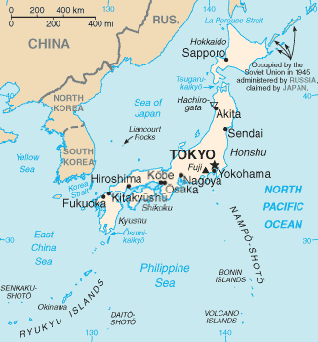

"Japan sea map". Licensed under Public Domain via Commons - <https://commons.wikimedia.org/wiki/File:Japan_sea_map.png#/media/File:Japan_sea_map.png>

The United States Strategic Bombing Report (1946) lists the situation regarding crude oil. Table 1. Japanese imports, production and inventories of crude oil – Inner Zone 1931-45.

Table 1. Japanese imports, production and inventories of crude oil – Inner Zone 1931-45.

Thousands of barrels

|  |  |  |  |
| --- | --- | --- | --- |
| Fiscal Year & Quarter | Imports | Indigenous production | Inventories (beginning of period) |
| 1931 | 6,391 | 1,923 | 4,919 |
| 1932 | 9,136 | 1,594 | 3,699 |
| 1933 | 10,179 | 1,419 | 3,976 |
| 1934 | 11,953 | 1,785 | 4,040 |
| 1935 | 12,829 | 2,214 | 3,845 |
| 1936 | 15,996 | 2,458 | 5,001 |
| 1937 | 20,231 | 2,470 | 10,467 |
| 1938 | 18,404 | 2,465 | 12,465 |
| 1939 | 18,843 | 2,332 | 20,242 |
| 1940 | 22,050 | 2,063 | 19,901 |
| 1941 April to June  July to September  October to December  January to March | 3,004  -  -  126 | 518  492  478  453 | 20,857  18,078  14,650  14,492 |
| 1942 April to June  July to September  October to December  January to March | 1,133  1,861  3,093  2,059 | 430  407  400  453 | 12,346  10,390  8,748  7,677 |
| 1943 April to June  July to September  October to December  January to March | 3,712  2,264  2,546  1,326 | 441  442  446  465 | 6,839  5,557  4,839  3,512 |
| 1944 April to June  July to September  October to December  January to March | 994  224  423  - | 419  386  379  401 | 2,354  1,240  594  490 |
| 1945 April to June  July to September | -  - | 406  403 | 195  193 |

The above table shows the result of various actions:

(1) significant import of crude oil from 1932 to 1940 reaching 22.05 million barrels followed by the sudden impact of the US Oil Embargo in April-June 1941 with imports dropping to 3 million barrels and nil in July 1941 to March 1942 by which time the Japanese had captured the rich prizes of the Borneo and Dutch East Indies oil fields.

(2) With the reduction of oil imports consequently local production fell dramatically in this period to a steady 400,000 barrels and the resultant decline in inventories from over 20 million barrels to less than 200,000 barrels (1% of the peak inventories).

The data presented below shows the broad range of petroleum products required by the Japanese country particularly the military.

The United States Strategic Bombing Report (1946)[4] also lists the situation regarding crude and refined products. Table 2. Japanese imports of crude and refined oils (inner zone) 1931-1945.

Table 2. Japanese imports of crude and refined oils (inner zone) 1931-1945 (Thousands of barrels)

|  |  |  |  |  |  |  |  |
| --- | --- | --- | --- | --- | --- | --- | --- |
| Fiscal Year & Quarter | Crude Oil | Aviation Gasoline | Motor Gasoline | Diesel Fuel | Fuel Oil | Lubricating Oil | Total |
| 1931 | 6,391 | - | 2,640 | 7,275 | 3,145 | 243 | 19,694 |
| 1932 | 9,136 | - | 2,908 | 8,589 | 3,145 | 226 | 24,004 |
| 1933 | 10,179 | - | 3,041 | 8,737 | 3,145 | 154 | 25,256 |
| 1934 | 11,953 | - | 3,670 | 10,748 | 2,516 | 247 | 29,134 |
| 1935 | 12,829 | - | 3,988 | 13,859 | 2,516 | 270 | 33,462 |
| 1936 | 15,996 | - | 4,218 | 12,093 | 1,877 | 551 | 34,735 |
| 1937 | 20,231 | - | 4,011 | 10,809 | 1,573 | 258 | 36,882 |
| 1938 | 18,404 | - | 3,020 | 8,634 | 2,202 | 188 | 32,448 |
| 1939 | 18,843 | 440 | 1,966 | 7,760 | 1,258 | 394 | 30,661 |
| 1940 | 22,050 | 1,447 | 4,279 | 7,839 | 504 | 1,041 | 37,160 |
| 1941 April to June | 3,004 | 346 | 364 | 1,670 | - | 265 | 5,649 |
| July to September | - | 302 | 366 | 126 | - | 247 | 1,041 |
| October to December | - | 566 | 309 | - | - | 177 | 1,052 |
| 1942 January to March | 126 | 315 | 101 | - | - | 88 | 630 |
| April to June | 1,133 | 63 | 202 | - | - | - | 1,398 |
| July to September | 1,861 | 63 | 261 | - | 69 | - | 2,254 |
| October to December | 3,093 | 377 | 258 | 126 | 138 | - | 3,992 |
| 1943 January to March | 2,059 | 220 | 258 | 205 | 138 | - | 2,880 |
| April to June | 3,712 | 252 | 158 | 267 | 208 | - | 4,597 |
| July to September | 2,264 | 465 | 227 | 220 | 252 | - | 3,428 |
| October to December | 2,546 | 409 | 163 | 294 | 239 | - | 3,651 |
| 1944 January to March | 1,326 | 849 | 131 | 292 | 226 | - | 2,824 |
| April to June | 994 | 440 | 44 | 94 | 315 | - | 1,887 |
| July to September | 224 | 535 | 63 | 126 | 157 | - | 1,105 |
| October to December | 423 | 472 | 63 | 126 | 138 | - | 1,222 |
| 1945 January to March | - | 440 | 50 |  | 271 | - | 761 |

Kerosene and Gas oil not included

The same report lists Table 3. Japanese inventories of liquid fuels and lubricants - Inner Zone 1931-1945

Table 3. Japanese inventories of liquid fuels and lubricants - Inner Zone 1931-1945 (Thousands of barrels)

|  |  |  |  |  |  |  |  |  |  |  |  |  |
| --- | --- | --- | --- | --- | --- | --- | --- | --- | --- | --- | --- | --- |
| Date of Inventory | Aviation Gasoline | | | | Motor Gasoline | | | | Diesel Fuel | | | |
|  | Army | Navy | Civilian | Total | Army | Navy | Civilian | Total | Army | Navy | Civilian | Total |
| 01-April-1931 | 272 | 430 | 1 | 703 | 126 | 94 | 172 | 392 | - | 315 | 31 | 346 |
| 01-April-1932 | 268 | 443 | 1 | 712 | 126 | 101 | 191 | 418 | - | 315 | 31 | 346 |
| 01-April-1933 | 286 | 455 | 1 | 742 | 126 | 94 | 212 | 432 | - | 215 | 61 | 376 |
| 01-April-1934 | 291 | 531 | 1 | 843 | 126 | 94 | 248 | 468 | - | 315 | 96 | 411 |
| 01-April-1935 | 281 | 630 | 1 | 912 | 126 | 88 | 306 | 520 | - | 377 | 168 | 545 |
| 01-April-1936 | 278 | 656 | 1 | 935 | 189 | 94 | 342 | 625 | - | 377 | 220 | 597 |
| 01-April-1937 | 288 | 625 | 1 | 914 | 189 | 107 | 620 | 916 | - | 377 | 504 | 881 |
| 01-April-1938 | 274 | 614 | 1 | 889 | 189 | 107 | 418 | 714 | - | 377 | 464 | 841 |
| 01-April-1939 | 240 | 601 | 1 | 842 | 232 | 101 | 428 | 781 | - | 440 | 220 | 660 |
| 01-April-1940 | 323 | 945 | 1 | 1,269 | 252 | 107 | 413 | 772 | - | 440 | 189 | 629 |
| 01-April-1941 | 972 | 1,995 | 2 | 2,969 | 315 | 94 | 352 | 761 | - | 503 | 176 | 679 |
| 01-July-1941 | 1,200 | 2,200 | 2 | 3,402 | 377 | 94 | 333 | 804 | - | 516 | 170 | 686 |
| 01-October-1941 | 1,507 | 2,393 | 3 | 3,903 | 503 | 88 | 320 | 911 | - | 516 | 182 | 698 |
| 01-January-1942 | 1,700 | 2,551 | 3 | 4,254 | 629 | 88 | 320 | 1,037 | - | 440 | 179 | 619 |
| 01-April-1942 | 1,672 | 2,549 | 2 | 4,213 | 692 | 88 | 252 | 1,032 | - | 315 | 164 | 479 |
| 01-July-1942 | 1,603 | 2,476 | 2 | 4,081 | 818 | 82 | 201 | 1,101 | 63 | 283 | 170 | 516 |
| 01-October-1942 | 1,595 | 2,228 | 2 | 3,825 | 912 | 63 | 138 | 1,113 | 126 | 252 | 182 | 560 |
| 01-January-1943 | 1,581 | 2,157 | 3 | 3,741 | 944 | 63 | 75 | 1,082 | 220 | 189 | 195 | 604 |
| 01-April-1943 | 1,501 | 2,030 | 3 | 3,534 | 1,006 | 50 | 113 | 1,169 | 352 | 126 | 192 | 670 |
| 01-July-1943 | 1,436 | 1,611 | 3 | 3,050 | 1,038 | 50 | 126 | 1,214 | 283 | 126 | 182 | 591 |
| 01-October-1943 | 1,347 | 1,398 | 3 | 2,748 | 1,069 | 44 | 109 | 1,222 | 252 | 94 | 189 | 535 |
| 01-January-1944 | 1,125 | 1,245 | 2 | 2,372 | 1,101 | 38 | 94 | 1,233 | 252 | 94 | 176 | 522 |
| 01-April-1944 | 1,107 | 1,227 | 3 | 2,337 | 1,126 | 31 | 97 | 1,254 | 239 | 82 | 170 | 491 |
| 01-July-1944 | 1,013 | 771 | 2 | 1,786 | 989 | 31 | 75 | 1,095 | 239 | 63 | 145 | 447 |
| 01-October-1944 | 716 | 748 | 1 | 1,465 | 868 | 25 | 50 | 943 | 226 | 57 | 126 | 409 |
| 01-January-1945 | 682 | 640 | 1 | 1,323 | 723 | 25 | 47 | 795 | 220 | 44 | 94 | 358 |
| 01-April-1945 | 830 | 707 | 1 | 1,538 | 660 | 19 | 40 | 719 | 214 | 31 | 63 | 308 |
| 01-July-1945 | 704 | 452 | 1 | 1,157 | 315 | 19 | 31 | 365 | 101 | 19 | 53 | 173 |
| 01-October-1945 | 635 | 376 | 1 | 1,012 | 196 | 13 | 23 | 232 | - | 13 | 30 | 43 |

The above table shows the great need of the Japanese Navy for aviation gasoline once the Pacific War against the Americans had commenced. Following the crushing defeat of the Japanese Navy air power at Midway and the Mariana Islands ( known to the Americans as the “Mariana Turkey Shoot” where US Navy carrier based aircraft destroyed the Japanese carrier based aircraft), the need for dwindling stocks of aviation gasoline was now required for the Japanese Army the defence of the home islands.

Table 4. Japanese Consumption of liquid fuels and lubricants - Inner Zone 1931-1945.

Table 4. Japanese Consumption of liquid fuels and lubricants - Inner Zone 1931-1945 (Thousands of barrels)

|  |  |  |  |  |  |  |  |  |
| --- | --- | --- | --- | --- | --- | --- | --- | --- |
|  | Aviation Gasoline | | | | Motor Gasoline | | | |
| Fiscal Year & Quarter | Army | Navy | Civilian | Total | Army | Navy | Civilian | Total |
| 1931 | 145 | 145 | 6 | 296 | 377 | 94 | 3,628 | 4,099 |
| 1932 | 151 | 157 | 6 | 314 | 629 | 126 | 4,701 | 5,456 |
| 1933 | 189 | 189 | 9 | 387 | 692 | 126 | 4,795 | 5,613 |
| 1934 | 189 | 189 | 13 | 391 | 755 | 189 | 4,629 | 5,573 |
| 1935 | 201 | 208 | 19 | 428 | 881 | 189 | 6,464 | 7,534 |
| 1936 | 252 | 283 | 22 | 557 | 1,006 | 220 | 6,015 | 7,241 |
| 1937 | 315 | 377 | 22 | 714 | 1,132 | 220 | 7,522 | 8,874 |
| 1938 | 472 | 472 | 25 | 969 | 1,258 | 252 | 6,326 | 7,836 |
| 1939 | 566 | 503 | 25 | 1,094 | 1,258 | 252 | 4,595 | 6,105 |
| 1940 | 572 | 629 | 86 | 1,287 | 1,258 | 283 | 6,323 | 7,864 |
| 1941 April to June | 157 | 126 | 19 | 302 | 315 | 94 | 496 | 905 |
| July to September | 157 | 126 | 19 | 302 | 315 | 94 | 486 | 895 |
| October to December | 409 | 377 | 19 | 805 | 315 | 63 | 377 | 755 |
| January to March | 421 | 377 | 16 | 814 | 315 | 94 | 224 | 633 |
| 1942 April to June | 428 | 377 | 15 | 820 | 315 | 94 | 200 | 609 |
| July to September | 447 | 409 | 15 | 871 | 315 | 94 | 264 | 673 |
| October to December | 509 | 503 | 9 | 1,021 | 283 | 94 | 324 | 701 |
| January to March | 566 | 535 | 13 | 1,114 | 283 | 94 | 282 | 659 |
| 1943 April to June | 579 | 566 | 9 | 1,154 | 277 | 126 | 277 | 680 |
| July to September | 654 | 629 | 9 | 1,292 | 264 | 126 | 293 | 683 |
| October to December | 667 | 629 | 4 | 1,300 | 245 | 94 | 300 | 639 |
| January to March | 749 | 692 | 3 | 1,444 | 245 | 101 | 179 | 525 |
| 1944 April to June | 755 | 755 | 2 | 1,512 | 252 | 63 | 99 | 414 |
| July to September | 679 | 692 | - | 1,371 | 252 | 63 | 70 | 385 |
| October to December | 591 | 566 | - | 1,157 | 233 | 63 | 47 | 343 |
| January to March | 359 | 377 | - | 736 | 170 | 63 | 41 | 274 |
| 1945 April to June | 239 | 365 | - | 604 | 283 | 63 | 50 | 396 |
| July to September | 101 | 113 | - | 214 | 94 | 31 | 56 | 181 |

# Japan's World War II Business Practices[5]

One of the more interesting stories by Robert Maddox is that of US Senator Harley M Kilgore from West Virginia who in 1941 served on the US Military Affairs Committee.

Parts of that story are retold here:

Photo 4. Harley Martin Kilgore -United States Senator from West Virginia in office January 3, 1941 – February 28, 1956.

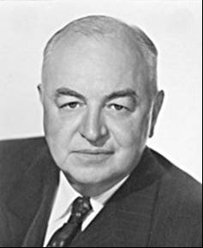

In the middle of October 1942, the US Senate authorized Kilgore to investigate technological mobilization, as chair of a special subcommittee of the Military Affairs Committee. This subcommittee evolved into the Subcommittee of War Mobilization of the Military Affairs Committee, which became known as the Kilgore Committee. The committee's investigations into mobilization led to the examination of international cartels and World War II. By early 1944, Kilgore was convinced that if international cartel agreements had been investigated before 1936, the United States would have had a more realistic view of the international situation. The committee devoted much attention to the impact of cartels in the development of the German military machine. However, it was the startling testimony on the use of business relationships by Japan to further its militaristic policies that was most revealing to the Kilgore Committee.

In the decade before Pearl Harbor, a constant stream of information flowed to Japan as a result of Japanese commercial transactions with American firms -technical information and economic data of the utmost importance to Japan's armed forces. Industries most involved included oil, aircraft, machine tools, and electronics. Our interest in this chapter relates to aviation gasoline.

The Japanese utilized cartel-like arrangements, such as patent licensing, pooling arrangements, and exchange of technology. Likewise, they purchased technical information and observed American technical achievements or made detailed inquiries about them. According Maddox, the Japanese were able to acquire technical information and certain processes necessary to the production of 100-octane aviation gasoline before this information was widely available to firms in the United States. They were even able to gain knowledge about petroleum shipments to Pearl Harbor.

Japan needed the processes for producing aviation gasoline in order to wage war and the knowledge was acquired to some degree from Universal Oil Products Company. This company, with its research center at Riverside, Illinois, had some six hundred technical specialists who were experts in oil refining. With its involvement in commercial applications, it had a worldwide clientele. The company had developed over eleven hundred U.S. patents, and this information was generally made available through the normal scientific methods of dissemination.

In 1928, Osaka financial interests incorporated Japan Gasoline Company as the mechanism to acquire Universal technology for the Dobbs process, which involved a means of cracking petroleum utilizing heat and pressure. On July 19, 1928, Universal and Hisashi Sekiguchi signed a contract which gave Japan Gasoline access to the technology and its future advances. In return, Universal received one million dollars for the process. The technology proved to be unprofitable, and only one Dobbs plant was built in Japan by 1938. However, Japan Gasoline manifested a new interest in Universal because of developments in iso-octane, a blending agent used in the production of high quality 100-octane aviation gasoline. Most major oil companies were engaged in research in this area at this time. Senator Kilgore pointed out that General Hap Arnold had stated the "limiting factor in air defense was not the ability to build planes or to train pilots, but the capacity to produce fuel for planes."

Two phases existed in the production of aviation gasoline, the production of iso-octane and the production of a base stock which, when blended with lead and iso-octane, yielded 100-octane fuel. The Japanese were particularly interested in the base stock production process which, through catalytic cracking, required less processing and resulted in more gasoline. These processes were not in general usage in 1938. The alkylation process, which promised more gasoline at much less cost, drew the interest of the Japanese, as did the technology to produce the catalyst used in the process.

The possibility that Japan gasoline might acquire these processes piqued the interest of other Japanese entities. In March 1937, Masao Saneyoshi, President of Japan Gasoline, wrote Universal Oil that "owing to the urgent need to produce high octane gasoline for aviation, there is a strong tendency to develop the Polymerization Process in Japan, which would be reviewed by Professor Horie. . .." Then he requested information concerning the new processes, including information on the catalysts. Fukio Horie, Japan Gasoline's chief engineer, also cited the demand for aviation gasoline: "Our Air Force requires keenly 100-octane fuel, therefore the quantity of iso-octane becomes the most essential point in our client's plan." Likewise, Horie indicated in a letter in February that all of the refineries under discussion were basically under government supervision.

The Japanese government was very interested in the deal with Universal Oil. Captain Yamagiware, who had visited the Riverside Laboratory of Universal Oil, was appointed to head up the fuel bureau. Believing that Universal was the best oil research institute in the world, he was willing to help Japan Gasoline become the vehicle to disseminate Universal's technology to Japan. Rokura Shinohara, a member of the Japanese Parliament, showed a great deal of interest in the processes. In fact, Universal attempted to use him to pressure Japan Gasoline to close a pending deal. Universal officials were aware they could be at cross purposes with the national interest when one of their executives wrote, "we are in a position where our Government could indicate some displeasure in our making these important processes of ours available to Japan."

As a result of negotiations, which were begun in 1937, three draft memoranda between Japan Gasoline and Universal were worked out by August 1938. With the first agreement, Japan Gasoline obtained the processes for iso-octane. The second option permitted the Japanese "to acquire the rights under all of Universal's processes in the entire petroleum field (whether solid, liquid, vapor, or gas; specifically including but without limitation of the generality of the foregoing) dehydrogenation, iso-merization, cyclization, and alkylation." This would include all processes which might be developed up to December 31, 1946. The resultant formal agreement of October 31, 1938, revealed the extent of Japan Gasoline's rights. The agreement stated:

Patent rights shall mean all unpatented technical knowledge and experience, all applications for patents based on inventions made prior to the termination of this agreement, issued patents, reissues, renewals, extensions of patents in the entire petroleum field and transferable interest in any of the foregoing, of which the companies designated may now or hereafter have the ownership or control in the sense of having the power to dispose thereof or grant licenses there under. Ultimately, the parties failed to sign the agreement because the Japanese wanted to extend it into 1953. However, the first option was executed with the payment by Japan Gasoline of six hundred thousand dollars as stipulated in the agreement.

In line with these agreements, Universal began to design iso-octane units to be used by Mitsubishi Oil Company and Nippon Oil, which had agreements with Japan Gasoline. Not only were the designs delivered to Japan in 1939, but Universal engineers were dispatched to help build these plants. Universal, prior to the signing of the agreements, informed the U.S. War and U.S. State Departments of the pending transactions. Universal felt the Japanese could "secure practically identical results from the knowledge they have and will obtain through technical publications and by the issuance of our patents and inspection of other plants and those other groups that are competitive to us outside the United States." The U.S. War Department expressed no objection, even though the agreement was signed before the department's position was rendered.

On July 5, 1939, Japan Gasoline Company exercised option two of its agreement with a payment of one hundred thousand dollars. This agreement allowed the company's technical staff to visit Universal's laboratories and other research facilities to obtain "all necessary technical know-how. “Two months after the option was activated, a force of Japanese technical representatives arrived to spend four months in Universal's facilities. The technologists included petroleum, mining, and chemical representatives, and technical staff from the Japanese army and navy. Other Japanese scientists apparently had no contractual relationships with Japan Gasoline. In reality, Kilgore pointed out, the contract was "with the Japanese nation as a whole so that anybody in Japan could utilize it. Thus, it functioned as a Japanese government monopoly. The technical staff of Universal Oil cooperated fully with them on their problem which was mainly the production of aviation fuel." In fact, Universal "carried out a very extensive program of research in catalytic cracking and hydrotransforming in order to arrive at a type of process which would satisfactorily meet the Japanese requirements." Eleven of the thirty-five people who attended were army and navy personnel.

Universal provided the Japanese with research and written test results from pilot plants. Likewise, all information concerning other Universal catalysts was given to the Japanese. Universal scientists conducted lectures on a variety of subjects and the lecturers even reviewed the notes of the Japanese to make sure they understood the material. Then they proceeded to design a plant for the Japanese. In other words, Universal was functioning in a treaty-like way with the Japanese government. This work continued until restrictions were imposed by the United States government. Even then, Universal representatives were convinced that due to the thoroughness of the technology-transfer activities, the Japanese were capable of proceeding on their own. In fact, Universal believed "that the information given to the Japanese representatives was as complete, if not more complete, than any information on these processes which we supplied to anyone."

In response to aggressive activities by the Japanese government in the Far East, the United States government by the summer of 1938 had gradually applied economic sanctions against Japan with a "moral embargo" of "aircraft, engines, parts, armaments, aerial bombs, and torpedoes." This embargo did not carry legal restrictions, yet these items were not sent to Japan after the summer of 1938. By December 1939, the restrictions were expanded to include molybdenum, aluminum, and information on the production of high quality aviation gasoline." Therefore, when on December 20, 1939, the State Department declared that "there should be no future delivery to certain countries of plans, plants, manufacturing rights, or technical information" involving production of aviation gasoline, Universal terminated the Japanese "school" immediately and duly informed Japan Gasoline Company that its 1938 agreements would have to be suspended. In June 1940, Japan Gasoline filed suit against Universal, seeking "specific performance of contracts, or the payment of $10,000,000.00." The case was postponed due to the advent of the war. This apparently did not deter the Japanese, who through appropriate internal agreements were able to plan and construct five catalytic cracking plants with a total daily capacity of fifteen thousand barrels. Each plant included units to manufacture iso-octane for blending as well as five independent units with a 650-barrel daily capacity. Apparently, the second option, which included the latest technical information, had not been approved by the State Department. Ironically, Japan Gasoline could "enter the American courts after the war and demand, under the 1938 agreement, not only information on all Universal's processes developed up to 1940 but also on all those developed since that date." However, American firms had difficulty securing the same kind of information which was made available to the Japanese. For example, Shell Oil Company, which owned 50 percent of Universal's voting stock and was a licensee for all Universal patents up through 1947, complained that information provided to them in 1938 concerning cracking and catalytic reforming was incomplete. D. Pyzel, a Shell vice president, asked Universal "to divulge . . . the full details of your research work and fundamental data relating to the design and operation of these processes." Universal responded on December 19, 1941, that Shell was not "entitled to our service or our technique, unless we are properly protected and compensated for our efforts. We cannot agree with your views that Shell, as a paid-up licensee under all our patents, is entitled to all of our technique." Kilgore concluded Universal "wouldn't conduct a school for Shell, but they did for the Japanese."

Likewise, in 1936, Standard Oil Company of Indiana had requested fifteen reports and other information similar to that widely distributed to the Japanese. Standard held over three million dollars of Universal paper and was a paid-up licensee through December 1947. Universal refused to provide the requested information and its board of directors supported this position. Under their agreements, an American firm would have to purchase the catalyst, while the Japanese firms would not. The Japanese, however, did buy a year's supply of the catalyst from Universal and thus received the rights to the technology. Fearing that this kind of information would find its way into the hands of the Kilgore Committee, J. G. Alther, vice president and general manager of Universal, "begged" a Justice Department official not to release this material. Mitsubishi Oil Company, another Japanese concern, developed some interesting relationships with companies in the United States. It was formed in 1930 with five million yen as a partnership involving Mitsubishi Trading Company and Associated Oil Company. Ultimately, Associated became Tide Water Associated Company. All but five hundred of the fifty thousand shares given to Tide Water were placed under the control of the company's president, William F. Humphrey. The companies maintained a positive relationship and they planned a joint venture in occupied China, which "would doubtless call for genuine cooperation on both sides."

However, difficulties existed when Japanese firms attempted to do business with the United States. In a January 3, 1941, letter, Hokichi Inouye of the Mitsubishi San Francisco office wrote S. Takeuchi of the Tokyo office to inform him of some of these potential difficulties as well as to provide a barometer on American sentiment at the time. He reported on a meeting he had with William Humphrey. Recently back from a trip to the eastern United States, Humphrey sensed strong antagonistic feeling toward the Japanese. In fact, this feeling seemed to be stronger in the East than in the West. On a trip to Washington, D.C., he discovered the views of high government officials to be "more adverse toward Japanese activities in China and some quite 'head strong.'" Humphrey attempted to improve sentiment toward Japan by indicating to these government officials and businessmen that his relationship with Mitsubishi had been "more pleasant than any other association with accounts in any other country in the world. . . ." The Japanese firm had even contributed 875,000-yen towards a loss of 1,875,000-yen Tide Water had suffered due to a drop in the exchange rate, which was the result of various crises in the Orient. Humphrey felt that in these circumstances and others, Mitsubishi would "not fail to take care of him even in the worst case." Inouye felt that the Tide Water board of directors had been "severely" critical of the president and that Mitsubishi should continue to maintain their cooperative relationship. Humphrey also opined that the appointment of Admiral Nomura to Washington would improve relationships with the United States. Yet Inouye felt that "even a superman cannot expect to improve and correct the deep-rooted adverse American sentiment and understanding of the real situation in the Far East overnight."

Recognizing Humphrey's efforts to improve relationships between the United States and Japan, F. Funada, Mitsubishi's chairman of the board, wrote in a January 1940 missive to Humphrey that he wanted to render his heartfelt thanks for the sincere efforts you have been making of late months for a betterment of political relationships between your country and mine. Indeed, it gives me a feeling of security to know that in these critical hours when the American-Japanese relationships have become rather complex, over in America, one gentleman influential in both political and business circles is doing everything possible on our account by allotting some of his valuable time and energies in an effort to combat passage of any political measures that might be fatal to our petroleum business.

He also indicated that he was sending a Mr. Mitani to the United States in early February 1940 to study the international petroleum situation "so that we may be fully prepared at all times to be assured of petroleum supplies in this country." He hoped that Humphrey would assist Mitani's efforts.

On July 26 and September 12, 1940, President Roosevelt issued proclamations which forbade "the export of plans, designs, and information that could be used in the production of high octane aviation gasoline." Thus, Tide Water found itself in the position of having to deny Mitsubishi's request for reference fuel, which was utilized in the measurement of octane ratings.

The Japanese also used business contacts to pass on strategic information. The Mitsubishi San Francisco branch manager wrote to the fuel department in Tokyo that "you may be interested to know that some of the 100-octane aviation gasoline produced from the alkylation plant at Avon, built mainly to meet Mitsubishi requirements, will supply the naval air station at Tongue Point, near Astoria, Oregon." Likewise, "[Tide Water] is also supplying 100-octane gasoline to United States Army airfields in the Pacific Northwest at Mc Chord Field near Tacoma, Washington, and Pearson Field, Vancouver, Washington." Moreover, Mitsubishi prepared a list of "Competitive Bulk Oil Shipments from Los Angeles Harbor." The focus of their attention seemed to be on shipments going to Pearl Harbor. They noted that in "less than a month from April 28th to May 23rd, 771,500 Bbls. fuel oil, and 132,299 Bbls. diesel fuel oil and 22,682 Bbls gasoline have been shipped from Los Angeles Harbor to Pearl Harbor." They speculated that similar shipments had gone out of San Francisco and Estero bays to Pearl during the same period. Kilgore pointed out that Tide Water's export department "prepared and furnished to Mitsubishi a study which indicated our shipments of vital fuel oils" to Pearl Harbor.

The Japanese apparently attempted to stimulate competition between American companies. A New York Mitsubishi representative cabled Tokyo on May 15, 1941, that in spite of "government policy and national tendency," Tide Water's president was "doing his best to convey friendship policy to Japan to the high officials in Washington through his petroleum business. . . ." He was unhappy that Mitsubishi dealt with his competitors. He wanted Mitsubishi to go through Tide Water or get the company's permission to acquire products which they did not produce. In fact, Tide Water was threatening breach of contract because Mitsubishi was dealing with Gulf Oil Corporation. Conceivably, this competition may have caused Tide Water to supply information in order to acquire business. Moreover, Cooper Oil Company, months after the moral embargo, supplied Mitsubishi with technical information concerning neohexane and alkylate, which were being developed as substitutes for iso-octane. Three months after the moral embargo, Cooper supplied Mitsubishi with confidential information on 92-octane gasoline from Maritime Oil Company. This provided "conclusive proof that our material will run up to 93 . . . and consequently there should be no doubt that we will meet any octane requirements your principals might require." The Cooper official wrote that the report "is sent you in complete confidence, and be very careful to whom you disclose it, as it would get me in a terrific jam if it ever leaked out that I sent you this data." Kilgore was forced to conclude that American companies would give information for business, and he wondered why, with the kind of pressure brought in Washington by companies like Tide Water, the United States was surprised at Pearl Harbor. Investigations by the Justice Department revealed that Mitsubishi was the "real spy outfit." As the largest Japanese company operating in the United States as an agent of the Japanese government, it is no wonder that company officials destroyed sensitive files after December 7, 1941.

In another case, the Ocon Petroleum Processes Corporation, in September 1940, indicated that discussions between its technical people and the technical people of Okura Company resulted in the conclusion that the Japanese company needed the "catalytic naphtha re-forming process." A unit with a 3,000-barrel-per-stream-day capacity was capable of producing 1,650 barrels of aviation gasoline. The Japanese wanted to see a test plant in operation, and Ocon was willing to demonstrate this process in Mexico, which obviously indicated the company was afraid to demonstrate it in the United States. Since the moral embargo had been proclaimed three months earlier, Ocon was willing to go south of the border to help the Japanese.

Furthermore, four months after Roosevelt had forbidden sending abroad information regarding high-octane gasoline and other items, Orchard Liske, a consulting petroleum technologist from New York City, wrote to Mr. Sawada of Mitsubishi concerning the production of toluene, an ingredient in explosives: "It would still be possible . . . to make a report on the potentialities of producing this solvent from Japanese and imported and crude petroleum without incurring any infringement of the Embargo Act. . . ." He believed that "valuable basic data as to these potentialities does not seem to be specified in this law - so long as actual refinery and process designs are not given." He offered to provide the "physical and chemical characteristics of toluene; its differentiation from the benzine with which it occurs; and some notes on the pyrolytic treatment of petroleum hydrocarbons and the tendency of pyrolysis to yield toluene." In addition, he would analyse foreign and domestic sources the Japanese could use and unpublished technical information on the extractive process. This information would allow Japanese engineers to replicate the process. This was an obvious attempt to get around the embargo and to provide the Japanese with strategic information of military value.

In their negotiations to purchase aircraft, the Japanese managed to acquire important technical information. In 1937, the Japanese were planning to acquire a Boeing bomber which the United States Army forbade the sale of for a one-year period. Boeing offered to sell them a "similar model." Boeing advised the Japanese that "they would be able to design and build a similar type of bombing plane, either independently or in conjunction with Japanese engineers and would manufacture a certain specified number per year, or make one model plane selling the manufacturing rights for the style so designed."

On June 13, 1938, Secretary of State Cordell Hull imposed a moral embargo on the shipment of airplanes and aircraft parts to any nation using them to bomb civilians. On October 28, Fairchild Aviation invited Okura's Vice Admiral Maehara and his entourage to visit a factory at Farmingdale, Long Island, which was operated by Ranger Engineering Company. Maehara would be shown how Ranger manufactured engines for the Fairchild "24" and the new trainer which was being developed for the United States.

Photo 5. Fairchild 24 Trainer

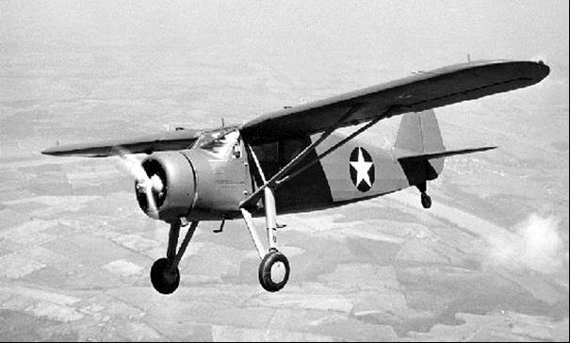

Earlier, Ranger had provided the Japanese with complete technical information on the trainer. The Japanese were aware that most companies in the aircraft industry were hesitant to accept their orders, fearing negative publicity and potential labour difficulties because the American Federation of Labor and the Congress of Industrial Organizations both opposed shipment of these materials to Japan. If American companies accepted orders, "stringent conditions are imposed."

Some aircraft parts manufacturers cooperated with the Japanese and offered ways around the embargo. Bethlehem Steel Export Corporation accepted orders on the basis of part numbers with no reference to the fact they were airplane parts. The American Hammered Piston Ring Company, which could not conceal the fact the parts were for aircraft, accepted orders made directly through its export manager. Only part numbers were ordered and all other specifications were provided in a separate confidential letter. The Aluminum Company of America refused to accept orders, but it sold the dies and shipped them to another factory where the parts could be produced. Canton Prop Forgings & Manufacturing Company shipped to the Japanese if they ordered part numbers and Thompson Products, Inc. shipped valve forgings utilizing the same process. After the president's embargo of military equipment and parts, which became effective on July 5, 1940, Douglas Aircraft Company offered to deliver ordered parts to the Mitsui office with the suggestion that the Japanese label them as automotive parts.

In early 1940, the Japanese were able to acquire information concerning the Boeing 307 Stratoliner.

Photo 6. Boeing 307 Stratoliner

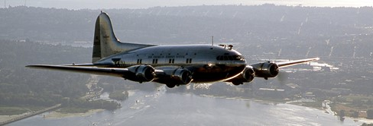

Lieutenant Y. Terai of the Japanese navy was invited to the Boeing factory in Seattle, where he was shown blueprints, diagrams, and other critical information concerning the plane. However, he was not allowed to see the plane because it was housed in the same hanger with the Flying Fortress B-17 bomber. On the way to the airport, he saw the Flying Fortresses engaged in test flights and observed some new features incorporated in the machine-gun housing. According to Kilgore, the features of the Stratoliner and the B-17 were combined in the B-29, which became a key weapon in the war against Japan.

The Kilgore Committee's exposure of Japanese-American business relationships, which led to strategic technical information flowing to Japan, revealed some significant dynamics. It showed that a Senate committee could work closely with an executive agency to expose pre-war economic relationships that worked to the detriment of the United States. In fact, the committee and the Justice Department's Board of Economic Warfare cooperated fully, and the possibility that information gleaned through Justice Department investigations might get to Kilgore struck fear in the hearts of business executives who did not want their questionable activities exposed.

The committee's activities influenced post-war policy toward Japan. On an NBC radio broadcast in October 1945, Major General John H. Hilldring, Director of Civil Affairs for the War Department, stated, "as a matter of policy we are going to destroy Japan's war-making power. That means the big combines must be broken up. There's no other way to accomplish it."

Photo 7. Major General John H. Hilldring

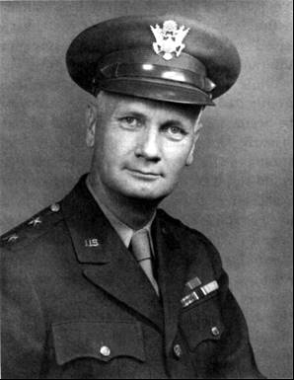

Likewise, the United States government believed in 1945 that Japanese business was "more highly concentrated" than "any industrialized nation." These combines had "participated in fomenting and shaping the Japanese program of sustained totalitarian aggression and on the economic side have been the principal beneficiaries of this program." Thus, government officials believed such organizations had to be dissolved, Japan's war potential eliminated, and cartel-like and monopolistic practices prohibited. During the post-war occupation of Japan by American military personnel, measures were taken to restrict Japan's war potential by the "dissolution of the Zaibatsu [a Japanese term referring to industrial and financial business conglomerates in the Empire of Japan], elimination of the control associations, segregation of industry and banking, reorganization of the so-called national policy companies and restrictions on the use of subsidies." Ultimately, General Douglas MacArthur called for the abolition of domestic and international cartels in Japan and their prohibition was included in the Japanese Antimonopoly Law of 1947. Despite this effort, cartels and combines were not completely eliminated after World War II, but James S. Martin wrote Kilgore that his committee's efforts had at least "made the attempt possible."

The notoriety, which resulted from the committee's work in exposing cartel and questionable business relationships involving Japanese and German companies, thrust Kilgore into the national spotlight and helped him demonstrate his effectiveness as a wartime senator to West Virginia voters. When Kilgore came up for re-election in 1946, his staff put together a "Speaker's Handbook" to be utilized in his campaign. Entitled "The Record of Harley Kilgore," the work placed a heavy emphasis on the accomplishments of the Kilgore Committee.

# Conquest for Oil

Japan’s Need for Aviation Gasoline

The Netherlands East Indies were to be the major suppliers of aviation gasoline in the region[6] and by May 1940 at least three new alkylation plants were planned. The blend was to be 40% alkylate (iso-octane), 50% base stock of straight run gasoline and 10% isopentane, and then doped with tetra ethyl lead. The consumption of aviation gasoline by the Japanese in 1937 was 835,000 Bbls (132 million litres); however, by 1939 it had risen to 2,148,000 Bbls (341 million litres). Up to this time all of Japan’s needs had been dependent on imports from the United States; Japan had a number of refineries which produced aviation gasoline from imported crude oil, but not enough to be self-sufficient. Japan had been able to manufacture base stock gasoline from California crudes, but the trade embargo cut that supply and alternate crude sources were required. Crude oil from Japanese fields accounted for only 11% of the nation’s needs, and while some of Japan’s naphthenic crude could yield a base gasoline of 75-76 octane, which with the addition of 3.7 cc TEL/USG could be raised to 92-94 octane.

In July 1940, the United States placed an embargo on the export of oil and scrap metal without a special license and of all aviation gasoline to Japan. When Japanese forces moved into northern French Indochina (Vietnam/Laos) in September, the United States reacted with an embargo on scrap iron and steel, and when they also moved into southern Indochina, in July 1941, all Japanese assets in the United States were frozen. Similar action by Great Britain and the Netherlands affected shipments of oil from the East Indies. This created such a critical situation for Japan that its cabinet decided that, unless the United States made concessions, the oilfields to the south would be seized by military operations.

Significance of Japan's first landings in Borneo.[7] 1941

The advances of the Imperial Japanese forces prior to 1941 were closely watched by those countries that were yet to be embroiled in the Second World War. The US was keenly interested in these activities as demonstrated in a report by the U.S. Dept. of State – Office of Intelligence Branch, US Office of Coordinator of Information – Research & Analysis Branch Far Eastern Section. Subject – Significance of Japan’s first landing in Borneo.

Japan’s peacetime consumption of oil was 35 million barrels. Production both in natural and synthetic from all sources probably did not exceed 1/5 of demand before US freezing order last July (1940). Reserves are estimated at 70 million barrels. Occupation of Miri field in Sarawak (Borneo) and Seria field in Brunei is the first step in general plan for more oil.

Sarawak – single refinery lies between two oil fields at Lutong.

Miri field comprises some 600 wells (older field).

Seria field developed since 1927 and has about 100 wells

Total Production Sarawak and Brunei is about 7 million barrels per annum, and that of entire Borneo is only 20 million barrels/year.

In recent years (circa 1940), NEI (Netherlands East Indies) annual production was 50 million barrels/year and that of Burma and British India 10 million barrels/year.

# Oil Fields, Refineries and Storage Centres Under Imperial Japanese Army Control[8]

This item only covers the East Indies oil resources and does not include oil resources in other captured territories such as Formosa (Taiwan) and Korea.

In an article by Bob Hackett, he describes the conquest and exploitation of the East Indies oil resources and the subsequent attacks by US bombers and British and US Naval forces as follows.

During World War II, the Japanese Army controlled the former Royal Dutch Shell oil refineries in Sumatra including Pangkalan Brandan and Pladjoe (Pladju) and Standard-Vacuum Oil Company's (Stanvac) refinery at Sungei (Soengai) Gerong.

The oil refined at the small Pangkalan Brandan refinery in northern Sumatra was transported to port facilities at nearby Pangkalan Susu and from there directly to Singapore, Malaya and other locations in the region.

Figure 4. Map Showing Palembang, Medan, Bangka in Sumatra and nearby Malaya (Malaysia)

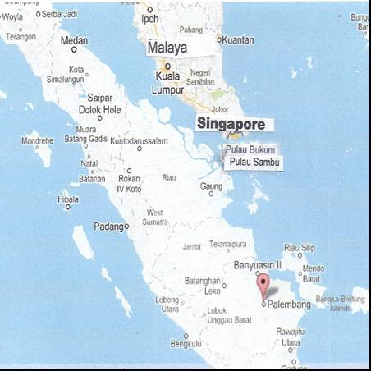

The center of oil production was at Prabumulih, 43 miles from Palembang in southern Sumatra, now the second-largest city in Sumatra, after Medan. Crude was transported via pipelines to the large Pladjoe refinery, a few miles north of Palembang. In February 1942, the Japanese 2nd Parachute Regiment captured Pladjoe intact. The Japanese later named Pladjoe the "No. 1 Refinery" and was managed by Nihon Sekiyu. It was capable of refining 45, 000 barrels a day and its speciality was high octane aviation gasoline production.

Pre-war, Stanvac, a joint venture between Standard Oil New Jersey (Esso) and Socony-Vacuum (Mobil), also operated several oil fields and transported its crude to its Sungei Gerong refinery, east of Palembang city. captured Pladjoe intact. After the Japanese captured Sungei Gerong they named it the "No. 2 Refinery". It was also capable of refining 45, 000 barrels a day and was managed by Mitsubishi Sekiyu. Together, these two refineries - the largest in Southeast Asia - had a reported annual capacity of 20,460,000 barrels of crude and were capable of producing 78 per cent of Japan's aviation gasoline and 22 per cent of its fuel oil.

The Japanese Army used mostly smaller captured British and Dutch tankers to transport fuel across the Musi (Moesi) River. The Musi joins the Ogan and Komering rivers near Palembang. Below Palembang, the Musi is deep enough for ocean-going vessels and about 50 miles north it enters the Bangka Strait.

Japan’s wartime demands for fuel were so great that almost daily trips were needed to transport the oil from Sumatra to Singapore for shipment to Empire and other distant destinations. Fuel also was transported either in bulk or by case (tins) to the smaller more remote locations in and around Malaya and the former Dutch East Indies.

Asiatic Petroleum, a subsidiary of Royal Dutch Shell Oil, formerly owned storage centers at Pulau Bukum and Pulau Sebarok near Singapore. Refined product was brought from Sumatra and stored in these captured storage centers near Singapore. Round trips from Palembang to Singapore and back, including loading and discharging fuel, averaged about one week, but many trips took longer, indicating possible loading and unloading difficulties and/or ships' engine troubles and perhaps groundings

# The Origins of the Imperial Japanese Navy Air Force[9]

The Japanese military carefully and methodically followed military and technical developments in other countries from the Meiji Restoration in 1868 on. Therefore, it isn't especially surprising that the airplane was investigated as a potential weapon by the Japanese military at a very early stage in its development. In 1910, a Japanese national acquired a primitive airplane, a type similar to that designed and flown by the French aviator Henri Farman. This machine was flown in Japan and the design was put into limited production at the Tokugawa Balloon Factory in 1911, this being the first Japanese aircraft production of any type.

During World War One, Japan joined the conflict on the British side and also acquired examples of several wartime allied aircraft types, including some French Nieuport fighters and Salmson 2A-2 bombers.

Photo 8. Nakajima Ko-2 Trainer (1916) was a Japanese produced version of the Nieuport 83 E.2, a variant of the Nieuport 10.

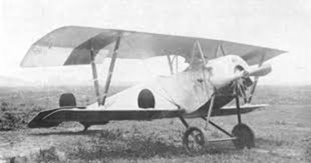

Photo 9. Otsu-1 Japanese version of Salmson 2A-2 [10]

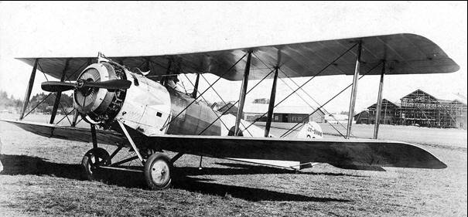

Notes: Post-war, Salmson 2s Japan undertook license production as the "Army Type Otsu 1", also known as the Kawasaki-Salmson. The number of aircraft built in Japan is unclear: 300 were built by Kawasaki, and the same quantity by the Imperial Japanese Army's Tokorozawa supply depot, although the total number of aircraft produced may have been as high as 1,000.

During the 1920s, as a consequence of its military treaty with Great Britain, Japan received a naval aviation delegation from the Royal Navy. The British delegates made recommendations for the establishment of a well-organized Imperial Japanese Navy Air Force and even helped to train some of its officers. The Imperial Japanese Navy Air Force was very conservative and, consequently, many of their operating practices and tactics in World War Two were those which they had adopted from the Royal Navy twenty years before. But while these had changed in Britain over that period, they did not change in Japan.

A typical example was the widespread use of floatplanes and flying boats. During the First World War and '20s, the Royal Navy made extensive use of such aircraft and found them to be very useful. If no water-based aircraft could then exceed 100 mph, then at that time, few multi-engined, land-based aircraft could exceed 100 mph either. But this situation radically changed over the next few years. The Short Sunderland notwithstanding, the British had found that, with the escalation of aircraft speeds in the '30s, the floatplanes and flying boats became too slow to be worthwhile. If the maximum speeds of water-based aircraft had reached 200 mph, then those of the land-based types had soared to over 300 mph. Prototypes of the British Spitfire were flown with floats but it is significant that they were never operational. By contrast, the Japanese relied on a substantial number of floatplanes and flying boats, including two floatplane fighter types comparable to a Spitfire on floats, the Kawanishi N1K1 (Kyofu "Mighty Wind") and the Nakajima A6M2-N[essentially a Mitsubishi A6M2 ‘Zero’ on floats]. The British had changed with the times, but the IJN hadn't.

Photo 10. Kawanishi N1K1 (Kyofu "Mighty Wind") designated as ‘Rex’

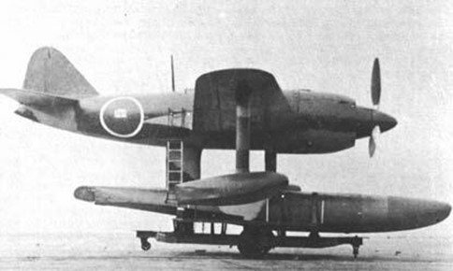

Photo 11. Nakajima A6M2-N designated as ‘Rufe” (the float plane version of the famous ‘Zero’ A6M2)

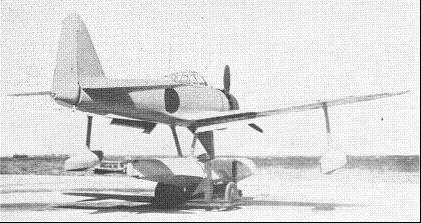

With the debut of the first Japanese aircraft carrier in the 1920s, the Imperial Japanese Navy Air Force (IJNAF) was initially tied to the battleships as some sort of reconnaissance and attack element, but like the US Navy, the IJN had real difficulty integrating them into their tactics. At that time a person in either country who alleged that future fleets would instead be built around the aircraft carrier, with the battleships simply providing anti-aircraft cover and mobile artillery against land targets, would have been immediately dismissed as a crank in any country.

During the '20s, there was a second foreign aviation delegation, which arrived in Japan. This one came from Germany and they trained the fledgling Imperial Japanese Army Air Force. Like the German Air Force in World War One, the IJAAF was closely tied to the Army and its movements, performing those operations which would later be called interdiction and close support in the United States. Like the IJNAF, the IJAAF revised these tactics during the Second World War, but in 1940 the Luftwaffe was beginning to find its own role independent of the German Army and its immediate needs. For all practical purposes, the IJAAF never did so.

At this time (say, the late '20s), it is remarkable to note that at least two major elements of Japanese aviation, as it stood in the Pacific War, were not in place. There was no element capable of conducting long range operations inside enemy airspace, nor was there any explicit arrangement for protecting air bases and air strips themselves from aerial attack. In addition, the IJAAF and the IJNAF had different--and even incompatible--sets of tactics and operating practices.

Changes in the IJNAF in the '30s, the China Incident

Up until the early 1930s, the two Japanese air services, the IJAAF and the IJNAF, were mainly equipped with obsolescent foreign aircraft types either imported or built in Japan under manufacturing licenses. At about this time, Japanese aircraft designers began to produce home-designed aircraft types that were better adapted to their own operational requirements, and they were by no means primitive given world standards at the time. Because of the distances involved and the general secretiveness of the Japanese government and society, this important change was not recognized in the West, and not fully appreciated by the Americans, even at the start of the Pacific War in 1941.

In fact, when the United States was on the verge of war against Japan in 1941, it was assumed that the air services of Japan would be, at most, a few hundred aircraft, mainly copies of older British, German, Italian and American designs. This was not simply an example of racist thinking. The widely respected Jane's All the World's Aircraft for 1941 showed current Japanese types as being a flea market of older, foreign designs with a few obsolescent indigenous designs on the side. There seemed no reason to suppose that the Japanese would make particularly good pilots. Consequently, it must have seemed to American airmen and aviators, whether they were in the USAAF or the US Navy, as if the force facing them would be comparable to, say, the Polish Air Force in 1939. On the basis of numbers, equipment and pilot quality, American airmen and naval aviators expected that the result of combat would be a series of one-sided American massacres. And that expectation was more or less reasonable in terms of the picture, which they had. But that picture was very wrong.

Before 1937, China and Japan had fought in small, localized engagements in the so-called "incidents," as the two sides for a variety of reasons, refrained from fighting a total war. The 1931 invasion of Manchuria by Japan is known as the "Mukden Incident". The last of these incidents was the ‘Marco Polo Bridge Incident’ of 1937, marking the official beginning of full-scale war between the two countries.

In 1937, Japan began a campaign to conquer China and, in fact, rather quickly overran its then capital city of Nanking, the coastal provinces and many of its larger inland river valleys. When the war in China began, the IJNAF found itself with new tasks. With long-ranging Type 96 Land-Based Attack Bombers (Mitsubishi G3Ms, later code-named ‘Nells’) the IJNAF bombed targets in the Nanking area from bases on Taiwan, then a Japanese possession. (Note: Just before these flights, the ‘Nells’ were retrofitted with the autopilots imported from the US. They were not fitted to any operational American military aircraft at that time presumably because they were either too new or too expensive). To support both Army and Navy operations in China, fighter aircraft of the Imperial Japanese Navy were also assigned to land bases on the Chinese mainland. The ‘Nells’ followed a little later on.

Photo 12. Mitsubishi G3M ‘Nell”[11]

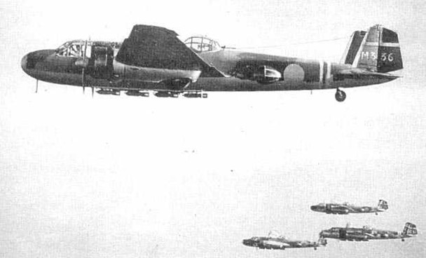

As the ‘senior service’, the IJN was able to have a remarkable spread of duties assigned to it along with, hopefully, the assets (planes, factories, personnel, etc.) necessary to perform them. Since they had long-ranging twin-engined bombers and the best fighters, the IJNAF was assigned to bomb targets on land with its own land-based bombers and to protect all Japanese air bases, both those of the Army and its own, from enemy planes. In addition, the Imperial Japanese Navy had primary responsibility for the defence of the Home Islands. During the “China Incident” this imposing spread of duties, while it might have created some problems, seemed to be a source of strength for the IJNAF.

Perhaps their most stunning success was the surprise attack on the US naval base at Pearl Harbour by carrier-based aircraft on December 7, 1941. The Americans would call this ‘the day of infamy’. The lessons from Billy Mitchell’s aerial bombing trials in 1923, and the British Navy torpedo bomber attack on the Italian Navy at Taranto in 1940 were to be developed into an extraordinarily audacious plan designed to cripple the US Navy in the Pacific, and allow the Imperial Japanese Navy and land forces to pursue their quest for resources.

Photo 13. Japanese aircraft take off for the attack on the US naval base at Pearl Harbour December 7, 1941

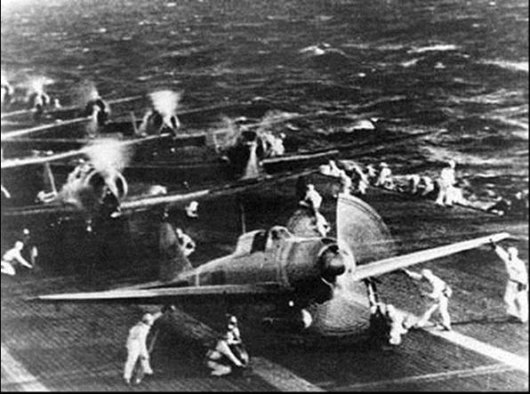

Japanese naval aircraft prepare to take off from an aircraft carrier (reportedly Shokaku) to attack Pearl Harbor during the morning of 7 December 1941. Plane in the foreground is a Mitsubishi A6M Zero. This is probably the launch of the second attack wave.

From the middle of the Pacific War, on the other hand, this extraordinary spread of duties impacted the IJNAF very severely. The central problem was that while the responsibilities had been assigned to it years before, the needed assets simply were not available.

It shouldn't be assumed that the IJAAF was doing very well, either. It had fewer responsibilities, but it also had fewer assets than the IJNAF. In addition, the IJAAF had been assigned, without Navy support of any type, to face the enemy air forces in China, India and Burma. By contrast, the IJNAF had responsibility for almost all of the rest of the war, including the defence of the Japanese Home Islands. A high level meeting to resolve these discrepancies and to make the most of the assets, which each service really had, would have been a reasonable response to the situation. But this never happened.

Even as the Japanese Empire staggered toward total collapse a couple of years later, the preponderance of duties and assets still went to the IJNAF. During the last few months of the Pacific War, the remaining units of the IJAAF outside of the Home Islands were mainly isolated and impotent, their planes parked near their runways or airstrips without any prospect for deliveries of aviation gasoline, spare parts or ammunition. By that time, the planes of the IJAAF in the Home Islands were also parked near their respective runways as well, being saved along with stocks of aviation gasoline for the anticipated Allied invasion of Kyushu.

Photo 14. Rabaul New Guinea 1943 IJNAF carrier based Mitsubishi A6M3 Zeros from the Japanese aircraft carrier Zuikaku preparing for a mission on Guadalcanal. Note the belly fuel tanks

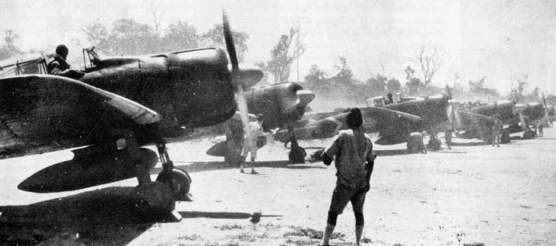

Photo 15. The classic Japanese Mitsubishi A6M5 Type 0 Model 52 ‘Zero’ (RAF Hendon 2008)

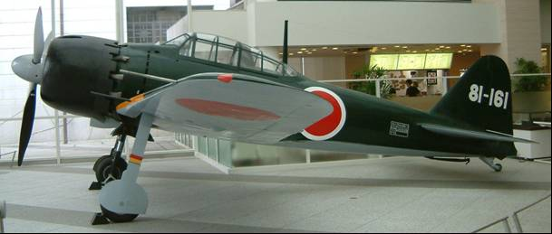

Photo 16. Kawanishi H8K ‘Emily’ Flying Boat (note the similarity to the British Sunderland flying boat) circa 1941

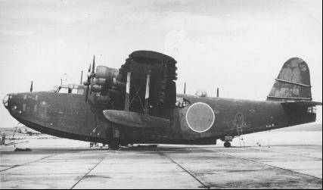

Photo 17. Early production Mitsubishi G4M1s (“Betty”) with the original shape tail cones circa 1942

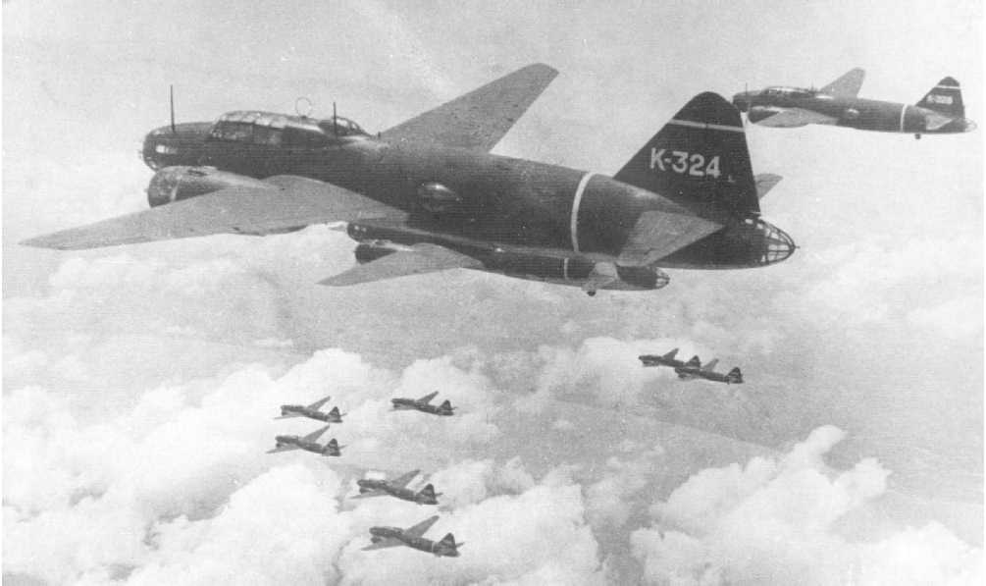

In 1944 as the American forces advanced toward the main Japanese Home Islands, the IJNAF and IJAAF tactics became increasingly desperate, and the Kamikaze “Divine Wind’ suicide attacks began against US Navy aircraft carriers and other warships. These suicide attacks consisted of crashing their aircraft into the largest vessels. Special rocket powered suicide bomb aircraft were also launched from bomber aircraft

Photo 18. Mitsubishi G4M2e Model 24J (‘Betty’) bombers launching suicide bomb Yokosuka MXY-7 Ohka "Baka"

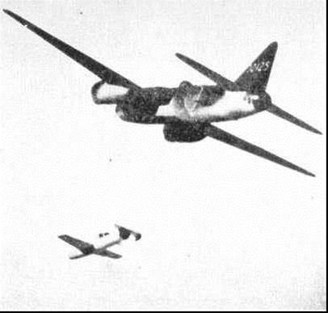

Photo 19. Yokosuka MXY-7 Ohka "Baka" (RAF Cosford Museum UK 2000)

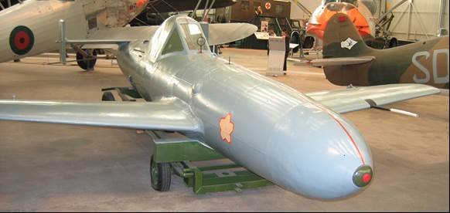

Photo. 20. Byoritsu Oil Refinery Formosa under ait attack from American B-25 bombers

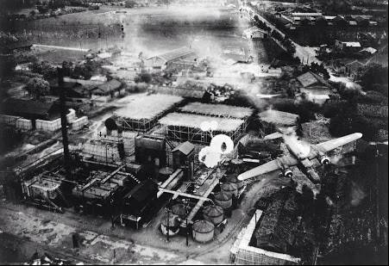

Spectacular crash at Byoritsu Oil Refinery, Formosa, was photographed by a B-25 of the 5th Air Force's 345th Bomb Group on 26 May 1945. Just as it released its string of parafrags B-25 No. 192 was hit by flak from a camouflaged battery and trails smoke. A gaping hole is visible on the pilot’s side. The aircraft visible is the North American B-25J-10-NC Mitchell (s/n 43-36192) "Jaunty Jo". Crew: 2/Lt Robert J. Knauf Pilot, 2/Lt Martin H. Mulner Jr. Co-Pilot, 1/Lt Lloyd E. Bodell Navigator, Cpl Harold O. Montville Eng/Gunner, Sgt Tennyson C. Harrell Radio/Gunner.

Photo 21. The aftermath of war – Japanese Zeros unable to fly due to lack of aviation gasoline

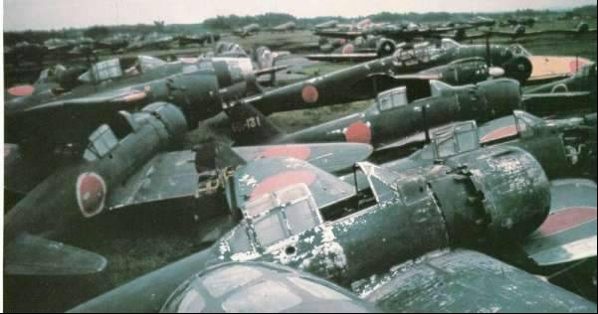

Captured Mitsubishi A6M5 Model 52, abandoned by the Japanese towards the end of WWII. Aircraft in flying condition were shipped on board of light aircraft carriers to the US (NAS ‘Anacosta’) and tested by US Navy personnel of the TAIC (Technical Air Intelligence Center).

# Japanese Oil Refineries 1936

N.N.C. Type Cracking in Japan

A cracking unit devised by engineers on the Japan Oil Co., which has been on operation in the Tsurumi Refinery since May 1935 is described. Daily capacity 1500 BSD yielding 45% gasoline under pressure 400 psi. Heavy oil for cracking is heated in a cracking furnace and is led to a reaction furnace at a pressure of 500 psi. (More detail in source) The gasoline requires little treatment. The process is only used by Japan Oil Co, other companies using various American processes. A list of 77 Japanese refineries and gasoline plants is given, showing location and name of operating company.*[12]*

Much information can be gleaned from this brief abstract. Firstly, that by May 1935 engineers from the Japan Oil Company had developed a cracking unit which produced a significant yield of gasoline; secondly the American refining process technology was in operation (and probably technology of other western countries). Finally, that there was considerable activity regarding production and distribution of gasoline with some 77 refineries and gasoline plants. It should not be forgotten that Japan was already at war with China, and occupied in Manchuria.

# Oil Companies and Refineries

The demand for petroleum products (and crude oil) had led Japan to war and as mentioned before there were some 77 refineries and gasoline plants. With no natural resources such as crude oil, the Japanese refineries depended on the captured oil fields of the East Indies. Information on the captured fields and refineries is presented in a separate chapter on the East Indies & Borneo.

There was some interesting information gleaned from intelligence reports of interrogation of Japanese military personnel and technologists. Again, obtained as part of U.S. Bombing Surveys.[13]

Japanese Navy Refineries

The following information was obtained from the interrogation of Rear Admiral Enomoto Ryuichiro on 29 October 1945. (This is possibly Vice Admiral Takaichiro Enomoto, Engineer 24th[14] - a graduate of (Imperial Japanese Naval) Naval Engineer Academy 24th class). There were four Navy refineries in Japan (1945), and two other captured refineries. Balikpapan, Tarakan (and Sangan).

Table 5. Japanese Navy Refineries located in Japan 1945

|  |  |  |
| --- | --- | --- |
| No. | Refinery | Comment |
| 1 | Ofuna Oil Refinery | experimental |
| 2 | Yokkaichi Oil Refinery |  |
| 3 | Tokuyana Oil Refinery |  |
| 4 | Fukuoka | Coal under construction |
| 5 | Heijo | Coal |
| 6 | Taiwan Oil Refinery | under construction |
| 7 | Unknown | under construction |

The first air raid by the Allies on Balikpapan was August 1943, but this had no effect until the raids in August 1944.

Japanese avgas was shipped in tankers. April 1945 Japanese Avgas stocks were 86,000 K. Litres.

# Japanese Gasoline Composition 1941-43

Captured documented identified publications referred to “Printed pamphlet on 87 Mixed Fuel Aviation Alcohol, Aviation motor benzol, and aviation cracked gasoline, issued by Japanese Army Air Headquarters dated 22 May 1942. There was information on printed pamphlets giving specifications for aviation gasoline, ethyl, gum formation preventative; urea plastic adhesive etc. issued by (Japanese) Army Air Headquarters dated 8 May to 28 August 1943.

“Army Air specifications for the following:

85 Aviation gasoline

90 Aviation gasoline

91 Aviation gasoline

Aviation Ethyl Fluid

Gum Formation Preventative

Aviation Lubricating Mineral Oil

Grade 1 Methanol Tube

The following table is a list of compounds used in blending aviation gasoline giving uses, abbreviations and symbols used to designate these compounds extracted from a printed book entitled. “Established Regulations on Handling Ship’s Stores and Fuels” 7th. Edition dated Nov 1940 (2nd Revision 1942) issued by the Navy Ministry, Bureau of Munitions.[15]

Table 6. Compounds used in Blending Aviation Gasoline (Japanese 1942).

|  |  |  |  |
| --- | --- | --- | --- |
| Detailed Classification | Abbreviation | Code | Usage Classification |
| Aviation base gasoline | KÜ Gen KI (TN the characters indicate “raw material” and “gasoline” respectively | G3 | Base for Aviation 92 Gasoline |
| Aviation 87 base gasoline | KÜ 87 Gen Ki | G 87 B | Base for Aviation 87 Gasoline and below |
| Alcohol | Alcohol | A | Mixed with various grade of gasoline base for light mixing materials. |
| Ethyl Fluid | Ethyl | Ef | Mixed with aviation gasoline |
|  | Octane | o | “ |
| Isopropyl ethyl | Ethpro | Ep | “ |
| Mark 1 Benzol | 1 Ben | Be | “ |
| Mark 2 Benzol | 2 Ben | Bea | “ |
| Aviation Straight Run (or Cracked) Mark 6A Gasoline | CHOKU (BUN) 6 (TN CHOKU for “straight run” and BUN “cracked”). | A6(R6) | Base for Aviation 70 Gasoline |
| Acetone | Acetone | Ac | Base for light materials |
| Butanol | Butanol | Bn | “ |
| Neohexane | Hexane | H | Mixed with aviation gasoline |
| Bromine | Brom | Br | Base for light mixing materials |

# Avgas Specifications & Test Methods 1942

Japanese Aviation Gasoline Specification

The Japanese always followed and adopted the US and European technical advances, and similarly with their aviation gasoline specification, which was based on the British Avgas 87 from the early 1930’s, and that of the German wartime specification. Due to Imperial Japan’s aggression in the 1930’s the U.S. and British aviation technical transfer was halted, and Japan then looked to Germany for aviation technical advances.

Table 7. Japanese Aviation Gasoline Specification 1942.

|  |  |
| --- | --- |
| Distillation | |
| Initial Boiling Point (deg. C) Max. | 60 |
| Temp 10%. (deg. C) Max. | 80 |
| Temp 50% Rec. (deg. C) Max | 105 |
| Temp 90% Rec. (deg. C) Max. | 150 |
| Temp 97% Rec. (deg. C) Max. | 170 |
| Sum of 10%+50%+90% Rec. (deg. C) Minimum | 260 |
| Recovered Minimum | 97% |
| Specific Gravity | 0.73 |
| Reid Vapour Pressure @38 deg. C psi Max  Atmospheres (Max) | 8.82  0.6 |
| Freezing Point (deg. C) Max | -50 |
| Existent Gum (mg/100 ml) Max. (Note 1) | 5 |
| Octane Rating, CFR Motor Method (unleaded) (Note 2.) | 70-72 |
| Octane Rating, CFR Motor Method (1% Vol Lead) (Note 3.) | 88-90 |
| Sulphur (wt.%) Max. | 0.1 |

Notes: The source document listed *Gum Max. mg/1,000 cc,* (Author’s note: this is thought to be a misprint and it has been corrected to mg/100cc.).

This appears to be similar to Australian Avgas Unleaded of 73 Octane.

The source document listed the Octane Rating at 1% volume Lead, however this is thought to be a misprint and it is probably 0.1% Vol. Lead, which equates to 4.56 cc TEL/Imp Gal or 3.8 cc/USG which was typical of Australian stocks of 87 in 1940 then later 1943, 91 Octane.

Comments: The Japanese aviation gasoline was:

Lighter (density 0.73 versus 0.79 for US/British)

Higher vapour pressure (8.8 psi versus 7.0 Max for US/British)

Lower distillation (Final boiling point 170 deg. C compared to 180 deg. C for US/British)

Freezing point higher (-50 deg. C compared to -60 deg. C for US/British)

Generally, this would mean that Japanese aircraft could not fly as high as US or British aircraft due to vapour lock, fuel icing, although with lighter fuel pay load, however this fuel was essentially used in the tropics and would not have to meet the requirements needed for a European winter.

It would appear that while initially the Japanese military were interested in producing 100-Octane Aviation Gasoline, that in fact it was not produced. This may be because the Japanese aircraft designs and their successes in early stages of the war did not require a higher grade of aviation gasoline, and towards the end of the war any supply of aviation gasoline (any grade) was critical.

# Japanese Army Aviation Gasoline 1943[16]

Captured documents and interrogation of prisoners of war are sources of intelligence, and during the War in the Pacific in May 1944 at Hollandia, the Allied Translator and Interpreter Section South West Pacific obtained a such information and translated the documents. They produced a document Enemy Publications No. 178 Date 9 Sept 44 titled “Specifications for Aviation Gasoline, Aviation Ethyl, Aviation Lubricating Oil, Bulletproof Glass, Etc.” which detailed information from the Japanese Imperial Army Air HQ, Dated 8 May to 28 Aug 43.

The following is an extract of that document relating to Japanese Army aviation gasolines.

## Air General Order No. 6535

Memorandum to the (Japanese) forces concerned on the establishment of the Army Aircraft (TN Not limited to air-planes). Material Specification for Aviation 85 Gasoline and 90 Gasoline. 10 May 43 Army Air HQ. This is to notify that the specifications for the items have been established as given in the separate copies by Air Specification Authorization No. 239, 8 May 43.

Army Aircraft Material Specification

Army Air Specification No. 13 Code No. 16-141-143 Established 8 May 43

Air Specification Authorization No. 239 Army Air HQ

## 85 Aviation Gasoline

### CHAPTER I APPLICATION AND CLASSIFICATION

Article 1. - This specification applies to 85 Aviation Gasoline (referred to hereafter simply as 85 Gasoline) which is use as fuel for airplane engines.

Article 2. - The classification and code numbers of 85 Gasoline fixed by this specification according to their base gasoline are as given in Table No. 1 (our table No. 8). The years shown in parentheses are the standard permissible limit of storage from the date of manufacture to the date of use.

Table No. 8. Classification Code Nos. for Japanese 85 Aviation Gasolines

|  |  |
| --- | --- |
| Classification | Code No. |
| 85 Aviation Gasoline A (3 yrs) | 16-141 |
| 85 Aviation Gasoline B (2 yrs) | 16-142 |
| 85 Aviation Gasoline C (2 yrs) | 1-143 |

However, fuel which has exceeded the permissible limit may be used if it passes the test prescribed in this specification.

Article 3. - The directly distilled gasoline referred to in this specification is obtained by direct distillation of natural petroleum or from synthetic petroleum (regardless of starting material). It is a hydrocarbon (mixture with 1% of less sulphuric acid absorption, octane value of 65 or above and an aromatic hydrocarbon content of 20% or less.

Article 4. - The catalytically cracked gasoline referred to in this specification is a hydrocarbon (mixture) obtained by the catalytic cracking of natural and synthetic petroleum (regardless of starting material). It has a sulphuric acid absorption of 10% or less and an aromatic hydrocarbon content of 30% or above.

Article 5. - The heat-cracked gasoline [thermally cracked gasoline] referred to in this specification is a hydrocarbon (mixture) obtained by the heat cracking of petroleum and is specifically refined for airplane use. Its sulphur content is 0.05% or less by weight.

### CHAPTER II PROCESSING

Article 6. - Base Gasoline

The base gasoline of 85 Gasoline A consists mainly of directly distilled gasoline. It may contain up to 50% of catalytically cracked gasoline.

The base gasoline of 85 Gasoline B consists mainly of catalytically cracked gasoline. It may contain direct distilled gasoline [straight run gasoline].

The base gasoline of 85 Gasoline C is a mixture of equal parts of heat-cracked gasoline and directly distilled gasoline. The proportion of direct distilled gasoline may be increased.

It is necessary to add 0.01% by volume of aviation gum formation preventative (Army Air Specification No. 17) to both catalytically cracked gasoline and heat-cracked gasoline.

Article 7. - The octane value of 85 Gasoline is adjusted by adding aviation ethyl fluid (Army Air Specification No. 15) to the base gasoline specified in the above articles. The limit of the amount of Aviation Ethyl added will be 0.19% by volume.

Article 8. - 85 Gasoline is blue and transparent and must not contain any water or sediment.

### CHAPTER III TESTS

Article 9. - Octane Value Test - Octane Value testing will be according to the Test Method, Air Specification No. 280 Supplement. This value must be 85 or higher (system of dropping 4 and 5 after decimal point will not be recognised).

Article 10. - Reaction Test - The reaction test will be made according to JAPAN Standard Specification (JES No. 174). The reaction test must be neutral.

Article 11. - Fractional Distillation Test - The fractional distillation test will be made according to the JAPAN Standard Specification (JES No. 174) and must meet the specifications of Table No. 2. (our Table No. 9).

Table No. 9. JAPAN Standard Specification (JES No. 174)

|  |  |
| --- | --- |
| Initial fractionating temperature | Below 60ºC |
| 10% fractionating temperature | Below 80ºC |
| 50% fractionating temperature | Below 85º-110ºC |
| 90% fractionating temperature | Below 150ºC |
| 97% fractionating temperature | Below 170ºC |
| Sum of centigrade temperatures for distillation of 10, 50, 90% fractions | Above 260ºC |

Article 12. - Vapour Pressure Test - The vapour pressure test will be made according to the Test Method, Air Specification No. 280 Supplement. The vapour pressure must not exceed 0.6 kg per cm2

Article 13. - Sulfur Fraction Test - The sulfur fraction will be determined by the RAMPU type test given in the JAPAN Standard Specification (JES No. 174) and must not exceed 0.05% by weight.

Article 14. - Sulfuric Acid Absorption Test - The sulfuric acid absorption test will be made according to the Test Method Air Specification No. 280, Supplement. The results must meet the specifications on table No. 3. (our Table 10.)

Table No. 10. Sulfuric Acid Absorption Test for Japanese 85 Aviation Gasoline

|  |  |
| --- | --- |
| Classification | Sulfuric Acid absorption Quantity |
| 85 Aviation Gasoline A (3 yrs) | 3% or less |
| 85 Aviation Gasoline B (2 yrs) | 5% or less |
| 85 Aviation Gasoline C (2 yrs) | 5% or less |

Article 15. - Gum Content Test - The test for amount of gum present will be made according to the test method in the supplement. The results must not exceed 6 mg per 100 cc.

Article 16. - Cooling Test - The cooling test will be made according to the JAPAN Standards Specification (JES No. 174) Solidification Point Test Method. When the test sample is cooled to -50 ºC there must not be any changes such as precipitation or separation.

Article 17. – Sampling - Material for sampling will be divided according to their container into groups, each group consisting of the number of containers or a fraction thereof stated in Table No. 4. (our Table No. 11). One container will be selected at random from each group and 1500 cc of sample taken from it. This will represent the material in the group.

Table No. 11. Material for sampling - selection of one container from each group

|  |  |
| --- | --- |
| Type of Container | Group |
| 200 Litre Drums | 1000 |
| 18 Litre Tin Cans | 5000 |

The method of taking a sample will be according to JAPAN Standards Specification (JES No. 174).

### CHAPTER IV INSPECTION

Article 18. - Inspection will normally consist of the appearance, octane value, reaction, fractional distillation, vapour pressure, sulphur content, sulphuric acid absorption, gum content and cooling test.

Article 19. - If the test results do not meet this specification either in part or in whole, the entire 85 Gasoline which it represents is to be considered as not meeting the specification.

Article 20. - 85 Gasoline which meets this specification will be put into the specified containers and marked as shown in the attached sketches. The name of the processing plant or its mark will be shown in an appropriate manner.

Figure 5. Japanese Army Air Avgas 85 drum markings (Attached Sketch No. 1)

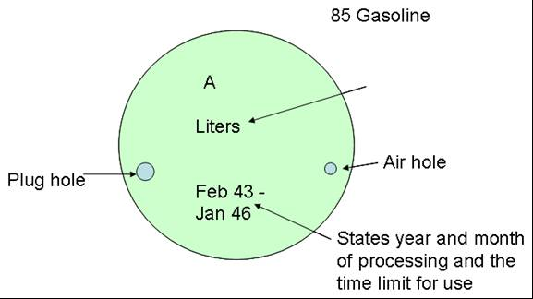

Figure 6. Japanese Army Air Avgas 85 tin can markings (Attached Sketch No. 2) on side of box (same on both sides)

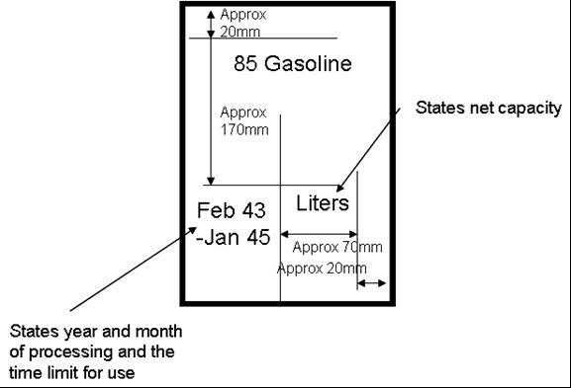

Notes

The size of the outline and lettering will be of appropriate size. The colour will normally be red.

Drums will be those prescribed in Air Specification No. 13 or any which is equivalent to this.

The name of item, month and year of processing, time limit for use and processing plant will be appropriately stated on the top of each tin can.

There were similar markings for the other grades Aviation Gasoline 90 and Aviation Gasoline 91.

### SUPPLEMENT

Gum Content Test Method

Gum content is the amounted gummy matter present in 100 cc of sample, and is expressed in milligrams. The average value of three trials will be taken in this test. The difference between the value obtained in each trail and the average value must not exceed 0.5 mg. The gum content testing set will be used in this test according to the following procedure. (see attached sketch) (our Figure 7.)

I - PREPARATION FOR TEST

1. Wash two 100 cc capacity hard glass beakers (for quantitative and tare use) in a mixture of equal parts of benzene and alcohol and soak in a chromic acid mixture for at least 12 hrs. The wash thoroughly with water and dry at 150ºC – after washing with chromic acid, and until the determination of gummy substances is completed both beakers must be handled with clean metal holders.

2. After drying, cool both beakers in a desiccator for at least one hour. Then weigh the quantitative beaker. In weighing the quantitative beaker place the tar beaker on the other pan.

3. After weighing the quantitative beaker place the tare beaker in the desiccator and place the quantitative beaker in its specified position in a constant temperature chamber as shown in the attached sketch. The constant temperature chamber should have been previously adjusted to take in 500 cc per second (+/- 5%) of heated air, at a temperature of 150ºC (+/- 1ºC).

II - DETERMINATION

1. Take 50 cc of the sample in a pipette and being careful not to touch the cone-shaped plug, place it in the quantitative beaker. Then while passing heated air through the chamber, adjust the resistor so as to prevent a drop in temperature and evaporate and dry the sample at 150ºC (+/- 3ºC).

2. After evaporating and drying the sample, continue sending the hot air for an additional 15 minutes. Heat the tare beaker in the same way at 150ºC for 15 minutes.

3. Place both beakers in a desiccator and cool for at least one hour. Then weigh the quantitative beaker as stated above and obtain in milligrams the increase in weight due to the residual gummy matter. (Round off to the first decimal place). Twice this figure will be taken as the gum content.

Figure 7. Gum Tester Apparatus

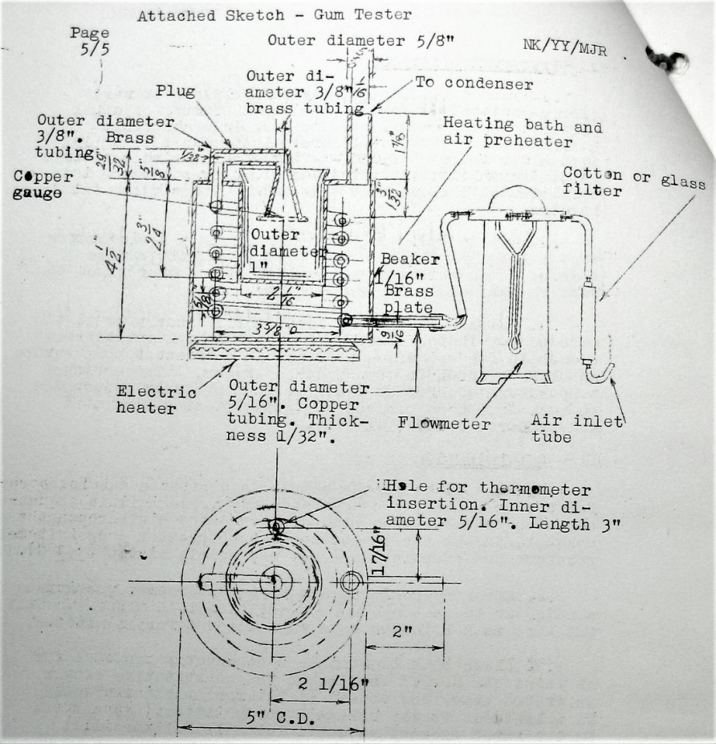

## 90 Aviation Gasoline

### CHAPTER I APPLICATION AND CLASSIFICATION

Article 1. - This specification applies to 90 Aviation Gasoline used as aviation fuel.

Article 2. - The classification and code numbers of 90 Gasoline fixed by this specification according to their base gasoline are as given in Table No. 1. (our Table No. 12). The number of years in the brackets indicates the standard permissible period of storage from the time of processing to the time of use.

Table No. 12. Classification Code Nos. for Japanese 90 Aviation Gasolines

|  |  |
| --- | --- |
| Classification | Code No. |
| 90 Aviation Gasoline A (3 yrs) | 16-144 |
| 90 Aviation Gasoline B (2 yrs) | 16-145 |

Material which has passed its permissible period but which upon testing meets this specification may still be used.

Article 3. - By directly distilled gasoline is meant the hydrocarbon mixture directly distilled from petroleum [straight run gasoline] or obtained from synthetic petroleum (regardless of starting material). with 1% of less of sulfuric acid absorption, an octane value of 65 or above and containing 20% or less of aromatic hydrocarbon.

Article 4. - By catalytically cracked gasoline is meant the hydrocarbon mixture obtained by catalytic cracking petroleum or synthetic petroleum (regardless of starting material) with 10% or less of sulphuric acid absorption and containing 30% or less of aromatic hydrocarbon content.

### CHAPTER II PROCESSING

Article 5. - Base Gasoline

The base gasoline of 90 Gasoline A has directly distilled gasoline [straight run gasoline] as its principal component and may contain catalytically cracked gasoline up to 50%.

The base gasoline of 90 Gasoline B has catalytically cracked gasoline as its principal component and may contain directly distilled gasoline.

Catalytically cracked gasoline must have 0.01% (by volume) of aviation gum formation preventative (Army Air Specification No. 17) added to it.

Article 6. - The octane value of 90 Gasoline will be adjusted by adding aviation ETHYL fluid (Army Air Specification No. 15) to the base gasoline specified in the preceding article. The maximum limit of aviation ETHYL to be added will be 0.19% by volume.

Article 7. - 90 Gasoline must be transparent blue and must not have any water or sediment in it.

### CHAPTER III TESTS

Article 8. - Octane Value Test - The octane value must be 90 of better (system of dropping 4 and 5 after decimal point will not be recognised).by the test method, Air Specification No. 280 Supplement.

Article 9. - Reaction Test - As given by JAPAN Standard Specification (JES No. 174). The reaction test must be neutral.

Article 10. - Fractional Distillation Test - As given by JAPAN Standard Specification (JES No. 174) and must meet the specifications of Table No. 2 (our Table No. 13).

Table No. 13. JAPAN Standard Specification (JES No. 174)

|  |  |
| --- | --- |
| Initial fractionating temperature | Below 60ºC |
| 10% fractionating temperature | Below 80ºC |
| 50% fractionating temperature | 90º-110ºC |
| 90% fractionating temperature | Below 150ºC |
| 97% fractionating temperature | Below 170ºC |
| Sum of centigrade temperatures for distillation of 10, 50, 90% fractions | Above 260ºC |

Article 11. - Vapour Pressure Test - As given by test method, Air Specification No. 280 Supplement. The vapour pressure must be 0.6 kg per cm2 or less.

Article 12. - Sulfur Fraction Test - As given by JAPAN Standard Specification (JES No. 174), RAMPU type. The sulphur fraction must be 0.05% (by weight) or less.

Article 13. - Sulfuric Acid Absorption Quantity Test - As given by test method Air Specification No. 280, Supplement. It must meet standards of Table No. 3 (our Table No. 14).

Table No. 14. Sulfuric Acid Absorption Test for Japanese 90 Aviation Gasoline

|  |  |
| --- | --- |
| Classification | Sulfuric Acid absorption Quantity |
| 90 Aviation Gasoline A | 3% or less |
| 90 Aviation Gasoline B | 5% or less |

Article 14. - Gum Content Test - As given by test method, Army Air Specification No. 13, supplement. The gum content must be 6 mg/100 cc or less.

Article 15. - Cooling Test - As given by Solidification Point Test Method, JAPAN Standards Specification (JES No. 174). No precipitation or separation should occur at -50 ºC.

Article 16. – Sampling - Depending on the type of container, a sample group consists of the number indicated in Table No. 4 (our Table No. 15) or a fraction thereof.

From each group arbitrarily select one container. A 1500 cc sample is drawn from this to represent the product in the group.

Table No. 15. Material for sampling - selection of one container from each group

|  |  |
| --- | --- |
| Type of Container | Group |
| 200 Litre Drums | 1000 |
| 18 Litre Tin Cans | 5000 |

The sample material will be taken according to JAPAN Standards Specification (JES No. 174).

### CHAPTER IV INSPECTION

Article 17. - The standard inspection will consist of the appearance, octane value, reaction, fractional distillation, vapour pressure, sulphur content, sulfuric acid absorption, gum content and cooling test.

Article 18. - When the test results of the sample material do not meet a part of any of this specification, the entire 90 Gasoline which it represents is to be considered as not meeting the specification.

Article 19. - The 90 Gasoline which meets this specification will be put into the specified containers and marked as shown in the attached sketches No.1 and No. 2. The name of the processing company or its trade mark will be appropriately shown.

Notes

The size of the outline and characters will be of suitable scale and usually done in red.

Drums prescribed in Special Air Specification No. 13 or one’s equivalent to this will be used.

The name of item, processing date, usable period, and the name of the processing company will be appropriately shown on the top of each tin can.

## AIR GENERAL ORDER No. 12819

Memorandum to the forces concerned on the establishment of the Army Aircraft Material Specification for Aviation 91 Gasoline. 25 Aug 43 Army Air HQ

This is to notify that the specification for the items have been established as given in the separate copies by Air Specifications Authorization No. 705, 24 Aug 43.

## ARMY AIRCRAFT MATERIAL SPECIFICATION

Army Air Specification No. 24 Code No. 16-091 A, 16-091 B Established 24 Aug 43. Air Specification Authorization No. 705 Army Air HQ

## 91 Aviation Gasoline

### CHAPTER I APPLICATION AND CLASSIFICATION

Article 1. - This specification applies to 91 Aviation Gasoline used as airplane engine fuel. It will be referred to simply as 91 Gasoline hereafter.

Article 2. - The classification, nature and code numbers of 91 Gasoline fixed by this specification are as given in Table No. 1. (our Table No. 16). The years in the brackets indicates the normal permissible period of storage from the time of processing to the time of use.

Table No. 16. Classification Code Nos. for Japanese 91 Aviation Gasolines

|  |  |
| --- | --- |
| Classification | Code No. |
| 91 Aviation Gasoline A (3 yrs) | 16-091 A |
| 91 Aviation Gasoline B (2 yrs) | 16-091 B |

However, even though the normal permissible storage period is exceeded, the fuel may be used if it passes test prescribed in this specification, and which are carried out by an inspector.

Article 3. - In this specification the direct distillation gasoline [straight run gasoline] referred to is a hydrocarbon mixture obtained by the direct distillation of petroleum or from synthetic petroleum (regardless of starting material) with less than 1% sulfuric acid absorption, octane value above 65 and an aromatic hydrocarbon content of less than 20%.

Article 4. - In this specification, the catalytically cracked gasoline referred to is a hydrocarbon mixture obtained by catalytic cracking of petroleum or synthetic petroleum (regardless of starting material) with less than 10% sulphuric acid absorption and an aromatic hydrocarbons content of less than 30%.

### CHAPTER II PROCESSING

Article 5. - Base Gasoline - The base gasoline of 91 Gasoline A has directly distilled gasoline [straight run gasoline] as its main component. It may contain up to 50% of catalytically cracked gasoline.

The main component of the base gasoline of 91 Gasoline B is catalytically cracked gasoline as its principal component and may contain directly distilled gasoline.

0.01% by volume of aviation gum formation preventative (Army Air Specification No. 17) is added to catalytically cracked gasoline.

Article 6. - In the 91 Gasoline aviation ETHYL fluid (Army Air Specification No. 15) is added to the base gasoline to adjust the octane value. The addition of aviation ETHYL is limited to 0.23% (by volume).

Article 7. - 91 Gasoline is clear blue. There should be no water or sediment in it. Approximately 0.003% of Blue 3G, manufactures by the Hodogaya Industrial Chemical Company Ltd. (Hodogaya Kagaku Kogyo Kabushiki Kaisha) or a similar colouring matter will be added.

### CHAPTER III TESTS

Article 8. - Octane Value Test - Test Method Air Specification No. 280, Supplement. The octane value must be 91 or higher. (The system of dropping 4 and 5 after decimal point will not be recognised).

Article 9. - Reaction Test - According to the JAPAN Standard Specification (JES No. 174). The reaction test must be neutral.

Article 10. - Fractional Distillation Test - According to the JAPAN Standard Specification (JES NO. 174). The fractional distillation result must meet the standards given in Table No. 2 (our Table No. 17).

Table No. 17. JAPAN Standard Specification (JES No. 174)

|  |  |
| --- | --- |
| Initial fractionating temperature | Below 60ºC |
| 10% fractionating temperature | Below 80ºC |
| 50% fractionating temperature | 90º-110ºC |
| 90% fractionating temperature | Below 150ºC |
| 97% fractionating temperature | Below 170ºC |
| Sum of centigrade temperatures for distillation of 10, 50, 90% fractions | Above 260ºC |

Article 11. - Vapour Pressure Test -According to the test method, Air Specification No. 280 Supplement. The vapour pressure must not exceed 0.6 kg per cm2.

Article 12. - Sulfur Fraction Test - According to the RAMPU type (*1) in JAPAN Standard Specification (JES No. 174). The sulphur fraction must not exceed 0.05% (by weight).

Article 13. - Sulfuric Acid Absorption Quantity Test - According to the test method Air Specification No. 280, supplement. The sulfuric acid absorption must meet standards of table No. 3 (our Table No.18).

Table No. 18. Sulfuric Acid Absorption Test for Japanese 91 Aviation Gasoline

|  |  |
| --- | --- |
| Classification | Sulfuric Acid absorption Quantity |
| 91 Aviation Gasoline A | Less than 3% |
| 91 Aviation Gasoline B | Less than 5% |

Article 14. - Gum Content Test - According to the test method, Army Air Specification No. 15, supplement. The gum content must not exceed 6 mg/100 cc [NT Comment other grades had Army Air Specification No. 13 as the test method].

Article 15. - Cooling Test - The cooling test is made according to the solidification point test method, JAPAN Standards Specification (JES No. 174). There should be no precipitation separation. [NT Comment no temperature was listed].

Article 16. – Sampling - Depending on the type of container, a group consists of the number indicated in Table No. 4 (our Table No. 19) or a fraction thereof.

From each group one container is selected at random. From this container approximately 1500 cc is taken as a representative example.

Table No. 19. Material for sampling - selection of one container from each group

|  |  |
| --- | --- |
| Type of Container | Group |
| 200 Litre Drums | 1000 |
| 18 Litre Tin Cans | 5000 |

Follow JAPAN Standards Specification (JES No. 174) for sampling method.

### CHAPTER IV INSPECTION

Article 17. - Normally the appearance, octane value, reaction, fractional distillation, vapour pressure, sulfur fraction, sulfuric acid absorption, gum content and cooling test are carried out.

Article 18. - If the results of the tests do not meet a part of any part of the specification, the whole group which is represented will be considered as not meeting this specification.

Article 19. - 91 Gasoline which meets the specification will be put into specified containers and they will be marked as shown in the attached sketches No.1 and No. 2. Name of place of processing or its trade mark will be appropriately shown.

Notes

The size of the outline and the characters will be of a suitable scale and usually done in red.

Drum container will be that prescribed by Special Air Specification No. 13 or one’s equivalent to this will be used.

On the upper surface of each tin can, the name of item, date of processing, usable period and the place of processing will be appropriately shown.

## Air General Order No. 6537

Memorandum to forces concerned on the establishment of Army Aircraft Material Specification for Aviation Ethyl Fluid, Special Aviation Ethyl Fluid and Aviation Gum Formation Preservative. 10 May 43 Army Air HQ

This is to notify that the specifications for the items have been fixed as given in attached copies by Air Specification Authorization No. 240 of 8 May 43.

The Army Air Specification No. 283 for Aviation Ethyl Fluid established by Air 2 Issue Order No. 2063 of 16 Jul 37 is rescinded.

Air Specification No. 280 fixed by Air Order “C” No. 1093 of 5 Nov 35 is revised as shown in the attached correction list.

(TN Correction list not translated except for extract below mentioning types of gasolines).

Extract from Army Aircraft Material Provisional Specification correction list 16 Jul 37. Air 2 Issue No. 2063 Air Specification No. 280 Classification P8

Page 1 Article 3 Line 2 Change “colourless or transparent blue” to “62 Aviation Gasoline in colourless and transparent. 77 Aviation Gasoline, 87 Aviation Gasoline and 92 Aviation Gasoline are transparent blue”.

## Army Air Material Specification

Special Air Specification No. 15 Classification No. 16-301 Established 8 May 43 Air Specification Authorization No. 240 Army Air HQ

## Aviation Ethyl Fluid

### CHAPTER I APPLICATION AND CLASSIFICATION

Article 1. - This specification applies to Aviation Ethyl Fluid (referred to hereafter simply as Ethyl Fluid) used as anti-knock chemical for aviation mixed fuel or aviation gasoline.

Article 2. - The classification and code number of Ethyl Fluid fixed by this specification is as given in Table No. 1 (our Table No. 20).

Table No. 20. Classification Code No. for Japanese Aviation Ethyl Fluid

|  |  |
| --- | --- |
| Classification | Code No. |
| Aviation Ethyl Fluid | 16-301 |

### CHAPTER II PREPARATION

Article 3. - The main components of Ethyl Fluid are tetraethyl lead and Ethylene dibromide. 1% of an organic compound is added as a stabiliser.

Article 4. - Ethyl Fluid is transparent. There must be no sediment or water.

### CHAPTER III TESTS

Article 5. - Specific Gravity - The specific gravity of the Ethyl Fluid must be from 1.740-1.770 (15/4ºC).

Article 6. - Composition Test - The results of the composition test must meet the standards of Table No. 2 (our Table No. 21). Procedure is as given in test method Air Specification No. 280, Supplement.

Table No. 21. Composition Test for Ethyl Fluid

|  |  |  |
| --- | --- | --- |
| Components | Weight (%) | Volume (%) |
| Tetraethyl lead | Above 60 | Above 64 |
| Ethylene Dibromide | Above 32 | Above 25 |

Article 7. - Effect of Lead Addition Test - When lead is added to the mixture of 70% iso-octane and 30% normal heptane which is the standard fuel for octane value determination, the octane value as determined by the test method, Air Specification No. 280 supplement should be as follows:

1. When adding 0.1% (by volume) of Tetraethyl Lead, 90 and above.

2. When adding 0.1% (by volume) of Ethyl Fluid, 87 and above.

Article 8. – Sampling - One container from each group consisting of ten 100 l (litre) containers or a fraction thereof will be selected at random. From this approximately 100 cc of sample will be taken to represent the product of that group.

### CHAPTER IV INSPECTION

Article 9. - The inspection will normally consist of the appearance, specific gravity, composition, and the effect of lead addition tests.

Article 10. - When the test results do not meet a part of the whole of this specification, the entire Ethyl Fluid represented will be considered as not meeting this specification.

Article 11. - The Ethyl Fluid which meets this specification will be put into 200 litre drums, sealed tightly so as to prevent leakage and marked as shown in the attached sketch (our Figure 8.). The name of the processing company or its trade mark will be shown in an appropriate manner.

Figure 8. Japanese Army Air Aviation Ethyl Fluid drum markings

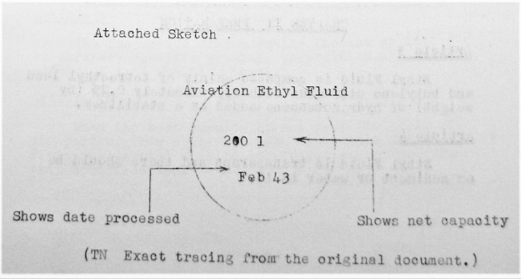

Notes

The outline and lettering will be of a suitable scale and red will be the standard colour.

The drum prescribed by the Air Specification Authorization No.195, Specification No. 16 or one equivalent to this will be used.

## Army Air Material Specification

Special Air Specification No. 16 Classification No. 16-302 Established 8 May 43 Air Specification Authorization No. 240 Army Air HQ

## Special Aviation Ethyl Fluid

### CHAPTER I APPLICATION AND CLASSIFICATION

Article 1. - This specification applies to Special Aviation Ethyl Fluid (referred to hereafter simply as Ethyl Fluid) used as anti-knock chemical for aviation mixed fuel or aviation gasoline.

Article 2. - The classification and code number of Ethyl Fluid fixed by this specification is as given in Table No. 1 (our Table No. 22).

Table No. 22. Classification Code No. for Japanese Special Aviation Ethyl Fluid

|  |  |
| --- | --- |
| Classification | Code No. |
| Special Aviation Ethyl Fluid | 16-302 |

### CHAPTER II PREPARATION

Article 3. - Ethyl Fluid is composed mainly of tetraethyl lead and butylene dibromide *(Comment: This may be Butylene Dichloride)* with approximately 0.2% (by weight) of hydrazobenzene added as a stabiliser.

Article 4. - Ethyl Fluid is transparent and there should be no sediment or water in it.

### CHAPTER III TESTS

Article 5. - Specific Gravity - The specific gravity of the Ethyl Fluid must be from 1.740-1.770 (15/4ºC).

Article 6. - Composition Test - The composition must meet the standards of Table No. 2 (our Table No. 23) by the test method, Air Specification No. 280, supplement and the test method given in the supplement of this specification.

Table No. 23. Composition Test for Special Aviation Ethyl Fluid

|  |  |  |
| --- | --- | --- |
| Components | Weight (%) | Volume (%) |
| Tetraethyl lead | Above 72 | Above 64 |
| Butylene Dichloride | Above 22 | Above 30 |

Article 7. - Effect of Added Lead Test - When lead is added to the mixture of 70% iso-octane and 30% normal heptane which is the standard fuel for octane value determination, the octane value as determined by the test method, Air Specification No. 280 supplement should be as follows:

1. When 0.1% (by volume) of Tetraethyl Lead is added, 90 and above.

2. When 0.1% (by volume) of Ethyl Fluid is added, 87 and above.

Article 8. – Sampling - One container from each group consisting of ten 100 litre containers or a fraction thereof will be selected at random. From this approximately 100 cc of sample will be taken to represent the product of that group.

### CHAPTER IV INSPECTION

Article 9. - The inspection will normally consist of the appearance, specific gravity, composition, and the effect of lead addition tests.

Article 10. - When the test results do not meet the whole or part of this specification, the entire Ethyl Fluid represented will be considered as not meeting this specification.

Article 11. - The Ethyl Fluid which meets this specification will be put into 200 litre drums, sealed tightly so as to prevent leakage and marked as shown in the attached sketch. (our Figure 9.) The name of the processing company or its trade mark will be shown in an appropriate manner.

Figure 9. Japanese Army Air Special Aviation Ethyl Fluid drum marking

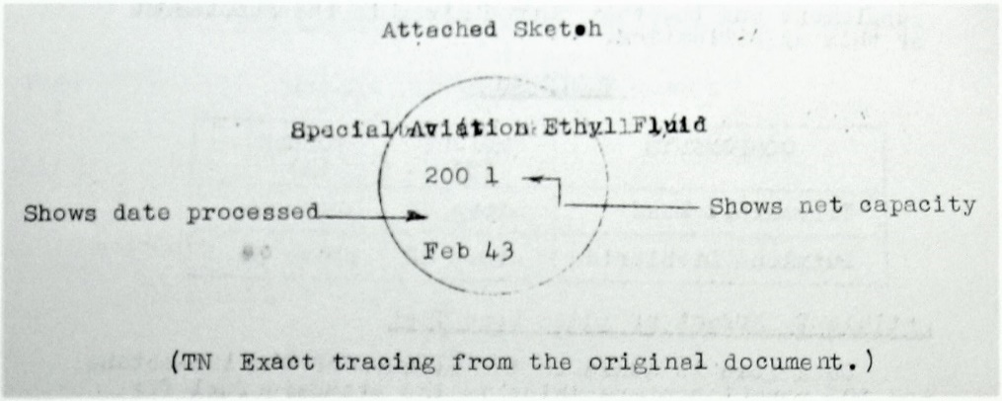

Notes

The outline and lettering will be of a suitable scale and red will be the standard colour.

The drum prescribed by the Air Specification Authorization No. 195, Specification No. 16 or one equivalent to this will be used.

### SUPPLEMENT

Quantitative Analysis for Butylene Dichloride

The analysis will be conducted as given by the test method, Air Specification No. 280, supplement and the amount of butylene dichloride calculated by the formulas given below.

% of Butylene Dichloride (by weight)

= Wt. of AgCl (gm) x 43.91

Wt. of sample (gm)

% of Butylene Dichloride (by volume)

= Wt. of AgCl (gm) x Sp. Gr. of sample x 39.56

Wt. of sample (gm)

The specific gravity of butylene dichloride, 1.11 (15/4ºC), will be used as the conversion factor for calculating weight percentage to volume percentage.

## Army Air Material Specification

Special Air Specification No. 17 Classification No. 16-321 Established 8 May 43 Air Specification Authorization No. 240 Army Air HQ

## Aviation Gum Formation Preventative

### CHAPTER I APPLICATION AND CLASSIFICATION

Article 1. - This specification applies to the gum formation preventative used for that purpose in aviation gasoline. (It will be referred to hereafter simply as preventative).

Article 2. - The classification and code number of preventative which is fixed by this specification are as follows:

Table 24. Classification Code No. for Japanese Aviation Gum Preventative

|  |  |
| --- | --- |
| Classification | Code No. |
| Aviation Gum Formation Preventative | 16-321 |

### CHAPTER II PREPARATION

Article 3. - The preventative is made by dissolving hydro-oxynaphthalene (25% or over) and lecithin (5% or over) as main ingredients in an appropriate solvent. It is necessary to use lecithin which has 2% or more phosphorous content.

Article 4. - There should be no sediment or water in the preventative.

### CHAPTER III TESTS

Article 5. - Specific Gravity - The specific gravity of the preventative should be 0.90 to 0.95 (15/4ºC).

Article 6. - Solubility in Water Test - To test the solubility in water add 1 cc of sample to 500 cc of base aviation gasoline. Transfer this into a separatory funnel of about 1000 cc capacity, add 25 cc water and shake for five minutes. After letting it settle for 24 hours, separate the water layer into a porcelain evaporating dish of about 50 cc capacity. Evaporate this in an air-bath at 100ºC (+/- 1ºC) and weight the residue. The residue must be 5 mg or less.

Article 7. - Cooling Test - The cooling test is made according to the Solidification Point Test Method (JES No. 174). Aviation base gasoline containing 0.01% by volume of the preventative is cooled to 50ºC *(This should be minus 50ºC)* and kept there for 30 minutes. There should be no turbidity or separation in the solution.

Article 8. - Stability Test - The stability test is made according to the test method in the supplement and is applied to catalytically cracked gasoline. The induction period (*1) of catalytically cracked gasoline which has 0.01% by weight of the preventative must be twice or more that of catalytically cracked gasoline without the preventative. However, catalytically cracked gasoline is to be used, the sulfuric acid absorption quantity of which is less than 5%-10%, the gum content of which is less than 1 mg per 100 cc (by test method, Army Air Specification No. 13, Supplement.) and the induction period of which is in the stability test is 100 to 300 minutes.

Article 9. – Sampling - Select one container at random from each group of thirty 20 litre containers or a fraction thereof. Take a 100 cc sample from this can to represent the product of that group.

### CHAPTER IV INSPECTION

Article 10. - The standard inspection consists of the appearance and specific gravity tests, the solubility on water, freezing test *(cooling test),* and stability test.

Article 11. - If the results of the test do not meet the whole or any part of this specification, the whole group it represents will be considered as not meeting this specification.

Article 12. - The preventative that meets the specification will be put into 20 litre glass carboy which is protected by bamboo basket or something equivalent to this. Labels will be placed on the side and on the mouth as shown in sketches 1 and 2 (our Figure 10.) with the place of processing or its mark suitable indicated.

Figure 10. Japanese Army Air Aviation Gum Formation Preventative Labels

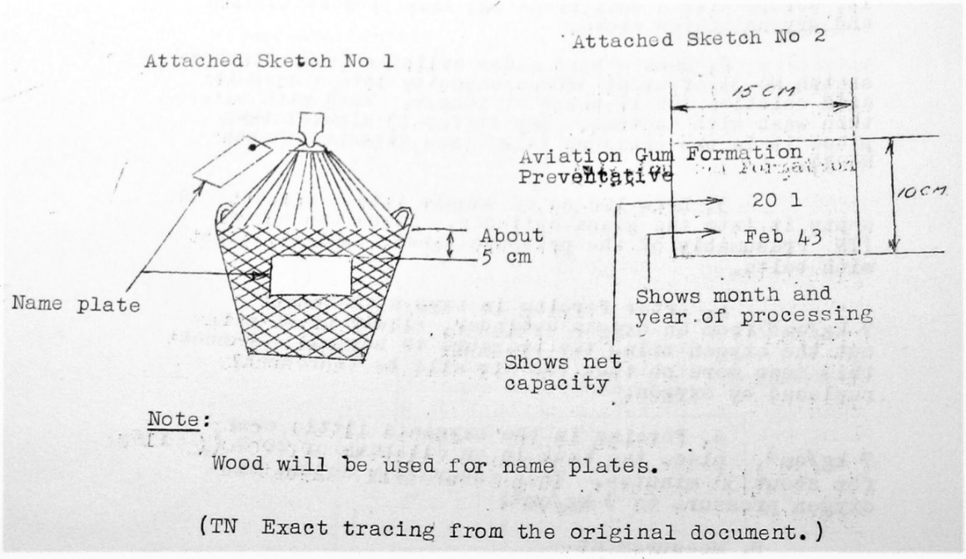

### SUPPLEMENT

Procedure for Stability Test - In the stability test, oxidize the sample with oxygen under pressure under the conditions below. Measure the rate of decrease of oxygen pressure due to the oxidation process. The induction period (in minutes) will be taken as the time from which heating is started to the time the rate decreased to 0.035 kg/cm2 per minute. The stability of sample will be indicated by this. However, if the rate of pressure decrease is to slow, it will be determined in another way (see under measurement.)

Sample 100 cc

Oxygen pressure at beginning 7 kg/cm2 (at 20ºC)

Oxidation temperature 100 ºC (+/- 1 ºC)

The average of three tests will be taken and this difference between any of the tests should not exceed 30 minutes. Using the stability testing apparatus, the procedure is as follows:

Preparation for Test

With a clean rag which is soaked with acetone wipe inside the 500 cc pressure tank. (See attached sketch No. 2) Dry it by passing dry warm air through. If there is any gum material sticking on it, scrape with a dull blade and then proceed to wipe and dry as stated above.

Soak a hard glass cylinder (see attached sketch No. 3) (our Figure 12.) of about 300 cc capacity into a chromic acid solution for 12 hours or longer. Wash with water then wash with acetone. Dry it for 10 minutes then place it in the pressure tank. (see attached sketch No. 1) (our Figure 11.)

Draw 100 cc of sample into a pipette and empty it into the glass cylinder. Place the cover (TN Presumably of the pressure tank.), seal it tight with bolts.

After forcing in oxygen to about 7 kg/cm2 from an oxygen cylinder, slowly by drawing out the oxygen bring the pressure to normal. Repeat this once more so that the air will be thoroughly replaced by oxygen.

Forcing in the oxygen a little over 7 kg/cm2, place the tank in an oil-bath of 20ºC (+/- 1ºC) for about 30 minutes. The accurately adjust the oxygen pressure to 7 kg/cm2.

Measurement

Upon setting the recording gauge to turn, start heating. Raise the temperature of the oil-bath to 100ºC in 30 minutes. (+/- 5 minutes) and maintain this temperature of the oil-bath at 100ºC (+/-1ºC), continuing the test until pressure becomes 5 kg/cm2.

When the pressure becomes 5 kg/cm2 stop heating. Record on a form the period in minutes from the time at which heating started to the time the rate of pressure decrease becomes 0.035 kg/cm2 per minute. This period is the induction period.

If the rate of pressure decrease is too slow, the period in minutes between the start of heating to the time the pressure decreases 0.7 kg/cm2 from the highest pressure is taken as the induction period.

Figure 11. Stability Testing Apparatus

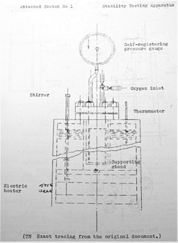

Figure 12. Stability Testing Apparatus

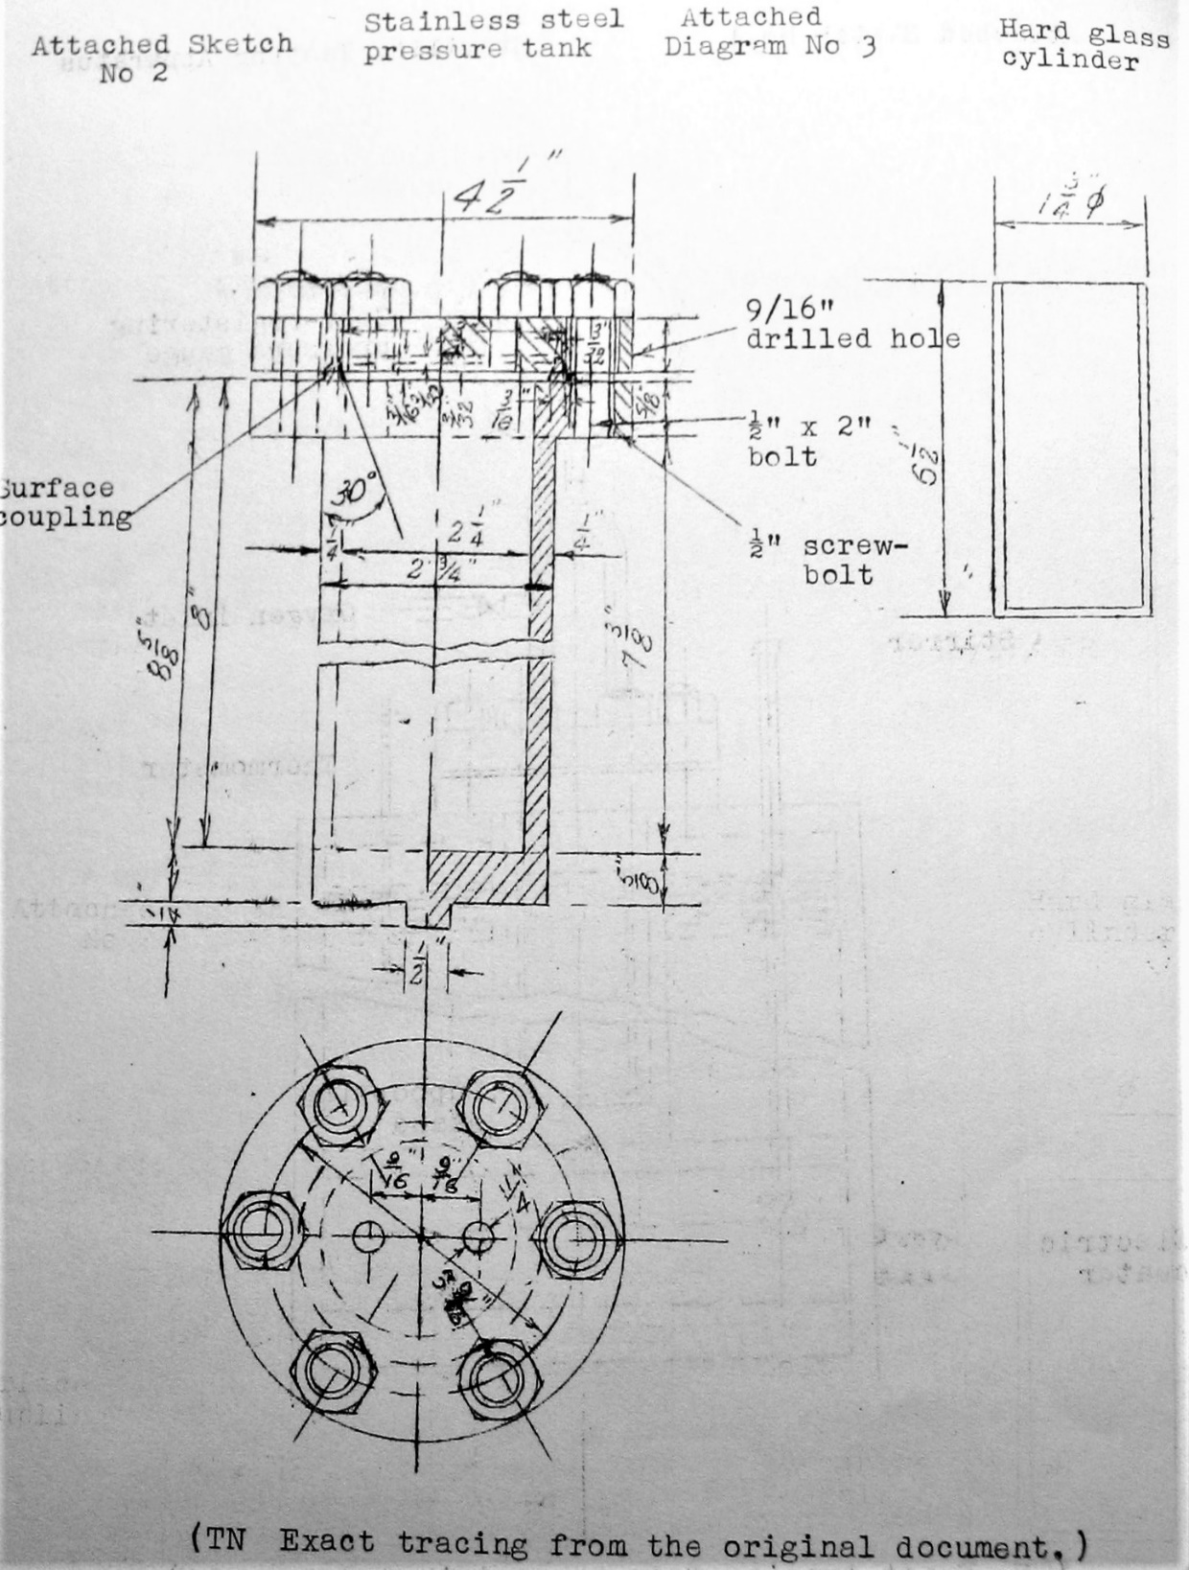

# Manufacturing Process 1941-1945

The manufacturing processes used by the Japanese after the denial of supplies was similar to that of the Germans – Hydrogenation, Fischer-Tropsch Process, and oil refining of captured crude oil sources. The similar processes as the Germans were applied to coal, petroleum residues and other carbonaceous materials; and this was how the Axis made their aviation gasoline.

Prior to the war the Japanese were in negotiations with major German industrial companies for technology and designs; companies such as Ruhrchemie A.G. and I.G. Farben.

Information from the Japanese Intelligence Report 2/5/1945 Serial J/023 Subject: “Japan – I.G. Farben data on Japanese oil industry” (assumed 1945) illustrates the status of Japanese situation.

An iso-octane plant of the Toa Fuel industry was reported about to start and a second plant for Japan Oil Co. was reported under construction. The Japanese were reported to want German technical assistance in the following:

(1) Hydrogenation planes to produce aviation gasoline.

(2) Iso Octane production from Isobutanol.

(3) Iso Octane production from Acetylene.

(4) Catalytic Cracking

(5) Process for manufacturing Isobutanol

Negotiations with I.G. Farben resulted in licence agreement dated 11 Jan 1945 followed in March 1945 by a construction agreement for I.G. Farben to supply the Japanese with the necessary drawings. The final project was based on using Utibuti coal to make 93,000 tons/year of aviation gasoline from coal and tar.

The project was never built. (The War in Europe finished May 1945 before work could get underway).

German Technology Transfer in Japan

The transfer of economic and technical information between Germany and Japan was investigated by the Supreme Headquarters Allied Expeditionary Force (SHAEF) in 1945. They discovered a number of documents[17] concerned with economic and technical co-operation between Germany and Japan, Japanese counter intelligence activity, Japanese organisation for collection of technical intelligence in Europe, chemical plants and oil plants in Japan, exchange of aircraft and naval information between Germany and Japan, 1944-45. On such subject was Japanese Synthetic Oil Plants, where there were various Japanese intelligence and documents, reports on I.G. Farben and Lurgi companies - 21 June 1945.

I.G. Farben - Japanese Army Negotiations[18]

Before the war the Japanese had several preliminary discussions with International Hydrogenation Patents (I.H.P.) on the question of acquiring rights of the hydrogenation process. Similar discussions had apparently taken place from time to time with the I.G. Farben during the war years, but it was not until late in 1944 that the I.G. Farben were instructed by the German Government that it was essential that they should conclude an agreement with the Japanese Army.

Serious discussions began in November 1944, cantering round the erection of a plant at Kinsei in Manchukuo for the production of 70-100,000 tons/year of aviation gasoline from Fupin coal. In mid-January 1945 the Japanese changed their plan regarding the location of the first hydrogenation plant and decided on a site in South Sakhalin using Utibuti coal. I.G. Farben provided detailed flow-sheets for the production of 73,000 tons/year aviation petrol by direct coal hydrogenation of tar alone. It was assumed that the tar would be obtained by low temperature carbonization of the Utibuti coal. (Yield 17-18% by wt. on coal carbonized).

Information supplied by the I.G. Farben was limited to 300 atmosphere pressure coal hydrogenation technique and no data were supplied concerning naphtha dehydrogenation or alkylate synthesis processes.

A general hydrogenation licence agreement between the I.G. Farben and the Japanese Army was signed on the 11th January 1945. This agreement provided for the use of the hydrogenation process in Japan, Manchukuo and China for the production of gasoline of all types, hydrocarbon gases, burning oil, gas oil, fuel oil, lubricating oil and paraffin was from crude petroleum, bituminous coal, brown coal, peat, wood, shale or from products derived from these raw materials. The I.G. agreed to hand over their knowhow and patent rights as far as they were able to do so in view of the I.H.P. agreement. The I.G. Farben agreed to send specialised technical personnel to Japan for the erection and start-up of the new plant and to afford facilities for training of Japanese technicians in German plants. It was agreed that the Japanese and the I.G. Farben should continue to exchange technical information. The agreement was for a period of 10 years after which time the Japanese should continue to have free use of patents, irrespective of whether the agreement was renewed or not.

From the start of the discussions, the Japanese were anxious to obtain a full description of the German hydrogenation plants and processes in advance of flow sheet and design data on the new Japanese project. They were also anxious to get the German technicians out to Japan immediately. From letters written at the end of February and beginning of March 1945, it seems doubtful whether the Japanese seriously intended building a new plant and that the main object in concluding a general hydrogenation agreement with the I.G. Farben was to secure the necessary information to operate existing Japanese plants.

Extremely little information concerning these Japanese plants were available either from documents of from interrogation of the I.G. Farben staff. It is understood that there were three plants for the hydrogenation of tar. These were located in Kinsei, Mukden and Hokkaido.

There is some confusion as to whether these plants have a rated capacity for gasoline production of 50,000 tons/year each or whether their combined capacity is this figure. The plants are built for 300 atmosphere pressure operation and comprise liquid phase and vapour phase stalls. The converters are 10 m. long and 600 mm. internal diameter. Chlorine is used as a catalyst in both liquid and vapour phase and considerable difficulty has been experienced due to corrosion. There is an indication that the achieved production of these plants was of the order of 10,000 tons/year of gasoline each.

Interrogation of German scientists/engineers Dr. Mathias Pier and Dr. Ernest Donath at Heidelberg produced only vague information on Japan's general fuel production position. It was stated that the Japanese had a licence for the Fischer-Tropsch process some years before the war and that they have a plant somewhere in Manchuria. The Japanese have also a carbonisation plant of their own construction for Fushun shale and it is thought that they have a cracking plant, probably of U.O.P. design, which has been very much enlarged during the war. At least 300,000 tons of shale oil is treated.

As noted earlier the Japanese Army and Japanese Navy ran separate operations and plants. The Japanese had problems with hydrogenation plants.

Hydrogenation Plants[19]

The Japanese Army had 3 plants Kinsei, Makdem, Hokkaido designed for 50,000 tons/year, but could only produce 5-10,000 tons/year. The Army plants were intended to produce aviation gasoline, and the units were not working properly at the beginning of 1945. The problem was serious corrosion from the chlorine catalyst. The Japanese Navy Hydrogenation Process used bituminous oil feed stock was used to produce navy fuel oil.

Table 25. Japanese Hydrogenation Plants 1945

|  |  |  |
| --- | --- | --- |
| Process | Location | Capacity Metric Tons/year |
| Low temperature Carbonisation | | |
|  | Wanishi | 15-30,000 |
|  | Eian | 20-30,000 |
|  | Tsurumi | 15,000 |
|  | Naihoro | 15-40,000 |
|  | Naibuchi | 30-60,000 |
|  | Sub-total | 95-175,000 |
| Tar Hydrogenation | | |
|  | Kawasaki | 10,000 |
|  | Nagoya | 30,000 |
|  | Ube | 40,000 |
|  | Wakamatsu | 10,000 |
|  | Ssupingkai (China) | 20,000 |
|  | Sub-total | 110,000 |
| Navy Process Hydrogenation | | |
|  | Tokuyama | 20,000 |
|  | Agochi | 50-100,000 |
|  | Kirin | 50-125,000 |
|  | Fushun | 40,000 |
|  | Yokkaichi | 55,000 |
|  | Sub-total | 215-340,000 |
| Army Process Hydrogenation | | |
|  | Hokkaido | 20-50,000 |
|  | Mukdei | 20-50,000 |
|  | Kinsei | 20,000 |
|  | Sub-total | 60-120,000 |

It is clear from the above table that the Japanese Imperial Navy had control of the majority of the oil production, with more and larger capacity plants.

The Japanese Army plants at Kinsei, Makdem, Hokkaido designed for 50,000 tons/year, but could only produce 5-10,000 tons/year. The Army plants were intended to produce aviation gasoline, and the unit was not working properly at the beginning of 1945. The problem was serious corrosion from the chlorine catalyst.

Fischer- Tropsch Process in Japan

The adoption of the (German) Fischer-Tropsch processes started before the war. The Miike (Omuta) Plant was started in 1938 based on a German design - the Ruhrchemie A.G. design plant was 30,000 tons/year and intended to yield 65% motor gasoline, 25% diesel, 10% wax. Charcoal absorption was used to extract the light hydrocarbons (propane and butane). However poor yields occurred due to catalyst difficulties (reported elsewhere as corrosion from Chlorine).

Table 26. Japanese Fischer-Tropsch Plants 1945

|  |  |
| --- | --- |
| Location (Fischer-Tropsch Process) | Est. Capacity Metric tons/year |
| Miike (Omuta) | 40,000 |
| Amagasaki | 40,000 |
| Chinchow | 35,000 |
| Rumoe | 40,000 |
| Takikawa | 40,000 |
| Total | 195,000 |

From the reports it appears that Germans did not provide information on Catalytic Cracking or Alkylation or Fischer-Tropsch processes. This may explain the difficulties that the Japanese had with hydrogenation units.

# Japan – TEL Production

It is clear from wartime intelligence reports that the Japanese chemical industry was able to manufacture Tetra Ethyl Lead (TEL) for their aviation gasoline. The principal manufacturers of this essential lead antiknock additive were the British company “Associated Octel” which had a close association with the American Company “Ethyl Corporation”. Indeed, the gasoline to which TEL had been added was referred to as “Ethylized” gasoline or “Ethyl Gasoline”. As early as 1927 Ethyl Corporation made a shipment to Japan through Asano Bussan, later called the Totsu Company. The TEL business grew and by the mid 1930’s the Japanese market was considered an important outlet.

During World War II Japan attempted to manufacture its own TEL and, in terms prior to the war Ethyl had established TEL manufacture in Europe, so the technology was already known around the world.

The key chemical component for TEL manufacture required were, of course, a source of Lead, and a source of Sodium to enable the Lead-Sodium mix to be formed prior to reaction with Ethylene Chloride. Ethylene Chloride was formed from the reaction of Chlorine and Ethane. The most abundant source of Sodium and Chlorine was from the common salt (Sodium Chloride) found in seawater, thus it was desirable to build these plants close to the source of raw material. Another important component of the “Ethyl Fluid” was the lead scavenger Ethylene Dibromide which comprised about 1/3 the mixture to minimise the fouling of engine spark plugs from lead oxide deposits, formed when the fuel was combusted.

Thus, the Allied intelligence sources searched for references to these key chemicals when trying to assess the status of the enemy’s knowledge and progress on TEL manufacture.

The following are excerpts from some of the Allied intelligence reports (and their source.) [20]

“A Review and Interpretation Of Available Evidence of Japanese Production of Ethylene Dibromide And Tetra Ethyl Lead with Notes on Possible Iso-Octane Planes other than previously listed – Washington April 1943.”

(Not covered in Refineries listed by Enemy Oil Committee on Map EOC-67)

Summary

The following summary if probable:

That some or all constituents of Ethyl Fluid are produced by NIPPON SODA at an undisclosed plant and by HODOGAYA KAGAKU KOGYO at its Koriyama and perhaps other plants.

Ethylene Dibromide and possibly also Tetra Ethyl Lead are manufactured at the First Naval Fuel Depot at Ofuna, possibly in conjunction with NIPPON SODA and HODOGAYA KAGAKU KOGYO.

Ethylene Dibromide is manufactured by RIKEN KINZOKU at an unknown plant (or plants).

Iso Octane and possibly also aviation base stock are produced by Nippon Soda near Marifu using processes sponsored by TOA NENRYO KOGYO (East Asia Fuel Industries) believed to be based in large part on American techniques as developed up to 1939.

Reported plans for the erection of a plant by NIPPON SEKIYU at Hiroshima City may also indicate additional Iso-octane capacity.

HODOGAYA KAGAKU KOGYO was established in 1917 and is known to be a producer of chemicals, especially alkalies, underwent rapid expansion since the end of 1940.

In 1941 four plants existed

Hodogaya plant at Yokohama, Hodogaya Ku, TENNO cho #791

Oji plant in Tokyo, Oji Ku Kamiya cho NICHOME #1042

Koriyama plant is located at Koriyama (Fukushima) TANIJIMA #53 , and the

HIDE Plant in front of the rail-road station at HIDE, HAYAMI GUN, OITA Prefecture.

OJI and HODOGAYA plants produce bromide at combined rate of 5 tons/month. This is the most likely form of Ethylene Dibromide. There is some suggestion that HODOGAYA produces TEL.

Japan – German Cooperation

There is significance information on the cooperation between the Axis Powers of Japan and Germany, particularly on the subject of Oil – which Japan was desperate to exploit. The following are but a few examples of the technical transfer.[21]

These documents concerned the economic and technical co-operation between Germany and Japan. Japanese counter Intelligence Activity, Japanese organisation for collection of technical intelligence in Europe, Chemical Plants Japan, Oil Plants Japan, Exchange of aircraft and naval information between Germany and Japan, 1944-45 prepared by Supreme Headquarters Allied Expeditionary Force

“Results of preliminary investigation by members of Oil Division of uses of Japanese oil, chemical and rubber industries”

Information from interrogations of Germans and German documents by US Strategic Bombing Survey.

“No information on Japanese TEL plants could be obtained. It seems fairly certain that the Japanese did not get the process from I.G. Farben. Definite information on shipment of Ethylene Dibromide to Japan was obtained which is conclusive evidence that Japan has lead (TEL) manufacturing facilities. A total of 1200 tons of Ethylene Dibromide were shipped from Germany in 1942 and 1943. Assuming that one third of this reaches Japan, it would be equivalent to about 600 tons of TEL. (Only one plant in Germany made Ethylene Dibromide).

(Comment: 600 Tons TEL would make 92 million gallons of Avgas @ 4 cc/IG assuming all TEL went to Avgas, and none to motor gasoline).

Most interrogators stated Avgas was the most important and critical item in Japanese Oil

Appendix J-058

Material found in files of Associated Ethyl in London in 1939, Asano Bussan attempted to obtain from Associated Ethyl the process for making TEL. They explained that Nippon Soda & Hodasgaya Soda had a pilot plant in Japan proper for TEL. Asano Bussan was planning to develop their production in conjunction with Manshu Salt Co.

There is also a reference in Oil & Gas Journal 15 Aug 1940 to Japanese Ethyl Dibromide plant of Dai Nippon Salt Co. at Kamata near Tokyo.

Another reference to Japan &TEL Production

In the history of the Ethyl Corporation, the following comments are made regarding the Japanese TEL enterprises.

During World War II Japan attempted to manufacture its own TEL and, in terms of pounds produced, succeeded in a small way, but in the process reportedly killed 16 or more operators. At one time over 40% of all workers in the TEL enterprise were suffering from lead poisoning.

After the war Ethyl Corporation developed a close association with the Japanese oil industry, firstly helping to dispose of a widely dispersed quantity of contaminated TEL. Ethyl soon succeeded in re-establishing its position as the leading supplier of TEL and by 1961 was contributing over 60% of all TEL used in Japan. Ethyl formed a joint enterprise, Mitsui-Ethyl.

The importance of Tetraethyl Lead TEL)

Tetraethyl Lead (TEL) was an essential additive to achieve the necessary octane performance for the aviation gasoline grades used by the Japanese Army and Navy. The following details their efforts to meet this demand. From US Strategic Bombing Report 1946. Table C-79 Production of TEL in Japan 1940-1945[22]

Table 27. Production of TEL in Japan 1940-1945

Pounds of Tetraethyl Lead in Japan 1940-45

|  |  |  |  |
| --- | --- | --- | --- |
| Fiscal Year & Month | Army | Navy | Total |
| 1940 | 35,200 | 49,900 | 85,100 |
| 1941 | 426,600 | 398,600 | 825,200 |
| 1942 | 1,599,300 | 2,036,100 | 3,635,400 |
| 1943 | 2,923,000 | 3,295,400 | 6,218,400 |
| 1944 | 3,671,200 | 3,353,200 | 7,024,400 |
| 1945 (5 months) | 635,900 | 475,700 | 1,111,600 |
| **1940** | | | |
| September |  | 14,000 | 14,000 |
| October | 5,600 | 4,900 | 10,500 |
| November | 5,900 | 4,900 | 10,800 |
| December | 7,300 | 6,700 | 14,000 |
| **1941** | | | |
| January | 8,300 | 7,200 | 15,500 |
| February | 5,500 | 5,500 | 11,000 |
| March | 2,600 | 6,700 | 9,300 |
| April | 9,500 | 7,700 | 17,200 |
| May | 26,100 | 5,700 | 31,800 |
| June | 15,300 | 5,800 | 21,100 |
| July | 16,400 | 15,200 | 31,600 |
| August | 24,800 | 23,300 | 48,100 |
| September | 36,400 | 36,200 | 72,600 |
| October | 37,900 | 35,300 | 73,200 |
| November | 40,900 | 42,400 | 83,300 |
| December | 54,600 | 46,200 | 100,800 |
| **1942** | | | |
| January | 48,400 | 50,100 | 98,500 |
| February | 53,400 | 59,700 | 113,100 |
| March | 62,900 | 71,000 | 133,900 |
| April | 68,200 | 81,300 | 149,500 |
| May | 84,900 | 101,100 | 186,000 |
| June | 90,100 | 102,000 | 192,100 |
| July | 77,500 | 108,600 | 186,100 |
| August | 109,300 | 138,000 | 247,300 |
| September | 118,300 | 175,000 | 293,300 |
| October | 156,600 | 242,300 | 398,900 |
| November | 161,200 | 225,600 | 386,800 |
| December | 200,800 | 215,500 | 416,300 |
| **1943** | | | |
| January | 165,600 | 188,800 | 354,400 |
| February | 169,500 | 217,000 | 386,500 |
| March | 196,700 | 240,900 | 437,600 |
| April | 179,000 | 226,900 | 405,900 |
| May | 178,900 | 256,500 | 435,400 |
| June | 186,600 | 217,300 | 403,900 |
| July | 200,300 | 210,100 | 410,400 |
| August | 198,500 | 223,000 | 421,500 |
| September | 221,500 | 263,700 | 485,200 |
| October | 233,100 | 285,800 | 518,900 |
| November | 269,800 | 323,600 | 593,400 |
| December | 301,800 | 309,500 | 611,300 |
| **1944** | | | |
| January | 283,700 | 308,700 | 592,400 |
| February | 289,800 | 289,400 | 579,200 |
| March | 380,000 | 380,900 | 760,900 |
| April | 423,100 | 350,600 | 773,700 |
| May | 303,200 | 397,100 | 700,300 |
| June | 323,400 | 310,300 | 633,700 |
| July | 305,400 | 298,000 | 603,400 |
| August | 337,600 | 323,100 | 660,700 |
| September | 464,700 | 369,500 | 834,200 |
| October | 334,200 | 287,700 | 621,900 |
| November | 360,800 | 261,100 | 621,900 |
| December | 292,500 | 299,600 | 592,100 |
| **1945** | | | |
| January | 240,900 | 219,000 | 459,900 |
| February | 125,700 | 140,800 | 266,500 |
| March | 159,700 | 96,400 | 256,100 |
| April | 106,600 | 67,900 | 174,500 |
| May | 163,000 | 87,900 | 250,900 |
| June | 196,700 | 132,200 | 328,900 |
| July | 110,600 | 136,400 | 247,000 |
| August | 59,000 | 51,300 | 110,300 |

# Japanese Petroleum Position in 1944

In April 1944 the Allied Joint Intelligence Committee (JIC) sought information on the Japanese petroleum position and referred the matter to the Enemy Oil Committee. This information would be then forwarded to the Allied Combined Chiefs of Staff. The subsequent report outlines the general position and also highlights the high demands by the Imperial Japanese Navy for fuel oil.

Selected items related to aviation gasoline are detailed below.

Note by the Secretary[23]

1. At their 97th meeting of the Joint Intelligence Committee referred JIC 170 back to the Enemy Oil Committee for revision using the new estimate of Japanese naval fuel oil requirements, and resubmission to the JIC with subsequent collaboration with the Hartley Committee in the preparation of a combined paper.

2. The attached revision of JIC 170 prepared by the Enemy Oil Committee as directed, is submitted for JIC consideration.

3. It is recommended that, if the attached paper is approved the Enemy Oil Committee be authorized to collaborate with the Hartley Committee in the preparation of a proposed C.I.C. paper for submission to the Combined Chiefs of Staff in response to C.C.S directive

James S Lay Jr. Secretary

While the focus is on aviation gasoline, it is important to understand the demands for petroleum products from both the Japanese Army and particularly the Japanese Navy who were now facing the onslaught of the U.S. Navy in the Pacific. The needs of this one powerful Japanese Navy for fuel oil for their ships (including aircraft carriers) and aviation gasoline for the Japanese Navy carrier aircraft to defend the outer defence line of Pacific Islands was now critical.

There would be a decisive battle in the Mariana Islands which would reduce this once powerful offensive carrier based Japanese naval force to one of a defensive role protecting the home islands from the Allied continued offensive.

Report by the Allied Joint Intelligence Committee.

The Problem

1. To determine the Japanese oil position of 1944 by taking into consideration the changes that have taken place in 1943

Facts Bearing On the Problem

2. We estimate Japan’s stock position in the Inner Zone [Japan proper, Korea, Manchuria, North China, Formosa and Karafuto (Japanese Sakhalin)] commencing 1944 (including remaining balance of stocks captured in 1942), production and consumption in 1944 and balance of stocks as of 1 January 1945 as follows:

*Table 11. U.S. Estimate of the Japanese Avgas stocks in 1944*

Thousands of Barrels of 42 US Gallons Each - For details see Appendix A of US Strategic Bombing Report 1946.

Table 28. U.S. Estimate of Japanese petroleum products 1944-45.

|  |  |  |  |  |  |
| --- | --- | --- | --- | --- | --- |
| Product | Stocks 1 Jan 1944 | Production 1944 | Total | Consumption 1944 | Balance 1 Jan 1945 |
| Aviation Gasoline | 6,888 | 4,152 | 11,040 | 4,455 | 6,585 |
| Motor Gasoline | 7,071 | 10,487 | 17,558 | 4,566 | 12,992 |
| Diesel & Fuel Oil | 25,764 | 41,930 | 67,694 | 40,100 | 27,594 |
| Lube Oil | 3,034 | 1,852 | 4,886 | 2,673 | 2,213 |
| Kerosene | 763 | 291 | 1,054 | 918 | 136 |
| Totals | 43,520 | 58,712 | 102,232 | 52,172 | 49,520 |

Discussion

3. Fuel Oil

(A) Summary. Naval and merchant fleet consumption in 1944 is estimated at 37,000,000 barrels, industrial consumption at only 2,000,000 barrels; and tanker losses are figured at 400,000 barrels. Thus, Japan’s total fuel oil consumption of 39,400,000 barrels is estimated in 1944 to be less than supplies which are believed to equal 41,930,000 barrels. This will enable Japan to add to stockpiles a total of 1,830,000 barrels after providing for 700,000 barrels representing the unconsumed balance of stocks captured in 1942. The position is therefore relatively unchanged from a year ago, when it was estimated that stocks on hand of fuel oil were equivalent to about eight months requirements. Japan remains very greatly dependent upon a constant flow of black oils from the East Indies to keep her stocks in balance or from decreasing.

(B) Possibility of Increased Production. Approximately 75% of total Japanese fuel oil is derived from the East Indies. East Indies crude production in 1944 is estimated at 54,140,000 barrels compared to 51,700,000 barrels in 1943. This is considered to represent t maximum achievement on the part of the enemy. This production provides Japan with 31,590,000 barrels of fuel oil, of which 11,740,000 barrels is obtained without refining. To obtain the balance Japan must produce a large surplus of unneeded gasoline which is probably dumped. Production of black oils in the Inner Zone is estimated at only 10,340,000 barrels. Further progress in synthetic production and additional planned development of oil fields in Japan in 1944 are not likely to add appreciably to fuel oil supplies. The recent loss of potential supplies from Soviet Sakhalin oil fields effects the situation more with respect to lubricating oil than fuel oil and may be said to a been discounted already.

4. Aviation Gasoline

Production and requirements of aviation gasoline are now almost in balance. Sufficient production of aviation gasoline will become a problem upon the loss of the East Indies as a source of a satisfactory base crude. If Japan losses the East Indies, stocks plus current production of aviation gas in the Inner Zone are now sufficient to last approximately two years at the present rate of consumption. Inner Zone production now constitutes only about one-quarter of current consumption.

5. Motor Gasoline and Kerosene

Stocks of motor gasoline are heavy and production is greatly in excess of estimated requirements. Assuming that the crudes are available, stocks of kerosene, now quite low, may be increased when needed but such increase would have to be partly at the expense of fuel oils

6. Lubricating Oils

There are now indications of an increasing need for replacement of the dwindling stocks of lubricating oils. We believe that stocks on hand 1 January 1944 are made up largely for the pre-war imported stocks. Japan, therefore, appears to be independent of sources outside the Inner Zone for quality products for some time to come. As current consumption of lubricants, consisting largely of medium and low grade oils, is more than double the Inner Zone production, however, there is an increasingly urgent necessity for larger production and apparently as almost insurmountable dependence upon the East Indies as a source of suitable crude. The loss of potential crude from Soviet Sakhalin adversely affects Japan’s lubricating oil supplies since that crude contains a 20% fraction of good quality lubes.

7. Oil Transport

In order to offset partially the loss of tankers, Japan has resorted to conversion of cargo ships for carrying of oil in bulk. It is logical to assume that by this time Japan has reconstructed sufficient refinery capacity in the East Indies to process all the East Indies crude locally. Hence it is no longer necessary to carry East Indies crude to Japan for refining. This study has been predicated on the assumption that production quantities taken up in stockpile calculations (i.e. excluding gasoline assumed to have been dumped in the East Indies) will be moved to consuming areas or to Japan in 1944.

8. Miscellaneous production sources

Intelligence for some time has indicated a restriction in imports of crude from Japanese- operated Soviet Sakhalin oil fields. Based on recent arrangements with the Soviets, Japan is permitted to take out stocks now on hand. These may amount to more than the figure credited to Japan on attached statements as imports in 1944, but it seems doubtful that stocks are greater than three or four hundred thousand barrels. There has been partial rehabilitation of oil fields and facilities in Burma, but it is believed that the Burma operations are confined to the production and refining of sufficient gasoline for local needs excepting aviation.

It would appear that in Japan there is no longer any admixture of gasoline with alcohol produced from food –valuable potatoes and sugar cane. There is evidence also that Japan is preparing for the possibility of being forced back into the Inner Zone for future supplies of petroleum products.

Summary and Conclusions

9. Japan’s petroleum weakness lies in the fact that Japan is dependent for the bulk of her vital fuel oil supply (which in turn constitutes more than three-quarters of her total petroleum requirements) on East Indies sources distant from consuming areas and that her supply lines thereto are vulnerable to attack by sea and air. Moreover, since almost 95% of Japan’s fuel oil requirement is consumed by the navy and merchant fleet, loss or disruption of East Indies supplies would have a seriously adverse effect upon Japanese military capabilities. Fuel oil supplies and consumption should remain in balance so long as Japan retains existing East Indies oil facilities and her lines of communication thereto remains open.

10. Production and requirements of aviation gasoline are now approximately in balance. Inner Zone production is sufficient for only about one-quarter of present requirements and Japan is therefore dependent upon the East Indies for the balance. Stocks plus current production of aviation gasoline in the Inner Zone are now sufficient to last approximately two years at the present rate of consumption.

11. Stocks of motor gasoline are heavy and production is greatly in excess of demands. This excess motor gasoline production is a necessary result of such large fuel oil production.

12. The lubricating oil position is becoming increasingly serious. While stocks of high quality oils are still quite large, additional sources of crude oil will be necessary to supply the requirements of medium and low-grade product as well as the demand for high-grade products after the stockpile is exhausted. As current total consumption of lubricants is more than double the output of the Inner Zone, supplies from the East Indies are necessary to meet requirements.

*13. Stocks 1 January 1944*

*We estimate the Japan had the following stocks available as of 1 January 1944:*

Table 29. US Estimate of Japanese Petroleum Stocks January 1944

Quantities in thousands of barrels

|  |  |  |  |
| --- | --- | --- | --- |
|  | At home and Captured stocks | East Indies | Combined |
| Aviation Gasoline | 6,888 | 1,592 | 8,480 |
| Motor Gasoline | 7,071 | 14,575 | 21,646 |
| Diesel & Fuel Oil | 25,764 |  | 25,764 |
| Lubricating Oil | 3,034 |  | 3,034 |
| Kerosene | 763 |  | 763 |
| Grand Total | 43,520 | 16,167 | 57,687 |

Division in stocks has been predicated on the belief that in order to obtain maximum fuel oil yields from East Indies crudes Japan has been forced to make large quantities of both aviation and motor gasolines at refinery points in the East Indies which will either have to be dumped or perhaps stored in part depending on available storage facilities. Transport facilities will not permit of carrying all of the gasoline to Japan, nor is it required there – based on estimated stocks, home production and consumption.

14. Production

We estimate that Japan will produce the following quantities in 1944 from all sources now in its hands:

Table 30. Japan’s Estimated Oil Production in 1944 by Sources *

(Quantities in thousands of barrels)

|  |  |  |  |  |  |  |
| --- | --- | --- | --- | --- | --- | --- |
| Product | Japan & Formosa | Sakhalin Crude | Manchuria (Shale Oil) | Japan, Korea, Manchuria (Synthetic) | East Indies Crude | Totals |
| Aviation Gasoline | 410 |  |  | 742 | 3,000 | 4,152 |
| Motor Gasoline | 510 |  | 1,811 | 7,491 (a) | 675 (c ) | 10,487 |
| Total Gasoline | 920 | 0 | 1,811 | 8,233 | 3,675 | 14,639 |
| Fuel Oils | 1,143 | 55 | 2,940 | 6,202 (b) | 31,590 | 41,930 |
| Lubricating Oil | 531 | 20 |  | 551 (d) | 750 | 1,852 |
| Kerosene | 276 | 15 |  |  |  | 291 |
| Total product | 2,870 | 90 | 4,751 | 14,986 | 36,015 | 58,712 |
| Crude Oil Equivalent | 3,320 | 100 | 5,250 | 12,074 (e) | 54,140 | 74,884 |

Coke & Gas Industry (a) Benzol 720, 000 Bbls (a) Gasoline 77,000 Bbls, (b) Fuel Oil 1,615,000 Bbls

(c) While we estimate 4,000,000 Bbls. Aviation gasoline base stock and 13,000,000 Bbls of motor gasoline may be produced in 1944 in the East Indies in the process of obtaining requisite fuel oil, only 3,000,000 Bbls of aviation gasoline and 675,000 Bbls of motor gasoline will be moved to Japan or into consumption in the Southern Pacific for military purposes. Some motor gasoline will be consumed in the East Indies for civilian purposes where no ocean transport is involved, but this must be small.

(d) Includes 250,000 Bbls vegetable oils and animal oils, 250,000 Bbls oil saved by reclamation.

(e) Synthetic oil production.

15. Requirements

We estimate that Japan’s petroleum requirements for 1944 in quantities of thousands of barrels are:

Table 31. Japan’s Estimated Oil Requirements in 1944*

(Quantities in thousands of barrels) * see attached Appendix “A” USSBS for details.

|  |  |  |  |  |  |  |
| --- | --- | --- | --- | --- | --- | --- |
| Product | Navy | Army | Merchant Marine | Civilian | Evaporation & Tanker Loss | Totals |
| Aviation Gasoline | 1,740 | 2,460 |  |  | 255 | 4,455 |
| Motor Gasoline |  | 2,675 |  | 1,425 | 466 | 4,566 |
| Total Gasoline | 1,740 | 5,135 |  | 1,425 | 721 | 9,021 |
| Fuel Oils | 27,000 |  | 10,000 | 2,700 | 400 | 40,100 |
| Lubricants | 388 | 222 | 350 | 1,713 |  | 2,673 |
| Kerosene |  |  |  | 918 |  | 918 |
| Total Requirements | 29,128 | 5,357 | 10,350 | 6,756 | 1,121 | 52,712 |

(a) Includes Motor Gasoline 425,000 Bbls consumed in occupied areas

(b) Includes 700,000 Bbls consumed in occupied areas

(c) Includes Lubricants 63,000 Bbls consumed in occupied areas

(d) Includes Kerosene 197,500 Bbls consumed in occupied areas

(All balances of capture stocks in 1942)

Table 32. Total Supply & Requirements in 1944*

(Quantities in thousands of barrels) * see attached Appendix “A” USSBS for details

|  |  |  |  |
| --- | --- | --- | --- |
|  | Japan at Home | East Indies | Japan & East Indies |
| Stocks 1 January 1944 | 43,520 | 16,167 | 59,687 |
| Production in 1944 | 22,697 | 48,660 | 71,357 |
| Total | 66,217 | 64,827 | 131,044 |
| Transferred from East indies | 36,015 | -36,015 | 0 |
| Total Available | 102,232 | 28,812 | 131,044 |
| Product Civil and Military Consumption | 52,712 |  | 52,712 |
| Balance Stocks Available 1 January 1945 | 49,520 | 28,812 | 78,332 |
| Loss Tied or Non-operational Stocks | 11,057 | 1,500 | 12,557 |
| Balance Operational Stocks Available 1 January 1945 | 38,463 | 27,312** | 65,775 |

** This is gasoline made in the period since Japanese occupation or to be made in 1944 in the refining of crude in the East Indies in the effort to obtain maximum requisite fuel oil. A very small part of this will be used for local East Indies consumption but in view of the quantity and the lack of storage and transport facilities it must be expected that a large part of the balance has been or will be dumped, i.e. where possible back into the ground.

Photo 22. Japanese Army Nakajima Ki-44 Shoki (‘Tojo’) refuelling (rear) and a Hucks starter lorry (front), note the boss on the spinner the front aircraft where the starter connects. 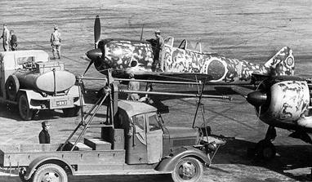

## DETAIL OF PRODUCTION IN 1944 BY SOURCES

JAPAN AND TAIWAN*

Table 33. Detail of production in 1944 by sources.

Japan & Taiwan* Refined Product Quantities in thousands of barrels

|  |  |  |  |  |  |  |  |
| --- | --- | --- | --- | --- | --- | --- | --- |
|  | Crude | Aviation Gasoline | Motor Gasoline | Fuel | Lube | Kerosene | Total |
| Production | 3,000 | 300 | 300 | 1,143 | 531 | 276 | 2,550 |
| Casing head gasoline | 320 | 110 | 210 |  |  |  | 320 |
| Coke & Gas |  |  | 46 | 969 |  |  | 1,015 |
| Benzol |  |  | 432 |  |  |  | 432 |
| Vegetable oils & animal oils |  |  |  |  | 150 |  | 150 |
| Low Temp Carb. |  |  | 11 | 85 |  |  | 96 |
| Hydrogenation |  |  | 661 | 632 |  |  | 1,293 |
| Hydrocarbon Synthesis |  | 165 | 2,581 | 1,093 | 35 |  | 3,874 |
| Reclamation |  |  |  |  | 250 |  | 250 |
| Total |  | 575 | 4,241 | 3,922 | 966 | 276 | 9,980 |

* Taiwan crude production is less than 100,000 barrels annually and casing head gasoline is estimated at 130,000 barrels. Taiwan has no other petroleum production or synthesis except that it probably is turning alcohol into butanol, claimed by the Japanese to be used as an ingredient of aviation gasoline.

Table 34. Taiwan (also known as Formosa) - Crudes

Sakhalin

|  |  |  |  |  |  |  |  |
| --- | --- | --- | --- | --- | --- | --- | --- |
|  | Crude | Aviation Gasoline | Motor Gasoline | Fuel | Lube | Kerosene | Total |
| Crude | 100 |  |  | 55 | 20 | 15 | 90 |
| Low Temp Carb. |  |  |  |  |  |  | 0 |
| Hydrogenation |  | 53 | 209 | 200 |  |  | 462 |
| Total |  | 53 | 209 | 255 | 20 | 15 | 552 |

Korea

|  |  |  |  |  |  |  |  |
| --- | --- | --- | --- | --- | --- | --- | --- |
|  | Crude | Aviation | Motor Gasoline | Fuel | Lube | Kerosene | Total |
| Low Temp Carb. |  |  | 11 | 96 |  |  | 107 |
| Hydrogenation |  | 150 | 598 | 572 |  |  | 1,320 |
| Total |  | 150 | 609 | 668 |  |  | 1,427 |

Manchuria

|  |  |  |  |  |  |  |  |
| --- | --- | --- | --- | --- | --- | --- | --- |
|  | Crude | Aviation Gasoline | Motor Gasoline | Fuel | Lube | Kerosene | Total |
| Coke & Gas |  |  | 31 | 646 |  |  | 677 |
| Benzol |  |  | 288 |  |  |  | 288 |
| Vegetable & animal oils |  |  |  |  | 100 |  | 100 |
| Distilled form Shale |  |  | 1,811 | 2,940 |  |  | 4,751 |
| Hydrogenation |  | 375 | 1,500 | 1,434 |  |  | 3,309 |
| Hydrocarbon Synthesis |  |  | 1,122 | 475 | 16 |  | 1,613 |
| Total |  | 375 | 4,752 | 5,495 | 116 |  | 10,738 |
| Grand Total |  | 1,153 | 9,811 | 10,340 | 1,102 | 291 | 22,697 |

N.E.I. and Borneo

|  |  |  |  |  |  |  |  |
| --- | --- | --- | --- | --- | --- | --- | --- |
|  | Crude | Aviation | Motor Gasoline | Fuel | Lube | Kerosene | Total |
| Seria (light non-waxy) | 6,000 |  |  | 6,000 |  |  | 6,000 |
| Seria (light paraffinic) | 9,600 |  | 2,400 | 6,820 |  |  | 9,220 |
| Tarakan | 3,600 |  |  | 3,600 |  |  | 3,600 |
| Djambi (heavy) | 1,500 |  |  | 1,250 | 200 |  | 1,450 |
| Djambi (light) | 12,000 | 1,920 | 4,800 | 4,680 |  |  | 11,400 |
| Mangoondjaja | 1,200 |  |  | 1,200 |  |  | 1,200 |
| Talang Akar | 7,800 | 710 | 1,400 | 2,960 |  |  | 5,070 |
| Kawengan | 3,600 |  | 400 | 1,710 | 300 |  | 2,410 |
| Kroeka | 600 |  | 180 | 400 |  |  | 580 |
| Rantau | 6,000 | 1,260 | 2,760 | 1,680 |  |  | 5,700 |
| Ledek, Nglebo | 500 |  | 150 | 330 |  |  | 480 |
| Boela | 240 |  |  | 240 |  |  | 240 |
| Louise & Anganna | 1,500 | 70 | 270 | 720 | 250 |  | 1,310 |
| Total | 54,140 | 3,960 | 12,360* | 31,590 | 750 | 0 | 48,660 |
| Grand Total |  | 5,113 | 22,171 | 41,930 | 1,852 | 291 | 71,357 |

* This quantity of gasoline must be produced in order to secure requisite fuel oil, but we estimate that only 3,000,000 Bbls, of aviation gasoline and 675,000 Bbls of motor gasoline will be moved to Japan or into consumption in the southern Pacific for military purposes. Deducting, therefore 960,000 Bbls aviation and 11,685,000 (Bbls) motor gasoline or 12,645,000 barrels (total gasolines) from 48,660,000 (Bbls) leaves a figure of 31,015,000 (Bbls) produced in the East Indies and moved or consumed; and a quantity of 58,712,000 Bbls as total usable production in 1944.

Appendix A

Japan’s Petroleum Requirements Production and Supplies for 1944 - Report by the Enemy Oil Committee

Table 35. Japan’s Petroleum Requirements Production and Supplies for 1944.

Refined product in thousands of barrels (42 US gallons)

|  |  |  |  |  |  |  |
| --- | --- | --- | --- | --- | --- | --- |
|  | Aviation | Motor Gasoline | Diesel & Fuel Oil | Lube Oil | Kerosene | Total |
| Stock 1 January 1944 | **6,888** | **7,071** | **25,764** | **3,034** | **763** | **43,520** |
| **Production** | | | | | | |
| Japan crude (3,000) | 300 | 300 | 1,143 | 531 | 276 | **2,550** |
| Casing head (320) | 110 | 210 |  |  |  | **320** |
| Sakhalin crude (100) |  |  | 55 | 20 | 15 | **90** |
| From East Indies crude (54,140,000) | 3,000 | 560 | 31,590 | 750 |  | **36,015** |
| From Burma crude |  | 115 |  |  |  |
| Distilled from Shale |  | 1,811 | 2,940 |  |  | **4,751** |
| Coke Oven & Gas Industry |  | 77 | 1,615 |  |  | **1,692** |
| Benzol |  | 720 |  |  |  | **720** |
| Motor Alcohol |  | - |  |  |  | **-** |
| Vegetable & Animal Oils |  |  |  | 250 |  | **250** |
| Low temperature carbonization |  | 22 | 181 |  |  | **203** |
| Hydrogenation | 742 | 2,969 | 2,838 |  |  | **6,549** |
| Hydrocarbon Synthesis |  | 3,703 | 1,568 | 51 |  | **5,322** |
| Reclamation |  |  |  | 250 |  | **250** |
| **Total Production in 1944** | **4,152** | **10,487** | **41,930** | **1,852** | **291** | **58,712** |
| **Total Supply in 1944** | **11,040** | **17,558** | **67,694** | **4,886** | **1,054** | **102,232** |
| **Requirements** | | | | | | |
| Civil Consumption |  | 1,000 | 12,000 | 2,000 | 720 | **15,720** |
| Military Consumption | 4,200 | 2,675 | 27,000 | 610 |  | **34,485** |
| Captured Stocks |  | 425 | 700 | 63 | 198 | **1,386** |
| Tanker Losses | 50 | 50 | 400 |  |  | **500** |
| Evaporation 3% | 205 | 416 |  |  |  | **621** |
| **Total Consumption** | **4,455** | **4,566** | **40,100** | **2,673** | **918** | **52,712** |
| Balance Stocks | 6,585 | 12,992 | 27,594 | 2,213 | 136 | **49520** |
| Deduct Tied Stocks | 570 | 750 | 9,300 | 353 | 84 | **11,057** |
| **Balance Operational Stocks 1 January 1945** | **6,015** | **12,242** | **18,294** | **1,860** | **52** | **38,463** |

# Some Experiments – Aviation Fuels & Lubricants in World War II

While there was limited information available on Japanese activities, most of this came from Allied intelligence sources. There was however one interesting paper in April 1955 from the Japanese perspective titled “Some Experiments On Aviation Fuels And Lubricants Carried Out In Japan At The End Of The Second World War” by Yoshihiko Kano who was the former manager of Mitsubishi Oil Company Research Laboratory.[24]. Much of that enlightening paper is presented here (Explanatory comments are shown in italics):

Introduction

During the Second World War, Japan use 14 cylinder, double row air cooled radial aero-engines for 1,000 to 1,500 HP (horsepower) represented by engines named ‘Sakae’ 10 type and 20 type, and ‘Kensei’ 40 type and 50 type; and 18 cylinder double row air cooled engines for 1,500 to 2,000 HP represented by engines names ‘Mamori’ and ‘Homare’. The production of aero-engines in 1944 amounted to 40,700, of which 94% (39,600) were air-cooled. Nearly at the end of the war, Japan completed the type test of 3,100 HP, 22-cylinder double row radial air-cooled engine, the performance of which surpassed the rest of the world in those days.

(Comment: Air cooled radial aero engines were favoured by most naval aviation forces around the world (particularly the U.S. Navy). The reasons were: (1) Radial engines were more compact than in-line liquid cooled engines, so the aircraft were more compact - an essential factor in limited aircraft carrier hanger space, (2) air cooled meant that there was no need for a coolant and associated supply systems, which could be subject to battle damage. (3) Radial engines could take considerably more battle damage than in-line engines, e.g. radial engines have operated with the loss of a cylinder (blown away by cannon fire) and still enabled the aircraft to return to base).

To fulfil the high performance required on these engines satisfactorily, high antiknock fuels and superior mineral lubricants of equal grade as used in America were naturally required. However, due to the American moral embargo. The measure for producing such fuels and oils were not enough in this country and therefore Japan had to find some counter measures for the long term war according to the following methods which had been studied and partly put in practice before the war.

The methods referred to above were:

The adoption of water-alcohol auxiliary injection pumps, the studies of which were completed in 1940.

The adoption of fuel injection pumps instead of carburettors, the studies of which were completed in 1940.

The use of iso-octane (produced by dehydration, isomerization, polymerization, and hydrogenation of normal butanol obtained by fermentation of corn, and by synthesis of Ethylene C2H2, and Benzex (?), the Edeleanu extract for the blending fuels. The studies on changing normal butanol into iso-octane and on changing CH4, C2H6 and C2H4 contained in natural gas or petroleum cracked gas into C2H2 by the electric arc decomposition process were completed in 1935 and 1934 respectively, and had been put in practice before the war.

The use of the base gasoline obtained by hydrogenation of cracked gasolines and gas oils, and by catalytic cracking of gas oils.

The use of 87 and 92 Octane ethyl gasolines (both TEL 0.1%) which had the following fractional distillation characteristics as the combat grade fuel.

Table 36. Japanese Combat Grade Aviation Gasolines

|  |  |
| --- | --- |
| Distillation | Deg. C |
| Initial Boiling Point | 60 max. |
| 10% point | 80 max. |
| 50% point | 105 max. |
| 90% point | 150 max. |
| 97% point | 170 max. |
| Sum 10%, 50%, 90% points | 260 min. |

1. The use of aviation mineral lubricants produced by the following methods.

Acetone-benzol dewaxing process

Barisol dewaxing process

Furfural refining process

Duo-Sol refining process

Amyl alcohol-Furfural refining process. (The study of this process was completed by Mr. Kano and his associates in 1939).

Fischer’s synthetic process

Thermal decomposition and polymerization of wax.

Refining process of shale oil (This process was studied by Mr. Kano and associates during 1934-39 and put into practice at Fushin, South Manchuria).

Voltol process (under construction at the time of armistice -1945)

Mineralization process of animal and vegetable oils. (Methods of Nippon, Dai Nippon, Lion and Honen Oil and Fat Companies were adopted)

Refining process of gum

After 1943, the import of the southern oil became hard to obtain because of the severe attacks by American submarines, and in the autumn of 1943, to meet the urgent need for increasing the production of aviation gasoline, Japan had to change the practical specification as follows:

Cut down the highest octane number to 91.

Change the fraction distillation characteristics as follows:

Table 37, Changes in Japanese Aviation Gasolines due to supply shortages 1943

|  |  |  |  |
| --- | --- | --- | --- |
| Grade (Octane Number) | 91, 87 | 87, 85 | 80,70 |
| Remarks | For combat aircraft | For low boost and cruising | For training aircraft and torpedo boats |
| Distillation | Deg. C | Deg. C | Deg. C |
| Initial Boiling Point | 60 max. | 70 max. | 70 max. |
| 10% point | 80 max. | 90 max. | 95 max. |
| 50% point | 115 max. | 125 max. | 140 max. |
| 90% point | 150 max. | 180 max. | 200 max. |
| 97% point | 170 max. | 200 max. | 220 max. |
| Sum 10%, 50%, 90% points | 260 min. | 260 min. | - |

1. To increase TEL up to 0.15% in the Japanese Navy and 0.2% in the Japanese Army.

To study and put into practice the mixing of alcohol, acetone, aniline, and or butanol with the gasoline.

And, at the same time, the military instructed oil companies to cooperate in these changes.

In September 1944, the Japanese Ambassador to Sweden informed the government that in Sweden gasoline was manufactured from something like pine-root crude oil. There upon, the military commenced the study suddenly and gave instructions to oil companies to cooperate in the study.

The report describes a number of studies carried out on full-scale single cylinder engines and with regular aircraft engines, and later with flying tests with front line aircraft.

Water-Alcohol Auxiliary Injection

Some 30% to 70% of the water/alcohol mixture for the quantity of fuel was injected into the charging manifold in the opposite direction to the charge. By this means, the same power output was obtained with 300g/HP/hr. of 87 octane fuel as with 370g/HP/hr. of 100 octane fuel. And, if 100 octane fuel had been used, some higher performance unattainable in those days could have been realized by the same means. Soon after this method was adopted by the military.

The quantity of water-alcohol mixture thus needed was little, as it was used only in case of take-off or other high boost time. The corrosion caused by water was prevented perfectly by adding 0.03% of Potassium Dichromate or 0.3% of specially emulsified oil. 10 to 50% of alcohol was blended to prevent the freezing of the water.

Aircraft Engine Tests with Heavy Gasoline

The shortage of aviation gasoline resulted in studies into extending the gasoline yield available for aviation. Purposes, this was a heavy gasoline almost akin to motor gasoline. These studies also included increasing the TEL content of this gasoline. The heavy gasoline was produced from Light Seria crude. The characteristics of this gasoline were as follows:

Table 38. Japanese Heavy Gasoline studies

|  |  |  |  |  |  |
| --- | --- | --- | --- | --- | --- |
| Grade | S0  Regular Avgas | S1 | S2 | S3 | S4 |
| Specific Gravity (15/4 deg. C) | 0.756 | 0.771 | 0.783 | 0.796 | 0.817 |
| Reid Vapour Pressure kg/cm2 at 40 deg. C  RVP (psi) | 0.37  5.3 | 0.32  4.6 | 0.32  4.6 | 0.22  3.1 | - |
| Distillation (deg. C) | | | | | |
| Initial Boiling Point | 45 | 51 | 62 | 63 | 63 |
| 10% point | 74 | 82 | 90 | 103 | 131 |
| 50% point | 103 | 121 | 130 | 149 | 164 |
| 90% point | 159 | 179 | 188 | 192 | 196 |
| 97% point | 187 | 200 | 208 | 216 | 222 |
| Octane (CFR Motor Method) | | | | | |
| Octane Clear | 76.8 | 72.6 | 71.5 | 69.0 | - |
| Octane 0.1% TEL | 87.2 | 85.4 | 84.8 | 83.8 | 82.0 |
| Octane 0.2% TEL | 91.2 | 89.3 | 88.6 | 87.3 | 86.4 |
| Octane 0.3% TEL | 93.1 | 91.3 | 90.8 | 90.0 | 89.1 |

All fuels used in these tests contained Ethylene Dibromide C2H4.Br2 of one theoretical equivalent to TEL.

The results of these tests showed:

With heavy gasoline capable of the same maximum power as Regular 87 Aviation Gasoline, the gasoline yield from Light Seria crude oil would increase from 11% to 30%, but the TEL content should be increased by 0.18%.

For multi-cylinder fuel injection engines, the volatility of the fuel was a problem with fuel distribution to each cylinder. It was indicated that modification of the fuel specification was required.

By mixing Acetone, Aniline, and other blending fuels with S3 (at 0.2% TEL) it was expected that the same maximum power output could be developed as that of regular 91 Octane aviation gasoline.

As to the prevention of the contamination and deterioration of sparkplugs due to the increase of TEL, another study would be necessary. (The solution would be increased Ethylene Dibromide content to 1.3 theoretical equivalents, and 0.5 theoretical equivalents of Ethylene Dichloride).

Heavy Gasoline and Acetone

In these tests, the maximum power output and other performance properties were investigated, comparing heavy gasoline 80% - Acetone 20% blend, with those obtained from heavy gasoline, and regular 91 Octane aviation gasoline. This study showed that while the Acetone/heavy gasoline blend had comparable power outputs, it should only be used at low air-fuel ratios, charging air temperature over 100 degrees C. was required, and that minimum fuel consumption at cruising increased by 7%, and so it would be unfavourable for use in long flights.

Flight Tests with Heavy Gasoline

Following bench engine tests in March 1944 by the Japanese Naval authorities at the Nagoya Aero-Engine Laboratory of Mitsubishi Heavy Industries Ltd., the Japanese Army undertook flight tests with this experimental aviation gasoline in April 1944 using two different engine types (in-line and radial). The combat aircraft used were (a) Kawasaki Ki-61 “Hien” fitted with Ha-40 engine (in-line inverted V-12 German Daimler-Benz series engine), and (b) Mitsubishi Ki-46 III fitted with Ha-112 II radial engines.

Photo 23. Kawasaki Ki-61 “Hien” (also known by the Allies as ‘Tony’) with in-line Ha-40 engine similar to the type used in fuel trials 1944.

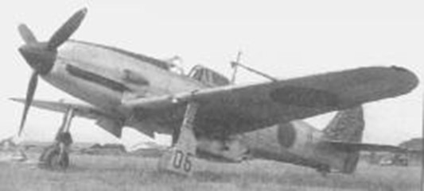

Japanese Army fighter. The only Japanese fighter of the war powered by an in-line engine. Code named "Swallow." This aircraft was one of the few examples of German-Japanese technical cooperation in the war. Using a submarine, Germany sent blueprints and two working examples of its excellent Messerschmitt Bf-109, including the Daimler Benz DB 601A engine. Modified for Japanese production, the Ki61 emerged, a good fighter in theory, but which always bedevilled the Japanese in their attempts to build it in numbers, build it reliably, and maintain it in the field. The Japanese Army Airforce deployed the ‘Tony’ to Rabaul in New Guinea. One-on-one, a well-maintained Ki-61 Tony, with a good pilot, could threaten any Allied (U.S.) fighter. But difficulties with production, maintenance, and pilot training made that the exceptional case.[25]

Tests using this Ki-61 (Fighting Aircraft) were carried out in June 1944 at Fossa Aerodrome near Tokyo. As many test pilots had been lost, the tests were not conducted satisfactorily, but the following results were obtained.

Take-off, climbing, cruising and acrobatic flights were satisfactory.

Performances in the air were almost equal to those obtained with the regular 92 Octane aviation gasoline, but fuel consumption increased a little. The exhaust temperature was lower by 10-20 deg. C.

The carbon deposits on the spark plug (RS-41) was a little more.

Some pilots ‘felt bad smell and stimulation’ of the exhaust gas.

There was no particular defect for practical use.

Tests using the Mitsubishi Ki-46 II (Scouting Aircraft) were carried out in July 1944 at Kagamigahara Aerodrome near Gifu City. As the Ha-112 engines had been well studied in bench tests, all flight tests were completed with no problems, and the possibility of using this fuel (heavy gasoline) for practical purposes was confirmed.

(Comment. In mid-1944, at the battle for the Mariana Islands, many seasoned Japanese naval pilots were lost, and this together with the forthcoming U.S. B-29 bomber raids would start to limit the resources both in avgas and pilots that the Japanese could afford on such research.)

Photo 24. Mitsubishi Ki-46 II “Dinah” with Ha-112 radial engines similar to the type used for fuel trials 1944.

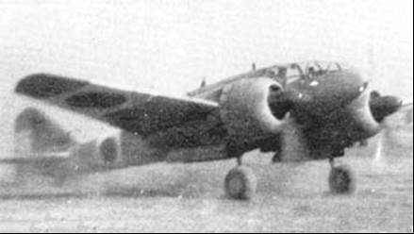

Photo 25. Mitsubishi Ki-46 Type II “Dinah” on display at RAF Cosford Museum UK (2000).

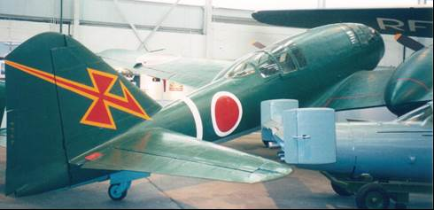

(A Japanese piloted flying bomb Yokosuka MXY-7 Ohka “Baka” is located to the right of the aircraft).

The flight tests for the Mitsubishi Ki-46 II “Dinah” aircraft were:

1. Continuous use for 70 hours.
2. Take-off and climbing - 5 times. Full power climbing test was carried out including starting conditions.
3. Full speed test – 15 times. Five times each at altitudes 2,000m (6,560 ft.), 3,000m (9,840 ft.), and 6,000m (19,685 ft.)
4. Cruising speed test – 6 times. Twice each at altitudes 2,000m (6,560 ft.), 3,000m (9,840 ft.), and 6,000m (19,685 ft.)

The characteristics and constituents of the test fuel used in these trials was:

Table 39. Japanese experimental fuel for flight tests - April 1944

|  |  |
| --- | --- |
| Property | |
| S3 gasoline from Heavy Seria crude | 95% (vol.) |
| Acetone | 5% |
| Butanol | 1% |
| TEL | 0.3% |
| Ethylene Dibromide (theoretical equivalents) | 1.3 T |
| Ethylene Dichloride (theoretical equivalents) | 0.5 T |
| Specific Gravity (15/4 deg. C.) | 0.801 |
| Reid Vapour Pressure kg/cm2 at 40 deg. C  RVP (psi) | 0.2  2.8 |
| Initial Boiling Point (deg. C) | 50 |
| 10% point (deg. C) | 90 |
| 50% point (deg. C) | 146 |
| 90% point (deg. C) | 196 |
| 95% point (deg. C) | 207 |
| End Point (deg. C) | 227 |
| Octane Number (MON) | 91.0 |

# Avgas from Pine-Root Tar

Perhaps one of the most curious topics of research was the investigation of producing avgas from pine-roots; this demonstrated the desperate measures that the Japanese were taking to obtain this previous aviation gasoline. By contrast, the Americans were producing an abundance of avgas, enough to support the Allied forces in the Pacific War and most of the European theatre.

Since the early days, pine-root oil had been produced at many places in Japan by dry or steam distillation of pine roots in small pot stills, or by solvent extraction to make solvents, agricultural medicines, paints, etc. There were three kinds of pine root oil in Japan:

‘Pine-root crude oil’ - oil condensed in the condenser with a boiling point <250 deg. C.

‘Pine-root tar’ - tar separated in the separator with a boiling point >250 deg. C.

Mixed pine-root crude oil which was a mixture of the two above.

The total production in 1940 was nearly 6,200 tons.

However, in September 1944, the Japanese military commenced a study of the production of aviation gasoline from mixed pine root crude oil due to the dramatic shortage of aviation gasoline. Soon after that, the Japanese Navy succeeded in the study, using a fraction below 300 deg. C, and planned a mass production of pine root crude oil amounting to 200,000 tons at the end of 1945.

Figure 13. Gasoline from Pine Root Crude Oil – Japan 1944

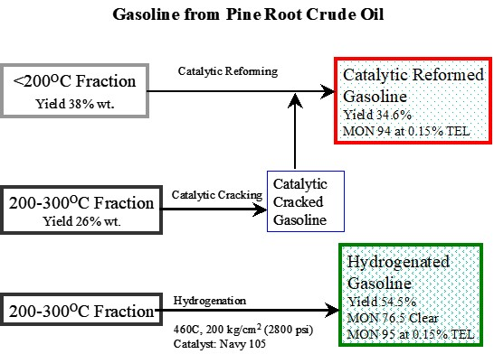

However, the gasoline produced from this process was heavy and did not meet the specifications for aviation gasoline distillation. Therefore, it needed the addition of some alcohol or light gasoline. Later, the yield, distillation characteristics, and octane number were vastly improved by using Molybdenum Sulphide (MoS3) catalyst. Octane number attained at 0.15% TEL was 96.7 MON.

In December 1944, the Japanese Navy asked Mr. Kano to undertake a study on refining pine-root tar. He was given 6 months to complete the study.

The components of pine root crude oil distilling below 300 deg. C. had been fairly well known through the literature, but as for those above 300 deg. C., little was known except that it was almost composed of ‘abietic acid’

Abietic Acid[26] C20H30O2 (CAS No. 514-10-3) MW 302.46 RC Index 9167

Figure 14. Abietic Acid

1-Phenanthrenecarboxylic acid, 1,2,3,4,4a,4b,5,6,10,10a-decahydro-1,4a-dimethyl-7-(1-methlyethyl)-

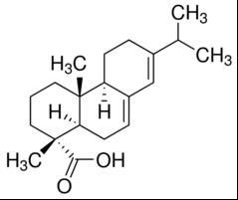

Other similar compounds which may be present C20H30O2 (MW 302.46) are Palustric acid (CAS No. 1945-53-5) and Levopimaric acid (CAS No. 79-54-9)

In 1940, Mr. Kano has succeeded in producing a base gasoline of 75 octane (clear), and 91 Octane at 0.1% TEL, by the high temperature and pressure hydrogenation of low temperature carbonization tar with a yield of 50% (volume). In a pilot plant study, he subjected the preheated pine root tar to the same hydrogenation, and obtained the following results in a number of tests. It appears from the results that the hydrogenated product below 180 deg. C. required further treatment to achieve a satisfactory product.

Reaction conditions: (Tests No. 5 &7)

Raw Material: Pine-Root Tar

Temperature 400 deg. C, & 420 deg. C.

Space velocity 0.5

Catalyst: Molybdenum Sulphide: Clay (1:1)

Hydrogen consumed: 4-6% (by wt.)

Water produced: 13-15% (by wt.)

Gas & loss: 11-12% (by wt.)

Table 40. Results of Tests No. 5 & 7

|  |  |  |
| --- | --- | --- |
| Test | 5 | 7 |
| Appearance of product | Reddish-brown clear liquid | Reddish-brown clear liquid |
| Specific Gravity (15/4 deg. C.) | 0.859 | 0.861 |
| Initial Boiling Point (deg. C) | 84.5 | 54 |
| 10% point (deg. C) | 110 | 100 |
| 50% point (deg. C) | 197 | 196 |
| 90% point (deg. C) | 294 | 296 |
| Yield to 180 deg. C. (%Vol.) | 43.0% | 43.6% |
| Yield to 200 deg. C. (%Vol.) | 51.0% | 52.3% |
| Yield to 300 deg. C. (%Vol.) | 91.5% | 91.0% |
| Yield over 300 deg. C. (%Vol.) | 8.5% | 9.0% |
| Characteristics of Hydrogenated Gasoline (<180 deg. C) | | |
| Yield Treated Hydrogenated <180C on pine-root tar (% Vol.) | 32.6% | 35.2% |
| Specific Gravity (15/4 deg. C.) | 0.789 | 0.790 |
| Initial Boiling Point (deg. C) | 66.5 | 69.5 |
| 10% point (deg. C) | 93.5 | 94.5 |
| 50% point (deg. C) | 125 | 127 |
| 90% point (deg. C) | 166 | 162 |
| 97% point (deg. C) | 182 | - |
| Sum 10%, 50%,90% points (deg. C) | 384.5 | 389.5 |
| Octane Number (MON) Clear | 77.0 | 77.7 |
| Octane Number (MON) 0.15% TEL | 92.6 | 92.9 |
| Unsaturated hydrocarbons (% Vol.) | 11.5 | 6.8 |
| Aromatic hydrocarbons (% Vol.) | 16.7 | 17.7 |
| Saturated hydrocarbons (% Vol.) (naphthenes, paraffins) | 71.8 | 75.5 |
| Aniline Point (deg. C.) | 38.8 | 39.0 |

In other tests, Re-hydrogenation of the Hydrogenated Gas Oil fraction (180-300 deg. C) using Molybdenum Sulphide catalyst produced a yield of gasoline fraction (<180 deg. C) between 42 to 48 %. From these tests, Mr. Kano concluded that high octane aviation gasoline could be produced from pine-root tar with the yield of some 50% by hydrogenation.

# Lubricants of Aircraft Engines

While the topic of this book is the History of Avgas, the following items on lubricants have been included to illustrate the difficulties that the Japanese faced in obtaining the necessary petroleum products to sustain their war effort.

Castor Oil for High Performance Aircraft Engines

The Japanese researchers undertook a study on the improvement of Castor Oil for use in high performance aircraft engines. Castor oil was an early aircraft engine lubricant used prior to, and during in the First World War, but it had been superseded by treated mineral oil lubricants which were more stable.

The greatest defect of castor oil (vegetable oil) as an aviation lubricant was its insufficient stability to heat and oxidation; this defect becomes more severe with the increased demands for higher engine performance. Under such conditions, it easily forms viscous gummy substances which cause sticking of piston rings. This fact led various manufacturing processes of mineral lubricants to make great progress, and high grade lubricants had been supplied at reasonable prices.

In Japan, high grade mineral aviation lubricants made in America (chiefly Airplane Oil 100 and Airplane Oil 120) were used from 1940, and also various manufacturing methods were studied and gradually put into practice. However, from about 1944, the shortage of imported products, the difficulty of imports of raw materials (wax, gum), and the lack of materials for lube plants under construction were experienced. Thus, there was an urgent need to study the improvement of castor oil for high performance aircraft engines. Antioxidants such as Guanidine Carbonate added at 0.2% in castor oil were successful in a single cylinder engine.

Other studies were carried out in 1944 at the Research Laboratory of Mitsubishi Oil Co. There were considerable difficulties to obtain materials for antioxidants. Nevertheless, fundamental research on such materials as alkyl amine, aromatic amine, alky phenol, sulfide, thiazol, metallic sale of fatty acid, etc. were conducted and phenyl-β-naphthylamine alone or plus copper ricinoleate was found to be comparatively effective.

As for the method of improving viscosity index and viscosity, the mixing of the air-blown refined peanut oil, the air blown castor oil, the polymerized castor oil, and the polymerized soy-bean oil with castor oil, and the esterification of castor oil with stearic acid were studied.

However, just as aircraft engine tests were to commence at the Second Aeronautical Research Institute of the Japanese Army, Tachikawa, near Tokyo, both the Institute and the Oil Refinery of the Mitsubishi Oil Co at Kawasaki City were almost completely destroyed by heavy allied air raids, and the tests were abandoned.

Aircraft lubricants from Fish Oil

In November 1939, the following item was published in the Journal of Ind. and Eng. Chem. Volume 17, No. 22, it was later reported in other abstracts[27] as follows: The Japan Oil and Fat Company has decided to industrialise its process of manufacturing aircraft lubricants from fish oil. Besides whale oil, sardine and herring oils will serve as raw materials. The oil produced by the company’s secret process is supposed to be superior in quality.

# “Target – Destroy Japan’s Oil Industry”

In the Pacific, great naval battles would be fought using aircraft flown from aircraft carriers where the opposing ships never sighted each other. Therefore, all those involved knew the importance of maintaining and securing supplies of petroleum products. For the Allies a major part of their strategy was to destroy the Axis oil industry, and this would be demonstrated by the strategic targeting by the bomber forces of both U.S. Army Air Forces and Australian R.A.A.F. Their targets were the refineries, chemical plants, oil depots and supply routes. After the Allied victory in Europe, the American and Australian air forces would be joined by the Royal Navy Fleet Air Arm to attack the refineries in Dutch East Indies and British Borneo occupied by Japanese forces. These would be known as ‘Operation Meridian’.

In 1945, as MacArthur’s American forces island hopped along the Marianas and Philippines on their way to attack Japan, the Australian Army would recapture the Dutch and British oil possessions of Balikpapan, Palembang, Pladjoe and Tarakan, as part of ‘Operation Oboe’. This is discussed in later chapters on the East Indies.

As with any conflict, there is always a need for intelligence on the enemy’s capabilities. This extended to war materials as well, and so captured documents were an important source of information.

Photo 26. Allied Liberator B-24 bombers attack Japanese held Balikpapan 1944

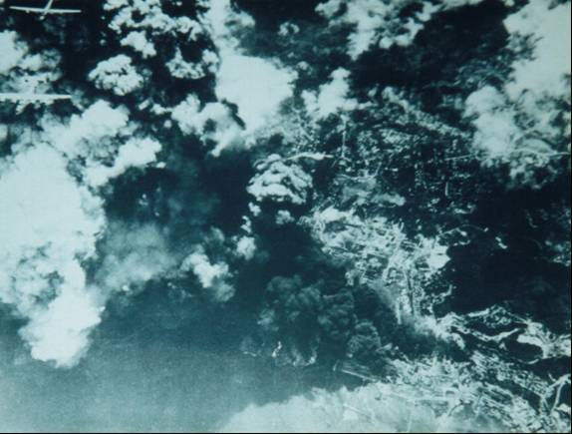

The first air raid by the Allies on Balikpapan was August 1943, but this had no effect until the raids in August 1944.

# “Airspeed records Japan takes the record 1943”

The war effort put paid to the air races as fuel and aircraft were now essential war materiel. The interest was now in faster and better military aircraft; however, some speed records were still noted – all from military aircraft. In this period the (land-based) aircraft achieved the following:

Table 41. Air Speed Record 1943

|  |  |  |  |  |
| --- | --- | --- | --- | --- |
| Date[28] | Location | Pilot | Aircraft | Achieved Km/hr |
| 27 Dec 1943 | Japan | unknown | Kawasaki Ki 78 (Ken-3) | 700 |

Photo 27. Air Speed Record Holder -1943 - Kawasaki Ki-78[29]

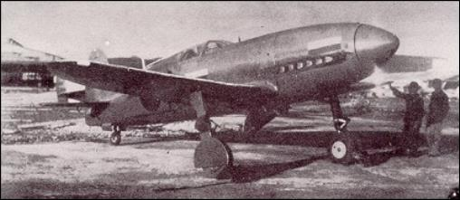

Crew: 1, engine: 1 x Daimler-Benz DB-601A, 880 kW (1550 hp), wingspan: 8 m, length: 8.1 m, height: 3.07 m, wing area: 11 m2, start mass: 2300 kg, empty mass: 1930 kg, max speed: 700 kph (435 mph), ceiling: 8,000 m. (26,000 ft.), range: 600 km (370 miles). The first prototype flew on December 26, 1942.

# Epilogue for the Japanese years – Desperate measures.

Japan, like the other Axis powers, suffered from lack of supply and quality of aviation gasoline, but not imagination and innovation. In their preparation for war, they systematically sought information and technology from around the world, modifying and adopting it to meet its needs. They also stockpiled as much crude oil and aviation products fuels and lubricants with the expectation of a short war with America. This would not be the case and the Pacific War would drag on for five long years over many islands and countries and the vast Pacific Ocean. It would see the emergence of the aircraft carrier and naval air power as the mainstay of the opposing navies.

From the commencement of war and the Axis formation, the technology became somewhat dependent on Germany, however as both their fortunes of war declined this source essentially vanished. Initially Japan’s ambitions were the conquest for oil, denied to them by the oil embargo. As the war progressed, and defeat was evident, desperate measures were adopted to stop the foreign invaders, but to no avail.

The end of Japan’s military expansion would come with two devastating events – the atomic bombs. ‘Little Boy” dropped on Hiroshima (August 7, 1945) by Colonel Paul Tibbetts in a Boeing B-29 bomber named ‘Enola Gay’, and ‘Fat Man’ dropped on Nagasaki (August 9, 1945) from another Boeing B-29 named ‘Bockscar’ piloted by Major Charles W. Sweeney.

# Index

# 

1

1 Ben 34

100-octane aviation gasoline 14, 15, 18, 35

100-octane fuel. 15

100-octane gasoline 18

2

2 Ben 34

3

345th Bomb Group 31

5

5th Air Force 31

6

62 Aviation Gasoline 45

7

73 Octane 35

75 octane (clear) 77

77 Aviation Gasoline 45

8

85 Aviation gasoline 33

85 Gasoline 36, 37, 38

87 Aviation Gasoline 45

9

90 Aviation gasoline 33, 40

90 Gasoline 36, 42

90 Gasoline A 41

90 Gasoline B 41

91 Aviation gasoline 33, 43

91 Gasoline 45

91 Gasoline B 43

91 Octane 35, 72, 73, 77

92 Aviation Gasoline 45

92 Octane 18, 73

A

abietic acid 76

Acetone 34, 51, 70, 71, 72, 73, 75

Acetylene 53

Added Lead Test 48

Admiral Nomura 17

Agochi 55

Air General Order No. 6535 36

Air General Order No. 6537 45

Air General Order No. 12819 43

Air Specification Authorization No. 195 47, 48

Air Specification Authorization No. 239 36

Air Specification Authorization No. 240 45, 47, 49

Air Specification No. 13 39

Air Specification No. 280 Supplement ..37, 41, 42, 44, 46, 48

Air Specifications Authorization No. 705 43

Airplane Oil 100 79

Airplane Oil 120 79

alcohol 33, 34, 39, 68, 71

alkylamine 79

alkylate 18

alkylate synthesis process 54

alkylation 15, 18, 21, 56

alkyphenol 79

Allied Combined Chiefs of Staff 61

Allied Joint Intelligence Committee 61

Allied Translator and Interpreter Section South West Pacific 35

Alther 17

aluminum 16

Aluminum Company of America 20

Amagasaki 56

American Federation of Labor 19

American Hammered Piston Ring Company 20

Amyl alcohol-Furfural refining proces 70

aniline 71, 72

Aniline Point 78

animal oils 65, 66, 67

antioxidants 79

Army Air Specification No. 13, Supplement 42, 49

Army Air Specification No. 15 37, 41, 43

Army Air Specification No. 17 37, 41, 43

Army Air Specification No. 24 43

Army Air Specification No. 283 45

aromatic amine 79

aromatic hydrocarbon 36, 43, 78

Asano Bussan 58

Asiatic Petroleum 23

Assano Busam 56

Associated Ethyl 58

Associated Octel 56

Associated Oil Company 17

Astoria, Oregon 18

Australian Army 80

Australian Avgas Unleaded 35

Australian R.A.A.F. 80

Aviation 87 base gasoline 34

Aviation 87 Gasoline 34

Aviation 92 Gasoline 34

Aviation base gasoline 34

Aviation Ethyl Fluid 33, 37, 46

aviation fuel 16

aviation gasoline 3, 6, 13, 14, 15, 16, 18, 21, 22, 23, 28, 32, 33, 34, 35, 53, 54, 55, 56, 58, 61, 62, 63, 65, 66, 68, 71, 72, 73, 76, 79, 81

Aviation Gasoline 11, 12, 13, 62, 64, 65, 66, 67

Aviation Gasoline 90 39

Aviation Gasoline 91 39

aviation lubricant 79

Aviation Lubricating Mineral Oil 33

Avon 18

B

B-29 20

Balikpapan 33, 80

Bangka 23

Barisol dewaxing process 70

Base Gasoline 36, 41, 43

base stock 15, 21, 57, 65

benzene 39

Benzex 70

benzine 19

Benzol 33, 66, 67, 68

Bethlehem Steel Export Corporation 20

Billy Mitchell 27

bituminous coal 54

bituminous oil feed stock 54

Board of Economic Warfare 20

Boeing 307 Stratoliner 20

Boeing bomber 19

Borneo 6, 11, 22, 32, 67, 80, 88

British 26

British Avgas 87 34

British Navy 27

Bromine 34

brown coal 54

Brunei 22

Burma 22, 28, 63, 68

burning oil 54

butane 56

butanol 34, 71, 75

butylene dibromide 47

Butylene Dichloride 47, 48

Byoritsu Oil Refinery 31

C

Canton Prop Forgings & Manufacturing Company .20

carbonisation plant 8, 54

carbonization tar 77

casing head gasoline 66

Castor Oil 79

catalyst 15, 17, 54, 56, 76, 78

catalytic cracking 15, 16, 53, 56

catalytic naphtha re-forming process 18

catalytic reforming 17

catalytically cracked gasoline 36, 41, 43

CFR Motor Method 35

Charcoal absorption 56

chemical plants 80

Chiang Kai-shek 8

China 3, 6, 17, 26, 28, 32, 54

China Incident 8, 26, 27

Chinchow 56

Chlorine 54, 56

chlorine catalyst 54, 56

Chosen 7

chromic acid 39

coal feedstocks 8

coal hydrogenation 53, 54

coal tar 8

Congress of Industrial Organizations 19

Cooling Test 38, 42, 44, 49

Cooper Oil Company 18

copper ricinoleate 79

Cordell Hull 19

cracked gasoline 33, 70

cracking 15, 17, 32, 54, 70

Crude Oil 11

crude petroleum 54

cyclization 15

D

Dai Nippon Salt Co. 58

Daimler Benz DB 601A 73, 81

dehydration 70

dehydrogenation 15

Diesel 56, 62, 64

Diesel Fuel 11, 12

diesel fuel oil 18

direct distilled gasoline 36, 43

Distillation 34

Dobbs process 15

Douglas Aircraft Company 20

Dr. Ernest Donath 54

Dr. Mathias Pier 54

Duo-Sol refining process 70

Dutch East Indies 7, 11, 23, 80

E

East Asia Fuel Industries 57

East Indies 3, 4, 6, 8, 21, 22, 32, 62, 63, 64, 65, 66, 68, 80

Edeleanu extract 70

Eian 55

Embargo Act 19

Enemy Oil Committee 57, 61, 68

Enemy Publications No. 178 35

esterification of castor oil 79

Estero Bay 18

Ethane 56

Ethpro 34

Ethyl 33, 34, 41, 43, 37

Ethyl Corporation 56, 58

Ethyl Dibromide 58

Ethyl Fluid 34, 46, 47, 48, 56, 57

Ethyl Gasoline 56

Ethylene 70

Ethylene Chloride 56

Ethylene Dibromide 46, 56, 57, 58, 72, 75

Ethylene Dichloride 75

Existent Gum 35

explosives 19

F

Fairchild "24" 19

Fairchild Aviation 19

Far East 16, 17

Farmingdale, Long Island 19

Final boiling point 35

Fischer’s synthetic process 70

Fischer-Tropsch 8, 53, 54, 56

fish oil 79

floatplanes 25

flying boats 25

Flying Fortress B-17 bomber 20

Formosa 6, 7, 22, 31, 61, 64, 67

Fractional Distillation Test 37, 41, 44

Freezing Point 35

French Indochina 22

fuel injection 70

fuel oil 6, 8, 11, 18, 54, 62, 64, 65, 68

Fukio Horie 15

Fukuoka 33

Funada 17

Fupin coal 53

Furfural refining process 70

Fushin 8, 70

Fushun 54, 55

Fushun shale 54

Fussa Aerodrome 73

G

gas oil 54, 70

gasoline 18, 32, 54

gasoline plants 32

gasoline production 54

General Douglas MacArthur 21

General Hap Arnold 15

German 14, 21, 26

German Air Force 26

German Army 26

German treaty ports 6

Germans 53

Germany 26, 34

Gifu City 74

Grade 1 Methanol 33

Great Britain 22, 24

Guadalcanal 29

Guanidine Carbonate 79

Gulf Oil Corporation 18

gum 79

Gum Content Test 37, 39, 42, 44

gum formation preventative 33, 37, 41, 43, 49, 50

Gum Tester Apparatus 40

H

Ha-112 radial engine 74

Hackett 22, 88

Harley M Kilgore 14

Hartley Committee 61

heat-cracked gasoline 36

heavy gasoline 72, 73, 74

Heavy oil 32

Heavy Seria crude 75

Heijo 33

Henri Farman 24

herring oils 79

Hexane 34

HIDE, HAYAMI GUN, OITA Prefecture. 57

Hiroshima 57, 81

Hisashi Sekiguchi 15

Hodasgaya Soda 58

Hoden Oil Co. 7

Hodogaya Industrial Chemical Company Ltd. 44

HODOGAYA KAGAKU KOGYO 57

Hodogaya Kagaku Kogyo Kabushiki Kaisha 44

Hodogaya Ku, TENNO cho #791 57

Hokichi Inouye 17

Hokkaido 6, 8, 54, 55

Hollandia 35

Homare 69

Home Islands 9, 27, 28, 30

Honshu 6, 8

hydrazobenzene 47

hydrocarbon gases 54

Hydrocarbon Synthesis 66

Hydrogenated Gasoline 78

hydrogenation 53, 54, 55, 66, 67, 69, 70, 77, 79

hydrogenation of tar 54

hydrogenation plant 8, 53, 54

hydrogenation process 53, 54

hydro-oxynaphthalene 49

hydrotransforming 16

I

I.G. Farben 53, 54, 58

IJAAF 26, 28, 30

IJNAF 25, 26, 27, 28, 29, 30

Imperial Japanese Army 6, 24

Imperial Japanese Army Air Force 26

Imperial Japanese Navy 6, 27

Imperial Japanese Navy Air Force 24, 25

imported crude 7

India 22, 28

Initial Boiling Point 34, 72, 75, 78

Inner Zone 8, 10, 12, 13, 61, 62, 63, 64

International Hydrogenation Patents (I.H.P.) 53

Iso Octane 53, 57

Isobutanol 53

isomerization 15, 70

iso-octane 15, 16, 18, 21, 46, 53, 57, 70

Isopropyl ethyl 34

Italian 26

Italian Navy 27

J

James S Lay Jr. 61

Jane's All the World's Aircraft 26

Japan Gasoline Company 15, 16

Japan Oil and Fat Company 79

Japan Oil Co. 32, 53

JAPAN Standards Specification (JES No. 174) 37, 38, 41, 45

Japanese Antimonopoly Law 21

Japanese Army 6, 13, 22, 23, 53, 54, 55, 58, 61, 73, 79, 88

Japanese Army Air Headquarters 33

Japanese Army Air Special Aviation Ethyl Fluid 48

Japanese Aviation Gasoline Specification 34

Japanese Combat Grade Aviation Gasoline 70

Japanese Heavy Gasoline 72

Japanese Navy 8, 13, 33, 54, 61, 76, 88

Japanese refineries 7

Justice Department 17, 18, 20

K

Kagamigahara Aerodrome 74

Kamata 58

Kamikaze 30

Karafuto 61

Kawanishi H8K ‘Emily’ 29

Kawanishi N1K1 25

Kawasaki 24, 55, 73, 79

Kawasaki City 79

Kawasaki Ki 78 (Ken-3) 80

Kawasaki Ki-61 73

Kensei 69

Kerosene 11, 62, 64, 65, 66, 67, 68

Kilgore 16, 17, 20

Kilgore Committee 14, 17, 20, 21

Kinsei 53, 54, 55

Kirin 55

Komering 23

Korea 6, 7, 22, 61, 64, 67

Koriyama 57

Koriyama (Fukushima) TANIJIMA #53 57

KÜ 87 Gen Ki 34

KÜ Gen KI 34

Kwantung 7

Kyofu "Mighty Wind" 25

Kyushu 8, 28

L

Laos 22

lead 15, 35, 21, 56, 58

Lead Addition Test 46

lead antiknock additive 56

lead oxide 56

lead scavenger 56

Lead-Sodium mix 56

lecithin 49

Levopimaric acid 77

Liberator B-24 bomber 80

light gasoline 76

Light Seria crude 72

Los Angeles 18

Low Temp Carb. 66, 67

Low temperature Carbonisation 55

Lube Oil 62, 68

Lubricants 65

lubricating oil 11, 54, 63, 64

Luftwaffe 26

Lurgi 53

M

Major General John H. Hilldring 20

Makdem 54, 55

Malay Peninsula 3, 6

Malaya 22, 23

Mamori 69

Manchukuo 53, 54

Manchuria 6, 8, 26, 32, 54, 61, 64, 67, 70

Manshu Salt Co. 58

Marco Polo Bridge Incident 26

Marianas 80

Mariana Islands 13, 61, 74

Mariana Turkey Shoot 13

Marifu 57

Maritime Oil Company 18

Mark 1 Benzol 34

Mark 2 Benzol 34

Mark 6A Gasoline 34

Masao Saneyoshi 15

Mc Chord Field 18

Medan 23

Meiji Restoration 6, 24

Messerschmitt Bf-109 73

Mexico 18

Midway 13

Miike (Omuta) 56

Miikoa (Omuta) Plant 56

Military Affairs Committee 14

Miri 22

Mitani 18

Mitsubishi 19

Mitsubishi A6M Zero 25, 28

Mitsubishi A6M3 Zero 29

Mitsubishi A6M5 29, 32

Mitsubishi G3M 26, 27

Mitsubishi G4M1 30

Mitsubishi G4M2e Model 24J (‘Betty’) 30

Mitsubishi Heavy Industries Ltd 73

Mitsubishi Ki-46 II 74

Mitsubishi Ki-46 III 73

Mitsubishi Oil Company 16, 17, 69, 79

Mitsubishi San Francisco 17, 18

Mitsubishi Sekiyu 23

Mitsubishi Trading Company 17

Mitsui office 20

Mitsui-Ethyl. 58

Molybdenum Sulphide 76, 77, 78

molybdenum 16

moral embargo 16, 18, 19, 70

motor gasoline 56, 58, 62, 63, 65, 68, 72

Motor Gasoline 11, 12, 13, 62, 64, 65, 66, 67

Mr. Kano 70, 76, 77, 79

Mukdei 55

Mukden 54

Mukden Incident 26

Musi 23

N

Nagasaki 81

Nagoya 55, 73

Nagoya Aero-Engine Laboratory 73

Naibuchi 55

Naihoro 55

Nakajima A6M2-N 25

Nakajima Ko-2 Trainer 24

Nanking 26

naphtha dehydrogenation 54

naphthenes 78

Navy Ministry, Bureau of Munitions 33

Nells 26

neohexane 18, 34

Netherlands 8, 21, 22, 88

Netherlands East Indies 22

Nieuport 10 24

Nieuport 83 E.2 24

Nieuport fighter 24

Nihon Sekiyu 23

Nippon Oil Co. 7, 16

NIPPON SEKIYU 57

Nippon Soda 57, 58

No. 1 Refinery 23

No. 2 Refinery 23

normal butanol 70

normal heptane 46

North China 61

O

Ocon Petroleum Processes Corporation 18

Octane 34

Octane (CFR Motor Method) 72

Octane Number 71

Octane Number (MON) 75, 78

Octane Rating 18, 35

Octane Value Test 37, 41, 44

Office of Intelligence Branch 22

Ofuna Oil Refinery 33

Ofuna 57

Ogan 23

oil depots 80

Oil Refinery 79

Oil Transport 63

Oji Ku Kamiya cho NICHOME #1042 57

Okura 19

Okura Company 18

Operation Meridian 80

Operation Oboe 80

Orchard Liske 19

Otsu-1 24

Oxidation temperature 50

oxygen 51

Oxygen pressure 50

P

Pacific Northwest 18

Palembang 23, 80

Palustric acid 77

Pangkalan Brandan 22

Pangkalan Susu 22

paraffin 54

paraffins 78

patents 17

peanut oil 79

Pearl Harbour 3, 4, 14, 18, 27, 28

Pearson Field 18

peat, 54

phenyl-β-naphthylamine 79

Philippines 80

phosphorous 49

pine root crude oil 71, 76

pine root tar 76, 77

Pladjoe 22, 23, 80

Polish Air Force 26

polymerization 70

Polymerization Process 15

polymerized castor oil 79

polymerized soy-bean oil 79

Potassium Bichromate 71

Prabumulih 23

President Roosevelt 18

propane 56

Pulau Bukum 23

Pulau Sebarok 23

pyrolitic treatment 19

pyrolysis 19

Pyzel 17

R

Rabaul 29, 73

Ranger Engineering Company 19

Reaction Test 37, 41, 44

Rear Admiral Enomoto Ryuichiro 33

reclamation 65, 66

reference fuel 18

refineries 8, 15, 32, 33, 80

Reid Vapour Pressure 35, 72, 75

RIKEN KINZOKU 57

Riverside Laboratory 15

Robert Maddox 14

Rokura Shinohara 15

Roosevelt 19

Royal Dutch Shell 8, 22, 23

Royal Navy 24

Royal Navy Fleet Air Arm 80

Ruhrchemie A.G. 53, 56

Rumoe 56

Russia 8

Russo-Japanese War 8

S

Saghalien Island 6, 7, 8

Sakae 69

Sakhalin 8, 61, 62, 63, 64, 67, 68

Salmson 2A-2 bomber 24

Sampling 38, 42, 44, 46, 48, 49

Sangan 33

Sarawak 22

sardine 79

Saturated hydrocarbons 78

Sawada 19

Second Aeronautical Research Institute 79

Secretary of State 19

Senate committee 20

Seria 22, 67

Seven-Year Plan 8

shale 8, 54, 67, 70

Shell Oil Company 17

Shikoku 8

Shokaku 28

Short Sunderland 25

Siberian Intervention 8

Sinclair Oil Company 8

Singapore 22, 23

Socony-Vacuum (Mobil) 23

Sodium 56

Sodium Chloride 56

Solidification Point Test Method 42, 49

Solubility in Water Test 49

South Manchuria 7

South Manchurian Railway Company 8

South Sakhalin 53

Soviet 8

Soviet Union 8

Special Air Specification No. 13 42, 45

Special Air Specification No. 15 45

Special Air Specification No. 16 47

Special Air Specification No. 17 49

Special Aviation Ethyl Fluid 47

Specific Gravity 35, 46, 47, 49, 72, 75, 78

Specifications for Aviation Gasoline 35

Spitfire 25

Ssupingkai (China) 55

Stability Test 49, 50

Stability Testing Apparatus 51, 52

Standard Oil 8

Standard Oil Company of Indiana 17

Standard Oil New Jersey (Esso) 23

Standard-Vacuum Oil Company 22

Stanvac 23

State Department 16

stearic acid 79

Straight Run 34

straight run gasoline 36, 41, 43

Subcommittee of War Mobilization 14

Sulfur Fraction Test 37, 42, 44

sulfuric acid absorption 36, 37, 42, 43

Sulfuric Acid Absorption Quantity Test 44

sulphur 35, 36

Sumatra 6, 22, 23

Sunderland 29

Sungei (Soengai) Gerong 22

Sungei Gerong 23

Supreme Headquarters Allied Expeditionary Force (SHAEF) 53, 57

Swallow 73

synthetic oil 8

Synthetic Oil Plants 53

synthetic petroleum 36, 41, 43

T

Tachikawa 79

Tacoma, Washington 18

Taiwan 22, 26, 66, 67

Taiwan Oil Refinery 33

Takeuchi 17

Takikawa 56

Tar Hydrogenation 55

Tarakan 33, 67, 80

Taranto 27

Technical Air Intelligence Center 32

Teichi Suzuki 8

TEL 22, 35, 56, 57, 58, 70, 71, 72, 75, 76, 77, 78

Tetra Ethyl Lead 46, 47, 56, 57, 58

Thermal decomposition 70

thermally cracked gasoline 36

thiazol 79

Thompson Products, Inc. 20

Tide Water Associated Company 17

Toa Fuel 53

TOA NENRYO KOGYO 57

Tokorozawa supply depot 24

Tokugawa Balloon Factory 24

Tokuyama 55

Tokuyana Oil Refinery 33

toluene 19

Tongue Point 18

Tony 73

Totsu Company 56

Treaty of Portsmouth 8

Tsurumi 55

Tsurumi Refinery 32

Type 96 26

U

U.O.P. 54

U.S. Army Air Force 80

U.S. State Department 16

U.S. War Department 16

Ube 55

United States 18, 20, 26

United States government 16

United States Strategic Bombing Report 10, 11

Universal Oil 15, 16, 17

Universal Oil Products Company. 14

Unsaturated hydrocarbons 78

urea plastic adhesive 33

US Military Affairs Committee. 14

US Navy 13, 25, 26, 27, 30, 32, 61

US Oil Embargo 11

USAAF 26

Utibuti coal 53

V

Vancouver 18

Vapour Pressure Test 37, 41, 44

vegetable oil 65, 66, 71, 79

Vice Admiral Maehara 19

Vice Admiral Takaichiro Enomoto 33

Vietnam 22

viscosity index 79

Voltol process 71

W

Wakamatsu 55

Wanishi 55

War Department 20

water-alcohol 70, 71

Water-Alcohol Auxiliary Injection 71

wax 56, 79

whale oil 79

William F. Humphrey 17

wood 54

Y

Yamagiware 15

Yokkaichi 55

Yokkaichi Oil Refinery 33

Yokosuka MXY-7 Ohka 30, 31, 75

Yoshihiko Kano 69

Z

Zaibatsu 21

Zuikaku 29

# Research Sources

1. “The Military Atlas of World War II” by Chris Bishop, Amber Books ISBN 1-904687-53-9 page 115
2. Australian War Memorial Library. Title Japan – Oil Series, Number A981/4, Item Number JAP 88, Date Range 1925 to 1925 “Military Intelligence No.56 Army HQ Victoria Barracks 18 Feb 1925”
3. Choke Hold: The Attack On Japanese Oil in WWII by Stephen L. Wolborsky. Specifically Chapter 2, "The Campaign Against Japanese Oil”. A Thesis Presented To The Faculty Of The School Of Advanced Airpower Studies For Completion Of Graduation Requirements, School of Advanced Airpower Studies, Air University, Maxwell Air Force Base, Alabama, June 1994
4. US Library of Congress: US Strategic Bombing Report 1946
5. <http://www.wvculture.org/HISTORY/journal_wvh/wvh55-6.html> “Senator Harley M. Kilgore and Japan's World War II Business Practices By Robert F. Maddox Volume 55 (1996), pp. 127-142, accessed Sept 4, 2007
6. “Netherlands Indies to Produce Aviation Fuel for Far East” by Ellen van Zyll de Jong, Far Eastern Survey, Vol. 9, No. 10 (May 8 1940) pp 116-117
7. US Library of Congress Call Number: UB250. U33 no. 107 Title: “Significance of Japan's first landings in Borneo”. United States. Office of Coordinator of Information. Research and Analysis Branch. Far Eastern Section., Washington 1941.3 l.
8. Oil Fields, Refineries and Storage Centers Under Imperial Japanese Army Control, By Bob Hackett <http://www.combinedfleet.com/SumatraOil.htm> accessed Nov 29, 2015
9. “The Imperial Japanese Navy Air Force In The Pacific War” ©1996 by Steve Lange
10. Photo courtesy by 撮影者不明 - http://blog.goo.ne.jp/summer-ochibo/e/7a711256c529b16beb206740e3d92801, Public Domain, https://commons.wikimedia.org/w/index.php?curid=12451854
11. Photo courtesy of http://www.ijnafpics.com/jbwg3m1.htm
12. Source: National Aero Space Museum – Washington DC. Ref: NASM B4-292100-01. Journal of Institute of Petroleum Technologists Vol 23. Feb 1937 No. 160 p61-2 - Abstract. “World Petroleum Oct 1936, 7 (10), 490”
13. Australian War Memorial Library. Title [Oil - including enemy - Production and Supply:] HQ US Bombing Survey interrogation reports Japanese, South Sea production of oil, Army, Navy, production and overall allocation, production and administration of oil in the South. Series Number AWM54, Item Number 517/6/1, Date Range 1945 to 1945.
14. http://homepage2.nifty.com/nishidah/e/p_xa1.htm#5
15. Australian War Memorial Library. Title [Allied Translator and Interpreter Section, South West Pacific Area:] Research Report No 118: Oil Situation in Japan and Occupied Territories (8 Feb 1945) Series Number AWM55, Item Number 12/90, Date Range 1945 to 1945.
16. UK Public Records Office WO 208/2452 “Specifications for Aviation Gasoline, Aviation Ethyl, Aviation Lubricating Oil, Bulletproof Glass, Etc.” Allied Translator and Interpreter Section South West Pacific Enemy Publications No. 178 Date 9 Sept 44, Accessed 8 May 2008
17. Australian War Memorial Library. Title [Economic Affairs - Enemy and Occupied Countries - Far East:] Japanese Intelligence Reports (i.e. reports on Japanese affairs) Nos J/001-J/058 Series Number AWM54, Item Number 03/4/6 PART 1, Date Range 1945 to 1945.
18. “Report On Investigations by Fuels and Lubricants Teams At The I.G. Farbenindustrie, A. G., Works, Ludwigshafen and Oppau” Information Circular I. C. 7375 August 1946, United States Department of the Interior, Bureau of Mines, R. R. Sayers, Director
19. Australian War Memorial Library. Title [Economic Affairs - Enemy and Occupied Countries - Far East:] Japanese Intelligence Reports (i.e. reports on Japanese affairs) Nos J/001-J/058 Series Number AWM54, Item Number 303/4/6 PART 2, Date Range 1945 to 1945
20. US Library of Congress Call NUMBER: UB250. U33 No. 3009. Main Title: Information pertaining to Japanese facilities for production of anti-knock compound. Published/Created: Washington, 1945. Series: US. Dept. of State. Office of Intelligence Research. R & A no. 3009.
21. : Australian War Memorial Library: Series Number AWM54, Item Number 303/4/6 PART 3, Date Range 1945 to 1945 Serial J-058 June 1945 --27 June 1945. Title [Economic Affairs - Enemy and Occupied Countries - Far East:] Japanese Intelligence Reports (i.e. reports on Japanese affairs) Nos J/001-J/058
22. US Library of Congress: US Strategic Bombing Report 1946 Appendix C. Table C-79 Production of TEL in Japan 1940-1945
23. UK Public Records Office CAB 122/901 JIC (Joint Intelligence Committee) 170/1 12 April 1944, Japanese Petroleum Position in 1944
24. “Some Experiments On Aviation Fuels And Lubricants Carried Out AT The End Of The Second World War” by Yoshihiko Kano, Mitsubishi Oil Company April 1955 - Source Institute of Petroleum Library, London UK
25. http://www.acepilots.com/planes/jap_fighters.html
26. CRC Handbook of Chemistry & Physics 75th. Edition ISBN 0-8493-0475-X (1994)
27. The Journal of the Royal Aeronautical Society Vol. XLIV 1940 page 209 (item 74/39 Japan)
28. “World Speed Record Aircraft” by Ferdinand Kasman F.C.W. -Cologne - June 1990. Leicestershire Library (UK) Call No. 639.1334.
29. Website http://avia.russian.ee/air/japan/kawasaki_ki-78.html