Chapter

22

Russian Aviation Gasoline

Photo 1. Russian Illyushin Il-2 ‘Stormovik’ dive bomber in action during World War II

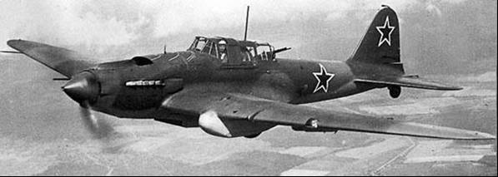

Photo 2. LA-5 Russian fighter on display at Moscow Victory Park, Russia – Petroch Services ©

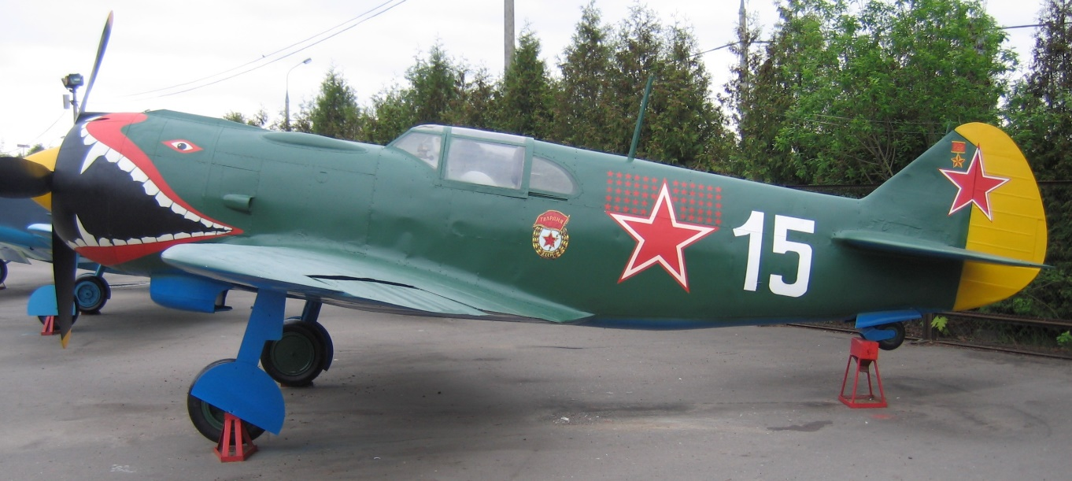

Table of Contents

Summary 3

Russian Aviation 1900-1914 5

Russian Aviation 1914-1936 5

Russian Aviation 1936-1940 9

Russian Aviation 1941-1945 10

Russian Industry 14

Russian Naphtha 17

Lend-Lease To Russia 1941-1945 22

Russian Aviation Gasoline Supplies 27

Persian Corridor 1941-1945 29

Petrol For Russia 32

Russian Technical Research 33

Soviet Aviation 1945-1950 34

Russian Aviation Gasoline Specifications 36

Russian Suppliers Impex Petroleum 2013 37

War Prizes – German Jets In The Soviet Union 37

Index 41

Research Sources 44

# Summary

**Chronology**

1881-1885 Russian engineer Alexander F. Mozhaisky designed and manufactured the first Russian full-scale airplane with two propellers and two steam engines. The airplane passed the ground tests and took off successfully, but crashed on landing.

Photo 3. Alexander F. Mozhaisky

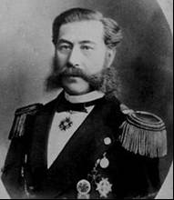

1897-1910 Russian aeronautical scientists Nikolai Zhukovsky and Sergei Chaplygin undertook basic research, which was very important for the development of the basis of aerodynamics science. Their fundamental published works were about - the optimal angle of attack of an airplane (1897, N. Zhukovsky), about jet flow (1902, S. Chaplygin), about attached vortex (1905, N. Zhukovsky)

Photo 4. Professor Nikolai Zhukovsky Photo 5. Sergei Chaplygin

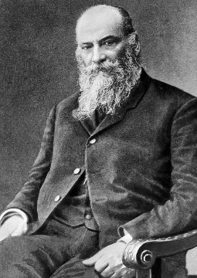 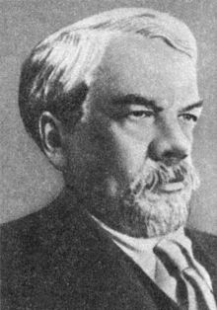

1886 Professor Zhukovsky – began a lecture a course on Hydrodynamics.

1889 Aeronautical research at the Applied Mechanics Laboratory of Moscow University.

1902 Professor Zhukovsky – founded an aerodynamics laboratory, which was equipped with a wind tunnel, and a device for testing airplane propellers.

1904 Dmitriy Ryabushunskiy created Aerodynamics Research and Development Institute under the supervision of Professor Zhukovsky. This was one of the first Research Institutes in the world, which was situated in the village of Kuchino, near Moscow.

1908-1916 Moscow Technical University -Professor Zhukovsky - created the Aeronautical Society, started a lecture course on “Aeronautics”, created the aerodynamics laboratory, created the Aeronautical Research and Development Department.

1909 Training of aeronautical engineers commenced at St. Petersburg Polytechnic University.

1914 World War I commences, Russia joins Britain and France. Russia fights the German, Austria-Hungary alliance on the Eastern Front.

1917 Bolshevik Revolution, Russia withdraws from World War I conflict.

1917 Many Russian Aviation Specialists were forced to leave the country after 1917. Many fled to the United States

1919 Moscow Technical University - Professor Zhukovsky created Moscow Aviation College. Creation of the Aeronautical Faculty of Donskoy Polytechnic University.

1921 Training of aeronautical engineers at Kiev Polytechnic University.

1923 Creation of the Aviation Faculty of Kharkov Technical Institute

1918 -1930 Foundation of The Central Aerohydrodynamics Institute (TsAGI). It was headed by Professor Zhukovsky. CIAM – the Central Institute of Aviation Motor- Building. VIAM – the All-Soviet Union Institute of Aviation Materials.

1929-1931 First wave of political arrests of Russian aircraft designers.

1934 May 19 First flight of the ANT-20 Maxim Gorky, at the time the world's largest aircraft.

1937 New political arrests started. Their scale was even wider than previous ones. Many thousands of specialists from all aviation organizations were arrested.

1937 Russians aviators achieve the first trans-arctic flight Moscow to Vancouver in an ANT –25/RD

1939 Aug. 23 Germany and the U.S.S.R. sign non-aggression pact.

1939 Sept 17 U.S.S.R. attacks Poland from the west (Nazi Germany had attacked from the east on Sept 1, 1939). This deal was hatched between Baron Joachim von Ribbentrop, the German foreign minister and Josef Stalin to carve up Poland.

1941 June 22 Operation ‘Barbarossa’ - the German Campaign against the U.S.S.R. begins.

1944 June 2 United States Fifteenth Air Force begins shuttle bombing between Italian and Soviet bases.

1944 Sept. 13 Shuttle bombing between Western and Soviet bases is discontinued.

1944 Aug 30 Second Ukrainian Front captured the Ploësti oilfields

1945 Aug 8 Russia declares war on Japan (two days after the atomic bomb is dropped on Hiroshima by the U.S.)

1945 Germany is divided into four occupation zones French, American, British and Russian, and Berlin becomes a divided city also into four sectors and the establishment of “Checkpoint Charlie”.

1948 June Russia blockades Berlin closing all rail, road and water access to the city. This results in the Allies supplying Berlin by air- known as the Berlin Airlift which operated from 26 June 1948 to 12 May 1949 (see chapter 25)

1949 Germany is divided into East Germany (German Democratic Republic) and West Germany (Federated Republic of Germany) and the “Cold War” has begun.

1951 Russia supports the North Korean invasion of South Korea with WWII aircraft but it will be a testing ground for the new Russian jets such as the MiG-15

Photo 6. Refuelling MiG-15

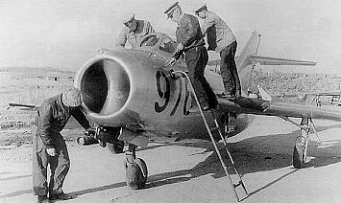

As with other nations Russia had entered the “Jet Age” and now jet fuel and jet and turbo-prop aircraft were replacing avgas and piston driven aircraft, however there would still be a role for obsolete WWII aircraft in the Soviet Bloc countries. But the story of Russian aviation starts much earlier.

# Russian Aviation 1900-1914

The Russians had always been at the forefront of aircraft design; it had the first institute for aircraft design as early as 1904 – Dmitriy Ryabushunskiy created Aerodynamics Research and Development Institute under the supervision of Professor Zhukovsky. This was one of the first Research Institutes in the world, which was situated in the village of Kuchino near Moscow.[1]

# Russian Aviation 1914-1936

Russian Aviation Industry during World War I (1914-1917)

In 1913, Russia manufactured 270 aircraft however the onset of the World War I would see a rapid growth of the Russian aviation industry during the ‘Great War’ - World War I. In 1914, there were 1,871 workers employed by aviation plants, by 1917 there were 7,385 workers. During the period from 1914 to 1917 Russia manufactured 5,565 aircraft with:

– 17 airplane manufacturing plants;

– 7 aviation engine manufacturing plants;

– 3 propeller manufacturing plants;

– 1 aircraft instrument manufacturing plant

Russian Aviation Specialists flee to USA

After the Bolshevik Revolution of 1917, due to the purges a significant number of Russian aviation specialists and designers were forced to leave the country. While some would remain and also become famous, many others would go to America and become famous in their own right. Names such as:

Igor Sikorsky –the creator of the first mass produced helicopters in USA and the founder of the Sikorsky helicopter company.

Photo 7. Igor Sikorsky Photo 8. Sikorsky helicopter R4 withdrawing troops from Korea 1952.

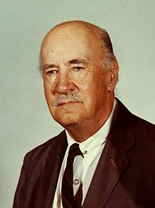 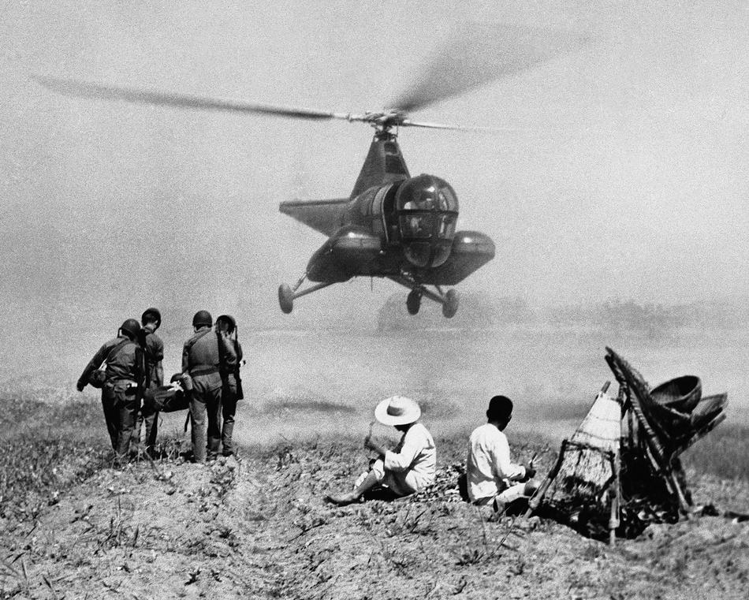

Alexander Prokofiev-Seversky had been a pilot in the Russian Imperial Air Force during WWI, had been in the U.S. on a Naval Air Mission in 1917 when the Bolshevik Revolution broke out, and he stayed in America and become one of the foremost aviation designers with aircraft which won the Bendix Trophy. He would form the Seversky aircraft company and develop the P-35 pursuit aircraft for the U.S. Army Air Force.

Photo 9. Alexander Prokofiev-Seversky – designer of Seversky P-35 Photo 10. P-35 U.S. Army Air Force fighter

 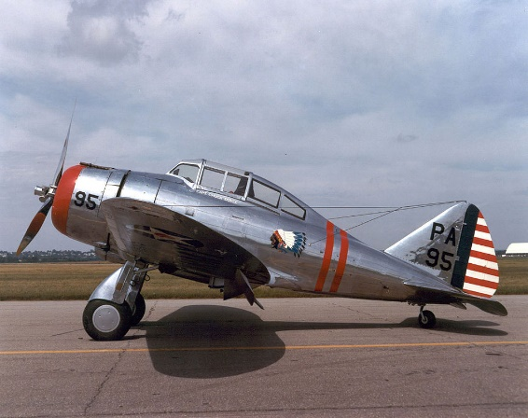

Another refugee from the Soviet purges was Alexander Kartveli – designer of Republic P-47 “Thunderbolt” Fighter-bomber widely used by the Allied air forces in WWII commonly known as “the Jug”; and in the jet era, the Republic F-84 “Thunderjet”, and Republic F-105 “Thunderchief”.

Photo 11. Republic P-47 Thunderbolt test flight 1941.

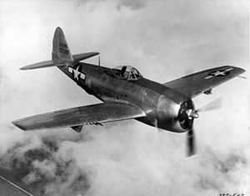

Another was Mikhail Watter – designer of Vought 02U Corsair (The Vought 02U Corsair was a 1920s biplane scout and observation aircraft), Martin B-10 Bomber, Martin 170 Mars seaplane, Martin 162 Mariner seaplane.

Photo 12. Martin B-10 Bomber U.S. Army Air Force circa 1935.

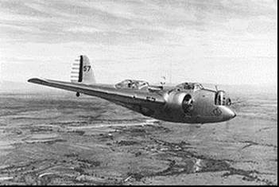

Other Russian Designs and Achievements

While there was an exodus of great aircraft designers to the United States, there was still a wealth of great, talented Russian designers who would continue the legacy of Zhukovsky, Chaplygin and Ryabushunskiy and others. Designers such as Tupolev, Illyushin, Polikarpov, Yakovlev and others would continue to produce aircraft which would become icons of the Russian aviation industry.

For example, on May 19, 1934 the first flight of the ANT-20 Maxim Gorky designed by Andrei Tupolev, at the time this was the world's largest aircraft.[2]

Photo 13. Russian ANT-20 Maxim Gorky (1934)

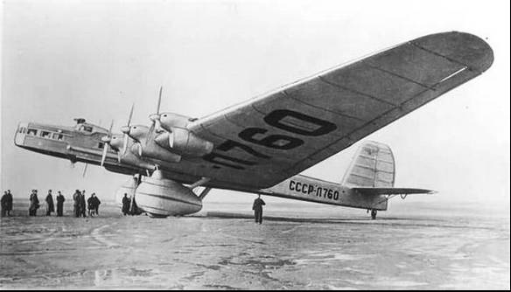

Another notable aviation milestone was the first flight over the North Pole by the record breaking ANT-25/RD (Recordnaya Dal'nost). Russian aviators Chkalov, Belyakov and Baidukov flew the ANT-25 in a trans-arctic flight on the route from Moscow to Vancouver. It was designed with long range bombing in mind. Pavel Sukhoi was leading the ANT-25 design team. One of the original aircraft is on display at Chkalov's museum.

Photo 14. ANT-25/RD (1937)

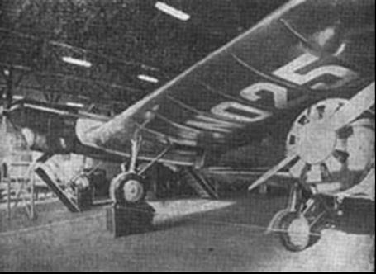

# Russian Aviation 1936-1940

The period 1936-1937 saw great changes in the world. The Spanish Civil War was raging and both the Fascists and the Communists were engaged in the conflict providing aircraft and support to the respective combatants. Nazi Germany providing the German Condor Legion to the Spanish Nationalist under General Franco, while the Russian supported the Communists (Republicans). The German Condor Legion were combat testing their Messerschmitt Bf-109’s fighters, Heinkel He-111 bombers, and Junker Ju-52 transports with Franco’s Nationalists, while the Russians were testing their combat aircraft such as the I-16 fighter and LAGG-3 with the Republicans. These were single seat monoplanes of mixed construction (wood and metal), an open cockpit and retractable landing gear. It was designed by the U.S.S.R. Central Design Bureau under the guidance of N.N. Polikarpov in 1933 and was used by the Republican Air Force (Spain). However, given its performance (top speed 462 km/hr), it was no match for the new German Bf-109 (top speed 620 km/hr or 385 mph).

Photo 15. Polikarpov IL-16 Fighter on display at Moscow Victory Park Russia – Petroch Services ©

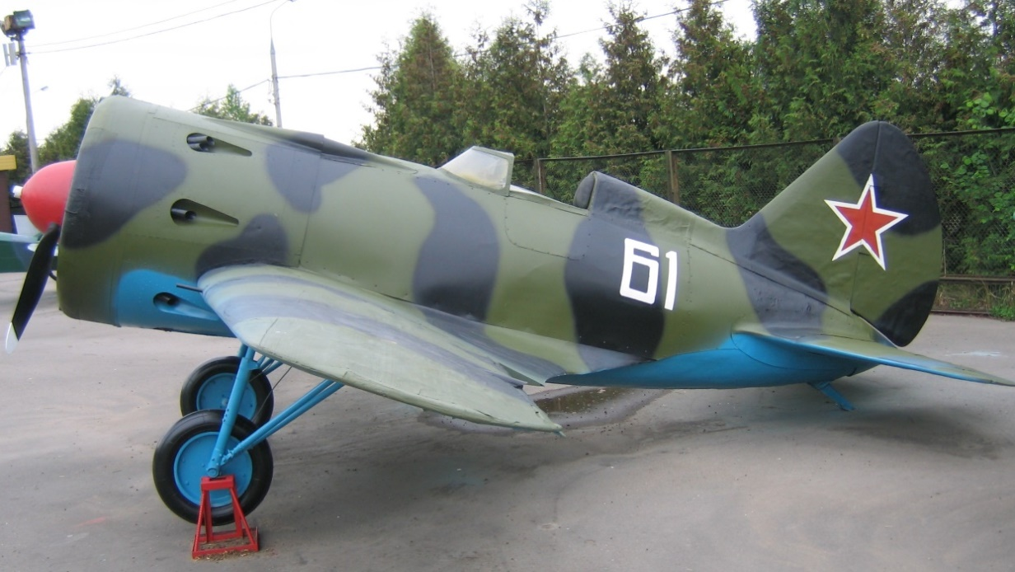

Photo 16. Russian LAGG-3 Fighter on display at Moscow Victory Park) Russia – Petroch Services ©

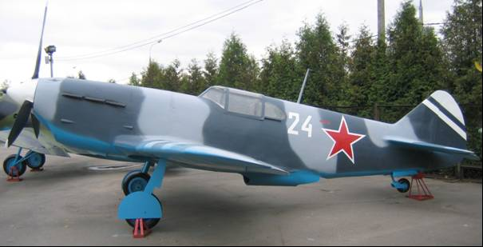

Every air force needs training aircraft and the U.S.S.R. was no exception. Theirs was the PO-2 Trainer – a two seater biplane of mixed construction (wood/fabric/metal) with an open cockpit and fixed undercarriage. It was, like most of the Russian aircraft, designed by the Central Design Bureau, for the PO-2 it was under the guidance of N.N. Polikarpov in 1928. It was designed as a training aircraft, but during the ‘Great Patriotic War’ - World War II, the PO-2 was actively used in a number of roles including reconnaissance, communications, evacuation of wounded, supply of guerrilla group and as a night light bomber.

Photo 17. PO-2 Training Aircraft on display at Moscow Victory Park) Russia – Petroch Services ©

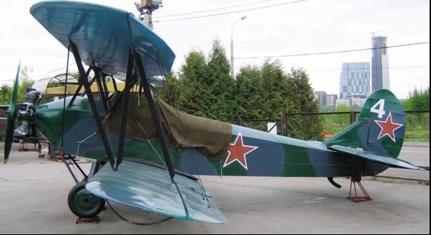

# Russian Aviation 1941-1945

Always limited supply.

The Russians were essentially fighting a land-based army and air battle against the Axis, so their fuel requirements were for aviation gasoline for their air force, motor gasoline for motor vehicles, and diesel for their tanks. The diesel and motor gasoline could be made from Russian oil processed in Russian refineries; however, the aviation gasoline was another matter.

As the war progressed and the distance between the United States air bases in Italy and the Soviet air bases became closer, the American heavy bombers (B-24 Liberators) began to fly shuttle bombing raids over the Axis occupied territories; these sorties required aviation gasoline to be available for the U.S. bombers at the Soviet bases to make the return journey.

An interesting anecdote from RAF

From the book “Lancaster: The Second World War's Greatest Bomber” By Leo McKinstry comes the following tale of experience of RAF Lancaster crews with Russian aviation spirit after bombing the German battleship Tirpitz and flying on to Russia- *‘The next day, it was back to Britain. John Sanders recalled the startling results of using Russian aviation spirit for the trip home, because normal 100-octane fuel was in short supply. When you took off in a Lancaster with 100-octane fuel at full power you got sheets of bright blue flame, about a yard long, out of all the exhausts. But with this Russian stuff you got a red flame. And you could smell the lead in the cockpit*. *Apparently when we arrived back at Woodhall, on the ground they heard the noise from the Lancs and thought. “Good grief, what’s happen here?’ Every single plug on all the engine mountings had to be changed because they’d all been burnt with this dreadful petrol.’*

Lend-Lease in action

To support the Russian war effort in the air, the Allies shipped various aircraft predominantly fighters. The British provided mostly Hawker Hurricane IIs (which were being superseded in the RAF) and some Spitfire VB and IX variants, while the U.S. supplied the following types - Bell P-39 Airacobra, Curtiss P-40 Kittyhawk, and Bell P-63A Kingcobra. So, having provided the aircraft, it was also necessary to provide the precious avgas to get them in the air.

Photo 18. Bell ‘Kingcobra’ P-63A supplied under the US Lend-Lease program, now on display at Moscow Victory Park) Russia – Petroch Services © 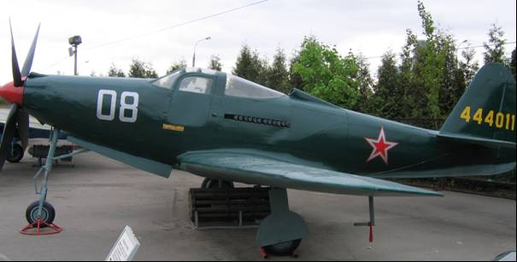

The Russians had also quickly developed some of their own aircraft designs which would also require Allied avgas. Famous aircraft such as Illyushin Il-2 and the later Il-10 dive bomber/tank buster which would be used to great effect against the German armour as the Soviet armies pressed westward towards Berlin and south towards the rich oilfields of Rumania. The Il-2M ‘Sturmovik’ was known as the ‘Winged tank” by the Red Army, and “der Schwarze Tod” – The Black Death by the German Army, it was produced in great numbers, over 42,000.

Photo 19. Russian Illyushin Il-2M Sturmovik (Storm Bird) on display at Victory Park, Moscow, Russia 2009 Petroch Services ©

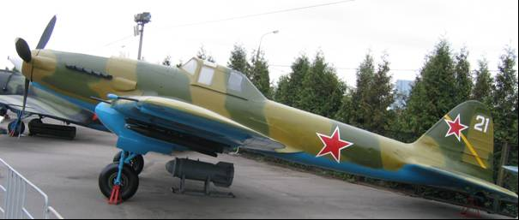

Perhaps the most popular passenger aircraft of the late 1930’s was the iconic Douglas DC-3. The Russians commenced building this aircraft as a passenger aircraft under licence from the American Douglas company in 1938[3], and it was designated the PS-84.

The licensing of the Douglas DC-3 (Li-2) American Cargo- Passenger Airplane was not without its problems. The documentation and drawings of the initial DC-3 were revised with the purpose of converting all imperial (US) dimensions and material thicknesses into metric measurement system. This revision also included a careful re-evaluation of all structure elements according to the Soviet strength standards.

By 1942, it was redesignated the Li-2 after the works engineer N.N. Liusnov.

With the advent of World War II – the ‘Great Patriotic War’, the design was modified to include a rear gun turret.

Photo 20. Li-2 Military Transport on display at Victory Park, Moscow, Russia 2009– Petroch Services ©

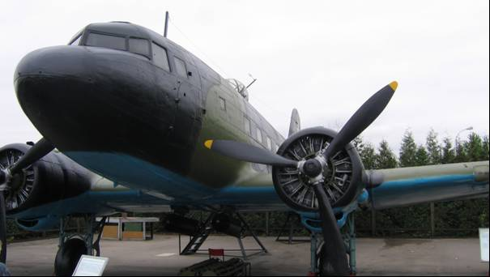

Photo 21. Li-2 rear gun turret on display at Victory Park, Moscow, Russia 2009– Petroch Services ©

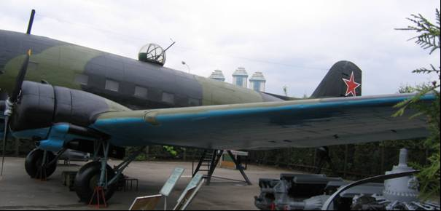

The U.S.S.R. aircraft designers saw the need for modern front line aircraft and commenced to produce some of the famous Russian aircraft of World War II. These would be crucial in rebuilding their air force and attaining air superiority over the axis forces both in the air and, to attack the enemy on the ground during the great tank battles which were to come.

Photo 22. Yak-3 on display at Victory Park, Moscow, Russia 2009– Petroch Services ©

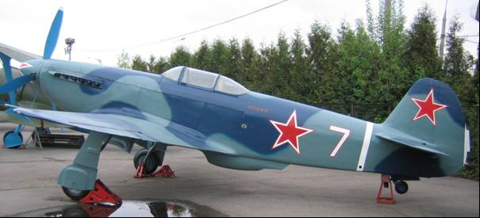

The famous Yak-3 and later the Yak-9 claimed by some Allied pilots to be the best fighter in the world. In June 1941, the German Army swept into Russia; caught by surprise the Russia's Air Force was decimated on the ground and in the air. Alexander Yakovlev moved his design and manufacturing facilities east of the Ural Mountains and began production of the Yak-9 in 1942. Eventually 16,769 Yak-9 models were built, more than any other fighter aircraft in the Russian Air Force.

Photo 23. Yak-9U at Tyabb Airfield, Victoria 2006-Petroch Services ©

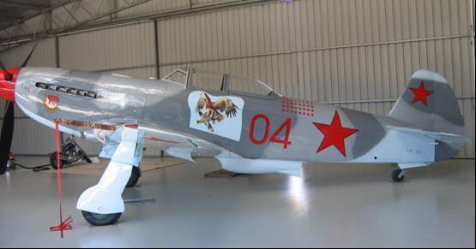

The above example was located at Peninsula Aero Club at Tyabb, Victoria, Australia. It was owned by Mr. Jim Wickham who flew this wonderful aircraft at local air shows. It is painted in the markings of the famous Soviet ace Major Ivan Nikiforovick Stepanenko 4 IAP 2 Baltic Front in December 1944. Sadly, this aircraft was destroyed in a crash some years later by the new owner.

Other privately owned aircraft of Soviet/Communist Chinese origin which are located at this aero club are Soviet Yak-52 trainer and Chinese Nanchang CJ-6 trainer, both operate on Avgas 100LL.

Photo 24. Yak-52 trainer (VH-YYB) ‘Yak Attack” taxiing at Tyabb Airfield 2006, owned by Jim Wickham.

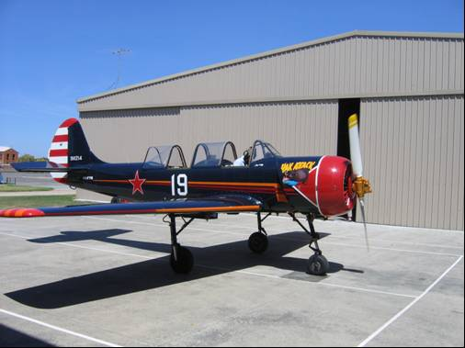

# Russian Industry

After the Bolshevik Revolution in 1917, the U.S.S.R. developed major industries including steel, coal, chemical plants, aluminium, and oil. The following map (Fig. 1.) illustrates the extent of Soviet industry in August 1941, the oil fields, oil pipelines and refineries. There were a significant number of refineries, while it is unknown whether they produced aviation gasoline, it can be assumed since the Allies were supplying 100 Octane aviation gasoline and blendstocks, that there was probably no 100 Octane gasoline produced, but there may have been lower grade aviation gasolines produced. It should also be noted that the massive Russian Army and their diesel-powered tanks would require large amounts of fuel to defend their motherland, and then repulse the Nazi aggression.

Refineries were located at:

Caspian region - Krasnovodsk, Grozny, and, Makhach-Kala, with a large refinery at Baku [the first Russian refinery built in 1861] - the Azerneftyag refinery, which was constructed in the early 1930s. Azerneftyag has a current throughput capacity of around of 235,000 Bbls/d. (in 2005). It contains several crude and vacuum distillation units, though lacks reforming units to produce marketable petrol. Currently (in 2005) it is used mainly to produce lubricating oil and bitumen, with by-products of diesel oil, fuel oils and straight run kerosene. Atyrau (formerly Guryev) refinery is located near the Caspian Sea coast. Its nominal capacity is about 5.5 Mt/year (110,000 Bbls/d) in 2005, and was established in 1945 with equipment provided under the U.S. Lend-Lease program and was originally intended for refining oil from Baku.

Black Sea region – Batum, Tuapse, Krasnodar, South of Stalino,

Saratov (which was destroyed), Syzran in the wheat belt region, and Stalingrad on the Volga.

Ural region – Orsk, Sterlitamak. A number of large modern oil refineries were also built in Kuybishev (circa 1944)

Central region – Gorki, Moscow

Western region – Leningrad.

Refer to Fig.1 Russian industries in August 1941, and Fig. 2 Caucasian oil producing areas, pipelines, and refineries in March 1940.

Figure 1. Map of Russian industries August 1941[4]

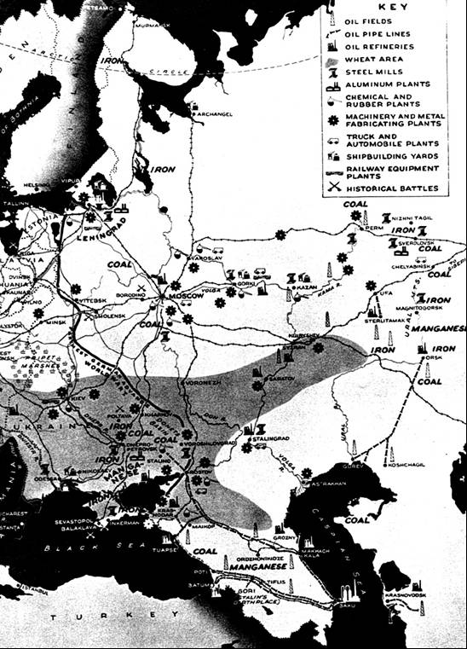

Figure 2. Caucasian oil fields March 1940

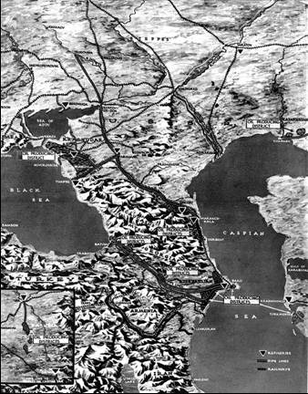

Baku-Main Source for Soviet Fuel Supply[5]

On the eve of what the Russians called ‘The Great Patriotic War,’ Baku was the cradle of the Soviet oil industry, and as such, the major supplier of oil and petroleum products. In 1940, for example, 22.2 million tons of oil were extracted from Baku which comprised nearly 72% of all the oil extracted in the entire U.S.S.R. Consequently, from the Soviet perspective, the war could barely have been won had it not been for Baku oil and the ‘fine quality’ of fuel that this city continuously supplied to the war front from 1941-45.

During that first year of the war, Azerbaijan produced 25.4 million tons of oil, a record for the entire history of its oil industry. Never before, nor ever afterwards would Baku extract so much oil. By the end of 1941, thousands of Azeris had joined the so-called People's Voluntary Corps. Mobilization affected all spheres of life, particularly the oil industries. A week after fighting began, the oil workers themselves took the initiative to extend their work to 12-hour shifts, with no days off, no holidays, and no vacations until the end of the war. By the end of the year, so many engineers and oil workers had left for the war front that positions had to be filled by women. By the summer of 1942, more than 25,000 women or 33% of all the workers were working 18-hour shifts in the oil industries. At refineries and chemical plants, the percentage of women was even higher estimated 38%. By 1944, women's participation had grown to 60%. Veterans and retirees also returned to the oil fields to help as much as they could.

# Russian Naphtha

The Russian oil fields of Baku, Grozny, Maikop produced crude oil from which naphtha could be refined. This naphtha, depending on its quality (composition of Paraffins, Olefins, Naphthenes and Aromatics known as PONA), could be used as a component of motor gasoline or aviation gasoline. The naphtha from Baku crude was rich in aromatics and naphthenes and low in normal heptane therefore suitable for aviation gasoline blend stocks. (Normal heptane has an octane rating of zero, and is in fact the starting point for the octane rating scale, iso-octane with its octane of 100 is the other end of the rating scale). Theoretical calculation of the Motor Octane Number (MON), assuming no synergism, has Baku naphtha MON = 58.7, Grozny naphtha MON = 44.3 and Maikop naphtha MON = 50.7, so clearly Baku naphtha is preferred for aviation gasoline.

The following are the compositions of these naphthas in 1938[6]:. The naphthas appears to be stabilised, that is the light gases such as Methane, Ethane, Propane and Butane have been removed. The naphtha cuts are 50 to 150 deg C.

Table 1. Composition of Naphthas from Russian crude oils 1938

|  |  |  |  |  |
| --- | --- | --- | --- | --- |
|  |  | Baku | Grozny | Maikop |
|  |  | % wt. | % wt. | % wt. |
| Isopentane |  | 0.5 | 2.1 | 2.2 |
| n-Pentane |  | 1.6 | 5.9 | 4.6 |
| Cyclopentane |  | 0.2 | 0.1 | 0.4 |
| Isohexanes | 2-Methyl pentane | 1 | 4 | 0.1 |
| n-Hexane |  | 3 | 7.6 | 8.6 |
| Methyl cyclopentane |  | 2.6 | 2.4 | 5.4 |
| Benzene |  | 0.2 | 0.3 | 2.1 |
| Cyclohexane |  | 7 | 3.3 | 2.5 |
| Heptanaphthenes |  | 19.3 | 10.1 | 13.3 |
| Isoheptanes | Incl. 2,3, Di Methyl Pentane | 6.1 | 4.4 | 2.8 |
| n-Heptane |  | 3 | 9.9 | 11.1 |
| Iso-Octanes |  | 9.6 | 9 | 5.2 |
| Octonaphthenes |  | 15.5 | 6.8 | 6.9 |
| Toluene |  | 1 | 1.5 | 4.7 |
| n-Octane & heavier |  | 5.6 | 8.9 | 7.9 |
| p-Xylene (or Xylenes) |  | 2.1 | 3.2 | 6.5 |
| Iso-Nonanes |  | 5.4 | 8.6 | 4.7 |
| n-Nonane |  | 3 | 6.1 | 3.5 |
| Nononaphthenes |  | 13.3 | 5.8 | 5.3 |
| PONA | | | | |
| Paraffins |  | 16.2 | 38.4 | 35.7 |
| Isoparaffins |  | 22.6 | 28.1 | 15 |
| Olefins |  | 0 | 0 | 0 |
| Naphthenes |  | 57.9 | 28.5 | 33.8 |
| Aromatics |  | 3.3 | 5 | 13.3 |

The following figures show the distribution of the hydrocarbons. Note the difference between Baku and Grozny and Maikop naphthas.

Figure 3. Baku Naphtha PONA

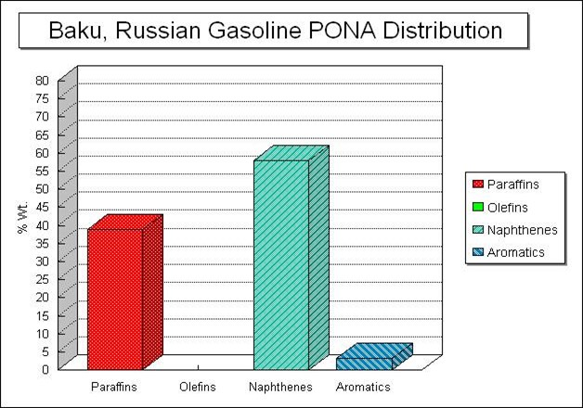

Figure 4. Grozny Naphtha PONA

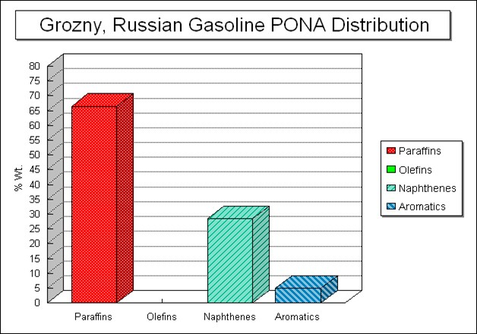

Figure 5. Maikop Naphtha PONA

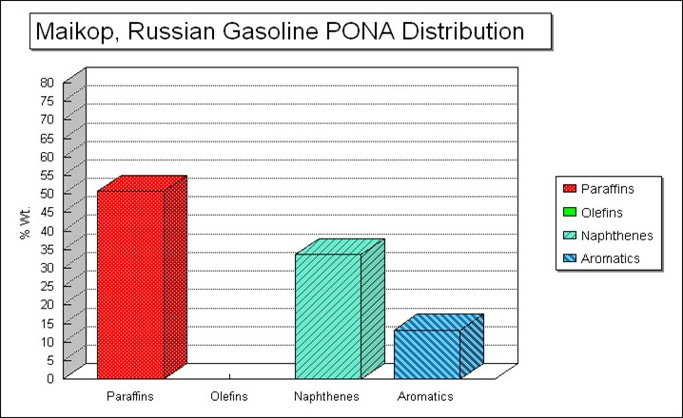

The Caspian Shipping Company

Another problem inseparably tied to fuel production was its transportation. By the summer of 1942, the German forces had blocked the main railways through which oil and its petroleum products were transported. Thus, alternate means of transport had to be found via the Caspian and Volga water way. When the Germans also succeeding in blocking this route, transportation was routed through Central Asia.

But the front could not wait. Aircraft, armoured carriers, trucks, and tanks all needed fuel. Then the naval experts of the Baku oil-tanker fleet performed an incredible feat. For the first time in the world's history, they began towing a floating railway of oil tankers (wagons) from Baku to Krasnovodsk (Turkmenistan) as well as several thousand tons of oil reservoirs from Makhach-Kala (Dagestan) to Krasnovodsk.

Baku sailors were desperate to find new ways to get the oil to the war front. Since there were not enough tankers to do the job, they improvised ways to tow cisterns across the Caspian Sea to Krasnovodsk, Turkmenistan (1942).

Photo 25. A Soviet tug tows oil tanks across the Caspian Sea (circa 1942).

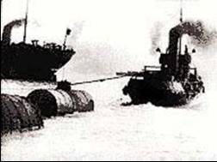

The fleets were extremely overloaded. For example, the amount of oil transport in July 1941 exceeded 10 million barrels of crude oil and fuel. This amount was beyond the technical capabilities of the tanker fleet in Baku. The demands from Moscow did not take into account the physical limitations. It was then that Baku naval experts hit upon the idea of attaching whole tanks and cisterns to each other by steel ropes and lowering them into the sea by cranes and towing them by steam tugs. This had never been done before in any place in the world and it enabled them to tow up to 35 cisterns together or 3 huge oil tanks (5-ton capacity) with a single tugboat.

Threats to the Russian Oil Fields[7]

Not only were the oil fields of the Caucasus under threat from the Germans, but also the British. According to Patrick Osborn, because of Winston Churchill's lack of faith in the Soviet Union's ability to defeat Adolf Hitler--and the suspicion and subterfuge that would eventually lead to the Cold War, Britain planned to bomb the Soviet oil fields at Baku to deny this vital war materiel to the Nazi war machine.

One clear day during the early stages of World War II, a solitary aircraft appeared in the skies over the great petroleum production center of Baku, capital of Azerbaijan and one of the most important cities in the Soviet Union. Incredibly, the plane lingered over the city for a full hour before returning to base. No attempt was made to intercept the intruder, and anti-aircraft batteries ringing the city remained silent. By the time the aircraft left Soviet airspace, it had taken dozens of photographs of oil refineries, pipelines, pumping stations, and power plants--all prime targets for strategic bombers.

A few days later, the same aircraft appeared in the skies over the vital Black Sea port of Batum. This time, however, the Soviets responded, opening fire with anti-aircraft guns and scrambling fighters in a vain attempt to intercept the high-flying invader.

This brief scenario will have a familiar ring to students of World War II. On dozens of occasions before Adolf Hitler launched Operation Barbarossa--the German invasion of the Soviet Union--in June 1941, the Luftwaffe carried out reconnaissance missions over the Soviet Union. In this case, though, the flights were undertaken in March and April 1940, and the intruder was not German, but British.

Under the terms of the German-Soviet Treaty of Friendship, Cooperation, and Demarcation signed in September 1939, Soviet leader Josef Stalin had agreed to deliver petroleum to fuel-deficient Nazi Germany. The British and their French allies were determined to hinder these shipments. One way to do this, they decided, was to attack oil production facilities located throughout the Soviet Caucasus. By April 1940, after obtaining reconnaissance photographs of the most important targets in the area, the Royal Air Force had developed a plan, dubbed ‘Operation Pike’, to cripple the Soviet oil industry. The plan was to conduct a strategic bombing campaign lasting up to three months to destroy Soviet oil production. The operation had advanced to the point that the Royal Air Force was in the process of transferring several squadrons of Bristol Blenheim Mk. IV bombers to the Middle East to launch ‘Pike’ when the Germans conquered France and the Low Countries in May.

‘Operation Pike; was relegated to the back burner while the RAF fought and won the Battle of Britain.

The British then gained a bit of breathing space in early 1941 as the Wehrmacht invaded Yugoslavia and Greece, and Hitler readied his own attack on the Soviet Union. London was aware of these preparations, but was unsure if Hitler intended to force concessions from Stalin (possibly including German control of the Caucasian oil fields), or if he was preparing a surprise attack without making any prior demands. Many British diplomats believed Stalin would submit to Hitler rather than take on the German army. To prevent this, the Foreign Office's permanent under-secretary, Sir Alexander Cadogan, said the British "must consider how we can use [the] threat or fact of bombing Baku" as a tool to force Stalin to resist Hitler.

On June 22, 1941, ‘Operation Barbarossa’ began. Although Churchill and others had warned Stalin, the German attack took the Red Army completely by surprise; its front-line units were quickly smashed. Many observers predicted that the Soviet Union would soon collapse, after which, Churchill feared, Hitler would attempt to invade Britain. The Caucasian oil fields might also fall into German hands, thus immeasurably strengthening Germany's economic and military position.

Osborn detailed the various diplomatic activities between the Soviets and British to get the Russians to destroy the Caucasian oil fields, as well as the many covert and overt operations the British planned to attack these vital strategic targets. To the British, time seemed to be running out. By the middle of July 1941, German troops were well on their way to Moscow and Leningrad and had driven deep into Ukraine. The Soviet Union's demise seemed inevitable.

By the middle of August 1941, German armies were advancing toward the Crimea and encircling Kiev, the Ukrainian capital. Churchill, although loath to "condemn large sections of the Russian people to starvation" by depriving Soviet agricultural machinery of fuel, now appealed to Stalin to expedite demolition of the oil fields, even though the Germans were still hundreds of miles away from the nearest Caucasian oil refineries at Armavir and Maikop. In return, Britain would provide the Soviet Union with one hundred million pounds to import petroleum. Privately, he believed that "[we] must be ready to bomb the oilfields ourselves if the Russians did not destroy them." By now the RAF had produced the most detailed plan yet for the destruction of the Soviet petroleum industry. The RAF's "Outline Plan for the Denial of Russian Oil to German Controlled Europe by Air Action" aimed at the total annihilation of oil pumping, refining, and transportation facilities in the Caucasus.

It is a fascinating story of oil politics in war-time. Our interest here is the Russian refineries that were operating in that period.

The RAF plan ranked sixteen principal targets. Near the top of the list were Baku's White Town and Black Town refinery areas. The Red Star power station in White Town was identified as the most important objective. Another vital target was the refinery complex and Soyuzneft oil storage area in Batum.

The RAF believed that a viable method of decreasing Soviet petroleum production would be to attack the dwellings of workers employed in the Caucasian oil industry. Worker housing complexes at Baku and Batum were ranked seventh and eighth on the priority list. The planners thought it so important to attack these areas that they made an extra notation on the topic: "Political or other conditions may introduce the temptation to relegate attacks on workers' dwellings to a lower category. But every attempt should be made to keep the priority of (7) and (8) above that of (10) [the Grozny refinery area] below."

Other targets identified were port facilities and oil storage tanks at Poti, the Tuapse refinery area, specific locations along the Grozny-Armavir and Baku-Batum railways, the Sabunchi and Surakhani refineries at Baku, and the Krasnovodsk refinery on the eastern shore of the Caspian Sea, which was within range of Vickers Wellington bombers operating with a reduced bomb load from Mosul. Air bases were even then being prepared at Mosul, Qiyara and Ain Zalah in Iraq. Other bases recently seized from hostile Vichy French forces in Syria could also be utilized.

While it may seem foolish, perhaps even insane for the British to seriously have considered launching an air offensive against the Soviet Union in 1940 or 1941, one of the excuses that Hitler had used to justify his invasion of the Soviet Union to his military chiefs, was to eliminate the British threat to the Caucasus. As evidenced by Britain's plans, this threat was quite real. Hitler's failure to accomplish his goal contributed to Germany's ultimate defeat, for had the Caucasus been captured, the Soviets would have been more apt to sue for peace, which in turn would have left Britain alone to resist the Nazis.

Hitler concentrated his efforts on capturing southern Russia and the Caucasus in the summer of 1942. Despite fanatical Soviet resistance, Armavir and Maikop fell to the Nazis in August. Naturally, the British were alarmed by these events, but by then they were more occupied with fending off Rommel's invasion of Egypt and were reeling from the Japanese seizure of Singapore and Burma. Under these circumstances, they were in no position to intervene unilaterally in the Soviet Union, although Churchill did approach President Franklin D. Roosevelt about the possibility of sending substantial American air forces to the Soviet southern front to defend the Caucasus. Hitler, however, soon became obsessed with capturing Stalingrad farther to the north, diverting forces away from the drive toward Baku. In February 1943 the Germans suffered a catastrophic defeat at Stalingrad, and by April 1943 they were all but driven out of the Caucasus. Despite the worst fears of the British and the Soviets, the Germans never crossed the Caucasus mountain range, and Baku was never again threatened seriously.

It must be noted, however that friction between Moscow and London over the Caucasian oil fields continued, and it cost the British dearly in the long run, as it did the United States. It is no accident that the Cold War began in earnest with a crisis over Soviet expansionist claims on Turkish and Iranian territory in 1945 and 1946. The purpose of Stalin's territorial demands was to gain depth for the defence of the oil fields of Baku and the Caucasus against potential air attack or sabotage.

# Lend-Lease to Russia 1941-1945

Lend-Lease aid to Russia

For a considerable period prior to the sudden German attack, the Soviet Union, along with the Axis Powers and Vichy France, had been subject to economic blockade by the Allied Powers. The United States had set up machinery for waging economic warfare and after the conclusion of the Hitler-Stalin non-aggression pact had taken various measures against the Russians.

With the German attack on Russia, the United States was in a delicate position. One of the issues in supplying aid to the Soviet Union at this time was the United States (which was neutral) had a lend-lease agreement with Great Britain, not Russia. The United States was still militarily neutral and the Soviet Union not yet officially eligible for lend-lease, a mission, while undertaking to aid Great Britain and Russia, was to proceed to aid the latter by aiding Britain. The policy arrived at was that no U.S. War Department materials could be made available to the Union of Soviet Socialist Republics without prior release by the British of materials allocated to them.

The ‘Protocols’ for supply

With Russia now drawn into the World War, the British (and Americans) wished to support the Russians in their struggle against the Axis powers, and so they were transferring supplies to Britain, who were sending some of the allocated American-sourced supplies on to Russia via the Arctic route. To ensure there was no misunderstandings in the new arrangements for lend-lease support from the United States, President Roosevelt sent Averell Harriman, his special representative in London on material aid to the British Empire, to Moscow for important three-cornered conferences there with a Soviet commission under Foreign Minister Vyacheslav M. Molotov and a British group under Lord Beaverbrook.

Photo 26. Lord Beaverbrook[8] Photo 27. Vyacheslav Molotov[9]

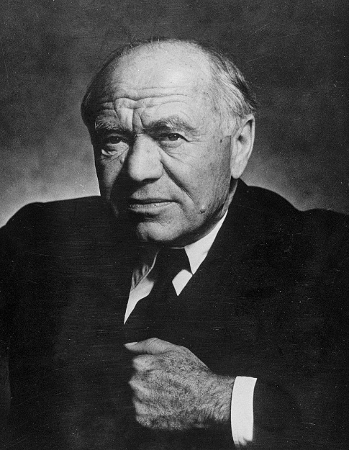 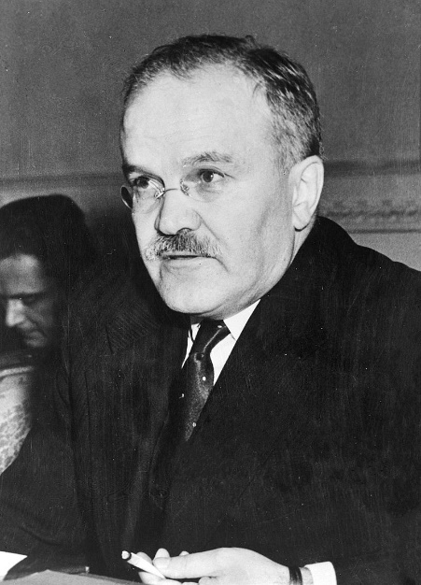

Photo 28. W. Averell Harriman[10]

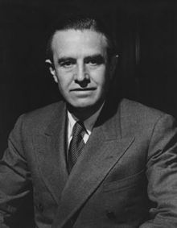

The discussions following, in which Marshal Joseph V. Stalin participated on three occasions, produced the signing at Moscow on 1 October by Beaverbrook, Harriman, and Molotov of the First (Moscow) Protocol, described as a binding promise by this Government to make specific quantities of supplies available for shipment to Russia by a specific date.

Photo 29. Marshal Josef Stalin

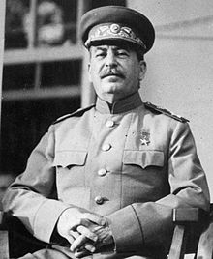

The Moscow Protocol was the first of four similar instruments for aid to Russia. It called for shipment from the United States through 30 June 1942, of roughly a million and a half tons of supplies.

The Second (Washington) Protocol, signed 6 October 1942 and covering the period to 1 July 1943, promised 3,300,000 tons to be shipped by the northern Russian ports and 1,100,000 via the Persian Gulf route.

The Third (London) Protocol, running through 30 June 1944, promised 2,700,000 tons via the Pacific route and 2,400,000 by either the northern Russian ports or the Persian Gulf. It was signed 19 October 1943.

The Fourth (Ottawa) Protocol, signed 17 April 1945, promised 2,700,000 tons via Pacific routes and 3,000,000 via Atlantic routes including the Persian Gulf and the route into the Black Sea, then newly available. It covered the period to 12 May 1945.

Routes to Russia

With the rich oilfields of the Balkans and Rumania and Caucasus regions under Axis control, the Russian were dependent on their supply of aviation gasoline from the West. In the world-wide effort to deliver war supplies to Soviet Russia, there were five routes: the Soviet Arctic, the Black Sea, the north Russian, the Persian Corridor, and the Soviet Far East.

**Soviet Artic Route** - The least important route, tonnage wise, was that which led from American Pacific ports to Siberian ports on the Arctic Ocean. Because the Arctic ports were ice free only during the summer months, sailings were restricted to those periods. The main military significance of the route was that aviation fuel was transported over it for an air ferry route across Siberia which, because of Soviet opposition, never materialized. Total tonnage was 452,393 long tons (459,653 tonnes).

**Black Sea Route** - Next in tonnage accomplishment was the Black Sea route, the last to be inaugurated. It was made possible by clearing the Axis from the Mediterranean and the Black Sea ports of Odessa, Constanta, and Novorossiysk. First ships arrived in January 1945. During the five months of operation of the route 680,723 long tons were delivered.

**North Russian Route** - British convoys first sailed to the north Russian port of Murmansk in August 1941. Archangel served as an alternative port. This was the shortest route from American ports to the U.S.S.R., 4,500 miles (7,240 km) and required twenty-one days' running time and five weeks' convoy time.

Inland clearance distance by rail from the ports to the battle front and industrial centres was satisfactorily short. During the last three months of 1941 and the first four months of 1942 the rate of shipments to north Russian ports was greater than by any other route then in use from the Western Hemisphere to Soviet ports. But the increasing severity of Axis attacks upon shipping in northern waters reduced its use drastically until July 1944, by which time an improvement in its safety reopened it to year-round activity. It did not again become a main artery of Soviet supply, for by that time it had been rivalled by the Soviet Far East and Persian Gulf routes. Its total of 3,964,231 long tons (4 million tonnes) was nearly equal to that of the Persian Gulf.

**Persian Gulf Route** - Longest in mileage and ship round-trip time, the Persian Gulf route was nevertheless desirable because of its relative safety, its all-year usefulness, and its accessibility to Soviet territory if other routes should be denied. The difficulties of providing and operating adequate port and inland clearance facilities were substantial handicaps in operation of the Gulf route; but so long as other routes were threatened either by military denial or, in the case of the Far Eastern route, by a sudden change in Japan's attitude toward its use, the Persian Gulf remained a necessity. In receiving 4,159,117 long tons (4.2 million tons) of Soviet-aid cargo from the Western Hemisphere, the Gulf was exceeded only by the Far Eastern route. The significance of the Persian Gulf route is measured by its tonnage accomplishment and its fulfilment of strategic necessity. Its handicaps were less serious than those which at one time or another afflicted the other routes; its advantages more solid and continuous. Development of the Persian Gulf line of communications to the U.S.S.R. was clearly basic to global planning.

**Soviet Far East Route** - Almost half, or 47 percent, of Russian-aid supplies from the Western Hemisphere reached the Soviet Union via a sea lane which extended from American Pacific ports around to the north of Honshu to eastern Siberian ports. The total tonnage via this route came to 8,243,397 long tons (8.4 million tonnes); but, because of the peculiar situation by which Japan winked at the traffic to her ally's enemy, only supplies classified as non-military were carried.

Table 2. Lend-lease Routes to Russia 1941-1945

|  |  |  |  |
| --- | --- | --- | --- |
| Route | Shipping Route | Tonnes | Comments |
| Soviet Artic Route | U.S. West Coast to Artic Siberia | 459,653 | Summer only |
| Black Sea Route | U.S. East Coast via Mediterranean to Black Sea ports | 691,647 | Operated only 5 months from January 1945 |
| North Russian Route | Shortest route from U.S. ports to Russia ports (7,240 km) | 4,027,845 | From August 1941 to 1945 |
| Persian Gulf Route | Longest route – ship around Africa to Middle East, then overland via Persian Corridor | 4,225,858 | Safest and continuous route, access to local refineries 1943-1945 |
| Soviet Far East Route | U.S. West Coast via north of Honshu to eastern Siberian ports. | 8,375,678 | Non-military cargoes |

While our interest is in aviation gasoline, we should perhaps briefly examine why the demand for this vital war materiel was important – it was to fuel the aircraft under Russian command. One of the war commodities supplied under lend lease was Allied aircraft. The following table illustrates the types and number of Allied aircraft delivered by the various shipping routes.

Table 3. Allied aircraft supplied to U.S.S.R. during WWII[11]

|  |  |
| --- | --- |
| P-39 Bell Airacobra | 5,707 (4,719 reached U.S.S.R.) |
| P-40 Curtiss Kittyhawk | 2,397 |
| P-47 Republic Thunderbolt | 195 |
| P-63 Bell Kingcobra (see Photo 18 above) | 2,397 (21 lost in transfer) |
| Hawker Hurricane | 2,952 |
| Supermarine Spitfire | 1,331 |
| Total Fighters | **14,982** |
| A-20 Havoc | 2,908 |
| B-25 Mitchell | 862 |
| B-24 Liberator | 1 |
| Handley Page Hampden | 23 |
| Armstrong-Whitworth Albemarle | 14 |
| DeHavilland Mosquito | 1 |
| **Total Bombers** | **3,809** |

A total of 18,791 Allied aircraft were delivered to the U.S.S.R. however this should be put in context with the total U.S.S.R. aircraft production which was 139,748. Thus, the Allies supplied less than 14% of the total aircraft requirement.

Russian Aviation Gasoline Supplies[12]

From the start of ‘Operations Barbarossa” by the Axis forces (Germany, Italy and Rumania) against Soviet Russia in June 1941, the Russians were in short supply of everything except man (and woman) power. With Rumania joining the Axis Powers in November 22, 1940, the oils fields of Rumania were now part of the Axis war production, so the only major source of aviation gasoline for the Russians was from their Western Allies – the British and Americans.

The Soviets were however very keen to establish their own production and supply using western technology as indicated by the following request from Soviet Minister Mikoyan[13].

Secretary of State, Washington.

Moscow Dated January 18, 1942 Rec’d 11:19 p.m., 24th TRIPLE PRIORITY 10, January 24, 8p.m.

FOR GENERAL S.P. SPADLING

Part One.

Mikoyan states that prompt action on projects for Soviet petroleum industry is essential. He desires hundred octane gasoline plants of latest type, and for many months has attempted to get necessary machinery and apparatus from United States. He states that expansion of British plant at Abadan will not suffice for Russian needs and says in any case more economical for Soviet Union to have hundred octane plants near own fields. He urges release of materials requested for new Soviet plants. Mr. E.A. Bertoud, member of Beaverbrook staff, Cairo, is now visiting Moscow and states that he hopes to persuade Soviet Government to agree to give British priority in enlarging British Abadan plant.

# 18 January 24, (1942) 8 p.m. from Moscow

Abadan plant with American machinery "in the common interest."

The United States had both the technology and raw materials to manufacture this essential petroleum process equipment. The decision to be made was who should get it? – The Russians or the British (for their Abadan Refinery) – It would be Abadan.

Supply the Soviets from Abadan

While there was the dangerous Arctic Circle route to supply Russia with aircraft and tanks, and other war materiel, despite the threat of the German Afrika Corp, it was the “Persian Corridor” that became an additional key source of supply for the desperately need avgas, and thus Abadan Refinery became a significant supplier to Soviet Russia (U.S.S.R.). These supplies were either as finished aviation gasoline or as aviation blendstocks such as Alkylate, Alkylate/Isopentane or Cumene which could then be blended with other lower octane blendstocks to make Avgas.

Delivery to U.S.S.R. was via the Persian railway system, overland using the Persian corridor route thus saving valuable shipping.

Under the Fourth Protocol, the United States were to supply 500,000 short tons ex US, while UK HMG (His Majesty’s Government) were to supply 300,000 short tons ex Abadan Refinery. (Comprising 240,000 short tons Avgas 100/130 and 60,000 short tons Alkylate).

To the end of January 1945 under the 4th Protocol to Russia the following product had been supplied.

From US 527,000 tons Avgas 100/130

From Abadan 237,000 tons Avgas 100/130, 40,500 tons Alkylate

This indicates that the US refineries were still the major supplier (66%) of avgas to Soviet Russia (U.S.S.R.). The shipments from the United States (U.S.A.) were from the East Coast.

Table 4. Aviation Gasoline and blendstocks from Abadan Refinery to U.S.S.R.

|  |  |  |  |  |
| --- | --- | --- | --- | --- |
| Month | Avgas 100/130 Bbls | Alkylate Bbls | Alkylate/Isopentane Bbls | Cumene |
| June 1943 | 45,054 |  |  |  |
| July 1943 | 90,500 |  |  |  |
| August 1943 | 65,400 |  |  |  |
| September 1943 | 68,589 |  |  |  |
| October 1943 | 75,402 | 19,170 |  |  |
| November 1943 | 74,358 |  | 11,250 (ratio 4:1) |  |
| August 1944 | 279,813 | 71,181 | 6,848 (ratio 70/30) |  |
| September 1944 | 279,883 | 43,636 | 284 |  |
| October 1944 | 218,070 | 67,565 | Nil |  |
| November 1944 | 304,109 | 41,675 | Nil |  |
| December 1944 | 280,990 | 45,002 |  |  |
| January 1945 | 293,299 | 45,220 |  |  |
| February 1945 | 328,500 | 99,000 |  | 14,830 (from U.S.) |
| May 1945 | 168,717 | 21,043 |  | 20,872 |

(Conversion 9 Bbls = 1 long tonnes)

While Abadan Refinery was the primary supplier in this region, the Bahrain Refinery was starting to overcome its construction problems and by 1945 was expected to contribute to the Allies demand for petroleum products. With regard to aviation gasoline products, the Bahrein Refinery was expected to supply Alkylate 30-50,000 Bbls (4,770-7,950 K. Litres) to the U.S.S.R. in mid-March 1945.

Cumene was produced from shipments of Benzol from India and South Africa.

With European hostilities ending officially at 12:01 am May 9, 1945 - the supply of aviation gasoline was concluded - shipments stopped after June 1, 1945.

One cargo of base stock was sent from Abadan and Bahrein for use in blending excess production of Alkylate into finished Avgas during June (1945).

The cessation of aviation gasoline shipments from Abadan and Bahrein refineries were to be expected with the Allies victory in Europe, however distrust by the West (Britain and America) of their Russian ally, which was to later lead to the ‘Cold War’ and the ‘Berlin Wall’ was perhaps not unfounded as evidenced in a report of October 28, 1944 to the UK Government.

“The Russians loot oil stores in Astra Romana, Romana American, and Steana Romana in Bucharest Rumania and ship back to Russia.”

In 1944 Aug. 23, Romania (Rumania) surrendered unconditionally. These were now under the control of the Soviets, and these were ‘spoils of war’. Prior to the war Rumania had been a major supplier in the region.

In 1928 Rumania had Refineries (33 leading) Total Capacity 4,685,900 tons/year, with 20 smaller refineries total combined capacity 15,000 tons/year. Ploësti - 9 refineries (including the two biggest Vega 648,000 tons/year, Astra Romana 540,000 tons/year). Many of these would have been destroyed or damaged by the British and American bomber raids which commenced in August 1943.

# Persian Corridor 1941-1945[14]

The following are excerpts from the history of U.S. Army, specifically the Middle East Theatre and ‘THE PERSIAN CORRIDOR AND AID TO RUSSIA’ by Dr. T. H. Vail Motter, published in 1952.

Supplying the Soviet War Machine

Military supply is a means, not an end. Mechanized warfare has made it a prime factor in planning and in operations. Skill, spirit, supply - these are essentials to victory; but without the third, the first two cannot prevail in a struggle of industrialized antagonists. The pooling of supply, the American idea which culminated in the Lend-Lease Act of 1941, produced one of the most potent weapons of World War II. Conceived as a defensive measure, on the principle that defense of Axis enemies was defense of the United States, the Lend-Lease Act was in effect a declaration of economic belligerency in a war that intertwined industrial with military power. It was lend-lease which, long before Pearl Harbor brought military belligerency to the United States, furnished the means by which American economic strength could be shared with Great Britain in 1941 in the Middle East. In that crucial area, Britain waged a David and Goliath struggle against Italian and German armies in North and East Africa, in Greece and Crete, and against pro-Nazi elements in Syria, Iraq, and Iran. Defeat would have entailed the loss of an area necessary to the victor in a global war. Defeat would have cut off Britain from her best source of essential petroleum. American aid in the form of war materials and logistic services, brought to Africa in 1941 and 1942, weighed fully in the reckoning which took place at El Alamein in October 1942. There, spirit, skill, and superior supply overcame spirit, skill, and vanishing supply, and the Axis threat from the west against the Middle East was eliminated.

It was lend-lease which, in September 1941 after the German attack on the Soviet Union, made the United States an auxiliary of Great Britain in the task of delivering supplies to the U.S.S.R. through the Persian Corridor. This route, joining Soviet territory to warm water across the mountains and deserts of Iran, was one of five by which 17 ½ million long tons of lend-lease supplies were carried from Western Hemisphere ports to Soviet destinations. It is difficult to visualize 17 ½ million long tons in .the abstract; but 2,803 ships crossed the seas to carry them, a fleet more than nine times as numerous as that which mounted the Anglo-American invasion of North Africa in November 1942. The total tonnage figure nearly matches the 22 million long tons landed on the Continent of Europe for the American forces between January 1942 and May 1945. Russia's share of the common pool was therefore considerable, befitting her share in the common conflict.

Figure 6. Middle East 1945

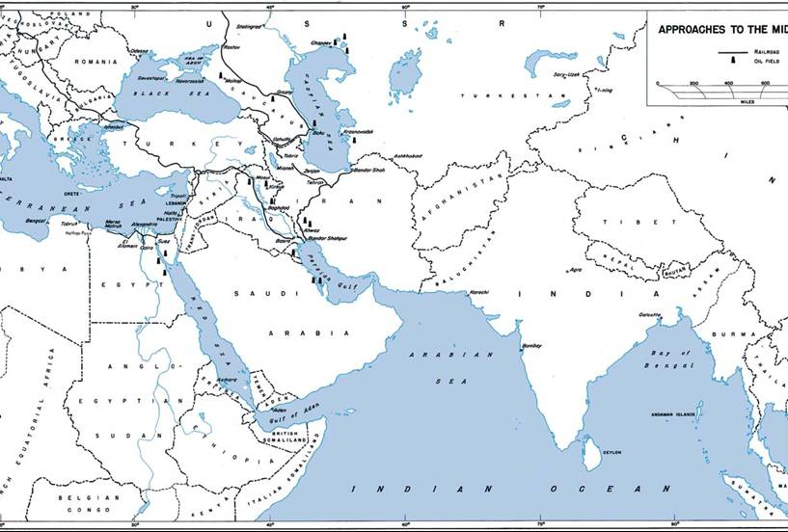

The expulsion of the last Nazis from Stalingrad, completed by 2 February 1943, removed the enemy threat to the Middle East from the north as El Alamein had done from the west. Supply tipped the scales in both battles that saved the Middle East. Afterward, as the German armies withdrew from the passes of the Caucasus and receded westward round the Black Sea, the task of supplying Russia through the Persian Corridor increased in intensity. The change in the American role in late 1942, from auxiliary to full partner of the British in the supply effort, raised the Corridor's tonnage to second place among the five routes to the U.S.S.R., and brought to the Persian Gulf ports nearly one fourth of the total lend-lease tonnage shipped to the Soviet Union from the Western Hemisphere.

The Persian Corridor operation was an experiment in international co-operation with no exact parallel or historical precedent. Here was Iran, forcibly occupied by Great Britain and the U.S.S.R., two long-standing rivals for its control, serving as a highway over which one of the rivals, calling upon the assistance of a fourth nation, the United States, delivered supplies to the other rival, now, by the fortunes of war, an ally. As an American officer put the case during the first months of confusion, ‘one nation was attempting to deliver supplies to a second nation with the occasional interference of a third through the country of a fourth in which none of the first three, save for the war, had any business to be; but the strange combination worked’.

So, there was a supplier – U.S. war production, and a route into Russia – the ‘Persian Corridor’.

For the Persian Corridor, operations closed, as they opened in 1942, at the ports. Khorramshahr, entrance for aid-to-Russia cargoes, served also as exit for the men and machines who had worked them. The tide of traffic turned about. Soldiers and baggage, once again packed aboard ship, headed for the open sea-the high-point men for home, the others for new assignment in Africa or Europe. Behind them, the once clamant wharves, the now empty storage yards, the roads no longer writhing with traffic, the hot shining rails, stilled after grinding and shrilling day and night under the weight of the long trains-these commenced imperceptibly to settle back into the decay that comes so naturally to the region. In a few years it would be as though the Americans had never worked at Khorramshahr, as if all that effort were a desert mirage.

Figure 7. Russian Aid Routes through the Middle East 1945

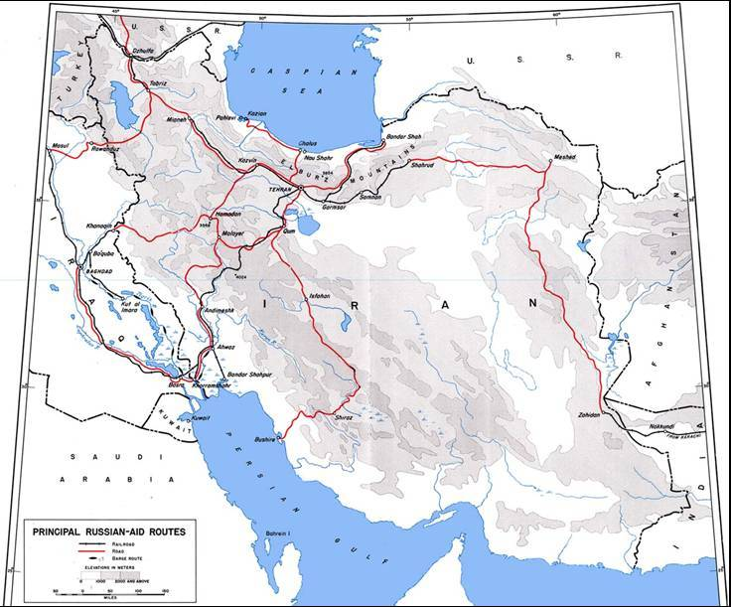

Photo 30. An Allied supply train en-route bearing supplies for the Red Army.

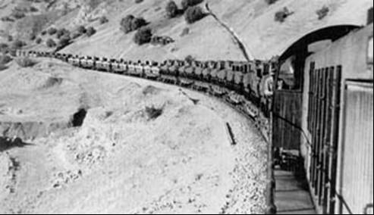

# Petrol for Russia

During the war years to meet their world-wide requirements for petroleum products, the British and Americans virtually pooled their oil resources. The Soviet Union which had large petroleum supplies within its own borders, characteristically remained aloof from the joint arrangements of the Western Allies, refusing even to exchange information on oil. Russia was not, however, entirely self-sufficient, for during the period of lend-lease the United States shipped 2,113,449 long tons of petroleum products to the U.S.S.R. To this figure should be added 621,826 short tons (555,202 long tons) shipped from the United States to the United Kingdom to replace petroleum shipped from the Abadan refinery to the U.S.S.R., charged as British reciprocal aid to the United States.

Because the Persian Corridor ran through one of the world's principal oil-producing areas, only certain types of lubricants of American origin passed through it to the U.S.S.R. The great bulk of American lend-lease petroleum went by other routes. The responsibilities of the American command in the Persian Corridor for petroleum shipments to Russia were therefore relatively minor, both as compared with total American petroleum shipments to Russia, and as compared with the total of other cargo tonnages delivered via the Persian Corridor.

Gasoline for Russia

In the spring of 1943, it was apparent that the struggle on the Eastern Front would soon require the Soviets to call for greatly increased supplies of aviation gasoline from the Western Powers. In May 1943, one solution was to send bulk shipments of aviation fuel via the Persian Corridor. The Aviation Gasoline Program, world-wide in scope, was based, in the Persian Corridor area, upon an agreement reached in following months whereby the Anglo-Iranian Oil Company (AIOC) made available for Russian delivery, amounts of high-octane aviation gasoline from their Abadan Refinery to be delivered by the American-operated transport agencies. The gasoline was supplied on reverse lend-lease, subject to delivery in the United Kingdom of equivalent amounts of petroleum from Western Hemisphere sources to compensate the United Kingdom for AIOC products normally intended for their (British) use. The Persian Gulf part in the program came into effect as of July 1, 1943 under the Third (London) Protocol and continued through the Fourth (Ottawa) Protocol, which was effective through May 12, 1945. Over half a million long tons thus went to the U.S.S.R. from the Abadan refinery.

Preliminary estimates in May 1943 were for haulage of 5,000 long tons per month. To superimpose the new burden upon the already increasing transport demands in the Corridor required not only new and complex arrangements for railway tank cars, highway haulage, shipping-including tankers and barges-storage facilities, and container filling, but development of new transport means such as pipelines, and a high degree of co-ordination of all these factors. As arrangements developed, capacity estimates by July 1943 had increased to 10,000 long tons per month and were projected at that level through June 1944. By November 1943, however, it was possible to raise the target to 25,000 long tons per month, and in the following July the target was stepped up to 37,000, of which 23,000 were to be carried in railway tank cars and 14,000 in drums. The figure of 37,000 long tons per month continued to April 1945, dropped in May to 25,000, and on June 1, 1945 the program was terminated.

The steady increase in U.S.S.R. bulk petroleum products (high-octane gasoline and alkylate), carried from September 1943 on into 1945, was accomplished without affecting the distribution of petroleum for other uses within the Corridor. This achievement was made possible through a number of factors. The fleet of tank cars available in July 1943 for U.S.S.R. petroleum was only forty cars. By March 1945, 400 tank cars transported 32,855 long tons of high-octane gasoline. The tank car turnaround period of fifteen days in 1943 dropped to half that in 1945. Economies and efficiencies all down the line contributed; but the most significant factor was the erection of new installations, called Petroleum Base 4 (P-4) and Petroleum Base 7 (P-7) near Khorramshahr.

Although by the summer of 1943 the AIOC in conjunction with Persian and Iraq Forces (PAI) had already established a number of fuel bases for reception, storage and distribution of petroleum, the increased requirements called for additional facilities. A site two miles north of Khorramshahr adjacent to the Persian Gulf Services Command's Ports Service Motor Pool was selected and in August 1943 construction of P-4 was begun. Levelling of the area and laying the concrete floor was accomplished by American Khorramshahr Post engineers while above-ground facilities were constructed by the British Royal Electrical and Mechanical Engineers. The AIOC installed pipelines and distribution points, and on 25 November 1943 rail tank cars began to move north out of P-4.

P-4 thus became the terminus of pipelines from the Abadan refinery. At this base fuel was distributed to tank cars by use of small pressure pumps. The installation also filled drums for truck haulage. In addition, it served as a transportation clearing yard for rail and truck movements to the Soviet receiving points on the Caspian Sea. The drumming of gasoline, with which American troops were particularly concerned in this co-operative Anglo-American undertaking, did not commence until May 1944. Responsibility was divided among numerous agencies. AIOC supplied the gasoline; U.S. Khorramshahr Port Transportation along with British Movement Control arranged for transport scheduling; the 6th British Petrol Staff and the 153rd. (later 154th.) Indian Depot (Indian Army Service Force) filled tank cars and tested, washed, and filled drums; while American personnel from Khorramshahr port handled the loading and unloading of drums and the spotting of rail cars and trucks. Russian inspection officers completed the P-4 team.

P-4 had been in operation something over a year when acute need for further facilities set the Americans to construction of the near-by sister installation, P-7, designed to serve for 100-octane fuel, while P-4 would handle 70-octane (for motor vehicles). Construction was quickly accomplished; but by January 1945, P-7 became a storage area and P-4 handled all 100-octane gasoline. At the end of April the U.S. Army withdrew, handing over to PAI Force, although the American Port Transportation Office continued to assist in movement matters. During the period of its operation P-4 cased and shipped over 275,000,000 gallons of 70 and 100-octane fuel to Soviet receiving points. The base averaged 1,200 tank cars or over 9,000,000 gallons of gasoline monthly by rail and approximately 2,500,000 gallons in drums monthly.

# Russian Technical Research

Like elsewhere in the technical world of aviation research, the Russian scientists and engineers were also undertaking research into aviation fuels and test methods. While Soviet Russia was somewhat of a closed society, there were some published reports of their activities. The following is one example:

**Effect of Supercharging on the Comparative Evaluation of the Anti-Knock Properties of Fuels** (M.M.Maslenikov and G.E.Bliessnukov, Aeron. Eng. U.S.S.R. Vol. 13, No. 11, Nov 1939, pp 30-9) (76/30 U.S.S.R.) (J XLIV p367-8)[15]

Experimental data obtained with a modified Waukesha fuel testing engine shows that when an engine is supercharged the knock tendency of various fuels does not alter to the same extent, since it depends on their on their chemical constitution; the anti-detonating effect of ethyl fluid apparently does not depend on induction pressure. Of the hydrocarbon groups constituting the fuels tested, the saturateds show best anti-knock stability in the case of supercharging. Naphthenes and aromatics show approximately the same anti-knock stability – inferior to that of the unsaturateds, and the paraffins show the worst behaviour. Thus the results obtained by comparison of the anti-knock properties of fuels which sharply differentiate the behaviour of paraffin – and unsaturated hydrocarbons, depends on the pressure of the air admitted to the engine.

Evaluation of the anti-knock properties of fuels by the C.F.R. engine method will characterise the value of the fuels for use in a supercharged engine only when there is a small difference between the contents of the fuels in paraffin and unsaturated compounds. For a larger difference a fuel of different octane will be required for use with supercharging; results of the present work show that this difference in octane rating may amount to four units.

This paper indicates that the Russian scientists were operating the standard octane testing engine - Waukesha C.F.R. Knock Engine; and that they also had discovered the standard Motor Octane Method octane test did not predict a good aviation gasoline when used under supercharge conditions in the modern aircraft engines then in service. The paper also reaches the same conclusion as the Western researchers, in that hydrocarbon types behaved differently when the test engine is supercharged - In the U.S. and U.K. this would lead to a new engine test in 1942.

# Soviet Aviation 1945-1950

Russian Aircraft for Soviet Communist Bloc

As the Russians began to develop their jet aircraft designs, the production of WWII combat aircraft continued and provided the necessary aircraft for the armies and air forces of the countries in the Communist Bloc such as Poland, Hungary and Czechoslovakia and others. These aircraft were the types used by the Russians in their ‘Great Patriotic War’ against Nazi Germany. Several examples can be found at Museum of the Polish Army (Muzeum Wojska Polskiego) in Warsaw, Poland.

Photo 31. Soviet IL-10 Sturmovik Ground Attack bomber –Polish Army circa 1946, on display at Polish Army Museum Warsaw 2009-Petroch Services ©

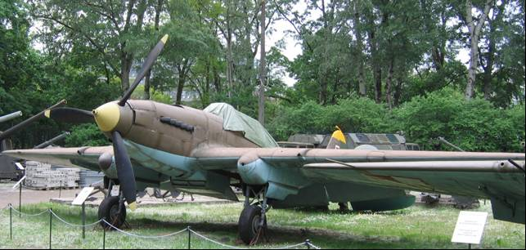

Photo 32. Soviet PE-2FT Dive Bomber- Polish Army circa 1945, on display at Polish Army Museum Warsaw 2009-Petroch Services ©

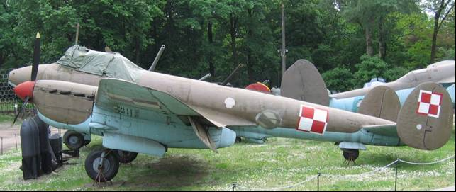

Photo 33. Soviet TU-2S Bomber – Polish Army 1945-1954 in the foreground with PE-2FT in the background. On display at Polish Army Museum Warsaw 2009-Petroch Services ©

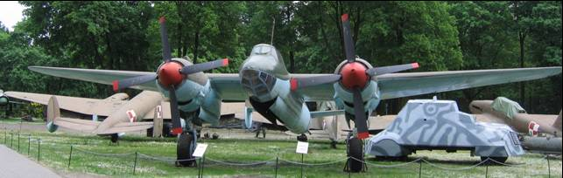

Photo 34. Famous Soviet Yak-9P of the Polish Army on display at Polish Army Museum Warsaw 2009-Petroch Services ©

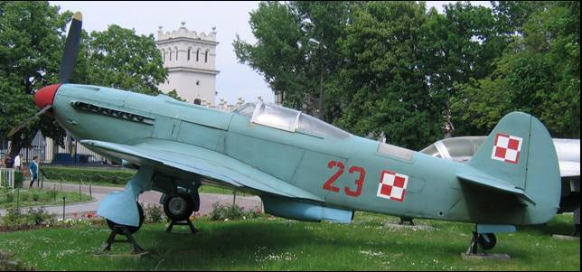

Russian Aviation Gasoline Specifications[16]

During World War II the specifications were those of the U.S. essentially for two reasons, the demand for production and distribution would not allow the luxury of another specification grade for a foreign country, already the U.S. and British (and Commonwealth) had rationalized aviation grades to common specifications. The second reason is that some of the aviation gasoline supplied under the lend-lease program would be used in Allied aircraft which had been designed to operate on U.S./British aviation grades.

In Russia, the equivalent to the U.S. A.S.T.M. (American Society for Testing Materials) is Gosudarstvennye Standarty State Standard (GOST, Russian Federation). In December 1972, they issued GOST-1012 ‘Specifications for Aviation Petrols’[17].

A publication by ASTM in 1977 ‘Significance of Tests for Petroleum Products” by Salvatore J. Rand[18] noted the following:

Due to the international nature of aviation activities, the technical requirements of all the Western specifications are virtually identical, and only difference of a minor nature exist between the specifications issued in the various major countries. The Russian GOST specifications (and their East European equivalents) differ in the grades covered and also in respect to some of the limits applied, but, in general, the same fuel properties are controlled, and most test methods basically are similar to their Western equivalents (American Society for Testing and Materials (ASTM) and (UK) Institute of Petroleum (IP) standards. Russian aviation gasoline grades were summarised as follows:

Table 5. Russian Aviation Gasoline Grades

|  |  |  |  |
| --- | --- | --- | --- |
| Specification | Grade | Colour | Use |
| GOST-1012 | B. 70 | Colourless | Current |
| GOST-1012 | B. 91/115 | Green | Obsolete (?) |
| GOST-1012 | B. 95/130 | Yellow | Obsolete (?) |
| GOST-1012 | B. 100/130 | Bright Orange | Current |
| GOST-5761 | BA 115/160 | Varies | Obsolete (?) |

The Russian GOST specification exhibits additional grade to grade variations in properties such as distillation range and vapour pressure.

A latter publication by ASTM around 1990 showed a reduction on the number of grades.

The two grades in the Russian, GOST specification are subdivided, somewhat curiously, into ordinary and premium qualities with differing limits for aromatics, olefins, sulfur, and acidity.

Table 6. Russian Aviation gasoline grades (as at circa 1990).

|  |  |  |  |
| --- | --- | --- | --- |
| Specification | Grade | Colour | Use |
| - | B.70 | Colourless | Obsolete |
| GOST-1012 | B.91/115 (a) | Green | Current |
| GOST-1012 | B.95/130 (a) | Yellow | Current |

1. In regular and premium qualities differing in limits for aromatics, olefins, sulfur, and acidity

However, with the Russians also moving to jet fuel it expected that these grades, if it has not already, will become obsolete due to greater access to the internationalization of the oil industry as indicated by the following:

September 14, 2003 - ‘Aerofuels started centralized supplies of Shell's aviation gasoline AVGAS 100LL in Russia. Last few years Russian industry did not produce aviation gasoline. General aviation had to use automobile fuel, which resulted in accelerated wear of engines. Now aviation units can fuel their aircraft with AVGAS — the best aviation gasoline in the world produced by Shell.’

# Russian Suppliers IMPEX Petroleum 2013

The following is the promotional material of a Russian supplier ‘Impex Petroleum’ in regard to aviation gasoline. However, it is not clear whether they manufacture aviation gasoline, but merely supply and distribute from another manufacturer, for example purchase aviation gasoline from Shell and then on-sell the product through Impex.

Today one of the suppliers of aviation gasoline is Impex Petroleum which is an oil trading consortium that specializes in storage, transportation and delivery of oil products in the Russian Federation home market and the markets of Central Asia and Eastern Europe. Their description of their aviation gasoline is as follows:

Aviation gasoline

Aviation gasoline is combustible matter obtained primarily from petroleum fractions by oil straight distillation, catalytic cracking or reforming without additives or with the addition of high-quality components, ethyl fluid and various additives.

Aviation gasoline differs from motor gasoline due to higher quality requirements; it typically has a higher octane number and is classified according to grades.

The sphere of use -It is used in piston aircraft engines.

Manufacturers

The plants of Rosneft (including TNK-BP),

LUKOIL OJSC,

TAIF-Oil Company OJSC,

Orsknefteorgsintez OJSC,

Krasnodar Refinery – Krasnodarekoneft CJSC,

Kirishinefteorgsintez Refinery Production Department LLC.

(OJSC = Open Joint Stock Company, CJSC = Closed Joint Stock Company, LLC = Limited Liability Company).

# War Prizes – German Jets in the Soviet Union

The Americans, British and Russian all captured German equipment including armoured vehicles, aircraft, but particularly jet and rocket powered aircraft as prizes of war, and transported them home. They also captured the German scientist and engineers who built them, and they were also ‘transported’ to the victor’s country. Many of the aircraft were used for research as the ‘Jet Age’ had commenced and the rivalry between the West and Soviets was about to escalate to the ‘Cold War’, the ‘Arms Race’ and the ‘Race for Space’. This capture of aircraft not only included enemy aircraft, but also extended to Allied aircraft particularly those which were technologically advanced.

Photo 35. German T-111 Medium Tank on display at Victory Park, Moscow, Russia 2009– Petroch Services ©

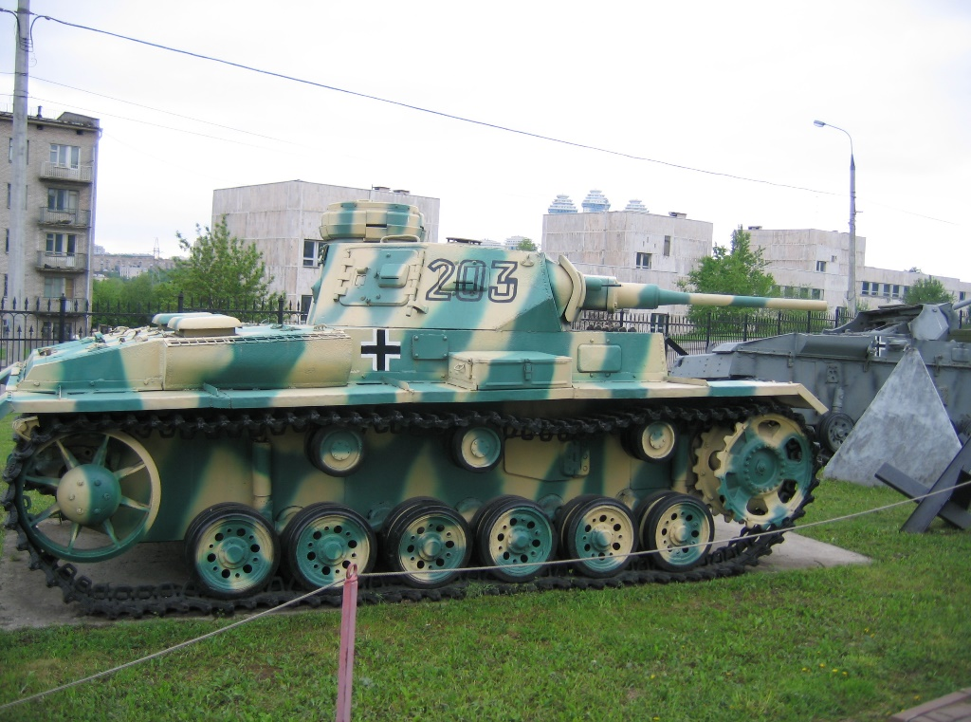

The spoils of war also included Japanese aircraft.

Photo 36. Japanese Ki-43 “HAYABUSA” (circa 1943) on display at Victory Park, Moscow, Russia 2009– Petroch Services ©

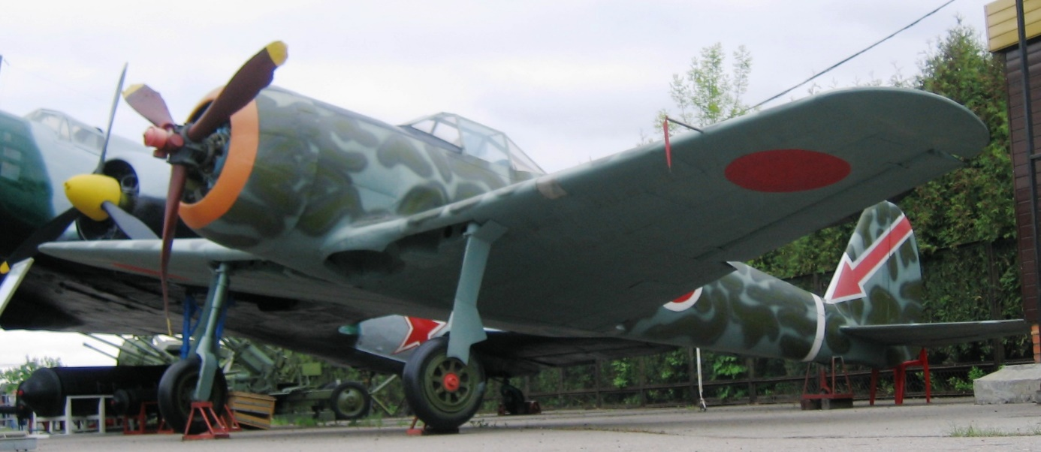Epilogue for the Russian era

Soviet Russia had substantial oil supplies, but not the necessary high octane aviation gasoline and lubricants which were produced from the technological advances of the 1930’s and early 40’s. These petroleum products would be supplied under the U.S. Lend-Lease program via the Persian Corridor. Anglo-Iranian Oil Company’s Abadan Refinery played an important role in producing those vital aviation gasoline supplies.

Russia initially suffered from lack of supply and quality of aviation gasoline, but not imagination and innovation. Perhaps one of the more curious aspects was the ‘exact copy’ of the famous B-29 Superfortress by the Russians under Stalin’s direction to be known as the Tupolev TU-4[19]. The aircraft was ‘reverse- engineered’ being taken apart bolt by bolt, part by part then scaled from imperial units (pounds, inches-feet) to metric units (kilograms, cm-metres) with some curious outcomes - for example the tale about the crew tunnel: two thirds was painted chromate green, the aft portion left in white primer because the American aircraft factory had run out of green paint. The copy duplicated this effect and later, this ratio was included in all the instruction books on how to paint the interior of the bomber. The Russian version was plagued with many mechanical problems.

It came into service around 1948 with the Long Range Air Force and in October 1951, a TU-4 would be used by the Soviets to drop their third atomic bomb in their atomic tests.

Photo 37. Russian Tupolev TU-4 on display at Monina Air Museum, Moscow Russia

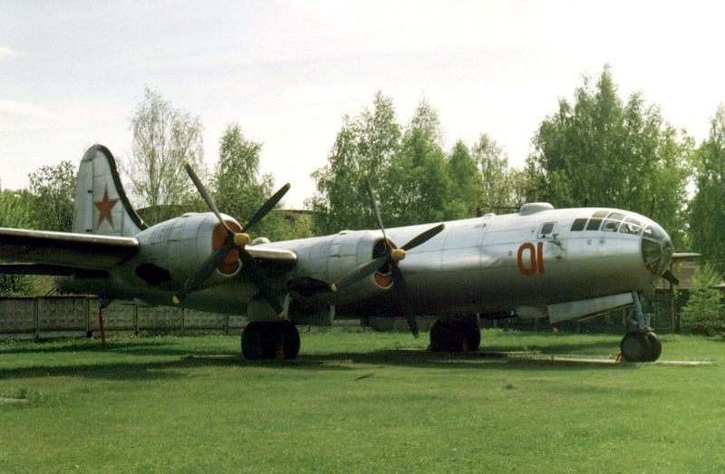

Post War Era

In aviation development, the U.S.S.R. with initial access to the plans and a Rolls Royce Nene jet engine, embarked on the development of jet and turbojet aircraft for both military and commercial purposes. They too had entered the ‘Jet-Age’.

Little is known of the Russian aviation gasolines after the Second World War, however it can be assumed that the desire to keep up with, and outmatch the West would require the some adoption of the refinery processes used in the West, if not the direct purchase (import) of aviation gasoline from the commercially friendly sources such as the Middle East.

# Index

1

100 Octane 15, 32

2

2,3, Di Methyl Pentane 18

2-Methyl pentane 18

7

70-octane 32

A

A-20 Havoc 26

Abadan 26, 27, 28, 31, 32, 38

Abadan refinery 31

acidity 35

Aerofuels 36

Africa 25, 28, 29

Ain Zalah 22

AIOC 31, 32

Alkylate 26, 27, 31

Alkylate/Isopentane 26

American Port Transportation Office 32

American Society for Testing and Materials (ASTM) 35

Anglo-Iranian Oil Company 31, 38

ANT-20 Maxim Gorky 8

anti-knock properties 33

Archangel 24

Arctic Circle 26

Arctic Ocean 24

Armavir 21, 22

Arms Race 37

Armstrong-Whitworth Albemarle 26

aromatics 18, 32, 35

Artic Siberia 25

ASTM 35

Astra Romana 28

Atlantic route 24

Atyrau 15

Avgas 100/130 27

AVGAS 100LL 36

aviation gasoline 18

Aviation Gasoline Program 31

Axis 11, 23, 24, 25, 26, 28

Azerbaijan 18, 20, 44

Azerneftyag 15

B

B.70 35

B.91/115 35

B.95/130 35

B-24 Liberator 26

B-25 Mitchell 26

B-29 Superfortress 38

BA 115/160 35

Bahrain Refinery 27

Bahrein 27, 28

Baidukov 8

Baku 15, 17, 18, 19, 20, 21, 22

Balkans 24

Barbarossa 4, 20, 21, 26

Battle of Britain 21

Batum 15, 20, 21

Beaverbrook 23, 26

Bell P-39 Aircobra 11

Bell P-63A Kingcobra 11

Belyakov 8

Benzene 18

Benzol 27

Berlin Wall 28

Bertoud 26

Black Sea 15, 20, 24, 25, 29

Black Sea Route 24

Black Town 21

blend stocks 18

Bliessnukov 32

Bolshevik Revolution 4, 6, 15

Bristol Blenheim Mk. IV 21

British Empire 23

British Petrol Staff 32

British Royal Electrical and Mechanical Engineers 32

Bucharest 28

Burma 22

Butane 18

C

C.F.R. engine 33

Cadogan 21

Cairo 26

Caspian 15, 19, 20, 21, 32

Caspian Sea 15

Caucasian oil 15, 17, 21, 22

Caucasus 20, 21, 22, 24, 29

Central Asia 36

Chaplygin 3

Chkalov 8

Churchill 20, 21, 22

cisterns 20

Cold War 5, 20, 22, 28, 37

Communist Bloc 33

Constanta 24

Crete 28

Crimea 21

Cumene 26, 27

Curtiss P-40 Kittyhawk 11

Cyclohexane 18

Cyclopentane 18

Czechoslovakia 33

D

DeHavilland Mosquito 26

E

East Coast 27

Eastern Europe 36

Eastern Front 4, 31

Egypt 22

El Alamein 28, 29

Ethane 18

F

First (Moscow) Protocol 23

Fourth (Ottawa) Protocol 24, 27, 31

G

German Afrika Corp 26

German T-111 Medium Tank 37

German-Soviet Treaty 21

Gorki 15

GOST 35

GOST-1012 35

GOST-5761 35

Gosudarstvennye Standarty State Standard 35

Great Patriotic War 33

Greece 21, 28

Grozny 15, 18, 21

Guryev 15

H

Handley Page Hampden 26

Harriman 23

Hawker Hurricane 11, 25

Heptanaphthenes 18

high-octane gasoline 31

Hitler 20

Hitler-Stalin non-aggression pact 23

Honshu 25

Hungary 4, 33

I

IL-10 Sturmovik 33

Illyushin Il-10 11

Illyushin Il-2 i, 11, 12

Impex Petroleum 36

India 27

Indian Army Service Force 32

Institute of Petroleum (IP) 35

Iran 28, 29

Iranian 22, 31, 38

Iraq 28

Isoheptanes 18

Isohexane 18

Iso-Nonanes 18

Iso-Octanes 18

Isoparaffins 18

Isopentane 18

J

Japan 4, 25

Jet-Age 39

K

Kartveli 7

Khorramshahr 29, 32

Ki-43 “HAYABUSA” 37

Kiev 21

Kirishinefteorgsintez Refinery 36

Krasnodar 15

Krasnodar Refinery – Krasnodarekoneft 36

Krasnovodsk 15, 20, 21

Kuybishev 15

L

Lend-Lease 15, 23, 28, 29, 31, 35, 38

Leningrad 15, 21

Long Range Air Force 38

Luftwaffe 20

LUKOIL 36

M

Maikop 18, 21, 22

Makhach-Kala 15, 20

Maslenikov 32

Mediterranean 24, 25

Methane 18

Methyl cyclopentane 18

Middle East 21, 25, 28, 29, 30, 39

Mikoyan 26

Molotov 23

Monina Air Museum 38

Moscow ….i, 4, 8, 9, 10, 11, 12, 13, 15, 20, 21, 22, 23, 24, 26, 37

Mosul 22

motor gasoline 18

Motter 28

Mozhaisky 3

Murmansk 24

Muzeum Wojska Polskiego 33

N

Nanchang CJ-6 14

naphtha 18

Naphthenes 18, 32

n-Heptane 18

n-Hexane 18

n-Nonane 18

n-Octane 18

Nononaphthenes 18

normal heptane 18

North Africa 28

North Russian Route 24, 25

Novorossiysk 24

n-Pentane 18

O

octane rating 18

Octonaphthenes 18

Odessa 24

olefins 18, 35

Operation Pike 21

Orsk 15

Orsknefteorgsintez 36

Osborn 20, 21

P

P-39 Bell Aircobra 25

P-4 32

P-40 Curtiss Kittyhawk 25

P-47 Republic Thunderbolt 25

P-63 Bell Kingcobra 25

P-7 32

Pacific route 24

PAI 32

paraffin 18, 33

PE-2FT Dive Bomber 34

Peninsula Aero Club 14

People's Voluntary Corps 18

Persian and Iraq Forces 32

Persian Corridor 24, 25, 26, 27, 28, 29, 31, 38, 44

Persian Gulf 29

Persian Gulf route 24, 25

Persian Gulf Services Command 32

Petroleum Base 4 32

Petroleum Base 7 32

Ploësti 4, 28

PO-2 Trainer 10

Poland 4, 33

Polikarpov 9, 10

PONA 18

Propane 18

p-Xylene 18

Q

Qiyara 22

R

Race for Space 37

rail tank cars 32

rating scale 18

Red Army 30

Red Star 21

Rolls Royce Nene 39

Romana American 28

Rommel 22

Roosevelt 22, 23

Rosneft 36

Royal Air Force 21

Rumania 12, 24, 26, 28

Russian crude oils 18

Ryabushunskiy 4, 5

S

Sabunchi 21

Saratov 15

Second (Washington) Protocol 24

Shell 36, 44

shuttle bombing 4, 11

Siberia 24

Siberian ports 24, 25

Sikorsky 6

Singapore 22

South Africa 27

Soviet Artic Route 24, 25

Soviet Far East 24, 25

Soviet Far Eat Route 25

Soyuzneft 21

SPADLING 26

Spitfire 11, 25

Stalin 21, 22, 23, 38

Stalingrad 15, 22, 29

Steana Romana 28

Sterlitamak 15

Sukhoi 8

sulfur 35

Surakhani 21

Syria 22, 28

Syzran 15

T

TAIF-Oil Company 36

Third (London) Protocol 24, 31

Tirpitz 11

Toluene 18

TU-2S Bomber 34

Tuapse 15, 21

Tupolev 8

Tupolev TU-4 38

Turkish 22

Turkmenistan 20

Tyabb Airfield 14

U

U.S. East Coast 25

U.S. West Coast 25

Union of Soviet Socialist Republics 23

United Kingdom 31

unsaturated 33

V

Vega 28

Vichy France 23

Vichy French 22

Vickers Wellington 21

Victory Park, Moscow 13, 37

Volga 15, 19

W

Watter 7

Waukesha 32, 33

Wehrmacht 21

White Town 21

Wickham 14

X

Xylenes 18

Y

Yak-3 13

Yak-52 14

Yak-9 13

Yak-9P 34

Yak-9U 14

Yakovlev 13

Yugoslavia 21

Z

Zhukovsky 3, 5

# Research Sources

1. Website <http://www.dias.unina.it/EWADE2011/Presentations/Session_3/01_V_Zhuravlev_EWADE_2011.pdf> Russian approach to Aircraft Design and Aeronautical Education by Vladimir Zhuravlevm Moscow Aviation Institute, Moscow, Russia. EWADE 2011. Naples, Italy 24-27 May 2011
2. Russian aviation mile stones Website accessed Jan 21, 2005 <http://aeroweb.lucia.it/~agretch/RAFAQ/Milestones.html>
3. Website <http://www.dias.unina.it/EWADE2011/Presentations/Session_3/01_V_Zhuravlev_EWADE_2011.pdf> Russian approach to Aircraft Design and Aeronautical Education by Vladimir Zhuravlevm Moscow Aviation Institute, Moscow, Russia. EWADE 2011. Naples, Italy 24-27 May 2011
4. Website: <http://history.acusd.edu/gen/WW2Index/picindex5.html> Accessed Sept 26, 2005
5. Website: <http://www.azer.com/aiweb/categories/magazine/32_folder/32_articles/32_ww22.html> Accessed Sept 27, 2005 “World War II and Azerbaijan” by Vagif Agayev, Fuad Akhundov, Fikrat T. Aliyev and Mikhail Agarunov
6. Chemical Constituents of Petroleum by Dr. A N Sachanen - R&D Division, Socony-Vacuum Oil Co., Reinhold Published 1945
7. Website: <http://historynet.com/mhq/bloperationunthinkable/index1.html> Accessed Sept 27, 2005 “Operation Unthinkable” by Patrick R. Osborn
8. "Lord Beaverbrook 1947b" by Yousuf Karsh - [1] Dutch National Archives, The Hague, Fotocollectie Algemeen Nederlands Persbureau (ANEFO), 1945-1989 bekijk toegang 2.24.01.04 Bestanddeelnummer 902-2070. Licensed under CC BY-SA 3.0 nl via Commons -https://commons.wikimedia.org/wiki/File:Lord_Beaverbrook_1947b.jpg#/media/File:Lord_Beaverbrook_1947b.jpg Accessed Dec 28, 2015
9. "Vyacheslav Molotov Anefo2" by Unknown - [1] Dutch National Archives, The Hague, Fotocollectie Algemeen Nederlands Persbureau (ANEFO), 1945-1989 bekijk toegang 2.24.01.04 Bestanddeelnummer 900-8982. Licensed under CC BY-SA 3.0 nl via Commons - <https://commons.wikimedia.org/wiki/File:Vyacheslav_Molotov_Anefo2.jpg#/media/File:Vyacheslav_Molotov_Anefo2.jpg> Accessed Dec 28, 2015
10. <https://en.wikipedia.org/wiki/W._Averell_Harriman> Accessed Dec 28, 2015
11. Website: <http://www.battlefield.ru/lendlease/intro.html> Accessed June 20, 2005
12. UK public Records Office Kew London Ref: AVIA 38/987 Russia
13. US National Archives and Records Administration - Memo from Thompson to Secretary of State - 1/18/42 (Jan 18, 1942) <http://www.fdrlibrary.marist.edu/psf/box5/t62c04.html> Accessed Jan 11, 2004
14. Website: <http://www.army.mil/cmh-pg/books/wwii/persian/chapter15.htm> Accessed Sept 30, 3005. “The Persian Corridor And Aid To Russia” By T. H. Vail Motter Center Of Military History United States Army, Washington, D.C., 2000 Library Of Congress Catalogue Card Number 52-60791 First Printed 1952-CMH Pub 8-1
15. Journal of the Royal Aeronautical Society JRAS Vol. XLIV 1940 Abstracts from the Scientific and Technical Papers January 1940 to June 1940
16. ASTM Manual on Significance of Tests for Petroleum Products 6th Edition. ASTM Publication Code Number (PCN) 28-001093-12. Chapter 5 Aviation Fuels By Geoffrey J. Bishop (Shell International Petroleum Company, London England) Cyrus P. Henry Jr. (DuPont Company, Deepwater, New Jersey, U.S.A.). circa 1990.
17. Website: <http://iash.net/resources/fuel_specifications.php> Accessed Oct 10, 2005
18. “Significance of Tests for Petroleum Products” By Salvatore J. Rand, by American Society For Testing and Materials 1977, Library of Congress Card Number 76-29513
19. Website: <http://aeroweb.lucia.it/~agretch/RAFAQ/Tu-4.html> Accessed Sept 30, 2005