Chapter

24

South West Pacific 1941-1946

Photo 1. Some of the famous aircraft which defended Australian and Pacific skies. Temora Aviation Museum fly past.

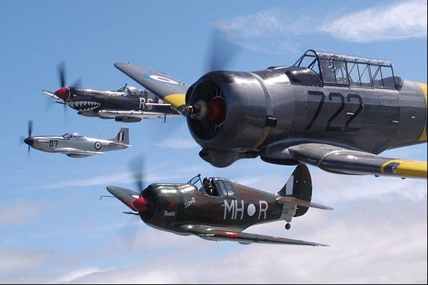

Left to right: CAC Mustang, Spitfire Mk III (owned by David Lowry), CAC Boomerang, CAC Wirraway.

Table of Contents

Summary 3

Japan's Seven-Point Assault 7

Singapore – The ‘Gibraltar’ Of The British Empire In The East 7

Australia Becomes Mcarthur’s Base In The Pacific 8

Key Personnel In The SWPA 11

Command & Supply 24

Advances Through The SWPA 39

New Guinea 41

Peace At Last – Time To Go Home 46

Transition Period – Transfer Of Supply US Forces To RAAF 46

Oil Companies And Refineries 52

Bulk Issue Petrol And Oil (BIPOD) 52

Spoils Of War 57

Epilogue For South West Pacific Area 58

Index 59

Research Sources 67

Figures 1. South West Pacific Area

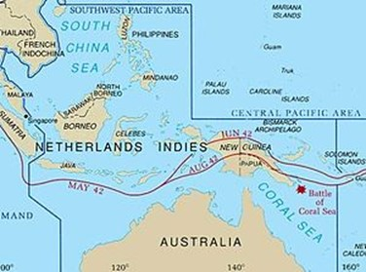

# Summary

This chapter covers the organisation of the allied forces and the combining of the air forces, their manpower, aircraft and supplies in the South West Pacific Area under General Douglas MacArthur.

**Chronology**

From October 1941 to September 1945

**1941**

7 Oct John Curtin becomes Prime Minister of Australia

7-8 Dec Japanese attack Malaya and Pearl Harbour

**1942**

Figure 2. Japanese Empire 1942

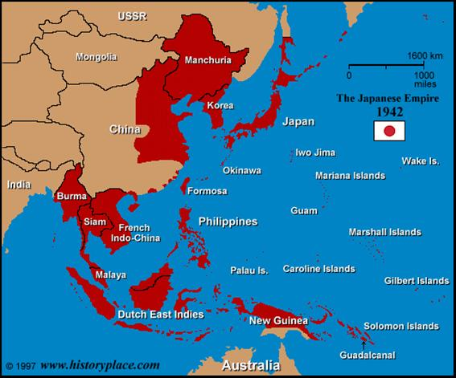

23 Jan Japanese capture Rabaul

3 Feb First Japanese air raid on Port Moresby

19-20 Feb Japanese forces land on Timor

28 Feb -1 Mar Japanese invade Java

8 Mar Japanese forces occupy Lae and Salamaua

9 Mar Leading brigade of 7th Division A.I.F. returns home from North African campaigns to defend Australia and arrives Adelaide

17 Mar General MacArthur arrives in Australia

26 Mar General Blarney becomes Commander-in-Chief, Australian Military Forces

6 Apr 41st U.S. Division arrives in Australia

18 Apr G.H.Q., S.W.P.A. (General Headquarters, South West Pacific Area) at Melbourne

5-8 May Battle of the Coral Sea

31 May- 1 June Japanese midget submarines attack Sydney Harbour

4-6 June Battle of Midway Island

21 July Japanese land in Gona area, Papua

7 Aug Americans land in Solomon Islands

25-26 Aug Japanese land at Milne Bay

17 Sept Japanese drive over Owen Stanley Ranges is halted at Imita Ridge

2 Nov Kokoda recaptured

12-15 Nov Naval Battle of Guadalcanal

9 Dec Australians forces capture Gona

**1943**

23 Jan Organised Japanese resistance in Papua ends

18 Feb 9th Australian Division arrives home at Fremantle

2-4 Mar Battle of Bismarck Sea

June 30 “Operation Cartwheel” begins with Allied landings in central Solomon Islands, Trobriand Islands, and Nassau Bay area of New Guinea.

Aug. 5 After 12 days of heavy fighting, Americans capture Munda Airfield, New Georgia, central Solomons.

Oct. 2 Japanese withdraw successfully from Kolombangara; Australians capture Finschhafen, New Guinea.

Oct. 12 United States Army Air Forces begin heavy air attacks on Rabaul, New Britain.

Nov. 1 Americans land on Bougainville Island, northern Solomons; during following night, Japanese naval task force is defeated offshore (Battle of Empress Augusta Bay).

Dec. 24 Bougainville beachhead, containing new airfields, is secured.

Dec. 26 Americans land at Cape Gloucester, New Britain. Cape Gloucester airfields are secured.

**1944**

Feb. 18 United States naval task forces complete neutralization of Japanese base at Truk; Americans begin landing on Eniwetok, Marshall Islands (atoll is secured by Feb. 23).

March 24 Organized Japanese resistance is broken on Bougainville and Los Negros.

April 22 Allied forces land in Hollandia area of New Guinea.

May 17 Allied operations commenced against Wakde Islands off Dutch New Guinea coast.

May 27 New Guinea area, Allied forces land on Biak Island.

June 15 United States Marines invade Saipan, Mariana Islands.

June 19 Japanese Fleet is badly defeated by United States carrier aviation in Battle of the Philippine Sea ("Marianas Turkey Shoot”; battle ends June 20).

July 9 Saipan is secured.

July 21 Americans land on Guam.

July 28 Organized Japanese resistance ends on Biak.

July 30 Americans land on Vogelkop Peninsula, New Guinea.

Aug. 10 Organized Japanese resistance is destroyed on Guam.

Sept. 15 Americans land on Morotai Island and Palau Islands.

6 Oct Headquarters Australian 3rd Division opens at Torokina, Bougainville

10 Oct American Third Fleet attacks Okinawa

11 Oct American Third Fleet attacks Luzon in the Philippines

23-26 Oct Naval Battle of Leyte Gulf

24 Nov B-29 Superfortresses attack Japan from bases in the Marianas

**1945**

9 Jan American forces land on Luzon, Philippines

19 Feb American forces land on Iwo Jima

10 Mar American forces land on Mindanao, Philippines

1 Apr Americans land on Okinawa

1 May Australian troops of 26th Brigade land on Tarakan Island, Borneo

7 May Germany surrenders unconditionally

8 May VE-Day

11 May Wewak captured by Australian 6th Division

10 June Australian troops of 9th Division land at Brunei Bay

1 July Australian troops of 7th Division land at Balikpapan

5 July Death of Mr John Curtin

6 Aug First atomic bomb dropped on Hiroshima

9 Aug Atomic bomb dropped on Nagasaki

15 Aug VJ-Day. All offensive action against Japan comes to an end

2 Sept 1945 Japanese envoys sign the Allied instrument of surrender aboard the USS Missouri in Tokyo Bay.

Photo 2. Japanese delegation for the surrender ceremony aboard the USS Missouri on 2 Sept 1945.

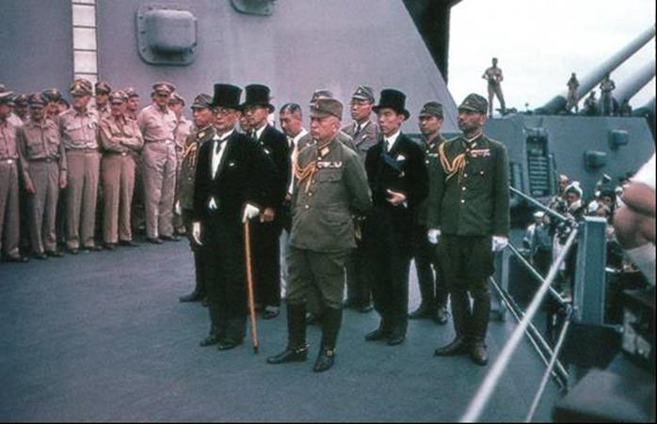

Japanese representatives on board USS Missouri (BB-63) during the surrender ceremonies, 2 September 1945.

Standing in front: Foreign Minister Mamoru Shigemitsu (wearing top hat) and General Yoshijiro Umezu, Chief of the Army General Staff.

In the back row, left to right (not all are visible): Rear Admiral Ichiro Yokoyama, Navy; Saburo Ota, Foreign Ministry; Captain Katsuo Shiba, Navy, and Colonel Kaziyi Sugita, Army.

Behind them are three representatives each of the Foreign Ministry, the Army and the Navy. They include, in middle row, left to right: Major General Yatsuji Nagai, Army; Katsuo Okazaki, Foreign Ministry; Rear Admiral Tadatoshi Tomioka, Navy; Toshikazu Kase, Foreign Ministry, and Lieutenant General Suichi Miyakazi, Army.

Photo 3. Sailors aboard the USS Missouri (BB-63) witness the signing of the Japanese surrender

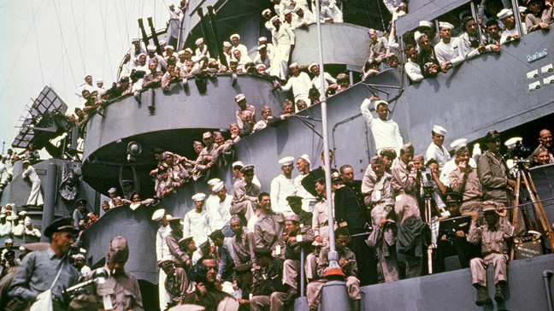

JAPAN'S SEVEN-POINT ASSAULT[1]

Half an hour before the midnight of 7th-8th December 1941, Japanese troops occupied the Bund in Shanghai. From there, south to the equator, and from Thailand across the Pacific to Hawaii, Japan unleashed her forces in a stunning seven-point assault on British, American and Thai territory.

In less than 14 hours Malaya, Hawaii, Thailand, the Philippines, Guam Island, Hong Kong and Wake Island had all been attacked and in that order. The speculations of Allied diplomats and military staffs about Japanese intentions were ended. Japan had become a principal antagonist of the Second World War.

One of the main factors in the military reasoning behind this decision for war on such a scale must be noted. The Japanese were keenly aware that there was no guarantee that the United States would stay out of the war. In America’s reactions to their foreign policy in the last two years (1939-1941) there was, in fact, very strong evidence to suggest the contrary. Thus, if the initial attack was to be made against Malaya alone, as the Germans had been advocating in an anxious effort to avoid war with America, their forces would be left open to the risk of attack on the flank or the rear by the United States Pacific Fleet, the greatest single coordinated force that could interpose itself between them and their objective—conquest in the south. The decision, then being for war in the plural, Japanese planners had to exploit the value of surprise. To achieve this surprise great reliance, obviously, must be placed upon air power. Japan's air strength, which had been the subject of so much speculation, was divided between her army and navy air forces. On this day on which she flung the challenge at combined British and American strength, Japan had an army air force with about 1,600 first-line aircraft and a navy air force with about 3,000 first-line aircraft.

# Singapore – the ‘Gibraltar’ of the British Empire in the East

The fortress at Singapore was deemed by British to be impregnable with its large naval guns guarding the sea lanes. It was also supported by an army garrison and air support from RAAF.

Photo 4. RAAF Beaufort Bombers refuel in Singapore 1941.

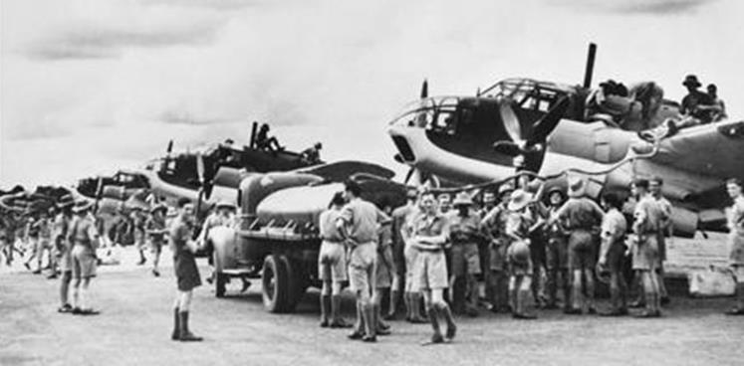

“Fortress Singapore” would fall to the Japanese forces in a disastrous defeat of British, Australian and Indian forces in January 1942.

# Australia becomes McArthur’s base in the Pacific

[2]The American strategic locations in their influence in the Pacific extended from the large naval base and airfields in Hawaii, then to bases at Wake Island and finally further east to the Philippines. The Japanese overwhelming attack on Wake Island on December 21-22, 1941, resulted in the loss of a key stop-over in the route to the Philippines.

Two days after the loss of Wake Island the Japanese seized the island of Jolo, in the Sulu Archipelago—a move which put the eastern coast of Borneo and the oil port of Tarakan under immediate threat.

USAAF Bombers flee from Philippines

Even in the face of continued reverses in the Philippines, General MacArthur had been maintaining his hope that reinforcements could and would arrive. In recent messages to Washington he had referred to the possibility of making counter-attacks on Formosa, but now his bombing force was about to move to Darwin. Six Flying Fortress B-17 bombers took off on 17th December 1941, and four more B-17’s next day. On the 19th the enemy attacked Del Monte with 12 fighters which destroyed 3 Douglas B-18 Bolo bombers (also known as Digby bombers) that had just landed, but they missed the remaining Boeing B-17 Flying Fortresses that were being loaded under camouflage for the flight to Australia. By 20th December all the surviving heavy bombers—14 of them—and 145 officers and men had been moved to Batchelor, Northern Territory, Australia. (Their destination was to be Darwin but the surface of the airfield there was unequal to the weight of Flying Fortresses and so all the bombers were sent on to Batchelor.)

Authority had been given already for the dispatch of 65 Boeing B-17 Flying Fortresses and of 15 LB-30A's (the export version of the Consolidated B-24 Liberator bomber) which had been repossessed from the RAF. But, before these could be sent, the loss of Wake Island had closed the trans-Pacific ferry route. Hurried efforts were made, therefore, to develop an alternative route across the Atlantic, Africa and India, so that these aircraft might reach the Philippines.

Alternate Route to Java

The route was from Tampa (Florida), USA through Trinidad, thence through Belem and Natal (Brazil), across the Atlantic to Accra (Gold Coast) and on to Khartoum, Cairo, Habbaniya, Karachi and thence through India and Ceylon to Bandung, Java. As early as 1939 this route had been considered by the USAAF for ferrying heavy bombers to the Philippines. The Liberators were now sent to MacDill Field near Tampa, to prepare for the flight (most of the Fortresses promised were still in the factory). The first serious delay then occurred. Few of the crews had had any training in long-distance flying or, in fact, in manning four-engined bombers. The urgency was great, and a plea for time to give the crews something like adequate training was agreed to only after an appeal to Washington, and then very reluctantly. The task of setting up refuelling bases at 12 points on the route was also vast; it entailed the construction of tanks and the sea transport from America of from 500,000 to 1,000,000 gallons of 100 octane fuel at each base (the RAF with their commitments in Europe and North Africa was now consuming about 90 per cent of the output from the Abadan refinery).

Under pressure from the mounting list of Japanese successes, President Roosevelt’s assertion that Australia would be a base of the utmost importance was now becoming fact. First indication of this had come when the American convoy which had been so anxiously awaited in the Philippines, was, on 12th December 1941, redirected to Brisbane, the forces it carried being designated Task Force South Pacific, and the senior officer, Brigadier-General Julian F. Barnes, being named as commander, not only of this force but of all American army forces in Australia. But General Barnes' command was brief. On 21st December he was informed that General Brett, who would soon reach Australia, would organise and command all American forces and that, until his arrival, General Clagett, who reached Brisbane on the 22nd, would assume command Barnes became Clagett's Chief of Staff.

Photo 5. March 18, 1942 US Army Lt. Gen. George H. Brett, Deputy Supreme Commander and Chief of Allied Air Forces in the South West Pacific, with his Chief of Staff, Brigadier General Stephen Chamberlin. [3]

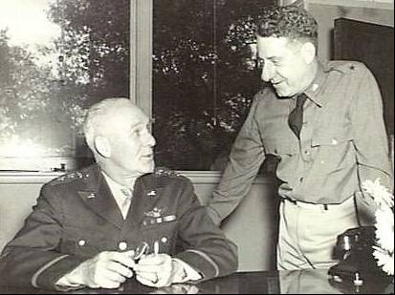

[In August 1941, Brett had been sent to Britain and the Middle East to study RAF operations and report on the expansion of technical maintenance for American aircraft operated by the RAF. He then visited India and China, leaving Chungking on 24th December for India again, and Java for conferences with the British and Dutch Commands before coming to Australia.]

The United States Military Attaché, Colonel Van S. Merle-Smith, under instructions from Washington, had made arrangements for the reception of the convoy at Brisbane and for the assembly of the aircraft it carried. The convoy consisted of seven transports or cargo vessels and the tender “Niagara”, escorted by the cruiser “Pensacola”. Of a total Air Corps strength of more than 2,000 there were 48 pilots, a number of whom were cadets and almost all of whom still required operational training. In addition to the 52 Douglas SBD Dauntless dive bombers of No. 27 Group, there were 18 Curtiss Kittyhawks. Air force supplies included nearly 7,000,000 rounds of 0.50 calibre ammunition, more than 5,000 bombs (from 30-lb to 500-lb) and several thousand barrels of aircraft fuel and oil. The convoy arrived on the 22nd December 1941 and on the 23rd the first American formations to come to Australia on a war mission disembarked. Brisbane's Ascot and Doomben racecourses provided their first camp sites while the RAAF stations at Archerfield and Amberley accommodated the units that would undertake the assembly of American aircraft. But the convoy had been loaded in what, for America, were then still peacetime conditions; there had been no thought of tactical loading, with each ship containing complete units. Thus, practically the entire cargo had to be unloaded, and equipment that was to go on by sea was then reloaded into the two fastest ships. With Australian waterside workers working 24 hours a day this task was completed by 28th December, and two days later both ships were at sea again and on course for the Philippines. Only when the assembly of the aircraft from the convoy began was it realised that essential parts for the Dauntless dive bombers (trigger motors, solenoids and mounts for the guns) were missing. None of the dive bombers could be ready for operations until these parts had been ordered from Washington and flown to Australia).

Photo 6. Douglas SBD Dauntless dive bomber

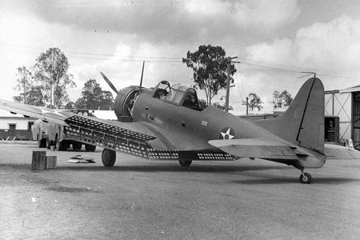

A-24 Douglas SBD Dauntless Dive Bomber, ex 27th Bomb Group, reassigned to the 8th Squadron of the 3rd Bomb Group.[4]

Photo 7. Vultee Vengeance

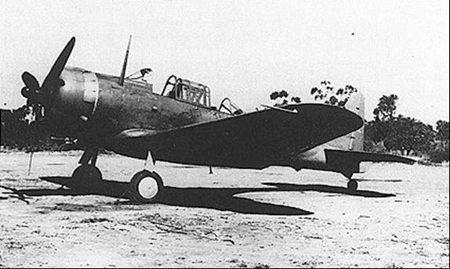

The most urgent American problem in Australia was the provision of adequate base facilities so that the flow of war materials, and particularly aircraft, might reach the Philippines. But by 22nd December, 1941 cable messages from U.S. General Marshall began to reflect doubt that the American units could be sent to the Philippines. While the route across the Atlantic and Africa was being developed both the American Army and Navy were preparing bases on an alternative trans-Pacific route by way of Christmas Island, Canton Island, Samoa, Fiji and New Caledonia.

Townsville was selected as the Australian port of entry. The second stage of this route was planned for the passage of short-range aircraft from the east coast of Australia to the Philippines thus: Brisbane, Townsville, Cloncurry, Daly Waters, Darwin, Koepang, Macassar, Balikpapan or Samarinda, Tarakan, and thence to airfields near Del Monte, with an intermediate stop at one or other of several bases on the route from Del Monte to Bataan. The total distance from Brisbane to Bataan by this route was almost 5,000 miles—about 25 hours flying time for a fighter aircraft. But the loss of Davao had created a very real fear that Del Monte, too, might soon be lost, and that the final section of the route would be cut.

In establishing their bases in the Commonwealth of Australia it was natural that the Americans should endeavour to economise in sea and air transport space by obtaining the greatest possible amount of their needs in Australia. Two obstacles were Australia's own expanding defence needs and a rail transport system in which there were breaks of gauge (different rail gauges across the network which would result in unloading and reloading cargo). It was now that the value of General Brereton's earlier visit began to be really appreciated. On that visit, he had initiated three major projects:

1. establishment of airfields for the trans-Australian ferry route,
2. provision of airfields for the tactical operation and training of members of the USAAF, and
3. development of bases for an American air force of, initially, four bombardment groups, four fighter groups and one fighter training centre.

# Key personnel in the SWPA

Photo 8. Lt. General Lewis H Brereton

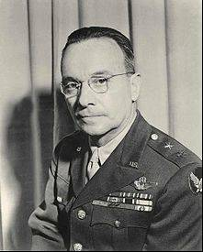

When American troops arrived in Australia all three projects had been adopted, and months of valuable time had been saved. No. 27 Group pilots who had reached Darwin from the Philippines left on 23rd December 1941 in a Qantas flying-boat, and on Christmas Eve alighted on the Brisbane River alongside the ships of the American convoy. But these planeless pilots had come for dive bombers that were desperately needed in the Philippines. They had found them, but, in the absence of crucial gun parts, they were on little use.

The first of several Allied staff conferences was held at Amberley on 28th December. American officers accepted responsibility for the assembly of their aircraft but, since these aircraft had to be ferried to Darwin, coordination with the RAAF was necessary and it was agreed that Group Captain Lachal, at that time commanding No. 3 Service Flying Training School, should assume general supervision. Refuelling depots with adequate supplies were required at Charleville, Cloncurry, Daly Waters and Darwin. The 100-octane fuel which was still available from the refineries in Netherland East Indies (N.E.I.) had an aromatic content so high that it would destroy the self-sealing linings of the American aircraft fuel tanks. A ship carrying 400,000 gallons of American aircraft fuel had been sunk while on her way to Brisbane and supplies were far short of the pre-war estimate of 100,000 gallons.

On the same day Clagett and Burnett agreed to inaugurate a training program—night flying, dive bombing and air gunnery—for the Dauntless crews at Archerfield and the Kittyhawk pilots at Amberley. This was undertaken by Major Davies with Group Captain Lachal again accepting the responsibility for general supervision. Here was the genesis of a long and important phase of collaboration between the USAAF and the RAAF.

When Brereton reached Darwin he conferred with Major Combs, then commanding the Flying Fortress formation, and made known his decision, already noted, that the group should move to Malang in Java. In contrast to the pilots of No. 27 Group on arrival at Brisbane, the Flying Fortress crews had little to compensate them for all they had endured. To them "Batchelor Field must have looked like the outpost of a lost world. - The stops along the line had sad, lost echoes in their names - as all names have in that tortured and irrational land where water and women become the focus of man's existence and his dreams." Their aircraft were not in good condition and the men themselves were weary. Their first task on arrival was to dig weapon pits for protection against air raids, which seemed to give the place a "more familiar look". But the fatiguing weather—shade temperatures up to 118 degrees (47OC) and frequent rain—took its toll; and maintenance with no greater facilities than they had had at Del Monte, Mindanao called for great effort. It was not surprising therefore that the crews and ground staff welcomed Brereton's latest order; Java would be much more in keeping with their idea of a "promised land". Brereton told them that they were going north again to do what they could to hold Java because they were the only air power the Allied nations had in the South Pacific area—perhaps an understandable exaggeration in the circumstances though true only in terms of heavy bombers. With some bitterness he spoke of his efforts to prevent the highly-trained group from being sent to the Philippines without adequate fighter protection. Now, instead of a group, they were barely a squadron.

By 31st December 10 B-17 Flying Fortresses had landed on Singasari airfield, six miles from Malang. This was now the full strength of No. 19 Group, which began to prepare for a new phase of combat still with their war-worn aircraft, but in high hopes that new aircraft would arrive soon.

Next day Brett sent a radio message to General Marshall (US Army) telling him that it would be impossible to undertake much in the way of tactical operations until he had developed an American "establishment" in Australia, including a large air base at Darwin and a supply and repair base at Townsville. Next day he flew to Melbourne where he conferred at length with the Australian Chiefs of Staff. Brett had found common ground with British General Wavell on the main principles of Allied strategy and with this agreement as background he presented his conclusions to the Australian defence authorities. He proposed a defensive strategy until such time as sufficient forces could be built up to undertake offensive operations by working from Burma into China and towards Shanghai to acquire advanced bases, by exerting slow pressure through the Netherlands East Indies and Malaya, and by exerting similar pressure from Australia into the islands to the north. On 4th January 1942, he ordered the two ships of the original convoy, then on their way to the Philippines, to go to Darwin and discharge all cargo and troops there.

On 3rd January 1942 General Marshall received a memorandum from his Assistant Chief of Staff, Brigadier-General Leonard T. Gerow, outlining the operations necessary for the restoration of American control in the Philippines, and concluding that "the forces required for the relief of the Philippines cannot be placed in the Far East Area within the time available". He recommended that "for the present" Allied efforts in the Far East be limited to holding the Malay Barrier, Burma and Australia and to operations projected northward "to provide maximum defense in depth"—a plan that would have received the full approval of the Australian Chiefs of Staff.

Another illustration of the awareness that it was now too late to aid MacArthur by delivering heavy bombers to the Philippines was a decision that all ferrying flights must report to General Brett at Darwin. Thus, none of the heavy bombers promised after Roosevelt's assurance of reinforcement "with all speed" was delivered to its original destination. From those who were aware just how the American forces were now being deployed and were conscious of Japan as the "ever-present" enemy, the plan to defeat Germany first must have demanded great faith in the virtues of the long-term plan. This must have been sharply apparent when it was realised that, whereas the American forces being prepared and dispatched for service in the European theatre were labelled "preparatory and precautionary deployments", the limited reinforcements then being sent to the Pacific were dispatched with the prospect, if not the certainty, of almost immediate combat. Apart from the question whether it was any longer possible to provide even indirect aid for the forces in the Philippines, the island chain between Hawaii and Australia, now becoming increasingly vulnerable, was a matter of concern at the conference at Washington. New Caledonia provided one example, Australia had been given responsibility for its defence but a practical fact was that if the island was to be made really secure it was necessary to base a substantial American ground force there. The crucial problem was not so much the provision of men, equipment or aircraft as it was one of providing the ships to transport them. The only course remaining was to revise the size of the convoys which were to carry American forces to Iceland and Northern Ireland. This was done and enough shipping space was squeezed from them to transport 21,800 men, including the ground forces for New Caledonia, and certain air units and aircraft that could be spared immediately.

On 3rd January General Wavell was appointed Supreme Commander of the A.B.D.A. Area (the initials deriving from the four nations concerned in the agreement—American, British, Dutch and Australian) and next day the appointment was publicly announced.

Photo 9. General Sir Archibald Wavell

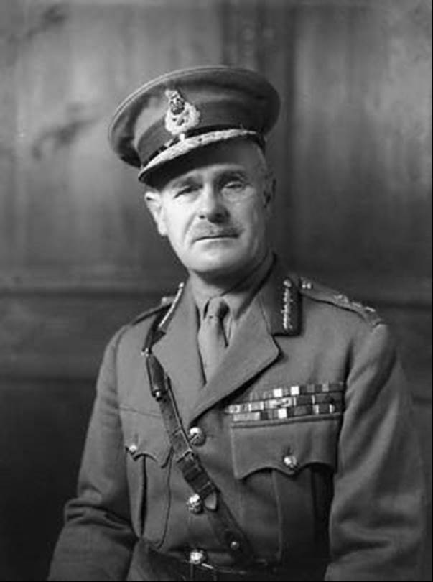

That day Brett received a directive from the Combined Chiefs of Staff in Washington designating him Deputy Commander-in-Chief to General Wavell in the ABDA Area ("ABDACOM" as the Command was to be designated). In this capacity he was also to be responsible for maintaining communications and supplies for all American air forces from Australian ports to the Netherlands East Indies. On 5th January, in keeping with earlier instructions, Brett assumed command of the United States Army Forces in Australia (USAFIA). Brereton, still formally commander of the Far East Air Force, now received a new appointment as commander of all American Air Forces in ABDA Command. He was directed to report to General Wavell for instructions and to operate under his strategic control.

On 9th January, in company with Air Chief Marshal Burnett, Brett and Brereton flew to Batavia to meet Wavell and review the whole command position. Next day Brereton learned that he had been appointed Deputy Chief of the Allied Air Forces in the new command, the Chief being Air Marshal Sir Richard Peirse, RAF, who would not arrive for another two or three weeks. It had been agreed between Brett and Brereton that staff duties should not be allowed to interfere with Brereton's task of directing the American Air Force and, after a conversation with Wavell, it was decided that he should serve both as Deputy Air Commander, ABDA Command, and Commander of the American Air Forces.

[5]The American-British-Dutch-Australian (ABDA) Command, code name ABDACOM, was a short-lived, supreme command for all Allied forces in South East Asia, in early 1942, during the Pacific War in World War II. The main objective of the command, led by General Sir Archibald Wavell, was to maintain control of the "Malay Barrier" (or "East Indies Barrier"), a notional line running down the Malayan Peninsula, through Singapore and the southernmost islands of Dutch East Indies. ABDACOM was also known in British military circles as the "South West Pacific Command", although it should not be confused with the later South West Pacific Area command (see below).

Figure 3. ABDACOM Area January 1942

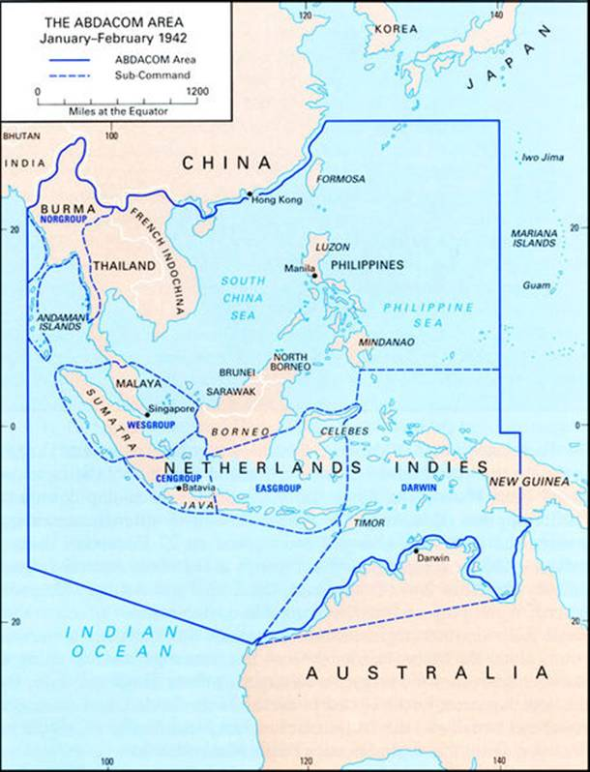

Although ABDACOM was only in existence for a few weeks, and it presided over one defeat after another, it did provide some useful lessons for combined Allied commands later in the war.

Efforts to organise the ABDA Command began soon after war between the Allies and Japan commenced, on December 7, 1941. On December 29, Winston Churchill said that it had been agreed Wavell would be supreme commander. Wavell then held the position of British Commander-in-Chief India.

Churchill added: It is intended that General Wavell should have a staff in the South Pacific accessible as Foch's High Control Staff was to the Great Staffs of the British and French armies in France [during World War I]. He would receive his orders from an appropriate joint body who will be responsible to me as the Minister of Defence and to the President of the United States who is also Commander-in-Chief of all United States forces.

Photo 10. British General Wavell and Dutch General Hein ter Poorten in Java, Dutch East Indies - January 22, 1942

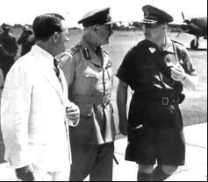

Wavell (left) is met by the Dutch commander, General Hein ter Poorten (soon to be appointed the ABDA land commander), at Batavia in 1942. Following the Declaration by the United Nations on January 1, 1942, the Allied governments formally appointed Wavell. The formation of ABDACOM meant that Wavell had nominal control of a huge, but thinly-spread force, covering an area from Burma in the west, to Dutch New Guinea and the Philippines in the east. Other areas, including India and Hawaii remained officially under separate commands, and in practice General Douglas MacArthur was in complete control of Allied forces in The Philippines. At Wavell's insistence, the western half of northern Australia (see map) was added to the ABDA area. The rest of Australia was under Australian control, as was the Territory of New Guinea.

ABDA was charged with holding the Malay Barrier for as long as possible in order to retain Allied control of the Indian Ocean and the western sea approaches to Australia. This was a nearly hopeless task, given the Japanese supremacy in naval forces in the western Pacific. The task was further complicated by the addition of Burma to the command; the difficulties of coordinating action between forces of four nationalities that used different equipment and had not trained together; and the different priorities of the national governments. British leaders were primarily interested in retaining control of Singapore; the military capacity of the Dutch East Indies had suffered as a result of the defeat of the Netherlands in 1940, and the Dutch administration was focused on defending the island of Java; the Australian government was heavily committed to the war in North Africa and Europe, and had few readily accessible military resources, and; the U.S. was preoccupied with the Philippines, which at the time was a U.S. Commonwealth territory.

Wavell arrived in Singapore, where the British Far East Command was based, on January 7, 1942. ABDACOM absorbed this British command in its entirety. On January 15, Wavell moved his headquarters to Bandung in Java and assumed control of Allied operations.The first notable success for forces under ABDACOM was the U.S. Navy's attack at Balikpapan, Borneo on January 24, which cost the Japanese six transport ships, but had little effect on them capturing the prized oil wells of Borneo.

The governments of Australia, the Netherlands and New Zealand lobbied Winston Churchill for an Allied inter-governmental war council, with overall responsibility for the Allied war effort in Asia and the Pacific, based in Washington D.C. A Far Eastern Council (later known as the Pacific War Council) was established in London on February 9, with a corresponding staff council in Washington. However, the smaller powers continued to push for a body based in the US.

In the meantime, the rapid collapse of Allied resistance to Japanese attacks in Malaya, Singapore, the Dutch East Indies, the Philippines and other countries had soon overwhelmed the Malay Barrier. The fall of Singapore on 15 February 1942 dislocated the ABDA command, which was dissolved a week later.

Japanese attacks along the Malay Barrier December 23, 1941 – February 21, 1943. Wavell resigned as supreme commander on the February 25, 1942 handing control of the ABDA Area to local commanders. He also recommended the establishment of two Allied commands to replace ABDACOM: a south west Pacific command, and one based in India. In anticipation of this, Wavell had handed control of Burma to the British India Command and reassumed his previous position, as Commander-in-Chief India.

Following the destruction of the main ABDA naval force under Rear-Admiral Karel Doorman, at the Battle of the Java Sea, in February-March 1942, ABDA effectively ceased to exist.

As the Japanese closed in on the remaining Allied forces in the Philippines, MacArthur was ordered to re-locate to Australia. On March 17, the US Government appointed him as Supreme Allied Commander South West Pacific Area, a command which included Australia and New Guinea in addition to Japanese-held areas. The rest of the geographic area of the Pacific Theater of Operations remained under the Pacific Ocean Areas command, led by Commander-in-Chief Admiral Chester Nimitz of the US Navy.

The inter-governmental Pacific War Council was established in Washington on April 1, 1942 but remained largely ineffectual due to the overwhelming predominance of US forces in Asia and the Pacific throughout the war.

Perhaps the most notable success for ABDA forces was the guerrilla campaign in Timor, waged by Australian and Dutch infantry for almost 12 months after Japanese landings there on February 19, 1942.

Photo 11. Lt. Gen George H. Brett, at the time Deputy Supreme Commander in the South West Pacific Area (SWPA) and Commander of Allied Air Forces in the SWPA

[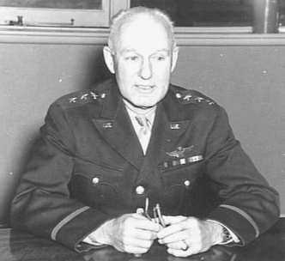](http://upload.wikimedia.org/wikipedia/en/e/e4/AWM_011744_george_brett.jpg)

Following the outbreak of the Pacific War, Brett was appointed commander of all United States forces in Australia and arrived there on December 28, 1941. He was based initially in Brisbane.

Brett was promoted to Lieutenant General in January 1942 and the Allied governments appointed him deputy to the British General Archibald Wavell, commander of ABDACOM. Brett travelled to ABDA headquarters at Bandung, in the Dutch East Indies. However, the rapid advance of Japanese forces through South East Asia had soon split the Allied-controlled area in two, and Brett returned to Australia.

MacArthur Arrives In Australia

Plans were made for the prompt transfer of MacArthur to Australia. Four Fortresses were dispatched for Mindanao, but only one succeeded in reaching its destination and it was in bad mechanical condition. Major Carmichael was then instructed to prepare more aircraft for the task and three, borrowed from the navy, reached Mindanao safely, carrying with them a consignment of much-needed medical supplies for the forces on Bataan. Meanwhile on a rainy evening (11th March) the general, his wife and young son and several staff officers, including General Harold H. George, boarded two patrol boats which, following separate courses, made the journey from Manila Bay to a rendezvous on Mindanao with all speed and without incident. For the next stage of the journey a night take-off was arranged from Del Monte aerodrome, no great distance from the enemy's base at Davao. The Flying Fortresses landed at Batchelor on 17th March 1942. From Darwin the party made its way by road to Alice Springs and thence to Melbourne by train, a journey that occupied three days and a half.

In the meantime, General Douglas MacArthur had also arrived in Australia and was appointed to the new post of Supreme Commander South West Pacific Area (SWPA), based in Melbourne. In April, Brett was made MacArthur's deputy and also commander of Allied air forces in the SWPA.

Following disagreements with MacArthur, Brett was transferred to the US on August 4, 1942. General George Kenney officially took over as Allied air commander, SWPA.

Photo 12. Melbourne, 21 March 1942. General Douglas Macarthur (left), Supreme Commander of the Allied Forces in the Southwest with his second in command Lieutenant General George H. Brett (right) [6]

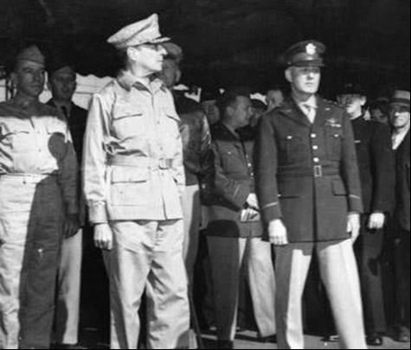

Figure 4. The Pacific theatre of war showing Japanese expansion and Allied advances to defeat the Japanese Empire.[7]

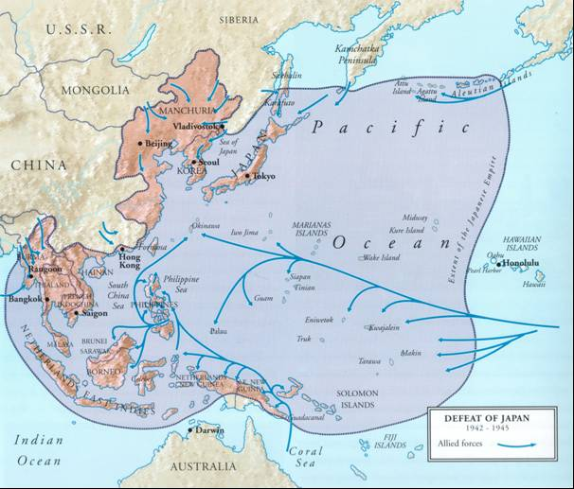

Figure 5. SWPA Organisation Structure

**ALLIED AIR FORCE, SWPA**

**ORGANISATION STRUCTURE IN AUSTRALIA DURING WW2**

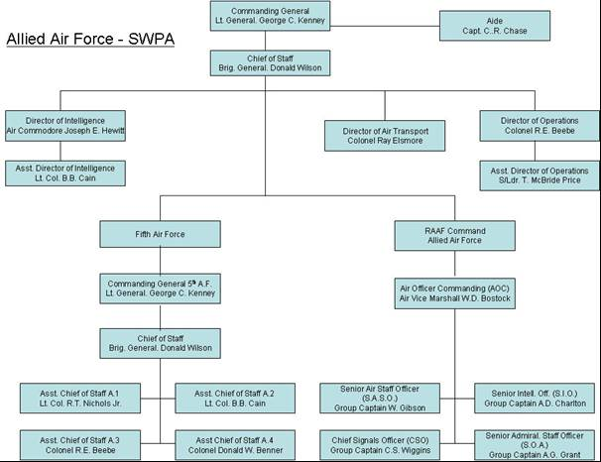

The Allied Air Force organizational structure for the South West Pacific Area SWPA was built around the USAAF 5th Air Force and the RAAF which included units of the Netherlands East Indies (NEI)).

Commanding General Lt George Kenney

George C. Kenney was born in Yarmouth, Nova Scotia, on 6 August 1889. He attended M.I.T., and at the outbreak of World War 1, he enlisted as a flying cadet. He received his commission as a 1st Lieutenant in the Aviation Section, Signal Corps Reserve on 5 November 1917. He served in France and Germany from 1917 to 1919. He was credited with knocking down two enemy aircraft. He graduated from the Army War College in June 1933. He was appointed as the Assistant Attaché for Air in Paris in 1940. In April 1942 he was appointed Commanding General of the 4th Air Force which was formed in the United States to provide air defense and combat training for the personnel of newly formed units. He was then appointed as Commanding General of the Allied Air Forces in the South West Pacific Area replacing Lt-General George H. Brett on 4 August 1942, and then appointed as the Commanding General of the 5th Air Force on 3 September 1942. When the 5th and the 13th Air Forces were combined to form the Far East Air Force (FEAF), Kenney was appointed as the Commander of this new Air Force. He was decorated with the DSC with Cluster, DSM, Silver Star, DFC and a Purple Heart. George Kenney died in 1977.

Photo 13. Lt. General George C. Kenney – Commanding General Allied Air Force South West Pacific Area (SWPA)

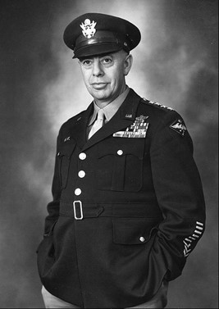

Air Vice Marshal William Dowling Bostock, CB, DSO, OBE

William Bostock, was one of the RAAF's senior officers during the Second World War and later a Liberal Party politician. He was born in Surry Hills, Sydney on 5 February 1892. In November 1914, having been a shipboard wireless operator, Bostock joined the AIF. He served on Gallipoli with the 2nd Signal Troop from the landing on 25 April until August when he was evacuated suffering from dysentery.

In April 1916 Bostock, then a sergeant, transferred to the Anzac Mounted Division's Signal Squadron. Like many who had served in the infantry or a mounted unit, Bostock sought to become an airman and in February 1917 he was discharged from the AIF and commissioned into Britain's Royal Flying Corps. After training, in August 1917, Bostock joined No. 48 Squadron on the Western Front. He was invalided to England in March 1918 and later transferred to the Royal Air Force.

On 6 March 1919 Bostock married Gwendolen Norton in Southampton and the couple returned to Australia when he retired from the RAF that October. In September 1921 he was appointed flying officer in the Royal Australian Air Force. Thus, began a steady rise through the ranks that included a two year stint at the RAF Staff College in England and the directorship of training at the RAAF's headquarters in Melbourne. He took command of No. 3 Squadron at Richmond in New South Wales in 1931, and was promoted to wing commander in 1934, after a period as Richmond's station commander. An exchange to England followed before Bostock returned to Melbourne, where, in 1938, he became Director of Operations and Intelligence. Shortly afterwards he was promoted to group captain.

Bostock was appointed Deputy Chief of the Air Staff shortly before the Second World War. By June 1940 he had risen to temporary air commodore and in October 1941 to air vice marshal. On 2 May 1942 he became Chief of Staff to the American Allied Air Forces commander. In August he was made Air Officer Commanding RAAF Command and given responsibility for the aerial defence of Australia and operations against the Japanese in the Netherlands East Indies.

Photo 14. 1942 Air Chief Marshal Sir Charles Burnett (Left) Former Chief Of Australian Air Staff, Congratulating Air Vice-Marshall William D. Bostock, RAAF, who was appointed Chief Of Staff to Lieut. General George H. Brett.

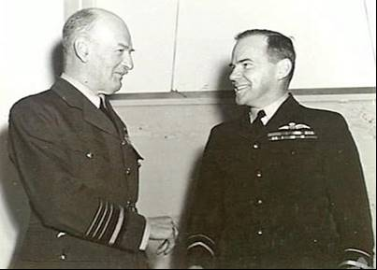

Photo 15. Manila, Philippines. 1945 Air Vice Marshal George Jones CB CBE DFC, the Chief of Air Staff RAAF (left) conferring with General George C. Kenney, the Commanding General of Far East Air Forces (right) during AVM Jones's visit to Gen. Kenney's Headquarters [8]

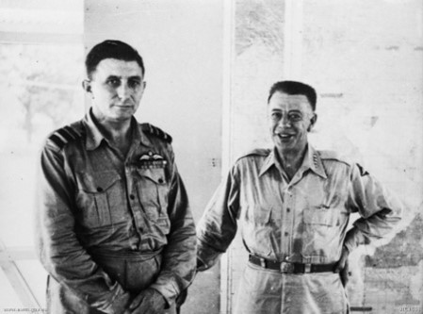

In March 1945, having overseen a series of successful operations against the Japanese to Australia's north between 1942 - 1944, Bostock was given responsibility for air support during the invasion of Borneo. General MacArthur praised Bostock's command and he was highly regarded for his intellect. The culmination of his wartime career came in September 1945 when he was invited to represent the RAAF at the Japanese surrender in Tokyo Bay.

Photo 16. August 1945 - Air Vice Marshal W. D. Bostock, Chief of RAAF Operational Command, who is a member of the Australian Official Party proceeding to Tokyo to sign the surrender documents.

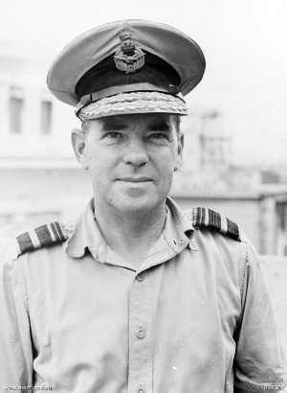

After the war Bostock ran a grazing property in Victoria and wrote numerous aviation articles for the Herald newspaper. In 1949 he won a seat in the House of Representatives for the Liberal Party which he held until 1958. He had also served on the Australian War Memorial's board of management. He died on 28 April 1968 and was survived by his second wife, Nanette.

Photo 17. May 1942 Air Vice-Marshal G. Jones, D.F.C. Chief of the Australian Air Staff, with RAAF Members of C-in-C Allied Air Forces South West Pacific, Lt. General Brett's Staff. Left to right: Group Captain C.S. Wiggins, Director Of Communications; Group Captain A.L. Walters, Assistant Director of Operations; Group Captain E. Hancock, Assistant Director of Plans; Air Commodore Hewitt, Director of Intelligence, and Air Vice-Marshal Jones (Seated).

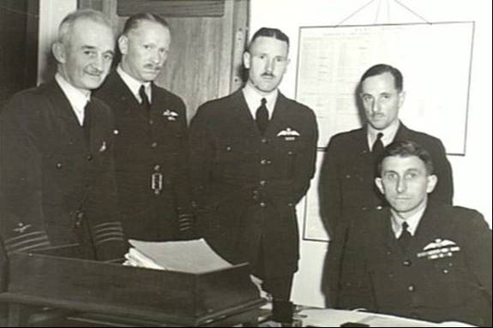

Avgas Demand

During the war years all of the aviation gasoline supplies would initially come from the Dutch East Indies and Borneo, and then after December 1941 come from primarily the United States, with a limited supply from the Middle East. There would be much demand for avgas as the various operations which would be required – operations such as ‘Operation Cartwheel’ (1943–1944)[9] which is described in other publications.

‘Operation Cartwheel’ (1943–1944) was the major military strategy for the Allies in the broad theatre of World War. Cartwheel was a twin-axis of advance operation, aimed at militarily neutralizing the major Japanese base at Rabaul. The operation was directed by the Supreme Allied Commander in the South West Pacific Area (SWPA), General Douglas MacArthur, whose forces advanced along the northeast coast of New Guinea and occupied nearby islands. Allied forces from the Pacific Ocean Areas command, under Admiral Chester W. Nimitz, advanced through the Solomon Islands towards Bougainville. The Allied forces involved were from the United States, Australia, New Zealand, the Netherlands and various Pacific Islands.

# Command & Supply[10]

US General Brett had again become one of the central military figures in Australia at the end of February 1942 when, on the eve of the dissolution of ABDA Command (ABDA stood for American, British, Dutch and Australian), he had resumed the role of Commanding General, United States Army Forces in Australia (USAFIA). His first task was to reorganise these forces and prepare them for combat and to do everything possible to strengthen the defences of the Commonwealth. He is quoted as saying at this time that it was necessary to build up the defence of Australia to make it "a second England", and he had already ordered radio direction finding equipment, anti-aircraft guns and even barrage balloons. In the light of the enemy's capacity to divert their strong carrier forces to attack almost any part of the Australian coastline, his plan was to base air units at Darwin, Townsville, Brisbane, Sydney, Melbourne, Adelaide and Perth; he would need, he estimated, a strength of 3 groups of heavy bombers (each of 4 squadrons), 3 of medium and 3 of light bombers; 6 groups of fighter aircraft and 3 of transport aircraft, plus 2 air depot groups and 2 aviation engineer battalions. But there were allocated to him only 2 groups of heavy, 2 of medium and one of light bombers, and 3 groups of fighters.

The American aircraft actually available were either survivors from Java or in units not yet fully organised. The transport ship ‘Abbekerk’had reached Fremantle on 5th March after a hazardous voyage from Tjilatjap with some of the ground staffs of Nos. 7 and 19 Bombardment Groups. Less than a fortnight later these two groups were reorganised as one No. 19 with 14 Flying Fortresses that had been able to fly into Broome from Java, plus the ground echelons that had come by sea. This group also absorbed the 12 Fortresses from the former naval task force that had been operating from Townsville under RAAF control. A second heavy bombardment group, No. 43, had been allotted for service in Australia and its ground staff had already arrived, but a long wait for their aircraft was inevitable.

On 18th March 1942 American units in Australia had in commission only 39 bombers (12 heavy and 27 dive bombers) and 177 fighters comprising 85 Bell Airacobras (33 P-39's and 52 P-400's —a lighter-armed version of the P-39) and 92 Curtiss Kittyhawks. The fighter strength was all that remained of more than 527 that had reached Australia between 23rd December 1941 and 18th March 1942. Most of the aircraft were in need of repair and most of the bomber crews in urgent need of rest.

The supply position for medium and light bombers was much the same. No. 3 (Light) Bombardment Group—both aircrews and ground staff—had arrived in Australia and two of its four squadrons (Nos. 13 and 90) were allotted Mitchell medium bombers which had been intended for Dutch units. No. 89 Squadron, while awaiting the arrival of A-20 Boston light bombers were engaged in service and maintenance work on No. 19 Group's Fortresses at Charters Towers. The group's fourth squadron (No. 8) was equipped with 27 Dauntless dive bombers which had been maintaining patrols in the Darwin area, flown by those members of No. 27 Group who had escaped from the Philippines. These experienced airmen were now appointed to key posts in No. 3 Group. Two medium bomber groups had also been assigned to Brett's command—Nos. 38 and 22. The ground staff of No. 38 had arrived on 25th February but, since they had no aircraft, their lot, while waiting, was aircraft assembly for other units and training in infantry tactics. No. 22 received aircraft in March 1942 it comprised 48 Martin Marauder medium bombers. The RAAF, still with its small but solid core of experienced operational squadrons—notably (early in March 1942) Nos. 11, 20 and 32 in the New Guinea area; Nos. 2 and 13 in North-Western Area—also had plans, some of which were on the point of achievement. However, a big change for both the USAAF and RAAF organisations in Australia was being planned at the highest level.

New Areas Defined

Since the Japanese had shattered the Malay Barrier and interposed their strong forces between the China-Burma-India theatre and the South-West Pacific theatre, the Allies had been set a new problem in organisation and command; a problem that had been receiving very close examination by the American President, the Combined Chiefs of Staff and the American Joint Chiefs of Staff. By 9th March the Joint Chiefs of Staff had worked out a plan whereby the Pacific theatre would be divided into the South -West Pacific Area and the Pacific Ocean Area. [The Pacific Ocean Area was sub-divided into three subordinate areas—North, Central and South Pacific]. Already President Roosevelt had decided to seek the acceptance of General MacArthur as Supreme Commander of the armed forces of the Governments whose formations were operating in the South-West Pacific; Admiral Nimitz was to be appointed Commander-in-Chief, Pacific Ocean Areas. The Governments concerned were those of Australia, New Zealand, United Kingdom, United States, and Holland.

Photo 18. General Douglas MacArthur and Admiral Chester Nimitz discuss strategies.

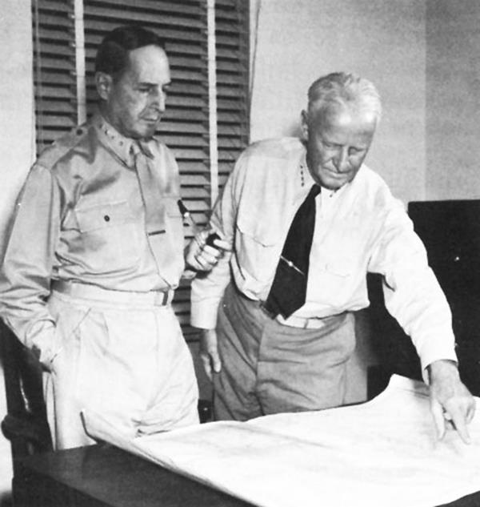Figure 6. Allied Operational Areas in the Pacific theatre[11]

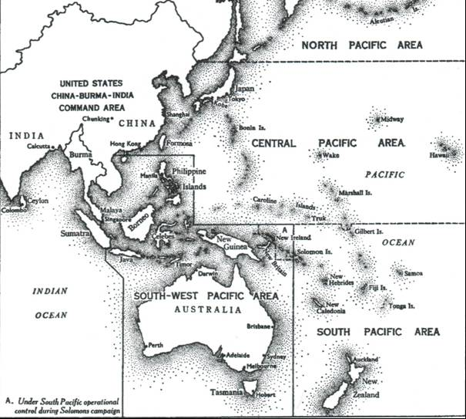

MacArthur appointed Supreme Commander SWPA

On the 17th General Brett had informed Mr. Curtin of MacArthur's arrival and added that the United States President would be pleased if the Australian Government were to nominate MacArthur as Supreme Commander of all Allied Forces in the South-West Pacific. The nomination should be submitted simultaneously to London and Washington. That day the War Cabinet agreed that Curtin should do this, and the nomination was approved.

MacArthur immediately began preparing for the establishment of his new command. The area for which he was to be responsible was vast : it included, from the north, the Philippine Islands ; the South China Sea—the boundary of the area on the west being the coastline of French Indo -China, Thailand and the Malay Peninsula and therefore including the waters of the Gulf of Siam; the whole of Borneo and the Netherlands East Indies, except Sumatra; New Guinea, New Britain and the western "half" of the Solomon Islands group; Australia, and the waters directly to the south of the continent. In relation to the task he had been given, MacArthur had serious misgivings about his forces. In a message to General Marshall, Chief of Staff of the United States Army, he expressed the opinion that none of his forces was adequate. Without a carrier his naval forces would be limited to minor operations; except for two divisions of the A.I.F. (one of reduced strength), his ground forces were inadequately trained; and through lack of organisation and training his air forces would need at least four months of intensive effort to reach a satisfactory condition.

On 17th April the Australian War Cabinet, on the recommendation of the Chiefs of Staff, approved the assignment to the SWPA, Command of all combat sections of the Australian Defence Forces, and on the 18th General MacArthur formally assumed his new appointment and issued General Order No. 1, which formally constituted the new Command and designated the five commanders who were to serve under him. Three of them were to command the Allied land, air and naval forces; respectively, General Sir Thomas Blarney, Lieut.-General Brett and Vice-Admiral Leary. The other two were Lieut.-General Wainwright, who had remained on Bataan and was now commander of the forces in the Philippines, and Major-General Barnes who, on Brett's assumption of the Allied air command, was to resume the task of administering the United States Army Forces in Australia. Allied Air Forces Headquarters, South-West Pacific Area, were established at Victoria Barracks, Melbourne, on 20th April. All United States Army Air Corps tactical units and associated Service elements of the United States Army in Australia, and the operational control of all RAAF service squadrons (excluding training units), and all service squadrons of the Royal Netherlands East Indies Army Air Force, were assigned to the command. Administrative control of RAAF units remained with RAAF Headquarters. On assuming command on that date General Brett announced the appointment to his staff of six Australians:

Air Vice-Marshal Bostock as Chief of Staff;

Air Commodore Hewitt, Director of Intelligence;

Group Captain Scherger, Director of Defence;

Group Captain Wiggins, Director of Communications;

Wing Commander Hancock, Assistant Director of Plans; and

Wing Commander Walters, Assistant Director of Operations.

Among the American officers appointed were:

Colonel E. S. Perrin, Deputy Chief of Staff;

Brigadier-General Royce, Senior Air Staff Officer;

Colonel Eubank, Director of Plans; and

Colonel R. G. Hoyt, Director of Operations.

About a month before Brett's assumption of his own command he had received a letter from Mr. Curtin informing him that, in keeping with an undertaking he had given to President Roosevelt, Australia was willing to place its air force under his control. This offer was made in general terms without attempting to define the necessary organisation; in fact the letter expressly stated that the Australian Chief of the Air Staff, Air Chief Marshal Sir Charles Burnett, was authorised to confer with Brett so that he could submit an outline of the organisation needed to provide for the control of the combined air forces and to define the sphere and responsibilities of the Air Board and the relation of both Brett and the Air Board to the Australian Government.

In a memorandum to MacArthur dated 23rd March, Brett had said that the plan which he and Burnett had prepared had been "thoroughly discussed" with the Australian Prime Minister and the Minister for Air. He stated that he had been informed that Burnett had prepared an order which would "place under the control of the Combined Air Forces Commander those combat and training units and establishments of the Royal Australian Air Force which are necessary for the effective accomplishment of the mission of these forces".

Appended to the memorandum was a detailed statement on the whole organisation "as worked out by Air Chief Marshal Burnett... and myself, which was approved by the Prime Minister under date 19th March ".

It contained this important assertion:

During a war period the efficient employment of forces can be achieved only if there is one responsible commander of all air forces. Consequently, the responsibilities of members of the Australian Air Board, with individual board members responsible for different phases of air force activities, will be modified, and this single commander will be solely responsible to the Supreme Command for all phases of air effort.

This joint statement noted that the officers on the staff would be "American and/or Australian", their choice being governed, in principle, by the ability of the individual. The Chief of the Air Staff (Australia) and the Chief of the United States Army Air Corps would be directly responsible, respectively, to the Australian Government (through the Minister for Air) and to the War Department, Washington, for relevant administrative matters.

Burnett' S Successor - Jones Appointed

Sir Charles Burnett's term of service as Chief of the Australian Air Staff would soon expire and a considerable amount of attention had been given to the selection of a successor. Air Marshal Drummond, a distinguished Australian officer of the Royal Air Force then serving in the Middle East, had been approached tentatively.

[Air Marshal Sir Peter Drummond, KCB, DSO, OBE, MC. (1914-18: AAMC 1914-15; RFC and RAF, Palestine 1916-18.) SASO HQ RAF ME 1937-41; Deputy AOC-in-C HQ RAF ME 1941 -43; Air Member for Training, Air Council 1943-45. Killed in aircraft accident 27 March 1945.]

He had declined the appointment and it was reported that his principal reason for doing so was that the command would be divided between RAAF Headquarters and Allied Air Forces Headquarters. Burnett then submitted far-reaching proposals affecting the RAAF, the substance of which had been very broadly indicated by Brett in the attachment to his memorandum to MacArthur. But whereas the text Brett had sent to the Supreme Commander stated that "the responsibilities of members of the Australian Air Board will be modified". Burnett's proposals included the abolition of the Board, the appointment of Bostock to succeed him as Chief of the Air Staff, and the union of the RAAF and the USAAF in the South-West Pacific. Here were issues of great contention. Despite Brett 's report to MacArthur that the plan had been "thoroughly discussed" with the Prime Minister and the Minister for Air, Mr. Drakeford was by no means prepared to accept Burnett's proposals. However desirable unity of command might be, the transfer of the administration of the RAAF to an American commander was a step to which he was strongly opposed. His opposition extended with equal force to the abolition of the Air Board and to the appointment of Bostock as Chief of the Air Staff.

It will be recalled that in 1940, on the eve of Burnett's appointment, Fairbairn had anticipated that Williams would succeed the English officer on his retirement. Drakeford was not unmindful of this. At his request, Williams had returned to Australia in February for consultation, after which he had an interview with the Prime Minister. But Mr. Curtin was not prepared, at this stage, to accept the return of Australia's highest ranking air officer as the solution to this problem, and took no action towards Williams' reappointment as Chief of the Air Staff. Drakeford did not press the matter further and the choice of Burnett's successor therefore lay between two officers who, in January 1940, had been eleventh and twelfth on the gradation list and who, like eight of the other ten, had had no operational experience in the war against Germany and Italy. The exceptions were Air Marshal Williams with several months' experience with Coastal Command, and Air Commodore Cole who had just been appointed to command No. 235 Wing RAF, in the Middle East.

The effect of the Government's failure to insist that senior RAAF officers should go overseas to gain operational experience in the 1939-41 period of the war against Germany, was now evident. It is necessary to go down the Air Force List for January 1940 to Nos. 27 and 28—Wing Commander Knox-Knight and Wing Commander Lachal, both of whom served in No. 10 Squadron—to find officers who were to gain extensive operational experience before December 1941, and these officers were then the two most junior wing commanders in the Service. Of the 15 Australian General Officers Commanding listed in the army reorganisation of April 1942, 9 had been in action in 1940-42 in Africa, Asia or Europe and some of them in all of these theatres. Until the end of the war only two of the General Officers Commanding in the field in the SWPA had not served in action in the Middle East and those two had served in that theatre though not in action

In the event, briefed by the permanent head of the Department of Air, Mr. Langslow, and supported, morally at least, by members of the Air Board, other than Burnett and Bostock, Drakeford made a strong protest to the Prime Minister. He proposed that the Air Board should be retained, that Jones and not Bostock should succeed Burnett as Chief of the Air Staff, that administrative control of the RAAF should remain with RAAF Headquarters, and that Bostock's appointment as Chief of Staff to Brett should be confirmed.

Mr. Curtin was thus presented with a particularly complex aspect of a problem that posed the fundamental question inevitable in an alliance between the forces of a small but strategically important nation and those of a much more powerful nation. The answer, as doubtless he was aware, had to lie in some kind of compromise that might submerge the identity of the Royal Australian Air Force and might also produce a multitude of administrative problems. The Prime Minister therefore heeded the Minister's contentions and agreed to the retention of the Air Board and to control of administration by RAAF Headquarters, though there was more than a hint of apprehension in his qualifying warning to Drakeford that, if it was proved that this plan did not work satisfactorily, it might be necessary to revert to the proposal that the operational and administrative control of the RAAF should be unified.

A condition essential to any satisfactory degree of achievement in such an organisation as that proposed by Drakeford was goodwill among the principals. Already there were two opposing camps, the most senior in each of which—Drakeford and Burnett—had already been in keen disagreement. This disagreement came more sharply into focus after an exchange of minutes at War Cabinet level. On 28th April the War Cabinet recorded this decision:

On the recommendation of the Advisory War Council (Minute 916) the following interpretation of the decision relating to the assignment of Australian forces to the Supreme Command was approved:

With the service squadrons there is also assigned RAAF Area Headquarters, Air Combined Headquarters, all Fighter Sector Headquarters, and such Station Headquarters as have been established for the operational control of RAAF service squadrons.

Operational control of the RAAF service squadrons and necessary Operational Headquarters as indicated above, is vested in the Commander of the Allied Air Forces.

The Australian Chief of the Air Staff will be responsible for all matters associated with RAAF. personnel, provision and maintenance of aircraft, supply and equipment, works and buildings, and training. These functions are not assigned to the Commander-in-Chief.

Next day Burnett sent a minute to the Minister in which he stated:

It was agreed at War Cabinet on 28th April 1942 that the interpretation of "the assignment of the Australian Air Forces" means that all operational units of the RAAF, including the headquarters concerned with such units, and the administration, maintenance and supply organisation to keep the operational units to their maximum efficiency, should come under the direct control of the Commander, Allied Air Forces (General Brett). The training organisation embracing the E.A.T.S. (Empire Air Training Scheme) and the administration of all RAAF personnel and recruiting, will remain the direct responsibility of the Chief of the Australian Air Force.

The minute also requested the Minister to confirm this interpretation with the Prime Minister to enable the new organisation to be established without delay and added that, to save time, a copy of the minute had been sent to the Prime Minister. Drakeford was annoyed by Burnett's action in sending a copy of his minute direct to the Prime Minister. "The need for saving time," he wrote to Burnett sharply, "does not justify failure to recognise my authority." But this perhaps over-sensitive reaction did not reveal the true point of conflict which lay in the words used by Burnett— "and the administration, maintenance and supply organisation to keep the operational units to their maximum in efficiency, should come under the direct control of the Commander, Allied Air Forces (General Brett) ". However wise and necessary their intention, these words were in opposition to the terms of the War Cabinet's minute which, as the final paragraph quoted shows, stated that these functions were not assigned to the Commander-in-Chief.

On 2nd May, Bostock was appointed as Brett's Chief of Staff. Curtin had written to Drakeford stating that "the services of Air Vice-Marshal Bostock are to be made available to Lieut.-General Brett as Chief of Staff to the Commander, Allied Air Forces, if the latter is desirous. . . .

It is my direction as Minister for Defence that the fullest cooperation is to be afforded the Commander of the Allied Air Forces and this instruction is to be promulgated to all concerned." Drakeford, in a directive to Burnett dated 30th April, in which he stated clearly that "the Chief of the Air Staff would assume responsibility for all matters such as personnel, provision and maintenance of aircraft, supply and equipment, works and buildings, and training of the RAAF " also directed that "the fullest cooperation should be offered Lieut.-General Brett".

Appointment of a successor to Burnett could not be delayed longer and on 5th May Jones was appointed Chief of the Air Staff and promoted from the acting rank of air commodore and substantive rank of group captain to the substantive rank of air vice-marshal. This placed him senior in appointment and equal in rank to Bostock, to whom he had been junior in the Service only slightly, but in age by nearly five years. Bostock was regarded as an able officer of driving temperament; Jones as an able and particularly conscientious officer, somewhat shy and reserved. It was characteristic of Jones that he had suggested that Bostock should be appointed Chief of the Air Staff.

Meanwhile the first amalgamation of Australian and American air forces was proving, as those who established it probably expected, that it was at the best an expedient. Despite Brett's assurance to MacArthur that in principle selection of staff officers would be governed by ability, the system of almost mechanical alternation of American and Australian staff officers right down the line of command, was applied at Allied Air Headquarters and in North-Eastern Area. This was more a diplomatic gesture than a practical method of war organisation. In the first circumstances it was probably the best expedient, however, and it certainly had the merit of throwing officers and men of the two air forces so closely together that they learned more of each other's characteristics and methods in a brief period than otherwise would have been possible. There was, in fact, considerable goodwill between the RAAF and USAAF staffs, and in North-Eastern Area, as an example, the atmosphere was happy and the staff extremely cooperative.

The operational control of the Allied Air Forces was exercised through the existing RAAF area organisation with American and Australian coordinated staffs or with American liaison officers attached to Australian staffs in the five areas—North-Eastern, Eastern, Southern, Western and North-Western. (3) Each area headquarters staff was under the sole command of an air officer commanding who was responsible to Headquarters USAAF or RAAF Headquarters (as appropriate) on all questions of personnel, provisioning, works and buildings, supply and equipment. The Americans, naturally, were conscious of the extent of Australian influence in the new organisation. Each of the five areas was commanded by an Australian; RAAF officers in fact held a majority of the key command posts. RAAF administrative forms, strange to the Americans, were used, and this tended to increase American dependence on the RAAF, which itself retained administrative control over its own units. One official American report described Australian control at this time as extending to "every echelon of American Air Forces and every airfield at which they are stationed". Two complete RAAF directorates— Operations and Plans—and a proportion of the staffs of the directorates of Intelligence and Signals were transferred to the control of Allied Air Headquarters.

Air Staff Reorganised

Brett sought flexibility of control for offensive operations and on 4th May established two US Air Commands, No. 1, commanded by Colonel (later Brigadier-General) Albert L. Sneed, at Darwin, and No. 2, commanded by Brigadier-General Martin F. Scanlon, at Townsville. The object was to place with the combat units in each area a mobile command which could move forward with them on the "leap frog" principle, to assume command at the next forward base acquired in an offensive campaign. But these were early days for such organisation, which quickly proved impracticable, and within the month the commands had been dissolved.

The area command organisation was adopted by the Allied Air Forces on 11th May 1942. Eastern Area was not formed until four days later. It covered New South Wales and southern Queensland while Southern Area covered Victoria, South Australia and Tasmania.

Meanwhile it had directed that, if invasion became imminent, all Australian and United States forces (army, navy and air) serving in the Darwin and Port Moresby areas should be placed under the operational control of the general officer commanding the respective forces. These general officers commanding would continue to operate under the direct command of the Commander, Allied Land Forces and would not, except when attack was imminent, "disturb the execution of the general plans" of local commanders of the Allied air and naval forces or of the Commanding General, U.S. Army Forces in Australia. Brett lost a highly competent officer in May when Brigadier-General George was killed on the ground at Darwin by an aircraft that swerved off the runway. Once Allied Air Force Headquarters had been established and the operational functions of the Australian Chief of the Air Staff had been taken away from him, the composition of the Air Board, which had been preserved at the Minister's insistence, necessarily underwent a change. Four appointments remained unaltered—Chief of the Air Staff (Air Vice-Marshal Jones), Air Member for Personnel (Air Commodore Wrigley), Finance Member (Mr. Elvins) and Business Member (Mr. W. Sydney Jones). The office of Air Member for Organisation and Equipment, held until 14th May by Air Vice-Marshal Anderson and from that date until 3rd June by the Chief of the Air Staff himself, was abolished. In its place the office of Air Member for Supply and Equipment was created and Air Commodore Mackinolty was appointed to it. Similarly, that of Director-General of Supply and Production, which had been held by Mr. R. Lawson, was deleted, and that of Air Member for Engineering and Maintenance substituted with Air Commodore E. C. Wackett as the appointee. Since Air Vice-Marshal Bostock's appointment to General Brett 's staff, there had been no Deputy Chief of the Air Staff; Air Commodore McCauley, who had held office briefly as Assistant Chief of the Air Staff, was now given this appointment.

Another change was a proposal to form five maintenance groups to improve the administration of all maintenance units. The first group (No. 5 Maintenance Group ) was formed at Sydney in June to control all maintenance units in New South Wales, Queensland and in Noumea. No. 4 Maintenance Group was formed at Melbourne on 14th September 1942 to serve Victoria, Tasmania and South Australia. No other groups were formed. At this time the RAAF still manned advanced operational bases at Noumea and Vila but only American naval aircraft were operating from them.

With the development of the Allied Air Forces in progress, the problems of achieving an efficient supply service put a heavy tax on both American and Australian resources. The haste inevitable in the dispatch of equipment and units from the United States still resulted in the arrival of one without the other, the equipment more often than not, requiring servicing and repair—notably that shipped as deck cargo. Brett therefore created a new command—the United States Army Air Services—with Major-General Rush B. Lincoln as commander. Formed on 27th April as an "administrative, supply, maintenance and engineering command", it accepted a vast and crucial task. Air service elements normally were attached to the tactical units, but under the new command air base groups were given area responsibility with the result that one such group in the Townsville area was called on to service and maintain seven different types of combat aircraft plus various kinds of transport aircraft. The responsibility of the air depot group, charged with assembly and maintenance of aircraft, was equally pressing. In April there was only one such group in Australia, so that its units had to be divided between three centres—one at Footscray, Victoria, where a central supply depot was established, one at Brisbane which was a branch supply depot, and one at Wagga Wagga (New South Wales) which was a major repair depot. In May another group was formed at Brisbane for aircraft assembly and maintenance. To ease the strain the Australian Department of Aircraft Production, together with private industrial organisations and airline companies, assisted by providing facilities and experienced staff. Perhaps the most ambitious project in this vital phase of the air war effort was that begun in May at Tocumwal, New South Wales, for the construction of a "permanent" supply and maintenance depot requiring four all-weather runways on the aerodrome, satellite airfields, a depot staff of 2,000, and accommodation for 4,600 "military personnel". The provision and distribution of aviation fuel was alone a huge undertaking beset by many difficulties, not the least of which was that imposed by the diversity of Australia's railway gauges. Supplies of 100 octane fuel were comparatively small and most of the storage capacity was in New South Wales and Victoria. Rail transport to the north where most combat units were stationed was out of the question, for every time a break in gauge occurred the fuel would have to be pumped from one rail tanker to another. Sea transport was the alternative and this meant handling the fuel in an enormous number of drums, which had to be brought from the United States.

New Transport Squadrons

As yet, the air transport services were unequal to the task of providing any substantial relief to the services of supply. Within the RAAF, air transport was still in the "luxury" class: the planes were not available. Transport aircraft were included in the pressing requests being made for the allocation of aircraft—requests addressed particularly to the United States. But, no less than combat aircraft, these were in such demand that the waiting list was huge and the deliveries few. Some planes had been acquired from the civil airlines and others requisitioned for service under contract, and the civil airlines, notably Qantas Empire Airways, Australian National Airways, Guinea Airways and Airlines of Australia, gave splendid service. With its Sydney-Singapore mail service suspended since February 1942 because of enemy action on the route, Qantas were operating their flying-boats between Sydney and Darwin as required. Their crews were also undertaking reconnaissance flights, as were the crews on the trans-Tasman service. By the end of April 1942, the Commonwealth had impressed 36 aircraft from the regular airline companies and 94 other privately owned aircraft. Most of the impressed aircraft were light types suitable for use in flying training.

A notable, though very limited contribution by the USAAF had already been made when Captain Paul I. ("Pappy") Gunn, formerly manager of Philippine Airlines, whose wartime exploits in the Philippines had made him a legendary figure in the Service, was placed in command of an American air force transport unit. In January 1942 a group of officers and enlisted men, who "happened" to be available, were allotted to Captain Gunn to fly and service a strange assortment of old and new aircraft—two aging Boeing B-18's and one C-39 (a hybrid of the famous Douglas DC-2 & DC-3) that had come from the Philippines, and five new C-53 's (Douglas DC-3 version troop carrier) and three Consolidated B-24 Liberator’s which had just arrived from the United States. The unit was based on Archerfield, near Brisbane, then the focal point for the delivery and distribution of American supplies. It worked under pressure and performed prodigious "lifts" until the Directorate of Air Transport, Allied Air Force, SWPA., was formed under the command of Group Captain Harold Gatty, an Australian pioneer airman who, professionally, had adopted, or been adopted by the United States.

Group Captain H. Gatty. (RAN College 1917-20.) Director of Air Transport, AAF SWPA, 1942-43. Regional Director Pan American Airways and research engineer for USAAC; born Campbell Town, Tasmania, 5 Jan 1903. Died 30 Aug 1957. (Author of The Raft Book and other works.)

By this time the RAAF, having received a number of Dakota C-47 transport aircraft, had set about establishing units of its own. Between 6th February and 12th March four transport squadrons—No. 33 Squadron (Empire flying-boats and Catalinas), 34 De Havilland Dragon DH-84's), DH-35 Fox Moths and DH-84's and 36 DC-2's—were formed in North-Eastern, North-Western, Western and Southern Areas respectively. No. 33 Squadron acquired the two Empire flying-boats which had been serving with No. 11 Squadron and No. 20 Squadron.

Lack of suitable air bases was not only a hindrance to the progress of the air war effort; it could become the very limiting factor in air defence. To supplement the already immense task being undertaken by the American engineering units in conjunction with the Allied Works Council, the Air Board made a realistic assessment of what was most urgently needed. It was "an organisation capable of producing landing fields in forward areas at short notice while under threat of air attack". This was not a task for a civil construction organisation. The Board therefore planned the formation of what was designated No. 1 Mobile Works Squadron, [later to be known as an airfield construction squadron], which would have a survey, planning and camouflage section, and engineering construction, camp construction and repair and maintenance sections (even including a small sawmill). The squadron would be organised for 24-hours-a-day operation and would be staffed by 27 officers and 1,010 airmen. It had been estimated that if such a unit was to undertake all the work projected for the RAAF and USAAF in the Northern Territory alone, it would be fully occupied for more than five years. [In the aerodrome section of the directorate alone the program in March 1942 provided for the selection and construction of 100 new airfields for use by the USAAF and RAAF].

On 19th March the War Cabinet gave its approval, and the new unit was formed in April and began field operations in North-Western Area in July. It was the forerunner of an organisation that was to grow until two wings were in operation.

The bombing of Darwin had intensified the demand for the development of an inland ferry route and "all engineering activities suddenly assumed an aspect of urgency". The engineering section of the USAFIA was, as already noted, heavily engaged in developing its own organisation and in coping with its share in the big task. [Nevertheless, when in June 1942 a plan for an inland ferry route was approved, comprising a project to construct 5 main and 3 emergency airfields from Melbourne to Cloncurry, the task was commenced immediately under top priority. The airfields were Roto, Cobar and Bourke in New South Wales, and Cunnamulla, Quilpie, Blackall, Longreach, Winton and Cloncurry in Queensland]. Added to these demands for aerodrome facilities were those of the Royal Navy and the United States Navy. The US Navy wanted a parent aerodrome and six dispersal fields in the Sydney area. The Royal Navy asked for one parent and two dispersal fields in the Schofield area, near Sydney, and jointly the two navies required one parent and four dispersal fields in the Fremantle area. Approval for the construction of these fifteen fields was given on 29th July. In North-Eastern Area there were four operational aerodromes in the Townsville region, Garbutt (near Townsville itself), Antil Plains, Reid River and Charters Towers. Plans had been made for the construction of an aerodrome at Iron Range on the east coast of Cape York Peninsula. In the Port Moresby region there were three—Seven Mile, Ten Mile and Three Mile, the last two being little more than emergency fields at this stage. In wet weather the fighters had to move from the Three Mile to the Ten Mile. Four more fields had been planned and were expected to be operational by October.

Figure 7. Allied Airfields in the South West Pacific Area

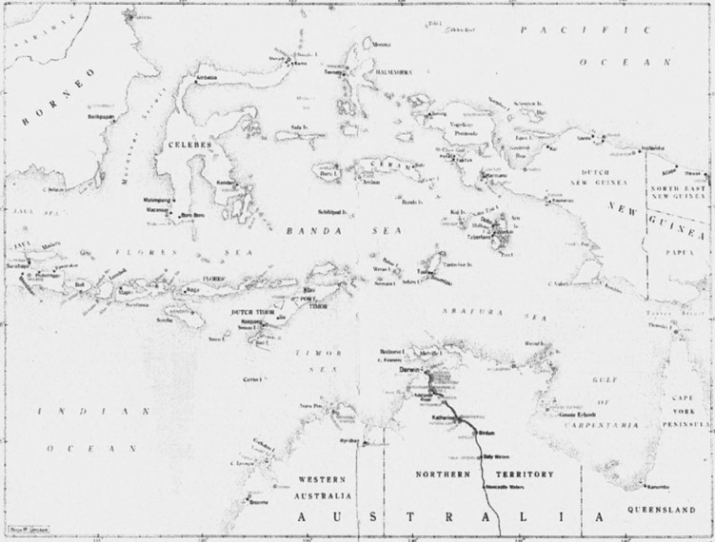

The Department of Civil Aviation also had considerable related responsibilities for aerodromes. At the end of April 1942 there were in Australia 188 aerodromes and emergency landing grounds provided and maintained by the Commonwealth, and 206 licensed public aerodromes controlled by local authorities. The RAAF had taken over 39 civil aerodromes for training in addition to using space at five capital city airports for the same purpose. The USAAF had also established units at certain civil airports, and other civil aerodromes had been enlarged for use by American aircraft. The Civil Aviation Department's aeronautical engineering branch was now undertaking important design and modification work to meet the demand by the RAAF for the conversion of both civil and service aircraft. This work included designing the modification of four DC-3 aircraft which, early in the war, had been commissioned on charter from Australian National Airways, and four Empire flying-boats taken over by the RAAF. Design work was also needed for the adaptation of DH-84 Dragon, DH-86 Express and DH-89 Dragon Rapide aircraft for use in the air observer schools. Twenty-two of these aircraft were converted in civil airline workshops under the supervision of the department's engineers. The re-design of three DH-86's for use as air ambulances had been accomplished in this way. Designs had also been prepared for the modification of DH-84, Douglas DC-2, Junkers G-31 and Ford aircraft as ambulances.

Photo 19. Douglas C-47 Dakota Aircraft requisitioned from Australian National Airways (ANA) to form No. 8 Squadron RAAF[12].

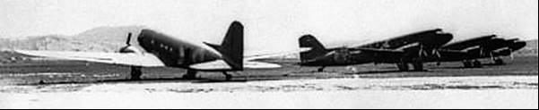

Aircraft Production and Supply

In April the War Cabinet asked the United Kingdom Government to allow Australia to retain the first 90 Australian-made Beaufort bombers that had been bespoken for Britain. The request was granted though the United Kingdom Government did not "officially endorse any change that would amount to withdrawing Australian Beauforts from the aircraft pool". At the same time, it was thought unlikely that Britain would bid for a share in the Australian Beaufort production. The Beaufort production program was a responsibility of the Department of Aircraft Production, which had been created in June 1941, with Senator Leckie as its first Minister [Minister for Aircraft Production]; and, from January 1942, with Mr. Essington Lewis as Director-General, it replaced the Aircraft Production Commission. On 18th February 1942 the War Cabinet had reviewed the practicability of building in Australia a well-armed interceptor fighter. There were three main reasons for supporting this proposal, which had been submitted by the Commonwealth Aircraft Corporation. The first was a recognition of the need for some insurance against the possibility that deliveries of American fighter aircraft might be seriously interrupted or prevented. The second was that, with the Wirraway program now regarded as complete, C.A.C. needed a project to occupy their 2,000 skilled workers until tooling up had been completed for the production of what was known as the CA-11 bomber; the prototype of this aircraft had been completed for flight testing in September 1941 and 105 had been ordered. The third reason submitted in support of the new fighter proposal was the ready availability of Wirraway parts and basic materials. Production of this aircraft could begin almost immediately. The War Cabinet accepted this planning and authorised an order for 100 of the new type, to be known initially as CA-12. [This aircraft was later to be named the ‘Boomerang’. It became CAC's second operational aircraft to be used in combat.]

Photo 20. CAC Boomerang (Temora NSW Air Show 2007)

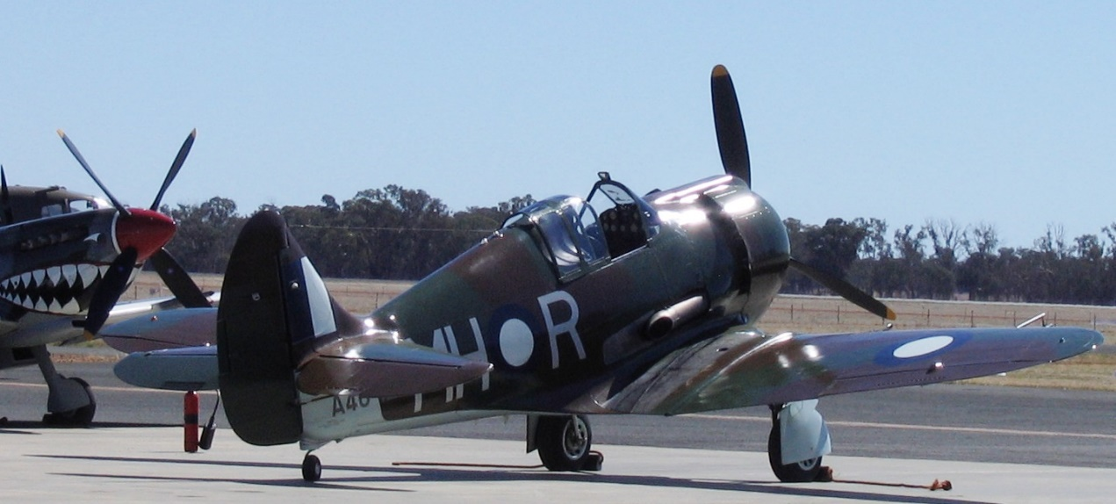

Photo 21. RAAF CAC Boomerang fighter aircraft coded BF-S (serial no. A46-126) nicknamed "Sinbad II" of No. 5 (Tactical Reconnaissance) Squadron RAAF, piloted by 402769 Flight Lieutenant A. W. B. Clare of Newcastle.

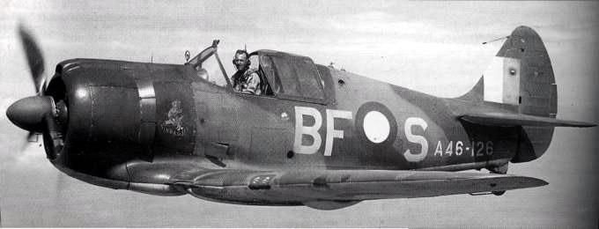

The Australian aircraft supply position, as it related to the principal operational types at 8th May 1942, is shown in the accompanying table.

Table 1. Australian Aircraft Supply 1942.

|  |  |  |  |
| --- | --- | --- | --- |
| Type | No. on Order | Source | Delivery details |
| Beaufort | 180 | Dept. of Aircraft Production | 80 by end July, 20 a month, then 40 a month |
| Catalina | 119 | USA | 27 received, 6 allocated |
| Hudson | 246 | USA | All received or en route |
| Kittyhawk | 771 | USA | 50 received, 69 en route, 6 allocated |
| Beaufighter | 362 | UK | 54 received or shipped |
| Vultee Vengeance | 367 | USA | Possibly 12 en route |
| Boston | — | USA | 27 received from NEI |
| CA-11 (bomber) | 105 | Dept. of Aircraft Production | To begin Jan 1943; planned production rate 20 a month |
| CA-12 (interceptor- fighter) | 100 | Dept. of Aircraft Production | To begin June 1942 at 10 a month |
| Transports (type not specified) | 90 | USA | Indefinite |
| Flying Fortress B-17 | 143 | USA | Indefinite |
| Mitchell B-25 | - | USA | 19 received or shipped |
| Vought Sikorsky | - | - | 34 received from NEI |
| Dornier Do24K | - | - | 6 received from NEI |

Inability to determine with any real degree of accuracy the numbers and types of aircraft that would be allotted to the Allied Air Forces made it very difficult to assess the aviation fuel needs. An “**Aviation Fuel Co-ordinating Committee**” was formed, the membership comprising one representative each from USAFIA, the RAAF, and the USAAF. The combined stock of aviation fuel on hand on 8th May was approximately 30,000,000 imperial gallons and the reserve in fuel and oil needed for six months of war operations, so far as it could be estimated, was set at 53,000,000 gallons of aviation spirit and 2,120,000 gallons of aircraft engine lubricating oils. The War Cabinet approved of the installation of additional tanks for inland bulk storage in Australia with a capacity of 20,760,000 gallons which would bring this "safe area" storage capacity to about 25,000,000 gallons of aviation spirit.

These problems of service and supply, though they were many and great, were not insuperable. The American concept of the supply situation at this stage has been expressed thus:

Considering the brief interval that had elapsed since the debacle in the Netherlands East Indies, however, the emphasis must be placed on the progress made. During April and May 1942, significant steps were taken by the Australian Government to adjust the economic capacities of the country to the needs of Allied military forces. In close coordination with General MacArthur's staff, the administrative machinery was provided to relieve congestion in the harbors, for a more efficient direction of the production and distribution of food, and for the supply of labour and equipment required in the construction of military installations. Through these and other actions, Australia's productive capacity would substantially reduce the burden imposed on Allied shipping

Photo 22. Vultee Vengeance (circa 1943)

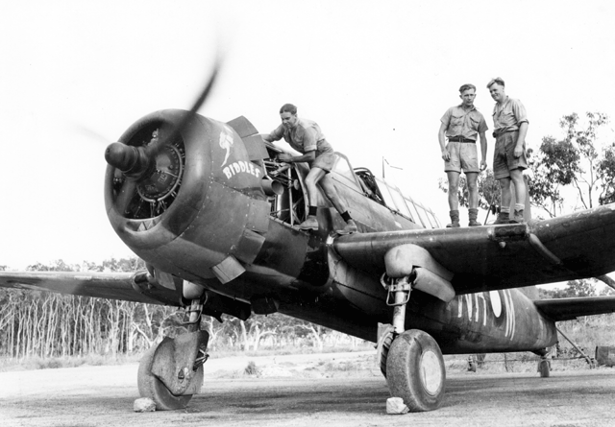

Vast Expansion

If the dominant Australian role in the initial structure of the Allied Air Forces had soon to become subdued, the RAAF itself was now, in May 1942, a force twenty-two times greater than its immediate pre-war numerical strength of 3,489 (310 officers and 3,179 other ranks). In little more than two years and a half its numbers had reached 79,074 (5,714 officers and 73,360 other ranks). The total was divided as shown in the accompanying table.

Table 2. RAAF Personnel distribution May 1942

|  |  |  |  |
| --- | --- | --- | --- |
| **Home Defence Units** | **Officers** | **Airmen** | **Total** |
| Serving in Australia | 1,714 | 40,200 | 41,914 (2) |
| Serving overseas | 295 | 1,050 | 1,345 |
| Prisoners of war | 150 | 198 | 348 |
| **Total Home Defence** | **2,159** | **41,448** | **43,607** |
| **Empire Air Training Scheme (E.A.T.S):** | **Officers** | **Airmen** | **Total** |
| Staffs of units | 2,247 | 16,094 | 18,341 |
| Aircrew under instruction in Australia | 44 | 8,285 | 8,329 |
| Aircrew under instruction overseas | - | 1,213 | 1,213 |
| Aircrew serving overseas | 1,230 | 3,794 | 5,024 |
| Awaiting embarkation (as at May 1, 1942) | 34 | 375 | 409 (3) |
| **Total E.A.T.S.** | **3,555** | **29,761** | **33,316** |
| E.A.T.S. Squadrons | - | 2,151 | 2,151 |
| **Grand Total** | **5,714** | **73,360** | **79,074 (4)** |

To meet the demands of the war in the East the Air Staff prepared a plan for the expansion of the RAAF to a force of 73 squadrons. This was sent to the Minister on 6th February in the form of a draft War Cabinet Agendum, but 17 days later no action had been taken. Thereupon Burnett bypassed the Secretariat, took a copy of the draft Agendum to a War Cabinet meeting and it was approved in principle. On 2nd March the War Cabinet approved a re-drafted Agendum, with an important though obvious qualification being expressed in the words "having regard to the availability of aircraft".

With 73 squadrons established, the first line strength was to be 1,314 aircraft. Mobility was to be the key to the use of this force, and so provision was made in the plan for 9 transport squadrons so that combat squadrons in any one area could be reinforced speedily from other areas if necessary. Apart from these units, the composition of the force could be: 11 general reconnaissance (medium and torpedo bomber), 12 dive bomber, 7 flying-boat, 24 fighter, 4 heavy bomber, 1 fleet co-operation, and 5 army cooperation squadrons.

On 20th May the Air Board decided to make 45 squadrons the objective to be achieved by the end of the year, but it was soon seen that not enough aircraft would be available, and the revised objective, set in October, was to have 35 squadrons by April 1943.

These, then, were the terms on which the RAAF was planning. The answer to the problem lay not only in the provision of sufficient aircraft of the right type but in training the crews to man them, a need that was being heavily emphasised by the extreme strain under which the existing combat units were operating. One of the keenest questions of the time, therefore, was the extent of the Australian overseas contribution to the Empire Training Scheme. (also known as the Empire Air Training Scheme – E.A.T.S.). The last draft for Rhodesia had been dispatched on 7th January, and when the 300 still in training there had passed out, that phase of the program would end. At that time the drafts to Canada had been suspended but, on 24th February, the War Cabinet had decided that "for the present" Australia would continue to provide her agreed quota. There were six qualifying factors attached to this decision:

1. the reduction in the number of partially-trained men sent abroad caused by the increase in the percentage of men given advanced training in Australia,
2. development to the highest stage possible of facilities for operational training in Australia,
3. the acquisition of the aircraft needed for the proposed developments,
4. a regulated inward flow of Australian aircrew with combat experience to provide a nucleus in each RAAF unit in Australia,
5. retention of sufficient fully-trained aircrew to fill the establishments of Australian squadrons at home and abroad, and
6. the allotment of as many Australian aircrew as possible to fill the establishments of the "infiltrated" RAAF squadrons in the Pacific theatre.

So far as ground staff were concerned, the planned growth of the RAAF was such that obviously airmen in the essential musterings, whose numbers had been banking up in anticipation of the formation of further Article XV squadrons for overseas service, would be absorbed by units forming in Australia.

"Post-graduate" training was now an essential need, and the capacity of the operational training units to meet it was being developed. Gunnery and reconnaissance schools, torpedo training units and seaplane training squadrons were being formed, their establishments being keyed to the "undergraduate" training plan. In these days when actual combat units were so few and so hard pressed, the front-line value of these operational training units and even of service flying training schools, could not be overlooked and provision was made for their use in an emergency.

New Status For WAAAF

An important decision affecting the progress of the Women's Auxiliary Australian Air Force was that by which the War Cabinet on 14th July 1943 made it a part of the Citizen Force branch of the Commonwealth Defence Forces. This meant that, instead of being enrolled, airwomen were formally enlisted, and officers were granted commissions by the Governor- General as were members of the RAAF. The WAAAF now numbered more than 12,500 airwomen and almost 350 officers. (The WAAAF was formed in March 1941).

Fresh service trades in which members of the WAAAF might serve had been proposed early in 1942. Some of these were new for women in Australian civil life; examples were meteorological assistant, instrument repairer and radar operator, the last also having no civilian counterpart among civilian men. Women of the WAAAF would also take on the task of refuelling aircraft.

# Advances through the SWPA

Once the Japanese had been stopped on land at Kokoda, and dealt a severe blow in the Battle of the Coral Sea, the laborious and dangerous task before the Allied Forces was to drive the Japanese back through New Guinea, Papua, New Britain and the many other island strongholds.

To do this would require the establishment of new airstrips, recapturing enemy airstrips and maintaining the necessary supplies to the ground forces (mostly supplied by air). In addition, the enemy forces were to be attacked by air forces of USAAF, RAAF, NEI and New Zealand. This would require stocks of aviation gasoline to be brought to the ports and loading jetties of many locations. Essential there were requirements for two fuels, aviation gasoline (100 Octane or 87 Octane gasolines) for aircraft, and motor gasoline MT80 (Mogas 80) for transport.

The initial supply stages were delivery by air transport to the newly captured airstrips. Special army units were formed and assigned the role of providing fuel to the other fighting units.

Photo 23. Unloading petrol drums from a Douglas C-47 Dakota, Wau, New Guinea Aug 8 1943

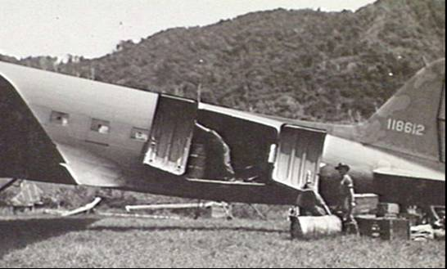

“Dakota’ was the RAF and RAAF designation for the Douglas C-47 (the military version of the famous Douglas DC-3). The American designation was Douglas C-47 Skytrain.

Gradually this would become a ‘regular service’ to many of the areas such as Hollandia, in Dutch New Guinea, maintaining supplies of food, stores and fuel.

Photo 24. US transport Douglas C-47 ‘Skytrains’ lined up on an airfield in Hollandia, Dutch New Guinea May 1944

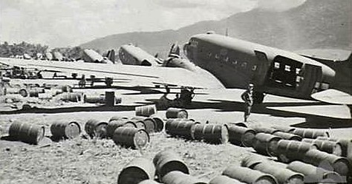

US transport aircraft which did a remarkable job keeping fighter squadrons in the Hollandia Area supplied with fuel, stores and food. It was like a giant taxi service with the transports lined up ready for take-off. Note the fuel drums lying on the ground beside the aircraft.

Once the ports and loading jetties were secured it was possible to ship in supplies as drum stock, and later by tanker when storage tanks had been built. Once the bulk storage facilities were operational smaller coastal vessels would transfer the valuable fuel supplies to units further north.

# New Guinea

Milne Bay was to be one of the spearheads for the Allied advance along New Guinea and through into the South West Pacific area and provide the essential supplies for the US and Australian forces, but support from the air would also be essential as McArthur’s forces ‘leapt frog’ past the Japanese garrison on New Guinea. The valuable fuel supplies of aviation gasolines (Avgas 100 and Avgas 87) and motor transport fuel (MT80) (Mogas 80) would be supplied by sea and air and would require the building of necessary facilities such as temporary landing strips, jetties, pipelines and storage tanks. There would be bases both in Australia and the Pacific Islands and these would require trained personnel.

Photo 25. Milne Bay, Papua, New Guinea. 1944-04-03. General view of the Oil Wharf with 'Empire Silver', An Oil Tanker discharging cargo and smaller vessels refilling fuel tanks. The fuel is piped directly from the tankers to bulk oil installations at 2nd Bulk Petroleum Storage Company.

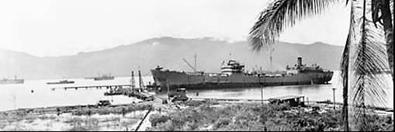

Photo 26. Milne Bay, New Guinea, July 1943. The new 960 Feet "T" Jetty being built by the 4th Australian Field Company, Royal Australian Engineers, to allow discharge of petroleum products in bulk from tankers and refuelling of large ships.

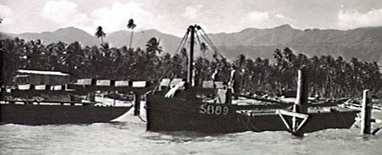

Photo 27 Milne Bay, New Guinea. April 1944. The United States Army coastal tanker Y 18 taking on aviation fuel at the oil wharf.

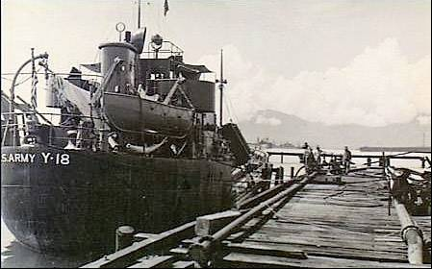

The shore fuel installation was manned by the 2nd Australian Bulk Petroleum Storage Company.

Photo 28. Wewak Area, New Guinea January 1945 RAAF Beaufort Bombers of No. 100 Squadron in flight head for Wewak to destroy Japanese fuel and ammunition dumps. Aircraft in the foreground is coded QH-X, Serial No. A9-626

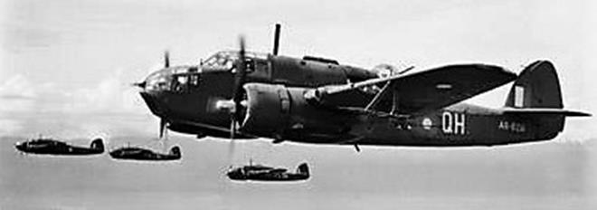

Photo 29. Millingimbi Island, Northern Territory, Australia. November 1943. Barge loaded with oil being towed ashore by launches known as Miney AWLS. This oil is being taken to the fuel supply depot of No. 452 Squadron, RAAF, Group 605.

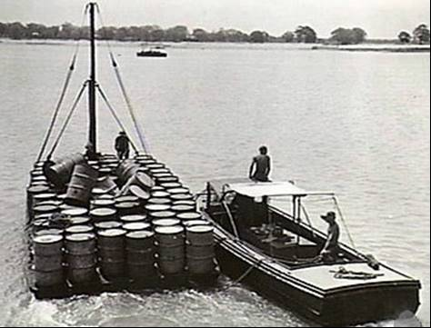

Photo 30. Milne Bay, Papua, New Guinea. April 1944. The pipelines leading to the pier and a berthed tanker discharging fuel to bulk storage tanks at 2nd Bulk Petroleum Storage Company.

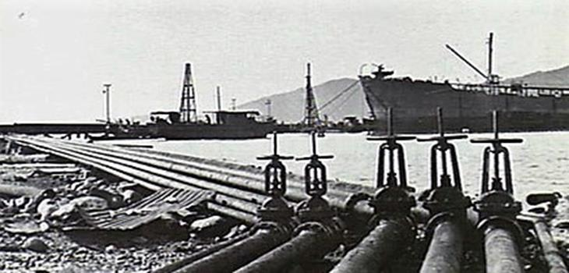

Photo 31. Milne Bay, Papua, New Guinea. April 1944. The deep sea tanker "EMPIRE SILVER", with a capacity of 3,600,000 imperial gallons discharging a cargo of petrol from the oil wharf. The fuel is pumped directly from the tanker to storage tanks at 2nd Bulk Petroleum Storage Company.

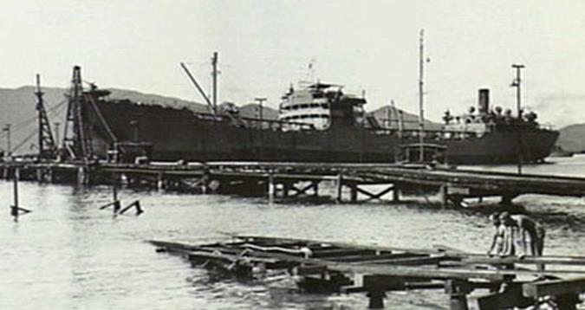

Photo 32. Madang, New Guinea. 1944. United States Army personnel refuelling a barge at the 593rd United States barge company repair workshops fuel dump.

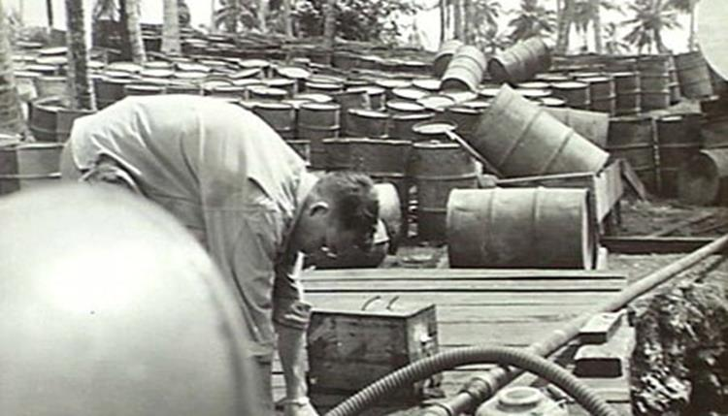

Photo 33. Canberra, ACT - December 1945. Royal Military College, Duntroon. Three-ton bulk fuel lorry

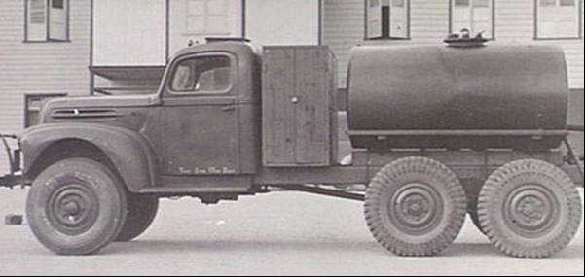

Photo 34. Labuan, North Borneo. August 1945. Drums of fuel for the tanks of mosquito aircraft of No. 1 Squadron RAAF operating from Labuan against Borneo targets, being handled by New South Wales members of the squadron.

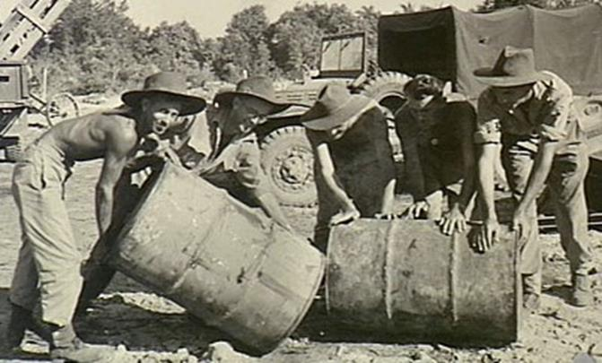

Photo 35. Townsville, Qld. February 1945. Line-up of three North American P-51K Mustang fighter aircraft of No. 84 Squadron RAAF, based at Ross River airfield.

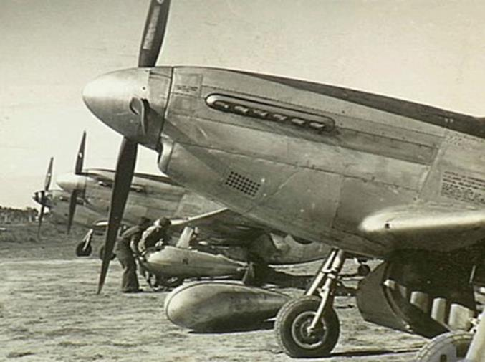

Townsville, Qld. February 1945. Line-up of three North American P-51K Mustang fighter aircraft of No. 84 Squadron RAAF, based at Ross River airfield. Ground staff fit an underwing long-range fuel tank (drop tank) to the second aircraft. The nearest aircraft is a P-51K-10-NT, formerly United States Army Air Force Serial No. 44-12347; the Mustang aircraft in the background is A68-526

Peace at Last – Time to go Home

Finally, the Second World War had ended and a new era dominated by the threat of the terrifying ‘atomic bomb’ was about to begin. There would not be another ‘World War’ and it was time to go home and rebuild the nation. But there needed to be a period of transition from war-time operations to peace time and the demobilisation of service men and women, and the disposal of supplies and equipment.

The following are a number of communication dealing with the uncertain period of the ‘War is Over’ and now the vast supply and distribution networks that were developed to defeat the Japanese Empire now had to be dismantled and turned toward a new world order, where the colonial empires in the East of the Netherlands, France and Britain had now changed forever

# Transition Period – Transfer of supply US Forces to RAAF[13]

In 1945 with war over the US Forces were returning home and transitional arrangements had to be made to transfer the avgas supply responsibility from the United States Forces to Australian Forces in Borneo, New Guinea and Solomon Islands within SEAC, the Allied South East Asian Command which was to fill the vacuum left by withdrawal of the American forces from part of the SWPA.

Having established a supply chain for aviation gasoline, it was now time to dismantle that chain.

It was also time to abolish the South West Pacific Area Command.

Figure 8. The Asia- Pacific Command Areas circa 1942

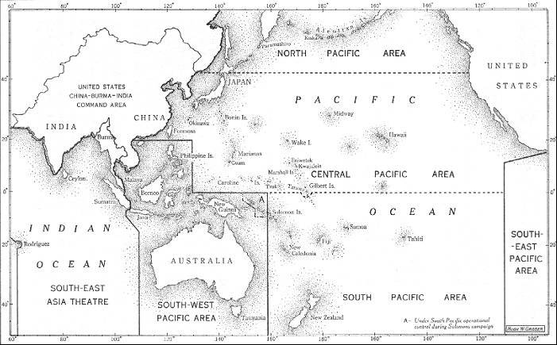

SEAC[14]

In August 1943, the Allies created the combined South East Asian Command, to take over from British India Command strategic responsibilities and command of the separate national commands in the theatre. In October 1943, Winston Churchill appointed Admiral Lord Louis Mountbatten as Supreme Allied Commander South East Asia, a post he held until SEAC was disbanded in 1946. The initial land forces operational area for SEAC was India, Burma, Ceylon, Malaya, Sumatra, and for offensive operations in Siam (Thailand) and French Indochina. On August 15, 1945 this was expanded to include the Dutch East Indies and French Indochina. Command arrangements in SEAC were always complicated. The air forces in the region were, at first, not joined under one command. The RAF Third Tactical Air Force and the USAAF units were separate. However, by early 1944, integration was achieved.

With the war over SEAC would not be in control of the Dutch East Indies and French Indochina for long. The Netherlands and France wanted their resource rich colonies back, however the peoples of these countries now sought freedom from their colonial masters and wanted their own national identity.

Memo APO 500 28 Aug 1945

Change in SWPA boundary with the termination of Allied Forces - US Joint Chief of Staff 1200 hrs Sept 2, 1945. The portion of SWPA south of the prescribed boundary is transferred to British Empire control. This will abolish the commands established on 18 April 1942. I.e. Allied Land Forces SWPA, Allied Naval Forces SWPA, Allied Air Forces SWPA

RAAF Bases (avgas) withdrawal

The US Army Air Force bases in the region were to be taken over by the RAAF, and in turn decisions would need to be made to retain or close these RAAF bases. The Australian Army had the responsibility to supply these bases, however they advised the following:

Hollandia (Australian Army not agreeable to re-supply this base).

Tadji (Army advise re-supply would be extremely difficult)

Madang (Army expect evacuation to Finschhafen)

Dobodura (Army unable to re-supply)

The RAAF realized that action needed to be taken and the following directive was given on 26 Sept 1945. ‘Due to limited shipping and the change from lend lease to cash transaction, the number of bases in use is to be reduced to the absolute minimum - Wing Commander D.D.S.S. (ii) A.M.S.E. (through D.S.S.)’. *AMSE = Air Member for Supply and Equipment*

Figure 9. Papua New Guinea

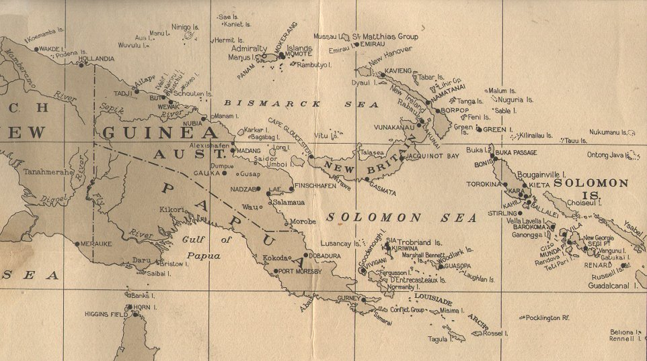

Transfer of Petroleum stocks from US Forces to Australian Forces

With such a massive storage capacity of aviation gasoline it was important to ensure that these stocks were not destroyed, and since there were Lend-Lease implications they needed to be accounted for in the government ledgers. But there also needed to be a continuity of supply if required. From the Australian view point the areas of interest were requests for petroleum products in the Borneo, New Guinea and the Solomon Area. This included transfer from SWPA to SEAC of certain island areas at that time occupied by Australian forces.

With the advance of the allies and the nearing of war’s end - These areas were to be occupied by British forces. The responsibility for supply of petroleum fuels and oils would be that of the Australian Services. This responsibility was to commence as of 1st October 1945 at certain points and increase progressively as US forces moved out of the area. In moving out US Forces had undertaken to leave behind as at 1st October 1945, 60 days of supplies in bulk and 85 days in packed petroleum stocks.

The following outlines how this was to occur:

Division of responsibility between Australian Army and RAAF.

Financial

(i) Australian Army will assume ownership (custody) of all bulk Aviation fuel held in ocean terminals.

(ii) Aust. Army will assume financial responsibility for ocean terminals, plant and facilities necessary for the maintenance of supply, and which have been taken over by them from US Forces.

(iii) RAAF will assume ownership of all packed aviation stocks and oil stocks taken over from US Forces as of 1 Oct. 1945.

Physical

(i) Aust. Army will be responsible for the physical operation of all bulk ocean terminals taken over from the US Forces.

(ii) Aust. Army will be responsible for re-supply of both bulk and packed aviation fuel and oil to all points where RAAF are operating.

(iii) RAAF will be responsible for handling all aviation fuel and oil stocks at the airstrip, and also in certain instances by mutual agreement, it is agreed that RAAF will transport fuel from the beachhead to the airstrip.

Reply from Air Board. October 18, 1945

The (Aust.) Air Board has now agreed that Lae will be the RAAF Sea Transport Terminal for the New Guinea area. This is essential from an operational viewpoint because Nedzab is the only area in New Guinea where suitable and sufficient air strips can be provided. We propose to move our installations including stores Depot at Finschhafen to Lae - Nedzab area and leave only an air sea rescue flight and perhaps a communications flight at Finschhafen.

Memo 164/1/1B57 from APO 500 36 Nov 1945

Subject: Petroleum Supply for Area South of AFPAC Boundary.

To Commanding General Far East Air Force APO 925

Commanding General United States Army Air Force Western Pacific APO 707

From Col. G.E.Issacs Assistant Adjutant General (under General MacArthur).

Effective 1 October 1945 the responsibility for the re-supply of petroleum products to the United States and Allied Forces in the area south of the new AFPAC boundary passed to British Command (V-J day).

Action will be taken by C.G. AFWESPAC to transfer serviceable petroleum stocks and transfer custody, pending disposition as indicated in paragraph II below; of bulk handling product to appropriate agencies of Aust. Army, RAAF or RNZAF as indicated below.

Base A Milne Bay (US)

Bulk Avgas 600,000 gallons (US Army stock)

Black Oil to be taken over Sept 1945 by RAN

Base B Oro Bay- Dobodura (US) Packed avgas and avoil to RAAF. Stocks to be disposed. (Site not required by British Command)

Base D Port Moresby Bulk avgas now held by Aust. Army and US Army

Base E Lae (excluding Nadzab). All bulk petroleum stocks and packaged mogas and diesel fuel storage transferred to AMF

Base F Finschhafen (US) 1 x 10,000-barrel storage tank with material and equipment for distribution of avgas to airstrip to RAAF. Drummed avgas and, Avoil to meet RAAF requirements to be transferred to RAAF

Morotai (US) Bulk mogas and diesel fuel. Drummed avgas, Avoil for transferred to the RAAF.

Base G Hollandia Drummed Avgas, Avoil. This base not required by the British Command and disposed and transferred stock. Hollandia is located at Tanahmera Bay

Base H Biak (US) Bulk avgas 2 x 10,000-barrel tanks with discharge and distribution facilities.

This memo also listed the following orders:

All serviceable US owned drummed stock of avgas and avoil in New Guinea will be transferred to Madang, Wewak, Tadji

Australian Military Forces advised that the bulk petroleum facilities at Torokina, Bougainville in the North Solomons will not be required after present stocks are exhausted.

**Class III POL packed and bulk (Mogas Diesel)**

Bases A, B, D, E, F, Bougainville with the 1st Army at Lae

Morotai with advanced HQ AMF

**Bulk Avgas**

Morotai and Base H (Biak) with advance HG AMF

Base A & G with RAAF Northern Command Madang

Bases D, E & F with the 1st. Australian Army.

Bougainville with RNZAF Wellington

**Packed Avgas and Avoil**

Morotai with number 11 Group RAAF Morotai

Bases A, B, D, E, F, G, H, Madang, Wewak, Tadji with RAAF Northern Command Madang

Jacquinot Bay, Green Island, Torokina and Emirau with RNZAF Wellington

The stock position also needed to be established and the situation in October 1945 was as follows:

**Base G Hollandia** as at 25 Oct 1945

|  |  |  |  |
| --- | --- | --- | --- |
| **Avgas 100** | US Gallons | Imp. Gallons | KLitres |
| Receipts from Bahrain | 546,000 | 454,640 | 2,067 |
| Bulk stocks | 872,366 | 726,397 | 3,302 |
| **Total** | **1,418,366** | **1,181,037** | **5,369** |

**Base H Biak (US)** As at 31 Oct 1945

|  |  |  |  |
| --- | --- | --- | --- |
| **Avgas 100** | US Gallons | Imp. Gallons | KLitres |
| Bulk | 231,798 | 193,012 | 877 |
| Packed | 165,159 | 137,524 | 625 |
| **Total** | **396,957** | **330,536** | **1,503** |

**Base F Finschhafen (US)** As at 31 Oct 1945

|  |  |  |  |
| --- | --- | --- | --- |
| **Avgas 100** | US Gallons | Imp. Gallons | KLitres |
| Bulk | 654,490 | 544,977 | 2,478 |
| Packed | 262,880 | 218,893 | 995 |
| **Total** | **917,370** | **763,870** | **3,473** |

[By Dec 1946 the stocks at Finschhafen would be nil bulk, and only 51,596 USG in drum stock (42,963 IG, or 195 KLitres.)]

**Torokina (Bougainville Island)** Drummed stocks came from Australia (from Avgas supplies shipped from the US and Middle East).

This was some 2,732,693 USG (2,275,443 Imp. Gal. or 10,344 KLitres) of Avgas 100 in this region of which 64% was in bulk storage.

Other supplies still need to be shipped into the area to maintain the forces in these locations. It is interesting to note that Avgas 100 was now being shipped from the large Caltex Refinery in Bahrain.

While the fighting had ceased there was still an occupying Australian Army on the ground which had to be supplied by air transport, and there were POWs and medical evacuations to be returned to Australia.

**Morotai (US)**

Ship “Donacilla” with 2,000,000 gallons of Avgas, 1,300,000 MT80 (Mogas 80 octane) sailed for Morotai 9 October 1945.

Photo 36. Shell Tanker “Donacilla”

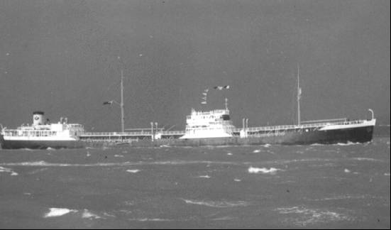

Shell tanker “Donacilla” built in 1939, tonnage: 8,113 gross, this vessel finished service in 1961[15],

Australian Forces withdraw from the Region

By early 1946, although there were still some shipments coming from the US to the Australian Forces who had taken control of the area under SEAC, the withdrawal of the Australian Army was underway. A shipment of 200,000 gallons of Avgas was discharged at Biak 19 Feb 1946 by US for control of Australian Army.

Feb 15, 1946

Cable from Land forces Brigadier Secombe 14/2/46 to CG AFWESPAC Manila

“MT POL & AVGAS SUPPLY - NG/NEI Axis Policy

AFPAC DIRECTIVE 26 Nov 1945

Subject: Supply for Area South of AFPAC Boundary and AFWESPAC - Signal CX24314 refers

Following is present status of bulk terminals

Torokina Evacuated by Aust. Forces

Hollandia was not taken over from US Forces and RAAF no longer interested in site.

Biak RAAF evacuating area and installation being handed back to US Forces.

Morotai AMF will evacuate Terminal by 31 March 1946.

Finschhafen & Lae RAAF at present operating tankage at both these installations for Avgas only. Expect to evacuate within the next 60 days, but can switch consumption to drums sooner if essential.

Suggest early advise if evacuation required before this period in order to enable provision of drum stocks. Confirm if foregoing is satisfactory”

Jan 17, 1946

Cable Q616 advising that RAAF have taken over operation of Finschhafen from 12 Jan, 1946. RAAF has accepted custody of 10,000-barrel tank, 2,000-barrel strip tank also further 2,000-barrel tank required to assist pumping and minimization of losses and pipelines pumping plant. Ownership has been accepted for 310,385 Imp Gallon Avgas and 1120 drums of AVOIL

Madang - from Northern Command to AF HQ - Com General AFWESPAC APO707 Manila FAA

# Oil Companies and Refineries

In the South West Pacific Area (SWPA) there were no refineries in operation producing aviation fuels. The only small refineries operating in Australia producing motor gasoline for the local Australia requirements were Commonwealth Oil Refineries (COR) at Laverton Victoria, Shell Clyde Refinery in New South Wales and the shale oil refinery of Glen Davis in New South Wales – this is discussed elsewhere in other chapters.

The only two companies providing aviation gasoline – these were Standard-Vacuum and Shell.

All the aviation gasoline was supplied essentially from the U.S. as discussed in the chapter on US Petroleum Administration for War with minor contributions from Abadan Refinery.

# Bulk Issue Petrol and Oil (BIPOD)

Once the aviation gasoline and motor gasoline had been delivered by tanker to the wharf facilities it then came under the control of the Bulk Issue Petrol and Oil Depot (known as BIPOD) and then stored and distributed to supply the fighting units. These units together with Petrol and Lubricant (POL) companies would ensure that there were sufficient petroleum products to supply the air force and ground units. The difficult terrain to New Guinea and other islands meant that supplies had to be delivered by air to the troops on the ground.

Photo 37. Papua. August 1942. Loading a Douglas C-47 Dakota aircraft with supplies for troops in the forward area. For troops near Kokoda, supplies are dropped from the aircraft, nicknamed as the "biscuit bombers".

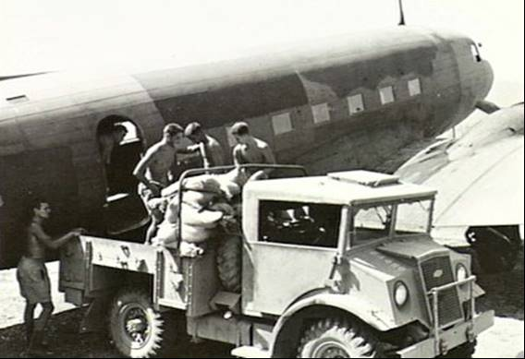

Photo 38. Redlynch, Qld, Australia. June 1943. Group portrait of members of the 51st Bulk Issue Petrol and Oil Depot (51st BIPOD) Platoon

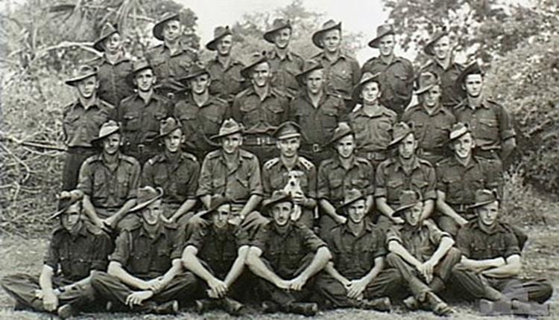

Summary: Redlynch, Qld. c. June 1943. Group portrait of members of the 51 Bulk Issue Petrol and Oil Depot (51 BIPOD) Platoon. From left to right: back row: Lionel Maddocks, Len Bignall, Charlie Rehfeldt, Fred Kernke, Ray Miers, Bill Gilbert, 'Blue' Ryan. Third row: Harry Dan, Gordon Dunwell, Mick Reed, George Kneipp, Doug Krough, Les Morris, Bob Kroll, Phil Watkins. Second row: Corporal (Cpl) George Huff, Cpl Jack McCawatt, Staff Sergeant Bargenquest, Lieutenant A.J. (Tony) Alexander holding a dog mascot, Sergeant Ron King, Cpl Maurice Kingston, Noel Eastment. Front row: Jack Mohle, Bill Power, Arthur Tregea, 'Brig' Burke, Les Lee, Ted Gray, Jack Cokely. This unit served in Queensland, Merauke and Morotai. (Donor M. Kingston)

Photo 39. Los Negros Island, Admiralty Islands. March 1944. A Beaufighter aircraft from No. 30 Squadron RAAF being refuelled at Mogote airstrip after escorting aircraft of No. 79 (Spitfire) Squadron RAAF during the flight from Kiriwina to the Admiralty Islands.

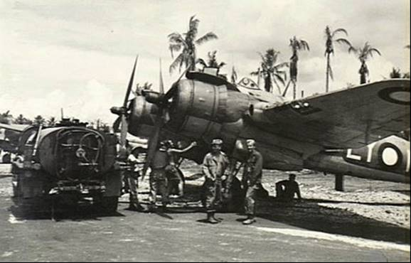

Photo 40. Lae, New Guinea. March 1944. Members of the 55th Bulk Issue Petrol and Oil Depot Platoon, (BIPOD). Tighten the bungs on empty 44-gallon petrol drums. This is a necessary action to ensure the safety of shipping by preventing the escape of explosive petrol fumes.

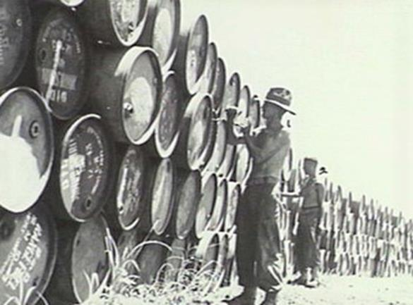

Photo 41 Milne Bay, New Guinea. April 1944. A refilling shed with the loading platform for 44-gallon drums shown in the mid foreground at the 2nd Australian Bulk Petroleum Storage Company Terminal.

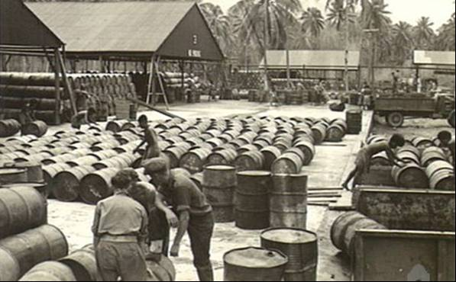

Photo 42. Port Moresby, Dutch New Guinea. September 1944. A Papuan native (right) assists to refuel a Martin PBM Mariner flying boat aircraft of No. 41 (Transport Sea) Squadron RAAF based at Cairns, from a refuelling barge.

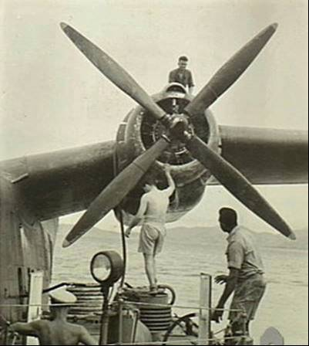

Photo 43 Morotai Island, Halmahera Islands, Netherlands East Indies. June 1945-RAAF fuel tankers which will be used for refuelling aircraft, on the airstrip at Balikpapan, after its capture and repair, ready to be loaded onto a liberty ship. In the background can be seen some of the ships which will make up the convoy transporting the Allied Forces to Balikpapan.

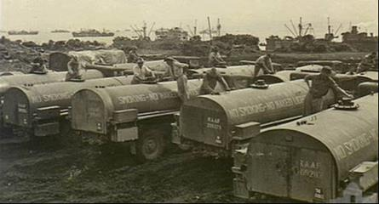

Photo 44: Lae Area, New Guinea. July 1945. 2nd Bulk Petroleum Storage Company, operating the stencilling plant to mark drums. Three thousand 44-gallon drums are turned out daily by the unit's filling plant. These drums were for overseas distribution. Note. The stencil Avgas 7-45 (July 1945).

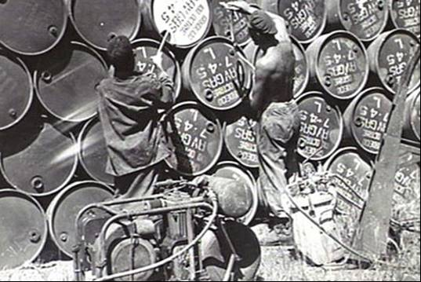

It was important to identify the batch number and date of supply as the harsh tropical climate over a short period (6 months) could cause the quality of the aviation fuel to deteriorate resulting in reduced vapour pressure, gum formation and Tetra Ethyl Lead (TEL) decomposition leading to lead oxide deposits in the fuel.

Photo 45. Lae Area, New Guinea. July 1945. Lae Base Sub-Area Petrol Oil and Lubricants. Inspection of the tank farm, and the No. 5 Bulk Aviation Base bolted storage tank which has a 350,000-gallon capacity.

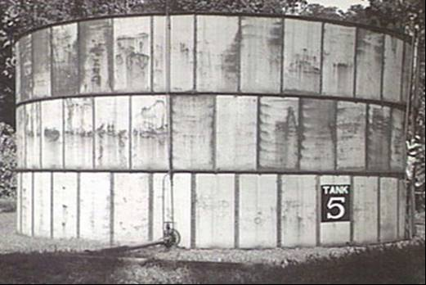

It was also necessary to construct storage tanks to accommodate the large demand for aviation gasoline as the war progressed further north.

Photo 46. Torokina, Bougainville. July 1945. Petrol wagons refuelling an Avro York aircraft. The ‘Endeavour’. This aircraft carried His Royal Highness, the Duke of Gloucester, Governor-General of Australia, and official party to headquarters Australian Army 2 Corps.

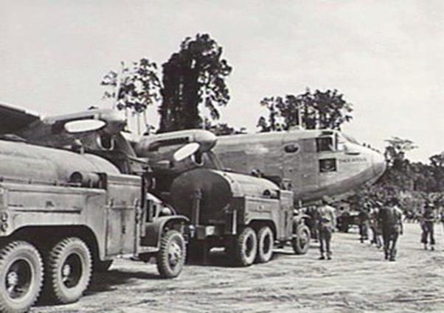

# Spoils of War

In every conflict the spoils of war go to the victor, in this war this also applied.

Photo 47. Australian troops load captured Japanese avgas onto a barge (circa 1944)

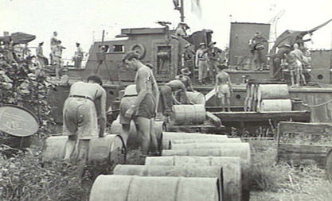

Madang, New Guinea, 30 April 1944. Australian troops load high octane aviation spirit abandoned by the Japanese in dumps at Madang airfield. The petrol was found suitable for the motors in HMA Motor Launch ML424. (It would have been unsuitable for allied aircraft due to lower octane rating and suspect quality).

Photo 48. Australian sailors transfer captured Japanese avgas onto a barge (circa 1944)

Madang, New Guinea, 30 April 1944. RAN sailors piping valuable high-octane aviation spirit abandoned by the Japanese at Madang airfield into HMA Motor Launch ML424. The petrol has been found suitable for use in the motors of HMA motor launches.

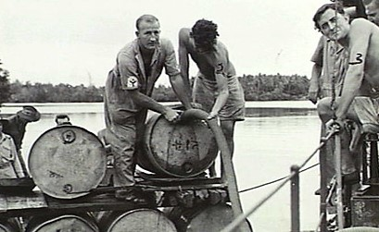

# Epilogue for South West Pacific Area

Perhaps the best tribute to their efforts that can be made is that there was no one single example of an aircraft failing to leave the ground because of lack of petrol.

It was a great feat of logistics to maintain the supply of aviation gasoline (and other petroleum products) across the many islands in the vast South West Pacific area with the added bonus of recapturing the Netherlands East Indies and Borneo refineries and oil fields which the Japanese had exploited.

# Index

1

100 Octane 40

100 octane fuel 12, 32

11 Group RAAF Morotai 49

13th Air Forces 20

19 Bombardment Group 24

1st Australian Army 49

2

26th Brigade 5

27th Bomb Group 10

2nd Australian Bulk Petroleum Storage Company 42, 54

2nd Bulk Petroleum Storage Company 41, 44, 56

2nd Signal Troop 21

3

3rd Bomb Group 10

3rd Division 5

4

41st U.S. Division 4

4th Australian Field Company 41

5

51st Bulk Issue Petrol and Oil Depot 53

55th Bulk Issue Petrol and Oil Depot Platoon 54

593rd United States barge company 44

5th Air Force 20

6

6th Division 5

7

7th Division 4, 5

8

87 Octane 40

8th Squadron 10

9

9th Division 4, 5

A

A.B.D.A. Area 13

A.I.F. 26

A-20 Boston 25

Abadan refinery 8, 52

Abbekerk 24

ABDA Command 24

ABDACOM 14, 15, 16, 17, 18

Accra (Gold Coast) 8

Adelaide 4, 24

Admiral Chester Nimitz 17, 25

Admiral Lord Louis Mountbatten 47

Admiralty Islands 53

Advisory War Council 29

AFPAC 49

Africa 10

AFWESPAC 51

Air Board 27, 28, 29, 31, 33, 38, 48

Air Chief Marshal Burnett 14, 28

Air Chief Marshal Sir Charles Burnett 22, 27

Air Commodore Cole 29

Air Commodore E. C. Wackett 31

Air Commodore Hewitt 27

Air Commodore Hewitt, 23

Air Commodore Mackinolty 31

Air Commodore McCauley 31

Air Commodore Wrigley 31

Air Marshal Drummond 28

Air Marshal Sir Richard Peirse 14

Air Marshal Williams 28

Air Member for Engineering and Maintenance 31

Air Member for Organisation and Equipment 31

Air Member for Personnel 31

Air Member for Supply and Equipment 31, 47

Air Vice Marshal William Dowling 21

Air Vice-Marshal Anderson 31

Air Vice-Marshal Bostock 23, 27, 30, 31

Air Vice-Marshal G. Jones 22, 23, 31

Aircraft Production Commission 35

Airlines of Australia 32

Alice Springs 18

Allied Air Force 33

Allied Air Headquarters 31

Allied Forces - US Joint Chief of Staff 47

Allied South East Asian Command 46

Allied Works Council 33

Amberley 9, 12

American Joint Chiefs of Staff 25

American Third Fleet 5

Antil Plains 34

Archerfield 9, 12, 33

army cooperation squadrons 38

aromatic 12

Ascot 9

Atlantic 10

Aust. Army 49

Australia 13, 24, 25

Australian Air Board 28

Australian Army 47, 48, 51

Australian Army 2 Corps. 57

Australian Chief of the Air Staff 27

Australian Defence Forces 27

Australian Department of Aircraft Production 32

Australian Government 26, 27, 28, 37

Australian Military Forces 49

Australian National Airways 32, 34, 35, 66

Australian Prime Minister 27

Australian War Cabinet 27

Avgas 49, 51

Avgas 100 41, 50

Avgas 87 41

aviation fuel 32, 36, 48

Aviation Fuel Co-ordinating Committee 36

aviation gasoline 40, 46, 48, 52, 56, 58

aviation spirit 37, 57, 58

avoil 49

Avro York 57

B

B-29 Superfortresses 5

Bahrain 50

Balikpapan 5, 11, 17, 55

Bandung 8, 17, 18

Base A 49

Base B 49

Base D 49

Base E 49

Base F 49, 50

Base G 49, 50

Base H 49, 50

Bataan 11, 18, 27

Batavia 14, 16

Batchelor 8, 12, 18

Battle of Bismarck Sea 4

Battle of Empress Augusta Bay 4

Battle of Guadalcanal 4

Battle of Leyte Gulf 5

Battle of Midway Island 4

Battle of the Coral Sea 4, 39

Battle of the Java Sea 17

Battle of the Philippine Sea 5

Beaufighter 36, 53

Beaufort 7, 35, 36, 42

Belem 8

Bell Airacobras 24

Biak 49, 51

Biak Island 5

BIPOD 52, 53, 54

Black Oil 49

Blackall 33

Boeing B-17 Flying Fortresses 8

Boeing B-18 33

Boomerang 35

Borneo 5, 8, 17, 26, 46, 48

Borneo refineries 58

Bostock 28, 29

Boston 36

Bougainville 24, 49

Bougainville Island 4, 50

Bourke 33

Brereton 12, 14

Brett 12, 14

Brigadier General Stephen Chamberlin 9

Brigadier Secombe 51

Brigadier-General Albert L. Sneed 31

Brigadier-General George 31

Brigadier-General Julian F. Barnes 8

Brigadier-General Leonard T. Gerow 13

Brigadier-General Martin F. Scanlon 31

Brigadier-General Royce 27

Brisbane 8, 9, 11, 12, 24, 32

Brisbane River 12

Britain 46

British India Command 46

Broome 24

Brunei Bay 5

Bulk Issue Petrol and Oil Depot 52

Burma 13, 16, 47

Burnett 12, 27, 28, 29, 30, 38

Business Member 31

C

C-39 33

C-53 33

CA-11 35, 36

CA-12 35, 36

CAC Boomerang 1, 35, 36

CAC Mustang 1

CAC Wirraway 1

Cairns 55

Cairo 8

Caltex Refinery 50

Canada 39

Canton Island 10

Cape Gloucester 4

Cape York Peninsula 34

Captain A.L. Walters 23

Captain Katsuo Shiba 6

Captain Paul I. ("Pappy") Gunn 32

Catalina 33, 36

Ceylon 8, 47

Charleville 12

Charters Towers 25, 34

Chief of Staff of the United States Army 26

Chief of the Air Staff 21, 28, 29, 30, 31

Chief of the Australian Air Staff 28

Chief of the United States Army Air Corps 28

Chiefs of Staff 27

China 9, 13

China-Burma-India theatre 25

Christmas Island 10

Chungking 9

Clagett 12

Cloncurry 11, 12, 33

Coastal Command 29

Cobar 33

Col. G.E.Issacs 48

Colonel E. S. Perrin 27

Colonel Eubank 27

Colonel Kaziyi Sugita 6

Colonel R. G. Hoyt 27

Colonel Van S. Merle-Smith 9

combat squadron 38

Combined Air Forces Commander 27

Combined Chiefs of Staff 25

Commander of the Allied Air Forces 29, 30

Commander-in-Chief 30

Commander-in-Chief, Pacific Ocean Areas 25

Commonwealth Aircraft Corporation 35

Commonwealth Defence Forces 39

Commonwealth of Australia 11

Commonwealth Oil Refineries 52

Consolidated B-24 Liberator 8, 33

Cunnamulla 33

Curtin 3, 5, 26, 27, 28, 29, 30

Curtiss Kittyhawk 9, 24

D

Dakota C-47 33

Daly Waters 11, 12

Darwin 8, 11, 12, 13, 18, 24, 25, 31, 32, 33

Dauntless dive bombers 25

Davao 11, 18

DC-3 34

De Havilland DH-84 Dragon 33

Del Monte 8, 11, 12, 18

Department of Air 29

Department of Aircraft Production 35, 36

Department of Civil Aviation 34

DH-35 Fox Moth 33

DH-84 Dragon 34

DH-86 Express 34

DH-89 Dragon Rapide 34

Diesel 49

diesel fuel 49

Directorate of Air Transport 33

Director-General 35

Director-General of Supply and Production 31

dive bomber 38

Dobodura 47

Donacilla 51

Doomben 9

Dornier Do24K 36

Douglas B-18 Bolo 8

Douglas C-47 Dakota 40, 52

Douglas C-47 Skytrain 40

Douglas DC-2 33

Douglas DC-3 33, 40

Douglas SBD Dauntless 9, 10

Drakeford 28, 29, 30

Duke of Gloucester 57

Dutch East Indies 14, 16, 17, 18, 24, 47

Dutch New Guinea 16, 40, 55

E

East Indies Barrier 14

Emirau 49

Empire Air Training Scheme 30, 39

Empire flying-boat 34

Empire flying-boats 33

Empire Silver 41, 44

Endeavour 57

Eniwetok 4

F

Fairbairn 28

Far East Air Force 14, 20, 22

Far East Area 13

Far Eastern Council 17

fighter 38

Fiji 10

Finance Member 31

Finschhafen 4, 47, 48, 49, 50, 51, 52

fleet co-operation 38

Flight Lieutenant A. W. B. Clare 36

Flying Fortress B-17 12, 36

Flying Fortresses 8, 18, 24

flying-boat 38

Foch 16

Footscray, Victoria 32

Foreign Minister Mamoru Shigemitsu 6

Formosa 8

Fortress Singapore 7

France 16, 46, 47

Fremantle 4, 24, 33

French Indo-China 26, 47

G

Garbutt 33

General Archibald Wavell 18

General Blarney 4

General Brett 8, 13, 23, 24, 26, 27, 30, 31

General Clagett 9

General Douglas MacArthur 3, 16, 18, 24

General George C. Kenney 18, 21, 22

General Harold H. George 18

General Headquarters, South West Pacific Area 4

General Hein ter Poorten 16

General MacArthur 8, 25, 27, 37

General Marshall 10, 12, 13, 26

General Order No. 1 27

general reconnaissance 38

General Sir Thomas Blarney 27

General Wavell 12, 13, 14, 16

General Yoshijiro Umezu 6

George C. Kenney 20

Germany 28, 29

Glen Davis 52

Gona 4

Governor-General of Australia 57

Green Island 49

Group Captain C.S. Wiggins, 23

Group Captain E. Hancock 23

Group Captain Harold Gatty 33

Group Captain Lachal 12

Group Captain Scherger 27

Group Captain Wiggins 27

Guam 5

Guam Island 7

Guinea Airways 32

Gulf of Siam 26

H

Habbaniya 8

Halmahera Islands 55

Hawaii 7, 8, 13, 16

heavy bomber 38

Hiroshima 5

HMA Motor Launch ML424 57

Holland 25

Hollandia 5, 40, 47, 49, 50, 51

Hong Kong 7

Hudson 36

I

Iceland 13

Imita Ridge 4

India 8, 9, 16, 47

Indian Ocean 16

inland bulk storage 37

Iron Range 34

Italy 28

Iwo Jima 5

J

Jacquinot Bay 49

Japanese avgas 57

Japanese Fleet 5

Java 3, 9, 12, 24

Jolo 8

Jones 22, 28, 29, 30, 66

K

Karachi 8

Katsuo Okazaki 6

Khartoum 8

Kiriwina 53

Kittyhawk 12, 36

Koepang 11

Kokoda 4, 39, 52

L

Labuan, North Borneo 45

Lae 3, 48, 49, 51, 54, 56

Lae Base Sub-Area Petrol Oil and Lubricants 56

Laverton Victoria 52

lead oxide 56

Lend-Lease 47, 48

Lieut.-General Brett 18, 22, 27, 30

Lieut.-General Wainwright 27

Lieutenant General Suichi Miyakazi 6

London 17

Longreach 33

Los Negros Island 53

Lt. General Lewis H Brereton 11

lubricating oils 37

Luzon 5

M

MacArthur 4, 13, 17, 18, 22, 26, 27, 28, 30

Macassar 11

MacDill Field 8

Madang 44, 47, 49, 52, 57

Major Carmichael 18

Major Combs 12

Major Davies 12

Major General Yatsuji Nagai 6

Major-General Barnes 27

Major-General Rush B. Lincoln 32

Malang 12

Malay Barrier 13, 14, 25

Malay Peninsula 26

Malaya 7, 13, 17, 47

Malayan Peninsula 14

Manila Bay 18

Mariana Islands 5

Marianas 5

Martin Marauder 25

Martin PBM Mariner flying boat 55

Melbourne 12, 24, 33

Middle East 9, 28, 29

Millingimbi Island, Northern Territory 43

Milne Bay 4, 41, 42, 43, 44, 49, 54

Mindanao 5, 12, 18

Miney AWLS 43

Minister for Air 27, 28

Minister for Aircraft Production 35

Minister for Defence 30

Mitchell B-25 36

Mogas 49

Mogas 80 40, 41, 51

Momote 53

Morotai 5, 49, 51, 53

Morotai Island 55

motor gasoline 52

motor gasoline MT80 40

Mr. Drakeford 28

Mr. Elvins 31

Mr. Essington Lewis 35

Mr. Langslow 29

Mr. R. Lawson 31

Mr. W. Sydney Jones 31

Munda Airfield 4

N

Nagasaki 5

Nassau Bay 4

Natal (Brazil) 8

Nedzab 48

NEI 40

Netherlands 17, 24, 46, 47

Netherlands East Indies 12, 13, 14, 20, 21, 26, 27, 37, 55, 58

New Britain 26, 39

New Caledonia 10, 13

New Guinea 16, 26, 46, 48, 49, 52

New Zealand 17, 24, 25, 40

Niagara 9

No. 1 Mobile Works Squadron 33

No. 1 Squadron 45

No. 10 Squadron 29

No. 100 Squadron 42

No. 11 Squadron 33

No. 19 Group 12, 25

No. 20 Squadron 33

No. 235 Wing RAF 29

No. 27 Group 9, 12, 25

No. 3 (Light) Bombardment Group 24

No. 3 Group 25

No. 3 Service Flying Training School 12

No. 30 Squadron 53

No. 33 Squadron 33

No. 41 (Transport Sea) Squadron 55

No. 452 Squadron 43

No. 48 Squadron 21

No. 5 Bulk Aviation Base 56

No. 5 Maintenance Group 31

No. 79 (Spitfire) Squadron 53

No. 8 Squadron 35

No. 84 Squadron 45

No. 89 Squadron 25

North American P-51K Mustang 45

North Solomons 49

North-Eastern Area 30, 33

Northern Command 49

Northern Ireland 13

Northern Territory 33

North-Western Area 33

Noumea 31

O

ocean terminals 48

oil stocks 48

Okinawa 5

Operation Cartwheel 4, 24

Oro Bay- Dobodura 49

Owen Stanley Ranges 4

P

P-39 24

P-400 24

Pacific Ocean Area 25

Pacific theatre 25, 39

Pacific War Council 17

packed aviation stocks 48

Palau Islands 5

Papua 39, 52

Pearl Harbour 3

Pensacola 9

Perth 24

Petrol and Lubricant 52

petroleum products 48

Philippine Airlines 32

Philippine Islands 26

Philippines 5, 7, 8, 9, 10, 11, 12, 13, 16, 17, 22, 25, 27, 66

POL 52

Port Moresby 3, 31, 34, 49, 55

President Roosevelt 8, 25, 27

Prime Minister 3, 28, 29, 30, 66

Q

Qantas 12, 32

Qantas Empire Airways 32

Quilpie 33

R

RAAF 7, 12, 20, 25, 27, 28, 30, 32, 33, 34, 36, 38, 39, 40, 47, 48, 49

RAAF Sea Transport Terminal 48

RAAF stations 9

Rabaul 3, 4, 24

RAF 8, 9, 14

RAF Third Tactical Air Force 47

RAN 49

Rear Admiral Ichiro Yokoyama 6

Rear Admiral Tadatoshi Tomioka 6

Rear-Admiral Karel Doorman 17

Redlynch 53

Reid River 34

Rhodesia 39

Richmond 21

RNZAF 49

Roosevelt 13

Ross River airfield 45

Roto 33

Royal Air Force 28

Royal Australian Air Force 21, 29

Royal Flying Corps 21

Royal Navy 33

Royal Netherlands East Indies Army Air Force 27

S

Saburo Ota 6

Saipan 5

Salamaua 3

Samarinda 11

Samoa 10

Schofield 33

SEAC 46, 48, 51

self-sealing linings 12

Senator Leckie 35

Seven Mile 34

Shanghai 7, 13

Shell 52

Shell Clyde Refinery 52

Siam 47

Singapore 7, 14, 17

Singasari 12

Solomon Area 48

Solomon Islands 4, 24, 26, 46, 66

South China Sea 26

South East Asian Command 46

South West Pacific Area 3, 14, 17, 18, 20, 21, 24, 25, 26, 28, 34, 41, 52, 58

South West Pacific Area Command 14, 46

Spitfire Mk III 1

Standard-Vacuum 52

Sumatra 26, 47

Supreme Allied Commander South East Asia 47

SWPA 27, 29, 33, 46, 47, 48, 52

Sydney 24, 32, 33

Sydney Harbour 4

T

Tadji 47, 49

Tampa (Florida) 8

Tanahmera Bay 49

Tarakan 8, 11

Tarakan Island 5

Task Force South Pacific 8

Ten Mile 34

Tetra Ethyl Lead 56

Thailand 7, 26, 47

Three Mile 34

Timor 3, 17

Tjilatjap 24

Tocumwal, New South Wales 32

Tokyo Bay 5, 22

Torokina 5, 49, 50, 51, 57

torpedo bomber 38

Toshikazu Kase 6

Townsville 11, 12, 24, 31, 32, 45

transport squadron 38

Trinidad 8

Trobriand Islands 4

Truk 4

U

U.S. Navy 17

United Kingdom 25

United Kingdom Government 35

United Nations 16

United States 24, 25, 32

United States Army Air Services 32

United States Army coastal tanker Y 18 42

United States Army Forces 14, 27

United States Forces 46

United States Navy 33

United States Pacific Fleet 7

US Army Air Force 47

US Navy 17

US Petroleum Administration for War 52

USAAF 8, 11, 12, 25, 28, 30, 33, 34, 36, 40, 47

USAFIA 14, 24, 33, 36

USS Missouri 5

V

VE-Day 5

Vice-Admiral Leary 27

Victoria Barracks, Melbourne 27

Vila 32

VJ-Day 5

Vogelkop Peninsula 5

Vought Sikorsky 36

Vultee Vengeance 10, 36, 37

W

Wagga Wagga (New South Wales) 32

Wakde Islands 5

Wake Island 7, 8

War Cabinet 26, 29, 30, 33, 35, 37, 38, 39

War Department, Washington 28

Washington D.C. 17

Wau 40

Wewak 5, 49

Wewak Area 42

Williams 28

Wing Commander Hancock 27

Wing Commander Knox-Knight 29

Wing Commander Lachal 29

Wing Commander Walters 27

Winston Churchill 15, 17, 46

Winton 33

Wirraway 35

Women's Auxiliary Australian Air Force 39

Y

Yarmouth, Nova Scotia 20

# Research Sources

1. Website accessed Jan 28, 2008 <http://www.awm.gov.au/cms_images/histories/26/chapters/10.pdf>
2. Australian War Memorial accessed 6 April 2008 <http://www.awm.gov.au/cms_images/histories/26/chapters/14.pdf>
3. Australian War Memorial Photo ID Number: 011743 Summary: 1942-03-18. Lt. Gen. George H. Brett, Deputy Supreme Commander and Chief Of Allied Air Forces in the South West Pacific, with his Chief of Staff, Brigadier General Stephen Chamberlin.
4. “Australia @ War” Peter Dunn
5. Website accessed April 6, 2008 <http://en.wikipedia.org/wiki/American-British-Dutch-Australian_Command>
6. AWM ID Number: 011867 Date made: 21 March 1942 Summary: Melbourne, Vic. 1942-03-21. General Douglas Macarthur, Supreme Commander of the Allied Forces in the Southwest (in light uniform) arrives at Spencer Street Station from Adelaide, South Australia, to begin his duties. On his left is Lieutenant General George H. Brett, his second in command. Macarthur was met by the Minister for the Army (and Deputy Prime Minister), Mr Forde, and leading representatives of politics, administration and the fighting services.
7. “The Second World War In Color” Binns & Wood ISBN0-8092-9967-4
8. AWM ID Number: VIC1638 Summary: Manila, Philippines. C. 1945-07. Air Vice Marshal (AVM) George Jones CB CBE DFC, the Chief of Air Staff RAAF (left) conferring with General (Gen) G. C. Kenney, the Commanding General of Far East Air Forces (right) during AVM Jones's visit to Gen Kenney's Headquarters
9. Website accessed April 17, 2008 <http://en.wikipedia.org/wiki/Operation_Cartwheel>
10. Website accessed Jan 27, 2008 <http://www.awm.gov.au/cms_images/histories/26/chapters/24.pdf>
11. Website accessed Jan 27, 2008 <http://www.awm.gov.au/cms_images/histories/26/chapters/24.pdf>
12. AWM ID Number: 044710 Physical description: Black & white Summary: Canberra, Act. 1939-10. At the RAAF Base Four Douglas C47 Dakota Aircraft Requisitioned from Australian National Airways (ANA) to form No. 8 Squadron RAAF. (Donor B. Thornton)
13. NAA file Title Air Force Headquarters - DSS [Director of Supplies Services] - Distribution and storage - Aircraft fuel and oil - Transfer of supply responsibility from United States Forces to Australian Forces in Borneo, New Guinea and Solomon Islands within SEAC Series Number A705/1 Item Number 164/1/1357 PART 1 Date Range 1945 to 1946
14. Website Accessed 13 April 2008 <http://en.wikipedia.org/wiki/South_East_Asia_Command>
15. Website accessed 15 April 2008 <http://www.helderline.nl/tankers/779/Donacilla+%281%29/>