Chapter

25

Allied Avgas Specifications & Grades

1939-1945

Photo 1. U.S. Army Air Force B-24 Liberator bomber fuel instruction under pilot’s cockpit window

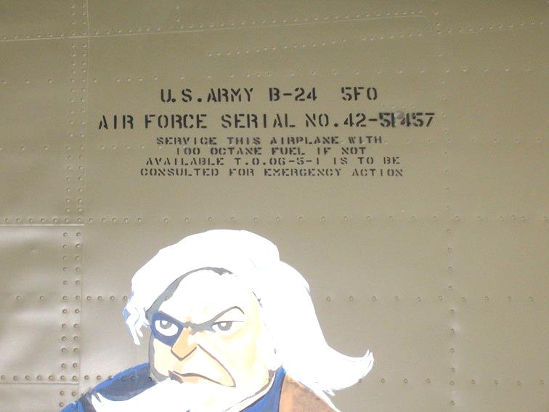

Table of Contents

Summary 3

Aircraft Engines And Avgas Specifications 3

U.S. Navy Requirements 6

ASTM Avgas Specifications & Test Methods 1941 10

U.S. Avgas 100 Specification Developments 1935-1945 13

U.S. Navy Fuel Grades 1944 21

U.S. Avgas 115/145 Specification Developments 1935-1945 21

British & Australian (British Empire) - 1940 23

British Avgas Specifications & Test Methods 1942 25

French Military - 1940 27

U.S. Engine Manufacturers 1940 29

Epilogue For The War Years 1939-1945 29

Index 30

Research Sources 33

Photo 2. Ryan PT-22 US Army Air Corp trainer.



# Summary

This period – the War Years saw the greatest convergence and development of the aviation gasoline specifications, primarily because the United States produced over 80% of the aviation gasoline and therefore their views tended to dominate the specifications. This chapter covers the changes in the aviation gasoline specifications and the reasons why.

This period also saw the emergence of a new grade Avgas 115/145, and the introduction of the Rich Mixture engine test for all aviation gasolines.

– This would be the ‘Golden Years of Avgas”.

Note: Some of the specifications listed below have already been presented in earlier chapters in particular, Chapter 9 - ‘The Phoney War’ - 1940 Military and Commercial Aviation Gasoline Specifications.

# Aircraft Engines and Avgas Specifications

As if almost a repeat of the First World War, the United States of America became the major supplier of aviation gasoline to the military forces in Europe, and again there were complaints about the quality of aviation spirit which was required for the British aircraft. The American engines (mostly air-cooled radial engines) performed satisfactorily on their Avgas 100, while the British engines (mostly liquid cooled in-line engines) required a higher performance number (rich rating) for supercharged conditions such as take-off and attack.

This would result in the inclusion of the Supercharge knock rating or Performance Number specification as determined by the CFR F-4 engine test. More information of this method can be found in the chapter devoted to Octane and Lead.

It would lead to a rationalization of the aviation gasoline specifications.

Aircraft Engines Types

In general terms there are three major types of engine, which have been used on aircraft – these are liquid cooled in-line, air-cooled radial and the turbine engine. There have also been rocket powered aircraft and aircraft propelled by ramjets, however these are outside our scope of interest here.

Engine- Liquid Cooled In-line

The liquid cooled in-line engine was originally a modification of the typical automobile engine, however it used thinner castings and aluminium alloys. As a result of intensive development during World War I, practical in-line engines became available for military use. They continued to be used after the War (WWI) and were favoured by the British (and other European engine designers and builders). It was extensively developed in the air races in the 1920’s such as the Schneider Trophy and was favoured by these designers because of its streamlined profile. Perhaps the most famous example is the Rolls Royce Merlin which powered the legendary Spitfire in WWII. The Rolls Royce Merlin also powered the famous Avro Lancaster bomber.

Photo 3. Spitfire preparing for flight at Duxford Museum (2000)

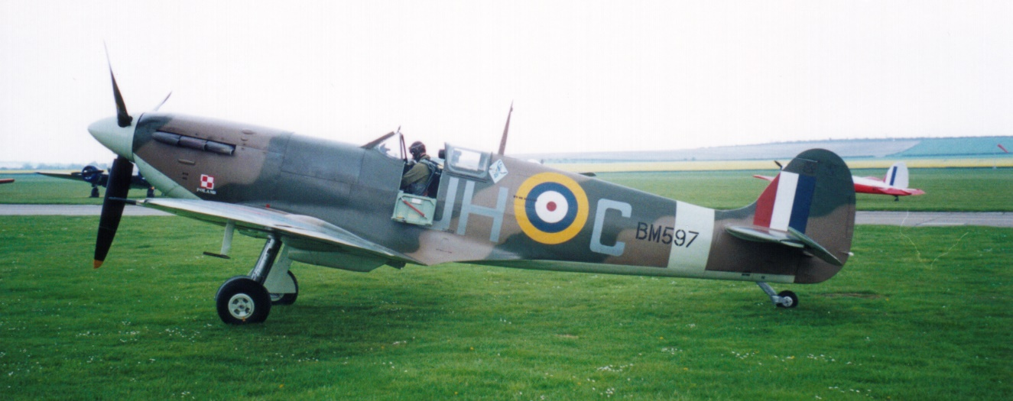

Most German WWII aircraft were powered by liquid cooled in-line engines, with only a few exceptions such as Focke-Wulf FW 190, Junkers Ju-88, and Dornier Do-17.

Photo 4. Allison V-12 in-line engine used in the P-51 Mustang and Bell P-39 Airacobra. (on display at San Diego Aerospace Museum (2003)

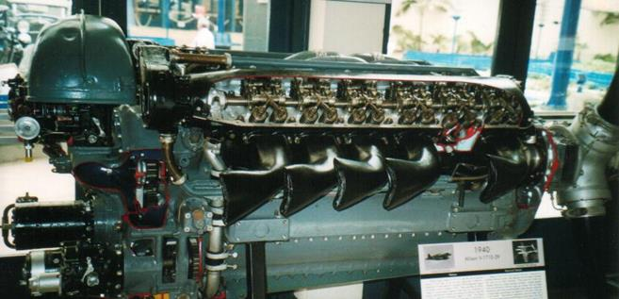

Engine – Air-cooled Radial

The air-cooled radial engine was designed specifically for aircraft use and was lighter and simpler than the in-line engine. The short crankshaft and crankcase reduced the weight and increased strength. The use of air to cool the cylinders eliminated the weight and complications of a radiator and its plumbing. These ‘radial’ engines began in rotary form from 1908 (in the rotary engine the engine rotates with the propeller, and while this provided good air cooling, the engine mass exerted significant gyroscopic forces which required considerable pilot skill to counteract). By the end of WWI, the rotary engine had been replaced by the radial engine, where the engine was fixed and only the propeller rotated.

Radial engine was easy to maintain particularly in difficult conditions such as the humid wet conditions of the Pacific Islands and dry, dusty conditions of the desert.

Photo 5. Preparation of radial engine (Circa 1940)

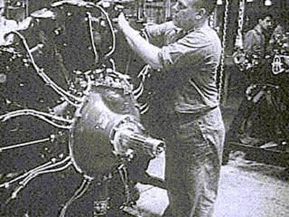

This engine was favoured by the Americans and it dominated the field of carrier borne aircraft until displaced by the turbine in the 1950’s. The classic examples are the Wright and Pratt & Whitney engines used in the large American bombers such as the B-17 Flying Fortress, B-24 Liberator (Pratt & Whitney R-1830-65 ‘Twin Wasp’ piston engines (4) each of 1,200 hp) which required Avgas 100/130 and B-29 Super Fortress (Wright Cyclone R-3350 piston engines (4) each of 2,200 hp) which required Avgas 115/145.

Photo 6. RAAF. B-24 Liberator 4 'MJ-S' of No. 21 Squadron undergoes engine maintenance at Morotai, 27th May 1945.[1]

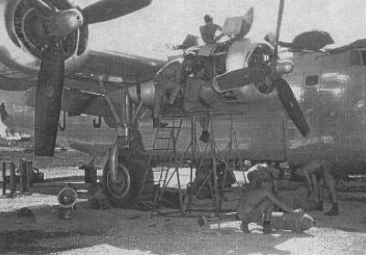

Perhaps one of the major driving forces for the radial engine in America was the U.S. Navy. Their influence started as early as 1919.

# U.S. Navy Requirements**[2]**

At the end of World War I, the role of naval aviation changed from one of training and coastal patrol to that of a more integral part of the fleet, with aircraft capable of going to sea. This required lightweight, small aircraft with light, reliable, fuel-efficient engines. Analysis revealed that when the sizable 0.6 - 0.7 lb/hp penalty for the cooling system was taken into account, air-cooled engines were lighter than liquid-cooled. Further, nearly one-fifth of engine failures were due to problems with cooling system plumbing. The U.S. Navy established a set of engine requirements that are classic in the aircraft field:

(a) Low weight per horsepower

(b) High economy in fuel

(c) Maximum dependability

(d) Maximum durability

(e) Maximum ease in maintenance

(f) Minimum cost

(g) Easy adaptability to quantity production

This set of requirements favoured air-cooled engines, but none available were satisfactory. The Navy tried unsuccessfully to interest U.S. engine makers in development of air-cooled engines. Finally, they awarded an experimental contract to the Lawrance Aero-Engine Corporation for the development of a 9-cylinder radial using cylinders from an earlier Lawrance 3-cylinder radial.

Photo 7. Lawrance 3-cylinder radial engine[3]

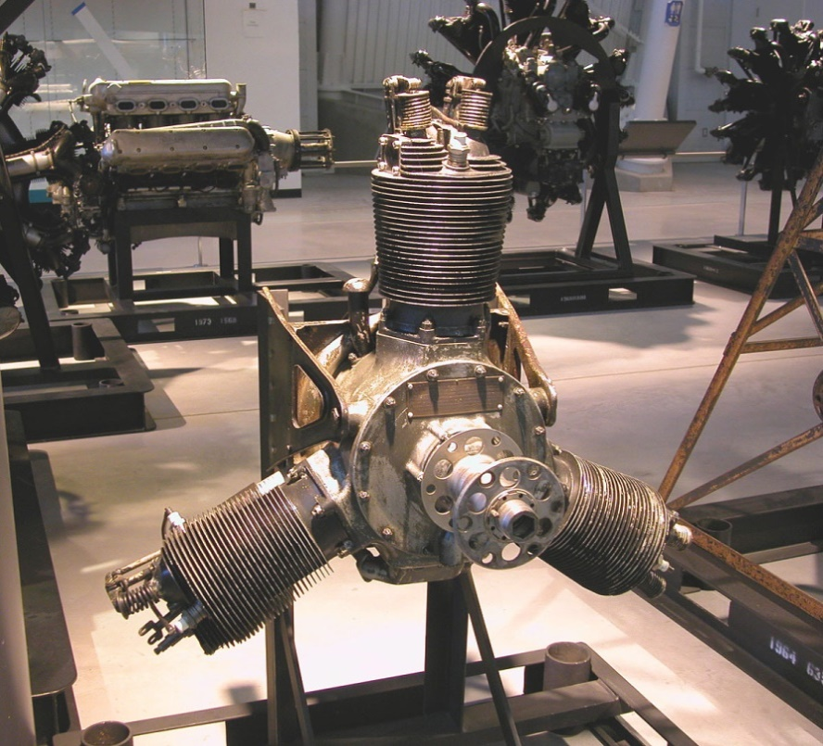

The Navy, not convinced that the Lawrance Company was substantial enough to be their sole supplier of engines, tried to promote competition from other engine makers. Again, neither of the big two, Curtiss or Wright, showed any interest.

Wilbur and Orville Wright got into the engine business when they could find none light enough to suit their 1902 engine requirements. After being the first to fly with an engine, they continued to build a series of unremarkable engines until 1916 when the Wright-Martin Aircraft Corporation was formed to make Hispano-Suiza engines under license. Wright-Martin was dispersed in 1919, and a new corporation, Wright Aeronautical Corporation (Wright) formed with Frederick B. Rentschler as President. Wright continued to build and improve the Hispano-Suiza.

Try as it might, the Navy could not persuade Wright Aeronautical Corporation to develop 200 hp class engines for naval use. Rear Admiral W. A. Moffett and Commander E. E. Wilson, head of Naval engine section, pushed Wright to acquire Lawrance and produce the radial engines. To help Wright with the decision, the Navy informed the Wright Corporation that no further orders for other liquid-cooled Hispano-Suiza engines or spares would be forthcoming. The stormy merger was accomplished, and Charles Lanier Lawrance became vice-president of Wright Aeronautical Corporation.

Rentschler resigned as president of Wright effective September 1, 1924. He had grown tired of arguing with the board of directors, largely composed of investment bankers with little stock in the company, no appreciation of the technical merits of air-cooled engines, and no resolve to do the research and development required for air-cooled engines larger than the Whirlwind.

Photo 8 Frederick B. Rentschler

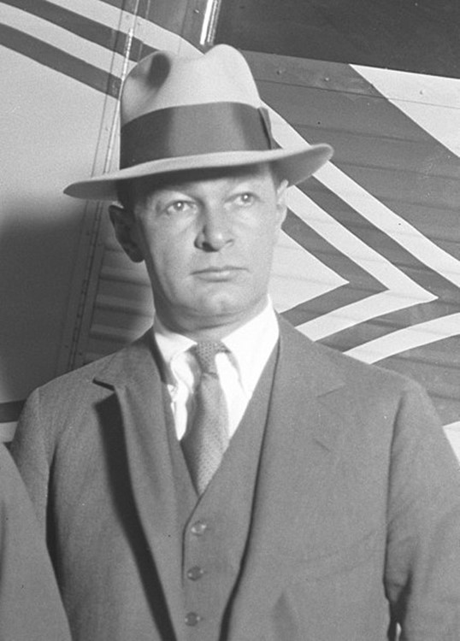

C.L. Lawrance became president of Wright Aeronautical Corporation. In July of 1925 after leaving Wright, Rentschler formed Pratt & Whitney Aircraft.

This would be start of the U.S. Navy association with the Wright Aeronautical Corporation and Pratt & Whitney Aircraft and lead to a U.S. Navy preference for radial aircraft engines and the famous line of U.S. carrier based aircraft such as Grumman Hellcat and Chance-Vought F4U Corsair. The air-cooled radial engine was ideal for carrier-based aircraft where simplicity, and limited space are considerations - the radial engine is shorter (but wider) than an in-line engine and therefore the aircraft fuselage is shorter and thus more aircraft can be stored on the aircraft carrier.

Photo 9. Grumman Hellcat F6F takes off from USS Yorktown 1943.

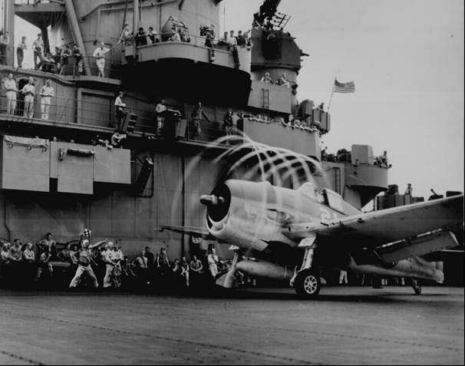

Photo 10. Chance-Vought F4U Corsair about to take off from a U.S. aircraft carrier (Circa 1945)

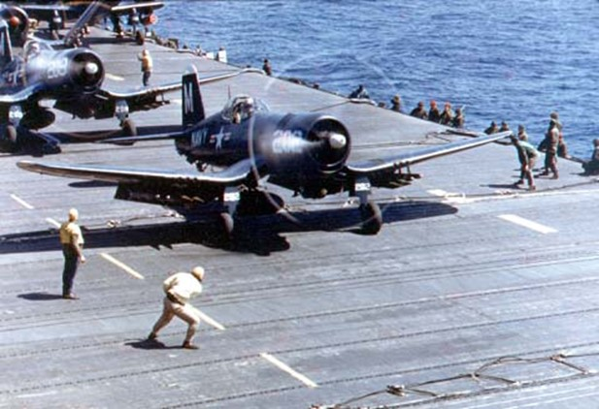

The development of the radial engine continued throughout World War II. The final chapter in the radial engine story was the Pratt & Whitney “Wasp-Major” R-4360. The R-4360 was the largest air-cooled piston engine ever produced in the United States.

Photo 11. Pratt & Whitney “Wasp-Major” R-4360 cutaway in section for training purposes, on display at Chino Air Museum, California, U.S.A. (1999).

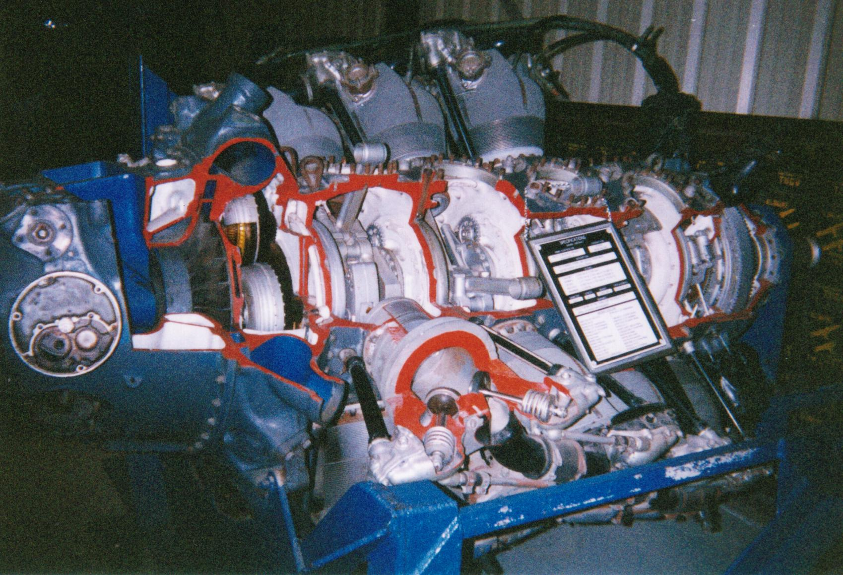

The four-row arrangement of the 28 cylinders earned it the name ‘Corncob”. Weighing about 3,420 lb. (1.55 tonne), it was used on the Convair B-36 Peacemaker and Boeing B-50 bombers, as well as the C-74 and C-97 transports. [On 26 February 1949, a USAF Boeing B-50A Superfortress completed the first non-stop flight around the world relying on in-flight refuelling]. The Hughes “Spruce Goose” also mounted eight of these engines. It required Avgas 115/145.

There were 18,769 of these engines made from 1943 to 1955. Delivering 3,400 HP, the R-4360 was the last big piston engine that was produced before jet propulsion and turboprops became the power plants for large aircraft.

Enter the Jet Engine

A revolution in aircraft power plants occurred during World War II with the advent of the gas turbine, or ‘jet engine’. At this time the piston engine had nearly reached the practical limit of its development and was gradually replaced by the more powerful, much lighter and mechanically simpler turbine engine.

A sign of things to come – Bell P-59A ‘Airacomet’ the first U.S. jet powered aircraft flew on October 1, 1942, here it is accompanied by its stable mate Bell P-39 Airacobra (in-line piston engine).

Photo 12. Bell P-59A ‘Airacomet’ the first US Jet and Bell P-63 Kingcobra (circa 1942)

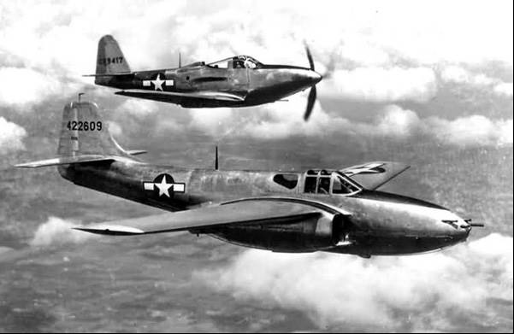

There would be many other examples where the jet engine would replace the piston engine, even in similar airframes, but new aircraft deigns would be required.

These new designs would also include the ideas and technologies of the German aeronautical engineers captured during the war, who defected to the West rather than be captured by the Soviets, and those who were captured in the East and would provide the Soviets with their knowledge - Swept wings and improved engine design. Captured Messerschmitt Me-262s were studied and flight tested by the major powers, and ultimately influenced the designs of post-war aircraft such as the North American F-86 Sabre, Russian MiG-15 and Boeing B-47 Stratojet. But the piston aircraft would continue for many decades both in military service for the next global and regional conflicts. Later they would continue as ‘War Birds’ air shows.

Photo 13. Warbirds air show WWI and WWII aircraft

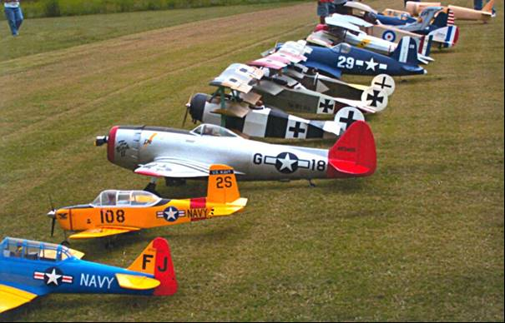

# ASTM Avgas Specifications & Test Methods 1941

1941 A.S.T.M. Tentative Aviation Gasolines Specification[4]

Since 1898 the American Society for Testing Materials (A.S.T.M.) has developed and published voluntary consensus standards for materials and products - (see below). One of the important ASTM Committees was (and still is) D-2 on Petroleum Products and Lubricants. In 1941 ASTM Committee D-2 issued the proposed ‘Tentative Specifications for Aviation Gasolines’. One of the driving forces in getting the ASTM specification established was the (U.S.) Aviation Manager for Shell – Jimmy Doolittle. His desire for change came from his exasperation with the situation in 1937 where Shell had to supply some 14 different aviation gasolines to satisfy all the octane number and volatility requirements of the military and commercial specifications.

1. Scope

(a) These specifications were for the use of purchasing agencies in formulating specifications for purchases of aviation gasolines under contract.

(b) These specifications were not a definition of aviation gasoline, nor did they include all types of fuel satisfactory for spark-ignition aviation engines. Certain equipment or conditions of use may require fuels having special characteristics.

2. Grades

Three grades of aviation gasoline were provided, varying chiefly as to knock value. The grades were designated by their respective A.S.T.M. aviation knock values as follows:

Grade 73

Grade 91

Grade 100

3. General

These specifications stated the required properties of aviation gasoline at the time and place of delivery in bulk.

4. Detailed Requirements

The three grades of aviation gasoline shall conform to the requirements prescribed in the following table.

5. Methods of Testing

The test methods were designated by A.S.T.M. in their ‘Book of Standards’ which was published each year. In some cases, the methods F.S.B. came from the (U.S.) Federal Specification for Lubricants and Liquid Fuels; General Specifications (Methods for Sampling and Testing) (VV-L-791a) – these were described in detail in the A.S.T.M. Tentative Specification. [The details of these test methods will not be discussed here – reference should be made to the A.S.T.M. Book of Standards].

[**ASTM International**: Founded in 1898, ASTM International is a not-for-profit organization that provides a global forum for the development and publication of voluntary consensus standards for materials, products, systems, and services. Over 30,000 individuals from 100 nations are the members of ASTM International, who are producers, users, consumers, and representatives of government and academia. Formerly known as the American Society for Testing and Materials, ASTM International provides standards that are accepted and used in research and development, product testing, quality systems, and commercial transactions around the globe. – ASTM website Jan 2004].

Table 1. Requirements for Aviation Gasoline (ASTM 1941 Tentative) – All Grades

[Metric values have been included where appropriate]

|  |  |  |
| --- | --- | --- |
| Test All grades | Result | Test Method |
| Distillation | | ASTM D86 |
| 10% evaporated, max. deg. F (C) | 158 (70C) |  |
| 50% evaporated, max. deg. F (C) | 212 (100C) |
| 90% evaporated, max. deg. F (C) | 257 (125C) |
| Sum 10%+50% evaporated, min. deg. F (C) | 307 (153C) |
| Recovered, min. % | 97% |
| Residue, max. % | 1.5% |
| Loss, max. % | 1.5% |
| Vapor Pressure max. lb [psi] | 7.0 (48.3 kPa) | ASTM D323 |
| Acidity of distillation residue | Neutral | FSB 510.2 |
| Colour | Blue | See Note 1. |
| Corrosion: Copper strip | No gray or black discoloration | ASTM D130 |
| Corrosion: Copper dish | No gray or black discoloration; residue on evaporation of 100 ml. not to exceed 5 mg. | FSB 530.11 |
| Gum, Accelerated, max., mg. per 100 ml. | 6 | See Note 2. |
| Sulphur, max. % | 0.05% | ASTM D90 |
| Freezing Point, max. deg. F (C) | -76 (-60OC) | FSB 141.1 |
| Water tolerance | Volume change not to exceed 2 ml. | See Note 3. |
| Permissible gum inhibitors max. lb. per 5,000 [US] gallons | 1.0 (24 mg/L) | See Note 4. |

Table 2. Requirements for Aviation Gasoline (ASTM 1941 Tentative)

[Metric values have been included where appropriate]

|  |  |  |  |  |
| --- | --- | --- | --- | --- |
| Test | **Grade 73** | **Grade 91** | **Grade 100** | Test Method |
| ASTM Aviation Knock Value, min. | 73 | 91 | 100 | ASTM D – See Note 5. |
| Tetra Ethyl Lead, ml per US Gallon  (TEL in the form of 1-T Ethyl Fluid) | 1  (0.26 ml/L) | 4  (1.06 ml/L) | 3  (0.79 ml/L) | ASTM D526 |
| Net Calorific Value, min. BTU per lb. | 18,300 | 18,700 | 18,700 | See Note 6. |

Note 1. Colour of gasoline containing tetra ethyl lead shall be equivalent to the colour imparted by not less than 3 ml. of tetra ethyl lead per gallon [USG] in the form 1-T ethyl fluid. Gasoline not containing tetra ethyl lead shall not be darker than +25 Saybolt Chronometer (ASTM D156). [It is interesting to note that the colour of Avgas 100 was specified as blue, the green colour for Avgas 100 would not come into use until December 1942].

Note 2. The ASTM Tentative Specification described the method as ‘Gum (Accelerated Aging Test with Oxygen) and detailed the apparatus and test method, which essentially was placing a 200 ml of gasoline sample with clean steel tubing (35 sq. in (or 226 sq. cm.) surface area) in a glass container. The container was placed in a metal bomb and maintained under a pure oxygen atmosphere at a pressure of 95-100 psi (655-689 kPa) for a duration of 5 hours at 208-212 deg. F (97.8-100 deg. C). The contents were then cooled, filtered, and half of the oxidized sample evaporated to dryness in a pre-weighed glass dish over a steam bath. The dish is then dried for 2 hours at about 230 deg. F (110 deg. C), after cooling the dish is reweighed to determine the gum content (expressed as milligrams per 100 ml.). If the amount of residue exceeds 6 mg. and the fuel contains tetra ethyl lead, the residue may be analyzed for lead compounds and a correction made to the residue for lead compounds. [This was later to become ASTM D525T].

Note 3. The ASTM Tentative Specification described the apparatus and test method, which essentially was placing an 80 ml of gasoline sample with a graduated glass stoppered cylinder with 20 ml of distilled water at room temperature, and shaking vigorously for at least 2 minutes. After shaking, the mix was allowed to settle and the volume of the aqueous layer recorded. [This test would quickly identify any water soluble components such as alcohols in the aviation fuel].

Note 4. Approved Inhibitors: The permissible inhibitors were as follows:

Monobenzyl-para-aminophenol

Isobutyl-para-aminophenol

Normal butyl-para-aminophenol

N,N’-dibutyl-para-aminophenol

Ortho-, meta-, and para-cresols

Alpha-naphthol

These inhibitors may be added to the gasoline separately or in combination, in total concentration not to exceed 1.0 lb. of inhibitor (not including the weight of solvent) per 5,000 [US] gallon of gasoline. [This is a maximum of 24 mg/L of inhibitor].

Note 5. At the same time ASTM issued the ‘Tentative Method of Test for Knock Characteristics of Aviation Fuels’ which described the test method, apparatus and conditions for determining the knock rating. [This was later to be known ASTM D357-41T as the ‘Motor Method’, or Lean Mixture Knock Rating].

Note 6. The ASTM Tentative Specification described approach to be taken in determining the weight of water formed by combustion of each pound of fuel, then the calculations required to obtain the Net Calorific Value.

Figure 1. Chemical structure of ortho-, meta, para-cresol, one of the many approved inhibitors to prevent gum formation.

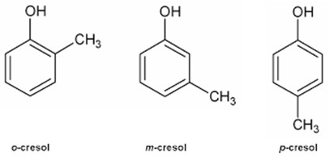

Photo 14. Saybolt Chronometer (ASTM D156) (see note 1. above).

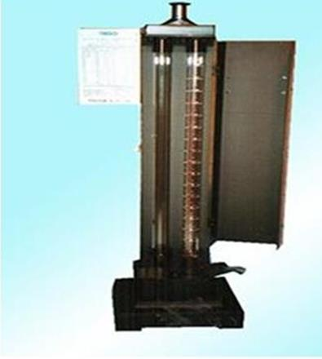

Figure 2. Reid Vapour Pressure apparatus

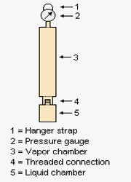

Gum (Accelerated Aging Test with Oxygen) ASTM D525T

Photo 15. Oxidation Stability Apparatus Photo 16. Sample container glass for ASTM D525 which is placed in the metal chamber

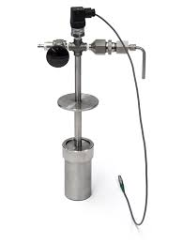 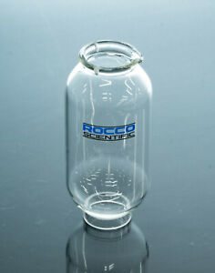

# U.S. Avgas 100 Specification Developments 1935-1945[5]

In Robert Kerley’s book on the Military Aviation Fuel Characteristics, he lists the various (U.S.) specifications for Avgas 100 from 1935 to 1945, and also Avgas 115/145 from its introduction in June 1944 to 1945, although both these grades were to continue in use for many years after. In order to understand the developments in these grades the information has been restated in a different format.

Table 3. U.S. Avgas 100 specifications 1935-1945 (selected specifications) (Only significant changes are listed here)

|  |  |  |  |  |  |
| --- | --- | --- | --- | --- | --- |
| Specification No. | 2-92 | AN-9531 | AN-VV-F-781 Amdt #5. | AN-F-28 | AN-F-27 Amdt #1 |
| Date | 20 June 1935 | 1 March 1939 | 13 May 1942 | 23 Dec. 1942 | 5 Jan 1944 |
| Lean Mixture Rating | 100 Octane |  | 100 Octane |  | 98 Octane |
| To Specification | 2-94 | AN-9525 | AN-VV-F-746 |  |  |
| Rich Mixture Rating | None |  | 1.0 ml TEL | 1.25 ml TEL |  |
| To Specification |  |  | AN-VV-F-748 |  |  |
| PN actually delivered | 100/110 | 100/115 | 125 | **130** |  |
| TEL ml/US Gallon (Max.) | 3.0 |  | 4.0 |  | 4.6 |
| Colour | Blue |  |  | **Green** |  |
| Dye Content mg/US Gallon | 10.0 |  |  | 20.0 | 23.0 |
| Distillation | | | | | |
| 10% Evap. Max Temp deg. F. | 167 (75OC) |  | 167 (75OC) |  | 167 (75OC) |
| 40% Evap. Max Temp deg. F. | Not listed |  | 167 (75OC) |  | 167 (75OC) |
| 50% Evap. Max Temp deg. F. | 212 (100OC) |  | 221 (105OC) |  | 221 (105OC) |
| 90% Evap. Max Temp deg. F. | 275 (135OC) |  | 293 (145OC) |  | 284 (140OC) |
| End point Max Temp deg. F. | No listed |  | 356 (180OC) |  | 374 (190OC) |
| 10%+50% Evap. Min. Temp deg. F. | 307 (153OC) |  | 307 (153OC) |  | 307 (153OC) |
| Acid Heat, deg. F. Rise | None | 20 (11.1OC) | None |  |  |
| Freezing Point deg. F. | -76 (-60OC) |  |  |  |  |
| Aromatic Hydrocarbons | Not specified |  | Permitted |  |  |
| Hydrocarbon compounds | Essentially |  | Completely |  | 1% Xylidene |
| Heating Value, Lower (or Net) Minimum |  | 19,000 | 18,700 |  |  |
| Gum Content | | | | | |
| Copper Dish mg/100ml. | No corrosion- |  | No corrosion, 5.0 |  |  |
| Accelerated Gum mg/100ml. | 4 hours, 10.0 | 5 hours, 6.0 |  |  |  |
| Inhibitor permitted | No |  | Yes |  |  |
| Sulphur Content % | 0.10 |  | 0.05 |  |  |

Note that none of the above specifications lists a Reid Vapour Pressure limit.

During the period 1935 to 1945 there was essentially the evolution of the Avgas 100/130 specifications under five major designations. There were of course many amendments along the way. The changes and where possible the reasons for these changes are as follows.

1935 Specification 2-92

The U.S. Specification 2-92 was introduced 20 June 1935 and contained the specification limit for Lean Mixture Rating of 100 octane; the Rich mixture method had not yet been developed and the demands of British supercharged in-line engines not yet known. [The Performance number of the fuels of the day was estimated between 100 and 110].

The maximum Lead level was 3.0 mg/USG (0.79 mg/l) and because it contained Lead it was to be Blue in colour.

The problems of volatility were nearly over and the distillation requirements had been settled sometime earlier. The avgas was described as ‘containing essentially hydrocarbons’ so there was some latitude to include no-hydrocarbon compounds, perhaps alcohols.

The product of (Specific Gravity X Heating Value) was to be not less than 13,700 - this was approximately a Heating Value of 18,000- 19,000 depending on the specific gravity. This was to be eliminated in the next revision.

Freezing Point of –60oC (–76oF) was already established as the limit which suited nearly all operational aircraft of most nations.

No inhibitors were permitted, and Gum content and storage stability was still a concern.

Sulphur content was limited to 0.10% - this may have been to accommodate some of the higher sulphur U.S. crudes, by contrast the progressive British specification of 1923 had limited the Sulphur content to 0.05% - the Americans would wait another 5 years before reducing the Sulphur content.

1938 Specification 2-92A

Specification 2-92A was a revision of 1935 Specification 2-92, and was introduced on February 7, 1938. The significant changes were the compositional requirement that the avgas be completely composed of ‘hydrocarbons’; there was no limitation on the aromatic content – this would come later in 1941. The Heating Value requirement was simplified to a minimum of 18,500. The problems of storage stability were revised to include and accelerated ageing gum content which increased the test time from 4 to 5 hours, reduced the maximum gum content from 10.0 to 6.0 mg per 100 ml of sample, and included the presence of iron catalyst, namely a polished iron rod.

1939 Specification AN-9531

With the shadows of war looming in Europe, this specification introduced on March 1, 1939, and it saw the combination of the Army (U.S. Army Air Corps) and the Navy requirements with the ‘AN’ designation. As stated earlier, Standardization of (U.S.) Army and (U.S.) Navy requirements was started by Heron and Fliedner. This was to be continued by Captain Frank D. Klein and his counterparts in the U.S. Bureau of Aeronautics Lt. Coe and Lt. Eckstrom, and later Robert Kerley (representing the U.S. Army Air Corps), and Lt. H. Dozier U.S. Navy.

This specification also introduced Army/Navy test methods AN-9525 for Lean Mixture Rating; it may be recalled that in the late 1920’s had developed the U.S. Army Motor Method for evaluating aviation gasolines, while the U.S. Navy used a different method. [The Performance number of the fuels of this period was estimated between 100 and 115]. This specification also saw the reintroduction of the “Acid Heat’ test with a limit of 20 degrees F. (11.1 deg. C.) rise. This test involved Sulphuric Acid and was intended to ascertain the presence of aromatics and unsaturated hydrocarbons. This test had been popular with the U.S. in the 1920’s – at that time the limit was only 10 deg. F rise.

In order to provide greater power, the Heating Value was increased to 19,000 however this would be reduced back to 18,700 with Amendment #1 on 20 March 1940.

1939 Specification AN-VV-F-781

The next major change in Avgas 100 specification was the introduction of AN-VV-F-781 on 26 September 1940. With this specification there was a change in the test method for Lean Rating method to AN-VV-F-746.

The Lead in the avgas was specified as 1½ -T Mix Aviation Ethyl Fluid, however according to Kerley, before this could be introduced the previous 1-T Mix Aviation Ethyl Fluid was reinstated by Amendment #2 on 3 February 1941, and very little 1½ -T Mix Aviation Ethyl Fluid was delivered.

The Acid Heat test had been dropped, and Copper Dish corrosion test introduced a limit of 5.0 mg (per 100 ml of sample), on the precipitate from the oxidized sample.

Inhibitors were now permitted, however the fuel inhibitors were specified by active ingredients rather that trade name, according to Kerley, this resulted in no change in the fuel delivered. The following inhibitors were permitted:

Monobenzyl-para-aminophenol

Isobutyl-para-aminophenol

Normal butyl-para-aminophenol

N,N’-dibutyl-para-aminophenol

Ortho-, meta-, and para-cresols

Alpha-naphthol

These were the same as the ASTM 1941 Tentative specification for Aviation Gasoline.

Sulphur level was reduced to 0.05% maximum (this was now consistent with the British Specification).

### AN-VV-F-781 Amendment #4 on 14 November 1941

Ban on Aromatics – Increased Lead Content

This amendment saw a significant change in the composition of U.S. Aviation Gasoline composition because it banned the inclusion of Aromatic Hydrocarbons because of fuel system problems (described earlier).

There was an increase in the permitted Lead level from 3.0 ml/USG to 4.0 ml/USG (1.06 ml/Litre) together with an increase in the permitted Dye content 13.3 mg/USG (and increase from 10.0 mg/USG).

## AN-VV-F-781 Amendment #5 on 13 May 1942

Rich Mixture Rating of PN 125 minimum – Distillation changes – Aromatic permitted

The problems of Rich Mixture rating for supercharged in-line engines used in particular by the British in their Spitfires and Hurricanes were to be addressed in this Amendment #5.

Amendment #5 included a Rich Mixture Rating method of AN-VV-F-748 and set a minimum Performance Number of 125 (or equivalent to 1.0 ml TEL/USG of Iso-Octane).

‘The story of the 40% point’

Inclusion of 40% Evaporated maximum of 167oF (75oC) was at the urging of the British. Mr. W.G. Dukek of Esso Research & Engineering Company recalled that: - ‘this requirement was included in the proposed specification as a result of a meeting with representatives of the U.S. Army Air Force, U.S. Navy and the Office of Petroleum Coordinator and the British Air Ministry. Other changes at the same time in the distillation were to increase the 50% minimum at 221oF (105oC), the 90% maximum at 293oF (145oC), and an end point of 356oF (180oC).

This requirement was based on the urgent request of the British Air Ministry and on data submitted by Mr. E.L. Bass.

Mr. Terry B. Rendel of the Shell Oil Company replaced Mr. Bass at a later date as the representative of the British Air Ministry. Rendel was later to explain that the inclusion of a 40% maximum point of 167oF was considered necessary to avoid the use of gasolines having a very flat distillation curve in the first 50% distilled. At the time (1942) the clause was introduced into the specification, the use of highly stabilized Isopentane (approx. boiling point 28oC) was becoming more and more in evidence, and there was a distinct tendency for the distillation curve to ‘flatten out’ at the 10% point. Bass, Rendel and their colleagues at the British Air Ministry felt strongly that the use of Reid Vapour Pressure as a significant criterion of vapour lock depended quite largely on a normal slope of the distillation curve at the 10% point. This British view was thought to be supported by Dr. Bridgeman (U.S. National Bureau of Standards, who was involved in the earlier ‘negotiations/agreement’ on the 90% point).

At this time there were a couple of operational aircraft in the U.K., which were border line with regard to their vapour locking characteristics. Consequently, it was felt desirable to include some clauses in the volatility specifications, which would prevent the introduction of too much light ends which would give a very flat initial distillations curve. Since one of the control points was 75oC or 167oF, it was thought that a 40% maximum would be sufficient control when taken with the 10% maximum, which had already been established.

E.L. Bass offered the following recollections that: ‘the problem first arose with high altitude Spitfires operating in India, where they were experiencing vapour locking problems. We were not only concerned with the particular problems in India but with all developments in the British high-altitude military aircraft. As often occurs in wartime, one is never really sure whether the change in specification was justified or not because the installation of booster pumps in the Spitfires and Hurricanes, and later on, fuel coolers, particularly in the Mosquitoes, thus prevented a clear cut conclusion.’

The inclusion of an end point in the distillation specification was to control crankcase dilution of the lubricant from the heavy ends of the gasoline.

1942 Specification AN-F-28

The next major change came on 23 December 1942 with AN-F-28. This saw two major changes - Rich Mixture Rating to PN 130, and the colour change to **Green,** both of would essentially remain unchanged from then onwards. The other major change was the permission of aromatic hydrocarbons following the upgrade of the U.S. aircraft fuel systems to accommodate higher aromatic aviation gasolines.

The Rich Mixture Rating was increased to a minimum Performance Number of 130 (or equivalent to 1.25 ml TEL/USG of Iso-Octane).

Changes in approved inhibitors: Ortho-, meta-, and para-cresols and Alpha-naphthol were removed from the approved list.

### AN-F-28 Amendment #1 on 24 March 1943

Changes in approved inhibitors: Monobenzyl-para-aminophenol was removed from the approved list. The minimum inhibitor quantity was specified as 0.8 pound per 5,000 U.S. Gallons (0.019 mg/Litres).

### AN-F-28 Amendment #2 on 28 July 1943

Changes in Lead Content: Increased from 4.0 ml/USG (1.06 cc TEL/Litre) to 4.6 cc/USG (1.22 cc TEL/Litre).

Changes in Dye Content: Increased from 20.0 (5.28 mg/L) to 23.0 mg/USG (6.08 mg/L)

### AN-F-28 Amendment #3 on 15 March 1944

Changes in Dye Content: Returned to 20.0 (5.28 mg/L) to provide the same colour intensity as obtained with lead content of 4.0 ml TEL/USG, even though the maximum Lead content was now 4.6 ml. TEL/USG.

Avgas 100 Octane Substitutes AN-F-27

As discussed earlier to increase supply and production certain blending agents were used - these included the addition of 1 % Xylidene. The first specification was AN-F-27 which was introduced on 10 July 1943. It was essentially the same as AN-F-28 Amendment 1 except that the end point was increase to 374oF (190oC.) some changes were required.

### AN-F-27 Amendment #1 on 5 January 1944

Changes in Lead Content: Increased from 4.0 ml/USG (1.06 cc TEL/Litre) to 4.6 cc/USG (1.22 cc TEL/Litre).

Changes in Dye Content: Increased from 20.0 (5.28 mg/L) to 23.0 mg/USG (6.08 mg/L).

Distillation 90% Evaporated maximum temperature reduced from 293oF (145oC.) to 284oF (140oC.)

Which Avgas grade for this aircraft?

With the development of the various grades Avgas 73, Avgas 91, Avgas 100/130, and the later Avgas 115/145, it was important that the aircraft ground crews and refuellers at the airfields quickly knew which fuel was required for which aircraft, and in particular if there were any limitations for that particular model of aircraft. For American military aircraft this dilemma was solved by a stencil marking on the aircraft on the left side nose usually under the cockpit window. The markings would often be so specific that the actual military serial number of the aircraft would be listed. In the following example the year of manufacture of this B-17 was 1942, and the fuel is listed as ‘100 OCTANE FUEL’ which indicates that was before the acceptance of Specification AN-F-28 which introduced the Rich rating of 130. Later marking would list ‘100/130 GRADE’ from 1943 onwards.

Photo 17. Marking for Boeing B-17 G-35-BO Flying Fortress “Mary Alice” (on display at Duxford Air Museum, UK 2000)

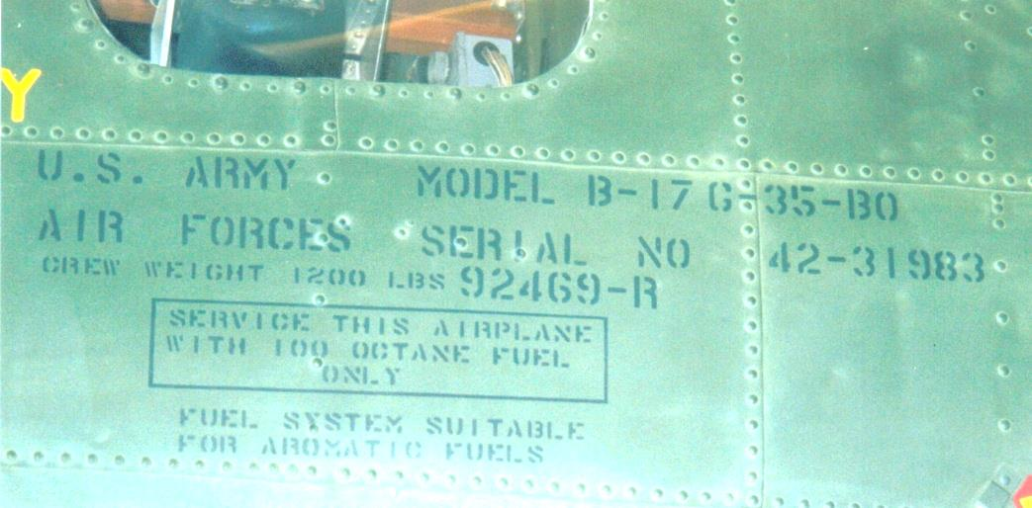

Photo 18. Markings on the famous “Memphis Belle” Boeing B-17F after their 25th mission.

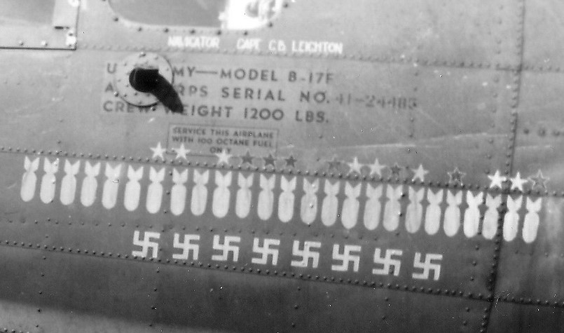

# US Navy Fuel Grades 1944**[6]**

By 1944 the U.S. Navy had some six grades of aviation gasoline, but with the war in the Pacific advancing at a rapid pace, an attempt was made to consolidate all existing directives on the uses of aircraft fuel.

# U.S. Avgas 115/145 Specification Developments 1935-1945[7]

The initial specifications for ‘Avgas 140’ appears to have been was based on Avgas 100 with the addition of 5% Aromatic Hydrocarbons to increase Rich Mixture Rating.

Kerley makes an interesting comment on the development of Avgas 115/145. In May 1941 the initial specification values for this new grade was Avgas 130/140, this was followed by a Prototype ‘Avgas 140’. It was hoped that a minimum knock rating under both lean and rich conditions in the supercharged (F-4) knock test method would result in a higher grade for engine development. For various reasons, including lack of accurate lean mixture reproducibility by the F-4 method, shortage of excess fuel quality capacity, disinterest by engine builders in this fuel as represented by the 140 prototype, and increasing interest in lean cruising performance, led to the cancellation of this prototype grade.

Avgas 115/145 – a compromise

The specification for new Grade Avgas 115/145 dated from June 13, 1944 and it was essentially the first accepted specification. The knock ratings for this engine development fuel were a compromise between the technical representatives of the (U.S.) Navy and the (U.S. Army) Air Corps. The Navy pleaded the need for longer range aircraft and desired a grade of Avgas 120/150. [The U.S. Navy in 1943-44 was engaged in great naval battles with the Japanese Imperial Navy in the vast Pacific Ocean; these battles were being fought by carrier-based aircraft – such as the Battle of Midway, the first naval battle in which the opposing carrier forces never sighted each other - the battle was fought by aircraft against ship]. The U.S. Army Air Corp, at the staff level, claimed that a grade Avgas 100/140 was the maximum quality which could be available in sufficient quantity for war needs. [In 1944, the USAAF was engaged in strategic bombing in Axis occupied Europe and they were preparing for the greatest land invasion the world had seen – D-Day at Normandy. Their concern was adequacy of supply]. **Avgas 115/145 was the compromise grade.** Avgas 115/145 was introduced in June 1944, and would continue to be in use for many years after, albeit with minor amendments, mostly related to test methods and approved inhibitors and additives. Because this was a new grade, it required a different colour from the existing aviation gasolines in use – the colour chosen was Purple. Further, because now all the knock ratings were over 100 Octane, both the Lean Mixture and Rich Mixture knock ratings would be expressed as ‘Performance Number or PN’, sometimes this was quoted as the equivalent to Iso-Octane with a specific Lead content, for example Lean Mixture 115 PN or Iso-Octane plus 0.5 ml TEL. [Performance Number is explained in previous chapters]. In order to understand the developments in these grades the information has again been restated in a different format.

Table 4. U.S. Avgas 115/145 specifications 1941-1945 (selected specifications) (Only significant changes are listed here)

|  |  |  |  |
| --- | --- | --- | --- |
| Specification No. | AN-VV-F-786 | 140 Prototype (See Note 1) | AN-F-33 |
| Date | 9 May 1941 | Est. early 1943 | 13 June 1944 |
| Lean Mixture Rating | 130 PN  1.5 ml TEL | 99.8 | **115 PN**  0.5 ml TEL |
| To Specification | AN-VV-F-748 | AN-VV-F-746 | AN-VV-F-746 |
| Rich Mixture Rating | 2.0 ml TEL | 2.0 ml TEL | **3.0** ml TEL |
| To Specification | AN-VV-F-748 | AN-VV-F-748 | AN-VV-F-748 |
| PN actually delivered | *-* | 138 | **145** |
| TEL ml/US Gallon (Max.) | 3.0 | 4.0 | **4.6** |
| Colour | Blue | Green | **Purple** |
| Dye Content mg/US Gallon | 10.0 | 20.0 | **14.0** |
| Distillation | | | |
| 10% Evap. Max Temp deg. F. | 167 (75OC) | 142 (61OC) | 167 (75OC) |
| 40% Evap. Max Temp deg. F. | Not listed | Not listed | 167 (75OC) |
| 50% Evap. Max Temp deg. F. | 221 (105OC) | 225 (107OC) | 221 (105OC) |
| 90% Evap. Max Temp deg. F. | 275 (135OC) | 289 (143OC) | 293 (145OC) |
| End point Max Temp deg. F. | No listed | 346 (174OC) | 356 (180OC) |
| 10%+50% Evap. Min. Temp deg. F. | 307 (153OC) | Not listed | 307 (153OC) |
| Acid Heat, deg. F. Rise | None | Not listed | None |
| Freezing Point deg. F. | -76 (-60OC) | Below –76 (-60OC) | -76 (-60OC) |
| Aromatic Hydrocarbons | 5% permitted | 23% Total | Permitted |
| Hydrocarbon compounds | Completely | Completely | Completely |
| Heating Value, Lower (or Net) Minimum | 18,700 | Above 18,700 | 18,700 |
| Gum Content | | | |
| Copper Dish mg/100ml. | No corrosion, 5.0 | No corrosion | No corrosion, 5.0 |
| Accelerated Gum mg/100ml. | 5 hours, 6.0 |  | 5 hours, 6.0 |
| Inhibitor permitted | Yes | 1 lb./5,000 USG | Yes |
| Sulphur Content % | 0.05 |  | 0.05 |

Again, none of the above specifications lists a Reid Vapour Pressure limit.

Note 1. The ‘140 Prototype’ information appears to be the test results of this prototype grade. No date is given however it is estimated to be between Dec 1942 and March 1943. The distillation data appears to be that of the prototype product and is not necessarily a specification limit; it will also be affected for the total aromatic hydrocarbon content of 23%.

1941 Specification AN-VV-F-786

The U.S. Specification AN-VV-F-786 was introduced in September 1941 and was essentially the June 1941 Avgas 100 product (AN-VV-F-781 Amendment #3) with 5% aromatic hydrocarbon. However, there was little interest at this time for a higher grade; this was a period of the development of Avgas 100 and there was a shortage of aviation gasoline in any case. The attempt to use the F4 (Rich Rating) test method for the Lean Rating was unsuccessful, but the F-4 Engine test method was still in a state of development.

140 Prototype AN-F-29

As part of the development of Avgas 115/145, a number of prototype specifications were proposed. The first was significant because the colour changed from Blue to Green, along with the Avgas 100. This was introduced in 24 March 1943 however the focus was on Avgas 100 and by this specification AN-F-29 was later cancelled.

AN-F-33 the ‘First Avgas 115/145’

The specification AN-F-33 for Avgas 115/145 can be considered the ‘first Avgas 115/145’ Specification, and was introduced 13 June 1944 (after the D-Day invasion was underway). The significant features of this specification were the minimum Rich Mixture Rating of 145 Performance Number, and the colour change to Purple. The Lead content was increased from 4.0 ml TEL/USG (1.06 cc TEL/Litre) to 4.6 cc/USG (1.22 cc TEL/Litre); and the dye content was reduced to 14.0 mg/USG - the dye content of the Ethyl TEL Fluid was reduced to give equal colour intensity as previously attained using 4.0 cc TEL/USG .

### AN-F-33 Amendment #1

This amendment introduced on 23 February 1945 and allowed for the use of the Aniline Gravity Constant in the calculation of the Lower Heating Value. This specification would be included in every aviation gasoline specification thereafter.

Photo 19. Douglas C-54 cockpit showing fuel grade required. - PIMA Museum, Tucson Arizona, USA (2000)

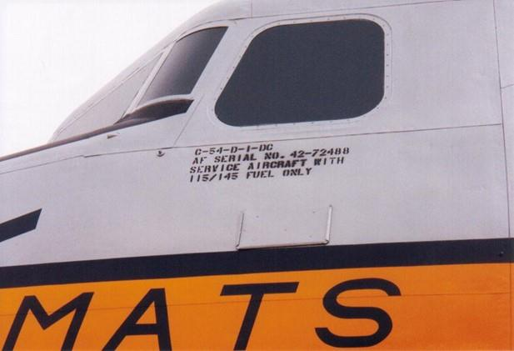

Photo 20. Lockheed C-121 Constellation cockpit showing furl grade required - PIMA Museum, Tucson Arizona, USA (2000)

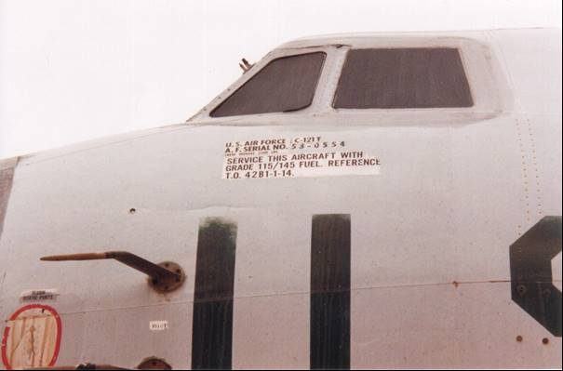

# British & Australian (British Empire) - 1940

The Specifications DTD-224 for Avgas 77 and DTD-230 for Avgas 87, which were issued in October 1933 were still in use by the British Air Ministry and other countries linked by the British Empire to its technical standards, and this included Australia. In 1940 the following specifications were used by the Shell Company of Australia to meet the requirements of both the military and commercial customers.[8]

This specification used by Shell Co. for British & Australian (British Empire), also Holland & Netherlands East Indies(except CFR Motor Method for 87 & 100).

Table 5. Specification: British Air Ministry (Department of Technical Development) (circa 1940)

|  |  |  |  |  |
| --- | --- | --- | --- | --- |
| **Grade Designation** | **73 (Estimated)** | **87** | **Typical** | **100 (Tentative)** |
| Specification No. | DTD-224 | DTD-230 |  | Tentative |
| Colour |  | Blue |  | Green |
| Sulphur (wt.%) Max. | 0.15 | 0.15 |  | 0.15 |
| Aromatics (vol.% Benzol (BTX) Min. |  | 25 |  | 25 |
| Distillation  Temp 10% Rec. (deg. C) Max.  Temp 50% Rec. (deg. C) Max.  Temp 90% Rec. (deg. C) Max.  End Point (deg. C) Max | 75  100  150  180 | 75  100  150  180 | 67  97  142  175 | 75  100  150  180 |
| Specific Gravity |  | 0.79 Max | 0.73-0.75 | 0.79 Max |
| Reid Vapour Pressure (@37.8 deg. C) psi Max  KPa | 7.0  49.0 | 7.0  49.0 |  | 7.0  49.0 |
| Freezing Point (deg. C) Max | -60 | -60 |  | -60 |
| Net Heat of Combustion MJ/kg Min  (BTU/lb.) |  |  | 46.5  20,000 |  |
| Knock Rating, Lean mixture  CFR Modified Motor Rating Min.  (Aviation method) | ?  (was 77 reduced to 73 | 87  88 |  | 100 |
| Knock Rating, Rich mixture Supercharge Rating Min. Note: This method was issued by ASTM as a tentative method in June 1941 (ASTM D---41T) | not applic. | not applic. |  | not applic. |
| Copper Strip Corrosion (2 hrs @100 deg. C) Max. | | | | |
| Potential Gum (16 hr aging mg/100 ml) Max. | 10 | 10 |  | 10 |
| Existent Gum (mg/100 ml) Max. | 10 | 10 |  | 10 |
| Tetra Ethyl Lead Content (cc/Imp G) Max. | unleaded | 4 |  | 4 |

Features of the British Avgas Specification are:

* Colour for Tentative Avgas 100 is Green. This would not be revised in the American grade for several years.
* The sulphur content had increased to 0.15%, perhaps due to limited suitable crude supplies.
* Minimum aromatic content for both Avgas 87 and Tentative Avgas 100 is 25% Benzol (as BTX). [BTX = Benzene, Toluene, Xylene] [This was desirable for British in-line engines]
* Inclusion of specific gravity limit.

# British Avgas Specifications & Test Methods 1942

*1942 British Empire Aviation Gasoline Specification*

As if almost a repeat of the First World War, America became the major supplier of aviation gasoline to the military forces in Europe, and again there were complaints about the quality which was required for the British aircraft. The American engines (mostly air-cooled radial engines) performed satisfactorily on their Avgas 100, while the British engines (mostly liquid cooled in-line engines) required a higher performance number (rich rating) for supercharged conditions such as take-off and attack.

This resulted in the inclusion of the Supercharge rating or Performance Number specification of 130 as determined by the F-4 engine test. More information of this method can be found in the chapter devoted to Octane and Lead.

To ensure that aviation gasoline for British aircraft the British Air Ministry provided their testing requirements as noted in the following letter from Colonel S. J. M. Auld to Wing Commander J. A. Easton of the British Air Ministry, 4 June 1941.

Wing Commander J. A. Easton was the Deputy Director of Intelligence (Section 2) Operations in the Air Ministry.

Lt. Col. S. J. M. Auld, O.B.E., M.C., DSc, PhD was a noted chemist, Chairman of the Petroleum Board, and later the President of the Institute of Petroleum.

The following testing is presumed to be of aviation gasoline supplied to British Forces in the Middle East in their battles against the Axis Forces of the Italians and the feared German Afrika Corps led by Field Marshal Erwin Rommel.

Photo 21. RAF Lockheed Hudson refuelling in Africa

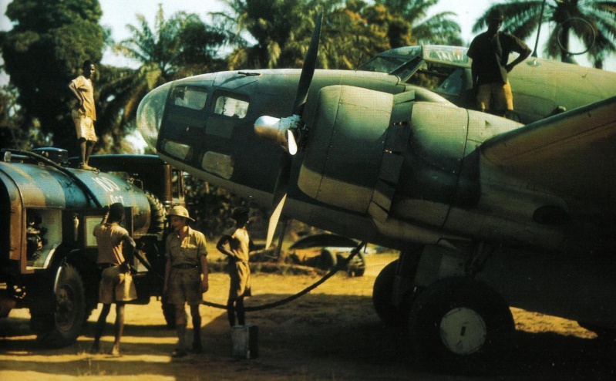

*Testing of Middle East samples done at INTAVA Laboratories*

*c/- Socony-Vacuum Oil Inc. Sharia Ibrahim Pasta 62 Cairo*

*Shell Company of Egypt Ltd. Cairo*

Table 6. Test Methods Institute of Petroleum

|  |  |  |
| --- | --- | --- |
| Test | Method | Comments |
| Specific Gravity | IPT G1 |  |
| Distillation | IPT G3 |  |
| Freezing Point | IPT G11 (T) |  |
| Vapour Pressure | IPT G37 |  |
| Free Sulphur | IPT G4b |  |
| Total Sulphur | IPT G4 |  |
| Gum (Existent) | IPT G25 (T) |  |
| Bromine No. | IPT G39 (T) |  |
| Lead Content | IPT G38 |  |
| Octane | IPT G39 T |  |
| Hydrocarbon Analysis (Aromatics) | IPT G39 (T) | Note 1. |
| Unsaturated Hydrocarbons | IPT G39 (T) | Bromine No. |
| Water solubility | Note 2. |  |

Note 1. H/C (hydrocarbon) analysis Aromatics by Method IPT G39 (T) applying no correction for unsaturated hydrocarbons if Bromine No. is less than 5.

Note 2. Test for Water Solubility – Shake with equal volume of brine and note any decrease in volume of spirit layer. (In the event of water soluble material being detected, the aqueous solution should be tested qualitatively for alcohols and/or ketones).

The notation (T) in the test methods indicates that the method is classified as ‘Tentative”. The notation ‘IPT’ refers to UK ‘Institute of Petroleum Technologists’- this was later to become simply Institute of Petroleum (IP).

*Limit on Benzole Content[9]*

September 1942 - One of the issues identified with carburetted engines was the problem of high Benzene content (as found in Benzole). Of all the aromatic compounds used in aviation fuels benzene has the highest melting point (approx. 5 deg. C), consequently at high (cold) altitude benzene can start to ice up the fuel system. This problem was addressed by having a freezing point test with an appropriate limit in the test methods for aviation fuels. Benzole can contain up to 70% Benzene and as such, a limit was required on the amount of Benzole which could be used without failing the freezing point test. For production of UK Avgas 100/130 from Curacao, a maximum limit of Benzole to about 10% was required due to the freezing point specification. As a result, nearly all refined Benzole went to motor spirit.

The issue of freezing point was of particular concern to the Allies because their aircraft engines had carburettors and were subject to icing in fuel lines, however the Germans had no such concerns because most of their engines were fuel injected and could accommodate a high level of benzene.

*Use more TEL to achieve 130 PN[10]*

In order to meet the rich rating of 130 required by the British, the U.S. authorities decided simply increase the lead (TEL) level of the avgas they supplied to the British. So, as of Aug 10, 1943 the U.S. authorities decided all supplies of 130 grade be leaded up to 5.5 TEL cc/IG compared with 4.8 TEL cc/IG. This created a problem with spark plug fouling of US engines such as Allisons used in North American P-51 Mustangs and Lockheed P-39 Lightnings. As a result, the UK planned to blend with old stock to dilute lead back to 5.0 cc/IG).

*Amending the UK DTD-230 Specification*

From August 1, 1943 there were a number of amendments to British Avgas Specification UK DTD-230. These were advised to the UK avgas producers - advice to Pointe-a-Pierre Trinidad from Trinidad Leasehold. Maidenhead UK.

The included changes to the distillation specification

10% evaporation minimum below 75 deg. C

50% evaporation minimum at 105 deg. C

90% evaporation minimum 150 deg. C

All production 100 Octane include 5.5 cc TEL/IG.

# French Military -1940

Photo 22. French Air Force WW2 fighter Morane D-3801 circa 1940 (Dutch Catalina in background)

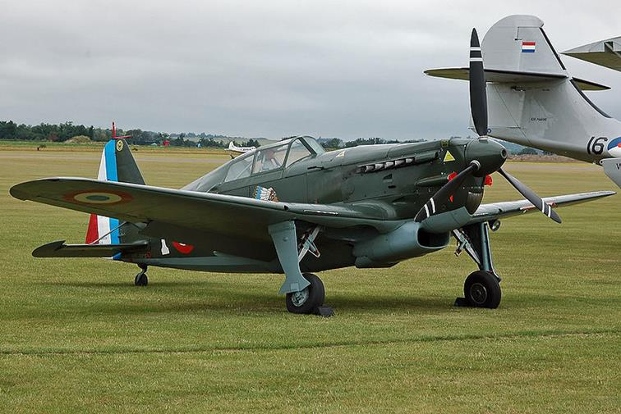

In 1940 this specification was used by Shell Company of Australia for supply the French Army & Navy (& French Possessions).

Table 7. Military Specification for French Army & Navy (& French Possessions) 1940.

|  |  |  |  |
| --- | --- | --- | --- |
| Grade Designation | 87 | 92 | 100 |
| Specification Number | 3401 Class 2 | 3401 Class 3 | 3401 Class 4 |
| Colour | Blue | Blue | Blue |
| Sulphur (wt.%) Max. | 0.15 | 0.10 | 0.10 |
| Distillation | | | |
| % Rec. + Loss (@ 75 deg. C) Min.  % Rec. + Loss (@100 deg. C) Min  % Rec. + Loss @ 135 deg. C) Min.  Final Boiling Point (deg. C) | 10-28%  50  90  180 | 10-28%  50  90  180 | 10-28%  50  90  180 |
| Specific Gravity | Not listed | Not listed | Not listed |
| Reid Vapour Pressure (@37.8 deg. C) psi Max  kPa | 7.25  50.8 | 7.25  50.8 | 7.25  50.8 |
| Freezing Point (deg. C) Max | -60 | -60 | -60 |
| Knock Rating, Lean mixture CFR Motor Rating Min. | 87  CFR Modified Motor Method | 92  US Amy Method No. 2-94 | 100  US Amy Method No. 2-94 |
| Knock Rating, Rich mixture Supercharge Rating Min. | not applic. | not applic. | not applic. |
| Potential Gum (mg/100 ml) Max. | 10 | 10 | 10 |
| Existent Gum (mg/100 ml) Max. | 6 | 5 | 5 |
| Tetra Ethyl Lead Content (gm/l). (cc/Imp G) Max. | 4.09 | 4.54 | 3.63 |

The French specification had some unusual feature:

* The distillation limits are presented as minimum % recovered at a specified temperature, rather than a maximum temperature for a specified % recovered. The 90% recovered temperature (135oC) is lower than the British and U.S. specification (150oC)
* Sulphur content 0.15% is higher than British and American specifications.
* Reid Vapour Pressure limit is higher at 7.25 psi maximum.
* Maximum Lead levels are lower than the equivalent grades of the British and American aviation gasolines.

Photo 23. French bombers Lioré et Olivier LeO.451

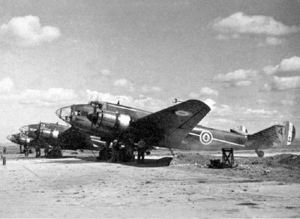

# US Engine Manufacturers 1940

Engine manufacturers also issued specifications for the fuels most desirable for their engines, - the following is those for the major U.S. engine manufacturers Pratt & Whitney, and Wright Aeronautical Corporation. The source is the Shell Company of Australia circa 1940.

Table 7. US Engine ManufacturersAvgas Specification for Pratt & Whitney, Wright Aeronautical Corporation.

|  |  |  |  |  |  |
| --- | --- | --- | --- | --- | --- |
| Grade Designation | 87 | 90 | 95 | 100 | 100 |
| Specification Number | PWA571-B  Wright 5803-F | PWA812-A  Wright 5804-A | PWA818-A  Wright 5805-B | Wright 5806-A | PWA513-B |
| Colour | Blue | Blue | Blue | Blue | Blue |
| Sulphur (wt.%) Max. | 0.10 | 0.10 | 0.10 | 0.10 | 0.10 |
| Distillation |  |  |  |  |  |
| % Rec.+Loss (@ 70 deg. C) Min.  % Rec. + Loss (@100 deg. C) Min  % Rec. + Loss @ 125 deg. C) Min.  10%+50%+90% (deg. C) | 10  50  90 | 10  50  90 | 10  50  90 | 10  50  90 | 10  50  90 |
| Specific Gravity | Not listed | Not listed | Not listed | Not listed | Not listed |
| Reid Vapour Pressure (@37.8 deg. C) psi Max.  KPa Max. | 7.0  49 | 7.0  49 | 7.0  49 | 7.0  49 | 7.0  49 |
| Acid Heat (Max) | 15 Deg. F | 15 Deg. F | 15 Deg. F | 15 Deg. F | 15 Deg. F |
| Freezing Point (deg. C) Max | -60 | -60 | -60 | -60 | -60 |
| Knock Rating, Lean mixture CFR Motor Rating Min. | 87  CFR Motor Method | 90  CFR Motor Method | 95  CFR Motor Method | 100  US Army Method | 100  US Army Method |
| Knock Rating, Rich mixture Supercharge Rating Min. | not applic. | Not applic. | Not applic. | Not applic. | Not applic. |
| Potential Gum (mg/100 ml) Max. | 6 | 6 | 6 | 6 | 6 |
| Tetra Ethyl Lead Content (gm/l).  (cc/Imp G) Max.  (cc/USG) Max. | 0.79  3.6  3 | 1.06  4.8  4 | 1.06  4.8  4 | 1.06  4.8  4 | 0.79  3.6  3 |

# Epilogue for the War Years 1939-1945

This period saw the introduction of the rich knock rating requirement in the aviation gasoline specification. Equally important was the development of the new Avgas 115/145 grade, which would be the highest performance gasoline fuel that would be available for piston powered aircraft engines, (excluding experimental and special application fuels). It would also see the convergence of the various Allied specifications into a common specification accepted by all, primarily driven by the fact the United States were the main supplier of aviation gasoline.

# Index

1

100 Octane 15, 16, 21

100 OCTANE FUEL 19

1½ -T Mix Aviation Ethyl Fluid 17

140 Prototype 22

1-T ethyl fluid 12

1-T Mix Aviation Ethyl Fluid 17

2

2-92 15

2-94 15

4

40% point 17

9

98 Octane 15

A

accelerated ageing gum content 16

Accelerated Gum 15, 22

Acid Heat 15, 16, 17, 22, 29

Admiral W. A. Moffett 7

air-cooled radial 3, 4, 8, 25

alcohols 26

Allison 4, 27

Alpha-naphthol 13, 17, 18

aluminium alloys 3

Amendment #1 17, 19

Amendment #2 17, 19

Amendment #3 19, 22

Amendment #4 17

Amendment #5 17

American Society of Testing Materials 11

AN-9525 15, 16

AN-9531 15

AN-F-27 15, 19

AN-F-28 15, 18, 19

AN-F-28 Amendment 1 19

AN-F-29 22

AN-F-33 23

AN-F-33 Amendment #1 23

Aniline Gravity Constant 23

AN-VV-F-746 15, 17, 22

AN-VV-F-748 15, 17, 22

AN-VV-F-781 15, 17, 22

AN-VV-F-786 22

Approved Inhibitors 13

aromatic 16, 17, 24, 26

aromatic compound 26

aromatic content 16

aromatic hydrocarbon 15, 18, 21, 22

ASTM 11, 24, 34

ASTM 1941 Tentative 12

ASTM 1941 Tentative specification 17

ASTM Committee D-2 11

ASTM D130 12

ASTM D156 12

ASTM D323 12

ASTM D357-41T 13

ASTM D525T 12

ASTM D526 12

ASTM D86 12

ASTM D90 12

ASTM International 11

ASTM Tentative Specification 12, 13

Australia 24, 34

Avgas 100 3, 12, 15, 17, 19, 21, 22, 24, 25

Avgas 100/130 5, 15, 19, 26

Avgas 100/140 21

Avgas 115/145 3, 5, 9, 15, 19, 21, 22, 23, 29

Avgas 120/150 21

Avgas 130/140 21

Avgas 140 21

Avgas 73 19

Avgas 87 24

Avgas 91 19

aviation fuels 26

aviation gasoline 3, 11, 16, 18, 21, 22, 25, 28, 29

aviation gasoline specification 3, 23, 29

aviation knock values 11, 12

Aviation method 24

Avro Lancaster 3

Axis 21

B

B-17 19

B-17 Flying Fortress 5

B-24 Liberator 1, 5

B-29 Super Fortress 5

Bass 18

Battle of Midway 21

Bell P-39 Airacobra 4, 9

Bell P-59A ‘Airacomet’ 9, 10

Bell P-63 Kingcobra 10

Benzene 24, 26

Benzol 24

Benzole 26

Boeing B-17 20

Boeing B-50 9

Book of Standards 11

Bridgeman 18

British Air Ministry 18, 24, 25

Bromine No. 26

BTX 24

Bureau of Aeronautic 16

C

C-74 9

C-97 9

CFR F-4 engine test 3

CFR Modified Motor Rating 24

CFR Motor Method 24, 29

Chance-Vought F4U Corsair 8

Coe 16

Colonel S. J. M Auld 25

Commander E. E. Wilson 7

Convair B-36 9

Copper dish 12, 15, 17, 22

Copper strip 12, 24

Corncob 9

corrosion test 17

crankcase dilution 18

Curacao 26

Curtiss 7

D

D-Day 21, 23

Distillation 12, 15, 22, 24, 26, 28

Dornier Do-17 4

Douglas C-54 23

Dozier 16

DTD-224 24

DTD-230 24, 27

Dukek 17

Dye Content 15, 19, 22

E

Eckstrom 16

end point 15, 18, 24

Esso Research & Engineering Company 17

Ethyl TEL Fluid 23

Europe 3, 16, 25

Existent Gum 24, 28

F

F-4 Engine test method 22

F-4 method 21

F4U Corsair 8

Federal Specification for Lubricants and Liquid Fuels 11

Fliedner 16

Focke-Wulf FW 190 4

Frank D. Klein 16

Freezing Point 12, 15, 16, 22, 24, 26, 28, 29

French Army 27

FSB 141.1 12

FSB 510.2 12

FSB 530.11 12

G

gas turbine 9

gasoline 12, 18

German 26

Grade 100 11, 12

Grade 73 11, 12

Grade 91 11, 12

Grumman Hellcat 8

Gum (Existent) 26

Gum Accelerated Aging Test 12

Gum content 15, 16, 22

gum inhibitors 12

H

Heating Value 15, 16, 17, 22, 23

heavy ends 18

Heron 16

Hispano-Suiza 7

Holland 24

Hurricane 18

I

India 18

Inhibitors 17

in-line engine 4, 8

Institute of Petroleum Technologists 26

INTAVA Laboratories 26

IPT G39 (T) 26

iron catalyst 16

Isobutyl-para-aminophenol 13, 17

Iso-Octane 21

Isopentane 18

J

Japanese Imperial Navy 21

jet engine 9

Jimmy Doolittle 11

Junkers Ju-88 4

K

Kerley 17, 21

ketones 26

knock rating 21

L

Lawrance Aero-Engine Corporation 6

Lawrance Company 7

Lead 16, 17

Lead content 17, 19, 21, 23, 26

Lead levels 28

Lean Mixture 21, 24

Lean mixture CFR Motor Rating 28

Lean Mixture Rating 13, 15, 16, 22

Lean Rating 22

liquid cooled in-line engine 3, 4, 25

Lockheed P-39 Lightning 27

lubricant 18

M

Monobenzyl-para-aminophenol 13, 17, 19

Morane D-3801 27

Morotai 5

Mosquito 18

Motor Method 13

N

N,N’-dibutyl-para-aminophenol 13, 17

National Bureau of Standards 18

Net Calorific Value 12, 13

Net Heat of Combustion 24

Netherlands East Indies 24

No. 21 Squadron 5

Normal butyl-para-aminophenol 13, 17

Normandy 21

O

Octane 26

Office of Petroleum Coordinator 18

Ortho-, meta-, and para-cresols 13, 17, 18

Orville Wright 7

P

P-51 Mustang 4, 27

Performance Number 3, 16, 17, 18, 21, 23, 25

PN 130 18

Pointe-a-Pierre Trinidad 27

Potential Gum 24, 28, 29

Pratt & Whitney 5, 7, 9, 29

Pratt & Whitney R-1830-65 ‘Twin Wasp’ 5

Prototype ‘Avgas 140’ 21

R

radial engine 9

ramjets 3

Reid Vapour Pressure 15, 18, 22, 24, 28, 29

Rendel 18

Rentschler 7

rich knock rating 29

Rich Mixture 3, 15, 16, 17, 18, 21, 22, 23

Rich mixture Supercharge Rating 24, 28, 29

rich rating 3, 19, 22, 25, 26

Robert Kerley 15, 16

rocket powered aircraft 3

Rolls Royce Merlin 3

rotary engine 4

S

Saybolt Chronometer 12

Schneider Trophy 3

Shell 11

Shell Company of Australia 24, 27, 29

Shell Company of Egypt Ltd. Cairo 26

Shell Oil Company 18

Socony-Vacuum Oil Inc. 26

spark plug fouling 27

Specific Gravity 16, 24, 26, 28, 29

Specification 2-92 16

Spitfire 3, 4, 18

Spruce Goose 9

storage stability 16

strategic bombing 21

Sulphur 12, 15, 16, 17, 22, 24, 26, 28, 29

Sulphuric Acid 16

Supercharge knock rating 3

supercharged (F-4) knock test method 21

supercharged in-line engine 16, 17

T

TEL 15, 26

Tentative Specifications for Aviation Gasolines 11

Tetra Ethyl Lead 12, 24, 28, 29

Toluene 24

Trinidad Leasehold. Maidenhead 27

turbine engine 3, 9

U

U.S. Army Air Corps 16, 21

U.S. Army Air Force 18

U.S. Army Motor Method 16

U.S. Navy 5, 16, 18, 21

U.S. Specification 2-92 16

unsaturated hydrocarbon 16, 26

USAAF 21

V

vapour lock 18

Vapour Pressure 12, 26

VV-L-791a 11

W

Water solubility 26

Water tolerance 12

Whirlwind 7

Wing Commander J. A. Easton 25

Wright 5, 7, 29

Wright Aeronautical Corporation 7, 29

Wright Cyclone R-3350 5

Wright-Martin Aircraft Corporation 7

X

Xylene 24

Xylidene 15, 19

# Research Sources

1. Australian Aviation History - Web site accessed January 3, 2004 - <http://users.chariot.net.au/~theburfs/index_mil.html>
2. “Ageless Engines” <http://www.cincinnati.com/ageless/J5.html> Website accessed Jan 11, 2004
3. <https://airandspace.si.edu/collection-objects/lawrance-l-3-radial-engine/nasm_A19731573000>
4. Report presented at ASTM 44th. Annual Meeting Chicago, Illinois, June 23-27, 1941
5. Military Aviation Fuel Characteristics 1917-1945 by Robert Kerley SAE Publication SP-1008 (ISBN 1-56091-454-8)
6. U.S. Navy Department Bureau of Aeronautics, Washington Directive NavAer 02-1-509 Aer-Ma-1323-JEF. Source San Diego Aerospace Museum TL 701.1.U62
7. Military Aviation Fuel Characteristics 1917-1945 by Robert Kerley SAE Publication SP-1008 (ISBN 1-56091-454-8)
8. Military and Commercial Aviation Gasoline Specifications, Sources Shell Co. of Australia Tech Department Aircraft Fuels & Lubricant (Circa 1940)
9. UK Public Records Office POWE 33/1814, Ref PE 9/13/42 (13 Sept 1942)
10. UK Public Records Office POWE 33/1470, POWE 33/594