Chapter

26

Allies World Avgas Supply 1940-1945

Greater production

Photo 1. Baton Rouge Refinery No. 1 FCC (1942), Baton Rouge Louisiana, U.S.A.

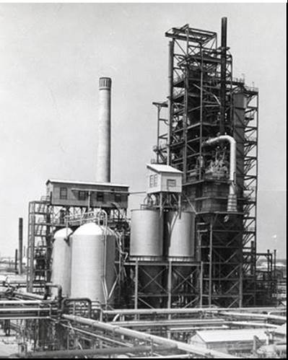

Table of Contents

Summary 3

The Allies Oil Industry Gets Organized 4

The Allies ‘Avgas Supply To The World’ 4

1943 Avgas Suppliers & Users 7

1944 Avgas Suppliers & Users 10

Preparations For D-Day 10

Allies Advance Into Europe From The West 14

Avgas Supplies By Air – ‘Flying The Hump’ 17

Avgas Supplies By Sea 20

Petrol Supply By Pipeline – “Pluto” 30

The World War Is Over 34

Oil Companies And Refineries – $US & £ Sterling 35

Epilogue For The War Years 37

Index 38

Research Sources 44

Photo 2. Loading RAAF tanker trucks from AOG tankers

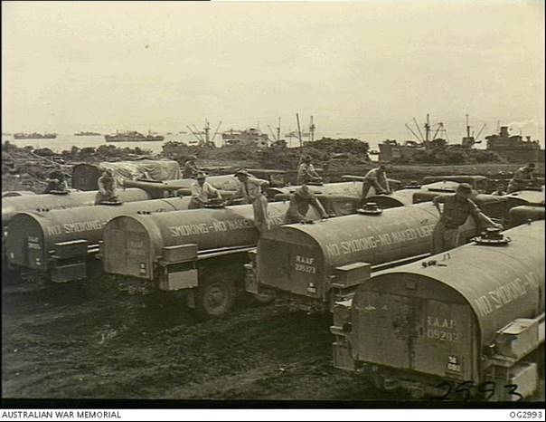

# Summary

Chronology

1939 (UK) Petroleum Board established which included aviation spirit.

1940 President Roosevelt declares that ‘the United States of America would be the Arsenal of the Free World’ and to provide aviation gasoline to British Empire under the lend lease scheme.

Oct 1941 Proposed advanced fuelling base for U.S. aircraft (B-17, A-24, P-40) in the Pacific

Oct 1942 U.S. Army and Navy Petroleum Board & the Petroleum Administration for War (PAW) established the Aviation Gasoline Advisory Committee.

Jan 1943 Operational requirements exceed production by approx. 20,000 BSD.

March 1943 Need for a higher grade of fuel (140 instead of 130) would be required for higher performance engines now in production. Conversion from 130 to 140 grade

June 1943 Aviation gasoline supply (100 Octane and 90/87 Octane) divided into five areas of influence around world and allocated into regions. [1]

Late 1943 Massive increase in production as the Allies prepare for “Operation Overlord” in June 1944.

Dec 1943 Proposal to derate 100/130 engines in U.S. (domestic use) to 91/96 to reduce consumption and allow 100/130 for operational theatres.

January 1944 All production ex U.S. Gulf and East Coast refineries after providing for essential requirements of North Africa, U.S. (Domestic), will be allocated to UK.

March-May 1944 Allied air power relentlessly attack German targets in preparation for D-Day, the Allied invasion of Europe. “Operation Overlord”

June 6, 1944 “Operation Overlord” begins

Sept 1944 More avgas through the use of Xylidene blending agents.

Photo 3. Refuelling B-25 Mitchell bomber

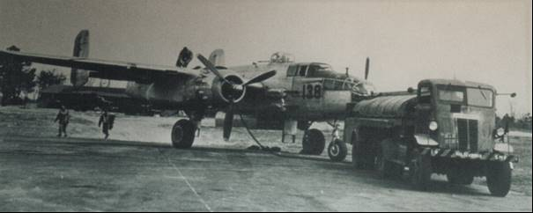

# The Allies Oil Industry gets organized

Petroleum Boards around the World

As noted in earlier chapters the (UK) Petroleum Board was established (in 1939) which included aviation spirit, and across the Atlantic the U.S. Army and Navy Petroleum Board & the Petroleum Administration for War (PAW). Specifically, in the October 1942 the U.S. government and U.S. oil industry established the Aviation Gasoline Advisory Committee to secure the maximum production of the critical grades of aviation gasolines. Many other committees would be involved in various aspects of production, distribution and shipping and would usually be referenced by their initials, for example MAB which was the ‘Munitions Assignment Board’ in Washington U.S.A.

In Australia, the oil industry resources primarily storage and distribution together with petrol production from shale oil refining were to come under the control of the ‘Petroleum Pool’. The aviation gasoline supply to Australia would be handled by only two companies Standard-Vacuum and the Shell Company of Australia – each with their respective connections to American and UK sources, although except for the U.S. Armed Forces, the Australian supplies would be coordinated through the British Empire representatives.

# The Allies ‘Avgas Supply to the World’

In May 1940, the Second World War had commenced and was less than one year old; Avgas supplies had been stored in Britain with the anticipation of war with Germany. With America still out of the war and the Nazi Blitzkrieg conquering Europe threatening to plunge the world into one of oppression, it was in 1940 that President Roosevelt stated – “that the United States of America would be the Arsenal of the Free World”, and it began to provide aviation gasoline to British Empire under the lend lease scheme.

The British for their part were producing aviation gasoline as fast as possible from the Stanlow Refinery and Heysham facilities, and the British owned refineries in the Dutch West Indies, (Caribbean) (Shell and Standard Refineries), Dutch East Indies & Borneo - (Shell and Standard Refineries) and Middle East (Abadan). However, after December 7, 1941 (the Imperial Japanese attack on U.S. Naval Base at Pearl Harbour), the situation changed dramatically. It would take about a year of planning and building of aviation gasoline facilities before the situation had come under control.

While the Japanese attacks were a surprise, there was some concern by the U.S. and others prior to 1941, as indicated by the forward planning by this British memo in October 1941.[2]

1941 Establishment of advanced fuelling bases for U.S. aircraft in the Pacific.

11th Oct 1941 - Proposed advanced fuelling base for U.S. aircraft (B-17, A-24, P-40) in the Pacific. [The British could see the threat and wanted to be in a position to support the U.S. Army Air Force Boeing B-17 bombers, A-24 attack aircraft, and P-40 Kittyhawk fighters]. Their proposal was for supplies in Singapore, Darwin (Australia) and Rabaul (New Guinea) and an advanced depot at Rockhampton (Northern Queensland, Australia)

Coordination begins 1942[3]

The Japanese assault on the U.S. Hawaiian bases and those of the British and Dutch colonies stunned the world, and it would take some time before a coordinated global approach was underway. The two key players were of course the British and the United States, and some understanding of the supply operations by both parties was essential. The following letter described the U.S. (PAW) position.

**1940-1943 Oil:** *General - Lloyd reports 22nd June 1943 Letter to Field Marshall Dill et al.*

### Handling of Petroleum Requirements by U.S. Army & Navy.

*The following summarizes the situation between the (U.S.) Army and Navy Petroleum Board & the Petroleum Administration for War (PAW).*

*Army & Navy place requirements for product with PAW either quarterly or at such shorter periods as demand occurs indicating the general area in which product must be made available.*

*PAW schedules crude runs and refinery production with Industry to meet these requirements.*

*PAW advises the Services of the sources of supply for petroleum products.*

*After designation of sources of supply, Services contact Industry direct and make contacts accordingly.*

*Movement of product is made either by Services or by Industry upon receipt of direction from Services through PAW.*

*Responsibility for movement offshore is entirely in the hands of the Services.*

Who gets what?

In order to ensure that the ‘War Machine’ and supply of avgas was run in the most efficient manner, the world was divided into regions. In June 1943, in order to determine the relative priorities of theatre operational requirements for aviation fuel, the aviation gasoline supply (100 Octane and 80/87 Octane) was divided into five areas of the influence around world and allocated into regions. [4]

“A” U.K.

“B” Western Mediterranean (Casablanca to Tunis)

“C” Eastern Mediterranean (Iraq, Persia, East Africa including the Red Sea)

“D” India, Burma, China, (including Indian Ocean)

“E” Southwest Pacific

There was to be a massive increase in production within a year as the Allies prepared for “Operation Overlord” in June 1944 – the Allies invasion of Europe commencing with the Normandy landings on June 6, 1944.

1943 Avgas in short supply

Throughout the Second World War it was necessary that a global view be taken on the supply of avgas. To ensure that there were adequate avgas supplies in the required operational theatre, there were various committees charged with the task of ensuring aviation gasoline supplies, these reported through various organizational bodies and would be included in the agendas of a number of meetings both in the Washington and London which involved the U.S., the British and representatives of its Empire members (Australia, Canada, Ceylon, India, New Zealand, South Africa and others). At these meetings both technical and supply matters were discussed. For example, the meeting in March 1943:

*Ref (a) C.C.S. (Combined Chiefs of Staff) 74th. Meeting Item 6*

*Related to prioritizing of theatre operational requirements of Aviation Gasoline 100 Octane (125/130) from March 1942 to Jan 1, 1943. Operational requirements exceeded production by 2,800,000 Bbls; with the deficit coming from reserve stocks in continental U.S. (these stocks are now depleted).*

*Current operational requirements are exceeding production by approx. 20,000 BSD. Of the total production of 100 Octane gasoline under U.S. and U.K. control (159,300 Bbls per day as of January 1, 1943, approximately 10% is produced in the eastern hemisphere).*

*CPS 49th Meeting 25th Jan 1943*

*Canadian Air Commodore Tackaberry advised that operations consisted of sea plane patrols and that current 100 Octane fuel consumption was approx. 8,000 Bbls/Month. (The sea plane patrols undertook attacks on German U-Boats in the North Atlantic Ocean).*

*MM(5) (43) 7th. Meeting C.C.S 141 & C.C.S. 141/1 4th March 1943*

*One of the items discussed was “the necessity for producing a higher grade of fuel (140 instead of 130) which would be required for the higher performance engines now in production. Conversion from 130 to 140 grade fuel was estimated to produce a 20% reduction in production” commented Mr. Leigh (Munitions Assignment Committee).*

**23 Dec 1943** There was a proposal to derate 100/130 engines in U.S. (domestic use) to 91/96 to reduce consumption and allow 100/130 for operational theatres in order to increase supply.

Photo 4. Allied Combined Chiefs of Staff (CCS) in Ottawa, Canada, August 1943

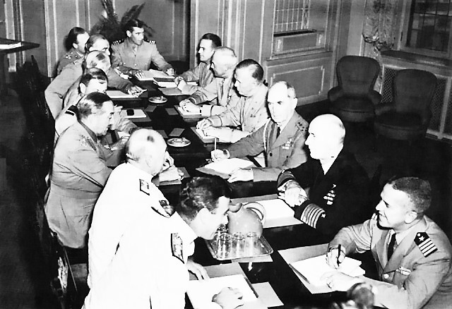

Combined Chiefs of Staff in Quebec, Canada – August 23, 1943. Seated around the table from left foreground: Vice Admiral Lord Louis Mountbatten (Burma & India), Sir Dudley Pound, Sir Alan Brooke, Air Marshall Sir Charles Portal (R.A.F.), Field Marshal Sir John Dill (British Army), Lt. General Sir Hastings L. Ismay (British Intelligence), Brigadier Harold Redman, Commander R.D. Coleridge, Brigadier General John R. Deane, General Henry (Hap) Arnold (U.S.A.A.F.), General George Marshall (Chief of Staff U.S. Army) , Admiral William D. Leahy, Admiral Ernest King (U.S. Navy), and Captain F.B. Royal.

# 1943 Avgas Suppliers & Users

The production of aviation gasoline was limited to five major regions – the East Coast, West Coast and Gulf (of Mexico) area of the United States, Caribbean and Middle East.

The number of refineries with avgas production plants was some 11 in the East Coast, about 12 in the West Coast, and some 20 in the Gulf area. In the Caribbean there was the Shell refinery at Trinidad, the Shell and Standard Refineries at Curaçao and Aruba. In the Middle East there was the Persian-Anglo Abadan Refinery and Caltex Bahrain Refinery in late 1943. There were smaller sources of supply such as Heysham and Billingham in the U.K. but these were not included in the bigger picture, primarily due to the relatively small output and localized demand.

The following memo in January 1943 describes the sources of supply for each of the operational theatres and the alternate source of supply together with the lead time required to get the precious aviation fuel to that area, and the alternate source.

Memo 14th. Jan 1943

To Combined Chiefs of Staff Washington from Secretary, Combined Staff Planners Major General J.H. Burns, USA Executive MAC. References (a) MWB (AIR) 34/1 (b) JCS 174/1 (c) CCS 141, Revisions approved by Aviation Petroleum Products Allocation Committee of the Munitions Assignment Committee (AIR).

Photo 5. Major General James Henry Burns (left) in discussion with staffer Colonel John B. Franks (right).

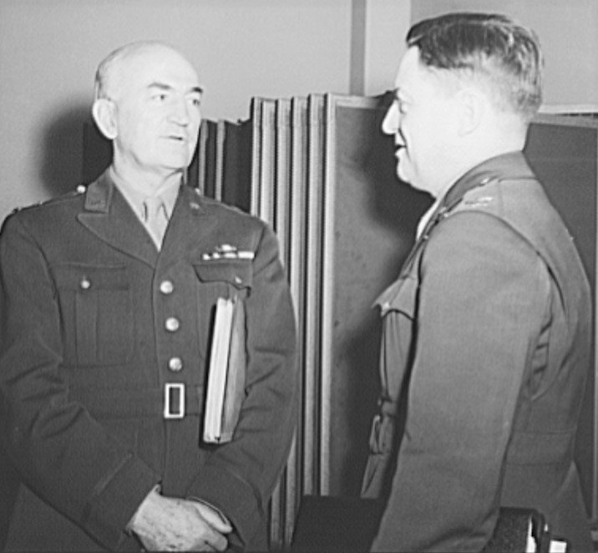Table 1. Sources of Allied Aviation Gasoline supply January 1943

|  |  |  |  |  |  |
| --- | --- | --- | --- | --- | --- |
| Area | Source Place | Voyage days | 2nd Source Place | Days | Comment |
| India | Abadan | 10 | Caribbean | 74 | Cannot meet all demands |
|  | | California | 76 |  |
| Gulf & East Coast | 82 | Meet balance |
| West Africa | Caribbean |  | Gulf |  |  |
| North Africa | Caribbean |  | Gulf | 35 | +21 days for arranging supplies and tanker nomination |
| USA | USA | 0 | USA |  | Used for training & testing. Can meet all demands |
| Canada | USA | 7 | USA |  | Used for training & testing. Can meet all demands |
| Caribbean | Caribbean | 10 | Caribbean |  | Used for vital patrols. Can meet all demands |
| South America | Caribbean | 21 | Caribbean |  | Used for vital patrols. Can meet all demands |
| Alaska | US West Coast | 21 | US West Coast |  | Used for vital active operations. Can meet all demands |
| Central Pacific | US West Coast | 21 | US West Coast |  | Used for vital active operations plus patrols. Can meet demands if given priority |
| South Pacific | US West Coast | 30 | US West Coast |  | Used for vital active operations plus patrols. Can meet demands if given priority |
| South West Pacific | US West Coast | 30-40 | US Gulf & West Coast |  | Used for vital active operations plus patrols. Can meet demands if given priority |

Representative of U.S. Army & U.S. Navy and R.A.F. participated in formation of document.

Replenishment of Supplies

While the production of aviation gasoline primarily in the U.S. was continuing at an ever-increasing pace, it was essential that the aviation gasoline got to the theatres of war where it was most needed. Part of that process was to determine how long it took from production of finished, on-specification aviation gasoline (whatever grade) to reach its final destination on the war zones.

By the end of 1943, at the 97th Meeting MAB on 22 Dec 1943, the following replacement times were used on the calculation of reserves of aviation fuel in operational theatres.

Table 2. Replacement times for Aviation Gasolines December 1943

|  |  |  |  |  |  |  |
| --- | --- | --- | --- | --- | --- | --- |
| Theatre | Lifting | Total Available in refinery in days | Time en route to Pool (days) | Max time in Pool (days) | Voyage Time (days) | Max. Replacement (days) |
| UK | Ex East Coast US Refineries | 30 | - | - | 18 | 48 |
| UK | Ex East Coast Pool | 35 | 8 | 12 | 18 | 73 |
| North Africa | Ex East Coast Pool | 35 | 8 | 10 | 30 | 83 |
| Middle East | Ex East Coast Pool | 30 | 8 | 10 | 40 | 88 |
| West Africa | Ex East Coast Pool | 30 | 8 | 10 | 40 | 88 |
| India/Ceylon | Ex West Coast Refineries | 30 | - | - | 62 | 92 |
| Australia | Ex West Coast Refineries | 35 | - | - | 26 | 61 |
| Pacific Area | Ex West Coast Refineries | 35 | - | - | 26 | 61 |

The above table indicates the primary source of aviation gasoline for the various operational theatres, essentially the European theatres (including Middle East and Africa) were supplied from the east coast of the U.S., while the Pacific region was supplied from the west coast. The shipping times were much the same throughout the year of 1943, despite increased tanker ship construction, for this was the time of the successful German U-boat ‘Wolf pack’ attacks on the Allied shipping route across the Atlantic Ocean and tankers were a prime target. This would be known as the “Battle of the Atlantic”.

In January 1943 the position was becoming critical both from supply and tanker availability position, hence the memo from the Oil & Tanker Mission from Mr. Eden (later Sir Anthony Eden - British Prime Minister) to Viscount Halifax Jan 16, 1943.

Table 3. Gasoline supplies for Overseas Distributors January 1943 from British controlled ’Sterling’ sources (assumed thousand barrels)

|  |  |  |  |
| --- | --- | --- | --- |
| Sources of Supply for O/S Distributors | Aviation Spirit 100 | Other Aviation Spirit | Motor Gasolines |
| Haifa | - | - | 696 |
| Tripoli | - | - | 30 |
| Suez | - | - | 191 |
| India | - | 28 | 82 |
| Abadan/Bahrein | 439 | 100 | 1,896 |
| Iraq & Persia | - | - | 108 |
| NWI/Trinidad/Gulf | 599 | 131 | - |
| NWI Trinidad | - | - | 140 |
| California/Talara | - | - | 778 |

NWI = Netherlands West Indies

It can be seen from this table that only Abadan Refinery (and to some extent Bahrein) were the only avgas suppliers in the Middle East, while other refineries in this region were sources of motor spirit.

In an earlier memo from India Office to Viscount Halifax - April 12, 1942, the situation with avgas production in India was noted - India Digboi (refinery) was beginning to produce Aviation Spirit base, which could be blended up to 90 Octane. 810,000 Imp Gallons/monthly. (This was in the period before the British had high performance aircraft in the East (such as Spitfires which required Avgas 100/130). This refinery would be a very small producer of 90 Octane aviation fuel for the remainder of the war.

Air War Efforts in 1943

In Europe, the American 8th Air Force had arrived in England and it was undertaking strategic bombing raids against the Third Reich at Schweinfurt and Regensburg; while Royal Air Force was attacking German V-weapons experimental centre at Peenemunde. In the Mediterranean, Aug. 17 1943 - American and British forces converged at Messina, Sicily supported by U.S. Air Force units from North Africa.

Oct. 14, 1943 - United States Eighth Air Force raids Schweinfurt ball-bearing plants.

Dec. 24, 1943 - United States Eighth Air Force makes major effort against German secret weapon sites.

This increase in Allied air raids on the Axis would obviously require an increase in aviation fuel requirements.

# 1944 Avgas Suppliers & Users

Even though the war in the Pacific was slowly turning in the Allies favour, the directive driven by Churchill of “defeat the Axis in Europe first, then defeat Japan” always determined that avgas supplies would be directed eastward across the Atlantic. This was evident in the January 1944 meeting where it was determined that “All production ex US Gulf and East Coast refineries after providing for essential requirements of North Africa, U.S. (Domestic), will be allocated to UK.”

Further Roosevelt and Churchill were always under pressure from Stalin to open a second front in Europe against Nazi Germany.

# Preparations for D-Day

The requirements for petroleum products to support the invasion of Europe on the western front would be massive. The primary products would be fuel oil and diesel for the naval craft required for the landing, petrol for the armies for vehicles and tanks, and aviation gasoline for the air support required for such a feat. With America as the mains avgas supplier these stores would need to be in the UK prior to the onslaught into Europe, therefore the planning, production and shipment needed to be done well before the proposed landings in June 1944. This required estimations of current usage, increased production, and faster turnaround of tankers to deliver the avgas to the UK.

In May 1944 the consumption in Europe theatre was 4,050,000 Bbls (450,000 Tons), trans-Atlantic convoys took about 15 days to deliver their valuable cargo. Even 15 days across the Atlantic was a dangerous journey with the prowling German U-boat Wolf packs. There was however a decrease in the German U-Boat threat to trans-Atlantic convoys with introduction of long-range air patrols from both sides of the Atlantic together with better radar detection. Long range aircraft such as the Consolidated B-24 Liberator (operated by the U.S. Navy as PB4Y-1 Patrol Bomber), Boeing B-17 Flying Fortress and Catalina PBY operating from Newfoundland and Iceland, and R.A.F. Short Sunderland aircraft operating from the south west of England which closed the air patrol gap in the trans-Atlantic convoy route. The Liberators were to sink 72 U-boats, Sunderlands accounted for 26 U-boats, the Consolidated Catalinas would claim 38 U-boats, and the Lockheed Hudsons scored 26 victories against this menace to Allied shipping.

Photo 6. Boeing B-17 Flying Fortress and Consolidated B-24 Liberator

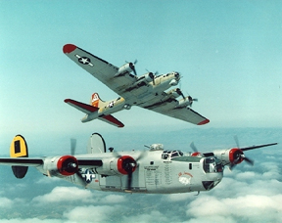

Photo 7. Short Sunderland on anti-sub patrol

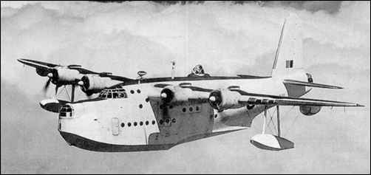

In a memo to the Combined Chiefs of Staff at the meeting of the Munitions Assignment Board Washington 24 May 1944.[5]

*Subject: Assignment Grade 100/130 Aviation Fuel in June 1944*

*It was agreed that the Total request for the month of June for all theatres to be supplied by assignments made in Washington were 15,654,000 Bbls. Total available supplies 11,670,000 Bbls.*

*British Position: All users in UK of 100/130 for the first quarter 1944 showed that estimates were exceeded by 18.3%. Average weekly consumption for 3 weeks ending May 11 was 938,000 Bbls.*

*Over 4 weeks 21st April – May 18 consumption averaged 850,000 Bbls/week.*

*June 1944 Consumption U.K. & Iceland was 4,553,000 Bbls.*

This was a period of high activity with the R.A.F. and U.S. 8th Air Force increasing their bombing raids as a prelude to the Normandy landings planned for June 1944.

March 30 1944 - Royal Air Force bombing raid on Nurnberg suffers extremely heavy losses.

May 9 - United States Eighth Air Force begins attacks on German airfields in northern France.

May 12 - United States Eighth Air Force attacks oil plants in central Germany.

May 21 - Allied fighter aircraft begin operations against enemy railroads in France and Germany.

Avgas for D-Day June 6, 1944

On June 6, 1944 the Allies launched their invasion of Europe with five beach landings on the Normandy coastline. By this stage the Allied air forces almost dominated the German Luftwaffe, and the Allies commanded the skies above the invasion forces. This was a result of the United States Strategic Air Forces Europe (USSTAFE) under General Carl (‘Toohey’) A. Spaatz. Until a foothold could be established in France and airfields captured from the Germans, all Allied aircraft would still be based and fuelled in England. This increased air operations would require more avgas. The Combined Chiefs of Staff memo 456/6 indicates the extent of the supply position immediately after the D-Day landings and how the avgas supply would be maintained now that the ‘second front’ in Europe had commenced. But even with these stocks the supply position would still be short.

*Memo Ref. CCS 456/6 7th. June 1944 Assignment of Grade 100/130 Aviation Fuel June 1944*

*2. (ii) Distribution in UK is from four principal marine terminals through pipeline to tankage in the vicinity and from indigenous production; then by pipeline or rail car or tank wagon, or coasters to dispersed tankage at places determined by strategic and security considerations, but generally near groups of airfields in the eastern and southern counties, then pipeline, rail car, or tank wagon to airfield tankage. [Marine Terminals were Thames Haven, Stanlow, Avonmouth, Southampton]*

*(ii) The airfields exceed 675 in number and the daily operation load at each varies in relation to the war situation and effort maintained by the air forces.*

*The off-take at airfields is irregular. The average holding at bomber airfields does not exceed 2-3 days consumption at present rates.*

*Minimum amounts of aviation fuel in the distribution system should be maintained as follows:*

*(a) Marine Terminals 3,150,000 Bbls. (equal to less than 1 months feed to system)*

*(b) At Depots near airfields 1,350,000 Bbls.*

*(c) In transit & pipeline 1,800,000 Bbls*.

*(d) At 23 System outlying storages having a regular local demand 2,250,000 Bbls.*

*(e) Packed stock 900,000 Bbls.*

*Total 9,450,000 Bbls (1,503 M Litres)*

1944 Avgas shortage in U.K. – Divert cargoes.

With allocation of supply of aviation fuel determined by a central organisation it was possible to divert cargoes and assign the fuel to the theatre of most need. While much preparation has gone into D-Day supply planning, the vagaries of war required that the supply chain be flexible and responsive to immediate demands. The following is but one example:

*ELFUXL 835 Washington June 13, 1944 To Ministry of Fuel & Power*

*From British Petroleum Representatives (G. C. Dear) In order to increase availability of 100/130 (fuel) in UK.*

*“In addition, we hope to secure a further cargo of 135,000 Bbls ex New York pool and also divert to UK 72,000 Bbls at present allocated to Australia ex Aruba” for convoy CU-30. (Convoy cycle to UK is now 8 days).*

1944 Reduce Octane to Increase Supply

One of the ways to increase supply was to lower the octane requirement, but there were operational limits to how far this could be taken. The British requirement for a minimum rich knock rating of 130 PN for their liquid cooled in-line engines could not be relaxed, however the minimum lean knock rating of 100 MON could be eased, if this meant increased production to cover the expected shortfall in the U.K.

*Memo to M.A.B. from C.C.S Washington 29th July 1944 Subject: Assignment of grade 100/130 Octane to UK*

*Ref: (a) CCS 456/7, 456/8, 456/9*

*(b) CCS 168th Meeting Item 4 (due to projected Avgas 100 shortages)*

*“Agreed to require the maximum use of grade 99/130 fuel as a substitute for 100/130 fuel for all combat planes in the UK and Mediterranean areas, except for carrier aircraft.”*

As the war progressed and the Allies (predominantly U.S. forces) advanced further westward across the Pacific, and increased activity was occurring in Europe and Mediterranean, the demand for aviation fuel was increasing.

Aviation Fuel Consumption in July 1944

UK 4,800,000 Bbls

US 8,000,000 Bbls (of which non-operational 3,500,000 Bbls was Avgas 100)

The British controlled production of 100 Octane at Abadan and this was supplied to C.B.I. theatre (China, Burma, India) – this was a ‘Sterling’ refinery.

Other Plans to meet Avgas Shortage

Other efforts were made to increase production and supply by the use of blending agents such as Xylidene and lower octane aviation fuels for training and certain operational requirements. The important point in this memo is the acceptance by R.A.F. of Xylidene blended aviation gasoline during this emergency supply situation.

*Memo by U.S. Chiefs of Staff 27th July 1944 Ref CCS 456/9*

*The U.S. Chiefs of Staff are making every effort to alleviate the extremely critical shortage of high-octane aviation fuel by substitution US 91/96 and Xylidene blends for higher octane fuels. Air Chief Marshal Portal (UK) has indicated willingness to accept Xylidene fuels during this emergency.*

*Maximum use of 99/130 fuel as substitute for 100/130 for old combat planes in UK and Mediterranean areas except carrier aircraft. 99/130 is being used for training in combat planes in US.*

*Normally fast convoys containing 1,000,000 Bbls of 100 Octane (fuel) arrive every 8 days in UK. Distribution centre was Thames Haven. UK August 1944 local production of 100/130 is estimated to be 387,000 Bbls.*

While the prospect of more avgas through the use of Xylidene blending agents was appealing there were limitations which were detailed in the Sept 1, 1944 memo. [The subject of Xylidene is discussed in detail in Chapter 38 Blending Agents]

Photo 8. Air Chief Marshal Sir Edward Portal

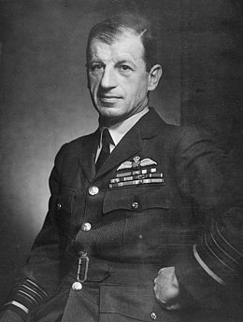

*Sept 1, 1944 Ref: CCS 465/13 Subject: Use of 99/130 Octane Fuel*

*Availability of Xylidine is such that the quantity of 99/130 that can be produced is sufficient for distribution and maintenance of supply in only one general area (limited supply).*

*Distribution System cannot handle an additive type of fuel. Not suitable for carrier-based planes, therefore 99/130 not recommended for Pacific Area.*

# Allies Advance into Europe from the west

With the Allied Normandy landings achieved in June 1944; the Allies started their long arduous journey to the heart of the Axis – Berlin. The demands for all petroleum fuels would be greater particularly since there were now new Allied armies on land in Europe, and their thirst for gasoline for tanks and vehicles would be great. The air cover required to support the advancing army would also increase the demand on aviation gasoline; and the strategic bombing campaigns which had started in 1943 would continue, however by now new long-range fighters with auxiliary tanks (drop tanks) would accompany the bombers.

Photo 9. P-51 Mustangs equipped with drop tanks on a mission over Europe August 1944 375th Fighter Squadron, 361st Fighter Group, USAAF 8th Air Force.

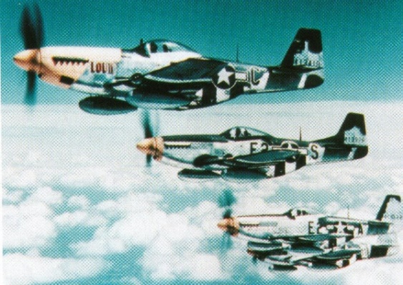

The bold black and white stripes on the fuselage and wings were used on all Allied aircraft after June 1944 to indicate to Allied ground forces in Europe that these were ‘friendly’ aircraft. The addition of the drop tanks extended the range of the P-51D Mustang to 2080 miles (3347 km), more than adequate to escort their charges into the heartland of the German Third Reich and back.

October 1944 Position

The position in October 1944 was still one of short supply. The forward estimates for Avgas 100/130 showed that the major theatres were still Europe with the U.K. the major consumer. So, it was essential that the avgas supply position was clearly understood by all parties involved. Since the major supplier would be from the U.S., it was important to have information on the estimated consumption of Avgas 100/130 which was the grade used for combat aircraft. This was supplied primarily from the U.S.

Table 4. October 1944 Grade 100/130 Estimated Consumption Thousands of Barrels

|  |  |  |  |
| --- | --- | --- | --- |
| Theatre | Est. Consumption | Source ex USA | Other* |
| UK | 4,122 | 8,501 | 1,353 |
| West Mediterranean | 1,740 | 3,759 |  |
| Central Pacific | 1,100 | 2,444 |  |
| India China | 949 | 3,130 | 1,375 |
| South West Pacific II | 665 | 1,283 |  |
| Middle East I | 259 | 519 | 72 |
| South West Pacific I | 157 | 309 | 129 |
| Middle East II | 78 |  | 156 |
| Ceylon | 42 | 40 | 71 |
| Iceland | 40 |  | 138 |
| South Pacific | 19 |  |  |
| Middle East III | 10 |  | 41 |

* The other sources were the refineries in the Caribbean and the Middle East refineries of Abadan and Bahrain, and the avgas production from Heysham and Billingham facilities.

The grade of aviation gasoline supplied was predominantly Avgas 100/130.

Table 5. October 1944 Aviation Gasoline Supply Thousands of Barrels

|  |  |  |  |  |
| --- | --- | --- | --- | --- |
| Grade | U.S. Sources | *U.S. Sources* | Other Sources | *Other Sources* |
| Avgas 100/130 | 28,226 | *86.9%* | 4,238 | *13.1%* |
| Avgas 91/96 | 2,036 | *77.8%* | 582 | *22.2%* |
| Avgas 91/96 South West Pacific I | 147 | *71.0%* | 60 | *29.0%* |
| Avgas 87 | 1,913 | *59.6%* | 1,295 | *40.4%* |
| Avgas 87 South Pacific | 20 | *100.0%* | - | *0.0%* |
| **Total** | **32,342** | ***84.0%*** | **6,175** | ***16.0%*** |

Further analysis of the above data reveals that in October 1944: Nearly 87% of Avgas 100/130 came from the U.S. This was because in the United States was where nearly all the catalytic cracking, alkylation and co-dimer plants were located.

* Nearly 78% of the Avgas 91/96 came from the U.S. – again because this was where the catalytic cracking units were located.
* For the South West Pacific Islands 71% of the Avgas 91/96 came from the U.S. but the Middle East refineries could contribute to the supply.
* For Avgas 87, the refineries outside the U.S. contributed just over 40%; this was because the lower grade did not require the ‘modern’ process units of alkylation. Refineries such as Digboi in India could contribute to the avgas supply of lower octane grades. However, all the Avgas 87 for the South Pacific region came from the U.S. mostly from the west coast refineries.
* Overall, the U.S. supplied 84% of all the Avgas fuel and was thus the major source of fuel for the Allies to achieve of the skies.

Avgas Allocation November 1944

Generally, the war in Europe against the Axis was progressing well; the Allies armies (U.S., British and Canadian together with the Free French and Poles) had made great progress. After the D-Day landings Paris was liberated, Holland was free, Italy was now on the side of the Allies, North Africa was now in Allied hand, and Russia was pressing hard against the Axis.

As indicated earlier, the centralization of the production and supply of aviation gasoline had led to efficiencies in the provision of this valuable war materiel. However, in order to carry out this work required forward estimates of consumption so that production and supply could be matched with demand. This is illustrated in the table below which shows the extent of the operation – essentially covering all continents of the world. There was no estimated consumption from Russia, however there was, as always, the request for a considerable supply.

Munitions Assignment Committee (MAC)MAC (AIR) to MAB Case 5055 28th October 1944. For November 1944 Estimated Consumption Thousands of Barrels

Table 6. Aviation Gasoline estimated consumption by theatre – November 1944

|  |  |  |  |  |  |  |
| --- | --- | --- | --- | --- | --- | --- |
| Theatre | Estimated Consumption 000’s Bbls | | | Request | | |
| Grade 100/130 | 91/96 | 87 | 100/130 | 91/96 | 80/87 |
| U.S. Army (Air Force) | 4,830 | 944 | 703 |  |  |  |
| UK | 3,983 | - | 495 |  |  |  |
| Mediterranean | 1,693 | - | - |  |  |  |
| U.S. Navy | 1,130 | 289 | 240 |  |  |  |
| Central Pacific | 1,100 |  |  |  |  |  |
| Asiatic - India China | 1,078 | 51 | 27 |  |  |  |
| South-West Pacific | 887 | 69 |  |  |  |  |
| Testing & Flyaway | 485 | 450 | 15 |  |  |  |
| Middle East Group I | 245 | 29 | 6 |  |  |  |
| Canada (Incl. Newfoundland, Labrador) | 191 | 43 | 240 |  |  |  |
| Caribbean | 179 | 31 | 6 |  |  |  |
| Brazil & Ascension | 100 | 40 | 10 |  |  |  |
| Alaska | 70 | 3 |  |  |  |  |
| Middle East Group II | 57 | 3 | - |  |  |  |
| West Africa & Dakar | 54 | 8 | - |  |  |  |
| Ceylon | 43 | 5 | - |  |  |  |
| North Atlantic | 43 |  |  |  |  |  |
| Iceland | 30 | - | - |  |  |  |
| Bahamas | 20 |  |  |  |  |  |
| South Pacific | 19 | - | 12 |  |  |  |
| South Africa | 14 | - | 62 |  |  |  |
| East Africa | 10 | 2 | - |  |  |  |
| Spain | No Data |  |  |  |  | 2 |
| Russian | No Data | - | - | 796 |  |  |
| Bolivia | No Data | - |  |  |  |  |
| Total | 16,261 | 1,967 | 1,816 |  |  |  |

Equally important was the amount of available stock, and one way of assessing the situation was to establish a minimum stock position and determine the current stock position against that minimum.

As at 16th Nov 1944 the 100/130 Aviation Fuel Grade stock position expressed as % of theatre level was as follows:

Table 7. Avgas 100/130 stock position November 1944

|  |  |  |  |
| --- | --- | --- | --- |
| Theatre | Stock 000’s Bbls | Minimum Stock 000’s Bbls | % of minimum level |
| UK-Iceland | 9,654 | 9,550 | 101 |
| Central Pacific | 3,035 | 6,000 | 50.6 |
| Western Mediterranean | 2,727 | 4,887 | 55.8 |
| China-Burma-India | 1,767 | 2,014 | 87 |
| South-West Pacific | 1,478 | 3.223 | 45.8 |

Again, the situation in Europe continued to be tight for the avgas supply.

# Avgas Supplies by Air – ‘Flying The Hump’

One area of supply (Area ‘D’) was China, Burma and India. While the supplies to Burma and India were hazardous in the long flight from the Middle East, the most dangerous part was known as ‘Flying the Hump’– essentially flying the avgas supplies over the Himalayan mountain range at the Tibetan- China border – which is one of the highest mountain ranges in the world, and includes Mount Everest.

Airborne Assault and Air Transport

The Anglo-American organization of airlift forces placed central control of most such units under a troop carrier headquarters, which could employ the transport planes either for airlift or for air assault operations. Allied airborne assaults accompanied invasions in North Africa in November 1942, in Sicily in July 1943, in Normandy in June 1944, in southern France in August 1944, in the Netherlands in September 1944, and across the Rhine River in March 1945.

When not employed in air assault operations, British and American troop carrier forces in all theatres hauled high priority supplies to forward airfields and evacuated sick and wounded men to rear-area hospitals on their return trips. In each Anglo-American theatre of war, the allocation of cargo space was managed by some form of central air transport control agency, which set priorities in terms of the immediate requirements of the theatre commander's mission. Global air transport developments were almost entirely American. The Army's Air Transport Command reached from the United States into every combat theatre with scheduled flights, while the Naval Air Transport Service centred its operations in the Pacific.

Flying the “hump” route across the Himalayas, the Air Transport Command's India-China Division delivered critically needed supplies to otherwise inaccessible China. On return trips to the United States both Army and Navy air transport planes brought sick and wounded men to hospitals near their homes. Air Transport Command crews also ferried replacement aircraft to combat air forces in various theatres.

Photo 10. Curtiss Commando C-46 ‘Flying the Hump’’

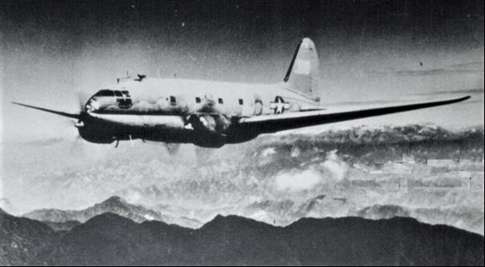

Photo 11. Inside Curtiss Commando C-46 loaded with aviation on its way over the Hump to China (1943)

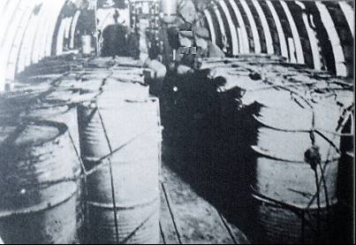

Drums of 100 Octane Avgas. C-46 on route over the hump to supply the 14th Air Force in China.

Photo 12. USAAF Curtiss Commando C-46 refuels in India before setting off the perilous mission over the ‘Hump’ circa 1943

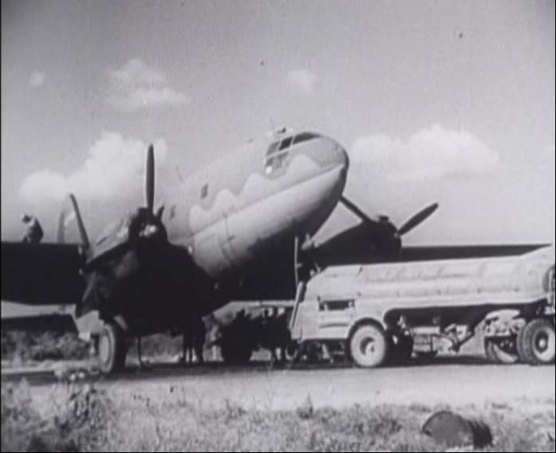

Photo 13. Unloading Avgas from cargo aircraft after flying the Hump, China 1943

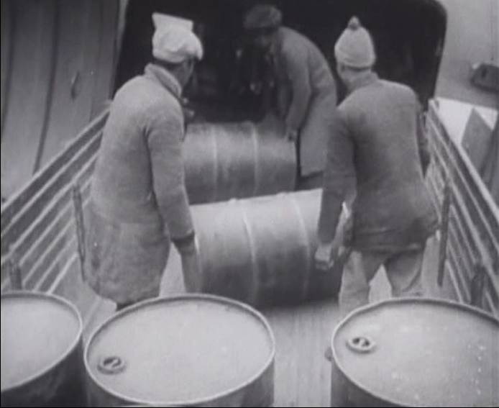

Operations in 1943 - Lt. Gen. (later Gen.) Joseph W. Stilwell was working feverishly to organize Chinese divisions and train them into effective fighting units. An air transport system had been put into operation over the 500 miles of the Himalayan “hump” to move supplies into China, and construction had begun on a new road to replace the portion of the Burma Road lost to the Japanese forces. In 1944, the first of the B-29 Superfortress Bombers were being sent to air force bases in China in order to strike at the Japanese homeland islands.

# Avgas Supplies by Sea[6]

The U.S. Navy developed a supply operation for delivering petroleum products to the fighting forces overseas in the Pacific, North African and the European theatres. For gasoline they had a designated fleet of gasoline tankers. These would be the lifeblood of the fighting forces in Europe and the Pacific theatres.

Tankers Built in U.S. During World War II**[7]**

The T1 types were named after major oil fields in the United States. The T2 types were named after monuments, national parks, forts, battles, historic settlements, trails, lakes, swamps. Later T3 type were built for private companies and named by the company. Many tankers were built for, or taken over by the U.S. Navy and named after Native American names of rivers and lakes. The Navy AO designation indicates Fleet Oilers.

Tankers were developed around the turn of the century to carry liquid cargo: gasoline, oil, or molasses. During World War II, American tankers made 6,500 voyages to carry 65 million tons of oil and gasoline from the U.S. and the Caribbean to the war zones, and to the Allies. They supplied 80% of the fuel used by bombers, tanks, jeeps and ships during the War.

T2-SE-A1 was the workhorse of the tanker fleet (481 built):

* 523 feet long overall
* 68 foot beam
* 30 foot draft
* 10,448 Gross tons
* 21,880 Loaded displacement tons
* 6,000 shaft horsepower Turbo-Electric propulsion
* Speed 14.5-16 knots
* Liquid capacity 141,200 barrels (42 gallons or 162 litres per barrel). [nearly 6 million gallons]

T3-S2-A1 (All became Fleet Oilers and several were converted to Escort Carriers CVE):

* 553 feet long overall
* 75 foot beam
* 32 foot draft
* 11,335 Gross tons
* 24,830 Loaded displacement tons
* 4 Steam turbines geared to twin shafts
* 13,500 shaft horsepower
* Speed 18 knots
* Capacity: 146,000 barrels

T3-S-A1

* 501 feet long overall
* 68 foot beam
* 29.6 foot draft
* 9,880 Gross tons
* 2 Steam turbines single-screw
* 7,700 shaft horsepower
* Speed 15 knots
* Capacity: 133,800 barrels

T3-M-AZ1 One Motor tanker, Brandywine, was built

* 547 feet long overall
* 70 foot beam
* 11,401 Gross tons
* 5 cylinder single-acting two-cycle oil engine
* 7,500 horsepower
* Speed 15.5 knots

A typical tanker crew included 42 to 45 mariners and 17 Navy Armed Guard. The same ship as a Navy Fleet Oiler carried a crew of 250 to 325.

In 1943, desperate for cargo capacity, "skeleton decks" about 7 or 8 feet (2.1-2.4 m) above the deck were used to carry planes and PT (Patrol Torpedo) boats to war zones. The planes were lashed to many tankers.

Photo 14. Partially built Republic P-47 Thunderbolt aircraft lashed to the deck of a tanker

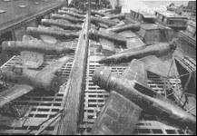

Immediately after Pearl Harbour, when the U.S. declared war on Germany and Japan, the German U-Boats arrived on the Atlantic seaboard. They concentrated on the tanker fleets, knowing how essential fuel was to the war effort. Americans faced rationing of gasoline for their cars and heating oil for their homes, to spare fuel for the war. However, for Great Britain and the war effort, this threat was perilous.

The following is an outline of the U.S. Navy’s involvement in gasoline tanker usage in WWII.

U.S. Navy 1942-1945List of Gasoline tankers used by the U.S. Navy in WWII.

Oilers & Gasoline Tankers

‘Oilers’ were designated AO and the ships were named after American rivers with Indian names. Gasoline Tankers were designated AOG, and again these ships were named after American rivers with Indian names. These ships would transport gasoline to land bases, and aviation gasoline to land bases and aircraft carriers mostly in the Pacific.

Photo 15. AO-41 “USS Mattaponi” – 135, 000 Bbls Tanker

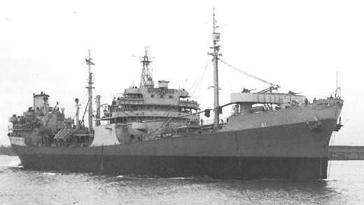

**Mattaponi Class Fleet Oiler:**

Displacement: 21,750 tons

Length: 520' Beam: 68' Draft: 30'6"

Speed: 17 knots (max); 10.5 knots (econ)

Armament: One 5"/38 DP, four 3"/50 DP guns; four twin 40 mm, four twin 20 mm cannons

Complement: 242

Capacity: 135,000 barrels (21,465 K Litres)

Geared turbine engines, single screw, 12,800 hp

Maritime Commission T2-A (MC-K) type

Built at Sun Shipbuilding & Drydock Co, and commissioned 11 May 1942.

Ex- ‘SS Kalkay”

Notes:

Displacement is given as fully loaded

Length is given as total length

Draft is given as fully loaded

Speed is given both as (max): when keeping up with Task Forces and as (econ): the economical speed giving the maximum cruising range.

Complement of officers and enlisted. This is considerably in excess of the crew numbers for a commercial tanker of similar size: the extra crew is needed on a naval vessel to handle at-sea refuelling, battle stations, damage control, communications, etc.

Capacity in barrels. In addition to bunker fuel for ships, the Fleet Oilers carried gasoline for ships' boats, aviation fuel, lubricants, and other POL (Petrol, Oil & Lubes) products. As the war progressed, the Oilers increasingly carried additional dry cargo and stores, reducing the need for ships to make multiple rendezvous for underway replenishment.

AOG Gasoline Tankers

These ships were armed with guns and cannons and speed typically less than 10 knots. Some were purpose built; others were converted from coastal tankers, however regardless of their origin or size, they provided a valuable avgas supply line to air forces gasoline depots.

**Patapsco Class:**

Displacement: 4,130 tons

Length: 311' Beam: 49' Draft: 14'6"

Speed: 15.5 knots (max); 8.8 knots (econ)

Armament: Four 3"/50 DP guns; Twelve 20 mm cannon

Complement: 124

Capacity: Cargo DWT 2,120 (approx. 17,820 barrels) (2,834 K. Litres)

Diesel electric engines, twin screws, 3,300 hp

Table 8. List of Patapsco Class Gasoline Tankers

|  |  |  |  |  |
| --- | --- | --- | --- | --- |
| No. | Name | Commissioned | Disp. | Notes (Lost) |
| AOG- 1 | Patapsco | 4 Feb 1943 | 1,841 | Built at Seattle-Tacoma |
| AOG- 2 | Kern | 1943 | 1,842 |  |
| AOG- 3 | Rio Grande | 1943 | 1,841 |  |
| AOG- 4 | Wabash | 1943 | 1,842 |  |
| AOG- 5 | Susquehanna | 1943 | 1,842 |  |
| AOG- 6 | Agawam | 1943 | 1,783 |  |
| AOG 7 | Elkhorn | 1944 | 1,783 |  |
| AOG- 8 | Genesee | 1944 | 1,783 |  |
| AOG -9 | Kishwaukee | 1944 | 1,783 |  |
| AOG-10 | Nemasket | 1944 | 1,783 |  |
| AOG-11 | Tombigbee | 1944 | 1,783 |  |
| AOG-48 | Chehalis | 1944 | 1,764 |  |
| AOG-49 | Chestatee | 1944 | 1,842 |  |
| AOG-49 | Chewaucan | 1944 | 1,842 |  |
| AOG-51 | Maquoketa | 1945 | 1,842 |  |
| AOG-52 | Mattabesset | 1945 | 1,842 |  |
| AOG-53 | Namakagon | 1945 | 1,764 |  |
| AOG-54 | Natchaug | 1945 | 1,764 |  |
| AOG-55 | Nespelen | 1945 | 1,764 |  |
| AOG-56 | Noxubee | 1945 | 1,764 |  |

Photo 16. AOG-1 “USS Patapsco” – 17, 800 Bbls Gasoline Tanker

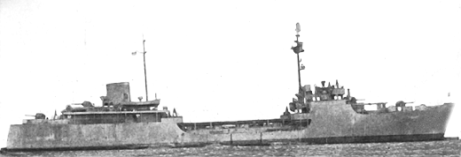

Photo 17. AOG-8 “USS Genesee”[8]

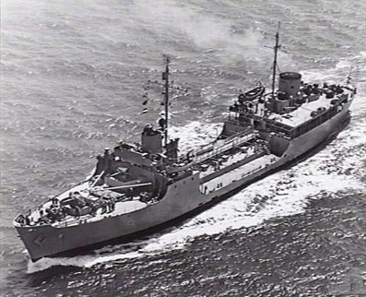

Photo 18. AOG-5 “USS Susquehanna”[9]

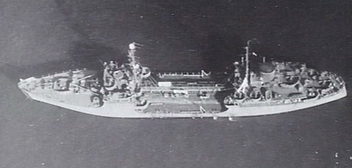

**Halawa Class:**

Displacement: 2,000-7,000 tons (full load)

Length: 200'-300' Beam: 40-50' Draft: 13'-20'

Speed: 8-10 knots

Armament: One 3"/50 DP gun; two-four 20 mm cannons

Complement: ~100

Capacity: 12,000-40,000 barrels (1,908-6,360 K Litres)

Converted from small coastal tankers.

Table 9. List of Halawa Class Gasoline Tankers

|  |  |  |  |  |
| --- | --- | --- | --- | --- |
| No. | Name | Commissioned | Disp. | Notes (Lost) |
| AOG-12 | Halawa | 1942 | 1,155 |  |
| AOG-13 | Kaloli | 1942 | 1,155 |  |
| AOG-14 | Aroostook | 1943  1945 | 1,007 | Built as Newport Shipyards as tank barge *‘Esso Delivery No. 11’* Lend-Lease to France as *‘Lac Pavin’* |
| AOG-15 | Conasauga | 1943 | 3,100 | Lend-Lease to France |
| AOG-16 | Guyandot | 1943 | 800 | Lend-Lease to France |

**Klickitat Class:**

Displacement: 5,940 tons (full load)

Length: 325' Beam: 48' Draft: 19'

Speed: 11 knots (max); 10 knots (econ)

Armament: One 3"/50 DP gun; two 40 mm; eight 20 mm cannon

Complement: 80

Capacity:

Diesel engines, single screw, 1,400 hp

Maritime Commission T1-M-BT1 type

Table 10. List of Klickitat Class Gasoline Tankers

|  |  |  |  |  |
| --- | --- | --- | --- | --- |
| No. | Name | Commissioned. | Disp. | Notes (Lost) |
| AOG-64 | Klickitat | 1945 | 1,988 |  |
| AOG-65 | Michigamme | 1945 | 1,988 |  |
| AOG-66 | Nanticoke | 1945 | 1,988 |  |
| AOG-67 | Nordaway | 1945 | 1,988 |  |
| AOG-68 | Peconic | 1945 | 1,988 |  |
| AOG-69 | Petaluma | 1945 | 1,988 |  |
| AOG-70 | Piscataqua | 1945 | 1,988 |  |
| AOG-71 | Quinnebaug | 1945 | 1,988 |  |
| AOG-72 | Sebasticook | 1945 | 1,988 |  |
| AOG-73 | Kamahi | 1945 | 1,988 |  |
| AOG-74 | Tellico | 1945 | 1,988 |  |
| AOG-75 | Truckee | 1945 | 1,988 |  |

**Mettawee Class:**

Displacement: 2,280 tons (full load)

Length: 221' Beam: 37' Draft: 14'

Speed: 9.5 knots (max); 8.5 (econ)

Armament: One 3"/50 DP gun; two 40 mm; three 20 mm cannon

Complement: 58

Capacity: Cargo DWT 1,228

Diesel engines, single screw, 720 hp

Maritime Commission T1-M-A1 type

Table 11. List of Mettawee Class Gasoline Tankers

|  |  |  |  |  |
| --- | --- | --- | --- | --- |
| No. | Name | Commissioned. | Disp. | Notes (Lost) |
| AOG-17 | Mettawee | 1943 | 769 |  |
| AOG-18 | Pasquotank | 1943 | 769 |  |
| AOG-19 | Sakatonchee | 1944 | 769 |  |
| AOG-20 | Seekonk | 1944 | 769 |  |
| AOG-21 | Sequatchie | 1944 | 846 |  |
| AOG-22 | Wautauga | 1944 | 846 |  |
| AOG-23 | Ammonusuc | 1944 | 845 |  |
| AOG-24 | Sheepscot | 1944 | 846 |  |
| AOG-25 | Calamus | 1944 | 845 |  |
| AOG-26 | Chiwaukum | 1944 | 846 |  |
| AOG-27 | Escatawpa | 1944 | 846 |  |
| AOG-28 | Gualala | 1944 | 846 |  |
| AOG-29 | Hiwassee | 1944 | 846 |  |
| AOG-30 | Kalamazoo | 1944 | 846 |  |
| AOG-31 | Kanawha | 1944 | 846 |  |
| AOG-32 | Narraguagas | 1944 | 846 |  |
| AOG-33 | Ochlockonee | 1944 | 846 |  |
| AOG-34 | Oconee | 1945 | 846 |  |
| AOG-35 | Ogeechee | 1944 | 846 |  |
| AOG-36 | Ontonagon | 1944 | 846 |  |
| AOG-37 | Yahara | 1944 | 846 |  |
| AOG-38 | Ponchatoula | 1944 | 846 |  |
| AOG-39 | Quastinet | 1944 | 646 |  |
| AOG-40 | Sacandaga | 1944 | 846 |  |
| AOG-41 | Tetonkaha | 1944 | 846 |  |
| AOG-42 | Towaliga | 1944 | 846 |  |
| AOG-43 | Tularosa | 1945 | 846 |  |
| AOG-44 | Wakulla | 1945 | 846 |  |
| AOG-45 | Yacona | 1945 | 846 |  |
| AOG-46 | Waupaca | 1945 | 846 |  |
| AOG-60 | Manokin | 1944 | 850 |  |
| AOG-61 | Sakonnet | 1944 | 850 |  |
| AOG-62 | Conemaugh | 1945 | 850 |  |
| AOG-63 | Klaskanine | 1945 | 850 |  |

**Shikellamy Class**:

Displacement: 6,045 tons (full load)

Length: 523'6" Beam: 53' Draft: 25'

Speed: 11 knots (max); 9 knots (econ)

Armament: One 5"/38 DP gun, two twin 40 mm, four twin 20 mm cannon

Complement: 267

Capacity: 51,300 barrels (8,157 K Litres)

Turbo-electric engines, single screw, 8,000 hp

Maritime Commission T2-SE-A2 type

Table 12. List of Shikellamy Class Gasoline Tankers

|  |  |  |  |  |
| --- | --- | --- | --- | --- |
| No. | Name | Commissioned. | Disp. | Notes (Lost) |
| AOG-47 | Shikellamy | 1943 | 3,200 | Converted from Fleet Oiler AO-90 |

Photo 19. AOG-47 “USS Shikellamy”[10]

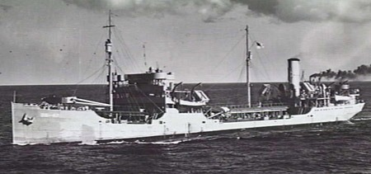

Alternate Service for Oilers

Not all oilers were in dedicated service carrying only one product. Many of the oilers carried mixed cargoes. A case in point is the USS Trinity and the USS Cimarron. The following is a memo from August 28, 1943 regarding the loading of aviation gasoline supplies ex Abadan Refinery, Bahrein.[11]

*Memo 28 August 1943 US Navy Department, Bureau of Supplies and Accounts, Washington DC USA*

*To Office of British Petroleum Representative (Washington DC)*

*100 Octane Aviation Gasoline delivered to US Navy for Abadan.*

*From Commander Service Force 7th. Fleet, the following quantities of 100 Octane Aviation Gasoline on the vessels named were landed by the US Navy in Australia.*

*Date Imp Gallons ex vessel*

*20 July 1942 216,052 USS Trinity*

*14 Nov 1942 229,990 USS Trinity*

*10 Feb 1943 233,699 USS Trinity*

*30 Apr 1943 230,878 USS Trinity*

*16 June 1943 251,488 USS Cimarron*

*This gasoline was lifted from stocks of the Anglo-Iranian Oil Company. The lifting point, however, was Bahrein as the products were moved in each instant from Abadan to permit loading with other cargoes. No payment was made to the Anglo-Iranian Oil Company at the time of shipment. It is not believed that any payment had been made by the US Navy since that time.*

*The gasoline was delivered to common stock in Australia where it was received as a local lend-lease transaction.*

*It is believed that the most preferable way to treat these shipments is to regard them as received by the US Navy under reverse lend-lease. Advice is requested as to whether this may be accomplished.*

*Respectfully W.B. Young Rear Admiral S.C. US Navy Paymaster General of the Navy*

The following is an excerpt from the war service of the ‘USS Trinity’, more information is listed by the U.S. Department of the Navy-Naval Historical Center, Washington[12]

USS Trinity (AO-13) 1920-1946

Trinity was named after a river in California. ‘USS Trinity’ (AO-13) had a displacement of 16,800 tons; length. 477 ft. 10 inches; beam 60 ft. draft 26 ft. 2 inches (mean); complement 107; armament two 5" gun. The ship was laid down on 10 November, 1919 at Newport News, Virginia, U.S.A. by the Newport News Shipbuilding and Drydock Co. and was launched on 3 July 1920; and commissioned on 4 September 1920, Commander Harry M. Bostwick, USNRF, in command.

Her service in WWII was extensive, but our interest is her voyages in 1942 and 1943 to the Persian Gulf.

On 14 December, 1941 USS Trinity now commenced her wartime operations with the hard-pressed Asiatic Fleet. After a one-month stay there fuelling Allied warships, she steamed first to Koepang Bay, Timor, and then to Kebola Bay, at Amor Island, in the Netherlands East Indies. Standing out of Kebola Bay on 17 January 1942, Trinity set course for Australia, escorted by destroyers Alden (DD-211) and Edsall (DD-219). Upon her arrival at Darwin, Trinity filled the depleted fuel bunkers of Holland (AS-3) and Otus (AS-20) the tenders to the Asiatic Fleet submarine forces operating in the Malay Barrier. When she had delivered this "liquid gold," orders came for ships Trinity, Otus, and Holland to accompany Black Hawk (AD-9) and four destroyers on a voyage to the south coast of Java to establish a base there.

Dropping anchor at the congested port of Tjilatjap, she remained there a week before Vice Admiral William A. Glassford, Commander, United States Naval Forces, Southwest Pacific (COMSOWESPAC), dispatched her to Iran to obtain refined fuel oil to relieve the critical fuel shortage in the war zone. Departing Tjilatjap on 17 February 1942 in company with Edsall, she proceeded independently after her escort was ordered back to port and arrived at Abadan, Iran on 9 March 1942.

The first United States warship in local memory to have visited this part of the world, Trinity gathered valuable intelligence material on local conditions in Iraq and Iran, including observations of the port-of-entry (Abadan) for war materials slated for use by the Soviet Union. She also collected oceanographic data on the Persian Gulf. After loading her vital cargo, she headed for Fremantle, Western Australia on 17 March, 1942.

Unfortunately, Java (Indonesia) fell to the Japanese even before Trinity arrived at her destination. Although Allied forces had been driven out of the Malay Barrier, they gathered in Australia to begin building for the long road back. COMSOWESPAC retained Trinity for the Persian Gulf-Fremantle run, calling at such varied ports as Basra, Iraq; Bahrein, Arabia; Diego Garcia, Chagos Archipelago; Bombay, India; and Geraldton and Albany in Australia; as well as the now-familiar ports of Abadan and Fremantle.

In 1943, with Papuan New Guinea secured and the Buna-Gona campaign successfully resolved, Trinity moved her base to Milne Bay, New Guinea, where she arrived on 13 August 1943 and came under the control of Commander, Base Force, 7th Fleet. Attached to this command for the remainder of the year, Trinity plied the Milne Bay-Brisbane route, while also touching at Cairns and Townsville, Australia. When anchored at Milne Bay, she provided oil for miscellaneous Allied ships. She subsequently moved north to commence operations in the Buna-Cape Cretin vicinity, an area in which she remained until early March 1944. Trinity received one battle star for her World War II service.

USS Cimarron (AO-22), 1939-1969

During the latter 1940’s, Cimarron transported oil from the Persian Gulf to the Pacific. USS Cimarron was the first of the Navy's many World War II era T-3 type oilers was built at Chester, Pennsylvania. She went into commission in March 1939 and transported oil along the US West Coast and to Hawaii during her first year of service. In mid-1940, Cimarron entered the Philadelphia Navy Yard to receive her armament and other features required for her intended combat support employment. Upon completion of this work in the spring of 1941, she began operations in the Atlantic that lasted until March 1942, when she transited the Panama Canal to join the Pacific Fleet.

Cimarron's first Pacific war undertaking was to provide oil for the carriers and other ships involved in the April 1942 Doolittle Raid on Japan. In June she replenished ships taking part in the Battle of Midway. During the rest of 1942 and into 1943, the oiler took part in the Guadalcanal campaign and the early stages of the Central Solomons campaign. She spent the rest of the war supporting the advance across the central Pacific and up toward Japan. After the fighting stopped in August 1945, Cimarron remained in the Far East to assist with occupation efforts until early 1946.

Photo 20. “USS Cimarron”[13]

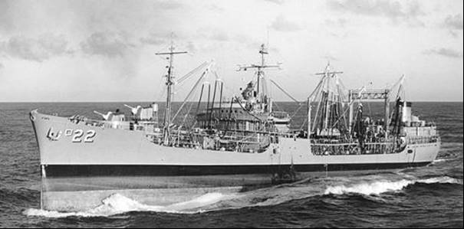

Other Options

While the U.S. Navy were using the ocean-going tankers to deliver the essential fuels, in particular aviation gasoline, other options were explored. One of the most ingenious was the development of an underwater pipeline “Pluto”. This would be another of the delivery methods, along with drum shipments, pipelines, and any other delivery method which would get the aviation fuel to the fighting forces.

# Petrol Supply by Pipeline – “PLUTO[14]”

Perhaps one of the more imaginative systems used by the Allies during World War II to deliver petroleum products to the European theatre following the 1944 Normandy landings, was by land and subsea pipeline. ‘PLUTO’ – Pipeline Under The Ocean, described by Winston Churchill as ‘a remarkable feat of British engineering, distinguished in its originality, pursued with tenacity and crowned with success.’

The significance of ‘PLUTO’ is that it provided another method for the petroleum distribution of petrol and relieved network for distribution of avgas.

It all began with a conversation in April 1942 between Lord Louis Mountbatten and Geoffrey Lloyd (Minister in charge of the secret Petroleum Warfare Department) whose enthusiasm gave birth to the “PLUTO” project. Lloyd asked if there was anything more that his Department could do to help the proposed liberation of Europe. Mountbatten replied – “Yes, you can lay an oil pipeline across the English Channel”.

Mountbatten pointed out that after the Normandy Landing a distribution system would be needed to transport petrol to thousands of Allied army vehicles scattered over thousands of square miles of Europe. A force that would land 15,000 or more vehicles on the first day and thousands more with every week that passed would have a tremendous thirst for fuel. The usual method of non-returnable 4-gallon tins would prove an almost impossible logistics exercise. Use of the returnable robust German ‘jerry-can’ was a great improvement. However, vast numbers of these were necessary to cater for re-filling operations - in the first days after the Normandy landings the logistics of such an operation would be unrealistic, because there were no large tanker berths and the number of jerry-cans required would be prohibitive.

Photo 21. American soldiers filling jerry cans from road tankers for dispatch to combat units.

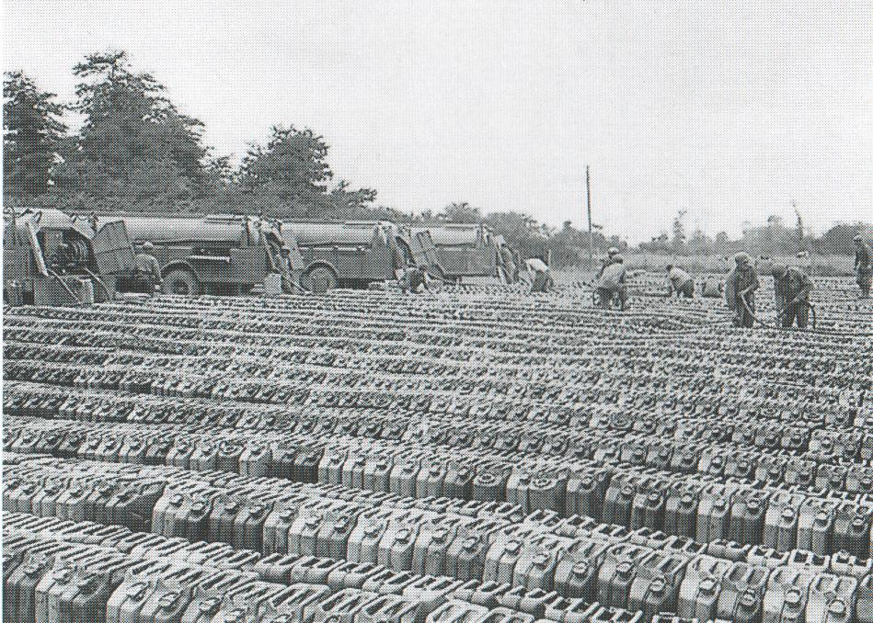

A few days after this meeting, the Chief Engineer of the Anglo-Iranian Oil Company (later BP) A. C. Hartley suggested it might be possible to produce a pipeline similar to a coreless lead sheathed electrical power cable. Such a pipeline could be produced at short notice and laid in the English Channel by conventional cable laying ships.

Located on the south bank of the River Thames, some 24 km to the east of central London is the Callender Factory which began making electric cables in 1882. The company grew and prospered, and the factory developed expertise in making high voltage power cables and also had strong engineering resources. Callender’s was therefore an obvious choice to be invited to participate in the PLUTO Project.

If the liberation of France in 1944 was to be successful, the continuous supply of oil and petrol to the Allied Forces would be one of the most important challenges. PLUTO was the solution.

The pipeline consisted of a lead pipe overwound with successive layers of paper, cotton, steel tape and jute yarn, then steel wires and finally a second layer of jute yarn, all impregnated with bitumen. The lead pipe was made in 700-yard (640 m) lengths, the first trial length was one mile long (1.6 km); later in the project 30-mile lengths (48 km) were required. Thus, it was essential that no leaks occur in the pipeline and special techniques were developed to join the lead pipe. In a 30-mile length of 3-inch (76 mm) diameter armoured pipeline there were 75 joints and it weighed 1,620 tons (1,470 metric tonnes).

Another type of pipe used in PLUTO for some of the land-based oil lines was a 3” steel pipeline. This was known as ‘HAMEL’ named after H. A. Hammick of the Iraq Petroleum Company and B. J. Ellis of Burmah Oil Company. ‘HAMEL’ was developed as insurance against any wartime shortage of lead, and in case there was a failure of the lead pipelines.

Before June 1943, it was assumed by many people, including the Germans that the invasion of the Continent would be across the shortest crossing from Kent to Calais. The planning was based on undersea pipelines of about 20 miles long (32 km). This short crossing was too obvious to everyone and the Germans forces fortified the Pas de Calais with guns, under water obstructions and sea mines. By July 1943 Normandy was the invasion target and the undersea pipeline would now need to be 70 miles long (113 km).

There would be a network on land to get the essential petrol supplies to the English coast and then into Europe.

The invasion of Normandy took place on June 6 1944, D-Day. Operation PLUTO would be laid over the next months, but it would be 22 September 1944 before petrol started to flow to the Continent.

The pipeline system would eventually extend from the refinery at Stanlow, and key supply areas of Misterton and Avonmouth to the half million gallon reservoir (1.9 million litres) on high ground behind Shanklin. Petrol was gravity fed from there to the pumping stations at Shanklin and Sandown (on the Isle of Wight). It was pumped across the Channel to Cherbourg initially then later to Calais and extended through France, Belgium, Luxembourg and end in German Rhine in 1945.

Photo 22. PLUTO Cable drum with pipeline

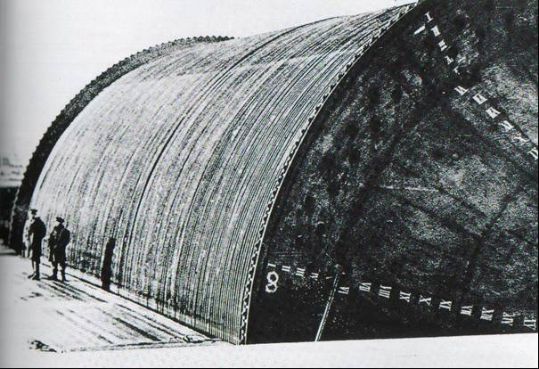

Photo 23. Tugs laying the PLUTO pipeline

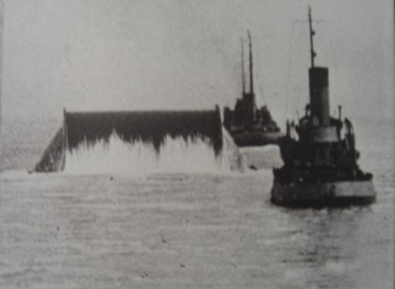

Photo 24. Pluto Pump

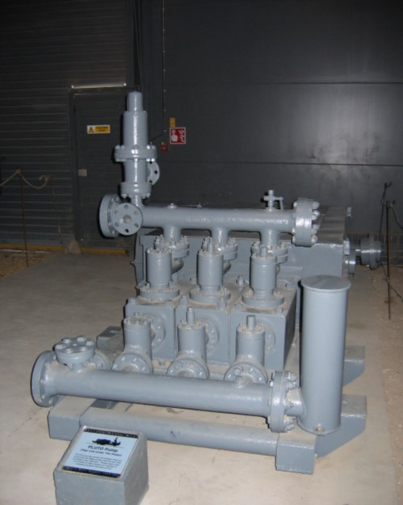

The PLUTO Project delivered 172 million gallons of valuable fuel (over 650 million litres) from Sept 1944 to July 1945.

Figure 1. Operation ‘PLUTO’ the complete land and subsea pipeline system from the north of England to the Rhine in 1945 (BICC Cables)

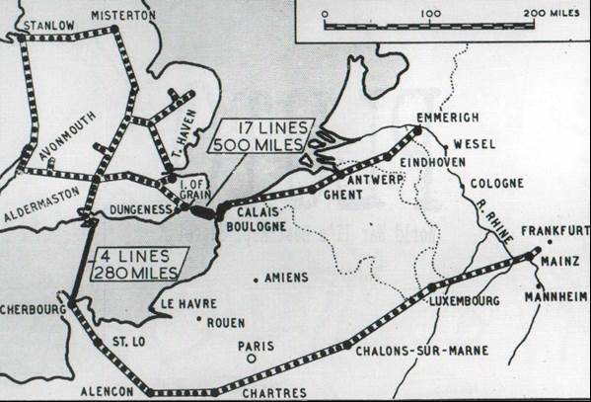

The pipeline system would operate until August 1946, when it became a hazard to coastal shipping. It was closed and salvaged to recover the valuable materials, principally lead.

A section of the pipeline known as ‘HAIS’ piping is located at the Australian War Memorial in Canberra. It was known as ‘HAIS’ because it was designed by Hartley, of Anglo-Iranian, and Siemens.

# The World War Is Over

With the War in Europe concluded in May 1945, and the war against Japan dramatically concluded in August 1945, the avgas demand for the massive air offensives greatly diminished and the Allies attention turned to the peacetime demand for motor spirit. On 12 October 1945, British planning for the new world situation was underway with the 4th Quarter 1945 Curtailment of Aviation Fuel in preference for Motor Spirit.

For the ‘Sterling Refineries’ in Caribbean, Trinidad & Curaçao the following was recommended:

1. Reduce Avgas 100/130 production at Trinidad & Curaçao until the end of 1945.
2. Divert Heysham Refinery to Motor Spirit.
3. Maintain Aviation Spirit production at Stanlow & Billingham at rate of 50,000 tons/quarter.
4. Ship some 30,000 tons of aviation fuel to the UK as soon as possible from stocks in Caribbean refineries in order to provide the storage space necessary for efficient refining operations. This will also free the way for further shipment of aviation spirit from the Caribbean in unleaded state which could be segregated in the UK for emergency use as motor spirit.

* Increase Sterling motor spirit supplies during the next three months.
* Reduction of Aviation Spirit at Abadan 150,000 to 75,000 tons.
* Reduction of Aviation Spirit in Caribbean 80,000 to 30,000 tons.
* Reduction of Aviation Spirit in UK 120,000 to 50,000 tons.

(With increased production when making motor spirit amounting to 30,000 tons).

British Petroleum Position end of 1945

The petroleum stock position at the end of 1945 also included its obligations in Germany where the country had come under control of the four allies (United States, Britain, France, and the U.S.S.R.). The stock position was estimated in January 1946 to be as follows:

Table 13. Annex Stocks in UK (including Germany British Zone) estimated 3rd. Jan 1946[15]

|  |  |
| --- | --- |
| Product | Tons |
| Avgas 100 | 423,000 |
| Avgas other | 101,000 |
| Motor Spirit | 621,000 |
| Other white products | 362,000 |
| Admiralty Fuel Oil | 730,000 |
| Gas Oil | 380,000 |
| Marine Diesel | 94,000 |
| Fuel Oil (incl. Tar Oil) | 474,000 |
| Lube Oil | 347,000 |
| Crude, Process Oil & Bitumen | 325,000 |
| Total | 3,857,000 |

British supply of Avgas was from Abadan due to the need to use “Sterling” (currency) Refineries, not $US sources. Supply 200,000 tons/quarter.

# Oil Companies and Refineries – $US & £ Sterling

The war brought a new dimension to oil companies and their trading. That dimension was foreign country balance of payments. This divided the Allied countries into “Sterling” and “US Dollar” operations, and this would play an important part in British thinking is determining where avgas would be produced and supplied. By contrast the Axis countries acquired their stocks by seizure as acts of war.

The ‘Sterling” refineries were based in the Caribbean and were operated by the Shell Company and Trinidad Leasehold; and also in the Middle East at Abadan, and India; and of course local U.K. refineries such as Stanlow, Billingham and Heysham.

The “US Dollar” refineries were essentially any operation in the U.S.A. and the Standard Oil Company operation in the Caribbean. The Bahrain Refinery in the Middle East was also a $US operation. There is more to the story of the Caltex Bahrain Refinery.

Union Oil Refineries

The Union Oil Company in its publication “The 76 Bonanza” [16] and further publication “The fabulous life and times of Union Company of California, and The Pure Oil Company” the following refineries were listed:

* Oleum Refinery - San Francisco 48 MBSD
* Los Angeles Refinery opened 1917, by 1996 this was 106.5 MBSD refinery
* Smiths Bluff Refinery Nederland, Texas 88.5 MBSD
* Santa Maria Refinery (near Avila)

However, our interest is avgas here in the period in WWII. In 1940 there were three refineries 26,000,000 Bbls/year, an alkylation plant at Los Angeles Refinery, a polymerisation plant at Oleum Refinery. There was a small refinery recommissioned for war efforts.

All U.S. tanker shipping was taken over by the U.S. War Shipping Administration 1942.

Catalytic cracking was an important process in the production of aviation gasoline in 1942 - a new catalytic cracker was constructed at Los Angeles Refinery. Even old refineries were brought to support the production, for example Rocky Mountain Refinery (1904) Cut Bank, Montana.

Pure Oil Company 1942

Many of the refineries required two of the key processes for aviation gasoline; these were catalytic cracking and alkylation. For example, the alkylation plant at Smiths Bluff Refinery, Thermofor Catalytic Cracker (TCC) and catalytic cracking rerun unit. There was always competing demands between explosives (TNT) and aviation gasoline. At the Toledo Refinery the hydrofiner unit produced Toluene for TNT, Xylene for explosives. Catalytic polymerisation units produced co-dimer for avgas at Heath, Cabin Creek and Toledo. Cabin Creek was shut down in 1954.

Texas Refineries

In the Texas area there were five refineries - Pure, Gulf, Socony-Vacuum (Mobil), Atlantic (Esso), Texas (Texaco), also producing butadiene. Butadiene is an important precursor for the production of synthetic rubber. These important refineries would be part of the Gulf Coast refineries supplying the European theatre of operations.

Operation “Roll Out The Barrel” 1942

To engage the public interest many slogans were used to increase the production of aviation gasoline and gasoline. Such item received notable press of the day, for example: 4,000 drums of gasoline/day, Total 862,000 Bbls. San Francisco area special plant filled 46,000,000 drums of gasoline. These would be shipped to the Pacific.

In the publication “Phillips - the First 66 Years”[17] the following items related to aviation gasoline production were noted. Dec 24, 1942 the world’s first Hydrofluoric Acid Alkylation Plant (HF) at Phillips Borger Refinery Texas. The process was discovered in 1939 by Fred Frey, based on earlier work in the 1930’s on polymerisation - Phillips “Poly Gas”.

Phillips research led to commercial production of iso-pentane, iso-octane, neo-hexane, cumene. Phillips processes – Sulphuric Acid Alkylation, Hydrofluoric Acid Alkylation and ‘Cycloversion’ used in the production of 100 Octane aviation gasoline.

Fred Frey revealed that sulphur was a contributing cause of gasoline knocking. This led to a desulphurising process to increase quantity and quality of aviation gasoline.

1944

Phillips became the first and only producer of di-isopropyl. This ingredient played a major role in giving military planes a superfuel of more power during take-off, sustained speed in flight and superior performance under combat conditions.

Phillips also developed a new catalytic process called ‘cycloversion’. This changed petroleum materials formerly of little value into products needed in large quantities of 100 Octane avgas.

Frank Phillips was chairman of Petroleum Industry General Commission - District 2.

Photo 25. US Army Air Force B-29 ‘Enola Gay’ at Tinian atoll 1945.

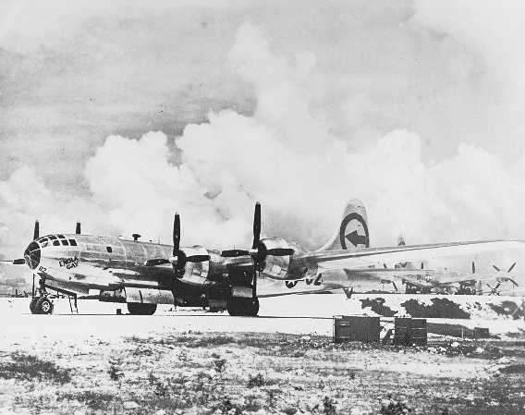

At 2:45 pm August 6, 1945 Colonel Paul W. Tibbetts, commander of the 509th Bomb Group (U.S. Army Air Force) departed the tiny Pacific atoll of Tinian as pilot in command of the ‘Enola Gay’ Boeing B-29 Superfortress Air Forces Serial No. 44-86292. This aircraft was loaded with a single bomb weighing four and half tons called ‘Little Boy’. The bomb had an explosive power equal to 20,000 tons of TNT. At 8:15 am Japanese time, the first atomic bomb was dropped and exploded over Hiroshima.

# Epilogue for the War Years

Perhaps the best tribute to their efforts that can be made is that there was no one single example of an aircraft failing to leave the ground because of lack of aviation gasoline.

The Atomic Age had arrived.

In a single blow, it crippled an empire and changed the world forever.

Tibbett’s Boeing B-29 ‘Enola Gay’ was fuelled with Avgas 100/130 as evidenced on the panel markings of S/N 44-86292 on display at Smithsonian Uzar-Hazy Air Museum Washington DC.

Photo 26. Panel markings on Boeing B-29 S/N 44-86292

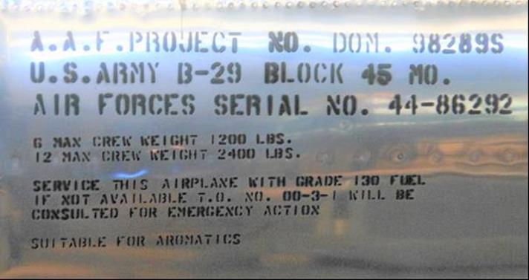

Two days later U.S. Army Air Force Boeing B-29 Superfortress ‘Bockscar’ piloted by Major Charles W. Sweeney would target the city of Nagasaki, and drop the second atomic bomb ‘Fat Man’, to finally bring the Second World War to a close.

Photo 27. Boeing B-29 ‘Bockscar’ S/N 44-27297 Panel markings indicating Avgas 100/130 Grade.

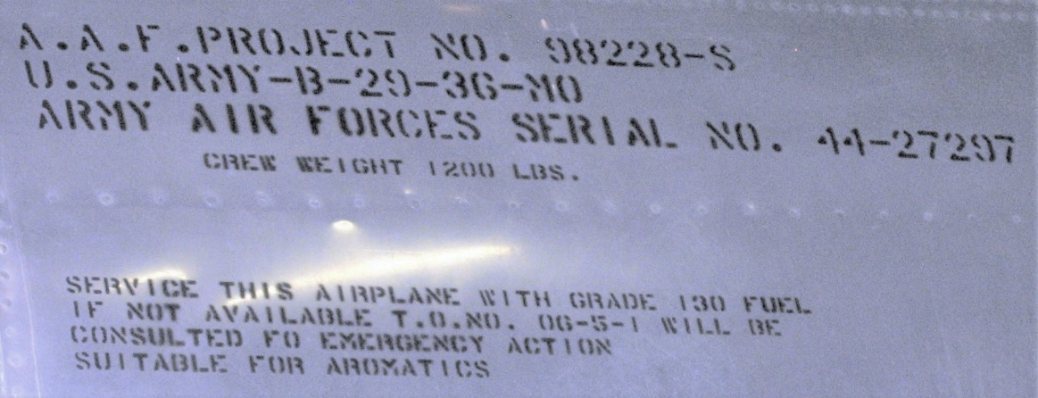

Thus, ended World War II.

# Index

1

100 Octane 3, 5, 6, 13, 18, 28, 36

100/130 3

100/130 Aviation Fuel 17

100/130 engines 6

100/130 fuel 13

14th  Air Force 18

3

361st Fighter Group 14

375th Fighter Squadron 14

5

509th Bomb Group 36

7

76 Bonanza 35

7th Fleet 28

8

80/87 Octane 5

8th Air Force 10, 12, 14

9

90 Octane 9, 10

90/87 Octane 3

99/130 fuel 13

A

A. C. Hartley 31

A-24 3, 4

Abadan 4, 8, 9, 13, 15, 28, 29, 34, 35, 47

Abadan Refinery 9

Admiral Ernest King 6

Admiral Lord Louis Mountbatten 6

Admiral William D. Leahy 6

Admiralty Fuel Oil 34

Africa 9

Agawam 23

Air Chief Marshal Sir Edward Portal 14

Air Commodore Tackaberry 6

Air Transport Command 18

Air Transport Command's India-China Division 18

Alaska 8, 16

Albany 29

Alden (DD-211) 28

alkylation 15, 16, 35

Ammonusuc 26

Amor Island 28

Anglo-Iranian 33

Anglo-Iranian Oil Company 28, 31

AO 21, 28, 29

AO-41 22

AO-90 27

AOG 21, 47

AOG- 1 23

AOG- 2 23

AOG- 3 23

AOG- 4 23

AOG- 5 23

AOG- 6 23

AOG 7 23

AOG- 8 23

AOG -9 23

AOG-1 24

AOG-10 23

AOG-11 23

AOG-12 25

AOG-13 25

AOG-14 25

AOG-15 25

AOG-16 25

AOG-17 26

AOG-18 26

AOG-19 26

AOG-20 26

AOG-21 26

AOG-22 26

AOG-23 26

AOG-24 26

AOG-25 26

AOG-26 26

AOG-27 26

AOG-28 26

AOG-29 26

AOG-30 26

AOG-31 26

AOG-32 26

AOG-33 26

AOG-34 26

AOG-35 26

AOG-36 26

AOG-37 26

AOG-38 27

AOG-39 27

AOG-40 27

AOG-41 27

AOG-42 27

AOG-43 27

AOG-44 27

AOG-45 27

AOG-46 27

AOG-47 27

AOG-48 23

AOG-49 23

AOG-5 24

AOG-51 23

AOG-52 23

AOG-53 23

AOG-54 23

AOG-55 23

AOG-56 23

AOG-60 27

AOG-61 27

AOG-62 27

AOG-63 27

AOG-64 25

AOG-65 25

AOG-66 25

AOG-67 25

AOG-68 25

AOG-69 25

AOG-70 25

AOG-71 25

AOG-72 26

AOG-73 26

AOG-74 26

AOG-75 26

AOG-8 24

Army's Air Transport Command 17

Aroostook 25

Arsenal of the Free World 4

Aruba 7, 13

Ascension 16

Asiatic Fleet 28

Atlantic 10, 21, 29

Atlantic (Esso) 35

Atlantic Ocean 6, 9

atomic bomb 37, 38

Australia 4, 5, 9, 13, 28, 29

Australian War Memorial 33

Avgas 100/130 10, 15, 17, 34, 37, 38

Avgas 87 15, 16

Avgas 91/96 15

aviation fuel 22

aviation gasoline…..3, 4, 5, 8, 9, 10, 13, 14, 15, 16, 21, 28, 30, 35, 36

Aviation Gasoline 3, 5, 7, 15, 16

Aviation Gasoline Advisory Committee 3, 4

Aviation Petroleum Products Allocation Committee 7

Aviation Spirit 9, 34, 47

Avonmouth 12, 32

Axis 10, 14, 16, 35

B

B. J. Ellis 31

B-25 Mitchell 3

Bahamas 17

Bahrain 15

Bahrain Refinery 7, 35

Bahrein 9, 28, 47

Bahrein, Arabia 29

Base Force, 7th Fleet 29

Basra, Iraq 29

Baton Rouge Refinery i

Battle of Midway 29

Battle of the Atlantic 9

Belgium 32

Berlin 14

BICC Cables 33

Billingham 7, 15, 34, 35

Bitumen 34

Black Hawk (AD-9) 28

Bockscar 38, 39

Boeing B-17 4

Boeing B-17 Flying Fortress 10, 11

Boeing B-29 Superfortress 19, 37, 38

Bolivia 17

Bombay, India 29

Borneo 4

Brandywine 21

Brazil 16

Brigadier General John R. Deane 6

Brigadier Harold Redman 6

Brisbane 29

Britain 34

British Empire 4

British Petroleum 13, 28, 34

Buna-Cape Cretin 29

Buna-Gona 29

Burma 5, 6, 13, 17, 19

Burmah Oil Company 31

Butadiene 35

C

Cabin Creek 35

Cairns 29

Calais 31, 32

Calamus 26

California 8, 9, 28

Callender Factory 31

Caltex 7

Canada 5, 6, 8, 16

Canberra 33

Captain F.B. Royal 6

Caribbean 4, 7, 8, 15, 16, 20, 34, 35

Casablanca 5

Cat Cracking rerun unit 35

catalytic cracking 15, 35

Catalytic polymerisation 35

Central Pacific 8, 15, 16, 17

Ceylon 5, 9, 15, 16

Chehalis 23

Cherbourg 32

Chestatee 23

Chester, Pennsylvania 29

Chewaucan 23

China 5, 13, 15, 16, 17, 19

Chiwaukum 26

Churchill 10, 30

Cimarron 29

coastal tankers 23

co-dimer 15, 35

Colonel Paul W. Tibbetts 36

Combined Chiefs of Staff 5, 6, 7, 12

Commander Harry M. Bostwick 28

Commander R.D. Coleridge 6

COMSOWESPAC 29

Conasauga 25

Conemaugh 27

Consolidated B-24 Liberator 10, 11

Crude 34

cumene 36

Curaçao 7, 34

Curtiss Commando C-46 18

cycloversion 36

D

Dakar 16

Darwin 4, 28

D-Day 3, 10, 12, 13, 16, 32

desulphurising process 36

Diego Garcia, Chagos Archipelago 29

Digboi 9, 16

di-isopropyl 36

Doolittle Raid 29

Dutch East Indies 4

Dutch West Indies 4

E

East Africa 5, 17

East Coast 3, 7, 8, 9, 10

East Coast refineries 3

Eastern Mediterranean 5

Edsall 28, 29

Eighth Air Force 10, 12

Elkhorn 23

England 10, 12, 33

English Channel 30, 31

Enola Gay 36

Escatawpa 26

Escort Carriers CVE 20

Esso Delivery No.11 25

Europe 20, 34

F

Fat Man 38, 39

Field Marshall Dill 5

Fleet Oiler 20, 21, 22, 27

Flying the Hump 17

France 12, 17, 25, 31, 32, 34

Frank Phillips 36

Fred Frey 36

Free French 16

Fremantle 29

Fuel Oil 34

G

G. C. Dear 13

Gas Oil 34

gasoline 22

Gasoline Tankers 21, 47

General Carl (‘Toohey’) A. Spaatz 12

General Douglas Macarthur 40

General George Marshall 6

General Henry (Hap) Arnold 6

General Lloyd 5

Genesee 23

Geraldton 29

German 3, 12

German secret weapon sites 10

German Third Reich 14

German U-boat ‘Wolf pack’ 9, 10

German U-Boats 6, 21

German V-weapons 10

Germany 12, 21, 34

Germany British Zone 34

Great Britain 21

Guadalcanal 29

Gualala 26

Gulf 7, 8, 9, 10, 29, 35

Gulf Coast refineries 35

Guyandot 25

H

H. A. Hammick 31

Haifa 9

HAIS 33

Halawa 25

Halawa Class 25

HAMEL 31

Hartley 33

Hawaii 29

Hawaiian bases 4

Heath, Cabin Creek 35

Heysham 4, 7, 15, 34, 35

Himalayan mountain 17

Himalayas 18

Hiroshima 37

Hiwassee 26

Holland 16

Holland (AS-3) 28

Hump 18, 19

Hydrofiner 35

Hydrofluoric Acid Alkylation 36

I

Iceland 10, 12, 15, 17

India 5, 6, 8, 9, 13, 15, 16, 17, 18, 35

Indonesia 29

Iran 29

Iraq 5, 9, 29

Iraq Petroleum Company 31

Isle of Wight 32

iso-octane 36

iso-pentane 36

Italy 16

J

Japan 10, 21, 29, 34

Japanese 4, 19, 37

Java 28, 29

jerry-can 30, 31

K

Kalamazoo 26

Kaloli 25

Kamahi 26

Kanawha 26

Kebola Bay 28

Kent 31

Kern 23

Kishwaukee 23

Klaskanine 27

Klickitat 25

Klickitat Class 25

Koepang Bay, Timor 28

L

Lac Pavin 25

Leigh 6

Little Boy 37

Lloyd 30, 47

Lockheed Hudson 10

Lord Louis Mountbatten 30

Los Angeles Refinery 35

Lt. General Joseph W. Stilwell 19

Lt. General Sir Hastings L. Ismay 6

Lube Oil 34

lubricants 22

Luftwaffe 12

Luxembourg 32

M

MAB 4, 8, 16

Major Charles W. Sweeney 38

Major General J.H. Burns 7

Malay Barrier 28, 29

Manokin 27

Maquoketa 23

Marine Diesel 34

Marine Terminals 12

Mattabesset 23

Mattaponi Class Fleet Oiler 22

Mediterranean 10, 13, 16

Messina 10

Mettawee 26

Mettawee Class 26

Michigamme 25

Middle East 4, 9, 35

Middle East Group I 16

Middle East Group II 16

Middle East I 15

Middle East II 15

Middle East III 15

Milne Bay, New Guinea 29

Ministry of Fuel & Power 13

Misterton 32

molasses 20

Mount Everest 17

Munitions Assignment Board 4, 12, 47

Munitions Assignment Committee 6, 7, 16

N

Nagasaki 38, 39

Namakagon 23

Nanticoke 25

Narraguagas 26

Natchaug 23

Naval Air Transport Service 18

Navy AO designation 20

Navy-Naval Historical Center 28

Nazi Blitzkrieg 4

Nazi Germany 10

Nederland Texas 35

Nemasket 23

neo-hexane 36

Nespelen 23

Netherlands 17

Netherlands East Indies 28

Netherlands West Indies 9

New Zealand 5

Newfoundland 10, 16

Newport News Shipbuilding and Drydock Co 28

Newport News, Virginia 28

Nordaway 25

Normandy 5, 12, 14, 17, 30, 32

North Africa 3, 8, 9, 10, 16, 17, 20

North Atlantic 6, 17

Noxubee 23

Nurnberg 12

O

Ochlockonee 26

Oconee 26

Ogeechee 26

Oil & Tanker Mission 9

Oleum Refinery 35

Ontonagon 26

Operation Overlord 3, 5

Otus (AS-20) 28

P

P-40 Kittyhawk 4

P-47 Thunderbolt 21

P-51 Mustang 14

Pacific 3, 4, 9, 10, 13, 14, 18, 20, 29, 36, 47

Pacific Area 9, 14

Pacific Fleet 29

Panama Canal 29

Papuan New Guinea 29

Paris 16

Pas de Calais 31

Pasquotank 26

Patapsco 23

Patapsco Class 23

Patrol Torpedo 21

PAW 3, 4, 5

PB4Y-1 Patrol Bomber 10

Pearl Harbour 4, 21

Peconic 25

Peenemunde 10

Persia 5, 9

Persian Gulf 28, 29

Persian-Anglo Abadan Refinery 7

Petaluma 25

Petroleum Administration for War 3, 4, 5

Petroleum Board 3, 4, 5

Petroleum Industry General Commission - District 2. 36

Petroleum Pool 4

Petroleum Warfare Department 30

Philadelphia Navy Yard 29

Phillips 36

Phillips “Poly Gas” 36

Phillips Borger Refinery Texas 36

Piscataqua 25

PLUTO 30, 31, 32, 33

Poles 16

polymerisation 35, 36

Ponchatoula 27

President Roosevelt 3, 4

Process Oil 34

Pure 35

Q

Quastinet 27

Quebec 6

Quinnebaug 25

R

R.A.F. 6, 8, 10, 12, 13

Rabaul (New Guinea) 4

Rear Admiral W.B.Young 28

Red Sea 5

Regensburg 10

Rhine 32, 33

Rhine River 17

Rio Grande 23

River Thames 31

Rockhampton 4

Rocky Mountain Refinery 35

Roosevelt 10

Royal Air Force 10, 12

Russia 16

Russian 17

S

Sacandaga 27

Sakatonchee 26

Sakonnet 27

San Francisco 36

Sandown 32

Santa Maria Refinery 35

Schweinfurt 10

Seattle-Tacoma 23

Sebasticook 26

Seekonk 26

Sequatchie 26

shale oil refining 4

Shanklin 32

Sheepscot 26

Shell 4

Shell Company of Australia 4

Shell refinery 7

Shikellamy 27

Shikellamy Class 27

Short Sunderland 10, 11

Sicily 10, 17

Siemens 33

Singapore 4

Sir Alan Brooke 6

Sir Anthony Eden 9

Sir Charles Portal 6

Sir Dudley Pound 6

Sir John Dill 6

Smiths Bluff Refinery 35

Smithsonian Uzar-Hazy Air Museum 37

Socony-Vacuum (Mobil) 35

Solomons 29

South Africa 5, 17

South America 8

South Pacific 8, 15, 16, 17

South West Pacific 8, 15

South West Pacific I 15

South West Pacific II 15

Southampton 12

Southwest Pacific 5, 29

South-West Pacific 16, 17

Soviet Union 29

Spain 17

Spitfires 10

SS Kalkay 22

Standard Oil Company 35

Standard Refineries 4

Standard-Vacuum 4

Stanlow 4, 12, 32, 34, 35

Sterling 9, 13, 34, 35

Sterling Refineries 34

Suez 9

Sulphur 36

Sulphuric Acid Alkylation 36

Sun Shipbuilding & Drydock Co 22

superfuel 36

Susquehanna 23

synthetic rubber 35

T

T1 types 20

T2 types 20

T3 type 20

Talara 9

Tar Oil 34

TCC 35

Tellico 26

Tetonkaha 27

Texas (Texaco) 35

Thames Haven 12, 13

The Pure Oil Company 35

Tibetan- China border 17

Tinian 36

Tjilatjap 29

TNT 35, 37

Toledo 35

Toledo Refinery 35

Toluene 35

Tombigbee 23

Towaliga 27

Townsville 29

Trinidad 7, 9, 34, 35

Trinity 28, 29

Tripoli 9

Truckee 26

Tularosa 27

Tunis 5

U

U.S. Air Force 10

U.S. Army 3, 6, 8, 16

U.S. Army Air Force 4, 36, 38, 39

U.S. Army and Navy Petroleum Board 3, 4

U.S. Chiefs of Staff 13

U.S. Gulf 3

U.S. Navy 6, 8, 10, 16, 20, 21, 30

U.S. War Shipping Administration 35

U.S.S.R. 34

undersea pipeline 32

Union Company of California 35

Union Oil Company 35

United States 34

United States Strategic Air Forces Europe 12

US Dollar 35

US Navy 28

US Navy Department, Bureau of Supplies and Accounts 28

USS Cimarron 28, 29

USS Cinnamon 30

USS Genesee 24

USS Mattaponi 22

USS Missouri 40

USS Patapsco 24

USS Shikellamy 27

USS Susquehanna 24

USS Trinity 28

V

Vice Admiral William A. Glassford 29

Viscount Halifax 9

W

Wabash 23

Wakulla 27

Washington 5, 12, 13, 47

Waupaca 27

Wautauga 26

West Africa 8, 9, 16

West Coast 7, 8, 9, 29

West Mediterranean 15

Western Mediterranean 5, 17

Wright-Patterson, Dayton Ohio 37, 39

X

Xylene 35

Xylidene 3, 13, 14

Y

Yacona 27

Yahara 26

# Research Sources

1. UK Public Records Office Kew London. Piece: CAB 122/145 1942-1943 Relative priorities of theatre operational requirements for aviation fuel
2. UK Public Records Office Kew London. Piece: CAB 122/132 96, “1941 Establishment of advanced fuelling bases for US aircraft in the Pacific”.
3. UK Public Records Office Kew London. Piece: CAB 122/145 107. “1940-1943 Oil: general - Lloyd reports”
4. UK Public Records Office Kew London. Piece: CAB 122/145 1942-1943 Relative priorities of theatre operational requirements for aviation fuel
5. UK Public Records Kew London. MBW (AIR) 236/1 Munitions Assignment Board Washington 24 May 1944 Memo to CCS
6. US Navy 1942-1945, List of Gasoline Tankers used by the US Navy in WWII, from web site <http://www.ibiblio.org/hyperwar/USN/ships/ships-ao.html#mattaponi> Accessed Dec 30, 2001
7. Website Accessed 23 March 2008 http://www.usmm.org/tankers.html
8. Australian War Memorial (AWM) ID Number: 302609, Maker: US Navy Summary: Aerial Port Bow View Of The Gasoline Tanker USS GENESEE (AOG-8). (Naval Historical Collection) Copyright: Clear
9. Australian War Memorial (AWM) ID Number: 302754 Summary: 1943-09-30. Aerial Port Side View Of The Gasoline Tanker USS SUSQUEHANNA (AOG-5). (Naval Historical Collection) Copyright: Clear
10. Australian War Memorial (AWM) ID Number: 302741, Maker: No 66 Squadron RAAF, Summary: 1943-11-03. Port Side View of The Gasoline Tanker USS Shikellamy (AOG-47) (Ex-Daniel Pearce). (Naval Historical Collection) Copyright: Clear
11. UK Public Records Office Kew London Ref: POWE 33/1352 Supplies of Aviation Spirit Bahrein, Abadan, 1943, 1944.
12. Department Of The Navy -- Naval Historical Center, 805 Kidder Breese Se -- Washington Navy Yard, Washington DC 20374-5060 <https://www.navysite.de/ao/ao22.htm> Accessed October 25, 2019
13. USS Cimarron Photo #NH67530 circa 1939-40
14. “Pluto – World War II’s Best Kept Secret” - BICC Cables Limited Supertension & Subsea Cables 1998-Bexley Council Local Studies by Bob Knight, Harry Smith & Barry Barnett
15. UK Public Records Office Kew London Ref: CAB 122/1477 17/3/3 Part 2 1944-1945 Relative priorities of theatre operational requirements for aviation fuel Ref: CSA (45) 139 Received 6th Dec 1945
16. “The 76 Bonanza” by Earl W Welty and Frank J Taylor - PIMA Call No. HD9565 U58 W4 PAM
17. “Phillips - the First 66 Years” PIMA Call No. HD9569 P53 p49 1983 Phillips