Chapter

27

United States during the War 1940 – 1945

The Powerhouse of Avgas Supplies

Photo 1. Bayway Standard Oil No. 6 Pipe Still (1942), New Jersey, USA

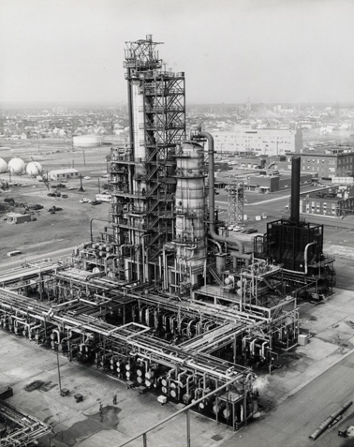

Table of Contents

Summary 4

US Lend–Lease Act 1941 5

1940 Aviation Gasoline 5

1940 Stocks 6

1941 Refinery Capacity 6

1942 Aviation Gasoline 8

1943 Aviation Gasoline 9

1944 Aviation Gasoline 10

1945 Aviation Gasoline 10

Epilogue For The War Years In The US 14

Index 15

Research Sources 17

Photo 2. Baytown Refinery, Texas USA

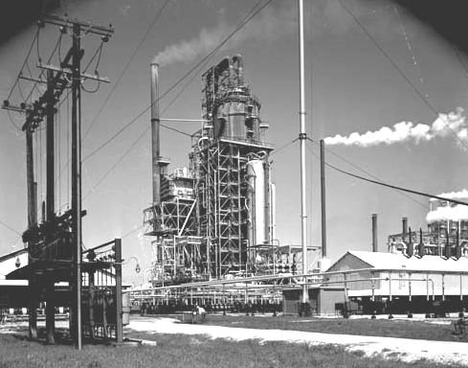

# Summary

In reviewing the production of aviation gasoline in the United States between 1940 to 1945 and beyond, a considerable background information was located in (US) Minerals Yearbook Review.[1] The information regarding aviation gasoline and its manufacture is presented here:

Table 1. U.S. Refineries 1938-1948

|  |  |  |  |  |  |  |  |  |  |
| --- | --- | --- | --- | --- | --- | --- | --- | --- | --- |
| Year | Number of US refineries | | | | Capacity BSD | | | | MBSD |
| Operating | Shutdown | Building | Total | Operating | Shutdown | Building | Total | Total Capacity |
| 1938 | 431 | 120 | 10 | 561 | 3,970,196 | 380,955 | 283,020 | 4,634,171 | 4,634 |
| 1939 | 435 | 103 | 7 | 545 | 3,933,785 | 574,770 | 142,250 | 4,650,805 | 4,651 |
| 1940 | 461 | 86 | 10 | 557 | 4,196,694 | 431,952 | 92,567 | 4,721,213 | 4,721 |
| 1941 | 420 | 136 | 6 | 562 | 4,180,588 | 538,381 | 141,225 | 4,860,194 | 4,860 |
| 1942 | 430 | 92 | 1 | 523 | 4,496,843 | 459,756 | 43,400 | 4,999,999 | 5,000 |
| 1943 | 386 | 85 | 1 | 472 | 4,409,013 | 492,998 | 195,100 | 5,097,111 | 5,097 |
| 1944 | 384 | 68 |  | 452 | 4,709,382 | 383,641 | 118,270 | 5,211,293 | 5,211 |
| 1945 | 380 | 33 | 1 | 414 | 5,077,690 | 223,463 | 36,075 | 5,337,228 | 5,337 |
| 1946 | 364 | 29 | 1 | 394 | 5,086,165 | 229,691 | 53,100 | 5,368,956 | 5,369 |
| 1947 | 361 | 38 |  | 399 | 5,336,399 | 233,083 | 162,200 | 5,731,682 | 5,732 |
| 1948 | 352 | 38 | 2 | 392 | 5,825,566 | 208,686 | 367,250 | 6,401,502 | 6,402 |

Figure 1. US Refineries 1940 to 1948.

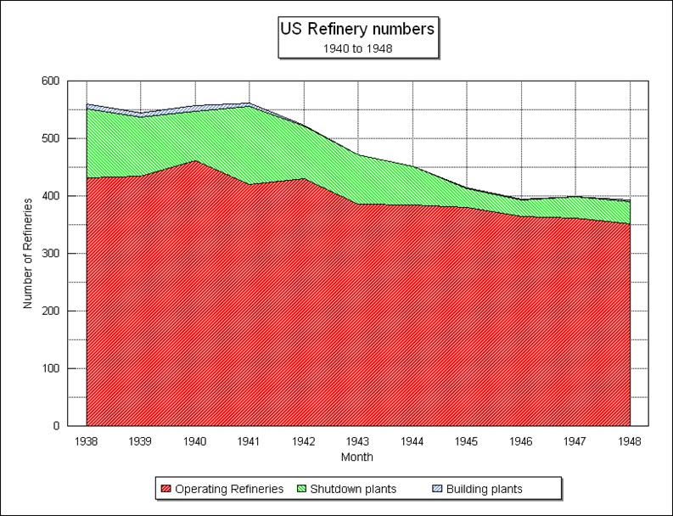

US Lend–Lease Act 1941[2]

Re-elected to a third term as President of the United States in November 1940, Roosevelt proposed in December a new form of aid to the Allies, which was adopted by Congress as the Lend-Lease Act of March 11, 1941. With supporting appropriations, the act provided at the outset $7 billion worth of war materials for nations whose defence the president deemed "vital to the defense of the United States”.

Photo 3. President Roosevelt signs the Lend-Lease Act

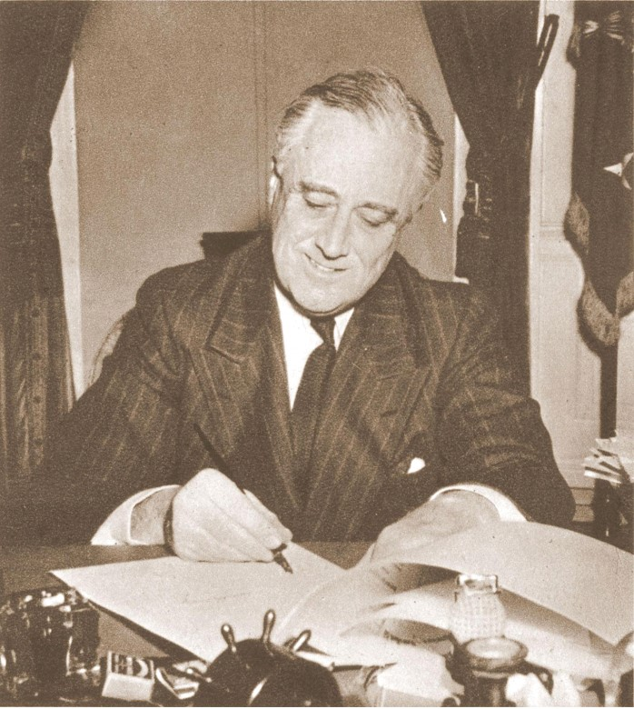

On September 3, 1941 the US White House announced more significant support for Britain with the trade (by executive agreement) of 50 over-aged destroyers in return for rent-free leases of 99 years on sites for American military bases in Newfoundland, Bermuda, the Bahamas, Jamaica, other Caribbean islands, and British Guiana.

# 1940 Aviation Gasoline

In 1940 there were 15 Refineries making Avgas 100.

The production of finished and unfinished aviation gasoline in 1940 was 14,736,000 barrels, (2,343 M.Litres) estimated to be gain of 40% on 1939 production. Transfers of low octane material to regular grade motor gasoline on 1940 were 723,000 barrels (115 M.Litres), exports of aviation gasoline were 4,649,000 barrels (739 M.Litres) (including 1,203,000 barrels (191 M.Litres) of anti-knock compounds) and 6,658,000 barrels (1,059 M.Litres) were for domestic demand.

Preliminary figures indicated that 2,259,000 barrels of aviation gasoline were consumed during the year by civilian aircraft. 1,797,000 barrels by 448 commercial planes, and 462,000 barrels by 16,903 private planes, leaving about 4 million barrels for military purchases and miscellaneous consumption. Stocks of aviation gasoline on December 31, 1940, totalled 6,354,000 barrels compared with 3,648,000 barrels on hand in January 1, 1940, a 74% increase in this valuable war material.

Exports of aviation gasoline, including antiknock compounds amounted to 4,649,00 barrels in 1940, this was higher than the 1939 total (4,234,000 barrels), but the figures were not comparable as data on exports of anti-knock compounds were not available before Jan 1, 1940.

Up to the time of its collapse, France led in the receipts of this product. Shipments to France were 514,000 barrels in the first 6 months of the year compared with 504,000 barrels shipped to the United Kingdom in the same period. With the fall of France to the Germans nearly all of remaining stocks of aviation gasoline would fall into enemy hands.

The most important shipments for the year (1940) were United Kingdom 1,525,000 barrels, Netherlands Indies 578,000 Bbls, **Japan 528,000 Bbls,** and France 514,000 Bbls. (The United States froze Japanese assets on July 26, 1941, and on August 1 established an embargo on oil and gasoline exports to Japan, and before that it was still procuring and stock piling as much aviation products that were available on the open market as a prelude to war).

# 1940 Stocks

Motor fuel stocks exceeded all records in 1940, finished and unfinished gasoline inventories amounted to 103,710,000 Bbls on March 31, or 15,589,000 Bbls more than on the same date in 1939, over 500% increase.

# 1941 Refinery Capacity

A huge program of refinery construction was initiated in 1941, but little of it was destined to increase crude oil capacity, as it was mostly ear marked for the production of such special commodities as butadiene for synthetic rubber, aviation gasoline, and toluene for explosives. Only one new plant of 4,000 Bbls (BSD) crude oil capacity was being built on Jan 1, 1942 and additional crude oil capacity of 39,400 Bbls was under construction at existing refineries.

Crude Capacity -1941

Total number of refineries dropped from 562 to 523, however, their daily capacity rose from 4,860,194 to 4,999,999 Bbls/day (BSD) due largely to the elimination of shutdown plants of small capacity, which declined in number from 136 to 92, and additional capacity completed for existing plants. The number of operating plants increased from 420 to 430 and their daily capacity rose from 4,180,588 to 4,496,843 Bbls/day (BSD). The largest increases in capacity were in the Texas Gulf Coast, California and Indiana, Illinois, Kentucky, etc., districts where the gains were 163,000, 157,000 and 149,000 Bbls/day respectively.

Cracking Capacity -1941

Cracking capacity rose from 1,151,193 BSD of gasoline output on Jan 1, 1941 to 1,222,684 BSD on Jan 1, 1942. A decline in both capacity shut-down and that under construction made the operating capacity 1,144,594 BSD compared with 1,021,006 BSD on Jan 1, 1941.

Emphasis in refinery construction during 1941 centred on aviation gasoline refineries, but interest in synthetic rubber plants developed at the end of the year. These included catalytic cracking plants, polymerisation plants, alkylation plants, isobutane and isopentane plants and aviation-base stocks plants.

Avgas 1941

Production of high octane blending agents by the alkylation method was rapidly supplanting the method of polymerising butane to iso-octene followed by hydrogenation of the codimer obtained. The principal reason was that the alkylation process required less investment and ran at lower operating costs. In addition to the thermal alkylation and low-temperature sulphuric acid catalytic methods, a patent was granted late in 1941 covering alkylation method using hydrofluoric acid as a catalyst. One of the principal advantages claimed for this method was the ability to use propane (comment: this is probably Propylene, not propane) as well as butane (comment: this is probably Butenes, not butane, since the alkylation reaction is between propylene or butenes and isobutane) for the charging stock in addition to the advantage of operating at normal temperatures, thus eliminating the need for refrigeration.

One plant to be completed early in 1942 was to produce a new aviation gasoline blending agent – Cumene also known as isopropyl benzene (C9H12). It is manufactured by alkylating benzene with propylene and it was an essential component of the high octane aviation gasoline (Avgas 115/145) because it has the highest known performance number. Unlike most aromatics, it has excellent response to anti-knock compounds such as tetra-ethyl lead (TEL).

The increase in production of 100-Octane aviation gasoline from 40,000 BSD to 120,000 BSD was one of the most important defence projects initiated in 1941. Efforts in this direction included concentration of crude oils yielding high-octane gasoline, increasing the production of butane, diversion of butane from other uses to serve as a source of iso-octane, isomerisation of butane, and raising the tolerance of tetra-ethyl lead from 3cc to 4cc per US gallon. (cc = millilitres or mls)

The high boiling range of iso-octane (blend) 225-263OF (107 –128 deg C) necessitated blending with other agents to produce an aviation fuel of required volatility. These blending agents usually were a light gravity cut of straight run gasoline of high octane, or a catalytically cracked gasoline with iso-pentane. The naphthenic-base crude oils, which traditionally had been considered less desirable because of their low gasoline content, made the highest octane gasoline, although the cut suitable for use as an aviation fuel blending agent usually was very small. Texas, California, and Louisiana were the sources of most crude oils of this type.

The need for increasing the production of butane was most essential both for the production of 100-Octane gasoline and for the synthesis of rubber. Greater efficiency in its recovery and the use of more absorber oil could supply a quantity that heretofore had been wasted, estimated by one authority at 15,000 BSD compared with 40,000 BSD used. An additional amount probably would have to be produced from the cracking of oils.

Isomerization

Isomerization is the changing of one chemical to another with the same percentage composition and molecular weight, but with different physical properties, and for aviation gasoline a significant increase in Motor Octane Number (MON) for example: normal pentane (C5H12) has a MON of 61.9 however, when isomerized to iso-pentane (C5H12), the MON is 90.3, and for normal hexane (C6H14) the MON is only 26, but when isomerized to iso-hexane (or 2-methyl pentane) (C6H14) the MON is 73.5, thus a significant increase in octane can be achieved by this process.

Applied to butane, it is the process of changing that gas, which is inert in the alkylation process to iso-butane which is an essential component.

Alkylation

The most usual raw material for alkylation (which, as it pertains to the petroleum industry, brings about direct union of a paraffin molecule with an olefin molecule) and isobutane (C4H10) and butene (C4H8). When these products are alkylated, they produce iso-octane (C8H18) a saturated iso-paraffin. Small proportions of natural gas consist of butane and isobutane, both constituents having the same chemical formula but isobutane having what is termed a “branched-chain molecule”. To be used in the alkylation process, the butane must be isomerized to isobutane by a catalytic process.

Tetra Ethyl Lead (TEL)

The deleterious effect of tetra-ethyl lead on motors long ago made it necessary to limit the proportion of this anti-knock component in motor fuel. Although the (US) Navy had permitted as much as 6cc/USG to be used in its aviation fuel, specifications for all military gasoline in the recent past have set the limit at 3cc/USG. In December 1941 the maximum lead level was raised to 4cc/USG. This would result in greater production of 100-octane gasoline by permitting lower-octane blending agents to be used.

Hydroforming

Several hydroforming plants for the aromatisation of the non-aromatic constituents of naphtha were either put in operation or were under construction in 1941. One such plant was designed to produce a new solvent claimed to be superior in many ways to present solvents. Hydroforming, though, is of even more immediate importance in the production of toluene, essential in the manufacture of explosives. The proportion obtainable through aromatisation of crude oil is very small, and the aromatic naphtha produced by the hydroforming process must go through several highly complicated operations for separation and purification of the toluene.

It was estimated that war needs would require about 1,500,000 Bbls/year of toluene. Although production from coking operations amounted to approximately 700,000 Bbls in 1941, most of this was required in the chemical industry and could be diverted only at a serious loss. The hydroforming plants then under construction probably would be able to supply the needs for this product, although not all of these plants had provided for production of toluene.

Synthetic Rubber

The synthetic rubber industry competed with 100-Octane gasoline for the supply of butane. Because almost all natural rubber came for the East Indies, Japan’s declaration of war precipitated a problem that had previously been considered only as a long term project – that of manufacturing rubber. Of all the major countries at war, the United States was best situated to meet this problem. Although Germany and Russia had more experience in producing synthetic rubber for practical use, they particularly Germany, did not have the petroleum resources available in the US. The petroleum industry had been called upon to furnish rubber at the rate of 400,000 tons annually within 18 months. Butadiene, from which petroleum-synthesized rubber is polymerized is made from butane and must share the supply of this gas with 100-octane gasoline.

# 1942 Aviation Gasoline

The program for the production of aviation gasoline launched in 1941 was well under way by the end of 1942, when approximately 16 times as much 100-Octane gasoline was being produced as at the beginning of 1941. With the largest part of the proposed plants yet unfinished, however, that production was still considerably short of the goal of 250,000 BSD.

The change from production of motor fuel to production of high-octane gasoline sufficient to fly the planes of the United States and its allies can be appreciated better when it was realized that iso-octane was merely a laboratory curiosity until a few years before; and that the first output of 100-octane gasoline in commercial quantities was to fill a (US) War Department order in 1934 for 1,000 gallons; that the first commercial catalytic polymerization plant was put in operation in 1937 and the first alkylation plant in 1938; in fact, the chemical world learned that olefins could be combined with paraffins, from which discovery, the alkylation process was developed. (Dr. James (Jimmy) Doolittle, then Shell Aviation Manager, was one of those who was involved in the first output of 100-octane gasoline, when he convinced Shell to build a hydrogenation plant at their St. Louis Refinery, Missouri, USA).

Stocks of finished and unfinished gasoline mounted to a record peak of 108,297,000 on February 28, 1942, the plunged to 73,216,000 barrels on November 30 – the lowest point since 1939. They totalled 80,126,000 barrels at the end of the year (1942), compared with 93,844,000 at the end of 1941, although the smaller amount on hand at the end of 1942 represented 63.3 days’ supply compared with 55.6 days’ supply on hand at the end of 1941.

The Gulf Coast Texas and Louisiana, California, and inland Louisiana-Arkansas districts had larger stocks at the end of 1942 than at the end of 1941; in fact, stocks in the Louisiana-Arkansas districts more than doubled during the year. In the East Coast district, the stocks dropped 47 percent. Such a severe cut was made possible in this district by pooling stocks and eliminating brand identities, by stopping cross-hauls, and by pooling facilities. [This was the start of PAW (Petroleum Administration for War) refer Chapter 11].

# 1943 Aviation Gasoline

In 1943 the contributions to 100 Avgas production came from 161 refineries, codimers were produced at 72 plants. There were 107 producers of Avgas 100 or its major components and 40 plants producing aviation gasoline or base stocks.

The continued upward revision of estimated requirements necessitated construction of new plants and the use of short-cut methods of expanding the output of essential constituents. Even with new plants coming into operation, it was necessary to relax the specifications early in 1944 to obtain enough high-octane aviation fuel. TEL content was increased from 4cc/USG to 4.6cc/USG. On January 5, 1944, distillation points also were raised to expand production.

Thirty-two (32) of the new aviation gasoline plants were supplying 100-Octane gasoline by the end of 1943, and 40 more were scheduled for completion early in 1944.

War requirements necessitated a double octane index to describe the anti-knock quality of aviation fuel; a rich mixture (3-C) rating in addition to the lean mixture (1-C) rating (CFR Motor Octane) previously in use. The rich mixture rating described the superior quality of the fuel for take-offs, climbing, sudden loads, and similar circumstances extremely important under combat conditions and not indicated by the ordinary octane rating (CFR Motor Octane). The rich-mixture rating is determined in a supercharged knock test engine by comparing the fuel to be tested with a standard reference fuel. Thus a 130 rich mixture number indicates that the fuel is 30% better than the reference fuel. Specifications for the two upper grades of aviation fuel were avgas 100/130 and avgas 91/96.

Cumene

Cumene, first produced for aviation fuel blending in 1942 had been the principal rich mixture additive. It was being manufactured in substantial quantities in 18 plants in 1943. Other additives about five times as potent as Cumene came into used during 1943, and together made possible a surplus rich-mixture fuel, with the result that by the end of 1943 the emphasis was on the production of lean-mixture rather than rich-mixture fuel.

Quality of motor gasoline

As a result of the pressure to increase the output of aviation gasoline, the quality of normal motor grades began to suffer early in the war, when the octane number was reduced from 72-74 to 71-72 for Regular Grade, and from a minimum of 80 to minimum of 78 for Premium Grade because of insufficient tetra-ethyl lead. The supply of tetra-ethyl lead however improved, so that by October 16, 1942 the minimum of 80 octane for Premium Grade fuel was reinstated. The Bureau of Mines Cooperative Fuel Research Motor Gasoline Survey for the winter 1942-43 found an average of 79.6 octane for Premium Grade gasoline and 72.5 octane for Regular Grade, compared with 80.2 and 74.4 octane, respectively, in the winter 1940-41 survey.

The Ethyl Corporation in January 1943 permitted production of 78 minimum motor gasoline where production of war material prevented refiners from meeting the 80-octane specification. The Petroleum Administration for War placed a maximum as of November 1, 1943, of 72 octane on Regular Grade motor gasoline and 76 octane on Premium Grade motor gasoline, while the Ethyl Corporation placed a minimum of 75 octane on Premium Grade motor gasoline. Thus, the octane rating of Premium Grade motor gasoline at the end of 1943 was but little above the 74.4 octane average found for Regular Grade in the winter 1941-42 survey. Furthermore, reductions in motor fuel quality were made not only to foster the production of aviation fuel but also to provide 80-octane fuel (MT-80) for all military ground vehicles in foreign zones.

Motor Fuel

The total demand for motor fuel reflected the combined trends of the growing requirements of the US armed forces, the reduction in less essential civilian consumption, and changes in exports. The most significant factor in 1942 was the rationing of gasoline for civilian automotive use, which caused a sharp decline in total gasoline demand, which disturbed the balance of refinery operations and reduced the yield of gasoline from crude.

# 1944 Aviation Gasoline

In 1944 there were 14 new plants due to come onstream

In 1943 and 1944 the production of all grades of aviation gasoline in the United States expanded rapidly and according to published estimates materially exceeded an average of 500,000 barrels daily in 1944. The production of 100-Octane or above, constituted to about two/thirds of the total in 1944. The expansion in the production of aviation gasoline was so great in 1944 as to offset the war decline in the civilian consumption of motor fuel and to raise the total production and demand for motor gasoline to new record levels.

In 1942 a program for the construction of new plants initiated by the Petroleum Administration for War, and the objectives as to quantity and quality continued to rise.

# 1945 Aviation Gasoline

The wartime expansion in the production and use of aviation gasoline was much greater than the increase in demand for other petroleum products because of the growth of the use of air power in war. The total demand for aviation gasoline (domestic plus exports) rose daily from an average of 49,000 barrels in 1941 to a peak of 701,000 barrels daily in April 1945. Since the requirements followed wartime use pattern, it was necessary to divide the months on 1945 into two parts to get a picture of the changes within the year. Total demand dropped from a daily average of 560,000 barrels for the first 8 months (the end of the war in Europe in May 1945 and the near end of the war in the Pacific in September 1945) to 123,000 barrels for the last 4 months, with 37,000 barrels daily in December 1945.

The production of all aviation grades increased from an average of 58,000 barrels daily in 1941 to an average of 537,000 barrels daily in 1944 and 620,000 barrels daily in the peak month of March 1945. The average production for the first 8 months of 1945 was 578,000 barrels daily compared with 99,000 barrels daily for the last 4 months. The greatest monthly decrease came between the August daily average production of 425,000 barrels and the 133,000 barrels average in September. As a result of the abrupt curtailment of military demand in the last 4 months of 1945, [the Second World War ended with the surrender of Japan; Germany had surrendered in May 1945], the total quantity of aviation gasoline including components, transferred to other products was abnormally large, amounting to 57% of production compared with 3% in the first 8 months. There was a substantial drop in stocks from 15 million barrels to 5 million barrels at the end of the year.

Exports of all grades of aviation gasoline averaged 135,000 barrels daily in the first 8 months of 1945 with 244,000 barrels daily in April, and dropped to an average of 7,000 barrels in the last 4 months of the year, with a low of only 2,000 barrels daily in September (1% of the April demand). Almost all the wartime exports went to other Allied Nations.

Peak aviation gasoline production was 620,000 BSD in March 1945.

Average for first 8 months 1945 was 578,000 BSD, compared with only 99,000 BSD for the last 4 months.

Photo 4. Boeing B-17 Flying Fortress “Yankee Lady” (MAAM 2007)

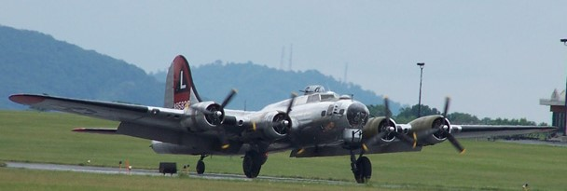

Photo 5. North American B-25 Mitchell bomber (MAAM 2007)

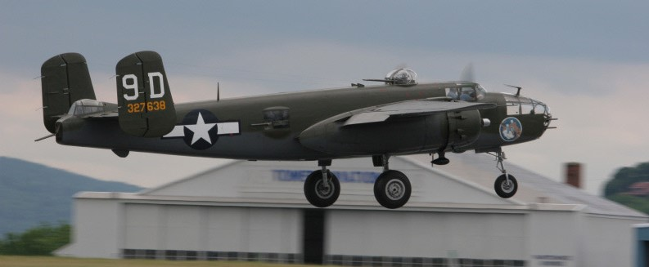

Table 2. Monthly Aviation Gasoline Production 1939-1945

|  |  |  |  |  |  |  |  |  |  |  |  |  |  |  |
| --- | --- | --- | --- | --- | --- | --- | --- | --- | --- | --- | --- | --- | --- | --- |
| Thousands of Barrels |  |  |  |  |  |  |  |  |  |  |  |  |  |  |
| 1939 | Jan | Feb | Mar | Apr | May | June | July | Aug | Sept | Oct | Nov | Dec | Total | 1939 |
| Production | no data |  |  |  |  |  |  |  | no data | 981 | 8,435 | 1,048 | 9,400 | Production |
| Transfers to regular motor gasoline |  |  |  |  |  |  |  |  |  | 0 | 0 | 0 | no data | Transfers to regular motor gasoline |
| Exports |  |  |  |  |  |  |  |  |  |  |  |  |  | Exports |
| Anti-knock compound |  |  |  |  |  |  |  |  |  | 0 | 0 | 0 | no data | antiknock compound |
| Other |  |  |  |  |  |  |  |  |  | 287 | 274 | 372 | no data | Other |
| Total Exports |  |  |  |  |  |  |  |  |  |  |  |  | 4,200 | Total Exports |
| US Domestic demand |  |  |  |  |  |  |  |  |  | 234 | 467 | 518 | 3,000 | US Domestic demand |
| 1940 | Jan | Feb | Mar | Apr | May | June | July | Aug | Sept | Oct | Nov | Dec | Total | 1940 |
| Production | 952 | 1,022 | 1,347 | 1,441 | 1,185 | 1,041 | 1,148 | 1,255 | 1,161 | 1,279 | 1,593 | 1,312 | 14,736 | Production |
| Transfers to regular motor gasoline | 0 | 0 | 0 | 0 | 0 | 0 | 0 | 0 | 20 | 89 | 344 | 270 | 723 | Transfers to regular motor gasoline |
| Exports |  |  |  |  |  |  |  |  |  |  |  |  |  | Exports |
| Anti-knock compound | 23 | 154 | 87 | 18 | 72 | 106 | 24 | 187 | 145 | 132 | 178 | 77 | 1,203 | antiknock compound |
| Other | 155 | 125 | 249 | 302 | 415 | 540 | 186 | 382 | 156 | 159 | 357 | 420 | 3,446 | Other |
| Total Exports | 178 | 279 | 336 | 320 | 487 | 646 | 210 | 569 | 301 | 291 | 535 | 497 | 4,649 | Total Exports |
| US Domestic demand | 504 | 397 | 457 | 761 | 362 | 641 | 741 | 371 | 602 | 701 | 612 | 509 | 6,658 | US Domestic demand |
| 1941 | Jan | Feb | Mar | Apr | May | June | July | Aug | Sept | Oct | Nov | Dec | Total | 1941 |
| Production |  |  |  |  |  |  |  |  |  |  |  |  | 21,100 | Production |
| Transfers to regular motor gasoline |  |  |  |  |  |  |  |  |  |  |  |  | 0 | Transfers to regular motor gasoline |
| Exports |  |  |  |  |  |  |  |  |  |  |  |  |  | Exports |
| Anti-knock compound |  |  |  |  |  |  |  |  |  |  |  |  | 0 | antiknock compound |
| Other |  |  |  |  |  |  |  |  |  |  |  |  | 0 | Other |
| Total Exports |  |  |  |  |  |  |  |  |  |  |  |  | 7,500 | Total Exports |
| US Domestic demand |  |  |  |  |  |  |  |  |  |  |  |  | 10,200 | US Domestic demand |
| 1942 | Jan | Feb | Mar | Apr | May | June | July | Aug | Sept | Oct | Nov | Dec | Total | 1942 |
| Production 100 Octane & above |  |  |  |  |  |  |  |  |  |  |  |  | 28,591.70 | Production 100 Octane & above |
| Other avgas grades |  |  |  |  |  |  |  |  |  |  |  |  | 16,820.40 | Other avgas grades |
| Exports |  |  |  |  |  |  |  |  |  |  |  |  |  | Exports |
| Anti-knock compound |  |  |  |  |  |  |  |  |  |  |  |  | 0 | antiknock compound |
| Other |  |  |  |  |  |  |  |  |  |  |  |  | 0 | Other |
| Total Exports |  |  |  |  |  |  |  |  |  |  |  |  | 0 | Total Exports |
| US Domestic demand |  |  |  |  |  |  |  |  |  |  |  |  | 0 | US Domestic demand |
| 1943 | Jan | Feb | Mar | Apr | May | June | July | Aug | Sept | Oct | Nov | Dec | Total | 1943 |
| Production 100 Octane & above |  |  |  |  |  |  |  |  |  |  |  |  | 62,044 | Production 100 Octane |
| Other avgas grades |  |  |  |  |  |  |  |  |  |  |  |  | 44,179 | Other avgas grades |
| Transfers out |  |  |  |  |  |  |  |  |  |  |  |  | 2,175 | Transfers out |
| Total Exports |  |  |  |  |  |  |  |  |  |  |  |  | 23,516 | Total Exports |
| US Domestic demand all grades |  |  |  |  |  |  |  |  |  |  |  |  | 79,944 | US Domestic all grades |
| Total demand by grades |  |  |  |  |  |  |  |  |  |  |  |  |  | Total demand by grades |
| 100-Octane & Above |  |  |  |  |  |  |  |  |  |  |  |  | 60,992 | 100-Octane & Above |
| Other finished |  |  |  |  |  |  |  |  |  |  |  |  | 37,929 | Other finished |
| Components |  |  |  |  |  |  |  |  |  |  |  |  | 4,539 | Components |
| 1944 | Jan | Feb | Mar | Apr | May | June | July | Aug | Sept | Oct | Nov | Dec | Total | 1944 |
| Production 100 Octane & above | 7,483 | 8,291 | 8,733 | 9,761 | 10,414 | 11,502 | 12,414 | 13,092 | 12,914 | 14,597 | 12,798 | 14,131 | 136,130 | Production 100 Octane (Includes 98 & 99 Octane) |
| Other avgas grades | 5,482 | 4,575 | 5,734 | 5,434 | 5,455 | 5,145 | 4,878 | 5,442 | 5,465 | 4,597 | 3,861 | 4,185 | 60,253 | Other avgas grades |
| Transfers out | 172 | 221 | 410 | 413 | 360 | 417 | 152 | 240 | 248 | 231 | 497 | 582 | 3,943 | Transfers out |
| Total Exports | 3,290 | 3,241 | 3,573 | 4,060 | 4,215 | 6,105 | 5,317 | 6,707 | 5,622 | 7,095 | 4,150 | 3,775 | 57,150 | Total Exports (does not include 80/87 avgas) |
| US Domestic demand all grades | 8,703 | 9,815 | 10,747 | 9,819 | 10,979 | 11,053 | 12,687 | 10,861 | 11,977 | 10,809 | 13,102 | 12,076 | 132,628 | US Domestic all grades |
| Total demand by grades |  |  |  |  |  |  |  |  |  |  |  |  |  | Total demand by grades |
| 100-Octane & Above | 7,408 | 8,468 | 8,529 | 9,065 | 10,064 | 11,881 | 12,746 | 12,705 | 12,443 | 13,928 | 13,848 | 13,055 | 134,140 | 100-Octane & Above |
| Other finished | 4,011 | 4,049 | 5,511 | 4,549 | 4,657 | 4,887 | 4,801 | 4,398 | 4,638 | 3,585 | 2,835 | 2,295 | 50,216 | Other finished |
| Components | 574 | 539 | 280 | 265 | 473 | 390 | 457 | 465 | 518 | 391 | 569 | 501 | 5,422 | Components |
| 1945 | Jan | Feb | Mar | Apr | May | June | July | Aug | Sept | Oct | Nov | Dec | Total | 1945 |
| Production 100 Octane & above | 14,731 | 13,673 | 15,644 | 15,531 | 16,525 | 15,332 | 15,364 | 12,454 | 3,566 | 970 | 278 | 147 | 124,215 | Production 100 Octane |
| Other avgas grades | 3,181 | 3,366 | 3,563 | 2,508 | 2,663 | 1,914 | 3,176 | 715 | 409 | 1,831 | 2,366 | 2,488 | 28,180 | Other avgas grades |
| Transfers out | 363 | 348 | 426 | 683 | 298 | 372 | 472 | 1,275 | 2,929 | 1,314 | 1,336 | 1,346 | 11,162 | Transfers out |
| Total Exports | 4,575 | 4,490 | 6,035 | 7,351 | 4,907 | 3,567 | 1,652 | 521 | 141 | 187 | 388 | 303 | 34,117 | Total Exports |
| US Domestic demand all grades | 11,698 | 10,166 | 12,853 | 13,673 | 13,233 | 13,489 | 14,761 | 13,084 | 9,586 | 2,399 | 1,191 | 867 | 117,000 | US Domestic all grades |
| Total demand by grades |  |  |  |  |  |  |  |  |  |  |  |  |  | Total demand by grades |
| 100-Octane & Above | 13,580 | 12,055 | 16,094 | 17,989 | 15,470 | 14,753 | 14,216 | 12,172 | 8,638 | 1,733 | 676 | 298 | 127,674 | 100-Octane & Above |
| Other finished | 2,072 | 2,011 | 2,096 | 2,260 | 1,872 | 1,869 | 1,653 | 1,137 | 807 | 721 | 686 | 709 | 17,893 | Other finished |
| Components | 621 | 590 | 698 | 775 | 798 | 434 | 544 | 296 | 282 | 132 | 217 | 153 | 5,540 | Components |

Figure 2. U.S. Aviation Gasoline Production 1939-1945



# Epilogue for the War Years in the US

The declaration of President Roosevelt that the United States of America would be the ‘Arsenal of the Free World’ would include all war materials and was to provide aviation gasoline to US armed forces and Allies, including the British Empire under the lend lease scheme; this proved to be a correct. The United States oil industry would provide the majority of the aviation gasoline to supply the Allies to defeat the Axis Powers. New aviation gasoline processes would be discovered, new aviation blending stocks would be found. After 1945 aviation gasoline production would never reach these levels again, because a new aviation fuel was to replace it. – JET FUEL. But that is a story for the next chapters.

Photo 6. Lockheed F-80 Shooting Star – first US combat jet aircraft



# Index

1

100-Octane 6, 7, 8, 9, 11, 12

100-octane gasoline 8

130 rich mixture 8

2

2-methyl pentane 6

8

80-octane 9

A

absorber oil 6

alkylation 5, 6, 7

alkylation plants 5

Allied Nations 10

anti-knock 8

anti-knock component 7

anti-knock compounds 4, 5, 6, 11

aromatic 6, 7

aromatisation 7

Avgas 100/130 8

Avgas 115/145 6

Avgas 91/96 8

aviation fuel 6, 7, 8

aviation gasoline 3, 4, 5, 6, 7, 8, 9, 10, 11, 13

aviation-base stocks 5

B

B-25 Mitchell 10

Bahamas 4

base stocks 8

Baytown Refinery 2

Bayway Standard Oil i

benzene 6

Bermuda 4

blending agents 5, 6

Boeing B-17 10

British Guiana 4

Bureau of Mines 9

butadiene 7

butane 5, 6, 7

butene 6

C

California 5, 6, 8

Caribbean islands 4

catalytic 6

catalytic cracking plants 5

catalytic process 7

catalytically cracked gasoline 6

codimer 5, 8

coking operations 7

Cracking capacity 5

crude 9

crude oil 5, 6, 7

Cumene 6, 8

D

distillation 8

Doolittle 8

E

East Indies 7

embargo 5

Ethyl Corporation 9

explosives 5, 7

exports 9, 10, 11, 12

F

France 5

G

German 5

Germany 7, 10

Gulf Coast Texas 8

H

high octane aviation fuel 8

high-octane gasoline 7

hydrofluoric acid 6

hydroforming 7

hydrogenation 5, 8

I

Illinois 5

Indiana 5

iso-butane 5, 6, 7

isomerisation 6

isomerized 7

iso-octane 6, 7

iso-octene 5

iso-paraffin 6

iso-pentane 5, 6

iso-pentane 6

isopropyl benzene 6

J

Jamaica 4

Japan 5, 7, 10

Jet Fuel 13

K

Kentucky 5

L

lean mixture 8

Lend-Lease 4

Louisiana 6, 8

Louisiana-Arkansas 8

M

motor 5

motor fuel 7

motor gasoline 4, 9, 11

motor grades 8

Motor Octane Number 6

MT-80 9

N

naphtha 7

naphthenic-base crude oils 6

natural gas 6

natural rubber 7

Navy 7

Netherlands Indies 5

Newfoundland 4

normal hexane 6

O

octane index 8

octane number 8

olefin 6, 7

P

paraffins 8

performance number 6

Petroleum Administration for War 8, 9

polymerisation plants 5

polymerization 7

Production 11, 12

propane 6

propylene 6

R

rationing 9

refineries 5

refinery construction 5

refinery operations 9

refrigeration 6

rich mixture 8

Roosevelt 4, 13

rubber 6

Russia 7

S

Shell 8

St. Louis Refinery 8

straight run gasoline 6

sulphuric acid 6

synthetic rubber 5, 7

T

TEL 6, 8

tetra-ethyl lead 6, 7, 9

Texas 6

Texas Gulf Coast 5

thermal alkylation 6

toluene 5, 7

U

United Kingdom 5

United States 7

W

War Department 7

Y

Yankee Lady 10

# Research Sources

1. Minerals Yearbook, Review of 1940, 1941, 1942, 1943, 1944, 1945 located at US San Francisco Public Library (accessed 2000).
2. World War II - Diplomatic History John L. Snell, Professor of History, Tulane University, access from web.