Chapter
28

After the War 1946-1950

Prelude to the ‘Cold War’
Photo 1. Commercial aircraft refuelling in U.S. 1946
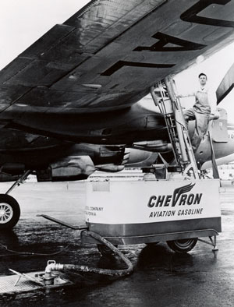

Table of Contents
Introduction 3
Chronology – World Aviation 3
Chronology – Australian Aviation Time Lines 8
World Events 11
Berlin Airlift 1948 13
Epilogue – Berlin Air Lift 21
Other Battles 22
Civil War In China 24
Surplus WWII Aircraft Used For Civilian Purposes 25
API Project No. 6 26
Aviation Gasoline Composition 1946 27
Aviation Gasoline Grades And Colours 27
Oil Companies And Refineries 27
Aviation Gasoline Production, Exports And Demand 1945-1948 33
“Airspeed Records Were Now Made By Jets” 35
The ‘Sound Barrier’ Is Broken 36
Epilogue For 1949 – The ‘Cold War’ Starts 37
Index 38
Research Sources 43
Photo 2. Bell X-1 “Glamorous Glennis” #46-062 Bell X-1 rocket-powered experimental aircraft (known for becoming the first piloted aircraft to fly faster than Mach 1, or the speed of sound, on October 14, 1947) photographed during a test flight.
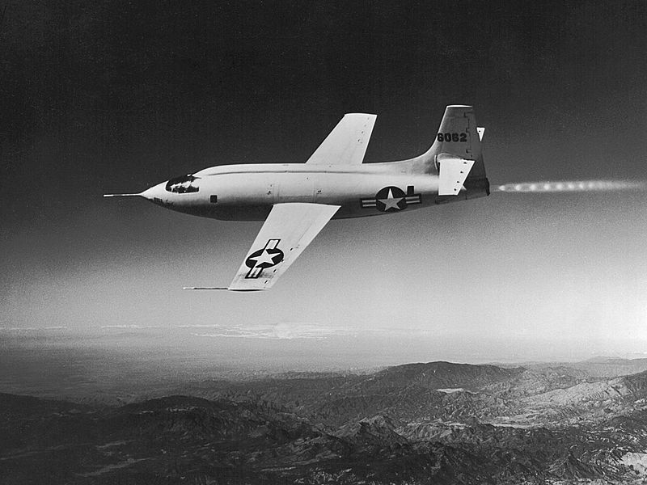

Introduction
The period after the Second World War was one of rapid expansion of civilian airlines and travel for the war-weary public. It was also a period of military development from the building of air forces for those countries emerging from the colonial rule of the British, Dutch and French. But it was also a period when those countries were seeking their independence from colonial rule, such as India, Pakistan, African colonies of the British, Belgians, French, and in the East - French Indo China, Malaya, and Dutch East Indies. These would lead to localised wars, insurrections and the advance of communism.
The captured knowledge treasure trove of German jet aircraft design, rocket propulsion and guided missiles would be exploited by the American, British and Russians.
Having seen the power of the atomic bombs dropped by the U.S. Army Air Forces B-29’s on the Japanese cities of Hiroshima and Nagasaki, other nations such as Britain, France and Russia, all wanted this nuclear capability – later, other nations such as Israel, China, India, Iraq, Iran and others would also seek to develop this nuclear capability.
The aviation records continued, helicopters were no longer an unusual innovation, but becoming part of the aviation’s normal operations; new developments such as ejector seats; new international aviation organisations, and the ‘Sound Barrier’ would be broken.
But a new threat was emerging, described by Winston Churchill as an “Iron Curtain” coming down over Europe, and separating those countries and areas under Soviet control, in particular, Berlin and Vienna. The actions of Soviet Russia to isolate Berlin from the west would result in the Allies response to this threat with the ‘Berlin Airlift”.

Chronology – World Aviation

World Aviation in 1946
26 January: Colonel William H. Council, piloting a Lockheed P-80 Shooting Star, makes a record breaking flight from Long Beach in Los Angeles to La Guardia in New York. It is the fastest crossing of the United States to date - 2,470 miles in 4 hours 13 minutes 26 seconds at an average speed of 584 mph. Also, the longest non-stop flight by a jet aircraft.
Photo 3. Bell Model 47 Helicopter
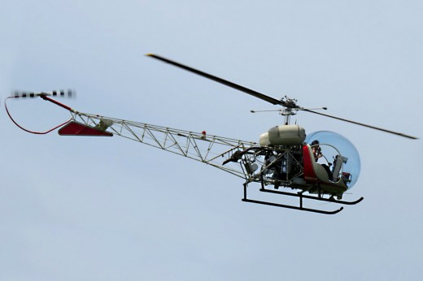

8 March: The Bell Model 47 is granted the first commercial helicopter certificate to be awarded by the United States Civil Aviation Authority.
21 March: The United States Army Air Force (USAAF) establishes its Air Defense Command, Strategic Air Command and Tactical Air Command.
1 June: A Pan American World Airways (Pan-Am) Lockheed Constellation lands at London Heathrow on the Airline's first scheduled New York to London service.
26 June: The United States Army Air Force (USAAF) and United States Navy (USN) officially adopt the knot and nautical mile as standard aeronautical units for speed and distance.
1 July: ‘Operation Crossroads’: a Boeing B-29 Superfortress of the United States Army Air Force (USAAF) drops an atomic bomb over 73 naval vessels anchored at Bikini Atoll in the Pacific Ocean.
21 July: A McDonnell XFD-1 Phantom jet takes off from, and lands on, an aircraft carrier, the USS Franklin D. Roosevelt, while she lies off Cape Henry in Virginia. The aircraft is piloted by Lieutenant Commander James J. Davidson.
25 July: Just over 10 years after his death, Brigadier General William 'Billy' Mitchell is posthumously awarded the United States Congressional Medal of Honour. [The U.S. Medium bomber, North American B-25 Mitchell bears his name].
17 August: Sergeant L. Lambert of the United States Army Air Force (USAAF) becomes the first person in the United States to make a manned test of an ejection seat. A Northrop P-61 Black Widow flying at 483 kph (300 mph) at 2,375 metres (7,800 feet) is used as the test aircraft.
11-12 September: The first post war meeting of the Fédération Aéronautique International (FAI).
29 September: A United States Navy (USN) Lockheed P2V Neptune crewed by Commander T. Davis and E.P. Rankin, sets a new non-stop world distance record of 18,081 kilometres (11,235 miles) flying from Perth in Australia to Columbus in Ohio.
1 October: The Belgian Air Force is re-established.
6 October: The first non-stop flight from Hawaii to Egypt over the North Pole is made in a Boeing B-29 Superfortress aircraft of the United States Army Air Force (USAAF), covering a distance of 17,498 kilometres (10,873 miles).

World Aviation in 1947
4 April: The International Civil Aviation Organisation (ICAO) is established with headquarters at Montreal in Canada.
3 July: The Philippine Air Force is re-established.
26 July: President Truman signs the United States Armed Forces Unification Act.
3 August: The first public appearance of the Tupolev Tu-4 heavy bomber takes place at the Soviet Aviation Day parade. The aircraft is a reverse engineered copy of the American Boeing B-29 Superfortress. (Refer to chapter 22 Russian Avgas for more detail)

Photo 4. Russian Tupolev Tu-4
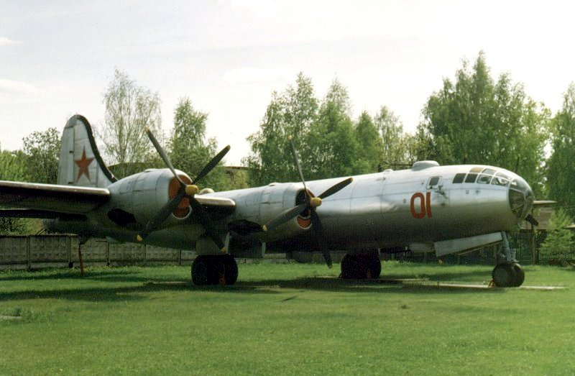
14 August: Following the partition of India, the Royal Pakistan Air Force is established. It drops Royal from its title on 23 March 1956.
18 September: The United States Air Force (USAF) is founded, and the new service becomes independent within a newly unified United States armed forces. The United States Air Force (USAF) was led by General Carl A. Spatz.
22 September: A United States Air Force (USAF) C-54 Skymaster makes a fully-automatic flight from Stephenville in Newfoundland to the United Kingdom.
14 October: The Bell X-1 rocket-powered aircraft, piloted by Captain Charles 'Chuck' Yeager, becomes the first to exceed the speed of sound in level flight. It reaches a speed of Mach 1.015 or 1,078 kph (670 mph) at an altitude 12,800 metres (42,000 feet).
Photo 5. Bell X-1 “Glamorous Glennis” with Chuck Yeager
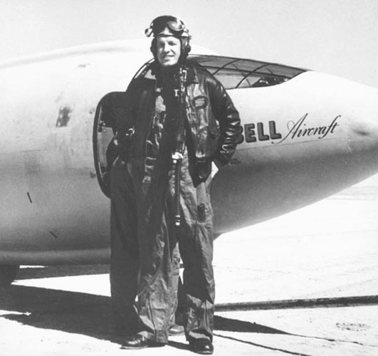

World Aviation in 1948
30 January: Orville Wright dies at Dayton in Ohio, aged 76.
4 February: The United States Air Force (USAF) Military Air Transport Service (MATS) is established.
Photo 6. USAF MATS Douglas C-54 Skymaster (Petroch Services PIMA 2004)
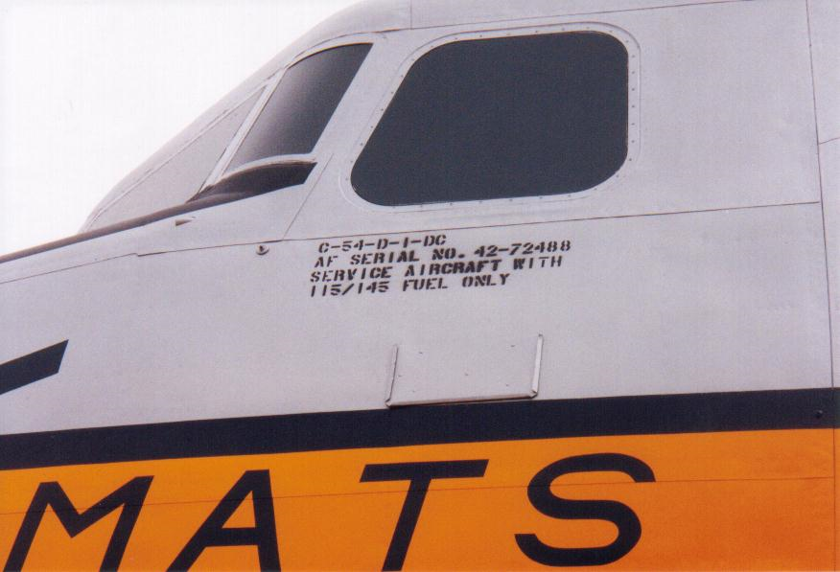
1 April: Railway passenger traffic between Berlin and West Germany is cancelled by Soviet military authorities.
5 May: The first carrier-based jet squadron, United States Navy (USN) 17A, is established with sixteen Phantoms and operates from the USS Saipan from 5 to 7 May.
20 May: The Israeli Air Force is in action against Arab forces for the first time.
18-19 June: All road traffic between Berlin and West Germany is halted by Soviet military authorities.
24 June: For 'technical reasons', the Soviet military authorities stop all rail services between Berlin and West Germany.
26 June: The first airlift of supplies into Berlin is organised by the United States Air Force (USAF), using C-47s based at Frankfurt. This marks the beginning of the Berlin Airlift.
28 June: British participation in Berlin Airlift operations begin.
20 July: The first west to east crossing of the North Atlantic by turbojet powered aircraft is recorded by sixteen Lockheed F-80 Shooting Stars. They fly from Selfridge Field in Michigan to Scotland.
23 July: The United States Air Force (USAF) Military Air Transport Command is ordered to establish an Airlift task force for the possible long term support of Berlin and its citizens.
21 August: C-54 Skymasters of the United States Air Force (USAF) Military Air Transport Command begins operations on the Berlin Airlift.
5 September: The United States Navy's Caroline Mars flying boat airlifts a record 28,390 kilos (62,262 pounds) of cargo from the Patuxent River base to Cleveland in Ohio.
14 September: Royal Australian Air Force (RAAF) crews join the Berlin Airlift operations.
Photo 7. RAAF Dakota at Gatow Airport, Berlin (Petroch Services 2018)
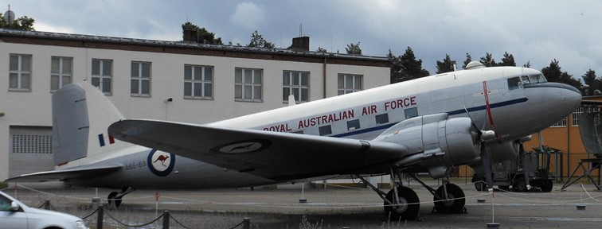
15 October: The Royal Air Force (RAF) and United States Air Force (USAF) combine their efforts on the Berlin Airlift as an Airlift task force.
16 October: South African Air Force crews join the Berlin Airlift operation.
3 November: Royal New Zealand Air Force (RNZAF) crews join the Berlin Airlift operation.
December 8: A United States Air Force (USAF) Consolidated B-36 completes a 15,128 kilometre (9,400 miles) un-refuelled, non-stop flight from Fort Worth in Texas to Hawaii and back again.
17 December: The 45th Anniversary of the first powered flight by the Wright brothers is celebrated by the return to the Smithsonian Institution of the original Wright Kitty Hawk Flyer which had been on display in the London Science Museum for many years.
29 December: The United States Defence Secretary announces that work has begun on 'an earth satellite vehicle program'.

World Aviation in 1949
4 February: The United States Civil Aviation Authority (CAA) authorises the use of Ground-Controlled Approach (GCA) radar as a primary landing aid in bad weather.
24 February: Termination of the Arab-Israeli war is confirmed by an Armistice signed on the island of Rhodes.
26 February - 2 March: The first non-stop round the world flight is made by the United States Air Force (USAF) Boeing B-50 'Lucky Lady II', piloted by Captain James Gallagher. The aircraft is refuelled in flight four times during its 94 hours flight and covers a distance of 37,742 kilometres (23,452 miles).
30 March: A Federal bill in the USA authorises the establishment of a permanent radar defence network.
4 April: The North Atlantic Treaty Organisation (NATO) is established, following the signature of twelve nations at Washington DC. It becomes effective on 24 August 1949.
16 April: The peak day of the Berlin Airlift - 1,398 sorties carry 12,940 tons of supplies in a 24 hour - period.
26 April: A flight-refuelled world endurance record is completed in the United States, when Bill Barris and Dick Reidel, flying an Aeronca Chief light plane 'Sunkist Lady', stay airborne for 1,008 hours 1 minute (one minute over six weeks). Fuel and food were hauled up daily from a Jeep speeding below.
1 May: The Air Arm, Hong Kong Defence Force is established with Royal Air Force (RAF) assistance. It adopts the title Royal Hong Kong Auxiliary Air Force in 1970.
12 May: The Soviet Union ends the blockade of Berlin, but the Allied airlift continues until 30 September 1949 to build up stocks in the city.
18 May: The first New York helicopter station is established at Pier 41 East River.
21 May: A Sikorsky S52 helicopter establishes a new helicopter altitude record of 6,468 metres (21,220 feet) over Stratford in Connecticut.
26 June: The first anniversary of the Berlin Airlift - 1.8 million tons of supplies has been airlifted in.
9 August: The first use in the United States of an ejection seat for an emergency escape from an aircraft. Lieutenant J.L. Fruin of the United States Navy (USN) ejects from a McDonnell F2H-1 Banshee flying in excess of 925 kph (575 mph) near Walterboro in South Carolina.
10 August: The first jet airliner air mail is flown in a Canadian Avro Jetliner from Toronto to New York.
23 September: The Soviet Union detonates its first atomic bomb and ends the United States nuclear monopoly.
30 September: The Allied Berlin Airlift ends. During 15 months of operation, 2.25 million tons of supplies and equipment have been flown into Berlin.
18 November: C-74 Globemaster I of the United States Air Force (USAF) Military Air Transport Service (MATS) lands at Marham in Norfolk U.K. after a non-stop flight from the United States. It carries a total of 103 passengers and crew, which is a record at the time for people crossing the North Atlantic in a single flight.

Chronology – Australian Aviation Time lines
1946 Feb. 9: Australian National Airlines (ANA) first Douglas DC-4, ‘Amana’, was delivered to Melbourne, Vic. from San Francisco. [Tragically destroyed in 26 June 1950, after it departed from Perth, Western Australia for an eight-hour flight to Adelaide, South Australia. It crashed 22 minutes after take-off, 35 miles (56 km) East from Perth Airport. All but one of the 29 occupants were killed in the accident and the sole survivor died six days later. It was the worst civil aviation accident in Australia.]
March 4: Commonwealth Aircraft Corporation (CAC) test pilot J. Schofields made the first test flight in the CA-15 at Fishermen's Bend, Vic. It was the fastest piston engined fighter to fly in Australia, at 721 km/hr. (448 mph) unfortunately, the world was looking to jet powered fighters, and the RAAF had already received the North American P-51 Mustang as its principle pre-jet fighter. Only one prototype CA-15 was built.

Photo 8. Commonwealth Aircraft Corporation CA-15
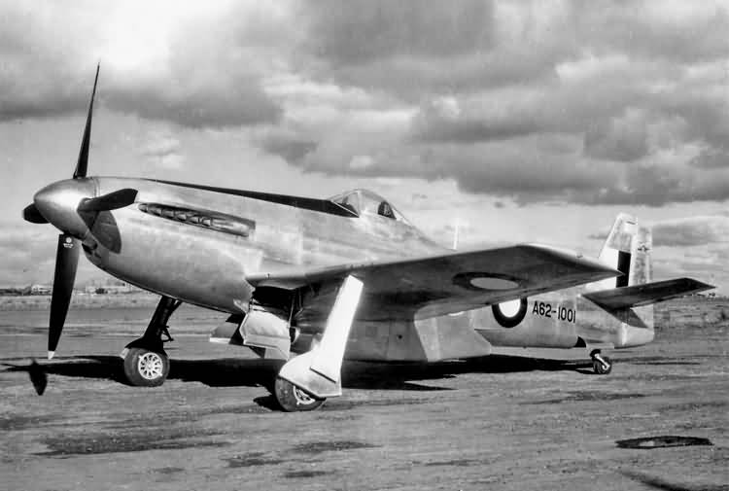
March 9: Occupation duties in Japan began for No. 76 Squadron RAAF, with a force of 12 Mustangs at Iwakuni. A total of 120 aircraft from No. 76, No. 77 and No. 82 Squadrons would arrive, making up the RAAF's largest ferry flight.
March 17: the first Avro Lincoln assembled by the Government Aircraft Factories was tested at Fishermen's Bend.
Photo 9. RAAF Avro Lincoln
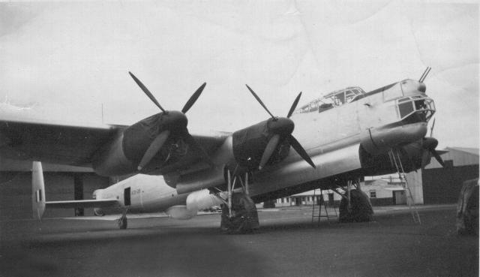
Avro Lincoln Mk. 30A A73-29 with engine tarps and wheel drip covers in place, RAAF Base Wagga, NSW, 1949. This aircraft flew with No. 1 Squadron in anti-terrorist operations in Malaya during the 1950’s. It was used in rainmaking experiments in 1958, and was down for disposal late in 1959.
April 9: An Avro Lancastrian made the first Kangaroo Route flight from Australia to England. [The Avro Lancastrian was the civilian passenger version of the famous wartime Lancaster bomber].
In June, the first jet-engined aircraft in Australia, a RAAF Meteor F.4 was flown by Squadron Leader. D.R. Cuming at RAAF Laverton.
Trans Australia Airlines (TAA) began operations with their daily Sydney-Melbourne flight, using DC-3 ‘Hawdon’ flown by Capt. J. Hepburn.
1947 May: The first RAF De Havilland. Vampire jet fighters arrived for evaluation, prior to manufacture in Australia.
Oct. 3: A Sikorsky S-51, the RAAF's first helicopter, was test flown at Laverton, Vic.
Dec. 1-5: The first through-service between Australia and England was flown by a Qantas Empire Airways.
1948 Jan 23: The prototype DHA Drover, a trimotor relative of the DH Dove, was test-flown. The first Drover was delivered to Qantas Empire Airways in September 1950.
Photo 10. De Havilland Drover
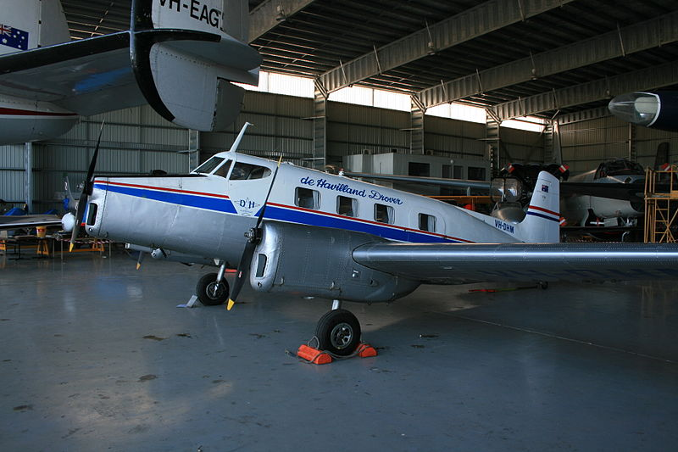
June 1: ‘Operation Firedog’ – RAF operations commence against terrorists in Malaya in support of the security forces.
Sept. 14: RAAF contingent flew RAF Dakotas on the Berlin airlift until the end of August 1949.
Oct. 18: Pressurised Consolidated Convair 240’s were introduced by TAA on the Melbourne-Brisbane route.
November: Australian National Airlines and MacRobertson Miller Airlines form Air Beef Pty. Ltd., to transport beef from remote cattle stations in the northwest, using Bristol Freighters, to Wyndham.
Photo 11. Bristol Freighter at RAAF Museum Point Cook (Petroch Services 2005)
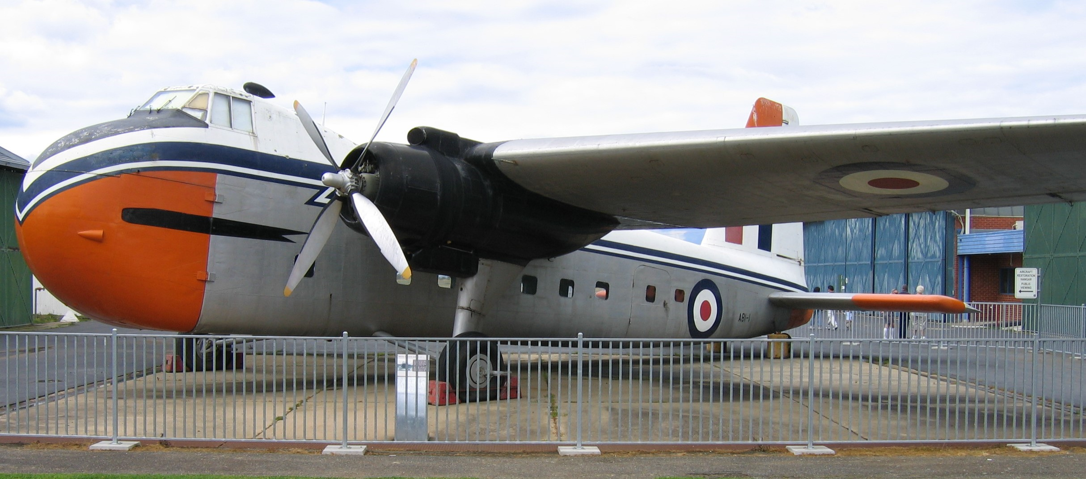
1949 April 2: TAA took over several outback air services from Qantas Empire Airways, as well as the Flying Doctor Services operating from out of Cloncurry and Charleville.
June 29: The RAAF's first Australian-built jet, the DHA Vampire F.30, was flight tested at Bankstown, NSW. On Sept. 26 the first DHA Vampire was delivered to the RAAF.
Photo 12. RAAF De Havilland Vampire A97-1
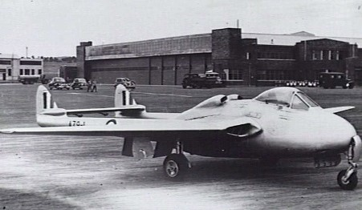
Photo 13. Lufthansa Convair 240 being refuelled from Shell tanker
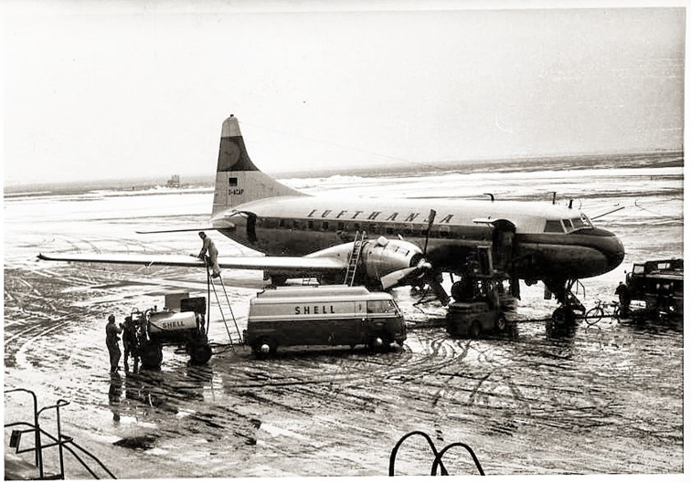
Not only had the passenger airliners become pressurised, but they would soon introduce aircraft with jet engines and propellors – the ‘Turboprop’ engine powered by jet fuel.

World Events
After the Second World War in which so much loss of life and destruction had occurred in Europe, and the devastation of Japan by atomic bombing, the world needed a period of reconstruction and return to normality. Millions of service men were discharged into civilian life, millions of Europeans were displaced, and the ‘Iron Curtain’ was starting to form. Germany was a divided country; Berlin was a divided city of four zones – American, British, French and Russian.
Figure 1. Partition of Berlin into the four zones
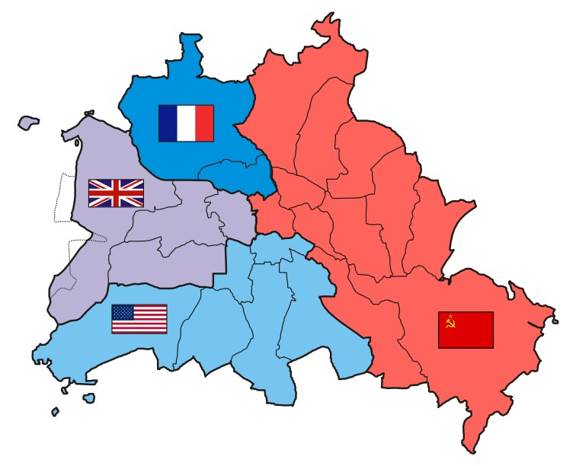
The most famous crossing between the American and Russian zones of Berlin was “Checkpoint Charlie” which still exists today as a tourist attraction, and was part of many movies from there on.
Photo 14. ‘Checkpoint Charlie’ (circa 1948) during a stand–off between American Army and Russian forces.
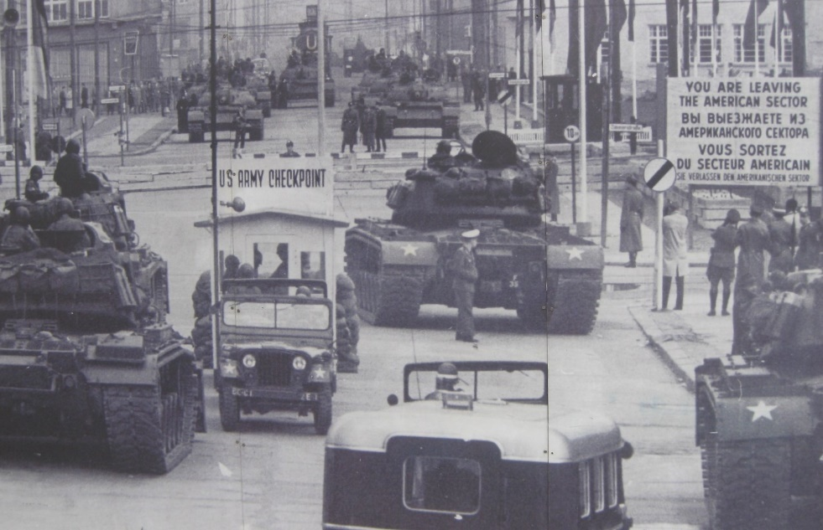

Berlin Airlift 1948
The Berlin Airlift in 1948 saw the involvement of nearly every available British, Commonwealth and U.S. military cargo aircraft. The transport aircraft of R.A.F., R.A.A.F., U.S. Air Force and U.S. Navy were all involved. Such an airlift required enormous supplies of avgas at a time when avgas production had been earlier changed over to motor gasoline production.

The Cause
Entry to Berlin from the West was by three rail routes, one major and two minor roads and by air. All these routes were carefully monitored by the Russians and as tension between the two sides escalated the Soviets announced, on 31 March 1948, that all road traffic would be subject to inspection.
The following day an American military train was stopped and inspected. The Americans immediately responded to the disruption by flying in all military supplies to support their garrison within the city. Following the Western Allies’ announcement of their intention to create a single unified West German state, the Russians stopped all traffic into Berlin on 15 June 1948. Four days later the British Air Forces of Occupation drew up a plan for the re-supply by air of their forces within the city. One of the reasons for the creation of a unified West German state was to introduce a new currency, the “Deutschmark”, in order to stabilize the currency and halt the rampant ‘black market’ trade
On June 24, all road and rail were formally cut and at the same time the Russians announced that they would no longer supply food to the 2½ million people living in the Western sector of Berlin. Their survival now depended on the ability of the R.A.F., U.S.A.F. and civilian organisations to supply Berlin by air alone.

The Response
The original idea for the Airlift came from the British who, even before the Soviet blockade, had produced an outline plan for an Anglo-American airlift to sustain Berlin. As the crisis developed RAF Transport Command began bringing in Dakotas from the United Kingdom to the German airfields of Wunstorf and Fassberg. On June 26 the RAF ordered the Airlift to begin and during the first twenty-four hours British Dakotas moved 39,900 kg. (44 tons). Two days later Avro Yorks joined the Dakotas in Germany. The population of Berlin needed about 31,800 kg. (35 tons) of salt a day as a dietary supplement in cooking to maintain health and on 5th of July Sunderland flying boats began flying from Hamburg to the Berlin Lakes. These flying boats were used as they had been designed to operate in a salt-water environment and had an anti-corrosion treatment not present on other aircraft. Five days later the first York sortie flew into Gatow.
Dakota numbers were increasing as quickly as new transport units could be activated. For crews the RAF often had to turn to the Commonwealth and very soon Australian, New Zealand and South African personnel were involved.
Photo 15. U.S. C-47 aircraft unloading in Berlin 1949
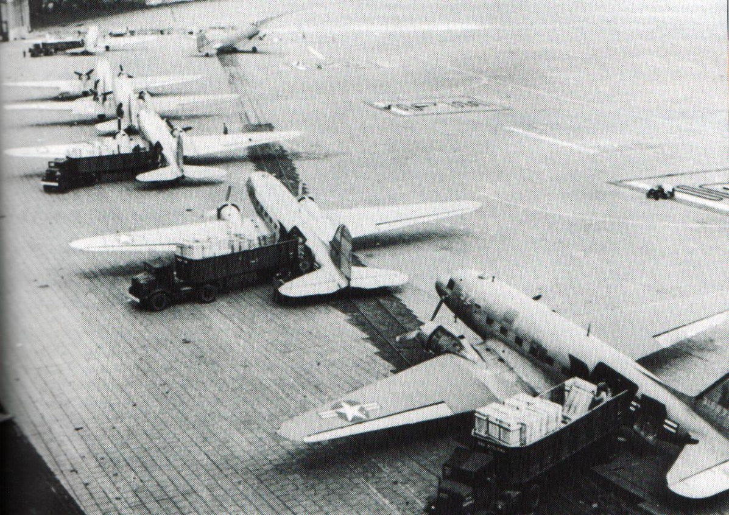
The first RAF Hastings sorties were made on 11 November. These new British assets more than compensated for the withdrawal of the RAF Sunderlands on 14 December due to the threat of ice on the Berlin lakes. The strain on RAF Transport Command was significant; almost all other activities were suspended during the Airlift. The last RAF Airlift flight took place on 23 September 1949.
Photo 16. RAF Sunderland flying boat unloading in Berlin 1948
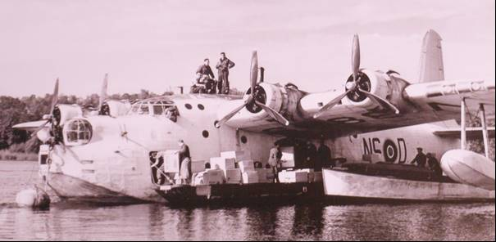
The airlift was not completed without cost. The RAF lost three Dakotas, one York and a Hasting. Eighteen Service personnel and seven German passengers were killed.
To run the Airlift a joint Anglo-American organisation was formed on 15 October 1948. Known as the Combined Air Lift Task Force (CALTF). It was intended to ease the problems of scheduling and coordinating the operation. CALTF was commanded by an American General William H Turner, who had been responsible for the organisation of a massive WWII airlift to South-East Asia from Assam (Burma) over the “Hump” (Himalayas) into China.
The British called the Berlin Airlift operation “Plane Fare”, while to the Americans it was “Operation Vittles”.
With the increasing number of aircraft flying into and out of Berlin it quickly became necessary to organize a flow pattern in the three air corridors to Berlin. The Americans flew in on the southern corridor and out through the central one. The British flew in and out at different heights via the northern corridor and also out through the central corridor. Differing types of aircraft were integrated into a steady stream by flying them at differing heights and dispatching them at timed intervals. This required a complex but efficient air traffic control system particularly when landing separation times at Berlin came down to 3 minutes.
The operation was a considerable achievement in planning and logistical support. To keep up with the demands of the Airlift, equipment had to be used as intensively as in war. This level of activity generated a huge maintenance task. Support organisations in the United Kingdom and in the United States had seen no comparable demands since the end of the Second World War in 1945. The RAF quickly established RAF Honington in Suffolk as its main UK spares and maintenance base for RAF Dakotas and created a special flight of six aircraft whose only task was to continually fly spares into RAF transport bases in Germany. This station became the centre of the vital ‘hub and spoke’ supply system for RAF airlift spares.
The Americans used their huge support base at RAF Burtonwood near Liverpool as the support hub for their units but aircraft requiring 1,000-hour overhauls were flown back to the United States.

U.S. MATS – Berlin Airlift 1948
The participation by the U.S. Navy in the Berlin Airlift was described as follows by Dr. Jeffrey G. Barlow, Contemporary History Branch, Naval Historical Center.
“The Soviet blockade of Berlin became complete on 24 June 1948. That same day, General Lucius Clay, Commander of U.S. Occupation Forces and Military Governor of the U.S. Zone of Germany, directed his air commander, Major General Curtis LeMay, to employ all available transport aircraft to supply the city by air.
On 26 June, President Truman directed that Clay's improvised aerial re-supply plan be put on a regular basis and that all available transport aircraft in the European Command be pressed into service.
On 22 July 1948, General Clay reported to the National Security Council (NSC) that he could meet the summertime needs of Berlin with an airlift of 3,500 tons a day, but that coal shipments required for winter heating would increase this figure to 4,500 tons once cold weather began. Clay told the NSC that he could meet the figure of 3,500 tons a day if he were given an additional 75 four-engined C-54 Skymaster transport aircraft to augment his existing fleet of 52 C-54s and 80 twin-engined C-47 Dakotas. Despite the concerns of Air Force Chief of Staff Hoyt Vandenberg that such an increase would disrupt worldwide Military Air Transport Service (MATS) operations, the NSC and President Truman approved assigning the additional C-54s to the airlift.
Accordingly, on 23 July, General Vandenberg ordered nine MATS squadrons (81 C-54 aircraft) to Germany and directed the establishment of a special task force to direct the airlift under the Commander in Chief, U.S. Air Forces in Europe. On 29 July, Major General William Tunner assumed command of Airlift Task Force (Provisional).”

Photo 17. C-54 Skymaster on display at PIMA Air Museum, Tucson, Arizona USA (Petroch Services 1998)
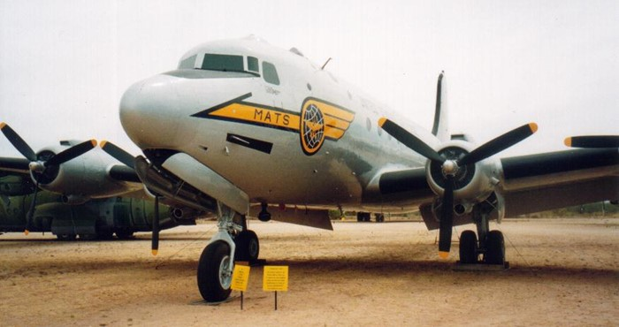
On 10 September, General Clay requested 116 additional C-54s - 69 to be made available by 1 October and the remaining 47 by 1 December 1948 - so that he could build up a stockpile of supplies for the winter months and could raise the daily tonnage total for Berlin up to an average of 4,500 tons. In response to this request, Washington decided to augment the Berlin airlift by 50 additional C-54s.
On 24 September, Clay strongly restated his appeal for the full 116 aircraft. After conducting a thorough reappraisal of U.S. objectives in Berlin, the NSC finally approved the recommendations of the Joint Chiefs of Staff for an immediate reinforcement of the airlift, and, on 22 October, President Truman approved the expansion of the airlift by the additional 66 C-54s that Clay wanted.
This is when the U.S. Navy became fully involved in the Berlin airlift. Although Navy tankers had been delivering huge quantities of aviation gasoline to Bremerhaven, Germany, to furnish fuel for the airlift since the beginning of the blockade, its planes heretofore had not been involved in the aerial supply effort. The new increase called for, however, would bring the use of C-54s in the airlift up to approximately 52% of the total number of such aircraft in the country's operational inventory - thus seriously reducing MATS support for implementing the military's emergency war plans. Because of his concerns over this situation, U.S. Air Force Secretary Stuart Symington asked U.S. Navy Secretary John Sullivan to provide the Navy's three MATS squadrons to the Airlift Task Force as part of the latest augmentation. The U.S. Navy readily agreed to this request.
On 27 October 1948, the Commander, Military Air Transport Service, with the concurrence of Chief of Naval Operations Louis Denfeld, ordered Navy MATS units Transport Squadrons (VRs) 6 and 8 to 180 days temporary additional duty (TAD) with the Airlift Task Force for participation in Operation Vittles (as the airlift was designated). At the time, both squadrons were assigned to MATS routes in the Pacific, VR-6 stationed at Guam and VR-8 based in Honolulu. Transport Squadron 8 got the word that same day, and on 29 October its first group of six R5D (C-54) aircraft took off for California. Transport Squadron 6 on Guam received its orders on 30 October, and on 1 November its first contingent of four aircraft left for the West Coast.
The planes of both squadrons assembled at Moffett Field, California, for pre-employment work-ups. At Moffett, high-engine-time R5Ds were exchanged or were reconditioned and inspected, and all planes were winterized. In addition, VR-6, which had a shortage of four aircraft, was provided with the additional planes to bring it up to its authorized strength of twelve aircraft. Once they were readied, the aircraft of the two squadrons took off for NAS Jacksonville, where APS-4 radars were installed. From Jacksonville they flew to Westover Air Force Base, Massachusetts, for movement to Germany. VR-8's last plane flew into Rhein-Main Air Base on 15 November, and VR-6's final aircraft arrived a week later, on 22 November.
In addition to the two Navy MATS squadrons stationed in Germany as part of the Airlift Task Force, the third Navy MATS squadron, the fifteen-plane-strong VR-3, provided transatlantic support to Operation Vittles, flying from the U.S. East Coast. Also, VR-44, a Navy transport training squadron that was not part of MATS, provided pilot training for replacement crews destined for the Navy MATS squadrons in Germany and training for personnel needed to man the expanded overhaul facility. In the meantime, Marine Transport Squadron 352 had been ordered by the Chief of Naval Operations to report to the commander of the Military Air Transport Service's Pacific Division to take over, within its fifteen-plane capability, the Pacific airlift duties that VR-6 and VR-8 had been handling.
The two Navy squadrons in Germany quickly made themselves known to their Air Force counterparts. The winter weather in Germany proved extremely trying for all of the squadrons engaged in the airlift, with cold fogs often blanketing Berlin. It was routine during these months for the aircraft to fly east and west through the air corridor on instruments and to make ground control approaches (GCA) at both Berlin's Tempelhof Airport and Rhein-Main. Fortunately for the Navy planes, their crews had been required to make all their approaches on GCA during the years that they had been part of the Naval Air Transport Service (NATS), and so they were, on average, more skilled in instrument flying than were their Air Force counterparts.
Although their planes had been averaging six hours a day in flying time in the Pacific, VR-6 and VR-8 arrived in Germany fully manned with skilled maintenance personnel prepared to maintain a schedule of eight hours a day per aircraft. This substantial increase in flight hours, however, was soon being regularly surpassed. During the first two weeks of flying the air route from Rhein-Main to Tempelhof, the two squadrons carried a total of 6,526 tons of cargo. By the end of December 1948, VR-8 was leading all squadrons in the airlift in every measurable phase of air transport operation, including aircraft utilization, total cargo carried, payload efficiency, and tons per plane. VR-6 was not far behind, though, being engaged for several weeks in a battle for second place with the two top Air Force squadrons. By the end of February 1949, VR-6 was equalling and frequently exceeding VR-8 in operational achievements. During April 1949, the two squadrons flew a combined total of 8,234 hours (an aircraft utilization rate of 13.1 hours per plane per day) and delivered 23,550 tons of food and coal to Berlin.
After several months of on-and-off-again negotiating, the Soviet Union finally agreed to end its blockade of Berlin if the three Western powers (Great Britain, France, and the United States) agreed to terminate their restrictions on trade with East Germany and East Berlin. On 5 May 1949, the four governments issued a communique announcing that the blockade would end on 12 May. The blockade was lifted on the day agreed upon.
On 30 July, an official announcement was made that the airlift would end on 31 October 1949. The two Navy squadrons were released from their duties with the Airlift Task Force in mid-August and returned to the continental United States. After having its aircraft reconditioned by the Fleet Logistic Support Wings at Moffett Field, VR-6 was stationed at Westover Air Force Base for operation with MATS between Westover and Rhein-Main, Germany. The reconditioned planes of VR-8 returned to their old base in Honolulu for duties on MATS Pacific routes.
During the months that VR-6 and VR-8 operated in Germany, their aircraft flew 45,990 hours, carrying 129,989 tons of cargo into Berlin and averaging 10.1 flight hours per plane per day for the entire period. Even though the twenty-four aircraft of the two squadrons had not been involved during the first three months of the Berlin airlift, by the end of Operation Vittles they had managed to deliver some 7.3 percent of the total tonnage flown into the besieged city by U.S. aircraft. It was a masterful achievement.
The U.S. Effort During the Airlift - A total 2.325 million tons of food, fuel, and supplies were delivered during the airlift. The other 0.542 million tons were carried by British aircraft.
Operational Aircraft (Average No.): 225
Tonnage Delivered (June 1948-Sept 1949): 1.783 million tons
Photo 18. Berlin children await the arrival of supplies - U.S. C-54 Skymaster 1948
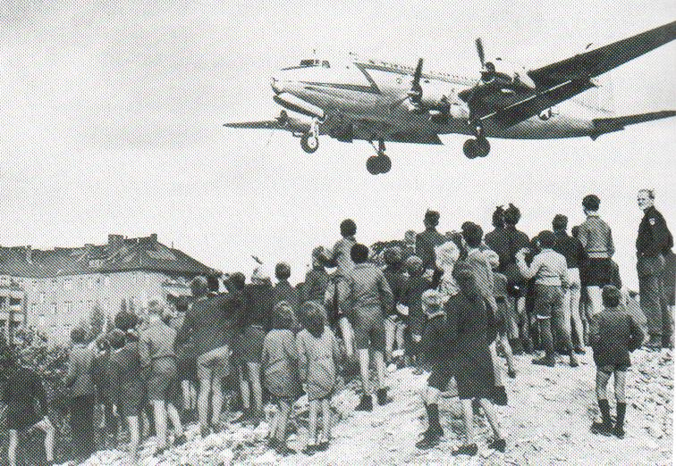

British Air Transport - Berlin Airlift
In addition to the US Air Force and U.S. Navy (MATS) aircraft, the British RAF were flying in supplies using Avro York transport aircraft (the transport based on the famous Lancaster), Douglas Dakotas (DC-3) and Handley-Page Hastings. In addition, Australia also participated in Berlin Airlift - on Sept. 14th 1948 the RAAF sent a contingent to fly RAF Dakotas (DC-3) until the end of August 1949.
Photo 19. British RAF Avro York transport aircraft await take off. 1949.
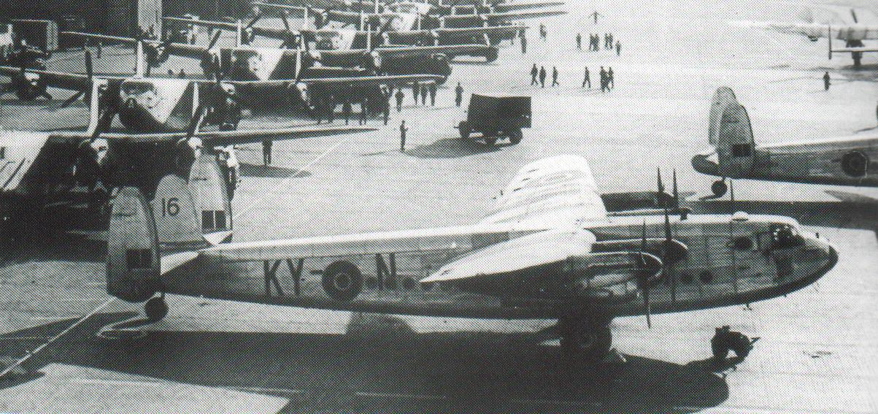
In 1999, at Duxford Air Museum an Avro York was being restored, this particular aircraft has seen service in the Berlin Airlift and traces of coal were still to be found in the crevices of the fuselage, some 50 years later.
Photo 20. RAF Hastings in service at Gatow airport during Berlin Airlift 1949.
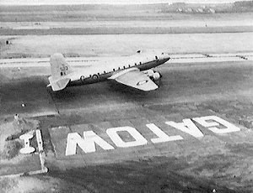
Two squadrons of RAF Hastings joined Operation ‘Vittles’ in the Berlin airlift.
Photo 21. Handley Page Hastings C1A on display at Duxford U.K. (Petroch Services 1999.)
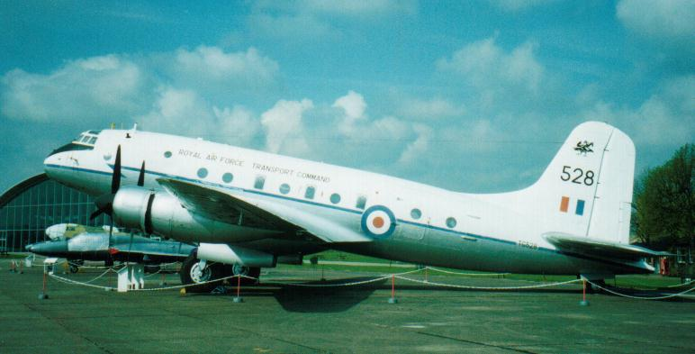

British Civil Aircraft - Berlin Airlift
As the tonnage requirements grew, the RAF realized it could not provide sufficient aircraft. British civilian aircraft were therefore chartered to make up the short fall. In mid-1948 British European Airways was appointed to coordinate the civil airlift. A collection of Douglas (DC-3) Dakotas, Haltons (a civilian variant of the RAF Handley-Page Halifax bomber), Avro Lancasters, Lancastrians (a civilian freighter variant of the RAF Avro Lancaster bomber), Avro Tudors, Hythe flying boats (a de-militarised version of the famous Short Sunderland flying boat), and other aircraft types operated by 25 United Kingdom civilian contractors were involved. The civilian airlift started on 4 August 1948. Six airfields in West Germany were used to fly in supplies. Generous terms were offered to civilian operators – each four-engined aircraft would result in a payment of £70 per hour plus free fuel and maintenance. Airlift payments often kept struggling companies in existence. Most did not long survive the end of the Airlift.

Liquid Fuels
In the summer of 1948, specialised aircraft were supplied for liquid transport and Flight Refuelling (FR) was the first to charter tankers to the British Air Ministry. The first FR flight took place on 27 July 1948 direct from the firm’s home base at Tarrant Rushton in Dorset. Subsequent operations continued from Bückeburg and Wussendorf.
As winter approached, stocks of domestic fuel in Berlin became alarmingly low and this led to an urgent search for additional tankers. Tudors and Haltons joined the tanker fleet. By the end of January 1949, the aircraft tanker fleet totalled 27. A target of 224,000 kg (220 tons) a day was set, but delays in converting tankers meant that during January only 150,000 kg (148 tons) a day was achieved. However, by the last week in February nearly 406,000 kg (400 tons) a day of liquid fuel were being transported.
Defuelling was handled by Shell Aviation Services at Gatow and by U.S. Standard Oil Company at Tegel & Tempelhof airports.
Photo 22. Avro Lancastrian unloading fuel at Gatow
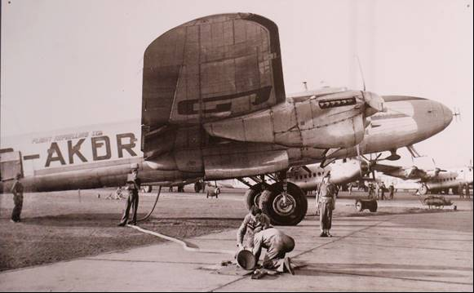

Photo 23. Avro Lancastrian of Flight Refuelling Limited 1948-49 with Shell Aviation Services and British Army of Occupation tanker.
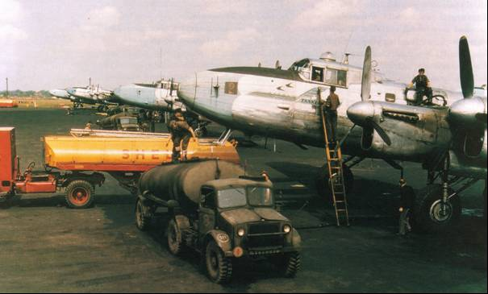

Fuel Supplies – Berlin Airlift
To maintain the supply of food and coal to the besieged Berlin required significant amounts of aviation gasoline. The estimates by the British were that consumption of 9,000 tons/month rising to 17,000 tons/month with 5,000 tons from Abadan was required. In 1949 the plant at Billingham was to provide 25,000 tons/year aviation spirit components and this was limited by the use of butane for the manufacture of other chemicals. In late 1948, in order to increase aviation gasoline supplies it was proposed to use Toluene and Benzole for the avgas product. The quality and quantity of these blendstocks was as follows:
750 tons Nitration grade Toluene
Pure Benzole <0.2% Sulphur content including “½ Degree” Benzole at 800 tons/month and some Pure Benzole of approx. 0.2% Sulphur. (There were concerns regarding the Benzole for it was found that high Sulphur of Benzole produced white precipitates with TEL).
It was pointed out in Aug 1948 that Abadan (Refinery) could not provide components suitable for blending with Toluol or Benzole. Thus, the proposal did not eventuate. However, it was possible to undertake Toluol blending with Billingham Avgas, and in Nov 1948, Toluol blending at Shell Stanlow Refinery with imported aviation spirit base stock.

Epilogue – Berlin Air Lift
Perhaps the best epilogue for the Berlin Air Lift was expressed on the last RAF Douglas Dakota KN652 which bore the following inscription;
“Positively the last load for Lübeck – 73,705 tons. Psalm 21, Verse 11 ‘For they intended evil against thee. They imagined a mischievous device which they were not able to perform.”

Other Battles
While the World War was over, there were still areas of the European colonial empires to defend, or at least re-establish their colonial administration in areas where fledgling nationalism was taking root.

Netherlands
The Dutch wished to regain the colonies lost to the Japanese in the rich Dutch East Indies, however the people of this area were seeking their own future free of colonial rule. This would become Indonesia.

France
The French returned to their colonies in Indo-China, and would fight a guerrilla war against Ho Chi-Minh and the Viet Cong and end up losing these colonies which would become Vietnam.

United Nations Occupation Forces
The Allied occupation of Japan at the end of World War II was led by General Douglas MacArthur, the Supreme Commander of the Allied Powers, with support from the British Commonwealth. Unlike in the occupation of Germany, the Soviet Union was allowed little to no influence over Japan.
The Division of Korea began at the end of World War II in 1945. With the declaration of the Soviet-Japanese War, the Soviet Union occupied the north of Korea, and the United States occupied the south, with the boundary between their zones being the 38th parallel.

British Empire
The British returned to the dominions which had been under Japanese control - Malay Peninsula, Singapore, Borneo, Burma, and Hong Kong. Their return was to re-establish the presence of British influence in the area, however many of the colonies wanted independence. Malaya would become Malaysia which would include parts of Borneo (Sarawak). Singapore would become an independent nation. Burma would gain independence in 1948 as the Union of Burma and eventually become Myanmar. Hong Kong would be a British possession until 1996.
Other African colonies would also seek independence and some would result in conflict.
Photo 24. RAF Spitfire FR18 in Malaya circa 1949.
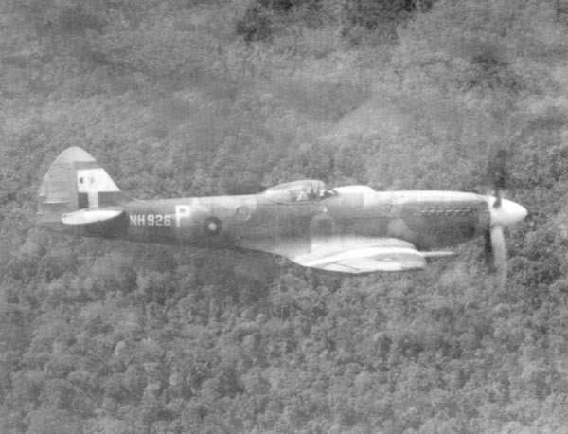
In light of the civil war then raging in China, No. 28 Squadron (Supermarine Spitfire FR18), under the command of Squadron Leader R.D. Yule, left Malaya in order to reinforce the defence of Hong Kong.
To support its dominions around the world, the British sent the remnants of their front-line fighters, which were slowly being replaced by the new faster jet fighters.
Photo 25. RAF Spitfire F-24 in Hong Kong.
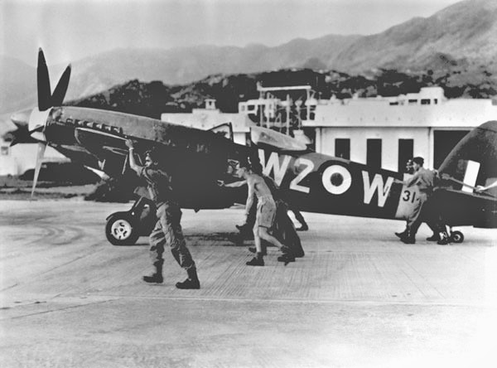
This would be one of the last versions in a long evolution of this famous British fighter. Note the five-bladed propeller, a far cry from the original prototype K5054 with its two-bladed propeller.
Photo 26. Supermarine Prototype K5054 (Spitfire) 1936.
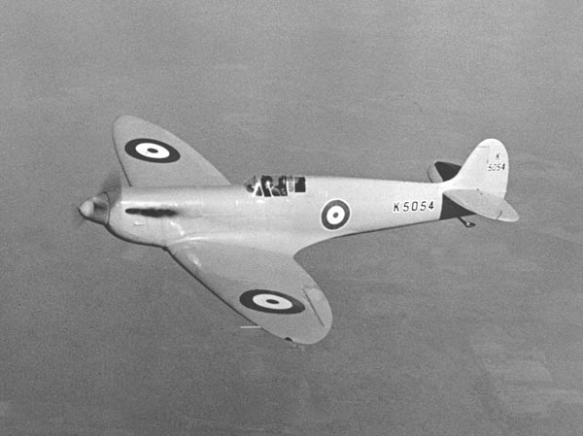

Civil War in China
The civil war in China between the Nationalist forces under General Chang Kai Shek, against the Communist Chinese forces led by Mao Tse-Tung had started in 1927 (the "Ten-Year Civil War" (十年内战) and continued until 1937 when the Japanese invaded. They were still fighting amongst themselves and the Japanese during the Japanese occupation. After the Japanese surrender to the Soviets, this civil war would erupt again with the Chinese Communists using captured Japanese weapons supplied by the Soviets in Manchuria. As post-war negotiations between the Nationalist government in Nanjing and the Communist Party failed, the civil war between these two parties resumed.
Photo 27. Mao Tse-Tung, leader of the Chinese Communists (circa 1948). Photo 28. General Chang Kai Shek, leader of Nationalist China (circa 1948).

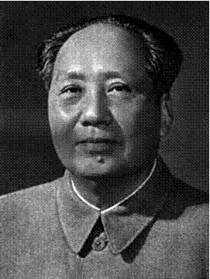

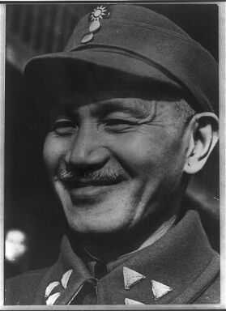

The Chinese Communists were supported by the Soviet Union with military equipment and abandoned Japanese equipment eventually formed the Peoples Republic of China.
The Nationalist Chinese fled to Taiwan and formed the Republic of China and were later supported by the United States with surplus WWII aircraft when the Korean War started.

Surplus WWII aircraft used for civilian purposes
Many of the WWII aircraft would continue after the war in civilian service, perhaps the most famous is the Douglas DC-3 which would still be in service some 50 years later somewhere in the world.
Photo 29. Douglas DC-3.
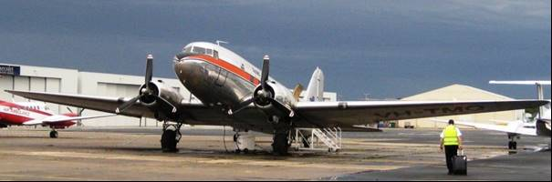
Photo 30. Douglas DC-6 of Northwest Airlines
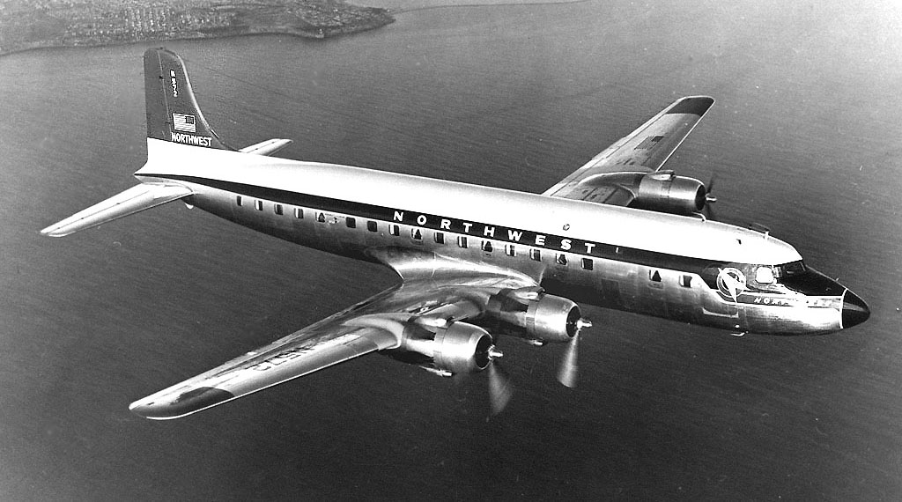
Photo 31. RN Sea Fury (wings folded) with spare radial engine – on display Fleet Air Arm Museum Yeovilton U.K.
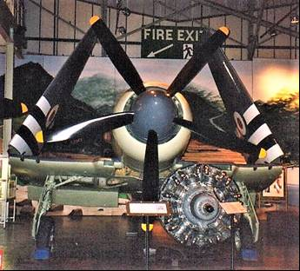
Sea Fury invasion markings, in front is the mighty 24 cylinder wet-sleeve 2,480 HP Bristol Centaur engine. The Hawker Sea Fury served in front-line service with the Royal Navy from 1947-1954 and served with distinction in the Korean War. It was the Royal Navy Fleet Air Arm’s last piston engined fighter in first line service.

API Project No. 6
Under this project the work started to conclude on the elusive search for composition of petroleum.
The work on this project focused mainly on the perfecting the laboratory analytical methods and not much was further progress was made on identifying the components of gasoline. However as part of the war research program API Project No. 6 was called upon by the Technical Advisory Committee of the Petroleum Industry War Council and the National Advisory Committee for Aeronautics, to determine the hydrocarbon components in a number of representative alkylates and hydrocodimers. This work was reported in 1946, and is listed later in later chapters.

Aviation Gasoline Composition 1946
After World War II the aviation gasoline composition did not change, although the demand for the newer Avgas 115/145 Grade would increase. The blend composition remained as:
Light Alkylate
Catalytically Cracked Light Naphtha (after acid treatment)
Catalytically Cracked Heavy Naphtha from TCC or FCC units
Virgin Naphtha (only used for lower grades 80 Octane)
Butane and Pentanes (to achieve the correct vapour pressure)
Tetra Ethyl Lead (4. ml/USG to achieve 100 Octane)
Aromatics (Toluene) addition to achieve 115/145 grade.

Aviation Gasoline Grades and Colours
In 1949, aviation gasolines were manufactured in various grades, these were distinguished by different colours: Avgas 80 (Red), Avgas 91/98 (Blue), Avgas 100/130 (Green), and Avgas 115/145 (Purple).
The purpose of adding dyes to aviation gasolines had always been to affect a means of distinguishing one grade from another. Such reliance was placed on this identification method by consumers that difficulties result when conditions cause the gasolines to change colour. One problem was the instability of the fuel colour which can also include changes in hue (colour fading). Changes in colour had been reported so pronounced that, for example Avgas 91/98 (blue) has been mistakenly identified as Avgas 115/145 (purple). The colours of red and yellow are unstable in direct light.

Oil Companies and Refineries
The war brought to a (temporary) close the huge demand for avgas and those refineries which had operated during the war producing aviation gasoline, now reverted back to the production of motor gasoline for the petrol-rationed public. There was however still a demand for avgas in 1946-47 as commercial airlines began to re-establish themselves using surplus WWII transport aircraft.
The Berlin airlift in 1948 would swing the production demands back to avgas in order to supply the transport aircraft.
This was also a period of reconstructions for a war-torn world. Everything was in short supply – the bomb-damaged refineries of Europe had to be rebuilt or new refineries constructed to replace them. The great refineries of Palembang and Pladjoe in the Dutch East Indies which had fallen to Japanese Imperial Forces were in ruins; the Nazi German refineries had been bombed out of existence, the vast oil refineries (and oil fields) of the Balkans (Ploësti Refinery, Rumania) were now under the control of communist Russia.
The new refinery processes are discussed in the chapter 30.

World Crude Oil Refining Capacity
A country's ability to convert crude petroleum into usable products is indicated by its refining capacity. The statistical picture of refining capacity, crude runs to stills, and production is presented in following table, by country and by geographical area for the year 1949.

Table 1. World crude oil refining capacity, crude runs to stills and production, 1949, by country and geographical area [in thousands of barrels daily]
Country | Crude refining capacity barrels daily as of July 1, 1950 (1) | Crude runs to stills 1949 (2) | Production 1949 (2)
North America
Canada | 341,550 | 263,216 | 57,562
Cuba | 6,080 | 5,389 | 477
Mexico | 201,190 | 136,003 | 166,877
United States | 6,750,000 | 5,330,189 | 5,041,937
Total | 7,298,820 | 5,734,797 | 5,266,582
South America and Caribbean
Argentina | 129,800 | 100,000 | 62,907
Bolivia | 2,790 | 1,658 | 1,858
Brazil | 3,515 | 1,622 | 299
Chile | 360 | -- | 301
Colombia | 30,900 | 21,167 | 81,430
Ecuador | 5,700 | 4,340 | 7,170
Netherlands West Indies | 657,000 | 696,405 | --
Peru | 34,900 | 33,660 | 40,521
Trinidad | 99,000 | 80,310 | 56,485
Uruguay | 25,000 | 13,973 | --
Venezuela | 287,950 | 145,389 | 1,321,414
Total | 1,276,915 | 1,100,523 | 1,572,384
Western Europe
Belgium | 16,500 | 7,263 | --
Denmark | 655 | 663 | --
France | 293,100 | 230,879 | 1,126
Western Germany | 71,070 | 33,863 | 16,293
Italy and Trieste | 128,280 | 60,729 | 195
Netherlands | 53,500 | 53,425 | 11,819
Portugal | 7,000 | 5,378 | --
Sweden | 24,800 | 8,918 | --
United Kingdom | 206,680 | 120,712 | 936
Total | 801,585 | 521,800 | 30,359
Middle East
Bahrein Island | 165,000 | 153,589 | 30,096
Egypt | 47,000 | 42,600 | 43,458
Iran and Kuwait | 572,100 | 487,118 | 807,238
Iraq | 9,500 | 6,115 | 84,932
Israel | 83,000 | 1,616 | --
Lebanon | 11,000 | 6,236 | --
Qatar | -- | -- | 2,055
Saudi Arabia | 140,000 | 126,767 | 476,734
Turkey | 1,400 | 142 | 260
Total | 1,029,000 | 824,244 | 1,444,773
Other Asia
China | 19,000 | 4,364 | 2,060
India, Burma and Pakistan | 12,800 | 7,658 | 8,274
Japan | 51,127 | 3,510 | 3,707
Total | 82,927 | 15,532 | 14,041
Other Africa
Canary Islands and Spain | 23,600 | 11,482 | --
French Morocco | 800 | 290 | 373
South Africa | 2,000 | -- | --
Total | 26,400 | 11,772 | 373
Oceania
Australia | 17,600 | 10,959 | 3
British Borneo | 35,000 | (175,800) | 68,789
Indonesia | -- | -- | 123,101 (3)
Netherlands East Indies | 146,300 | -- | --
Total | 198,900 | 186,819 | 191,893
Total above countries | 10,714,547 | 8,395,548 | 8,520,674
USSR and Eastern Europe
USSR | 675,000 | 640,000 | 658,000
Other Eastern Europe | 209,235 | 131,096 | 130,068
Total | 882,235 | 771,096 | 788,068
Switzerland, Norway, Korea | 7,850 | -- | --
World total | 11,606,632 | 9,166,614 | 9,308,742
(1) Source: World Petroleum Annual Refinery Review, 1950, vol. 21, no. 8.
(2) Source: Bureau of Mines, World Petroleum Statistics, 1949
(3) Includes production of New Guinea
As this table indicates, the three leading refining centres of the world were the United States, the Venezuela-Caribbean area, and the Middle East - a position essentially unchanged since the end of the World War.
In 1949, 58 percent of the world's refining capacity was in the United States, about 8 percent in Venezuela and the Netherlands West Indies, and 9 percent in the Middle East. Excluding USSR and Eastern Europe, more than 86 percent of the world's refining capacity was located in these three important refining areas. These areas were all important crude producing centres, with the exception of the Netherlands West Indies which produced no oil but refined large quantities of crude imported from Venezuela and other South American producing countries.
In the Middle East, large refineries were located on the Persian Gulf at Abadan, Bahrain, and Ras Tanura. At the eastern end of the Mediterranean were refineries at Haifa and Tripoli, which operated on crude from the Middle East fields. Since the Middle East was not a large consumer of oil, the products from these refineries must necessarily be moved to other parts of the world-principally Europe and the Far East. As we have seen, of these Middle East facilities only Abadan Refinery and Bahrain Refinery produced aviation gasoline.
Western Europe held in 1949 approximately 7.5 percent of the world's refining capacity. The total refining capacity of its 82 refineries was less than that of the three large refineries in the Netherlands West Indies. However, since World War II, there had been a tendency to increase the capacity of the European plants. Since Western Europe was not an important producer of crude, practically all of its refineries operated on imported crude. Thus, while total refinery runs to the stills in this area were about 522,000 barrels daily in 1949, production of crude in the area was only 30,000 barrels per day.
Exactly the opposite condition existed in South America and the Middle East. There, refinery runs in 1949 were less than daily crude production, indicating exportation of crude.
In 1949, the United States had refinery runs of almost 300,000 barrels per day in excess of crude production. Barring any reduction in crude stocks, the excess of crude runs is an index of the volume of crude imports.
Only a small percentage of the world's refining capacity was located in the Far East. This part of the world at this time was neither an important producing nor consuming area, and refining capacity was about equal to crude production.

World Petroleum Consumption and Supply
Just as the geographic pattern of reserves differs from that of production, and the pattern of production differs from that of refining, so also does the pattern of consumption differ from the other variables. The geographic differences in "demand" and "supply," which are synonymous terms in the petroleum trade for consumption and production, are indicated in Table 2 for the years 1947 and 1949. Thus, the table reveals those areas of the world which consumed more oil than they produced, as well as those areas which produced in excess of domestic needs.
The only two areas of the world that produced more petroleum than they consumed in 1947 and 1949 were the Caribbean and the Middle East. All other areas were dependent upon the surplus-producing regions to make up the balance between their consumption and production. These deficit areas were Europe, Africa, the Far East and Oceania, and parts of North and South America.
One of the most striking developments revealed in this data was the rise of the Middle East as an important supplier of the world's petroleum needs. In 1947, the Middle East had an excess of supply over consumption of about 671,000 barrels daily; by 1949, this excess had nearly doubled, reaching 1,191,000 barrels daily, which was almost enough to surpass the Caribbean area as a surplus producer of petroleum.
In the United States, in 1949 consumption exceeded domestic supply by about 322,000 barrels daily, while in 1947 consumption and supply were approximately equal.
Taking the major producing areas as a whole, in 1949 the United States, the Caribbean, and the Middle East supplied 85 percent of the world's oil but consumed only 64 percent. Thus, a surplus of 21 percent, or about 2,120,000 barrels per day, was available for the deficit-producing countries.
Table 2. Petroleum demand and supply by areas, 1947 and 1949 [in thousands of barrels daily]
Country | Domestic Demand (1) | Domestic Supply (2) | Excess of supply over demand | Excess of demand over supply | Percent of world supply of domestic demand | Percent of world supply of domestic supply
1947
United States | 5,449.2 | 5,449.2 | - | - | 62.36 | 62.02
Other North America | 487.3 | 176.8 | - | 310.5 | 5.58 | 2.03
Total North America | 5,936.5 | 5,626.0 | - | 310.5 | 67.94 | 64.65
Caribbean area | 181.6 | 1,318.4 | 1,136.8 | - | 2.08 | 15.15
Other South America | 262.3 | 106.0 | - | 156.3 | 3.00 | 1.22
Total South America | 443.9 | 1,424.4 | 1,136.8 | 156.3 | 5.08 | 16.37
Europe (excluding USSR) | 1,010.6 | 161.9 | - | 848.7 | 11.57 | 1.86
Africa | 180.3 | 26.5 | - | 153.8 | 2.06 | 0.30
Middle East | 168.8 | 840.3 | 671.5 | - | 1.93 | 9.66
Far East and Oceania | 419.5 | 70.5 | - | 349.0 | 4.80 | 0.81
Total world (excludes USSR) | 8,159.6 | 8,149.6 | 671.5 | 1,808.3 | 1,818.3 | 93.65
1949
United States | 5,792.4 | 5,470.4 | - | 322.0 | 59.42 | 55.70
Other North America | 478.2 | 232.2 | - | 246.0 | 4.91 | 2.36
Total, North America | 6,270.6 | 5,702.6 | - | 568.0 | 64.63 | 58.06
Caribbean Area | 212.9 | 1,464.1 | 1,251.2 | - | 2.18 | 14.91
Other South America | 397.5 | 117.8 | - | 279.7 | 4.08 | 1.20
Total South America | 610.4 | 1,581.9 | 1,251.2 | 279.7 | 6.26 | 16.11
Europe (excluding USSR) | 1,226.7 | 176.2 | - | 1,050.5 | 12.59 | 1.79
Africa | 236.8 | 44.5 | - | 192.3 | 2.43 | 0.45
Middle East | 211.8 | 1,402.9 | 1,191.1 | -- | 2.17 | 14.29
Far East and Oceania | 484.0 | 205.7 | -- | 278.3 | 4.97 | 2.10
Total world (excludes USSR) | 9,040.3 | 9,113.8 | 2,162.6 | 2,089.1 | 92.75 | 92.80
(1) "Demand" as used by the industry trade press, equals consumption plus or minus additions to or subtractions from stocks.
(2) Included production of crude oil, natural gasoline, and synthetic products.
Source: C.J. Bauer, petroleum economist, Standard Oil Co. (New Jersey), published in World Oil, July 15, 1950, p. 40.
Excluding the U.S.S.R., the United States was the only important industrialized country which was able to supply its own petroleum needs. Many of the major crude-oil-producing countries were not highly industrialized and, therefore, had a limited demand for petroleum. Typical of such countries were the nations of the Middle East and South America. The converse was true of most of the countries of Western Europe and Canada (the latter prior to recent discoveries), which are highly industrialized, but produce little petroleum.

Control over world crude oil refining capacity.
The crude oil refining capacity of the world was also largely controlled by the seven companies, as shown in Table 3. In 1950, these seven international oil companies controlled almost 57 percent of the world's crude-oil-refining capacity. In the Western Hemisphere, excluding the United States, they held more than 75 percent; and in the Eastern Hemisphere, 79 percent. Excluding the capacity of the United States and that under Russian control the seven international companies owned more than 77 percent of the rest of the world's crude-oil-refining capacity.
Table 3. --Crude oil refining capacity controlled by 7 international petroleum companies, 1950 [in thousands of barrels daily]
 | Western Hemisphere |  |  | Total Eastern hemisphere | Grand Total
 | United States | Other Western Hemisphere | Total
Anglo-Iranian Oil Co. Ltd. | -- | -- | -- | 707.9 | 707.9
Gulf Oil Corporation | 458.0 | 21.3 | 479.3 | 18.9 | 498.2
Royal Dutch-Shell | 367.0 | 448.9 | 815.9 | 443.0 | 1,258.9
Standard Oil Co. (New Jersey) | 782.0 | 818.9 | 1,600.9 | 145.0 | 1,746.5
Standard Oil Co. of California | 370.7 | 8.4 | 379.1 | 141.9 | 521.0
Socony-Vacuum Oil Co. Inc. | 528.5 | 3.5 | 532.0 | 128.6 | 660.6
The Texas Company. | 491.9 | 78.5 | 570.4 | 141.8 | 712.2
Total 7 companies | 2,908.1 | 1,379.5 | 4,377.6 | 1, 727.7 | 6,105.3
Total capacity | 6,750.0 ⁽²⁾ | 1,825.7 | 8,575.7 | 2,185.2 ⁽¹⁾ | 10,760.9 ⁽¹⁾
Percent of total 7 companies | 43.1% | 75.6% | 51.1% | 79.1% | 56.7%
- Excluding refining capacity of U.S.S.R., Hungary, Poland, and Rumania.
- Source: Refining capacity of individual companies in United States is from Bureau of Mines, Information Circular 7578, Petroleum Refineries, Including Cracking Plants in the United States, Jan 1, 1950. Statistics for Eastern Hemisphere, other Western Hemisphere and total capacity are from World Petroleum, Annual Refinery Issue, Vol. 21, No. 8, 1950, and from the companies' Annual Reports for 1949.

Control of world cracking capacity.
Control over cracking capacity is potentially of greater economic significance than control over crude-refining capacity. The cracking process enables a refiner to obtain a greater quantity of higher-value products (for example, gasoline as compared to residual fuel oil) from a given quantity of crude than can be obtained by the straight-run distillation method of refining. The cracking process also enables the refiner to vary the proportions of products produced, thus giving greater flexibility to the refining operation. Moreover, it is only by using cracking processes that the petroleum industry is able to produce high-octane gasoline and many of the chemicals which are the basic raw materials for synthetic rubber and many plastics. Thus, the cracking process has made the petroleum industry an important supplier of products to other industries, and the concentration of control over the world's cracking capacity thereby affects a broader segment, of the world economy than control over crude-refining capacity.
As will be seen from Table 4 control of the world's cracking capacity was even more concentrated in the hands of the seven international petroleum companies than is control of crude refining. In 1950, these seven companies owned 17 percent of the cracking capacity of the United States, 53 percent of that of the Western Hemisphere, 84 percent of that of the Eastern Hemisphere, and 55 percent of that of the world. If the capacity of the United States and Russia (including her satellites) is excluded, these seven companies held 85 percent of all cracking capacity in the rest of the world, as compared with 77 percent of the crude-refining capacity of the same area.
Table 4. --Capacity of cracking plants controlled by seven international petroleum companies, 1950 [In thousands of barrels daily]
 | Western Hemisphere |  |  | Total Eastern hemisphere | Grand Total
 | United States | Other Western Hemisphere | Total
Anglo-Iranian Oil Co. Ltd. | -- | -- | -- | 137.5 | 137.5
Gulf Oil Corporation | 237.9 | 7.3 | 245.2 | -- | 245.2
Royal Dutch-Shell | 248.3 | 186.9 | 435.2 | 83.4 | 518.6
Standard Oil Co. (New Jersey) | 464.2 | 386.3 | 850.5 | 25.3 | 875.8
Standard Oil Co. of California | 191.5 | -- | 191.5 | 15.7 | 207.2
Socony-Vacuum Oil Co. Inc. | 347.4 | 1.3 | 348.7 | 15.5 | 364.2
The Texas Company | 383.0 | 32.5 | 415.5 | 15.7 | 431.2
Total of 7 companies | 1,872.3 | 614.3 | 2,486.6 | 293.1 | 2,779.7
Total cracking capacity | 3,980.0 | 716.7 | 4,696.7 | 348.3 (1) | 5,045.0 (1)
Percent of total, 7 companies | 47.0% | 85.7% | 53.0% | 84.2% | 55.1%
- Excluding capacity of U.S.S.R., Rumania, Hungary, and Poland. Source: Data on individual company capacity In United States are from the Oil and Gas Journal, Mar. 23, 1950. Other data are from World Petroleum, annual refinery issue, vol. 21, No. 8, 1950.

Aviation Gasoline Production, Exports and Demand 1945-1948
1945 Aviation Gasoline
Table 5. U.S. Aviation Gasoline Production, Exports and Demand for 1945 (thousand barrels)
1945 | Jan | Feb | Mar | Apr | May | June | July | Aug | Sept | Oct | Nov | Dec | Total
Production 100 Octane & above | 14,731 | 13,673 | 15,644 | 15,531 | 16,525 | 15,332 | 15,364 | 12,454 | 3,566 | 970 | 278 | 147 | 124,215
Other avgas grades | 3,181 | 3,366 | 3,563 | 2,508 | 2,663 | 1,914 | 3,176 | 715 | 409 | 1,831 | 2,366 | 2,488 | 28,180
Transfers out | 363 | 348 | 426 | 683 | 298 | 372 | 472 | 1,275 | 2,929 | 1,314 | 1,336 | 1,346 | 11,162
Total Exports | 4,575 | 4,490 | 6,035 | 7,351 | 4,907 | 3,567 | 1,652 | 521 | 141 | 187 | 388 | 303 | 34,117
US Domestic demand all grades | 11,698 | 10,166 | 12,853 | 13,673 | 13,233 | 13,489 | 14,761 | 13,084 | 9,586 | 2,399 | 1,191 | 867 | 117,000
Total demand by grades
100-Octane & Above | 13,580 | 12,055 | 16,094 | 17,989 | 15,470 | 14,753 | 14,216 | 12,172 | 8,638 | 1,733 | 676 | 298 | 127,674
Other finished | 2,072 | 2,011 | 2,096 | 2,260 | 1,872 | 1,869 | 1,653 | 1,137 | 807 | 721 | 686 | 709 | 17,893
Components | 621 | 590 | 698 | 775 | 798 | 434 | 544 | 296 | 282 | 132 | 217 | 153 | 5,540
Transfers out refers to rejected material that is returned to regular grades of gasoline and this item should be subtracted from gross production figures to determine the net production of marketable aviation grades.
During this period particularly in the early part on 1945 when the Allied Forces were closing in on Berlin, Germany peak aviation gasoline production was 620,000 BSD in March 1945.
The average for first 8 months 1945 was 578,000 BSD, compared with only 99,000 BSD for the last 4 months when the war in Europe was over.
1946 Aviation Gasoline
Table 6. U.S. Aviation Gasoline Production, Exports and Demand for 1946 (thousand barrels)
1946 | Jan | Feb | Mar | Apr | May | June | July | Aug | Sept | Oct | Nov | Dec | Total
Production 100 Octane & above | 470 | 263 | 197 | 283 | 485 | 460 | 577 | 469 | 496 | 417 | 550 | 675 | 5,342
Other avgas grades | 2,036 | 1,441 | 1,871 | 1,613 | 1,662 | 1,676 | 1,693 | 1,919 | 1,680 | 1,773 | 1,392 | 1,314 | 20,070
Transfers out | 748 | 793 | 1,641 | 685 | 906 | 1,023 | 999 | 1,086 | 976 | 642 | 627 | 806 | 10,932
Total Exports | 93 | 135 | 371 | 129 | 198 | 233 | 125 | 249 | 273 | 121 | 221 | 146 | 2,294
US Domestic demand all grades | 1,429 | 733 | 901 | 835 | 1,003 | 969 | 1,291 | 1,257 | 994 | 1,298 | 964 | 1,226 | 12,900
Total demand by grades
100-Octane & Above | 621 | 263 | 501 | 243 | 399 | 429 | 537 | 525 | 445 | 582 | 585 | 695 | 5,825
Other finished | 747 | 591 | 694 | 644 | 738 | 719 | 821 | 888 | 740 | 754 | 581 | 659 | 8,576
Components | 154 | 14 | 77 | 77 | 64 | 55 | 59 | 95 | 83 | 83 | 19 | 18 | 798
During 1946 the war is over and life was hopefully returning to normal.
1947 Aviation Gasoline
The figures for aviation gasoline cover only the special grades identified as such by producing companies and do not include automotive gasoline that may be used by many smaller planes.
Table 7. U.S. Aviation Gasoline Production, Exports and Demand for 1947 (thousand barrels)
1947 | Jan | Feb | Mar | Apr | May | June | July | Aug | Sept | Oct | Nov | Dec | Total
Production 100 Octane & above | 704 | 713 | 954 | 566 | 1,219 | 1,353 | 1,545 | 2,061 | 2,258 | 2,121 | 2,187 | 2,186 | 17,867
Other avgas grades | 1,101 | 1,230 | 1,267 | 1,880 | 1,651 | 1,650 | 1,922 | 1,603 | 1,475 | 1,328 | 1,129 | 1,193 | 17,429
Transfers out | 870 | 623 | 793 | 719 | 703 | 780 | 771 | 538 | 467 | 284 | 311 | 247 | 7,106
Total Exports | 105 | 381 | 445 | 193 | 405 | 484 | 276 | 831 | 375 | 394 | 498 | 685 | 5,072
US Domestic demand all grades | 1,061 | 968 | 1,108 | 1,010 | 1,643 | 1,703 | 2,123 | 1,959 | 2,568 | 2,655 | 2,320 | 2,489 | 21,607
Total demand by grades
100-Octane & Above | 571 | 685 | 899 | 518 | 1,047 | 1,200 | 1,397 | 1,896 | 2,033 | 1,982 | 1,930 | 2,334 | 16,492
Other finished | 578 | 631 | 637 | 680 | 870 | 836 | 939 | 860 | 775 | 912 | 692 | 778 | 9,188
Components | 17 | 33 | 17 | 5 | 131 | 151 | 63 | 34 | 135 | 155 | 196 | 62 | 999
1948 Aviation Gasoline
The figures for aviation gasoline cover only the special grades identified as such by producing companies and do not include automotive gasoline that may be used by many smaller planes.
Table 8. U.S. Aviation Gasoline Production, Exports and Demand for 1948 (thousand barrels)
1948 | Jan | Feb | Mar | Apr | May | June | July | Aug | Sept | Oct | Nov | Dec | Total
Production 100 Octane & above | 2,385 | 1,825 | 2,329 | 2,945 | 2,775 | 2,943 | 2,747 | 3,190 | 2,562 | 2,864 | 3,143 | 3,713 | 33,421
Other avgas grades | 1,058 | 1,219 | 986 | 1,143 | 1,300 | 1,172 | 1,395 | 1,286 | 723 | 739 | 1,144 | 660 | 12,825
Transfers out | 242 | 270 | 223 | 453 | 301 | 505 | 384 | 374 | 196 | 124 | 96 | 117 | 3,285
Total Exports | 417 | 203 | 448 | 613 | 725 | 518 | 791 | 343 | 486 | 753 | 424 | 618 | 6,339
US Domestic demand all grades | 2,291 | 1,942 | 2,786 | 2,707 | 3,618 | 3,413 | 2,916 | 3,638 | 2,684 | 3,062 | 3,194 | 4,367 | 36,618
Total demand by grades
100-Octane & Above | 2,089 | 1,553 | 2,480 | 2,509 | 3,364 | 2,988 | 2,797 | 2,873 | 2,304 | 3,042 | 2,825 | 4,382 | 33,206
Other finished | 605 | 550 | 714 | 788 | 890 | 874 | 858 | 936 | 852 | 754 | 742 | 585 | 9,148
Components | 14 | 42 | 40 | 23 | 89 | 69 | 52 | 172 | 14 | 19 | 51 | 18 | 603

“Airspeed records were now made by jets”
The introduction of the jet powered aircraft saw the previous records smashed by over 100 mph, and the phenomenon of ‘sonic boom’ experienced by the test pilots in rocket powered aircraft.
Air speed records were still however, matters of national pride.
In November 1945, the first jet-powered aircraft to set the record was a British Gloster Meteor F Mk 4 at a speed of over 600 miles per hour (976 Km/hr). By contrast in 1947 at Boscombe Down in the U.K., a Supermarine 371 ‘Spiteful’ F.XVI (RB518) - one of the final variants of the famous WWII British Spitfire, could only achieve 494 mph (795 Km/hr.), while the American military jets were starting to fly at over 1,000 Km/hr.
Photo 32. Gloster Meteor F Mk 4 similar to that flown by Edward M. Donaldson from Tangmere Airfield achieved 615.8 mph. (now at home at Tangmere Air Museum).
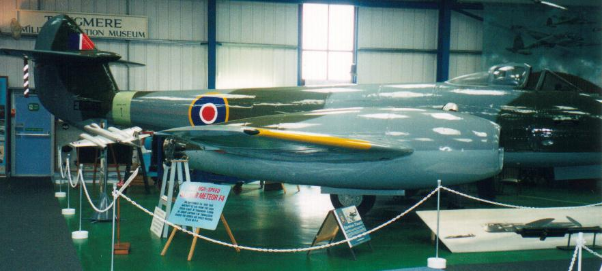
Table 9. Air Speed Records
Date | Location | Pilot | Aircraft | Achieved Km/hr
Nov 1945 | Herne Bay, Great Britain | H. J. Wilson | Gloster Meteor F Mk 4 | 975.87
7 Sep 1946 | Littlehampton, Great Britain | Edward M. Donaldson | Gloster Meteor F Mk 4 | 990.98
19 Jun 1947 | Murdoc, USA | Albert Boyd | Lockheed XP-80R Shooting Star | 1,003.99
25 Aug 1947 | Muroc, USA | Marion E. Carl | Douglas D-558-1 Skystreak | 1,047.52
15 Sep 1948 | Muroc, USA | Richard L. Johnson | North American F-86A-1 Sabre | 1,079.84
By 1947 the American pilots would exceed 1,000 kilometres per hour and looking to break the mystical ‘Sound Barrier’ with a rocket powered aircraft launched from a World War II modified Boeing B-29 Superfortress Bomber.

Photo 33. North American F-86 Sabre
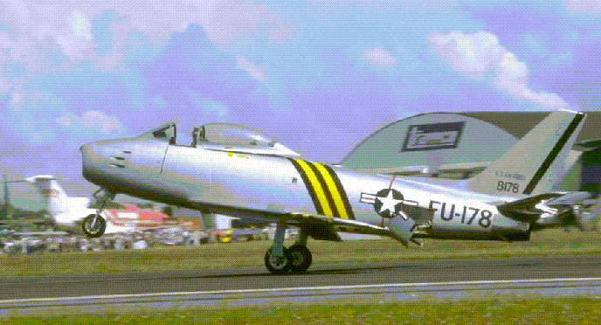

The ‘Sound Barrier’ is broken
1947 October 14: First supersonic flight - The sound barrier was broken when a rocket powered Bell XS-1 flown by Chuck Yeager was launched from a modified Boeing B-29 Superfortress at 29,000 feet.
Photo 34. Modified B-29 with Bell XS-1 (1947)
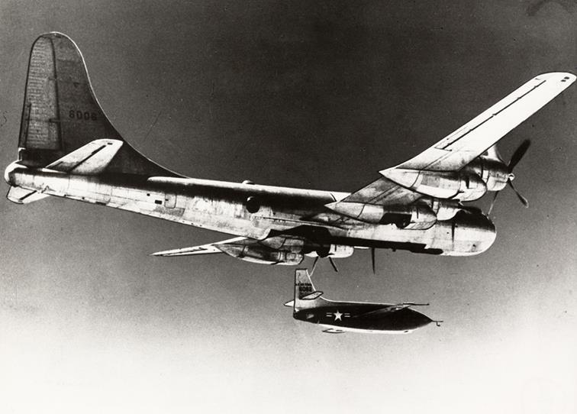
1948 April 28: The sound barrier was broken for the first time by a turbo powered jet fighter, when an XP-86 Sabre exceeded Mach 1 in a shallow dive.

Epilogue for 1949 – The ‘Cold War’ Starts
In this year 1949, just as the world was recovering from the Second World War and the United Nations had been established to unite the world powers and prevent another world war, the spread of Communism in Eastern Europe and the East set the western nations on a the path to a new war – a “Cold War’. The Berlin Air Lift was the prelude to this “Cold War”.
While the battles over the next 50 years would still continue and involve many nations, they would be restricted to a specific country such as Korea, Vietnam, Falkland Islands, Afghanistan or Iraq, or a region such as the South America, Malaya, Suez, or the Middle East. Nonetheless, the fighting machines and weapons required for such battles would continue to be developed and the ‘Arms Race’ was on again!
The Sound Barrier had been broken.
The whine of jet turbine engines was becoming a familiar occurrence – and aeroplanes without propellers were no longer an experimental oddity.
Man had flown faster than 1,000 km per hour.
The fighters were becoming jet powered, while the bombers and military transport aircraft were still piston engined and required aviation gasolines.
Bomber aircraft from WWII were redesigned and modified to become the civilian passenger airliners of the next decade. The irony is that in the prelude to WWII, Nazi Germany was designing civilian passenger airliners which would become their feared bombers.
The famous British Avro Lancaster would be morphed into the ‘Lancastrian’ and redesigned into the Avro York.
The Boeing 377 Stratocruiser, a large long-range airliner was developed from the C-97 Stratofreighter military transport, itself a derivative of the Boeing B-29 Superfortress. The Stratocruiser's first flight was on July 8, 1947. Its design was advanced for its day; its innovative features included two passenger decks and a pressurized cabin, a relatively new feature on transport aircraft, but not the B-29.
Photo 35. Boeing 377 Stratocruiser and Esso tanker refuelling.
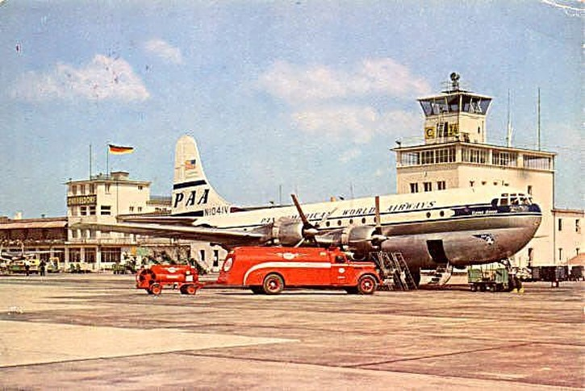

Index

1
100 Octane 27
115/145 grade 27
8
80 Octane 27
A
Abadan 21, 30
acid treatment 27
Adelaide 8
Aeronca Chief 7
Afghanistan 37
Africa 30, 31
Air Beef Pty. Ltd 10
Air Defense Command 4
Air Force Chief of Staff 15
aircraft carrier 4
airlift 13, 14, 15, 16, 20
Airlift Task Force 16, 17
Albert Boyd 35
alkylates 26
American Army 12
Anglo-American 14
Anglo-Iranian Oil Co. Ltd. 32, 33
API Project No. 6 26
APS-4 radar 16
Arab forces 6
Arab-Israeli war 7
Argentina 28
Arms Race 37
Aromatics 27
Assam 15
atomic bomb 4, 12
Australia 4, 10, 29
Australian National Airlines 8, 10
automotive gasoline 34
avgas 21, 27
Avgas 100/130 27
Avgas 115/145 27
Avgas 80 27
Avgas 91/98 27
aviation gasoline 16, 21, 27, 30, 33, 34, 43
Aviation Spirit 21
aviation spirit base stock 21
Avro Lancastrian 9, 20, 21, 37
Avro Lincoln 9
Avro York 13, 18, 37
B
B-25 Mitchell 4
B-29 3
Bahrain 30
Bahrain Refinery 30
Bahrein Island 28
Balkans 27
Bankstown 11
Belgian Air Force 4
Belgium 28
Bell Model 47 4
Bell X1 5
Bell XS-1 36
Benzole 21
Berlin 3, 6, 12, 13, 14, 15, 17, 20, 34
Berlin Airlift 3, 6, 7, 8, 10, 13, 15, 16, 17, 18, 19, 21, 27, 37, 43
Berlin Lakes 13
Bikini Atoll 4
Bill Barris 7
Billingham 21
blendstocks 21
blockade 17
Blue 27
Boeing 377 Stratocruiser 37
Boeing B-29 Superfortress 4, 35, 36, 37
Boeing B-50 'Lucky Lady II', 7
Bolivia 28
Boscombe Down 35
Brazil 28
Bremerhaven 16
Brigadier General William 'Billy' Mitchell 4
Brisbane 10
Bristol Centaur engine 26
Bristol Freighter 10
Britain 3
British 3, 12, 18, 21, 23
British Air Forces of Occupation 13
British Air Ministry 20
British Borneo 29
British European Airways 19
Bückeburg 20
Burma 15, 29
Burtonwood 15
Butane 21, 27
C
C-47 14, 15
C-54 Skymaster 5, 6, 15, 16, 18
C-74 Globemaster I 8
CA-15 8
California 16
Canada 4, 28, 32
Canary Islands 29
Cape Henry 4
Capt. J. Hepburn 10
Captain Charles 'Chuck' Yeager 5
Captain James Gallagher 7
Caribbean 28, 29, 30, 31
Caroline Mars 6
Catalytically Cracked Heavy Naphtha 27
Catalytically Cracked Light Naphtha 27
cattle stations 10
Charleville 10
Checkpoint Charlie 12
Chief of Naval Operations 16, 17
Chile 28
China 3, 15, 22, 24, 29
Chinese Communists 24
Chuck Yeager 36
Cleveland 6
Cloncurry 10
Cold War 37
Colombia 28
Colonel William H. Council 3
colonial empires 22
Columbus 4
Combined Air Lift Task Force (CALTF) 14
Commander T. Davis 4
commercial airlines 27
Commonwealth 13
Communism 3, 37
Communist Chinese 24
Consolidated B-36 7
Consolidated Convair 240 10
Contemporary History Branch, Naval Historical Center 15
cracking process 32
crude 27, 30
Cuba 28
D
Dakota 10, 13, 14, 15, 18, 20, 21
Dayton 6
DC-3 10
De Havilland Drover 10
De Havilland. Vampire 10
Denmark 28
Deutschmark 13
DH Dove 10
DHA Vampire F.30 11
Dick Reidel 7
Dorset 20
Douglas D-558-1 Skystreak 35
Douglas DC-3 25
Douglas DC-4 8
Douglas DC-6 25
Dr. Jeffrey G. Barlow 15
Dutch 3
Dutch East Indies 3, 22, 27
Duxford Air Museum 18
Duxford U.K 19
E
E.P. Rankin 4
East Berlin 17
East Germany 17
Eastern Europe 29, 30
Eastern Hemisphere 32, 33
Ecuador 28
Edward M Donaldson 35
Egypt 4, 29
ejection seat 3, 4
England 9, 10
Europe 3, 12, 27, 30, 31, 34
European 22
European Command 15
F
Falkland Islands 37
Far East 30
Fassberg 13
FCC 27
Fédération Aéronautique International (FAI) 4
Fishermen's Bend 8, 9
Fleet Air Arm Museum Yeovilton 26
Fleet Logistic Support Wings 17
Flight Refuelling 20, 21
flying boats 13, 20
Flying Doctor Services 10
Fort Worth 7
France 3, 17, 28
Frankfurt 6
French 3, 12
French Indo China 3
French Morocco 29
G
gasoline 32
Gatow 7, 13, 19, 20
General Carl A. Spatz 5
General Chang Kai Shek 24
General Clay 15, 16
General Lucius Clay 15
General William H Turner 14
German 3, 14
German refineries 27
Germany 12, 15, 16, 17, 34, 37
Gloster Meteor F Mk4 35
Government Aircraft Factories 9
Great Britain 17
Green 27
Ground-Controlled Approach (GCA) 7
Guam 16
Gulf Oil Corporation 32, 33
H
H J Wilson 35
Haifa 30
Halton 20
Hamburg 13
Handley Page Hastings 18, 19
Hasting 14
Hawaii 4, 7
Hawdon 10
Hawker Sea Fury 26
helicopters 3
Herne Bay 35
Himalayas 15
Hiroshima 3
Hong Kong 8, 22, 23
Hong Kong Defence Force 8
Honolulu 16, 17
Hump 15
hydrocarbon components 26
hydrocodimers 26
Hythe 20
I
India 3, 5
Indo-China 22
Indonesia 29
International Civil Aviation Organisation (ICAO) 4
Iran 3, 29
Iraq 3, 29, 37
Iron Curtain 3, 12
Israel 3, 29
Israeli Air Force 6
Italy 28
Iwakuni 9
J
J. Schofields 8
Jacksonville 16
Japan 9, 12, 22, 29
Japanese 3, 22, 24
Japanese Imperial Forces 27
John Sullivan 16
Joint Chiefs of Staff 16
K
K5054 23
Kangaroo Route 9
knot 4
Korea 22, 29, 37
Korean War 24, 26
Kuwait 29
L
La Guardia 3
Lancaster 9, 18, 20, 37
Lancastrians 20
Laverton 10
Lebanon 29
Lieutenant Commander James J. Davidson 4
Lieutenant J.L. Fruin 8
Light Alkylate 27
Littlehampton 35
Liverpool 15
Lockheed Constellation 4
Lockheed F80 Shooting Star 6
Lockheed P2V Neptune 4
Lockheed P80 Shooting Star 3
Lockheed XP-80R Shooting Star 35
London 4
London Heathrow 4
London Science Museum 7
Long Beach 3
Los Angeles 3
Louis Denfeld 16
Lübeck 21
M
Mach 1 5, 36
MacRobertson Miller Airlines 10
Major General Curtis LeMay 15
Malay Peninsula 22
Malaya 3, 9, 10, 22, 37
Manchuria 24
Mao Tse-Tung 24
Marham 8
Marine Transport Squadron 352 17
Marion E Carl 35
Massachusetts 16
MATS 16, 17
McDonnell F2H-1 Banshee 8
McDonnell XFD1 Phantom 4
Mediterranean 30
Melbourne 8, 10
Meteor F.4 9
Mexico 28
Michigan 6
Middle East 29, 30, 31, 32, 37
Military Air Transport Command 6
Military Air Transport Service 6, 8, 15, 16
Military Air Transport Service's Pacific Division 17
Moffett Field 16, 17
Montreal 4
motor gasoline 27
Muroc 35
N
Nagasaki 3
National Advisory Committee for Aeronautics 26
National Security Council (NSC) 15
Nationalist China 24
nautical mile 4
Naval Air Transport Service (NATS) 17
Navy tankers 16
Netherlands 28
Netherlands East Indies 29
Netherlands West Indies 28, 30
New York 3, 4
New Zealand 13
Newfoundland 5
Nitration grade Toluene 21
No. 28 Squadron 22
No. 76 9
No. 77 9
No. 82 9
No. 1 Squadron 9
North America 31
North American F-86A-1 Sabre 35
North American P-51 Mustang 8
North Atlantic 6
North Atlantic Treaty Organisation (NATO) 7
North Pole 4
Northrop P61 Black Widow 4
Northwest Airlines 25
Norway 29
nuclear 3
O
Occupation Forces 22
Oceania 29, 30, 31
Ohio 4, 6
Operation Firedog 10
Operation Vittles 15, 16, 17, 19
Orville Wright 6
P
Pacific 17
Pacific Ocean 4
Pakistan 3
Palembang 27
Pan American World Airways 4
Patuxent River base 6
Pentanes 27
Peoples Republic of China 24
Persian Gulf 30
Perth 4, 8
Perth Airport 8
Peru 28
Petroleum Industry War Council 26
petrol-rationed 27
Phantom 6
Philippine Air Force 4
PIMA Air Museum, Tucson 16
Pladjoe 27
Plane Fare 15
Ploësti Refinery 27
Point Cook 10
Portugal 28
President Truman 4, 15, 16
Q
Qantas Empire Airways 10
Qatar 29
R
R.A.A.F 13, 18
R.A.F 13, 18
RAAF Base Wagga 9
RAAF Laverton 9
RAAF Museum 10
RAF Honington 15
RAF Transport Command 13, 14
Ras Tanura 30
refineries 27
Republic of China 24
residual fuel oil 32
Rhein-Main 17
Richard L Johnson 35
Royal Air Force 7, 8
Royal Australian Air Force 6
Royal Dutch-Shell 32, 33
Royal Hong Kong Auxiliary Air Force 8
Royal Navy Fleet Air Arm 26
Royal New Zealand Air Force 7
Royal Pakistan Air Force 5
Rumania 27
Russia 3, 27, 33
Russian 12
Russian forces 12
Russians 3, 13
S
San Francisco 8, 43
Saudi Arabia 29
Scotland 6
Sea Fury 26
Selfridge Field 6
Sergeant L. Lambert 4
Shell Aviation Services 20, 21
Shell Stanlow Refiner 21
Sikorsky S51 10
Sikorsky S52 8
Smithsonian Institution 7
Socony-Vacuum Oil Co. Inc. 32, 33
Sound Barrier 3, 35, 36, 37
South Africa 13, 29
South African Air Force 7
South America 28, 30, 31, 32, 37
South-East Asia 15
Soviet 3, 6, 24
Soviet Aviation Day 4
Soviet blockade 13, 15
Soviet Union 8, 17, 24
Spain 29
Spitfire 22, 35
Spitfire F-24 23
Squadron Leader R D Yule 22
Squadron Leader. D.R. Cuming 9
Standard Oil Co. (New Jersey) 31, 32, 33
Standard Oil Co. of California 32, 33
Standard Oil Company 20
Stephenville 5
straight-run distillation 32
Strategic Air Command 4
Stratford 8
Stuart Symington 16
Suez 37
Suffolk 15
Sulphur 21
Sunderland 13, 14
Sunkist Lady 7
S
Supermarine 371 ‘Spiteful’ F.XVI (RB518) 35
Supermarine Spitfire FR18 22
Sweden 28
Switzerland 29
Sydney 10
synthetic rubber 33
T
TAA 10
Tactical Air Command. 4
Taiwan 24
Tangmere Air Museum 35
Tangmere Airfield 35
Tarrant Rushton 20
TCC 27
Technical Advisory Committee 26
Tegel 20
TEL 21
Tempelhof 17, 20
Tempelhof Airport 17
Ten-Year Civil War 24
Tetra Ethyl Lead 27
The Texas Company 32, 33
Toluene 21, 27
Toluol 21
Trans Australia Airlines (TAA) 10
Transport Squadron 6 16
Transport Squadron 8 16
Trieste 28
Trinidad 28
Tripoli 30
Tudor 20
Tupolev Tu-4 4
Turkey 29
U
U.S. Air Force Secretary 16
U.S. Navy Secretary 16
U.S. Zone of Germany 15
U.S.A.F. 13
U.S.S.R. 29, 30, 32
Unification Act 4
United Kingdom 5, 13, 15, 20, 28
United Nations 37
United States 15, 17, 28, 29, 30, 31, 32, 33
United States Air Force 5, 6, 7, 8, 13
United States Armed Forces 4
United States Army Air Force 3, 4
United States Civil Aviation Authority 4, 7
United States Defence Secretary 7
United States Navy 4, 6, 8, 13, 15, 16, 18, 43
Uruguay 28
USS Franklin D. Roosevelt 4
USS Saipan 6
V
Venezuela 28, 29
Vienna 3
Vietnam 22, 37
Virgin Naphtha 27
Virginia 4
VR-3 17
VR-44 17
VR-6 16, 17
VR-8 16, 17
W
Walterboro 8
Washington DC 7
West German 6, 13
West Germany 6, 20, 28
Western Australia 8
Western Europe 32
Western Hemisphere 32, 33
Western sector 13
Westover Air Force Base 16, 17
Winston Churchill 3
Wright brothers 7
Wright Kitty Hawk Flyer 7
Wunstorf 13
Wyndham 10
X
XP-86 Sabre 36
Y
York 14

Research Sources

Website: http://www.chevron.com/history/timeline/family_tree.asp. Accessed Sept 2000
By NASA - NASA Langley Research Center website, Public Domain, https://commons.wikimedia.org/w/index.php?curid=22975326
Australian Aviation History Time Lines - Web site accessed June 1, 2002 - http://users.chariot.net.au/~theburfs/index_mil.html
https://commons.wikimedia.org/wiki/File:VH-DHM.JPG, YSSYguy at en.wikipedia
Ref: https://commons.wikimedia.org/w/index.php?curid=10252531">Link</a>
“The U.S. Navy's Participation in the Berlin Airlift” written by: Jeffrey G. Barlow, Ph.D., Contemporary History Branch, Naval Historical Center. DEPARTMENT OF THE NAVY -- NAVAL HISTORICAL CENTER, 901 M STREET SE -- WASHINGTON NAVY YARD, WASHINGTON DC 20374-5060. US Navy Website accessed Jan 15, 2004 - http://www.history.navy.mil/branches/squades.htm
UK Public Record Office Ref: POWE 33/1814
https://en.wikipedia.org/wiki/Chinese_Civil_War
American Petroleum Institute 22nd. Annual Meeting San Francisco California November 3-7, 1941 Division – Refining. “Method For Analyzing The Gasoline Fraction Of Petroleum, With Preliminary Results On East Texas And Oklahoma Crudes”– API Research Project 6 by Frederick D. Rossini, et al.
American Petroleum Institute 14th. Mid-Year Meeting Houston, Texas April 4-7, 1949 Division – Refining. “The Determination Of Dyes In Aviation Gasoline” by B.B.Buchanan, et al.
Website: http://www.mtholyoke.edu/acad/intrel/Petroleum/ftc.htm Accessed Oct 30, 2005. The International Petroleum Cartel, Staff Report to the Federal Trade Commission, released through Subcommittee on Monopoly of Select Committee on Small Business, U.S. Senate, 83rd. Congress, 2nd session (Washington, DC, 1952), Chapter 1, "The World's Petroleum Resources," pp. 5-20.

