Chapter

2914

United States after the War 1946 – 1949

Photo 1. US 33rd President Harry S. Truman

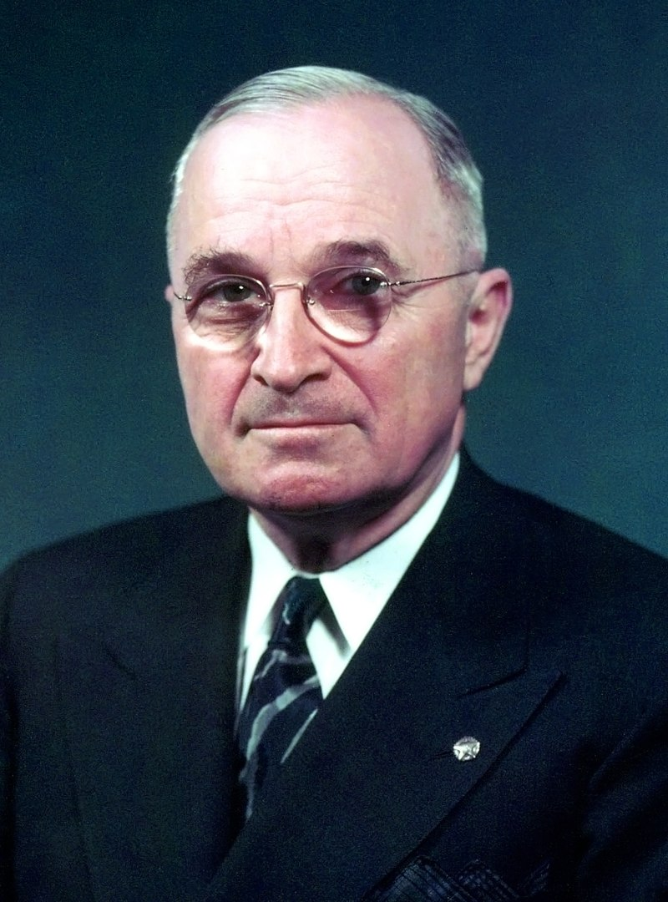

President Harry S. Truman, was the 33rd President of the United States from 1945 to 1953, succeeding upon the death of Franklin D. Roosevelt after serving as vice president. He made the decision to drop the first atomic bomb on Japan. He implemented the Marshall Plan to rebuild the economy of Western Europe, and established the Truman Doctrine and NATO.

Table of Contents

Summary 3

Peace At Last – Make Gasoline For Cars 4

Aviation Production Reduce The Surplus 5

Obsolete Aviation Gasoline Plants 6

1946 Aviation Gasoline 13

1947 Aviation Gasoline 13

1948 Aviation Gasoline 14

In-Flight Refuelling & World Records 14

Oil Companies And Refineries 15

Epilogue For 1949 15

Index 16

Research Sources 18

Photo 2. The War is over - heavy B-24 Liberator bombers awaiting disassembly at Kingman Air Force base in Arizona. 1947.

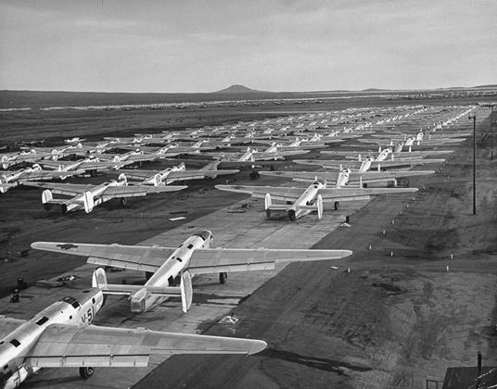

# Summary

The period in America after World War II was a time when industry, particularly the oil industry was seeking to get back to normal operations supplying the general population with the petroleum products denied during the war years, and gaining profits from the exports to the war-ravaged nations in Europe and the East.

Harry S. Truman would intend to rebuild the US economy, rebuild a worn-torn Europe and stem the tide of communism. In 1947, President Harry S. Truman pledged that the United States would help any nation resist communism in order to prevent its spread. His policy of containment is known as the ‘Truman Doctrine’.

The oil industry moved from aviation gasoline production to motor gasoline, but was then forced to change back due to the Berlin Airlift, and then the Korean War.

While this was the commencement of the jet era for the air forces, there was still a role for piston engines using aviation gasoline, and in some cases a combination of both.

Photo 3. Convair B-36 ‘Peacemaker’[1]

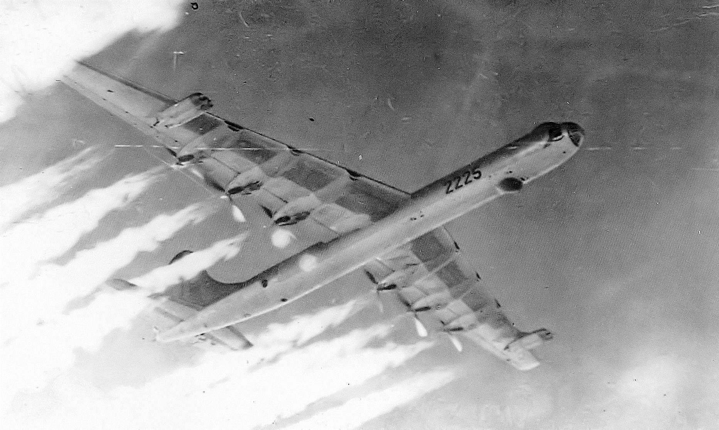

The Convair B-36 "Peacemaker" was a strategic bomber built by Convair and operated by the United States Air Force (USAF) from 1949 to 1959. The B-36 was the largest mass-produced piston-engined aircraft ever built. It had six piston (pusher) engines and four jet engines – ‘six turning, four burning’. It had the longest wingspan of any combat aircraft ever built, at 230 ft (70.1 m). The B-36 was the first bomber capable of delivering any of the nuclear weapons in the US arsenal from inside its four bomb bays without aircraft modifications. With a range of 10,000 miles (16,000 km) and a maximum payload of 87,200 lb (39,600 kg), the B-36 was capable of intercontinental flight without refuelling. It entered service in 1948, the B-36 was the primary nuclear weapons delivery vehicle of USAF Strategic Air Command (SAC) until it was replaced by the jet-powered Boeing B-52 Stratofortress beginning in 1955. All but five aircraft were scrapped.

# Peace at Last – Make gasoline for cars

Change Avgas production to Motor Gasoline Production.

With the end of the war, there was no longer the demand for aviation gasoline; however, the public, particularly in Europe and even the U.S. had been under petrol restrictions for some 6 years. Many of the process plants were converted to manufacture motor gasoline; others were shut down and demolished.

Photo 4. Ford coupe at a Mobil service station (circa 1948)

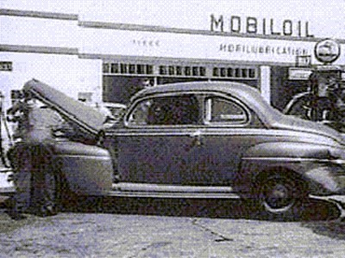

In the United States it was a time of great growth, the service men and women had returned home and together with the wartime workforce they wanted to return to their civilian lives, even start new careers. The Servicemen's Readjustment Act of 1944, commonly known as the G.I. Bill, was a U.S. law that provided a range of benefits for returning World War II veterans (commonly referred to as G.I.s). Benefits included low-cost mortgages, low-interest loans to start a business or farm, one year of unemployment compensation, and dedicated payments of tuition and living expenses to attend high school, college, or vocational school. These benefits were available to all veterans who had been on active duty during the war years for at least 90 days and had not been dishonourably discharged. The G.I. Bill was a major political and economic success and a major contribution to America's stock of human capital that encouraged long-term economic growth.

The American economy was booming.

For the US oil companies it was resume commercial business in a world free of war. New refineries were to be built; their overseas refinery assets destroyed during the war had to be rebuilt in the new world order.

An insight into these changes can be found in the “HISTORY of THE TEXAS COMPANY and PORT ARTHUR WORKS Refinery” by Elton N. Gish which described the transition to peace time.

*Within a few days after the end of World War II, plant production (at the Port Arthur Refinery) was converted from a war-time to a peace-time basis. A large quantity of high-octane gasoline that had been used to manufacture aviation gasoline was now available for motor fuel blending. Consequently, an octane race started to increase the quality of motor gasoline. The capacity limitations on the FCCU’s (Fluid Catalytic Cracking Unit) were removed in order to increase the volume of motor gasoline that could be produced. The charge rate was increased from 15,000 to 42,000 barrels per day; however, the conversion level decreased from 65% to about 45%. During the four-year period from 1945 to 1949, the production of motor gasoline practically doubled from 19 million barrels in 1945 to 37 million* *barrels in 1949. The demand for lubricating oils paralleled the demand for motor gasoline. To meet these demands in 1949, the construction of Vacuum Pipe Still No. 2, FRU No. 4, and SDU No. 3 was completed.* [Note: FRU=Furfural Refining Unit, SDU=Solvent Dewaxing Unit. Both these units are used to make lubrication oils.]

Photo 5. Texaco Port Arthur Refinery Alkylation Unit

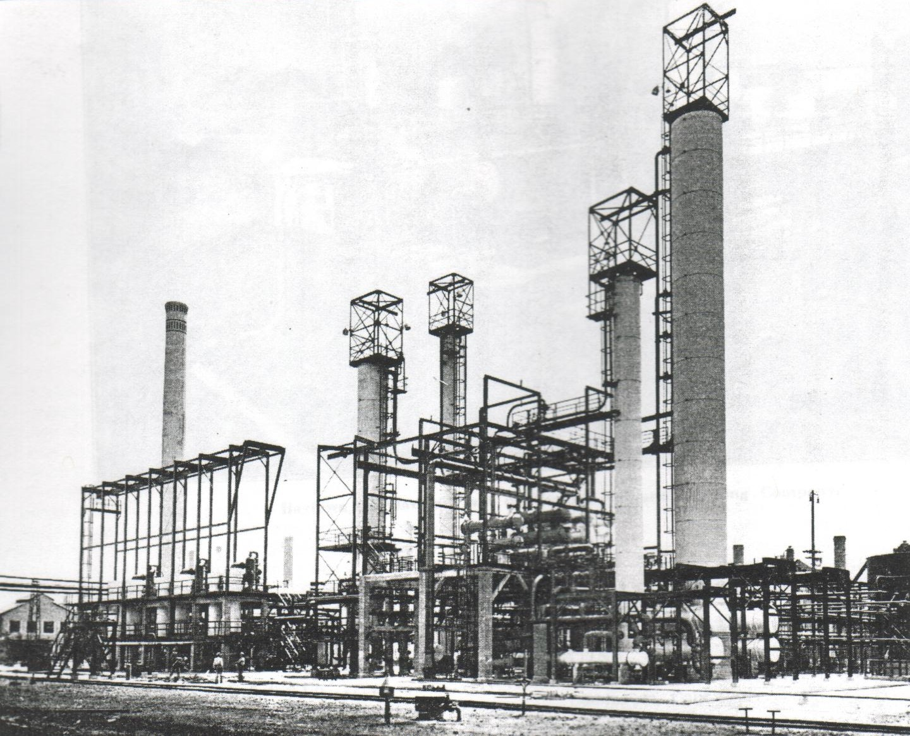

# Aviation Production Reduce the Surplus

Many of the U.S. Aviation Gasoline Plants were funded by the U.S. Government under the Reconstruction Finance Corporation and at the end of the war a report was made on Aviation Gasoline Plants and Facilities with the view to shutting down surplus production.[2]. The total wartime cost (as at November 1945) was in excess of US $230 million.

The following table shows those units destined for shutdown, some of the interesting points are:

The number of small companies engaged in production of alkylate and base stock (from thermal reforming and catalytic cracking), integration of feed stocks and blending to produce the maximum amount of aviation gasoline (as discussed in previous chapters), use of integrated pipelines to transport the aviation gasoline and blendstocks, use of adjacent refinery facilities such as utilities and storage.

The predominance of the ‘oil states’ of Texas (14 plants) and Oklahoma (4 plants).

The reduction in total capacity of alkylate from these closures would be over 44,500 Barrels/day (over 7 million litre/day), together with a loss of some 130,600 Barrels/day (nearly 21 million litres/day) of cracking capacity. Ironically within 4 years the demand for aviation gasoline would surge with the Berlin Airlift in 1949; and some 40 years later with the environmental pressures to reduce the lead content and benzene content of motor gasolines, one of the solutions to making high octane (benzene free) gasoline would be alkylate from the alkylation process.

# Obsolete Aviation Gasoline Plants

Table . Summary of Aviation Gasoline Plants holdings of Reconstruction Finance Corporation. (modified)

Unit capacities listed are based on Petroleum Administration for War Information, and are for high octane aviation gasoline production on a stream-day basis.

|  |  |  |  |  |  |  |  |  |  |  |
| --- | --- | --- | --- | --- | --- | --- | --- | --- | --- | --- |
| Plant No. | Wartime Operator & Plant Location | Catalytic Cracking | Gas Conc. | Alkylation | Isomerisation | Other Major Units | Principal Attendant Facilities | Location in respect to Basic Refinery | Dependency on Operator or Others | Status as of Dec. 15, 1945 |
| 880 | J S Abercrombie & Magnolia Petroleum Co. Sweeney, Texas | FCC 2 stage 13,000 B/D gas oil | Yes | HF  4,000 B/D Alkylate | Butane  1,500 B/D isobutane | Crude distillation 22,000 B/D, Thermal Reforming  7,000 B/D charge | TEL blending, loading racks, barge terminal, ocean terminals acid treatment, storage, pipelines to ocean & river terminals | Isolated (complete refinery) | Operator controls crude oil sources. Additional light ends from cycling plants of operator and others | Declared Surplus. Shutdown |
| 1036 | Anderson-Prichard Refining Corp. Cyril, Oklahoma |  | Yes  320 B/D Butane |  |  |  |  | Intermingled | Feed stocks & utilities from basic refinery of operator | Shutdown |
| 1067 | Ashland Oil & Refining Co. Catlettsburg, Kentucky | TCC 2 stage 10,000 B/D gas oil | Yes | HF  3,000 B/D Alkylate | Butane  1,300 B/D isobutane |  | TEL blending, loading racks, CS blending Girbitol unit storage | Adjacent | Feed stocks from basic refinery of operator | TCC, gas conc. & utilities operating under lease on monthly basis |
| 1059 | Associated Refiners Inc. Beckett, Oklahoma | FCC 2 stage 10,000 B/D gas oil | Yes | HF  2,200 B/D Alkylate | Butane 250 B/D isobutane |  | TEL blending, loading racks, storage | Isolated | Feed stocks from basic refineries of 8 operators located in area | Shutdown |
| 1229 | Bay Petroleum Corp. Denver, Colorado |  | Yes  130 B/D Butane |  |  |  | Loading racks, storage | Intermingled | Feed stocks & utilities from basic refinery of operator | Leasing on monthly basis |
| 1042 | Continental Oil Co. Ponca City, Oklahoma | TCC 2 stage gas oil, 1 stage retreat 20,000 B/D gas oil | Yes | HF  3,000 B/D Alkylate | Butane  1,500 B/D isobutane | Straight run stabilizer, delayed coker gas oil tower | TEL blending, loading racks, CS blending, storage | Adjacent | Feed stocks from basic refinery of operator | TCC, gas conc. & utilities operating under lease on monthly basis |
| 959 | Cooperative Refining Co. Coffeyville, Kansas | FCC 1 stage  3,800 B/D gas oil | Yes | HF  1,000 B/D Alkylate | Butane  400 B/D isobutane |  | TEL blending, storage, pipeline to Sinclair Refinery | Adjacent | Feed stocks from basic refinery of operator | Shutdown |
| 1068 | Crown Central Petroleum Corp. Pasadena, Texas | TCC 2 stage 10,000 B/D gas oil | Yes | HF  3,500 B/D Alkylate | Butane  1,300 B/D isobutane |  | Storage | Adjacent | Feed stocks from basic refinery of operator | Shutdown |
| 911 | Eastern States Petroleum Co. Inc. Houston, Texas | FCC 1 stage  5,000 B/D gas oil | Yes | HF  1,600 B/D Alkylate | Butane  600 B/D isobutane |  | TEL blending, loading racks, storage | Adjacent | Feed stocks from basic refinery of operator | FCC, gas conc. & utilities operating under lease on monthly basis |
| 1146 | The Frontier Refining Co. Cheyenne, Wyoming | FCC 1 stage  2,700 B/D gas oil | Yes | HF  1,100 B/D Alkylate | Butane  450 B/D isobutane | Crude Distillation 2,200 B/D, Thermal reforming 1,500 B/D charge debutaniser | TEL blending, loading racks, Sweetening unit, pipeline to Rocky Mountain pipeline | Adjacent | Feed stocks (including crude) from basic refinery of operator | Crude, reformer, FCC, gas conc. & utilities operating under lease on monthly basis |
| 638 | Great Southern Corp. Corpus Christi, Texas |  | Yes | HF  1,500 B/D Alkylate |  | Thermal Reforming 2,000 B/D charge, dehydrogenation naphtha feed preparation unit 5,000 B/D charge | TEL blending, | Adjacent | Feed stocks and terminalling facilities provided by operator | Reformer fractionation equipment & utilities operating under lease on monthly basis |
| 638 | Chicago Corp. Aqua Dulce, Texas |  | Absorption (cycling plant addition) |  |  |  |  | Intermingled | Feed stocks & utilities from cycling plant of operator | Shutdown |
| 638 | Chicago Corp. Bishop, Texas |  | Absorption (cycling plant addition) |  |  |  |  | Intermingled | Feed stocks & utilities from cycling plant of operator | Shutdown |
| 638 | Gulf Plains Corp. Driscoll, Texas |  | Absorption (cycling plant addition) |  |  |  |  | Intermingled | Feed stocks & utilities from cycling plant of operator | Shutdown |
| 638 | Lockhart Oil Co. Banquete Texas |  | Absorption (cycling plant addition) |  |  |  |  | Intermingled | Feed stocks & utilities from cycling plant of operator | Shutdown |
| 1909 | Humble Oil & Refining Co. Baytown, Texas |  |  |  |  | Hydrogenation 13,000 B/D charge | 8,000 B/D feed charge | Inside | Feed stocks from various operators, additional feed stocks, utilities & terminalling facilities from basic refinery of operator | Shutdown |
| 1041 | Mohawk Petroleum Corp. Bakersfield, California |  | Yes | HF  1,000 B/D Alkylate | Butane 450 B/D isobutane | Thermal Reforming 2,200 B/D charge, Pentane splitter | TEL blending, loading racks, tankage | Adjacent | Feed stocks from basic refinery of operator | Shutdown |
| 1871 | Pan American Petroleum & Transport Co. Texas City, Texas |  |  |  | Pentane 1,300 B/D isopentane | Pentane splitter | Storage | Inside | Feed stocks, utilities & storage from basic refinery of operator | Shutdown |
| 1044 | The Pennzoil Company. Oil City, Pennsylvania |  | Yes | HF  1,500 B/D Alkylate |  |  | TEL blending, loading racks. | Adjacent | Feed stocks from basic refineries of Pennzoil & three other operators | Shutdown |
| 592 | Premier Oil Refining Co. Cotton Valley, Louisiana |  | Yes | HF  2,200 B/D Alkylate |  | Dehydrogenation 750 B/D butylenes | TEL blending, loading racks, tankage | Adjacent | Feed stocks from basic refinery of operator, additional feed stocks from others | Shutdown |
| 562 | The Pure Oil Company, Smiths Bluff, Texas |  | Yes | H2SO4  1,330 B/D Alkylate |  |  |  | Adjacent | Feed stocks from basic refinery of operator | Shutdown |
| 718 | Republic Oil Refining Co. Texas City, Texas | FCC 12,000 B/D gas oil | Yes | HF  1,800 B/D Alkylate |  | Thermal Cracker 5,000 B/D charge | TEL blending, loading racks, storage | Adjacent | Feed stocks from basic refinery of operator | FCC, gas conc. & utilities operating under lease on monthly basis |
| 689 | Root Petroleum Co. El Dorado, Arkansas | FCC  4,600 B/D gas oil | Yes | HF  1,300 B/D Alkylate | Butane  250 B/D isobutane |  | TEL blending, Girbitol Unit storage | Inside | Feed stocks from basic refinery of operator | FCC, gas conc. Alkylation & utilities operating under lease on monthly basis |
| 591 | Southport Petroleum Company (later Liberty Oil Co.) Texas City, Texas | HCC 1 stage 13,000 B/D gas oil | Yes | HF  1,600 B/D Alkylate |  |  | TEL blending, loading racks, storage, pipeline to Pan American & Republic | Adjacent | Feed stocks from basic refinery of operator | Shutdown |
| 1833 | Standard Oil Company of California, Richmond, California | TCC 2 stage 14,000 B/D gas oil | Yes | HF  3,200 B/D Alkylate | Butane  1,400 B/D isobutane | Butane-pentane splitter |  | Adjacent | Feed stocks from basic refinery of operator | Under lease to Aug 1946 |
| 1868 | Standard Oil Company of New Jersey, Baton Rouge, Louisiana |  |  |  |  | Hydrogenation or CS manufacture 11,000 B/D charge |  | Inside | Feed stocks from basic refinery of operator, additional feed stocks from others | Shutdown |
| 1164 | Utah Oil Refining Co. Salt Lake City, Utah | FCC 1 stage  8,500 B/D gas oil | Yes | H2SO4  3,000 B/D Alkylate | Butane 1,000 B/D iso C4, naphtha 1,500 B/D iso C5, C6, C7 etc. | Naphtha fractionator  5,000 B/D feed | CS blending, HCl generator, TEL blending, H2SO4 recovery | Adjacent | Feed stocks, terminalling & utilities from basic refinery of operator | FCC, gas conc., alkylation & utilities under lease monthly basis |
| 1164 | Utah Oil Refining Co. Fort Laramie, Wyoming |  |  |  |  |  | Loading rack, storage for butane and other products | Isolated |  | Shutdown |
| 912 | Wilshire Oil Co. Inc. Norwalk, California | FCC 1 stage 4,000 B/D gas oil | Yes | HF  1,750 B/D Alkylate | Butane  1,000 B/D isobutane |  | TEL blending, loading racks, storage | Inside | Feed stocks from basic refinery of operator | Shutdown |

Table . Plants built under the Office of Defense Supplies (RFC) escrow contracts returnable to the U.S. Government

|  |  |  |  |  |  |  |  |  |  |  |
| --- | --- | --- | --- | --- | --- | --- | --- | --- | --- | --- |
| Plants built under the Office of Defense Supplies (RFC) escrow contracts returnable to the U.S. Government | | | | | | | | | | |
| Wartime Operator & Plant Location | Catalytic Cracking | Gas Conc. | Alkylation | Isomerisation | Other Major Units | Principal Attendant Facilities | Location in respect to Basic Refinery | Dependency on Operator or Others | Status as of Dec 15, 1945 |
| Champlin Refining Co. Enid, Oklahoma |  | Yes | HF  2,300 B/D Alkylate | Butane  1,350 B/D isobutane |  | Storage | Adjacent | Feed stocks & utilities from basic refinery of operator | Operating |
| Cities Service Oil Co.  East Chicago, Illinois |  | Yes | H2SO4  600 B/D Alkylate | Butane  1,000 B/D isobutane |  |  | Inside | Feed stocks, terminalling & utilities from basic refinery of operator | Part operating |
| Continental Oil Co. Wichita Falls, Texas |  |  |  | Isopentane |  |  |  |  |  |
| Socony-Vacuum Oil Co. East St. Louis, Illinois |  |  |  |  | Butene – butylene extraction unit |  |  |  |  |

Table 3. U.S. Production 1945-1948. (Take note of the dramatic change from 1945 to 1946)

|  |  |  |  |  |  |  |  |  |  |  |  |  |  |
| --- | --- | --- | --- | --- | --- | --- | --- | --- | --- | --- | --- | --- | --- |
| 1945 | Jan | Feb | Mar | Apr | May | June | July | Aug | Sept | Oct | Nov | Dec | Total |
| Production 100 Octane & above | 14,731 | 13,673 | 15,644 | 15,531 | 16,525 | 15,332 | 15,364 | 12,454 | 3,566 | 970 | 278 | 147 | 124,215 |
| Other avgas grades | 3,181 | 3,366 | 3,563 | 2,508 | 2,663 | 1,914 | 3,176 | 715 | 409 | 1,831 | 2,366 | 2,488 | 28,180 |
| Transfers out | 363 | 348 | 426 | 683 | 298 | 372 | 472 | 1,275 | 2,929 | 1,314 | 1,336 | 1,346 | 11,162 |
| Total Exports | 4,575 | 4,490 | 6,035 | 7,351 | 4,907 | 3,567 | 1,652 | 521 | 141 | 187 | 388 | 303 | 34,117 |
| US Domestic demand all grades | 11,698 | 10,166 | 12,853 | 13,673 | 13,233 | 13,489 | 14,761 | 13,084 | 9,586 | 2,399 | 1,191 | 867 | 117,000 |
| Total demand by grades | | | | | | | | | | | | | |
| 100-Octane & Above | 13,580 | 12,055 | 16,094 | 17,989 | 15,470 | 14,753 | 14,216 | 12,172 | 8,638 | 1,733 | 676 | 298 | 127,674 |
| Other finished | 2,072 | 2,011 | 2,096 | 2,260 | 1,872 | 1,869 | 1,653 | 1,137 | 807 | 721 | 686 | 709 | 17,893 |
| Components | 621 | 590 | 698 | 775 | 798 | 434 | 544 | 296 | 282 | 132 | 217 | 153 | 5,540 |

|  |  |  |  |  |  |  |  |  |  |  |  |  |  |
| --- | --- | --- | --- | --- | --- | --- | --- | --- | --- | --- | --- | --- | --- |
| 1946 | Jan | Feb | Mar | Apr | May | June | July | Aug | Sept | Oct | Nov | Dec | Total |
| Production 100 Octane & above | 470 | 263 | 197 | 283 | 485 | 460 | 577 | 469 | 496 | 417 | 550 | 675 | 5,342 |
| Other avgas grades | 2,036 | 1,441 | 1,871 | 1,613 | 1,662 | 1,676 | 1,693 | 1,919 | 1,680 | 1,773 | 1,392 | 1,314 | 20,070 |
| Transfers out | 748 | 793 | 1,641 | 685 | 906 | 1,023 | 999 | 1,086 | 976 | 642 | 627 | 806 | 10,932 |
| Total Exports | 93 | 135 | 371 | 129 | 198 | 233 | 125 | 249 | 273 | 121 | 221 | 146 | 2,294 |
| US Domestic demand all grades | 1,429 | 733 | 901 | 835 | 1,003 | 969 | 1,291 | 1,257 | 994 | 1,298 | 964 | 1,226 | 12,900 |
| Total demand by grades | | | | | | | | | | | | | |
| 100-Octane & Above | 621 | 263 | 501 | 243 | 399 | 429 | 537 | 525 | 445 | 582 | 585 | 695 | 5,825 |
| Other finished | 747 | 591 | 694 | 644 | 738 | 719 | 821 | 888 | 740 | 754 | 581 | 659 | 8,576 |
| Components | 154 | 14 | 77 | 77 | 64 | 55 | 59 | 95 | 83 | 83 | 19 | 18 | 798 |

|  |  |  |  |  |  |  |  |  |  |  |  |  |  |
| --- | --- | --- | --- | --- | --- | --- | --- | --- | --- | --- | --- | --- | --- |
| 1947 | Jan | Feb | Mar | Apr | May | June | July | Aug | Sept | Oct | Nov | Dec | Total |
| Production 100 Octane & above | 704 | 713 | 954 | 566 | 1,219 | 1,353 | 1,545 | 2,061 | 2,258 | 2,121 | 2,187 | 2,186 | 17,867 |
| Other avgas grades | 1,101 | 1,230 | 1,267 | 1,880 | 1,651 | 1,650 | 1,922 | 1,603 | 1,475 | 1,328 | 1,129 | 1,193 | 17,429 |
| Transfers out | 870 | 623 | 793 | 719 | 703 | 780 | 771 | 538 | 467 | 284 | 311 | 247 | 7,106 |
| Total Exports | 105 | 381 | 445 | 193 | 405 | 484 | 276 | 831 | 375 | 394 | 498 | 685 | 5,072 |
| US Domestic demand all grades | 1,061 | 968 | 1,108 | 1,010 | 1,643 | 1,703 | 2,123 | 1,959 | 2,568 | 2,655 | 2,320 | 2,489 | 21,607 |
| Total demand by grades | | | | | | | | | | | | | |
| 100-Octane & Above | 571 | 685 | 899 | 518 | 1,047 | 1,200 | 1,397 | 1,896 | 2,033 | 1,982 | 1,930 | 2,334 | 16,492 |
| Other finished | 578 | 631 | 637 | 680 | 870 | 836 | 939 | 860 | 775 | 912 | 692 | 778 | 9,188 |
| Components | 17 | 33 | 17 | 5 | 131 | 151 | 63 | 34 | 135 | 155 | 196 | 62 | 999 |

|  |  |  |  |  |  |  |  |  |  |  |  |  |  |
| --- | --- | --- | --- | --- | --- | --- | --- | --- | --- | --- | --- | --- | --- |
| 1948 | Jan | Feb | Mar | Apr | May | June | July | Aug | Sept | Oct | Nov | Dec | Total |
| Production 100 Octane & above | 2,385 | 1,825 | 2,329 | 2,945 | 2,775 | 2,943 | 2,747 | 3,190 | 2,562 | 2,864 | 3,143 | 3,713 | 33,421 |
| Other avgas grades | 1,058 | 1,219 | 986 | 1,143 | 1,300 | 1,172 | 1,395 | 1,286 | 723 | 739 | 1,144 | 660 | 12,825 |
| Transfers out | 242 | 270 | 223 | 453 | 301 | 505 | 384 | 374 | 196 | 124 | 96 | 117 | 3,285 |
| Total Exports | 417 | 203 | 448 | 613 | 725 | 518 | 791 | 343 | 486 | 753 | 424 | 618 | 6,339 |
| US Domestic demand all grades | 2,291 | 1,942 | 2,786 | 2,707 | 3,618 | 3,413 | 2,916 | 3,638 | 2,684 | 3,062 | 3,194 | 4,367 | 36,618 |
| Total demand by grades | | | | | | | | | | | | | |
| 100-Octane & Above | 2,089 | 1,553 | 2,480 | 2,509 | 3,364 | 2,988 | 2,797 | 2,873 | 2,304 | 3,042 | 2,825 | 4,382 | 33,206 |
| Other finished | 605 | 550 | 714 | 788 | 890 | 874 | 858 | 936 | 852 | 754 | 742 | 585 | 9,148 |
| Components | 14 | 42 | 40 | 23 | 89 | 69 | 52 | 172 | 14 | 19 | 51 | 18 | 603 |

# 1946 Aviation Gasoline

The demand for aviation gasoline in 1946 amounted to 15,199,000 barrels or only 10% of the demand in 1945 and 8% of wartime peak demand of 1944. In addition to the decline of 136 million barrels, there was a marked change in the demand for aviation gasoline by grades. The total demand for 100 octane gasoline in 1946 was only 4.6% of the 1945 demand for this grade, while the demand for other finished aviation grades was 48% of the 1945 demand for comparable grades.

The daily production of all grades of aviation gasoline dropped from 537,000 barrels in 1945 to 418,000 barrels in 1945 and to 70,000 barrels in 1946. This represented a production decrease of 83 percent in 1946 over 1945, compared with a drop of 90 percent in total demand.

When the war ended, the daily average aviation gasoline production capacity in the US amounted to about 600,000 barrels, compared with a post war demand of less than 50,000 barrels. With this excess capacity available and confronted with a shortage of lead for the production of anti-knock compounds, some refiners continued to produce aviation gasoline components and used the material in their automotive gasolines. A large part of the remaining capacity to produce aviation gasoline grades had been incorporated as parts of refineries producing automotive gasoline and other products.

Exports of all grades of aviation gasoline in 1946 totalled 6,299 barrels ad daily compared with a daily average of 93,471 barrels in 1945 and 156,148 barrels daily in 1944. The 1946 average was about the same as the average for the post war portion of 1945 and about one-third of the export demand of 1941 when the European countries were fighting the Axis and Japan was stock piling aviation gasoline.

Domestic demand (including military purchases in continental US dropped from 117 million barrels in 1945 to 13 million in 1946. Since most of the military requirements in 1946 were supplied from inventories in the custody of the armed forces, the 13 million barrel demand, for the most part, represented purchase for use in commercial and private planes. However, this may not represent the entire fuel demand for private and commercial aircraft, since it is believed that some of the smaller planes are using automotive types of gasoline.

# 1947 Aviation Gasoline

The total demand for aviation grade gasoline rose from 15.2 million barrels in 1946 to 26.7 million barrels in 1947. Exports increased from 2.3 million barrels in 1946 to 5.1 million in 1947. Domestic demand rose from 12.9 million barrels in 1946 to 21.6 million barrels in 1947. Domestic demand includes reported deliveries for military use, amounting to 1.0 million barrels in 1946 and 7.1 million barrels in 1947.

The total demand for grades of 100-octane and above rose from 5.8 million barrels in 1946 to 16.5 million in 1947. The total demand for all other grades, including components marketed as such, rose from 9.4 million barrels in 1946 to only 10.2 million in 1947. The rapid gain in the demand for 100-octane and above is indicated by the fact that it represented 38% of total demand in 1946 and 62% of the total in 1947.

Transfers out = rejected material that is returned to regular grades of gasoline and this item should be subtracted from gross production figures to determine the net production pf marketable aviation grades.

The figures for aviation gasoline cover only the special grades identified as such by producing companies and do not include automotive gasoline that may be used by many smaller planes.

# 1948 Aviation Gasoline

The total demand for aviation grade gasoline rose from 26.7 million barrels in 1947, and 43.0 million barrels in 1948. Exports increased from 5.1 million in 1947, and 6.3 million in 1948. Domestic demand rose from 21.6 million barrels in 1947, and 36.6 million in 1948. Domestic demand includes reported deliveries to all military agencies of 1.0 million barrels in 1946, 7.1 million barrels in 1947, and 17.6 million in 1948. As reports stocks represent only those in the custody of producers, indicated demand covers only new sales to customers. Large stocks in military custody at the end of 1945 were in process of liquidation during 1946 and part of 1947.

The total demand for grades of 100-octane and above amounted to 16.5 million in 1947, and 33.2 million in 1948. Virtually all of the increase has been in these grades as the total demand for all other grades (including components marketed as such), amounted to 9.4 million barrels in 1946, and showed as small gain to 10.2 million in 1947, and a slight decline to 9.8 million in 1948.

Transfers out = rejected material that is returned to regular grades of gasoline and this item should be subtracted from gross production figures to determine the net production of marketable aviation grades.

The figures for aviation gasoline cover only the special grades identified as such by producing companies and do not include automotive gasoline that may be used by many smaller planes.

# In-flight Refuelling & World Records

While the jet aircraft were setting new speed records there were still some records to be made by piston driven aircraft. The USAF Boeing B-50A which was a later variant of the famous Boeing B-29 Superfortress, and on 26 February 1949 completed the first non-stop round the world relying on in-flight refuelling.

Photo 6. Boeing B-50A “Lucky Lady II" refuelled by Boeing B-29M 45-21708 tanker on its non-stop flight around the world.[3]

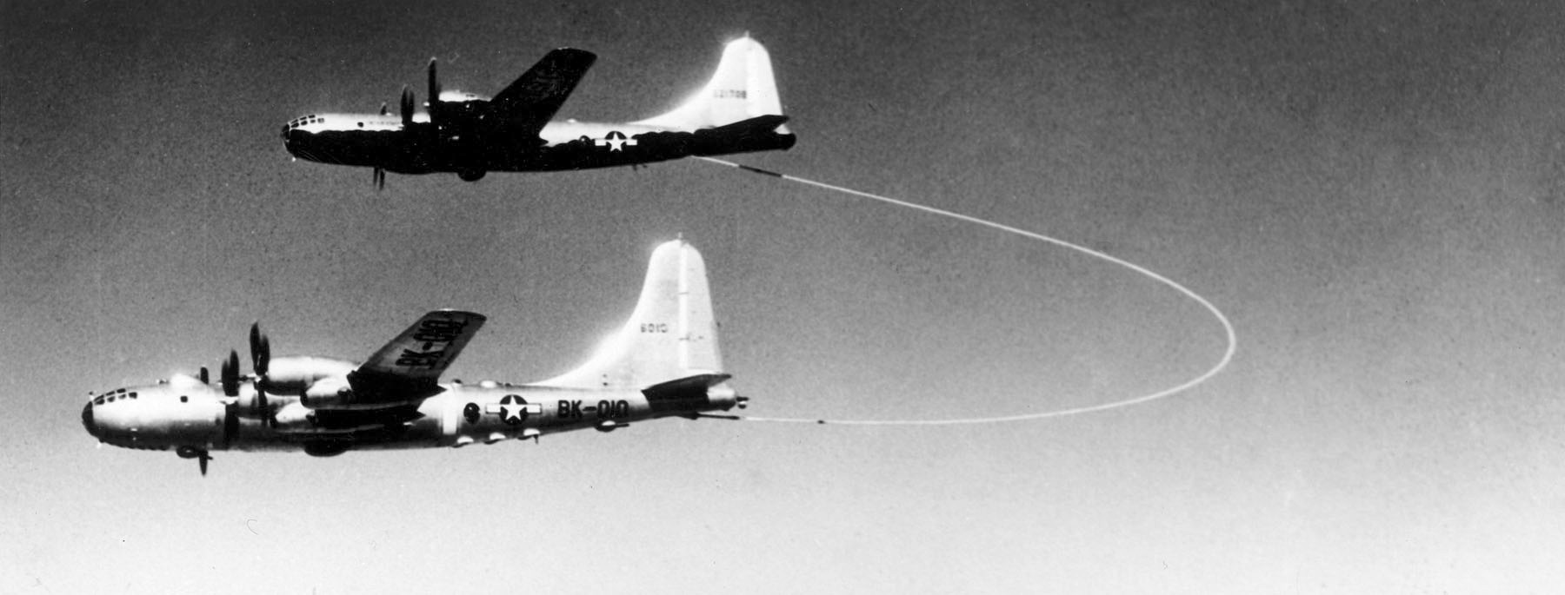

Photo 7. USAF Boeing B-50A Superfortress fuselage ‘Lucky Lady II’ on display at Chino Air Museum

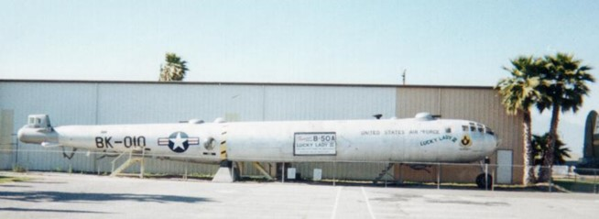

# Oil Companies and Refineries

Standard Oil of California (later Chevron)

Richmond Refinery 1901 San Joaquin crude, San Francisco, by 1921 65 MBSD

El Segundo Refinery

Bakersfield Refinery

All used Californian crudes and produced kerosene and lubes.

Standard Oil of New Jersey (later Esso, then Exxon)

Royal Dutch-Shell Group

The Texas Corporation (Texaco)

Standard Oil of New York (latter to become SOCONY and merge with Vacuum to become Mobil Corporation)

Standard Oil of Indiana (later Amoco)

Sinclair Consolidated Oil

Humble Oil & Refining Co. (later merged with Exxon)

Shell Union Oil Corporation

Vacuum Oil Co. (latter to merge with Socony to become Mobil Corporation)

Gulf Oil Corporation (later to merge Standard Oil of California (SOCAL))

San Diego was the general supply and repair base for all Air Service activities west of the Rocky Mountains including the Philippines and Hawaii and Canal Zone.

# Epilogue for 1949

In this year 1949, the sleek propeller driven monoplane was about to give way to the swept winged jet fighter. Air speed records would be smashed by the new jet aircraft, while the WWII fighters and bombers would be sent to the scrap heap and furnaces to make washing machines, refrigerators and automobiles. Many were sold off at bargain prices to equipped developing nations particularly in South America and other countries around the world.

A new fuel was required – Aviation kerosene – JET FUEL.

# Index

1

100-octane 11, 12, 13, 14

A

Absorption 7

acid treatment 6

Alkylate 5, 6, 7, 8, 9, 10

Alkylation 5, 6, 9, 10

Amoco 15

Anderson-Prichard Refining Corp 6

Aqua Dulce 7

Arkansas 9

Ashland Oil & Refining Co. 6

Associated Refiners Inc. 6

atomic bomb i

automotive gasoline 13

aviation gasoline 3, 4, 5, 13, 14

Aviation Gasoline Plants 5, 6

aviation grade gasoline 14

Aviation kerosene 15

Axis 13

B

Bakersfield 8

Bakersfield Refinery 15

Banquete 8

barge terminal 6

base stock 5

Bay Petroleum Corp. 6

Baytown 8

Beckett 6

benzene 5

Berlin Airlift 3, 5

Bishop 7

Boeing B-29 Superfortress 14

Boeing B-50A 14

Boeing B-52 Stratofortress 3

Butane 6, 7, 8, 9

Butene 10

butylene 10

C

California 8, 9

Canal Zone 15

Catalytic Cracking 5, 6, 10

Catlettsburg 6

Champlin Refining Co. 10

Chevron 15

Cheyenne 7

Chicago Corp 7

Chino Air Museum 14

Cities Service Oil Co. 10

Coffeyville 7

coker gas oil 6

Colorado 6

communism 3

Continental Oil Co. 6, 10

Convair B-36 ‘Peacemaker’ 3

Cooperative Refining Co 7

Corpus Christi 7

Cotton Valley 8

cracking capacity 5

Crown Central Petroleum Corp. 7

Crude 7

Crude distillation 6, 7

cycling plant 7

Cyril 6

D

debutaniser 7

dehydrogenation 7, 8

Denver 6

Driscoll 8

E

East 3

East Chicago 10

East St. Louis 10

Eastern States Petroleum Co. Inc. 7

El Dorado 9

El Segundo Refinery 15

Enid 10

Esso 15

Europe 3, 4

Exports 11, 12

Exxon 15

F

FCC 6, 7, 8, 9

Feed stocks 6

Fluid Catalytic Cracking Unit 4

Fort Laramie, 9

fractionation 7

Franklin D. Roosevelt 1

G

G.I. Bill 4

gas oil 6, 7, 9

Girbitol 6, 9

Great Southern Corp. 7

Gulf Oil Corporation 15

Gulf Plains Corp. 8

H

Harry S. Truman 1, 3

Hawaii 15

high-octane gasoline 4

Houston 7

Humble Oil & Refining Co. 8, 15

I

Illinois 10

isobutane 6, 7, 9, 10

Isomerisation 6, 10

isopentane 8, 10

J

J S Abercrombie 6

Japan 1, 13

Jet Fuel 15

K

Kansas 7

Kentucky 6

kerosene 15

Korean War 3

L

lead 5

Liberty Oil Co. 9

loading racks 6, 9

Lockhart Oil Co. 8

Louisiana 8, 9

lubes 15

lubricating oils 4

Lucky Lady II 14

M

Magnolia Petroleum Co. 6

Marshall Plan 1

Mobil Corporation 15

Mohawk Petroleum Corp 8

motor fuel blending 4

motor gasoline 3, 4, 5

N

naphtha 7

NATO 1

Norwalk 9

nuclear weapons 3

O

octane 4, 5

Office of Defense Supplies 10

Oil City 8

Oklahoma 5, 6, 10

P

Pan American Petroleum & Transport Co. 8

Pasadena 7

Pennsylvania 8

Pentane 8

petrol restrictions 4

Philippines 15

pipeline 5, 6

piston-engined aircraft 3

Ponca City 6

Port Arthur Refinery 4, 5

Premier Oil Refining Co. 8

process plants 4

R

Reconstruction Finance Corporation 5, 6

refinery 4, 5, 6

reformer 7

refuelling 14

Republic Oil Refining Co. 8

Richmond Refinery 9, 15

Rocky Mountain pipeline 7

Rocky Mountains 15

Root Petroleum Co. 9

Royal Dutch-Shell Group 15

S

Salt Lake City 9

San Diego 15

San Francisco 15

San Joaquin crude 15

Servicemen's Readjustment Act 4

Shell Union Oil Corporation 15

Sinclair Consolidated Oil 15

Smiths Bluff 8

SOCONY 15

Socony-Vacuum Oil Co. 10

South America 15

Southport Petroleum Company 9

Standard Oil Company of California 9,15

Standard Oil Company of New Jersey 9, 15

Standard Oil of Indiana 15

Standard Oil of New York 15

Straight run 6

Strategic Air Command (SAC) 3

Sweeney 6

Sweetening unit 7

T

tanker 14

TCC 6, 7, 9

TEL 6, 7, 8, 9

Texaco 5, 15

Texas 5, 7

Texas City 8, 9

The Frontier Refining Co. 7

The Pennzoil Company 8

The Pure Oil Company 8

The Texas Company 4

The Texas Corporation 15

Thermal Cracker 8

Thermal Reforming 5, 6, 7, 8

Truman Doctrine 1, 3

U

U.S. Government 5

United States 3

United States Air Force 3

Utah 9

Utah Oil Refining Co. 9

V

Vacuum 15

Vacuum Oil Co. 15

Vacuum Pipe Still 4

W

Western Europe 1

Wichita Falls 10

Wilshire Oil Co. Inc. 9

Wyoming 7, 9

# Research Sources

1. By United States Air Force - USAF photo via, Joaobsen, Wagner, Greer (1980), B-36 Peacemaker in action - Aircraft No. 42, Squadron/Signal Publications; 1st edition, ISBN-10: 0897471016, Public Domain, https://commons.wikimedia.org/w/index.php?curid=18758427
2. “Aviation Gasoline Plants and Facilities” Report of the Surplus Property Administration To The Congress January 14, 1946 – Institute Of The Aeronautical Sciences
3. US Government [Public domain]