Chapter

30

After the War 1946-1949

Refinery Processes

Photo 1. Standard - Vacuum De Florez Cracker, Brooklyn, New York, USA

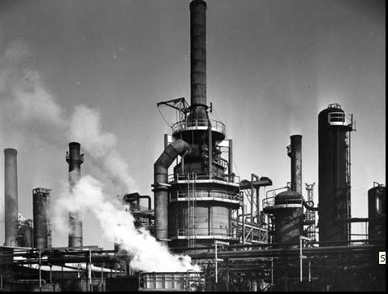

.

Table of Contents

Summary 3

Change Avgas Production To Motor Gasoline Production. 3

We Need More Avgas Again! 3

Refinery Production And Treatment Processes 4

Catalytic Reforming 11

Other Refinery Processes 22

Oil Companies And Refineries 22

Epilogue 22

Index 23

Research Sources 26

Photo 2. 1947 Chevrolet – make gasoline for motor cars.

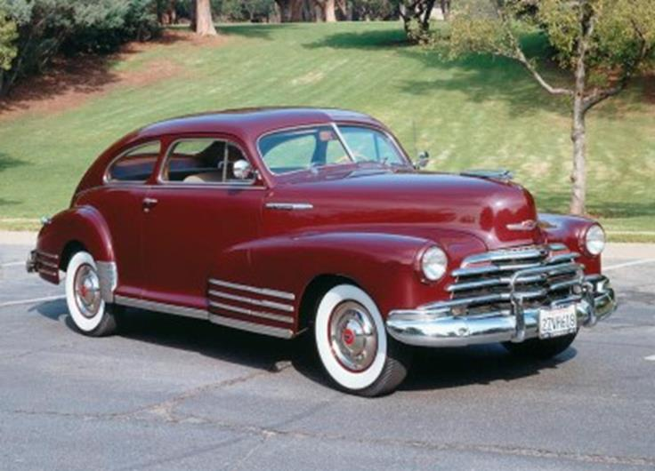

# Summary

With the arrival of peace after the terrible World War II, the world returned to the need for motor gasoline for the general public and the disposal of obsolete process plants. Petrol rationing was still in place immediately after the war and the public were anxious to return to normal life.

The availability of surplus military transport aircraft provided the basis for the growing commercial airline business and so there was still a need for avgas.

The refinery processes developed in the late 1930’s and early 1940’s were now being used to produce motor gasoline of higher octane ratings, and new refineries were being built to replace the war-ravaged plants of Europe and the Far East. Continuous distillation, catalytic cracking, reforming, and alkylation processes were now common in any modern refinery and necessary to produce the petroleum products needed by society.

But soon international tension would be raised again, this time between the West and USSR leading the need for more avgas – again!

But there was a new kerosene-based aviation fuel emerging – JET FUEL for new and faster aircraft.

Peace at Last – Make gasoline for cars

# Change Avgas production to Motor Gasoline Production.

With the end of the war, there was no longer the demand for aviation gasoline; however, the public, particularly in Europe and outside the U.S., had been under petrol restrictions for some 6 years. There was a great demand for motor gasoline. The U.S. refineries which had been expanded and engineered to produce aviation gasoline for the war effort were now changing to produce petroleum products for civilian market demands with all the accompanying economic pressures.

The war ravaged refineries of continental Europe could not operate or contribute to meet this demand so it fell to those refineries who had supplied the petroleum products during the war to meet the peace-time needs.

However in the U.S., what was to be done with those plants which had been built especially to manufacture aviation gasoline? Many of these process plants were converted to manufacture motor gasoline, others were shut down and demolished.

# We need more Avgas again!

Change Avgas production to Motor Gasoline Production [then back to Avgas again].

However, by 1948 a crisis in Europe would require the demand for aviation gasoline once again – this crisis was the isolation of Berlin by the Russian Soviet occupying forces in Germany by closing all road, rail and river transport. The only transport route open was air – thus in order to supply the people of Berlin with food, fuel (coal), and other rations the western powers Great Britain and United States undertook a massive air transport of supplies – this became generally known as the ‘Berlin Airlift’.

This would be followed by the Korean War in 1950, then the boom in civil aviation leading into the Jet Age as can be seen by the graph below of worldwide production.

Graph 1. World-wide production of Aviation Gasoline 1940 –1966 [1], [2]

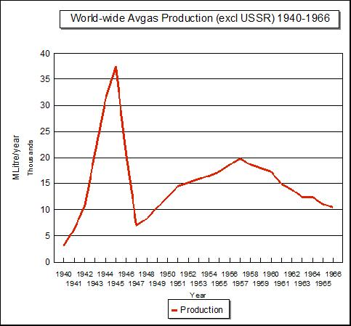

# Refinery Production and Treatment Processes[3]

The refinery production and treatment processes in 1948 were much the same as those used in the Second World War, indeed many were, in principle, the same as was first used in the 19th century refineries with primary distillation. Crude oil as received at a refinery is a complex mixture of many hydrocarbons of various types and impurities. In order to obtain specific products, the first step in the refining manufacturing process is to undertake a partial separation of this very complex mixture into portions such as naphtha, kerosene, gas oil, fuel oil, etc. Generally no attempt is made to separate individual hydrocarbons, and the well known petroleum products actually consist complex hydrocarbons of the desired boiling range. The usual method of separating crude petroleum into these main products is the process of distillation. Distillation is the process by which the liquid is converted to vapour by the application of heat, and then by back to a liquid by cooling.

Fractional Distillation

When a mixture of liquids of petroleum type is distilled from a container, there is a general tendency for the components of lower boiling point to distil over first, and the higher boiling point components are distilled over later when more heat is applied to raise the temperature of the boiling liquid. If the distillation process is arranged such that the vapour from the boiling liquid is thoroughly mixed with condensed liquid of approximately the same boiling point, then a much better separation of the components of different boiling points is obtained. This method of distillation is known as ‘fractional distillation’ and is applied in various ways to the distillation of crude petroleum.

Batch Distillation

In batch distillation one particular ‘batch’ of crude petroleum is fractionally distilled into the main products, and then another ‘batch’ is charged and distilled and so on. This method is not economical and is not used unless it is desired to split the crude petroleum into more than the main standard products. It was used extensively in the early days of refining and in particularly even up until the 1950’s for production of petroleum products from shale oil (produced from the thermal destruction of coal shale). However it required the clean-out of coke for the stills after each batch was processed.

Continuous Distillation

A continuous form of distillation is more convenient and economical. One earlier method was to have a series of stills, each heated to a temperature above that of the preceding still. A series of distillates is obtained in this way, one or more from each still. By incorporating suitable fractionating columns, a fair degree of separation can be obtained from the crude oil. This known as ‘continuous bench’ of stills, but this method was almost obsolete by 1948. It was in use in the 1920’s and also during the war by the Japanese at captured Dutch East Indies refineries.

The other continuous method is known as Flash Distillation and this is the method in common use today at most modern refineries.

Flash Distillation

The modern fractionating column is a long cylindrical tower fitted with a large number of trays. Superheated steam is fed in at the bottom of the tower of the fractionating column. The heated crude oil is introduced at a point a little way up the column. The liquid falls down two or three trays, meets the superheated steam and the lighter fractions then rise up the column through the vapour. As it rises, it cools and a certain amount condenses on each tray until the tray is full of liquid up to the level of overflow. The level is kept just above the level of the holes in the bubble caps, so that all the vapour has to pass through the liquid. It is apparent that each tray is a little cooler than the one below it and that lighter and lighter products will be present on each tray as the vapour passes up through the column. As the vapour bubble passes through the liquid on these trays, that part of the vapour, which has the same boiling point as the liquid in the tray, will condense, and any light fractions present in the liquid will evaporate and move further up the fractionating tower.

Figure 1. Crossflow bubble cap plates (trays)

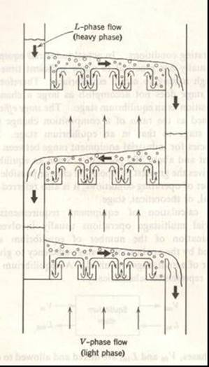

The V-phase (vapour) flow indicated by light arrows; the L-phase (liquid) is indicated by heavy arrows.

The temperature throughout the column is controlled at the bottom by the temperature of the incoming crude oil, and the top of the column is controlled by pumping back a certain amount of the material which leaves the top of the column after condensing it – this is known as the ‘reflux’. Thus, by controlling the temperature at the top and bottom, the temperature variation throughout is kept under control, and the temperature of each tray varies gradually from bottom to top. The amount of reflux pumped back is varies as required in order to get the correct temperature at top, which in turn controls the final boiling point of the naphtha leaving the top of the fractionating column.

Photo 3. Typical bubble cap tray (plate).

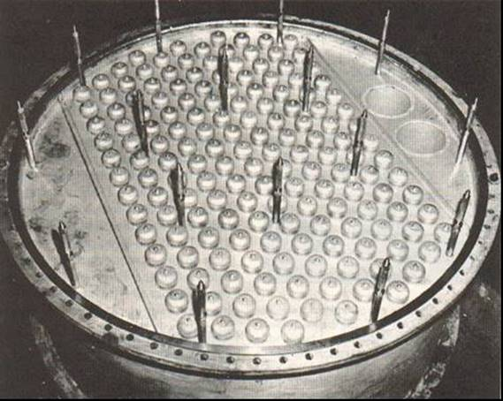

The sheet metal dams and weirs on the left and right side of the plate maintain the liquid level high enough to cover the slots in the bubble caps. The liquid flows downward from the plate above on to the left side of the plate, it then flows across the plate to the right to the two downcomers at the right side. The rods projecting from the plate are for support of the next plate above.

Side Strippers

Although each tray collects liquid of a small boiling point range, there is as a result of the complete range of vapours bubbling through any one tray, a certain amount of material which has condensed which has a lower boiling point (light ends) than the bulk of the liquid in that tray. It is customary therefore to draw the liquid from a selected tray out of the main column into a small auxiliary column , called a ‘side-stripper’, an allow it to flow down several bubble trays. While passing over these trays, the liquid meets an upward stream of steam injected at the bottom of the stripper, which boils off the lightest components and thus narrows the boiling range; theses vapours together with the steam are returned to the main column. By using two or more side-strippers in conjunction with the main column, streams of kerosene and gas oil can be obtained directly from the tower without further distillation.

Photo 4. Mobil Altona Refinery No. 2 Crude Unit Distillation Tower 38,000 Barrels/day (1954).

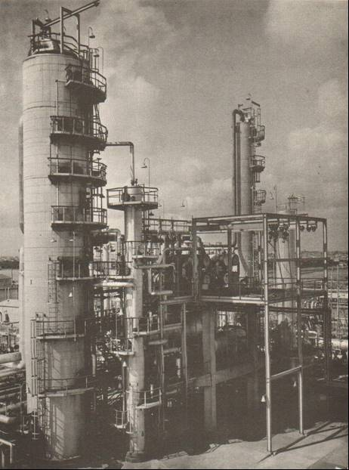

The tall large tower on the left is the main distillation column with the kerosene/gas oil side stripper beside it immediately on the right. The taller narrow fractionating tower in the background (right) is for separation of light ends from the crude tower overhead (unstabilised naphtha) to produce the stabilized gasoline cut (Straight Run Naphtha).

Vacuum Distillation

This process was originally introduced in 1870 to manufacture lubricants, indeed one oil company named itself after the process – ‘Vacuum Oil Company’. By 1930 it was used for preparation for cracking feedstocks. The residue (bottoms) from the main distillation of crude petroleum may be further distilled for the production of lubricating oils, paraffins wax, and bitumens; but if this petroleum is heated to high temperatures it may ‘crack’, which may spoil the products desired. In order to avoid this undesired ‘cracking’ the distillation may be carried out under a reduced pressure of ‘vacuum’. The actual pressure used is between 10mm and 40mm Hg. (1.3 – 5.3 kPa). The fractionating column is of larger diameter and the trays are placed further apart owing to the large volumes of vapour at the reduced pressure, otherwise the process is basically the same as for normal distillation. This process is usually the preliminary to the modern cracking processes.

Pressure Distillation

When dealing with very volatile liquids, distillation may be carried out under pressure. This is used for the manufacture of Butane and Propane from natural gasoline. (Natural gasoline is the term given to the naphtha found in association with natural gas fields).

Two Stage Distillation

This is a normal distillation plant with a vacuum plant in series, and it was used if it was desired to produce a larger range of products. It is more economical in terms of operating expenses. An example of two stage distillation is shown below.

Photo 5. Mobil Altona Refinery No. 1 Crude Unit & Rerun 2,800 Barrels/day (1949).

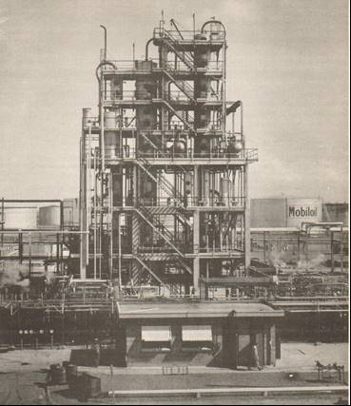

The three fractionating towers from left to right are: atmospheric crude tower (main distillation column), reduced crude vacuum tower, and re-run vacuum tower.

This unit – atmospheric column (18 trays) produced light naphtha from the overhead (top – above tray 18), heavy naphtha (or kerosene) from a side draw (tray 16), and diesel oil (gas oil side draw at tray 10); the residue (bottoms) went to the Vacuum tower to produce light lube distillate, heavy lube distillate, and bitumen. The Re-Run tower was a separate batch operation used to treat the lube distillates or diesel oil.

Cracking Process

The basic process for increasing the yield of gasoline from crude oil is the cracking process, in which higher boiling fractions from the distillation of crude oils are heated to higher temperatures with or without a catalyst. However nearly all modern cracking processes now use catalysts. Generally when a hydrocarbon or mixture of hydrocarbons is subjected to heat treatment or cracking, products both simpler and more complex are obtained, and some of the initial material remains unchanged. As the resultant products can be ‘fractionated’ this becomes a general means of increasing the yield of desired products.

Figure 2. Cracking Process

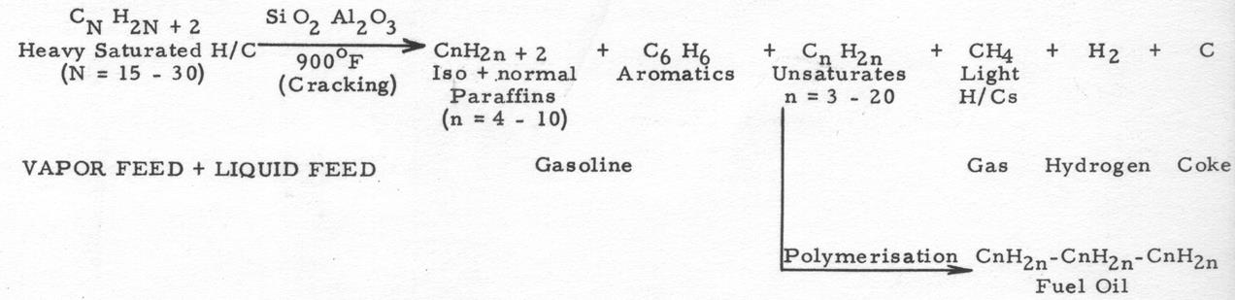

As a result of cracking of higher boiling petroleum fractions, the yield of gasoline including both ‘straight run’ and ‘cracked’ gasoline may be as high as 50-60% or more of the original crude oil feedstock. Since on average, crude petroleum contains about 25-30% of gasoline (or naphtha) boiling up to 400oC., the cracking process doubles the yield of gasoline.

There are two main types of cracking processes – Thermal Cracking and the more common, Catalytic Cracking.

Thermal Cracking

This process was introduced in 1913 and was popular from the early 1920’s. This process depends on temperature 850-1,000oF (454 – 538oC.), and pressure 100-500 psi (690 –3,450 kPa) and reaction time. The feedstock for cracking varies both in boiling point and the relative proportions of paraffin and cyclic hydrocarbons. By the best application of thermal cracking, a yield of 60-65% volume of 65-70 octane number motor gasoline can be obtained. However if attempts are made to increase the knock ratings by using more severe cracking conditions, such as higher temperatures, higher pressures and longer reaction times then the gasoline yield decreases. When less severe cracking conditions are used, higher gasoline yields are obtained but with lower knock ratings.

As well as cracked gasoline, the process also produces a certain amount of carbon and heavy oil, and a considerable amount of hydrocarbon gases. These gases are essentially the lighter hydrocarbon fragments produced by breaking of large hydrocarbon molecules, and contain hydrogen, paraffins (such as methane, ethane, propane, butanes) and olefins (such as ethylene, propylene, butylenes).

This process lost favour when next development catalytic cracking was established in the 1930’s.

Catalytic cracking

This process is much the same as thermal cracking but it makes use of catalysts to accelerate hydrocarbon reactions to give increased yields and improved quality of products. ‘Cat Cracking’ was introduced in 1937 although the Houdry Cracking Process (described earlier) was around from the late 1920’s. Fluidized Catalytic Cracking began in 1942 and is now the generally accepted as the modern cat- cracking process and is an integral part of every modern refinery. These processes were discussed in detail earlier.

Thermal Reforming

This process was introduced in 1930 to improve the octane of gasolines. If a straight run gasoline is heat treated, its anti-knock value will be increased although considerable losses occur due to gas formation. However, with increased demand for high octane gasoline, it was profitable in many cases to accept these losses, which with modern processes utilizing the gases, they were not necessarily wasted. This process is known as Thermal Reforming. In the majority of reforming processes the gasoline or naphtha is heated to 950-1,100oF (510 – 593oC.), under a pressure of 400-750 psi (2,758 –5,171 kPa).

However, after the war, this process would be replaced in the 1950’s by Catalytic Reforming.

Catalytic Reforming

Catalysts are used in the reforming processes to obtain products of higher anti-knock values, to increase the yield of reformed gasoline and to produce larger amounts of aromatic hydrocarbons such as benzene, toluene and xylenes. Various catalysts, notably bauxite (or alumina) with trace elements such as 0.6% Platinum to aid the reaction. This first catalytic reforming process using Platinum catalyst was introduced in 1949 and it became widely accepted by 1952.

This would be the last of the refinery processes producing gasoline which would be blended into aviation gasoline. It would become the main gasoline process for any refinery and while aviation gasoline production would decline, motor gasoline production would continue to increase.

Reforming is the only refining process that is capable of economically making a gasoline component having a clear Research Octane Number (RON) up to 100 or greater. Octane improvements in naphthas of up to 40-50 octane numbers (Clear) are not unusual. [‘Clear’ refers to the octane rating without the addition of anti-knock additives such as tetra ethyl lead, TEL]

[Reformers are used to perform two steps in the production of high quality U.S. military JP-7 Jet fuel, isomerization of paraffins to isoparaffins for freeze point lowering and, hydrogenation of aromatics to naphthenes to improve the heating value BTU/lb)] .

Various oil companies and catalyst manufacturers, depending on their research, use a variety of names to describe the same general operation.

Platforming Universal Oil Products (U.O.P.)

Magnaforming Engelhard (catalyst manufacturer)

Powerforming Esso Research & Engineering

Houdriforming Houdry

Rheniforming Chevron

Sovaformer Standard-Vacuum Refining Company

Ultraforming Standard Oil of Indiana

It is discussed in detail here.

# Catalytic Reforming

The reformer process and catalysts would be developed over the next 30 or more years. All commercial reformers use a Platinum catalyst with hydrogen recycle stream.

Reformer Types – Semi Regen

There are a wide variety of process designs, but most are classified as ‘semi-regenerative’ type. This type is one which runs until the catalyst is coked and then it is shut down, and the catalyst regenerated in-situ. The time period between regenerations varies from several months up to 1½ years depending on the catalyst activity. Nearly three quarters of the reformers operating around the world are of this type.

Within this category of semi-regenerative reformer further sub-types exist on the basis of operating pressure. The earlier units were generally operated at high separator pressure of 450 psi (3,100 kPa) or higher, later units were operated at low pressure 300 psi (2,070 kPa) or less. Those in between are ‘intermediate’ pressure. Low pressure units give better reformate yields.

Figure 3. Semi-Regenerative Catalytic Reformer Process

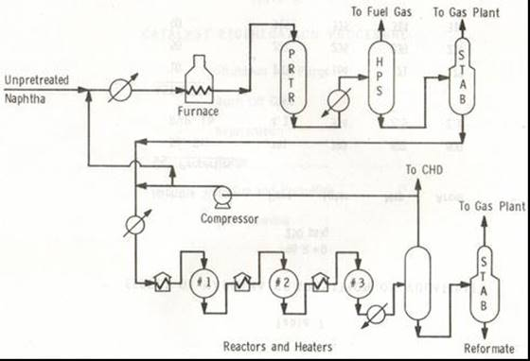

The unpretreated naphtha (low octane) is heated then pretreated (PRTR) with hydrogen rich recycle gas (>90% H2) to remove primarily sulphur compounds, also nitrogen and other trace compounds. The light gases generated are removed in the high pressure separator (HPS) and the hydrocarbons which will not generally be reformed such as propane, butanes are separated in the Stabilizer (STAB) and sent to the Gas Plant. This leaves a pretreated charge ready for the reactors where the various reactions will take place. After reacting the charge, the hydrogen rich recycle gas is recovered in another high pressure separator for reuse in the process (or some may be sent to another unit Catalytic Hydro-Desulphurizer (CHD) to be used to remove sulphur compounds from jet fuels). The bottoms from the HP Separator then go to the Stabilizer (STAB) to remove propane, butane in order to obtain the correct vapour pressure and recover these light hydrocarbons for further processing in the Gas Plant.

Catalyst Regeneration Process

This operation takes about 4-7 days. The steps in this process are to shut-down the reformer and purge all hydrocarbons from the unit. Then the coke is burnt off by slowly introducing air into the reactor. After this operation the catalyst is rejuvenated – usually sieving and removal of fines. The catalyst is returned to the reactor and perhaps fresh catalyst added. The unit is closed and purged of air and then hydrogen rich atmosphere established, the unit is heated and the catalyst activate by presulphiding to achieve the desired reaction profile, and finally the low octane naphtha is charged to the unit, and the process cycle begins again until the next regeneration.

Because any downtime in a critical refinery process unit is a substantial (unproductive) cost, other designs have been to developed to adopt some of the ideas from cat cracking where the catalyst can be regenerated on the run and thus minimize or eliminate downtime for the reformer operation. These are the Cyclic Powerformer and Continuous Platforming.

Reformer Types - Cyclic Powerformer

This process is essentially the same as the type above except that a fourth reactor is used as a swing reactor. A cyclic unit has the reactors manifolded in such a way that any reactor can be taken out of service and regenerated while the other three reactors continue to operate. The time period between regenerations for a cyclic reactor varies from 2 to 10 days, but the remainder of the unit is still operating during this regeneration. All cyclic units are low pressure.

Figure 4. Cyclic Powerformer Process

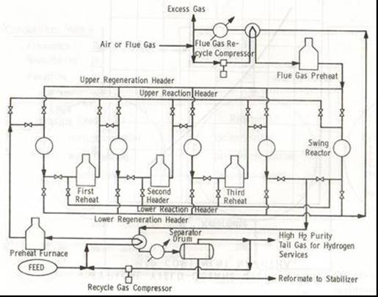

Reformer Types - Continuous Platforming’

The third type of reformer unit which came into service in the early 1980’s was the continuous reformer. In this type of unit catalyst is withdrawn from the unit while reforming, regenerated in small batches in separate regeneration facilities and then replaced in the unit. The regeneration period for continuous units is about one month. All units are low pressure.

Figure 5. Continuous Platforming Process

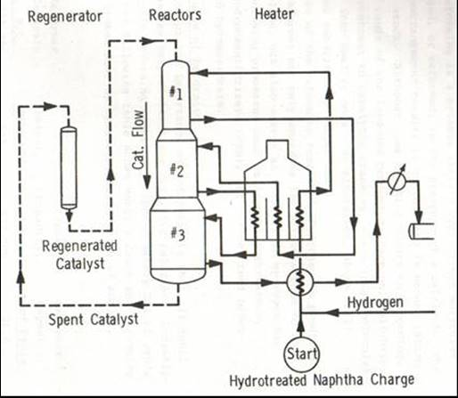

Catalyst Types

All reformers use catalysts containing Platinum at about 0.3-0.375% wt. in modern units. The next major development in catalysts was in the 1960’s with introduction of bimetallic catalysts by the addition of other metal activators such as Rhenium at levels ranging from 0.2-0.375% wt. or Germanium or Iridium.

Reformer Reactions

There are three main octane improving reactions occurring in the reforming process. These are Naphthene Dehydrogenation, Naphthene Dehydro-isomerisation, and Paraffin Dehydrocyclization. In addition there are other supporting reactions – these are: Paraffin Isomerisation, Paraffin Hydrocracking, Desulphurization and Olefin Saturation.

The following examples show how specific hydrocarbons react however it should be noted that the reformer charge is naphtha comprising a mixture of hydrocarbons and that these reactions also occur with other hydrocarbons of similar types.

1. Naphthene Dehydrogenation

Figure 6. Naphthene Dehydrogenation reaction

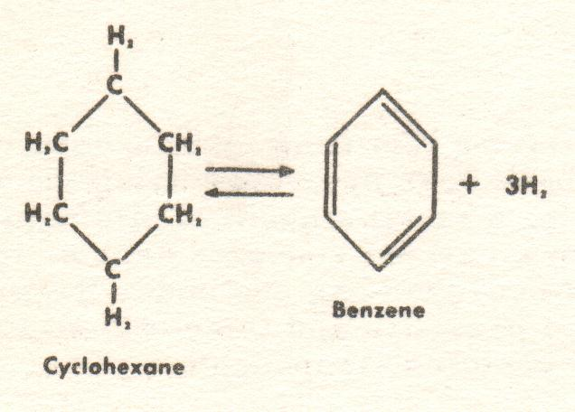

Increase in Octane 77 MON (Clear) to 86 MON (Clear), Rich rating (with 4.8 cc TEL /Imp Gal.) 130 PN for Cyclohexane to >160 PN for Benzene.

1. Naphthene Dehydro-isomerisation

Figure 7. Naphthene Dehydro-isomerisation

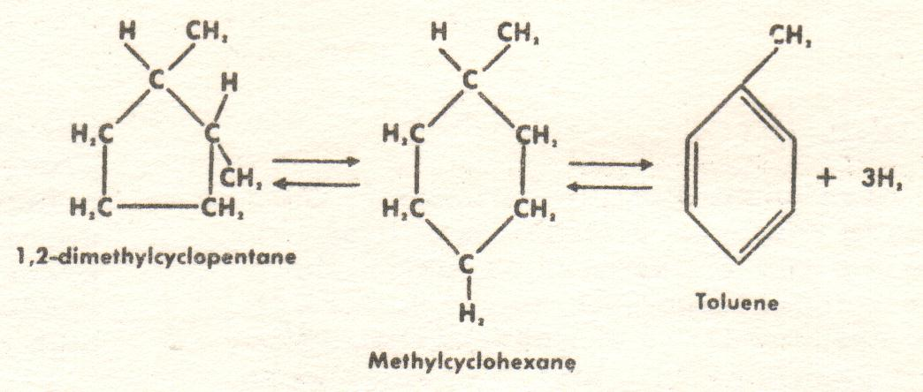

Increase in Octane 85 MON (Clear) to 97 MON (Clear), Rich rating (with 4.8 cc TEL /Imp Gal.) >160 PN for Toluene.

1. Paraffin Dehydrocyclization

Figure 8. Paraffin Dehydrocyclization

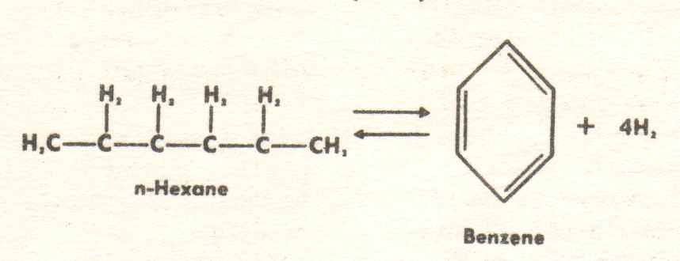

Increase in Octane 26 MON (Clear) for n-Hexane to 86 MON (Clear) for Benzene.

Other reactions

1. Paraffin Isomerisation

Figure 9. Paraffin Isomerisation

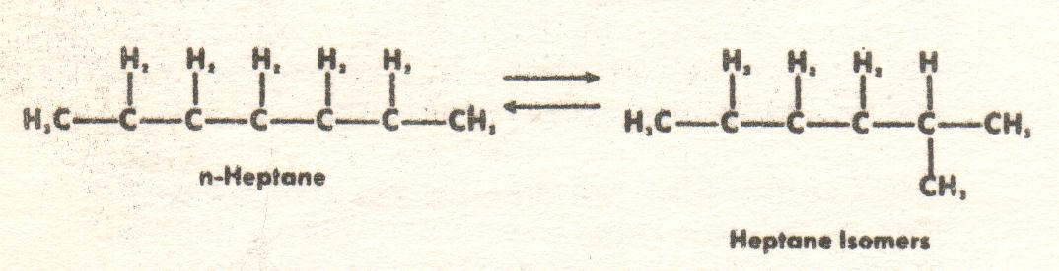

Increase in Octane 0 MON (Clear) for n-Heptane to 46.4 MON (Clear) for 2 Methyl Hexane.

1. Paraffin Hydrocracking

Figure 10. Paraffin Hydrocracking

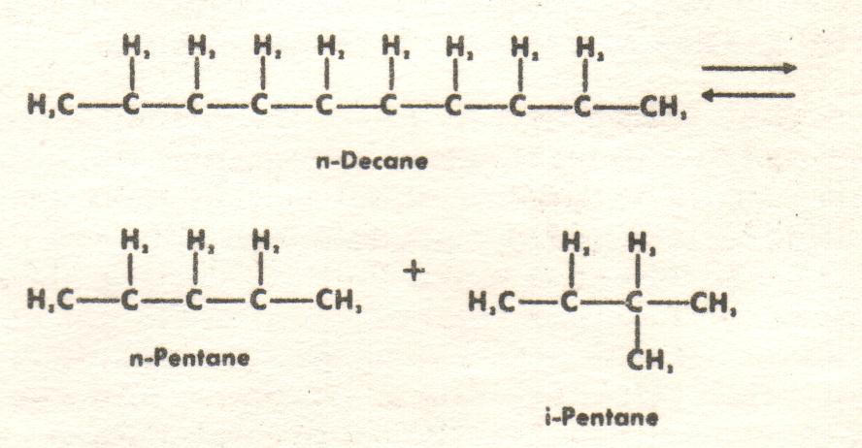

Conversion of high boiling point hydrocarbons of low octane to low boiling point components of high octane.

1. Desulphurization

Figure 11. Desulphurization

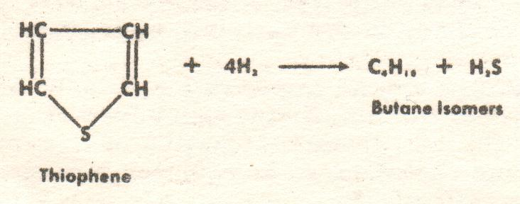

Removal of Sulphur compounds which are detrimental to lead susceptibility.

1. Olefin Saturation

Figure 12. Olefin Saturation

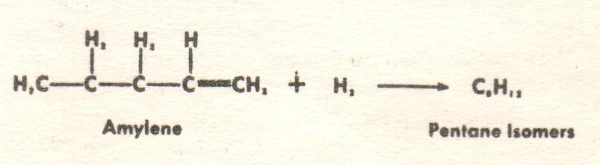

Increase in Octane 77.1 MON (Clear) for Amylene to 90.3 MON (Clear) for Isopentane, plus removal of gum-forming olefins.

The following table illustrates the changes in PONA and Octane as the low octane naphtha is processed into high octane gasoline blendstock.

Table 1. Progress of Reforming Reactions of Kuwait Naphtha Feed

|  |  |  |  |  |  |
| --- | --- | --- | --- | --- | --- |
| Stream | Octane RON +3cc TEL | Aromatics Mole% | Naphthenes Mole% | Paraffins Mole% | Reaction |
| Feed | 64 | 15 | 28 | 57 | - |
| Reactor #1 | 92 | 37 | 8 | 55 | Dehydrogenation, Ring opening, Isomerisation |
| Reactor #2 | 102 | 50 | 2 | 48 | Isomerisation, Dehydrocyclization. Dehydrogenation |
| Reactor #3 Reformate | 104 | 54 | 2 | 44 | Hydrocracking, Isoparaffins. Paraffins, Dehydrocyclization |

Graph 2. Naphtha from Kuwait crude PONA Distribution

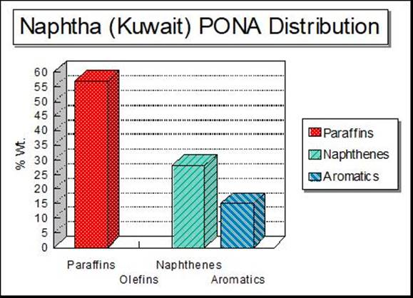

Graph 3. Reformate from Kuwait crude PONA Distribution

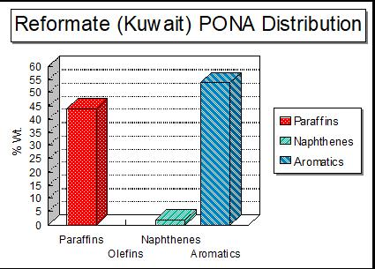

Composition of Naphtha & Reformate

The following is the detailed composition of naphtha (reformer charge) from Gippsland crude and the subsequent product (reformate) after processing through a Platinum Reformer at Mobil Altona Refinery. Note the increase in aromatic content of benzene, toluene, ethyl benzene, xylenes and trimethyl benzenes.

Table 2. Detailed Composition of Naphtha & Reformate.

|  |  |  |  |  |  |  |  |
| --- | --- | --- | --- | --- | --- | --- | --- |
| Component ID | Reformer Charge | Reformate | CRC Handbook | | | | |
| Vol. % | Vol. % | Structure No. | Other Name | CAS No. | MW | Formula |
| Ethane | 0.13 |  | 5448 |  | 74-84-0 | 30.07 | C 2H 6 |
| Propane | 1.07 |  | 9834 |  | 74-98-6 | 44.10 | C 3H 8 |
| Isobutane | 1.38 | 1.00 | 10073 | 2 Methyl Propane | 75-28-5 | 58.12 | C 4H10 |
| n-Butane | 3.28 | 3.78 | 3229 |  | 106-97-8 | 58.12 | C 4H10 |
| 2,2, Dimethyl Propane | 0.07 |  | 9910 | Neopentane | 463-82-1 | 72.15 | C 5H12 |
| Isopentane | 9.75 | 8.50 | 3397 | 2 Methyl Butane | 78-78-4 | 72.15 | C 5H12 |
| 2-Methyl -1-Butene |  | 0.03 | 3799 |  | 563-46-2 | 70.13 | C 5H10 |
| n-Pentane | 8.24 | 6.35 | 8709 |  | 109-66-0 | 72.15 | C 5H12 |
| trans-2 Pentene |  | 0.03 | 9005 |  | 646-04-8 | 70.13 | C 5H10 |
| C5 Cyclopentane | 0.37 |  | 4774 |  | 287-92-3 | 70.13 | C 5H10 |
| 2,2 Dimethyl Butane | 0.36 | 1.53 | 3289 | Neohexane | 75-83-2 | 86.18 | C 6H14 |
| 2,3 Dimethyl Butane | 1.04 | 1.80 | 3290 |  | 79-29-8 | 86.18 | C 6H14 |
| 2-Methyl Pentane | 4.39 | 6.33 | 8823 | Isohexane | 107-83-5 | 86.18 | C 6H14 |
| 3-Methyl Pentane | 2.69 | 4.79 | 8824 |  | 96-14-0 | 86.18 | C 6H14 |
| 2-Methyl-2-Pentene |  | 0.08 | 9050 |  | 625-27-4 | 84.16 | C 6H12 |
| n-Hexane | 6.16 | 5.68 | 6731 |  | 110-54-3 | 86.18 | C 6H14 |
| Methyl Cyclopentane | 2.59 | 0.45 | 4826 |  | 96-37-7 | 84.13 | C 6H12 |
| 2,2 Dimethyl Pentane | 0.22 | 0.23 | 8760 |  | 590-35-2 | 100.20 | C 7H16 |
| Benzene | 0.30 | 5.91 | 867 |  | 71-43-2 | 78.11 | C 6H 6 |
| 2,4 Dimethyl Pentane | 0.41 | 0.24 | 8762 |  | 108-08-7 | 100.20 | C 7H16 |
| Cyclohexane | 2.91 | 0.04 | 4305 |  | 110-82-7 | 84.16 | C 6H12 |
| 2,2,3-Trimethyl Butane | 0.06 | 0.03 | 3457 | Triptane | 464-06-2 | 100.20 | C 7H16 |
| 3,3 Dimethyl Pentane | 0.12 | 0.20 | 8763 |  | 562-49-2 | 100.20 | C 7H16 |
| 1,1-Dimethyl Cyclopentane | 0.36 | 0.02 | 4800 |  | 1638-26-2 | 98.19 | C 7H14 |
| 2,3 Dimethyl Pentane | 0.70 | 0.53 | 8761 |  | 565-59-3 | 100.20 | C 7H16 |
| 2-Methyl Hexane | 1.90 | 1.44 | 6834 | Isoheptane | 591-76-4 | 100.20 | C 7H16 |
| cis 1,3-Dimethyl Cyclopentane | 0.82 | 0.05 | 4803 |  | 2632-58-3 | 98.19 | C 7H14 |
| trans 1,3-Dimethyl Cyclopentane | 0.75 | 0.05 | 4804 |  | 1759-58-6 | 98.19 | C 7H14 |
| trans 1,2-Dimethyl Cyclopentane | 1.03 | 0.06 | 4802 |  | 822-50-4 | 98.19 | C 7H14 |
| 3-Methyl Hexane | 1.91 | 1.74 | 6835 |  | 6131-24-4 | 100.20 | C 7H16 |
| 3-Ethyl Pentane | 0.12 | 0.17 | 8809 |  | 617-78-7 | 100.20 | C 7H16 |
| n-Heptane | 4.96 | 1.23 | 6355 |  | 142-82-5 | 100.20 | C 7H16 |
| Methyl Cyclohexane | 8.51 | 0.08 | 4426 |  | 108-87-2 | 98.19 | C 7H14 |
| Ethyl Cyclopentane | 0.47 | 0.03 | 4812 |  | 1640-89-7 | 98.19 | C 7H14 |
| 2,2 Dimethyl Hexane | 0.45 | 0.03 | 6771 |  | 590-73-8 | 114.23 | C 8H18 |
| 2,5 Dimethyl Hexane | 0.30 | 0.03 | 6774 |  | 592-13-2 | 114.23 | C 8H18 |
| 1-trans-2-cis-4-Trimethyl Cyclopentane | 0.40 |  | 4860 |  | 16883-48-0 | 112.22 | C 8H16 |
| 2,4 Dimethyl Hexane | 0.33 | 0.06 | 6773 |  | 589-43-5 | 114.23 | C 8H18 |
| 1-trans-2-cis-3-Trimethyl Cyclopentane | 0.32 |  | 4857 |  | 19374-46-0 | 112.22 | C 8H16 |
| Toluene | 1.53 | 18.55 | 1947 |  | 108-88-3 | 92.14 | C 7H 8 |
| 3,3 Dimethyl Hexane | 0.11 |  | 6775 |  | 563-16-6 | 114.23 | C 8H18 |
| 2-Methyl 3-Ethyl Pentane | 0.09 |  | 8813 |  | 609-26-7 | 114.23 | C 8H18 |
| 2,3 Dimethyl Hexane | 0.36 | 0.04 | 6772 |  | 584-94-1 | 114.23 | C 8H18 |
| 3-Methyl Heptane | 3.70 | 0.14 | 6423 |  | 6131-25-5 | 114.23 | C 8H18 |
| 2-Methyl Heptane | 1.38 | 0.14 | 6422 |  | 592-27-8 | 114.23 | C 8H18 |
| 4-Methyl Heptane | 0.39 | 0.05 | 6424 |  | 589-53-7 | 114.23 | C 8H18 |
| 1,1-Dimethyl Cyclohexane | 0.27 |  | 4364 |  | 590-66-9 | 112.22 | C 8H16 |
| 1-Methyl-cis-3-Ethyl Cyclopentane | 0.22 |  | 4817 |  | 2613-66-3 | 112.22 | C 8H16 |
| 1-Methyl-trans-3-Ethyl Cyclopentane | 0.15 |  | 4818 |  | 2613-65-2 | 112.22 | C 8H16 |
| 1-Methyl-trans-2-Ethyl Cyclopentane | 1.08 |  | 4816 |  | 930-90-5 | 112.22 | C 8H16 |
| 1-Methyl-1-Ethyl Cyclopentane | 0.04 |  | 4814 |  | 16747-50-5 | 112.22 | C 8H16 |
| trans 1,2-Dimethyl Cyclohexane | 0.95 |  | 4366 |  | 6876-23-9 | 112.22 | C 8H16 |
| n-Octane | 4.40 | 0.15 | 8355 |  | 111-65-9 | 114.23 | C 8H18 |
| iso-Propyl Cyclopentane | 0.06 |  | 4828 |  | 3875-51-2 | 112.22 | C 8H16 |
| 1-Methyl-cis-2-Ethyl Cyclopentane | 0.19 |  | 4815 |  | 930-89-2 | 112.22 | C 8H16 |
| cis 1,2-Dimethyl Cyclohexane | 0.30 |  | 4365 |  | 2207-01-4 | 112.22 | C 8H16 |
| 2,3,5-Trimethyl Hexane | 0.02 |  | 6864 |  | 1069-53-0 | 128.26 | C 9H20 |
| Ethyl Cyclohexane | 1.49 |  | 4390 |  | 1678-91-7 | 112.22 | C 8H16 |
| 1,1,4-Trimethyl Cyclohexane | 0.54 |  | 4487 |  | 7094-27-1 | 126.24 | C 9H18 |
| 2,5 Dimethyl Heptane | 0.04 |  | 6386 |  | 2216-30-0 | 128.26 | C 9H20 |
| Ethyl Benzene | 0.40 | 2.35 | 1668 |  | 100-41-4 | 106.17 | C 8H10 |
| 1,1,3-Trimethyl Cyclohexane | 0.24 |  | 4486 |  | 3073-66-3 | 126.24 | C 9H18 |
| 2,3,3-Trimethyl Hexane | 0.45 |  | 6862 |  | 16747-28-7 | 128.26 | C 9H20 |
| p-Xylene | 0.83 | 3.61 | 1454 |  | 106-42-3 | 106.17 | C 8H10 |
| 1-cis-3-cis-5-Trimethyl Cyclohexane | 0.22 |  | 4496 |  | 1795-27-3 | 126.24 | C 9H18 |
| m-Xylene | 1.50 | 8.13 | 1453 |  | 108-38-3 | 106.17 | C 8H10 |
| 3 Methyl 3-Ethyl Hexane | 0.17 |  | 6826 |  | 3074-76-8 | 128.26 | C 9H20 |
| 4-Ethyl Heptane | 0.06 |  | 6408 |  | 2216-32-2 | 128.26 | C 9H20 |
| 4-Methyl Octane | 0.35 |  | 8410 |  | 2216-34-4 | 128.26 | C 9H20 |
| 3-Ethyl Heptane | 0.13 |  | 6407 |  | 15869-80-4 | 128.26 | C 9H20 |
| 2-Methyl Octane | 0.57 |  | 8408 |  | 3221-61-2 | 128.26 | C 9H20 |
| 1-trans-2-cis-3-Trimethyl Cyclohexane | 0.04 |  | 4489 |  | 1678-81-5 | 126.24 | C 9H18 |
| 3-Methyl Octane | 0.52 |  | 8409 |  | 2216-33-3 | 128.26 | C 9H20 |
| o-Xylene | 0.47 | 3.81 | 1452 |  | 95-47-6 | 106.17 | C 8H10 |
| 1-Methyl-2-Propyl Cyclopentane | 0.09 |  | 4835 |  | 935-44-5 | 126.24 | C 9H18 |
| 2,2,6-Trimethyl Heptane | 0.04 |  | 6440 |  | 1190-83-6 | 142.28 | C10H22 |
| Nonane | 2.46 |  | 8120 |  | 111-84-2 | 128.26 | C 9H20 |
| 1-Methyl-trans-4-Ethyl Cyclohexane | 0.48 |  | 4396 |  | 4923-78-8 | 126.24 | C 9H18 |
| 1-Methyl-1-Ethyl Cyclohexane | 0.21 |  | 4394 |  | 4926-90-3 | 126.24 | C 9H18 |
| Isopropyl Benzene | 0.05 | 0.09 | 1975 | Cumene | 98-82-8 | 120.19 | C 9H12 |
| iso-Propyl Cyclohexane | 0.13 |  | 4431 |  | 696-29-7 | 126.24 | C 9H18 |
| 2,2 Dimethyl Octane | 0.10 |  | 8373 |  | 15869-87-1 | 142.28 | C10H22 |
| 1-Methyl-cis-4-Ethyl Cyclohexane | 0.26 |  | 4395 |  | 4923-77-7 | 126.24 | C 9H18 |
| n-Propyl Cyclohexane | 0.47 |  | 4471 |  | 1678-92-8 | 126.24 | C 9H18 |
| 4,4 Dimethyl Octane | 0.07 |  | 8383 |  | 15869-95-1 | 142.28 | C10H22 |
| Propyl Benzene | 0.17 | 0.47 | 2169 |  | 103-65-1 | 120.19 | C 9H12 |
| 2,7 Dimethyl Octane | 0.08 |  | 8378 |  | 1072-16-8 | 142.28 | C10H22 |
| 3,3 Dimethyl Octane | 0.24 |  | 8379 |  | 4110-44-5 | 142.28 | C10H22 |
| m-Ethyl Toluene | 0.28 | 1.81 | 1686 |  | 620-14-4 | 120.19 | C 9H12 |
| p-Ethyl Toluene | 0.16 | 0.85 | 1687 |  | 622-96-8 | 120.19 | C 9H12 |
| 3-Methyl-3-Ethyl Heptane | 0.15 |  | 6410 |  | 17302-01-1 | 142.28 | C10H22 |
| 1,3,5 Tri Methyl Benzene | 0.33 | 0.99 | 2359 | Mesitylene | 108-67-8 | 120.19 | C 9H12 |
| o-Ethyl Toluene | 0.18 | 0.54 | 1685 |  | 611-14-3 | 120.19 | C 9H12 |
| 4-Methyl Nonane | 0.10 |  | 8142 |  | 17301-94-9 | 142.28 | C10H22 |
| 2-Methyl Nonane | 0.02 |  | 8140 |  | 871-83-0 | 142.28 | C10H22 |
| 3-Methyl Nonane | 0.14 |  | 8141 |  | 5911-04-6 | 142.28 | C10H22 |
| tert Butyl Benzene | 0.02 |  | 1459 |  | 98-06-6 | 134.22 | C10H14 |
| 1,2,4-Trimethyl Benzene | 0.31 | 2.69 | 2358 | Psuedocumene | 95-63-6 | 120.19 | C 9H12 |
| sec Butyl Benzene |  | 0.01 | 1118 |  | 135-98-8 | 134.22 | C10H14 |
| n-Decane | 0.46 | 0.01 | 5033 |  | 124-18-5 | 142.28 | C10H22 |
| 1-Methyl 3 iso Propyl Benzene | 0.04 |  | 1989 |  | 535-77-3 | 134.22 | C10H14 |
| 1-Methyl-trans-4-iso-Propyl Cyclohexane | 0.04 |  | 4452 |  | 4291-81-0 | 140.27 | C10H22 |
| 1,2,3-Trimethyl Benzene | 0.06 | 0.46 | 2357 |  | 526-73-6 | 120.19 | C 9H12 |
| Indane |  | 0.09 | 7250 |  | 496-11-7 | 118.18 | C 9H10 |
| iso-Butyl Cyclohexane | 0.03 |  | 4448 |  | 7058-01-7 | 140.27 | C10H20 |
| n-Butyl Cyclohexane | 0.03 |  | 4325 |  | 1678-93-9 | 140.27 | C10H20 |
| (m-) 1,3 Diethyl Benzene |  | 0.05 | 1414 |  | 141-93-5 | 134.22 | C10H14 |
| 1-Methyl 3 n-Propyl Benzene | 0.03 | 0.12 | 2037 |  | 1074-43-7 | 134.22 | C10H14 |
| 1,3-Dimethyl 5-Ethyl Benzene | 0.03 | 0.19 | 1672 |  | 934-74-7 | 134.22 | C10H14 |
| (p-) 1,4 Diethyl Benzene |  | 0.08 | 1415 |  | 105-05-5 | 134.22 | C10H14 |
| 1-Methyl 2 n-Propyl Benzene |  | 0.03 | 2036 |  | 1074-17-5 | 134.22 | C10H14 |
| 1,4-Dimethyl 2-Ethyl Benzene |  | 0.10 | 1674 |  | 1758-88-9 | 134.22 | C10H14 |
| 1,3-Dimethyl 4-Ethyl Benzene |  | 0.10 | 1671 |  | 874-41-9 | 134.22 | C10H14 |
| 1,2-Dimethyl 4-Ethyl Benzene |  | 0.17 | 1675 |  | 934-80-5 | 134.22 | C10H14 |
| 1,3-Dimethyl 2-Ethyl Benzene |  | 0.03 | 1673 |  | 2870-04-4 | 134.22 | C10H14 |
| Methyl Indane |  | 0.02 | 7255 |  | 767-58-8 | 132.21 | C10H12 |
| Undecane | 0.04 |  | 11938 |  | 1120-21-4 | 156.31 | C11H24 |
| 1,2,4,5-Tetramethyl Benzene |  | 0.13 | 2280 |  | 95-93-2 | 134.22 | C10H14 |
| 1,2,3,5-Tetramethyl Benzene |  | 0.18 | 2279 |  | 527-53-7 | 134.22 | C10H14 |
| 1,2,3,4-Tetramethyl Benzene |  | 0.05 | 2278 |  | 488-23-3 | 134.22 | C10H14 |
| Naphthalene |  | 0.08 | 7732 |  | 91-20-3 | 128.17 | C10H 8 |
| 2-Methyl Naphthalene |  | 0.04 | 7916 |  | 91-57-6 | 142.20 | C11H10 |
| 1-Methyl Naphthalene |  | 0.02 | 7915 |  | 90-12-0 | 142.20 | C11H10 |
| C2-Naphthalene |  | 0.01 |  |  |  | 157.20 | C13H13 |
| Unidentified | 0.56 | 1.09 |  |  |  |  |  |

# Other Refinery Processes

The other refinery processes such as catalytic cracking, alkylation and isomerisation as related to the production of aviation gasoline and motor gasoline are discussed in Chapter 10.

# Oil Companies and Refineries

The war brought to a (temporary) close the huge demand for avgas, and those refineries which had operated during the war, now reverted back to the production of motor gasoline for the petrol-rationed public. There was however still a demand for avgas in 1946-47 as commercial airlines began to re-establish themselves using surplus WWII transport aircraft.

The Berlin Airlift in 1948 would swing the production demands back to avgas in order to supply the transport aircraft.

This was also a period of reconstructions for a war-torn world. Everything was in short supply – the bomb damaged refineries of Europe had to be rebuilt or new refineries constructed to replace them. The great refineries of Palembang and Pladjoe in the Dutch East Indies which had fallen to Japanese Imperial Forces were in ruins; the Nazi German refineries had been bombed out of existence, the vast oil refineries (and oil fields) of the Balkans (Ploësti Refineries, Rumania) were now under the control of communist Russia.

# Epilogue

The period from WWII to the start of the fifties was a major change from ‘produce more avgas’ for the war effort to defeat the Axis, to ‘when will petrol rationing stop? The war is over!’

There would also be a major shift in where petroleum products should be produced; because WWII highlighted a dilemma regarding where should refineries be located? Close to the need (market), or away from risk of attack? This will be discussed in other chapters.

However in this period there was several significant changes underway, the closure of Berlin by the Russians in 1948 which resulted in the Berlin Airlift and the need for more avgas for the WWII transport aircraft; the forthcoming Korean War – yet another conflict which would require more avgas for the late WWII aircraft still in service, and finally the transition from the avgas powered piston engine to new jet fuel powered aircraft.

New processes would be developed.

# Index

(m-) 1,3 Diethyl Benzene 21

(p-) 1,4 Diethyl Benzene 21

1

1,1,3-Trimethyl Cyclohexane 20

1,1,4-Trimethyl Cyclohexane 20

1,1-Dimethyl Cyclohexane 19

1,1-Dimethyl Cyclopentane 19

1,2,3,4-Tetramethyl Benzene 21

1,2,3,5-Tetramethyl Benzene 21

1,2,3-Trimethyl Benzene 21

1,2,4,5-Tetramethyl Benzene 21

1,2,4-Trimethyl Benzene 21

1,2-Dimethyl 4-Ethyl Benzene 21

1,3,5 Tri Methyl Benzene 21

1,3-Dimethyl 2-Ethyl Benzene 21

1,3-Dimethyl 4-Ethyl Benzene 21

1,3-Dimethyl 5-Ethyl Benzene 21

1,4-Dimethyl 2-Ethyl Benzene 21

1-cis-3-cis-5-Trimethyl Cyclohexane 20

1-Methyl 2 n-Propyl Benzene 21

1-Methyl 3 iso Propyl Benzene 21

1-Methyl 3 n-Propyl Benzene 21

1-Methyl Naphthalene 22

1-Methyl-1-Ethyl Cyclohexane 20

1-Methyl-1-Ethyl Cyclopentane 20

1-Methyl-2-Propyl Cyclopentane 20

1-Methyl-cis-2-Ethyl Cyclopentane 20

1-Methyl-cis-3-Ethyl Cyclopentane 19

1-Methyl-cis-4-Ethyl Cyclohexane 20

1-Methyl-trans-2-Ethyl Cyclopentane 20

1-Methyl-trans-3-Ethyl Cyclopentane 19

1-Methyl-trans-4-Ethyl Cyclohexane 20

1-Methyl-trans-4-iso-Propyl Cyclohexane 21

1-trans-2-cis-3-Trimethyl Cyclohexane 20

1-trans-2-cis-3-Trimethyl Cyclopentane 19

1-trans-2-cis-4-Trimethyl Cyclopentane 19

2

2 Methyl Butane 18

2 Methyl Hexane 16

2 Methyl Propane 18

2,2 Dimethyl Butane 18

2,2 Dimethyl Hexane 19

2,2 Dimethyl Octane 20

2,2 Dimethyl Pentane 19

2,2, Dimethyl Propane 18

2,2,3-Trimethyl Butane 19

2,2,6-Trimethyl Heptane 20

2,3 Dimethyl Butane 18

2,3 Dimethyl Hexane 19

2,3 Dimethyl Pentane 19

2,3,3-Trimethyl Hexane 20

2,3,5-Trimethyl Hexane 20

2,4 Dimethyl Hexane 19

2,4 Dimethyl Pentane 19

2,5 Dimethyl Heptane 20

2,5 Dimethyl Hexane 19

2,7 Dimethyl Octane 21

2-Methyl -1-Butene 18

2-Methyl Heptane 19

2-Methyl Hexane 19

2-Methyl Naphthalene 22

2-Methyl Nonane 21

2-Methyl Octane 20

2-Methyl Pentane 18

2-Methyl-2-Pentene 19

3

3 Methyl 3-Ethyl Hexane 20

3,3 Dimethyl Octane 21

3,3 Dimethyl Pentane 19

3-Ethyl Heptane 20

3-Ethyl Pentane 19

3-Methyl Heptane 19

3-Methyl Hexane 19

3-Methyl Nonane 21

3-Methyl Octane 20

3-Methyl Pentane 18

3-Methyl-3-Ethyl Heptane 21

4

4,4 Dimethyl Octane 20

4-Ethyl Heptane 20

4-Methyl Heptane 19

4-Methyl Nonane 21

4-Methyl Octane 20

A

alumina 11

Amylene 16

aromatics 11, 17

atmospheric crude tower 9

aviation gasoline 3, 11

B

Balkans 22

Batch Distillation 5

bauxite 11

Benzene 11, 15, 18, 19

Berlin 3, 22

Berlin Airlift 3, 22

bitumen 8, 9

bubble cap tray 7

bubble caps 5, 7

Butane 9, 10, 12

Butylenes 10

C

C2-Naphthalene 22

Cat Cracking 13

Catalyst Regeneration Process 12

Catalytic cracking 10

Catalytic Hydro-Desulphurizer 12

Catalytic Reforming 11

Chevron 11

cis 1,2-Dimethyl Cyclohexane 20

cis 1,3-Dimethyl Cyclopentane 19

coal shale 5

Continuous Distillation 5

Continuous Platforming 13

Crossflow bubble cap plates 6

Cumene 20

Cyclic Powerformer 13

Cyclohexane 15, 19

Cyclopentane 18

D

Dehydrocyclization 17

Dehydrogenation 17

Desulphurization 14, 16

Dutch East Indies 5, 22

E

Engelhard 11

Esso Research & Engineering 11

Ethane 10, 18

Ethyl Benzene 18, 20

Ethyl Cyclohexane 20

Ethyl Cyclopentane 19

Ethylene 10

Europe 3, 22

F

Flash Distillation 5

Fluidized Catalytic Cracking 10

fractionating column 6

freeze point 11

fuel oil 5

G

gas oil 5, 7, 8, 9

gasoline 3, 5, 6, 8, 9, 10, 11, 16

German refineries 22

Germanium 14

Germany 3

Gippsland Crude 18

Great Britain 3

gum-forming olefins 16

H

heating value 11

heavy naphtha 9

Houdriforming 11

Houdry Cracking Process 10

Hydrocracking 17

hydrogen recycle stream 11

hydrogen rich recycle gas 12

hydrogenation 11

I

Indane 21

Iridium 14

Isobutane 18

iso-Butyl Cyclohexane 21

Isoheptane 19

Isohexane 18

Isomerisation 11, 17

isoparaffins 11, 17

Isopentane 16, 18

Isopropyl Benzene 20

iso-Propyl Cyclohexane 20

iso-Propyl Cyclopentane 20

J

Japanese Imperial Forces 22

JP-7 Jet fuel 11

K

kerosene 5, 7, 8, 9

Korean War 3, 22

Kuwait crude 17, 18

Kuwait Naphtha 17

L

light lube distillate 9

light naphtha 9

lubricating oil 8

M

Magnaforming 11

Mesitylene 21

Methane 10

Methyl Cyclohexane 19

Methyl Cyclopentane 19

Methyl Indane 21

m-Ethyl Toluene 21

Mobil Altona Refinery 8, 9, 18

motor gasoline 3, 10, 11, 22

m-Xylene 20

N

naphtha 8, 9, 11, 12, 14, 16, 17, 18

Naphthalene 21

Naphthene Dehydrogenation 14, 15

Naphthene Dehydro-isomerisation 14, 15

naphthenes 11, 17

n-Butane 18

n-Butyl Cyclohexane 21

n-Decane 21

Neohexane 18

Neopentane 18

n-Heptane 16, 19

n-Hexane 15, 19

Nitrogen 12

n-Octane 20

Nonane 20

n-Pentane 18

n-Propyl Cyclohexane 20

O

Octane RON 17

o-Ethyl Toluene 21

Olefin Saturation 14, 16

o-Xylene 20

P

Palembang 22

Paraffin Dehydrocyclization 14, 15

Paraffin Hydrocracking 14, 16

Paraffin Isomerisation 14, 16

paraffins 8, 10, 11, 17

paraffins wax 8

Pentane 19

p-Ethyl Toluene 21

Pladjoe 22

Platforming 11, 14

Platinum 11, 14, 18

Ploësti Refineries 22

PONA 16, 17, 18

Powerforming 11

Pressure Distillation 9

presulphiding 12

pretreated charge 12

Propane 10, 12, 18

Propyl Benzene 21

Propylene 10

Psuedocumene 21

p-Xylene 20

R

reflux 6

Reformate 18

reformed gasoline 11

Reformer Charge 18

Reformers 11

Research Octane Number 11

Rheniforming 11

Rhenium 14

Rich rating 15

Rumania 22

Russia 22

S

sec Butyl Benzene 21

semi-regenerative 11

shale oil 5

side-stripper 7

Sovaformer 11

Soviet 3

Stabilizer 12

Standard Oil of Indiana 11

Standard-Vacuum Refining Company 11

Sulphur 12, 16

superheated steam 5

T

tert Butyl Benzene 21

Thermal Cracking 10

thermal destruction 5

Thermal Reforming 11

Toluene 11, 15, 18, 19

trans 1,2-Dimethyl Cyclohexane 20

trans 1,2-Dimethyl Cyclopentane 19

trans 1,3-Dimethyl Cyclopentane 19

trans-2 Pentene 18

Trimethyl Benzenes 18

Triptane 19

Two Stage Distillation 9

U

Ultraforming 11

Undecane 21

United States 3

Universal Oil Products (U.O.P.) 11

V

Vacuum Oil Company 8

vacuum tower 9

X

Xylenes 11, 18

# Research Sources

1. Short History of Avgas - Ogston
2. AIAA Paper No.69-779 Dukek, Winans & Ogston
3. Petroleum Refineries (Australia) Pty. Ltd. General Orientation Program