Chapter
31

War again! – Korean War 1950-1953

Atomic bomb testing & Space exploration
Photo 1. Australian troops arrive in Korea by USAF C-54 Skymaster transport (1950)
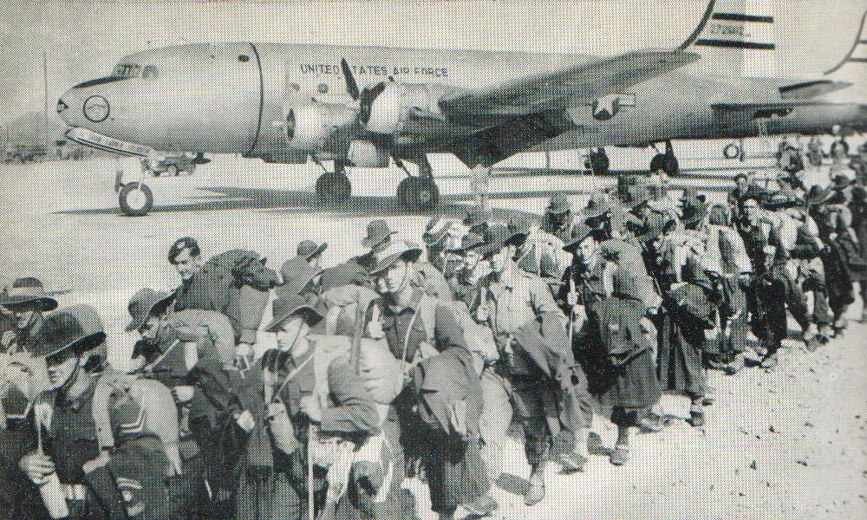
Table of Contents
Summary 4
Korean War - Prelude 7
Choppers Play A Vital Role 11
Jet Versus Jet Battles 13
Piston Engine Aircraft Still Have A Role To Play 16
Bombers 17
Transport Aircraft – Multiple Roles 19
Involvement In Korea - RAF 24
Australia’s Involvement In Korea – RAAF and RAN 25
25 Years Work On The Search For Composition Of Petroleum – API Project No. 6 31
Aviation Gasoline Composition 1950’s 31
Avgas Specifications & Test Methods 1950’s 34
The American (And Free-World) Oil Industry Gets Organized Again! - PAD 36
Oil Companies And Refineries 42
“Airspeed Records Would Have To Wait, Again” 42
Epilogue For 1953 43
Index 44
Research Sources 49

Summary
List of Events - Australian involvement in Korean War
1950
25 June: North Korea invades South Korea; U.N. Security Council meets.
26 June: U.S. air and sea forces directed to assist South Korea
27 June: Security Council recommends U.N. assistance.
30 June: It is announced that American ground forces have left Japan for operations in Korea and that Royal Australian Air Force (RAAF) No. 77 Fighter Squadron, with its (Australian built) CAC Mustang fighters, has been offered for service in Korea.
1 July: U.S. ground forces in Korea.
2 July: RAAF No. 77 Squadron in action; RAN ships in Korea waters.
29 August: British troops arrive in Hong Kong.
12 September: U.S. General Walker declares that Pusan Perimeter is safe.
15 September: Successful U.N. amphibious landing at Inchon.
28 September: U.S. Marines recapture Seoul, capital of South Korea; 3rd Battalion, Royal Australian Regiment arrives.
9 October: U.N. forces invade North Korea.
19 October: U.N. forces occupy Pyongyang, capital of North Korea.
1 November: First clash between Chinese and U.N. Forces.
7 November: Air fighting between United States Air Force (USAF) piston-engined Mustangs and Russian jet fighters takes place over North Korea.
14 November: Chinese forces break through as Tokchon.
5 December: North Korean and Chinese forces occupy Pyongyang.
1951
4 January: U.N. forces abandon Seoul.
14 March: U.N. forces reoccupy Seoul.
5 April: Australian forces re-cross 38th parallel.
11 April: U.S. General Ridgeway replaces General Douglas MacArthur
22 April: Chinese spring offensive.
23-24 April: Battle of Kapyong
21 May: Chinese offensive collapses.
23 June: Mr. Malik (Russian delegate to U.N.) proposes a cease-fire.
In June No. 77 Squadron, RAAF, replaced its CAC Mustangs with Gloster Meteor F.8s. Meteor T.7s were used for conversion training. RAAF moves to the jet age.
10 July: Cease-fire talks begin at Kaesong.
23 August: Cease-fire talks suspended.
On August 29 No. 77 Squadron Meteors made their first contact with North Korean aircraft when eight of them encountered six MiG-15s over Chingju, Korea. Although they lost one of their number, on this occasion to the newer, more nimble MiGs, RAAF 77 Squadron was able to claim 5 kills, with many others as damaged, during the course of the Korean conflict. Because of the inferiority of their aircraft against the MiG 15, RAAF 77 Squadron was mainly tasked with ground attack roles. It is a credit to the Australian pilots that they were able to keep an even score against the MiGs when flying Meteors instead of the more modern North American F-86 Sabres, or even CAC Sabres.
3-8 October: ‘Operation Commando’ establishes new line and static war begins.
25 October: Cease-fire talks resume at Panmunjom.
1952
2 April: 1st Battalion, Royal Australian Regiment arrives.
8 May: U.S. General Mark W. Clark succeeds General Ridgeway.
8 October: Cease-fire talks recessed on POW question.
1953
17 March: 2nd Battalion, Royal Australian Regiment arrives to replace 1st Battalion.
11 April: Agreement reached on exchange of sick and wounded POWs.
26 April: Cease-fire talks resume at Panmunjom.
8 June: Panmunjom negotiators sign agreement on POWs.
27 July An armistice agreement is concluded at Panmunjom between the Commander-in-Chief, United Nations Command, General Mark W. Clark of the United States Army, the Supreme Commander of the Korean People's Army, Kim Il Sung, and the Commander of the Chinese People's Volunteers, Peng Teh-Huai, with the aim of bringing about "a complete cessation of hostilities and of all acts of armed force in Korea until a final peace settlement is achieved." The armistice was signed at 10:12 hrs and became effective at 22:00 hrs. It still remains today in 2019, and the two countries Democratic People's Republic of Korea (North Korea) and Republic of Korea (South Korea) are separated by the (DMZ) demilitarized zone.
Photo 2. General Mark W. Clark, Far East commander, signs the Korean armistice agreement on July 27, 1953, after two years of negotiation. (U.S. Navy Museum photo)
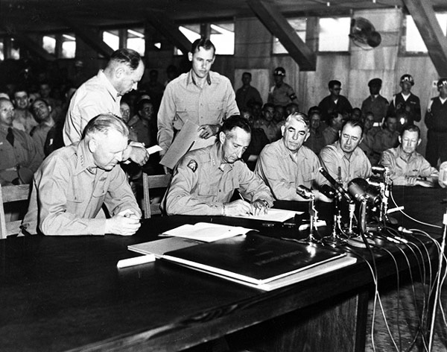
Photo 3. Freedom Bridge (Petroch Services 2014)
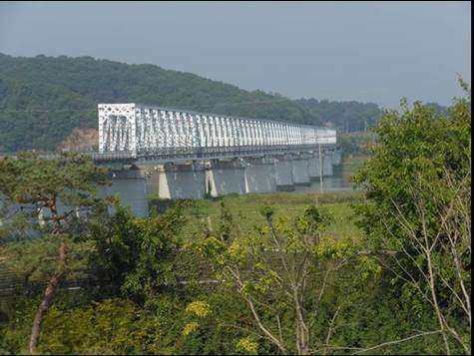
Photo 4. Demilitarized Zone at the Freedom Bridge (Petroch Services 2014) tourist post messages for peace
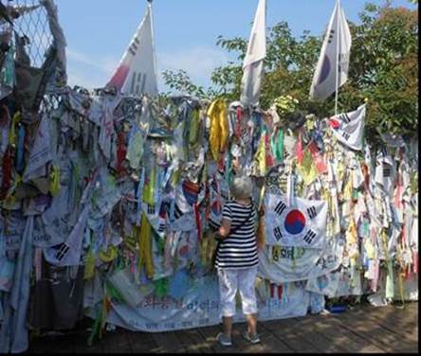

War again! – this time in Korea.
Will this be World War III?
Change back to Avgas production instead of Motor Gasoline.

Korean War - Prelude
Korean War – At 4 am, on Sunday June 25, 1950 the North Korean Army launched an attack on the flimsy defences of South Korea. It began with the now familiar air assault, when North Korean Yak fighters attacked Kimpo airfield. The United Nations had been formed 5 years earlier, and now a group of obscure Asian revolutionaries had challenged the expensive complicated machinery of international conciliation. Under the wing of a Great Power, the self-constituted Korean People’s Democratic Republic, led by Kim Il Sung, sought to settle a bitter political argument by force. The North – South Korean frontier had no ethnical, geographic or economic justification – it arose in 1945 when 100,000 Russian troops led by Colonel-General Chistyakov met 72,000 American troops under Lieutenant-General John R. Hodge.
From 1910 to 1945, the Japanese viceroys exercised dominion over Korea though no sovereignty was transferred to the Emperor of Japan with the expulsion of the Joseon dynasty from their realm such that the constituency merely exercised de facto rule for the period. With the defeat of Japan by the Americans and Allies, and rapid Soviet declaration of war against Japan (August 9, 1945 two days after the atomic bomb devastated Hiroshima), Korea was place of confrontation between Soviet and American forces. The dissolved Korean constituency was succeeded by de facto Soviet and U.S. military administrators of Korea who exercised rule from 1945 to 1948. After 1948, power passed to the (Soviet backed) Democratic People's Republic of Korea under Kim Il Sung in the North, and the (U.S. backed) Republic of Korea under Dr. Syngman Rhee in the South.
As the North Koreans, with their Russian-built Yak fighters, Stormovik bombers and T-34 tanks were rolling irresistibly toward Seoul, the United Nations was moving to intervene. The UN had recognised Dr. Rhee’s government as the only legitimate government, whereas, the self-appointed, self-perpetuating ‘Korean People’s Democratic Republic’ in North Korea claimed sovereignty over the whole of Korea and had now asserted that claim by force. Under the United Nations Charter some 58-member states had solemnly declared their determination to unite their strength to maintain peace and security. The United States was willing to take the lead. The UN was facing its greatest test to date, if it merely made pious protests and let the North Korean aggression succeed, the Charter would be worthless and the United Nations Organisation would be morally bankrupt. By compromising with aggression by the Italians in Abyssinia and the Japanese in China, the old League of Nations had slid down the steep pathway to World War II. The United Nations could not make the same mistake if it was to survive. On June 27, despite Russian objections the UN Members vote 48 to 6 with 3 abstentions ‘to take steps necessary to re-establish peace in that area’. Five members - the United States, United Kingdom, Australia, New Zealand and Netherlands - had already contributed forces to uphold the United Nations stand.
The UN would oppose this North Korean aggression and their forces would eventually comprise representation some 22 nations. These forces would be commanded by one of the U.S. most famous generals – General Douglas MacArthur.
From the American view point, strategically Korea was considered expendable, but President Truman had other political factors to take into account. The invasion of South Korea was a climax of post-war Communist political intransigence. A line must be drawn somewhere. The Americans had shown themselves ready to draw it over the Berlin Blockade. There, after a test period, the Russians had backed down American prestige demanded that South Korea should not be left unaided. American military forces were committed to the defence of South Korea and resist the Communist aggression.
Photo 5. Korean War Memorial – Battery Point New York City (Petroch Services 2005)
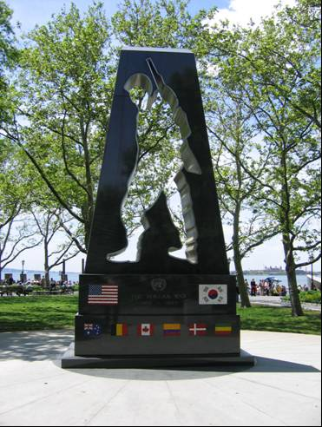
On 27 June 1950: President Harry Truman announces that the United States Air Force (USAF) will assist South Korea.
U.S. troops were immediately sent to Korea for what the Chairman of the Joint Chiefs of Staff Omar Bradley was to describe as "the wrong war, in the wrong place, at the wrong time, with the wrong enemy." For no group was this description truer than for the newly independent U.S. Air Force (formed in September 18, 1947).
The U.S. Air Force had gained independence based on the idea that strategic bombing could win a war independently of ground and sea forces. Since the end of World War II, it had focused on preparing for nuclear war, and most of its meagre funding had been directed toward this mission. Therefore, when the Far East Air Force (FEAF), the U.S. Air Force’s force in Asia, was ordered to Korea, it was composed of aging aircraft and too few men to fly them. Air Force Chief of Staff Hoyt Vandenburg called FEAF "the shoestring Air Force." And it found that because Korea was an agricultural nation with few industrial or military targets (North Korea received supplies from China and the USSR), strategic bombing would not affect the war. Other types of missions, often requiring close coordination with land or sea forces, were required. At the end of the war, only 0.2 percent of all missions flown were strategic bombing. In contrast, almost half consisted of ground interdiction (tactical bombing).
On June 25, 1950, a group of U.S. B-29s based at the U.S. base in Guam also began bombing targets in North Korea, with both conventional bombs and a new precision-guided cruise missile, the VB-13 Tarzan. Within two months, the few industrial targets were destroyed. Later sorties were operated from Japan.
Photo 6. Crewmen of the 61st Air Base Wing at Yokota, Japan refuelling a Boeing B-29 of the 98th Bombardment Group – February 1952.
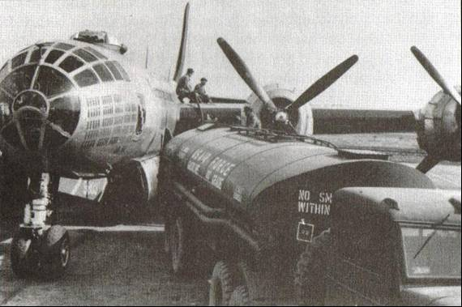
Photo 7. Fuselage panel near the cockpit of USAF B-29A bomber
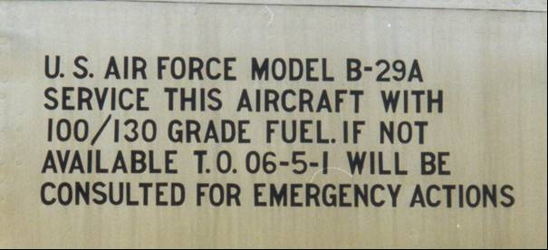
T.O. 06-5-1 is Technical Order 06-5-1
As the UN troops pushed the North Korean Peoples’ Army (NKPA) back over the 38th parallel and then farther into the north, bombing was halted.
Although strategic bombing did not yield any apparent results, air interdiction was more successful, especially as there were very few roads or railroads leading from the north to the south. The raids focused on NKPA’s supply routes to stop the flow of reinforcements and supplies.
After a year of advances and retreats, the sides settled into a two-year stalemate, during which interdiction became even more important because UN military planners hoped shortages would encourage peace negotiations.
Korea was the first conflict during which most of the aerial fighting was done by jets. There were still some propeller planes left, such as P-51 Mustangs and Australian-built CAC Mustang, F4U Corsairs and the B-26 Invader, but it was the second-generation jets that ruled the skies, among them Lockheed F-80 Shooting, Russian MiG-15s, and North American F-86 Sabres. The earlier jets such as the Gloster Meteor Mk 8 were no match for the newer swept wing jets. The jets fought mainly in an area of southwest Korea nicknamed "MiG Alley." UN pilots were forbidden to cross the border into China because of strict UN rules of engagement. So, they fought within a 6,500-square-mile (16,835-square-kilometre) area bordered by the Yellow Sea, Yalu River, and China. The Communist pilots would leave from bases in China near the border with Korea, fly into Korea, engage the enemy, and then return to the safety of the forbidden area.
The first enemy aircraft, a Yak 9 (obsolete Russian WWII fighter) was shot down by Lieutenant William G. Hudson, USAF, flying an F-82 Mustang also known as the ‘Twin Mustang’.
Photo 8. USAF North American F-82 Twin Mustang
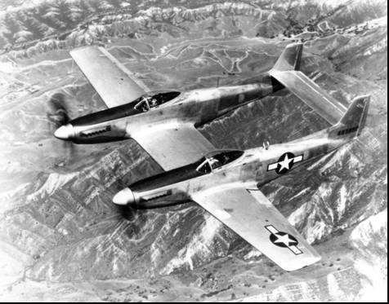
The F-82 Twin Mustang was a combination of one of the US Army Air Force’s most successful fighter into a twin fuselage long range fighter. There is an example on display at USAF Airman Heritage Training Complex, Lackland, Texas.
The F-82 was soon to be surpassed by the new jet fighters.
Photo 9. USAF P-51D Mustang (circa 1950)
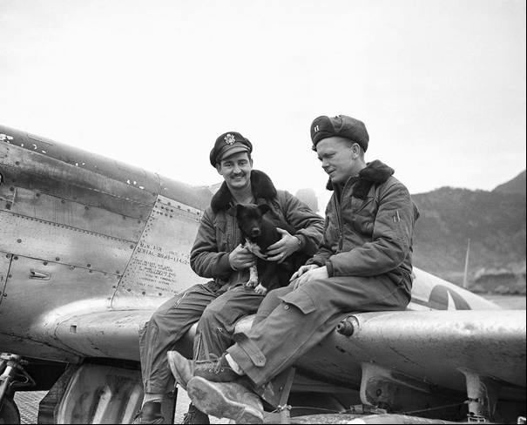
USAF P-51D Mustang. The markings on the cowling show Serial No. 45-11432, ‘100/150 Fuel’ However it is not known whether such an Avgas grade was used; it is more likely to be Avgas 100/130. This particular aircraft was involved in an accident on May 1, 1952 at Chinhae Air Base, Korea. The pilot was Basil W. Gurning.
The advent of the Korean War saw the combination of the future direction of military aircraft – fast new jet fighters, and the remnants of the World War II developments – piston driven, aviation gasoline fuelled aircraft for the bomber, ground attack support roles, and transport.
The WWII bombers B-26 Invader, B-29 Superfortress, and fighter-bombers P-51 Mustang, and transport aircraft C-47 Skytrain/Dakotas, C-54 Skymasters/DC-4, C-82 Fairchild Packet took up the same roles as before. But soon there was to be strange new and different sounds overhead.

Choppers play a vital role
There emerged a new aircraft type – the helicopter commonly called a ‘chopper’. Although developed during WWII, in this Korean ‘Police Action’, it would became the vital air link between the front-line fighting soldier on the ground and the support bases at the rear – for evacuation of wounded to Mobile Army Surgical Hospitals (MASH), and for support with supplies and reinforcements.
Helicopters, appearing in their first major conflict, also helped transport men, especially those in trouble. During one operation, 12 Sikorsky S-55s moved a battalion of 1,000 US Marines more than 16 miles in four hours. In a mission initiated by the U.S. Air Force but taken over by the army, the Bell H-13 Sioux evacuated troops from the battlefield and delivered them to MASH (Mobile Army Surgical Hospital) units right behind the front lines, helping to increase soldiers’ chances of surviving. Helicopters also aided in air-sea rescues, following distress signals to rescue downed pilots. For many men on the ground, the planes and helicopters were a lifeline.
Photo 10. Bell 47 MASH Chopper in action in Korea 1951
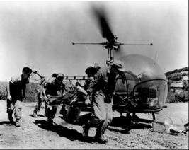
On 1 December 1950 Korea: United States Mobile Army Surgical Hospital (MASH) units receive unarmed Bell 47 helicopters equipped for carrying casualties.
Photo 11. US Army Sikorsky S-55 ‘chopper’ delivers heavy engineering store to 2nd Battalion Royal Australian Regiment at an inaccessible forward position in Korea (circa 1951).

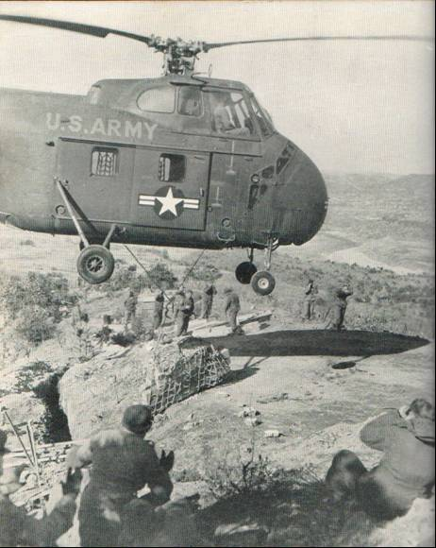
On 4 September 1950 Korea: The first helicopter rescue of a downed pilot, behind enemy lines, took place, and on 13 September, the first helicopter troop transport operation takes place when United States Marines of 1st Division were flown into Inje Punch Bowl battle zone.
Photo 12. U.S. Sikorsky S-51 helicopter lands on the flight deck of the HMAS Sydney in Korean waters (1951)
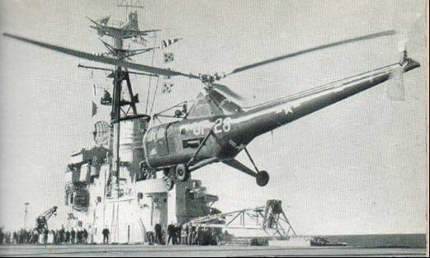
On July 27, 1953 an armistice was signed between the United States, North Korea, and China. (There is still no peace treaty.) Far East Air Force (FEAF) Commander General Otto Weyland testified several years later that “we are pretty sure that the Communists wanted peace, not because of a two-year stalemate on the ground, but to get air power off their back. FEAF, with support from the (U.S.) Navy and the Marines, had been able to maintain air superiority throughout the war.” Their efforts were also supported by the RAAF.
The conflict was ended, though not resolved, as Korea remains a divided country with South Korean troops stationed on its borders. The conflict in Korea was a war of firsts: the first jet war, the first helicopter war, the first major air war against an agricultural nation, and the first war of the nuclear era. As such, there were plenty of lessons to be learned, some of which were remembered and some which were quickly forgotten, as the world returned its attention to the Cold War.

Jet versus Jet Battles
It also saw the first contest between the last of the piston engine fighters (USAF North American P-51 Mustang and CAC Mustangs as flown by the RAAF), and the new jet fighters (MiG-15 as flown by the North Koreans.) – the speed and manoeuvrability of the jet fighter soon quickly relegated the piston engine aircraft to fighter-bomber and ground attack support role.
Photo 13. RAAF Base at Iwakuni, Japan, a Mustang prepares to take off, its replacement the Gloster Meteor Mk 8 stands by (1950)
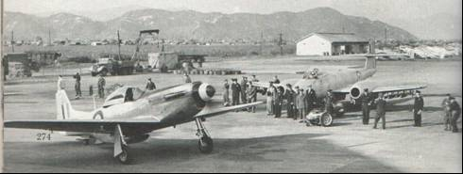

On 8 November 1950 a Mikoyan-Gurevich MiG-15 of the Chinese People's Republic Air Force was shot down by a United States Air Force (USAF) Lockheed F-80C Shooting Star flown by Lieutenant Russell J. Brown. This is the first air fighting between jet aircraft in the Korean War. Then one day later, the first all jet air battle took place when North Korean MiG-15’s attacked a flight of American F-80 Shooting Star aircraft high over the Yalu River.
Photo 14. USAF F-80 Lockheed Shooting Star (circa 1950)
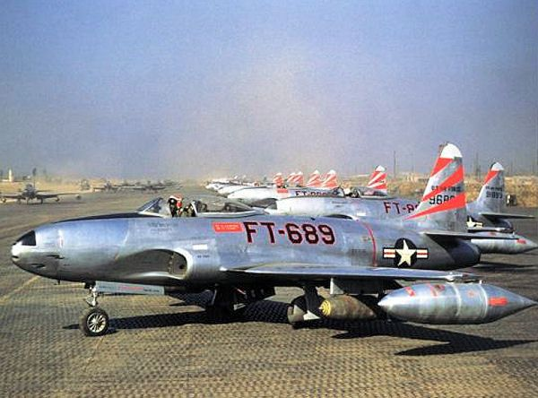
Later the all jet air battles would be between the Russian MiG-15 and the American F-86 Sabre and carrier-based Grumman F9F Panthers.
The Russian MiG-15 debuted on November 15, 1950. With its swept-wing design and Rolls-Royce jet engine, obtained from the British in a 1946 trade agreement. The American F-86 Sabre was in short supply but was roughly equivalent to the MiG. When the two jets met in high-speed dogfights, closing in 10 miles in less than 30 seconds, pilot skill was often the only difference, and the United States had the advantage. The American pilots were well-trained, mostly World War II veterans. The North Korean and Chinese pilots had received cursory training in the Soviet Union and had no combat experience.
In June 1951, with the utmost secrecy, Soviet fighter units began to be brought in. They were better trained and more aggressive, willing to venture past MiG Alley. These units, however, were on six-week rotations and often just as a pilot became adjusted, he would be returned to Russia. So, by the end of the war, the Sabres had downed 10 MiGs for each Sabre lost.
Photo 15. Russian MiG 15
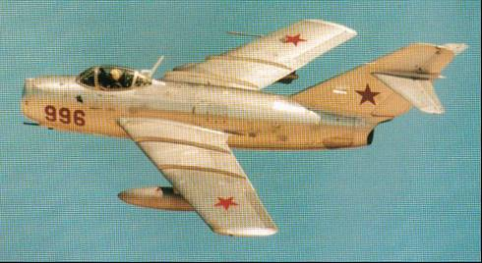
Photo 16. USAF F-86A Sabre (1951) (U.S. Air Force)
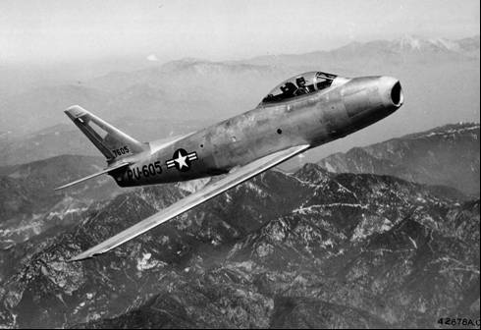
North American F-86A in flight (1951). It was shipped to Japan in December 1950 with the 4th Fighter Interceptor Wing, one of the first of the U.S. Air Forces Sabre units and flown in Korea. Most of its combat missions against MiG-15s were flown from Kimpo Air Base near Seoul.
Other air to air struggles would occur be between the MiGs and RAAF Meteors, however the Meteors (the British jet aircraft designed during WWII) were outclassed by the new swept wing Soviet built MiGs.

Piston Engine Aircraft Still Have A Role To Play

Ground Attack Role
There was however still a ground support role for the piston driven aircraft, such as the Mustangs and the carrier-based aircraft - U.S. Navy Douglas Skyraiders, Chance-Vought FU4 Corsairs and Grumman F8F Bearcats (reputed to be the fastest piston aircraft in the world). The Australians would contribute with the No. 77 Squadron of Mustangs initially based in Japan and the R.A.N. carrier H.M.A.S. Sydney and its Fairey Firefly and Hawker Sea Fury aircraft.
Photo 17. Grumman F8F Bearcat
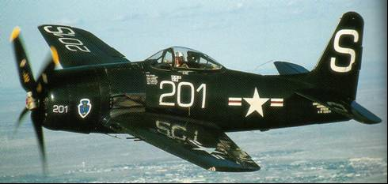
Photo 18. Douglas Skyraider AD-5 take-off from carrier deck
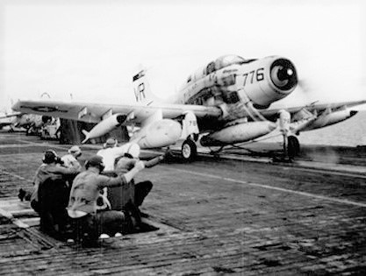

Bombers
The bomber aircraft used by the UN forces, primarily those of the USAF, were the same aircraft types used in the Second World War: the B-26 Invader, the famous B-29 Superfortress, and as always, they were under attack from enemy fighters and anti-aircraft guns.
Photo 19. USAF B-29 Superfortress on a bombing run over Korea August 1951
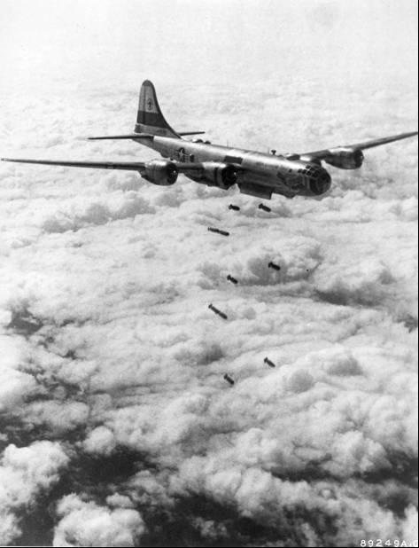
Husky 1,000-pound demolition bombs hurtle from this U.S. Far East Air Forces B-29 Superfortress of the 19th Bomb Group toward a Communist target somewhere beneath the cloud layers in Korea. The Bomber Command Superfortress were able to unload heavy tonnages of bombs with pin-point precision despite thick cloud coverage by use of new techniques in radar aiming.
Photo 20. USAF B-26 Invader bombers in action over North Korea
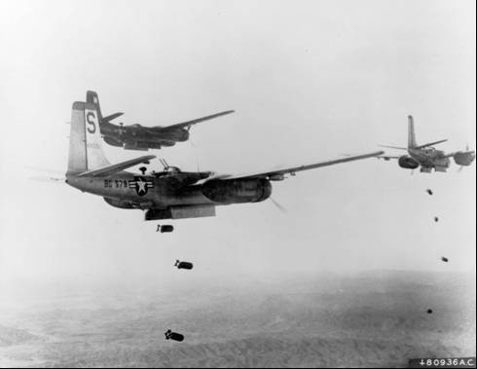
Photo 21. USAF Douglas B-26 Invader
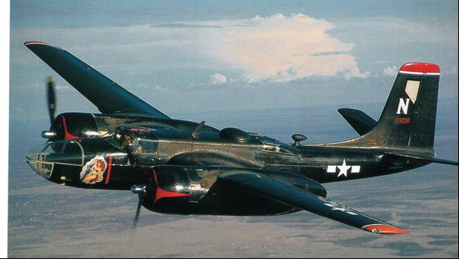
The Douglas B-26 Invader would continue in service into the Vietnam War and be the choice of aircraft of clandestine activities of the American Central Intelligence Agency (CIA).

Transport Aircraft – multiple roles
As with any conflict, the supply of military stores, troop movement, medical evacuations and communications falls to the transport aircraft of any modern air force.
A unique aspect of the Korean War was the Pacific Airlift, the longest aerial supply line in history. Each day more than 100 tons of emergency items, including major airplane parts, were flown from the U.S. to Japan for trans-shipment to the fighting units. On their return flights to the United States, the cargo planes carried seriously sick and wounded men, reducing to a matter of hours a trip that ocean vessels required weeks to complete.
Airlift techniques from the Berlin Airlift were perfected during Korea. Airlifts were especially important during the first year of the war when rapid advances and retreats would sometimes cut ground units off from the main force. They would be rescued by airlift or have supplies such as food, ammunition, medical supplies, and the beloved mail dropped to them by airplanes and helicopters. The C-119 cargo plane was even capable of dropping jeeps, big guns and on one occasion, a bridge to the 1st Marine Division during its retreat from the Chosin Reservoir. Cargo planes also carried wounded troops from medical units to hospitals in Japan.
The Korean War was no different, indeed the lessons learned from World War II and the Berlin Airlift were applied here with essentially the same aircraft types, although the giant transport aircraft types were coming into service such as the massive Douglas C-124 Globemaster.
Photo 22. USAF C-54 Skymaster of USAF MATS used as ambulance transport 1950.
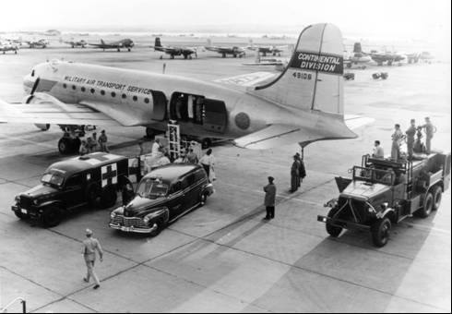
Evacuation of wounded - Korean battle casualties arrive at Bolling Air Force Base, Washington D.C. for transfer to Walter Reed Army General Hospital, Washington D.C., September 1950.
Photo 23. USAF Fairchild C-119 Boxcar transport 1950.
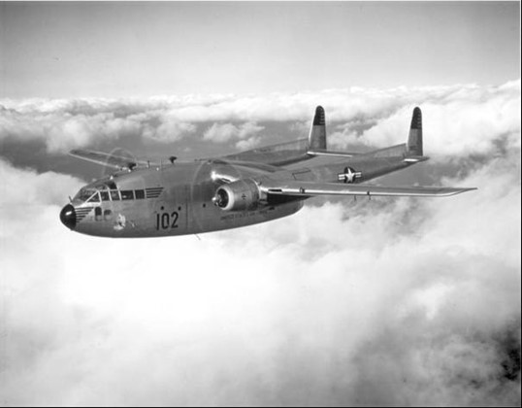
Fairchild C-119 Boxcar The aircraft saw extensive action during the Korean War as a troop and equipment transport. The C-119 Fairchild Boxcar was a later development of the Fairchild C-82 Packet.
These transport aircraft of the U.S.A.F. Military Air Transport Services (MATS) also delivered the vital Avgas 115/145 which was now in use by Fairchild C-119 Boxcar, which was becoming the mainstay for the air transport of troops and equipment.
Photo 24. USAF Fairchild C-119 Boxcar on display at PIMA, Arizona.
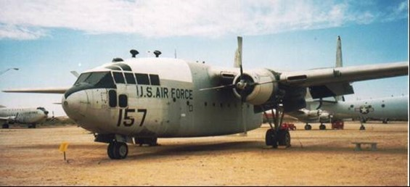

Photo 25. USAF Douglas C-124 Globemaster on display at PIMA, Arizona
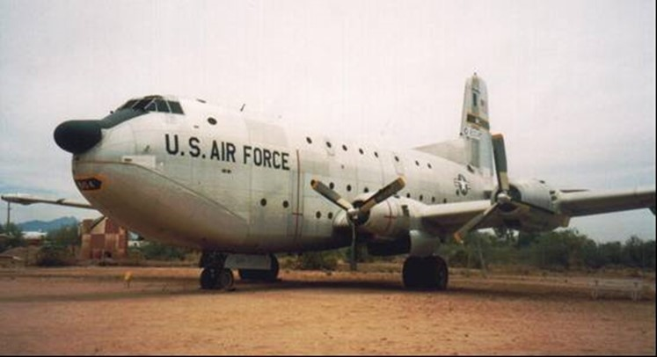
Photo 26. Cockpit markings USAF Douglas C-124 on display at PIMA, Arizona
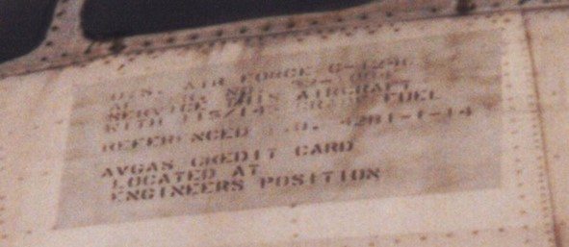
The markings near the cockpit ‘SERVICE THIS AIRCRAFT WITH 115/145 FUEL’ ‘REFERENCED T.O. 4281-1-14’
The following photos show some examples of delivery of aviation fuel to UN Forces in Korea.
Photo 27. USAF MATS C-54 Skymaster unloading 200L drums of Avgas 115/145 in Korea 1950.
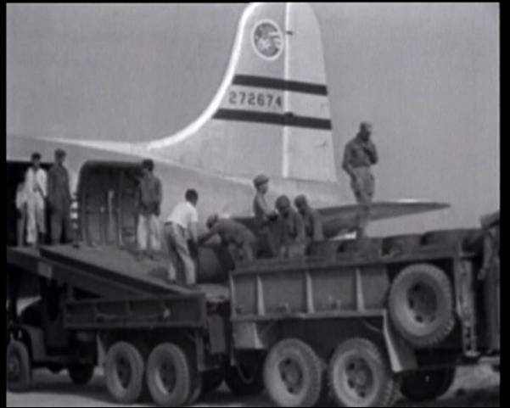
Photo 28. U.S. and Korean workers unload 200L drums of Avgas 115/145 [filled Aug 1950]
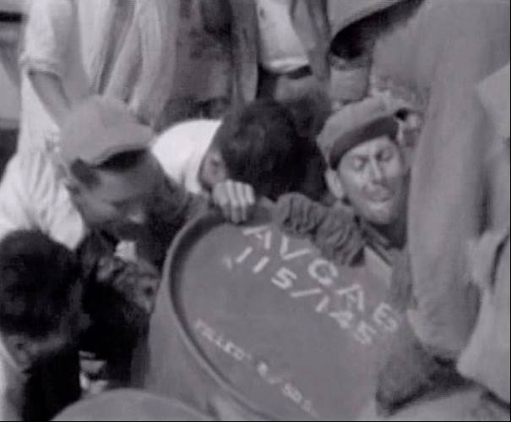
Photo 29. Douglas C-124 Globemaster loads cargo as F-84 Thunderjets fly overhead 1952.
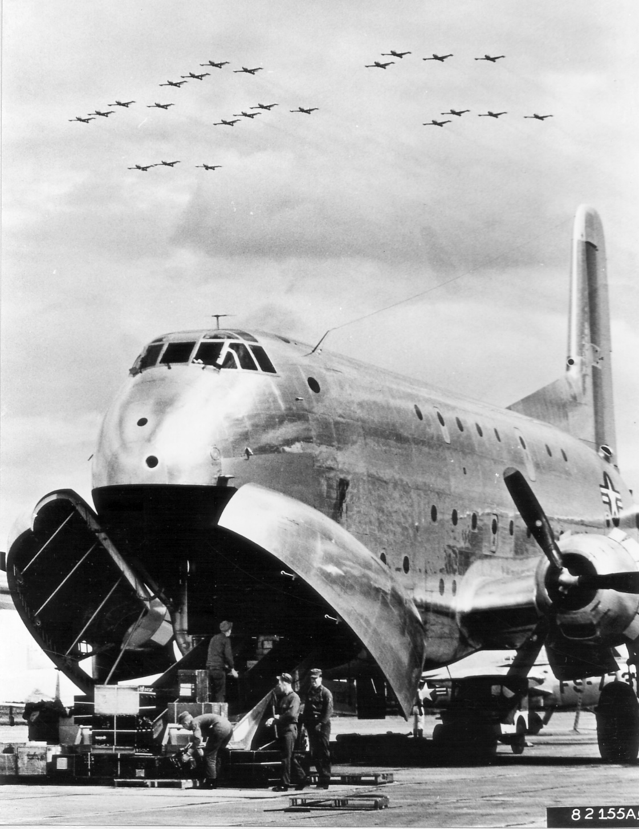
Flashing through the sky above a U.S. Air Force C-124 Globemaster, F-84G Thunderjets of the 27th Fighter Escort Wing arrive at a Japan Air Defense Force base in northern Japan after completing a trans-Pacific flight. The F-84s flew 7,800 miles from their home base to Japan and set a new record for over-water flight by single engine fighter aircraft. They flew the last 2,575 miles of their trip using in-flight refuelling, October 1952.
Britain’s Involvement in Korea - RAF
Following the outbreak of the Korean War, a squadron drawn from the Royal Air Force's Far East Flying Boat Wing, No. 88 Squadron (Short Sunderland GR5), commenced maritime reconnaissance operations from Iwakuni in Japan, in support of the United Nations blockade of North Korea.
Subsequently, the three Sunderland squadrons that comprised the Flying Boat Wing (Nos. 88, 205 and 209 Squadrons) operated out of Iwakuni on a monthly rotational basis. This detachment came under the operational control of the United States Navy's Fleet Air Wing (FAW) and their duties included maritime patrol, weather reconnaissance and transport. The last detachment concluded on 31 July 1953.
During the Korean War, South Korea was supported by a United Nations force including British ground troops, naval vessels and naval aircraft, however, with the exception of the Far East Flying Boat Wing, no RAF units participated in operations over Korea.
In September 1950, the Handley Page Hastings C1s of No. 53 Squadron RAF began regular casualty evacuation flights between Iwakuni in Japan and the United Kingdom, carrying wounded members of the British forces deployed to Korea.
Photo 30. RAF Short Sunderland No.88 Squadron
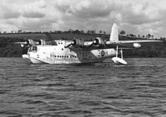
Photo 31. RAF Handley Page Hastings C1 No. 53 Squadron
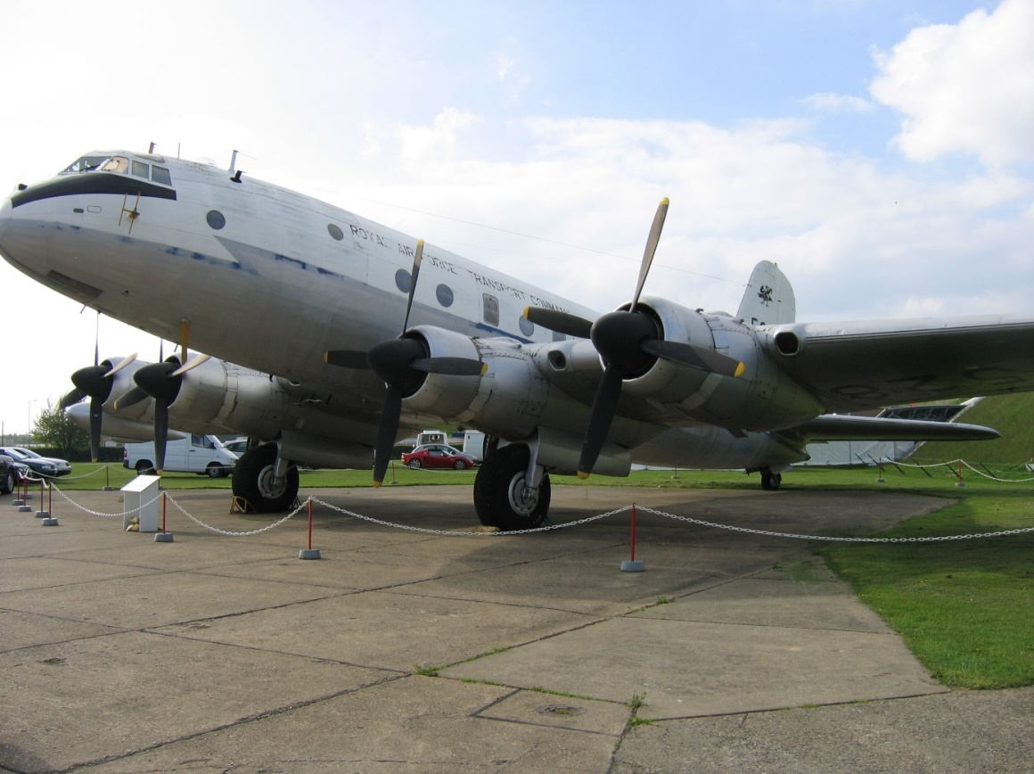

Australia’s Involvement in Korea – RAAF and RAN
Australia was one of the first United Nations countries to become involved. On 1 July 1950, US ground forces arrived in Korea and by 2 July RAAF No. 77 Squadron in action, and RAN ships were in Korea waters.
Photo 32. RAAF Mustang for No. 77 Squadron arrives in Korea (1950)
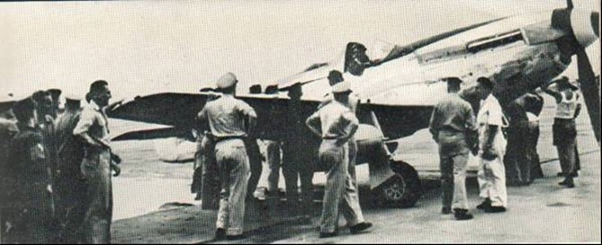
Photo 33. RAAF No. 77 Squadron Mustangs prepare for take-off (1950)
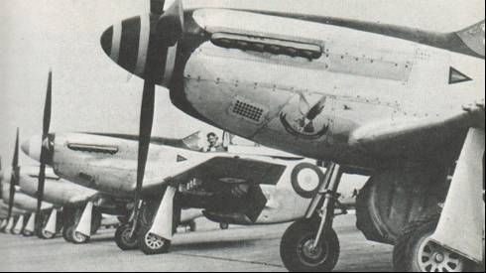
Photo 34. Ground crew work on refuelling a No. 77 Squadron P-51 Mustang with Avgas 100/130.
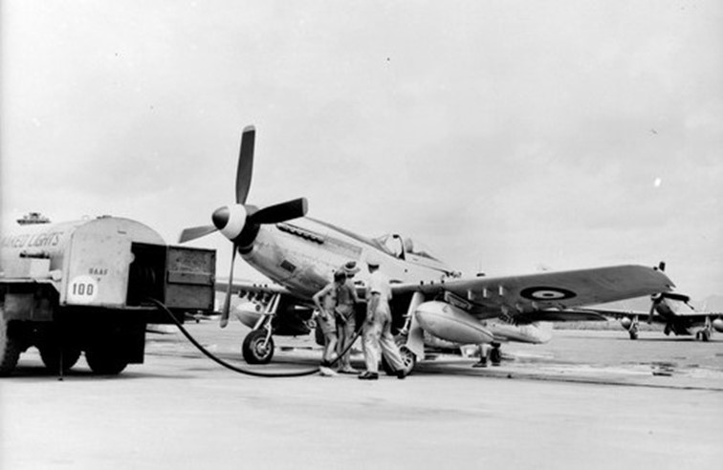

Photo 35. RAAF Mustang glycol engine coolant fill in Korea (circa 1950)
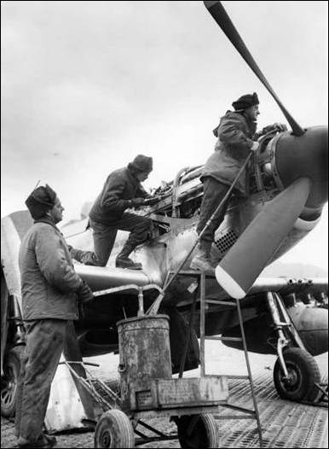
Photo 36. RAAF Mustang refuels its drop tanks in Korea
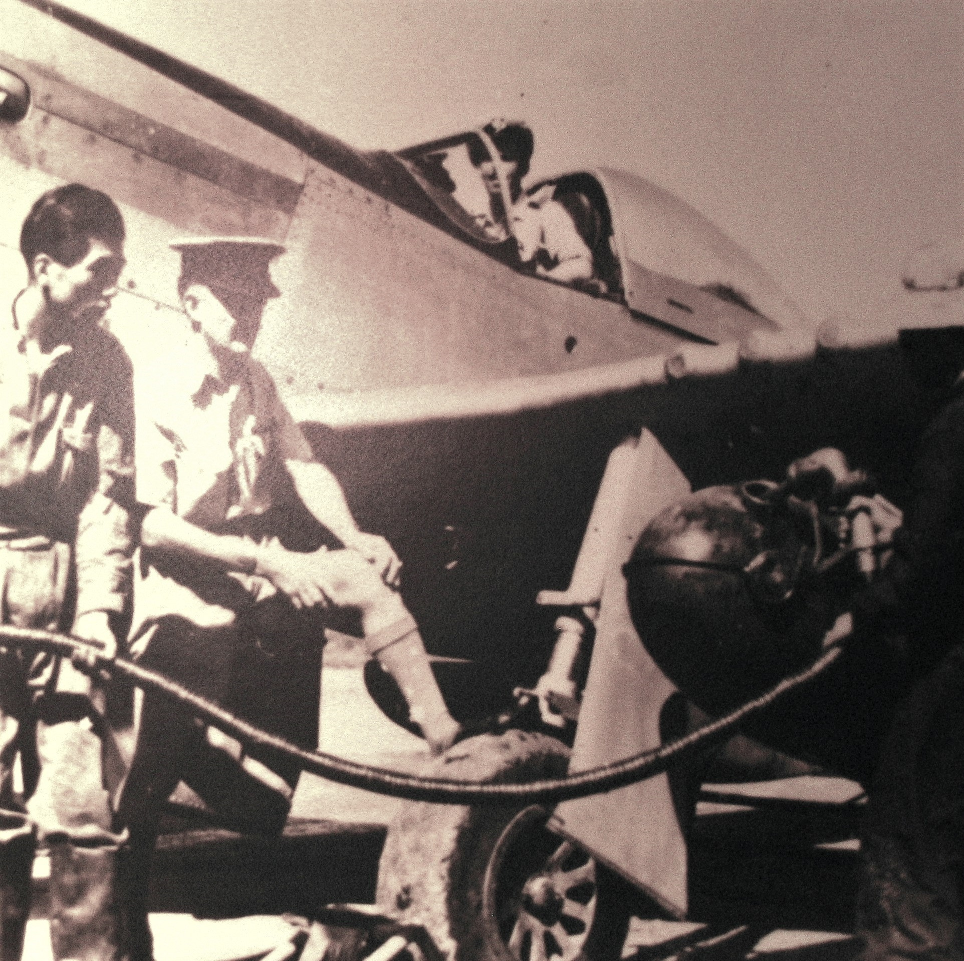

Photo 37. Flight deck of HMAS Sydney in Korea waters 1950 in winter. (Fairey Firefly on left, Hawker Sea Fury on right.)
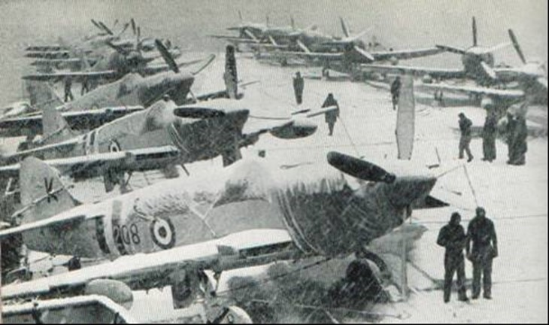
Photo 38. Fairy Firefly circa 1950’s.
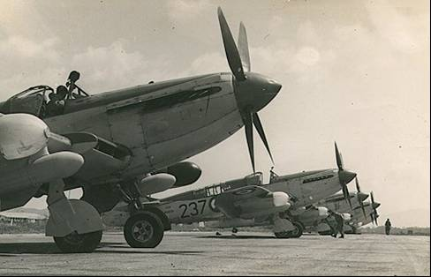

Photo 39. Hawker Sea Fury FB.11.
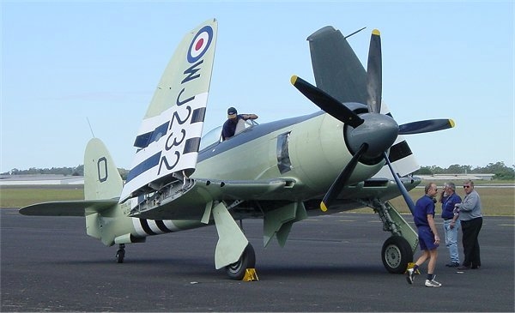
Hawker Sea Fury FB.11- Engine: One Bristol Centaurus XVIII piston engine of 2,550 hp which required Avgas 115/145. RAN SERVICE: 1949-1962, with 805, 808 and 850 Squadrons, and land-based 723, 724 and 725 Squadrons.
The Hawker Sea Fury and Fairey Firefly were the first operational aircraft to serve in the Royal Australian Navy's Fleet Air Arm, from HMAS Sydney and HMAS Vengeance. The RAN received 101 Furies in all, and operated other British aircraft, especially during the Korean War, from HMAS Sydney. They flew close army support, naval bombardment, strikes, reconnaissance, combat air patrol, spotting and anti-shipping missions.
Photo 40. Korea. 1954. A leading seaman refuelling the drop tank of a Hawker Sea Fury FB.11 fighter
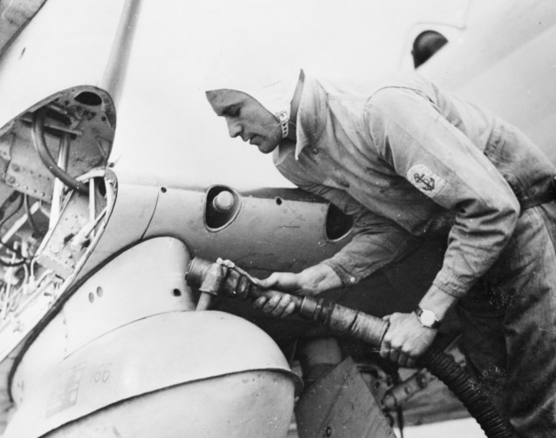
Figure 1. Korean conflict 1950-51
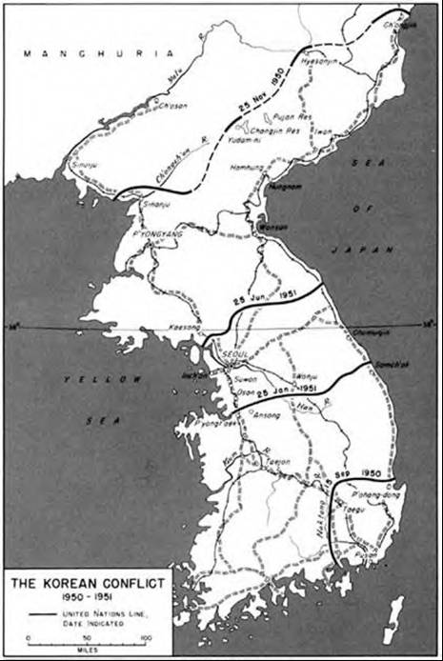
The map (Fig. 1) shows the advance of the United Nation forces under General Douglas MacArthur Nov 1950, then the withdrawal to the 38th parallel under the onslaught of Chinese Communist forces.
A stalemate developed, and while the North Korean and Chinese forces amassed and the UN forces in the south opposed them, the world waited anxiously to see if this would be another World War, and the first to be fought using atomic bombs. A diplomatic solution had to be sought and eventually the country was divided into North and South Korea separated by a demilitarised zone DMZ– a situation which still exists today.
The Korean War lasted until a cease-fire agreement was signed at Panmunjom on July 27, 1953 which partitioned the Korean peoples into two countries North Korea and South Korea which still exist today.
Photo 41. Wonsan Refinery Korea August 1950 after B-29 bombing raid.
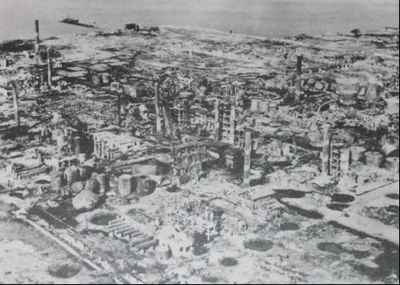

25 Years work on the search for composition of Petroleum – API Project No. 6
The project was established in 1927, thus by 1952 a quarter of a century of research had been fruitful. Some 139 technical publications had been issued; 130 individual hydrocarbon compounds had been isolated from a single large sample of Mid Continental crude oil. More than 200 API standard hydrocarbon samples had been purified and sold as spectrometric standards.
Methods of separation, purification and analysis had been developed which were to prove of great value to the laboratories of the petroleum industry. However, on the subject of aviation gasoline, the work done in analysing the various alkylates and hydropolymers was perhaps the most relevant.
Analytical methods were to change dramatically with the development of gas chromatography and mass spectrometry in the second half of the 20th Century.

Aviation Gasoline Composition 1950’s
The aviation gasolines of the 1950’s were much the same as those of the later part of World War II, for there had been little advances in piston engines development except in perhaps those in civil aircraft use. The composition of these aviation gasolines still comprised of
Alkylate
Catalytically Cracked Light Naphtha (after acid treatment)
Catalytically Cracked Heavy Naphtha
Virgin Naphtha
Butane and Pentanes (to achieve the correct vapour pressure)
Tetra Ethyl Lead (4. ml/USG to achieve 100 Octane)
and the addition or aromatics (Toluene) to make Avgas 115/145.

New Grade -Avgas 108/135
There was to be a new grade Avgas 108/135 which was required by the civilian airlines. This was essentially Avgas 115/145 with less lead to minimise sparkplug fouling and therefore reduce aircraft maintenance downtime – a critical factor in operation of an economically viable commercial airline. It would be used by the Lockheed Constellations and Super Constellations.

Photo 42. ‘Columbine-1’ Lockheed Super Constellation U.S. Air Force C-121A. (1999)
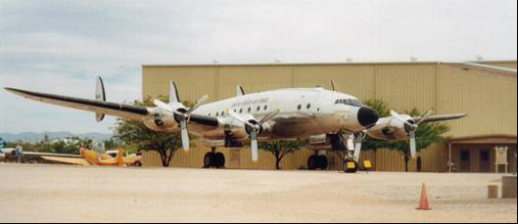
This aircraft entered service in the USAF on February 4, 1949 and was assigned to General Eisenhower from December 1950 to 1952. It retired from operational service in June 1967. For military service this particular aircraft used Avgas 115/145.
Photo 43. HARS “Connie” Lockheed Super Constellation (2007)
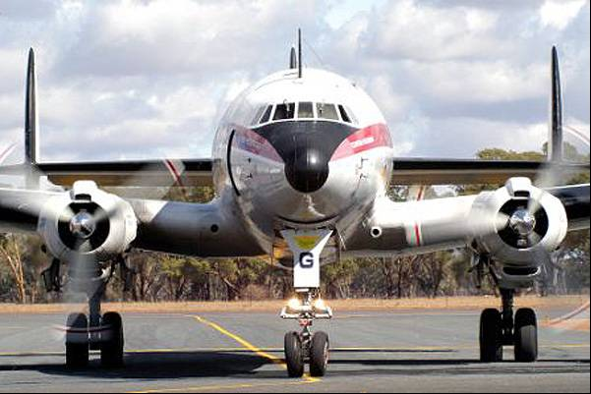
HARS (Historic Aircraft Restoration Society) Super Constellation ‘Connie’ Temora, NSW, Australia operates on Avgas 100LL (Avgas 100 Low Lead).
Training aircraft would still require lower grades of aviation gasoline. Aircraft such as the de Havilland Chipmunk and North American Harvard.
Photo 44. RAF de Havilland Chipmunks in formation (circa 1950)
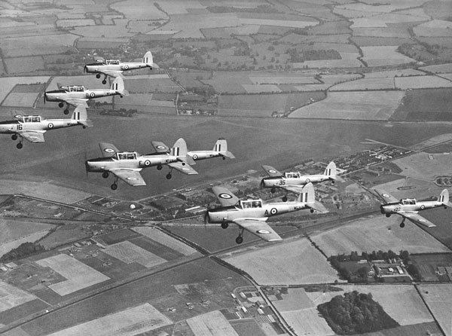
Photo 45. RAAF North American Harvard trainer at Point Cook, Victoria, Australia.
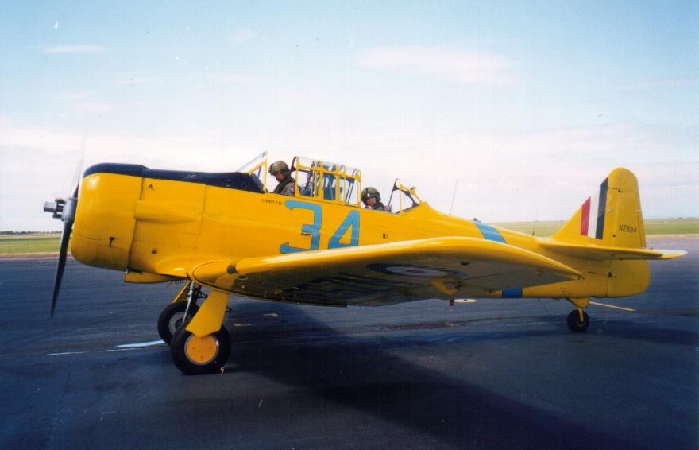

Avgas Specifications & Test Methods 1950’s

Aviation Gasoline Specification
The development of specifications, which occurred during WWII, set the basis for the specifications after the war. While the supply demands of aviation gasoline of WWII dictated that essentially military and commercial aviation specifications were the same, in the early 1950’s the expansion of commercial air travel saw the emergence of a different test methods and specifications, and a new grade (Avgas 108/135) for commercial airline use.

1950 US Aviation Gasoline Specifications - Military
The US military specification in the 1950’s was MIL-F-5572, and there were only four avgas grades. The demand for power over maintenance considerations during WWII saw the addition of unusual additives – these were no longer acceptable; thus, Aromatic Amines were no longer permitted in this specification.
Table 1. US Military Specifications MIL-F-5572 (circa 1950)
Grade Designation | 80 | 91/96 | 100/130 | 115/145
Colour | Red (1) | Blue | Green | Purple
Sulfur (wt. %) Max. | 0.05 | 0.05 | 0.05 | 0.05
Aromatics permitted. | Yes- | Yes | Yes | Yes
Aromatic Amines permitted | No | No | No | No
Distillation at least 10% Evap. (deg C) @  At most 40% Evap. (deg C) @  At least 50% Evap. (deg C) @  At most 90% Evap. (deg C) @  At least 90% Evap. (deg C) @  End Point (deg C)  Sum 10% & 50% Evap. Temp Min.  Residue (vol %) Max  Distillation loss (vol %) Max | 75  75  105  -  135  170  153  -  - | 75  75  105  -  135  170  153  -  - | 75  75  105  -  135  170  153  -  - | 75  75  105  -  135  170  153  -  -
Gravity API | Reported | Reported | Reported | Reported
Reid Vapour Pressure (@37.8 deg. C) psi Max. (kPa)  Reid Vapour Pressure (@37.8 deg. C) psi Min. (kPa) | 7.0 (48.3)  5.5 (37.9) | 7.0 (48.3)  5.5 (37.9) | 7.0 (48.3)  5.5 (37.9) | 7.0 (48.3)  5.5 (37.9)
Freezing Point (deg C) Max | -60 | -60 | -60 | -60
Net Heat of Combustion MJ/kg Min  (BTU/lb.), or  Aniline-Gravity Product Min. | 43.5  18700  7500 | 43.5  18700  7500 | 43.5  18700  7500 | 44.0  18900  9800
Octane Rating, Lean mixture Aviation Rating Min. | 80 | 91 | 100 | -
Performance No. Lean Min. | (58.3) | (76) | 100 | 115
Octane Rating, Rich mixture Supercharge Min. | - | 96 | - | -
Performance No. Rich mixture Supercharge Min. | - | (87.5) | 130 | 145
Copper Strip Corrosion (2 hrs @100 deg C) Max. | None | None | None | None
Existent Gum (mg/100 ml) Max. | 3.0 | 3.0 | 3.0 | 3.0
Cooper Dish Residue (mg/100 ml) Max | - | - | - | -
Accelerated Gum (5 hr aging mg/100 ml) Max  Accelerated Gum (16 hr aging mg/100 ml) Max. | -  6.0 | -  6.0 | -  6.0 | -  6.0
Precipitate (5 hr aging mg/100 ml) Max  Precipitate (16 hr aging mg/100 ml) Max. | -  2.0 | -  2.0 | -  2.0 | -  2.0
Existent Gum (mg/100 ml) Max. | 3.0 | 3.0 | 3.0 | 3.0
Water Tolerance permitted. | None | None | None | None
Tetra Ethyl Lead Content (cc/litre) Max. | 0.13 | 1.21 | 1.21 | 1.21
Dye (mg/l) Min  Dye (mg/l) Max (note 2) | 2.09  2.42 | 1.32  1.50 | 2.64  3.08 | 1.58  2.1
Inhibitors permitted (note 3) | Yes | Yes | Yes | Yes
See notes below

1950 US Aviation Gasoline Specifications - Commercial
The commercial specification in the 1950’s was ASTM D910-48T and there were now five avgas grades. The airlines required an avgas grade similar to the highest performance grade 115/145, but not with the high Tetra Ethyl Lead level due to spark plug fouling problems – this resulted in a new grade Avgas 108/135. The colour of this grade was brown which could be achieved addition of red dye to green, or green to purple – this also meant that Avgas 115/145 could be mixed with some avgas 100/130 and the colour would be brown.
Table 2. ASTM D910-48T Avgas specifications (circa 1950)
Grade Designation | 80/87 | 91/98 | 100/130 | 108/135 (Commercial) | 115/145
Colour | Red (1) | Blue | Green | Brown | Purple
Sulfur (wt. %) Max. | 0.05 | 0.05 | 0.05 | 0.05 | 005
Aromatics permitted. | Yes- | Yes | Yes | Yes | Yes
Aromatic Amines permitted | No | No | No | No | No
Distillation at least 10% Evap. (deg C) @  At most 40% Evap. (deg C) @  At least 50% Evap. (deg C) @  At most 90% Evap. (deg C) @  At least 90% Evap. (deg C) @  End Point (deg C)  Sum 10% & 50% Evaporated Temperature Min.  Residue (vol %) Max  Distillation loss (vol %) Max | 70  -  105  100  125  170  153  -  - | 70  -  105  100  125  170  153  -  - | 70  -  105  100  125  170  153  -  - | 70  -  105  100  125  170  153  -  - | 70  -  105  100  125  170  153  -  -
Gravity API | Reported | Reported | Reported | Reported | Reported
Reid Vapour Pressure (@37.8 deg C) psi Max. (kPa) | 7.0 (48.3) | 7.0 (48.3) | 7.0 (48.3) | 7.0 (48.3) | 7.0 (48.3)
Freezing Point (deg C) Max | -60 | -60 | -60 | -60 | -60
Net Heat of Combustion MJ/kg Min  (BTU/lb.), or  Aniline-Gravity Product Min | 43.5  18700  7500 | 43.5  18700  7500 | 43.5  18700  7500 | 43.5  18700  7500 | 44.0  18900  9800
Octane Rating, Lean mixture Aviation Rating Min. | 80 | 91 | 100 | - | -
Performance No. Lean Min. | (58.3) | (76) | 100 | 108 | 115
Octane Rating, Rich mixture Supercharge Min. | 87 | 98 | - | - | -
Performance No. Rich mixture Supercharge Min. | (68) | (87.5) | 130 | 135 | 145
Copper Strip Corrosion (2 hrs @100 deg C) Max. | None | None | None | None | None
Existent Gum (mg/100 ml) Max. | - | - | - | - | -
Cooper Dish Residue (mg/100 ml) Max | 5.0 | 5.0 | 5.0 | 5.0 | 5.0
Accelerated Gum (5 hr aging mg/100 ml) Max  Accelerated Gum (16 hr aging mg/100 ml) Max. | 6.0  10.0 | 6.0  10.0 | 6.0  10.0 | 6.0  10.0 | 6.0  10.0
Precipitate (5 hr aging mg/100 ml) Max  Precipitate (16 hr aging mg/100 ml) Max. | 3.0  4.0 | 3.0  4.0 | 3.0  4.0 | 3.0  4.0 | 3.0  4.0
Existent Gum (mg/100 ml) Max. | 3.0 | 3.0 | 3.0 | 3.0 | 3.0
Water Tolerance permitted. | None | None | None | None | None
Tetra Ethyl Lead Content (cc/litre) Max. | 0.13 | 0.53 | 0.79 | 0.79 | 1.21
Dye (mg/l) Min  Dye (mg/l) Max (note 2) | 2.09  2.42 | 1.32  1.50 | 2.64  3.08 | 2.60  3.12 | 1.58  2.1
Inhibitors permitted (note 3) | Yes | Yes | Yes | Yes | Yes
If unleaded shall be white +20 Saybolt (min.)
Dye concentrations are not specified directly for military fuel but finished fuel must be within minimum and maximum military colour standards. Concentrations are specified for commercial fuels.
Inhibitors may be added to the extent required to prevent formation of excessive precipitate or excessive gum during the oxygen bomb test. Not more than 1.0 pound of approved inhibitor may be used for each 5,000 US gallon (24 mg/Litre) of finished fuels blend for the 16-hr. test or not more than one-half this quantity for the 5-hr. test. Several inhibitors are approved for both military and commercial use.
Aromatic content limited by heating value requirement.
There were several notable differences between the military (MIL-F-5572) and commercial (ASTM D910-48T) specifications. These were:
- Commercial avgas could have a lower initial boiling range Min 10% evaporated of 70^{O}C compared with the military grades 75^{O}C. Further there was no 40% evaporated limit for commercial grades
- Commercial avgas could have a lower ‘tail-end’ boiling range Min 90% evaporated of 125^{O}C compared with the military grades 135^{O}C. But the commercial grade also had a minimum of 100^{O}C for 90% evaporated. The end points for both commercial and military were 170^{O}C.
- Colours and dye content were the same for comparable grades.
- Residues and gum testing were different: Military grades were tested for Existent Gum, Accelerated Gum (16 hrs), Precipitate (16 hrs), while the commercial specification required Copper Dish Residue (not Existent Gum), and in addition Accelerated Gum (5 hrs), Precipitate (5 hrs) as well as the 16 hrs tests. The allowable limits were far greater for commercial grades, perhaps due to the high turn-over of product.
For the 91 grade, the military only required a minimum rich rating of 96 (Avgas 91/96), while the commercial specification called for a minimum rich octane of 98 (Avgas 91/98).
For the 80 grade, the military specification did not list a minimum rich rating (Avgas 80), while the commercial specification called for a minimum rich octane of 87 (Avgas 80/87).

The American (and Free-World) Oil Industry Gets Organized Again! - PAD
The experiences of the Second World War and the Petroleum Administration for War (PAW) were re-established for the Korean War with the organisation of the Petroleum Administration for Defense.
An account of this U.S. administration can be found in the publication - “Oil Men In Washington – An informal account of the organisation and activities of the Petroleum Administrations for Defense during the Korean War 1950-1952” by Bruce K Brown
Before the Korean outbreak there had been a practical balance between motor gasoline demand and aviation gasoline supply. As soon as the demand went sharply upward because of the military demand, aviation gasoline became a scarce commodity all over the world. The U.S. refineries now had to swing production back to maximizing aviation gasolines as in the WWII days.
This period in world history also saw the continuation of nationalism which followed the Second World War, as many former colonies of the British, Dutch, Belgian and French powers sought independence from their colonial masters. In addition, there was ‘the advance and influence of communism’ to be stopped. The view from the Petroleum Administration for Defense (PAD) was as follows:

Iranian Shutdown
In early 1951, a tense labour situation developed and the great Abadan Refinery shut down for a period of two or three weeks. Chaos resulted. The Abadan Refinery was capable of producing 16,000 Bbls (2.5 Million Litres) of aviation gasoline per day – this was between 10% and 20% of the world production of avgas. It was the largest single supply source for aviation gasoline outside the continental United States, and the only one of any size in the Eastern hemisphere. Because of its location, the Abadan Refinery produced the aviation gasoline used to fuel practically all
of the aircraft landing in the Middle East or in the Orient. The stocks of avgas were also an important supply source for Western Europe.
Not only was aviation gasoline supply important but perhaps a greater problem was the threat to bunkers for ship operations, for Abadan was the greatest single supplier of residual fuel for the merchant vessels and navies of the Eastern hemisphere.
In late May 1951 it became evident that Iranian crude oil production was going to stop and the Abadan Refinery was going to be shut down, not by strikers this time, but by the Iranian Premier Mossadegh. PAD reported the matter thus:
‘In mid-April 1951, as a result of a national uprising followed by Communist inspired activity, there was an almost complete shutdown of the Anglo-Iranian Oil Company’s Abadan Refinery, this shutdown was of relatively short duration. But even this brief interruption of full-scale operations at this single refinery has resulted in the irretrievable loss of up to 7,000,000 barrels of petroleum product otherwise available for world consumption. Many oil companies, including American ones, had been directly affected by the Abadan shutdown.
Current events in Iran, stemming from her aggressive oil nationalization program, threaten the maintenance of the continued flow of essential petroleum products originating in that country. On May 28, 1951, the Iranian Premier threatened the imposition of custom controls upon the Anglo-Iranian Oil Company. The fulfilment of this threat would cause the Abadan Refinery to shut down. It is no exaggeration to say that at the moment, either as result of inflamed Iranian nationalism or Communist inspired activity, the free nations of the world may lose access to both Iranian crude oil and the refined products manufactured at Abadan. That loss would be catastrophic and whatever the cause, would represent a triumph of major proportions for the forces of aggression.’
‘Normal crude oil production in Iran is (1951) at the rate of approximately 700,000 barrels a day; 550,000 barrels a day of crude is refined at Abadan; 150,000 barrels a day move to other refineries located primarily in Western Europe. Refined products manufactured at Abadan move almost wholly to Eastern hemisphere markets; some 60%, west of Suez, the balance, east of Suez. Fuel oil supplies for the British Navy and for the world merchant fleet operating in the Middle East, aviation gasoline for the armed forces of many of America’s allies, and for international air lines, vital kerosene supplies for India, essential petroleum products for Europe’s reviving industries – all are dependent upon Iranian oil’

Proposed Voluntary Agreements - PAD
The experience of even a temporary interruption of oil supply from Iran led to the idea of mobilizing the oil companies doing business abroad as part of the general free-world mobilization. To mobilize oil companies doing business abroad, PAD would have to deal with companies strictly foreign in ownership and attitude, as well as the American corporations which had expanded into other parts of the world. The foreign companies could not be regulated by American laws; they could only be reached by diplomatic persuasion, or by some kind of contractual arrangements. Rather than set up an industry advisory committee such as the “Foreign Operations Committee” of World War II, it was proposed that an industry organisation be accomplished by ‘Voluntary Agreements’ as provided under the U.S. Defense Production Act. Yet another reason for the voluntary agreements was to get approval in advance from the U.S. government for the oil companies to take the necessary operational steps without fear of later prosecution by the U.S. Justice Department [the feared ‘anti-trust laws’ which had broken up the Rockefeller’s Standard Oil Company empire].
This agreement would be complex because there were 125 countries involved.
After much discussion within the U.S. administration, an official meeting was held with the oil companies doing business abroad to request them to enter into a Voluntary Agreement to assist in the world petroleum supply crisis created by the shutdown in Iran. In addition to the oil company representatives there was present a considerable group of government people from the various other interested agencies. The Voluntary Agreement was accepted by the companies and it was announced publicly as follows:
“The agreement, drafted under the terms of the (US) Defense Production Act of 1950, provides for joint action by American petroleum companies engaged in foreign petroleum operations, under the direction of the Petroleum Administration for Defense, to alleviate future world petroleum shortages arising from dislocation of the world-wide supply-demand balance.
‘In accordance with the provisions of the (US) Defense Production Act, immunity from prosecution under the (US) Federal anti-trust laws and the (US) Federal Trade Commission Act will be given to participating companies, the letter said, provided their actions are within the scope of the voluntary agreement. Mr. Charles E. Wilson (Defense Mobilizer) said that the (US) Attorney General has approved the request to the companies to participate in the agreement.
‘The arrangement provides for the establishment by Secretary Chapman, as Petroleum Administrator for Defense, of a Foreign Petroleum Supply Committee composed of participating companies and headed by a Chairman to be appointed by the Petroleum Administration.

PAD underway
PAD got the Voluntary Agreement into operation immediately, appointing a network of operating committees and a general committee, chaired by Stewart Coleman of the Standard Oil Company of New Jersey (later Exxon). Coleman was ideally suited for this job – world supply problems were his specialty and he had served as Director of the Program Division of the Petroleum Administrations for War throughout most of World War II.
The official name of the main committee for operating the Voluntary Agreement was appropriately the Foreign Petroleum Supply Committee. This committee operated from rented office space in Park Avenue, New York City, New York. The committee reported directly to C.S. Snodgrass, Assistant Deputy Administrator in charge of foreign oil operations; Charles Gately of PAD’s legal division moved to New York to give daily supervision to the committee’s activities. The head of the foreign refining division was George Ballou; William Farrand of the Texas Company became director of the foreign production division; John Wahlstrom of Asiatic Petroleum became the director in charge of the supply and transportation abroad.
[PAD was involved in the full range of petroleum production and supply, but our interest in this chapter will be limited to those matted related to avgas].

Allocating Avgas
During the first part of the supply crisis in 1951 created by the shutdown of the refinery at Abadan, there was a significant disruption to the aviation gasoline supply. The industry committees, working under the Voluntary agreement, supplied PAD with almost daily reports of the available stocks of aviation gasoline in all depots throughout the worlds and these figures were considered by the foreign petroleum committee. It frequently happened that privately planned supply movements did not fit with indicated demand requirements. For example, a tanker of aviation gasoline might have been bought and paid for by a company in Australia and the tanker might be about to set out for Australia to make delivery. At this time Australia might have enough aviation gasoline in stock to last another 90 days, and there might be a distressing shortage of avgas in Morocco. The (US) Office of International Trade, being an integral part of this foreign petroleum committee, functioned by refusing to grant export shipments of aviation gasoline to areas having adequate inventories. This left the supply group free to shift intended deliveries to some other point which was about to run out of avgas.

Implementing the Agreement
The overall plan was to expand petroleum refining operations in Europe and in the Eastern hemisphere, [this would continue well into the 1950’s and 1960’s]; oil companies operating oil wells in Saudi Arabia and Kuwait should expand production to offset the loss of crude oil formerly supplied by Iran. Since there were few refineries in the Middle East, most Middle Eastern crude oil would have to be shipped to the refineries in Europe.
The cooperative action authorised by the plan included:
Increasing crude oil production in some or all of the following 11 countries – Bahrein Island, Canada, Columbia, Egypt, Indonesia, Iraq, Qatar, Kuwait, New Guinea, Saudi Arabia, and Venezuela.
Increasing the manufacture of refined petroleum products at some or all of the refineries located in the following 27 countries – Argentina, Australia, Bahrein Island, Belgium, British West Indies, Canada, Columbia, Cuba, Denmark, Egypt, France, Germany, Indonesia, Italy, Japan, Kuwait, Netherlands, Norway, Netherlands West Indies, Peru, Saudi Arabia, Spain, Trieste Zone, Trinidad, United Kingdom, Uruguay, Venezuela.
Arrangements among the participating companies for the purchase, loan, sale or exchange of crude oil, petroleum products and blending agents for distribution in foreign countries.
Arrangements for the most efficient use, without regard to ownership, of terminal and storage facilities, as well as tankers, pipelines and other transportation facilities so as to minimize duplications, multiple loadings and discharging, split cargoes, cross hauling and back hauling, and idle time in port.
However, the aviation gasoline shortage remained because it required special equipment for its manufacture [Alkylation unit] and there was none such available to offset the loss of the Abadan Refinery. [Ironically the many avgas plants in the US during the war had been converted to motor gasoline production or dismantled and gone].

Summary of Approved Expansion of Refining
As of mid-September 1951, the new refining program which PAD had sponsored from the standpoint of accelerated amortization and for which it was committed to try to supply construction materials through a priority system, totalled about a billion dollars (US) in expenditure. It provided for an expansion in processing capacity as follows:
Table 3. Process Units
Charging Capacity | Barrels/day
Crude distillation | 1,1013,000
Catalytic Cracking | 750,000
Catalytic Reforming | 190,000
Catalytic Polymerization | 13,000

Table 4. Production Capacity
Production Capacity | Barrels/day
Aviation Alkylate | 50,000
Benzene | 8,000
Toluene and Aromatic aviation base | 20,000

Stimulating Avgas Production
Meanwhile a number of specific projects were designed to contribute to the increase of avgas production. Firstly, under PAD Order No. 1 the refiners in effect, had to make a maximum of aviation gasoline. Second, under PAD sponsorship, there were a number of extraordinary practices occurring in the aviation gasoline manufacturing industry which contributed to an increased production at an increased cost. Components for aviation gasoline were being moved by tank car from one plant to another and were blended in such a way as to take advantage of the maximum possible production, more or less in the same manner that had developed during World War II.
The Economics Section of the Refining Division was certifying the propriety of payment by the armed services of additional higher costs for gasoline produced by these extraordinary methods at additional, higher expense by the refiners.
Plans were being developed with the (US) Defense Department for the rehabilitation of idle or obsolete World War II alkylate plant facilities to produce more of that vitally necessary product. Accelerated amortization of 100% was offered to people who would invest their own funds in such projects and, in addition, the Defense Department was working on plans to guarantee the purchase of the alkylate produced or, alternatively, the reimbursement of the entire amount of the capital that had been expended in rehabilitating obsolete facilities.

Shortage of Metallic Lead for Anti-knock Agents
Just as the avgas supply situation was coming under control and the refiners were reconciled to the PAD order restricting the use of tetra ethyl lead, there arose a new problem. This came about indirectly as a result of the fact that while the United States was ‘mobilized’ under the Defense Production Act, the rest of the world was not.
The United States Office of Price Stabilization had ‘frozen’ the prices of all basic materials including metallic lead. It was illegal for anyone to pay more than a specified price for pig lead. But this regulation did not reach abroad where most of the lead was produced. So, a shortage of metallic lead occurred in the United States.
Lead, like steel, was subject to allocation by the (US) National Production Authority. While the two manufacturers of tetra ethyl lead (TEL) needed all the metallic lead they could get to maintain 100% production of TEL. In the May 1951 they received an allocation of only 50% of what was required. Consequently, TEL became scarcer than ever before. This occurred only two months after the Abadan Refinery shutdown and thus eliminated 16,000 irreplaceable barrels per day of high-octane avgas from the supply picture.
As of October 1951, PAD estimated a world-wide shortage of avgas in the order of 24,000 barrels/day. This was due partly to the Abadan Refinery shutdown and partly to the diminished supply of TEL, and partly to an increased demand [the Korean war].
By mid-February 1952, the lead situation had improved sufficiently that PAD by the middle of 1952 removed all restrictions on TEL use (refer to PAD Order No. 4).

Lead Content of Avgas
Ever since World War II, it had been customary for avgas used by the military to contain 4 ml TEL/USG, (whereas the maximum permissible TEL in motor gasoline was 3 ml TEL/USG). Military aircraft operated satisfactorily on this higher lead level as did all commercial airliners during World War II. Nevertheless, it was an acknowledged fact that the higher the TEL level used in an engine, the more frequent it was necessary to overhaul the engine to remove lead deposits and associated carbonization.
After WWII when ardent competition started up again between the oil companies, some of them tried a new competitive gimmick. They offered to sell aviation gasoline to the airlines at no higher a price than their competitors, but to offer a ‘better product’ by reducing the TEL content from 4 ml TEL/USG to 3 ml TEL/USG which generally prevailed before WWII. The outcome was that as of 1951 there were again no uniform standards left in the business of making avgas for commercial airlines. Some refining companies made only gasoline containing 4 ml TEL/USG, some refiners made only gasoline containing 3 ml TEL/USG. Some companies made both and offered a price differential to their customers, with a higher price offered on the product containing less TEL. Some airlines, for reasons of economy purchased only the cheaper (higher TEL) avgas, while other bought only avgas containing lesser amount of TEL.
While these details may seem trivial, and they seemed trivial to PAD when first discovered, but in late 1951 and early 1952 they were a serious issue in Washington.

PAD Orders No. 3 & No. 4
On October 19, 1951 PAD issued two orders: - PAD Order No. 3 was issued against the refiners. It required them to cease use in a motor gasoline any petroleum hydrocarbon components that could be used, if properly blended, to make aviation gasoline; (estimations of the PAD Refining Division were that compliance with this order might result in 8,000 barrels/day of badly needed aviation gasoline).
The other order, PAD No. 4 put a ‘floor’ or minimum on the amount of TEL that could be used in the manufacture of aviation gasoline. It required that all aviation gasoline contain at least 4 ml TEL/USG. It was hoped that by this procedure the production of avgas would increase by another 6,000 barrels/day.
The overall effect of both orders would be to reduce the shortage from 24,000 barrels/day world-wide to 10,000 barrels/day world-wide.
Not surprisingly in the weeks before PAD Order No. 4 was issued, PAD was contacted by nearly every commercial airline. Without exception, all, even those that were already using avgas containing 4 ml TEL/USG, argued against this order. On the other side, PAD were pressured by the British authorities to issue the order because they badly needed the aviation gasoline and had lost their only source of supply when Abadan Refinery shutdown [a £Sterling refinery].
Fortunately, the metallic lead supply situation improved and in December 1951 the allocating authorities were able to give the two TEL manufacturers their normal allocation of lead. But it did not cure the avgas shortage, only prevented it becoming worse.
PAD Order No. 4 (Minimum 4 ml TEL/USG for Avgas) was not without controversy. Following several commercial airline crashes, the press blamed the accidents on avgas quality and this resulted in U.S. Congressional hearing.

New Problems in the U.S. 1952
By mid-April 1952 it was evident that there was going to be a serious strike in the U.S. petroleum refineries by the CIO Oil Workers Union. Even before the strike the U.S. was in a short supply situation with aviation gasoline – estimated on April 17 – there is only a 4-day supply of military aviation gasoline in the United States.
Despite intervention at high government levels, some U.S. refineries were shutdown.
The petroleum supply situation as at May 6, 1952 was described by PAD thus:
‘Out of the 369 (US) refineries having a capacity of 7,350,000 barrels/day, 47 having a capacity of 2,327,000 barrels/day are shut down due to strikes, 61 more refineries having a capacity of 1,863,570 barrels/day are involved in wage disputes, but have not shutdown.’
‘Pacific Coast refineries ordinarily refine about 1,000,000 barrels/day and none are on strike. The CIO Unions have been avoiding striking at west coast plants, but if the strike is not settled, some (not all) may go on strike.’
The avgas position was described as:
‘Aviation gasoline has been in short supply ever since the Communist invasion of Korea and shorter still since the Iranians shut down the great Abadan Refinery. PAD has been managing avgas production since October 1950. About 40% of current production of avgas has been lost by the strike and there was no real reserve supply available, only the material in process of manufacturing.’

PAD Orders No. 5 & No. 6
In early May 1952 PAD issued two orders on strike affected supplies: - PAD Order No. 5 put inventory and export limitations on automotive gasolines, kerosene and fuel oils. It banned, without specific PAD approval, all exports of these products except those from the U.S. West Coast, or to Canada.
PAD Order No. 6 put an absolute ban on buying aviation gasoline for pleasure or sport flying, limited purchases for all other purposes, and barred all exports without PAD approval. During the 28 days beginning May 6 (1952), carriers, non-carriers and foreign carriers could not get more than 65% of the aviation gasoline that they used during all of March.
However, by late May, the strike was just about over and PAD Order No. 6 was eased then finally cancelled in mid-June 1952.

Iranian situation settled 1954
Finally in 1954 a settlement was effected under the terms of which five American oil companies and three foreign oil companies including Anglo-Iranian did start up the Iranian operation again with the blessing of the Iranian Government, the companies did have to recruit technicians to operate the Abadan Refinery. Many of those recruited were of European origin.

Oil Companies and Refineries
World events such as increasing tension between the Soviets and the ‘Free World’ across the ‘Iron Curtain’, the continuing spread of Communism throughout South East Asia, and the spread of Nationalism as highlighted by the Iranian situation were to impact on the thinking of the major oil companies.
Immediately after the Second World War, the oil companies were busy in rebuilding their war-ravaged assets; some had been lost in Eastern Europe which was now under the firm hold of the Soviets; but it was thought that it would be ‘back to business’ as usual. But world events now made the oil companies unwilling to invest in areas of unstable or uncertain government allegiances. A change in refinery construction was about to occur with new refineries planned in Western Europe and certain stable British Commonwealth countries such as Australia.
The U.S. refineries would continue to produce the majority of aviation gasoline for the ‘Free World’.

“Airspeed records would have to wait, again”
With the onset of the Korean War, air speed records would have to wait as the world anxiously awaited the outcome of the first war in the ‘Atomic Age’. Would the Atomic Bomb be dropped again - and the first ‘Atomic War’ begin?

Epilogue for 1953
The Korean War saw the emergence of new fast jet aircraft as the successor of the gasoline powered fighter aircraft that had gallantly served the military powers during World War II.
The transport aircraft and special purpose aircraft such as long-range reconnaissance still required aviation gasoline (for at least the next 20 years).
There would still be a place for aviation gasoline as the international and domestic commercial airline business re-established itself and began to expand.
The helicopter (’chopper’) moved from a strange experimental research ‘flying machine’ to become a major aircraft type such as air ambulance and combat troop carrier.
Soviet Russia became an atomic power with the successful atomic bomb tests some of which used the Tupelov TU-4 (the reverse engineered B-29 Superfortress).
Photo 46. Sikorsky S-55 on a rescue mission.
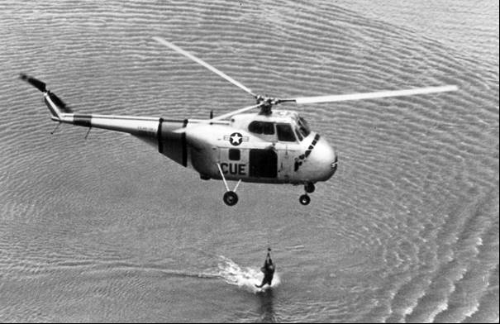

Index

1
100 Octane 33
100/150 Fuel 13
11th Airborne Division 6
16th Independent Parachute Brigade 7
19th Bomb Group 19
1st Battalion 4, 7
1st Division 14
1st Marine Division 21
2
27th Fighter Escort Wing 25
2nd Battalion 4, 14
3
38th parallel 3, 12, 32
3rd Battalion 3
4
4th Fighter Interceptor Wing 17
6
61st Air Base Wing 11
9
98th Bombardment Group 11
A
Abadan 6, 39, 40
Abadan Refinery 38, 39, 41, 42, 43, 44
Abyssinia 9
Accelerated Gum 36, 37
Aden 7
AHQ East Africa 7
air ambulance 45
Air Cargo Pty. Ltd. 6
Alkylate 33
alkylate plant 42
Alkylation unit 41
American Airlines 8
Anglo-Iranian 44
Anglo-Iranian Oil Company 6, 39
Aniline-Gravity Product 36, 37
anti-trust laws 39
API Project No. 6 33
Argentina 41
Arlid Viking 8
Aromatic Amines 36, 37
Aromatic aviation base 41
Aromatics 36, 37
Asiatic Petroleum 40
ASTM D910-48T 37, 38
Atomic Age 44
atomic bomb 7, 32, 44
atomic weapons 7
Auster 7
Australia 6, 9, 40, 41
Australian National Airways 8
automotive gasolines 44
Avgas 100/130 13
Avgas 100LL 34
Avgas 108/135 33, 36, 37
Avgas 115/145 22, 24, 30, 33, 34, 37
Avgas 80/87 38
Avgas 91/96 38
Avgas 91/98 38
Aviation Alkylate 41
aviation gasoline 33, 34, 36, 38, 39, 40, 41, 43, 44, 45
Ayrshire, Scotland 7
B
B-26 Invader 12, 13, 19, 20
B-29 Superfortress 6, 7, 11, 13, 19, 45
Bahrein Island 41
Basil W. Gurning 13
Belgian 38, 41
Bell 47 helicopter 14
Bell H-13 Sioux 13
Bell X-1 6
Benzene 41
Berlin Airlift 21
Berlin Blockade 10
Boeing B-47 6
Boeing KC-97A 6
Boeing Washington B1 6
Bolling Air Force Base 21
Brigadier General J. Stanley Holtoner 8
Bristol Brigand 6
Bristol Centaurus XVIII 30
Britain 6
British 16, 38, 43
British Air Forces of Occupation 7
British atomic device 8
British Commonwealth 44
British Navy 7, 39
British Overseas Airways Corporation (BOAC) 6
British West Indies 41
Brown 37, 51
Bruce K Brown 38
bunkers 39
Butane 33
C
C.S. Snodgrass 40
C-119 6, 21
C-121A 34
C-47 6
C-47 Skytrain 13
C-54 Skymaster 1, 13, 21, 24
C-82 Fairchild Packet 13
CAC Mustang 3, 12, 15
Canada 41, 44
Capt. Chuck Yeager 6
Captain Vincent H. McGovern 7
carbonization 42
Catalina 6
Catalytic Cracking 41
Catalytic Polymerization 41
Catalytic Reforming 41
Catalytically Cracked Heavy Naphtha 33
Catalytically Cracked Light Naphtha 33
Central Intelligence Agency 20
Chance-Vought FU4 Corsair 18
Charles E. Wilson 40
Charles Gately 40
Chief Waruhiu 7
China 9, 10, 12
Chinese Communist forces 32
Chinese People's Republic Air Force 16
Chinese People's Volunteers 4
Chingju 3
Chosin Reservoir 21
CIO Oil Workers Union 43
Cocos Islands 7
Cold War 15
Colonel-General Chistyakov 9
Colour 36, 37
Columbia 41
Columbine-1 34
combat troop carrier 45
Communist aggression 10
Consolidated Catalina PB2B 6
Coolangatta 6
Cooper Dish Residue 36, 37
Copenhagen 8
Copper Strip Corrosion 36, 37
Crude distillation 41
Cuba 41
Cyprus 7
D
Dakota 7
DC-3 ‘Lutana’ 6
DC-4 13
DC-4 ‘Amana’ 6
de Havilland Chipmunk 34, 35
de Havilland Comet III 8
de Havilland Vampire FB5 7
de Havilland Venom 6
Defense Department 42
Defense Production Act 42
Democratic People's Republic of Korea (North Korea) 4, 9
Denmark 41
Dharan airfield 6
Director of the Program Division 40
Distillation 36, 37
DMZ demilitarized zone 4, 32
Douglas B-26 Invader 20
Douglas C-124 Globemaster 21, 23, 25
Douglas C-47 Skytrain 7
Douglas D558-2 Skyrocket 7
Douglas Dakota 6
Douglas DC-6 7
Douglas DC-6B 8
Douglas DC-7 8
Douglas Skyraider AD-5 18
Dr. Syngman Rhee 9
drop tanks 28
Dutch 38
E
Easter Island 6
Economics Section of the Refining Division 42
Egypt 41
Egyptian Government 7
Emperor of Japan 9
End Poin 36
End Point 37
Existent Gum 36, 37
Exxon 40
F
F4U Corsair 12
F-80 Shooting Star 6
F-82 Twin Mustang 12
F-84 Thunderjet 25
F-86 Sabre 12, 16
F-86A Sabre 17
F-86D Sabre 8
F8F Bearcat 18
Fairchild C-119 Boxcar 22
Fairchild C-82 Packet 22
Fairey Firefly 18, 29, 30
Far East Air Force 10, 15
Far East Flying Boat Wing 26
Fayid 6
FEAF 10, 15
Federal anti-trust laws 40
Federal Trade Commission Act 40
first space flight 7
Fleet Air Arm 7, 30
Flight Lieutenant Bentleigh 8
Ford Sussex 7
Foreign Operations Committee 39
foreign petroleum committee 40
Foreign Petroleum Supply Committee 40
France 41
Freedom Bridge 5
Freezing Point 36, 37
French 38
Frigate Bird II 6
fuel oil 44
G
General Douglas MacArthur 3, 9, 32
General Eisenhower 34
General Mark W. Clark 4
General Otto Weyland 15
General Ridgeway 3, 4
General Walker 3
George Ballou 40
Germany 6, 7, 41
Gloster Meteor F.8 3
Gloster Meteor Mk 8 12, 15
glycol engine coolant 28
Gravity API 36, 37
Grumman F8F Bearcat 18
Grumman F9F Panthers 16
Guam 11
Guildford, WA 6
H
Hamasa 7
Handley Page Hastings 7, 26
Hawker Sea Fury 18, 29, 30
helicopter 45
Hiroshima 9
Historic Aircraft Restoration Society 34
HMAS Sydney 15, 18, 29, 30
HMAS Vengeance 30
HMS Plym 8
Hong Kong 3
Hoyt Vandenburg 10
I
Inchon 3
India 39
Indian Ocean 7
Indonesia 41
in-flight refuelling 25
Inhibitors 36, 37
Inje Punch Bowl 14
International Air Exhibition 6
Iran 39, 40
Iranian Government 44
Iranian Shutdown 38
Iraq 41
Iron Curtain 44
Italians 9
Italy 41
Iwakuni 15, 26
J
Japan 3, 11, 17, 18, 21, 26, 41
Japan Air Lines 6
Japanese 9
Johannesburg 7
John Wahlstrom 40
Joint Chiefs of Staff 10
Joseon dynasty 9
K
Kaesong 3
Kapyong 3
KB-29 6
Kenya 7
Kenya Land Freedom Party 7
Kenyan Police Reserve Air Wing 7
kerosene 39, 44
Kikuyu tribe 7
Kim Il Sung 4, 9
Kimpo Air Base 17
Korean War 32, 44
Korean War Memorial 10
Kuwait 40, 41
L
Lancashire Fusiliers 7
lead deposits 42
League of Nations 9
Lean mixture Aviation Rating 36, 37
Lieutenant Harold Moore 7
Lieutenant Russell J. Brown 16
Lieutenant William G. Hudson 12
Lieutenant-General John R. Hodge 9
Lockheed Constellation 6, 33
Lockheed F-80 Shooting 12
Lockheed F-80C Shooting Star 16
Lockheed Lodestar 6
Lockheed Super Constellation 34
Lockheed T-33 6
Lord Howe Island 6
Los Angeles 8
M
MacDill Air Force Base 6
MacRobertson-Miller 6
Major William Bridgeman 7
Malaya 6, 7
Malayan Emergency 7
Malik 3
MASH 13, 14, 51
Massachusetts 7
Mau Mau 7
Mauritius 7
metallic lead 42, 43
Middle East 39
MiG Alley 12, 16
MiG-15 3, 6, 12, 15, 16, 17
MIL-F-5572 36, 38
Military Air Transport Services (MATS) 22
Mobile Army Surgical Hospitals (M.A.S.H.) 13
Monte Bello Islands 8
Morocco 40
motor gasoline 38, 43
N
Nairobi 7
Nancy Ellis 6
National Production Authority 42
Net Heat of Combustion 36, 37
Netherlands 9, 41
Netherlands West Indies 41
New Guinea 41
New Mexico 7
New Zealand 9
No. 249 Squadron 6
No. 267 Squadron 7
No. 511 Squadron 7
No. 53 Squadron 26
No. 6 Squadron 6, 7
No. 77 Squadron 3, 18, 26
No. 8 Squadron 6
No. 800 Squadron 7
No. 88 Squadron 26
North American F86 Sabres 4
North American Harvard 34
North Atlantic Treaty Organisation (NATO). 7
North Korea 10, 11, 15, 32
North Korean Peoples’ Army (NKPA) 12
North West Airlines 8
Norway 41
nuclear war 10
O
Office of International Trade 40
Office of Price Stabilization 42
Oman 7
Omar Bradley 10
Operation Albert 7
Operation Commando 4
Operation Firedog 7
Operation Hurricane 8
P
P.G. Taylor 6
P-51 Mustang 12, 13, 15
P-51D Mustang 13
Pacific Airlift 21
PAD Order No.1 41
PAD Order No.3 43
PAD Order No.4 42, 43
PAD Order No.5 44
PAD Order No.6 44
PAD Refining Division 43
Pan American World Airways 7, 8
Panmunjom 4, 32
Peng Teh-Huai 4
Pentanes 33
Performance No. 36, 37
Persian Gulf 6
Perth 7
Peru 41
Petrol rationing 6
Petroleum Administration for Defense 38, 40
Petroleum Administrations for War 38, 40
Petroleum Administrator for Defense 40
pig lead 42
pipelines 41
precision-guided cruise missile 11
Premier Mossadegh 39
President Harry Truman 7, 10
Pusan Perimeter 3
Pyongyang 3
Q
Qantas Empire Airways 7
Qatar 41
Quirindi 6
R
RAAF 3, 6, 8, 15, 26, 27
RAF 7, 26
RAF Bomber Command 6
RAF Eastleigh 7
RAF Habbaniyah 7
RAF Sharjah 7
RAN 3, 26
Reid Vapour Pressure 36, 37
Republic of Korea (South Korea) 4, 9
Research & Development Command 6
residual fuel 39
RF-80As 6
Rich mixture Supercharge 36, 37
Rockefeller 39
Rolls-Royce jet engine 16
Royal Air Force 26
Royal Air Force Transport Command 6
Royal Australian Regiment 3, 4
Russian 9
Russian troops 9
S
Saudi Arabia 6, 7, 40, 41
Saybolt 37
Scandinavian Air Lines 8
Second Tactical Air Force 7
Secretary Chapman 40
Seoul 3, 9, 17
Short Sunderland GR5 26
Sikorsky S-55 7, 13, 14
sound barrier 6, 8
South African Airways 6
South Korea 10, 32
South Pacific 6
Soviet Russia 45
Soviet Union 7, 16
Soviets 44
Spain 41
sparkplug fouling 33
Standard Oil Company 39
Standard Oil Company of New Jersey 40
Stewart Coleman 40
Stormovik bomber 9
Strategic Air Command (SAC) 6
strategic bombing 11
Suez 39
Suez Canal Zone 7
Sukchon 6
Sulfur 36, 37
Sunchon 6
Supermarine Attacker 7
T
T-34 tanks 9
tactical bombing 11
tank car 42
tankers 41
Technical Order 06-5-1 11
TEL 42, 43
Temora, NSW 34
Tetra Ethyl Lead 33, 36, 37, 42
Texas Company 40
Tokchon 3
Toluene 33, 41
Trans World Airlines 6
Transcontinental & Western Air 6
Trieste Zone 41
Trimouille 8
Trinidad 41
Tupelov TU-4 45
U
U.S. Air Force 10
U.S. Defense Production Act 39
U.S. Justice Department 39
United Kingdom 9, 26, 41
United Nations 9
United States 7, 9
United States Navy's Fleet Air Wing (FAW) 26
Uruguay 41
USAF Airman Heritage Training Complex, Lackland, Texas 12
USSR 10
V
Valparaiso, Chile 6
VB-13 Tarzan 11
Venezuela 41
Vickers Valetta 7
Vickers Viking 7
Virgin Naphtha 33
Voice Flight 7
Voluntary Agreements 39
W
Walter Reed Army General Hospital 21
Water Tolerance 36, 37
West Coast 44
White Sands 7
William Farrand 40
Wonsan Refinery 32
Y
Yak 9 12
Yak fighter 9
Yalu River 12, 16
Yellow Sea 12
Yokota 11

Research Sources

“With the Australians in Korea” by Norman Bartlett, Australian War Memorial, Canberra 1957.
“With the Australians in Korea” by Norman Bartlett, Australian War Memorial, Canberra 1957.
Website: http://www.century-of-flight.freeola.com/Aviation%20history/jet%20age/The%20Korean%20War.htm Accessed Oct 7, 2005
Website: http://www.centennialofflight.gov/essay/Rotary/MASH/HE12G6.htm Accessed Oct 29,2005
‘A Pictorial History of Australians at War’ Published by Paul Hamlyn 1970 ISBN 0 600 39656 0.
Website: http://www.af.mil/photos/index.asp?galleryID=157 Accessed Oct 28, 2005
Website: http://www.af.mil/photos Accessed Oct 27, 2005.
Website: http://www.af.mil/photos/index.asp?galleryID=157 Accessed Oct 28, 2005
Website: http://www.af.mil/history/ Accessed Nov 2004
Website: http://www.af.mil/photos/index.asp?galleryID=157 Accessed Oct 28, 2005
Wings of Glory – The Air Force Story Vol. 1 ,2, 3 CD RBC Entertainment
Website: http://www.af.mil/photos/index.asp?galleryID=157 Accessed Oct 28, 2005
“With the Australians in Korea” by Norman Bartlett, Australian War Memorial, Canberra 1957.
‘A Pictorial History of Australians at War’ Published by Paul Hamlyn 1970 ISBN 0 600 39656 0.
Australian War Memorial Photograph Accession Number HOBJ0950, Maker Hobson, Phillip Oliver, Place made Japan: Iwakuni, Date made 3 July 1950, Copyright expired - public domain
“With the Australians in Korea” by Norman Bartlett, Australian War Memorial, Canberra 1957.
Australian War Memorial Photograph Accession Number 305722, HMAS Sydney (1949-1958), Korea, Copyright expired - public domain
American Petroleum Institute 32nd Annual Meeting Chicago Illinois November 10-13, 1952 Forum on Fundamental Research. “Analysis, Purification, And Properties Of Petroleum Hydrocarbons” – API Research Project 6 by Sherman S. Shaffer & Frederick D. Rossini.
Website http://hars.org.au/ photos from private collection.
Website: http://www.rafmuseum.org.uk/milestones-of-flight/timeline.html Accessed 19 Oct 2005.
Aviation Fuels and their effect on Engine Performance prepared by Ethyl Corporation for US Air Force and (US) Department of the Navy 1951 sourced San Diego Aerospace Museum.
Oil Men In Washington – An informal account of the organisation and activities of the Petroleum Administrations for Defense during the Korean War 1950-1952 by Bruce K Brown, published by Evanil Press 1965. Sourced from API Library Washington D.C. U.S.A.

