Chapter

32

Australia – Peace, Prosperity, and the occasional ‘Emergency’ 1946-1960

Photo 1. Butterworth Malaya. No. 1 bomber squadron RAAF crew in front of their Avro Lincoln bomber after returning from a mission over Malaya (1951).

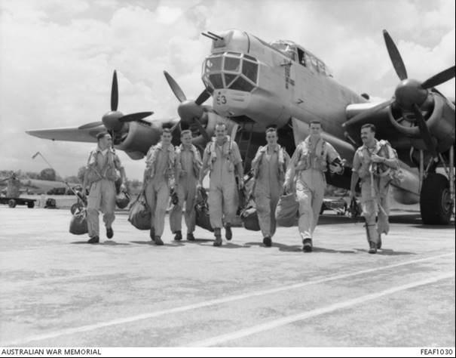

Left to right: Pilot Officer Len Hilton of South Perth, WA, Pilot Officer Terry Meagher of Windsor, Vic, Flight Sergeant Jim Glover of Fremantle, WA, Sergeant Kim Hunt of Melbourne, Vic, Sergeant Bill Smyth of Parramatta, NSW, Sergeant Erik Sunstrup of Sydney, NSW and Captain Peter Heardon, Flying Officer of Footscray, Vic

Table of Contents

Summary 3

Recovery From The Second World War 1946-1960 3

Oil Companies And Refineries 3

Australian Contracts (Wartime) 5

Termination Of Wartime Contracts 5

BP Enters The Aviation Gasoline Market 5

Shell Company Of Australia & Vacuum Oil Company Contract Renewals 6

Shell & Vacuum Contracts 2259 & 2260 Sept 1946 8

Contract No. 2259 & 2260 Between Raaf & Vacuum, Shell Co. 9

Contacts Extended To December 1947 10

Avgas Grades 1953-1957 11

Australia Still At ‘War’ – Sort Of! 12

Epilogue For 1960 13

Index 14

Research Sources 14

Photo 2. RAAF Base Laverton, Victoria, “Open Day” 1956.

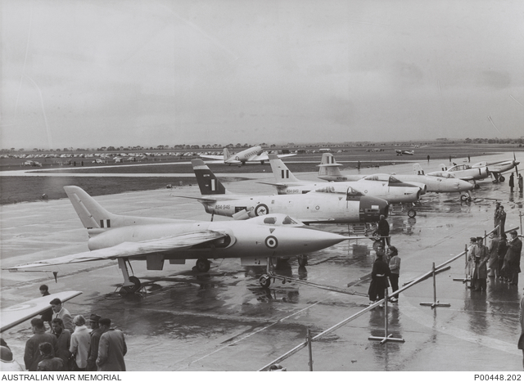

Laverton, Vic. 1956. A variety of aircraft types displayed at "Open Day" At RAAF Base Laverton. From Left: Avro 707, CAC Avon- Sabre (two), Gloster Meteor, CAC Winjeel, North American P-51D Mustang and a Douglas C47 Dakota (centre background).

# Summary

This was a period of recovery from World War II, rebuilding refineries and hopefully returning to normal. Colonial empires were unravelling, but the European powers were still keen to retain their colonial possessions however, those in the colonies wanted their own destinies. The threat of communism with the ‘domino theory’ would impact upon Australia’s place in the world.

For Australia and the suppliers of aviation gasoline (Shell Company of Australia and Vacuum Oil Company), there were still commitments to be honoured and new contracts to be made. But there was to be a new competitor about to enter the Australian market - BP Air.

# Recovery from the Second World War 1946-1960

Australian Forces had fought on three continents, Africa, Europe and Southeast Asia.

What initially started as defending ‘Mother England’ and the British Empire in remote lands from the ‘evils threat of the Hun’ – again – but this time in the form of Hitler’s Nazis, had changed to defending ‘AUSTRALIA’ on the home front with the “Japs at our front door’. From this turmoil there would emerge the ANZUS Treaty (signed in 1951) and the ‘domino theory’ on Communism (1954).

[The Australia, New Zealand, United States Security Treaty (ANZUS or ANZUS Treaty) was the military alliance which bound Australia and New Zealand and, separately, Australia and the United States to cooperate on defence matters in the Pacific Ocean area, though today the treaty is understood to relate to attacks in any area][1]

[The ‘domino theory’ was a mid-20th century foreign policy theory, promoted by the government of the United States; that speculated that if one land in a region came under the influence of communism, then the surrounding countries would follow in a domino effect.][2]

# Oil Companies and Refineries

Immediately after WWII the production of aviation gasoline was still limited to those refineries of the war years, namely the United States with lesser contributions from the Caribbean region, the Middle East and Britain. The refineries of the Dutch East Indies were in ruins and the colonies of the European empires, particularly in the East, were seeking self-determination – Batavia (Indonesia) from the Dutch, Indochina from the French, Malaya from the British. This prompted a change in oil company strategy in the late 40’s through to the 70’s in which the approach would be to build refineries in regions of stable governments such as Australia and New Zealand. However, these were to supply the local market with a full range of petroleum products. In the meantime, the oil companies Shell and Standard Vacuum wished to repair the war damaged refineries of the East Indies. With the war over, the supply of the necessary process equipment would take several years. Petrol rationing was still in place.

Netherlands East Indies

By the end of 1948 the Palembang refinery was producing high octane aviation gasoline which was supplied to Australia.[3] Prior to the war there were five refineries operating in the region; by 1951 two more refineries had resumed operations - Pladjoe Refinery (Shell Co.) 200,000 tons/month and Sungei Gerong plant (Standard Vacuum Oil) (production was 196,000 tons in 1942) in 1948 it was 4,000 tons/month increasing to 6,000 tons/month.

The press of the day reported on the nationalization of Indonesian oil industry (May 6, 1951)

In 1957[4], Dutch assets in petroleum were nationalised, from which Permina was founded as a state-owned oil monopoly, headed by Lieutenant-General Ibnu Sutowo. Ibnu Sutowo's position as the second deputy of Abdul Haris Nasution was the beginning of the armed forces' involvement in the oil industry. Permina distributed oil for the entire archipelago.

Permina founded the Apprentice Technical School (Sekolah Kader Teknik) in Brandan to train and produce experts in the field. To meet this goal Permina established the Oil Academy in Bandung in 1962. Oil Academy's curriculum pertains to the technical aspects of the oil industry, and the graduates became the main forces of Pertamin (which later transformed to Pertamina).

In 1960, the Congress enacted a policy that the mining of Indonesian oil and ground gases are only permitted for the state, through a state-administered company. Pertamin, established in 1961, was responsible for the administration, management and controlling of the exploration and production. The policy was short lived. An agreement between the state and foreign companies was affirmed that gradually, oil refinery manufactures and other assets in marketing and distribution were to be sold to Indonesia within five to fifteen years.

In 1968, to consolidate oil and gas industry for its management, exploration, marketing and distribution, Permina and Pertamin merged and became PN Pertamina. It continued to do little drilling itself, but made production-sharing agreements with foreign companies.

Netherlands West Indies

In 1948 the biggest refinery in the world was in Aruba - Netherlands West Indies; this was Lago Oil & Transport Refinery 400,000 BSD with a 200,000 BSD cracker located in the Lago Colony[5]. This was a community on the eastern end of Aruba; a Dutch island located roughly 17 miles north of Venezuela, in an area now called Seroe Colorado. The colony served, for the most part, as a company town for Lago Oil & Transport Company, Ltd., which owned and operated a refinery on the island. Lago Oil was a subsidiary of Standard Oil Company (New Jersey), later known as Exxon Corporation.

At its peak, Lago Colony included about 700 homes for employees and their families and included amenities familiar to other communities, such as a school, a hospital, a church, and a variety of social and recreational opportunities. Residents of the colony were mostly Americans. Other nationalities represented were Dutch, Danish, Spanish, English, Irish and Scottish.

The refinery, which began operating in 1924 as a trans-shipping facility for crude oil from Lake Maracaibo, was at one time the largest refinery complex in the world. The facility remained in operation until 1985 when Exxon moved to shut down and dismantle the refinery and Lago Colony. Parts of the facility were sold to the Aruban government and later to Coastal Petroleum. Though a much smaller operation today, Valero Energy Corporation now operates the refinery.

[The trend of major oil companies to shut down or sell-off refineries would be common place in the late 20th and into the 21st century].

# Australian Contracts (Wartime)

During the war the two contracts for aviation gasoline and oils were with the Shell Company of Australia and Vacuum Oil Company. They were:

Contract No. 2164 between RAAF & Shell Co.

Contract Board File No. GS 80228 Contract 2164 was arranged on 27 June 1941 with product supply with 31 March 1944.

In 1942 Cairns 100,000 gallons was required for a high period of air action in this region. *(Comment: perhaps the Battle of Coral Sea fought from 4–8 May 1942, it was a major naval battle between the Imperial Japanese Navy and naval and air forces from the United States and Australia, taking place in the Pacific. A naval battle fought between ship and aircraft, where the naval ships never sighted each other)*.

Since 1942 Aviation Products Co-ordinating Committee had been operating to coordinate supplies to both the armed services and public.

Two further contracts were negotiated with Shell since No. 2164. The last expired 31 Dec 1947.

Contract No. 2236 issued 12 April 1944 Shell Co. for Avgas and Avoil

Contract No. 2237 issued 12 April 1944 Vacuum Oil Co. for Avgas and Avoil

In addition, there was Contract No. C301/21990 with Pool Petroleum Pty. Ltd. for supply of motor transport fuel and oil until March 2, 1947. *(Comment: Pool Petroleum was a consortium of all oil companies for the supply and distribution of products to the armed services and the public).*

# Termination of Wartime Contracts

The wartime contracts were to be terminated and noted in a letter from Air Member for Supply & Equipment - Branch Circular No. 332 March 4, 1946 - Termination of Wartime Contracts. The letter stated that the contracts provide for termination 12 months after the cessation of hostilities - assumes Sept 2, 1945. The contracts were with Shell and Vacuum Oil Co. to supply Avgas, Avoil (aviation lubricating oils) and TEL (Tetra Ethyl Lead).

# BP enters the Aviation Gasoline Market

In a letter from C.O.R. to the Department of Air, it was stated that Commonwealth Oil Refineries (C.O.R.) plan to market avgas. This will be imported from the Anglo-Iranian Oil Co. (later BP) from their Abadan Refinery using British ships and delivery to Australian ports. The first shipment of avgas would be arriving late 1946.

It also saw the first steps of a new competitor in the market. – ‘BP Air’ who wished to gain access to this market, via its lubricating oil subsidiary – Wakefield.

By the 1980’s BP would be producing aviation gasoline at their BP Kwinana Refinery, near Perth, Australia and supplying both military and commercial aviation in the South East Asian region and the west of Australia through the oil company ‘borrow & loan arrangements”. [This is an arrangement whereby an oil company in one state with a refinery or supply of a particular product, can ‘loan’ petroleum products to another oil company, and ‘borrow’ with the same product elsewhere where they do not have product. For example, Mobil can borrow avgas from BP in Western Australia to supply their Mobil customers in the west, and repay BP with avgas from its supplies in Victoria. This eliminates the need for both companies to transport avgas from their respective refineries across the country to supply their customers.]

# Shell Company of Australia & Vacuum Oil Company Contract Renewals[6]

Immediately after the war in order to maintain supply of aviation products it was necessary to renew the war time contracts with the Shell Company and Vacuum Oil Company since these contracts would expire in September 1946 and new contracts were to be negotiated.

At this time after the war Australian aircraft types using Avgas 100/130 were: North American Mustang, Consolidated Liberator B-24, De Havilland Mosquito, Douglas (DC-3) Dakota, Bristol Beaufort, Avro Lincoln, Consolidated PBY Catalina.

Photo 3. Liberator B-24 “Silver Lady” RAAF crews on attachment to the USAAF 380th Bomber Group.

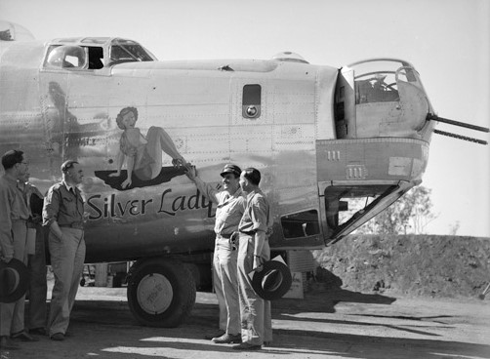

Photo 4. RAAF de Havilland DH-98 Mk III Mosquitos from No. 5 Operation Training Unit (many of these aircraft were transferred to the Royal New Zealand Air Force).

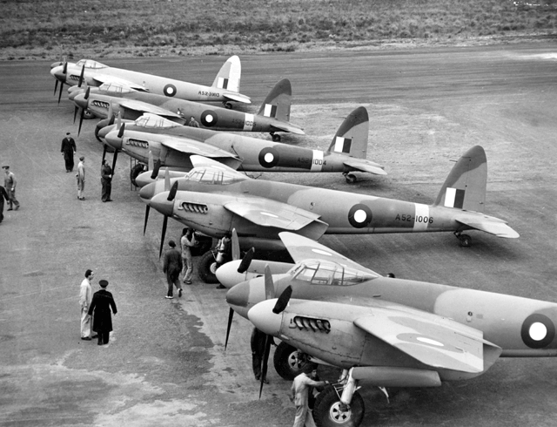

Photo 5. Bristol Beaufort undergoing maintenance. Note the INTAVA drum in the foreground.

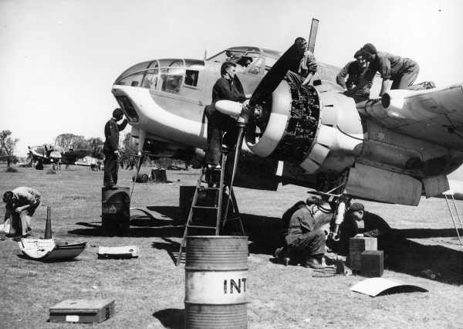

Photo 6. RAAF Catalina A24-99 refuelling

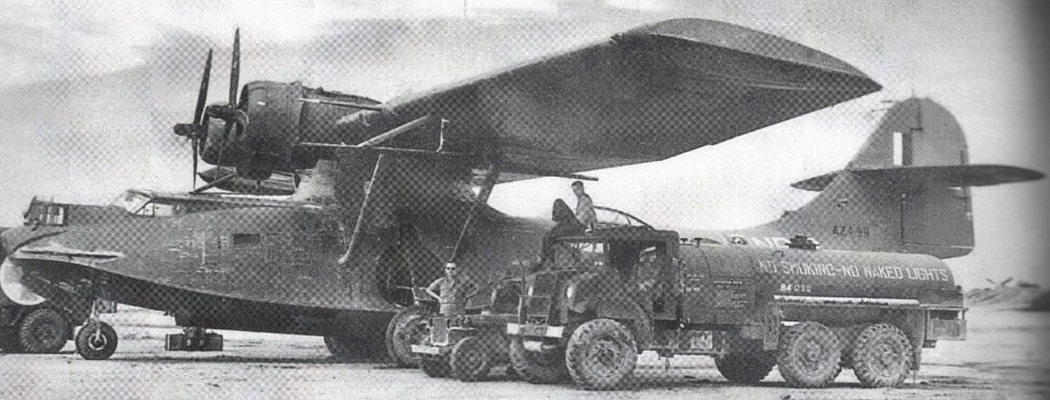

Aircraft types using Avgas 91 were: Avro Anson, Airspeed Oxford.

Photo 7 Vacuum Oil (Mobiloil) refuelling from drum stock to an Avro Anson in Adelaide.

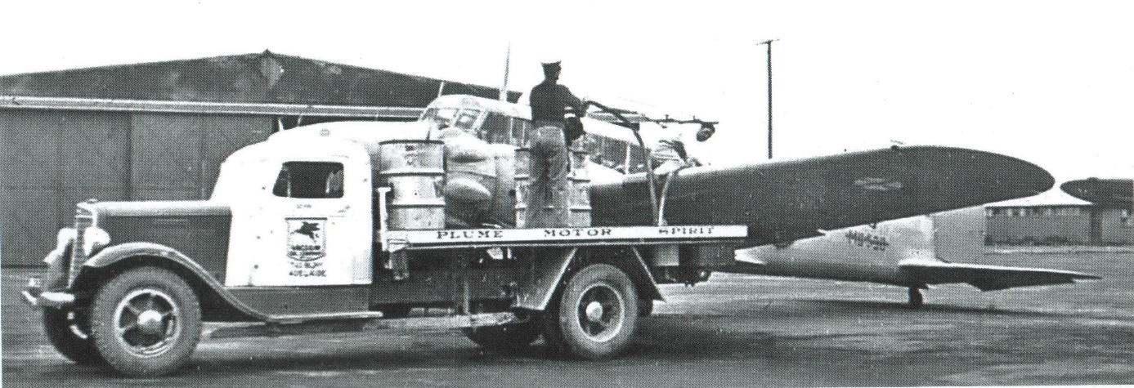

The following information obtained from the National Archives of Australia details the requirements for the new contracts and showed the introduction of a new aviation product for the RAAF - Jet Fuel for new British aircraft such as the Gloster Meteor and De Havilland Vampire.

With WWII over, there was still aircraft to be refuelled in the Pacific region at the many island airfields and transport routes, and to determine who would be responsible for the fuel supply at these locations, the stock situation and the demand. The following gives us some insight.

# Shell & Vacuum Contracts 2259 & 2260 Sept 1946

The new contracts to be negotiated required a minimum refuelling rate of 45 Imp. Gallons/mins.

Minimum Refuelling Rates:

Hand operated 15 Imperial gallons/minute

Power operated 35 Imperial gallons/minute

**Product Specifications**

**Fuels:**

* Petrol 100 Octane Grade 130 Spec. DED 2475 (Latest issue)
* Petrol 90/91 Octane Spec. DED 2474 (Latest issue)
* Petrol 73 Octane Spec. RDE/F/73 Unleaded
* Aviation Kerosene Spec. RDE/F/KER *(Comment: this is the introduction of Jet fuel for RAAF aircraft such as the Gloster Meteor and De Havilland Vampire which were powered Goblin or Rolls Royce Nene or Rolls Royce Derwent jet engines).*

**Oils**

* Oil Lubricating (120 Sec) Spec DED 2472 C/O.

The following are only required in small quantities.

* Oil Lubricating Turbine Engine Type B Derwent Engine

No specification: following oils approved

1. INTAVA Experimental 7106
2. Wakefield Perfecto Extra Light
3. Aero-Shell 40

* Oil Lubricating (60 Sec) Type B Spec RDE/O/59 Goblin Engine
* Oil Lubricating Spec DTD 44D Nene Engine

[Note the inclusion of Wakefield oils as BP tries to enter the aviation fuel market].

**Existing Contracts**

* Existing contracts with Shell Co. and Vacuum Oil Co. extended to Sept 2, 1947
* Locations in operation at 10 July 1946

Hobart, Launceston, Oodnadatta, Broome, Onslow, Rockhampton, Charleville,

Learmonth, Noonkanbah, Cloncurry.

* Alice Springs off take 15,000 Imp. Gallons/month
* Shell and Vacuum are not responsible for Port Moresby (Jacksons), Rabaul (Lakunai), Lae, Finschhafen. These are RAAF’s responsibility.
* Dutch will refuel at Morotai, US Forces refuel for staging points Australia to Japan route.
* Shell are to take over supply in New Guinea area, take-over date unknown probably 22 Jan 1947.

Table 1. Avgas 100 stocks December 1946

Stocks at 31 Dec 1946 Avgas 100 (Imp Gallons)

|  |  |  |  |
| --- | --- | --- | --- |
| **Location** | **Bulk** | **in drums** | **Consumption** |
| Finschhafen | - | 42,963 | 6,175 |
| Lae | 108,548 | 61,996 | 13,605 |
| Port Moresby | 52,917 | - | 23,934 |
| Rabaul | - | 117,156 | 2,220 |

Shell Refuelling at Port Moresby to take over RAAF operation on 21 Oct 1947.

# Contract No. 2259 & 2260 between RAAF & Vacuum, Shell Co.

Supply in Australia was again divided between Shell Company of Australia and Vacuum Oil Company. The following lists the airfields supplied by each of the only two companies in the market. It also includes the supply to the Royal Australian Navy and seaplane bases.

Sept 3, 1946 Schedule “A” Refuelling Points. (Those struck through indicate those not required post war (WWII).

## Schedule “A”

## Vacuum Oil Co.

**W.A.**

~~Albany~~, Broome, Bussleton, Carnarvon, Cunderdin, Derby, Esperance, Fitzroy Crossing, Forrest, Geraldton (supplies ex Fremantle, overseas), ~~Halls Creek (ex Wyndham)~~, Kalgoorlie, Meekatharra, Narragin, ~~Onslow~~, Pearce, Port Hedland, ~~Rawlinna,~~ Roebourne (Pt. Beadon), ~~Wyndham.~~

**S.A**.

HMAS Adelaide (RAN), Balaklava, Bordertown, ~~Broken Hill~~, Ceduna (Supplies ex Birkenhead, via Port Lincoln), ~~Cook~~, ~~Kimba,~~ ~~Kingscote~~, Mallal, ~~Mt. Eba~~, Mt. Gambier, Oodnadatta, ~~Port Lincoln~~, Port Pirie (ex Birkenhead, ex overseas), ~~Tintinarra~~

**N.S.W.**

Forrest Hills, Uranquinty (ex Wagga)

**Vic.**

Bairnsdale, Ballarat, Benalla, Cressy, Deniliquin, Essendon, Fulham, Geelong (Little River & Lara), Hamilton, Lake Boga, ~~Leongatha~~ Laverton, ~~Mallacoota~~, Mildura, Nhill, Pt. Cook, Sale, Swan Hill, Tocumwal (ex IAFD 73), ~~Warrnambool~~, Yanakie (see Leongatha)

Bass Strait Currie (King Is.), Whitemark (Flinders Is.)

## Shell Company of Australia.

**Vic** Essendon

**N.S.W.**

HMAS Sydney (RAN), Bourke, Camden, Coffs Harbour, Cootamundra, Dubbo, Evans Head, Eden, Hay, Mascot, Jervis Bay, Nabiac, Narrandara, Narromine, Nowra, Nyngan, Parkes, Rathmines, Richmond, St. George’s Basin, Tamworth, Temora,

Williamtown (Newcastle)

**ACT** Canberra

**QLD**

HMAS Brisbane (RAN), Amberley, Archerfield, Blackall, Bowen (land & seaplane), Bundaberg, Cairns (land & seaplane), ~~Comooweal,~~ Cecil Plains, Charleville, Cloncurry, Cooktown, Gladstone (land & seaplane), Kingaroy, Leyburn, ~~Longreach~~, Lowood, ~~Mackay,~~ Maryborough Oakey, ~~Rockhampton~~, Townsville (land & seaplane), Winton.

**S.A.** Parafield

**TAS**

HMAS Hobart (RAN), Hobart (Cambridge), Launceston (Western Junction), ~~Smithton~~

# Contacts extended to December 1947

Shell Co. March 25, 1947 Feb Sales

Avgas 73 929 Imp. Gallons

Avgas 91/98 12,088 Imp. Gallons

Avgas 100/130 169,043 Imp. Gallons

Total 182,057 Imp. Gallons

March 20, 1947 Current Contract No. 2259 Vacuum Oil Co.

Supply of avgas and Aero engine lubricating oils for RAAF by Shell and Vacuum has been extended to 31 Dec 1947.

New Guinea supplies are drawn from Australia.

Supplemental Agreement 21 May 1947 between Commonwealth of Aust. & Shell

Table 2. Stocks required by location 1947

|  |  |  |  |  |
| --- | --- | --- | --- | --- |
| **Location** | **Avgas 100** | **Avgas 91** | **Avgas 73** | **Lube Oil (1120 Sec)** |
| Darwin | 53,700 | - | 10,000 | 15,000 |
| Townsville | 200,000 | - | 5,000 | 6,000 |
| Cairns | 50,000 | - | 5,000 | 200 |
| Brisbane | 300,000 | - | 1,500 | - |
| Sydney | 856,000 | 12,000 | 40,000 | - |
| Port Moresby | 84,000 | - | 10,000 | 2,500 |
| Lae | 60,000 | - | - | 1,800 |
| Finschhafen | 36,000 | - | - | 1,000 |
| Rabaul | 36,000 | - | - | 1,000 |

Supplemental Agreement to Contract 2260 - Letter from Shell Co. to Director of Supply & Development 28 June 1948. Shell was required to maintain a supply of 60,000 Imp. Gallons of Avgas 100/130 at Lae.

Shell Company of Australia supplies RAAF in Australia and South East Asia [7]

During the period 1948 to 1959 the Shell Company was supplying the RAAF both in Australia and in various locations in the Pacific and South East Asia (specifically Malaysia). This was noted in memo to Headquarters RAAF Richmond NSW which related to various claims regarding the uplift of aviation fuel for RAAF aircraft outside Australia. Claims were also made by Vacuum Oil Company for avgas supplied in Nadi, Fiji, and Avoil supplied in Canton Island. There were also similar claims for supplies for Shell Bangkok, Thailand.

June 1959: This indicated that Vacuum Oil Co. and Shell Company still had contracts with RAAF for Lockheed Neptunes and Douglas Dakotas. No. 1 Squadron at Butterworth (Malaysia) and No. 2 Squadron at Amberley Qld. (Jet Fuel, Avgas 115/145, Avgas 100/130).

Photo 8. Lockheed Neptune start-up at Temora NSW 2007. Note: two turning (propellers), two burning (jet engines).

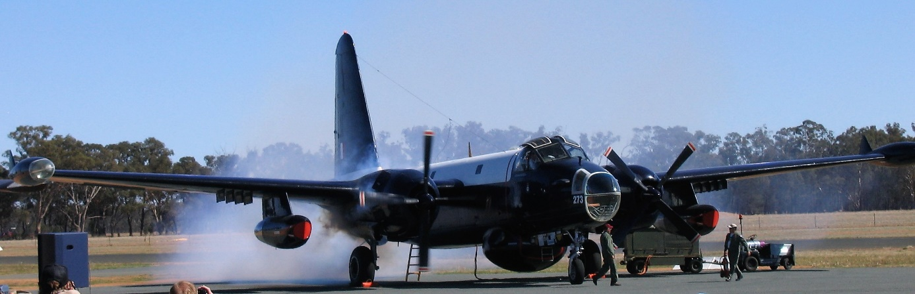

June 18, 1956. There were no facilities for handling Avgas 100/130 at RAAF Darwin.

# Avgas Grades 1953-1957

1953 British Empire Aviation Gasoline Specification Apply

Because Australia and New Zealand were still part of the British Empire, the respective military services followed the British Air Ministry specifications of the day. The contracts to supply aviation gasoline were still held by the Shell Company of Australia and the Standard Vacuum Oil Company. It must be remembered that all aviation gasoline was still imported into Australia at this time, and for Shell their sources was the Pladjoe refinery in South East Sumatra which was one of the greatest producers of high octane aviation spirit in the Netherlands East Indies. For Standard Vacuum, it was Palembang which had only resumed production after the war.

In 1953 the Australian Services Aviation Gasoline Specifications[8] was based on the UK D Eng. RD-2485 Issue 1 Amendment 6 (revised Feb 1957) specification.

This fuel was used by the Royal Australian Navy, Australian Military Forces, and the Royal Australian Air Force.

Nomenclature- General: The system was based on the use of symbols allotted by the Ministry of Supply in the United Kingdom to ensure a rational nomenclature which indicated the nature of each product, uniformity between the Services and the maximum standardizations within the United Kingdom.

Table 3. UK D Eng. RD Specifications Feb 21957 Specification UK D Eng. RD (Director of Engine Research and Technical Development) - Issue: Revised Feb 1957.

|  |  |  |  |  |  |
| --- | --- | --- | --- | --- | --- |
| Grade Designation | 73 | 80 | 91/96 | 100/130 | 115/145 |
| Specification No. | D Eng. RD-2485 Issue 1 Amdt. 6 | D Eng. RD-2485 Issue 1 Amdt. 6 | D Eng. RD-2485 Issue 1 Amdt. 6 | D Eng. RD-2485 Issue 1 Amdt. 6 | D Eng. RD-2485 Issue 1 Amdt. 6 |
| Old name | 73 Octane Aviation Spirit | 80 Octane Aviation Spirit | 91 Octane Aviation Spirit | 100 Octane Aviation Spirit | 115 Octane Aviation Spirit |

# Australia still at ‘War’ – sort of!

One of the consequences of the Second World War was the destruction of the European ‘colonial empires’ of Holland, Britain, France and Belgium.

The invasions of the Japanese throughout South East Asia had changed for ever the aspirations of these peoples. The peoples of the Sumatra, Java and other possessions of Netherlands East Indies, so long a prized, resource rich (especially oil) colony, having suffered under the oppressive rules of the Japanese, were not about to return to colonial rule by the Dutch.

This would become the nation of Indonesia.

Communism was moving south and the first encounter resulted in the Korean War which is discussed in Chapter 31. Korean War.

After World War II, the British Empire was gradually dismantled, partly owing to the rise of independence movements in the then subject territories, and partly owing to the British Government's strained circumstances resulting from the cost of the Second World War.

In Malaya, the communists’ insurgents were fighting the British Forces, and Australia as part of the Commonwealth, would join the British Forces to fight the ‘insurgent threat’ known as the ‘Malayan Emergency’.

[The Malayan Emergency was a state of emergency declared by the British colonial government of Malaya in 1948 and lifted in 1960, as well as an insurrection and guerrilla war fought between government forces and the Malayan National Liberation Army around the same period.][9]

Photo 9. Avro Lincoln Bomber A73-33 of No 1 Squadron RAAF on a bombing mission over the Malayan jungle. A 500-pound bomb can be seen falling from the aircraft.

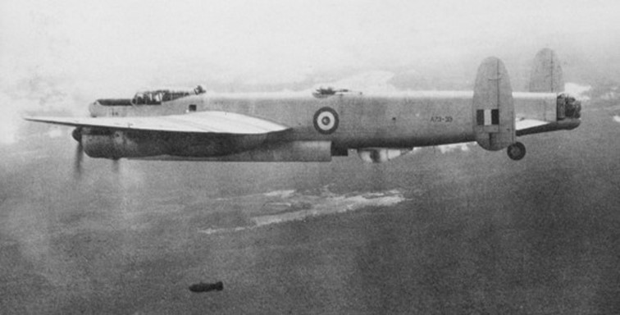

The French returned to Indo-China, and would end up losing these colonies which would become Vietnam, - and the Vietnamese would later fight a war against the United States and its allies – Australia; and be the controversial ‘Vietnam War’.

Photo 10. Avro Lancaster B VII WU15 of France's Aeronavale operating in the Pacific Area. The aircraft is refuelling at Darwin, Northern Territory on May 3, 1965 during the ferry flight. [10]

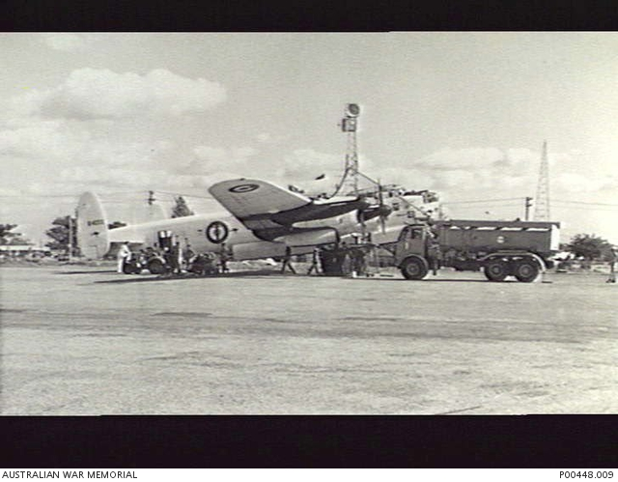

# Epilogue for 1960

The major suppliers of aviation products were still divided between the Shell Company of Australia and the Vacuum Oil Company and this would continue after the war years with Australian until the 1980’s. These companies had basically divided the market into two district areas from before World War II. But there would be new suppliers after the 1980’s - BP Air.

Photo 11. Standard-Vacuum Altona Refinery gas spheres, with alkylation depropaniser and re-run towers (left background), Thermofor catalytic cracker (TCC) (right) 1956. [These units were essential for the production of aviation gasoline].

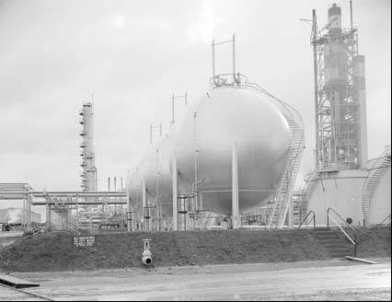

# Index

# 

1

100 Octane Aviation Spirit 12

100 Octane Grade 8

115 Octane Aviation Spirit 12

7

73 Octane 8, 12

8

80 Octane Aviation Spirit 12

9

90/91 Octane 8

91 Octane Aviation Spirit 12

A

Abadan Refinery 5

Aeronavale 13

Aero-Shell 40 8

Africa 3

airfields 8, 9

Albany 9

Alice Springs 8

Amberley 10, 11

Anglo-Iranian Oil Co. 5

ANZUS Treaty 3

Archerfield 10

Aruba 4

Australia 3, 8, 9, 10, 11, 13

Australian Military Forces 11

Australian ports 5

avgas 5, 10

Avgas 100/130 6, 9, 10, 11

Avgas 115/145 11

Avgas 73 10

Avgas 91 7, 10

Avgas 91/98 10

aviation fuel 11

aviation gasoline 3, 5, 11

Aviation Kerosene 8

aviation lubricating oils 5

aviation products 6

Aviation Products Co-ordinating Committee 5

Avoil 5, 11

Avro 707 2

Avro Anson 7

Avro Lancaster 13

Avro Lincoln 1, 6, 12

B

Bairnsdale 9

Balaklava 9

Ballarat 9

Bangkok 11

Bass Strait 9

Batavia 3

Battle of Coral Sea 5

Belgium 12

Benalla 9

Birkenhead 9

Blackall 10

Bordertown 9

Bourke 10

Bowen 10

BP Air 3, 5, 13

BP Kwinana Refinery 5

Brisbane 10

Bristol Beaufort 6

Britain 3, 12

British 8

British Air Ministry 11

British Empire 3, 11, 12

British Government 12

British ships 5

Broken Hill 9

Broome 8, 9

Bundaberg 10

Bussleton 9

Butterworth 1, 11

C

C.O.R. 5

CAC Avon- Sabre 2

CAC Winjeel 2

Cairns 5, 10

Cambridge 10

Camden 10

Canberra 10

Canton Island 11

Captain Peter Heardon 1

Caribbean 3

Carnarvon 9

Cecil Plains 10

Ceduna 9

Charleville 8, 10

Circular No.332 5

Cloncurry 10

Coffs Harbour 10

colonial empires 12

commercial aviation 5

Commonwealth 10, 12

Commonwealth Oil Refineries 5

Communism 3, 12

Comooweal 10

Consolidated Liberator B-24 6

Consolidated PBY Catalina 6

Contract 2260 10

Contract No. 2164 5

Contract No. 2236 5

Contract No. 2237 5

Contract No. 2259 10

Contract No. C301/21990 5

contracts 5, 6

Cook 9

Cooktown 10

Cootamundra 10

cracker 4

Cressy 9

Cunderdin 9

Currie 9

D

D Eng RD 2485 11, 12

Darwin 10, 11, 13

De Havilland Mosquito 6

De Havilland Vampire 8

DED 2472 8

DED 2474 8

DED 2475 8

Deniliquin 9

Derby 9

domino theory 3

Douglas (DC-3) Dakota 6

Douglas C47 Dakota 2

Douglas Dakota 11

Dubbo 10

Dutch 8, 12

Dutch East Indies 3

E

East Indies 3

Eden 10

engine lubricating oils 10

Engine Research and Technical Development 12

England 3

Essendon 9

Europe 3

Evans Head 10

Experimental 7106 8

F

Fiji ……………………………………………… 11

Finschhafen 8, 9, 10

Fitzroy Crossing 9

Flight Sergeant Jim Glover 1

Flinders Is. 9

Forrest 9

Forrest Hills 9

France 12

Fremantle 9

French 3, 13

Fulham 9

G

Geelong 9

Geraldton 9

Gladstone 10

Gloster Meteor 2, 8

Goblin Engine 8

guerrilla war 12

H

Halls Creek 9

Hamilton 9

Hay 10

high octane aviation spirit 11

HMAS Adelaide 9

HMAS Brisbane 10

HMAS Hobart 10

HMAS Sydney 10

Hobart 8, 10

Holland 12

I

IAFD 73 9

Indo-China 3, 13

Indonesia 3, 12

insurgent threat 12

INTAVA 8

J

Jacksons 8

Japan 8

Japanese 12

Java 12

Jervis Bay 10

Jet Fuel 8, 11

K

Kalgoorlie 9

Kimba 9

King Is. 9

Kingaroy 10

Kingscote 9

Korean War 12

L

Lae 8, 9, 10

Lago Oil & Transport Refinery 4

Lake Boga 9

Lakunai 8

Lara 9

Launceston 8, 10

Laverton 9

Learmonth 8

Leongatha 9

Leyburn 10

Little River 9

Lockheed Neptune 11

Longreach 10

Lowood 10

Lube Oil 10

lubricating oil 5

M

Mackay 10

Malaya 1, 3, 12

Malayan Emergency 12

Malayan National Liberation Army 12

Malaysia 11

Mallacoota 9

Mallal 9

Maryborough 10

Mascot 10

Meekatharra 9

Middle East 3

Mildura 9

Ministry of Supply 11

Morotai 8

motor transport fuel 5

Mt. Eba 9

Mt. Gambier 9

Mustang 6

N

Nabiac 10

Nadi 11

Narragin 9

Narrandara 10

Narromine 10

National Archives of Australia 8

nationalization 3

Nene Engine 8

Netherland East Indies 11, 12

Netherland West Indies 4

New Guinea 8, 10

New Zealand 3, 11

Newcastle 10

Nhill 9

No.1 Squadron 1, 11, 12

No.2 Squadron 11

Noonkanbah 8

Northern Territory 13

Nowra 10

Nyngan 10

O

Oakey 10

Oil Lubricating 8

Onlsow 8, 9

Oodnadatta 8, 9

P

P-51D Mustang 2

Pacific 3, 8, 11

Palembang 3, 11

Parafield 10

Parkes 10

Pearce 9

Perfecto Extra Light 8

Perth 5

Petrol rationing 3

Pilot Officer Terry Meagher 1

Pladjoe Refinery 3, 11

Pool Petroleum Pty. Ltd. 5

Port Hedland 9

Port Lincoln 9

Port Moresby 9, 10

Port Pirie 9

Pt. Beadon 9

Pt. Cook 9

R

RAAF 5, 9, 10, 11, 12

RAAF Base Laverton 2

Rabaul 8, 9, 10

RAN 9, 10

Rathmines 10

Rawlinna 9

RDE/F/73 Unleaded 8

RDE/F/KER 8

refineries 3, 4

refuel 8

Refuelling Points 9

Refuelling Rates 8

Richmond 10, 11

Rockhampton 8, 10

Roebourne 9

Rolls Royce Derwent 8

Rolls Royce Nene 8

Royal Australian Air Force 11

Royal Australian Navy 9, 11

S

Sale 9

Schedule “A” 9

seaplane 10

seaplane bases 9

Sergeant Bill Smyth 1

Sergeant Erik Sunstrup 1

Sergeant Kim Hunt 1

Shell 3, 5, 6, 8, 9, 10, 11, 13

Smithton 10

South East Asia 3, 11, 12

Spec DTD 44D 8

Specifications 8

St. George’s Basin 10

Standard Vacuum 3, 11

Sumatra 11, 12

Sungei Gerong 3

Supply & Development 10

Supply & Equipment - Branch 5

Swan Hill 9

Sydney 10

T

Tamworth 10

TEL 5

Temora 10

Termination of Wartime Contracts 5

Tetra Ethyl Lead 5

Thailand 11

Tintinarra 9

Tocumwal 9

Townsville 10

transport routes 8

Turbine Engine 8

Type B Derwent Engine 8

Type B Spec RDE/O/59 8

U

United Kingdom 11

United States 3, 13

United States Security Treaty 3

Uranquinty 9

V

Vacuum Oil Company 3, 5, 6, 8, 9, 10, 11, 13

Vietnam 13

Vietnam War 13

W

Wagga 9

Wakefield 5, 8

Warrnambool 9

Western Junction 10

Whitemark 9

Williamtown 10

Winton 10

Wyndham 9

Y

Yanakie 9

# Research Sources

1. Website accessed 1 Feb 2008 <http://en.wikipedia.org/wiki/ANZUS>
2. Website accessed 1 Feb 2008 <http://en.wikipedia.org/wiki/Domino_Theory>
3. National Archives of Australia. Title Netherlands East Indies - Oil and Minerals – General, Series Number A1838/1, Item Number 404/4/1/1, Date Range 1945 to 1951, Access Status OPEN, Location Canberra, ACT, Review: (21/2/2000)
4. Website accessed 3 November 2019 <https://en.wikipedia.org/wiki/Pertamina>
5. Website accessed 3 November 2019 <https://legacy.lib.utexas.edu/taro/utcah/03179/cah-03179.html>
6. National Archives of Australia - Series Number A705/1, Item Number 164/2/2219 PART 1, Date Range 1946 to 1948, Access Status NONE, Location ACT. Shell & Vacuum Contracts 2259 & 2260 Sept 1946. Title Supply of aviation fuel and oil - Policy - Period September 1946-1947 – Contracts 2259-2260 [2.5cm]
7. National Archives of Australia - Series Number A705/8, Item Number 2/1/6592 PART 4, Date Range 1948 to 1959, Access Status OPEN, Location ACT. Title Claims - Aviation fuel and oil - Shell Co. of Australia Ltd [2 cm], Review: (21/2/2000
8. Sources Handbook of Fuels, Lubricants and Allied Products for Australian Services June 1953 (revised Feb 1957) Ministry of Defence. (no details on specification only grades)
9. Website accessed 1 Feb 2008 <http://en.wikipedia.org/wiki/Malayan_Emergency>
10. Australian War Memorial ID Number: P00448.009 Summary: Darwin, NT. 1965-05-03. Avro Lancaster B VII aircraft which was originally RAF Serial No. NX611 and later became WU15 of France's Aeronavale operating in the Pacific area. The aircraft was subsequently restored at Bankstown NSW and registered as G-ASXX and flown by Ex- RAAF aircrew from Sydney NSW to Biggin Hill United Kingdom arriving on 1965-05-13. The photograph shows the aircraft refuelling at Darwin on 1965-05-03 during the ferry flight. Copyright: clear