Chapter

33

1953 - 1959

Transition to the Jet Age

‘Cold War’ era – ‘Stop Communism’

Photo . Composite photo RAAF Avro Lincoln bomber and de Havilland Vampire jet fighter [1]

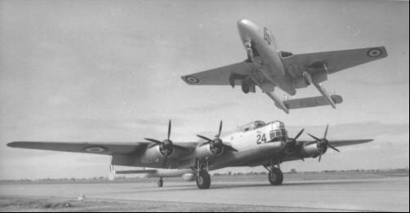

The above shows the transition to the jet age – piston engine to jet engine.

Table of Contents

Summary 3

Transition To The Jet Age 5

Military Transition To Jet Powered Air Force 6

Civil Aviation Also Changes To Jet Power 10

API Meeting Refining Division 1955 15

Oil Companies And Refineries 16

Refinery Construction In Australia 19

1956 - First Australian Refinery To Make Avgas 20

Aviation Gasoline Blending 1950’s 30

Methods Of Selection Of Blendstocks 33

Australian Avgas – Altona Refinery 35

Aviation Fuels – Australian Defence Services 36

Avgas Specifications And Test Methods 1950’s 40

Fuel Tanks - Portable 43

Commercial Airline Refuelling 45

Airspeed Records Were Now Military Pride 46

Epilogue For 1959 47

Index 48

Research Sources 55

Photo 2. Gloster Meteors of RAAF No. 77 Squadron refuelling

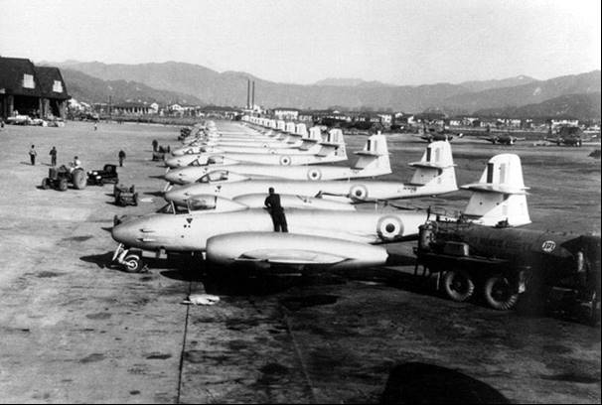

# Summary

On a personal note, much of the material in this chapter relates to my time at Altona Refinery as a laboratory chemist testing aviation gasoline in the late 1960’s, then as refinery planner in which I was deciding on the blendstocks to make aviation gasoline at this refinery.

**Chronology – Australian Aviation Time lines**[2]

**1952** September 1, 1952: Qantas Empire Airways (QEA) Constellation ‘Charles Kingsford Smith’ departed from Sydney on the first Wallaby service between Australia and South Africa.

**1953** July 17: J.L. Whiteman flew a Mustang from Sydney to Whenuapia, NZ, in the record time of 3 hrs 31 mins. and 30 secs.

August 3: Flt. Lt. W.H. Scott test flew the first Commonwealth Aircraft Corp. (CAC) Avon-engined Sabre (CA-27) at Avalon, Victoria. The first sonic booms were heard in Australia when Scott broke the sound barrier by diving the Sabre on August 11 and 14.

**1954** April 15: QEA's first Lockheed Super Constellation ‘Southern Constellation’, was delivered. On August 2, QEA's ‘Southern Sky’ left Sydney on the first Super Constellation service to London.

August 30: First production CAC CA-27 Sabre was officially handed over to the RAAF.

October 5: Trans Australian Airlines (TAA) received its first Vickers-Armstrong Viscount V720 ‘John Batman’. It was a British turboprop airliner fuelled by aviation jet fuel. The Melbourne-Sydney-Brisbane service began on December 18.

**1955** October 14: TAA began a weekly DC-4 Melbourne-Alice Springs-Darwin service. This year also saw the opening of Adelaide Airport, at this stage handling only domestic flights.

**1956** Qantas carried the Olympic flame from Athens to Australia for the Melbourne Olympic Games.

September 26: RAAF and RAN aircraft fuselage roundels would feature a "leaping kangaroo". The kangaroo later appeared also on the wing roundels.

**1957** The idea of a crash and fire protected device to record both the voices and the instrument readings in the cockpit - later known as a ‘black box’ - originated with a Dr. David Warren, a young research scientist at the Aeronautical Research Laboratories (ARL), Melbourne. A demonstrator unit produced in 1957 received a lukewarm reception from the Australian aviation authorities, and was taken to Britain for further development. Australia made fitting them to aircraft mandatory in 1961, becoming the first country to do so. [On a personal note: the author met Dr. Warren to discuss his work on aviation gasoline].

Australian National Airways (ANA) agreed to pay bonuses to its pilots involved in cargo operations in their DC-3s, DC-4s and Bristol Freighters.

Feb.-April: The RAAF completed its first world-circling flight in April. Three Lockheed Neptune P2V-5 of No. 11 Squadron (numbers A89-305, A89-311 and A89-312) left RAAF Richmond, New South Wales on 20 February, on ‘Operation Westbound’. They crossed Africa, flying on to the United States and returning across the Pacific to land in Australia on April 4. The 30,310 mile journey took approximately 149 flying hours.

September 13: the first Australian built de Havilland DHA Vampire 35 Trainer was officially handed over to the RAAF. 68 were initially ordered for the RAAF and one for the RAN.

October 4: Ansett Transport Industries Ltd acquired ANA and began operations as Ansett-ANA.

**1958** January 14: QEA inaugurated a round-the-world service. Super Constellation ‘Southern Aurora’, flew eastbound-Sydney-USA-London-in 5½ days and Super Constellation ‘Southern Zephyr’, flew westbound-Sydney-India-Middle East-London-in 6 days. Both met in London on January 17, and returned to Sydney on January 20, within 70 minutes of each other.

In July, RAAF Avro Lincolns of No. 1 Squadron returned home after 8 years' active service in Malaya. The Lincolns were replaced by No. 2 Squadron's English Electric/GAF (Government Aircraft Factory) Canberras which were based at Butterworth, near Penang. The avgas powered piston engine Avro Lincolns were making way for the new jet powered English Electric Canberra bombers.

October 27: RAAF's ‘Operation Sabre Ferry’ began with the departure of the first 8 of 19 Sabres of No. 3 Squadron. The aircraft flew from RAAF Williamtown, New South Wales, Australia to RAAF Butterworth, Malaya as a component of the British Commonwealth Strategic Reserve. 16 more Sabres of No. 77 Squadron flew to Butterworth the following February.

December 13: the first 5 of 12 Lockheed C-130A Hercules transports arrived at RAAF Richmond after a ferry flight from the USA.

**1959** March 18: Ansett-ANA introduced the American Lockheed Electras – another turboprop airliner. TAA's first Electra entered service on July 8.

July 29: QEA's first Boeing 707-138 jet flight was made on the Sydney-San Francisco route.

November 1: British Overseas Airways Corporation (BOAC) began de Havilland Comet 4 services from London to Sydney.

Photo 3. BOAC Comet 1 at Entebbe Airport, Uganda in 1952[3]

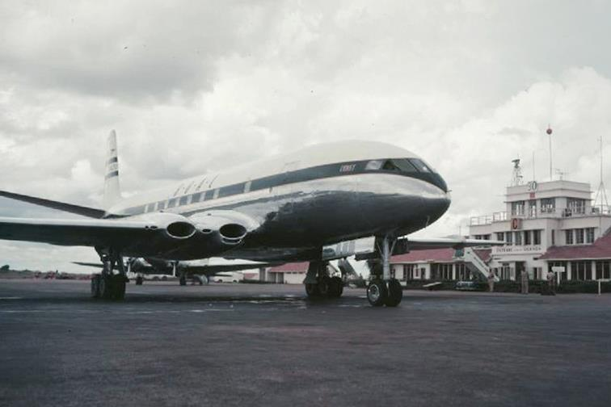

# Transition to the Jet Age

The beginning of the change from Avgas to Jet fuel.

After the Korean War, a period known as the ‘Cold War’ era emerged with the main antagonists the United States and the U.S.S.R. – Europe was divided by the ‘Iron Curtain’ and polarized the ‘East’ and ‘West’. Berlin was a divided city separating East and West by the Berlin Wall.

China would become a closed Communist state, Japan would commence a major reconstruction and emerge as a major industrial and technical power. While there were no significant world wars there were many minor battles with insurgent struggles in Malaya against the Communists, and in Africa, as many of the former colonies of the European powers sought independence. In these struggles the aircraft used were usually the last developments of the piston driven, avgas fuelled military aircraft, which had been sold off by the major powers now committed to jet powered aircraft for their air forces and navies. These piston engine aircraft were Avro Lincoln (the successor to the famous WWII Lancaster bomber), Lockheed Neptune (long range maritime aircraft), but already the fighters were jet powered.

Civil aviation was still in the early development stage of jet aircraft with the most notable being the de Havilland Comet, meanwhile the aircraft developments from WWII in the last few years were now incorporated into civil aircraft design, aircraft such as the Boeing Stratocruiser 377, Lockheed Constellation, Douglas DC-B were now common place in the skies around the world, particularly in Australia.

Photo 4. Boeing Stratocruiser 377 circa 1950s

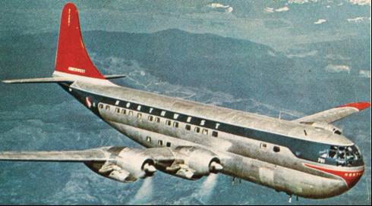

However, by the end of the decade a new jet variant engine – ‘turbo-prop’ - using jet fuel, would be used in the next generation of passenger aircraft.

# Military transition to jet powered air force

Perhaps the best illustration of the transition from the ‘avgas period’ to the ‘Jet Age’ is that of the history of the air base in Malaya (now Malaysia) known as RAAF Butterworth,[4]

With the Japanese surrender in 1945, the RAF returned. Butterworth was used as a staging and refuelling post for aircraft flying between Singapore and Ceylon. In this context the strategic importance of the base was well recognised and in January 1950, the RAF stepped up its deployment and established the base as a link with the far-east bases in Singapore. In addition, a staging base was developed at Glugor (on Penang Island) for the Sunderland Flying boats that visited on a regular basis.

At the outbreak of operations in Malaya against the communist in 1950, No. 33 Squadron RAF (equipped initially with Hawker Tempests, and later with de Havilland DH-103 Hornets) were based at Butterworth. No. 33 Squadron made daily bombing and rocket attacks against the communist guerrillas. These operations continued during 1952, 1953 and 1954 aided by detachments of various RAF squadrons flying Bristol Brigand, de Havilland Vampire and Short Sunderland aircraft. RAAF Avro Lincoln bombers were also deployed to Butterworth to assist in these operations.

Photo 5. The last RAF Short Sunderland Flying Boat of RAF No. 205 Squadron. 1959[5]

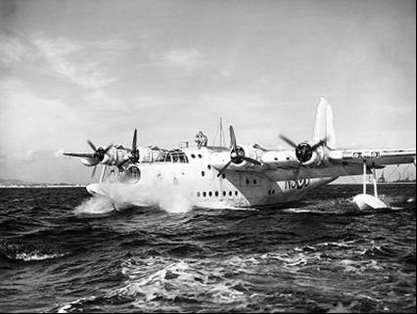

In 1955 a new chapter in Butterworth's history began. No. 2 Airfield Construction Squadron RAAF moved in to re-construct the airfield. Included in the reconstruction was a 9,000 ft. north-south runway with 800 ft. hardened overruns at each end. Air Base Butterworth, although owned by the RAF, was placed under RAAF control in 1958 as part of the Commonwealth Strategic Reserve. Shortly after, RAAF 78 Fighter Wing, comprising No. 3 Squadron and No. 77 Squadron flying Sabre aircraft, and also No. 2 Squadron flying Canberra bombers, was established in Butterworth.

Photo 6. RAAF Avro Lincoln No. 1 Squadron takes off from Tangah airfield Singapore 1950.[6]

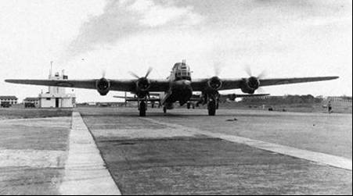

So here we have the new jet fighters and bomber aircraft such as RAAF Sabre and Canberra, and RAF de Havilland Vampire taking over from the aircraft from a previous World War II – Hawker Tempest, de Havilland Hornet, Avro Lincoln, Short Sunderland, all of which needed aviation gasoline.

Photo 7. RAAF Sabre in service

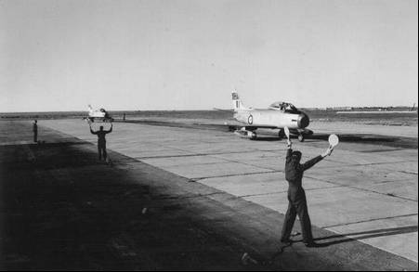

The same situation was occurring all around the world – in the U.S., the fighter aircraft such as the famous P-51 Mustang of World War II was replaced by the F-80 Lockheed Shooting Star, which in turn would be superseded by the North American F-86 Sabre. The famous Boeing B-29 Superfortress was superseded by the Convair B-36 Peacemaker, then the Boeing B-47 Stratojet only to be superseded by the giant Boeing B-52 Stratofortress.

Photo 8. Convair B-36 Peacemaker (‘six turning, four burning’)

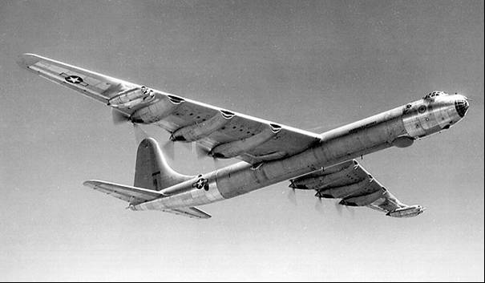

Photo 9. Boeing B-47 Stratojet – jet powered and using rocket assisted take-off

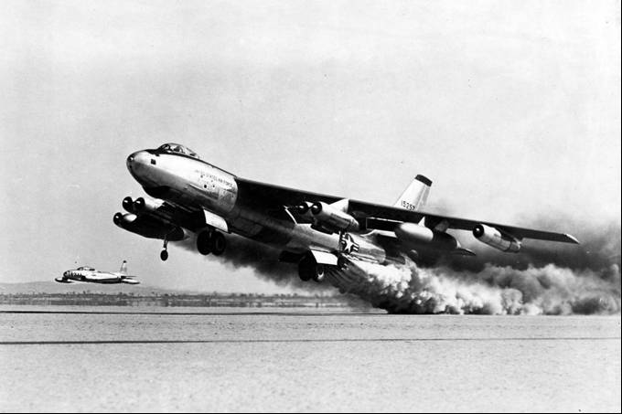

While this applied to the front-line combat aircraft, the transport and support aircraft would not change to jets for at least another two decades. Some of these piston driven bombers would change roles and become air-to-air refuel tankers, or advance warning aircraft (Awake).

In the U.S.S.R., the famous Yak-9 fighter had been replaced by the MiG-15 jet fighter, and new turbo-prop bomber/reconnaissance Soviet aircraft were being sighted over the skies of Eastern Europe and the North Atlantic.

For these modern air forces, it would mean supplies and refuelling equipment for both jet fuel and aviation gasoline. Avgas was still required for the training aircraft and this would continue, even though in later years there would be few front-line aircraft requiring aviation gasoline. But for the time being some front-line aircraft were still powered by propeller drive piston engines. Aircraft such as the Lockheed Neptune, indeed some would be modified to have both jet engines and piston engines as shown below in the Royal Netherlands Navy aircraft which was powered by two Wright Cyclone radial engines plus two Westinghouse J-34 turbojet engines. Interestingly, only one fuel was required to power both the piston engine and also used for the turbojet, and that was Avgas 115/145.

Photo 10. Royal Netherlands Navy Lockheed P2P Neptune on display at RAF Cosford museum (Petroch Services 2005).

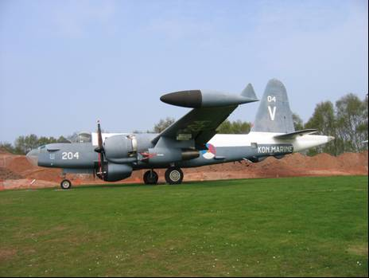

While the major powers were converting to all jet combat aircraft, their obsolete piston driven combat aircraft were either scrapped, or sold off to smaller air forces around the world, or even built under licence. For example, the Spanish Air Force was equipped with famous German Heinkel 111 bomber and Messerschmidt Me-109 fighter built under licence to be the Hispano HA 1112-M1L Buchon, (ironically, this Me-109 with its German Daimler engine; in this new Spanish variant the Buchon was powered by the famous Rolls Royce Merlin engine, which had powered its foe – the Supermarine Spitfire). The French and Belgian Air Force were using surplus U.S. aircraft while the British dominions were using surplus British aircraft such Spitfires and Mosquitoes.

It was also recognised that in the insurgent struggles in Africa and South-East Asia, where the opponents had no air support, the requirement for military attack aircraft was armament payload, not speed. This concept would continue into the Vietnam War, and into the Iraq and Afghanistan Wars in 21st century.

The area where the piston engine did survive, was that of transport and support aircraft such as tankers, AWACs (Airborne Warning and Control), and it would be decades before the jet engine and turbo-prop variants would replace the now highly developed reliable piston engine. These piston engines were now using Avgas 115/145 and this was the final stage and highest octane grade of aviation gasolines. Transport aircraft such as the Fairchild C-119 Boxcar and Douglas C-124 Globemaster would see service into the mid 1970’s and would require Avgas 115/145 around the world.

Photo 11. Lockheed Constellation RC-121 AWAC - Warning Star on display at PIMA, Arizona, USA (1999 - Petroch Services).

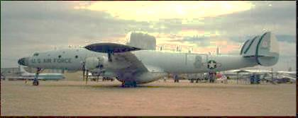

The see-saw development between aircraft engine designers and aviation gasoline manufacturers, which had been in progress for the last 40 years, was drawing to a close; and it had changed dramatically with a totally new and radical engine (the jet engine) which required an entirely new fuel - Jet Fuel. So, the refiners were now required to produce a new jet fuels as well as the aviation gasoline grades.

Turbo-prop engines replace piston engines

Jet fuel usage passes Avgas usage

In Australia, all avgas was imported until 1956 when Standard Vacuum’s Altona Refinery in Melbourne, commenced aviation gasoline manufacture, but this new local supply did not meet the demands of the nation and avgas was still imported by Mobil (which was part of Standard Vacuum) and by Shell.

Jet fuel usage was about to dramatically surpass avgas demand.

In 1957 in Australia, avgas demand was 205 M.Litres and was starting to decline. By 1959, Avtur (Aviation turbine fuel) or jet fuel usage (174 M.Litres) was nearly equal to avgas usage (182 M.Litres). By 1960 jet fuel usage doubled avgas usage, by 1961 it was treble, and by 1969 it was over ten times that of avgas. It was not so much the replacement of avgas demand by jet fuel, since avgas demand would stabilise at around 100 to 130 M.Litres for the next 30 years, it was that the ‘Jet-Age’ had arrived and commercial aviation, with their new jet and turboprop aircraft, was booming.

# Civil Aviation also changes to Jet power

This era in civil aviation was the greatest use of aviation gasoline since the Second World War as the airline travel expanded with the introduction of new long distance airliners from the U.S., manufacturers such as Boeing Stratocruiser 377, Lockheed Constellation, and Douglas DC-6B. These aircraft would grace the Australian skies on the routes from the U.S. West Coast to Australia and the Pacific.

Photo 12. Lockheed Constellation of TWA circa 1950s

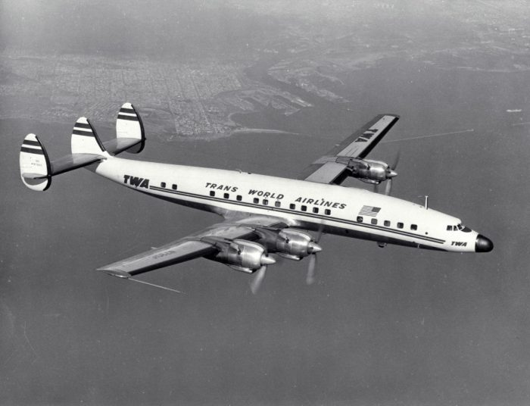

Photo 13. Pan American routes around the world in 1955.

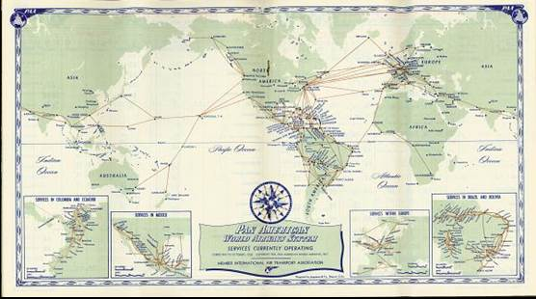

The Pacific Ocean route westward from the U.S. West Coast via Hawaii to the Orient, and further south to Australia and New Zealand were the new holiday and business destinations. From the U.S. East Coast across the Atlantic Ocean was the route to the European continent. Further south, the Caribbean and exciting South American countries beckoned.

Photo 14. Douglas DC-6B of Northwest airlines circa 1950’s.

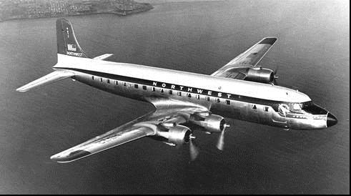

The British were using the Avro York, Handley Page Hastings and de Havilland Herons, but they were already looking to an all-jet future with the de Havilland Comet. They were travelling to Europe, Africa, to the Commonwealth countries of the sub-continent and further east to Singapore, Australia and New Zealand to the old British Empire, probably the longest of overseas flights.

Photo 15. de Havilland Heron 1955

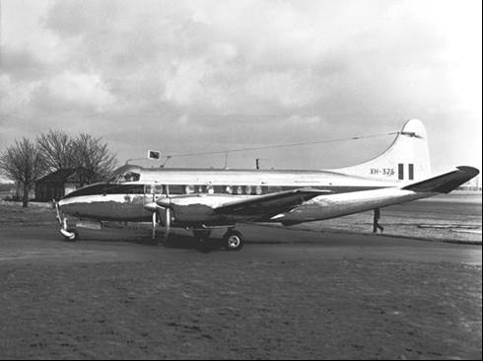

All of these locations around the world were essential refuelling stops (for aviation gasoline) established and utilized during World War II, and indeed many were set up in the pre-war years in the period of England to Australia flights of 1919, and the 1934 MacRobertson International Air Race from London to Melbourne.

Turbo prop engine replaces piston engine

Both the British and the American were also developing new aircraft based on a variant of the jet engine – the Turbo-prop engine – an engine using jet fuel, however the power is transferred to a propeller rather than used as pure thrust. Vickers would create a new aircraft the ‘Viscount’, Lockheed would develop the ‘Electra’ – these aircraft would be the van of the ‘Jet Age’ in civil aviation particularly in Australia.

Photo 16. Vickers Viscount of British Empire Airways on display at RAF Cosford, UK. (2005 - Petroch Services).

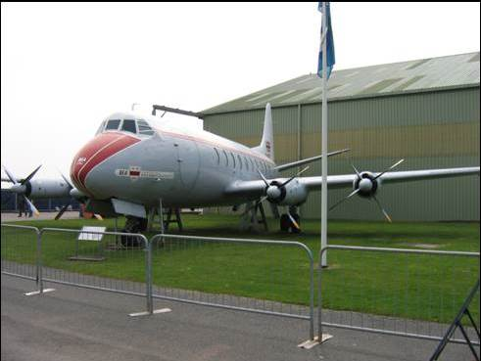

This engine would continue to be developed and become the engine for the civil aviation business through to the next century. It would also become the engine that would power any propeller driven aircraft (military or civil) and spell the demise of aviation gasoline except for the small single and twin engine light aircraft such as Cessna, Beechcraft and Piper.

Thus, for civil aviation both aviation gasoline and jet fuel were required at all major airports around the world in order to meet the refuelling needs of mixed piston engine and jet powered aircraft fleets.

Photo 17. TAA Lockheed Electra VH-TLA at Melbourne Airport (1966)

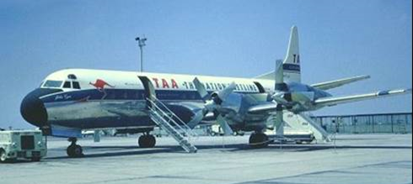

“Right aircraft, Wrong engines”

Perhaps one of the best examples of the change in aircraft design was the [7]Handley Page Herald (H.P.R.3) which commenced as a four engine passenger aircraft powered by four 870 HP Avis Leonides Major 701/1 piston radial engines. This would become the Handley Page Dart Herald (H.P.R. 7) (Series 100/200/400) powered by only two 2,105 e.s.h.p. Rolls-Royce Dart Mk 527 Turboprop engines. The outcome was an increase in maximum cruising speed from 224 mph to 275 mph; and increased rate of climb from 980 ft./min. to 2,000 ft./min.; and increase ceiling from 19,900 ft. to 26,700 ft.

Photo 18. PR.3 Herald prototype with four Alvis Leonides Major engines, demonstrating at the Farnborough Airshow in September 1955[8]

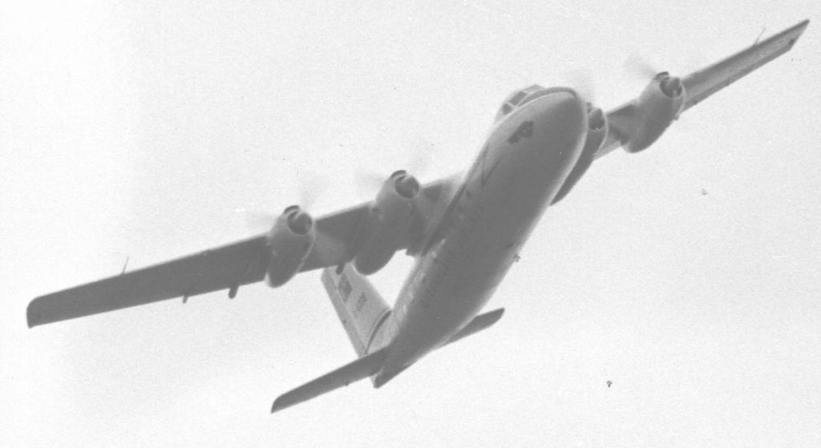

Photo 19. Handley Page Dart Herald (H.P.R. 7) powered by only two Rolls-Royce Dart Mk 527 Turboprop engines[9]

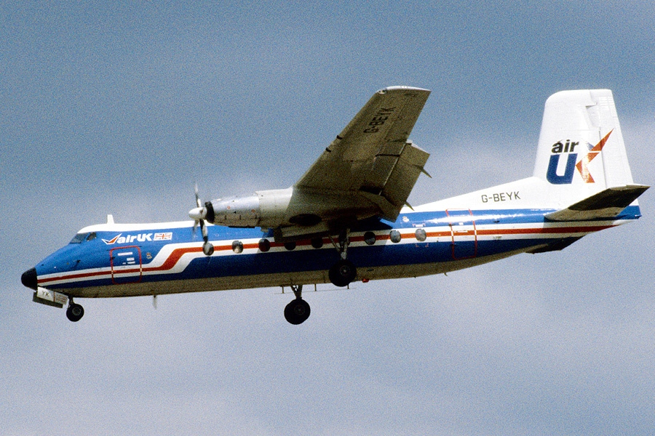

# API Meeting Refining Division 1955[10]

It is often risky to predict the future particularly in an industry as dynamic as the oil industry. In an interesting paper presented by A L Lyman of the California Research Corporation in May 1955 there are some reflections on the past trends and how they will translate into future demands on U.S. refiners - and consequently other developed countries in the period 1955 to 1965. One prediction was that for the rapidly increasing U.S. requirement for energy, ‘ultimately atomic and solar sources will make a significant contribution to the energy supply’, but in the immediate future the major sources would be petroleum, natural gas and coal. In meeting the demands placed on the petroleum industry, the refiners were called upon to make continuing changes in product qualities and yields.

With regard to aviation gasoline, Lyman noted that the demand for regular motor gasoline and premium motor gasoline would increase while aviation gasoline demand was expected to decline very slowly with the jet fuel supply increasing to meet a growing aviation industry, first military and later civilian. Aviation gasoline quality requirements were expected to remain high with over 90% of the demand being for grades in excess of 100 Octane. Thus, the advent of the jet engine will have little effect on the demand for high quality aviation gasoline as this new engine will be used to power a new more powerful type of aircraft. Further, it was predicted that there would be no significant contribution to motor gasoline octane quality from excess aviation gasoline capacity. (Refer Figure 1.)

Figure . Gasoline demand on U.S. Refineries 1945 -1965

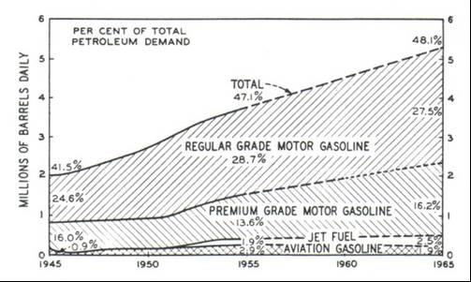

To meet the predicted demand for higher octane gasolines, the refiners would continue the growth in catalytic processes, principally catalytic reforming. The growth of thermal cracking and reforming developed in the 1920’s took about 20 to 25 year to reach the peak around 1940. Although the primary advantage of thermal cracking was the transformation of heavier oils into products in the gasoline range, it did contribute to increased octane ratings. The growth in catalytic cracking was somewhat more rapid than the growth of thermal cracking. The principal advantage of catalytic cracking was its improvement in octane and higher gasoline yields.

A new process catalytic reforming, in less than 10 years was expected to be the most significant process by upgrading both straight run and cracked stocks to high octane gasolines.

Figure . Gasoline process units by type 1930-1965

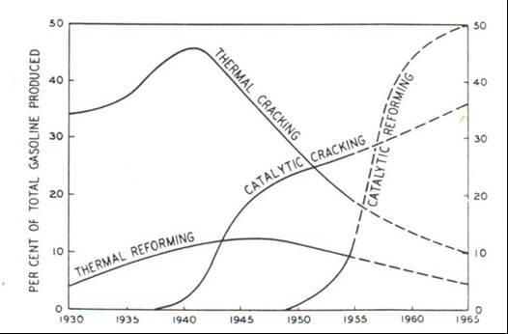

Lyman was generally correct with his predictions on motor gasoline, but totally underestimated the demand for jet fuels.

# Oil Companies and Refineries

The Iranian situation in 1951 resulted in a shift in philosophy of refinery location – while crude oil could be obtained from around the world, the threat to supply of finished petroleum products from refineries made it desirable to locate the refinery is a region where governments were stable, and ship the crude oil away from trouble spots. This led to the world-wide trend to refine at the area of consumption rather than production. This philosophy would continue well into the 1960’s and 1970’s in Australia and the Far East.

In 1953, there were 298 refineries around the world owned by 270 operating companies, of course not all of these were producing avgas.

Standard Oil Company (New Jersey)

The Standard Oil Company (New Jersey) was incorporated in New Jersey, U.S.A. on August 5, 1882. The company marketed its products under the principal brand name of ‘ESSO’.

The more important crude producing subsidiaries in the Western hemisphere were:

Humble Oil and Refining Company

Carter Oil Company

Creole Petroleum Corporation

Imperial Oil Limited

The principal ‘Esso’ refineries at this time were:

Baton Rouge, Louisiana, U.S.A. (produced avgas)

Bayway, New Jersey, U.S.A. (produced avgas)

Baytown, Texas, U.S.A. (produced avgas)

Aruba, Netherlands West Indies. (produced avgas)

Port Jerome, France

Fawley, Hampshire (near Southampton), England

Whitegate, Ireland

Interests outside the U.S.A. include participation in Europe, Venezuela, Peru, Canada, Saudi Arabia, Iran, Iraq, Qatar and most areas where crude was found, refined and used.

In the field of product research and development the Esso Research and Engineering Company and other research affiliates have produced some major applications. The most significant new processes over the last 40 years include Fluid Catalytic Cracking, Fluid Coking, Hydrofining, Power-Forming, Synthetic Lubricants for jet aircraft, fungicides and a number of petrochemical materials.

Socony Mobil Oil Company Incorporated

The Socony Mobil Oil Company Inc. was formed on August 10, 1882 in New York, U.S.A. when it was known as the Standard Oil Company of New York. An amalgamation with the Vacuum Oil Company in July 1931 resulted in the company being known as Socony-Vacuum Corporation, and from April 1955 it became known as Socony Mobil Oil Company Incorporated. The company marketed its products under the principal brand name of ‘Mobil’, including Mobiloil and Mobilgas.

The principal Mobil refineries in the U.S.A. at this time were:

Torrance, (near Los Angeles), California, U.S.A. 125,000 Barrels/day (produced avgas)

Paulsboro, New Jersey, U.S.A. 87,000 Barrels/day (produced avgas)

Beaumont, Texas, U.S.A. 220,000 Barrels/day (produced avgas)

East St. Louis, Illinois, U.S.A. 43,000 Barrels/day

Augusta, Kansas, U.S.A. 40,000 Barrels/day

Of these refineries only Torrance, Paulsboro and Beaumont made aviation gasoline and had done so throughout World War II. [On a personal note, the author visited the following Mobil refineries – Torrance, Paulsboro, Augusta in 1977.]

Standard-Vacuum Oil Company

The Standard-Vacuum Refining Company (Australia) Pty. Ltd. and the Vacuum Oil Company Pty. Ltd. were the wholly owned subsidiaries of the Standard-Vacuum Oil Company which was incorporated in the state of Delaware, U.S.A. on September 7, 1933. The shares of capital stock of S.V.O.C. are owned equally by two major oil companies – Standard Oil Company (New Jersey) and Socony Mobil Oil Company Inc. S.V.O.C. became known as ‘Stanvac’.

Prior to the formation of S.V.O.C., the parent companies operated independently in the Far East but neither had fully integrated operations. Socony-Mobil had neither crude supplies or refining capacity in its Far East marketing area, whilst Standard Oil Company (New Jersey) (Esso) had developed crude supplies and refining facilities in Indonesia, but no nearby marketing operations.

The regional areas were:

**Far East** Japan, Korea, Hong Kong, Philippines, Vietnam, Cambodia, Thailand, Malaya.

**Indonesia** included Western New Guinea

**Australia-New Zealand** Vacuum Oil Co Pty. Ltd., Atlantic Union Oil Co. Pty. Ltd., Standard-Vacuum Refining Co. (Aust.) Pty. Ltd., Standard-Vacuum Oil Co. (N.Z.) Ltd., Australian Synthetic Rubber Pty. Ltd.

**South Asia** India, Burma, Ceylon (Sri Lanka), Pakistan

**Africa** East Africa, South Africa

Graph 1. Total Stanvac Refinery Throughput Barrels/day

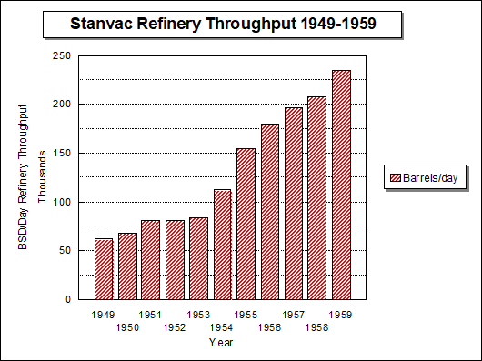

The principal STANVAC Refineries (outside the U.S.A.) at this time (1959) were:

Wakayama, Japan

Shimizu, Japan

Limay, Bataan Peninsula, Philippines (planned 25 MBSD)

Sungei Gerong (Palembang), Indonesia (produced avgas)

Altona, Victoria, Australia (produced avgas)

Bombay, India

Durban, South Africa

Middle East Refineries

The great refineries of Middle East which had supplied aviation gasoline during World War II were still a major source of supply. The Caltex Bahrein Refinery was producing aviation gasoline grades, and the Abadan Refinery was restarted in 1954 following nationalization by the Iran government, and would once again be an aviation gasoline supplier to the Far East.

Alkylation Units 1956

As we have seen earlier, one of the main components of aviation gasoline is light alkylate produced from the combination of isobutane and propylene/butylene using an acid catalyst. The main construction companies of these vital refinery process were Kellogg and UOP. In a paper titled “Alkylation for motor fuels of the future” by S.R. Stiles (Kellogg) in 1956 noted the following: *The production history of alkylation processes in which Sulphuric Acid (H2SO4) and Hydrofluoric Acid (HF) are the most commonly used catalysts, began during World War II. At that time, alkylation was moved from laboratories to the refineries under the urgency of the mobilization programs to produce aviation gasoline for the war effort (World War II). Up until 1955 in the U.S. generally the location and capacity of alkylation units were generally kept out of printed surveys for security reasons. In 1956 there were 66 alkylation units in the U.S. including those under construction ranging in size from 650 BSD to 12,500 Barrels/day. Total capacity is 258,000 Barrels/day. Of these 19 were HF units (54,000 Barrels/day) and 47 units used Sulphuric Acid (203,000 Barrels/day).*

# Refinery Construction in Australia

The political developments in the Middle East in the early 1950’s with growing nationalization, and the lessons of the Second World War regarding threats to supply, prompted the oil industry to seek stable regimes and nations to construct oil refineries in their own country. This was also true of Australia, which before WWII had only two small refineries (C.O.R. - Laverton, Vic. and Shell - Clyde NSW). By the end of the 1950’s new refineries were in operation at:

Shell - Geelong, Victoria.

Petroleum Refineries Australia – Altona, Melbourne, Victoria (which was a Standard-Vacuum (Mobil/Esso) operation).

Australian Oil Refining (Caltex) – Kurnell, Sydney, New South Wales.

BP Kwinana – near Perth, Western Australia.

Australian Refineries[11]

Four large modern refineries were constructed between 1954 and 1956. Shell Refining at Geelong ,Victoria; BP at Kwinana, Western Australia; Australian Oil Refining (Caltex) at Kurnell, Sydney, New South Wales; and Standard-Vacuum (Mobil/Esso) at Altona, Melbourne, Victoria. These were large (60-100,000 barrels/day) by 1950 standards. This allowed Australia to refined at least 90% of its own petroleum product requirements.

Photo 20. ‘British Crusader’ tanker berths at BP Kwinana Refinery 1955

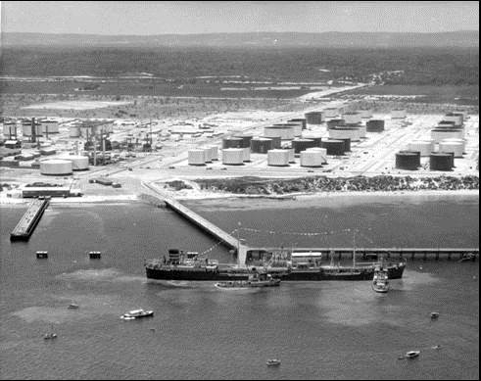

Only one of these new refineries – Altona Refinery made aviation gasoline.

# 1956 - First Australian Refinery to make Avgas[12]

As described earlier, the key refinery process units required for the manufacture of the aviation gasoline blendstocks were a catalytic cracking unit to produce the high octane base gasoline and also produce the feedstock gases (iso-butane, propylene and butylenes); and an alkylation unit to convert those feedstock gases into high octane blendstock - **alkylate**.

With these processes now on stream at P.R.A. Altona Refinery, in 1956 it became the first refinery in Australia to manufacture aviation gasoline.

Previously all aviation gasoline used in aircraft in Australia, was imported from the Dutch East Indies, Borneo, Middle East or the United States. This would still be the case for some decades because Altona Refinery could not supply all of Australia’s aviation gasoline demands.

While many of the overseas refineries made their aviation gasoline using a blend of catalytically cracked naphtha (from a TCC or FCC unit), straight run naphtha from the crude unit, alkylate and isopentane, at Altona Refinery the TCC gasoline was not used for aviation gasoline blendstock – it was only used as a motor gasoline blendstock. The reason was that to achieve the narrower distillation range required by the avgas distillation end point, it was necessary to re-run the cracked gasoline through a splitter column – Altona had no such process for its TCC gasoline. The Altona TCC only produced the feedstock for the alkylation process, so that light alkylate was the main blendstock for Altona aviation gasolines Avgas 100/130, Avgas 115/145. The light straight run gasoline or naphtha (LSRN) used in Avgas 80/87 blends was produced from the Naphtha Splitter overheads which were sent the Sweetening Unit (to remove sulphur compounds). Aviation gasoline blending will be discussed later in this chapter.

Photo 21. Altona Alkylation Unit used to make Australia’s first aviation gasoline. (1956)

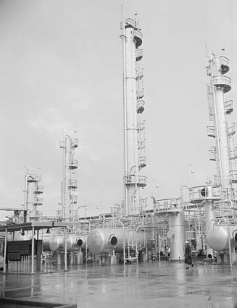

Altona Refinery 1949

The Standard-Vacuum Refinery at Altona, Melbourne, Victoria, was also known as Petroleum Refineries (Australia) or P.R.A. This refinery was owned 74% Socony Mobil Oil Company Inc. and 26% Standard Oil Company (New Jersey), (commonly known as Esso, later Exxon). Although Altona Refinery was first planned in 1939, World War II halted these plans and it was not until after the war that construction could commence. In 1949 the No. 1 Crude Unit, the Lube Oil Rerun Unit, Acid Treating Plant and Bitumen Oxidizer were completed. It was designed to process Klamono crude oil from Dutch New Guinea to satisfy the emerging industrial lubricating oil market in Australia and to provide bitumen. Aviation gasoline, motor gasoline and kerosene were still being imported. This unit was small and its design capacity was only 1,300 barrels per day, but modifications allowed the capacity to be increased to 2,800 barrels per day (still a small throughput); this allowed the processing of other available crudes such as Lirik.

This unit would be shut down and demolished by 1967 to make way for further expansions at this refinery with the discovery of substantial quantities of Australian crude oil in Bass Strait.

Photo 22. Altona Refinery No. 1 Crude Unit (1949) [Note the ‘Mobiloil’ sign on the storage tank in the background]

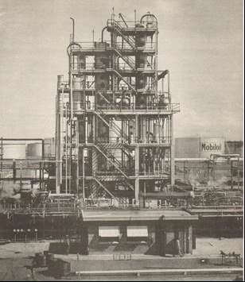

Altona Refinery 1954

In 1954 Altona Refinery underwent a major expansion with the addition of another crude unit (No. 2 CDU) of 41,000 barrels per day design capacity (which would later be increased to 55,000 barrels per day). The other important part of this expansion was the construction of the Thermofor Catalytic Cracker (TCC – Type 75) ( 25,000 barrels per day) and associated feed preparation units; and a Sulphuric Acid Alkylation Unit (Kellogg design), which would be essential for the manufacture of high octane gasoline. The alkylation unit was completed in December 1955 and had a capacity of 1,670 barrels per day of light alkylate. Other units constructed as part of this expansion were Platinum Catalytic Reformer – ‘Sovaformer’ of 8,000 barrels per day capacity – this unit is used for upgrading the octane of motor gasoline blendstocks - completed in January 1955.

Photo 23. Altona Refinery No. 2 Crude Unit (1956)

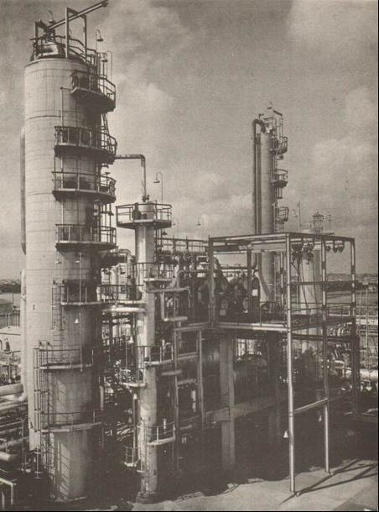

A general view of the No. 2 Crude Unit (40 MBSD)– shown left to right Crude Tower, Side Strippers incorporating the Naphtha Splitter and Naphtha Stabilizer, with the light ends and recovery (Saturates Gas Plant) in the background.

Photo 24. Altona Refinery Thermofor Catalytic Cracker - TCC (1956)

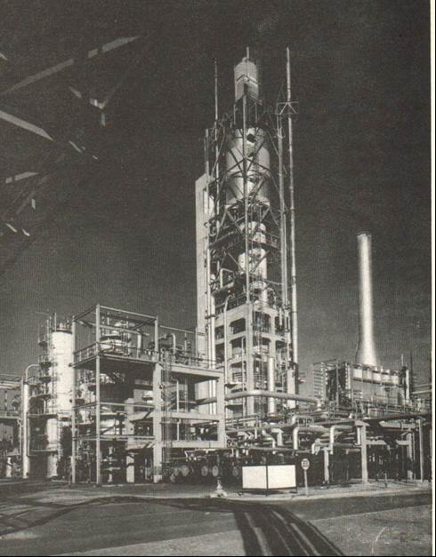

A general view of the Altona TCC (25 MBSD) – shown left to right, the Synthetic Crude Tower [to separate the TCC reaction products], Tar Separator and Vacuum Tower (partly obscured) [part of the feed preparation] and the Vapour Feed Heater.

Photo 25. Altona Alkylation Unit (1956)

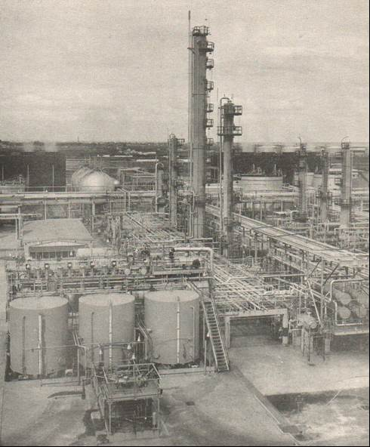

General view of the Alkylation Unit (2,600 BSD) – in the foreground the three acid tanks to store fresh sulphuric acid (98%) and spent sulphuric acid (<90%), behind these tanks is the reactor. On the right are the fractionation towers Depropanizer in front [to recover C3 gases propylene and propane], tall Deisobutaniser [to recover unreacted isobutane], Debutanizer [to recover butane] and Rerun tower in the rear, to separate the total alkylate into Light Alkylate (for avgas) and Heavy Alkylate (which went to motor gasoline blendstocks).

Photo 26. Altona Alkylation Unit Reactor (1956)

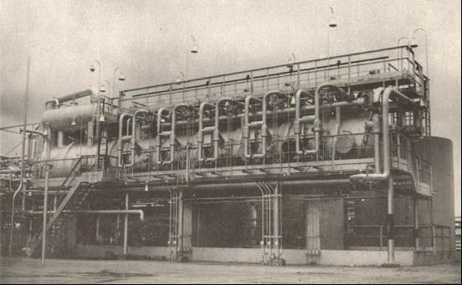

Altona Alkylation Reactor – the three recycle streams (isobutane, sulphuric acid (91-93%) and refrigerant) enter the reactor on the right side. The olefinic feed (propylene, butylenes) is injected through five flow controllers (in the front) into five zones of the reactor. The hydrocarbons are separated from the acid in the settling zone on the left side. On the top of the reactor on the left, a knock-out drum for the refrigerant is installed.

Figure . Altona Alkylation Process Flow

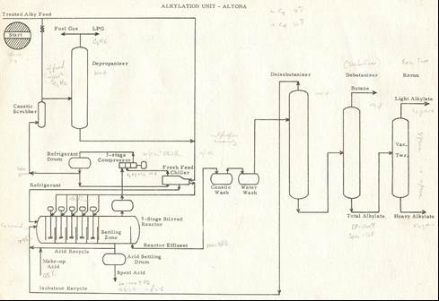

Preparation of the Alky Feed

The total refinery by-product gas and unstabilized cracked gasoline for the TCC is fractionated in the TCC gas plant into three parts:

(a) light part containing all C2 gases (ethane, ethene) and lighter gases along with some C3’s - these are used as fuel gas to operate the refinery heaters.

(b) heavy part containing TCC cracked gasoline which is treated to remove sulphur and phenolic components and becomes a motor gasoline blendstock.

(c) middle C3/C4 cut which contains no C2’s and only small amounts of C5’s - this is termed ‘Alkylation Feed’ or ‘Alky Feed’.

Refer to Table 1. Alkylation Unit stream compositions

Process Flow

The Alky Feed contains essentially propylene, propane, butylene, isobutane and normal butane. Propylene consumes more acid and produces a lower octane alkylate (C7 isomers), but it is still more economical to use it for alkylation feed under normal circumstances. However, if there is not enough isobutane available, or an extremely high octane number alkylate must be achieved (as for avgas 115/145 blendstock), then some of the propylene is rejected to LPG (liquified petroleum gas) or fuel gas by depropanizing the alky feed in the Depropanizer tower.

The olefin feed is then contacted with isobutane and sulphuric acid in the multi-stage stirred reactor. To promote the alkylation reaction and to suppress polymerisation, a great excess of isobutane and sulphuric acid must be present during the whole reaction. This is achieved by recycling both isobutane and acid through the reactor gradually adding the olefins to the recycle stream. To keep up the uniform distribution of isobutane, sulphuric acid and olefins, strong agitation is required at each of the injection points. The impellers of the mixing pumps produce an emulsion of isobutane and sulphuric acid and the olefin feed is injected at high speed into this emulsion. The olefins are absorbed almost instantaneously into the emulsion and subsequently react with the isobutane. Then the excess isobutane, sulphuric acid and the formed alkylate flow to the next zone where the same reaction is repeated. In the alkylation reaction, heat is produced and this is removed by partly evaporating the light products. These light products containing mainly propane and isobutane are compressed in a three-stage compressor condensed and recycled to the reactor as ‘refrigerant’.

A side stream of this refrigerant is fed to the Depropanizer and in this manner the propane which was in the alkylation feed is removed to be sold as LPG or used as fuel gas. The effluent from the last (5th) reaction zone in the reactor passes to a separate settling zone where the sulphuric acid and the ‘reactor effluent’ containing excess isobutane and alkylate are separated. The acid, which becomes partly diluted due to the reaction, is made up to original strength with fresh acid. The surplus is rejected as ‘spent acid’ and the other part is recycled to the reactor.

The cool reactor effluent chills the incoming isobutane recycle and is then caustic treated (washed) to remove any entrained acid and some sulphuric esters formed as by-products of polymerisation. At higher temperatures these esters decompose and form sulphuric acid which would corrode the equipment. [This matter would be a key factor in 2000 when the ‘Mobil Avgas Problem’ occurred].

After caustic washing and water washing the reactor effluent is fed to the Deisobutaniser tower where the overhead (the stream from the top of the fractionation tower), which is a mixture of mostly isobutane with some propane and normal butane is produced. This mixture – called isobutane recycle - is then recycled to the reactor to keep up the high isobutane concentration. The bottoms of the Deisobutaniser contain large amounts of normal butane (and alkylate), and the normal butane is recovered in the Debutanizer tower known as ‘stabilizing’ (where the light butane gases are removed to lower the vapour pressure). The bottoms from the debutanizer tower are called ‘total alkylate’ and can be used as a blendstock for motor gasoline. However it has a high distillation end point and must be re-run (refractionated) if the alkylate is to be used for aviation gasoline. The Re-run tower is operated under vacuum to prevent decomposition of the heavy alkylate.

The refrigerant always contains some SO2 (sulphur dioxide) so the LPG produced from the depropanization of the refrigerant must also be caustic treated before it enters the Depropanizer tower.

Table . Alkylation Unit stream compositions Wt.% (Design data from Altona FCC 1997)

|  |  |  |  |  |  |  |  |  |
| --- | --- | --- | --- | --- | --- | --- | --- | --- |
| Component | Alky Feed | Reactor Effluent | Deiso Overheads | Deiso Bottoms | Debut Overheads | Debut Bottoms | Deprop Overheads | Deprop Bottoms |
| Ethane/Ethylene | 0.1 | 0.0 | 0.0 | 0.0 | 0.0 | 0.0 | 0.3 | 0.0 |
| Propane | 8.9 | 2.8 | 0.0 | 0.0 | 0.0 | 0.0 | 28.6 | 2.8 |
| Propylene | 32.5 | 0.0 | 4.2 | 0.0 | 0.0 | 0.0 | 70.9 | 2.4 |
| Isobutane | 27.3 | 55.4 | 86.1 | 2.7 | 8.4 | 0.0 | 0.1 | 60.7 |
| n-butane | 6.9 | 9.9 | 9.6 | 30.4 | 89.4 | 2.0 | 0.0 | 10.6 |
| Butene-1 | 5.7 | 0.0 | 0.0 | 0.0 | 0.0 | 0.0 | 0.0 | 0.0 |
| Isobutene | 5.7 | 0.0 | 0.0 | 0.0 | 0.0 | 0.0 | 0.0 | 22.2 |
| trans-Butene-2 | 6.1 | 0.0 | 0.0 | 0.0 | 0.0 | 0.0 | 0.0 | 0.0 |
| cis-Butene-2 | 6.1 | 0.0 | 0.0 | 0.0 | 0.0 | 0.0 | 0.0 | 0.0 |
| Isopentane | 0.8 | 2.0 | 0.1 | 5.0 | 2.2 | 6.4 | 0.0 | 1.0 |
| n-Pentane | 0.0 | 0.0 | 0.0 | 0.4 | 0.0 | 0.6 | 0.0 | 0.2 |
| Pentenes | 0.0 | 0.0 | 0.0 | 0.0 | 0.0 | 0.0 | 0.0 | 0.0 |
| Alkylate | 0.0 | 29.9 | 0.0 | 61.4 | 0.0 | 90.9 | 0.0 | 0.0 |

In 1997 Altona Refinery added a Fluidized Catalytic Cracker unit (FCC) to replace the ageing TCC unit.

Operating Variables

With such a unique reaction there are a number of operating variables which will influence the outcome of the reactor product. These vary from poor or incomplete polymerisation yielding from a low octane gasoline product through to continuing polymerisation producing a thick black acidic tar which clogs the reactor. These operating variables are:

**Isobutane Concentration**

Increased isobutane content in the reactor increases alkylate yield and octane number, and decreased acid consumption. Consequently, it is desirable to maintain a high isobutane content, usually above 50% isobutane in the reactor effluent.

**Butylene and Propylene Content of Alky Feed**

Propylene consumes three times as much acid as butylene, and the propylene alkylate has a C.F.R. F4 engine Performance Number (PN) [Rich rating] some 21 PN lower than butylene alkylate produced under the same operating conditions.

**Space Velocity**

Space velocity is a measure of the amount of feed which is in contact with the amount of catalyst (sulphuric acid) in one hour. In alkylation, the space velocity is expressed as the ratio of processed olefins to the quantity of acid in the reactor. However, in this situation the quantity of acid is relatively constant and therefore the space velocity can be expressed in terms of total alkylate. In other words, the lower the throughput the better the reaction and higher the octane number.

**Acid Strength**

The acid concentration in the reactor must be kept between 91 and 93% because at lower acid concentrations polymerisation becomes predominant and in extremes can result in a ‘black tarry goo’ rather than high octane gasoline. Higher acid concentration would improve the octane number of the alkylate but would increase alkylation costs.

**Temperature**

The temperatures of the reactor must be kept between 35OF (1.7OC) and 45OF (7.2OC) to suppress polymerisation. At temperature below 35OF (1.7OC) the acid becomes too viscous to achieve good mixing.

The relationship of butylene alkylate and propylene alkylate to Research Octane Numbers (RON), Performance Numbers (PN) and isobutane content can be seen in Graph 2.

Graph 2. Relationship of Alkylates, Octanes and Isobutane content

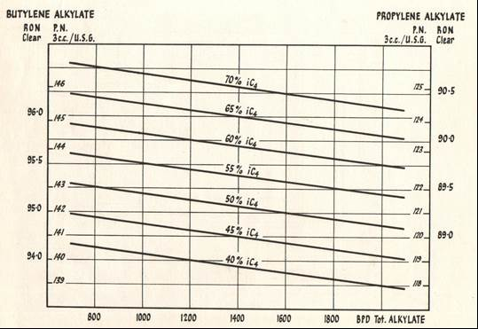

# Aviation Gasoline Blending 1950’s

The aviation gasoline manufacturing processes were essentially the same as those used in the Second World War. That is:

Base gasoline (or Base stock)

Catalytic Cracked Gasoline

Light Alkylate

Butane and Pentanes (to achieve the correct vapour pressure)

Tetra Ethyl Lead (4 ml/USG to achieve 100 Octane)

Aromatic blendstock (required for Avgas 115/145)

Aviation Gasoline Components 1955[13]

Aviation fuel of 100/130 grade or higher may be regarded as basically a binary blend of base stock and a blendstock. The refinery processes for the manufacture of aviation gasoline components are listed below.

**Base Stocks**

The methods of manufacture of base stocks for Avgas 100/130 are as follows:

Distillation from selected crudes (principally naphthenic type): straight-run gasolines of not less than 72 Octane Number are usually prepared.

Catalytic cracking of middle distillates with subsequent treatment of the product distilling to about 150oC for the removal or conversion of olefins. Such treatments comprise hydrogenation, re-treatment (multi-pass cracking), and heavy acid treatment. Depending on the type of process and feedstock gasoline of 75-82 O.N. is produced. This may be further distilled to yield a volatile base stock distilling to about 100oC and an aromatic intermediate stock of 85 O.N. and high rich mixture rating. The catalytic cracking process comprised the Houdry fixed bed, the fluid catalytic process developed by the Standard Oil Company (New Jersey) (ESSO), and the Thermofor or TCC process developed by Socony-Vacuum Co. (Mobil).

Isomerisation of paraffinic gasoline, usually a pentane-hexane fraction, for the production of a volatile base stock of increased isoparaffin content. The octane number of such a product is generally about 80.

Superfractionation of low octane number gasoline with the recovery of isoparaffin-naphthene fraction of 75-80 O.N. and substantial rich mixture ratings. The fractions recovered are generally isohexane-cyclopentane and isoheptane with associated naphthenes. Superfractionation can also yield blend or intermediate stocks of high rich mixture rating by shortening the fractions with the recovery of higher concentrations of the highest rating compounds such as cyclopentane.

**Intermediate Stocks**

Intermediate type stocks are manufactured principally by the following processes:

Severe catalytic cracking producing a gasoline of approximately 83 O.N. and a high rich mixture rating.

Hydroforming of heavy naphtha producing an aromatic gasoline of approximately 80 O.N. and a medium to high rich mixture rating depending on the aromatic content. Catalytic reforming may also be used at high severity levels to produce aromatic stocks of this type.

Solvent extraction of 100-180oC naphtha for the recovery of C7 to C9 aromatics. Depending on the aromatic such as ‘benzene extracts’ vary from 84 to 100 O.N. and have a high rich mixture rating.

Aromatics for aviation gasolines are also produced by two-pass or severe single pass thermal reforming (e.g. the ‘Avaro’ process). The product is generally heavily acid-treated for removal of olefins. The redistilled product had an aromatic content of 70 to 95%, an octane number of 85-95 and a high rich mixture rating.

Distillation of coal tar for the recovery for aromatics of high rich mixture rating. Such material, unless carefully refined can contain undesirable sulphur compounds. [Sulphur compounds are detrimental to the effect of TEL in improving anti-knock ratings.]

**Blendstocks**

High quality blendstocks comprise the synthetic isoparaffins and certain aromatic materials:

The familiar sulphuric acid alkylation process is generally applied to the production of isoparaffins from the combination of isobutane from natural gas and butanes from cracked gases (C4 Alkylation). The supplies of alkylate were supplemented during World War II by alkylating pentanes (C5 Alkylation) and to a lesser extent propylene (C3 Alkylation).

The newer alkylation process utilizing anhydrous hydrofluoric acid as at the catalyst also produces high quality isoparaffins.

From both processes a product of high octane number 90-95 for (C4 alkylate) and high rich mixture rating is obtained. The principal constituents are the isometric trimethyl pentanes. The olefins used are derived partly from thermal cracking and partly from catalytic cracking. It is a feature of the catalytic cracking process that the C4 and C5 olefins produced provide sufficient alkylate to blend off the catalytically cracked base stock to 100/130 grade aviation fuel.

The alkylation processes have the advantage over the older polymerization/ hydrogenation processes for the production of isoparaffins in yielding approximately twice the quantity of product based on olefin feed and in one step process instead of two.

Catalytic polymerization-hydrogenation processes produce isoparaffins by selectively polymerizing isobutenes to liquid iso-olefins which are then hydrogenated to be the corresponding isoparaffins. Included are:

‘Cold acid’ di-isobutene process which yields practically pure isooctane (2, 2, 4 - Trimethyl pentane).

‘Hot acid’ process in which butanes and isobutenes are copolymerized with a consequent increase in yield. The hydrogenated product contains 2, 3, 4 - trimethyl pentane and has an octane number of about 94 - 95 and a higher rich mixture rating than the product from the cold acid process. Both of these processes were developed by the Shell Group.

Selective phosphoric acid polymerization was developed by Ipatieff. The product after hydrogenation consists principally of the isomeric trimethyl pentanes and usually has an octane number of about 94 and a rich mixture rating better than 2, 2, 4 - trimethyl pentane.

Codimer or copper pyrophosphate polymerization process operated selectively on cracked C4 feed, it produces polymers which hydrogenate to mixtures of the trimethyl pentanes of about 94 O.N. and rich mixture rating above 2, 2, 4 - trimethyl pentane. The product is usually known as ‘hydrocodimer’.

Thermal alkylation of ethane-isobutane has been used to a limited extent for the production of neohexane (or 2, 2 - dimethyl butane) which may also be produced by multi-pass isomerization of hexanes. This compound has an octane number of 95 and a rich mixture rating equal to isooctane. Isomerization however is generally used to convert valueless n-butane to isobutane for the alkylation feedstock.

A similar compound, di-isopropyl (2, 3 - dimethyl butane) is prepared by alkylating ethene-propene with isobutane in the presence of aluminium chloride catalyst. Its high octane rating under both lean and rich mixture conditions make it a valuable blending agent.

An isoparaffin of great interest is Triptane (or 2, 2, 3 - trimethyl butane). It is reported to have exceptionally high engine performance, both lean and rich, and a very good lead susceptibility.

Isopentane, which is generally produced from crude oil or natural gasoline by distillation, is a widely used blendstock within the limitations imposed by its high vapour pressure. The O.N. of the commercial product is about 88 and the rich mixture rating slightly better than 130 grade.

High rating aromatic hydrocarbons are produced by the alkylation of the lower aromatics principally benzene, (as stated before benzene cannot be used in aviation gasoline in high concentrations due to its freezing point). Benzene is generally combined with propene in an alkylation reaction to produce isopropyl benzene or ‘Cumene’, occasionally with butanes to form tert-butyl benzene. These compounds have low freezing points, octane numbers of about 100, relatively high lead responses, and high rich mixture ratings. The use of these materials is however limited by their relatively low volatility.

Blending Aviation Gasolines

In order that full and economical use may be made of the components available, it is essential that the selection and calculation of aviation blend compositions be given careful consideration. Therefore, the properties of the components and their effect on the finished fuel must be known and applied to the particular refinery program - crude throughput and plant operation have a large effect on the optimum blend composition.

**Calculation of the Properties of Blends and Selection of Optimum Compositions**

Whilst the rich mixture rating is usually the quality controlling blend composition, it is necessary to be able to calculate certain other properties in order to be reasonably certain that the blend will meet specification. These properties are:

Octane number (Lean & Rich mixture ratings)

Calorific value

Vapour pressure

Distillation

The selection of the optimum blend composition to suit a particular refinery situation is based on the knowledge of the ratio of production of the components and their properties. The rules to be observed as far as possible are:

The blend should be ‘balanced’, i.e. it should have the minimum margin above the specification on the major points such as octane number, rich mixture rating and vapour pressure. (This ‘margin’ is known as ‘quality give-away’ – giving away quality above that required by the specification for no financial gain, this quality margin is synonymous with profit.)

The minimum of high quality and hence expensive components should be used together with the maximum content of base stock of the highest possible quality.

Intermediate type stocks should be used judiciously to obtain the optimum blend. (These stocks require the highest processing and hence are more expensive to manufacture).

The maximum permissible TEL content should be used. (This allows the use of lower octane components and therefore extends the quantity of aviation gasoline produced).

# Methods of Selection of Blendstocks

There are three methods of selection of the appropriate blending components.

**Trial and error method of calculation and blending**.

Some may think this method is often tedious and seldom results in a truly optimum blend, while this is true, in actual practice this method is usually the basis of many blends since it is based on the experience of the refinery planner-blender; and the blend is often determined by refinery process operation and overall economic imperatives for a profitable refinery operation, of which aviation gasoline manufacture may be only a small part. [This differs from the approach taken during WWII when the availability of blendstock sources was continuously changing and supplying the essential aviation gasoline and other war materials to win the war was the imperative].

**Solution of a number of simultaneous equations.**

This method was reported to give a single blend composition. With the development of mainframe computers in the mid 1960’s this method was later utilized as part of overall refinery planning techniques known as ‘Linear Programming’.

**Experimental determinations using the triangular blending chart.**

This triangular blending chart shows the composition of all blends which may be made to meet specification from a given set of components.

Graph 3. Avgas blending chart.

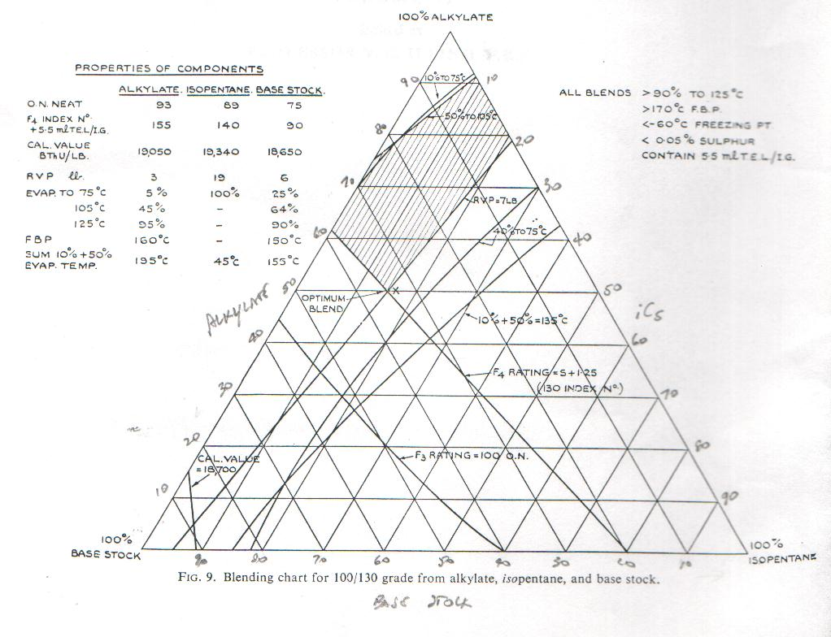

A simple example of the use of the blending chart is shown above. This covers the blending of light alkylate, isopentane and base stock to make 100/130 grade aviation gasoline by plotting the loci of all blends meeting the various points of the specification. The area enclosed by the limiting datum lines, which is shown shaded, represents the composition of all blends meeting specification; the optimum blend being that given by the point *X* which is:

Light Alkylate 50% vol.

Isopentane 15% vol.

Base Stock 35% vol.

The triangle blend chart is based on three components or tertiary blends. However, it may be used with 4, 5, or even 6 components by making some preliminary assumptions. For example in the case of a refinery producing alkylate, Cumene, Isopentane and two different base stocks, it may be determined that a maximum of say 5% Cumene can be used in any blend without exceeding the specification for 90% minimum distilling to 125OC. If therefore sufficient Cumene is available, each of the other components except isopentane may be upgraded by the addition of 5% Cumene. Isopentane may then be added to the resulting new components to bring their vapour pressures to 7 psi, thus reducing the problem to a ternary mixture which may be solved by the blending chart. In the case of the five component mixture cited above the RVP datum line would be omitted since all ‘blends’ would be 7 psi. It is usually octane number and volatility which determines the blend.

# Australian Avgas – Altona Refinery

Because of the Altona Refinery process operations, aviation gasolines of all grades were made from essentially only one ‘formulation’ - alkylates with butanes to achieve the correct vapour pressure. TEL, dyes and anti-oxidant additives were used to meet the required specification. In the lower grades light straight run gasoline (LSRN) was also used, and where economics allowed, imported aviation base stock may be used.

In 1959 the Avgas grades manufactured at Altona Refinery were: Avgas 80/87, Avgas 100/130 and Avgas 115/145. Altona Refinery supplied all finished gasoline product by pipeline to local distribution terminals (of all companies) in the area (Yarraville, Newport, Altona, Spotswood which are located within 3 miles of the refinery). Avgas was supplied only to Mobil’s Yarraville Terminal.

[14]Avgas 80/87 was a blend of light straight run gasoline from the No. 2 Crude unit processing Qatar and Aramco crudes from the Middle East. This light straight run gasoline from Qatar crude had a specific gravity of 0.65 and 300 deg. F (149 deg. C) end point, (Molecular weight 87.6); it was blended with TEL and dyes. Later in 1970, after process modifications resulting from the refinery expansion to process the newly available local Gippsland crude, Avgas 80/87 was blended only using light alkylate and pentanes.

Avgas 100/130 was a blend of light alkylate and blendstock imported from Palembang. Again after 1970, Avgas 100/130 was blended only with light alkylate and butane.

Avgas 115/145 was only light alkylate and butane. Alkylate for this grade was produced to maximise the performance number (P.N.) by alkylating butylenes and rejecting the maximum propylene. From a process viewpoint, propylene consumes three times as much acid (catalyst) as butylene. Propylene alkylate is 21 P.N. (F-4) less than butylene alkylate and therefore undesirable in Avgas 115/145.

Later in 1970 Avgas 115/145 was light alkylate, and butane; the addition of the necessary aromatics content (Toluene) was used to raise the rich rating to specification. This was blended at Mobil’s Yarraville Terminal during the transfer of base Avgas 115/145 blend to the distribution terminal.

In 1960 Altona refinery was operating at 40,000 Barrels/day and aviation gasoline only accounted for 3.4% of production, while motor gasoline was nearly 40%, jet fuel was 3%, and automotive diesel 12%.

The aviation gasoline production was split as follows:

Avgas 115/145 15%

Avgas 100/130 79.4%

Avgas 80/87 5.6%

So clearly at this time Avgas 100/130 was the predominant grade and generally used by the commercial operators.

# Aviation Fuels – Australian Defence Services[15]

The fuels used by the Australian Defence forces in 1953 were designated by codes and abbreviations for use by each of the services – Royal Australian Air Force, Australian Military Forces, and Royal Australian Navy. Since there was interchange of Australian services with those of other UN forces it was important for the Australian services to know the designations/specifications of similar fuels by their allies.

Table . Specifications – Issuing Authority

|  |  |
| --- | --- |
| Series | Issued by |
| **Australian** | |
| DEF (Aust) | Department of Defence |
| MGO | Master General of the Ordnance |
| SAA | Standards Association of Australia |
| K | Royal Australian Air Force |
| **United Kingdom** | |
| BS | British Standards Institution |
| CS | Director of Chemical Inspection |
| DED, D Eng R D | Director of Engine Research and Development |
| DEF, DTD | HM Stationery Office |
| E-in -C | Admiralty |
| Esso | Standard Oil Company |
| ST | Director of Supplies and Transport, The War Office |
| TP | Torpedo Experimental Establishment |
| **Canada** | |
| 3-GP- | Canadian Government Specification Board |
| **United States** | |
| AN-G- | U.S. Air Force Navy Aeronautical |
| AXS | U.S. Army Ordnance Department |
| MIL | U.S. Military Specification |
| VV- | U.S. Federal |
| 2- | U.S. Army |

To identify the various stores for the Australian Services the following designations were used.

RAN E7/, E8/, E9/, K/, 34A/, 34B/

RAASC Stores numbers were not used.

RAAOC H1/HAA

RAAF K1/, K2/

The Aviation fuels in use at this time by Australian Services were as follows:

Table . Aviation Fuels used by Australian Services 1953.

|  |  |  |  |  |
| --- | --- | --- | --- | --- |
| Fuel | Name | Specification | Stores Number | Comment |
| Avgas 115/145 | Aviation Gasoline 115/145 Grade | D.Eng.R.D.2485 Issue 1 Amdt 6 | RAN-34A/100443  RAASC  RAAF-K1/10020 | Used for aviation piston engines. |
| Avgas 100/130 | Aviation Gasoline 100/130 Grade | D.Eng.R.D.2485 Issue 1 Amdt 6 | RAN-34A/100444  RAASC  RAAF-K1/10010 | Used for aviation piston engines & certain marine craft. Old name: 100 octane aviation spirit |
| Avgas 91/96 | Aviation Gasoline 91/96 Grade | D.Eng.R.D.2485 Issue 1 Amdt 6 | RAN-34A/100445  RAASC  RAAF-K1/10009 | Used for aviation piston engines & certain marine craft. Old name: 91 octane aviation spirit |
| Avgas 80 | Aviation Gasoline 80 Grade | D.Eng.R.D.2485 Issue 1 Amdt 6 | RAN  RAASC | Used for Auster aircraft engines - Australian Army. Old name: 80 octane aviation spirit |
| Avgas 73 | Aviation Gasoline Non-Leaded 73 Grade | D.Eng.R.D.2485 Issue 1 Amdt 6 | RAN-34A/100447  RAASC  RAAF-K1/10007 | Used for certain small aviation piston engines. Old name: 73 octane aviation spirit |
| AVTAG | Aviation Turbine Gasoline | D.Eng.R.D.2486 Issue 2 | RAASC  RAAF-K1/10020 | Used for aviation turbine engines. |
| AVTUR | Aviation Turbine Fuel | D.Eng.R.D.2482 Issue 2 Amdt 2 | RAN-34A/100449  RAASC  RAAF-K1/10019 | Used for aviation turbine engines. Old name: Aviation Kerosene |
| AVTAG | Aviation Turbine Gasoline | D.Eng.R.D.2488 | RAN-34A/100450  RAAF-K1/10030 | Used for aviation turbine engines in carrier borne aircraft. |

The principal Australian military aircraft still using Avgas 115/145 in this period were the Avro Lincoln bomber which was phased out of service in 1958, and the Lockheed Neptune. The RAN were operating Hawker Sea Fury and Fairey Firefly aircraft from the aircraft carrier H.M.A.S. Sydney. The Hawker Sea Fury which was one of the last and faster piston engined aircraft used Avgas 115/145.

Photo 27. RAAF Neptune A89-304 of No. 11 Squadron

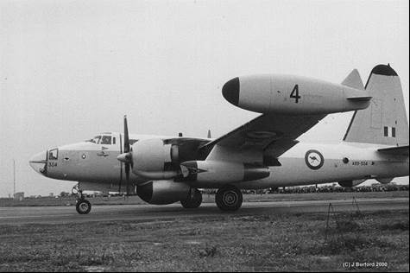

The RAAF completed its first world-circling flight in April 1957. Three Lockheed Neptunes of No. 11 Squadron (numbers A89-305, A89-311 and A89-312) left Richmond Air Base, New South Wales on 20 February 1957, on ‘Operation Westbound’.

Photo 28. H.M.A.S. Sydney flight deck Fairey Fireflys on the left, Hawker Sea Fury’s on the right (1955)

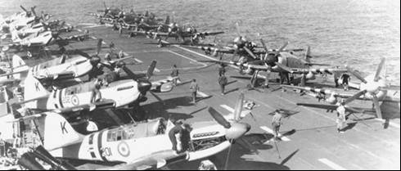

Photo 29. RAN Hawker Sea Fury from H.M.A.S. Sydney with new roundels after 1956.

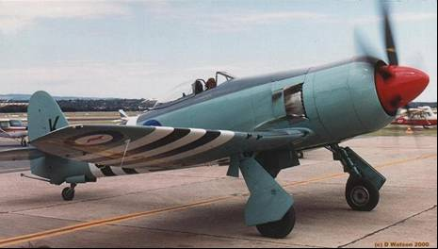

Photo 30. RAAF Auster AOP Mark III Utility Aircraft (A11-14) Balikpapan, Borneo 1945 (required Avgas 80).

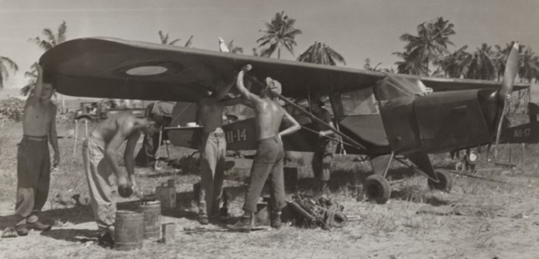

Avgas 100/130 was used for training aircraft such as the new Australian designed CAC Winjeel which was in RAAF service in 1955 to 1975, transport aircraft such as the Bristol Freighter, and older World War II aircraft types still in service such as Douglas DC-3 or Dakota.

Photo 31. RAAF Winjeel A85-439 Sqn. Leader Fox at the controls at RAAF Museum Point Cook. Melbourne

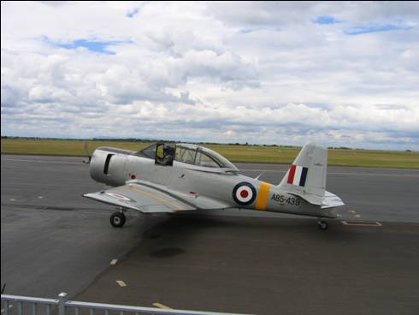

The Bristol Freighter was typical of the cargo aircraft of the time used both commercially and by the services.

Photo 32. RAAF Bristol Freighter on display at RAAF Museum Point Cook, Melbourne (2005- Petroch Services).

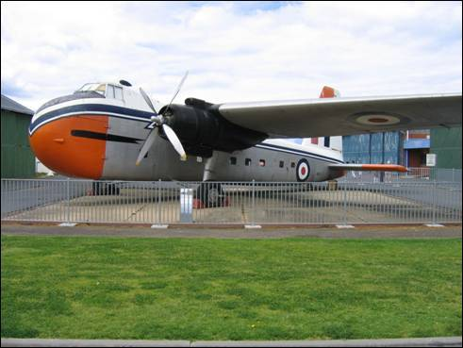

# Avgas Specifications and Test Methods 1950’s

British Aviation Gasoline Specification D.Eng.R.D.2485

The significant properties which characterised aviation gasoline remained essentially unchanged since aircraft first flew; there was now perhaps a far greater understanding of these properties, therefore it may be useful to examine a ‘modern’ post WWII specification in some detail to illustrate the important characteristics and how they are controlled within a military specification. The example taken is British Ministry of Aviation Specification D.Eng.R.D.2485 which contained the specification requirements for the following grades of aviation gasoline – Avgas 73, Avgas 91/96, Avgas 100/130, Avgas 115/145.

This specification would continue into the 21st. century with some modifications mostly for test methods and approved additives such as anti-oxidants and dyes.

The British Ministry of Aviation Specification D.Eng.R.D.2485 was described thus:

**Composition**

This is a general clause requiring the fuel to consist completely of hydrocarbon compounds and free from water, sediment and suspended matter. [Author’s note: The exotic additives such as amines used during WWII would be excluded by this description.]

**Distillation**

Distillation range – a minimum figure for percentage fuel evaporated at 75oC. is specified to ensure good start-ability and the maximum figure for the same temperature is specified to limit the possibility of carburettor icing. The minimum figure for percentage evaporated at 105oC. and 135oC. are specified to ensure good distribution.

The sum of the individual temperatures of the 10% and 50% evaporated points is specified to limit the possibility of carburettor icing.

The maximum final boiling point is specified to ensure good distribution and avoid oil dilution by heavy ends [heavy fractions].

The residue is specified to ensure that the percentages above have not been disturbed by a large quantity of contaminant, e.g. (lubricating oil) in the gasoline sample.

Some loss of vapour is inevitable in this test method, and a maximum loss is specified so that the above percentages are not materially affected.

**Freezing Point**

The gasoline must obviously be able to flow readily from the tank to the engine, and it is, therefore essential that the gasoline should not freeze in the tank or fuel lines at any temperature to which the aircraft may be exposed. It is also essential that particular hydrocarbons or water shall not ‘freeze out’ as crystals and block fuel filters. Since the lowest atmosphere temperature likely to be encountered is about -50oC. to -60oC., it is normally specified that the freezing point shall not be above -60oC. Most hydrocarbons normally present in modern aviation gasoline have freezing points below -60oC., the principle exceptions being certain aromatics, principally Benzene and Xylenes. Specifying the freezing point therefore sets a limit to the percentage of these hydrocarbons which can be included in modern aviation gasoline. Water in solution is controlled by the water reaction clause.

**Existent Gum**

A maximum figure is specified, as excessive quantities of gum in the fuel will lead to large build-ups in the induction system and to the possibility of inlet valve sticking.

**Accelerated Gum**

A maximum figure is specified in order that the gasoline shall have good storage stability.

**Heat of Combustion**

Each combustion engine converts a fairly definite proportion of the heat energy in the fuel, which is known as the heat of combustion, into useful mechanical work. The amount converted of course varies with the operating conditions. Therefore, the higher the heat of combustion of a fuel per lb, the greater the mechanical energy which can be obtained from a given fuel load in an aircraft.

*Definition: -* The heat of combustion is expressed in British Thermal Units. One B.T.U. is the amount of heat required to raise the temperature of 1 pound of water by 1oF. The heat of combustion of a gasoline is found in a special bomb, the details of which need not be discussed here. This method is not convenient to perform and the following substitute method has been devised. It has been found that the product of the specific gravity of the fuel in degrees API, and the Aniline Point of the fuel is related to the heat of combustion, and thus the minimum figure for this product is usually specified as an alternative to the more difficult bomb method of estimating the heat of combustion.

(‘Degrees API’ is an American method of expressing the Specific Gravity, API is the American Petroleum Institute).

API= 141.5/ (Sp.Gr.60/60 OF) - 131.5

The Specific Gravity of the fuel 60/60OF = Mass of a given volume of the fuel at 60OF

Mass of an equal volume of water at 60OF

The Aniline Point of gasoline is the lowest temperature at which the gasoline (completely free from water) is completely mixable with an equal volume of Aniline.

**Addition of Inhibitor**

This clause state the quantity and identity of the inhibitor added to the gasoline to deter gum formation and the precipitation of lead compounds.

**Specific Gravity**

The specific gravity of a liquid or solid is the ratio of the mass of a given volume of the product at a temperature T1, to the mass of an equal volume of pure water at a temperature T2. The temperature T1 and T2 must be stated when the specific gravity is reported. In general, the standard temperature employed in the petroleum industry is 60oF. and the results are expressed thus: Sp.Gr.60/60oF.

Specific gravity should not be confused with density, which is defined as the mass of a substance occupying unit volume at a specified temperature e.g. grams per millilitre at T o C.

The specific gravity clause in the specification states: ‘The specific gravity is not directly limited, but is shall be determined.’ The specific gravity does vary but only by a small amount and that is not enough to upset service aircraft centre of gravity calculations, carburettor adjustments of fuel pump calibrations etc. The specific gravity which is quoted in all tests reports for gasoline is necessary for all volume/weight conversions and other quantity calculations.

**Corrosive Sulphur**

The reason for this specification clause was discussed earlier.

**Total Sulphur**

The reason for this specification clause was discussed earlier.

**Vapour Pressure**

A maximum figure is specified to keep the tendency to vapour lock within acceptable limits and a minimum figure is specified for standardization purposes.

**Water Tolerance**

The solubility of water in aviation gasoline is normally quite small, being less than 0.02% by volume as a rule. The presence of certain materials, notably alcohols, may increase the solubility considerably. For this reason (and also for their very low heat of combustion) alcohols are not permitted in aviation gasolines. Water dissolved in gasoline may separate out as ice crystals at low temperatures.

**Colour**

Some aviation gasolines are coloured by oil-soluble dyes, the colour serving as a safety measure to indicate that the fuel contains TEL and as a means of differentiating between grades. Thus Avgas 73 is colourless, being non-leaded, while Avgas 91/96 is coloured blue, Avgas 100/130 is coloured green, and Avgas 115/145 is coloured purple, and these are leaded fuels. To avoid difficulties due to the deposition of the dye stuff in the induction system the maximum dye content is limited by specification, while a minimum content is specified to ensure adequate colour definition.

**Addition of Tetra Ethyl Lead (TEL)**

As stated in Chapter 36, even with the scavenger and use of austenitic steel and special alloy valves, valve seats, etc. and special spark plugs, as more TEL was added to the fuel, the greater was the pitting and burning of valves, etc. and the deposits on the spark plugs. The amount of TEL which may be added to the fuel is, therefore limited by the specification.

**Lean Mixture Knock Rating**

This is discussed in Chapter 37. Note that the octane number for both the Motor method and the C.F.R. F3 Method are specified.

**Rich Mixture Knock Rating**

This is discussed in Chapter 37. The rating is reported as performance number for values above 100, and below 100 either as Octane or Performance Number.

**Methods of Test**

Throughout the specification various limits are specified and there are laboratory methods of estimating these specified figures. It is important that the method of estimating these specification requirements is specified exactly, since some methods may be more accurate than others. Also, when the method has been decided it is necessary to standardize the condition under which each method is carried out, as for example, too high or too low a temperature at some stage of the estimation may give rise to an inaccurate result.

For most estimations Specification D.Eng.R.D.2485 refers to the standard methods laid down in current editions of ‘Standard Methods of Testing Petroleum and its Products’, a standard book on the laboratory testing of petroleum products constantly revised by the Committees on which the military services and all aspects of the petroleum industry are represented and issued yearly by the British ‘Institute of Petroleum’. Specification D.Eng.R.D.2485 also refers to the equivalent American book issued by the American Society for Testing Materials (A.S.T.M.) and U.S. Federal Specification VV-L-791-Lubricants, Liquid Fuels and Related Products.

Aviation Gasoline Specifications-1953

In 1953 for commercial aviation gasoline, the A.S.T.M. Aviation Gasoline Specification D-910-53T was much the same as earlier D-910 versions. There were still five grades, Avgas 80/87, Avgas 91/96, Avgas 100/130, Avgas 108/135 and Avgas 115/145. There was some rationalisation of test method with other specification in particular with regard to maximum potential gum of 6 mg/100 ml by ASTM method D-873.

The U.S. military aviation gasoline specifications was MIL-G-5572 B 1956. There were still only four grades (same as the commercial specification except no Avgas 108/135 which was used only by commercial airlines). The military specification was much the same as the commercial specification except in the distillation test. The higher front-end minimum 10% and 40% maximum of 75oC still applied.

# Fuel tanks - Portable

One of the more novel approaches to moving aviation gasoline from place to place was to use portable inflatable fuel bladders which could be easily transported. Several types were developed by Standard Vacuum in the 1950’s.

Photo 33. Portable gasoline bladder (1956)

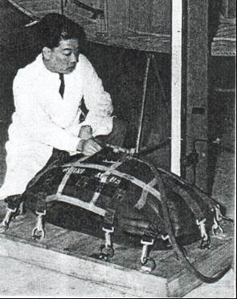

Photo 34. Empty fuel bladder (1956)

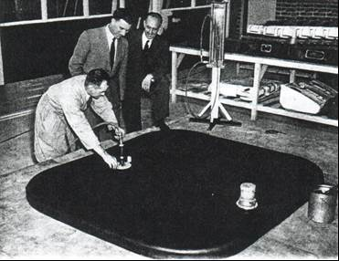

Photo 35. Filled fuel bladder (1956)

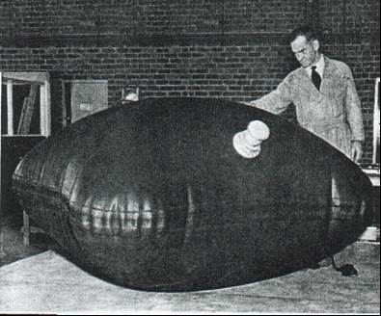

# Commercial Airline refuelling

The following are examples of aircraft refuelling of the period.

Photo 36. Esso refuelling of TWA Constellation wing tanks in London (1957)

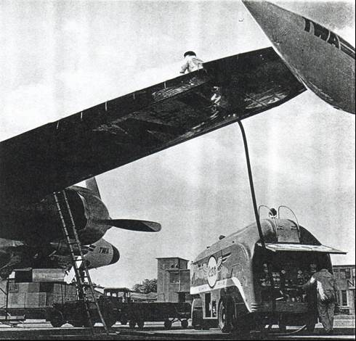

Photo 37. Esso refuelling a Lockheed Constellation with Avgas 115/145 at Bogota Airport.

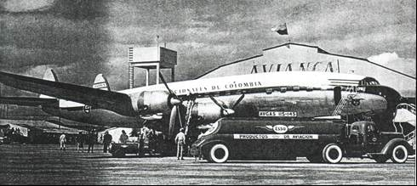

Photo 38. Esso refuelling a SAS Convair 1955 in Europe, note the small trailer possibly for water-methanol mix.

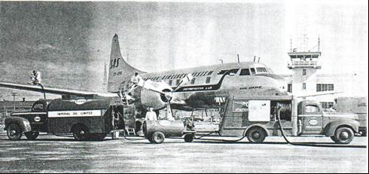

Photo 39. Esso refuelling a SAS DC6-B in Europe 1956.

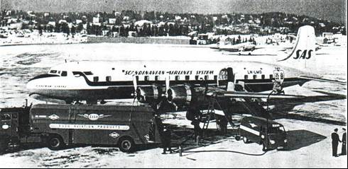

# “Airspeed records were now military pride”

Military aircraft flown by service personnel would set all the air speed records in this period. With the ‘Cold War’ just starting and the ‘Iron Curtain’ coming down, the activities of the Soviets would either be kept secret by the Russians or rarely acknowledged by the west. In any case the public fascination was turning to ‘space’ with the Russian achievement of the successful launching of ‘Sputnik’ in 1957.

Table . Air Speed Records[16]

|  |  |  |  |  |
| --- | --- | --- | --- | --- |
| Date | Location | Pilot | Aircraft | Achieved Km/hr |
| 6 Jul 1953 | Salton Sea, USA | William F Barnes | North American F-86D Sabre | 1,152 |
| 7 Sep 1953 | Littlehampton, Great Britain | Neville Duke | Hawker Hunter F Mk3 (refer to photo below) | 1,171 |
| 25 Sep 1953 | Castel Idris, Libya | Michael J Lithgow (UK) | Supermarine Swift F Mk4 | 1,184 |
| 3 Oct 1953 | Salton Sea, USA | James B Verdin | Douglas XF4D-1 Skyray | 1,212 |
| 29 Oct 1953 | Salton Sea, USA | F K Everest | North American YF-100A Super Sabre (Note 1.) | 1,215 |
| 20 Aug 1955 | Palmdale, USA | Horace A Hanes | North American F-100C Super Sabre (Note 2.) | 1,323 |
| 10 Mar 1956 | Ford/Chichester, Great Britain | Peter Twiss | Fairey Delta Two (Note 3.) | 1,822 |
| 12 Dec 1957 | Edwards AFB, USA | Adrian E Drew | McDonnell F-101A Voodoo | 1,943 |
| 16 May 1958 | Edwards AFB, USA | Walter W Irwin | Lockheed YF-104A Starfighter | 2,260 |
| 31 Oct 1959 | Jukowski-Petrowskol, USSR | Georgii Mossolov | Mikoyan E-66 | 2,388 |
| 15 Dec 1959 | Edwards AFB, USA | Joseph W Rogers | Convair F-106A Delta Dart | 2,456 |

Note 1. Last record set at low-level

Note 2. First supersonic record. First record set at altitude.

Note 3. Largest record increase (310 mph, or 499 Km/hr)

Photo 40. Hawker Hunter WB188 flown by Squadron Leader Neville Duke from Tangmere Airfield achieved 727.63 mph. (now at home at Tangmere Air Museum (1999 - Petroch Services)

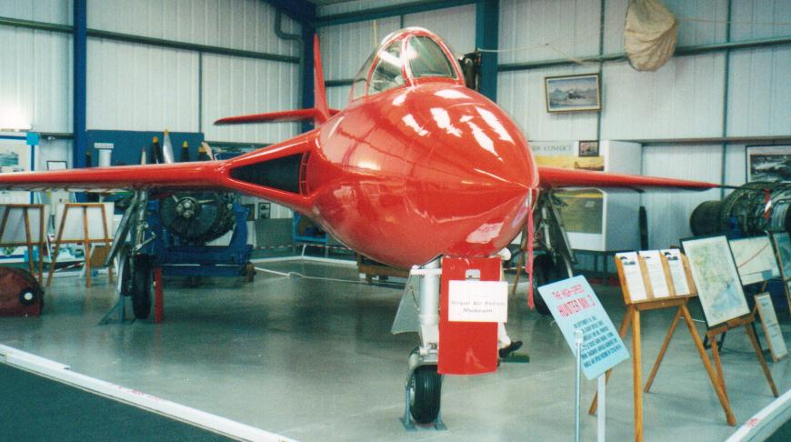

# Epilogue for 1959

The ‘Jet Age’ had arrived and would start to dominate all forms of air transport. Aircraft designers had a new power plant to propel their aircraft into the next decade, but the piston/propeller driven aircraft still would have a place for some years to come. Indeed, there was yet another war just around the corner.

The sound barrier was broken by jet aircraft.

The Space Race had started with the launch of the Russian ‘Sputnik’.

The first aviation gasoline was produced by Standard-Vacuum at their Altona Refinery in 1956, but aviation gasoline was still imported to meet demand.

In Australia, in 1959 jet fuel demand nearly equalled avgas demand, within a year it had doubled, within ten years it was ten times the avgas demand.

New refineries were built in Australia - Shell Geelong, Caltex Kurnell, and BP Kwinana, but it would be another two decades before these refineries (Shell & BP) would produce any aviation gasoline.

# Index

1

100 Octane 15, 30

100 octane aviation spirit 37

100/130 grade 34

2

2, 2 - dimethyl butane 32

2, 2, 3 - Trimethyl butane 32

2, 2, 4 - Trimethyl pentane 31, 32

2, 3 - dimethyl butane 32

2, 3, 4 - trimethyl pentane 31

7

73 octane aviation spirit 37

78 Fighter Wing 6

8

80 octane aviation spirit 37

9

91 octane aviation spirit 37

A

Abadan Refinery 19

Accelerated Gum 41

acid 29

Acid Strength 29

Acid Treating Plant 21

acid-treated 31

additives 40

Adelaide 3

Admiralty 36

Adrian E Drew 47

advance warning aircraft 8

Afghanistan 9

Africa 3, 5, 9, 12

air speed records 46

Airborne Warning and Control 9

airliners 10

alcohols 42

Alice Springs 3

Alky Feed 27, 28

alkylate 20, 27, 28, 29, 31, 34, 35

alkylating butylenes 35

alkylation 19, 21, 29, 31, 32

alkylation feed 27

Alkylation Process Flow 26

Alkylation Reactor 26

Alkylation Unit 19, 20, 22, 25, 26, 27, 28

alloy valves 42

Altona 19, 20, 21, 35

Altona Refinery 3, 10, 20, 21, 22, 24, 28, 35, 47

aluminium chloride 32

American Society for Testing Materials (A.S.T.M.) 43

amines 40

ANA 3, 4

Aniline Point 41

Ansett Transport Industries 4

Ansett-ANA 4

anti-oxidant 35, 40

Aramco crude 35

aromatic 30, 31

aromatic gasoline 31

Aruba 17

Athens 3

Atlantic Ocean 11

Atlantic Union Oil Co. 18

atomic 15

Augusta 17

austenitic steel 42

Australia 10, 11, 12, 13, 16, 18, 47

Australian Defence forces 36

Australian Military Forces 36

Australian National Airways 3

Australian Oil Refining (Caltex) 19, 20

Australian Synthetic Rubber Pty. Ltd. 18

automotive diesel 35

Avalon 3

Avaro 31

avgas 5, 9, 10, 16, 17, 21

Avgas 100/130 21, 30, 35, 37, 39, 40, 42, 43

Avgas 108/135 43

Avgas 115/145 9, 21, 27, 35, 37, 40, 42, 43

Avgas 73 37, 40, 42

Avgas 80 37

Avgas 80/87 21, 35, 43

Avgas 91/96 37, 40, 42, 43

aviation gasoline 3, 7, 9, 10, 13, 15, 19, 20, 21, 28, 30, 33, 34, 35, 40, 42, 43, 47

Aviation Kerosene 37

Aviation Specification 40

aviation turbine engines 37

Aviation turbine fuel 10

Aviation Turbine Gasoline 37

Avis Leonides Major 14

Avon-engined Sabre 3

Avro Lincoln 1, 4, 5, 6, 7, 37

Avro York 12

AVTAG 37

AVTUR 10, 37

AWAC 9, 10

B

B-36 Peacemaker 7, 8

B-47 Stratojet 7, 8

B-52 Stratofortress 7

Bahrein Refinery 19

Base gasoline 30

base stock 30, 34, 35

Bass Strait 21

Bataan Peninsula 19

Baton Rouge 17

Baytown 17

Bayway 17

Beaumont 17

Beechcraft 13

Belgian 9

Benzene 32, 40

benzene extracts 31

Berlin 5

bitumen 21

Bitumen Oxidizer 21

black acidic tar 28

black box 3

black tarry goo 29

blending chart 34

blendstock 3, 20, 21, 27, 30, 31, 35

BOAC 4

Boeing 707-138 4

Boeing B-29 Superfortress 7

Boeing Stratocruiser 377 5, 10

Bogata Airport 45

Bombay 19

BP 20

BP Kwinana 19, 20, 47

Brisbane 3

Bristol Brigand 6

Bristol Freighter 3, 39

British 9, 13

British Commonwealth Strategic Reserve 4

British Crusader 20

British Empire 12

British Empire Airways 13

British Ministry 40

British Standards Institution 36

British Thermal Units 41

Burma 18

butane 25, 27, 28, 30, 31, 32, 35

Butene-1 28

Butterworth 4, 6

butylene 19, 27, 28, 35

butylene alkylate 28, 29, 35

butylenes 20, 26

C

C.F.R. F3 Method 42

C.O.R. - Laverton 19

CA-27 3

CAC 3, 39

California 17

California Research Corporation 15

calorific value 32

Caltex 19

Caltex Kurnell 47

Cambodia 18

Canada 17, 36

Canadian Government Specification Board 36

Canberra 4, 6, 7

carburettor icing 40

Caribbean 11

Carter Oil Company 17

Castel Idris 46

catalyst 19, 32

Catalytic Cracked Gasoline 30

catalytic cracking 15, 20, 30, 31

catalytic reforming 15, 16, 31

caustic 28

caustic treated 27

caustic washing 28

centre of gravity 41

Cessna 13

Ceylon 6, 18

Charles Kingsford Smith 3

cis-Butene-2 28

coal 15

Codimer 32

Cold War 5, 46

colour 42

commercial airlines 43

Commonwealth Aircraft Corp 3

Commonwealth Strategic Reserve 6

Communist 5

communist guerrillas 6

Composition 40

Construction Squadron 6

contaminant 40

Convair 46

Convair F-106A Delta Dart 47

copolymerized 31

copper pyrophosphate 32

Corrosive Sulphur 41

cracked gasoline 21

cracked stocks 16

Creole Petroleum Corporation 17

crude 17, 18

crude oil 32

Crude Tower 23

Cumene 32, 34

cyclopentane 30

D

D.Eng.R.D.2482 37

D.Eng.R.D.2485 37, 40, 42

D.Eng.R.D.2486 37

D.Eng.R.D.2488 37

D-873 43

D-910-53T 43

Daimler engine 9

Dakota 39

Darwin 3

DC-3 3

DC-4 3

DC6-B 46

de Havilland Comet 4, 5, 12

de Havilland DH.103 Hornets 6

de Havilland DHA Vampire 35 Trainer 4

de Havilland Heron 12

de Havilland Hornet 7

de Havilland Vampire 1, 6, 7

Debut Bottoms 28

Debut Overheads 28

Debutanizer 25

Debutanizer tower 28

degrees API 41

Deiso Bottoms 28

Deiso Overheads 28

Deisobutaniser 25, 28

Deisobutaniser tower 28

Delaware 17

Department of Defence 36

Deprop Bottoms 28

Deprop Overheads 28

depropanization 28

Depropanizer 25, 27

Depropanizer tower 27, 28

di-isopropyl 32

Director of Chemical Inspection 36

Director of Engine Research and Development 36

Director of Supplies and Transport 36

distillates 30

distillation 28, 30, 31, 32, 40, 43

distillation range 21

Douglas C-124 Globemaster 9

Douglas DC-3 39

Douglas DC-6B 5, 10, 12

Douglas XF4D-1 Skyray 46

Dr. David Warren 3

Duke 46

Durban 19

Dutch New Guinea 21

dye content 42

dyes 35, 40

E

East Africa 18

East Coast 11

East St. Louis 17

Eastern Europe 8

Edwards AFB 47

effluent 27

Electra 13

end point 35

England 12, 17

English Electric Canberra 4

Esso 16, 17, 18, 19, 20, 21, 30, 36, 45, 46

Esso Research and Engineering Company 17

ethane 27, 28

ethane-isobutane 32

ethene 27

ethene-propene 32

Ethylene 28

Europe 5, 12, 17

Existent Gum 41

Exxon 21

F

F K Everest 46

F-100C Super Sabre 47

F4 engine Performance Number 28

F-80 Lockheed Shooting Star 7

F-86 Sabre 7

F-86D Sabre 46

Fairchild C-119 Boxcar 9

Fairey Delta Two 47

Fairey Firefly 37

Far East 16, 18, 19

Farnborough 14

Fawley 17

FCC 21, 28

feed preparation 24

feedstock gases 20

final boiling point 40

Flt. Lt. W.H. Scott 3

Fluid Catalytic Cracking 17

fluid catalytic process 30

Fluid Coking 17

Fluidized Catalytic Cracker 28

Ford/Chichester 47

fractionation tower 25, 28

France 17

freezing point 32, 40

French 9

fuel bladders 43

fuel gas 27

Fuel tanks - Portable 43

fungicides 17

G

GAF 4

gasoline 30, 40

Georgii Mossolov 47

Gippsland crude 35

Glugor 6

Government Aircraft Factory 4

Great Britain 46

gum 41

H

H.M.A.S. Sydney 37, 38

Hampshire 17

Handley Page Dart Herald 14

Handley Page Hastings 12

Handley Page Herald 14

Hawaii 11

Hawker Hunter F Mk3 46

Hawker Sea Fury 37, 38

Hawker Tempest 6, 7

heat of combustion 41, 42

heavier oils 15

heavy acid treatment 30

heavy alkylate 25, 28

heavy ends 40

heavy fractions 40

heavy naphtha 31

Heinkel 111 9

high octane base gasoline 20

high octane gasoline 16, 22, 29

Hispano HA 1112-M1L Buchon 9

Hong Kong 18

Horace A Hanes 47

Hot acid 31

Houdry 30

Humble Oil and Refining Company 17

hydrocodimer 32

Hydrofining 17

hydrofluoric acid 31

Hydrofluoric Acid 19

Hydroforming 31

hydrogenation 30, 31, 32

I

ice crystals 42

Illinois 17

Imperial Oil Limited 17

India 4, 18, 19

Indonesia 18, 19

induction system 41, 42

inhibitor 41

Institute of Petroleum 43

International Air Race 12

Iran 17, 19

Iranian situation 16

Iraq 9, 17

Ireland 17

Iron Curtain 5, 46

isobutane 19, 20, 25, 26, 27, 28, 29, 31, 32

Isobutene 28, 31

isoheptane 30

isohexane-cyclopentane 30

Isomerisation 30

Isomerization 32

isomers 27

iso-olefins 31

isoparaffin 31

Isopentane 28, 32, 34

isopropylbenzene 32

J

J.L. Whiteman 3

James B Verdin 46

Japan 5, 18, 19

Japanese 6

Jet Age 13, 47

jet engine 9, 10, 13

jet fuel 3, 9, 10, 13, 15, 16, 35, 47

John Batman 3

Joseph W Rogers 47

Jukowski-Petrowskol 47

K

kangaroo 3

Kansas 17

Kellogg 19, 22

kerosene 21

Klamono crude 21

Korea 18

Korean War 5

Kurnell 19, 20

L

laboratories 19

laboratory chemist 3

Lancaster 5

lead compounds 41

lead response 32

lead susceptibility 32

leaded fuels 42

Lean Mixture Knock Rating 42

Libya 46

light alkylate 19, 21, 22, 25, 30, 34, 35

light ends 23

light straight run gasoline 21, 35

Limay 19

Linear Programming 33

liquified petroleum gas 27

Lirik 21

Littlehampton 46

Lockheed C-130A Hercules 4

Lockheed Constellation 5, 10, 11, 45

Lockheed Electra 4, 13

Lockheed Neptune 5, 9, 37

Lockheed Neptune P2V-5 3

Lockheed Super Constellation 3

Lockheed YF-104A Starfighter 47

London 4, 12

Los Angeles 17

Louisiana 17

LPG 27, 28

LSRN 35

Lube Oil Rerun Unit 21

lubricating oil 21, 40

Lyman 15, 16, 56

M

MacRobertson 12

Malaya 4, 5, 6, 18

Malaysia 6

maritime aircraft 5

Master General of the Ordnance 36

McDonnell F-101A Voodoo 47

Melbourne 3, 10, 12, 13, 19, 21, 39

Messerschmidt Me-109 9

Michael J Lithgow 46

Middle East 4, 19

MiG-15 8

Mikoyan E-66 47

MIL-G-5572 B 43

Mobil 10, 17, 19

Mobil Avgas Problem 27

Mobilgas 17

mobilization 19

Mobiloil 17, 22

Mosquitoes 9

motor fuels 19

motor gasoline 15, 16, 21, 22, 25, 28, 35

Motor method 42

Mustang 3

N

naphtha 21, 31

Naphtha Splitter 23

Naphtha Splitter overheads 21

Naphtha Stabilizer 23

naphthene 30

naphthenic 30

nationalization 19

natural gas 15, 31

natural gasoline 32

n-butane 28, 32

neohexane 32

Netherlands West Indies 17

New Jersey 17

New Zealand 11, 12, 18

Newport 35

No. 1 Crude Unit 21

No. 1 Squadron 4, 7

No. 11 Squadron 37

No. 2 Airfield 6

No. 2 CDU 22

No. 2 Crude Unit 23, 35

No. 2 Squadron 4, 6

No. 205 Squadron 6

No. 3 Squadron 4, 6

No. 33 Squadron 6

No. 77 Squadron 4, 6

non-leaded 42

North Atlantic 8

Northwest airlines 12

n-Pentane 28

O

octane number 29, 30, 32

octane ratings 15

Octanes 29

oil dilution 40

oil refineries 19

oil-soluble dyes 42

olefin feed 27

olefins 29, 30, 31

Olympic Games 3

Operation Sabre Ferry 4

Operation Westbound 3, 37

optimum blend 34

Orient 11

overhead 28

P

P.R.A. Altona Refinery 20

P-51 Mustang 7

Pacific 4, 10

Pacific Ocean 11

Pakistan 18

Palembang 19, 35

Palmdale 47

Pan American 11

paraffinic 30

Paulsboro 17

Penang 4

Penang Island 6

Pentane 30, 31, 35

pentane-hexane 30

Pentenes 28

performance number 29, 35, 42

Perth 19

Peru 17

Peter Twiss 47

petrochemical 17

Petroleum Refineries (Australia) 19, 21

Philippines 18, 19

phosphoric acid 32

pipeline 35

Piper 13

Platinum Catalytic Reformer 22

polymerisation 27, 28, 29

polymerization 31

Port Jerome 17

Portable gasoline bladder 43

portable inflatable 43

potential gum 43

Power-Forming 17

propane 25, 27, 28

propeller 9, 13

propylene 19, 20, 25, 26, 27, 28, 31

propylene alkylate 28, 29

Q

Qantas 3

Qantas Empire Airways 3

Qatar 17

Qatar crude 35

QEA 3, 4

quality give-away 33

R

RAAF 3, 6, 7, 36, 37, 39

RAAF Museum Point Cook 39

RAAOC 36

RAASC 36

RAF 6

RAF Cosford 9, 13

RAN 3, 36, 37, 38

reactor 28

reactor effluent 27, 28

reconnaissance 8

reconstruction 5

recycle 27, 28

refineries 16, 19

refinery 21, 33

refinery planner 3

reforming 15

refractionated 28

refrigerant 26, 27, 28

refuel tanker 8

refuelling 9, 12, 13, 45, 46

Rerun tower 25, 28

Research Octane Numbers 29

residue 40

rich mixture 30, 32

Rich Mixture Knock Rating 42

rich mixture rating 30, 31, 32, 33

Rich rating 28

Richmond 3, 4, 37

Rolls Royce Merlin 9

Rolls-Royce Dart Mk 527 14

Royal Australian Air Force 36

Royal Australian Navy 36

Royal Netherlands Navy 9

Russian 46, 47

S

S.R.Stiles 19

S.V.O.C. 18

Sabre 6, 7

San Francisco 4

Saturates Gas Plant 23

Saudi Arabia 17

scavenger 42

Shell 10, 31

Shell - Clyde 19

Shell - Geelong 19, 47

Shell Refining 20

Shimizu 19

Singapore 6, 7, 12

Socony Mobil Oil Company Inc. 17, 18, 21

Socony-Mobil 18

Socony-Vacuum Co. 30

Socony-Vacuum Corporation 17

solar 15

solubility 42

solvent extraction 31

sonic boom 3

sound barrier 47

South Africa 3, 18, 19

South American 11

South Asia 18

South-East Asia 9

Southern Aurora 4

Southern Constellation 3

Southern Sky 3

Southern Zephyr 4

Sovaformer 22

Soviet 8, 46

Space Race 47

Space velocity 29

Spanish Air Force 9

spark plugs 42

specific gravity 35, 41

Specification 33, 36, 40, 42, 43

spent acid 27

Spitfires 9

splitter column 21

Spotswood 35

Sputnik 46, 47

Squadron Leader Neville Duke 47

Sri Lanka 18

Standard Methods 42

Standard Oil Company 36

Standard Oil Company (New Jersey) 16, 18, 21, 30

Standard Oil Company of New York 17

Standard Vacuum 10, 43

Standards Association of Australia 36

Standard-Vacuum 19, 47

Standard-Vacuum Oil Co. (N.Z.) 18

Standard-Vacuum Oil Company 17

Standard-Vacuum Refinery 21

Standard-Vacuum Refining Company (Australia) 17, 18

Stanvac 18

Stanvac Refinery 18

straight run 16

straight-run gasoline 30

sulphur 21, 31

sulphur dioxide 28

sulphuric acid 19, 22, 25, 26, 27, 29, 31

sulphuric esters 27

Sunderland 6, 7

Sungei Gerong 19

Superfractionation 30

Supermarine Spitfire 9

Supermarine Swift F Mk4 46

supersonic record 47

suspended matter 40

Sweetening Unit 21

Sydney 3, 4, 19

Synthetic Crude Tower 24

Synthetic Lubricants 17

T

TAA 3

Tangah airfield 7

Tangmere 47

Tar Separator 24

TCC 21, 22, 24, 27, 28, 30

TCC cracked gasoline 27

TCC gas plant 27

TCC gasoline 21

TEL 31, 33, 35, 42

tert-butyl benzene 32

Tetra Ethyl Lead 30, 42

Texas 17

Thailand 18

Thermal alkylation 32

thermal cracking 15, 31

thermal reforming 31

Thermofor Catalytic Cracker 22, 24

Toluene 30, 35

Torpedo Experimental Establishment 36

Torrance 17

total alkylate 28, 29

Total Sulphur 42

Trans Australian Airlines 3

trans-Butene-2 28

Trial and error method 33

triangle blend chart 34

triangular blending chart 33

trimethyl pentanes 31

Triptane 32

turbo-prop 5, 8, 9, 10

turboprop airliner 3, 4

turbo-prop engine 13, 14

TWA 11

TWA Constellation 45

U

U.S. Air Force Navy Aeronautical 36

U.S. Army 36

U.S. Army Ordnance Department 36

U.S. Federal 36

U.S. Federal Specification VV-L-791-Lubricants 43

U.S. Military Specification 36

U.S.S.R. 5, 8

United Kingdom 36

United States 4, 36

unstabilized cracked gasoline 27

UOP 19

V

Vacuum Oil Co Pty. Ltd 18

Vacuum Oil Company 17

Vacuum Tower 24

valve seats 42

valve sticking 41

Vapour Feed Heater 24

vapour lock 42

vapour pressure 28, 30, 32, 33, 35, 42

Venezuela 17

Vickers Viscount 13

Vickers-Armstrong Viscount 3

Vietnam 18

Vietnam War 9

Viscount 13

W

Wakayama 19

Wallaby 3

Walter W Irwin 47

Warning Star 10

water reaction 40

Water Tolerance 42

water washing 28

water-methanol mix 46

West Coast 11

Western Australia 19

Western New Guinea 18

Westinghouse J-34 turbojet 9

Whenuapia 3

Whitegate 17

William F Barnes 46

Williamtown 4

Winjeel 39

Wright Cyclone 9

X

xylenes 40

Y

Yak-9 8

Yarraville 35

Yarraville Terminal 35

YF-100A Super Sabre 46

# Research Sources

1. Website: <http://members.tripod.com/~imogiri/aircraft/vampire.jpg> Accessed Oct 21, 2005
2. Australian Aviation History Time Lines - Web site accessed June 1, 2002 - <http://users.chariot.net.au/~theburfs/aahistpage1.html#preww1>
3. By BOAC_Comet_1952.jpg: Ministry of Information official photographerderivative work: Altair78 - This file was derived from:  BOAC Comet 1952.jpg:, Public Domain, <https://commons.wikimedia.org/w/index.php?curid=19710659>
4. Website: <http://www.defence.gov.au/raaf/organisation/info_on/bases/butterworth/history.htm> Accessed Oct 20, 2005.
5. Website: [http://www.raf.mod.uk/history/line1950-59.html](http://www.raf.mod.uk/history/line1950-59.html%20Accessed%20Oct%2020) Accessed Oct 20, 2005.
6. Website: [http://www.raf.mod.uk/history/line1950-59.html](http://www.raf.mod.uk/history/line1950-59.html%20Accessed%20Oct%2020) Accessed Oct 20, 2005.
7. Aeroplane Summer 2013 Vol. 41, No.7 issue No 483 Data Base Page 80 ‘Right Aircraft, wrong engines”
8. By Rutha’s - Own work, CC BY 3.0, <https://commons.wikimedia.org/w/index.php?curid=6388160>
9. By Tim Rees - Gallery page http://www.airliners.net/photo/Air-UK/Handley-Page-HPR-7/1104923/LPhoto http://cdn-www.airliners.net/aviation-photos/photos/3/2/9/1104923.jpg, GFDL 1.2, <https://commons.wikimedia.org/w/index.php?curid=28490858>
10. American Petroleum Institute 20th Midyear Meeting St. Louis Missouri May 12, 1955 “The Changing Product Demands On Our (US) Refineries” by A.L.Lyman California Research Corp.
11. Petroleum Refineries (Australia) -Technical Orientation Program 1960
12. Petroleum Refineries (Australia) -Technical Orientation Program 1960
13. The Science of Petroleum Volume V Part III Refinery Products – Editors Cr. B T Brooks, Dr. A E Dunstan – published by Oxford University Press, London 1955
14. Petroleum Refineries (Australia) Pty. Ltd. Technical Orientation Program 1960
15. Handbook of Fuels, Lubricants and Allied Products for Australian Services June 1953, (Revised Feb 1957), An Australian Joint Services Publication issued under the authority of the Minister of Defence.
16. <http://www.speedrecordclub.com/records/outair.htm> Website accessed Dec 30, 2003