Chapter

35

The Declining Years 1981-2003

Photo . Shell Aviation over-wing refuelling a Cessna Duchess at Archerfield Airport Brisbane, Qld. 2001.

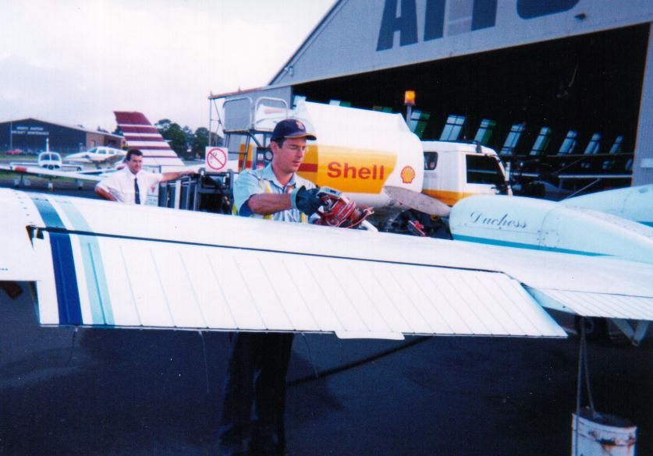

Table of Contents

Summary 3

Avgas Demand Stabilizes, But More Local Production 8

Avgas In Iraq War 2003 11

Aviation Fuel- Shale Oil 12

Aviation Gasoline Composition 1990’s 13

Avgas Composition (Detailed) 21

Avgas Specifications & Test Methods 1980’s 24

The Future Of Aviation Gasoline 32

Oil Companies And Refineries 37

Shell Geelong Refinery 1980 38

BP Kwinana Refinery 1984 38

Mobil Altona Refinery 1955-2000 38

Mobil’s ‘Avgas Problem’ 2000 39

Refuelling By Tankers 40

Airspeed Records Are Now A Serious Sport 41

Warbirds & Heritage Aircraft 42

Epilogues For 2003 46

Index 48

Research Sources 54

Photo 2. ‘Wild Horses’- Mustangs on airfield ‘thirsting for avgas’

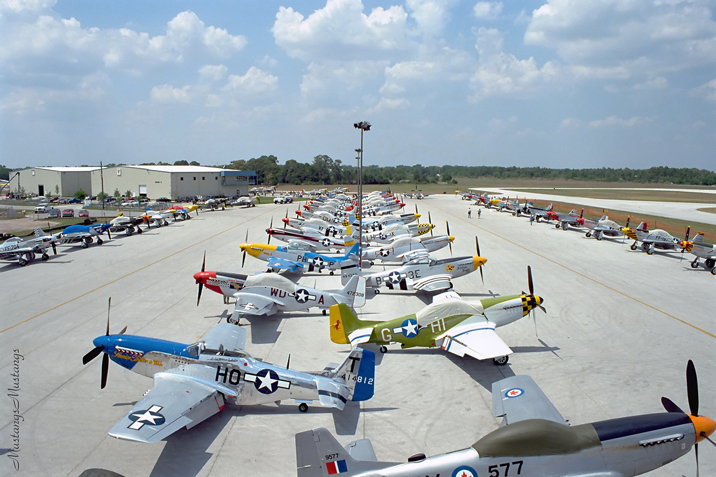

# Summary

Chronology – Australian Aviation Timelines[1]

The Eighties

Australia's busiest small airports: Official statistics released showed that Moorabbin Airport, Melbourne, Victoria, was Australia's busiest airport, with 282,062 movements for 1980. Next was Sydney's Bankstown, with 281,295 movements, followed by Brisbane's Archerfield at 268,295. [The main fuel used was aviation gasoline].

**1981** April 24; Pioneer aviator and founder of Butler Aviation, Arthur Butler, died aged 77.

**1982** March 18; Sir Lawrence Wackett, one of the pioneers of Australian aviation, died aged 86.

July 2: Royal Australian Navy Fleet Air Arm Squadrons No. 805 and No. 816 were disbanded at a parade held at Naval Air Station, Nowra. The two squadrons, which formed the Carrier Air Group aboard HMAS Melbourne, and which had seen front line service for 34 years, were amalgamated to a second-line training squadron at Nowra. No. 805 Squadron operated Douglas A4G Skyhawk fighter-bombers, and No. 816 Squadron was made up of Grumman Tracker anti-submarine aircraft. September: The Sikorsky Seahawk, Aerospatiale Puma and Westland Lynx were short-listed as candidates to serve on the RAN's guided missile frigates and as fleet utility aircraft.

November 4: Pan American inaugurated the longest non-stop commercial air service on record - a Boeing 747 route 7,487 miles (12,049 km.) from Los Angeles, California U.S.A. to Sydney, NSW, Australia - a flight time of 14 hours, 30 minutes.

December 23: Sir Reginald Ansett died. Ansett was one of Australia’s commercial airline pioneers establishing Ansett Airways Pty. Ltd.

In 1982 Australia's military air strength was:

AIR FORCE

Air defence: 71 Mirage III-O

Ground support: 20 General Dynamics F-111C

Recce: 4 General Dynamics RF-111C, 1 Learjet 35

Transport; 12 C-130E, 12 C-130H, 22 DHC-4 Caribou, 3 Dassault Falcon 20, 2 BAe HS-748, 2 BAC-111, 2 Boeing 707.

Helo: 12 CH-47C Chinook, 46 Bell UH-1B/D/H

Maritime: 10 P-3B Orion, 10 P-3C Orion

Training: 35 NZAI CT-4A Airtrainer, 15 Mirage II-DO, 68 Aermacchi MH-326H, 8 BAe HS-748T.2

NAVY

Ground support: 7 A-4G Skyhawk

Maritime: 19 Grumman S-2E/G Tracker

Transport / ECM: 2 BAe HS-748

Helo: 7 Westland Sea King Mk. 50, 19 Westland Wessex HAS. 31B, 5 Bell UH-1B, 3 Bell 206 Kiowa

Training: 3 TA-4 Skyhawk, 8 Aermacchi MB-326H

ARMY

Transport; 16 Pilatus Turbo-Porter, 11 GAF N22 Nomad Mission Master

Helo: 44 Bell 206B Kiowa

**1983** The decision was finally made not to replace the carrier HMAS Melbourne. The decision to do without an aircraft carrier meant, among other things, that the RAN's fixed-wing aircraft had little future, and its anti-submarine Sea King helicopters were now land-based and limited in their capabilities.

**1984** June: RAN's surviving Grumman Trackers were withdrawn from service.

Photo 3. RAN Grumman S-2E/G Tracker on the flight deck of HMAS Melbourne (circa 1980’s)

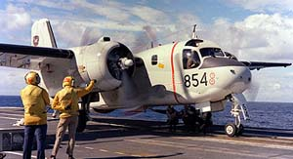

Manufacturer: Grumman, Type: carrier-borne anti-submarine patrol aircraft, delivered: 32 aircraft, 1966-77, Crew: four, Engines: two Wright Cyclone engines, each 1,520 hp, Speed: 265 mph, Range: 1,300 miles, Withdrawn: 1967-84

**1985** The first two F/A-18 Hornet aircraft ordered by the RAAF, A21-101 and A21-102, were delivered in May 1985, after a non-stop flight of 12,640 km from California to Williamtown RAAF base in NSW, refuelled by a KC-10 tanker of the USAF en route.

**1988** February: The RAAF received its first Sikorsky Blackhawk helicopter, delivered to No. 9 Squadron at Amberley, Qld. Australian assembly resulted in the first locally-built machine being handed over in May. The Blackhawks would be progressively taken over by Army Air Corps personnel to form A Squadron, 5 Aviation Regiment.

**1989** February 8th the last official RAAF Mirage flight took place, when Mirage IIID A3-101 flew to Woomera, South Australia for storage. By 1988 only No. 75 Squadron (at Darwin NT) and No. 79 Squadron (Butterworth, Malaysia) were still flying the Mirage. The last public flight was in October 1988 at the Bicentennial Air Show at Richmond.

August: A non-stop Qantas flight from London to Sydney was formally recognised as a record for a jet passenger land plane of over 300,000 kg. The Boeing 747-438 VH-OJA ‘City of Canberra’ skippered by Capt. D. Massey-Greene flew the 17,953 km on August 17 in 20 hours, 9 minutes and 5 seconds. The aircraft, with 23 passengers, was towed to the start of the runway for take-off to conserve fuel.

In 1989, Gaby Kennard became the first Australian woman to fly solo around the world in a single-engined Piper Saratoga, covering 29,000 nautical miles.

**The Nineties**

**1994:** March: Australia's inaugural pylon air race took place at former World War II training base Valleyfield, Tasmania. It featured Winjeels, Harvards, T-38s, CT-4s and a Hawker Sea Fury.

In 1999-2000 Australia's military air strength stood at:

AIR FORCE

Tactical Fighter: 71 F/A-18A/Bs

Strike/Recce: 17 F-111C, 4 RF-111c and 15 F-111G

Maritime: 19 P-3C, 3 P-3B Orion

Transport: 12 C-130H, 12 C-130J; 14 DHC-4 Caribou; 5 Boeing 707-320C (4 fitted for mid-air refuelling), 5 Falcon 900S (VIP Transport)

Training: 2 BAe Hawk, 31 Aermacchi MB-326H, 65 Pilatus PC-9

Of all the aircraft in RAAF service, the DHC-4 Caribou was the last piston-engined aircraft in the Royal Australian Air Force and was the only aircraft to employ the Low Altitude Parachute Extraction System (LAPES), where up to 2000 kg of sled-mounted cargo is extracted from the aircraft by a parachute from a metre above the ground.

Photo 4. RAAF Caribou undertaking a LAPES

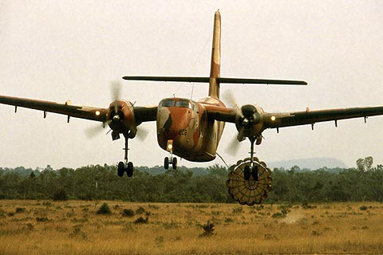

DHC-4 Caribou is made by De Havilland Canada, its role is light tactical transport. It has a crew of two pilots and a flight engineer. Engines: Two Pratt and Whitney radials (2000 horsepower each) Airframe Length: 22.5m height: 9.6m, Wingspan 29m Weight 15,400 kg. Speed 280 km/h (cruise) Range 2000 km Ceiling 28,000 feet or 13,000 feet with passengers. Accommodation 4 tonnes of cargo: two four-wheel drives or light artillery pieces, or 32 equipped troops seated, or 22 stretcher patients plus medical attendants.

NAVY

Helo: 16 S-70B Seahawk, 7 Sea King Mk50, 6 Bell 206B-1

Transport/EW: 2 HS-748

ARMY

Helo: 27 SA-70A Blackhawk, 43 OH-58 Kiowa, 4 CH-47D Chinook, 25 Bell UH-1 & 18 AS-350 Ecuriel (Squirrel)

**The 21st Century**

**2000** May; the first Australian-built BAe Hawk lead-in fighter flew at Williamtown, NSW on 12th May, 2000. Some 21 were being built in Australia, whilst 12 were under construction in England. It would fill the trainer role previously occupied by the ageing Macchi 326's (of which various air museums hoped to acquire examples), and the Pilatus PC-9.

Photo 5. RAAF BAe Hawk 127

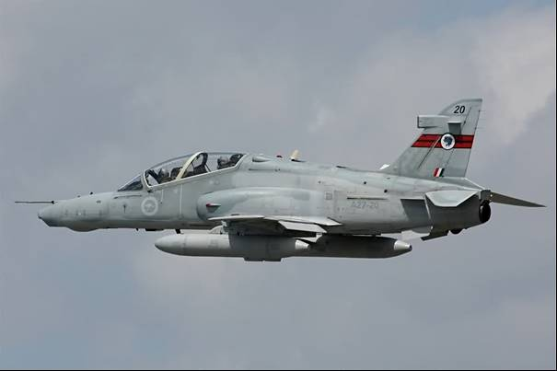

August; Virgin Blue airline was launched in Australia on August 3, 2000, initially offering seven return flights a day between Brisbane and Sydney. Connections to other centres followed. Virgin Blue, who operated two Boeing 737s in August 2000, ended the year with five in operation, and in early 2002 had 16.

On 27th August, formal approval was given to begin work on the new combined domestic and international terminal at Adelaide, South Australia's main airport at West Beach. The $260m Adelaide Terminal T1 commenced construction on November 2003 and commenced operations in October 2005.

**2001** The RAAF continued to look to its future air to air refuelling needs, the alternatives being refurbishment of its four 30-year-old Boeing 707s, purchase of new tankers, or a lease or Private Finance Initiative. The 707 tankers provided a limited service the RAAF's F/A-18 Hornets, but were incompatible with the F-111s. The RAAF was already looking ahead to replacing both the F/A-18 A and B Hornets and F-111s, with main contenders appearing to be the F/A-18 E/F and the JSF (Joint Strike Fighter).

The RAAF's Caribou transports, once due to retire in 2000, look set to soldier on until 2010. Some have already gone to fire training or been offered for sale or to museums.

After testing and evaluation was conducted on the C-130J Hercules in conjunction with the RAAF's Airlift Group (Richmond, NSW) and ARDU (Edinburgh, South Australia), the type entered service in mid-2001. The RAAF's last C-130E has left Richmond RAAF base to take up residence at the RAAF Museum, Point Cook, alongside a C-130A. The RAAF was also looking ahead to its options when its C-130H transports become due for withdrawal in 2008. Airbus Military was promoting its A400M as a replacement for the C-130J.

The Government had committed to acquisition of four 737-based Boeing Wedgetail AEW&Cs, described as an advanced "pocket AWACS" aircraft.

Major refurbishment or replacement of the Orion fleet from 2007 was also being considered. Some 19 of the type provide the RAAF's maritime patrol backbone. The Army's Air 87 project led to consideration of which helicopters would equip two squadrons of 20-24 armed reconnaissance aircraft. A further squadron of approximately 12 troop transport helicopters was also planned for around 2007. By October 2001 the Eurocopter Tiger ARH had won the attack 'copter role. The Navy took delivery of the Kaman SH-2G(A) helicopter in mid-2001.

The Federal Government's mid-2000 freeze on project expenditure put defence spending in a delicate position, and was blamed for the sale of interests in Hawker de Havilland, which placed Boeing in ownership of every major Australian aerospace structures facility. Another loss attributed to the freeze has been constriction of BAe operations and job losses in Sydney and Adelaide.

Early 2001 Qantas announced its long-term fleet plans would include twelve Airbus A380 aircraft making it one of the first users of the new airliner when it enters service in 2006. It would also acquire 7 Airbus A330-200 and 6 Airbus A330-60 aircraft between 2002 and 2005. The 747 would remain part of Qantas' fleet. Qantas would be a first operator of the new 747-400X, (described variously as the Long Ranger, Long Range, or Longer Range) in 2002.

New Zealand: RNZAF A-4K Skyhawks met with mishaps in rapid succession, in two cases whilst in Australia. The first, NZ6211, crashed on 16th February, near Nowra, NSW, during practice for the Avalon air show, killing its pilot, Squadron Leader Murray Nielson. The second, a TA-4K serial NZ6256, crashed into the sea off Western Australia on 20th March during an exercise with RAN ships. Pilot Flt. Lt. Phillip Barnes ejected and was rescued. A third RNZAF Skyhawk cut a power line a day later in Buller Gorge, on New Zealand's South Island, during an authorised low-level exercise. The line severed part of the aircraft's fin, and the Skyhawk made an emergency landing at Woodburne, near Blenheim. In New Zealand, the Prime Minister Helen Clark’s government announced grounding of the RNZAF's A-4K Skyhawk fleet; as a consequence, their Aermacchi MB-339C jet trainers would also become redundant. The NZ government said this would free money for other defence spending, including an upgrade to their Orion aircraft. The RNZAF strength became; six P-3K Orions, five C-130H Hercules, two Boeing 727s and 14 Iroquois helicopters, plus some training aircraft.

April: A USAF Global Hawk became the first UAV (unmanned aerial vehicle) to fly unrefuelled 7,500 miles from the United States to Australia on April 22, 2001. It left Edwards Air Force Base, California, on its 22-hour flight to arrive at RAAF Edinburgh, near Adelaide, on April 23. In Australia it was scheduled to participate in exercise ‘Tandem Thrust 01’. Whilst in Australia the UAV was designated Southern Cross II, commemorating the original US-Australia flight of Charles Kingsford Smith in Fokker trimotor Southern Cross in 1928.

September 14: Ansett Airlines and its subsidiaries were grounded, after the public revelation of its deteriorating financial position. In early November a bid to purchase the airline by businessmen Lindsay Fox and Solomon Lew was accepted.

**2002** March: after six months of attempts to revive it, ailing Ansett Airlines finally ceased operations when the Lew/Fox syndicate withdrew from purchase.

# Avgas demand stabilizes, but more local production

Nearly all aircraft engine developments were for turbine types. Avgas demand became stagnant, Jet Fuel is increasing significantly. All military and civilian aircraft were now jet powered.

While the demand and production of jet fuel through this period continued to grow significantly, the demand for aviation gasoline essentially remained stagnant due to the fact that the main demand was from light aircraft customers. The major airlines had essentially converted to jet turbine powered aircraft. There were however, significant development in Australian production of aviation gasoline with two new competitors to Mobil’s Altona Refinery – these were Shell Geelong Refinery, Victoria and BP Kwinana Refinery in Western Australia.

Graph . Comparison of Avgas and Avtur (jet fuel) usage from 1940 to 2007



Note some data was unavailable in the period 1945 to 1957. There were no jet aircraft in Australia until the 1950’s. Data from 1999 to 2007 is from oil industry forecasts.

Military Services Convert to Jet Fuel

With theend of the Vietnam War in the 1970’s the last of the piston engined aircraft in front line service were replaced by more modern jet powered equivalents. For example, in 1982 the military aircraft in service in Australian Defence Forces were nearly all jet powered except for the RAAF CT-4A Airtrainer, DHC-4 Caribou and RAN Grumman S-2E/G Tracker which required Avgas 100. The Grumman S-2 Tracker were operated by the Royal Australian Navy until withdrawn from service in 1984 and replaced by Sea King helicopters. The RAAF CT-4A Airtrainers were replaced Pilatus PC-9 trainers. Only the piston engine DHC-4 Caribou remained in service until 2009. On 27 November 2009, Caribou A4-140 flew into Canberra from RAAF Richmond base on the last flight before this aircraft type ceased operations with the Royal Australian Air Force.

While the major air forces were converted to jet powered aircraft, their obsolete aircraft were often sold off to smaller national air forces such as Philippines, Thailand, or commercial aviation services. As a consequence, there was still a demand in some areas for military aviation grades - Avgas 115/145 and Avgas 100/130 in particular. Indeed, even some civilian light aircraft became part of these national air forces.

Photo 6. Cessna L-19/O-1 Bird Dog of the Royal Thai Air Force. Note the rocket mountings under the wing (Temora 2005)

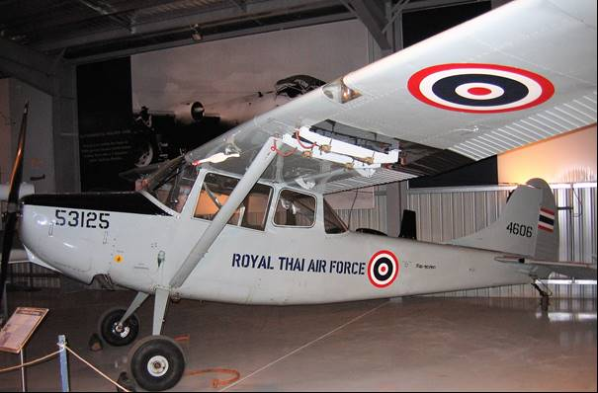

Avgas 100LL

As aviation became dominated by jet aircraft there was less demand for AVGAS 87 and AVGAS 115/145 Also at this time there was a world-wide move to unleaded gasolines and emerging environmental issues which would later affect the composition of motor gasolines. The environmental pressure for low lead motor gasolines also impacted on aviation gasolines resulting with the development of a new grade –

Aviation Gasoline 100LL (Avgas 100LL) which had a lower lead level than the traditional Avgas 100/130. This new aviation gasoline (Avgas 100LL) was essentially equivalent to Avgas 100/130 in all respects except that the lead level was lower and to distinguish it from the green Avgas 100/130, the new grade was coloured blue. It was introduced in the United States in 1975, but it would not be available in Australia until the 1980’s.

With the introduction of Avgas 100LL there was no need for a low lead grade such as the red Avgas 80/87, and so this was no longer manufactured.

One of the last service aircraft to use Avgas 115/145 was the Lockheed Neptune which was used by the RAAF for maritime patrols. The Neptunes left Royal Australian Air Force service in the 1970s and were replaced by turbo-prop powered Orions, but a few remain airworthy as warbirds (by aircraft collectors such as the Historical Aircraft Restoration Society - HARS).

Photo 7. HARS Lockheed Neptune A05-273 starts up for flight at Temora Airfield (now uses Avgas 100LL) (Petroch Services 2007)

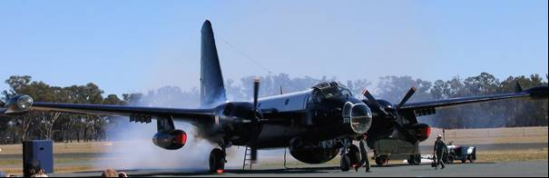

Note the combination of two Wright R-3350-32W Turbo Compound piston engines, of 3,700 hp; plus two Westinghouse J34-WE-36 turbojets of 3,400 lb. thrust - “jet assisted take-off for piston engines”.

Currently there are only two grades used in Australia – AVGAS 100/130 and AVGAS 100LL.

These grades are supplied at most major airports using tankers, while jet fuel is supplied by underground hydrant system using refuelling trucks. Most of the aircraft using avgas are single or twin engined aircraft, such as Cessna and Piper aircraft.

Photo 8. Mobil Avgas 100/130 tanker refuelling a Socata TB-10 Tobago at Archerfield Airport 2001

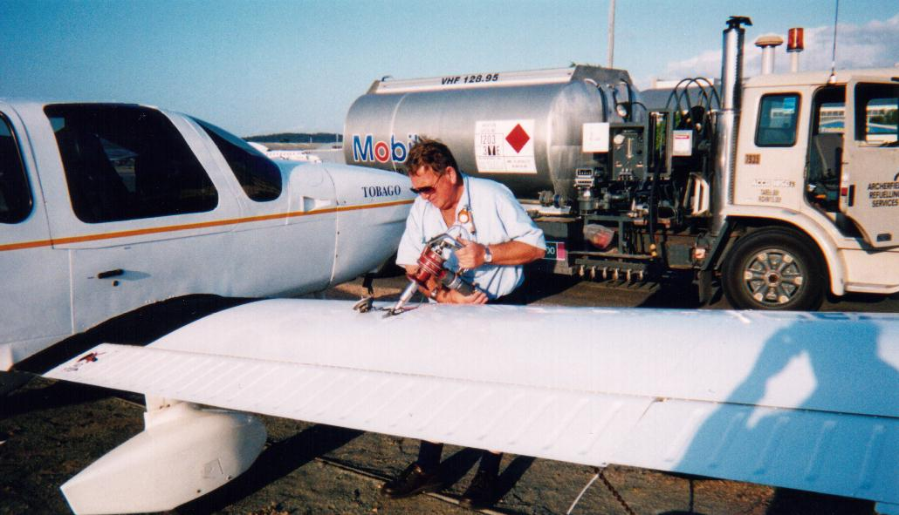

# Avgas in Iraq War 2003[2]

While we now consider avgas as no longer a fuel of military use, this is not quite correct; aviation gasoline played an important role in the Iraq War. The following describes the use of avgas in Iraq war and how it was transported.

DESC Supports the Warfighter During Operations ‘Enduring Freedom’ and ‘Iraqi Freedom’ June 27, 2003.

Fort Belvoir, Va. (Virginia. USA) - The Defense Energy Support Center (DESC) continues to fuel the Coalition Forces during Operation ‘Enduring Freedom’ and Operation ‘Iraqi Freedom’. Two Commodity Business Units supporting these operations are Direct Delivery Fuels and Bulk Fuels; both provide the war fighter comprehensive fuel support in the most effective and economical manner possible.

**Direct Delivery Fuels**

In support of both Operation ‘Enduring Freedom’ and Operation ‘Iraqi Freedom’, the US Air Force contacted Ground Fuels Division I in January 2003 regarding supply of Aviation Gasoline (AVGAS). The Air Force requested AVGAS to Seeb Air Base, Oman, in support of their Predator mission. (The Predator is a medium-altitude, long-endurance unmanned aerial vehicle (UMV) system utilized for reconnaissance, surveillance and target acquisition.).

Photo 9. Predator unmanned aircraft 2003UMV (this version - environmental research for NASA)

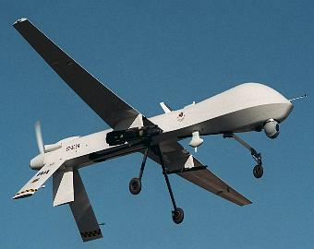

The Air Force established Seeb Air Base as the hub for distributing avgas to various locations throughout the theatre. Although avgas is commercially available throughout most parts of the world, DESC and the US Air Force Petroleum Office (AFPET) identified a supplier that was capable and willing to produce a special batch of military specification avgas to meet the US Air Force's product specification requirement. From January to April 2003, the Ground Fuels Division I supported the Air Force by purchasing 1,119 drums of avgas (59,307 US gallons) under five separate open market purchase contracts totalling an estimated US$437,004. DESC continues to support the Air Force and its Predator mission in support of post-Iraq operations. [3]

In support of Operation ‘Iraqi Freedom’, Direct Delivery Fuels conducted extensive market research of potential military grade avgas suppliers. This research included the market's capabilities and anticipated deliver timeframes of drummed product to Diyarbakir, Turkey. In anticipation of the Turkish Parliament's approval of US troop’s deployment on Turkish soil, Direct Delivery Fuels awarded contracts for truck-to-truck and direct delivery of ground fuels products to the Port of Iskenderun and to Kiziltepe, Turkey. Direct Delivery Fuels also extended the current Turkey commercial service station fuel coupon contract and ordered additional coupon printings to allow troops the capability to refuel tax-free at commercial service stations en-route.

DESC awarded several into-plane contracts in Turkey that were not used because of the Turkish government's decision to not allow the US military access to their bases. As a result, DESC added Burgas, Bulgaria, on very short notice to supplement en-route traffic into Iraq. This involved coordination of additives. The contractors added a line-item at Rhein Mein International Airport to supplement the government-owned contractor-operated (GOCO) facility at Rhein Mein via the commercial airport to support en-route traffic. Constanta, Romania, was another location added in the absence of Turkey's support. Several smaller locations were added to provide additional support when the Defense Fuel Supply Points (DFSPs) (fuel storage facilities) were taxed to the limit. Excess Fuel System Icing Inhibitors (FSII) were purchased from an into-plane contractor in the event of potential shortage of FSII. (FSII is a jet fuel additive used to prevent the fuel from freezing or jellying up during high altitude flights).

# Aviation Fuel- Shale Oil

The use of shale oil as a source of fuel products dates back as far as the discovery of crude oil. Even as early as the 1920’s and particularly in the 1940’s in wartime, there had been many attempts to make a suitable aviation gasoline from shale oil – nearly all were unsuccessful, either because of quality or economics, or both.

The predominance of jet fuel in the aviation industry has made this the fuel (kerosene) of interest now. The interest in alternative sources of jet fuel has from time to time led to more experimentation with aviation fuels produced from shale oil. This is illustrated by US Air Force trials with shale oil fuels.

Photo 10. US Air Force jet aircraft refuelling with shale oil fuel

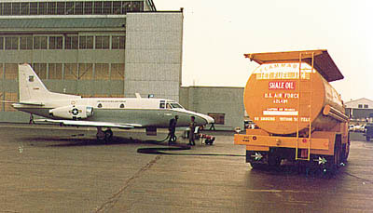

# Aviation Gasoline Composition 1990’s

In 1999 samples of all aviation gasoline then manufactured by Australian refineries were analysed by gas chromatography and mass spectroscopy to determine their composition. The laboratory test results from the test reports of these aviation gasolines listed below.

AVGAS 100/130 Test Results

The following table lists the test results of typical batches of AVGAS 100/130 grade manufactured at Mobil Altona Refinery and BP Kwinana Refinery in 1999/2000. The tests were undertaken at the respective refinery laboratory and the test reports were made available to the author.

Table Australian AVGAS 100/130 tested in 1999

|  |  |  |  |
| --- | --- | --- | --- |
| Petroch ID | | 2 | 4 |
| Refinery Source | | 100% Mobil Altona | 100% BP Kwinana |
| Sample | | Not listed | 42271 |
| Batch No | | M317J9AM | 0013 |
| Date sampled | | Not advised | Jan 12, 2000 |
| Tank No. | | Yarraville Tk. 36 | Kwinana Tk. 408 |
| Report No. | | 3/8004 | 42271-3 |
| Composition | | 13.47% 3/7960, 86.53% V41 | 100% BP Kwinana |
| Report Date | | Sept 16, 1999 | Jan 14,2000 |
| Specification | | DERD2485 | DERD2484-May 1996 |
| Test | Method ASTM or IP | Results | Results |
| Visual Appearance | Visual | B,C (Bright & Clear) | B,C |
| Density kg/l @ 15 deg C | D4052 | 0.6968 | 0.7047 |
| Distillation | D86 |  |  |
| Initial Boiling Point |  | 35.2 | 35.8 |
| 10% evaporated |  | 71.6 | 69.9 |
| 40% evaporated |  | 101.2 | 96.7 |
| 50% evaporated |  | 104.0 | 100.6 |
| 90% evaporated |  | 112.4 | 112.3 |
| Final Boiling Point |  | 130.3 | 141.3 |
| 10%+50% evaporated |  | 175.6 | 170.5 |
| Residue |  | 1.2 | 1.1 |
| Loss |  | 1.0 | 0.9 |
| Vapour Pressure kPa @ 38 deg C | D323 (or D5191) | 46.00 | 46.7 |
| Colour | IP17 (or IP17A) Lovibond | Green | Green |
| Blue |  | 2.2 | 2.5 |
| Red |  | Nil |  |
| Yellow |  | 2.2 | 2.1 |
| Dye Concentration | Blue mg/L | 1.81 | 2.2 |
| Type | Auto Blue 8 |  |
| Yellow mg/L | 0.6 | 2.8 |
| Type | Auto Yellow 8 |  |
| Freezing Point deg C | D2386 | <-70 | -60 |
| Sulphur Content | D1266 (or IP 336) | <0.01 | 0.01 |
| Corrosion Copper Strip | D130 | 1a | 1a |
| Existent Gum mg/100 ml | D381 | 0 | 1 |
| Oxidation Stability  Potential Gum mg/100ml | D873 | 1 | 1 |
| Lead Precipitate mg/100ml |  | 1 | <1 |
| Oxidation inhibitor | Conc. Mg/L | 12.0 | 16.4 |
| Reference |  | RDE/A/609 | RDE/A/607 |
| Type |  | Ethyl Hitec 4776 | “Spec Aid” |
| Conductivity pS/m @ 21.2 deg C | D2624 | 0 |  |
| Net Heat of Combustion MJ/kg | D1405 (or D3338) | 44.35 | 44.023 |
| Water Reaction | D1094 |  |  |
| Volume change |  | <0.5 | 0 |
| Interface Rating |  | 1 | 1 |
| Separation Rating |  |  |  |
| Hydrocarbons Aromatics Vol.% | D1319 |  | 7.6 |
| Motor Method (Performance No.) | D2700 | 108.7 | 116.3 |
| Supercharge Method (Perf. No.) | D909 | 132.8 | 131.6 |
| Lead Content (TEL) gm/L | IP270 | 0.49 | 0.694 |

A cursory examination of the above table shows that many of the test parameters established over half a century earlier (Anti-knock value, Volatility, Vapour locking tendency, Stability, Solvent and corrosion properties) are still in use: - Performance Numbers for MON and F4 Supercharge motor, Distillation 10% evaporated and (10%+50% evaporated), Volatility (vapour pressure is still 7.0 psi Max. (48.2 kPa), Oxidation stability – potential gum, existent gum, Corrosion – Copper strip, Sulphur content limits are unchanged. The colour is still green. The only change has been the optional inclusion of a Conductivity Test to ensure that static electricity will dissipate. There is more detail on the dyes and antioxidants to ensure that only ‘approved’ additives have been used in the fuel.

Comparison of Sources of AVGAS 100/130

Comparison of these two batches shows there are subtle differences due to the different compositions (BP Avgas 100/130 contains 7.6% aromatics from the use of an aromatic blendstock, namely narrow cut reformate, while Altona Avgas 100/130 has no aromatics). The differences (effect of aromatics) can be seen in that the BP Avgas has a slightly higher density, higher distillation final boiling point, significantly higher MON, and a markedly higher freezing point near to the limit of the specification. The difference can be illustrated by the Carbon Number distribution – the Mobil Altona Refinery Avgas 100/130 is entirely 100% paraffins (nil Aromatics, nil Naphthenes) and predominantly C8 hydrocarbons, whereas the BP Kwinana Refinery Avgas 100/130 contains 7.6% aromatics.

Graph . Mobil Altona Refinery Avgas 100/130 Carbon Number Distribution – 1999

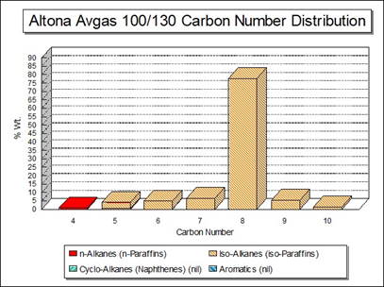

Graph . BP Kwinana Refinery Avgas 100/130 Carbon Number Distribution – 1999

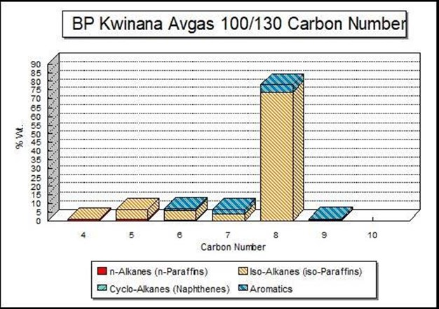

AVGAS 100 LL Test Results

Mobil’s Altona Refinery and BP’s Kwinana Refinery produced AVGAS 100/130, however the other aviation gasoline grade also available on the market is AVGAS 100LL, which is produced at Shell Geelong Refinery. Altona Refinery also produced a test batch of this low lead grade aviation gasoline, however this was not pursued, and until 2000 Altona continued to produce AVGAS 100/130 as its principal avgas grade.

Table . Australian AVGAS 100LL tested 1999/2000

|  |  |  |  |
| --- | --- | --- | --- |
| Petroch ID | | 3 | 5 |
| Refinery Source | | Mobil Altona | Shell Geelong |
| Sample | | Not listed | Not listed |
| Batch No | | Not listed | SV009A0 |
| Date sampled | | Not listed | Not listed |
| Tank No. | | Altona Tk. 509 | Geelong Tk 96 |
| Report No. | | 99/679a | 142/00 |
| Composition | | 100% Altona | 100% Geelong |
| Report Date | | Nov 11, 1999 | Jan 16, 2000 |
| Specification | | DERD 2485 Issue 9 | Def Stan 91-90 |
| Test | Method ASTM or IP | Results | Results |
| Visual Appearance | Visual | B, C | C & B (Clear & Bright) |
| Indirect Odour |  |  | Marketable |
| Density kg/l @ 15 deg C | D4052 | 0.6965 | 0.7207 |
| Distillation | D86 |  |  |
| Initial Boiling Point |  | 34.5 | 38 |
| 10% evaporated |  | 71.7 | 69 |
| 40% evaporated |  | 99.7 | 97 |
| 50% evaporated |  | 102.9 | 101 |
| 90% evaporated |  | 111.1 | 114 |
| Final Boiling Point |  | 130.7 | 140 |
| 10%+50% evaporated |  | 174.6 | 170 |
| Residue |  | 0.9 | 1 |
| Loss |  | 0.8 | 1.3 |
| Vapour Pressure kPa @ 38 deg C | D323 (or D5191) | 44.25 | 43.0 |
| Colour | IP17 (or IP17A) Lovibond | Blue | Blue |
| Blue |  | 2.1 | 2.7 |
| Red |  | - |  |
| Yellow |  | - |  |
| Dye Concentration | Blue mg/L | 1 | 1.8 |
| Freezing Point deg C | D2386 | <-70 | <-80 |
| Sulphur Content | D1266 (or IP 336) | 0.02 | <0.01 |
| Corrosion Copper Strip | D130 | 1A | 1 |
| Existent Gum mg/100ml | D381 | 0 | 1 |
| Oxidation Stability Potential Gum mg/100ml | D873 | 0 | 2 |
| Lead Precipitate mg/100ml |  | 0 | <1 |
| Oxidation inhibitor | Conc. mg/L | 12.0 | 20 |
| Reference |  | RDE/A/609 | RDE/A/609 |
| Type |  | Ethyl Hitec 4776 | Isonox 133 |
| Conductivity pS/m @ 21.2 deg C | D2624 |  |  |
| Net Heat of Combustion MJ/kg | D1405 (or D3338) | 44.35 | 43.7 |
| Aniline Gravity Product | D611/D4052 |  |  |
| Water Reaction | D1094 |  |  |
| Volume change |  | 0.0 | <1 |
| Interface Rating |  | 1b | 1b |
| Separation Rating |  | 1 |  |
| Hydrocarbons Aromatics Vol.% | D1319 | 0.6 | 18.0 |
| Motor Method (Performance No.) | D2700 | 106.4 | 105.9 |
| Supercharge Method (Perf. No.) | D909 | 133.6 | 136.6 |
| Lead Content (TEL) gm/L | IP270 | 0.493 | 0.54 |

Comparison of Sources of AVGAS 100LL

Again comparison of the two batches shows that there are subtle differences due to the different compositions (Shell Avgas 100LL contains 18% aromatics from the use of an aromatic blendstock, namely narrow cut reformate, while Altona Avgas 100LL has very little aromatics 0.6% as measured by Test Method D1319 which used liquid-solid separation and not as accurate as GC-Mass Spec.).

The differences (effect of aromatics) can be seen in that the Shell Avgas 100LL has a markedly higher density, higher distillation final boiling point, higher Supercharge Performance Number possibly due to lower Sulphur content, and a markedly lower freezing point.

Again the difference can be illustrated by the Carbon Number distribution showing Mobil Altona Refinery Avgas 100LL is entirely 100% paraffins (nil aromatics by GC-MS, nil naphthenes) and predominantly C8 hydrocarbons, whereas the Shell Geelong Avgas 100LL contains 18% aromatics.

It should be remembered that the Altona Avgas 100LL was a test batch to determine if this grade could be manufactured, however further production of this Low-lead avgas grade at this refinery was not progressed.

Graph . Shell Geelong Refinery Avgas 100LL Carbon Number Distribution (circa 2000)



Graph . Mobil Altona Refinery Avgas 100LL Carbon Number Distribution (1999)



Comparison with Early Gasolines

The significant changes in aviation gasoline composition are clearly illustrated when the comparison of the carbon number distribution is made with the early gasolines used for aviation gasoline (1910), when there were no chemical or refinery alkylation or reforming processes utilised, and the quality of the gasoline was dependent entirely on the selection of crude type and simple distillation. The carbon number was distributed across predominantly C5 to C8 and contained substantial amount of naphthenes and normal alkanes.

Graph . Shell 1910 Gasoline Carbon Number Distribution

As stated earlier, avgas samples from three different Australian refineries were examined in detail.

The analyses of samples supplied by Petroch Services was undertaken by Deakin University Department of Biological and Chemical Sciences in 2000 using gas chromatograph- mass spectroscopy techniques. The output data was reviewed by Petroch Services and corrected where required.

The composition of these avgas samples is listed in Table 3. Summary of Australian Aviation Gasolines Composition (circa 1999).

# Avgas Composition (Detailed)

Table . Summary of Australian Aviation Gasolines Composition (circa 1999)

|  |  |  |  |  |  |  |  |  |  |
| --- | --- | --- | --- | --- | --- | --- | --- | --- | --- |
| Refinery Source | Mobil Altona | BP Kwinana | Mobil Altona | Shell Geelong | CRC Handbook | | | | |
| Batch | M317J9AM | 0013 | Tk. 509 | SV009A0 |
| Grade | Avgas 100/130 | Avgas 100/130 | Avgas 100LL | Avgas 100LL |
| **Component ID** | **%W/W** | **%W/W** | **%W/W** | **%W/W** | Structure No. | Other names | CAS No. | MW | Formula |
| Isobutane |  | 0.14 |  | 0.19 | 10073 | 2 Methyl Propane | 75-28-5 | 58.12 | C 4H10 |
| n-Butane | 0.80 | 0.92 | 0.16 | 0.57 | 3229 |  | 106-97-8 | 58.12 | C 4H10 |
| Cyclopentane |  |  |  | 0.04 | 4774 |  | 287-92-3 | 70.13 | C 5H10 |
| Isopentane | 3.65 | 5.29 | 1.97 | 6.73 | 3397 | 2 Methyl Butane | 78-78-4 | 72.15 | C 5H12 |
| n-Pentane | 0.33 | 1.11 | 0.24 | 1.04 | 8709 |  | 109-66-0 | 72.15 | C 5H12 |
| Benzene |  | 0.92 |  | 2.89 | 867 |  | 71-43-2 | 78.11 | C 6H6 |
| Methyl Cyclopentane |  | 0.04 |  | 0.11 | 4826 |  | 96-37-7 | 84.13 | C 6H12 |
| Cyclohexane |  | 0.03 |  | 0.08 | 4305 |  | 110-82-7 | 84.16 | C 6H12 |
| 2,2 Dimethyl Butane | 0.03 | 1.40 | 0.08 | 0.24 | 3289 | Neohexane | 75-83-2 | 86.18 | C 6H14 |
| 2,3 Dimethyl Butane | 4.13 | 2.88 | 3.36 | 1.89 | 3290 |  | 79-29-8 | 86.18 | C 6H14 |
| 3 Methyl Pentane | 0.52 | 0.99 | 0.47 | 0.81 | 8824 |  | 96-14-0 | 86.18 | C 6H14 |
| n-Hexane | 0.05 | 0.58 | 0.09 | 0.69 | 6731 |  | 110-54-3 | 86.18 | C 6H14 |
| Toluene |  | 2.57 |  | 10.88 | 1947 |  | 108-88-3 | 92.14 | C 7H 8 |
| trans 1,2-Dimethyl Cyclopentane |  |  |  | 0.01 | 4802 |  | 822-50-4 | 98.19 | C 7H14 |
| Methyl Cyclohexane |  | 0.01 |  |  | 4426 |  | 108-87-2 | 98.19 | C 7H14 |
| 2,2 Dimethyl Pentane | 3.39 | 2.16 | 3.08 | 1.70 | 8760 |  | 590-35-2 | 100.20 | C 7H16 |
| 2,2,3-Trimethyl Butane | 0.28 | 0.09 | 0.23 | 0.06 | 3457 | Triptane | 464-06-2 | 100.20 | C 7H16 |
| 2,3 Dimethyl Pentane | 0.26 |  | 0.26 |  | 8761 |  | 565-59-3 | 100.20 | C 7H16 |
| 2 Methyl Hexane | 2.35 | 1.37 | 2.48 | 1.89 | 6834 | Isoheptane | 591-76-4 | 100.20 | C 7H16 |
| 3-Ethyl Pentane | 0.11 | 0.25 | 0.19 | 0.73 | 8809 |  | 617-78-7 | 100.20 | C 7H16 |
| n-Heptane |  | 0.12 | 0.03 | 0.54 | 6355 |  | 142-82-5 | 100.20 | C 7H16 |
| Ethyl Benzene |  | 0.54 |  | 0.82 | 1668 |  | 100-41-4 | 106.17 | C 8H10 |
| p-Xylene |  | 2.70 |  | 3.40 | 1454 |  | 106-42-3 | 106.17 | C 8H10 |
| o-Xylene |  | 1.11 |  | 1.01 | 1452 |  | 95-47-6 | 106.17 | C 8H10 |
| 1,1-Dimethyl Cyclohexane |  |  |  | 0.05 | 4364 |  | 590-66-9 | 112.22 | C 8H16 |
| 2,2,4-Trimethyl Pentane | 29.05 | 43.06 | 30.20 | 32.56 | 8848 | Iso-octane | 540-84-1 | 114.23 | C 8H18 |
| 2,5 Dimethyl Hexane | 5.58 | 3.09 | 5.28 | 2.67 | 6774 |  | 592-13-2 | 114.23 | C 8H18 |
| 2,4 Dimethyl Hexane | 3.80 | 4.18 | 4.24 | 3.52 | 6773 |  | 589-43-5 | 114.23 | C 8H18 |
| 2,2,3-Trimethyl Pentane | 1.66 |  | 1.86 |  | 8847 | 2-tert-Butyl Butane | 564-02-3 | 114.23 | C 8H18 |
| 2,3,4-Trimethyl Pentane | 19.21 | 13.04 | 20.33 | 9.66 | 8850 |  | 565-75-3 | 114.23 | C 8H18 |
| 2,3,3-Trimethyl Pentane | 17.86 | 6.56 | 19.66 | 6.08 | 8849 |  | 560-21-4 | 114.23 | C 8H18 |
| 2,3 Dimethyl Hexane |  | 3.40 |  | 3.02 | 6772 |  | 584-94-1 | 114.23 | C 8H18 |
| 3 Methyl Heptane |  | 0.14 |  | 0.19 | 6423 |  | 6131-25-5 | 114.23 | C 8H18 |
| 3,4 Dimethyl Hexane | 0.57 |  | 0.67 |  | 6776 |  | 583-48-2 | 114.23 | C 8H18 |
| n-Octane | 0.02 | 0.00 | 0.02 | 0.05 | 8355 |  | 111-65-9 | 114.23 | C 8H18 |
| Isopropyl Benzene |  | 0.04 |  | 0.03 | 1975 | Cumene | 98-82-8 | 120.19 | C 9H12 |
| Propyl Benzene |  | 0.08 |  | 0.10 | 2169 |  | 103-65-1 | 120.19 | C 9H12 |
| m-Ethyl Toluene |  | 0.19 |  | 0.22 | 1686 |  | 620-14-4 | 120.19 | C 9H12 |
| p-Ethyl Toluene |  | 0.09 |  | 0.13 | 1687 |  | 622-96-8 | 120.19 | C 9H12 |
| 1,3,5 Tri Methyl Benzene |  | 0.06 |  | 0.05 | 2359 | Mesitylene | 108-67-8 | 120.19 | C 9H12 |
| 1,2,4-Trimethyl Benzene |  | 0.22 |  | 0.20 | 2358 | Psuedocumene | 95-63-6 | 120.19 | C 9H12 |
| 1,2,3-Trimethyl Benzene |  | 0.02 |  | 0.04 | 2357 |  | 526-73-6 | 120.19 | C 9H12 |
| 2,2,5-Trimethyl Hexane | 3.36 | 0.50 | 3.06 | 3.71 | 6861 |  | 3522-94-9 | 128.26 | C 9H20 |
| 2,2,4-Trimethyl Hexane |  | 0.04 |  | 0.06 | 6860 |  | 16747-26-5 | 128.26 | C 9H20 |
| 2,4,4-Trimethyl Hexane | 0.09 | 0.00 | 0.05 | 0.09 | 6865 |  | 16747-30-1 | 128.26 | C 9H20 |
| 2,3,5-Trimethyl Hexane | 0.57 | 0.03 | 0.52 | 0.53 | 6864 |  | 1069-53-0 | 128.26 | C 9H20 |
| 2,2,3-Trimethyl Hexane | 0.04 |  | 0.03 | 0.13 | 6859 |  | 16747-25-4 | 128.26 | C 9H20 |
| 2 Methyl 4-Ethyl Hexane | 0.05 |  | 0.04 | 0.03 | 6828 |  | 3074-75-7 | 128.26 | C 9H20 |
| 2,6 Dimethyl Heptane | 0.17 |  | 0.12 | 0.16 | 6387 |  | 1072-05-5 | 128.26 | C 9H20 |
| 3 Ethyl 2,4-Dimethyl Pentane | 0.09 |  |  |  | 8812 |  | 1068-87-7 | 128.26 | C 9H20 |
| 2,3,3-Trimethyl Hexane | 0.02 |  | 0.03 | 0.02 | 6862 |  | 16747-28-7 | 128.26 | C 9H20 |
| 2,3,4-Trimethyl Hexane | 0.07 |  | 0.08 | 0.16 | 6863 |  | 921-47-1 | 128.26 | C 9H20 |
| 4 Methyl 3-Ethyl Hexane | 0.44 |  | 0.41 |  | 6827 |  | 3074-77-9 | 128.26 | C 9H20 |
| 3,3,4-Trimethyl Hexane | 0.16 |  | 0.10 | 0.06 | 6866 |  | 16747-31-2 | 128.26 | C 9H20 |
| 3,4 Dimethyl Heptane | 0.28 | 0.02 | 0.21 |  | 6389 |  | 922-28-1 | 128.26 | C 9H20 |
| 2,4,6-Trimethyl Heptane | 0.14 |  | 0.10 |  | 6447 |  | 2613-61-8 | 142.28 | C10H22 |
| 2,2,4-Trimethyl Heptane | 0.09 |  | 0.05 | 0.01 | 6438 |  | 14720-74-2 | 142.28 | C10H22 |
| 2,2,6-Trimethyl Heptane | 0.02 |  | 0.01 |  | 6440 |  | 1190-83-6 | 142.28 | C10H22 |
| 2,5,5-Trimethyl Heptane | 0.34 |  | 0.16 | 0.10 | 6448 |  | 1189-99-7 | 142.28 | C10H22 |
| 2,4,5-Trimethyl Heptane | 0.07 |  | 0.02 |  | 6446 |  | 20278-84-6 | 142.28 | C10H22 |
| 2,2,3-Trimethyl Heptane | 0.05 |  | 0.01 | 0.05 | 6437 |  | 52896-92-1 | 142.28 | C10H22 |
| 2,3,4-Trimethyl Heptane | 0.02 |  |  |  | 6442 |  | 52896-95-4 | 142.28 | C10H22 |
| 3,3,4-Trimethyl Heptane | 0.05 |  | 0.01 |  | 6449 |  | 20278-87-9 | 142.28 | C10H22 |
| 3,6 Dimethyl Octane | 0.01 |  |  |  | 8382 |  | 15869-94-0 | 142.28 | C10H22 |
| 3,4 Diethyl Hexane | 0.11 |  | 0.04 |  | 6768 |  | 19398-77-7 | 142.28 | C10H22 |
| 3, Diethyl Hexane | 0.08 |  | 0.02 |  | 6767 |  | 17302-02-2 | 142.28 | C10H22 |
| 3,3,3,4 Tetramethyl Hexane | 0.02 |  |  |  | 6854 |  | 5171-84-6 | 142.28 | C10H22 |
| *Tetra Ethyl Lead* | *0.02* | *0.02* | *0.02* | *0.04* |  |  |  |  |  |

# Avgas Specifications & Test Methods 1980’s

Australian Aviation Gasoline Specification

The reliance on the British technical standards for aviation products continued through this period. This was the United Kingdom specification D.Eng.RD (Director of Engine Research and Development) 2485 with various amendments – this applied to all grades of aviation gasoline, however there would be a convergence of specifications by the end of the 1980’s. This would lead to some difficulties for the refiners in meeting the remaining specifications; for example, in the use of dyes.

1. Dye Issue with Avgas 115/145

Difference in US and British specification for Avgas 115/145. ASTM 910 uses only weight and colour match, while DERD 2485 uses weight, colour match and Lovibond colour specification. This makes the British specification difficult to meet using American dyes.

2. Liquid dyes vs. Powder Dyes

When DERD 2485 and ASTM 910 were revised in 1978 Avgas 115/145 was not included in the new specification and consequently the powder dyes (purple) have not been maintained. This can be a problem now since nearly all the powder dyes have been replaced by liquid dyes, and there is no equivalent approved avgas dye. There is also no provision for new additives such as Stadis 450, for example.

ASTM D-910 Specification[4]

ASTM publish many publications, one relevant to this subject is ASTM Manual on Significance of Tests for Petroleum Products 6th Edition. George V. Dyroff – editor. ASTM Manual Series MNL-1 Sixth Edition. ASTM Publication Code Number (PCN) 28-001093-12. Of particular interest is Chapter 5 Aviation Fuels by Geoffrey J. Bishop (Shell International Petroleum Company, London England) Cyrus P. Henry Jr. (DuPont Company, Deepwater, New Jersey, U.S.A.), which describes the various aspects of aviation gasoline testing. Part of that chapter is restated here:

Fuel Grades

About six basic fuel grades have been in use since the 1939 to 1945 war period. In recent years, the diminishing demand for aviation gasolines has led to a reduction in the number of grades available. With fewer fuel grades, manufacturing, storage, and handling costs were reduced with subsequent benefits to consumers. At present (year 2004), three grades - 80, 100, and 100 low lead are specified in ASTM Specification for Aviation Gasoline (D910).

Specifications covering the various grades have been drawn up by a number of bodies, and these have been revised as engine requirements changed. The most commonly quoted aviation gasoline specifications are those issued by the American Society for Testing and Materials (ASTM D910) and the British Ministry of Defence (DERD 2485). Table 4 lists the main aviation gasoline specifications in current use and indicates the various grades together with their identifying dye colours.

Table . Aviation Gasolines main international specification grades

|  |  |  |  |  |  |
| --- | --- | --- | --- | --- | --- |
| Identifying Colour | Nominal Antiknock Characteristics Lean/Rich | NATO Code Number | Current Specifications | | Use |
| DERD 2485 British Ministry of Defence | ASTM D910 |
| Colourless | 73 | F-13 (a) | - | - | Blending component |
| Colourless | 80 | - | - | - | Blending, historic |
| Red | 80/87 | F-12 | 80 | 80 | Minor civil |
| Blue | 91/96 | F-15 (a) | - |  | Obsolete |
| Blue | 100/130 | F-18 | 100LL | 100LL | Major civil |
| Green | 100/130 | - | 100 | 100 | Minor military |
| Brown | 108/135 | - | - | - | Obsolete |
| Purple | 115/145 | F-22 | 115 | - | Military - virtually obsolete |

(a) Obsolete designation.

The US Department of Defense former specification for Avgas MIL-G-5572 was withdrawn in 1988.

Due to the international nature of aviation activities, the technical requirements of all the Western specifications are virtually identical, and only differences of a minor nature exist between the specifications issued in the various major countries.

Table 5. provides detailed requirements for aviation gasoline as contained in ASTM Specification for Aviation Gasoline (D910). In general, the main technical requirements of all other Western specifications are virtually identical to those in Table 5, although differences occur in the number of grades covered and, in some cases, the amount of tetraethyl lead (TEL) permitted. The various grades within the specification differ fundamentally in only a few vital respects, such as colour, antiknock ratings, and TEL content. This is true of all the Western aviation gasoline specifications.

The limits specified for Western grades of aviation gasoline were, in most cases, dictated originally by military aircraft engine requirements. Since then, the performance requirements for civil and military aircraft engines have changed very little. However, improved fuel manufacturing techniques and the reduced demand for certain grade, has allowed fuel suppliers to produce modified fuel grades more suited to market requirements. In some cases, the objective has been to offer a technically superior fuel; in other cases, the aim has been the reduction of production, storage, and handling costs by providing a fuel suitable for use in a wider range of engine types than was possible with the standard grades.

Table . Detailed requirements for ASTM Specification for Aviation Gasolines (D910).

|  |  |  |  |
| --- | --- | --- | --- |
| Test | Grade 80 | Grade 100 | Grade 100LL |
| Knock value, lean rating: Minimum octane number (MON) | 80 | 100 | 100 |
| Knock value, rich rating. Minimum octane number (MON) | 87 | - | - |
| Minimum performance number (PN) | - | 130 | 130 |
| Colour | Red | Green | Blue |
| Dye Content | | | |
| Permissible blue dye, max, mg/US gal | 0.5 | 4.7 | 5.7 |
| Permissible yellow dye, mg/US gal | None | 5.9 | None |
| Permissible red dye, max, g/US gal | 8.65 | None | None |
| Tetraethyl lead, max. mL/US gal | 0.5 | 4.0 | 2.0 |
| TEL max gm Pb/L | 0.14 | 1.12 | 0.56 |

Requirements for All Grades

|  |  |
| --- | --- |
| Test | All Grades |
| Distillation temperature. oC (oF): |  |
| 10% evaporated, max temp | 73 (167) |
| 40% evaporated, min temp | 75 (167) |
| 50% evaporated, max temp | 105 (221) |
| 90% evaporated, max temp | 135 (275) |
| Final boiling point, max. oC (oF): | 170 (338) |
| Sum of 10 and 50% evaporated temperatures, min. oC (oF): | 135 (307) |
| Distillation recovery, min. % | 97 |
| Distillation residue, max. % | 1.5 |
| Distillation loss, max. % | 1.5 |
| Net heat of combustion, min. Btu/lb (MJ/kg) | 18720 (43.54) |
| Vapour pressure: min. kPa (psi) | 38 (5.5) |
| max, kPa (psi) | 49 (7.0) |
| Copper strip corrosion, max | No. 1 |
| Potential gum (5-hr aging gum) max. mg/100 mL | 6 |
| Visible lead precipitate, max. mg/100 mL | 3 |
| Sulfur max %m | 0.05 |
| Freezing point, max. oC (oF) | -58 (-72) |
| Water reaction | Volume change not to exceed ± 2 mL |
| Permissible antioxidants, max. mg/L | 12 |

The following ASTM test methods are based on those issued in 2004. There have been subsequent revisions as of 2017.

ASTM Test Methods D910[5]

The specification scope and ASTM test methods, and other relevant information for Aviation Gasoline specification ASTM D910-04a which can be found in ASTM Book of Standards Volume: 05.01 are summarized as follows:

Scope (of ASTM D910-04a Specification)

1.1 This specification is for the use of purchasing agencies in formulating specifications for purchases of aviation gasoline under contract.

1.2 This specification defines specific types of aviation gasolines for civil use. It does not include all gasolines satisfactory for reciprocating aviation engines. Certain equipment or conditions of use may permit a wider, or require a narrower, range of characteristics than is shown by this specification.

Referenced Documents – Test methods

D86 Test Method for Distillation of Petroleum Products at Atmospheric Pressure

D93 Test Methods for Flash-Point by Pensky-Martens Closed Cup Tester [Comment – this is not relevant for avgas, since the flash point is below ambient. It is more appropriate for jet fuels]

D130 Test Method for Detection of Copper Corrosion from Petroleum Products by the Copper Strip Tarnish Test

D323 Test Method for Vapor Pressure of Petroleum Products (Reid Method)

D381 Test Method for Gum Content in Fuels by Jet Evaporation

D873 Test Method for Oxidation Stability of Aviation Fuels (Potential Residue Method)

D909 Test Method for Knock Characteristics of Aviation Gasolines by the Supercharge Method

D1094 Test Method for Water Reaction of Aviation Fuels

D1266 Test Method for Sulfur in Petroleum Products (Lamp Method)

D1298 Test Method for Density, Relative Density (Specific Gravity), or API Gravity of Crude Petroleum and Liquid Petroleum Products by Hydrometer Method

D2386 Test Method for Freezing Point of Aviation Fuels

D2392 Test Method for Color of Dyed Aviation Gasolines

D2622 Test Method for Sulfur in Petroleum Products by Wavelength Dispersive X-ray Fluorescence Spectrometry

D2624 Test Methods for Electrical Conductivity of Aviation and Distillate Fuels. [Comment – this is not relevant for avgas; it is more appropriate for jet fuels]

D2700 Test Method for Motor Octane Number of Spark-Ignition Engine Fuel

D3338 Test Method for Estimation of Net Heat of Combustion of Aviation Fuels

D3341 Test Method for Lead in Gasoline-Iodine Monochloride Method

D4052 Test Method for Density and Relative Density of Liquids by Digital Density Meter

D4057 Practice for Manual Sampling of Petroleum and Petroleum Products

D4171 Specification for Fuel System Icing Inhibitors

D4306 Practice for Aviation Fuel Sample Containers for Tests Affected by Trace Contamination

D4529 Test Method for Estimation of Net Heat of Combustion of Aviation Fuels

D4809 Test Method for Heat of Combustion of Liquid Hydrocarbon Fuels by Bomb Calorimeter (Precision Method)

D4865 Guide for Generation and Dissipation of Static Electricity in Petroleum Fuel Systems. [Comment – this is not relevant for avgas; it is more appropriate for jet fuels]

D5006 Test Method for Measurement of Fuel System Icing Inhibitors (Ether Type) in Aviation Fuels

D5059 Test Methods for Lead in Gasoline by X-Ray Spectroscopy

D5190 Test Method for Vapor Pressure of Petroleum Products (Automatic Method)

D5191 Test Method for Vapor Pressure of Petroleum Products (Mini Method)

D6469 Guide for Microbial Contamination in Fuels and Fuel Systems

E29 Practice for Using Significant Digits in Test Data to Determine Conformance with Specifications

D357 Method of Test for Knock Characteristics of Motor Fuels Below 100 Octane Number by the Motor Method

D614 Method of Test for Knock Characteristics of Aviation Fuels by the Aviation Method

ASTM Test Methods D6227[6]

It is of note that a number of test methods relate to compositions or properties not normally associated with aviation gasoline - for example D4815 Test Method for Determination of MTBE, ETBE, TAME, DIPE, Amyl Alcohol and C1 to C4 Alcohols in Gasoline by Gas Chromatography – this are blendstocks (oxygenates) usually associated with motor gasoline. Further, as laboratory equipment has become more advanced, the introduction of automated testing equipment is now incorporated – for example traditional Sulphur test D1266 (Lamp method) being superceded by D2622 using Wavelength Dispersive X-ray Fluorescence Spectrometry.

The specification scope and ASTM test methods, and other relevant information for Aviation Gasoline specification ASTM D6227-04a which can be found in ASTM Book of Standards Volume: 05.03 are summarized as follows:

Scope (of ASTM D6227-04a Specification)

1.1 Grade 82 unleaded aviation gasoline defined by this specification is for use only in engines and associated aircraft that are specifically approved by the engine and aircraft manufacturers, and certified by the National Certifying Agencies to use this fuel. This fuel is not considered suitable for use in other engines and associated aircraft that are certified to use aviation gasolines meeting Specification D910.

1.2 A fuel may be certified to meet this specification by a producer as Grade 82 UL aviation gasoline, only if blended from component(s) approved for use in Grade 82 UL aviation gasoline by the refiner(s) of such components because only the refiner(s) can attest to the component source and processing, absence of contamination, and the additives used and their concentrations. Consequently, re-classifying and any other product to Grade 82 UL aviation gasoline does not meet this specification.

Referenced Documents – Test methods

D86 Test Method for Distillation of Petroleum Products at Atmospheric Pressure

D130 Test Method for Corrosiveness to Copper from Petroleum Products by Copper Strip Test

D381 Test Method for Gum Content in Fuels by Jet Evaporation

D873 Test Method for Oxidation Stability of Aviation Fuels (Potential Residue Method)

D909 Test Method for Knock Characteristics of Aviation Gasolines by the Supercharge Method

D910 Specification for Aviation Gasolines

D1266 Test Method for Sulfur in Petroleum Products (Lamp Method)

D2386 Test Method for Freezing Point of Aviation Fuels

D2392 Test Method for Color of Dyed Aviation Gasolines

D2622 Test Method for Sulfur in Petroleum Products by Wavelength Dispersive X-ray Fluorescence Spectrometry

D2700 Test Method for Motor Octane Number of Spark-Ignition Engine Fuel

D3120 Test Method for Trace Quantities of Sulfur in Light Liquid Petroleum Hydrocarbons by Oxidative Microcoulometry

D3231 Test Method for Phosphorus in Gasoline

D3237 Test Method for Lead in Gasoline by Atomic Absorption Spectroscopy

D3338 Test Method for Estimation of Net Heat of Combustion of Aviation Fuels

D4057 Practice for Manual Sampling of Petroleum and Petroleum Products

D4171 Specification for Fuel System Icing Inhibitors

D4294 Test Method for Sulfur in Petroleum and Petroleum Products by Energy-Dispersive X-Ray Fluorescence Spectroscopy

D4529 Test Method for Estimation of Net Heat of Combustion of Aviation Fuels

D4809 Test Method for Heat of Combustion of Liquid Hydrocarbon Fuels by Bomb Calorimeter (Precision Method)

D4815 Test Method for Determination of MTBE, ETBE, TAME, DIPE, -Amyl Alcohol and C1 to C4 Alcohols in Gasoline by Gas Chromatography

D4953 Test Method for Vapor Pressure of Gasoline and Gasoline-Oxygenate Blends (Dry Method)

D5059 Test Methods for Lead in Gasoline by X-Ray Spectroscopy

D5190 Test Method for Vapor Pressure of Petroleum Products (Automatic Method)

D5191 Test Method for Vapor Pressure of Petroleum Products (Mini Method)

D5453 Test Method for Determination of Total Sulfur in Light Hydrocarbons, Motor Fuels and Oils by Ultraviolet Fluorescence

D5482 Test Method for Vapor Pressure of Petroleum Products (Mini Method-Atmospheric)

D5599 Test Method for Determination of Oxygenates in Gasoline by Gas Chromatography and Oxygen Selective Flame Ionization Detection

D5845 Test Method for Determination of MTBE, ETBE, TAME, DIPE, Methanol, Ethanol and -Butanol in Gasoline by Infrared Spectroscopy

D5983 Specification for Methyl -Butyl Ether (MTBE) for Downstream Blending for Use in Automotive Spark-Ignition Engine Fuel

D6469 Guide for Microbial Contamination in Fuels and Fuel Systems

E29 Practice for Using Significant Digits in Test Data to Determine Conformance with Specifications

D357 Method of Test for Knock Characteristics of Motor Fuels Below 100 Octane Number by the Motor Method

MIL-PRF-25017F Performance Specification for Inhibitor, Corrosion/Lubricity Improver, Fuel Soluble

QPL-25017 Qualified Products List of Products Qualified Under Performance Specification MIL-PRF-25017F

Index Terms: aviation gasoline; ether; fuel; gasoline/alcohol blends; gasoline/ether blends; gasoline/oxygenate blends; octane requirement; unleaded aviation gasoline.

ASTM & IP Methods[7]

While the American ASTM methods are favoured by US developed specifications, and by the American Petroleum Institute; there is also British aviation fuel specifications, which uses the (British) Institute of Petroleum (IP) methods. With the international use of aviation fuels (both avgas and jet fuels), ever since World War II when standardisation was attempted and implemented, some of the test methods have become with joint methods ASTM/IP, or they are accepted as alternatives test methods. The following table shows this comparison.

Table . Applicable ASTM/IP Standards for aviation fuels

|  |  |  |
| --- | --- | --- |
| ASTM | IP | Title |
| D 56 |  | Flash Point by Tag Closed Tester |
| D 86 | 123 | Distillation of Petroleum Products |
| D 93 | 34 | Flash Point by Pensky‑Martin Closed Tester‑ |
|  | 170 | Flash Point by Abel Apparatus |
| D 130 | 154 | Detection of Copper Corrosion from Petroleum Products by the Copper Strip Tarnish Test |
| D 156 |  | Saybolt Color of Petroleum Products (Saybolt Chromometer Method) |
|  | 17 | Colour by the Lovibond Tintometer |
| D 240 | (12) | Heat of Combustion of Liquid Hydrocarbon Fuels by Bomb Calorimeter |
| D 323 | (69) | Vapor Pressure of Petroleum Products (Reid Method) |
| D 381 | 131 | Existent Gum in Fuels by Jet Evaporation |
| D 445 | 71 | Kinematic Viscosity of Transparent and Opaque Liquids (and the Calculation of Dynamic Viscosity) |
| D 611 | 2 | Aniline Point and Mixed Aniline Point of Petroleum Products and Hydrocarbon Solvents |
| D 873 | 138 | Oxidation Stability of Aviation Fuels (Potential Residue Method) |
| D 909 | 119 | Knock Characteristics of Aviation Gasolines by the Supercharge Method |
| D 974 | 139 | Neutralization Number by Color-Indicator Titration |
|  | 225 | Copper in Aviation Turbine Fuels and Light Petroleum Distillates |
| D 1094 | 289 | Water Reaction of Aviation Fuels |
| D 1159 | 130 | Bromine Number of Petroleum Distillates and Commercial Aliphatic Olefins by Electrometric Titration |
| D 1266 | 107 | Sulfur in Petroleum Products (Lamp Method) |
| D 1298 | 160 | Density, Relative Density (Specific Gravity), or API Gravity of Crude Petroleum and Liquid Petroleum Products by Hydrometer Method |
| D 1319 | 156 | Hydrocarbon Types in Liquid Petroleum Products by Fluorescent Indicator Adsorption |
|  | 227 | Silver Corrosion by Aviation Turbine Fuels |
| D 1322 | (57) | Smoke Point of Aviation Turbine Fuels |
| D 1405 |  | Estimation of Net Heat of Combustion of Aviation Fuels |
| D 1552 |  | Sulfur in Petroleum Products (High Temperature Method) |
| D 1740 |  | Luminometer Number of Aviation Turbine Fuels |
| D 1744 |  | Water in Liquid Petroleum Products by Karl Fischer Reagent |
|  | 277 | Icing Inhibitor in Aviation Turbine Fuels |
| D 1840 |  | Naphthalene Hydrocarbons in Aviation Turbine Fuels by Ultraviolet Spectrophotometry |
| D 2276 | 216 | Particulate Contaminant in Aviation Turbine Fuels |
| D 2382 |  | Heat of Combustion of Hydrocarbon Fuels by Bomb Calorimeter (High Precision Method) |
| D 2386 | 16 | Freezing Point of Aviation Fuels |
| D 2392 |  | Color of Dyed Aviation Gasolines |
|  | 224 | Trace Amounts of Lead in Aviation Turbine Fuels and Light Petroleum Distillates |
| D 2622 |  | Sulfur in Petroleum Product, (X-Ray Spectrographic Method) |
| D 2624 | 274 | Electrical Conductivity of Aviation and Distillate Fuels |
| D 2700 | 236 | Knock Characteristics of Motor and Aviation Fuels by the Motor Method |
| D 2887 |  | Boiling Range Distribution of Petroleum Fractions by Gas Chromatography |

Suppliers Specifications

The following is an example of a typical supplier’s specification for Avgas 100LL for UK, as published by PQ&LC Issue 1/1 - Jan ’97 © 2003 Conoco Phillips Company. This is to meet the British DERD 2485 Defence Standard.

Conoco Phillips Limited U.K. Marketing Specification

Table 7. Aviation Gasoline (AVGAS 100LL, Def. Stan. 91-90/1, DERD 2485)

|  |  |  |  |
| --- | --- | --- | --- |
| Property & Units | Limit | | Test Method: ASTM/IP |
| Appearance | Clear, bright and free from solid matter and undissolved water at normal ambient temperatures | | |
| Colour |  | Visual Blue |  |
| Colour, Lovibond |  | Blue | IP 17 (1) |
| Corrosion, Copper Strip | Max | 1 | D130 / 154 |
| Density @ 15 OC kg/litre |  | Report | D1298 / 160 (3) |
| Initial Boiling Point OC |  | Report | D86 / 123 |
| Fuel Evaporation | | | |
| 10 % @ OC | Max | 75 |  |
| 40 % @ OC | Min | 75 |  |
| 50 % @ OC | Max | 105 |  |
| 90 % @ OC | Max | 135 |  |
| End Point OC | Max | 170 |  |
| Sum of 10% & 50% evaporated temp OC | Min | 135 |  |
| Residue % Vol | Max | 1.5 |  |
| Loss % Vol | Max | 1.5 |  |
| Existent Gum mg/100ml | Max | 3 | D381 / 131 |
| Freezing Point OC | Max | -60 | D2386 / 16 |
| Knock Rating Lean Mixture, Motor Method Octane Number | Min | 99.5 | D2700 / 236 (2) |
| Rich Mixture Performance Number | Min | 130 | D909 / 119 |
| Oxidation Stability, 16 hr Potential Gum, mg/100ml | Max | 6 | D873 / 138 |
| Precipitate, mg/100ml | Max | 2 |  |
| Reid Vapour Pressure @37.8C (kPa) | Range | 38.0 - 49.0 | D323 / 69 (4) |
| Specific Energy MJ/kg | Min | 43.5 | IP 12 (3) |
| Sulphur, Total % mass | Max | 0.05 | D1266 / 107 (3) |
| Tetraethyl Lead Content gm Pb/l | Max | 0.56 | IP 270 (3) |
| Water Reaction Interface Rating | Max | 2 | D1094 / 289 |
| Volume Change (ml) | Max | 2 |  |
| Electrical Conductivity, pS/m | Range | 50 - 600 | D2624 / 274 (4) |

Note 1. Colour blue by IP 17, result to be in the range 1.7 - 3.5

Note 2. Knock rating shall be reported to the nearest 0.1 octane / performance number

Note 3. Alternative test methods may be used as specified in Annex B of Def Stan 91-90/1

Note 4. When a static dissipator additive has been added to fuel the conductivity at the point, time and temperature of delivery to the purchaser shall be in the range 50 to 600 pS/m.

# The Future of Aviation Gasoline

The 1990 Amendments to the US Clean Air Act called for the complete phase-out of leaded automotive gasolines, by 1995. Although aviation gasolines were exempt from this legislation, the continued supply of leaded avgas would become increasingly difficult for both logistical and commercial reasons. In the US industry working groups were formed involving interested parties including aircraft operators, engine and aircraft manufacturers, fuel suppliers, aviation authorities, etc. The aim of these industry working groups was two-fold: to develop means and procedures for the safe utilization of selected batches of automotive gasolines in small aircraft requiring low-octane fuel, and to develop a new no-lead or ultra low-lead avgas to replace Avgas 100LL in higher powered engines. Both of these tasks, presented formidable challenges to the aviation industry; the development of an unleaded avgas grade with the performance properties of Avgas 100/130 may prove infeasible and some redefinition of engine requirements may be necessary.

Meanwhile Avgas 82UL had been developed which would indicate that while the golden era of aviation gasoline had long gone and will never return, there may still be a need for this fuel more than 100 years after the Wright Brothers first flew at Kittyhawk.

New Avgas 82UL Grade[8]

With the world-wide trend to eliminated TEL from motor gasolines it would not be long before this would also include aviation gasolines While the number of aviation gasoline grades have decreased, there has been one interesting development in the US with the introduction of a new unleaded aviation gasoline grade based on motor gasoline, This has resulted in a new ASTM specification D6227-04a Standard Specification for Grade 82 Unleaded Aviation Gasoline.

Grade 82 unleaded aviation gasoline defined by this specification is for use only in engines and associated aircraft that are specifically approved by the engine and aircraft manufacturers, and certified by the National Certifying Agencies to use this fuel. This fuel is not considered suitable for use in other engines and associated aircraft that are certified to use aviation gasolines meeting Specification D910.

A fuel may be certified to meet this specification by a producer as Grade 82UL aviation gasoline, only if blended from component(s) approved for use in Grade 82UL aviation gasoline by the refiner(s) of such components because only the refiner(s) can attest to the component source and processing, absence of contamination, and the additives used and their concentrations. Consequently, re-classifying and any other product to Grade 82UL aviation gasoline does not meet this specification.

Avgas beyond ASTM D910 and Leaded Fuels

In a very interesting paper titled “ASTM Aviation Gasoline Fuel Specifications - Beyond ASTM D910 and Leaded Fuels”[9] published in January 2018, it details the efforts and the problems of developing an unleaded aviation gasoline to replace Avgas 100. Part of this paper is listed as follows to show the future of avgas specifications as seen in 2018.

*ASTM D910 is the major specification covering Aviation Gasoline. ASTM D910 now has four grades Grade 91, Grade 100VLL, Grade 100 LL and Grade 100. (The grade 80/87 was removed from ASTM D910 to free up a dye colour for possible use in an unleaded grade to aid in identification as it is anticipated that several unleaded avgas grades might come onto the market.) A UL91 grade has been added to ASTM D7547 and it is anticipated that the Grade 91 will now be removed from ASTM D910 freeing up the brown color and reducing ASTM D910 to three grades.*

*All four of the current grades in ASTM D910 are leaded.*

|  |  |  |  |  |
| --- | --- | --- | --- | --- |
| *Grade 91* | *91.0 min octane by ASTM D2700* | *98 min octane by ASTM D909* | *Lead g/L 0.56 max* | *Dyed Brown* |
| *Grade 100VLL* | *100.0 min octane by ASTM D2700* | *130.0 Performance Number by ASTM D909* | *Lead g/L 0.43 max* | *Dyed Blue* |
| *Grade 100LL* | *100.0 min octane by ASTM D2700* | *130.0 Performance Number by ASTM D909* | *Lead g/L 0.53 max* | *Dyed Blue* |
| *Grade 100* | *100.0 min octane by ASTM D2700* | *130.0 Performance Number by ASTM D909* | *Lead g/L 1.06 max* | *Dyed Green* |

*The industry has been under pressure to move away from these leaded grades and to make and sell unleaded aviation gasoline. The effort to safely move General Aviation over to unleaded aviation gasoline has shifted from industry efforts over to the Piston Aviation Fuel Initiative (PAFI) being led by Peter White of the US Federal Aviation Administration (FAA).*

*There are now four unleaded aviation gasoline specifications:*

*ASTM D6227 “Standard Specification for Unleaded Aviation Gasoline Containing a Non-Hydrocarbon Component”*

*ASTM D7547 “Standard Specification for Hydrocarbon Unleaded Aviation Gasoline”.*

*ASTM D7719 “Standard Specification for High Aromatic Content Unleaded Hydrocarbon Aviation Gasoline”*

*ASTM D7960 “Standard Specification for Unleaded Aviation Gasoline Test Fuel Containing a Non-hydrocarbon Component”*

This paper lists the efforts of several companies involved in developing the new no-lead avgas; some are familiar names BP, Shell, Total, and there are some other new names – Swift Fuels, Afton Chemical Company, Avgas LLC, General Aviation Modifications Inc. and Hjelmco.

Swift Fuels

Swift Fuels makes the UL94 and sells it as a replacement grade for Avgas 100LL for use by lower-octane requirement piston engines that don’t require 100LL. Swift advertised that the UL94 is made with normal petroleum stocks.

*ASTM D7719 (Swift Fuel) “Standard Specification for High Aromatic Content Unleaded Hydrocarbon Gasoline” is based on the high octane Swift fuel. See scope on ASTM D7719. This is for purchasing of a high octane unleaded fuel for testing purposes. It is a 102.2 minimum Motor Octane by ASTM D2700. Usually thought of as a mix of mesitylene and isopentane.*

*There are reportedly problems with the compatibility between this Swift fuel and 100LL Avgas. The octanes tend to drop below an acceptable level in the mid-range of mixture volume percentages. The current leaded fuels are made up of alkanes and the lead works well with the alkanes giving a high Motor Octane Number. As you add the high aromatic fuels to the alkane leaded fuels the ability of the lead to give a high Motor Octane response drops away and somewhere in the 40 to 60pct range of high aromatic fuel inclusion in the blend you get a fuel with a lowered MON (so called incompatible fuels). Then as you move towards higher aromatic inclusions moving from the 60 % to a 100% so the aromatics take over and become predominant and the MON is restored to an acceptable level. To possibly ease some of these compatibility questions Swift has hinted at an ASTM meeting of introducing another fuel to this specification, it would be a UL100. They then changed this and said it may come under another test fuel specification and be called 100R.*

*ASTM D7960 “Standard Specification for Unleaded Aviation Gasoline Test Fuel Containing a Non-hydrocarbon Component.” This is an unleaded aviation gasoline specification being championed by Shell. The grade designation is UL 102 and it is a 102.5 minimum Motor Octane Number fuel. It is generally thought of as a blend of high octane alkylate and a range of aromatic amines and aromatic components.*

(Note: The use of aromatic amines such as Xylidene was one of those used in WWII (refer of the chapter on Blending Agents).

This paper presented the following table (their Table 1.)

*Table 1. Brief Outline of ASTM Specifications and Guides Being Used or Intended for Use in Looking for a Replacement Unleaded Aviation Gasoline. - Replacing Avgas 100LL .*

|  |  |  |  |
| --- | --- | --- | --- |
| ASTM Specification No. | Name | MON | Comments and Possible Future Application (Some of these comments should be considered speculative) |
| ASTM D 910 | Specification for Aviation Gasoline | 100 Leaded | Contains only leaded fuels. Could be phased out but probably only very slowly. Grade 100 used where refiners can’t make the octane requirements of MON 100 Aviation Lean Rating without the use of higher lead levels than allowed in 100LL. The 100VLL is a lower lead version of 100LL. The Grade 91 may be withdrawn in the future leaving the three 100 grades. |
| ASTM D7547 | Specification for Unleaded Aviation Gasoline | 91 and 94 Unleaded | Originally the 91 octane grade was used by the military purchasing agency for use in aircraft designed to operate on 91 MON unleaded fuel. The 94 MON unleaded grade is made and sold by Swift fuels and possibly others. Both grades are finding increased usage. Hjelmco 91/96 UL is a product that can be sold against the 91 grade. Hjelmco uses lean/rich MON numbers and so the product is similar to the 91 aviation grade. Aircraft/engine manufacturers have been making engines certified to run on 91 octane fuel and have issued approvals for the Hjelmco 91/96 and the Total UL91. Both fuels are available in Europe. |
| ASTM D7719 | Specification for High Octane Unleaded Test Fuel | 102.2 Unleaded | Swift Fuel. See scope on ASTM D7719. This is for purchasing of a high octane unleaded fuel for testing purposes. Usually thought of as a mix of mesitylene and isopentane and is a high aromatic content gasoline. The spec is being used to purchase fuels for submission to PAFI testing program. |
| ASTM D7960 | Standard Specification for Unleaded Aviation Gasoline Test Fuel Containing a Nonhydrocarbon Component | 102.5 Unleaded | This is an unleaded aviation gasoline specification being championed by Shell. Like ASTM D7719 this is a test fuel as explained in the scope. The Shell fuel is thought of as a high aromatic fuel with a range of aromatic amines and alkylate. |
| ASTM D6227 | Specification for Unleaded Aviation Gasoline Containing a Non-Hydrocarbon Component | 82.0 and 87.0 Unleaded | Loosely based on automotive gasoline. See write up in previous section to this table. Only for use in engines and associated aircraft that are specifically approved by the engine and aircraft manufacturers and certified by the National Certifying Agencies with Supplemental Type Certificates. Components containing ethers may be present but alcohols are specifically excluded. |

|  |  |  |  |
| --- | --- | --- | --- |
| New Fuel Testing Guide | | | |
| ASTM D7826 | Standard Guide for the Evaluation of New Fuels and New Fuel Additives for Use in Aviation Spark-ignition Engines and Associated Aircraft Installations | See guide for MON’s required | Very much a part of the UAT ARC recommendations and requirements to be met by prospective suppliers of new fuels before undertaking actual engine testing. Quite extensive and requires up-front capital to demonstrate meeting all the test requirements. There have been constant changes to this specification over the last 5 years – and it’s still a work in progress. |
| Detonation Test Methods | | | |
| ASTM D6424 | Standard Practice for Octane Rating Naturally Aspirated Spark Ignition Aircraft Engines | Rates MON for PRF’s at specific points in engine operation | Put in place to be able to standardize test procedures for evaluating the octane rating of new fuels. It is for ground based octane rating for naturally aspirated spark ignition engines using primary reference fuels. |
| ASTM D6812 | Standard Practice for Ground-Based Octane Rating Procedures for Turbocharged/Super charged Spark Ignition Aircraft Engines | Collect data on knocking and conditions | Put in place to be able to standardize test procedures for evaluating the octane rating of new fuels. Similar to ASTM D6424 but this method is for ground based ratings of turbocharged/supercharged engines |

Other Fuels Not Covered By Specifications

There are two other fuels of interest.

One is the Afton- P66 fuel which is a blend of alkylate and Manganese Methcyclopentadienyl Manganese Tricarbonyl (MMT) and the other is GAMI’s G100UL Unleaded Aviation Fuel.

**Afton – P66 UL Avgas.**

There is no current specification on this fuel but Afton is developing a research report which they will ballot along with a specification at some time in the future. Afton has however issued two administrative ballots on their proposed fuel.

The scavenger chemistry is being deliberately obfuscated at this time and is considered proprietary. Intellectual Property data is being put in place and eventually information on the scavenger will be made public. Some scavengers will hurt and are detrimental to octane. It has been decided to stick with the so called “Scavenger B” for the time being.

Afton said getting the right scavenger and right amount is proving to be a challenge. A good scavenger that will not moderate the octane downwards will be one that tends to build up deposits in the combustion chamber. Unlike the ethylene dibromide scavenger in leaded fuel which is very volatile and exits the combustion chamber the scavenger for MMT is not volatile and tends to build up deposits.

**General Aviation Modifications Inc. (GAMI) - G100UL Unleaded Aviation Fuel.**

The GAMI fuel is made up of 1,3,5- trimethyl benzene (also known as mesitylene) plus meta toluide and a limited concentration of amines. The GAMI fuel was not accepted for further evaluation in PAFI and so GAMI decide to pursue an STC. While GAMI claims the components could be easily made in a refinery that may not be the case in reality and the components could be expensive*.*

Problem of taking lead out of avgas

*The On-Going Conundrum of Taking the Lead Out of Aviation Gasoline. The 1990 amendments to the US Clean Air Act (CAA) mandated lead phase out for all “non-road” engines and vehicles. It stated that after 1992 engines could not be manufactured that required leaded fuels. In addition, in 1996 no leaded fuel was to be sold commercially. These amendments to the CAA were responsible for initiating the effort towards the development of an unleaded fuel to replace Avgas 100LL.* For further information refer to the original source.

*To that end, an industry group consisting of the FAA, Original Equipment Manufacturers (OEMs) and aviation consumer groups visited producers to demonstrate the desire for, and requested the development of an unleaded 100 octane aviation gasoline (i.e., UL100 Avgas).*

*Simple solutions that were thought to hold promise, such as replacing TEL with more toluene (the option adopted in moving from Grade 100/130 normal lead to 100/130 low lead, referred to as 100LL) or attempting the use of other metal additives* [such as MMT]*, failed. Moreover, the use of readily available octane boosting oxygenated streams used in motor gasoline (Mogas) at the time (e.g., Methyl tertiary butyl ether (MTBE), Ethyl tertiary butyl ether (ETBE), Tertiary amyl methyl ether (TAME) and Ethanol) also failed to produce the necessary octane performance. It was then recognized that the problem was more complex than initially anticipated, and that a significant effort would be required to remove lead from aviation gasoline and maintain safe octane levels for the existing aircraft fleet.*

*Parallel to this initial effort, the industry was attempting to determine the aircraft fleet octane requirements. In order to make this determination two ASTM methods needed to be developed, providing standard practices for octane rating aircraft engines (i.e., ASTM D6424 & ASTM D6812). One method applies to naturally aspirated spark ignition aircraft engines while the other applies to turbocharged engine octane rating.*

*Despite extensive effort going back to the late 1970’s and the acceleration in developments after 1990, no unleaded replacement aviation gasoline fuel has been found and approved that provides adequate and comparable safety and performance to 100LL. Work on this important issue continues and is now moving forwards through the FAA with efforts to study and develop a suitable unleaded alternative to 100LL.*

*Through PAFI the FAA has now embarked on the search for an unleaded avgas to replace 100LL. On July 1, 2014 the FAA closed its submission for fuels under the PAFI plan. Nine fuels were submitted from five different groups, including Afton Chemical Company, Avgas LLC, Shell Oil, Swift Fuels, and a consortium made up of BP, TOTAL, and Hjelmco. From the original nine submitted fuels the FAA selected three candidate fuels which underwent preliminary testing at the FAA’s William J Hughes Technical Center. Results of this testing led to just two fuels going forward for extensive aircraft and engine testing both on the ground and in the air.*

Perhaps it should be left to this paper for their views.

*Overview and Concluding Remarks*

*There are approximately 167,000 piston-engine aircraft in the United States and a total of 230,000 worldwide that primarily rely on the currently available Avgas 100LL as defined in ASTM D910 “Standard Specification for Aviation Gasoline”. The 100LL specification has been developed iteratively over many years using the ASTM consensus process. The limits for all the critical properties have been vetted and agreed to only after considerable debate and understanding of aircraft and engine operations and always with a view to safety of flight. All grades of gasoline in ASTM D910 are currently leaded but a considerable research effort is being headed up by the FAA through the PAFI program to come up with an unleaded alternative to Avgas 100 LL. ASTM will continue as the main organization setting the specifications for Avgas, based on safety of flight for these new and alternative replacement unleaded fuels.*

*ASTM members are not expecting there to be any specification put in place on the books until the FAA completes its work in 2019 and even then, it seems unlikely there will be any ultra-quick moves to see ASTM D910 100LL removed from the market. It will be a slow and deliberate transition.*

# Oil Companies and Refineries

The eighties saw the demise of aviation gasoline production at nearly all US refineries but a few, and most of those in Europe and the Middle East. There were a number of factors for this, principally lower avgas demand was the main one, but there were other global developments which also impacted on this situation – lead reduction in all gasolines leading to unleaded gasolines, rationalization of the oil industry in particular refineries.

In Australia however, the domestic demand for aviation gasoline was still such that product still had to be imported to meet demand before 1979, therefore there was a commercial incentive for other refineries to invest in the manufacture of aviation gasoline in this country. Two companies took up the prospect – Shell and BP.

Graph . Australian Avgas Production & Usage 1939-1998.[10]

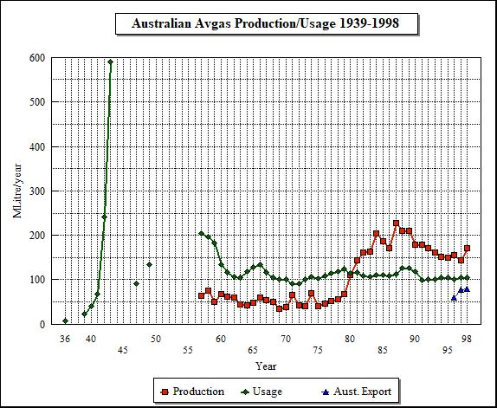

The above graph highlights the sudden increase in avgas usage in Australia during the Second World War 1939-1945, followed by the start of local production in 1955 at Altona Refinery, and the decline in usage as the ‘jet age’ commenced for civil aviation, then the increase in local production in 1980 (Shell Geelong Refinery) and again in 1984-5 (BP Kwinana Refinery). The excess production over local demand was shipped to affiliates of the major producers in the Pacific region, New Zealand, New Guinea, Fiji, etc. Exports are most likely to other companies in the region.

# Shell Geelong Refinery 1980

Around 1980 Shell Company of Australia, Geelong Refinery made the necessary process changes to its operation to enable the production of aviation gasoline. The process was different to Altona and allowed it to produce the new grade of low lead Avgas 100 known as Avgas 100LL. The Shell Avgas was made from HF Light Alkylate, light ends (Butane/Pentanes) and a narrow cut of Reformate. [Reformates are high in aromatics and are produced by treating straight run naphtha over a Platinum (or Platinum/Rhenium) catalyst under a hydrogen atmosphere resulting in dehydrogenation of naphthene ring structures to form aromatics, and converting straight chain hydrocarbons into aromatic hydrocarbons. Reformate gasoline is usually too high in boiling point for aviation gasoline so further distillation is required to reduce the end point – hence a narrower cut.]. The usual anti-oxidants, dyes and TEL are added to produce low lead aviation gasoline – Avgas 100LL.

Post Script: Shell sold the Geelong Refinery to Viva Energy in 2014.

# BP Kwinana Refinery 1984[11]

BP Kwinana Refinery, in Western Australia commenced aviation gasoline production around 1984; initially with Avgas 100/130 grade. Their market covered all of Western Australia (including other oil companies marketing Avgas in the west– Mobil and Shell), New Zealand and the Philippines, and BP South East Asia marketing region. BP Kwinana avgas is made for all of WA requirements and is piped from BP Kwinana Refinery to their North Fremantle Depot for drum and truck delivery.

Other BP Refineries making aviation gasoline around the world in 1999 were:

BP Toledo, Ohio, USA. (This refinery was formerly owned by Amoco).

BP Coryton, UK. (formerly the Mobil Coryton Refinery). The process same as used at BP Kwinana.

The grades of aviation gasoline produced at BP Kwinana Refinery were:

Avgas 100/130 (Composition Alky Re-run Overheads (light ends) and Light alkylate (“isomerate”) from the HF Alkylation Unit (Phillips Type)

Avgas 100LL (Composition Alky Re-run Overheads (light ends) and Light alkylate (“isomerate”) plus Reformate cut (probably only 1 batch/year for export).

Avgas 115/145 (Composition Alky Re-run Overheads (light ends) and Light alkylate (“isomerate”) made infrequently for a specific customer. Since this is a military grade presumably this grade was made for defence use. Export grade.

Post Script: BP will cease production from its Kwinana oil refinery south of Perth and convert the facility into a fuel import terminal in first-half of 2021. It has been in operation for 65 years,

# Mobil Altona Refinery 1955-2000

The process used by Altona Refinery has essentially not changed since the 1960’s. Their Avgas 100/130 is produced from Light Alkylate (from a Kellogg designed Sulphuric Alkylation unit), plus light ends (Butanes/Pentanes) together with additives, dyes and TEL. The process was described in detail earlier.

However, in the year 2000, Altona Refinery essentially ceased to manufacture Aviation gasoline (refer to Mobil’s Avgas Problem 2000).

# Mobil’s ‘Avgas Problem’ 2000

The following item appeared in the Melbourne Age newspaper and summarised the situation thus:

*Mobil halts Altona avgas production - By Peter Patrick Sunday 30 January 2000*

*Mobil Australia has stopped the production of avgas at its Altona refinery, the source of thousands of litres of the contaminated fuel to aircraft around the country.*

*A Mobil spokesman, Mr. Alan Bailey, said it was not possible to say when manufacture of the aviation fuel would start again.*

*Between late November and 21 December last year (1999), Mobil delivered tainted avgas throughout Victoria, New South Wales, South Australia and southern Queensland. By the time the problem was discovered on 23 December (1999) thousands of light aircraft fuel systems had been contaminated.*

*About 5000 aircraft were grounded, and commuter flights between Melbourne and regional centres affected. Rural Victoria and the Bass Straight islands were particularly hard hit.*

*Mobil supplies more than half the Australian avgas market, estimated at 150 million litres a year. The petrochemical giant is currently sourcing its fuel from either the BP Refinery at Kwinana, near Perth, in Western Australia or from the Shell refinery, at Geelong. Both Shell and BP have told The Sunday Age they have no difficulty meeting demand.*

*Mr. Bailey said Mobil had flown experts from the United States to Melbourne to identify the contamination source and develop a remedy. He said the problem occurred when a pump in the plant's caustic wash procedure failed. The Mobil Altona plant was built in 1952 and has operated continuously since being brought on line. The manufacture of avgas involves the introduction of a strong acid into a petroleum gas stream to produce the powerful fuel. The Mobil process uses sulphuric acid, which is difficult to remove after manufacture because of its very high boiling point. Rivals BP and Shell use hydrofluoric acid which evaporates at lower temperatures.*

*One unconfirmed theory is that the fuel contaminant, Ethyl Di-amine, was introduced by Mobil because it would neutralise any sulphuric acid in the avgas.*

*Mr. Kerry Rutherford, a senior chemist at Air BP, said that by its very nature, "pure" avgas had a low tolerance to contamination.*

**Postscript:** This was to spell the end of Altona Refinery’s production of Aviation Gasoline – this refinery never made another batch of aviation gasoline. The first refinery in Australia to make avgas had ceased production.

# Refuelling by Tankers

The modern air force still requires tankers to refuel its aircraft, as do many of the civilian airports. While the fuel of today is jet fuel, for those aircraft such as Cessna, Piper and Beechcraft which require Avgas, the sturdy tanker still has a role to play as it has for 80 years.

Photo 11. Archerfield Airport, Brisbane Qld. 2001 – Mobil Avgas 100/130 refuelling a Beechcraft Duchess (Petroch Services)

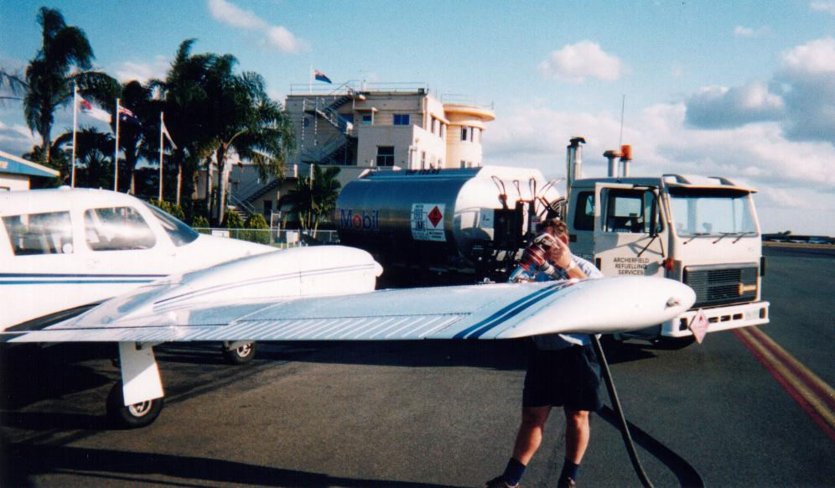

Photo 12. Archerfield Airport, Brisbane Qld. 2001 – Shell Avgas 100LL refuelling (Petroch Services)

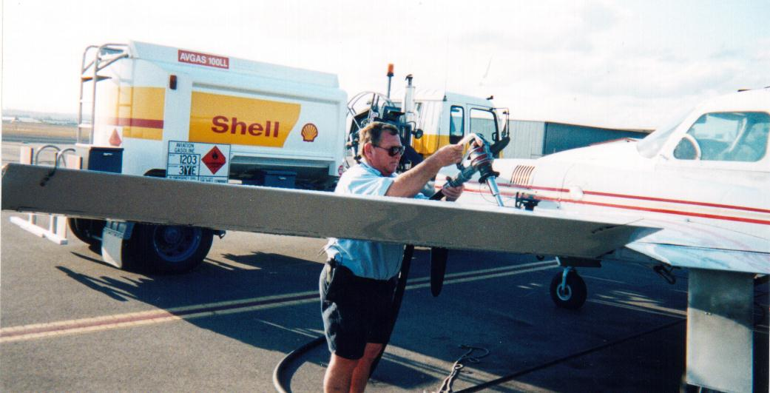

# Airspeed records are now a serious sport

The jet age sent the air speed records past three times the speed of sound (Mach 3), and the space age allowed man to travel at unimagined speed, however there was and is today, still much interest in racing piston engine/propellers driven aircraft. The Second World War and the immediate years afterwards provided the last and fastest of the piston engine military service aircraft. The aircraft of choice for theses racing enthusiasts is the North American P-51 Mustang, however other fast ex-service aircraft such as the British Hawker Sea Fury II (probably the fastest carrier based propeller driven aircraft in the world), and the American Grumman Bearcat (the last in the line of famous ‘cat’ fighters dating from the ‘Wildcat’ and ‘Hellcat’ which achieved fame in the naval battles against the Japanese in the Pacific), have also been used, albeit in modified form, to achieve world air speed records.

Table 8. World Air Speed Records for propeller driven aircraft.

|  |  |  |  |  |
| --- | --- | --- | --- | --- |
| Date | Location | Pilot | Aircraft | Achieved Speed Km/hr |
| Aug 1966 | USA - Texas | Michael D Carroll | Hawker Sea Fury II “Miss Merced” N878M | 837 (521 MPH) |
| 30 July 1983 | USA -Mojave, California | Frank Taylor | North American Mustang NA-124 P51D-25 Mustang “Dago Red” N5410V | 832.12 (official) (517 MPH) |
| 21 Aug 1989 | USA - New Mexico | Lyle Shelton | Grumman G-588B F8F-2 Bearcat “Rare BearQ” | 871(850.26 official) (541 MPH) |

Photo 13. Lyle Shelton’s “Rare Bear” 1990 – the record holder at 541 mph.[12]

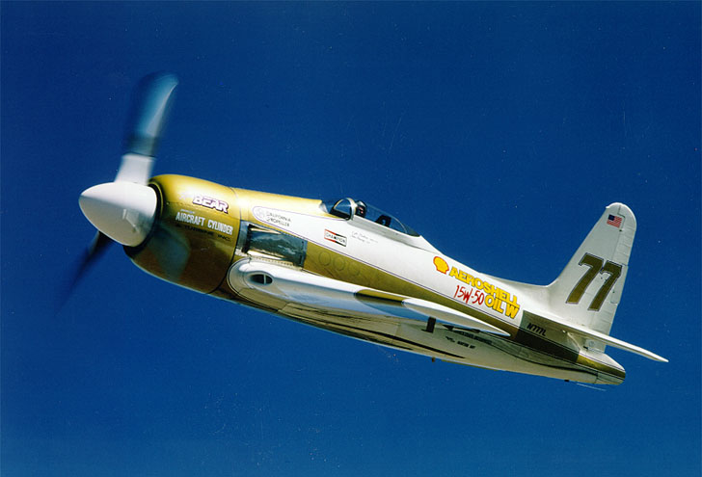

Note the Shell Company logo and Aeroshell brand on the side of the aircraft fuselage behind the cockpit; indicating that the oil industry sponsorship and its continued involvement in aviation.

# Warbirds & Heritage Aircraft

The enthusiasm for piston engine/propeller driven aircraft continues to this day. The realization that there was ‘magic’ associated with this type of flying has led to a large number of ‘warbird’ and historical aircraft associations around the world dedicated to preserving these aircraft.

Avgas is still required to get these planes in the air.

Duxford UK

Organisations such as The Fighter Collection which operates, rebuilds and maintains Europe's largest collection of airworthy WWII aircraft and is based at Duxford Airfield, in the UK. It is run by a professional team of engineers and pilots for both air show and film work, the aircraft fly all over Europe during the summer months to attend air shows from Austria to Switzerland. The fleet comprises of aircraft from the UK, USA, Germany, Russia and Italy. The aircraft and airfield of Duxford were used in the 1969 film “Battle of Britain” starring Michael Caine.

Photo 14. Avgas Tanker at Duxford (to the left is the tail of the operational B-17 Flying Fortress, in the rear static displays of Concorde and Trident) (Duxford 2005)

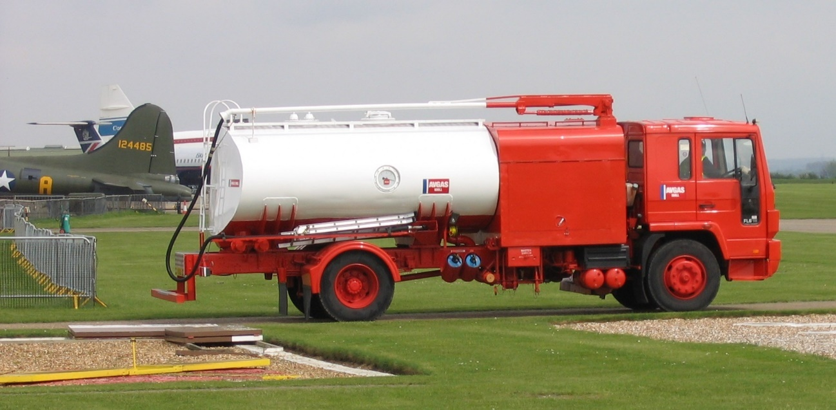

Photo 15. De Havilland Dragon Rapide, with De Havilland Tiger Moth in the background (Duxford 2005)

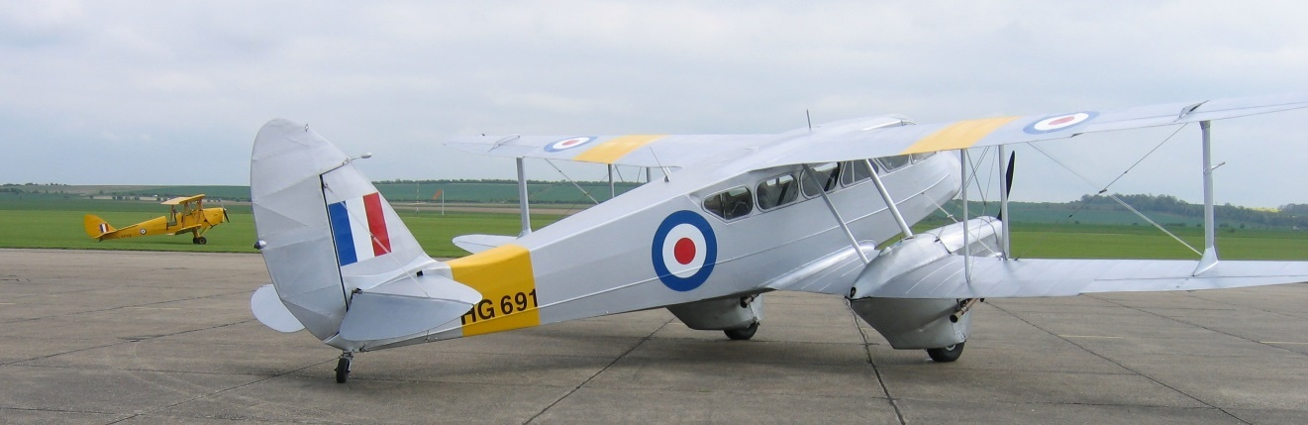

Commemorative Air Force USA

In the US there is the Commemorative Air Force (CAF) sometimes called the ‘Confederate Air Force’ which operates the world's largest fleet of World War II combat aircraft, numbering over 145 in total. The CAF Fleet includes many notable and extremely rare aircraft from both the Allied Forces and the Axis Powers. Amongst the Allied aircraft are one of the only remaining flying Boeing B-29 Superfortress bomber ‘FIFI” and the Curtiss SB2C Helldiver carrier-based dive bomber. Rare Axis aircraft operated by the CAF include an original Japanese Mitsubishi A6M3 Zero carrier-based fighter and a German Junkers Ju-52.

Photo 16. CAF B-29 Superfortress “FIFI”

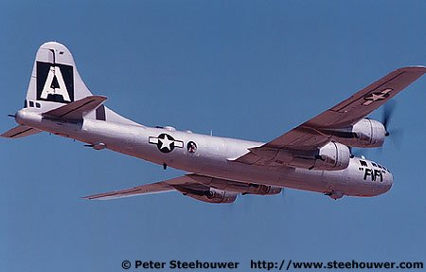

Temora Aviation Museum

The passion and enthusiasm for these aircraft is often evident at air shows around the world and in Australia there are at least two organisations who are maintaining and flying these aircraft from a previous era - Temora Aviation Museum in Temora, New South Wales (NSW 2666) and the Historical Aircraft Restoration Society at Illawarra Regional Airport, Albion Park Rail, NSW 2527.

Temora has a rich and noteworthy aviation history having been home to the No. 10 Elementary Flying Training School (10 EFTS) set up by the Royal Australian Air Force (RAAF) in May 1941. No 10 EFTS was the largest and longest lived of the flying schools established under the Empire Air Training Scheme during World War Two (WWII). Throughout WWII more than 10,000 personnel were involved at the school with upwards of 2,400 pilots being trained. At its peak the unit contained a total of 97 De Havilland Tiger Moth aircraft. Four satellite airfields were set up around the Temora district to cope with the demand to train RAAF pilots. No 10 EFTS ceased operation on 12 March 1946 making it the last WWII flying school to close. Since then, Temora has continued its aviation heritage becoming the preferred airfield for a growing number of sport aviation activities including gliding, parachuting and ultra-light aircraft operations.

Photo 17. Temora Air Show 2007

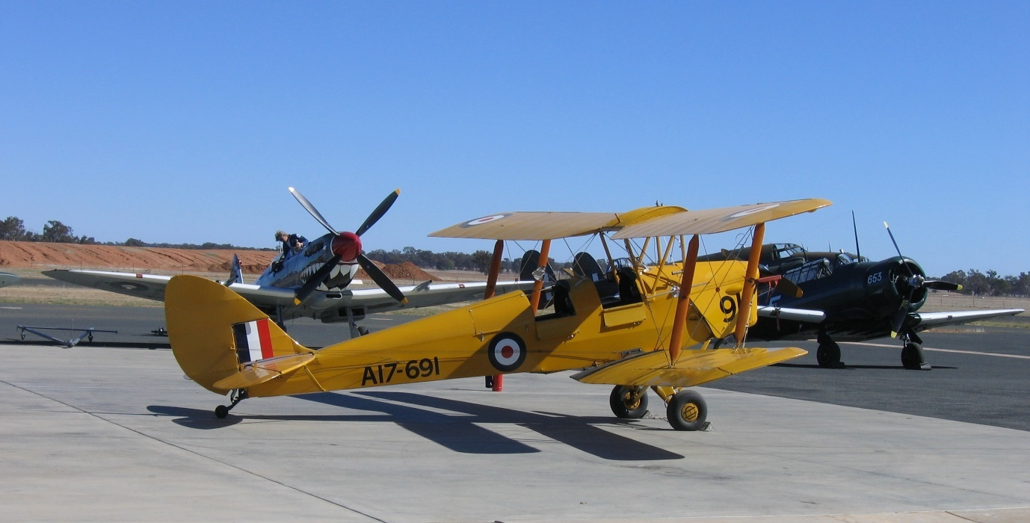

Aircraft (L-R) at rear Supermarine Spitfire Mk VIII (pilot David Lowy entering cockpit. The aircraft carries the markings of the late Wing Commander R.H. (Bobby) Gibbes AM WG CMR DSO DFC.), foreground DH-82A Tiger Moth in the markings of 10EFTS, Lockheed Hudson (far background) – the only flying Hudson in the world, CA-16 Wirraway.

Photo 18. Shell Avgas tanker refuelling a T-28D Trojan rear. (Temora 2007)

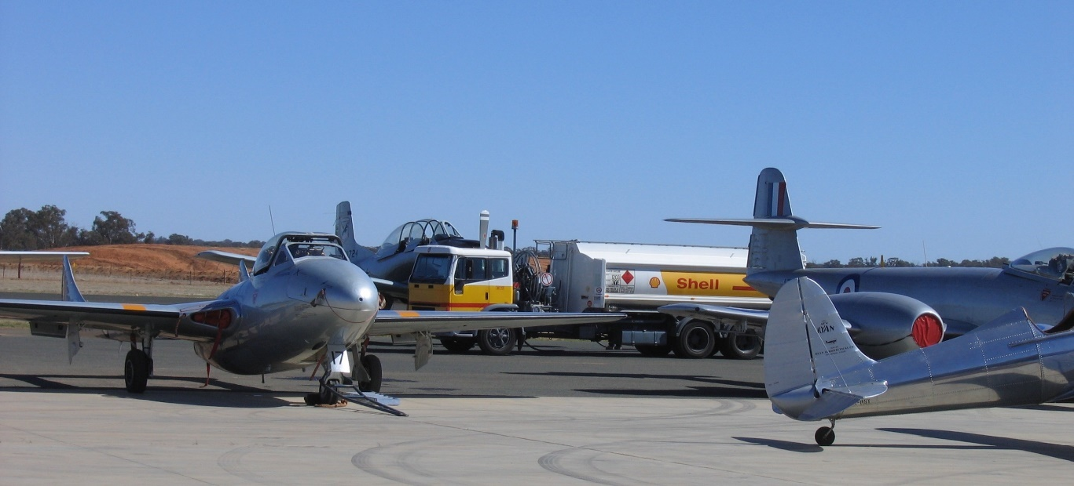

Aircraft (L-R) DH-115 Vampire T35, T-28D Trojan (background), Gloster Meteor F.8, tail of Ryan STM S2 (foreground).

Historical Aircraft Restoration Society

The Historical Aircraft Restoration Society was formed in 1979 by a group of aviation enthusiasts interested in the preservation of Australian aviation history. Their mission is to recover and where possible restore to flying condition, aircraft or types of aircraft that have played a significant part in Australian aviation history both in the civil and military arenas.

Photo 19. HARS Lockheed Super Constellation ‘Connie” painted in Qantas livery of the 1950’s

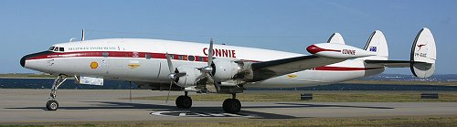

Photo 20. HARS Consolidated PBY-2 Catalina in the livery of the RAAF ‘Black Cat’ Squadrons

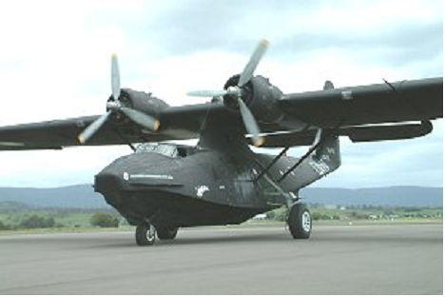

RAAF 76 Wing known as the “Black Cats” comprised Nos. 20, 42, and 43 Squadrons.

# Epilogues for 2003

In 2000, Altona Refinery the first refinery to make aviation gasoline in Australia ceased production of aviation gasoline, but its marketing arm Mobil Oil Australia would continue to market avgas, but it would come from Shell Geelong. Its competitors Shell and BP, as of 2003 continue to manufacture Avgas 100/130 and Avgas 100 LL.

Caltex did not market aviation gasoline but did manufacture jet fuel.

As long as piston engines and propellers are used to power aeroplanes there will be a need for aviation gasoline. But however, it is ‘Yesterday’s Fuel’.

Last Piston Aircraft in RAF Service

The last piston aircraft in military service in the RAF was the Avro Shackleton, which was designed by Sir Roy Chadwick (designer of the famous Avro Lancaster) and first flew on March 9, 1949 and entered service with the RAF and South African Air Force. This aircraft undertook reconnaissance and maritime surveillance duties in the North Atlantic during the “Cold War” of the 60’s and 70’s. The engines had developed to counter rotating propellers types. It would be superceded by jet powered reconnaissance and maritime patrol aircraft such the successful Nimrod MR-2 based on the ill-fated de Havilland Comet civilian passenger aircraft of the 1960’s. While in the US similar aircraft also based on the successful civilian designs such as the Boeing 707 would become the US Air Force E-3 Sentry.

Photo 21. RAF Shackleton (circa 1990) is joined by a jet powered successor USAir Force E-3 Sentry

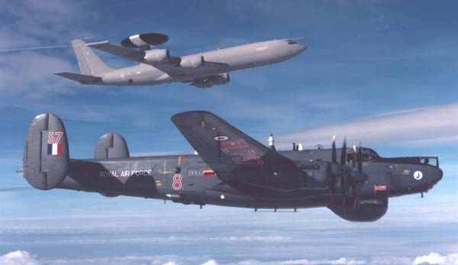

Sad Epitaph!

Perhaps the saddest epitaph to the fuel that won World War II is that the aircraft it fuelled were destined to the funeral pyre. The sad finish for these wonderful aircraft was to serve as burning wrecks to train fire-fighters.

Photo 22. RAF Shackleton on the scrap heap of a desolate airfield

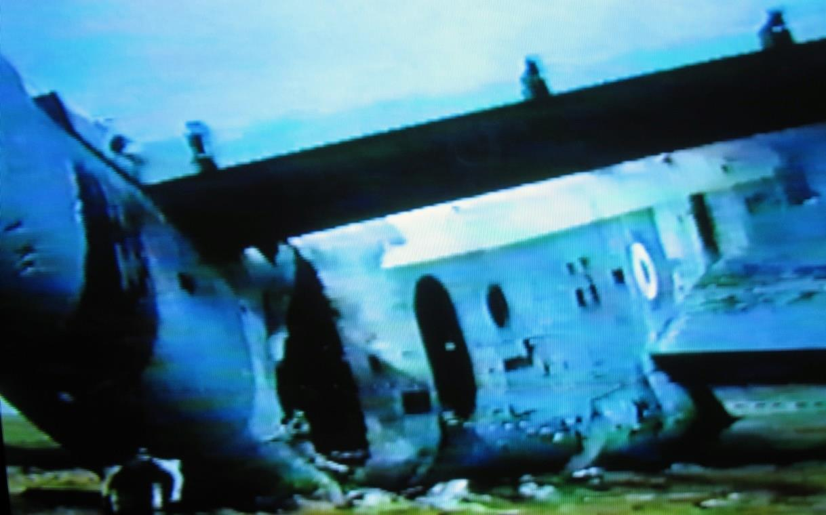

Photo 23. RAF Shackleton bonfire – ‘A sad end for a distinguished aircraft’ after 40 years’ service

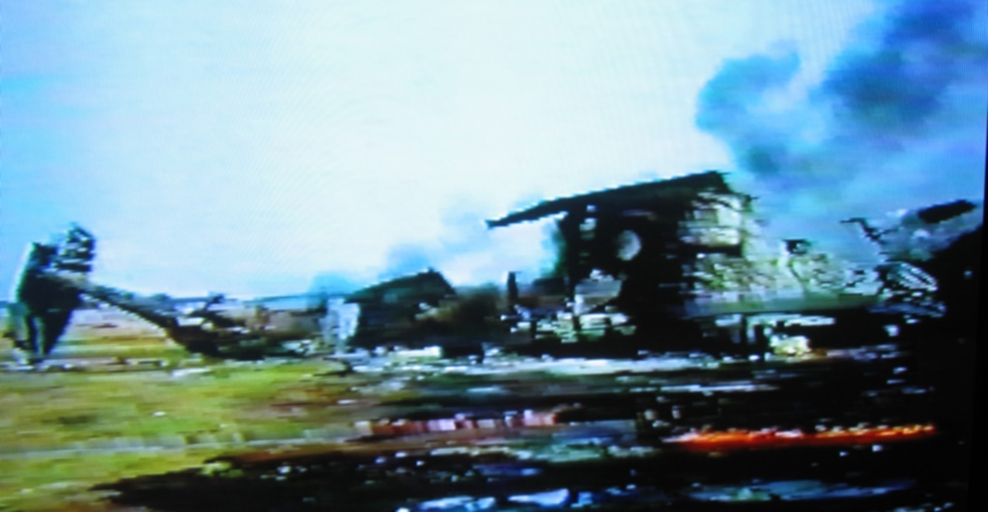

But They Live On! It is understood that two of these Avro Shackeltons are still flying one in the US WL790, and South African Air Force Mark III – 1722.

# Index

# 

1

1,1-Dimethyl Cyclohexane 22

1,2,3-Trimethyl Benzene 22

1,2,4-Trimethyl Benzene 22

1,3,5 Tri Methyl Benzene 22

1,3,5- trimethyl benzene 36

100/130 13, 15, 25

100LL 19, 25, 35, 39

100VLL 35

115/145 25

2

2 Methyl 4-Ethyl Hexane 23

2 Methyl Butane 21

2 Methyl Hexane 22

2 Methyl Propane 21

2,2 Dimethyl Butane 21

2,2 Dimethyl Pentane 21

2,2,3-Trimethyl Butane 22

2,2,3-Trimethyl Heptane 23

2,2,3-Trimethyl Hexane 23

2,2,3-Trimethyl Pentane 22

2,2,4-Trimethyl Heptane 23

2,2,4-Trimethyl Hexane 23

2,2,4-Trimethyl Pentane 22

2,2,5-Trimethyl Hexane 22

2,2,6-Trimethyl Heptane 23

2,3 Dimethyl Butane 21

2,3 Dimethyl Hexane 22

2,3 Dimethyl Pentane 22

2,3,3-Trimethyl Hexane 23

2,3,3-Trimethyl Pentane 22

2,3,4-Trimethyl Heptane 23

2,3,4-Trimethyl Hexane 23

2,3,4-Trimethyl Pentane 22

2,3,5-Trimethyl Hexane 23

2,4 Dimethyl Hexane 22

2,4,4-Trimethyl Hexane 23

2,4,5-Trimethyl Heptane 23

2,4,6-Trimethyl Heptane 23

2,5 Dimethyl Hexane 22

2,5,5-Trimethyl Heptane 23

2,6 Dimethyl Heptane 23

2-tert-Butyl Butane 22

3

3 Ethyl 2,4-Dimethyl Pentane 23

3 Methyl Heptane 22

3 Methyl Pentane 21

3, Diethyl Hexane 23

3,3,3,4 Tetramethyl Hexane 23

3,3,4-Trimethyl Heptane 23

3,3,4-Trimethyl Hexane 23

3,4 Diethyl Hexane 23

3,4 Dimethyl Heptane 23

3,4 Dimethyl Hexane 22

3,6 Dimethyl Octane 23

3-Ethyl Pentane 22

4

4 Methyl 3-Ethyl Hexane 23

8

87 25

9

91/96 25

A

A Squadron, 5 Aviation Regiment 4

A-4G Skyhawk 3

A-4K Skyhawks 7

Abel Apparatus 30

acid 40

additive 12, 39

Adelaide 6, 7

Aermacchi MB-326H 3, 5

Aermacchi MB-339C 7

Aermacchi MH-326H 3

Aeroshell 42

Aerospatiale Puma 3

AEW&C 6

AFPET 12

Afton – P66 UL Avgas 36

Afton Chemical Company 34, 37

Air BP 40

Airbus A330-200 7

Airbus A330-60 7

Airbus A380 7

Airlift Group 6

Alan Bailey 40

alcohol 29

alkanes 20, 34

Alky Re-run Overheads 39

alkylate 35, 36

alkylation 20

Altona 39, 40

Altona Refinery 8, 13, 16, 17, 19, 20, 38, 39, 40, 47

Amberley 4

American Petroleum Institute 29

amines 36

Amoco 39

Amyl Alcohol 28

Aniline Gravity 18

Aniline Point 30

Ansett Airlines 7

Ansett Airways Pty. Ltd. 3

Anti-knock value 15

anti-oxidants 15, 27, 39

Archerfield i, 3, 10, 41

Army Air Corps 4

aromatic amines 35

aromatic hydrocarbons 39

aromatics 15, 16, 18, 19, 34, 39

Arthur Butler 3

AS-350 Ecuriel (Squirrel) 5

ASTM 24, 29, 33

ASTM 910 24

ASTM D2700 34

ASTM D909 34

ASTM D910 33

Auto Blue 8 14

Auto Yellow 8 14

Avalon air show 7

avgas 11, 12, 38, 39, 40

Avgas 100 8, 15, 39

Avgas 100 LL 37, 47

Avgas 100/130…… 8, 9, 10, 13, 15, 16, 17, 21, 33, 39, 41, 47

Avgas 100LL …..9, 10, 19, 20, 21, 31, 32, 33, 34, 35, 36, 37, 39, 41

Avgas 115/145 8, 9, 24, 39

Avgas 80/87 9

Avgas 82UL 33

Avgas 87 9

Avgas LLC 34, 37

Avgas MIL-G-5572 25

Avgas UL100 37

aviation fuel 40

aviation gasoline .7, 11, 12, 13, 17, 20, 21, 24, 25, 28, 29, 33, 35, 36, 37, 38, 39, 40

Aviation Turbine Fuels 30

Avro Lancaster 47

Avro Shackelton 47, 48

B

BAC-111 3

BAe Hawk 5, 6

BAe HS-748 3

Bankstown 3

Bass Straight 40

Beechcraft Duchess 41

Bell 206 Kiowa 3

Bell 206B-1 5

Bell UH-1 3, 5

Benzene 21

Black Cats 46

blendstocks 28

Boeing 7

Boeing 707 3, 5, 6, 47

Boeing 727 7

Boeing 737 6

Boeing 747 3

Boeing 747-438 4

Boeing B-17 Flying Fortress 43

Boeing B-29 Superfortress 44

Boeing Wedgetail 6

boiling point 39, 40

Bomb Calorimeter 30

BP 34, 37, 38, 40

BP Avgas 15

BP Coryton 39

BP Kwinana Refinery 8, 13, 16, 17, 21, 38, 39

BP Refinery 40

BP South East Asia 39

BP Toledo 39

British 24, 29

Bulgaria 12

Buller Gorge 7

Burgas 12

Butane 39

Butane/Pentanes 39

Butterworth 4

C

C-130H Hercules 7

C-130J Hercules 6

Capt. D. Massey-Greene 4

carbon number 19, 20

Caribou 3, 5, 6

Carrier Air Group 3

catalyst 39

caustic wash 40

Cessna 10

Cessna L-19/O-1 Bird Dog 9

CH-47C Chinook 3

Charles Kingsford Smith 7

City of Canberra 4

Cold War 47

Colour 14

Commemorative Air Force 44

Conductivity 15, 18, 33

Conoco Phillips Company 31

Consolidated PBY-2 Catalina 46

Constanta 12

Copper Corrosion 30

Copper Strip 15, 26, 32

Corrosion 15, 32

CT-4A Airtrainer 3, 8

Cumene 22

Curtiss SB2C Helldiver 44

Cyclohexane 21

Cyclopentane 21

Cyrus P.Henry Jr 24

D

D 1094 30

D 1159 30

D 1266 30

D 1298 30

D 130 30

D 1319 30

D 1322 31

D 1405 31

D 1552 31

D 156 30

D 1740 31

D 1744 31

D 1840 31

D 2276 31

D 2382 31

D 2386 31

D 2392 31

D 240 30

D 2622 31

D 2624 31

D 2700 31

D 2887 31

D 323 30

D 381 30

D 445 30

D 56 30

D 611 30

D 86 30

D 873 30

D 909 30

D 910 35

D 93 30

D 974 30

D.Eng.RD 2485 24

D1094 15, 18, 27

D1266 14, 18, 27, 28, 29

D1298 27, 32

D130 15, 18, 27, 28, 32

D1319 15, 18, 19

D1405 15, 18

D2386 14, 18, 27, 29

D2392 27, 29

D2622 27, 28, 29

D2624 15, 18, 27

D2700 15, 18, 27, 29, 34

D3120 29

D323 14, 18, 27

D3231 29

D3237 29

D3338 15, 18, 27, 29

D3341 28

D357 28, 29

D381 15, 18, 27, 28

D4052 14, 17, 18, 28

D4057 28, 29

D4171 28, 29

D4294 29

D4306 28

D4529 28, 29

D4809 28, 29

D4815 28, 29

D4865 28

D4953 29

D5006 28

D5059 28, 29

D5190 28, 29

D5191 14, 18, 28, 29

D5453 29

D5482 29

D5599 29

D5845 29

D5983 29

D611 18

D614 28

D6227 28, 34, 35

D6227-04a 33, 52

D6424 36, 37

D6469 28, 29

D6812 36, 37

D7547 34, 35

D7719 34, 35

D7826 36

D7960 34, 35

D86 14, 17, 27, 28, 32

D873 15, 18, 27, 29

D909 15, 18, 27, 29

D910 24, 25, 26, 27, 28, 29, 33, 37

D93 27

Dassault Falcon 20 3

De Havilland Canada 5

De Havilland Comet 47

De Havilland Dragon Rapide 43

De Havilland Tiger Moth 43, 44

Deakin University 21

Def Stan 91-90/1 33

Defense Energy Support Center 11

Defense Fuel Supply Points 12

dehydrogenation 39

density 15, 17, 19

DERD2484 14

DERD2485 14, 17, 24, 25, 31, 32

DESC 12

DFSP 12

DHC-4 Caribou 5, 8

DIPE 28

Direct Delivery Fuels 11, 12

Director of Engine Research and Development 24

Distillation 14, 15, 17, 30, 39

Diyarbakir 12

DuPont Company 24

Duxford 43

dyes 39

Dynamic Viscosity 30

E

E29 28, 29

E-3 Sentry 47

Edinburgh 6

Edwards Air Force Base 7

Electrical Conductivity 31, 32

Empire Air Training Scheme 44

ETBE 28, 37

Ethanol 37

ether 29

Ethyl Benzene 22

Ethyl Hitec 4776 15, 18

Ethyl tertiary butyl ether 37

Eurocopter Tiger ARH 7

Europe 38

Existent Gum 15, 30, 32

F

F/A-18 Hornet 4, 6

F-12 25

F-13 25

F-15 25

F-18 25

F-22 25

F4 Supercharge 15

FAA 37

Falcon 900S 5

Fiji 38

final boiling point 15, 17, 19, 26

Flash Point 30

Flt. Lt. Phillip Barnes 7

Fokker 7

freezing 12

Freezing point 14, 15, 19, 27, 31, 32

FSII 12

Fuel System Icing Inhibitor 12

G

G100UL 36

Gaby Kennard 4

GAF N22 Nomad Mission Master 3

GAMI 36

Gas Chromatography 31

gasoline 20

Geelong 40

Geelong Refinery 8, 17, 19, 39

General Aviation Modifications Inc. 34, 36

General Dynamics F-111C 3

Geoffrey J. Bishop 24

George V. Dyroff 24

Global Hawk 7

Gloster Meteor F.8 45

GOCO 12

Grade 100 26, 34

Grade 100 LL 26, 34

Grade 100/130 37

Grade 100VLL 34

Grade 80 26

Grade 82 28

Grade 82UL 28, 33

Grade 91 34, 35

Ground Fuels Division I 11

Grumman G-588B F8F-2 Bearcat 42

Grumman S-2E/G Tracker 3, 4, 8

H

Harvard 4

Hawker de Havilland 7

Hawker Sea Fury 4, 42

Heat of Combustion 18

Hellcat 42

HF Alkylation 39

HF Light Alkylate 39

Historical Aircraft Restoration Society 9, 44, 46

Hjelmco 34, 37

HMAS Melbourne 3, 4

hydrofluoric acid 40

hydrogen 39

I

Initial Boiling Point 17, 32

Institute of Petroleum 30

IP 17 32, 33

IP 336 14, 18

IP Methods 29

IP17 14, 18

IP17A 14, 18

IP270 15, 18

Iraq 12

Iraq War 11

Iroquois helicopter 7

Isobutane 21

Isoheptane 22

isomerate 39

Isonox 133 18

Iso-octane 22

Isopentane 21, 34

Isopropyl Benzene 22

J

Japanese 42

jet fuel 12

Joint Strike Fighter 6

Junkers Ju-52 44

K

Kaman SH-2G(A) 7

KC-10 tanker 4

Kellogg 39

kerosene 12

Kinematic Viscosity 30

Kittyhawk 33

Kiziltepe 12

L

Lamp method 28

Lana D. Hampton 12

LAPES 5

Lead 31

Lead Content 15, 18

Lead Precipitate 15, 18

leaded avgas 33

Lean Rating 35

Learjet 35 3

Light Alkylate 39

light ends 39

Light Petroleum Distillates 30

Lindsay Fox 7

Liquid dyes 24

Lockheed Hudson 45

Lockheed Neptune 9, 10

Lockheed Super Constellation 46

Lovibond 24, 30, 32

Low-lead 19, 39

M

Manganese Methcyclopentadienyl Manganese Tricarbonyl 36

Melbourne Age 40

Mesitylene 22, 34

meta toluide 36

Methyl Cyclohexane 21

Methyl Cyclopentane 21

Methyl tertiary butyl ether 37

m-Ethyl Toluene 22

Middle East 38

MIL-PRF-25017F 29

Mirage II-DO 3

Mirage IIID 4

Mirage III-O 3

Mitsubishi A6M3 Zero 44

MMT 36, 37

Mobil 8, 39, 40

Mobil Altona 17, 21

Mobil Coryton Refinery 39

Mobil’s Avgas Problem 40

MON 15, 26, 34, 35

Moorabbin 3

motor gasoline 28, 33, 37

Motor Method 15, 18, 31, 32

motor octane 34

Motor Octane Number 29, 35

MTBE 28, 37

N

Naphthenes 16, 19, 20, 39

narrow cut reformate 15

narrower cut 39

n-Butane 21

Neohexane 21

Net Heat of Combustion 15

New Guinea 38

New Zealand 7, 38, 39

n-Heptane 22

n-Hexane 21

Nimrod MR-2 47

No. 10 EFTS 44

No. 75 Squadron 4

No. 79 Squadron 4

No. 805 Squadron 3

No. 816 Squadron 3

No. 9 Squadron 4

n-Octane 22

non-hydrocarbon component 34, 35

North Atlantic 47

North Fremantle Depot 39

Nowra 3

n-Pentane 21

O

Operation ‘Enduring Freedom’ 11

Operation ‘Iraqi Freedom’ 11, 12

Original Equipment Manufacturers 37

Orion 9

Oxidation inhibitor 15, 18

Oxidation Stability 15, 18, 30, 32

oxygenates 28, 29

o-Xylene 22

P

P-3B Orion 3

P-3C Orion 3

P-3K Orion 7

P-51 Mustang 42

P51D-25 Mustang 42

Pacific region 38

PAFI 36, 37

Pan American 3

paraffins 16, 19

Particulate Contaminant 31

Pensky‑Martin Closed Tester 30

Pentane 39

Performance Number 15, 26, 32

Peter Patrick 40

p-Ethyl Toluene 22

Philippines 8, 39

Phillips 39

Pilatus PC-9 5, 6, 8

Pilatus Turbo-Porter 3

Piper 10

Piper Saratoga 4

Platinum 39

Platinum/Rhenium 39

Point Cook 6

Port of Iskenderun 12

Potential gum 15, 27, 32

Potential Residue 30

Powder Dyes 24

Pratt and Whitney 5

Precipitate 32

Predator 11, 12

Prime Minister Helen Clark 7

Propyl Benzene 22

Psuedocumene 22

p-Xylene 22

Q

Qantas 4, 7, 46

QPL-25017 29

R

RAAF 76 Wing 46

RAAF Edinburgh 7

RAAF Richmond 8

RAF 47

Rare Bear 42

RDE/A/607 15

RDE/A/609 15, 18

Reformate 39

reforming 20

Reid Method 30

Rhein Mein 12

Richmond 4, 6

RNZAF 7

Romania 12

Royal Australian Air Force 8, 9

Royal Australian Navy 8

Royal Thai Air Force 9

Ryan STM S2 45

S

S-70B Seahawk 5

SA-70A Blackhawk 5

Saybolt Color 30

scavenger 36

Sea King 8

Sea King Mk50 5

Seeb Air Base 11, 12

Shackleton 47, 48

shale oil 12, 13

Shell 8, 17, 19, 34, 35, 37, 38, 39, 40

Shell 1910 Gasoline 20

Shell Company of Australia 39

Shell Geelong 17, 19, 21, 38

Shell International Petroleum Company 24

Shell refinery 40

Sikorsky Blackhawk 4

Sikorsky Seahawk 3

Sir Lawrence Wackett 3

Sir Reginald Ansett 3

Sir Roy Chadwick 47

Socata TB-10 Tobago 10

Solomon Lew 7

South African Air Force 47, 48

Southern Cross 7

Southern Cross II 7

Spark-ignition Engines 36

Spitfire 45

Squadron Leader Murray Nielson 7

Stadis 450 24

static dissipator additive 33

static electricity 15

STC 36

straight chain hydrocarbons 39

straight run naphtha 39

Sulphur 14, 15, 19, 27. 28, 31, 32

Sulphuric Alkylation unit 39

Supercharge Method 15, 18, 30

Supercharge Performance Number 19

Swift Fuels 34, 37

T

T-28D Trojan 45

Tag Closed Tester 30

TAME 28, 37

Tandem Thrust 01 7

Tarnish Test 30

TEL 15, 33, 37, 39

Temora 9, 10, 44, 45

Tertiary amyl methyl ether 37

Tetraethyl Lead 23, 25, 26, 32

Thailand 8

The Fighter Collection 43

Toluene 21, 37

Total 34

TOTAL 37

trans 1,2-Dimethyl Cyclopentane 21

Triptane 22

Turkey 12

Turkish government 12

U

UL102 35

UL94 34

ultra low-lead avgas 33

UMV 11

United Kingdom 24

United States 7, 9, 37, 40

unleaded 29

unleaded aviation fuel 36

unleaded aviation gasoline 33, 35, 37

unleaded fuel 34, 37

unleaded gasoline 38

unmanned aerial vehicle 7, 11

US Air Force 11, 12

US Air Force Petroleum Office 12

US Clean Air Act 33, 36

US Department of Defense 25

US Federal Aviation 34

USAF 4

V

Valleyfield 4

Vampire 45

Vapor Pressure 30

Vapour locking 15

Vapour Pressure 14, 18, 26, 32

Vietnam War 8

Virgin Blue 6

Visible lead precipitate 27

Volatility 15

W

Water Reaction 15, 18, 27, 30, 32

Western Australia 39

Westinghouse J34-WE-36 turbojets 10

Westland Lynx 3

Westland Sea King 3

Westland Wessex 3

Wildcat 42

William J Hughes Technical Center 37

Williamtown 4, 6

Winjeel 4

Wirraway 45

Woodburne 7

Woomera 4

Wright Brothers 33

Wright Cyclone engine 4

Wright R-3350-32W 10

X

X-ray Fluorescence Spectrometry 28

X-Ray Spectrographic Method 31

Xylidene 35

Y

Yarraville 13

# Research Sources

1. Australian Aviation History Time Lines - Web site accessed June 1, 2002 - http://users.chariot.net.au/~theburfs/aahistpage1.html#preww1
2. ‘DESC Supports the Warfighter During Operations Enduring Freedom And Iraqi Freedom’ June 27, 2003 <http://www.dla.mil/public_info/read_news.asp?track=175> Accessed Jan 5, 2005
3. DESC Supports the warfighter during Operations ‘Enduring Freedom’ and ‘Iraqi Freedom’ June 27, 2003 DLA 03-20’ Media Contact: Lana D. Hampton (703) 767-9691 [Lana.Hampton@dla.mil](mailto:Lana.Hampton@dla.mil)
4. ASTM Manual on Significance of Tests for Petroleum Products 6th Edition. ASTM Publication Code Number (PCN) 28-001093-12. Chapter 5 Aviation Fuels By Geoffrey J. Bishop (Shell International Petroleum Company, London England) Cyrus P.Henry Jr. (DuPont Company, Deepwater, New Jersey, U.S.A.). circa 1990
5. ASTM website [http://www.astm.org](http://www.astm.org/) Accessed Jan 6, 2005
6. ASTM website [http://www.astm.org](http://www.astm.org/) Accessed Jan 6, 2005
7. ASTM Manual on Significance of Tests for Petroleum Products 6th Edition. ASTM Publication Code Number (PCN) 28-001093-12. Chapter 5 Aviation Fuels By Geoffrey J. Bishop (Shell International Petroleum Company, London England) Cyrus P.Henry Jr. (DuPont Company, Deepwater, New Jersey, U.S.A.). circa 1990
8. ASTM D6227-04a Standard Specification for Grade 82 Unleaded Aviation Gasoline <http://www.astm.org/cgi-bin/SoftCart.exe/DATABASE.CART/REDLINE_PAGES/D6227.htm?L+mystore+ufcg5854+1105013152> Accessed Jan 6, 2005
9. https://faba.aero/pdf/ASTM_Aviation_Gasoline_Fuel_Specifications_Beyond_ASTM_D910_Update_Jan_2018.pdf
10. ‘Facts & Figures’ from Australian Institute of Petroleum –assorted publications of Facts & Figures.
11. Personal communications with Mr. Bill Rogers (BP Commercial, formerly in BP Kwinana Laboratory, Perth) Jan 2000.
12. <http://www.rarebear.com/pilots-crew/shelton.htm>, Accessed Dec 29, 2003