Chapter

36

Alkyl Lead - TEL

Photo .[1] Tetra Ethyl Lead molecule

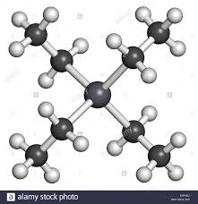

The centre is Lead atom (Pb), each arm is an ethyl group (C2 H5) (two carbon atoms, five hydrogen atoms); there are four ethyl groups, hence tetra (four) - Tetra Ethyl Lead.

.

Table of Contents

Summary 3

Tetra Ethyl Lead (TEL) - The Great Anti-Knock Additive 3

Lead Susceptibility 4

Manufacture And Use Of Tetraethyl Lead 6

“Ethyl Fluid” 10

Alkyl Lead Production During World War II 13

Shipping And Distribution Of Alkyl Lead 14

‘Ethylizing’ Aviation Gasoline 15

European Alkyl Lead Production 17

German TEL Plants 17

French TEL Plant 18

U.K. TEL Plant 18

Australian Inland Aircraft Fuel Depots 19

Other Alkyl Lead Production 20

Other Antiknock Additives 21

German Antiknock Additive 22

Epilogue For Lead 23

Index 24

Research Sources 29

Photo 2. Ellesmere Port Associated Octel Works (March 1955)

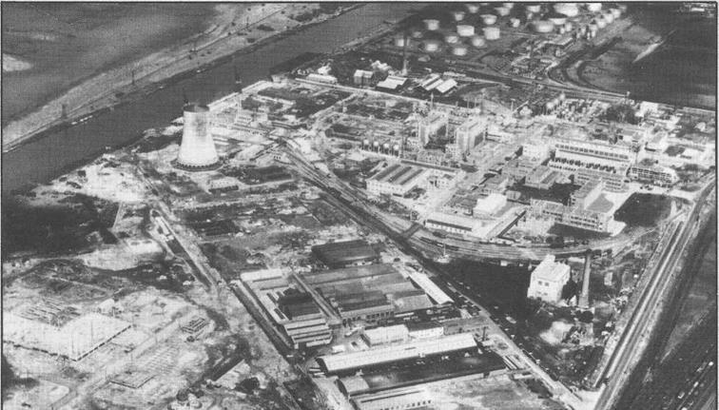

# Summary

The problem of engine knock is understood. Octane scale is established, and Alkyl Lead is discovered – the ‘dope’ which will reduce knock.

The fuel factor which, more than any other, tends to limit engine output is **detonation**. Other important factors are freedom from vapour lock, uniform distribution of fuel among the various cylinders, absence of a tendency to form deposits in the combustion chamber, or on the spark plugs, or valves. In addition, the fuel must be stable in storage, free from corrosive action on engine parts or fuel tanks and sufficiently volatile to give easy starting at low temperatures and to avoid dilution of the lubricating oil with heavy ends of the fuel.[2]

# Tetra Ethyl Lead (TEL) - the great anti-knock additive

Discovery of Alkyl Lead

During the pre-war (WWII) period when detonation was being investigated by Hopkinson, Ricardo, and Gibson in Britain, knock in engines became a serious problem to the Dayton Engineering Laboratories (Delco) of Charles Kettering in the U.S. Kettering was concerned because his system of battery ignition in automobile engines was blamed for knock. In addition, Delco was faced with a rash of failures in the kerosene powered engines they sold with their lighting generator sets. The supposedly superior Pennsylvania kerosenes caused detonation, while the poor quality illuminating grade California kerosenes performed well. Kettering asked his assistant, Thomas Midgley, to investigate the detonation characteristics of fuels. Kettering and Midgely used a standard air-cooled Delco-Lite engine with modified cylinder heads for different compression ratios in their first experiments.

Photo 3. Delco-Lite engine lighting generator set.

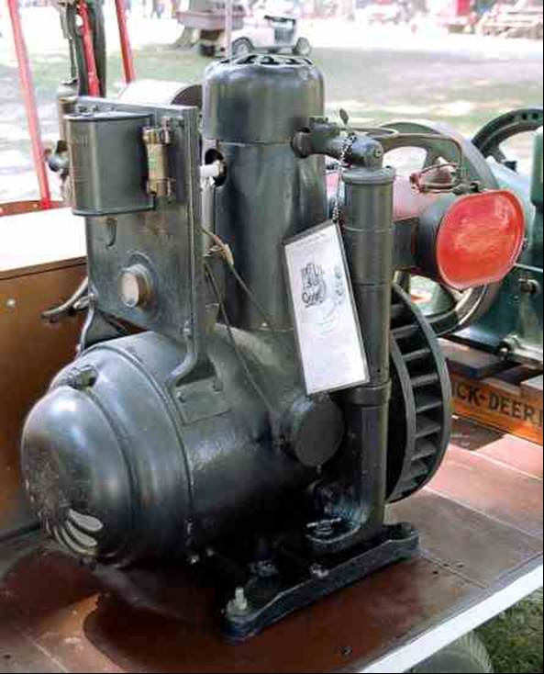

Photo 4. Dr. Thomas Midgley Jr. Photo 5. Charles F. Kettering

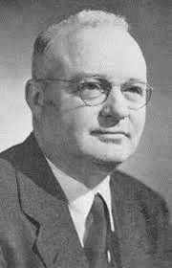 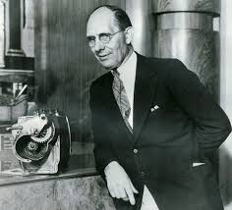

They developed a "bouncing pin" device to measure differences in detonation pressures. They determined that detonation was related to both the compression ratio and the different molecular structure of the fuel. Theorizing that knock resulted because some of the vaporized kerosene was liquefying on the cylinder walls, Kettering and Midgely thought that a dark coloured kerosene would absorb more heat energy, and thus be less likely to condense on the cylinder walls. One of the theories was that the radiation from the flame overheated the surfaces of the combustion chamber and piston thus promoting detonation and pre-ignition. They thought that they had confirmed this theory when they added iodine to kerosene to make it dark, and found that knock was reduced. This was the beginning of what was to become a very long line of anti-knock additives to be investigated. A vigorous program of research was launched in 1920 to find compounds that could be added to gasoline to suppress knock. This work lead Midgely and Boyd to concentrate much of their investigation on organo-metallic compounds. Around 30,000 compounds of all chemical types were screened and large number subjected to engine tests. On December 9, 1921, Midgely and his assistant, Thomas Boyd, discovered the remarkable anti-knock properties of tetraethyl lead (TEL) - This is one of the ‘Alkyl Lead’ class of compounds.

This discovery that ranks as the single most important achievement in the development of gasoline fuels Avgas; for without it the later development of Avgas 100/130 and Avgas 115/145 would not have been possible.

Although nearly ten years were to lapse before this remarkable compound became widely accepted as an essential component of aviation gasoline, its use opened the way to the great advances in anti-knock value of fuel that made possible the high power output and efficient aircraft engines that dominated military and commercial aviation until the arrival of the gas turbine.

# Lead Susceptibility

With the discovery of this new anti-knock additive, the next question was how much improvement in octane could be attained. At one end of the scale there was a limit to the amount of TEL that could be added to gasoline (particularly aviation gasoline) before problems occurred with lead deposits on valves and spark plugs which could ultimately result in engine failure, at the other it was noted that a small amount of TEL initially increased octane dramatically but the octane increase became less and less for a same increase in TEL – this was lead susceptibility or lead response. For example, the addition of TEL to a straight run gasoline gave the following octanes.

Table . Straight Run Gasoline Octane increase with increased Lead Content

|  |  |  |
| --- | --- | --- |
| Lead Content cc. TEL/US Gallon | Octane | Octane Increase per cc TEL |
| Nil - unleaded | 74.3 | Base |
| 1 | 82.8 | 8.5 |
| 2 | 86.5 | 3.7 |
| 3 | 88.8 | 2.3 |
| 4 | 90.6 | 1.8 |
| 5 | 92.0 | 1.4 |
| 6 | 93.3 | 1.3 |
| 7 | 94.6 | 1.3 |
| 8 | 95.8 | 1.2 |

The laboratory chemists developed lead susceptibility charts to assist them in developing various blends Figure 1. which shows a chart from 1938 for blendstocks of that period.

Figure 1. TEL Susceptibility Chart of Gasolines (1938)[3]

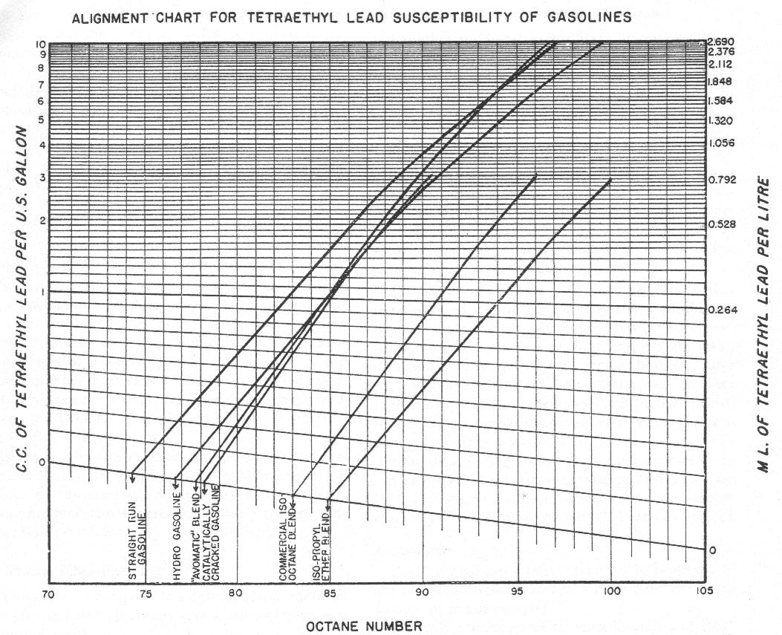

‘Avomatic’ blend was a mixture of Toluene, Xylenes and Ethyl Benzene extracted from highly aromatic crudes oils.

The presence of Sulphur in the gasoline acts as an impurity and decreases lead response.

# Manufacture and Use of Tetraethyl Lead[4]

Perhaps one of the most interesting papers on this subject is “The Manufacture and Use of Tetraethyl Lead” that was presented in 1939 by Dr. Graham Edgar of the Ethyl Gasoline Corporation, New York. (Dr. Edgar was the founder of the “Octane scale”). Significant sections of that paper are listed here.

In the sixteen years which have elapsed since the first commercial use of tetraethyl lead (TEL), many facts about it have become a matter of general knowledge. The genius of Kettering in recognising the problem of knock; the researches of Midgely, Boyd, and their associates on anti-knock agents which culminated in the discovery of the effectiveness of tetraethyl lead; the many investigations, theoretical and practical, stimulated by this discovery; the successful efforts of the oil refiner to improve the anti-knock value of gasoline by changes in refining methods; the improvements in automotive and aircraft engines made possible by anti-knock fuels – all are familiar.

The purpose of this (Edgar’s) paper is to survey briefly the present status (in 1939) of the tetraethyl lead industry, to discuss some of the less familiar problems associated with the manufacture and utilization, and to attempt to peer a short distance into the future.

Gasoline containing tetraethyl lead (TEL) was first put on public sale at a single service station in Dayton, Ohio, on February 1, 1923, under the now familiar name of “Ethyl” gasoline. Immediate acceptance of the new product indicated that the ordinary fuel of that day was not satisfactory for even the low compression automotive engine of the time, and the sale of Ethyl gasoline began to spread rapidly.

Photo 6. Ethyl sign on service station gasoline pump

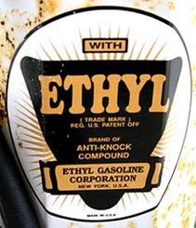

In 1924 a manufacturing accident led to unwarranted fears that the new product might represent a danger to public health, and early in 1925 sales were suspended for a year while the United Sates Public Health Service carried out an investigation of the problem. (Author’s note. The results of that investigation were published in 1922). (See Graham Edgar author’s postscript No. 1). In 1926 sales were resumed, and for several years following, the volume of business increased rapidly. Ethyl gasoline survived, the first years of the great depression admirably, but in 1932, as in the case of many premium products, the sales volume began to decline rapidly. Meanwhile, developments of the refining art had begun to bring about substantial increases in the anti-knock value of regular grade gasoline.

In 1933 the use of tetraethyl lead (TEL) was initiated in regular grade gasoline as an economical means of achieving a part of the needed anti-knock value.

Data presented shows the following:

In early 1933, TEL was used in approximately half of all (US) aviation gasoline, by mid 1933 this had increased to 75%.

Today (1939) about 75 per cent of all gasoline sold in the United States contains tetraethyl lead (TEL). In the aviation field, almost all gasoline of 80 octane number or better contains tetraethyl lead (TEL); in fact, the performance of the modern military or transport plane is due to in large part to the development of high-octane gasoline, a development in which tetraethyl lead (TEL) played an important role.

Outside of the United States tetraethyl lead, (TEL) is used (in 1939) in motor gasoline extensively in Canada, England, France, Australia, New Zealand, and Germany, and to a smaller extent in many other countries. In the aviation field it is used in nearly every country in the world for both military and transport purposes. Manufacturing plants are in operation in Germany and France and are planned for other countries, although a share of the foreign demand is still supplied from the United States.

A surprising feature is that tetraethyl lead (TEL) has been on the market for sixteen years without serious competition in its field. Many laboratories have studied anti-knock compounds and continue to study them. Many anti-knocks are known, but so far, all others have possessed economic or technical disadvantages which have relegated them to a temporary or minor role.

This paper is concerned with the broad aspects of some of the problems encountered and some of those which are anticipated.

Problems of Manufacture

The manufacture of tetraethyl lead (TEL) has represented serious problems from the start. There was no “prior art” in the large scale production of any organo-metallic compounds, and knowledge had to be accumulated by gradual and sometimes painful experience.

Several years ago, it was obvious that the capacity of the existing tetraethyl lead (TEL) plants at Deepwater, New Jersey (U.S.A.) would not long be adequate for an expanding business, and it was decided to locate a plant elsewhere. Baton Rouge, Louisiana, appeared to offer a satisfactory site from the standpoint of availability of raw materials, power, and transportation. The Ethyl Gasoline Corporation therefore purchased a plot of land in Baton Rouge, began construction shortly thereafter, and by the end of 1938, had created a plant development equal capacity to the plants at Deepwater. As the Baton Rouge plants represent the most modern developments (in 1939), they will be taken as the basis for a brief discussion of some of the manufacturing problems.

Tetraethyl lead (TEL) is manufactured by the reaction of Ethyl Chloride with an alloy of Sodium and metallic lead, and the intermediate raw materials are therefore ethyl chloride, sodium and lead. With the exception of metallic lead, none of these are available commercially in the quantities required, and for this reason, as well as in the interest of manufacturing economy, it was necessary to include their manufacture at Baton Rouge.

Figure 2. gives a flow sheet of the manufacturing operations. Salt, obtained from the adjoining works of the Solvay Company, is electrolyzed to produce elemental sodium and chlorine. The sodium is melted with lead to form the alloy which, after grinding, is ready for the final reaction. The chlorine formed in the electrolysis is burned with hydrogen, obtained from the adjoining refinery of the Standard Oil Company of Louisiana, to form gaseous hydrochloric acid.

Ethyl chloride is produced from hydrochloric acid by two distinct processes. The first is the familiar reaction with ethyl alcohol. The second is by reaction with ethylene. In this process, refinery stabilizer gases consisting largely of propane are cracked and the cracked gases fractionated at low temperatures to separate the ethylene formed. This is allowed to react with hydrochloric acid gas at low temperature in the presence of a catalyst to produce ethyl chloride. The Baton Rouge plant is the first commercial development of this method of manufacturing ethyl chloride. Ethyl chloride produced by either process is subjected to appropriate purification processes and is then ready for the final reaction with the sodium–lead alloy.

The reaction is represented by the equation:

4PbNa + 4 C2H5Cl = Pb(C2H5)4 + 4NaCl + 3Pb

Figure 2. Flow sheet of Tetraethyl Lead Manufacture

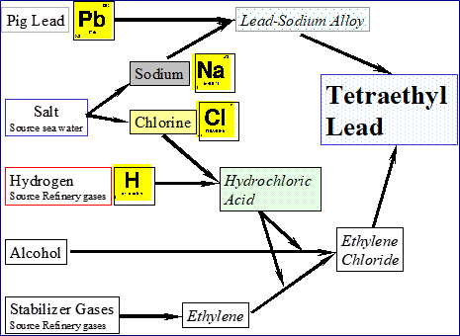

In the manufacturing process the alloy and the ethyl chloride are allowed to react at moderate pressures and temperatures. At the completion of the reaction, the product is distilled with steam to separate the tetraethyl lead (TEL), and the lead sludge is collected and resmelted into pig lead. Although the reaction appears simple, this appearance is illusory. Side reactions invariably occur, and the conditions under which the formation of tetraethyl lead (TEL) take place with a minimum of side reaction have required extended study. Furthermore, tetraethyl lead (TEL) is thermally unstable, and the closest control of the reaction rate is essential to prevent the initiation of decomposition which may reach dangerous proportions.

Tetraethyl lead (TEL) is poisonous and may be absorbed into the body by skin contact and inhalation of vapour, as well as by ingestion. This fact has necessitated the development of specialized equipment and well controlled operating techniques in order to safeguard the health of the operators. Ventilating equipment of unusual capacity must be provided; valves, stuffing boxes, and gaskets required special design, as an entire absence of leaks must be achieved; and emergency conditions must be provided for. Despite the difficulties inherent in the problem the safety record of the tetraethyl lead (TEL) industry has for many years been far better than that of any other lead industry, according to the best available figures.

The Baton Rouge plants give a picture of a self-contained manufacturing development utilizing only the basic raw materials, and representing the most efficient and economic processes known to the art today. The total capacity is better than 60,000,000 pounds (27,000 tonnes) of tetraethyl lead (TEL) per year, and the plant has involved an investment of many millions of dollars.

In addition to tetraethyl lead (TEL), the finished anti-knock fluid requires the addition of ethylene dibromide, ethylene dichloride and dye. The latter two are purchased in the open market, but an adequate supply of ethylene dibromide at reasonable cost has represented a serious manufacturing problem for many years. Supplies of bromine are limited, and for this reason recourse was had a few years, to go to that great reservoir of raw materials, the sea. The dramatic success, both technical and economic, of the Ethyl-Dow plant at Kure Beach, North Carolina, (U.S.A.), for producing ethylene dibromide from sea water, has been described (in Ind. Eng. Chem. 26, 361-9 (1934 by L.C. Stewart).

Sea water contains an average of only 67 parts of bromine per million of water, or about one pound of bromine in 7.5 tons of water, but research has been equal to the task of extracting this minute amount. The sea water is acidified and chlorinated, the bromine is blown out with air and concentrated by absorption, reliberated from the concentrated solution, recovered by distillation, and finally allowed to react with ethylene to form the desired product, ethylene dibromide. (The Ethyl-Dow plant has been substantially expanded since it was first described in 1934.)

The Future (as at 1939)

Vast progress has been made and will continue to be made by the oil refiners. What effect will these developments have on the use of the anti-knock compounds? When the Ethyl gasoline was first put on the market, the octane scale was unknown, and the methods of measuring anti-knock value were uncertain, to say the least. The Ethyl gasoline of today (1939) is 10 octane numbers better than it was fifteen years ago.

What will the future fuels be? No answer can be given. Amazing progress has been made and is being made by the [petroleum industry in modifying the structure of petroleum hydrocarbons to produce gasoline of high anti-knock value. Cracking and reforming, both thermal and catalytic, coupled with isomerization, alkylation, polymerisation, aromatisation, etc. are developing rapidly, and are increasing both yield and quality of gasoline.

What part will tetraethyl lead (TEL) play in this development? Perhaps we should say “anti-knock compounds” instead of “tetraethyl lead” since we are considering the future, and particularly since some mixtures of lead alkyls are already known which possess advantages over tetraethyl lead. (See Author’s postscript 4.)

In summary, we can say that the discovery of the anti-knock value of tetraethyl lead (TEL) has played an important role in the development of the petroleum and automotive industries; that many problems of manufacture and utilization have been solved, and it is expected that others will be solved as they arise; that after sixteen years we find tetraethyl lead (TEL) a well established factor in the economic life of the petroleum industry; and finally, that there is every expectation that it will continue to play its part in the fuel and automobile of the future, either unchanged or in the form of an improved substitute.

Postscript

The results of the U.S. Public Health Service report were published in 1922 by A. M. Stimson, Assistant Surgeon General. The demise of tetraethyl lead (TEL) was brought about in the 1980’s by the progressive use of catalytic converters on automobiles. While there was the claim of improved environment from the reduction of vehicle exhaust emissions, driven primarily by the United States and slavishly adopted by the rest of the world, there was also the claim of reduction in lead toxicity in public health by the “lead free gasoline zealots”. This author does not share this view on lead toxicity based on 30 years’ experience in the oil industry which included lead monitoring of TEL facilities and lead contaminated gasoline tanks. Essentially the problem with lead in gasoline was one of poisoning of the catalyst in the catalytic converters.

The replacements for tetraethyl lead (TEL) in gasolines were: (a) oxygenates (blending agents) such as Methyl Tertiary Butyl Ether, Ethanol, etc. (b) increased aromatic content in particular Toluene (but reduced Benzene), and (c) addition on new anti-knock additives such as Methyl cyclopentadienyl Manganese Tricarbonyl (MMT).

Later developments in alkyl lead anti-knock compounds saw the introduction of Tetramethyl Lead (TML), and blends of TEL and TML. Refer to Table 5.

Only TEL-B was used in aviation gasolines.

# “Ethyl Fluid”[5]

The composition of “Ethyl Fluid” in 1940 is listed Table 2.

Table .Composition of ‘Ethyl Fluid’ (1940)

|  |  |
| --- | --- |
| Compound | % Weight |
| Tetraethyl Lead | 63.3 |
| Ethylene Dibromide | 25.75 |
| Ethylene Dichloride | 8.72 |
| Dyes, petroleum and other admixtures | 2.23 |
| Property | |
| Density at 20 deg C | 1.671 |
| Ratio by volume of Ethyl Fluid to TEL | 1.561 |
| Freezing Point Deg C | -23 |
| Flash Point Deg C | 110 |

In prolonged engine operation with leaded fuels, a fine deposit of lead on the cylinder bottom and walls became noticeable, this resulted in corrosion of these engine parts. The addition of Ethylene Dibromide, eliminated the objectionable features to some extent, since it was thought to form a volatile halogen compound at combustion temperatures which were discharged with the engine exhaust gases.

The amount of Ethyl Fluid that can be added to the fuel is limited, first, because of the danger of corrosion, second, the efficiency of tetraethyl lead decreases again in increasing concentration.

The technical view in 1948 by the R.A.F. and others was as follows:

TEL[6] is added to aviation gasoline in the form of Ethyl Fluid I-T Aviation Mix. The Ethyl Fluid consists of TEL, Ethylene Dibromide, dye and inhibitor (against gum formation). The Ethylene Dibromide (C2 H4 Br2) is added to prevent the formation of lead oxide, which not being volatile, tends to deposit on the combustion chamber, valves, and spark plugs of the engine. This Ethylene Dibromide is known as a ‘scavenger’. The effect of this addition is that during the combustion of leaded fuels, the Ethylene Dibromide combines with the lead oxide to form Lead Bromide which is volatile at the combustion temperatures, and thus most of the lead is carried away in the exhaust gases in the form of Lead Bromide. Ethylene Dichloride is sometimes used in place of Ethylene Dibromide in motor fuels.

The ‘I-T Mix’ in the name stands for ‘one x theoretical’, which means that the amount of Ethylene Dibromide added to the I-T Mix is exactly the amount which is theoretically required to combine with all the Lead in the TEL, to form Lead Bromide.

Table . Composition of ‘I-T Mix’ (1934)[7]

|  |  |
| --- | --- |
| Compound | % Weight |
| Tetra Ethyl Lead | 61.42 |
| Ethylene Dibromide | 35.68 |
| Dyes | 0.17 |
| Kerosene and impurities | 2.73 |
| Property | |
| Density at 20 deg C | 1.659 |
| Ratio by volume of Ethyl Fluid to TEL | 1.561 |
| Freezing Point Deg C | -156 |
| Boiling point (with decomposition) Deg C | 110 |

The use of Ethylene Dibromide is very effective in engines having good distribution (even distribution of fuel/air mixture to each cylinder, such as direct fuel injection). However, one of the main difficulties with TEL anti-knock and Ethylene Dibromide scavenger is their widely different boiling points. This leads to considerable trouble with lead fouling of spark plugs and erosion of exhaust valves in engines having (under certain circumstances) poor distribution, particularly certain in-line carburetted engines when running at low charge temperatures.

At low charge temperatures, the heavy ends (fractions) of the fuel (i.e. those proportions of the fuel with the highest boiling points) collect as a liquid in the induction pipe. TEL has a boiling point of about 200oC. and only about 10% of modern (1948) aviation gasolines have a greater boiling point than 140oC., so virtually all the TEL remains with this small quantity of liquid fuel.

Ethylene Dibromide, however, with a boiling point of 130oC. is vapourized with the more volatile fractions of the fuel, so virtually no Ethylene Dibromide is present in this heavier liquid. In certain in-line engines, although the gases may be distributed evenly between the cylinders, liquids are not. Certain cylinders therefore get more of this liquid fuel than others. The cylinders which get large quantities of this liquid fuel, therefore receive large quantities of TEL, but only the normal distribution of Ethylene Dibromide (i.e. less than a I-T Mix), and plug fouling results. The cylinders receiving small quantities of this liquid have a relative excess of Ethylene Dibromide (i.e. more than a I-T Mix), and Hydrobromic Acid so formed, results in exhaust valve corrosion. It was found that there is a certain charge temperature (often 40oC.) at which liquid fuel is no longer present in the induction pipe and thus plug fouling and exhaust valve corrosion through this cause no longer apply above this temperature. These troubles may be overcome by fitting charge heaters in order to heat the charge above this critical temperature, but this results in loss of efficiency and pay-load. A more promising line of investigation (in 1948) is the development of alternative lead scavengers having a boiling point nearer to that of TEL.

It might be thought that another solution would be to add more that the theoretical amount of Ethylene Dibromide, say a 1½-T Mix. This is not desirable as bromine compounds in combination with water are highly corrosive, and every effort is made to keep the total quantity of bromine as low as possible.

Although Ethylene Dibromide scavenges the lead from the cylinders, the presence of lead compounds promotes pitting of valves, valve seats, spark plug electrodes, etc. This has largely been overcome by using austenitic steel or special alloys for valves, valves seats, etc. and attention to detail in spark plug design. However, it must be pointed out that the greater the amount of TEL added to the gasoline, the greater will be the troubles of this sort, austenitic steel valves notwithstanding. Thus, specifications always limit the maximum TEL content of a grade of gasoline.

The superiority of tetraethyl lead over other anti-knock components according to Midgely and Boyd can be seen from the following table 4.

Table . Relative Efficiency of Different Anti-knock Compounds.

|  |  |
| --- | --- |
| Compound | Relative efficiency |
| Benzol | 1 |
| Toluene | 1.1 |
| Xylene | 1.2 |
| Ethanol | 1.9 |
| Aniline | 11.5 |
| Toluidine | 11.9 |
| Xylidene | 12.0 |
| Ethyl Iodide | 13.9 |
| Tetraethyl Tin | 20.4 |
| Diethyl Selenide | 62.5 |
| Diethyl Telluride | 250 |
| Iron Carbonyl | 250 |
| Nickel Carbonyl | 277 |
| Tetraethyl Lead | 528 |

Alkyl Lead Manufacturers

Some of the other companies which manufactured Alkyl Lead Compounds were:

Octel in the United Kingdom at Ellesmere Port, South Wirral (near Liverpool) which commenced during the 1940’s after initially starting at a smaller site in the same region. (The Octel facility at Ellesmere Port was to continue until the late 1990s. when Octel was sold to another chemical company – Great Lakes Chemical Company, but later spun off as a separate company on the New York Stock Exchange around 1996).

[The author visited Octel at Ellesmere Port in April 1998]

NALCO Chemical Company produces a range of Alkyl Lead products for use in motor gasolines. E.g. NALKYL M-1, NALKYL ME-25-1, NALKYL ME-75-1

Dupont in the U.S. (probably the Baton Rouge facility).

In the late 1990’s Dupont and Great Lakes Chemical Company rationalised the operations for the dwindling alkyl lead market, with one company manufacturing and the other operating the distribution and shipping around the world.

Table . Selected Alkyl Lead Antiknock compounds (2002) (Various suppliers)[8]

|  |  |  |  |  |  |  |
| --- | --- | --- | --- | --- | --- | --- |
| Compound | TEL | TML | Ethylene Dibromide  (1,2-Dibromo-ethane) | 1,2-Dichloroethane | Toluene | Kerosene |
| CAS No. | 78-00-2 | 75-74-1 | 106-93-4 | 107-06-2 | 108-88-3 | 8008-20-6 |
| TEL | 60% |  | 30% | 10% |  |  |
| TEL-B | 61.5% |  | 35.7% |  | - |  |
| MTT152 | 61.5% |  | 17.9% | 18.8% |  | 1.8% |
| MTT153 | 61.4% |  | 35.7% |  |  | 2.9% |
| MTT154 | 28.1% | 28.1% | 17.9% | 18.8% |  | 7.1% |
| TML |  | 52% | 25% | 10% | 13% |  |
| NALKYL M-1 Motor Mix |  | 50.8% | 17.9% | 18.8% | 4.17% |  |
| NALKYL ME-75-1 Motor Mix | 26.7% | 26.7% | 17.9% | 18.8% | 3.28% |  |
| NALKYL ME-25-1 Motor Mix | 29.4% | 29.4% | 17.9% | 18.8% | 1.5% |  |
| Octel TEL-CB | 61.5% |  | 17.9% | 18.8% | - |  |
| Octel TML-CB |  | 50.8% | 17.9% | 18.8% | 12.4% |  |
| Octel CR50-CB | 28.1% | 28.1% | 17.9% | 18.8% | 6.2% |  |
| Octel PM25-CB | 46.1% | 12.7% | 17.9% | 18.8% | 3.1% |  |
| Octel PM50-CB | 30.8% | 25.4% | 17.9% | 18.8% | 6.2% |  |
| Octel PM75-CB | 15.4% | 38.1% | 17.9% | 18.8% | 9.3% |  |

Later there would be Alkyl Lead manufacture in Eastern Germany; this was started during the Second World War and continued after the Russian occupation and subsequent communist block regime.

In Japan during World War II, there was possibly Alky Lead manufacture however the information is limited (Refer to the chapter on Japanese Avgas).

# Alkyl Lead Production during World War II[9]

In 1940 there were only a few chemical plants throughout the world established for the manufacture of Tetraethyl Lead. Originally the anti-knock material was manufactured in the U.S.A. (Baton Rouge, Louisiana), but plants were in operation in England (near Liverpool) and Germany. In view of the necessity for using Tetraethyl Lead in making higher grades of aviation gasoline, TEL manufacturing plants were closely guarded and brought under government control from the beginning of the war. All supplies used in Australia for aviation and motor gasolines were obtained from U.S.A.[10].

Tetraethyl Lead which was added to nearly all commercial gasolines in the form of ‘Ethyl Fluid’ was also recognised as perhaps the most important single ingredient in combat grades of fuel. Early in the war it was recognised that production and supply of adequate quantities of TEL may be critical. In the U.S. the production and supply of Tetraethyl Lead was the responsibility of U.S. War Production Board (WPB), distribution and use were the responsibility of the Petroleum Administration for War (PAW). Despite the doubling of manufacturing facilities, the TEL supply situation was tight through the war, and it was necessary to restrict drastically the amount available for civilian use. This became the responsibility of PAW when asked by the U.S. Army-Navy Petroleum Board to control civilian consumption in order that a minimum world (Allied) reserve of 44 million pounds (20,000 metric tonnes) might be reached by June 30, 1944 and thereafter maintained. Production during 1944 reached just over 258 million pounds (117,000 metric tonnes) world -wide, and through progressive cuts in civilian use, the required world stock pile of 44 million pounds was reached by December 1, 1944. At the time of the German surrender (May 1945), the world stock pile had reached approximately 60 million pounds (27,000 metric tonnes) over and above the refinery working inventories.

Graph 1. Production and Usage of TEL 1942-1945 (August)

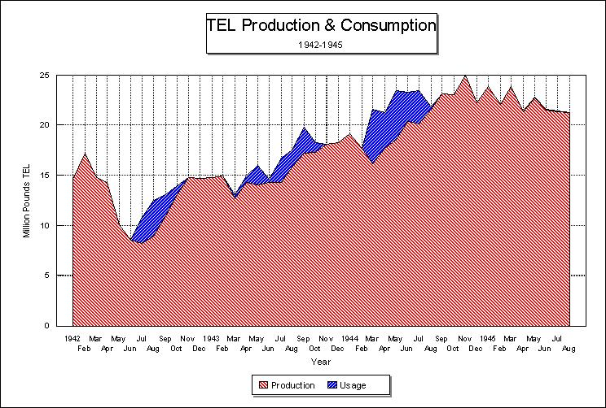

In July 1943 the TEL content of 100-Octane aviation gasoline was increased from 4 ml/USG to 4.6 ml/USG as a temporary measure to increase aviation gasoline output. At this time the Allied air forces had commenced long range bombing raids. In April-May 1944 there was a great demand for aviation gasolines for the Pacific campaigns and the build-up of war materiel for the forthcoming D-Day Normandy landings by the Allied armies.

# Shipping and Distribution of Alkyl Lead

With a limited number of specialised facilities to manufacture Alkyl Lead compounds and a vast number of gasoline production plants (refineries and gasoline blend plants) around the world, there was a need to ship this essential anti-knock agent to the various gasoline plants. Initially Alky Lead compound was drummed into specially strengthened 205 L drums and shipped with other petroleum cargoes around the world. Later special Alkyl Lead facilities would be established at or near refineries, in this case bulk Alky Lead compound would be brought in by purpose built ocean going tanker ships, discharged into the shore facility, then the Alkyl Lead would be later transferred to refinery Alkyl Lead storage facilities for subsequent blending with gasolines blendstocks. However, this was to occur after the Second World War, for the war years, drum stock would have to suffice.

# ‘Ethylizing’ Aviation Gasoline[11]

The addition of Tetra Ethyl Lead (TEL) to aviation gasoline offered an economical method of raising the octane rating. Tetra Ethyl Lead is a component of a mixture known as ‘Ethyl Fluid’ and it is supplied by the manufacturers in a variety of concentrations, but for aviation gasoline blending usually only version is used Ethyl Fluid I-T Aviation Mix which is dyed blue.

Ethyl fluid is supplied in special containers, which are drums of heavy construction with double bungs, and the actual blending is carried out in mixing plants which are purpose built – ‘Ethylizing Plants’. These plants were located throughout the world usually at refineries and at larger gasoline storage facilities where gasoline blending was undertaken in order to provide leaded gasolines to aerodromes.

Because of the toxic nature of concentrated TEL, great care is required in handling this mixture. The plant operators wear white overalls, white rubber gloves and boots so that any splashes of blue Ethyl fluid can be detected. They are required to shower after completion of the work as part of the decontamination procedure.

The Ethylizing Plant consists of a suitable storage tank for the gasoline blend– these vary in capacity from 10 tons (12 K.Litres) to 5,000 tons (5.5 M.Litres). The mixing plant shown below is designed to blend 30 tons of aviation gasoline in Italy (1934). A mixing shed is erected in an isolated location and as far as possible open on all sides (to prevent accumulation of toxic TEL vapours), the dressing rooms and showers are inside or adjacent to the shed. A gasoline pump is provided to supply gasoline from the blending tank as sufficient pressure (about 50 psi) to operate an eductor which is similar to an ordinary injector which draws Ethyl fluid out of the drum and delivers the concentrated mixture back to the storage tank.

If the mix is small, then the drum is positioned on a platform weighing machine (scales) and the required quantity of Ethyl fluid (by weight) is taken from the drum to bring the total contents of the blending tank up to the required octane number.

Photo 7. Ethyl Blending plant in Italy - circa 1934.

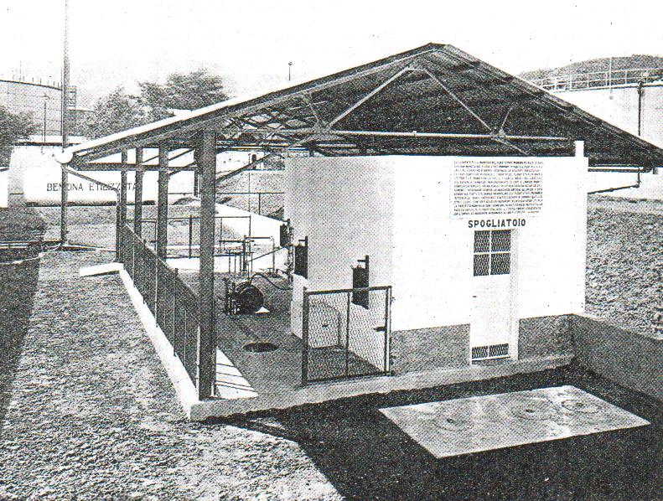

Note the Ethyl fluid drum (barrel) on its side on the weighing platform, to the left of the building. ‘Spogliatoio’ = locker or dressing room.

Photo 8. Ethyl Blending plant work area- Italy circa 1934.

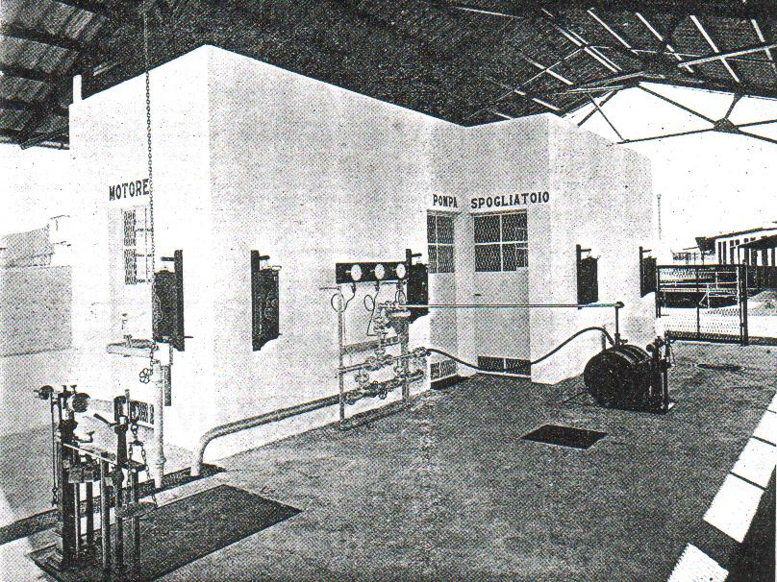

Note the piping arrangement/eductor assembly/gauges on the wall, in particular the funnel. On the left is the vacant scales, on the right is the Ethyl fluid drum connected to the eductor which shows the eductor assembly panel with the swing pipe in the barrel. The flexible hose enables gasoline to be sprayed into the drum so that the empty container can be washed out to remove all traces of Ethyl fluid before it is taken of the scales.

Any additional dye required to bring the colour of the gasoline up to standard is added in the liquid form via the funnel shown at the pipe work on the side of the building near the pump room ‘Pompa’. This concentrated dye/gasoline mixture is also returned to the blending tank. The eductor assembly is then washed through with gasoline into the blending tank, the mixing shed and equipment are carefully washed down and the workers go to the change room, shower and change their clothes.

The gasoline pump is then allowed to circulate the contents of the blending tank for a sufficient time to ensure a homogeneous mixture to make the finished aviation gasoline product.

Photo 9. Men in protective equipment unloading TEL from drums.

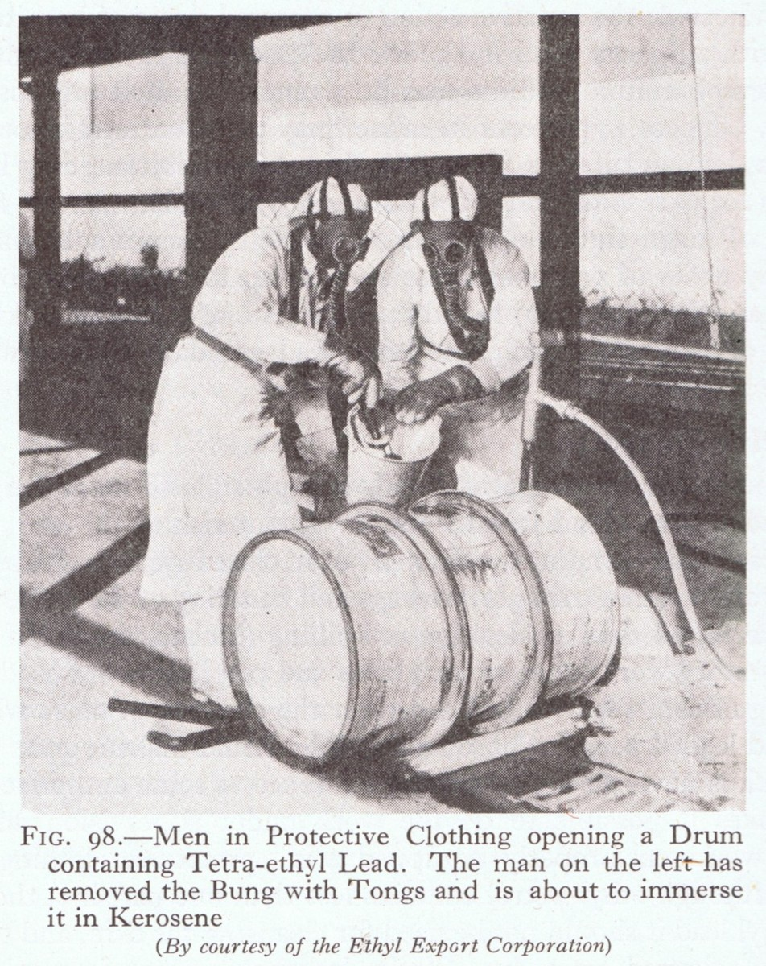

Men in protective clothing opening a drum containing Tetra-ethyl Lead. The man on the left has removed the bung with tongs and is about to immerse it in kerosene. (Courtesy of Ethyl Export Corporation).

# European Alkyl Lead Production[12]

There was not a great deal of TEL used in Europe before the outbreak of World War II.

Mr. F.D. Banks (Ethyl Export Technical Manager) concentrated his efforts on explaining the advantages of TEL in aviation fuel and encouraging aircraft engine manufacturers to develop engines capable of taking advantage of the additive.

The result was that for Europe there was an appreciable increase in the use of leaded gasolines in aircraft, but the development was much slower in the automobile market.

A special difficulty in the distribution of Ethyl gasoline in Europe was the fact that rival fluids were often under government monopoly, and it was sometimes difficult to compete. Excess alcohol from the vineyards and expendable benzol from the steel plants, both government monopolies in the major European countries, were added to gasoline to raise the octane number.

The Ethyl organisation, either directly through the Ethyl American office or through the Ethyl Export Corporation in London, licensed plants abroad for the manufacture of anti-knock fluid in the period 1936-1940. Under shared ownership arrangements the construction of factories for the manufacture of anti-knock fluid took place in Germany, France and England.

The German plant was built in 1936, the French in 1938 and the British in 1940, though authorised in 1936. Also, plants for the extraction of bromine from seawater were completed in France and in the United Kingdom to permit the manufacture of ethylene bromide.

The relations between Ethyl Corporation and Ethyl Export Corporation on the one hand, and the Germans on the other during the 1930’s were in part conditioned by the always complex and sometimes debatable agreements between Standard Oil of New Jersey (later Esso) and the German chemical trust I G Farben. An inevitable principal in negotiations was Frank A. Howard, who was head of Standard Oil Development Corporation and also an officer of both Standard Oil of New Jersey and Ethyl Corporation.

In 1929 there was an understanding between I G Farben and Standard Oil of New Jersey for exchange of patent information. Frank Howard had long been interested in German experiments in the hydrogenation of coal, and then especially in the development of synthetic rubber.

With the assistance of F.D. Banks of Ethyl Export Corporation, in 1931 Lufthansa began a series of tests using the Ethyl additive. In their flights to China in 1933 the German pilots carried litre cans of TEL that had been imported through Ethyl Export of London. The German flight crews blended the TEL with fuel at the Gobi Desert stop. The German nation imported only 12 tons of TEL in 1934, 104 tons in 1935. In 1936, only 4.65 tons of TEL because in that year the German TEL plant began operating.

# German TEL Plants

Negotiations for this plant had begun in the winter of 1934-35. At the request of the German Ministry of Aviation, I G Farben communicated with the Ethyl Gasoline Corporation about the possibility of constructing such a plant. Frank Howard became interested and feared that efforts would be made by European competitors to counter Ethyl – in a series of cables he urged the authorisation of a joint enterprise, part German and part American. Howard’s viewpoint is illustrated in the following cable December 7, 1934. “The problem is to out-manoeuvre the benzole people who may, if they have time to do so, try to stir public opposition by campaigning poison propaganda. Also, probably Royal Dutch Shell will oppose if possible.”

Dupont officials now issued a warning to Ethyl, whether from economic or patriotic consideration is not known. According to Dupont, the proposed plant would be commercially valuable, but it also would furnish the German war machine with technical knowledge it had not yet obtained. Ethyl’s London office tended to oppose the building of the German plant. Banks noted “When the Germans indicated that they wished to build a lead manufacturing plant in their own country, this was at first resisted by us as uneconomic. Eventually, we had to agree to a joint manufacturing company formed between ourselves and I G Farben.” The company Ethyl G.m.b.H. was owned 50% by I G Farben, 25% by subsidiaries of General Motors and Standard Oil of New Jersey. The stocks of these subsidiaries (GM and Standard Oil NJ) were soon transferred to Ethyl Export Corporation. After agreement had been reached between Ethyl and I G Farben, the German chemists went to Dupont and Ethyl for training. The plant was built at Gatel, about 50 miles west of Berlin. By April 1936 the Gatel plant was supplying TEL for use in aviation gasoline.

Secret Second German TEL Plant

The second plant in Germany was built in 1939 at Frose, this theoretically without Ethyl’s knowledge or permission. The London office had heard rumours of an unauthorised plant and through a mailing mix-up obtained firsthand information on the plant. By mistake the Germans had put an envelope directed to the Frose plant into a packet of mail addressed to Ethyl Export. Banks promptly steamed open the envelope, read all about this unauthorised plant, resealed the envelope and returned it to the Germans, who were telephoning frantically for the return of this particular piece of mail. Banks notified the British authorities when then knew exactly where the second plant was located.

This plant was also later to be an Allied bombing target.

# French TEL Plant

Permission for the construction of TEL plant in France evolved from a clause in a supply contract dated August 24, 1935, between the French Ministry of War represented by Mr. Blanchard, military engineer and chief director of explosives, and the Ethyl Export Corporation. The definitive contract was concluded April 3, 1937, when Ethyl agreed that a plant would be constructed by no later than July 1938. The firm of Kuhlmann was to build a plant for Ethyl’s account and under supervision of Ethyl Export Corporation. [details of arrangement]

The completed plant was to be owned by a manufacturing company comprising 4% French Government, 46% Kuhlmann and 50% Ethyl Export Corporation. The French Government would have veto power in matters of national defence. Ethyl was to organise a sales company wholly owned by Ethyl Export Corporation.

The plant was constructed at Nazaire, France, and was about the same size as the first German TEL plant. The accompanying bromine plant was built under license from Dow Chemical and was operated by Ethyl Kuhlmann.

# U.K. TEL Plant

The U.K. TEL plant was being discussed by the Ethyl Export and the British Air Ministry as early as 1935. It was decided that the TEL plant would not be built at that time, but plans would be drawn and an agreement made that could be carried out in times of emergency. To ensure smooth operations in this anticipated crisis, British Ethyl Corporation was formed on May 9, 1936 owned 50% by Ethyl Corporation and 50% by Imperial Chemical Industries (ICI). The basic technology was to come from Ethyl Corporation and the operating staff from ICI. To cope with the demand before actual construction, large stocks of Ethyl aviation anti-knock fluid was imported. Eventually both the TEL plant and the bromine plant were owned by the British Air Ministry and leased to British Ethyl Corporation. Both plants were operated during the war by the Alkali Division of ICI on behalf of British Ethyl Corporation.

Not all refineries were interested in purchasing TEL; Shell Oil in particular was unenthusiastic about TEL and purchased it only when aviation customers so demanded. It was thought that one of the reasons for Shell’s resistance was the fact that Ethyl was half-owned by Standard Oil of New Jersey – a competitor. To overcome this problem a new organisation, in which ownership would be shared by the great oil companies, was to be created. Profits would be determined roughly by their purchases of TEL. This led to the creation of Associated Ethyl Company based in England and operated under English law. The stockholders were the major oil companies of the world (including Standard Oil of New Jersey) and General Motors. The Associated Ethyl Company was formed on July 16, 1938, with the formal agreement with Ethyl Corporation that on May 1, 1939 the business of Ethyl Export would be taken over by Associated Ethyl Company. Essentially all Associated Ethyl Company would operate throughout the world except for the continent of North America, which was reserved for Ethyl Corporation itself.

Table . Associated Ethyl Company ownership 1939.

|  |  |  |  |  |  |
| --- | --- | --- | --- | --- | --- |
| Company |  | GB Pounds | % | US $ | % |
| Anglo-Saxon |  | 126,426 | 49.33% | $591,994.15 | 49.33% |
| Anglo-Iranian | BP | 61,628 | 24.05% | $288,573.68 | 24.05% |
| Socony | Mobil | 33,805 | 13.19% | $158,293.61 | 13.19% |
| Texas | Texaco | 24,934 | 9.73% | $116,755.86 | 9.73% |
| California | Chevron | 9,478 | 3.70% | $44,382.70 | 3.70% |
| **Total** |  | **256,271** | **100.00%** | **$1,200,000** | **100.00%** |

Although Standard Oil of New Jersey kept membership in the new group (Associated Ethyl Company) for a brief period, neither of Ethyl Corporation’s owners (Standard Oil New Jersey & GM) remained permanent partners in Associated Ethyl Company.

# Australian Inland Aircraft Fuel Depots

During the Second World War a unique aviation gasoline supply system was set up to supply the Allied air forces fighting the Japanese in the South West Pacific. Early in 1939, a RAAF Committee investigated the requirements of aviation fuel and oils for operational and training purposes. This Committee recommended the erection of groups of storage tanks at inland locations to be selected which offered security from attack by sea-borne aircraft. Australia relied totally on imported aviation fuel products and because of its vast distribution area (over 3 million sq. miles, and of equivalent size to continental U.S.A. or Western Europe including the Mediterranean) it was ideally suited to such a supply system.

In 1940, the Commonwealth of Australia Cabinet approved the establishment of a number of RAAF inland aircraft fuel depots (IAFD). Initially the proposal was to establish major depots on seaboard near major capital cities, however it was decided that a larger number of smaller depots was a better proposition in view of the current war situation. Following America’s entry into the war, the Americans requested that additional tanks be built and positioned along the air route between the Australian east coast and Darwin. The fuel requirements of the US Army Air Corp were integrated into the RAAF requirement.

A typical Stage One Depot comprised three 200,000-gallon (909 K.Litres) storage tanks and a 40,000-gallon (182 K.Litres) Ethyl mixing tank. They were located next to a rail siding and had drum filling and storage facilities. Aviation oil was also stored in drums. This required a dedicated gasoline blend tanks, an induction system and a supply of Alkyl Lead compound. The Alkyl Lead compound was imported in 205 L drums and transported to selected Inland Aircraft Fuel Depots (IAFD) which had these facilities.

The two grades of avgas stored were Avgas 77 and by blending Ethyl compound (Tetra Ethyl Lead) Avgas 87 could be made or later Avgas 90 octane. Later Avgas 100 octane base gasoline which was blended with Ethyl compound to make Avgas 100.

More detail of these IAFD is provided in earlier chapters.

# Other Alkyl Lead Production[13]

Canada 1955

To produce and market anti-knock products in Canada, a new company Ethyl Corporation of Canada was established under the laws of the Province of Ontario in 1955. A new TEL plant was completed in 1956 in the area called Chemical Valley, near Sarnia (located in the Great Lakes area on the Canadian-USA border, about 50 miles NE of Detroit) – the first authorised TEL plant on the continent of North America outside the United States – the first of its kind in Canada. It was formally opened on June 5, 1957.

Mexico (late 1950’s)

Until about 1950, Ethyl gasoline could only be purchased in the area of Mexico City. The oil administration of the Mexican Government provided for a wider distribution of this premium grade motor fuel. By late 1950’s Pemex (the Mexican Government’s petroleum administration decided that it wanted an anti-knock plant within its own borders. However, under Mexican law a foreign company could not own more that 49% of a company, this was unacceptable to Ethyl’s owners especially General Motors. Agreement could not be reached so Pemex turned to Dupont who were willing to accept the Mexican terms.

Supplies to Russia 1943

During World War II, the Russians needed ethyl fluid to blend with aviation blendstocks imported from Abadan Refinery. The ethyl fluid was supplied to Abadan Refinery from American sources; in turn part of this supply would be shipped to Russia. This was detailed in memo[14] from Mr. E. A. Berthoud (PE220/7/1) of May 29, 1943.

Ethyl Fluid – Abadan

The Russian requested 100-125 tons of ethyl fluid from Abadan. The matter was investigated and advice was that 700 drums of ethyl fluid could be spared, equivalent to 150 tons for delivery from Abadan at any time after June (1943). This is of course, also subject to mutually satisfactory transport arrangements across Persia being possible. [The ‘Persian Corridor’].

Ethyl Fluid at Abadan is at present derived from America and involves a long replacement route. In the meantime, we are holding at your disposal in the UK 1,740 drums of ethyl fluid recently diverted here, and hope to be able to on-ship this quantity to the Soviet Union at a suitable moment. We have not discussed the question of payment for the 5,000 tons of 130 grade and the above maximum of 700 drums of ethyl fluid.

Signed E A Berthoud

For more detail on Mr. E. A. Berthoud refer to Chapter 23. Mr Berthoud later Sir Eric Berthoud became Assistant Under Secretary who supervised the Economic Relations Department of the British Foreign Office 1948.

# Other Antiknock Additives[15]

Ohio State University

While the work of Midgley and Boyd attracted considerable attention, there were other developments in the research into anti-knock agents. The following illustrates some of the other work in progress. A new theory of the action of anti-knock detonating preparations was advanced in a report issued by the American Chemical Society concerning researches covering a large number of chemical compounds. These researches were carried out in the chemical laboratory of Ohio State University by William Hale Church, Edward Mack Jr., and Cecil E. Boord, where they showed that lead compounds were the best antidotes against knocking in automobile engines. The new theory offered by the investigators attempted to explain the way in which tetraethyl lead prevented knock. In the explosion, which takes place in the engine, tetraethyl lead is decomposed suddenly into infinitesimal particles of metallic lead which act as centres for partial burning. These little particles themselves burn as the flame front approaches them and, thus they make the flame travel faster than if they were not present. This condition was described as somewhat like millions of unimaginably small sparkplugs that ignite the gas just ahead of the flame front.

“Thus, by virtue of the multiple centres of high temperature created by the burning of these little particles of lead there is initiated evenly ahead of the main flame front a partial oxidation or an auxiliary burning tendency to maintain combustion in a region of fuel which otherwise would be subject to detonation. The decomposition temperature of anti-knock materials, taken in conjunction with the temperature of the cylinder gases, thus determines at what stage in the cycle they shall begin to function. The ideal anti-knock compound should possess a decomposition temperature which will cause it to begin to function just with or just after ignition of the charge by the spark plug.”

Five properties, according to the researchers, are essential to this anti-knock material.

Volatility, with the boiling point under 400 deg. C.

Amount of free metal liberated when the compound is heated in the air should be complete.

Decomposition temperature should be between 200 and 300 deg. C.

Temperatures developed by oxidation of the metal should be high compared to the ignition temperature of the fuel.

Particles should be of colloidal size to favour rapid oxidation.

The knock of the engine, it is explained, is supposed to be due to the fact that burning of part of the gas mixture so compresses the unburned portion that this unburned portion becomes hot enough to ignite spontaneously. The little particles of lead distributed throughout the gas mixtures vastly increase the swiftness of the flame travel and make it possible for the flame to reach every part of the gas before it has had chance to ignite spontaneously.

Value of Antiknock Chemicals

Important to chemical science was the finding of a method of comparing one anti-knock with another. Tetraethyl Lead was found to be the most formidable of all the anti-knock compounds and all comparisons were based upon this compound. The following table of anti-knock coefficients illustrates the range of exotic chemicals that were synthesized in an attempt to overcome the problem of engine knock – based on Tetraethyl lead as 100.

Table 7. Comparative Values of Antiknock Compounds

|  |  |  |
| --- | --- | --- |
| Compound | Composition | Antiknock Coefficient |
| Lead Tetraethyl | (C2H5)4.Pb | 100 |
| Lead Diphenyl Dimethyl | (CH3)2..(C6H5 .CH3)2.Pb | 97 |
| Lead Diphenyl Diethyl | (C2H5)2..(C6H5 .CH3)2.Pb | 93.5 |
| Lead Diphenyl Diiodide | (C6H5 .CH3)2.Pb.I2 | 80 |
| Lead Diphenyl Dichloride | (C6H5 .CH3)2.Pb.Cl2 | 72 |
| Lead Diethyl Dichloride | (C2H5)2.Pb.Cl2 | 67 |
| Lead Tri-p-xylyl | (C6H5.C2H5)3.Pb | 64.7 |
| Lead Diethyl Dibromide | (C2H5)2.Pb.Br2 | 60 |
| Lead Tetraphenyl | (C6H5.CH3)4.Pb | 59 |
| Bismuth Trimethyl | (CH3)3.Bi | 20.2 |
| Bismuth Triethyl | (C2H5)3.Bi | 20.2 |
| Bismuth Triphenyl | (C6H5.CH3)3.Bi | 18.2 |
| Stannic (Tin) Iodide | Sn.I4 | 12.8 |
| Stannic (Tin) Diethyl Iodide | Sn.(C2H5)2.I2 | 12.3 |
| Lead Thioacetate |  | 8.4 |
| Lead Ethyl Xanthogenate |  | 7.1 |
| Antimony Triphenyl Diiodide |  | 4 |
| Stannic Chloride | Sn.Cl4 | 3.5 |
| Titanium Tetrachloride | Ti.Cl4 | 2.7 |
| Triphenyl Arsine | (C6H5.CH3)3.AsH? | 1.4 |

# German Antiknock Additive

In 1929 a new anti-knock fuel marketed under the trade name of “Motalin” and used Iron Pentacarbonyl for its anti-knock qualities, made its appearance in Germany. The fuel consisted of 0.2 to 0.25% of Iron Pentacarbonyl Fe.(Co)5 .

Furfural

In 1939 the Germans were experimenting with other anti-knock additives. The following was reported in the scientific press of the time[16]:

Furfural (C5H4O) is obtained from a few petroleums and from many waste products, e.g. grain distilleries products, wood carbonisation liquors, etc. The latest method of production is from sawdust or oat husks, which yield 11% furfural.

It is itself non-explosive but extends the explosion limits of compressed gases in both directions. It imparts increased knock stability to motor fuels and by promoting complete combustion gives considerable economy in fuel consumption. Carbon and tar deposits on sparking plugs are reduced so that ignition is more reliable and the running of the engine more smoothly, thereby reducing stresses in the moving parts. Furfural also has a certain lubricating effect and its high flame point reduces the danger of carburettor fires. Many large American companies, such as Texas Gulf Company, are already using large quantities of furfural as an anti-knock, thereby reaching knock ratings of 99. Addition of furfural does not reduce lead sensitivity. As a substitute for tetraethyl lead the Standard Oil Co. is using a mixture of metal carbonyls such as Fe.(CO)4,  Fe.(CO)5,  Fe.(CO)6,  Co.(CO)3,  Co.(CO)4,  Ni.(CO)4,  Mo.(CO)6,  with furfural and amines.

Furfural is also added to lubricating oils in small quantities to improve their properties by extracting polyaromatic aromatics (PAHs), also known as polynuclear aromatics (PNAs).

# Epilogue for Lead

By the start of the 1930’s the “Octane Scale” was established and Tetra Ethyl Lead would become the predominant anti-knock additives, surpassing all others. This would remain so for the next 70 years until public concerns about environmental issues about “lead” would see its demise.

Other anti-knock additives would be developed MMT (Methyl cyclopentadienyl Manganese Tricarbonyl ), while these were trialled there were problems, and at this time would not be used in aviation gasolines.

As at 2020, Alkyl Lead (TEL) was still in use, albeit at lower level.

# Index

# 

1

1,2 Dibromo-ethane 12

1,2 Dichloroethane 12

100-Octane aviation gasoline 13

1½-T Mix 11

8

80 octane 6

A

A. M. Stimson 9

Abadan Refinery 20

absorption 8

accident 6

acidified 8

additive 16

admixtures 9

aerodromes 14

aircraft engine 4, 5, 16

alcohol 16

Alkali Division 18

Alkyl Lead 3, 4, 12, 14, 19

alkylation 8

Allied air forces 13, 19

Allied bombing target 18

alloy 7, 11

American Chemical Society 20

amines 22

Anglo-Iranian 19

Anglo-Saxon 19

Aniline 11

anti-knock 10

anti-knock additives 4, 9, 22, 23

anti-knock agents 5, 20

anti-knock coefficients 21

anti-knock compounds 6, 8, 11, 21

anti-knock detonating 20

anti-knock fluid 8, 16

anti-knock fuel 5, 22

anti-knock plant 20

anti-knock properties 4

anti-knock value 4, 6, 8

Antimony Triphenyl Diiodide 22

aromatic content 9

aromatic crudes 5

aromatisation 8

Assistant Surgeon General 9

Assistant Under Secretary 20

Associated Ethyl Company 18, 19

Associated Octel 12

austenitic steel 11

Australia 6, 12, 19

automobile 8, 9, 16

automobile engine 3, 6, 20

automotive 5

automotive industries 8

Avgas 4

Avgas 100 19

Avgas 100/130 4

Avgas 115/145 4

Avgas 77 19

Avgas 87 19

Avgas 90 19

aviation anti-knock fluid 18

aviation blendstocks 20

aviation field 6

aviation fuel 16, 19

aviation gasoline 4, 6, 9, 10, 12, 13, 14, 16, 17, 23

Aviation oil 19

Avomatic 5

B

Banks 17

Baton Rouge 7, 8, 12

battery ignition 3

Benzene 9

Benzol 11, 16, 17

Berlin 17

Bismuth Triethyl 22

Bismuth Trimethyl 22

Bismuth Triphenyl 22

blending agents 9

blending tank 14, 16

blendstocks 4

blue 14

boiling point 10, 11, 21

bombing raids 13

bouncing pin 3

Boyd 4, 5, 11, 20

BP 19

British 16, 17

British Air Ministry 18

British Ethyl Corporation 18

British Foreign Office 20

bromine 8, 16

bromine compounds 11

bromine plant 18

C

Cabinet 19

California 3, 19

Canada 6, 19

Carbon 22

carbon atoms i

carburetted engines 10

catalyst 7, 9

catalytic 8

catalytic converters 9

Cecil E. Boord 20

change room 16

charge heaters 11

Charles Kettering 3

Chemical Valley 20

Chevron 19

chief director of explosives 18

China 17

chlorinated 8

chlorine 7

coal 17

colloidal size 21

combat grades 13

combustion 10

combustion chamber 3, 4, 10

commercial aviation 4

Commonwealth of Australia 19

communist 12

compressed gases 22

compression ratios 3

corrosion 9

corrosive 3, 11

cracked gases 7

Cracking 8

cylinder 9, 10

cylinder gases 21

cylinder walls 4

D

Darwin 19

Dayton Engineering Laboratories 3

Dayton, Ohio 6

D-Day Normandy 13

decomposition 8, 10

Decomposition temperature 21

decontamination 14

Deepwater 7

Delco-Lite engine 3

Density 9, 10

deposit 10

depots 19

detonation 3

Detroit 20

Diethyl Selenide 11

Diethyl Telluride 11

distillation 8

dope 3

double bungs 14

Dow Chemical 18

dressing rooms 14

drum 14, 19

DuPont 12, 17, 20

dye 8, 10, 14, 16

Dyes 9, 10

E

E. A. Berthoud 20

Eastern Germany 12

Economic Relations Department 20

eductor 14, 15, 16

Edward Mack Jr 20

electrolysis 7

electrolyzed 7

elemental sodium 7

Ellesmere Port 11

engine 21

engine exhaust gases 9

engine tests 4

England 6, 12, 16, 18

environmental issues 23

erosion 10

Esso 17

Ethanol 9, 11

Ethyl 6, 17

Ethyl additive 17

ethyl alcohol 7

Ethyl American 16

Ethyl Benzene 5

Ethyl Blending plant 15

ethyl chloride 7, 8

Ethyl compound 19

Ethyl Corporation 17, 18, 19

Ethyl Corporation of Canada 19

Ethyl Export 16, 17, 18

Ethyl Export Technical Manager 16

Ethyl Fluid 9, 10, 13, 14, 15, 20

Ethyl Fluid I-T Aviation Mix 10, 14

Ethyl G.m.b.H. 17

Ethyl gasoline 6, 8, 16, 20

Ethyl Gasoline Corporation 5, 7, 17

Ethyl Iodide 11

Ethyl mixing tank 19

Ethyl organisation 16

Ethyl-Dow 8

ethylene 7, 8

ethylene bromide 16

Ethylene Dibromide 8, 9, 10, 11, 12

Ethylene Dichloride 8, 9, 10

Ethylizing 14

Europe 16

exhaust emissions 9

exhaust gases 10

exhaust valves 10, 11

extraction 16

Exxon-Mobil 12

F

F.D.Banks 16, 17

factories 16

flame front 20

Flash Point 9

France 6, 16, 18

Frank Howard 17

Freezing Point 9, 10

French 16

French Government 18

French Ministry of War 18

French TEL Plant 18

Frose 17

fuel 10, 13, 17, 21

fuel injection 10

fuel tanks 3

fuel/air mixture 10

funnel 15, 16

Furfural. 22

G

gas mixture 21

gas turbine 4

gases 10

gaskets 8

gasoline 4, 5, 6, 8, 11, 14, 16, 19

gasoline blend 14

gasoline blend tanks 19

gasoline blending 14

gasoline pump 14, 16

gasoline storage 14

gasolines 5, 9, 13

Gatel 17

General Motors 17, 18, 20

German 13

German Antiknock Additive 22

German chemists 17

German Ministry of Aviation 17

German pilots 17

German plant 16, 17

German TEL plant 17, 18

Germany 6, 12, 16, 22

Gibson 3

Gobi Desert 17

government monopoly 16

Graham Edgar 5. 6

grain distilleries 22

Great Lakes 20

Great Lakes Chemical Company 12

gum formation 10

H

halogen compound 9

health 8

heavy ends 3, 10

high-octane gasoline 6

Hopkinson 3

Hydrobromic Acid 10

hydrochloric acid 7

hydrogen 7

hydrogen atoms i

hydrogenation 17

I

I G Farben 17

IAFD 19

ICI 18

ignition temperature 21

illuminating grade 3

Imperial Chemical Industries 18

impurities 5, 10

Ind. Eng. Chem 8

induction pipe 10, 11

induction system 19

ingestion 8

inhalation 8

inhibitor 10

injector 14

Inland Aircraft Fuel Depots 19

iodine 4

Iron Carbonyl 11

Iron Pentacarbonyl 22

isomerization 8

I-T Mix 10

Italy 14, 15

J

Japan 12

Japanese 19

K

kerosene 3, 4, 10, 12,16

Kettering 5

knock 4, 5

knock stability 22

Kuhlmann 18

Kure Beach 8

L

L.C.Stewart 8

laboratories 6

lead 7, 11

lead alkyls 8

Lead atom i

Lead Bromide 10

lead compounds 20

lead contaminated gasoline tanks 9

Lead Content 4

lead deposits 4

Lead Diethyl Dibromide 21

Lead Diethyl Dichloride 21

Lead Diphenyl Dichloride 21

Lead Diphenyl Diethyl 21

Lead Diphenyl Diiodide 21

Lead Diphenyl Dimethyl 21

Lead Ethyl Xanthogenate 22

lead fouling 10

lead free gasoline zealots 9

lead industry 8

lead manufacturing plant 17

lead monitoring 9

lead oxide 10

lead response 4, 5

lead scavengers 11

lead sensitivity 22

lead sludge 8

lead susceptibility 4

Lead Tetraethyl 21

Lead Tetraphenyl 22

Lead Thioacetate 22

lead toxicity 9

Lead Tri-p-xylyl 21

leaded fuels 9, 10

leaded gasolines 14, 16

licensed plants 16

lighting generator sets 3

liquid fuel 10

Liverpool 12

London 16, 17

Louisiana 7, 12

low compression 6

lubricating oil 3, 22

Lufthansa 17

M

manufacture 5, 7, 8, 12, 16

manufacturer 14

manufacturing 6, 7, 8, 12

metal carbonyls 22

metallic lead 7, 20

Methyl cyclopentadienyl Manganese Tricarbonyl 9, 23

Methyl Tertiary Butyl Ether 9

Mexican Government 20

Mexico City 20

Midgely 4, 5, 11, 20

mixing plant 14

mixing shed 14, 16

MMT 9, 23

Mobil 19

molecular structure 4

Motalin 22

motor fuels 10, 22

motor gasoline 6, 12

Motor Mix 12

Mr. Blanchard 18

MTT152 12

MTT153 12

MTT154 12

N

NALCO Chemical Company 12

NALKYL M-1 12

NALKYL ME-25-1 12

NALKYL ME-75-1 12

Nazaire 18

New Jersey 7

New York 5

New York Stock Exchange 12

New Zealand 6

Nickel Carbonyl 11

North America 18

North Carolina 8

O

oat husks 22

octane 4, 19

octane number 8, 14, 16

octane rating 14

Octane scale 3, 5, 8, 23

octanes 4

Octel 12

Octel CR50-CB 12

Octel PM25-CB 12

Octel PM50-CB 12

Octel PM75-CB 12

Octel TEL-CB 12

Octel TML-CB 12

Ohio State University 20

oil companies 18

oil industry 9

oil refiner 5, 8

organo-metallic compounds 4, 7

oxidation 21

oxygenates 9

P

Pacific 13

partial oxidation 21

patent information 17

Pemex 20

Pennsylvania 3

Persian Corridor 20

petroleum 8, 9

Petroleum Administration for War 13

petroleum hydrocarbons 8

petroleum industry 8

pig lead 8

pipe work 16

piping arrangement 15

piston 4

plant 7, 8, 17, 18

plug fouling 10

poison 17

poisoning 9

poisonous 8

polymerisation 8

Pompa 16

pre-ignition 4

premium grade motor fuel 20

propaganda 17

propane 7

protective equipment 16

Province of Ontario 19

public health 6, 9

pump room 16

R

R.A.F. 9

RAAF 19

RAAF Committee 19

rail siding 19

refineries 14, 18

refinery 7, 13

reforming 8

regular grade gasoline 6

Relative efficiency 11

Ricardo 3

Royal Dutch Shell 17

Russian 12, 20

S

Salt 7

Sarnia 20

sawdust 22

scales 15

scavenger 10

sea water 8, 16

sea-borne aircraft 19

service station 6

Shell Oil 18

shower 14, 16

side reaction 8

skin contact 8

Socony 19

Sodium 7

sodium–lead alloy 7

Solvay Company 7

South West Pacific 19

South Wirral 12

Soviet Union 20

spark plug electrodes 11

spark plug 3, 4, 10, 21, 22

Spogliatoio 15

stabilizer gases 7

Stage One Depot 19

Standard Oil Co 22

Standard Oil Company of Louisiana 7

Standard Oil Development Corporation 17

Standard Oil of New Jersey 17, 18, 19

Stannic (Tin) Diethyl Iodide 22

Stannic (Tin) Iodide 22

Stannic Chloride 22

steel plants 16

storage facilities 19

storage tank 14, 19

straight run gasoline 4

stuffing boxes 8

Sulphur 5

supply system 19

synthetic rubber 17

T

tanker ships 14

tar deposits 22

TEL 4, 6, 8, 9, 10, 12, 14, 17

TEL plant 18, 19, 20

TEL Susceptibility 5

TEL-B 12

Tetra Ethyl Lead 1, 10, 14, 19, 23

tetraethyl lead 4, 5, 6, 8, 9, 20, 22

Tetraethyl Lead 5, 9, 11, 12, 13

Tetraethyl Lead Manufacture 7

Tetraethyl Tin 11

Tetramethyl Lead 9

Texaco 19

Texas 19

Texas Gulf Company 22

thermal 8

Thomas Boyd 4

Thomas Midgley 3

Titanium Tetrachloride 22

TML 9, 12

Toluene 5, 11, 12

Toluidine 11

toxic 14

transport plane 6

transportation 7

Triphenyl Arsine 22

U

U.K. TEL plant 18

U.S. Army-Navy Petroleum Board 13

U.S. Public Health Service 9

U.S. War Production Board 13

United Kingdom 11, 16

United Sates Public Health Service 6

United States 6, 9, 20

unleaded 4

US Army Air Corp 19

V

valve seats 11

valves 3, 4, 8, 10, 11

vaporized kerosene 4

vapour 8

vapour lock 3

vineyards 16

volatile fractions 10

Volatility 21

W

weighing machine 14

weighing platform 15

Western Europe 19

white overalls 14

white rubber gloves 14

William Hale Church 20

wood carbonisation liquors 22

X

Xylene 5, 11

Xylidene 11

# Research Sources

1. By Jynto (talk) - Own work This image was created with Discovery Studio Visualizer., CC0, https://commons.wikimedia.org/w/index.php?curid=15366026
2. Aviation Petrol – reprinted from The Aeroplane October 13, 20 & 27 1944. London. National Aerospace Museum Washington NASM B4-292100-21.
3. ‘The INTAVA World’ July 1938.
4. “The Manufacture and Use of Tetraethyllead” by Graham Edgar presented at API Meeting in Chicago Illinois 1939, reprinted from Industrial and Engineering Chemistry Vol. 31, Pages 1429-1446, December 1939.
5. National Advisory Committee For Aeronautics. Technical Memorandum No. 940 “The Lead Susceptibility of Fuels And Its Dependence On The Chemical Composition” by O Widmaier Circa 1940 – Source NASM B4-292260-02.
6. R.A.F. Manual of Fuels and Lubricants AIR Publication 3160. Vol. 1, Sect. 2, Chapter 1. British Air Ministry July 1948, Reprinted December 1959.
7. Shell Aviation News, April 1934.
8. Source Associated Octel Product Information (OIP 1 July 1995), Exxon-Mobil Material Safety Data Bulletins.
9. “A History of The Petroleum Administration for War 1941-1945” United States Government Printing Office Washington 1946 prepared by John W Frey and H Chandler Ide. Source: American Petroleum Institute.
10. “Aircraft Fuels and Lubricants” Shell Co. of Australia Limited - Technical Department (Circa 1940).
11. Shell Aviation News, September 1934.
12. “Ethyl – a history of the corporation and the people who made it” by Joseph C Roberts 1983 University of Virginia Press.
13. “Ethyl – a history of the corporation and the people who made it” by Joseph C Roberts 1983 University of Virginia Press.
14. UK Public Records Office CAB 111/116 Ethyl to Abadan
15. “Modern Aviation Engines” by Major Victor W. Page U.S. Air Corps Reserve. New York 1929.
16. The Journal of the Royal Aeronautical Society Vol. XLIV 1940 page 100 (item 73/31 Germany) “A New Antiknock Agent for Motor Fuel Substitute for Tetra Ethyl Lead” (E. Belani, Chemiker Zeitung No.37 10/5/39).