Chapter

38

Avgas Blending agents - The pursuit of more power, better quality

Photo . Refuelling a Spitfire circa 1943.

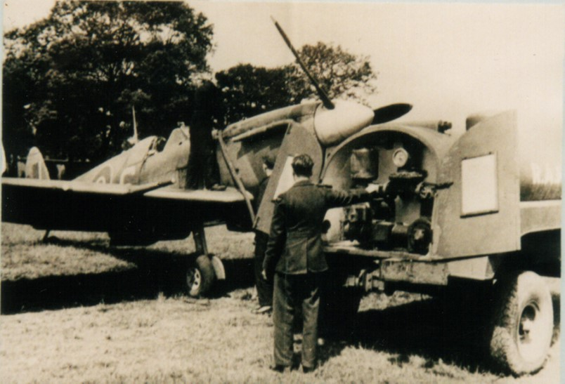

Table of Contents

Avgas Blending Agents - The Pursuit Of More Power. 4

Benzole 4

Aviation Gasolines 100/130 Blending Agents 5

Cumene 5

Victane (March 1944) 7

Aromatic Amines 9

Aromatic Amines Types 11

Toluene 13

Avaro 13

Performance Boosters 14

Alcohols Fuels For Aviation 15

Anti-Oxidants 18

Index 20

Research Sources 23

Photo 2. Supermarine Spitfire chasing down a German V1 Flying Bomb ‘Doodle bug” (this required Avgas 100/150).

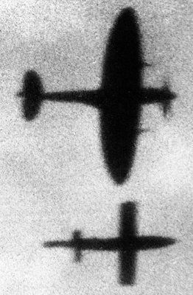

# Avgas blending agents - The pursuit of more power.

The addition of unusual chemicals was used to increase performance.

As early as 1915, the British were adding components which improved aircraft performance, at that time it was Benzole (also known as Benzol).

# Benzole

In 1915 British at the Royal Aircraft Factory discovered that benzol reduced knocking. British engineers determined that in order of engine performance - Aromatics (best), Naphthenes (intermediate), Paraffins (worst). This led to the preference of 38% aromatics content by British and use of PONA analysis (Paraffin, Olefin, Naphthene, Aromatic content) to determine quality. This high level of aromatics could be tolerated in aircraft where the operational ceiling (altitude) was less than 20,000 feet, and so freezing point of the fuel was not a significant consideration.

Sam Heron found that benzol blends performed worst in hotter air-cooled engines, an engine type in common use by the U.S. Army, and the preferred type by the U.S. Navy.

In the United States in 1928-1929 the choice of fuel components was Benzol, Straight Run gasoline 35-55 PN, cracked (olefinic) gasolines up to 50 PN, and Lead (TEL). Benzol was limited to 20% due to freezing of aviation fuel in the fuel system in cold weather, and also availability.

Problems with Benzole

The presence of hydrocarbons with high freezing points, such as benzene (freezing point 42 deg. F (5.5 deg. C), in certain aviation gasolines raised the freezing point of the fuel. Further, aromatic hydrocarbons can dissolve about 10 times as much water as do normal gasolines. According to the view of E.L. Bass, these undesirable characteristics limited the maximum benzol content to around 20% for a freezing point of -58 deg. F (-50 deg. C). Other aromatic hydrocarbons such as Toluene, Xylenes, or Cumene have satisfactory low freezing points.

Bass in his paper in 1935[1] noted that the average “Motor Benzole” used for blending aviation fuels has a freezing point about -10 deg. C., therefore for a freezing point specification of -50 deg. C would limit the amount of Benzole to about 20%. For the avgas specification of -60 deg. C freeze point, the limit of Benzole would be approximately 15%. By contrast, Toluene has a freezing point of -95 deg. C, therefore larger quantities can be used.)

Other specifications such as Sulphur and gum test are affected by Benzole (or coal spirit, cracked gasolines).

Graph . Relationship of Avgas freezing point and Benzole content.

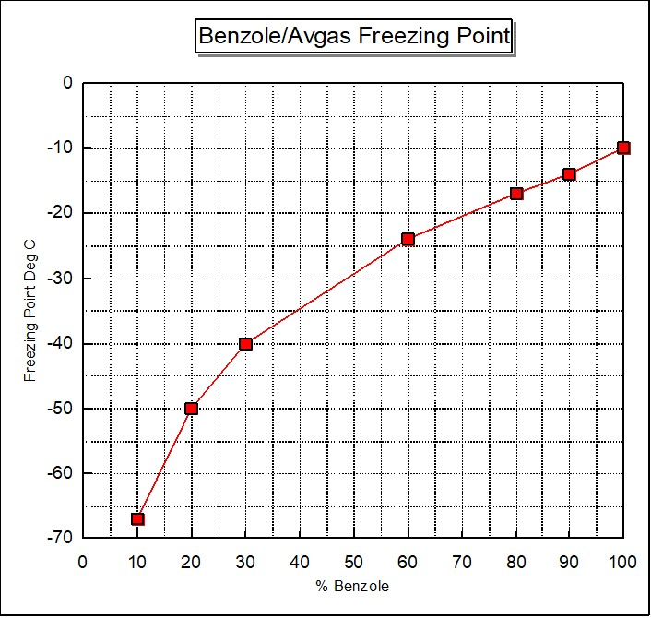

# Aviation Gasolines 100/130 Blending Agents

With the standardization of Avgas 100/130 as the Allied aviation gasoline grade for operational aircraft, there was still a need for a fuel to get even better performance, in particular, for Allied fighters and reconnaissance aircraft. This prompted the search for suitable chemicals which would boost the performance of these aircraft.

A number of aviation gasoline blending agents were tried in order to extend both the supply and quality of aviation gasolines. These agents included Cumene and “C-S” Cumene substitute which was probably Xylidene.[2] Another was made at Curaçao in the West Indies by Shell (this may have been “Avaro” a highly aromatic extract). [3]

# Cumene

The British requirement for improved rich mixture performance led to the use of Cumene as a desirable blending agent. Cumene had the following features:

* Produced from benzol, therefore it was not used in peace time.
* It was of great value in relieving the critical shortage of Avgas grade 100/130 during WWII for which shortage was largely due to the lack of components having good rich mixture knock properties.
* Somewhat undesirable owing to its high boiling point, which tends to produce uneven distribution of the fuel-air mixture to the various cylinders of aircraft engines equipped with carburettors.
* It is an aromatic hydrocarbon, and the pre-ignition resistance of the aromatics as a class, is distinctly inferior to that of paraffins.

Cumene was made by alkylating benzene with propylene. Developed in Shell’s American Laboratories, Cumene began to be produced in May 1942.

**Cumene** (CRC No. 1975).[4]

Other names: Isopropyl Benzene

Formula: C 9H12

Molecular Weight 126.24

CAS No. 3875-52-3

Melting Point -95.8OC

Boiling Point 144.9OC

Density 0.7870

Research Octane Number (RON) 122

RON Blending Octane Number 132

Motor Octane Number (MON) 99.3

MON Blending Octane Number 124

Because of its higher boiling point the amount that could be used in aviation fuel was limited to 10%.

The Research Octane Number (RON) and Motor Octane Number (MON) as measured for the pure compound, do not equate to these values when blended with other hydrocarbons, therefore for blending purpose other values are used, these are RON Blending Octane Number and MON Blending Octane Number. (Refer to Chapter 37). In this case, Cumene in a blended mixture behaves as if its RON value was 132, much higher than the actual measured value of 122 RON. Similarly, a blended mixture behaves as if its MON value was 124, again much higher than the actual measured value of 99.3 MON. This information is important in assisting the petroleum technologist to blend the aviation gasoline components such that the final product will meet that necessary specification.

Abadan Refinery

The Cumene plant in Abadan was built from spare and salvaged material and after some time it commenced operations in June 1944 with benzole from India and South Africa, but the results were disappointing. The makeshift plant proved inefficient and the benzole itself was of low quality.

Cumene was also manufactured at Abadan from Benzole shipped from India 4,000 tons/year and Australia where availability was 20,000 tons/year, part of which was shipped to California. Benzole was also shipped from Soviet Union.

Curaçao Refinery

In the spring of 1944 the new alkylation and Cumene plants came into operation. Then, because of defective materials the Cumene plant worked well below its rated capacity of 50,000 tons/year, and even had to shut down in the later months of 1944; it did not reach full output until the spring of 1945.

It required 40,000 tons of pure or 1oBenzole, and its operation increased Avgas production 164,000 tons/year. The highest quality benzole was obtained by re-running motor spirit benzole at the Shell Stanlow Refinery, Ellesmere Port, Cheshire, U.K.

Table . Cumene Specification P.A.W. (tentative) 1945[5]

|  |  |  |
| --- | --- | --- |
| Test | Minimum | Maximum |
| Distillation Initial Boiling Point (IBP) | 250 deg. F (121 deg. C) |  |
| 90% Evaporation |  | 330 deg. F (165.5 deg. C) |
| Final Boiling Point (FBP) |  | 356 deg. F (180 deg. C) |
| Bromine No. |  | 3 |
| Sulphur |  | 0.1% |
| Copper Dish |  | Pass AN-F-28 |
| Gum Accelerated |  | 6 ml/100 ml Cumene |
| Gum Potential |  | 5 ml/100 ml Cumene |

# Victane (March 1944)

At the Billingham plant (U.K.) an important technical advance was made with the development of ‘Victane’, a blending agent with the same properties as Cumene, but produced from alkylating benzene with butylene instead of propylene (as used in Cumene). Propylene was not available in Britain.

Victane Composition[6]

The approximate composition of ‘Victane’ was listed as a mixture of 60% tert-Butyl Benzene, 20% sec-Butyl Benzene with the remainder mainly other complex aromatic hydrocarbons. This blending agent had the following properties.

Boiling Point 230-250oF (110-176oC).

Freezing Point >-76oF (>-60oC).

Reid Vapour Pressure 0.7 psi (4.8 kPa)

Latent Heat of Evaporation 130 BTU/lb

Net Heating Value 17,730 BTU/lb, (or 152,150 BTU/Imp Gallon)

Specific Gravity at 60oF (15.5oC). 0.858

Lean Mixture Knock Rating (+ 4.8 cc TEL/Imp Gal) 100 PN

Rich Mixture Knock Rating (+ 4.8 cc TEL/Imp Gal) 150 PN

Victane may contain two or more of the following isomers of Butyl Benzene and based on the boiling range would also include some lighter aromatics.

**Tertiary Butyl Benzene** (CRC No. 1459).

Other names: Benzene, 1,1-dimethyl ethyl

Formula: C10H14

Molecular Weight 134.22

Chemical Abstract Number (CAS No.) 98-06-6

Melting Point -57.8OC

Boiling Point 169.1OC

Density 0.8665

Research Octane Number (RON) equivalent to 100 + 3cc/USG TEL

RON Blending Octane Number 138

Motor Octane Number (MON) equivalent to 100 + 0.8cc/USG TEL

MON Blending Octane Number 127

**Sec-Butyl Benzene** (CRC No. 2035).

Other names: Benzene, 1 methyl propyl

Formula: C10H14

Molecular Weight 134.22

CAS No. 135-98-9

Melting Point -82.7OC

Boiling Point 173.5OC

Density 0.8580

Research Octane Number (RON) 115

RON Blending Octane Number 116

Motor Octane Number (MON) 95.7

MON Blending Octane Number 117

**Iso-Butyl Benzene** (CRC No. 2039).

Other names: Benzene, 2 methyl propyl

Formula: C10H14

Molecular Weight 134.22

CAS No. 538-93-2

Melting Point -51.4OC

Boiling Point 172.7OC

Density 0.8532

Research Octane Number (RON) 120

RON Blending Octane Number 122

Motor Octane Number (MON) 98.0

MON Blending Octane Number 118

Victane production began in March 1944 at the rate of 20,000 tons/year. The benzole needed to make it was diverted from Heysham Refinery (U.K.) where the mixing of benzole with gas oil feedstock ceased in May 1944.

Now that the supply of blending agent had ceased to be the limiting factor on production, the output of 100-Octane aviation spirit could be raised at both Heysham and Billingham simply by increasing the throughput.

Between autumn 1943 and autumn 1944, production at both plants was raised several times since both had surplus hydrogenating capacity (previously devoted to ammonia production). Billingham was also fed with better quality Creosote feedstock so that the higher yield of base spirit per ton was obtained. The same effect was achieved at Heysham by lowering the standard of volatility required from Heysham base spirit. The result was that Billingham’s output of base spirit was nearly doubled, and in mid-1944 Heysham reached an output 20% greater than its pre-war capacity. However, this was achieved at the expense of stopping ammonia production for a short period in June-July 1944.

The U.K. plants also supplied part of that output to a more stringent specification Rich mixture rating of 150 PN (Performance Number). This was achieved by raising the Tetra Ethyl Lead (TEL) content to 7.2 cc/IG (or 1.58 cc/Litre well above the specification of 0.79 cc/Litre for Avgas 100/130).

# Aromatic amines[7]

As early as 1922, McCook Field (U.S. Army Air Force) were making limited use of aromatic amines (ortho-Toluidine and Xylidene), which were discovered by Midgley prior to his discovery of TEL. However it was not pursued perhaps due to poor experiment design which showed unsatisfactory performance.

Aniline was not used since it is not soluble in the current aviation fuels at low temperatures. Two aromatic amines - Xylidene and mono-Methyl Aniline were used in limited military service in WWII, but never in general service. mono-Methyl Aniline was better than Xylidene since a slightly higher percentage could be added to the fuel.

A new additive mono-Methyl Aniline developed in Britain was introduced to the U.K. blending program. mono-Methyl Aniline was one of the aromatic amines increasingly used as a “rich mixture” constituent in the final years of the war, despite its undesirable characteristics, to extend the supplies of blending agents.

Both Xylidene and mono-Methyl Aniline are much more powerful solvents than any other compounds used in aviation fuels. This solvent action is particularly noticeable with rubber and synthetic rubber used in fuel systems, and special rubber components may be needed for such parts.

Both of the above aromatic amines improved the rich mixture knock ratings very considerably, but did not improve weak or lean mixture knock rating [8]. Both have high boiling points which are undesirable and lead to distribution difficulties, so that one cylinder gets a fuel with a much higher knock rating than another. There are also other difficulties, such as corrosion and solvent action on the fuel system, associated with these knock improvers, which make their use less desirable.

In 1943, the Americans began using Xylidene to manufacture a slightly lower quality 100-Octane aviation fuel, rated at 98/130 and 99/130 for use by crew training aircraft. This blending agent was known as ‘CS’ or “Cumene Substitute”. By taking 80 barrels of 100-Octane gasoline as a starting material, it was possible to add one barrel of ‘CS’ (Xylidene) and 19 barrels of 91-Octane gasoline to produce 100 barrels of aviation gasoline which the U.S. Army approved for use within the continental United States, thus releasing the higher grade fuels for use on overseas combat areas. The use of ‘CS” began on a small scale in September 1943, and to the limit of its availability, was continued through October 1944; the peak output in the U.S. was 8,200 barrels/day (1.3 million Litres/day). In the U.K. the aromatic amines would also be used to produce a higher grade of aviation gasoline - Avgas 100/150 for a special service.

Avgas 100/150

In January 1944, the demand for 150 PN Avgas was estimated by the British Air Staff at 350,000 tons/year. Production began in Feb 1944. It was halted at the end of March 1944 when it was thought the problems caused by high TEL content might not be solved. Production of mono-Methyl Aniline also fell short of the estimated requirements. As a long term, solution it was planned to import Xylidene from the U.S., however this proved unnecessary, as consumption of Avgas 100/150 (PN) was lower than planned. Production of 100/150 (PN) Avgas began in June 1944 and ceased in April 1945.

Avgas 100/150 (PN) gave an advantage in speed and rate of climb to aircraft in Europe. Avgas 100/150 fuel was used by aircraft such as the Spitfire and Hawker Tempest, to intercept the German V-1 flying bombs (‘Doodlebugs’) coming over to England from the German held French and Dutch coast. The initial plan was for the British fighters to shoot down these flying bombs, but it was quickly discovered that avoiding a ton of high explosives exploding in front of your aircraft was a tricky operation, adjusting the concentration of their gunfire range to 300 yards minimized this risk – a few pilots returned with the fabric on the aircraft rudders burnt from these explosions. The next successful technique was to fly beside the flying bomb and cause excessive turbulence under its wing sufficient to upset the gyroscopic guidance system causing the flying bomb to lose control and crash harmlessly into the English Channel – a much safer option for the fighter pilot.

Photo 3. German V-1 Flying Bomb on display at R.A.F. Duxford U.K. (Petroch Services 1998)

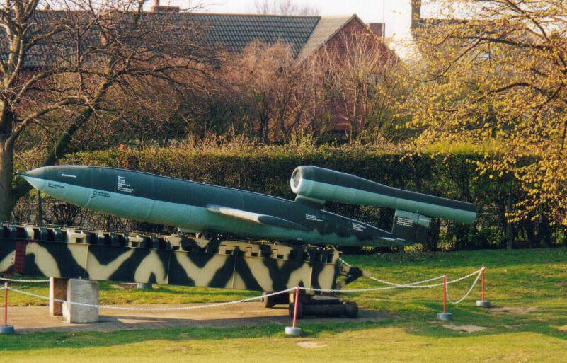

Photo 4. Hawker Tempest II on display at R.A.F. Hendon Museum, London. U.K.

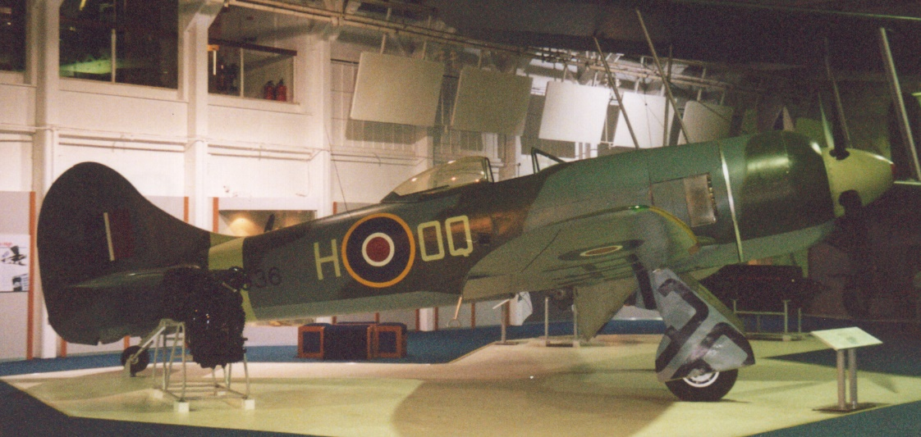

However, the demand never increased as expected; over July - Dec 1944 the consumption of Avgas 100/150 (PN) was less than 5% of the total U.K. consumption of 100-Octane spirit. All Avgas 100/150 PN was made with mono-Methyl Aniline; some was left over and went into Avgas 100/130 manufacture, although other sources suggest that Grade 100/150 used by the R.A.F. was also made with the addition of 3% Xylidene and 1.6 cc TEL/Imp. Gallon to Grade 100/130.

Anecdotal information from a Spitfire pilot serving in 1944 was - ‘You knew when you had the special mix because the smell was terrible and if it was spilt on the aircraft, it would lift the paint’.

# Aromatic Amines Types

“Cumene Substitutes”

The most effective were mono-Methyl Aniline (MMA) and Xylidene used for increasing the rich mixture rating of Aviation Spirit. MMA was manufactured from Toluene by ICI Dye Stuff Division. MMA is more potent than Cumene. 1 ton MMA could be blended with 15 tons of 90 Octane base to produce 15 tons of 100/130 grade Avgas, however it involved diversion of Benzole from other uses.

Xylidene was manufactured by ICI from Xylene. It too is more potent than Cumene, about 1% Xylidene = 6% Cumene when blended into Avgas components.

Both MMA and Xylidene hade the following disadvantages:

* They cause rapid deterioration of synthetic rubber used in aircraft engines.
* They are poisonous to handle, but as aviation spirit already contains lead (TEL), this was not a very serious objection to its use.
* They affect colour stability of aviation spirit.

Aniline

Benzamine (CRC No. 633)

Other names: Aniline

Formula: C6H7N

Molecular Weight 93.13

CAS No. 62-53-3

Melting Point -6OC

Boiling Point 184.1OC

Density 1.0217

Although an effective anti-knock agent it was not used in aviation fuels since it is not soluble in aviation gasoline at low temperatures – that is, the melting point of –6OC would cause the freezing point test to fail.

mono-Methyl Aniline

Benzamine, N-Methyl (CRC No. 781)

Other names: N-Methyl Aniline, mono Methyl Aniline

Formula: C7H9N

Molecular Weight 107.16

CAS No. 106-61-8

Melting Point -57OC

Boiling Point 196.2OC

Density 0.9891

RON Blending Octane Number 441

MON Blending Octane Number 411

Production ceased early April 1945.

Xylidene

There are six possible isomers of Xylidene, (Molecular weight 121.18, Formula C8H11N), but only five of these are present in commercially produced material.

Table . List of Xylidene isomers

|  |  |  |  |  |  |  |
| --- | --- | --- | --- | --- | --- | --- |
| Compound | CRC No. | Other names | CAS No. | Melting Point (deg. C) | Boiling Point (deg. C) | Density |
| Benzamine, 2, 3-Dimethyl | 704 | 2, 3 Xylidene | 87-59-2 | <-15 | 221.5 | 0.9931 |
| Benzamine, 2, 4-Dimethyl | 705 | 2, 4 Xylidene | 95-68-1 | -14.3 | 214 | 0.9723 |
| Benzamine, 2, 5-Dimethyl | 706 | 2, 5 Xylidene | 95-78-3 | 15.5 | 214 | 0.9790 |
| Benzamine, 2, 6-Dimethyl | 707 | 2, 6 Xylidene | 87-62-7 | 11.2 | 215 | 0.9842 |
| Benzamine, 3, 4-Dimethyl | 708 | 3, 4 Xylidene | 95-64-7 | 51 | 228 | 1.076 |
| Benzamine, 3, 5-Dimethyl | 709 | 3, 5 Xylidene | 108-69-0 | 9.8 | 220.5 | 0.9706 |

The markedly higher melting point, and higher boiling point and density of 3, 4 Xylidene compared to the other isomers would exclude it from aviation fuel.

**Performance:**

The addition of 3% Xylidene will increase the rich mixture rating Performance Number (PN) of Grade 100/130 fuel by about 15%, namely it will raise it to Grade 100/150. However, the addition of Xylidene (or of mono-Methyl Aniline) slightly reduces the lean mixture rating (100 PN) and in the production of Grade 100/150 containing 3% Xylidene it was necessary to increase the TEL content from 4.6 to 6.0 ml/USG.

While it was considered necessary to add additional lead (TEL) to restore the lean rating, it appears that this was only necessary to restore the laboratory rating and was not necessary as regards to performance of full scale aircraft engines. While Grade 100/150 will have 100 Performance Number under cruise conditions and 150 Performance Number under rich mixture conditions in some engines, there are some which will rate it at 150 PN at lean cruise.

It is commonly considered that aromatic amines are only effective anti-knock agents at rich mixture conditions, but this is not the case. When added to Grade 100/130 and Grade 115/145 they increase knocking at the lean condition and decrease knocking at the rich mixture condition, the apparent increase knocking effect is due to the severity of the laboratory knock engine lean test method. If the lean Performance Number of the fuel is low enough, the amines (Xylidene and mono-Methyl Aniline) then become effective anti-knock agents and are so indicated by the laboratory knock engine test method.

Two and a half (2½%) mono-Methyl Aniline produces the same effect as 3% Xylidene. Since both Xylidene and mono-Methyl Aniline are compounds of high boiling point they tend to aggravate fuel distribution difficulties. Both Xylidene and mono-Methyl Aniline sharply increase the pre-ignition tendency. Thus, it often occurs that full advantage cannot be taken of the improved Performance Number of such blends since the increased engine output causes the engine cylinders to run hotter and results in pre-ignition occurring before the knock limit of the fuel is reached. Use of such blends therefore is generally limited and requires modification in the engine installation with particular attention to spark plugs.

# Toluene[9]

During World War II, the U.S. refining industry’s wartime production of Toluene for explosives was arranged for by direct contract with the U.S. Army Ordnance Department, since the program had been initiated prior to the establishment of the Petroleum Administration for War (PAW). The new facilities were constructed as an integral part of Ordnance’s ammunition program, and prices were negotiated directly with Ordnance. PAW entered the scene in connection with the transfer of facilities or production from the ammunition to the aviation gasoline program.

Production of Toluene in the United States in 1939 was 25 million (US) gallons (95 million Litres), all of it from coal; in the peak year 1944, the total production was 208 million US gallons (787 million Litres), more than eight fold increase, of which 169 US gallons (640 million Litres) or more than 81% was produced from petroleum.

After the war, Toluene was to be used to produce Aviation Gasoline Grade 115/145; it was usually included at 5% of the blend of alkylate and isopentane.

# Avaro

Avaro was a highly aromatic extract produced in surplus quantities at Curaçao, and transferred to Trinidad and Aruba. Avaro has a high rich mixture response and enabled refineries to stretch out their supply of alkylates for Avgas 100.

The ‘Avaro’ process is a two-pass or severe single pass thermal reforming operation. The product is generally heavily acid-treated for removal of olefins. The redistilled product had an aromatic content of 70 to 95%, an octane number of 85-95 and a high rich mixture rating.

Performance Boosters

Water injection[10]

It is doubtful if this can be called an anti-knock in the true meaning of that term, but it does create conditions in the engine cylinder which allow the use of a fuel of lower knock rating than would be otherwise be possible. Pure water is most desirable, but a certain amount of methyl alcohol is added to create a ‘non-freezing’ mixture. Water injection produces its effect by reducing the temperature of the fuel/air charge and also by direct cooling of the engine cylinder and piston, removing heat from these parts which otherwise would have to be removed by the engine cooling system. Use of water injection is made during take-off to increase performance and increase engine cooling. For Grade 100/130 fuel, the use of water injection increases the engine power by 15-25%, in effect giving the same results as fuels with a rich mixture knock ratings of 140 or 160 PN.

The main disadvantage of water injection is the complication of the necessary additional equipment for a ‘performance booster’ only used during take-off.

Methanol/Water[11]

Boost fluids are used to augment engine power at take-off conditions. When a supercharged engine is operated at high boost, the mixture has to be enriched to keep the engine operating conditions knock-free. This extra fuel cools the cylinder walls and the charge, thus delaying the onset of knock which would otherwise occur at the associated higher temperatures. Various fluids and mixtures have been investigated as possible cheaper and more effective coolants and, in particular water, ammonia and methanol. Water is prone to icing difficulties; ammonia can give rise to corrosion, while pure methanol carries the risk of explosion. A combination of water and methanol has been found to be the most effective coolant and two concentrations are in general use

The British specification D.Eng.R.D. 2491 stipulates a 60/40 methanol/water blend. This blend has a minimum corrosive action on light alloy metals and a freezing point of –60 deg. C (-76 deg. F), equal to the freezing point maximum of aviation gasoline. Typical properties of water/methanol blends are given in Table 3. The overall effect of boost fluid injection is to permit a considerable increase in knock free engine power to be developed for the same combustion chamber temperature, this power increase being obtained from the higher allowable boost. In practice, the fuel mixture is usually weakened when using boost fluid injection and the ratio of the two fluid flows is approximately 100 parts of fuel to 25 parts of fluid. The resulting performance with such a ratio corresponds to an effective up-rating of the fuel rich mixture rating by about 25%, irrespective of its original value. The extent of power boosting is limited to about 40% in practice (assuming adequate mechanical strength) for beyond this value drowning of the engine by excessive liquid is possible and balance distribution of the fluid through the manifold to each cylinder becomes difficult to achieve.

Table . Methanol/Water Blends – Typical Properties

|  |  |  |  |
| --- | --- | --- | --- |
| Methanol %vol. | Specific Gravity @ 15O/15OC | Change of S.G. per OC | Freezing Point OC |
| 52 | 0.9106 | 0.00067 | -60 |
| 45 | 0.9304 | 0.00057 | -47 |
| 34 | 0.9461 | 0.00045 | -32 |
| 25 | 0.9613 | 0.00032 | -21 |

Sam Heron noted that the use of water-alcohol injection supplementary to the fuel, permitted maximum power to be increased by about 20%, this was probably due to his work at Wright Field for the U.S. Army. The idea of supplementary water injection to suppress knock was quite old and had been considered by several aircraft engine companies and laboratories. Mixture 50% water/50% methanol was considered appropriate. The alcohol is essential to prevent freezing of the water. U.S. Navy experiments with sea water in an emergency, was quite effective.

Alcohol injection

Use of Methanol (or Ethanol) to increase performance during take-off. The greatest value of alcohol as a constituent of internal combustion engine fuels is its pronounced anti-detonation characteristics and were it not for this desirable property alcohol fuels would not possess a single redeeming feature in comparison with petrols, with the possible exception of their high latent heat which, in certain circumstances has a beneficial effect upon the volumetric efficiency and power output. The high latent heat of alcohol reduces the temperature of the induction manifold and in this way increases the volumetric efficiency.

Iso-Propyl Ether[12]

The raw material from which iso-propyl ether is produced is propylene which is present in refinery gases or may be obtained by cracking natural gas.

Iso-propyl ether has an average boiling point of 154 deg. F (68 deg. C), a low vapour pressure and an octane number of about 92. The lead susceptibility is very good but as it contains about 12% oxygen [in the molecular structure] it tends to be rather unstable in storage although this disadvantage can be overcome by the use of suitable inhibitors.

The chief disadvantage of iso-propyl ether is that its calorific value is about 20% lower than iso-octane. Actual tests on 100 Octane aviation fuels have shown, however, that iso-propyl ether blends have a minimum specific fuel consumption only 5-7% higher than iso-octane blends under cruising conditions.

# Alcohols fuels for Aviation[13]

The use of alcohol fuels and blends has always had an attraction as an alternate source of fuel for use in aircraft particularly for those countries where there are adequate supplies of alcohols and no indigenous supplies of hydrocarbon fuels. From a national security aspect, the use of local fuels is often of paramount importance. However, the use of alcohol fuels and blends has some technical disadvantages which outweigh the use of these fuels in civil airline and military service. For some special stunt fuels, alcohol is extremely valuable, a feature which Banks exploited in the Schneider Trophy races of the 30’s.

The alcohols most commonly available for use as fuels are ethanol and methanol. Ethanol is produced from the fermentation of vegetable matter, while methanol is generally manufactured from water-gas or by destructive distillation of wood.

Some properties are listed below together with those of benzol and aviation gasoline.

Table . Selected properties of Alcohols and other fuels

|  |  |  |  |  |  |
| --- | --- | --- | --- | --- | --- |
| Property | Ethanol (98.5%) | Methanol | Acetone | Motor Benzol | Aviation gasoline |
| Specific Gravity at 15 deg. C. | 0.794 | 0.829 | 0.798 | 0.875 | 0.720-0.760 |
| Boiling Point deg. C. | 78 | 66 | 56 | 80 to 150 | 50 to 170 |
| Latent Heat of Evaporation  BTU/pound | 406 | 500 | 239 | 172 | 140 |
| Calorific Value | | | | | |
| BTU/pound | 11,470 | 9,630 | 12,350 | 17,300 | 18,800 |
| BTU/Imp Gal. | 91,600 | 79,800 | 98,500 | 151,400 | 143,100 |
| MON Clear | 105.7 | 104.5 | - | ~90 | 77-85 |

As discussed earlier the most important characteristics of aviation gasolines are:

1. Anti-knock value
2. Volatility
3. Calorific Value
4. Latent Heat
5. Stability
6. Solvent action

With alcohol fuels all of these properties vary considerably in comparison with those of gasoline.

Anti-knock value

The anti-knock values of ethanol and methanol are considerably higher than that of gasoline. A thorough investigation of this property was conducted by Sir Harry Ricardo for the Empire Motor Fuels Committee on his E.35 variable-compression engine. It is seldom that 100% alcohol fuel is considered, and in the usual blends containing up to 30% alcohol with gasoline and perhaps benzol, the resultant fuel has a higher octane.

Volatility

Because of the pure nature of alcohols the boiling range is extremely narrow of not a specific value, thus only a small amount of alcohol that can be used without gross distortion of the boiling range. However the volatility problem rarely arises because of other factors such as calorific value exerts a greater influence.

Calorific Value

The calorific value of ethanol amounts to only 61% of that of gasoline by weight, and 64% by volume. For an engine working at any given efficiency the fuel consumption is inversely proportional to the calorific value of the fuel. Consequently, the use of alcohol fuels or blends involves an increase in fuel consumption. For example, a 30% alcohol in the blend increased the consumption by 13%, and in other studies it was shown that the higher the engine compression ratio, the greater the consumption. Both these outcomes are undesirable for an aviation fuel.

Latent Heat

From the above table it can be seen that the latent heat of the alcohols is much greater than gasoline. High latent heat is a very desirable property in fuels in carburettor type engines, particularly those fitted with superchargers. The temperature of the charge between the carburettor and the inlet valve is dependent upon the latent heat of the fuel. The greater the latent heat the lower would be the temperature, and there the greater weight of charge which enters the cylinder. In simple terms as the fuel evaporates it removes heat from the surrounding metal components and lowers its temperature, so the more heat required to evaporate the fuel (latent heat), the cooler it becomes and more fuel can be drawn into the combustion chamber – the ‘bigger the bang’. In his report to the Empire Motor Fuels Committee, Ricardo eloquently described it as:

‘The volumetric efficiency, and therefore the power output, will be directly proportional to the latent heat of the fuel’.

Stability

Provided the alcohol is free of water, then any proportion can be blended with gasoline and benzol. Immediately a small amount of water is present, separation of the alcohol from the other components occurs. Alcohols used in gasoline blends have extremely low freezing points, one of the chief dangers is their tendency to separate from the gasoline at low temperatures such as in cold climates or at high altitude. Addition of Benzol to alcohol/gasoline blends reduces the tendency to separation.

Graph . Curves showing temperature of separation of Alcohol/Benzol/Gasoline blends with varying percentage of water.

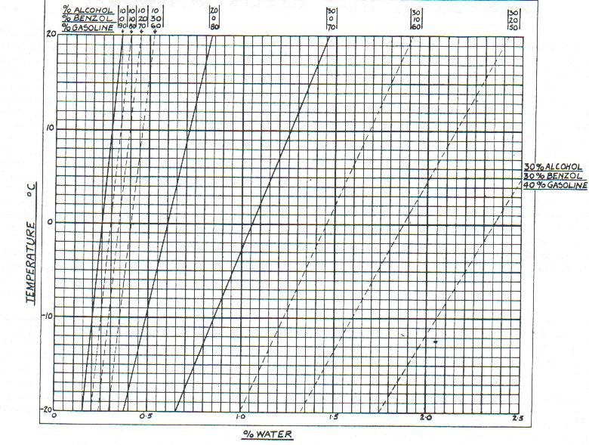

In practical terms, the possibility of avoiding the contamination of the fuels by water is extremely remote, since all fuels are subject to some moisture condensation from rapid changes in ambient temperature and humidity. Also owing to the hygroscopic nature of alcohols, it can readily absorb moisture adding to the problem of separation. Gasoline is not hygroscopic, so water is not a problem and can be drained from a sump and easily removed during periodic inspections.

Therefore due to this sensitivity to separation and their lower calorific value, alcohol fuels are considered by most authorities to be unsuitable for regular airline use.

This aspect of alcohols alone makes it unsuitable for regular use, since the separation of the fuel in the tanks would result in engine stoppage mid-flight.

Solvent Action

Normal aviation gasolines have no solvent action on the materials used in aircraft fuel systems. Alcohol blends possess a very strong action and readily remove any scale or deposits from the tank, pipelines, etc. Thus an aircraft which operated satisfactory on gasolines is liable to suffer from blocked fuel filters if the change is made to alcohol blends.

Conclusion on Alcohol Blends

From a technical viewpoint, the use of alcohol blends introduces difficulties with increased fuel consumption, dangers of phase separation of the fuel from the usual homogenous mixture, and high solvent properties of alcohol blends, outweigh the advantages they offer by virtue of their high anti-knock values. Even this latter advantage is lost when compared with gasolines containing TEL. Add to this the need to separately store alcohol blends with storage tanks and delivery facilities, and the use of aviation alcohol fuel blends is of little merit.

# Anti-Oxidants[14]

Storage Stability

Aviation gasolines must be able to retain their specification properties for long periods of storage varying from arctic to tropical conditions. Unstable fuels can produce three major unacceptable effects:

1. The deposition of insoluble materials within the fuel during extended storage leading to subsequent blocking of filter and metering equipment.
2. A loss of anti-knock rating due to the change of TEL from the gasoline soluble form to an insoluble whitish powder (sludge).
3. In long term storage[15] the Ethylene Dibromide in the TEL B compound used in avgas, decomposes and the gasoline becomes acidic and corrosive. [It is difficult to unscrew the bung from a 200-litre drum of avgas after long storage periods. This is due to the rusting by decomposition of the Ethylene Dibromide and the gasoline will be bleached, smelly and unusable due to gum content. This occurs in ungalvanized drums as well as galvanized drums.]

The gum compounds which can be present or produced in the fuel are classified into two types for test evaluation.

**Existent Gum**

Existent gum may be already formed in the fuel and can be deposited from solution on inlet ports and valves and other parts of the inlet manifold as the fuel evaporates. If present, it usually gives rise to inlet valve sticking and a decrease in supercharger performance.

**Potential Gum**

“Potential” or ‘accelerated’ gum may be formed under extended storage conditions and is determined in the laboratory by an accelerated oxidation test in which unstable hydrocarbons are thereby polymerized and oxidized to form gums. The gum limits established for these tests ensure satisfactory storage behaviour of specification gasolines under tropical conditions for at least two years, and considerably longer in temperate climates.

The greater inclusion of reformed stocks in aviation gasoline (as distinct from straight run gasolines) and concentrations of up to 5.5 ml TEL/Imp gallon in current high grade fuels (in 1970), necessitates the addition of an anti-oxidant to achieve the gum specification figures and also to improve the TEL stability. With such inhibited fuels it is now very rare to encounter deposits due to gum formation or TEL to degradation.

Approved Antioxidants

The approved anti-oxidant, or mixture of anti-oxidants, is added in order to retard the formation of gum and the precipitation of lead compounds. The total weight of active materials must not be less than 6.7 pounds, nor more than 8.4 pounds/35,000 Imp. Gallon of fuel. (19.2 to 24.0 mg/litre).

The following anti-oxidants are approved (1970) for use in aviation gasoline:

1. N, N - di-secondary-butyl-para-phenylenediamine
2. 2, 6 - ditertiary-butyl-phenol
3. 2, 6 - ditertiary-butyl-4-methyl-phenol
4. 2, 4 - dimethyl-6-tertiary-butyl-phenol
5. 75% min. of 2, 6 - ditertiary-butyl-phenol, with 25% max. tertiary and tritertiary-butyl phenols

A form of instability occasionally encountered and revealed by deposits, often accompanied by colour change of the identifying dye, is associated with storage under reducing conditions such as galvanized drums. This is caused (particularly in hot climates when the fuel is more likely to be damp) by loss of the ethylene dibromide scavenger in the TEL fluid. Galvanized drums should therefore never be used for storage of aviation gasolines.

It is the practice to check all aviation gasoline stocks containing lead compounds every six months for lead instability. In this test the fuel is incubated in the dark for 7 days at 120OF (48.9OC) in a vented glass bottle and then visually inspected and examined for lead precipitation.

# Index

1

100 Octane aviation fuel 9, 14

150 PN (Performance Number) 8

2

2, 4 - dimethyl-6-tertiary-butyl-phenol 18

2, 6 - ditertiary-butyl-4-methyl-phenol 18

2, 6 - ditertiary-butyl-phenol 18

2, 3 Xylidene 11

2, 4 Xylidene 11

2, 5 Xylidene 11

2, 6 Xylidene 11

3

3, 4 Xylidene 11

3, 5 Xylidene 11

9

91-Octane gasoline 9

98/130 9

99/130 9

A

Abadan 5, 6

accelerated oxidation test 17

Acetone 15

acidic 17

acid-treated 12

air cooled engines 3

aircraft engine companies 14

aircraft engines 10, 12

aircraft fuel systems 17

alcohol fuels 17

Alcohol/Benzol/Gasoline blends 16

alcohol/gasoline blends 16

alkylate 12

ammonia 8, 13

Aniline 8, 10

anti-detonation 14

anti-knock agent 11

anti-knock rating 17

anti-oxidant 17, 18

aromatic amines 8, 9, 12

aromatic content 12

aromatic extract 12

aromatic hydrocarbons 6

Aromatics 3

Aruba 12

Australia 6, 23

Avaro 4, 12

avgas 17

Avgas 100/130 9. 10, 12

aviation alcohol fuel blends 17

aviation fuel 11, 15

aviation gasoline 12, 13, 15, 17, 18

aviation spirit 10

B

Banks 14

base spirit 8

Bass 3

Benzamine 10

benzene 3

Benzol 3, 15, 16

Benzole 3, 8, 10

Billingham 6, 8

bleached 17

blocking of filter 17

boiling point 6, 7, 8, 11, 12, 14, 15

Britain 8

British Air Staff 9

British specification D.Eng.R.D. 2491 13

Bromine No. 6

bung 17

Butyl Benzene 7

C

California 6

calorific value 14, 15, 17

carburettor type engines 16

CAS No. 7, 10, 11

civil airline 14

coal 12

coal spirit 4

cold climates 16

colour change 18

colour stability 10

combustion chamber temperature 13

consumption 15

contamination 16

continental United States 9

Copper Dish 6

corrosion 9, 13

corrosive 17

cracked (olefinic) gasolines 3

cracking natural gas 14

Creosote feedstock 8

Cumene 3, 4, 5, 6, 10

Cumene Substitute 9

Curaçao 4, 6, 12

D

decomposition 17

delivery facilities 17

Density 7, 11

deposition 17

deposits 18

destructive distillation of wood 14

ditertiary-butyl-phenol 18

Doodlebugs 9

Dutch 9

dye 18

E

Empire Motor Fuels Committee 15, 16

engine compression ratio 15

engine cooling system 13

engine cylinders 12, 13

England 9

English Channel 9

Ethanol 14, 15

ethylene dibromide 17, 18

Europe 9

Existent Gum 17

explosives 12

F

fermentation 14

Final Boiling Point 6

freezing point 3, 4, 6, 11, 13, 16

French 9

fuel consumption 17

fuel distribution 12

fuel system 9

G

galvanized drums 17, 18

gas oil feedstock 8

gasoline 15, 16, 17

German V-1 Flying Bomb 9

Grade 100/130 10, 11, 12, 13

Grade 100/150 9, 10, 11, 12

Grade 115/145 12

Gum Accelerated 6

gum content 17

gum formation 18

Gum Potential 6

gum specification 18

gyroscopic guidance system 9

H

Hawker Tempest 9, 10

Heysham 8

high altitude 16

homogenous mixture 17

hot climates 18

humidity 16

hygroscopic 16

I

ICI Dye Stuff Division 10

icing difficulties 13

induction manifold 14

inhibited fuels 18

inhibitors 14

Initial Boiling Point 6

instability 18

Iso-Butyl Benzene 7

isomers 11

iso-octane 14

isopentane 12

iso-propyl ether 14

L

laboratory knock engine 12

latent heat 14, 16

Latent Heat of Evaporation 6, 15

lead instability 18

lead precipitation 18

lead susceptibility 14

lean mixture knock rating 7, 8

lean mixture rating 7, 11

light alloy metals 13

M

McCook Field 8

melting Point 7, 11

metering equipment 17

methanol 13, 14, 15

methanol/water blend 13

Methyl Alcohol 13

Methyl Aniline 8

Midgley 8

MMA 10

moisture 16

Molecular Weight 7, 10, 11

MON Blending Octane Number 7, 11

MON Clear 15

mono-Methyl Aniline 8, 9, 10, 11, 12

Motor Octane Number (MON) 7

N

N, N’ - disecondary-butyl-para-phenylenediamine 18

Naphthenes 3

Net Heating Value 6

non-freezing 13

O

octane number 12, 14

olefins 12

ortho-Toluidine 8

overseas combat areas 9

oxidized 17

oxygen 14

P

Paraffins 3

performance booster 13

petrol 14

Petroleum Administration for War (PAW) 12

phase separation 17

pipelines 17

piston 13

poisonous 10

polymerized 17

PONA analysis 3

Potential Gum 17

pre-ignition 12

propylene 5, 6, 14

R

R.A.F. 10

R.A.F. Duxford U.K. 9

R.A.F. Hendon Museum, London. U.K. 10

refinery gases 14

reformed stocks 18

Reid Vapour Pressure 6

Research Octane Number (RON) 7

Ricardo 15, 16

rich mixture 8

rich mixture knock rating 7, 8, 10, 11, 12, 13

RON Blending Octane Number 7, 11

Royal Aircraft Factory 3

rubber 8

rusting 17

S

Sam Heron 3, 14

scale 17

scavenger 18

Schneider Trophy 14

sea water 14

sec-Butyl Benzene 6, 7

separation 16

solvent action 9

solvent properties 17

Soviet Union 6

spark plugs 12

Specific Gravity 7, 13, 15

specification 18

Spitfire 9, 10

Stanlow 6

storage 17, 18

straight run gasolines 3, 18

Sulphur 6

superchargers 16

synthetic rubber 8, 10

T

tank 17

TEL 3, 8, 9, 10, 11, 17, 18

temperature 16

tert-Butyl Benzene 6, 7

tertiary and tritertiary-butyl phenols 18

thermal reforming operation 12

Toluene 3, 12

training aircraft 9

Trinidad 12

tropical conditions 18

U

U.K. blending program 8

U.S. Army 3, 9, 14

U.S. Army Air Force 8

U.S. Army Ordnance Department 12

U.S. Navy 3, 14

ungalvanised drums 17

unstable 14

unstable hydrocarbons 17

V

vapour pressure 14

Victane 6, 7, 8

volatility 8

volumetric efficiency 14, 16

W

Water injection 13

water-alcohol injection 14

whitish powder (sludge) 17

Wright Field 14

X

Xylene 3, 10

Xylidine 4, 8, 9, 10, 11, 12

# Research Sources

1. Fuels for Aircraft Engines by E.L. Bass March 1, 1935 Royal Aeronautical Society Lecture (Source: NASM B4 292260-02)
2. AAFHS-65 (USAF Historical Studies No.65 ISBN No. 0-89126-146-X MA/AA Publishing Eisenhower Hall Kansas State University. KS 66506-7186
3. Source Payton –Smith p 271
4. CRC Handbook of Chemistry & Physics – 75th. Edition (1995) ISBN 0-8493-0475-X
5. UK Public Records Office, Kew, London Ref: POWE 35/592
6. R.A.F. Manual of Fuels and Lubricants AIR Publication 3160. Vol. 1, Sect. 2, Chapter 1. British Air Ministry July 1948, Reprinted December 1959.
7. Ethyl Corporation. Aviation fuels and their effects on engine performance/ prepared by Ethyl Corporation; supplied to U.S. Air Forces on purchase order AF-300 (600) 5312; Department of the Navy, Bureau of Aeronautics on contract no. 52-202. -- New York. c 1951. 145 p. ill. Special Collection TL 704.7 E8 PAM c.1 TL 704.7 E8 PAM c.2
8. R.A.F. Manual of Fuels and Lubricants AIR Publication 3160. Vol. 1, Sect..2, Chapter 1. British Air Ministry July 1948, Reprinted December 1959.
9. “A History of The Petroleum Administration for War 1941-1945” United States Government Printing Office Washington 1946 prepared by John W Frey and H Chandler Ide. Page 222 Sourced from API Library Washington D.C. U.S.A.
10. R.A.F. Manual of Fuels and Lubricants AIR Publication 3160. Vol. 1, Sect. 2, Chapter 1. British Air Ministry July 1948, Reprinted December 1959.
11. Modern Petroleum Technology 4th. Edition G D Hobson& W Pohl – Applied Science Publishers Ltd for Institute of Petroleum 1973 ISBN: 085334 487 6, Chapter 14 “Aviation Fuels” by R.A.Vere
12. “Aviation Fuels- Lubricants and Special Petroleum Products” – Vacuum Oil Company Pty. Ltd – Melbourne Australia. Complimentary Booklet circa 1938
13. Shell Aviation News, May 1934
14. Modern Petroleum Technology 4th. Edition G D Hobson& W Pohl – Applied Science Publishers Ltd for Institute of Petroleum 1973 ISBN: 085334 487 6 Chapter 14 “Aviation Fuels” by R.A.Vere
15. Personal communication Warren R Hicks October 2007