Chapter
39

In-flight Refuelling
Photo 1. Under the direction of Sir Alan Cobham, preparing the tanker aircraft before take-off circa 1950.
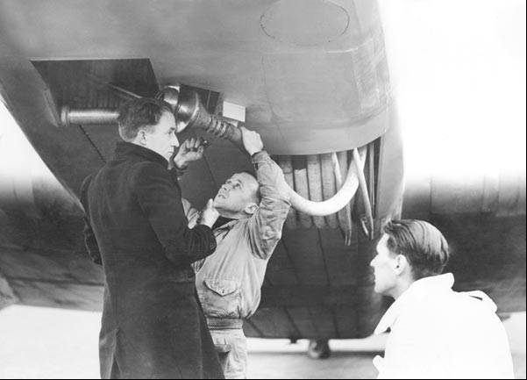

Table of Contents
Summary 3
Aircraft In-Flight Refuelling 4
Early Beginnings In The U.S. - 1921 4
British Efforts – 1920’s 8
Civil Development - Flight Refuelling Limited 10
U.S. Air Force In-Flight Refuelling 12
First Round The World Non-Stop Flight 1949 17
Developments In In-Flight Refuelling 20
Index 22
Research Sources 25

Photo 2. USAF Lockheed Hercules KC-130 tanker refuelling Sikorsky CH-53 helicopters
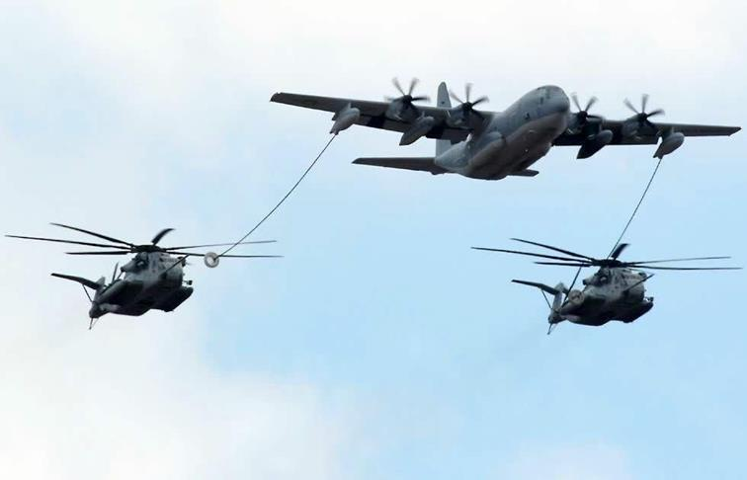

Summary
Inflight refuelling had its beginning with the U.S. military in the 1920’s in their efforts to achieve new endurance records, by the 1930’s British civil aviation became interested in long distance commercial flights with aerial refuelling. By the late 1940’s the air forces were establishing new squadrons whose sole purpose was to carry out air-to-air refuelling. This would continue through the next decades with initially surplus bombers being converted to tankers to inflight refuel fighters and bombers. It is now standard practice for military aircraft to carry out inflight refuelling to reach strategic targets around the world. The tankers are now variants of commercial airliners. While the military embraced inflight refuelling, commercial aviation lost interest for a variety of reasons, primarily coast and safety.
Chronology
Nov 12, 1921 Inflight refuelling of Curtiss JN-4, albeit foolhardy
Aug 27-28, 1923 “In-flight refuelling”, Capt. Lowell H. Smith and Lt. John Richter of the U.S.A. in a DH-4B Liberty 400 HP set a new flight duration record of 37 hours 15 mins. 14.8 sec. at Rockwell Field San Diego, California U.S.A.
1928 New refuelling in-flight duration record was set at Tirlement (Belgium), when Adjutant Louis Crooy and Sergeant Victor Groenen in a DH-9 with a Siddeley-Puma engine on June 2-3-4, 1928 achieved a duration record of 60 hours, 7 mins.
January 1-7, 1929 U.S. Army Air Corps Atlantic C-2A “Question Mark” refuelled from two Douglas C-A tankers, remained airborne for 150 hours 40 minutes over Los Angeles. The “Question Mark” was a Fokker monoplane powered by three Wright Whirlwinds engines.
1931 First public demonstration of the air-to-air refuelling system developed by Squadron Leader Atcherley of the Royal Aircraft Establishment (RAE) at the 1931 Royal Air Force Display at Hendon, London U.K.
1935 Formation of Flight Refuelling Ltd. by Sir Alan Cobham.
1939 Imperial Airways “C” Class flying boat “Cabot” and “Caribou”, refuelled by Flight Refuelling’s Harrow tankers over Ireland and Newfoundland completed eight return crossings of the Atlantic.
1948 U.S. Air Force 43rd and 509th Air Refueling Squadrons were activated at Davis-Monthan Air Force Base, Arizona.
1949 U.S. Air Force “Lucky Lady II” successfully completes around the world in-flight refuelling. The aircraft was piloted by Capt. James Gallagher who flew 37,742 km (23,452 miles) in 94 hours 1 minute. The aircraft was refuelled in flight four times during the flight.
1951 U.S. Air Force Boeing KB-29M flown by a SAC crew refuelled four Lockheed F-80 Shooting Stars over North Korea. This appears to have been the world’s first combat refuelling.
1956 U.S. Navy Convair R3Y-2 Tradewind flying boat was converted to a four-point tanker and the first simultaneous refuelling of four fighters was demonstrated in 1956, using wing mounted equipment produced by the Sergeant Fletcher Company.
1982 Falklands War, ‘Operation Black Buck 1’ to ‘Operation Black Buck 7’

Aircraft In-Flight Refuelling
While preceding chapters have discussed various refuelling methods and the interest of the oil companies in supplying their aviation product quickly and efficiently, often in difficult circumstances, perhaps the most innovative is the supply of fuel between aircraft in flight.

Refuelling in the air
The problem of refuelling aircraft during flight had long occupied the minds of technicians, transport operators and economists of flight. If perfect atmospheric conditions could always be guaranteed, the problem would be reduced to one of skilful piloting and installation of the necessary tanks, pipes and hailing gear. In the United States, when endurance flights were fashionable the aircraft was refuelled by the dangerous and unreliable method in which a crew member caught the end of a pipe trailed from the supplying aircraft. As perfect accuracy in flying, calm conditions and good visibility were essential to that method it seemed, at that time, to be without commercial practicability.
Air-to-air refuelling has three separate phases:
- Establishing physical connection between the refuelling aircraft (the ‘cow’) and the aircraft about to be refuelled (the ‘calf’).
- Transmitting fuel while maintaining connection.
- Mutual release of the ‘cow’ and the ‘calf’ after refuelling, or an immediate release in case of an emergency.
To provide for these phases, the ‘Interair System of Refuelling’ was developed and thoroughly tested in Great Britain. The system was first demonstrated at the Royal Air Force Display, Hendon, in 1937, where all three stages were carried out at a height of 1,000 feet (approximately 300 metres) and always within the bounds of the field.
While the possibilities of air-to-air refuelling appeared offer great possibilities in the late 1930’s it was however not adopted by commercial airlines and so was not developed by the aviation refuelling services.
After the Second World War, it would be adopted for military use with aviation gasoline and later jet fuel. Today mid-air refuelling (with jet fuel) is widely used in military aircraft operations; however it has still not been adopted by commercial airlines primarily for economic reasons and perhaps safety reasons.

Early Beginnings in the U.S. - 1921
On 12th November 1921, a stunt took place over Long Beach, California, which today would be regarded as foolhardy. Nevertheless, when the “Flying Tanker man” Wesley May with a 16 kg. (35 lb.) can of gasoline strapped to his back instead of a parachute - clambered from the top wing of a Lincoln Standard biplane onto the lower wing of a Curtiss JN-4, he carried out the first recorded transfer of fuel in flight
The Aircraft Year Book of 1923 lists a new official American record for duration on Aug 27-28, 1923. Using the new technique of “In flight refuelling”, Capt. Lowell H. Smith and Lt. John Richter of the U.S.A. in a DH-4B Liberty 400 HP set a new flight duration record of 37 hours 15 mins. 14.8 sec. at Rockwell Field San Diego, California U.S.A. The distance was 5,300 Km. (3,293.26 miles). The fuel used was Standard Aviation Gasoline supplied by Standard Oil of California (later to become Chevron).
Photo 3. Mid –air refuelling over San Diego 1923
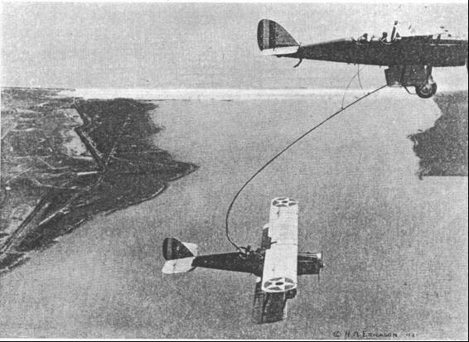
Photo 4. Capt. Lowell H. Smith and Lt. John Richter
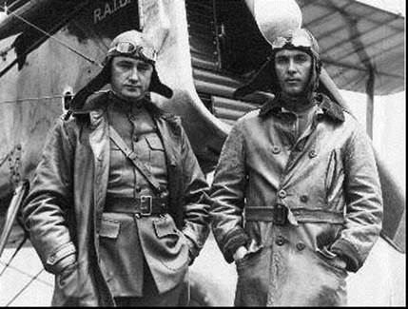

Photo 5. Mid –air refuelling over San Diego 1923
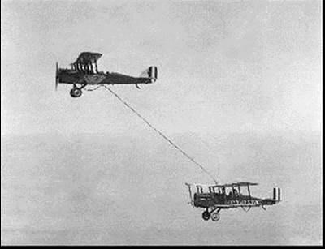
This endurance record did not last long. By 1928, a new refuelling in-flight duration record was set at Tirlement (Belgium), when Adj. Louis Crooy and Sgt. Victor Groenen in a DH-9 with a Siddeley-Puma engine on June 2-3-4, 1928 achieved a duration record of 60 hours, 7 mins.
This record would be shattered. During January 1-7, 1929, the U.S. Army Air Corps Atlantic C-2A “Question Mark” refuelled from two Douglas C-A tankers, remained airborne for 150 hours, 40 minutes over Los Angeles. The “Question Mark” was a Fokker monoplane powered by three Wright Whirlwinds engines. The U.S. Army Air Corps team comprised Major Carl Spaatz, Capt. Ira C. Eaker, Lt. Elwood R Quesada and Lt. Harry A. Halverson, and Staff Sgt. Roy Hooe. [Carl Spaatz and Ira Eaker would later win fame in their World War II Air Force commands of the U.S. Army Air Force in Europe. Carl Spaatz would be the first Chief of Staff of the U.S. Air Force in September 1947].
Photo 6. Crew of the ‘Question Mark’ 1929
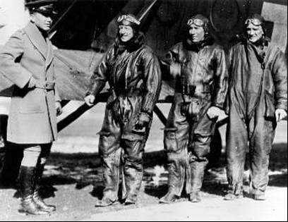
Photo 7. U.S. Army Air Corps “Question Mark” is refuelled during a record braking flight in 1929.
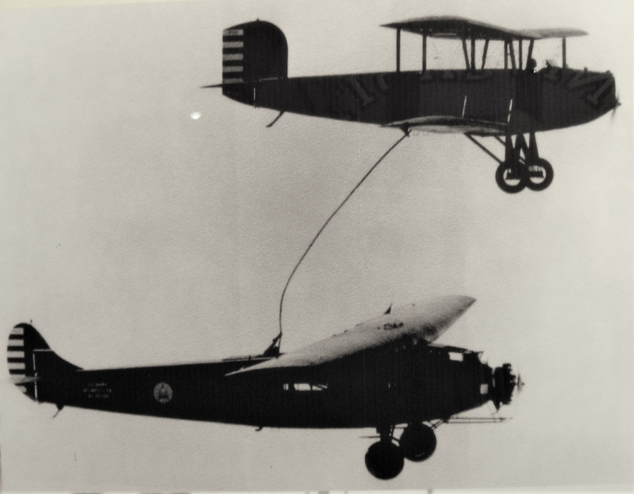
Flight of the "Question Mark" Crew - Major Howard C. Davidson, Commanding Officer, Bolling Field receiving Capt. Ross G. Hoyt, pilot of refuelling plane number 1; Lt. Elwood R. Quesada and Master Sgt. Roy W. Hooe, members of the crew. (U.S. Air Force photo)
In U.S., the Hunter brothers’ flight of 553 hours in 1930 was the last recognized endurance with refuelling record before the Federation Aeronautique Internationale withdrew the category from the record books.
The use of supply aircraft for the transfer of fuel and consumables such as food and engine oil was undertaken to enable both military and civil long endurance flights to take place. Although these took place mainly in the U.S., such flights were also carried out in Great Britain, France, Belgium, Russia and Japan. However, no serious consideration was given to developing a system suitable for everyday commercial use until Sir Alan Cobham began experimental trails in the U.K. during the early 1930s.

British Efforts – 1920’s
An attempt by Sir Alan Cobham to fly non-stop to India relied on air-to-air refuelling en route. Although a failed throttle linkage on the Airspeed Courier receiver aircraft caused the abandonment of the flight at Malta, it heralded the start of serious attempts by Alan Cobham to develop techniques suitable for civil and military operations. The plaque in the International Aerospace Hall of Fame - San Diego Aerospace Museum notes the following
Photo 8. Sir Alan Cobham KBE, AFC - Long Distance Flight Pioneer
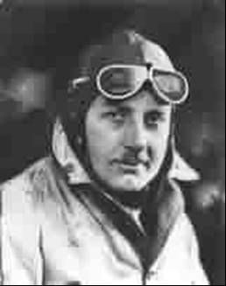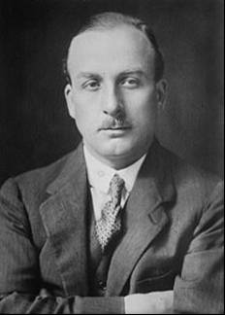
Born May 6, 1894 in Camberwell, England, Sir Alan J. Cobham began his flying career in 1917 as a pilot in the British Royal Flying Corps. After the war, he began a barnstorming business and in the early 1920’s flew as a photography and air-route survey pilot. In order to demonstrate the feasibility of long-range commercial air service, he flew extensive survey flights throughout Europe and Africa. In a further effort to promote the development of commercial aviation, Cobham organised and flew a round trip (from England) to Australia in 1926. He concluded this flight dramatically by landing his float plane on London’s Thames River before an estimated one million people. For his exploits, he was knighted by King George V.
His interest in extending the range of airplanes led to his formation of Flight Refuelling Ltd. in 1935. His company soon became an international leader in the development of aerial refuelling equipment and techniques. He died in October 21, 1973.
Sir Alan Cobham’s achievements as a visionary proponent of long distance commercial flights and aerial refuelling continue to serve mankind on an international basis.
In England during the early 1920’s, simple experiments involving the transfer of water from one Bristol Fighter to another were undertaken by the Royal Aircraft Establishment (RAE) at Farnborough. Further trials, which entailed the passing of fuel, were also conducted in the UK and lead to the first public demonstration of the air-to-air refuelling system developed by Sqn. Leader Atcherley of the RAE at the 1931 Royal Air Force Display at Hendon.
The following in-flight refuelling in 1935 shows a British (R.A.F.) two–seater Westland Wapiti Mk IIA K1142 used for early in-flight refuelling trials at Hendon London, UK with Vickers Virginia J-7275 from No. 7 Squadron.
The Vickers Virginia bomber had been involved in the trials with RAE since October 1934 and continued until its final flight on October 10, 1935.
Photo 9. RAF Westland Wapiti Mk IIA K1142 in-flight refuelling trials with Vickers Virginia J-7275 from No. 7 Squadron
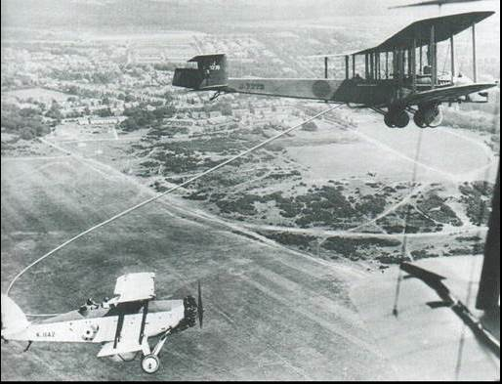

Civil Development - Flight Refuelling Limited
The desire to continually increase the range (or endurance) of aircraft led to the development of in-flight refuelling, particularly for military use. The initial work was usually done by the military and then taken over by commercial companies with in association with the air force. Such a case was a British company Flight Refuelling Limited
In 1938, the British Air Ministry decreed that all future research associated with the air-to-air refuelling had to be undertaken commercially by Sir Alan Cobham’s new company, Flight Refuelling Limited and that no further experimental work should be carried out by the RAE.
Flight Refuelling Limited, initially with Imperial Airways and later Shell as major shareholders, used a succession of aircraft loaned by the British Air Ministry to develop the “Looped Hose” method of air-to-air refuelling. This involved manoeuvring the tanker aircraft so that the weighted steel cables trailing from both aircraft meshed together. Once physical contact had been made, a crew member in the receiver aircraft operated a windlass (winch) to haul down the tanker’s fuel hose. Fuel then flowed under gravity.
Photo 10. Imperial Airways “C” Class flying boat “Cabria” being refuelled by possibly an Armstrong Whitworth A.W.23
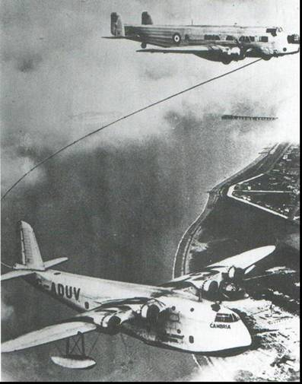
This looped hose was the method employed when in 1939 Imperial Airways “C” Class flying boat “Cabot” and “Caribou”, refuelled by Flight Refuelling’s Harrow tankers over Ireland and Newfoundland completed eight return crossings of the Atlantic. The trials were terminated following the outbreak of World War II.
Photo 11. Flight Refuelling Harrow tanker refuels Imperial Airways “C” Class flying boat 1939.
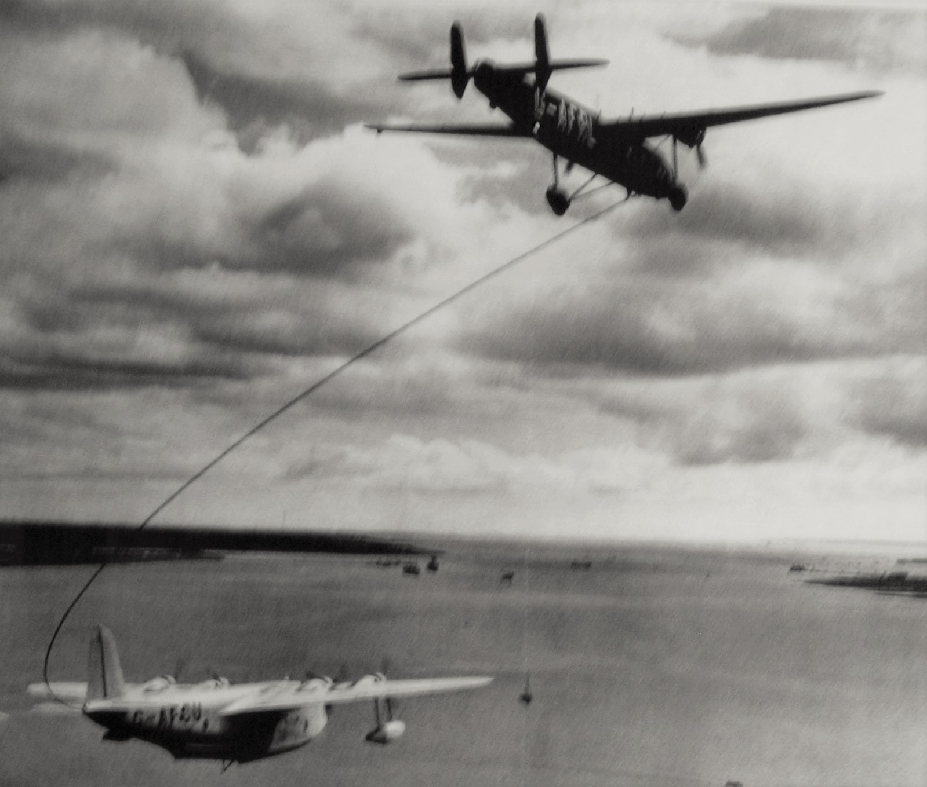
Civil trials resumed after the war, with Flight Refuelling’s Lancaster tankers and receivers using an improved “Looped Hose” method, and equipped with “Rebecca/Eureka” radio navigational aids for easier interception at the en-route refuelling points. A total of eleven weekly return non-stop flights between London and Bermuda were carried out in conjunction with British South American Airways in 1947.
Photo 12. Two Lancaster tankers in action – circa 1947
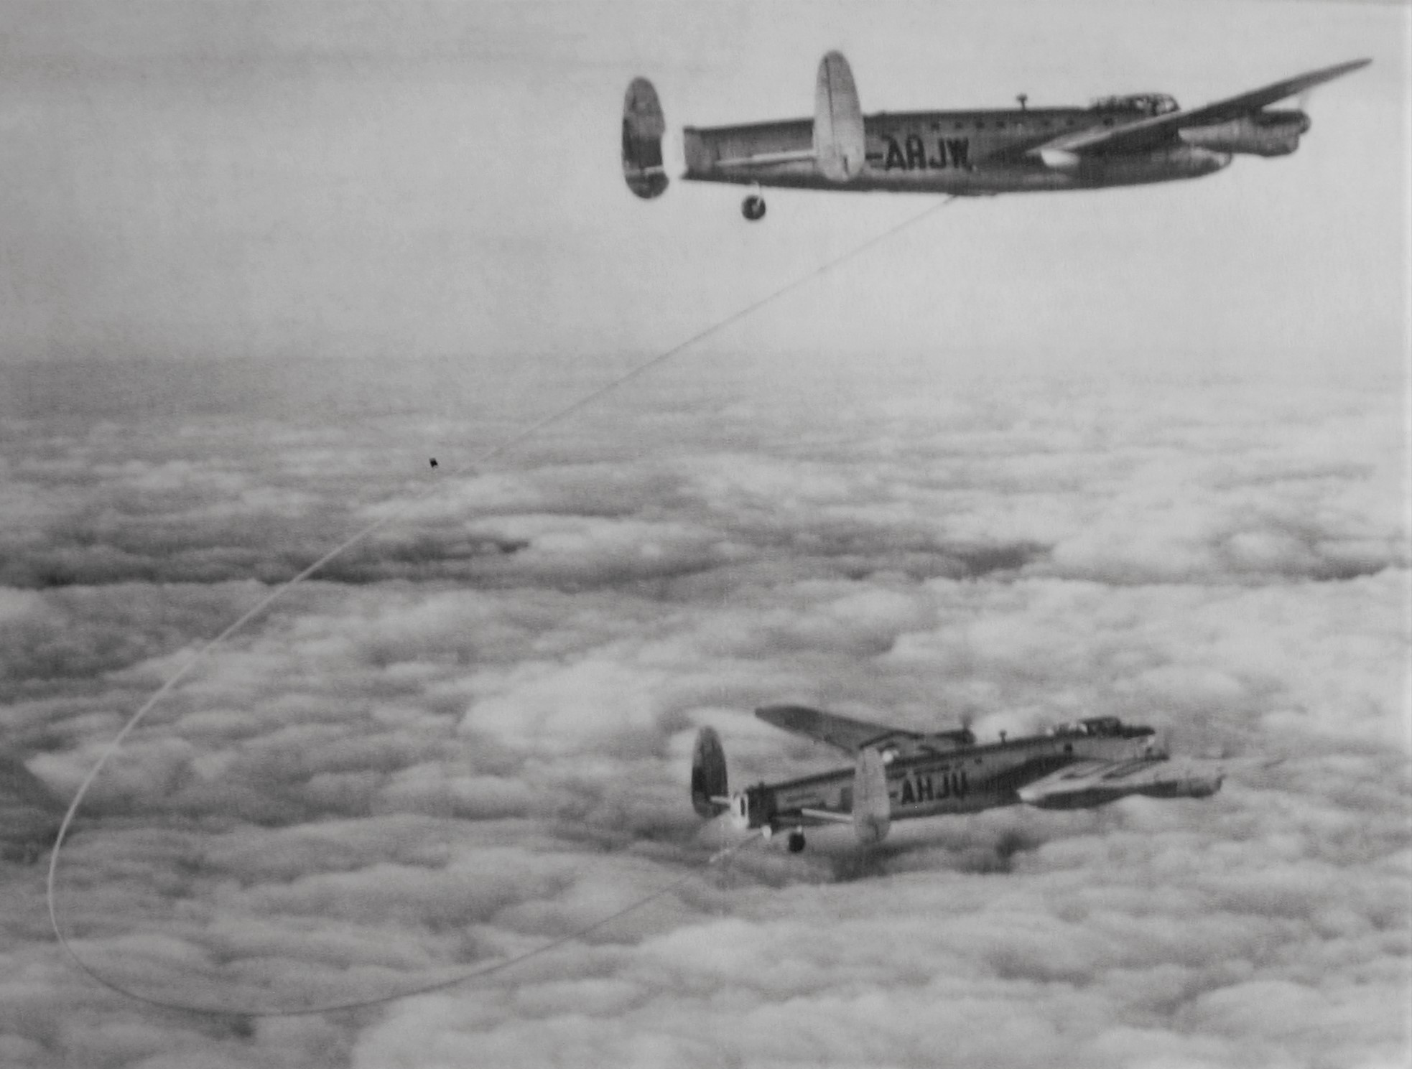
In 1948, further trials involving British Overseas Airways Corporation (BOAC) Lancastrian receiver and Lancastrian tankers by Flight Refuelling Limited were conducted over the North Atlantic. The refuelling contacts, which were carried out at night and in severe weather conditions, were highly successful.
These early “Looped Hose” trails inspired the Flight Refuelling logo. In 1961 the RAF Valiant trails No. 214 Squadron, applied a unique combination of this logo together with their official heraldic badge on the fins of their aircraft to show the close working relationship between the company and the Royal Air Force.
The development of in-flight refuelling continued and it is now an integral part of any military strike force. The modern civilian jet aircraft are converted to tanker duties and fitted with fuel tanks, pumps and hose reels.

U.S. Air Force In-Flight Refuelling

Strategic Air Command
On 21st March 1946, the United States Army Air Forces (USAAF) was divided into three separate commands: Tactical Air Command (TAC), Air Defense Command (ADC), and Strategic Air Command (SAC). SAC's original headquarters was Bolling Field, the headquarters of the disbanded Continental Air Force, in Washington, DC. Its first commander was General George C. Kenney (who was the commander of the air forces under MacArthur in the Pacific South West region).
SAC's original mission statement, expressed by General Carl Spaatz, then commanding general of the USAAF, was: The Strategic Air Command will be prepared to conduct long-range offensive operations in any part of the world, either independently or in co-operation with land and naval forces; to conduct maximum-range reconnaissance over land or sea, either independently or in co-operation with land and naval forces; to provide combat units capable of intense and sustained combat operations employing the latest and most advanced weapons; to train units and personnel of the maintenance of the Strategic Forces in all parts of the world; to perform such special missions as the Commanding General Army Air Forces may direct.
After World War II and demobilization of the armed forces, readiness in the Air Force Reserve declined. To address this issue, the Air Force formed the Continental Air Command in December 1948 to direct the Reserve from headquarters at Mitchel Air Force Base, N.Y.
That mission makes no specific reference to nuclear weapons, which in any case SAC did not yet possess. In the wake of World War II, the U.S. underwent a major drawdown of military forces, and the few USAAF units involved in the dropping of the atomic bombs were not spared.
SAC retained its organization and mission after the USAAF became the United States Air Force on 18 September 1947. From 9th November 1948, its headquarters was moved to Offutt Air Force Base near Bellevue, Nebraska. In October 1948 General Curtis LeMay took over as commander of SAC and set about a dramatic rebuilding of the command's forces, as well as their mission. LeMay, who had masterminded the American attacks on the Japanese mainland during the war (including the firebombing of Tokyo and other cities), was a staunch believer in the power of strategic bombing: the destruction of an enemy's cities and industrial centres. LeMay believed that the existence of the atomic bomb made this type of warfare the only workable strategy, rendering battlefield conflicts essentially obsolete.
Photo 13. General Curtis E LeMay
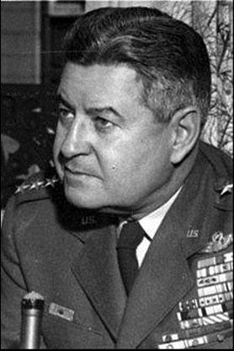
[General Curtis E LeMay was the commanding officer at Tinian in 1945 from where the atomic bombs were launched against Japan].
Under LeMay's command, SAC became the cornerstone of American national strategic policy during the Cold War with the Soviet Union, which was based on nuclear deterrence. SAC's motto became "Peace is Our Profession," symbolizing the intention to maintain peace through the threat of overwhelming force
Although World War II did not make refuelling seem urgent to U.S. military leaders, the Cold War was another story. Several events spawned this shift in thinking. First, the Strategic Air Command (SAC) came into being on March 21, 1946. This group was responsible for delivering nuclear weapons anywhere in the world, but all it could rely on were piston-driven Boeing B-29 bombers, which lacked intercontinental range. Then the U.S. government created the Air Force as a separate service on September 18, 1947. Carl Spaatz, now a general and the Air Force’s chief of staff, assigned top priority to in-flight refuelling in January 1948.
The Air Force sent General Jimmy Doolittle to Britain to investigate Flight Refuelling Limited and its apparatus. Doolittle had long been familiar with airborne innovations. In 1922 he had flown from Florida to California, making just one stop along the way for refuelling, of course. In 1925 he was the winner of the Schneider Trophy. In 1929 he’d made the first instruments-only flight, lifting off, flying a prescribed route, and then landing with a hood covering the cockpit windows the whole time. And in April 1942 he had led the famous bomber raid on Tokyo that boosted Allied morale tremendously.
Doolittle came back with an enthusiastic report. On June 30, 1948, the Air Force activated its first two refuelling units, the 43rd Air Refuelling Squadron, at Davis-Monthan Air Force Base, in Arizona, and the 509th Air Refuelling Squadron, at Roswell Air Field, in New Mexico. Late that year each unit received B-29s modified as tankers, which were called KB-29Ms. SAC wasted little time in showcasing its new capabilities. In December 1948 a SAC Boeing B-50 flew 9,870 miles in 41 hours and 40 minutes, during which it was refuelled three times by Boeing KB-29M tankers.
SAC didn’t stop there. From February 26 to March 2, 1949, Capt. James Gallagher flew non-stop around the world in 94 hours and 1 minute in the ‘Lucky Lady II’, a SAC Boeing B-50 (detailed later).
Although SAC’s system looked good to observers, in-flight refuelling was still unsophisticated. The method in use required a crewman to connect the hose manually in an unpressurized compartment. That limited the system to lower altitudes, where planes fly less efficiently because of thicker air. In addition, the system could transfer only 200 gallons of fuel per minute, and SAC wanted 600 gallons of fuel per minute. It also failed in severe cold because the hose froze on the reel. The shortcomings in the approach led to a long-running duel between refuelling systems.
In 1948 Boeing started testing its flying boom, an extendable pipe equipped with ruddervators—essentially little wings—to fly it into position.
A year later Flight Refuelling Limited tested its new probe-and-drogue method. In this technique, a tanker dangles a flexible hose that ends in a drogue, which looks like a giant shuttlecock with its open end outward. The receiver is equipped with a spear-tip-shaped probe. To transfer fuel, the receiver flies up behind the tanker and inserts the probe into the drogue.
Photo 14. Modern hose reel system for jet fuel in-flight refuelling
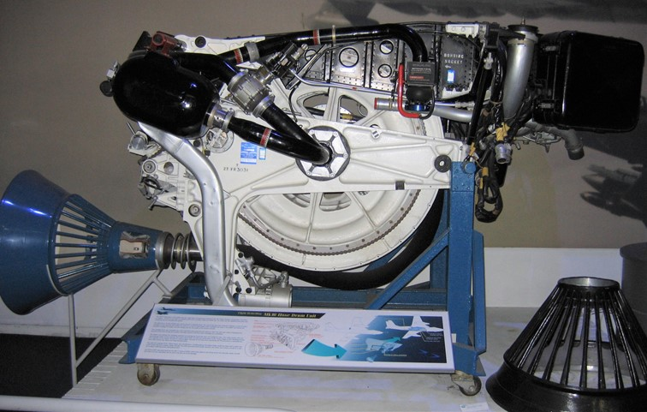
The Air Force tested the probe and drogue in December 1949 in Project Outing. It put probes on Boeing B-29s and Republic F-84 Thunderjets and outfitted a B-29 as a tanker that pulled a drogue from its tail section. The Air Force also modified a Boeing YKB-29T tanker with three drogues, one from the tail and one on each wingtip, so it could simultaneously refuel three planes (earning it the nickname ‘Triple Nipple’). Although these tests went well, on October 19, 1949 the Air Force put out a press release about the other system, the flying boom that stated: “It is expected that the new system, developed for the Air Force by the Boeing Airplane Company, Seattle, Washington, (U.S.A.), will alleviate some of the difficulties of the existing method.” Less than a year later Biggs Air Force Base, in Texas, received the first KB-29P, which was a B-29 converted to a tanker with a flying boom.
By the end of 1950 SAC needed a faster tanker, one that could keep up with Boeing’s B-47 Stratojet bomber. At that time the aeronautics industry offered few planes that were large enough to serve as tankers and fast enough to keep up with the jet-age military. To get more tanker speed, SAC selected the Boeing KC-97 Stratofreighter, which was based on the Boeing B-29. The KC-97 could outrun previous tankers, but its maximum speed when fully loaded still lagged behind a B-47’s minimum speed. Consequently, some refuelling between a KC-97 and a B-47 demanded a so-called toboggan manoeuvre, in which the tanker flies at a downward angle to pick up speed and the jet follows along the same path while reducing its thrust. Besides being hard to coordinate, the toboggan manoeuvre wasted fuel. The receiving plane could end up using half the fuel it had taken on just to get back to its former altitude.
Even as the technology was still being modified, tankers saw action in the Korean War. On July 6, 1951, a KB-29M flown by a SAC crew refuelled four Lockheed F-80 Shooting Stars over North Korea. This appears to have been the world’s first combat refuelling. A few days later a KB-29P used a flying boom to refuel a North American RB-45C Tornado photoreconnaissance plane.
Photo 15. Boeing KB-29M, originally, B-29-60-BW, S/N 44-69710 "Homogenized Ethyl" of the 43rd Air Refueling Squadron.
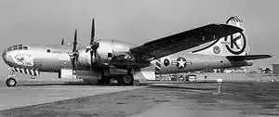

Photo 16. Boeing KB-29 refuelling a Republic F-84F Thunderstreak using the flying boom.
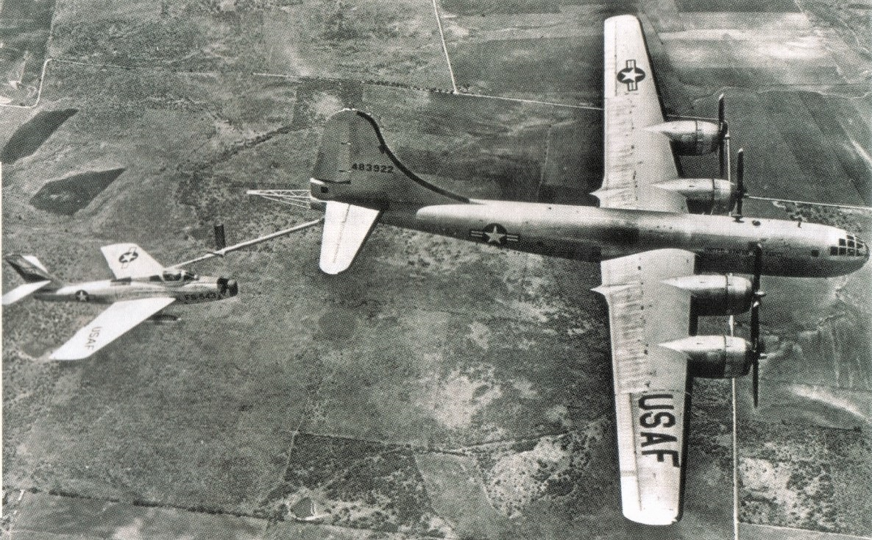

43rd Bombardment Wing
First organized as the 43rd Bombardment Wing, Very Heavy, on 17 November 1947, the newly formed wing's first task was to get the B-29s out of mothballs, make them serviceable and train crews to fly them. The new unit trained in strategic bombing with Boeing B-29 bombers at Davis-Monthan Air Force Base, Arizona. From November 1947 through December 1948, the unit served as a double-sized wing controlling the tactical and support components from another SAC wing. The giant Convair B-36 Peacemaker entered SAC's inventory, so B-29 wings received new designations. In July 1948, the unit was redesignated as the 43rd Bombardment Wing (Medium).
On 19 July 1948, the 43rd and 509th Air Refueling Squadrons were activated at Davis-Monthan Air Force Base, Arizona, and Roswell Air Force Base, New Mexico, in preparation for the assignment of tanker aircraft. These two squadrons were the first air refuelling units in the U.S. Air Force. They began receiving tanker aircraft in late 1948. These first tankers were simply B-29s modified to carry and dispense fuel while aloft. Employing the British-developed system of in-flight refuelling, that is, the use of trailing hoses and grapnel hooks, these tankers were designated KB-29Ms.
By January 1, 1949, the wing was fully operational to meet SAC's global commitments. It began receiving the new Boeing B-50, a greatly improved version of the B-29 and KC-29s, the tanker version of the B-29. Aerial refuelling was added to the mission. The 43rd Air Refueling Squadron was attached Feb. 10, 1951.

First Round the World Non-stop Flight 1949
In 1949 at the start of the “Cold War” and the nuclear age, the U.S. Air Force wished to demonstrate that its strategic bomber force could travel around the world and reach any target. To illustrate this point, a flight of specially modified Boeing B-50 bombers/tankers were used to achieve the first non-stop flight around the world.
A Boeing B-50A bomber named “Lady Luck II” piloted by Capt. James Gallagher departed Fort Worth, Texas, on Feb. 26, 1949 with the express goal of making the first nonstop trans global flight. Lucky Lady II landed at Carswell Air Force Base, Texas, on March 2, 1949 completing the first ever nonstop, around-the-world trip by an airplane, having flown 37,742 km (23,452 miles) in 94 hours 1 minute, averaging a ground speed of 249 miles per hour.
The modified bomber required air-to-air refuelling four times as it flew ever eastward. The Lucky Lady II was an updated version of the B-29 that had fought in World War II and was close to being obsolete by 1949.
After that flight General Curtis LeMay, the commander of SAC, said, “We can now deliver an atomic bomb to any place in the world that requires an atomic bomb.”
Refuelling while flying, was the biggest challenge of the flight. Though commonplace today with military, the technique was not widely used at the time. The “Lucky Lady II” was refuelled from its close relative, the tanker version KB-29. Four pairs of KB-29s based in the Azores, Saudi Arabia, the Philippines and Hawaii were used as airborne gas stations.
Photo 17. “Lucky Lady II’ being refuelled over the Himalayas in 1949 during its epic flight.
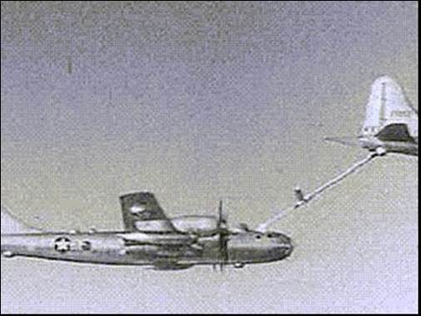
From the film of this epic flight over the Himalayas which show a flying boom delivery.
The record-setting flight used a probe-and-drogue system, similar to what the Navy uses today. Essentially a long hose is reeled out from the KB-29 tanker and is attached to a refuelling nozzle on the B-50 during flight.
Figure 1. Lucky Lady II flight path around the world
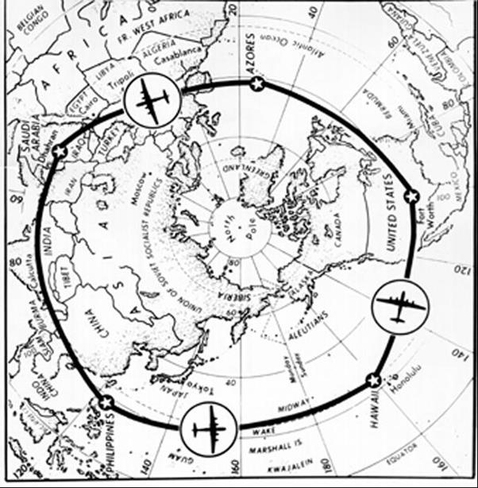
Photo 18. “Lucky Lady II’ being refuelled in 1949 during its epic flight.
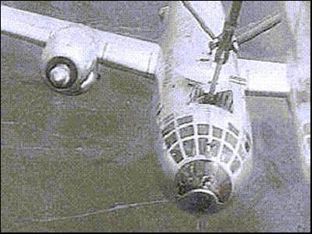

However looped hose system was also used.
Photo 19. A tanker plane refuels the Boeing B-50 Lucky Lady II. Photo: Courtesy National Museum of the U.S. Air Force
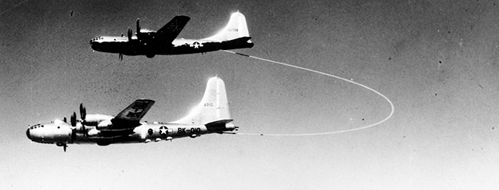
It interesting to note the different modes of delivery in this photo it shows the “looped hose”.
Jet aircraft were the future. The Boeing B-52, which continued to serve as the mainstay of the U.S. bomber fleet today, would make its first flight just three years later. Despite the fact that officials knew the propeller-driven Boeing B-50 would not remain the premier bomber for long, there was a need to send a strong message to an evolving Cold War adversary that the United States military could fly anywhere in the world with one of its aircraft.
World War II established the importance of controlling the skies during a modern conflict. Bombers from the major combatants inflicted devastating damage to cities in Europe and Asia. The ability of an aircraft to fly long distances to deliver a payload of bombs established the importance of the bomber fleet.
After the Soviets blocked land access to Berlin in 1948, the ability to deliver humanitarian assistance further established the importance of being able to fly heavy aircraft for long distances. The Berlin Airlift also made it clear the Cold War had truly begun.
The newly formed United States Air Force (USAF) wanted to demonstrate that air power eliminated all distance or geographical barriers for the military. The thinking was that aerial circumnavigation without the need to land would show the Soviet Union that the USAF could strike anywhere.
All that is left of the famous “Lucky Lady II” is the fuselage which now rests at Chino Air Museum in California.
Photo 20. “Boeing B-50A “Lucky Lady II” fuselage at Chino Air Museum
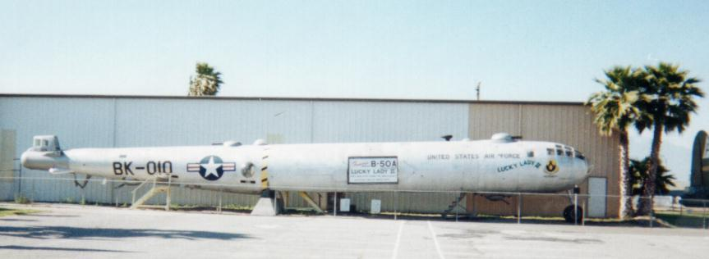

Developments in In-flight Refuelling

Multiple refuelling - 1956
In the U.S., for non-carrier duties, a Convair R3Y-2 Tradewind flying boat was converted to a four-point tanker and the first simultaneous refuelling of four fighters was demonstrated in 1956, using wing mounted equipment produced by the Sergeant Fletcher Company, which in the 1990’s was affiliated to Flight Refuelling Limited.
Photo 21. US Navy Convair R3Y-2 Tradewind flying boat refuels four US Navy fighters 1956.
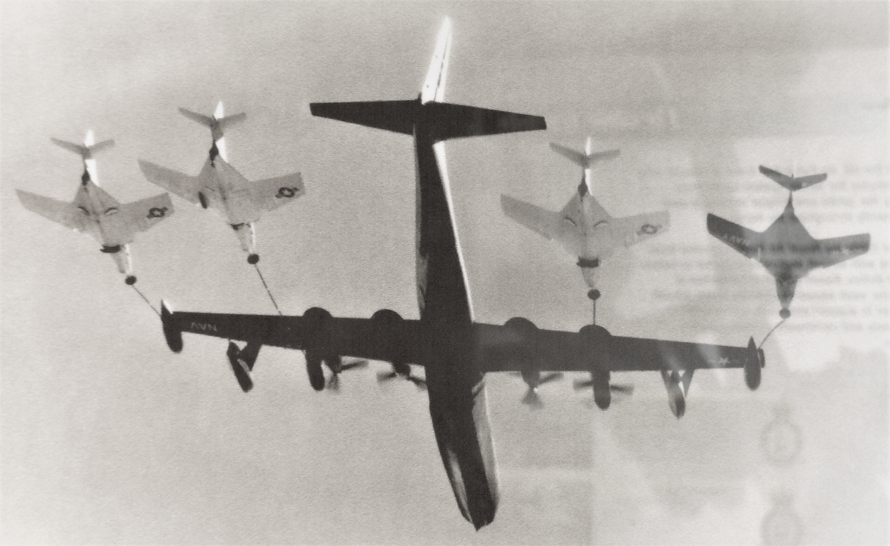

Buddy-Buddy Refuelling
Where no dedicated tanker aircraft is available one strike or fighter aircraft can refuel another. The so-called “Buddy-Buddy” refuelling system was developed by the United States Navy; and has been adopted by other Air Forces. The first aircraft flies with no weapons but maximum fuel load, while the second flies with a maximum weapons load but minimum fuel. Once airborne, the first aircraft provides part of its fuel to top up the tanks of the other. This pioneering work was done by the American Douglas and Sergeant Fletcher companies in the 1950’s.
In the 1990’s, the US Navy and US Marine Corps relied upon a succession of both dedicated and lighter readily adaptable “Buddy-Buddy” tankers to extend the range and strike capability of their carrier-based squadrons.
Photo 22. Douglas A-1 Skyraider refuels a Grumman F-9 Cougar in the 1950’s
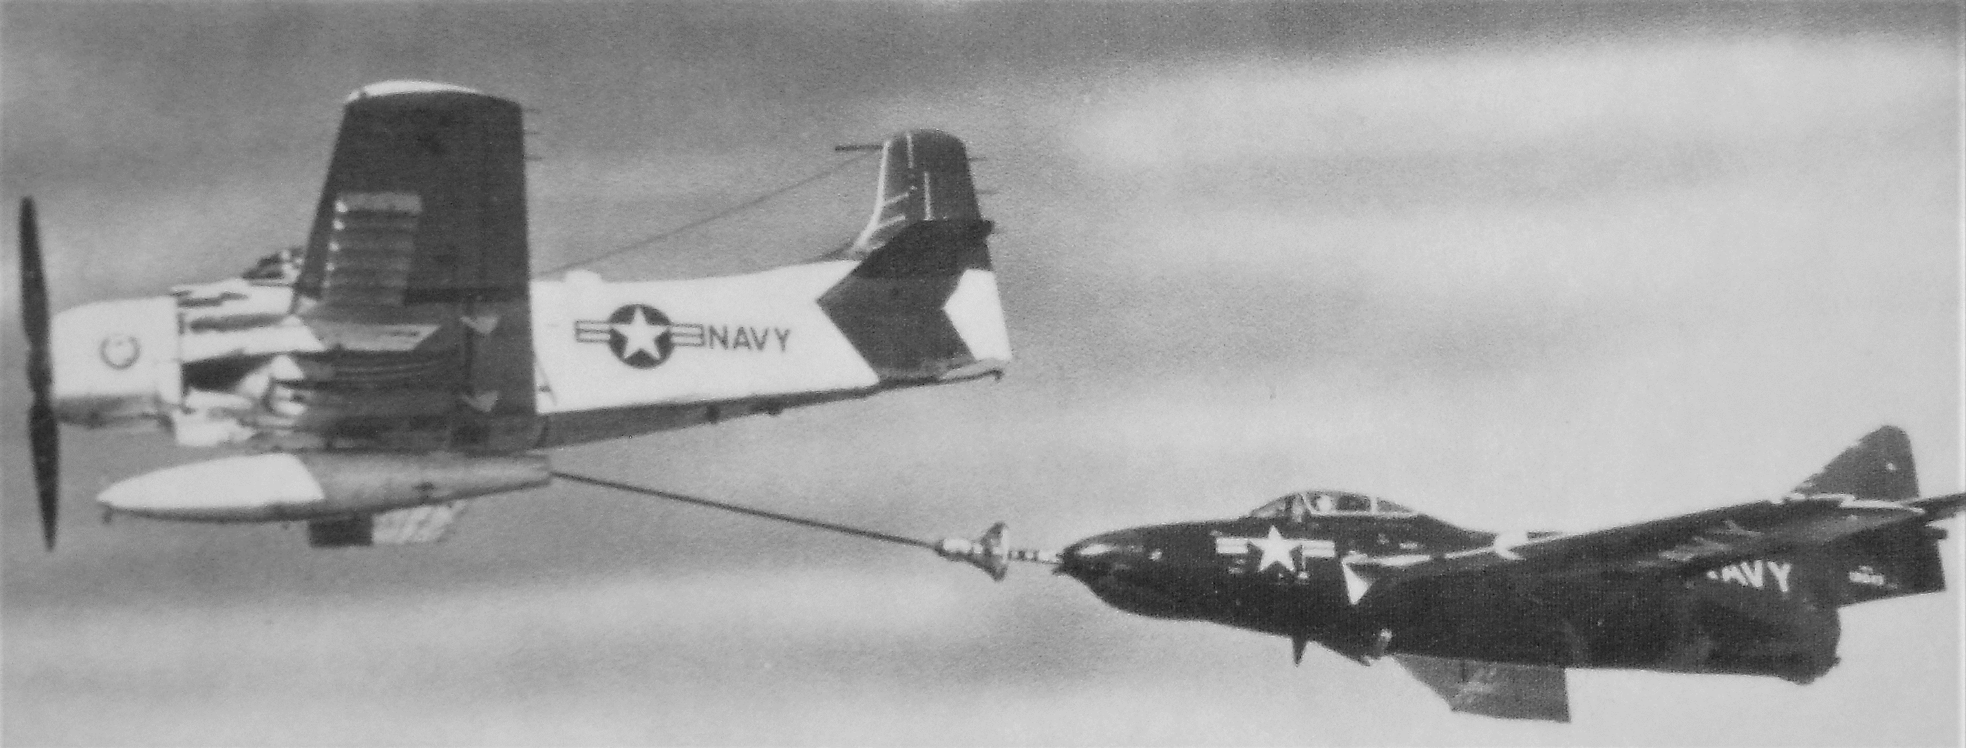
The irony of this picture is that the lead aircraft, a U.S. Navy Douglas A-1 Skyraider, is a powered by piston driven avgas-fuelled engine; it is ‘feeding’ a jet powered Grumman F-9 Cougar U.S. Navy fighter.

Faster tankers needed
One of the issues that did arise with the development of in-flight refuelling from piston driven aircraft such as KB-29 and others was that the jet aircraft when approaching the refuel tanker had difficulty flying slow enough behind the slower tanker. Hence the tanker fleet had to become jet powered as well and this saw the emergence of commercial aircraft such as Boeing 707, Lockheed Tristar LC-10 and others being converted to tanker roles. Even the mighty Boeing B-52 bombers had a tanker variant Boeing KB-52.

R.A.F. Vulcan & Falklands War
Perhaps one of the most famous air-to-air refuelling operations occurred during the 1982 Falklands War, ‘Operation Black Buck 1’ to ‘Operation Black Buck 7’ which were a series of seven extremely long-range ground attack missions by Royal Air Force Vulcan bombers of the RAF Waddington Wing, comprising aircraft from No. 44 Squadron, No. 50 Squadron, and No. 101 Squadron against Argentine positions in the Falkland Islands, of which five missions completed attacks on the Falklands. The objectives of all missions were to attack Port Stanley airfield and its associated defences.

Commercial In-Flight Refuelling- no viable
While in-flight refuelling became the norm for military aircraft, it did not become an operational option for commercial aircraft. There may be many reasons for this – there are sufficient well serviced airports around the world, the commercial air routes are fixed point to point predetermined destinations and therefore not variable in the same way that military aircraft may be seeking targets all around the world, the cost of maintaining both a tanker fleet which purely services the aircraft and has no paying passengers, the cost of modification of aircraft and the training of aircrew, and the inherent dangers associated with the transfer of aviation fuel mid-air to an aircraft containing over several hundred passengers.

Further Reading
Aerial refuelling, air-to-air refuelling, in-flight refuelling – it has many titles. Much has been written about in-flight refuelling and its various methods. It is not intended to cover these in the chapter as our prime interest is aviation gasoline and it appears since the rapid development of jet aircraft that avgas is no longer transferred by these methods and more can be found on the various websites
http://en.wikipedia.org/wiki/List_of_tanker_aircraft
http://www.militaryfactory.com/aircraft/inflight-refueling-tanker-aircraft.asp
http://en.wikipedia.org/wiki/Aerial_refueling
https://en.wikipedia.org/wiki/Operation_Black_Buck
CRS Report for Congress - Air Force Aerial Refueling Methods: Flying Boom versus Hose-and-Drogue. Updated June 5, 2006 by Christopher Bolkcom, Specialist in National Defense, Foreign Affairs, Defense, and Trade Division
http://fas.org/sgp/crs/weapons/RL32910.pdf

Index

4
43rd Air Refueling Squadron 13, 15, 16
43rd Bombardment Wing (Medium) 16
43rd Bombardment Wing, Very Heavy 16
5
509th Air Refueling Squadron 3, 14, 16
A
Adj. Louis Crooy 6
Aerial Refueling Methods 21
aerial refuelling 21
Africa. 8
Air Defense Command (ADC) 12
Air Force Reserve 12
air to air refuelling 4
Airspeed Courier 8
air-to-air refuelling 3, 4, 8, 9, 10, 17, 21
Argentine 21
Arizona 14
Armstrong Whitworth A.W.23 10
Asia 19
Atlantic 3, 10
Atlantic C-2A 6
atomic bomb 12, 13, 17
Australia 8
avgas 21
aviation fuel 21
aviation gasoline 4, 21
Azores 17
B
B-29 16
B-50 17
B-50A 17
B-52 19
Belgium 3, 6, 8
Bellevue, Nebraska 12
Berlin 19
Berlin Airlift 19
Bermuda 11
Biggs Air Force Base 15
BOAC 12
Boeing 14
Boeing 707 21
Boeing Airplane Company 15
Boeing B-29 13, 14, 15, 16
Boeing B-47 Stratojet 15
Boeing B-50 14, 16, 17, 19
Boeing B-52 21
Boeing KB-29 16
Boeing KB-29M 3, 14, 15
Boeing KB-52 21
Boeing KC-97 Stratofreighter 15
Boeing YKB-29T 15
Boeing B-47 Stratojet 15
Bolling Field 7, 12
Bristol Fighter 9
British Air Ministry 10
British Overseas Airways Corporation 12
British Royal Flying Corps 8
British South American Airways 11
Buddy-Buddy Refuelling 20
C
Cabot 3, 10
calf 4
California 13, 19
Capt. Ira C. Eaker 6
Capt. James Gallagher 3, 14, 17
Capt. Lowell H. Smith 4, 5
Capt. Ross G. Hoyt 7
Caribou 3, 10
Carl Spaatz 13
carrier-based squadrons 20
Carswell Air Force Base, Texas 17
Chevron 4
Chino Air Museum 19
Cold War 13, 17, 19
commercial aircraft 21
commercial airlines 4
Continental Air Command 12
Continental Air Force 12
Convair B-36 Peacemaker 16
Convair R3Y-2 Tradewind 3, 20
cow 4
Curtiss JN-4 3, 4
D
Davis-Monthan Air Force Base 3, 13, 16
DH-4B 3, 4
DH-9 3, 6
Douglas A-1 Skyraider 20
Douglas C-A 3, 6
drogue 15
E
engine oil 8
England 8
Europe 8, 19
F
Falkland Islands 21
Falklands War 3, 21
Farnborough 9
Federation Aeronautique Internationale 8
Fletcher 20
Flight Refuelling Limited 3, 8, 10, 12, 13, 14, 20
Florida 13
flying boom 14, 21
Flying Tankerman 4
Fokker 3, 6
Fort Worth, Texas 17
four-point tanker 20
France 8
fuel tanks 12
G
General Carl Spaatz 12
General Curtis LeMay 12, 17
General George C. Kenney 12
General Jimmy Doolittle 13
Great Britain 4, 8
Grumman F-9 Cougar 20
H
Harrow 3, 10, 11
Hawaii 17
Hendon 3, 4, 9, 14, 25
Himalayas 17
Homogenized Ethyl 15
hose reels 12
Hose-and-Drogue 21
Hunter brothers 8
I
Imperial Airways 3, 10, 11
India 8
in-flight refuelling 4, 9, 12, 14, 21
Interair System of Refuelling 4
International Aerospace Hall of Fame 8, 25
Ireland 3, 10
J
Japan 8, 13
Japanese 12
jet aircraft 12, 21
jet fuel 4
K
KB-29 17, 21
KB-29M 14, 16
KB-29P 15
KC-29 16
King George V 8
Korean War 15
L
Lady Luck II 17
Lancaster 11
Lancastrian 12
Liberator 12
Liberty 400 HP 3, 4
Lincoln Standard biplane 4
Lockheed F-80 Shooting Star 3, 15
Lockheed Tristar LC-10 21
London 3, 11
Long Beach, California 4
Looped Hose 10, 11, 12
Louis Crooy 3
Lowell H. Smith 3
Lt. Elwood R. Quesada 6, 7
Lt. Harry A. Halverson 6
Lt. John Richter 3, 4, 5
Lucky Lady II 3, 14, 17, 18, 19
M
MacArthur 12
Major Carl Spaatz 6
Major Howard C. Davidson 7
Malta 8
Master Sgt. Roy W. Hooe 7
mid-air refuelling 4, 6
military aircraft 21
Mitchel Air Force Base 12
N
New Mexico 14
Newfoundland 3, 10
No. 101 Squadron 21
No. 214 Squadron 12
No. 44 Squadron 21
No. 50 Squadron 21
No. 7 Squadron 9
nonstop trans global flight 17
North Atlantic 12
North Korea 3, 15
nuclear weapons 12, 13
O
Offutt Air Force Base 12
oil companies 4
Operation Black Buck 1 3, 21
Operation Black Buck 7 3, 21
P
Pacific South West 12
Philippines 17
Port Stanley 21
probe-and-drogue 14, 17
Project Outing 14
Q
Question Mark 3, 6, 7
R
RAE 3, 10
RAF Waddington 21
RB-45C Tornado 15
Rebecca/Eureka 11
refuel tanker 21
Republic F-84 Thunderjet 14
Republic F-84F Thunderstreak 16
Rockwell Field 3, 4
Roswell Air Field 14
Roswell Air Force Base, New Mexico 16
Royal Air Force 3, 4, 12, 21
Royal Air Force Display 9
Royal Aircraft Establishment 3, 9
ruddervators 14
Russia 8
S
SAC 12, 13, 14, 15, 16
San Diego 6
San Diego Aerospace Museum 8, 25
Saudi Arabia 17
Schneider Trophy 13
Seattle, Washington 15
Sergeant Fletcher Company 3, 20
Sgt. Roy Hooe 6
Sgt. Victor Groenen 6
Shell 10
Siddeley-Puma 3, 6
Sir Alan Cobham 1, 3, 8, 9, 10
Soviet 19
Soviet Union 13, 19
Squadron Leader Atcherley 3, 9
Standard Aviation Gasoline 4
Standard Oil of California 4
Strategic Air Command 12, 13
T
Tactical Air Command (TAC) 12
tanker aircraft 20
tanker fleet 21
Thames River 8
Tinian 13
Tirlement 3, 6
toboggan manoeuvre 15
Tokyo 12, 13
Triple Nipple 15
U
U.S. Air Force 6, 16, 17
U.S. Army Air Corps 3, 6
U.S. Navy 20
United States Air Force 12,19
United States Army Air Forces (USAAF) 12
United States Navy 20
US Marine Corps 20
V
Valiant 12
Vickers Virginia 9
Victor Groenen 3
Vulcan bomber 21
W
Washington, DC. 12
Wesley May 4
Westland Wapiti 9
windlass 10
Wright Whirlwinds 3, 6

Research Sources

RAF Hendon display April 2005, April 2006
Aircraft Year Book 1923 Page 321. 92004167 Official American Records, (NAM Call No. R629.058 A 1924 - TL501.A56 1924) U.S. Naval Aviation Museum, Pensacola, Florida, U.S.A.
Website: http://www.af.mil/history/people.asp?dec=Early_Years Accessed Nov 2004.
Plaque International Aerospace Hall of Fame - San Diego Aerospace Museum 1997
Website accessed March 21, 200 http://www.jcs-group.com/military/allyair/warcold.html
Website accessed July 25, 2013 http://www.wired.com/2010/03/0302b50-nonstop-circumnavigation
Website accessed April 17, 2018 https://en.wikipedia.org/wiki/Operation_Black_Buck

