Chapter

40

Laboratory Methods & Chemists 1900-1960

Photo 1. SOCAL research chemist at work 1931.

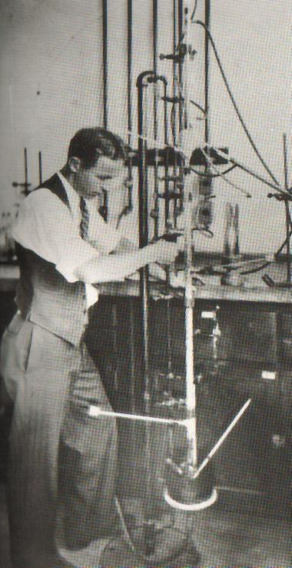

Table of Contents

Summary 3

Forward 4

Laboratory Methods And Chemists 4

1917 Aviation And The Chemist 4

1920 Research Interests 5

1926 PONA Analysis 5

1926 Petroleum Motor Fuel Definitions 8

1927 Oil Chemists Search For Composition Of Petroleum – API Project No. 6 9

Penn State College Research On Gasolines 12

New Apparatus & Equipment 16

New Automated Laboratory Equipment 19

New Physical Methods 21

New Analytical Techniques 21

Analytical Methods For Determining TEL Content 23

Search For New Refinery Process Methods 25

New Laboratories For Aviation Gasoline 28

Epilogue For Chemists 29

Index 30

References 34

# Summary

1917 First general U.S. government specification for gasoline was established

1922 Refining of Gasoline and Kerosene by Hypochlorites

1925 U.S. Government specification for gasoline

1926 Egloff PONA analysis

1927 Petroleum API Project No. 6

1928 X-Ray Methods

1931 “Apparatus and Methods for Precise Fractional Distillation Analysis - New Method of Gas Analysis” by Walter J. Podbielniak.

1933 “Apparatus and Methods for Precise Fractional Distillation Analysis - II. Laboratory Columns for Precise and Rapid Fractionation of Gaseous and Liquid Samples” by Walter J. Podbielniak.

1938 Symposium on Chemical Utilization of Petroleum Hydrocarbons

1941 “Apparatus and Methods for Precise Fractional Distillation Analysis - New Design of Adiabatic Fractionating Column and Precision-Spaced Wire Packing for Temperature Range -190 deg. to 300 deg. C.” by Walter J. Podbielniak

1944 Automatic Distillation of Gasolines

1944 New Physical Methods

1958 Texas Butadiene & Chemical Company Manufacturing Research and Control Laboratory

Photo 2. Walter J. Podbielniak (centre) receives and honorary degree from Dickson College, Pennsylvania, U.S.A. (1978)

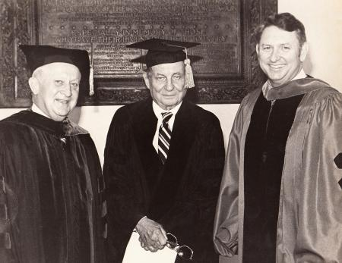

# 

# Forward

Author’s Note:

I suspect this chapter will be only of interest to the chemists, but the story needs to be told of the efforts of those who toiled in laboratories, research centres, universities, colleges and other establishment, only to find their research efforts were maybe in vain, but that through their efforts and the successes that were achieved, and through their publications of their work, the rest of the world would know of the contribution to the advances in science.

# Laboratory Methods and Chemists

The chemists developed new methods and apparatus to investigate the properties and composition of gasolines; this would lead to new specifications for petroleum products. Much research would be done to determine the composition of petroleum products and to define new parameters and tests to define the quality of gasolines. This research was not limited to fuels but extended to materials of construction of the aeroplane, and the environment in which it operated.

Their work would be published in many renowned journals, some dating back to 1879, and publications such as.

Industrial & Engineering Chemistry- Analytical Edition

Analytical Chemistry

Journal of American Chemical Society

The following examples are some of the knowledge gained from the publication of those chemists and engineers.

# 1917 Aviation and the Chemist[1]

In 1917, the engineers of the day observed that at the close of the war (WWI) the world would face a new era in transportation. The advent of the aeroplane in every-day life would be here, and that there was a field of research in which chemists must play a great part. In general, the materials entering into aeroplane construction are subjected to two unusual conditions: first, extreme vibration, a condition which will become more and more accentuated as greater possibilities of speed were realized; second, sudden and extreme changes of temperature due to rapid ascent or descent. Some of the problems identified were:

There was a need for an ideal “dope” for impregnation of the fabric, Irish linen. To be ideal, this material should make the fabric water-proof, air-proof, fire-proof, or at least slow-burning, should give low visibility, prevent deterioration and be non-poisonous; some of those in use were poisonous and the drippings seriously affect the aviators.

Another problem was the drying of all wood used in construction. Air-drying required at least nine months; kiln drying was not successful as the wood was thus injured by the outside being drier than the inside. Vacuum drying had been attempted, but so far without much success. An ideal impregnating medium for the wood was needed, not to prevent rotting, but the disintegration resulting from rapid changes of temperature, whereby the juices of the wood freeze, expand and weaken the cells.

For metals an ideal means was needed to prevent rusting, one which could be applied after the machine was built. Nickel-plating had not proved successful; the varnish makers in the past had previously no such conditions of vibration and sudden changes of temperature to overcome. Indeed, the whole subject of rusting had never been systematically studied from the standpoint of these conditions.

Much study was needed in the field of light alloys. Those with aluminium as a base, disintegrate under the intense vibration and stresses in high altitudes. Why?

A more thorough knowledge of magnesium alloys was desirable, both those with aluminium and those with other metals, while interesting possibilities which might be developed through a thorough study of beryllium alloys. Are the properties of aluminium alloys affected by occluded gases? For such studies more refined methods were needed for the determination of the presence and amount of occluded gases.

As to lubricants, the behaviour of such types as castor oil under the temperature conditions in question, called for investigation. What was the best method for testing and what should be the standard specifications for so important a factor in aeronautics?

In connection with the ignition system, a wide field of research was open for the study of spark discharge from the chemical standpoint. Better insulating material for spark plugs needed to be developed; at that time mica and porcelain were used. This was considered the weakest feature of current motors of the day.

Much of the advance in aeronautics had been empirical. Further progress could be best assured by the application of the strictest methods of scientific research. For the fuller grasp of the many problems here awaiting solution, chemists had to become familiar with the principles of aviation.

# 1920 Research Interests

In 1920 the U.S. Government’s National Advisory Committee For Aeronautics[2] published a number of reports which illustrate the matters of interest to the research chemists of the day in relation to aviation.

Power Characteristics of Fuels for Aircraft Engines. Report 47. 35 pp. 1920. (From Fourth Annual Report.)

(1) Power Characteristics of Aviation Gasoline. H. C. Dickinson, W. S. James, E. W. Roberts, V. R. Gage and D. R. Harper, 3rd.

(2) Power Characteristics of Sumatra and Borneo Gasolines. E. W. Roberts

(3) Power Characteristics of 20 Per cent Benzol Mixture. E. W. Roberts

The following are from the Fifth Annual Report:

Glues Used in Airplane Parts with Lists of References. Compiled by S. W. Allen and T. R. Truax. Report 66.28 pp. 1920. Prepared by Forest Service in cooperation with University of Wisconsin.

Effect of Kiln Drying on Strength of Airplane Woods. T.R. C. Wilson. Report 68. 69 pp. 1920. Prepared by Forest Service in Cooperation with the University of Wisconsin.

# 1926 PONA Analysis[3]

In 1926, Gustav Egloff and Jacque C. Morrell of Universal Oil Products published one of the first laboratory methods to determine the chemical structure of gasolines. It described a method by which the percentage of Paraffins, Unsaturated (or Olefins), Naphthenes and Aromatic hydrocarbons could be determined – PONA.

Determination of Unsaturated, Aromatic, Naphthene, and Paraffin Hydrocarbons in Motor Fuels and Their Automotive Equivalents' by Gustav Egloff and Jacque C. Morrell. Universal Oil Products Co., Chicago, Illinois, USA.

A procedure is described for determining the four series of hydrocarbons when in presence of each other, particularly in motor fuels, and for the calculation of their automotive equivalents. Unsaturated hydrocarbons are determined by means of sulfuric acid absorption and polymerization, aromatic hydrocarbons by nitration, naphthenes by means of the aniline index, and the paraffins by difference. The efficiency of the method is shown by an analysis of three synthetic mixtures. The aromatic hydrocarbon equivalent and the highest useful compression are calculated by means of Ricardo's data for toluene. To confirm the results obtained by chemical analysis, motor tests were made to determine the anti-knock properties of several of the gasolines tested.

One of the difficult problems in hydrocarbon chemistry is the quantitative determination of the paraffin, unsaturated, naphthene, and aromatic hydrocarbons in mixtures. Much study has been given to this problem in the laboratories of the world, but no systematic procedure has been devised. The primary purpose of this investigation was to relate the percentage composition of these hydrocarbons to the anti-knock properties of certain motor fuels. The analytical procedure is accurate enough to give practical information concerning the anti-knock qualities of motor fuels and is adapted as a standard laboratory method of determining the series of hydrocarbons when in presence of each other.

## Analytical Procedures

Unsaturated Hydrocarbons

A 500-cc. charge of the motor fuel is distilled through a Hempel column containing glass beads until the temperature of the vapor at the top of the column is 210 deg. C. The residue is discarded. This temperature is purely arbitrary, and any other may be used provided it is used throughout the analysis.

The 210 deg. C. fraction is treated with 80 per cent sulfuric acid, so that the volume ratio of acid to oil is 2: 1. The mixture is agitated for 15 minutes, allowed to settle, and the acid layer separated. The volume of the oil layer is measured and the per cent decrease of this volume calculated on the basis of the 210 deg. C. fraction. This calculation gives the percentage of the unsaturated hydrocarbons that have dissolved in the acid layer as reaction products.

In the sulfuric acid absorption, one is confronted with the overlapping effects of various concentrations of sulfuric acid upon the unsaturated and aromatic hydrocarbons. The acid has two effects on the unsaturated hydrocarbons -solution by reaction and polymerization. Therefore, the salient feature of this method is the selection of such a concentration of sulfuric acid as has no effect on the aromatic hydrocarbons but allows determination of the unsaturated hydrocarbons by this twofold effect. Experiments have shown that 80 per cent (by weight) sulfuric acid is without substantial effect on the pure aromatic hydrocarbons and, furthermore, does not react with those of the naphthene and paraffin series. Pure unsaturated hydrocarbons react with sulfuric acid of this concentration to form the sulfuric absorption products and polymers.

Comment: This reaction would become the basis for the ‘alkylation process’ which would be an important process for the WWII.

The acid-treated oil is washed with water, neutralized with a 10 per cent solution of sodium hydroxide, and then redistilled in the same apparatus until the vapor temperature in the Hempel column reaches 210 deg. C. The volume of the residue of the second fractionation to 210 deg. C. is calculated as a percentage of the first 210 deg. C. fraction, and is the percentage of the unsaturated hydrocarbons that have been polymerized during the acid treatment. This, added to the percentage of unsaturated hydrocarbons dissolved by the sulfuric acid, gives the total percentage of unsaturated hydrocarbons in the original 210 deg. C. fraction of the motor fuel.

Aromatic Hydrocarbons

Into a graduated separatory funnel provided with a stopcock and enlarged stem are put 20 cc. of the second 210 deg. C. fraction obtained during the analysis of the unsaturated hydrocarbons and 50 cc. of nitrating mixture-nitric acid 25 per cent, sulfuric acid 58 per cent, and water 17 per cent -added slowly with stirring and cooling. This particular combination of nitrating mixture is important, as it permits nitration of the aromatic hydrocarbons so that the nitration products do not dissolve substantially in the acid sludge but separate as a distinct layer which can be readily determined.

This operation will require from 15 minutes to an hour, as great care must be taken that the temperature of the hydrocarbon mixture does not reach the point where side reactions that might cause explosion may occur. The reaction mixture is allowed to stand until no more gas is evolved. Usually a three-layer system forms - the acid layer at the bottom, an intermediate layer of nitro derivatives, and the oil layer on top. By multiplying the number of cubic centimeters of nitrated compounds by the factor 4.3 the percentage of aromatic hydrocarbons in the second 210 deg. C. fraction is obtained. From this the percentage in the original 210 deg. C. fraction is calculated.

Naphthenes

Naphthene hydrocarbons were determined by the aniline method of Tizard and Marshall (2) which is based on the lowering of the temperature of complete miscibility of aniline and the paraffins by naphthenes. The oil from the nitration treatment is washed with water and a 10 per cent solution of sodium hydroxide and then thoroughly dried with calcium chloride. The aniline value is determined on this dried oil, which is a mixture of paraffin and naphthene hydrocarbons.

(1) Received January 16, 1926. To be presented before the joint session of the Divisions of Petroleum Chemistry, and Industrial and Engineering Chemistry at the 71st Meeting of the American Chemical Society, Tulsa, Oklahoma, April 5 to 9, 1926.

(2): J. SOC. Chem. Ind., 40, 20T (1921).

Photo 3. Dr. Gustav Egloff (‘Gasoline Gus’)

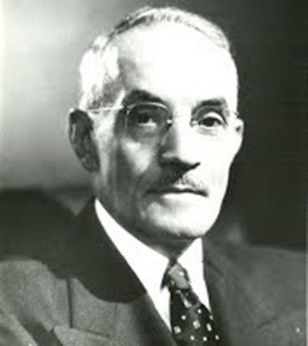 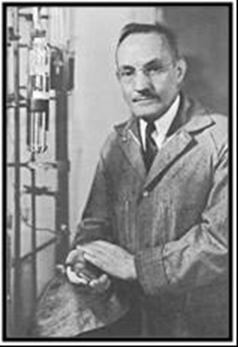

Dr. Gustav Egloff (1886-1955) was an American chemist nicknamed ‘Gasoline Gus’. He was UOP’s (Universal Oil Products) first chemist, and by 1917 became their Director, serving in this capacity until death. He was President of the American Institute of Chemists from 1942 to 1946 and Chairman of the American Chemical Society 1947-8. He has 280 patents to his name and wrote over 600 articles, mostly on the subject of petroleum and hydrocarbons.

# 1926 Petroleum Motor Fuel Definitions

By K. G. Mackenzie The Texas Company Co., New York, N. Y.

1925 November, Industrial and Engineering Chemistry 1105

From the gasoline of the automobile through the kerosine of the tractor, the distillate fuel oil of the semi-Diesel type of engine, to the residual fuel oil for the strictly Diesel type, we see that crude petroleum itself and most of its products are applicable as fuel for particular types of motors. This consideration will be restricted to the question of gasoline. We are at once confronted with the question- “What is gasoline?” In the Committee on Petroleum Products and Lubricants of the American Society for Testing Materials (ASTM), we have attempted to define this product, thus:

Gasoline: A refined petroleum naphtha which by its composition is suitable for use as a carburant in internal combustion engines.

This definition is again contingent upon the definition for naphtha, which is:

Petroleum Naphtha: A generic term applied to refined or unrefined petroleum products and liquid products of natural gas, not less than 10 per cent of which distils below 347 deg. F. (175 deg. C.) and not less than 95 per cent of which distils below 464 deg. F. (240 deg. C.), when subjected to distillation in accordance with the current method of test of the American Society for Testing Materials for petroleum products of this nature.

Attention should immediately be directed to the fact that the governing characteristic is distillation. It would seem at this late date to be almost unnecessary to speak of the use of specific gravity in gasoline specifications, since specific gravity does no more than tell the number of pounds per gallon. However, some of our states, such as Wisconsin, still have laws requiring that gasoline have a certain specific gravity, and that this specific gravity be posted, ignoring entirely the distillation test which is the best criterion we have at the present time for volatility.

Nor is it true that gasoline is an indefinite petroleum distillate containing as much of the kerosine fraction as the manufacturer and retailer can work off. While in certain parts of the country it is possible for a retail dealer to buy both gasoline and kerosine, and market a blend of the same, this blending is becoming very infrequent owing to the state laws definitely specifying the quality of the gasoline which may be sold within the state limits.

This quality is very largely governed by the distillation test, and in prescribing the proper distillation test the various states have largely followed the lead of the Federal Specifications Board of the U.S. Government. The specification of this board, therefore, is assuming increased importance as the national standard for gasoline, even though the specification per se was drawn only to control government purchases.

Table 1. Motor Gasoline. U.S. Government Specifications

Distillation Test-Maxima , Deg. F.

|  |  |  |  |  |  |  |
| --- | --- | --- | --- | --- | --- | --- |
| Date effective | Start | 20% | 45% | 50% | 90% | End |
| 1917 | 140 | 221 | 275 |  | 356 | 428 |
| 25 Nov 1919 | 140 | 221 |  | 284 | 374 | 437 |
| 31 Oct 1922 | 131 | 221 |  | 284 | 392 | 437 |
| 1925 (proposed) |  | 221 |  | 284 | 392 |  |

Distillation Temperatures, Deg. C. (Maximum)

|  |  |  |  |  |  |  |
| --- | --- | --- | --- | --- | --- | --- |
| Date effective | Start | 20% | 45% | 50% | 90% | End |
| 1917 | 60 | 105 | 135 |  | 180 | 220 |
| 25 Nov 1919 | 60 | 105 |  | 140 | 190 | 225 |
| 31 Oct 1922 | 55 | 105 |  | 140 | 200 | 225 |
| 1925 (proposed) |  | 105 |  | 140 | 200 |  |

The first general government specification for gasoline was established in 1917, soon after we (United States) entered the World War I (Table 1). The distillation requirements of this specification provided for an Engler flask with 100-cc. charge. The 1917 specification was later adopted by the Presidential Committee on Standardization of Petroleum Specifications, and was modified by this committee on November 25, 1919, as shown in the table. Later this committee was superseded by the Interdepartmental Petroleum Specifications Committee, which in October, 1922, changed the specification still further. Since then, the Interdepartmental Committee has been absorbed as a unit of the Federal Specifications Board, and it has proposed for consideration the elimination of both the initial boiling point and the end point. It will be seen from Table 1. that there has been comparatively little change in the distillation of gasoline during the last eight years, the 20 and 50 per cent requirements having remained constant, the largest increase being in the 90 per cent point.

# 1927 Oil Chemists search for composition of Petroleum – API Project No. 6

In 1927, the oil industry through the American Petroleum Institute provided the necessary interest and financial support; and the U.S. National Bureau of Standards provided the laboratory space, certain supplies, and the necessary direction of the Research Project No. 6 by Edward W. Washburn - the work of the Project No. 6 would continue through this decade and beyond.

The progress report of October 1933[4] noted that work had been proceeding up through the gasoline fractions, and was now under way into the lubricating oil range; it showed the presence of hydrocarbons previously unreported and the absence (in this particular crude Well No. 6 South Ponca, Field County, Oklahoma, at least) of other hydrocarbons formerly believed to be present. One astonishing result was the relatively large quantities of such hydrocarbons as benzene, toluene, and xylene in a petroleum crude which would be commonly classed as paraffinic. A number of entirely new laboratory procedures for handling this type of petroleum were developed, for example the development of an efficient laboratory still with such features as control of the atmosphere of the still using carbon dioxide, automatic control of the pressure at any desired value between 0.0001 and 760 mm. of mercury thereby minimising thermal decomposition, accurate (to within 0.01OC) and continuous determination of the true boiling point of the distillate as it was collected. One still was 11- metres tall and operated on a 24-hour basis to obtain the fractions.

[5]Edward Washburn died in 1934 and Frederick Rossini was asked to succeed him as director of the American Petroleum Institute Research Project No. 6 on hydrocarbons in petroleum. Rossini held this position at the National Bureau of Standards for 16 years, while he perfected calorimetric measurement and, with the help of a growing group of dedicated co-workers, determined the heats of combustion of a total of 118 compounds, including all alkane isomers through to C8 (octane), as well as some nonanes, a number of alkyl benzenes, alkyl cyclohexanes and alkyl cyclopentanes, ethene, propene, cyclopropane, cyclooctatetraene, carbon, benzoic acid, and deuterium. (The methods used for the extensive purification of these compounds are described in his 1953 book with Mair and Streiff.)

In 1936, Rossini also took on the position as Chief of the Section on Thermochemistry and Hydrocarbons at the U.S. National Bureau of Standards.

Photo 4. Frederick D. Rossini

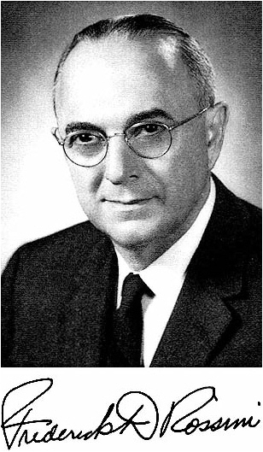

The progress report of May 1935[6] noted that work to date had determined the chemical composition of the major part of that fraction the Mid-Continent crude (Well No. 6 as above) normally boiling below 180OC. They had actually identified and isolated 34 hydrocarbons, 6 other hydrocarbons had been detected and were in the process of separation, and some 20 others were suspected to be present in significant amounts and require further investigation.

The progress report of November 1937[7] was a review of 10 years of research which discussed the general methods of operation, fractionation systems, separation of the Mid-Continent crude (Well No. 6 as above), summary of the results obtained from the naphtha fraction and the hydrocarbons isolated, results obtained on the lubrication fraction, work in progress and future problems.

While the focus was on the composition of crude petroleum, the methods, procedures and laboratory equipment, and understanding developed in this period would be vital for the analysis of aviation gasoline blendstocks in the next decade.

Figure 1. Rectifying still used in API Project No. 6

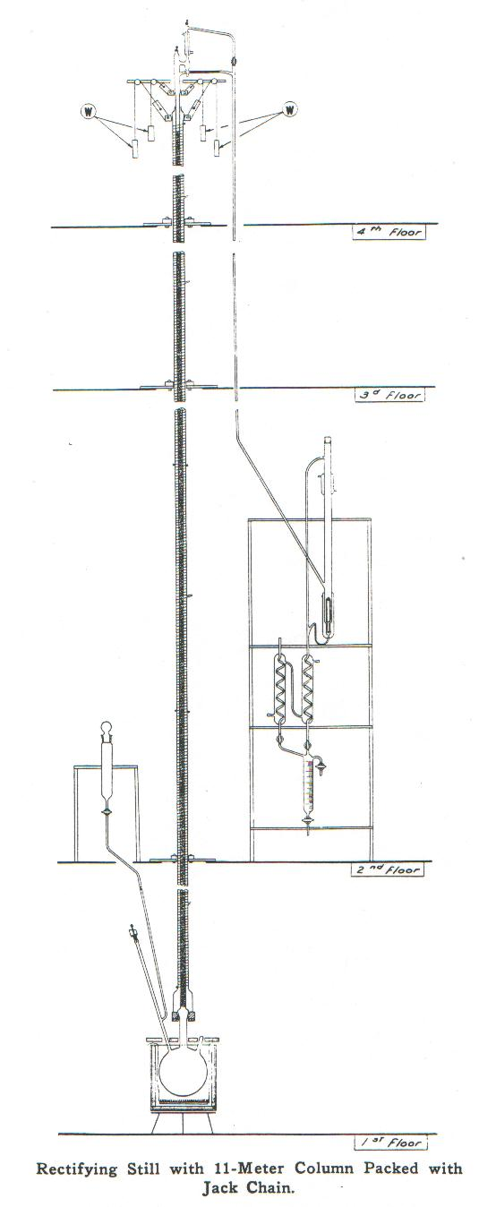

Note that this rectifying still stretches over 4 floors and is 11 metres tall (36 ft).

# Penn State College research on gasolines

One of the foremost institutions undertaking petroleum research in the United States was the Petroleum Refining Laboratory, Pennsylvania State College, State College, PA, USA.

During the 1938 Symposium On Chemical Utilization Of Petroleum Hydrocarbons, a paper by C.O. Tongberg and M. R. Fenske of Pennsylvania State College, and W. J. Sweeney of Standard Oil Development Company titled “Hydrocarbons in Virgin Naphthas” stated that:

The present utilization of petroleum for chemicals is confined almost exclusively to the normally gaseous hydrocarbons and the pentanes. The higher boiling hydrocarbons are not utilized because (a) knowledge of the hydrocarbons present in petroleum is limited, (b) hydrocarbons from petroleum are not available for either research or production use in sufficient quantity or purity, (c) data on the chemistry of these hydrocarbons are meagre, and (d) the products from the chemical reactions of hydrocarbons may frequently be complex.

The non-aromatic hydrocarbons present in petroleum are not economically available from any other source. However, before an extensive chemical study of these petroleum hydrocarbons is undertaken, it is important to know what hydrocarbons are present in petroleum, the quantity or proportion in which they are present, and the ease with which they may be separated. It may be necessary to study many different petroleums before finding the one that will yield the desired hydrocarbon most readily.

During the past three years the Petroleum Refining Laboratory at the Pennsylvania State College has fractionated, in a standardized manner, approximately twenty virgin naphthas from different fields in various parts of the world. Sixteen additional standardized fractionations comprising one cracked distillate, eleven special cuts obtained from virgin naphthas, and repeat fractionations on four of the above twenty naphthas were also made. The charge in each of the thirty-six fractional distillations was 151-170 liters (40-45 gallons).

In smaller columns having one hundred theoretical plates a second cracked distillate, a polymer gasoline, and fractions obtained from the above naphthas were fractionated. Certain of these results were published (3). The relatively large volume of charge, the efficiency of the column (equivalent to seventy-five theoretical plates), and the high reflux ratio (40 to 1) enabled a good separation of the constituents of the naphthas to be made. Accurate comparisons were possible by using the same column, the same volume of charge, the same reflux ratio, the same analytical procedures, and otherwise the same technique in each case.

The standardized fractionation of a sample of Ponca City naphtha, the same as that being studied so completely on A.P.I. Project No. 6 at the National Bureau of Standards, aided considerably the identification of certain of the hydrocarbons present in the naphthas. The conclusions reached regarding the composition of these naphthas were based on (a) the above Ponca City fractionation, (b) properties of the fractions such as boiling point, density, refractive index before and after sulfuric acid extraction, reaction with sulfuric acid nitration, and octane number, (c) survey of properties of known hydrocarbons, (d) survey of previous work, (e) refractionations and further studies made in this laboratory, and (f) known ability of the column to separate materials of certain relative volatilities.

Chemical Composition

The twenty virgin naphthas fractionated had an average 90 per cent point on an ASTM distillation of 365 deg. F. (185 deg. C.). Normal paraffins, isoparaffins, naphthenes of the cyclohexane type, naphthenes of the cyclopentane type, and aromatics were found. In some naphthas all of these species were present, so that classification is rather difficult. However, for convenience, the naphthas were classified into paraffinic and naphthenic types, designating the paraffinic as those containing normal paraffins, and as naphthenic, those containing normal paraffins in very small amounts or not at all.

The paraffinic type can be conveniently grouped into:

1. Naphthas containing large amounts of normal paraffins.
2. Naphthas containing considerable amounts of normal paraffins and also large amounts of aromatics
3. Naphthas containing appreciable amounts of normal paraffins and moderate amounts of naphthenes.

The naphthenic type can be conveniently grouped into:

1. Naphthas containing large amounts of naphthenes of the cyclohexane type but only traces of normal paraffins.
2. Naphthas containing large amounts of naphthenes of the cyclopentane type but only traces of normal paraffins.

They further concluded that:

It now appears possible by efficient fractionation to prepare fractions constituting 5 or more volume per cent of the over-all naphtha that may contain upwards of 50 per cent of a particular definite hydrocarbon, or other 5 per cent fractions that may contain a total of only three or four particular hydrocarbons as their principal components. These definite hydrocarbons, as far as virgin naphthas are concerned, are: 2-methyl butane, n-pentane, 2-methyl pentane, cyclopentane, n-hexane, methyl cyclopentane, cyclohexane, n-heptane, methyl cyclohexane, toluene, dimethyl cyclohexanes, n-octane, ethyl benzene and the xylenes, n-nonane, 9-carbon-atom aromatics, and n-decane.

In some cases, fractional distillation alone may suffice to produce in two distillations in columns with 30 to 100 theoretical plates, hydrocarbons ranging in purity from 80 to 95 per cent. This was done in the case of all the normal paraffins listed above and for cyclohexane, methyl cyclohexane, and ethyl cyclohexane.

Despite statements in the literature, no true constant-boiling mixture of hydrocarbons was found. It was again noted, however, that when aromatic and non-aromatic hydrocarbons were distilled together, they exhibited unusual distillation relationships. For this reason, it is practical to use a third component- for example, tert-butyl alcohol - in the separation of n-hexane from small amounts of benzene (4).

A great chemical industry has been developed for hydrocarbons from coal tar. It should be possible to develop similar fields for normal paraffins, isoparaffins, cyclopentane hydrocarbons, and cyclohexane hydrocarbons from petroleum.

The following are examples of some of this work and lists the properties of various gasolines which would be used in motor and aviation fuels.

“Fractionation of Michigan Straight-Run Naphthas” by S. Lawroski, C. O. Tongberg, A. H. Mazzarola, and M. R. Fenske. The Pennsylvania State College, State College, PA.*[8]* - 1936

Michigan gasoline was previously studied and found to contain substantial quantities of normal paraffins. Of the many gasolines fractionated in this laboratory, none was found to contain as great a percentage of normal paraffins or to be as relatively simple as Michigan gasoline. It is obvious that for the most advantageous isolation of a hydrocarbon by distillation, a large volume of a narrow boiling range charge should be used. Naphthas, available commercially from the Pure Oil Company and having relatively narrow boiling range were fractionated.

Naphtha Boiling at 44 -134 deg. C. Gravity API 71.4 Octane No. (Procedure 345) 41

The fractionation column has the equivalent of seventy to seventy-five theoretical plates. Forty-five (US) gallons were charged into the still and fractionated at a reflux ratio of about 40 to 1. The gasoline was divided into 179 fractions, each fraction consisting of 0.3 to 0.6 per cent of the charge. Refractive Index and boiling point were used as a means of identification. Approximately 12 per cent of the charge is n-hexane with a boiling spread of 0.9 deg. C., a refractive index of about 1.3811, and a purity of 90 to 93 mole per cent. Of course, the total percentage of n-hexane in the naphtha is greater than this figure, but at least this quantity is associated with this purity as obtained in one fractional distillation. The chief impurity is benzene. About half of the above material boils within 0.1 deg. C. of n-hexane and contains 92 to 93 mole per cent n-hexane.

The material boiling at 98.0 deg. to 98.8 deg. C., comprising 12.4 per cent of the charge, contains about 85 per cent n-heptane. About half of this material boils within 0.2 deg. C. of n-heptane and has a purity of 90 mole per cent: on extraction with sulfuric acid its purity is increased to 92-93 per cent. The remaining impurity is mainly methyl cyclohexane.

“Fractional Distillation of Cracked and Polymer Gasolines” by C. O. Tongberg, J. E. Nickels, S. Lawroski, and M. R. Fenske, The Pennsylvania State College, State College, PA*[9]* - 1937

A cracked and a polymer gasoline were fractionated in a hundred-plate column. Unlike the polymer gasoline, the cracked gasoline fractionates similarly to a Bradford straight-run gasoline as far as the general shape of the refractive index curve is concerned. The division of the cracked gasoline into molecular size approximates that of the straight-run gasoline. This is not true of the polymer gasoline. Blends of the polymer gasoline varied in octane number from 72 to 82; blends of the cracked gasoline varied from below 41 to 75.

The following show the improvement in octane achieved by the cracking process. In previous chapters the poor octane quality of Pennsylvania straight run gasolines was noted, the following lists the properties of Dubbs Cracked gasoline, Polymer gasoline and Straight Run Gasoline (from Pennsylvania crude).

The polymer gasoline was obtained from the Universal Oil Products Company. This gasoline was produced commercially from a stabilizing unit for cracked gasoline, with a capacity of 3,000,000 cubic feet of cracked gas per day. The olefin content of the cracked gas was 25 per cent propene and butenes. The gas, under a pressure of 200 pounds per square inch and a temperature of about 232 deg. C. (450 deg. F.), was passed over solid phosphoric acid catalyst in a series of four reaction chambers. The yield of polymer gasoline was 4.3 (US) gallons per 1000 cubic feet of gas, which represents about 85 per cent of the propene-butenes present in the gas.

The cracked gasoline was obtained from the Kendall Refining Company, Bradford, PA. It was the product of a two-coil selective Dubbs cracking unit, where the feed was 20 per cent kerosene, 10 per cent foots oil and slack wax, and 70 per cent gas oil, all of Pennsylvania origin. The unit was processing about 1550 barrels per day, to give a 74 per cent gasoline yield in a non-residue or coking type operation. The No. 1 furnace coil operated at 499 deg. C. (930 deg. F.) and 450 pounds per square inch pressure; the No. 2 furnace was run at 529 deg. C. (985 deg. F.) and 475 pounds per square inch pressure. The properties of these two gasolines are given below; for purposes of comparison a Bradford straight-run gasoline is included. In addition, data from an earlier study on Pennsylvania straight run gasolines by Tongberg et al has also been included.*[10]*

The data highlights the poor anti-knock (low octane) quality of Pennsylvania straight run gasolines.

Table. 2. Properties of various U.S. gasolines 1937

|  |  |  |  |  |  |  |  |  |
| --- | --- | --- | --- | --- | --- | --- | --- | --- |
|  | Cracked Gasoline  Kendall Refining | | Polymer Gasoline  UOP | | Straight-Run Gasoline  Bradford PA Crude | | Straight-Run Gasoline  Pennsylvania crude | |
| ASTM Engler Distillation | Deg. C. | Deg. F. | Deg. C. | Deg. F. | Deg. C. | Deg. F. | Deg. C. | Deg. F. |
| Initial boiling point | 30 | 86 | 58 | 136 | 40 | 104 | 39 | 102 |
| 10% | 54 | 129 | 85 | 185 | 70 | 158 | 82 | 179 |
| 20% | 73 | 164 | 91 | 196 | 87 | 188 | 97 | 207 |
| 30% | 94 | 201 | 95 | 203 | 102 | 215 | 109 | 229 |
| 40 % | 113 | 236 | 99 | 211 | 113 | 236 | 117 | 242 |
| 50 % | 131 | 268 | 103 | 218 | 126 | 258 | 131 | 268 |
| 60% | 152 | 306 | 108 | 227 | 136 | 277 | 140 | 284 |
| 70% | 171 | 339 | 117 | 243 | 154 | 309 | 151 | 303 |
| 80% | 189 | 372 | 135 | 275 | 169 | 337 | 162 | 323 |
| 90% | 208 | 406 | 164 | 328 | 188 | 370 | 173 | 343 |
| 95% | - | - | - | - | - | - | 182 | 360 |
| End point | 219 | 426 | 220 | 428 | 210 | 410 | 188 | 370 |
| Gravity deg. API | 58.3 | | 66.2 | | 62.3 | | 61.9 | |
| Octane No. CFR Motor method | 66 | | 81 | | 42 | | 48 | |

“Composition of a Yates Gasoline” by C. O. Tongberg, M. R. Fenske, and J. E. Nickels, The Pennsylvania State College, State College, PA.*[11]*

A fractional distillation of 45 gallons (170 liters) of a Yates straight-run gasoline run in a standardized manner yielded considerable information regarding its constitution. The gasoline was found to differ from other gasolines of paraffin type. A study of the fractions obtained showed that the gasoline consists mainly of naphthenes and branched paraffins - Methyl cyclohexane and ethyl cyclohexane were isolated and identified. No normal paraffins were found. Aromatic hydrocarbons are present in but negligible amounts below 157 deg. C. (315 deg. F.). However, certain fractions, with a lower refractive index and density than other fractions, have higher octane numbers.

The Yates pool is located in Pecos County, West Texas, and in 1935 was the eighth largest pool in the United States. The gasoline has a relatively high octane number, 60 to 64 ASTM (CFR), and is sometimes used as a base gasoline in making fuels of high octane number.

Boiling range 42 -210 deg. C.

Gravity API 54.9

Octane No. Procedure 345 60

Reid Vapour Pressure (100 deg. F, 38OC) 7 pounds/sq. in.

Sulphur content 0.24%

Refer to Chapter 2 on the problems of Pennsylvania straight run gasoline during World War I.

As analytical methods and engine test method evolved in the late 1920’s the answers to the aviation gasoline problems were revealed. For a start the octane number was about 48 which was poor.

# New Apparatus & Equipment

As the role of the ‘Petroleum Chemist’ developed new apparatus and equipment was developed to assist in the task of qualitative and quantitative analyses. Here are some examples:

Podbielniak Distillation[12]

Walter J. Podbielniak of Tulsa, Oklahoma was a key figure in the development of fractional distillation apparatus. He published many papers including a series of articles in the Industrial and Engineering Chemistry Journals from 1929 which described his apparatus. In 1940 Dr. Walter Podbielniak, by then an internationally famous petrochemical engineer, established Podbielniak Inc. at 8300 South Chicago Avenue, for his manufacturing and research centre. In 1947, the company moved to 341 E. Ohio Street, Chicago and later was later bought by Dresser Industries. Some examples of his work are listed below:

August 1929

“Vaporization of Complex Mixtures” by Walter J. Podbielniak and George Granger Brown, University of Michigan, Ann Arbor, Michigan, USA.

This was part of the thesis submitted by W. J Podbielniak in partial fulfilment of the requirements for the degree of doctor of philosophy in the University of Michigan.

[Reference: Industrial and Engineering Chemistry Journal - 1929; 21(8); 773-779. Presented before the Division of Petroleum Chemistry at the 76th Meeting of the American Chemical Society, Swampscott, Massachusetts, September 10 to 14, 1928.]

April 1931

“Apparatus and Methods for Precise Fractional Distillation Analysis - New Method of Gas Analysis” by Walter J. Podbielniak, Tulsa, Oklahoma.

The history of development of the Podbielniak apparatus for precise fractional distillation analysis is outlined, including a complete survey of low-temperature fractionation methods described in the literature. A comprehensive description is given of the apparatus and analytical procedures in their present state of development, including such topics as accuracy limitations, checking methods, sampling, and interpretation of results.

Precision-type fractionating columns are described for the first time; columns of the general design shown may be used to separate highly complex mixtures of saturated and unsaturated gaseous hydrocarbons into their individual components with high accuracy and in short time.

Numerous fractional distillation curves and check comparisons are given to show the performance of the apparatus on various kinds of gaseous and liquid mixtures.

The apparatus and method are widely used in the manufactured-gas, natural-gas, and petroleum industries; they are presented in this article as an accurate analytical tool for the complete analysis of gaseous (or volatile liquid) mixtures of all kind are too complex for the conventional tests.

[Reference: Industrial and Engineering Chemistry Analytical Journal Edition; 1931; 3(2); 177-188. Presented before the Division of Petroleum Chemistry at the 80th Meeting of the American Chemical Society, Cincinnati, Ohio, September 8 to 12, 1930.]

1933

“Apparatus and Methods for Precise Fractional Distillation Analysis - II. Laboratory Columns for Precise and Rapid Fractionation of Gaseous and Liquid Samples” by Walter J. Podbielniak, Tulsa, Oklahoma.

This paper reports the findings of intensive theoretical and experimental study of precise low- and high-temperature laboratory fractionating columns under the headings of the following factors which are shown to be of fundamental importance as well as highly convenient for direct experimental determination or control:

* *Composition and distilling characteristics of sample.*
* *Total time of distillation.*
* *Regulation of distillation rate, reflux ratio, distillation pressure, and all other variables except total time of distillation.*
* *Ratio of 10 times the hold-up of material in the fractionating section (excluding reflux or condenser) to maximum column capacity.*
* *Ratio of 10 times the hold-up of material in reflux condenser section to maximum column capacity. Effectiveness of column packing in securing repeated and intimate contact of refluxed liquid and ascending vapor.*
* *Efficiency of thermal insulation of column.*

General design and construction of fractionating columns and apparatus. Fractionating columns are described having an entirely separate sleeve-like metal reflector type vacuum jacket for thermal insulation at all temperatures ranging from -190 deg. C. up to 300 deg. C., within which jacket any of a large variety of distilling tubes of various diameters may be inserted for the rapid and precise fractionation of gaseous or liquid samples ranging from a fraction of a liquid cubic centimetre to as much as 20,000 cc. These distilling tubes are packed with highly effective, spiral, continuous, uniform, wire-coil packings shown to be superior to the usual chance-arrangement non-continuous column packings. Complete distillations with the apparatus assembly described take from one hour to several hours’ time, depending on the requirements; and the separation accomplished in a single distillation is materially superior to that possible with previously described laboratory fractionating columns including even extremely tall experimental columns operated at exceedingly slow rates.

This article presents the results and conclusions of exhaustive theoretical and experimental investigations and seven years’ experience in the development and intensive use of laboratory columns of high-fractionating effectiveness suitable for distilling components with boiling points ranging from - 190 deg. C. to 500 deg. C. This extreme range comprises practically all components which would be considered distillable, except a few gases like helium and carbon monoxide, non-condensable in liquid air, and the very high boiling petroleum and coal-tar pitches, asphalts, etc.

[Reference: Industrial and Engineering Chemistry Analytical Journal Edition – 1933; 5(2); 119-142]

1933

“Apparatus and Methods for Precise Fractional Distillation Analysis IV. Standardization of Low-Temperature Fractionation-Analysis Apparatus and Method Using Automatic Recording and Control” by Walter J. Podbielniak, Tulsa, Oklahoma.

The operation of the Podbielniak apparatus for low-temperature fractional distillation analysis of gases and volatile liquids has been standardized by the use of an automatic recording and control mechanism, together with a further development and standardization of the fractionating unit itself. After the sample is in the column, the robot operator controls reflux cooling, regulates distillation rate according to the difficulty of fractionation, summons the human operator with a buzzer and trouble light whenever necessary, takes all temperature and pressure readings, and turns out a complete printed fractional distillation curve, including a distillation time rate curve. The robot is 80 to 90 per cent automatic, conducts distillations in less time, and is more dependable and accurate than the human operator. Through the use of this automatic recorder and control, the complete standardization of the low-temperature fractionation-analysis method resolves itself into the problem of deciding on sample sizes, distilling tubes, and a few adjustments of the operating mechanism.

Reference: Industrial and Engineering Chemistry Analytical Journal –Edition; 1933; 5(3); 172-178.

1941

“Apparatus and Methods for Precise Fractional Distillation Analysis - New Design of Adiabatic Fractionating Column and Precision-Spaced Wire Packing for Temperature Range -190 deg. to 300 deg. C.” by Walter J. Podbielniak, Podbielniak Centrifugal Super-contactor Company, 8312 South Chicago Ave., Chicago, Ill.

A new- column design was developed and found satisfactory over the temperature range of – 190 to 300 deg. C. with extended use of vacuum jacketing around column, flask, reflux, and all connections, and with means for compensating for residual heat leakage through vacuum jacket. Kew vacuum jacketed standard-taper ground joints withstand both liquid air and 300 deg. C. temperatures, remaining vacuum-tight and easily detachable. Flexible glass bellows are used throughout as expansion joints for differential thermal dimensional changes. The column is made of four parts to permit inter- changeable use of various distilling tubes and flasks. A new form of precision-spaced wire-type packing was also developed for the fullest utilization of capillary reflux liquid films across closely spaced wire turns. This packing has tested as high as 75 plates in 35 cm. (14 inches) with the n-heptane and methyl cyclohexane test and its low- H.E.T.P. (Height Equivalent to a Theoretical Plate) and other desirable characteristics are maintained at least up to 25-mm. diameter. Performance data are submitted for packings of various size. This type of packing is now in use in many laboratories for both low- and high-temperature fractionation.

Reference: Industrial and Engineering Chemistry-Analytical Edition 13: 639-645 1941.

The ability to conduct fractional distillations allowed the petroleum chemist to at last delve into the composition of gasoline. The Podbielniak Fractional Distillation would later become a standard item of laboratory equipment in many petroleum refinery laboratories (including Standard-Vacuum Altona Refinery in 1949, it was still in use in 1970).

Photo 5. Podbielniak apparatus in use at BP Kwinana Refinery Laboratory, Western Australia 1955[13]

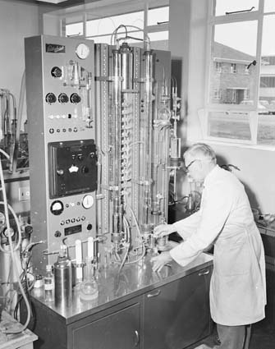

Perhaps one of the first Podbielniak Fractional Distillation apparatus in Australia was located at National Oil Pty. Ltd. Shale Oil Refinery at Glen Davis, New South Wales. It was in use there prior to 1944. This shale oil refinery was a significant supplier of petrol to Australia during the war years and remained in operation up until about 1954. It never made aviation gasoline..[14]

# New Automated Laboratory Equipment

Automatic Distillation 1944

While much of the routine laboratory equipment required manual operation by a skilled technician, there was also a desire to improve the operation by automating the equipment. One such example is distillation, perhaps the most common laboratory test after specific gravity. Distillation is used in the testing of every gasoline and aviation gasoline product.

Automatic Distillation Apparatus for Gasoline Analysis*[15]*

Lester Steffens and D. P. Heath

Socony-Vacuum Oil Company, Inc., General Laboratories, 419 Greenpoint Ave., Brooklyn 22, N. Y.

An apparatus is described which makes possible the automatic operation of an efficient laboratory distillation unit. While the device was designed for gasoline analysis, it can be adapted to the control of other distillations. It automatically collects the fractions of distillate and plots the distillation curve. It has been operated 24 hours per day for well over a year with an operator present only 8 hours per day.

The high level of the quality requirements specified for aviation gasoline makes it necessary to determine the composition of gasoline stocks in terms of individual hydrocarbons, in order to be able to produce the maximum amount of the desired components, and to eliminate or minimize production of materials of low quality. The first step in the analytical procedure is separation of the sample by distillation into fractions consisting of substantially pure hydrocarbons where possible, or, as a compromise, a mixture of a very few components.

Analytical distillation of gasoline requires s fractionating column with a large number of theoretical plates, and at the same time, small holdup per theoretical plate. In addition, as other researchers have shown, analytical distillations frequently require operation at reflux ratios of over 100 to 1, and use of a charge that is large compared to the holdup of the column in order to be able to isolate components present in small amounts. Under these conditions the distillation of a single sample may require several weeks of continuous operation. For this reason, an automatic distillate-collecting device was constructed which makes possible the operation of a laboratory distillation unit with only occasional attention from the operator.

This device uses some of the principles of the unit described by Bruun and Falconer but is more nearly fully automatic, it was developed to be used with Podbielniak Super-Gal Model B distillation unit with a column containing 90 cm. (3 feet) of 22 mm. Heligrid packing, but it could, of course, be used with any type of laboratory distillation units.

DESCRIPTION

A sketch of the distillate-collecting device is given in Figure 2, and a photograph of the entire unit in Figure 3. The photograph was taken during the development of the apparatus and does not show several minor improvements.

As shown in Figure 2. The distillate from the total condensing reflux head pass through a cooler into a float chamber. When the desired amount of fraction has been collected in this chamber, the float strikes a contact, the solenoid-operated valve on the bottom of the float opens, and the fraction drains into one of 18 bottles (120 ml.) held in the turntable. The valve then closes and the turntable moves, bringing an empty bottle under the float chamber.

Figure 2. Sketch of Distillate-Collecting Device

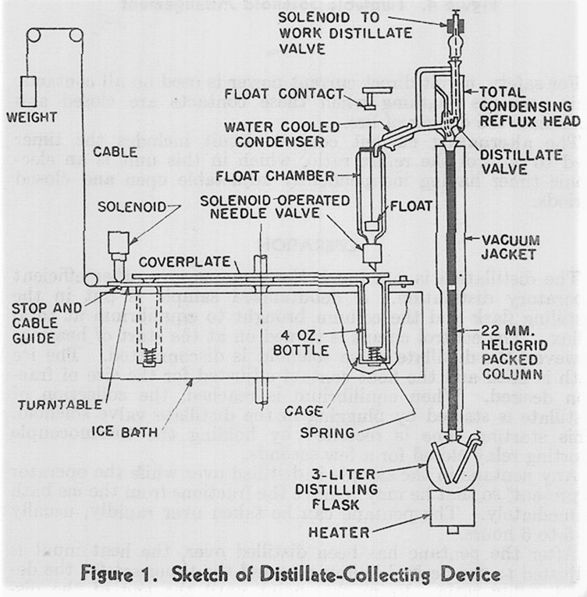

Photo 6. Automatic Distillation Apparatus

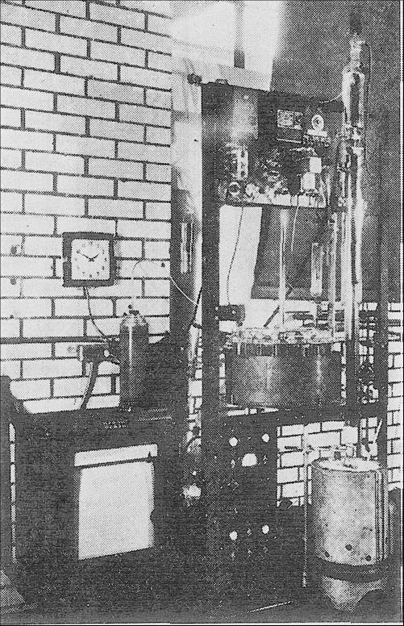

# New Physical Methods

In a paper published in 1944 W. J. Sweeney of the Esso Laboratories, Elizabeth, New Jersey, USA described “Applicability of Newer Physical Methods for Hydrocarbon Analyses[16]” he discussed some of the newer physical methods finding wider application in the analyses of hydrocarbons.

Over the past several years great progress has been made in applying the principles of physics to methods of analysis for hydrocarbons.

Experience has shown that it is profitable to take analytical work out of the routine class and to consider it as a vital part of petroleum research, development, and manufacturing. The physicists and the manufacturer of optical and electrical instruments have opened up a new field in this class of analytical work. This development is still in its infancy; but it has made such stride as to warrant confidence of its future indispensability in serving the petroleum industry in laboratory research as much as other physical methods have helped in the oil field production. These new analytical techniques will not replace older methods entirely. All analytical methods, new and old, are less competitive and more complementary when they are most efficiently applied.

The following is a partial list of the physical instruments currently (1944) used by the Esso Laboratories-Research Division of the Standard Oil Development Company.

20 Fractional distillation columns (Fenske packing)

6 Podbielniak Hyd-Robot columns

2 Podbielniak manually operated columns

1 Gaertner infrared spectrograph

1 Beckman infrared spectrograph

2 Beckman ultraviolet spectrophotomers

1 ARL-Dieter emission spectrograph

1 Westinghouse mass spectrometer

1 Raman spectrograph (accessible not owned)

This list does not, of course, include all the conventional chemical equipment that was used prior to the introduction of the newer techniques and was still being used concurrently with them.

(Author’s Note: Of these instruments the infrared, ultraviolet and Raman spectrographs would not have application for gasolines, but would be used for analysis of lubricants. The emission spectrograph for metals analysis in catalysts).

# New Analytical Techniques

As with any chemical analysis there is always the search for faster, better precision and more accurate analysis of a particular parameter. New approaches to determine a particular component by new methods and adopting new scientific applications are pursued. This work was conducted by the oil industry and also universities.

X-Ray Methods

One such example is the analysis of Tetraethyl Lead in gasoline. With the introduction on Ethyl’s Tetraethyl Lead in 1923 also came the need to analyse the lead content in gasoline. One approach was developed using x-ray methods and was published in the American Chemical Society Journal in 1928.

X-Ray Quantitative Analysis of Tetraethyl Lead in Gasoline[17]

R. H. Aborn and R. H. Brown

Department of Chemical Engineering Massachusetts Institute of Technology Cambridge, Mass.

August 20, 1928

X-RAY methods have been applied successfully to quantitative analysis in but very few instances and these have been confined largely to spectral absorption methods. The possibility that a mass absorption method might serve as a means of determining the amount of tetraethyl lead in gasoline was suggested to the writers by George Clingier of the Ethyl Gasoline Corporation. The concentration range of tetraethyl lead in commercial gasolines varies from under 0.5 to 3 cc. per gallon (3.7854 liters), and an error in analysis under 0.1 cc. per gallon is desirable. With the experimental arrangement described below the method is capable of an accuracy of 0.1 cc. per gallon. With further refinements it is believed the precision can be increased to the accuracy required in commercial analysis. 0.1 cc. per gallon is equivalent to 1 part in 14,000 parts by weight. Such high sensitivity is possible only when the constituents (in this case solvent and solute) differ very widely.

Colourmetric Methods

Colourmetric methods have been used almost since the days of alchemy as they provide a quick visual method of detection of a particular parameter or component in a mixture. As stated, earlier antioxidants in gasoline and particularly aviation gasolines are designed to prevent deleterious effects as a result of storage of the product over time. The following is an example of the work of the Esso Laboratories in September 1947.

Determination of Antioxidants in Gasoline [18]

Lois R. Williams and Barney R. Strickland

Esso Laboratories, Process Division, Standard

Antioxidant compounds are added to gasoline to inhibit the formation of gum and precipitation of lead and to maintain over-all stability. Since many inhibitors may be lost from gasoline upon contact with acid, alkali, or water, it is often important to check the amount of inhibitor present in a sample of gasoline. The analytical method presented proved of considerable value during the war (WWII) in investigating the stability of aviation gasoline supplies, and is particularly useful in studying loss of inhibitor (antioxidant compounds) from gasoline. Alkyl-substituted p-aminophenol and p-phenylenediamine derivatives are at present the most commonly used inhibitors of high potency. These materials are usually added in the concentration range of 1 pound per 5000 gallons of gasoline (2.4 mg. per 100 ml. is equivalent to 1 pound per 5000 gallons). The method for quantitatively determining the amount of aminophenol- and phenylenediamine-type inhibitors in gasoline was developed by the Esso Laboratories from a procedure suggested by E. I. du Pont de Nemours and Company, based on a reagent used by Folin and Denis (2) for indicating uric acid.

Certain other inhibitors, such as alkyl phenol derivatives, which are not extractable with acid or will not reduce Folin-Denis reagent cannot be used to determine inhibitor content in this manner.

It is a colorimetric technique based on extracting the amino-, phenol-, or phenylenediamine-type inhibitors from gasoline with aqueous hydrochloric acid solution, the respective hydrochlorides being formed. When the extract is neutralized with sodium carbonate in the presence of Folin and Denis reagent (phosphotungstic acid solution), a blue coloration is produced which is proportional to the concentration of the inhibitor originally present in the gasoline.

APPARATUS AND REAGENTS

Electric pH Meter. Instruments of the direct-reading type are preferable.

Photoelectric colorimeter.

Centrifuge.

Hydrochloric acid, 5% aqueous solution.

Sodium carbonate solution, 180 grams per liter.

Folin and Denis Reagent. A mixture of 100 grams of sodium tungstate, 750 ml. of distilled water, and 80 ml. of 85% phosphoric acid boiled under reflux for 2 hours, cooled and filtered if necessary, and diluted to 1 liter. Reagents used must be free of nitrates, since nitric acid interferes with the color formation.

Dye Solvent. A 1 to 1 mixture of toluene and alkylate or isooctane. The solvent must be free of inhibitor.

Diethyl ether may also be used.

# Analytical Methods for Determining TEL Content

With the introduction of the anti-knock additive Tetraethyl Lead in 1923, there was a need for methods to determine lead content of gasolines.

1945 Shell Development Company

The search for better methods continued throughout the decades. In a paper published in 1945 chemists from Shell Development Company discussed some of the issues associated with these analyses.

Determination of Tetraethyllead in Gasoline[19].

Versatile Direct Evaporation Methods

Louis Lykken, R.S. Treseder, F.D. Tuemmler, Victor Zahn

Shell Development Company, Emeryville, California, USA

Two methods of analysis involving direct evaporation of sample with decomposition agent allow accurate quantitative analysis of lead in all types of gasoline, special motor fuel blends and tetraethyl lead fluid, regardless of the chemical constituents present. These methods, which require no elaborate apparatus, are the result of a systematic review and investigation of existing methods for the decomposition of tetraethyl lead in gasoline ad for the determination of lead in soluble inorganic residues. The proposed methods convert the tetraethyl lead to inorganic lead by mixing lead with cold hydrochloric acid or iodine, evaporating the resulting mixture to dryness, and removing the organic matter by oxidation with nitric acid, perchloric, or sulfuric acid, depending on the nature of the decomposition used. The lead in the inorganic residue is determined by precipitating with a measured amount of dichromate by iodometric titration. For commercial gasolines, the reproducibility (different operation) of the methods is within 0.02 ml of tetraethyl fluids per gallon (US); for tetraethyl fluids, it is 0.04% lead or better.

The paper then describes the various methods;

Since the advent of tetraethyl lead antiknock gasoline blends some 20 years ago, there has been an increasing necessity for analysing all sorts of motor fuel for small amounts of lead. At the outset, most analytical were satisfied by methods that gave a good approximation of the total lead content; but with scientific development of modern motors and the consequent production of fuels requiring closer regulations of antiknock qualities, greater accuracy was desired. This situation has led to the development of a number of methods which allowed the accurate determination of the lead contained in the more volatile type of saturated gasolines, such as straight run aviation gasoline. However, these methods were not always of general applicability to all varieties of leaded fuels, particularly to cracked gasolines, alcohol-blend fuels, and modern motor fuels containing non-hydrocarbons additives. As a result, considerable difficulties have been encountered in obtaining accurate results when using most of the established methods regardless of their mode of decomposition of the tetraethyl lead (such as precipitation with bromine, extraction with cold nitric acid, and extraction with hot hydrochloric acid). Because of the uncertainty regarding the relative merits of the existing procedures, work was undertaken to compare them under comparable conditions.

The problem was considered on the basis of four natural classifications: reproducibility and relative accuracy of the common methods in use at the present time (1945); satisfactory determination of the expected amount of lead in the organic residues with special consideration of rapid methods; study of the decomposition of the organo-lead compounds with hydrochloric acid and iodine; and study of satisfactory methods for the removal of the organic matter remaining after the evaporation of gasoline- hydrochloric acid or gasoline-iodine mixtures.

Review of Literature

Methods of Determining Tetraethyl Lead in Gasoline. The following methods were chosen for study in that they were either outstanding or commonly used. A brief of the essential procedures, chemistry, and the techniques is given with each method, followed by an initial evaluation of its relative merits.

Author’s Note: I do not propose that we continue with all the details of their assessment but instead would refer you to the original 1945 source.

Here are the first five methods discussed.

1. Early Shell Method

2. Method by Baldeschwieler

3. IP Standard Methods for Testing Petroleum and Its Products IP 68/42.

4. Method of Catlin and Starrett

5. Method of Edgar and Calingaert

1947 Aircraft Engine Research Laboratory

In another paper in 1947, another method was proposed to determine the level of tetraethyl lead in aviation gasolines and identified some of the issues which could occur with this new method. It is interesting to note that this laboratory is not operated by an oil company, but is an aircraft engine research lab.

Determination of Tetraethyllead in Aviation Gasoline[20]

Rapid Iodometric Method.

Lester Newman, John F. Phillip, and Adolph R. Jensen

Aircraft Engine Research Laboratory, National Advisory Committee for Aeronautics, Cleveland, Ohio

An iodometric method for the determination of tetraethyl lead in aviation gasoline is presented. The fuel is shaken with an excess of alcoholic potassium triiodide solution which reacts with the tetraethyl lead; interferences due to olefins and aromatic amines are minimized, if necessary, by previous extraction with 70% (by volume) sulfuric acid. The excess iodine is titrated with sodium thiosulfate. The method requires about 15 minutes for two concurrent determinations on the same fuel. It is applicable to all aviation gasolines that are in current use and has a maximum deviation of +0.05 ml. of tetraethyl lead per gallon when it is compared with A.S.T.M. results.

The commercial blending of fuels and the engine rating of leaded fuels require a method for the determination of tetraethyl lead that is accurate and not too demanding of time, technique, or special equipment. During the past 15 to 20 years, many methods for the determination of tetraethyllead have been proposed. Lykken, Treseder, Tuemmler, and Zahn have given an excellent review of these existing methods and proposed an improved procedure.

This laboratory has used the A.S.T.M. gravimetric chromate procedure with an additional 15-minute refluxing time in order to ensure the complete decomposition of the tetraethyl lead. Although the time per sample for a number of samples is not excessive, the time elapsed between the entrance of the sample into the laboratory and the completed report in many cases unnecessarily delays engine projects. The proposed method requires about 10 minutes per determination for most fuels and is accurate enough for some laboratory needs.

Widmaier proposed a method based on a principle which differs from that employed in most of the methods now in use. It has been customary to decompose, the tetraethyl lead in gasoline with one or more reagents and then to determine the extracted inorganic lead by either a gravimetric or volumetric procedure.

Widmaier suggested a procedure involving the direct reaction between a potassium triiodide solution and tetraethyl lead. The Shell Marketing Company, Ltd., of London has also developed a method based on the same reaction. This paper gives the experience of this laboratory with Widmaier’s method modified so as to make use of the sharper end point obtainable from the starch-iodine reaction in aqueous solution. The reaction produces lead triethyl iodide and ethyl iodide as expressed by the equation:

Pb (C2H5)4 + I2 = Pb (C2H5)3I + C2H5I

An excess of iodine is added to a measured volume of gasoline and after complete reaction the unreacted iodine is titrated with sodium thiosulfate to a starch end point.

Widmaier has shown that most base stocks containing olefins do not react with the iodine from potassium triiodide solution to an appreciable extent; however, catalytically cracked stocks containing large amounts of olefins may absorb iodine.

Additives such as aromatic amines will also interfere by reaction with iodine. In such cases, the interfering substances must either be removed or rendered nonreactive with iodine. Widmaier (4) accomplished this by treatment with 70% sulfuric acid.

REAGENTS AND APPARATUS

Sulfuric Acid, 70% by volume. Mix 700 ml. of sulfuric acid (specific gravity 1.84) with 300 ml. of distilled water.

Iodine Solution, 0.1 N. Add 12.7 grams of iodine, A.C.S.,

# Search for New Refinery Process Methods

The chemists in industry of the time were also involved in seeking new refining methods to improve both production and quality of petroleum products.

From the 1922 Journal of Industrial and Engineering Chemistry, the following paper described the use of hypochlorites to refine gasoline and kerosenes, it also included a list of crude oils and the sulfur content at that period. Part of that paper is reproduced here.

Refining of Gasoline and Kerosene by Hypochlorites*[21]*

By A. E. Dunstan and B. T. Brooks

The Anglo-Persian Oil Co., London, England & The Mathieson Alkali Works, Inc., New York, N. Y.

Sulfur, though often present in relatively very small proportions, is the most objectionable impurity in motor fuel, and it is with the removal of sulfur that the present paper deals, although it should be pointed out that the refining method here described does a great deal more than merely remove sulfur. This method is not an academic process, but has been in successful large-scale operation or a little over one year and is now in operation in several refineries.

The advantages of the hypochlorite process for the refining of gasoline and kerosene, which are pointed out in this discussion, may be summarized as follows:

1. Lower refining cost.
2. Less loss on refining, adding materially to the total money saved.
3. No acid sludge is formed and no acid to be recovered.
4. The operation can be carried out in ordinary steel apparatus; one year’s experience has shown that the corrosion of apparatus, piping, etc., is much less than when acid is employed. Lead lined apparatus is not required.
5. The sum total of operation is easier to carry out than the acid-refining process with the acid recovery, etc., incident to the latter.
6. It is applicable to the light distillates from all types of crude petroleums.

It was inevitable that with the tremendous growth of the petroleum industry and particularly the production of gasoline for motor cars, considerable attention would be given to better methods of refining. Considerable impetus has been given to this general problem by the automobile industry and, during the war (WWI), by the necessity of finding superior motor fuels and lubricants for aeroplanes. Petroleum refiners, or at least their sales departments, have also come to realize that superior goods are appreciated by the consumer.

The question of good motor fuel is certainly one of universal interest. This country, owning 85 per cent of all the automobiles in the world, produced 5,145,000,000 gal. of gasoline in 1920. At certain seasons the demand has been so great and the lapse of time from the production of gasoline at the refinery to its consumption has been so brief that refiners have often sacrificed everything to ‘through put.’ Shipments of gasoline from America to England, Australia, South Africa, and other points, have sometimes had to be returned to be re-refined, or have led to money settlements of no small magnitude. The export of gasoline to foreign countries requires that such gasoline be better refined than is the custom for domestic consumption. The utilization of high sulfur crude oils for gasoline production, the rapid increase in the production of ‘cracked’ gasoline, the relatively insignificant production of very high-grade crudes, such as light Pennsylvania oil, the known merit of benzene in motor gasoline, and the very large losses resulting in the refining of crude benzene, have also been factors in the search for better refining methods. Although the proper refining of gasoline involves more than the removal of sulfur compounds, the removal of such compounds can, nevertheless, be taken as a fair index of the degree of refining. The nature of the sulfur compounds presents in a crude petroleum, or its distillates, makes a great deal of difference, for example, with respect to odor (mercaptans) and corrosive properties, but comparatively little is known as to their exact nature. Figures for the percentage of sulfur in unrefined gasoline distillates are not generally available, but average about one-tenth of the amount present in the original crude petroleum. The percentage of sulfur in a number of crude oils is given in the following table:

Crude Per Cent Sulfur

Persia 1.0

California 0.55 to 3.55

Illinois 0.40 (average)

Louisiana (Jennings) 0.40 to 0.57

Indiana 0.72 to 1.26

Ohio (Lima) 0.65

Texas, Beaumont 0.94 to 2.40

Texas, San Antonio 1.52 to 2.02

Texas, Reeves County 1.00

Texas, Medina County 2.09

Texas, Travis County 1.26

Mexico 1.9 to 4.8

Engler and Höfer gave the following sulfur contents of crude petroleum:

Crude Sulfur Per Cent Crude Sulfur Per Cent

Tegernsee 0.044 Pechelbroun 0.65

Olheim 0.58 Wietze 0.58

Galicia 0.21 Roumania 0.17

Montechine 0.045 Bi-bilibat 0.22

Balachany 0.147 Palembang 0.212

Java 0.473 Sumatra 0.066

Roem Koot 1.166 Pennsylvania 0.049

Burmah 0.121

Persian crude oil contains about 1.02 per cent and Burmah (Yenan Yung and Singu) about 0.1 per cent sulfur.

Free hydrogen sulfide has been identified in the crude petroleum from Canada, Ohio, Texas, Galicia, and Persia. The natural gas accompanying sulfurous crudes sometimes contains upwards of 10 per cent of hydrogen sulfide. The hydrogen sulfide which frequently appears during distillation is probably partly expelled from solution and partly results from the decomposition of sulfur compounds in the oil.

Free Sulfur-Elemental sulfur has been recognized in Texas petroleum, which, after being freed (at ordinary temperatures) from hydrogen sulphide and filtered through kaolin, deposited crystals of this element.

The natural gas accompanying petroleums rich in sulfur is usually rich in hydrogen sulfide, and the slow evolution of dissolved hydrogen sulfide from certain crudes has apparently been the cause of no small number of fatalities.

The presence of sulfur in petroleum is due to activity of certain bacteria, contemporaneous with the algae which these authors regard as the source of petroleum.

# New Laboratories for Aviation Gasoline

In 1958 the Texas Butadiene & Chemical Company opened a new laboratory facility which focused on butadiene for synthetic rubber and aviation gasoline. It was featured as ‘Laboratory of the Month’ in February issue of Analytical Chemistry[22]. In that publication it was described as follows:

Photo 7. Texas Butadiene & Chemical Company Manufacturing Research and Control Laboratory

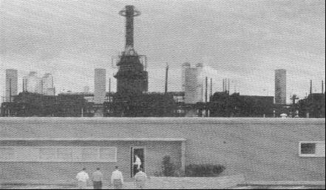

Process units of Texas Butadiene and Chemical’s new plant provide a backdrop for the company’s new Manufacturing Research and Control Laboratory. The 6,000 square foot structure houses the Spectro-chemical, Physical-Engine and Manufacturing Research Sections. The well-lighted, air-conditioned building features complete services at each analytical work space and sound-proofed knock engine rating rooms.

The newest instrumentation for analysis and process control have been incorporated in Texas Butadiene and Chemical’s new manufacturing and control laboratory. The facility is located 20 miles east of Houston near Channelview, Texas was designed to provide close control over the production of butadiene and aviation gasoline. The company can produce more than 65,000 tons of butadiene and 2.5 million barrels of 115/145 aviation gasoline annually at its new plant.

Company officials feel that efficient operation of the integrated processes for dehydrogenation of n-butane to butadiene and/or olefins for alkylation feed would not be possible without the rapid analyses and modern control instrumentation provided by the laboratory. Without the use of chromatographic instruments, personnel needs for control works would have been doubled, the company estimates.

The laboratory contains three functional sections devoted to chemical and spectroscopic analyses, physical and engine evaluation, and manufacturing research studies.

The Spectro-chemical sections installs and maintains the infrared, ultraviolet and chromatographic stream analysers used to measure and control butylene, butadiene, and other individual hydrocarbons in plant streams.

The Physical-Engine Section performs control analyses for the alkylation process, and conducts specification and other physical tests for aviation gasoline. It also operates a 100-plate fractionation column used to separate gasoline blending components and chemical mixtures. Aviation and supercharge engines are used to evaluate anti-knock and other performance characteristics of fuels.

In addition to new and improved product development, the Manufacturing Research Section’s work includes pilot plant studies on the activity and surface characteristics of catalysts used in the dehydrogenation process. It is also concerned with developing and improving plant processes, laboratory analytical techniques, and analytical tools for process control.

Smooth operation of the plant is attributed in part to the fact that the laboratory was set in operation before the plant itself and all process analyzers were checked out in the laboratory before installing in the plant.

It can be seen that Avgas 115/145 was still in high demand even though jet age had commenced.

# Epilogue for Chemists

The quest to discover the detailed composition of gasoline in the 20th century led to many new innovative items of apparatus such as the Podbielniak fractional distillation; and understanding of the relationship and properties of the hydrocarbon types – Paraffins, Olefins, Naphthenes and Aromatics. It resulted in the American Petroleum Institute Project No. 6 which would continue for over 25 years in its research into the composition of gasoline.

New laboratory equipment would be employed using infrared, ultraviolet methods. New analytical methods would be developed in the pursuit of more accurate, better reproducibility, quicker and simpler analysis of gasoline and its additives.

Photo 8. Beckman Infra-Red analyser Model IR-5A (1957)

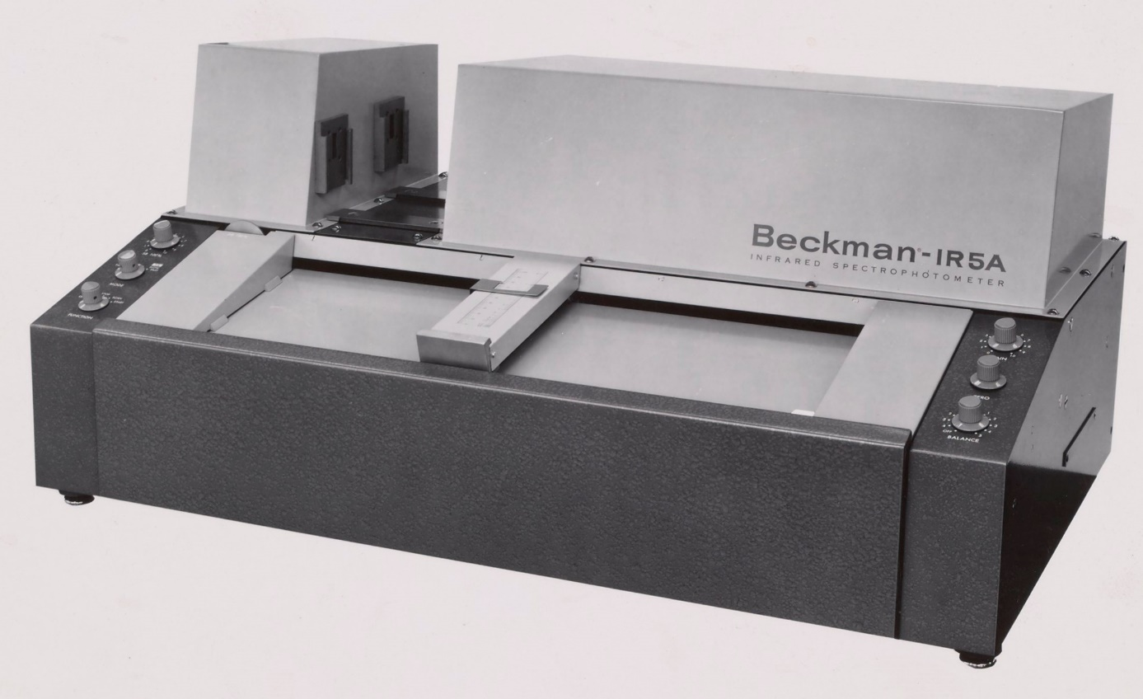

# Index

2

2-methyl butane 13

2-methyl pentane 13

9

9-carbon-atom aromatics 13

A

Aborn 22

accuracy 24

acid sludge 7, 26

acid-treated oil 6

Adiabatic Fractionating Column 18

Aircraft Engine Research Laboratory 24

air-drying 4

alcohol-blend fuels 24

algae 27

alkyl phenol 22

alkylate 23

alkylation 6, 28

alkylbenzenes 9

alkylcyclohexanes 9

alkylcyclopentanes 9

Allen 5

aluminium 5

America 26

American Chemical Society 7, 16, 22, 35

American Petroleum Institute 9, 29, 35

American Society for Testing Materials 8

Analytical Chemistry 4

Anglo-Persian Oil Co. 26

aniline index 6

aniline method 7

anti-knock 14, 23

anti-knock properties 6

antioxidants 22

API Project No. 6 3, 9, 11, 12

ARL-Dieter 21

aromatic 6, 13, 15

aromatic amines 24, 25

aromatic hydrocarbons 6, 7

aromatics 12, 13, 29

asphalts 17

ASTM 8, 15, 25

ASTM distillation 12

Australia 26

Automatic Distillation 3, 19

Automatic Distillation Apparatus 20

Avgas 115/145 29

aviation fuels 13

aviation gasoline 5, 16, 19, 22, 24, 28

aviation gasoline blendstocks 10

B

bacteria 27

Balachany 27

Baldeschwieler 24

base gasoline 15

Beaumont 27

Beckman 21

Beckman Infra-Red 29

benzene 9, 13, 14, 26

benzoic acid 9

Benzol 5

beryllium alloys 5

Bi-bilibat 27

boiling point 12, 14

Borneo 5

BP Kwinana Refinery Laboratory 18

Bradford PA Crude 15

Bradford straight-run gasoline 14

branched paraffins 15

bromine 24

Brooks 26

Brown 22

Bruun 19

Burmah 27

butadiene 28

butenes 14

butylene 28

C

calcium chloride 7

California 27

Calingaert 24

Canada 27

carbon 9

carbon dioxide 9

carbon monoxide 17

castor oil 5

catalysts 29

catalytically cracked stock 25

Catlin 24

centrifuge 23

CFR Motor method 15

Channelview 28

chromate 25

chromatographic 28

Clingier 22

coal tar 13

coal-tar pitches 17

coking type operation 14

Colourmetric methods 22

Committee on Petroleum Products and Lubricants 8

Committee on Standardization of Petroleum Specifications 9

cracked distillate 12

cracked gasoline 14, 15, 24, 26

cracking process 14

crude oil 26, 27

cyclohexane 12, 13

cyclooctatetraene 9

cyclopentane 12, 13

cyclopropane 9

D

dehydrogenation 28, 29

Denis 22

density 12

deuterium 9

dichromate 23

Dickinson 5

diesel type 8

dimethyl cyclohexanes 13

distillate fuel oil 8

Distillate-Collecting Device 20

distillation 8, 19, 27

Division of Petroleum Chemistry 7, 16

dope 4

Dresser Industries 16

du Pont de Nemours 22

Dubbs Cracked gasoline 14

Dubbs cracking unit 14

Dunstan 26

E

Edgar 24

Emeryville 23

emission spectrograph 21

end point 9, 15

engine evaluation 28

England 26

Engler 27

Engler Distillation 15

Engler flask 9

Esso Laboratories 21, 22

ethene 9

Ethyl 21

ethyl benzene 13

ethyl cyclohexane 13, 15

Ethyl Gasoline Corporation 22

Evaporation Methods 23

F

Falconer 19

Federal Specifications Board 8, 9

Fenske 12, 13, 14, 15, 21

Field County, Oklahoma 9

Folin 22

Folin-Denis reagent 22

foots oil 14

Forest Service 5

fractional distillation 3, 13, 14, 15, 16, 17, 18, 35

Fractional distillation columns 21

fractionating column 17, 29

G

Gaertner 21

Gage 5

Galicia 27

gas oil 14

gasoline 3, 6, 8, 14, 15, 18, 22, 23, 24, 25, 26, 29

gasoline fractions 9

gasoline specifications 8

gasoline-iodine mixtures 24

George Granger Brown 16

Glen Davis 18

Glues 5

government specification for gasoline 9

Gravity API 14, 15

gum 22

Gustav Egloff 5, 6, 7

H

H.E.T.P. 18

Harper 5

Heath 19

heats of combustion 9

Heligrid 19

helium 17

Hempel column 6

Höfer 27

Houston 28

hydrochloric acid 23, 24

hydrochlorides 22

hydrogen sulfide 27

hypochlorite 3, 26

I

ignition system 5

Illinois 27

Indiana 27

Industrial & Engineering Chemistry 4, 7, 18

infrared 28, 29

infrared spectrograph 21

inhibitor 22, 23

initial boiling point 9, 15

inorganic lead 25

inorganic residues 23

Interdepartmental Petroleum Specifications Committee 9

iodine 23, 25

iodometric method 24

iodometric titration 23

IP 68/42. 24

IP Standard Methods 24

Irish linen 4

isooctane. 23

isoparaffins 12, 13

J

Jacque C. Morrell 5, 6

James 5

Java 27

Jennings 27

Jensen 24

Journal of American Chemical Society 4

K

kaolin 27

Kendall Refining Company 14, 15

kerosene 3, 8, 14, 26

kiln drying 4, 5

knock engine 28

L

Lawroski 13, 14, 35

lead 22, 23

lead content 23

Lima 27

Louisiana 27

lubricants 5, 26

lubricating oil 9

lubrication fraction 10

Lykken 23, 25

M

Mackenzie 8

magnesium alloys 5

Mair 9

Manufacturing Research and Control Laboratory 3

Manufacturing Research Section 28

Marshall 7

mass spectrometer 21

Massachusetts Institute of Technology 22

Mathieson Alkali Works 26

Mazzarola 13

Medina County 27

mercaptans 27

mercury 9

methyl cyclohexane 13, 14, 15, 18

methyl cyclopentane 13

Mexico 27

mica 5

Michigan gasoline 13

Michigan Straight-Run Naphthas 13

Mid-Continent crude 10

Montechine 27

motor fuels 6, 23, 24, 26

motor gasoline 8, 26

N

naphtha 8, 13, 14

naphtha fraction 10

naphthenes 6, 7, 12, 13, 15, 29

naphthenic 13

National Advisory Committee for Aeronautics 24

National Advisory Committee For Aeronautics 5

National Bureau of Standards 9, 10, 12

National Oil Pty. Ltd. Shale Oil Refinery 18

natural gas 8, 27

natural-gas 16

n-butane 28

n-decane 13

Newman 24

n-heptane 13, 14, 18

n-hexane 13, 14

nickel-plating 5

Nickels 14, 15

nitrating mixture 7

nitration 6, 7

nitric acid 7, 23, 24

n-nonane 13

n-octane 13

nonanes 9

non-aromatic hydrocarbons 12, 13

normal paraffins 13, 15

n-pentane 13

O

octane 9, 14

Octane No. Procedure 345 14, 15

octane number 12, 14, 15, 16

Ohio 27

olefins 6, 14, 24, 25, 28, 29

Olheim 27

organo-lead 24

P

Palembang 27

p-aminophenol 22

paraffin 6, 7, 15

paraffinic 9, 13

paraffins 6, 29

Pechelbroun 27

Pecos County, West Texas 15

Pennsylvania 27

Pennsylvania crude 14, 15

Pennsylvania oil 26

Pennsylvania State College 12, 13, 14, 15, 35

Pennsylvania straight run gasolines 14

pentanes 12

perchloric acid 23

Persia 27

petroleum crude 9

petroleum naphtha 8

Petroleum Refining Laboratory 12

pH Meter 23

Phillip 24

phosphoric acid 14, 23

phosphotungstic acid 22

photoelectric colorimeter 23

Physical Methods 3

Physical-Engine Section 28

Podbielniak 3, 16, 18

Podbielniak fractional distillation 29

Podbielniak Fractional Distillation 18

Podbielniak Hyd-Robot columns 21

Podbielniak Super-Gal Model B distillation unit 19

polymer gasoline 12, 14, 15

polymerization 6

polymers 6

PONA 3, 5, 6

Ponca City naphtha 12

porcelain 5

potassium triiodide 24, 25

p-phenylenediamine 22

process analyzer 29

propene 9, 14

propene-butenes 14

Pure Oil Company 13

R

Raman 21

Rectifying still 11

Reeves County 27

reflux ratio 12, 14, 17, 19

refractive index 12, 14, 15

Reid Vapour Pressure 15

reproducibility 24

Research Project No. 6 9, 29

residual fuel oil 8

Ricardo 6

Roberts 5

Roem Koot 27

Rossini 9, 10, 35

Roumania 27

S

San Antonio 27

Shell Development Company 23

Shell Marketing Company 25

Shell Method 24

Singu 27

slack wax 14

Socony-Vacuum Oil Company 19

sodium carbonate 22, 23

sodium hydroxide 6, 7

sodium thiosulfate 25

sodium tungstate 23

South Africa 26

spark plugs 5

specific gravity 8

specification for gasoline 3

Spectro-chemical section 28

spectroscopic 28

Standard Oil Development Company 12, 21

Standard-Vacuum Altona Refinery 18

starch 25

Starrett 24

Steffens 19

straight run aviation gasoline 24

Straight Run Gasoline 14

straight-run gasoline 14

Straight-Run Gasoline 15

stream analysers 28

Streiff 9

Strickland 22

sulfur 26, 27

sulfuric acid 6, 7, 14, 23, 25

sulfuric acid absorption 6

sulfuric acid extraction 12

sulfuric acid nitration 12

Sulphur content 15

Sumatra 5, 27

supercharge engine 29

Sweeney 12, 21

T

Tegernsee 27

tert-butyl alcohol 13

tetraethyl lead 21, 22, 23, 24

Texas 27

Texas Butadiene & Chemical Company 3, 28

Texas Company Co. 8

theoretical plates 12, 13, 14

thermal decomposition 9

Tizard 7

toluene 6, 9, 13, 23

Tongberg 12, 13, 14, 15, 35

Travis County 27

Treseder 23, 25

Truax 5

true boiling point 9

true constant-boiling mixture 13

Tuemmler 23, 25

U

U.S. Government Specifications 8

ultraviolet 28, 29

ultraviolet spectrophotomers 21

Universal Oil Products 5, 6, 14

University of Michigan 16

University of Wisconsin 5

unsaturated 6

unsaturated gaseous hydrocarbons 16

unsaturated hydrocarbons 6, 7

UOP 15

uric acid 22

V

vacuum drying 4

vacuum jacket 17

varnish makers 5

virgin naphthas 12, 13

Virgin Naphthas 12

volatility 8

W

Walter J. Podbielniak 3, 16, 17, 18

Washburn 9

Well No. 6 South Ponca 9

Westinghouse 21

Widmaier 25

Wietze 27

Williams 22

Wilson 5

Wisconsin 8

wood 4

X

x-ray methods 3, 22

xylene 9, 13

Y

Yates Gasoline 15

Yates straight-run gasoline 15

Yenan Yung 27

Z

Zahn 23, 25

# References

1. The Journal of Industrial Engineering and Chemistry, September 1917, Ind. Eng. Chem.; 1917; 9(9); 826-827
2. The Journal of Industrial and Engineering Chemistry, Vol. 12, No. 4, 406, 1920
3. Journal of Industrial and Engineering Chemistry Vol. 18, No. 4 page 354
4. Proceedings of American Petroleum Institute 14th Annual Meeting Chicago, Illinois October 23-26, 1933. Source API Library, Washington D.C.
5. Website <http://www.nap.edu/readingroom/books/biomems/frossini.pdf> Accessed Sept 11, 2005 “Frederick Dominic Rossini 1899 – 1990” A Biographical Memoir by Ernest L Eliel.
6. Proceedings of American Petroleum Institute 5th Mid-Year Meeting Tulsa, Oklahoma May 14-16, 1935. Source API Library, Washington D.C.
7. Proceedings of American Petroleum Institute 18th Annual Meeting Chicago, Illinois November 8-12, 1937. Source API Library, Washington D.C.
8. “Fractionation of Michigan Straight-Run Naphthas” by S. Lawroski, C. O. Tongberg et al. Pennsylvania State College, State College, Journal of Industrial and Engineering Chemistry Vol. 29, No. 6 (1937) Page 674
9. “Composition of Straight-Run Pennsylvania Gasoline” by C.O. Tongberg, et al. Pennsylvania State College, State College, Journal of Industrial and Engineering Chemistry 1936 page 201
10. “Fractional Distillation of Cracked and Polymer Gasolines” by C.O. Tongberg, et al. Pennsylvania State College, State College, Journal of Industrial and Engineering Chemistry May 1937 page 571
11. “Composition of a Yates Gasoline” by C. O. Tongberg, et al. Pennsylvania State College, State College, Journal of Industrial and Engineering Chemistry Vol. 29, No. 1 (1937) Page 70
12. American Chemical Society Website: <http://pubs.acs.org/wls/journals/query/subscriberResults.html?op=searchJournals> Accessed 11 Aug 2007
13. Australian National Archives Title: Industry - Oil - Laboratory at Kwinana 1955. NAA: A1200/L19395
14. Colin B. McLaren operated this apparatus in 1944 at National Oil Pty. Ltd. Glen Davis, NSW
15. Industrial & Engineering Chemistry Analytical Edition 1944, 16, 8, 525-527 (Article) Publication Date (Print): August 19, 1944 DOI: 10.1021/i560132a017
16. Ind. Eng. Chem. Anal. Ed. 1944, 16, 12, 723-727 Publication Date: December 1, 1944 <https://doi.org/10.1021/i560136a001>
17. American Chemical Society Journal Analytical Edition Volume 1. No. 1, Page 26 (August 1928)
18. Analytical Chemistry 1947, 19, 9, 633-634 (Article) Publication Date (Print): September 1, 1947 DOI: 10.1021/ac60009a005
19. Ind. Eng. Chem. Anal. Ed. 1945, 17, 6, 353-360 Publication Date: June 1, 1945 https://doi.org/10.1021/i560142a004
20. Analytical Chemistry 1947, 19, 7, 451-453 (Article) Publication Date (Print) July 23, 1947 DOI: 10.1021/ac60007a007
21. Journal of Industrial and Engineering Chemistry Vol. 14, No. 12, Page 1112, 1922
22. Analytical Chemistry Vol. 30 No. 2 February 1958 Laboratory of the Month.