Chapter

41

Laboratory Methods & Chemists POL 1939-1945

Photo 1. US Army 947th Mobile Laboratory

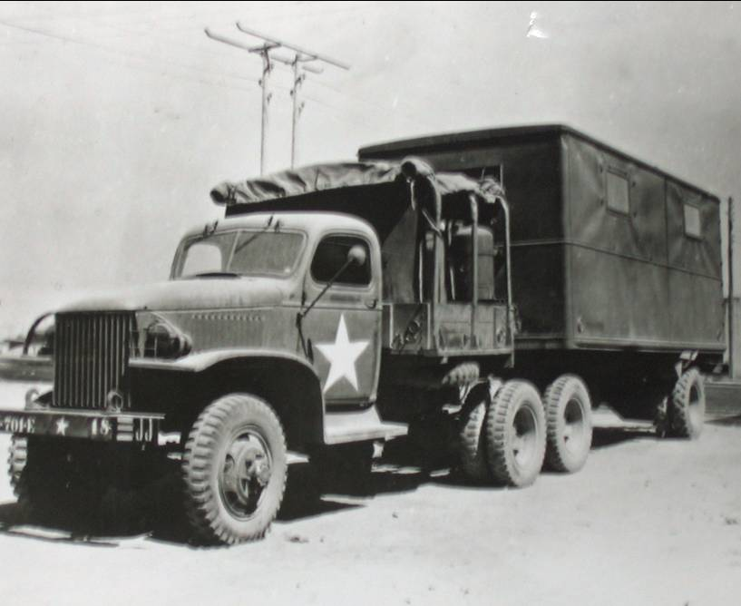

Table of Contents

Summary 3

1939 P.O.L. And The Chemist 3

Operation Of Mobile POL Laboratories – U.S. Army 4

EPDU Mobile Laboratories 18

Dispositions Of MTOUSA Petroleum Products Laboratories 28

Operational Responsibilities Of QM Petroleum Products Laboratories 30

Quality Control Of Fuels 31

Assessment Of Enemy Petroleum Products In The Field 40

Laboratory Methods And Chemists During WWII 47

Free French Army - Services Des Essences Des Armees 49

French POL Companies 53

POL In Europe 57

Epilogue For Chemists Of POL In WWII 59

Index 60

References 65

Photo 2. British Crusader tank being refuelled from 4-gallon petrol tin[1]

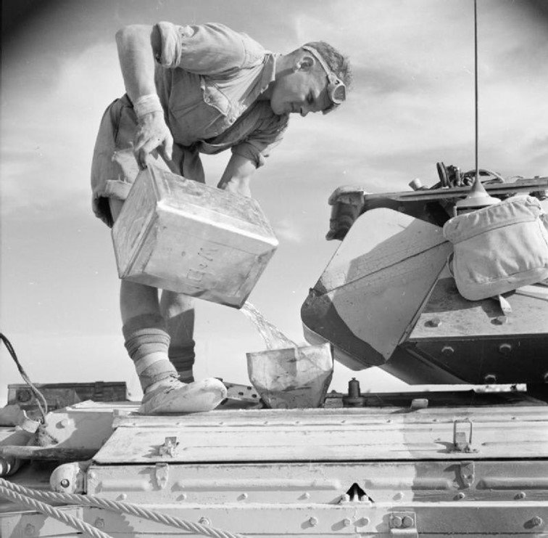

# Summary

Throughout World War II the operations of all the armed forces, both Allied and Axis were supported by specialised units known by various names, but essentially POL – Petrol, Oil, Lubricants and their technical staff. These units were responsible for providing the petroleum products to keep the ‘war machine’ operating. Without them, the armies would grind to a halt (as Patton and Rommel learned when their tanks ran out of gasoline), the navies could not sail, and particularly the air forces could not fly (as Goering discovered when the Luftwaffe were dragging the aircraft with oxen onto the airfields to save the precious aviation fuel, and later left stranded on the airfields for Allied fighter to destroyed due to the Axis lack of aviation fuel).

The following is a precis of, in particular two POL groups, the U.S. Army in the Mediterranean (MTOUSA), and the Free French Army. Both these groups worked together through the Mediterranean and southern European campaigns of World War II.

With the Allied invasion of Europe – Operation “OVERLORD” there would also POL units supporting the armies and air forces. There is much information in the histories of the U.S. Army in United States Army in World War II. The sections related POL Laboratories are included here.

Their role was not only to ensure the quality and supply of petroleum products for their own services, but to assess Axis captured supplies and identify any contamination or sabotage of this valuable resource.

# 1939 P.O.L. and the Chemist

With the onset of World War II, the military forces quickly realised that there would be a need for technical support of their campaigns on land and in the air from the petroleum industry. These were formed in service units known as P.O.L. units (or Petrol, Oil and Lubricants). These units were to play an important part in the operational theatres maintaining both supplies and ensuring the quality of petroleum products used by the armed services.

To ensure the quality of the petroleum products supplied required field testing of products, as well as any other demands for laboratory testing under active service conditions. For example, potable water supplies, assessment of captured petroleum supplies.

Fortunately, we can get some insight into the work of the ‘wartime chemist’ under active service conditions from a document published by Major Donald D. Mossman, Petroleum Section AFHQ of the U.S. Army titled “History of MTOUSA Q.M. Petroleum Products Laboratories with Recommendations” published in June 1945.[2]

MTOUSA = Mediterranean Theater of Operations, United States Army

[Mossman, Donald D., Major C.E. O-919935. Joined 701st EPDU, Camp Claiborne, he planned and equipped labs for 701st and 702nd, and chose personnel. He was commanding officer 931 Base Lab, Chief Laboratory Control Group Petroleum Section AFHQ]

[On 27th March, 1943 Captain Donald D. Mossman joined the U.S. Army Engineers Corps, Petroleum Distribution Branch at Camp Claiborne, Louisiana. He served in the Mediterranean Theater and on 14th March, 1946 retired from active service.]

Parts of this important historical document which are relevant to the operation and laboratory testing are presented here. The report contains much detail down to the quarterly inventory of every piece of laboratory equipment, chemicals, spare parts etc. and some are outside our area of interest with regard to aviation gasoline, however where appropriate other petroleum products are included for example, in the matter of contaminations of products.

The operation of POL units was part of nearly all armies and by way of example we can see the approach to these operations by the French in their report “History of Service Des Essences” By Capt. Alfred Tibor Services Des Essences, June 1945 HS-AFHQ/696/2 D. Le Service des Essences des Armees. A similar report was prepared by L.C. Jones, Lieut. Commander USNR “Memorandum concerning the Services des Essences des Armees”.

# Operation of Mobile POL Laboratories – U.S. Army

The following is part of the “History of MTOUSA Q.M. Petroleum Products Laboratories with Recommendations” by Major Donald D Mossman, CE Petroleum Section AFHQ. “Historical Report On The MTOUSA Quartermaster Petroleum Products Laboratories with Recommendations” Petroleum Section, MTOUSA Laboratory Control Group June 1945.

The Mossman report comprised the following:

1. Introduction
2. History

Sec. 1. Origin and Movements

Sec. 2. Personnel

Sec. 3. Organisation

Sec. 4. Activities

Sec. 5. Material

Sec. 6. Supply

III Recommendations

It also included a number of appendices

1. Plans of EPDU Laboratories
2. Photographs of EPDU Mobile Laboratories
3. Photographs of 2042 QM PPL (Mobile (Baird and Tatlock)
4. Disposition of MTOUSA QM PPL
5. List of Personnel who served with the QM PPL
6. Directive: “Operational Responsibilities of the QM PPL
7. Directive: “Quality Control of Petroleum Fuels”
8. Publication: “Elimination of Water, etc. from POL Products
9. Publication: “Notes of the Rapid Determination and Disposal of Enemy POL”
10. Publication: “Specifications of Petroleum Products”
11. Publication: “Schedule of Petroleum Products in Current Demand”
12. QM PPL “Quarterly Inventory Form
13. QM PPL “Consolidated Quarterly Inventory” sheet
14. QM PPL: Monthly Samples Log” Form
15. Proposed Table of Organisation

Some sections of the Mossman report are presented here.

## I Introduction

1. By VE day, U.S. Army petroleum laboratories had completed twenty-seven months of service in the Mediterranean Theatre of Operations. During this period, the laboratories had continuously served the Ground Forces, the Air Corps and the Navy, maintaining quality control of petroleum products in all parts of the theatre.

2. This report constitutes a brief record of the laboratory activities, of the modifications in their aims, of the changes in organisation, and of the development of control policy. Also presented are a number of recommendations based upon laboratory operations in this theatre and which, it is hoped may be of value to laboratory operations in other theatres, and in the formulating of future plans for the U.S. Army petroleum laboratories.

## II History

Sec. 1. Origin and Movements

1. The first petroleum laboratories to enter MTOUSA were activated at Camp Claiborne, Louisiana, USA in November 1942. Under a special T/O (Technical Order) and E, the 701st and 702nd Engineer Petroleum Distribution Units (EPDU) were each authorised five laboratory officers, six laboratory technicians and six mobile laboratories. Only five semi-trailer vans in all were made available. Rough plans were hastily prepared and laboratory installations were built inside the vans. A sixth (static) laboratory was authorised.

2. About 20% of the required equipment was on hand; the remainder was purchased, or back-ordered, at Port of Embarkation. Most of this followed the Units overseas but much was never received.

3. Eleven enlisted personnel and four officers joined the Units at Camp Claiborne. One enlisted man was medically disqualified and five additional officers reported at Port of Embarkation. The tenth officer reported in Casablanca about ten days after the arrival of the Units. The enlisted personnel never reached the authorised number of twelve.

4. The Units departed overseas 8 Feb. 1943. The 701st. EPDU disembarked in Casablanca 20th Feb. 1943; owing to a collision at sea, the 702nd EPDU did not arrive until 18 March 1943. Sufficient equipment had been received to begin partial operation of the static (later known as the 931st.) laboratory on 27th Feb. 1943, in the laboratory of a disused cement plant. The vans were not received until 12th March 1943 and their prime movers a month later.

5. On 2nd April 1943, the 702nd. EPDU moved forward to Algeria taking two (later the 947th. and 948th.) of the mobile laboratories, each with two officers and one enlisted man. Two weeks later a third mobile unit, without personnel, was sent forward and remained on indefinite loan to the British Army. The fourth mobile unit (later the 943rd.) was place in operation at Port Lyautey, 26th April 1943 and the fifth (to become the 930th. Base) at Marrakech, 4th May 1943. These points represented the terminals of the pipe line system originating primarily, in Casablanca and secondarily, in Fedala, French Morocco.

[Quneitra‎‎, al-Qonayṭéra, the little bridge) is a city in northern Morocco, formerly (1932–1956) known as Port Lyautey. It was a French Naval Air Station, taken over by the U.S. Navy during ‘Operation Torch’ in 1942].

6. The Port Lyautey (943rd.) laboratory was withdrawn in August 1943 and ordered to Tunisia with two officers and two enlisted men. And in October 1943 the static and Marrakech (930th.) laboratories were ordered to Algiers for duty with Petroleum Section AFHQ. (The mobile unit never operated there due to lack of personnel). Quality control in the Casablanca was handed over to the Shell Company civilian laboratory personnel. In November 1943, the static laboratory was divided. One section (later the 932nd) with two officers and two enlisted men remained in Algiers) the other (931st.) moved via Sicily to Bari, Italy, and became the base laboratory (AFHQ) for Italy.

7. Meanwhile, in April 1943, a laboratory designed, built and equipped by Baird and Tatlock of London, in consultation with U.S. Army Officers, was activated at Cheltenham by American personnel and proceeded to Oran [north-west Algiers], beginning operations there in May 1943. This laboratory, the only adequately equipped laboratory to arrive in the theatre, consisted of two special bodies built on a 2 ½ ton, 6x6 truck chassis. One served as the laboratory, the other as a store truck. These bodies were very carefully planned and expertly constructed around the apparatus. The material supplied was sufficient to permit continued operations over a period of 12-24 months. The personnel were adequate, consisting of two officers and seven enlisted men. Among the latter was a clerk and three drivers. It was first known as the 2032nd, later as the 2686th, and eventually the 942nd QM Petroleum Products Laboratory (Mobile). It was the first QM laboratory in the field.

8. In August 1943, the 703rd, 704th, and 705th Engineer Petroleum Distribution Unit arrived at Oran. The T/O and E of these units authorised each one laboratory only, housed in a K-19 (signals) trailer, no laboratory office, and four laboratory technicians. The units arrived with little or no testing equipment, short of trained laboratory personnel, and hence remained entirely inoperative for some months. They later became the 944th. and 946th QM PPL respectively

9. Civilian quality control in Casablanca proved to be dilatory and unsatisfactory and in July 1944 an officer was sent there from the 943rd to establish a military laboratory (later, the 945th ). Some equipment was available, some was borrowed, and some was contributed by the existing laboratories. Operations were carried on in the Socony-Vacuum installation, Casablanca; trained enlisted personnel were eventually found some time later.

10. Thus eleven U.S. Army Petroleum Laboratories were established in MTOUSA. Two of these, one acting as a base (930th ) and the other as a mobile (943rd ) unit, joined the invasion of Southern France and were assigned to Delta Base section and U.S. 7th Army respectively.

11. The various intra-theatre movements of these laboratories during the campaigns are depicted in Appendix 4.

12. In addition to the above, there were eventually five laboratories operated by the British Army (RASC). The first of these, a small mobile unit, was built and equipment in Egypt and moved with the (British) 8th Army across the desert and eventually into Sicily and Italy. It worked almost exclusively with captured enemy products and oil installations. The second (borrowed from the U.S. Army) operated at Bone and Algiers, and later in Sicily and from Naples to Venice in Italy. A third (static) began operations in Sicily but soon moved to and remained at Bari, Italy. The fourth was a mobile unit but operated only in the Naples area. The fifth (personnel only) began operations in Algiers, proceeded to Piraeus, Greece, and later to Naples and Ancona, Italy.

Sec. 2. Personnel

1. Prior to activation of the 701st and 702nd EPDU, U.S. Army officers and others sought among employees of petroleum companies, non-qualified for the numerous specialist ranks and grades available in these Units. Two officers and several of the original enlisted laboratory technicians volunteered. The remainder were obtained by transfer from other Army units, a large number of suitable personnel been suggested by oil companies or revealed by a survey of AG Records in Washington.

2. Facilities were not then available for training the laboratory personnel. Thus, it was imperative to the success of the mission that the most careful consideration be given to qualifications of the individuals chosen. Several of the officers had had either chemical laboratory experience and all were thoroughly familiar with petroleum tests and their significance. All the enlisted men possessed from two to twelve years civilian experience in petroleum laboratory operations. Every attempt was made to apply the same high standard in choosing replacements and additional personnel overseas but with decreasing success.

3. The special T/O authorised 5 officers and 6 enlisted men (EM) per EPD unit. This allowance was totally inadequate to operate the six laboratories authorised to each. A total of 10 officers and only 10 enlisted men arrived overseas with the six laboratories supplied, and this number was soon reduced. One EM became 1st Sergeant of the 702nd EPDU and never did duty with the laboratories. Fortunately, he was replaced by a well-qualified enlisted man who had preceded the laboratories and was found unassigned. A second EM was returned to the U.S. in August 1943 on medical grounds, in January 1944 another followed him but was replaced by requisition on the U.S. Shortly after this one of the senior officers was transferred to Petroleum Section, AFHQ.

4. At this time (February 1944) the original units operated two static and three mobile laboratories:

931st Base 2 Officers 3EM

932nd Base 1 Officer 2 EM

943rd Mobile 2 Officers 2 EM

947th Mobile 2 Officers 1 EM

948th Mobile 2 Officers 1 EM

The distribution of personnel, though unequal, was justified by circumstances and duties.

5. The 942nd (then, the 2600th QM) laboratory operated with two officers and six enlisted personnel, including a clerk and three drivers, until reorganised.

6. The 703rd, 704th and 705th EPDU were each authorised one mobile laboratory, four enlisted technicians, but no laboratory officers. Actually, these three units had five technicians in all, three of whom were untrained or only partially trained in petroleum testing. This lack of properly qualified personnel together with a grave shortage of laboratory equipment delayed the initial operations of the 944th, 946th and 949th laboratories and severely restricted their usefulness for some months therefore.

7. At no time were the MTOUSA laboratories adequately staffed; T/O restrictions in the parent organisation and the shortage of qualified personnel in the theatre made it impossible to remedy the situation. Fortunately, casualties were few and the time lost was small. This condition was somewhat alleviated when reorganisation under QM T/O & E 10-500s occurred in September 1944. Even so, the additional personnel obtained were no more than sufficient to provide an irreducible minimum for efficient operation and one laboratory (944th still operated almost continuously without any officer. A theatre survey indicated the absence of any reserve of available qualified personnel. Appendix 5 contains a list of personnel who served with the MTOUSA petroleum laboratories.

8. The personnel is in direct contrast to that found in the laboratories which entered France from the U.K. Some consisted of a static and a mobile laboratory each. They operated under QM T/O & E 10-500 with the authorised complement of three officers and fifteen enlisted men per unit. In conversations held with the Commanding Officers of two of these units, May 1945, these officers stated that they had no excess personnel though they could have operated with less.

Sec. 3. Organisation and Equipment

1. It was at first proposed that the Engineer Petroleum Distribution Units should, as a group of experts, plan and supervise the construction, operations and maintenance of 700-1000 miles of pipe line (the actual work was to be accomplished very largely by others). For this purpose, they were liberally supplied with laboratories, six per Unit, the chief function of which would be the testing of gasolines at terminals, and at intermediate storage and offtake points. For such a limited assignment, it was logical that the laboratories should operate under the direction of the Units.

2. The proposal was never developed in practice. The units were eventually reorganised and all pipe line troops operated as Companies whose mission it was to construct, operate and maintain pipe lines in a more limited area. For this purpose, the newly activated Companies were authorised but one mobile laboratory each and four enlisted personnel to operate it.

3. So long as the laboratories operated with their parent un its matters of administration, normal supply and vehicle requirements were relatively simple to adjust. It soon become evident, however, that only in rare cases could the mission of a pipe line Company require full-time the facilities offered by a laboratory. Furthermore, demands by other units and headquarters for testing services to be applied to other petroleum products grew. In the interests of economy and efficiency it became essential to extend the mission of the laboratories to activities unrelated to that of the parent organisation. Operational control rested less and less with EPDC commanding officers and more and more with local or Base Petroleum Officers. This was inevitable; efficient distribution of the laboratories necessitated their placement as much as 1,400 miles distant from the unit and where no pipe line operated; and the Base Petroleum Officer is the proper officer to coordinate quality reports on all petroleum products in his district.

4. These developments, while fully justified, were not without disadvantages:

(a) The T/E of the EPDG made no explicit provision for a personnel vehicle for laboratory use. While with its EPDG, a personnel vehicle could be borrowed as needed for a specified trip and otherwise use by the Company. On the departure of a laboratory for detached service, the parent unit was reluctant and sometimes unable to supply this transportation due to its own needs. Special arrangements had then to be made to supply the laboratories with its essential transportation. More often than not, this was accomplished only after a considerable delay seriously interfering with laboratory operations. Maintenance and repair by a motor-pool burdened with its own vehicles was a further impediment to operations and the need of a first-rate mechanic was reiterated many times by all laboratories.

(b) The movement of personnel between labs as required for temporary duty or transfer presented grave difficulties and delays in the absence of any coordinating and directing headquarters for all laboratories. Due to illness of personnel, one laboratory operated with one enlisted man for then days because no replacement could be arranged in time.

(c) The procurement and delivery of technical supplies became a highly involved and exceedingly slow process which completely broke down on several occasions until a central laboratory supply was established for the theatre.

(d) The division of operational control, at first between Commanding Officers of EPDC and later between Petroleum Officers of the various Base Sections, resulted in the application of quite different quality control programs. In some cases, unnecessary testing was required; in others quality control was superficial. This lack of uniformity in applicable test procedures was in part corrected by directives from Petroleum Section, AFHQ; and the necessity for supervision by technically trained personnel became more widely recognised.

(e) The chief source of technical information and advisory assistance for the laboratories was the Technical Branch of Petroleum Section AFHQ. Lacking direct communication, information intended for laboratories sometimes became side-tracked on the way to scattered lower echelons.

5. In July 1944, the 701st and 702nd EPDU were reconstituted as Engineer Petroleum Distribution Companies under T/O & E 5-327 which authorised only four laboratory enlisted men and no laboratory officer, or van. The excess laboratory personnel were permitted to remain as part of the new Companies pending reorganisation of the laboratories. In August, the laboratory officers were assigned to Replacement Depots but were instructed to remain at their posts. Finally, in September 1944, the eleven MTOUSA laboratories were reorganised as “QM Petroleum Products Laboratories” (Base and Mobile) under Columns FA and FB respectively, of T/O & E 10-500s, dated 6 July 1944 (Authority: W.D. letter, file: AG 322 OB-I-SPMOU-M, dated 25 July 1044, subject: “Constitution. Activation and Reorganisation of Certain Units” with 1st Ind. HQ. NATOUSA dated 24 Aug. 1944 and 2nd Ind. HQ. SOS NATOUSA dated 31 Aug. 1944.) (NATOUSA - North African Theatre of Operations, United States Army)

6. This T/A and E was a special modification of T/O & E 10-500 under which QM PPL ETOUSA operated. The modified form greatly reduced the personnel authorised by 10-500. E.g.

T/O & E 10-500s 10-500

Base Laboratory 2 Officers, 4 Enlisted men 2 Officers, 10 Enlisted men

Mobile Laboratory 1 Officers, 2 Enlisted men 1 Officers, 5 Enlisted men

No clerks or drivers were authorised, though both are considered essential. Operating as independent units, the administrative detail in addition to laboratory reports and stock records is adequate justification for a clerk general. In turn, the maintenance of two personnel vehicles, a refrigerator or ice machine, a generator and laboratory electrical equipment is considered justification for a driver-mechanic, supplied with a mechanic’s No. 1 tool set. Nevertheless, considerable advantages accrued. Personnel adjustments could be and were made as soon as the laboratories were freed of the T/O restrictions of their parent EPDC. One officer was obtained from the Replacement Company; three others were required but none qualified were available in the theatre nor from the U.S. Four enlisted technicians were transferred from the 785th EPDC. Two 2nd Lieutenants who had been in grade 34 and 31 months respectively, received promotion.

7. The original laboratories of the 701st and 702nd EPDU had no published T/E; what these required they got, if available, and if their arguments were sufficiently cogent. T/O and E 10-500s included a list of authorised equipment which, however, did not specifically mention the power generator, CFR engine, or laboratory van and lumped all purely laboratory equipment under the title, “Laboratory, Field, Set No. 2, petroleum testing” of which no breakdown was available. Special authority was obtained to retain essential equipment and most disabilities were removed by the publication of Change 1, dated 12 Feb 1945. Two vehicles were specially requested and were authorised each laboratory unit. For mobile laboratories, one of these was a 2½ ton truck which is uneconomical for use in performing administrative duties or in gathering samples. The primary purpose if as a prime mover for the laboratory van but in those cases in which the van is a semitrailer it cannot be so used without drastic modification.

8. Technical coordination of the laboratories had been assumed by Petroleum Section (Technical Branch), AFHQ, late in 1943 and gradually developed by the dissemination of technical information and directives. By the summer of 1944, this control had passed to POL Section, Engineer Branch SOS, NATOUSA. On reactivation of the laboratories under T/O and E 10-500s, it was proposed to secure a battalion headquarters to carry on their administration, supply and operational control. (Centralised control had been suggested in a report to Petroleum Section AFHQ by the 931st Base Laboratory in July 1943 and following conferences, the matter was referred to NATOUSA but was not approved. No suitable headquarters was available and the plan shelved’ shortly thereafter, SOS NATOUSA was disbanded.

9. On 30 Nov. 1944 Petroleum Section AFHQ requested an increase in personnel, as follows:

1 Lieut. Colonel Deputy to Chief of Section as commander of laboratories

1 Major assistant to Lieut. Col.

1 Captain supply and administrative officer

1 T/Sgt. supply

1 T/5 supply

1 T/Sgt. personnel

1 T/5 clerk typist

In order to establish within itself laboratories headquarters whose purposes briefly described, were to be:

(a) To relieve the laboratories of much administrative detail, for which they were not organised and which seriously detracted from their efficiency;

(b) To accomplish a unified personnel policy including the filling of vacancies, promotions, and transfers based upon qualifications;

(c) To provide technically qualified command with direct communications and personal inspections;

(d) To operate a theatre laboratory supply depot and supervise procurement, storage and distribution of technical supplies.

The necessary personnel increase was authorised 12 Dec. 1944. All U.S. Army petroleum laboratories were assigned to HQ. MTOUSA; attached to Headquarters Command, AF, for all purposed except supply; operational control and internal administration was vested in the Chief Petroleum Officer, MTOUSA. (Letter order AG 370.5/396 C-O, HQ. MTOUSA, subject: “Assignment and Attachment of Units” dated 19 Dec. 1944, effective 22 Dec. 1944). Immediately thereafter, the Laboratories Control Group of Petroleum Section AFHQ, began its functions.

Sec. 4. Activities

1. The ultimate responsibility for the quality control of petroleum products in a theatre rests with the Theatre (Area) Petroleum Officer. This responsibility is in turn delegated to Base Section Petroleum Officers, Pipe line Commands and Air Corps Service Commands, and so to commanders of depots, bulk installations, pipe line and airfield operating personnel. The primary object of the petroleum laboratories is to act for all of the above as one of the chief implementing agencies, advisory and operational, in the successful accomplishment of quality control programs.

2. To ensure uniform and adequate quality control of products and to coordinate its applications by the several components of the Services it is essential that the basic directives on quality control emanate from the Technical Branch of the Theatre (Area) Petroleum Office. And since the laboratories are important agencies in implementing these directives on behalf of all components it had been found most effective to assign their operational control and technical direction to the same office. This policy has been beneficial in many ways. It has broadened the activities of the laboratories making them much more effective in their mission. It has made possible their disposition on the basis of theatre rather than local needs. It has provided the Theatre (Area) Petroleum Office with a continuous picture of the condition of products throughout the theatre. And it has provided a means of frequent comparisons of laboratory reports thus ensuring technical efficiency in all parts of the theatre,

3. Appendix 6 provides a copy of the most recent directive prepared by Laboratory Control Group on the operational responsibilities of the MTOUSA Laboratories. The extent and variety of the testing program performed by a given laboratory is governed by the volume and form in which the products are delivered and handled in its area.

4. Combat operations in MTOUSA have paralleled coast lines and for the most part have seldom extended more the 100 miles inland. A number of ports, capable of receiving petroleum fuels from tankers, were captured as the advance proceeded and their use greatly shortened the supply lines making possible the delivery of fuels in bulk by relatively short pipe lines. Hence the quality control of bulk products in tankers, tank storage and pipe lines has been, perhaps, the chief phase of laboratory control. The use of numerous ports for the receipt of and transhipment of bulk products, and for each of which laboratory control was required, was the main factor in determining the distribution of laboratories within the theatre. In addition, it did much to break down the largely artificial distinction built up with regard to Base and Mobile Laboratories. With a very limited number of the former available, it became necessary for Mobile units to perform the duties of the so-called Base Laboratories on many occasions and for long periods despite the lack of adequate personnel. This required a careful consideration of the minimum testing operations essential to provide basic quality control. The program developed from experiences under varied conditions, is presented in Appendix 7 as the latest directive on the subject prepared by the Laboratory Control Group and coordinated with S and T Staff Section AFHQ.

5. With respect to products arriving in the theatre and being dispensed to users in their original containers (lube oils, greases and special products), dependence was placed on the necessity on the control measures in force at the point of origin. No formal program of laboratory testing was considered practicable due to possible waivers of specifications, mixing of batches during shipping and storage, the exceedingly large number of containers and the small number of personnel available. These products were identified in many instances when original marking had become illegible. They were tested also when the containers became damaged sufficiently to cause suspicion of contamination and when their performance fell below expectations.

6. On the other hand, packaged fuels, especially gasolines, were found to require very careful supervision. At first, “packed” stocks arrived in new containers, refinery filled and sealed, from the U.S. or the U.K. These were considered to require no tests. Time passed and complaints about packaged fuels appeared and grew in frequency. Some of the original packages had remained in depots for many months. Other containers, originally used for other fuels, were being refilled with different fuel; old markings were not removed; cleansing operations primitive and incomplete. Rust, water, high gum content and contaminations by other products were found. A thorough survey of packed gasoline stocks was accomplished and repeated at regular intervals; rules governing the rotation of depot stocks were instituted and rigidly applied; cleansing and filling procedures were made more rigorous and carefully supervised and the results, checked by the laboratories, showed marked improvement. (Appendix 8 prepared by Technical Branch Petroleum Section, AFHQ, refers.) The continuous inspections required in these operations were not carried out by the laboratories as they were in France. MTOUSA laboratories had not the necessary personnel and, in any case, it was considered the proper function of the responsible officer in charge. Laboratory personnel acted as advisors to these officers and did inspect installations for this purpose, making recommendations when these appeared necessary.

7. The study of enemy petroleum products was also a function of the laboratories, especially those nearest the front line. (Appendix 9 provides the early instructions issued on this subject by Technical Branch Petroleum Section, AFHQ.) Most of the samples of interest were sent to the 931st Base Laboratory after preliminary inspection. There they received more complete analysis and were forwarded to London for study. In general, the studies performed as a part of petroleum intelligence in the theatre. Only under exceptional circumstances should enemy products be used in Allied equipment as many have found to be inferior. In rapid advances when supplied have become short, e.g. in the Western Desert and in France and Germany, the use of enemy products may be imperative. The, and only then, is a mobile laboratory required with the Army – to identify enemy products and advise their disposition. Excellent work of this nature was done by the British laboratory with the 8th Army (Montgomery’s command), by the U.S. Army laboratories in Sicily and by those in Germany, where the captured products were in such demand that commanders kept secret the locations of captured depot in order that they might not be called upon to share the loot.

8. The above activities were normal routine matters and constituted the primary objectives of the laboratories. Strangely enough, the activities were not always appreciated at first. There were many who regarded quality control, as practiced by the laboratories, as “excessive” or “interfering”, the special equipment which they demanded as “not operationally necessary”, and others who thought the laboratories, per se, were “unjustified”. They overlooked the fact that not all the personnel handling petroleum products were skilled and experienced I their jobs. Mistakes were bound to and did occur; their detection by the laboratories before serious consequences followed gradually justified their existence and their needs to all doubters who became familiar with their work. Recognition of the essential value of their mission came slowly; it was discouragingly slow at times and affected morale. It was aided in many instances by the assistance they were able to give to other branches of the service in the solution of their problems.

9. These special problems were to a great extent chemical and required apparatus and chemicals not essential to the normal testing of petroleum products. Some of these problems are listed below. They are chosen to illustrate the variety rather than the number of such problems, e.g.

Comparison of foam stabilities of fire-fighting mixtures

Analysis of “doped” wines

Water analyses

Identity of vegetable (edible) oils

Analysis of airfield dusts

Potability of alcoholic beverages for clubs and messes

Critique of chemical research on synthetic plastics by an alien refugee, using this as a reason to be admitted to the U.S.

Analysis of metals and alloys

Investigation of corrosion in cooling systems

Reprocessing or rubber waste

Investigation of poisoned candy

Identification of chemicals

Analysis of engine deposits and sludges

Technical aid on the examination of prisoners

The additional equipment required for such problems was not too bulky to be stored in the trailers; the services rendered more than paid the additional cost; and the choice of personnel with chemical training and experience increased the potential value of the laboratories. Personnel had derived considerable satisfaction from the assistance they had been able to render other Services.

10. The laboratories require technical information and need it as soon as it becomes available; they require also an exchange of information and experiences to enrich their own. This service was never fully organised and developed in this theatre though the 931st Base Laboratory at Bari, Italy attempted a beginning by preparing 17 Base Lab Circulars which it distributed to the other laboratories. These included specifications and analyses of enemy products, methods of analyses, its own researched in fuel contamination and methods of detection, the results of special investigations by other laboratories and technical items of general interest. This work had to be carried on in addition to its other duties and without clerical assistance. On the formation of the Laboratory Control Group more ambitious contributions were planned, only one of which was completed by VE Day. (8 May 1945). The laboratories long suffered from an inadequate supply of specifications of American petroleum products. These had been received in the theatre but reproduction was difficult and distribution uncertain. The first project was the compilation of a consolidated set of specifications of all slated and unslated items (See Appendix 10.)

11. In the accumulation and dissemination of technical information as well as advice and assistance, the laboratories depended greatly on Technical Branch, Petroleum Section, AFHQ, and never in vain. Several of their publications were very helpful in the early stages (See Appendices 7 & 8). One of the most useful was the schedule of equivalent grades (see Appendix 11) which, because of its consistently valuable assistance should be included in the reference library of the petroleum laboratories.

12. The laboratories were visited every two months by one of the senior officers of the Laboratory Control Group. The local Petroleum Officer was consulted in every case to ensure that laboratory services were satisfactory. The personnel were interviewed. Technical problems, variations required in testing programs, personnel and supply difficulties and stock positions were discussed and remedial measures instituted. These frequent inspections proved of great benefit both to the laboratories and to the Control Group.

13. The Laboratory Control Group established a warehouse in Naples in which laboratory equipment from other depots was accumulated and stored systematically. At quarterly intervals laboratories were instructed to prepare an inventory in duplicate on prepared forms (Appendix 12 is the quarterly inventory form) and to forward one copy with its requisition. The inventories were entered on a consolidated quarterly inventory sheet (see Appendix 13) for record and the original filed at the warehouse. Requisitions were edited and passed to the warehouse for action.

14. Laboratories were further instructed to supply the Laboratory Control Group with copies of all acceptance and loading reports on tankers; of reports on any products not meeting specification, with their disposal recommendations; of reports of any special investigations, and a monthly samples log by which activities could be compared (see Appendix 14). Reports on incoming tankers were obtained by sampling at the first theatre port of call so that diversion could be planned by Transportation Branch, Petroleum Section AFHQ, if this was found necessary.

15. Close liaison was maintained between the Laboratory Control Group and S & T Branch, AFHQ, which controlled the British laboratories. The utmost cooperation prevailed at all times.

Sec. 5. Material

1. A detailed account of this subject would be confusing; consequently, only the more important items will be referred to, particularly those concerning which recommendation are to be made.

2. The use of petroleum laboratories was apparently a late decision. Their purpose was not clearly defined and no authorised T/E was immediately established. The first personnel were obtained when little time remained hence construction and equipment of the laboratories had to be accomplished in great haste. It is not surprising that some mistakes were made.

3. Many deficiencies in T/E have been remedied by later changes but a few items require emphasis.

a. CFR Engines

Only three engines were brought from the U.S. but practically every laboratory required the use of one the greater part of the time. In the absence of an engine either the fuel was judged solely by its other characteristics or samples were flown to be tested elsewhere necessitating a minimum delay of three days. In most instances limited storage facilities did not permit the necessary isolation of the products awaiting test; it was used without octane testing. This amounted to a serious gap on the quality control of 100 octane gasoline and became equally serious for 80 octane gasoline on the arrival of low octane fuel form Haifa at a critical period in the Italian campaign. The motor method was used consistently in this theatre and was considered superior to 1-C (Lean Mixture) rating in detecting the effects of contamination.

b. Power Units

Bottled gas has been carried by all laboratories, chiefly as an emergency fuel, and is essential in some determinations. The choice of electricity as the chief source of power was justified; electrical equipment is more precise, requires less attention, and permits more operations at one time. A 5 KW generator has been found sufficient for average laboratory operations though it will not power all the apparatus at the same time, and laboratories operating CFR engines require the 15 KW unit. Considerable delay was invariably experienced in moving laboratories, however, due to the fact that the generators were not trailer mounted and special equipment was required to load and place them. If generators were trailer mounted the mobility of the laboratories would be greatly increased.

c. Ice Machines

The first laboratories (701-2 EPDU) were supplied with huge 1,500 lb machines and a capacity of 1,200 lbs of “flak-ice” daily. While these made it possible to supply many neighbouring unit messes, the capacity was far in excess of that required; the machines so large and heavy they had to be operated outside the laboratory vans and shipped separately. Lighter household refrigerators, brought by other laboratories, yielded an inadequate supply of ice. Normal average consumption was approximately 50-60 lbs/day. In many instances, this had to be dispensed with entirely; in fact, necessity taught the laboratories that sufficiently accurate and reproducible results can be and have been obtained using as coolant, water at tis natural temperature. It is now considered that both ice machine and refrigerator are unnecessary. This does not refer to the equipment required to make dry ice.

d. Laboratory Vans

Movement of a static laboratory requires several days of careful packing by experienced personnel and the material is then exposed to rough handling during transit. Equipment packed in a van is safer from breakage; requires less packing space; is more quickly arranged and less time is lot; much of it can be permanently set up or stored; and protection against weather is achieved. Furthermore, prepared laboratories are not always available for occupation and many days have elapsed before new quarters could be wired, piped and benches built. For this reason, laboratory vans were obtained for existing Base as well as Mobile Laboratories. The interior design of the present vans is, in general, satisfactory but experience suggests modifications in future models, e.g. more working space to permit four to work inside at one time; elimination of the dark room which is unusable as originally intended; larger fume cupboards; elimination of a second door, replaced by an additional carbon dioxide fire extinguisher and possible an escape hatch this saving bench space; rearrangement of drawer and cupboard space so as to be more economically employed for storage of equipment.

e. Vehicles

An analysis can be of little value unless a proper sample has been obtained. Samples should be taken by experienced personnel preferably from the laboratory. This principle has been applied consistently whenever feasible. The average active laboratory in this theatre has driven its cars 2,500 miles per month for duty purposes (inspections, sampling, administration, and transport of personnel). It was demonstrated by MTOUSA laboratories that one car was not sufficient for the performance of their mission and a second car was authorised. These two vehicles are required in addition to the prime mover of the laboratory van; one should be capable of drawing the trailer mounted power unit (3/4 ton for 5 KW or 1 ½ ton for 15 KW); the second vehicle should be a jeep. It is not economical to use a 2 ½ ton truck for routine laboratory business; though this has been a necessity for Mobile Laboratories

f. Chemical Apparatus and Reagents

Experience has strengthened an early conviction that the U.S. Army petroleum laboratories should be prepared, both in personnel and equipment, to petroleum general chemical analysis. MTOUSA laboratories have been supplied, as much as practicable. With the material required, and this had made possible much of the special work they have accomplished. In the absence of a T/E, a list of proposed allowance (see Appendix 13) was prepared for the guidance of laboratories in preparing requisitions. Both the specific items and the proposed allowances are tentative. While such provision increased greatly the numbers of items carried, the quantities in each case were sufficiently small so as to add little to the required storage space. These items have undoubtedly increased both the potential and the actual values of the laboratories in the theatre. This material is not authorised for the QM. PPL in the latest breakdown of laboratory equipment of laboratory equipment received here.

Sec. 6. Supply

1. The problem of supply of laboratory equipment has been consistently one of the greatest faced by the laboratories. The basic difficulty lay in the fact that so many of the items demanded were critical and became available in the U.S. a considerable time after they were requisitioned. Priority of shipping space caused further delays. In these circumstances, the laboratories were on many occasions short of required apparatus and chemicals and a theatre reserve could not be established to provide for emergencies. Other contributing factors existed which were eventually discovered and remedied in time.

2. First, the necessity for special “LAB” markings was not recognised. The usual Engineer markings were employed; boxes were delivered to Engineer depots, in many cases without packing slips by which the contents could be identified. The depot personnel were unfamiliar with laboratory equipment and where identification became so difficult the material had to be set aside. This condition was aggravated by the rerouting of vessels so that laboratory supplies arrived at ports where they were unexpected or unknown. When the Petroleum Section, Engineer, SOS took a special interest in laboratory supply in October 1943, an attempt was made to gather all laboratory equipment in one spot. Despite these efforts, some material ordered early in 1943 was found late in 1944. Some equipment was never found. The Petroleum Section Engineer, SOS, obtained authorisation for special laboratory markings and otherwise aided greatly in locating and preserving the shipments for laboratories.

3. On a number of occasions laboratories, which did not know the status of previous requisitions, reordered months later. In some cases, these items had been given improper nomenclature and so accumulated in depots.

4. Again, vital spare parts for CFR engines were apparently shipped to Engineer spare parts depots and there appear to have been regarded as belonging to other Waukesha engines. (CFR engines were manufactured by the Waukesha Company). Repeated enquiries failed to reveal them under laboratory nomenclature.

5. Shipments from depot to laboratory within the theatre sometimes went astray and remained lost for some time chiefly due, it is believed, to smallness of the shipment.

6. It was to eliminate such difficulties that Pet. Sec. Engr., SOS arranged a special theatre depot for laboratory supplies in Oran and took special interest in handling of laboratory shipments. Previous requisitions on the U.S. were cancelled; a new comprehensive requisition was prepared and sent forward on behalf of the original Engineer laboratories. By the time these supplies arrived, other laboratories, almost devoid of equipment, entered the theatre and were issued much of the material.

7. No qualified laboratory personnel were available to edit individual requisitions. No records of individual laboratory holdings were available at the depot. Hence a fair distribution between laboratories could not be decided and some requisitioned more than their share leaving others short. This could not always be avoided as some chemicals, for example, had been ordered in large bottles as a measure of economy; smaller bottles (empty) to make division possible had been ordered also but nor received.

8. On the formation of the Laboratory Control Group a laboratory warehouse was constructed in Naples. The Engineer Branch, MTOUSA gave every cooperation possible and laboratory material was sent in from Engineer Depots wherever it was found. All items were systematically arranged with proper nomenclature assigned, stock cards were prepared and an inventory taken. The laboratories were informed of a proposed allowance on each item, instructed to inventory their own holdings and report the results quarterly. In this was a redistribution of material became possible and was effected. Requisitions were edited and filled from supplies on the basis of what was available to all. Shipments to laboratories were arranged by air and recipients were forewarned so that possible loss of irreplaceable items was minimised. Chemicals ordered from the U.S. were requested in packages of the proper size for distribution to be effected without breaking seals. A consolidated inventory of all laboratories was maintained so that shortages in any part of the theatre were evident and could be filled without receipt of request as soon as the material became available. In this the MTOUSA laboratories were brought of the best stock position they achieved during the campaign. This had become possible only because qualified laboratory personnel were made available to edit the requisitions and supervise the care and distribution of supplies. The laboratories remained lacking in many respects but not in essentials although supply of some items was very low. All these items were on requisition from the U.S. but had not been set up for shipment. After VE Day these requisitions were cancelled.

## III. Recommendations

The following recommendations re devised from twenty-seven months of laboratory service in an active theatre. They are offered for consideration because if the sincere conviction that their adoption will measurably improve the operational efficiency and broaden the effectiveness of U.S. Army petroleum laboratories in other theatres. It is further considered that, though it may be impracticable to adopt certain of the measures in the near future, they may prove to be of value in deciding the post-war organisation and equipment of U.S. military petroleum laboratories.

Organisation

It is recommended:

1. That a “Laboratory Control Group” consisting of three officers and five enlisted men be authorised as an organic element of the staff of the Theatre (Area) Petroleum Officer.

a. Suggest responsibilities follow

i. To implement theatre policy with respect to petroleum laboratories; to prepare technical directives and bulletins for their guidance and information; to initiate, assign, and direct special projects; and to ensure efficiency of operation by periodic inspections of facilities and procedures.

ii. To maintain records and keep the Theatre Petroleum Officer advised of conditions in the laboratories, the work accomplished, the quality of products in the theatre, and the laboratory material stock position.

iii. To make recommendations to the Theatre Petroleum Officer with respect to: laboratory policies, equipment; the qualifications choice, and assignments of personnel; technical procedures; and the location of laboratories.

iv. To establish and maintain a theatre stock of laboratory equipment; to maintain inventories at all laboratory stocks; to edit and consolidate requisitions; and ensure adequate and expeditious supply within the theatre.

v. To act as centre for the collections and dissemination of intelligence on the quality of enemy petroleum products.

vi. To ensure the cooperation of the laboratories with local petroleum Officers and other services.

b. This recommendation has been applied in the theatre and has been found to be practicable and to yield the most efficient operational results.

c. This recommendation is in accord with the proposed plans of the Army-Navy Petroleum Board as presented in their letter, File ANPB Ser. 562, subject; Establishment of a “Joint Services Petroleum Laboratory Coordinating Committee”, dated 11 May 1945.

2. That all petroleum laboratories in the theatre by assigned to the theatre Headquarters Command for everything but supply and that the internal administration and operational control of the laboratories rest with the Theatre (Area) Petroleum Officer, and that he implement his responsibilities through the proposed “Laboratory Control Group”

3. That all petroleum laboratories, both Base and Mobile, be organised and activated as separate units (as in T/O & E 10-500 S rather than in groups as authorised by T/O & E 10-500).

a. Experience in France, as in this theatre, showed that the mobile units operated so far away from any Base Laboratory that control by the latter was either negligible or required long absence from his headquarters by the C.O. of the Base Laboratory.

4. The T/O of the “Laboratory Control Group” and those of the Base and Mobile Laboratories are essentially those shown in Appendix 15.

a. The high professional qualifications required together with the great responsibility, for both lives and equipment, involved in their decisions justifies higher rank for laboratory officers than is now authorised. (It is noteworthy that of five British RASC laboratories, three were commanded by Majors and two by Captains.)

b. Some compromise seems desirable between T/O 10-500 S, which provides for no theatre reserve in case of casualties, losses, etc. and T/O 10-500, which provides and excessive number of laboratory personnel and so is wasteful of a critical item.

c. The need for clerks in both types of laboratories has been demonstrated in this theatre, where each is an individual unit; and the continuous maintenance possible if a driver-mechanic is available can save many major overhauls of equipment and consequent loss of time.

d. At best one man in every laboratory should be sufficiently trained in the operation of CFR engine to operate one in an emergency. But a number of men, equal to the number of CFR engines proposed for use in the theatre, who are expert in the operation and maintenance of these engines should be included in the laboratory personnel. As this number is indefinite, such personnel are shown in Appendix 15 only with Base Laboratories.

5. That the special qualifications of laboratory personnel be essentially as follows:

a. C.O. “Laboratory Control Group” – to possess a doctorate or equivalent research experience, preferably on analytical or organic chemistry together with experience in the administration and direction of laboratories.

b. Executive Officer “Laboratory Control Group” and C.O.’s Base Laboratories – to be fully qualified petroleum chemists and analysts with administration ability and at least two years of industrial or academic research experience.

c. C.O’s Mobile Laboratories – to be fully qualified petroleum chemists and analysts, preferably with analytical experience in at least one other chemical field.

d. Supply and Administrative Officer, “Laboratory Control Group” – a chemist or chemical engineer, thoroughly familiar with petroleum laboratory apparatus and supply procedures; a basic knowledge of administrative procedures.

e. Laboratory Officers – qualified chemist or chemical engineer with two years industrial analytical experience at least one of which should have been in petroleum products.

f. CFR Operators – a minimum of two years’ experience in the operation and maintenance of CFR engines (Motor Method and 1-C methods); capable of interpreting results; and through training in petroleum testing.

g. Laboratory Technicians – possess at least two years’ experience of civilian experience in the testing of petroleum products (Grade to depend upon length of and variety of experience, knowledge of chemical procedures, and general competence).

h. Supply Sergeant – “Laboratory Control Group” – civilian experience in a scientific supply house; familiar with proper methods of packing; experience in Army supply procedures is desirable but not essential.

i. Drive-Mechanic – proficient in driving heavy trailers or semi-trailers and capable of 1st and 2nd echelon vehicle maintenance and repair.

Equipment

It is further recommended:

6. That all laboratories be authorised a CFR engine with operator, a 15 KW generator and one 1½ ton, 6x6, weapons carrier (the actual number of laboratories so equipped to be decided after recommendations made by the Theatre Petroleum Officer) but that the T/O & E be so worded that laboratories not requiring CFR engines will be authorised a 5 KW generator and one ¾ ton 4x4 weapons carrier in lieu of the above.

7. That in other respects the Base and Mobile laboratories be authorised essentially to have the same equipment including a laboratory van.

8. That the power units, 5KW or 15KW, be trailer mounted for increased mobility and drawn by a ¾ ton or 1½ ton weapons carrier respectively.

9. That each laboratory be authorised one ¼ ton, 4x4 command and reconnaissance car.

10. That an ice-making machine or refrigerator be declared as non-essential and deleted from the T/E.

11. That every laboratory be authorised the additional texts, apparatus and chemicals required foe qualitative and quantitative inorganic analysis, organic identification, and spot testing.

12. That, providing a theatre supply depo is authorised, the petroleum testing equipment now authorised be reduced in amount to that proposed in Appendix 13.

13. The wrist watches be authorised for the first three grades.

Laboratory Vans – Future Construction

14. It is recommended that future construction of laboratory vans be based upon the use of the Fruehauf semi-trailer, Model B-2; dimensions: length 24 ft. 3 ¾ inches outside; width 8 ft. outside; height 6ft. 11 ½ inches; weight 5,680 lbs (which is at least 1,000 lbs lighter than the five semi-trailers supplied 701st and 702nd EPDU). The original semi-trailers were too heavy; the K-19 trailer is not strong enough. The Fruehauf semi-trailer is lightly built yet very strong. It will provide sufficient storage space and work room to accommodate both the recommended material and personnel without crowding; the K-19 trailer, in particular, is lacking in working space. The capacity (payload) is more than 10 tons, for in excess of that required, so the vehicle would ride well even on poor terrain.

15. It is further recommended that aluminium foil insulation be employed. This has been proved to be far more effective and much lighter than other type. The height of the van is such that a plenum space can be constructed in the roof, with ventilators, so that fresh air can be introduced to aerate the laboratory and ensure a draught for the fume cupboard.

16. That a 50-gallon (US) water tank and hand operated (gasoline) pump be included.

Special Testing Kits

It is further recommended

17. That supply of special testing kits (anti-sabotage and field gum tests) be discontinued.

a. Anti-sabotage kits supplied 15th AFSC, Bari, contained no instructions; could not be used except by trained personnel available only in laboratories and the latter already have the equipment.

b. Use of special field gum testing kits depends on accuracy of reference standards. These were found to be unreliable. Results varied with the observer.

June 1945 Signed D.D. Mossman, Major C.E.

# EPDU Mobile Laboratories

Appendix 2 Photographs of EPDU Mobile Laboratories

Appendix 3 Photographs of 2042 QM PPL (Mobile - Baird and Tatlock)

The following are photographs of the EPDU Mobile Laboratories, their vehicles and their laboratory equipment as fitted out by the British firm of Baird and Tatlock.

Photo 3. Trailer for Mobile Laboratory

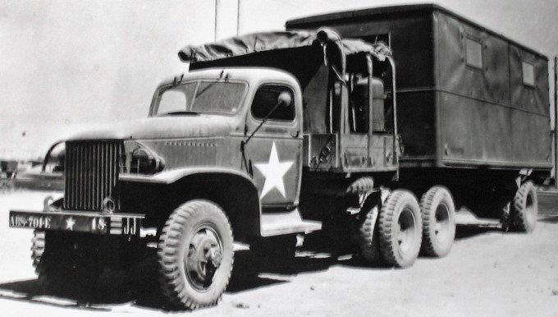

Photo 4. Exterior of Mobile Laboratory - Tractor

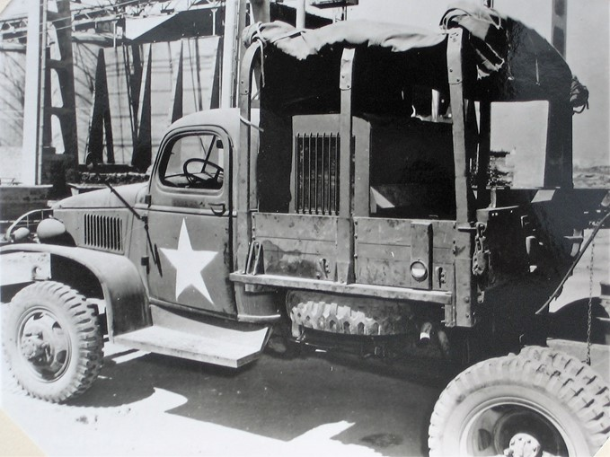

Photo 5. Interior (right) of trailer of 947th Mobile Laboratory

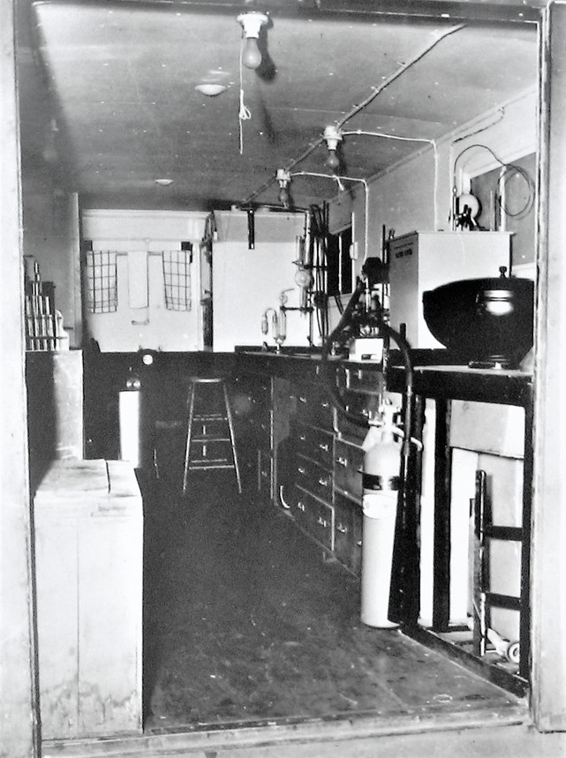

Photo 6. Interior (left) of trailer of 947th Mobile Laboratory

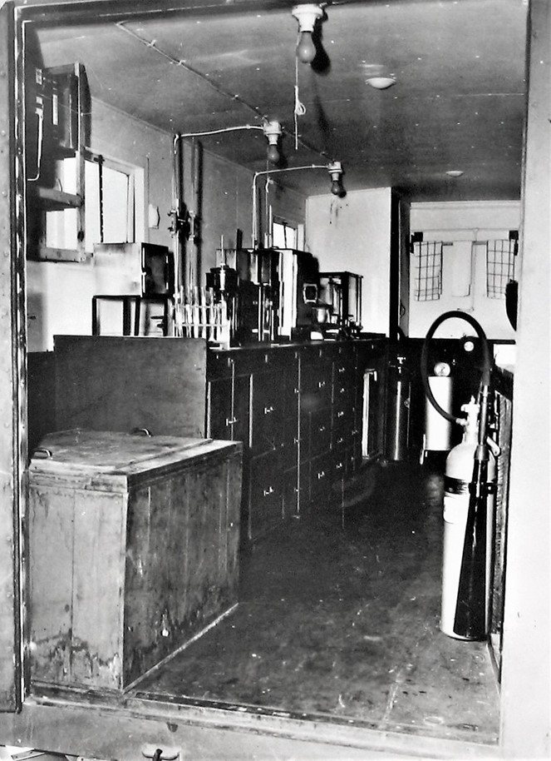

Photo 7. Interior of Mobile Laboratory looking towards the front.

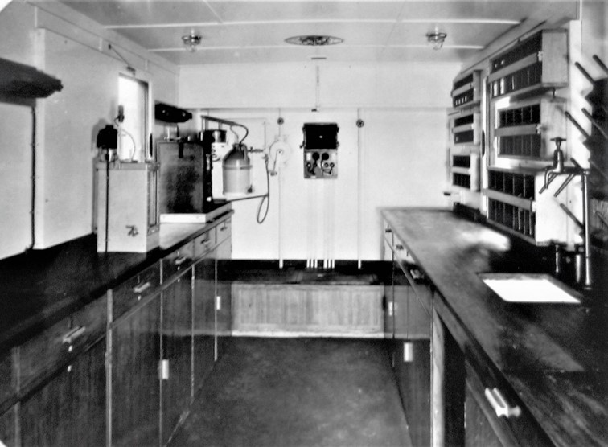

Photo 8. Interior of Mobile Laboratory looking towards the rear.

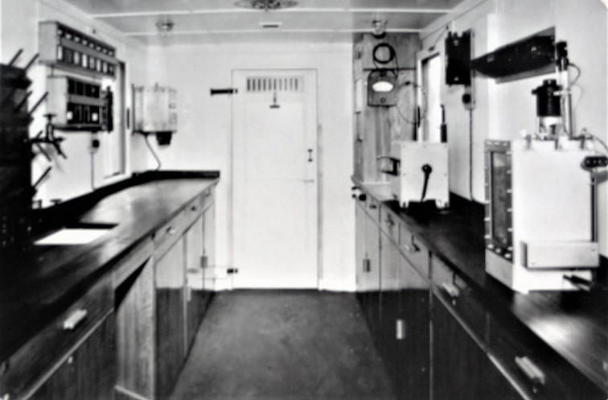

Photo 9. Interior of store truck showing refrigerator, CO2 cylinder and arrangement of drawers and lockers

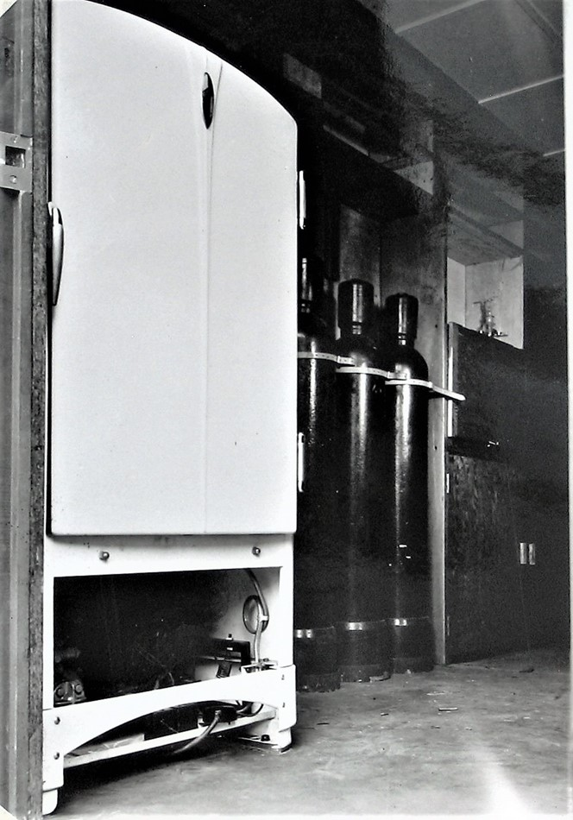

Photo 10. Drawer 10 showing the packing arrangement of glassware

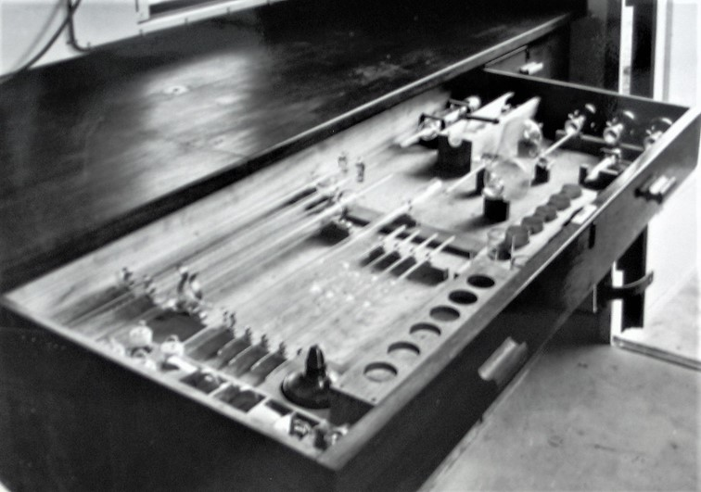

Photo 11. Drawer 11 U-tube viscometers, centrifuge tubes, coke test apparatus, etc.

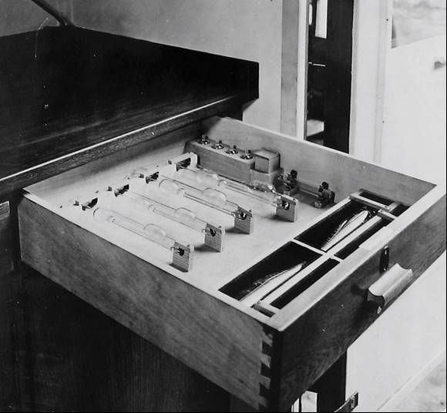

Photo 12. Drawer 7 Engler distillation glassware

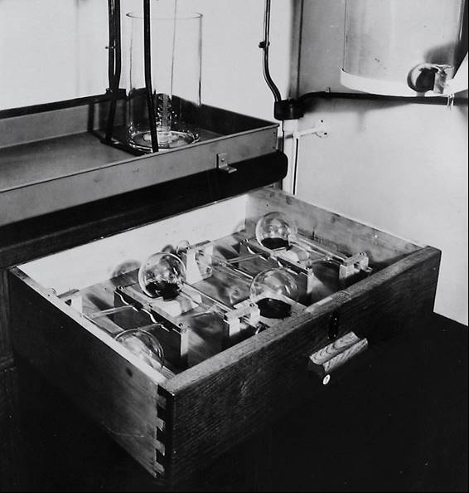

Photo 13. Drawer 5 showing two sets of sulphur apparatus (Lamp method – note Erlenmeyer flasks with wicks)

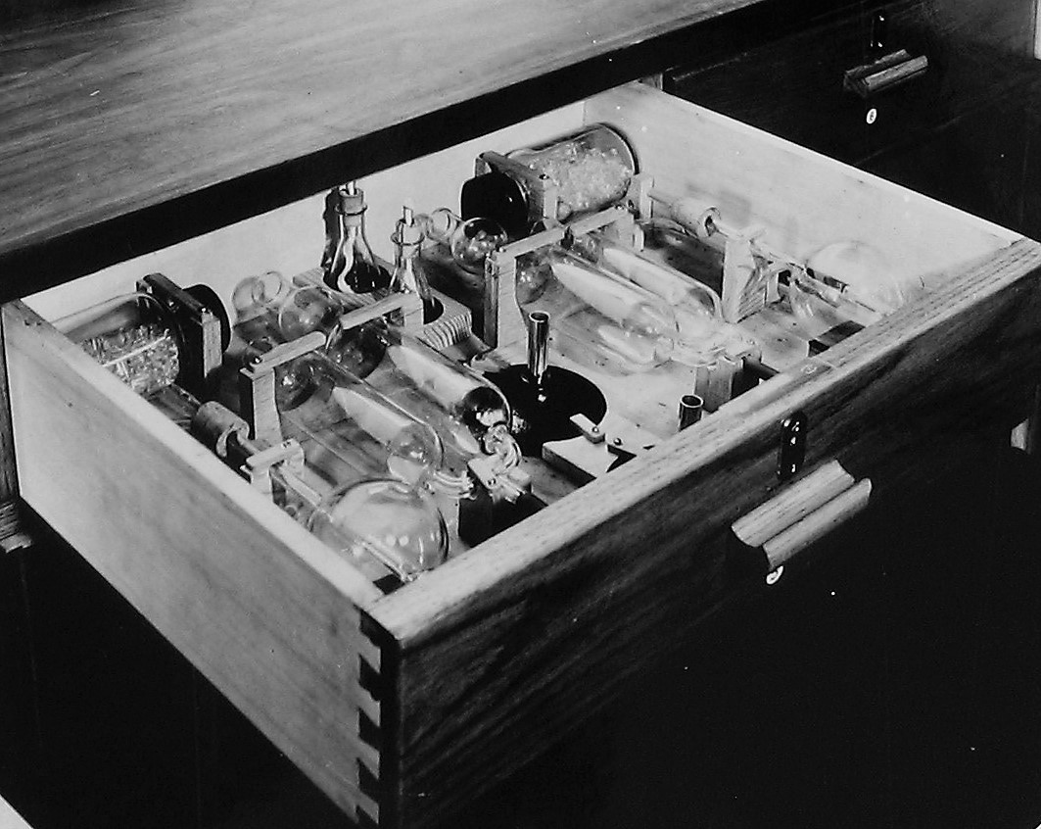

Photo 14. Cupboard C 12 showing general glassware

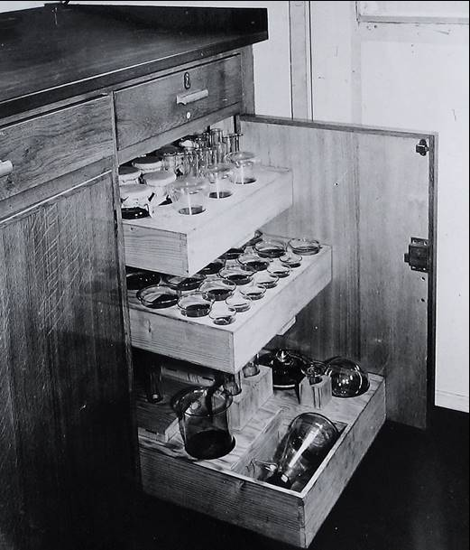

Photo 15. Drawer 9 showing saponification flask and condenser and accessories.

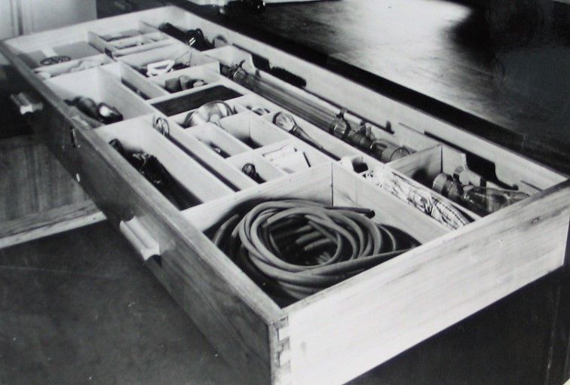

Photo 16. Cupboard C 14 showing packing arrangements for various equipment

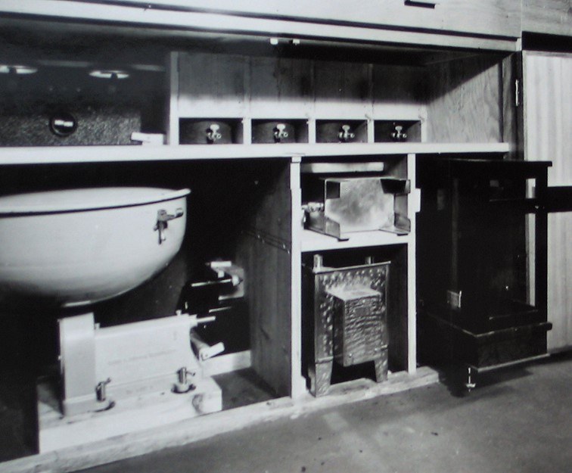

Photo 17. Electrically heated still and container (to produce distilled water)

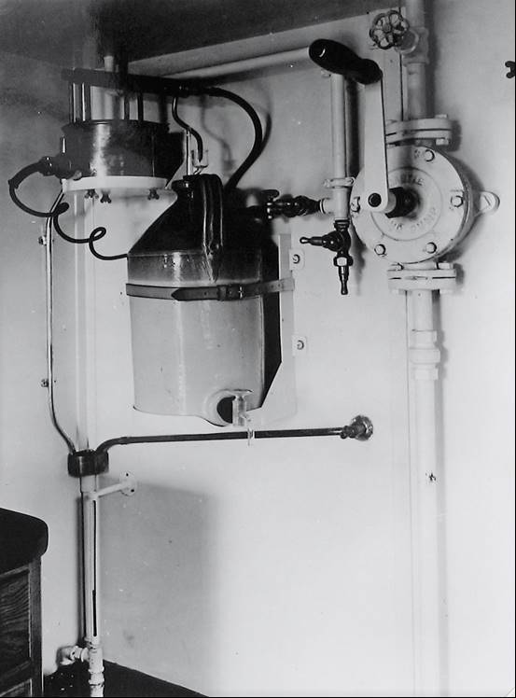

Photo 18. Cupboard C 16 storage of equipment

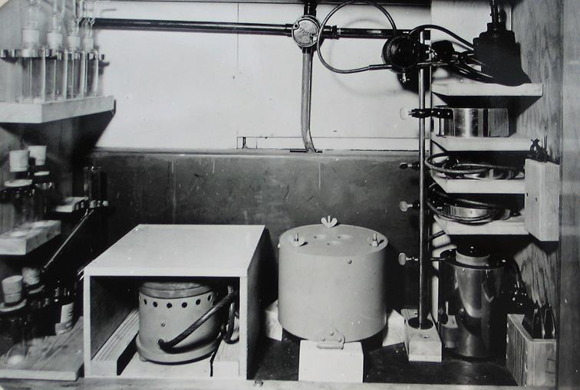

# Dispositions of MTOUSA Petroleum Products Laboratories

Appendix 4 - Dispositions of MTOUSA Petroleum Products Laboratories

930 QM PPL (Base) (Mobile Lab No. 4, 701st EPDU)

May- Sept 1943 Marrakech (French Morocco)

Oct 1943 - May 1944 Algiers (Algeria)

June -July 1944 Bastia (Corsica)

Aug 1944 - April 1945 Port du Bouc (Southern France) ETOUSA

931 QM PPL (Base) (Static Lab, 701st EPDU)

March - Sept 1943 Casablanca (Morocco)

Oct 1943 Algiers (Algeria)

Nov 1943 - April 1945 Bari (Italy)

932 QM PPL (Base) (Static Lab, 701st EPDU)

March - Sept 1943 Casablanca (Morocco)

Oct 1943 - March 1945 Algiers (Algeria)

April 1945 Naples (Italy)

942 QM PPL (Mobile) (2042nd later 2600th QM Lab)

April 1943 U.K.

May - Aug 1943 Oran (Morocco)

Sept 1943 - April 1944 Naples-Fertilia (Italy)

May 1944 - Dec 1944 Cagliari, Magdalena, Bastia, Sardinia Corsica

Jan 1945-April 1945 Naples (Italy)

943 QM PPL (Mobile) (Mobile Lab No. 3, 701st EPDU)

May 1943 – July 1943 Port Lyautey (French Morocco)

Aug - Oct 1943 Bizerte (Tunisia)

Nov 1943 – July 1944 Cerignola, Foggia, Manfredonia

Aug 1944 – April 1945 France 7th Army ETOUSA

944 QM PPL (Mobile) (Mobile Lab 703rd EPDU)

Jan 1944 – Dec 1944 Oran

Jan 1945 – April 1945 Foggia Area

945 QM PPL (Mobile) (organised in the theatre)

June 1944 – April 1945 Casablanca

946 QM PPL (Mobile) (Mobile Lab 705th EPDU)

May 1944 – April 1945 Naples

947 QM PPL (Mobile) (Mobile Lab No. 1, 702nd EPDU)

April 1943 Bizot (Algeria)

May - July 1943 Bizerte, Tunis, Ferryville

Aug – Sept 1943 Palermo (Sicily), Termini

Oct 1943 – June 1944 Naples

July – Aug 1944 San Stefano (Italy)

Sept 1944 – April 1945 Leghorn (Italy)

948 QM PPL (Mobile) (Mobile Lab No. 2, 702nd EPDU)

April 1943 Telergma (Algeria)

May - Oct 1943 Philippeville (Algeria)

Nov 1943 – Mar 1945 Bizerte, Tunis, Ferryville (Algeria)

April 1945 Algiers

949 QM PPL (Mobile) (Mobile Lab 704th EPDU)

Nov 1943 Oran

Dec 1943 – April 1945 Taranto (Italy)

# Operational Responsibilities of QM Petroleum Products Laboratories

Appendix 6 - Operational Responsibilities of QM Petroleum Products Laboratories

HEADQUARTERS MTOUSA

Petroleum Section APO 512 U.S. Army

Pet Lab 1/065 14 March 1945

Subject: Operational Responsibilities of QM Petroleum Products Laboratories

To: QM Petroleum Laboratories

1. Quality Control

Responsibility for the quality control of petroleum products in this theatre rests with Petroleum Section, MTOUSA. In conjunction with petroleum officers, petroleum laboratories constitute the chief agents by which this responsibility is implemented. Within their field of operations, the QM Petroleum Products Laboratories will carry out the program of quality control as laid down by the Petroleum Officers and in accordance with Petroleum Section directives. This will be accomplished by analytical and advisory reports as follows:

1. Routine control tests on bulk and packaged stocks at various stages during handling and storage in conformity with AFHQ and MTOUSA directives.
2. Identification of unmarked and erroneously designated products.
3. Identification of products suspected of being contaminated.
4. Recommendations with respect to:
   1. Disposal of stocks found to be below standard, contaminated or of enemy origin.
   2. Substitute products for use in emergencies.
   3. Other measures essential to the maintenance of efficient quality control.
5. Development and Intelligence
6. The QM Petroleum Products Laboratories will also engage in development and intelligence problems of the following types:
7. Investigations necessary to establish or confirm the equivalence of products.
8. The development of tests for possible contaminants.
9. The identification and study of enemy petroleum products including the examination of enemy POL depots.
10. Such problems will ordinarily originate in and be directed by this headquarters, but will be performed also upon request form the Petroleum Officer. In such case this headquarters will be informed and furnished a copy of the report.
11. Services to Others

The QM Petroleum Products Laboratories are authorised to act as consultants and to undertake special laboratory investigations on behalf of other arms of the Allied Forces providing these services do not prejudice the performance of the duties enumerated in I and II above. Copies of the reports rendered will be forwarded to this headquarters.

Signed G.H. Vogel, Colonel, QM

[Colonel Gustave Harold Vogel (ASN: 0-12793), United States Army, was awarded the Army Distinguished Service Medal for exceptionally meritorious and distinguished services to the Government of the United States, in a duty of great responsibility from 1945 to 1948. By 1954 he was a Brigadier General – Assistant Chief of Staff G-4 (Logistics)]

Distribution:

2 Each QM Petroleum Products Laboratories

4 AME

6 NA Service Command

12 S&T Branch, AFHQ

6 AFHQ Petroleum Section, S. France

1 AFHQ Petroleum Section, RAAC

3 AFHQ Petroleum Section, Azores

1 AFHQ Petroleum Section, N. Africa

1 AFHQ Petroleum Section, Greece

2 Fifth Army (Rear), Petroleum Officer

1 PBS (Main), Petroleum Officer

1 PBS (South), Petroleum Officer

1 Adriatic Base Group, Petroleum Officer

3 AAFSC/MTO, Petroleum Officer

2 File

# Quality Control of Fuels

Appendix 7 Series of 1945 P.T.B. No. 6 PETROLEUM TECHNICAL BULLETIN No. 6 (Quality Control Section) “QUALITY CONTROL OF PETROLEUM FUELS” Issued by Petroleum Section, MTOUSA 1 April 1945

Table of Contents

Part I. Quality Control Charts

Notes of use of Quality Control Charts:

1. Scope
2. Choice of Tests
3. Arrangement of Charts
4. Definition of Terms Employed
5. Special Notes on Tests

Quality Control Charts

1. Aviation Fuels
2. Motor Gasolines
3. Kerosenes
4. Diesel Fuels
5. Fuel Oils (Tentative)

Part II. Quality Control of Tanker Cargoes

1. Scope
2. Tanker Cargoes from U.S., M.E. or other sources
3. Loadings for Shipment
4. Receipt of Intra-Theatre Cargoes
5. Information with respect to Cargo Quality

Part III. Contamination

1. Scope
2. Common Sources of Contamination
   1. In Bulk Storage
   2. In Pipelines
   3. In Drums
3. Detection and Disposal
   1. General
   2. Fuel, Grade 100/130, Aircraft Engine (ANA spec. AN-F-28, Amend. 1)
   3. Motor Fuel, All Purpose (U.S. Army spec. 2-103B, Amend. 1)
   4. Kerosene (Federal spec. VV-K-211a)
   5. Oil, Fuel, Diesel (U.S. Navy spec. 7-0-2 INT)
   6. Oil, Fuel, Boiler, Special, (U.S. Navy spec. 7-0-1 INT)

Part I. Quality Control Charts

Notes of use of Quality Control Charts:

Scope

The five “Quality Control Charts” which follow present the minimum testing program required for the quality control of fuels in this theatre. In this respect, they constitute directives. Inasmuch as the present minimum requirements they cannot be regarded as sufficient to safeguard the quality of products under all possible circumstances. In this respect they are guides, designed to provide evidence of the probable purity or possible contamination of products. It is the responsibility of the individual chemist to ensure strict quality control by increasing the frequency and/or the diversity of recommended tests as circumstances dictate.

Choice of Test

The tests chosen are those which:

Measure some essential characteristic of the product and hence are useful in determining whether it meets specifications sufficiently well to be usable;

Are most likely to discover ordinary contamination or deterioration in quality;

May yield some indication of sabotage (an eventuality which becomes increasingly important as enemy soil is approached).

The tests most frequently recommended are those which are considered to serve two or more of these purposes

Arrangement

Each chart deals with one type of product, in bulk and packaged form, and each is divided into four columns representing the four chief stages in quality control:

Acceptance Analyses:

The tests required under this heading are intended to provide a comprehensive knowledge of a product as it enters an area or after decantation from containers, and thus serve as a basis for planning its disposal.

Post-Discharge Tests:

The tests listed in Colum 2 are those most likely to indicate any contamination which may have occurred during pumping from ship to shore. Should evidence of contamination be observed, additional confirmatory tests may be required and their nature will be governed by circumstances. In any case, the effect upon the product will be evaluated and recommendations made accordingly. On the other hand, a satisfactory cargo discharged from a one-cargo ship through a one-product line into storage requires no “pose-discharge test”.

Storage Control Tests:

It is the responsibility of the chemist to keep himself thoroughly informed as to the characteristics of products in bulk storage under his supervision. The testing program will be such as to ensure that no product unfit for its intended use is issued except for specific purposes.

Pre-Issue or Shipment Tests

The procedures outlined in Column 4 are intended to ensure that products leaving one area are of sufficiently high quality for any use for which they may be required in another. If such is not found to be true then the receiving area will be so notified.

Part I Page 3

Terms Employed:

When used in the Quality Control Chart, the terms listed below possess a special significance and will be interpreted as follows:

Inspect Samples – To subject samples to visual examination.

Appearance – This term includes colour, the degree of clarity, and the water and sediment observed during the visual examination of samples.

Composite Samples

A representative sample of a product prepared from samples drawn from several containers. With respect to tanker cargoes, attention is directed to the fact that, in general, centre tanks are approximately twice as large as wing (port and starboard) tanks. In preparing composite samples from a batch of drums or cans, the composite will be made from a minimum of 1 drum/100 or 1 can/1,000. The actual number of containers included must depend upon circumstances and the discretion of the chemist but where time permits it is recommended that samples be drawn from not less than 4 drums/100 or 4 cans/1,000.

Dead storage

Product which remains in storage undisturbed, e.g. reserve stock.

Spot Check

The random choice of containers whose content are to be subjected to visual examination of analysis. In spot checking batches of packaged products for appearance, a minimum of 4 drums/100 or 4 cans/1,000 will be examined, particular attention being given to the contents of badly weathered or damaged containers. Circumstances and the discretion of the chemist must determine the actual number of containers examined.

Special Notes of Tests

All the tests listed in the Quality Control Chart will be carried out as nearly in accordance with the methods laid down in the latest available edition of the ASTM Standards on Petroleum Products and Lubricants as is practicable, unless otherwise directed.

Gravity

Both the API and the specific gravities will be recorded in written reports. The gravity of a sample from each ship’s tanks will be determined only when, in the opinion of the chemist, such determinations will assist if detecting contamination. Otherwise the number of gravity determinations made on a ship’s cargo will be governed by the number required to calculate product tonnage.

IPT Gum, existent

This determination will be made in accordance with method I.P. -38/44(T) which differs from I.P.-38/42(T) as reproduced in B.P.L. Circular No. 8 in that the large (9 cm) dish only may be employed. Other methods, such as ASTM D.381-36 and Gum Content of Gasoline by copper dish, may be used at the discretion of the chemist but in such cases the IPT Gum will be reported also.

Corrosion

The copper strip method will be employed for gasolines: 3 hours at 122OF (50OC).

Octane Rating

The octane rating of aviation fuel is a characteristic of the utmost importance and should be determined when practicable as a routine test. In cases where an aviation fuel is suspected and no CFR engine is available, a 1-gallon sealed sample will be sent by air with all pertinent information to either of the following for rating before issue:

931 Q.M. Petroleum Products Laboratory (Bari), APO 512

932 Q.M. Petroleum Products Laboratory (Algiers), APO 497

Furthermore, it is imperative that all Motor Fuel supplied to Army (combat) areas have octane number not less than 80 since combat vehicles engines are not designed to operate on fuel of lower rating. All stocks of this fuel (bulk and packaged) destined for use in combat vehicles will be subjected to octane rating tests.

Pour Point – (Diesel Fuels)

Diesel fuels of Middle East origin have, in general, a considerably higher pour point (plus 10 to plus 20) than those of U.S. origin (minus 5 to plus 5) and are not suitable for use in combat vehicles operating in extremes of cold, i.e. atmospheric temperatures of +15OF or below, therefore the pour points of Diesel Fuel stocks must be known.

Compatibility (Fuel Oils)

The mixing of the British Admiralty fuel oil, “Bunker C”, with Oil, Fuel Boiler, Special Grade (Navy Special) frequently causes the gradual precipitation of a very undesirable asphaltic sludge. Where such addition is contemplated a compatibility, test will be performed in advance, as follows: a sample of each oil and one prepared by mixing equal volumes of the two oils are held at 212OF (100OC) for 12 hours; B.S. and W (Bottoms, Sediment and Water) is then determined on each sample and that of the mixture is compared with those of the individual oils. If the former exhibits a noticeable increase in sludge over the latter, the two fuels should not be mixed.

QUALITY CONTROL OF FUELS Quality Control Chart – A. Aviation Fuels

|  |  |  |  |  |
| --- | --- | --- | --- | --- |
|  | 1. Acceptance Analyses | 2. Post-Discharge Tests | 3. Storage Control Tests | 4. Pre-Issue or Shipment Tests |
| Bulk | Sec. 1. Before pumping: Inspect samples from each of ship’s tanks for:   * 1. Appearance and determine the   b. Gravity of each (See Sec. 5.) | Test representative samples one from each shore tank into which product has been discharged, for:   1. Appearance 2. Gravity 3. Distillation 4. IPT Gum, Existent 5. Octane rating, ASTM-Motor Method | No dead storage to remain without test longer than 6 months. If not tested within this period test representative sample of tanks as per Column 1, Sec. 2. and determine Oxidation Stability | Sec. 1. Before dispensing to drums of cans, or issue to tank trucks or rail tank cars, or discharge to pipelines:  Test representative sample of bulk storage tanks as per Column 2, plus carrion; and for disposal to packages, plus Oxidation Stability if stock has been in storage for 4 months |
| Sec. 2. Test composite sample of ship’s tanks for:   1. Appearance 2. Gravity 3. Distillation 4. Vapour pressure 5. IPT Gum, Existent 6. Octane rating, ASTM-Motor Method 7. TEL Content 8. Corrosion | Sec. 2. After discharge to tankers:   1. Inspect samples from each of the ship’s tanks as per Column 1, Sec. 1. 2. Test composite sample of ship’s tanks as per Column 2, plus corrosion |
| Packaged | After product has been decanted for turnover or from containers no longer suitable for use: Test representative sample of tanks as per Column 1 Sec. 2. plus Oxidation Stability |  |  |  |

QUALITY CONTROL OF FUELS Quality Control Chart – B. Motor Gasolines

|  |  |  |  |  |
| --- | --- | --- | --- | --- |
|  | 1. Acceptance Analyses | 2. Post-Discharge Tests | 3. Storage Control Tests | 4. Pre-Issue or Shipment Tests |
| Bulk | Sec. 1. Before pumping: Inspect samples from each of ship’s tanks for:  a. Appearance and determine the  b. Gravity of each (See Sec. 5.) | Test representative samples one from each shore tank into which product has been discharged, for:   1. Appearance 2. Gravity 3. Distillation 4. IPT Gum, Existent | No dead storage to remain without test longer than 6 months. If not tested within this period test representative sample of tanks as per Column 1, Sec. 2. | Sec. 1 Before dispensing to drums of cans, or issue to tank trucks or rail tank cars, or discharge to pipelines:  Test representative sample of bulk storage tanks as per Column 1 Sec 2. |
| Sec. 2 Test composite sample of ship’s tanks for:  a. Appearance  b. Gravity  c. Distillation  d. Vapour pressure  e. IPT Gum, Existent  f. Oxidation Stability  g. Octane rating, ASTM-Motor Method  h. TEL Content  i. Corrosion | Sec. 2 After discharge to tankers:   1. Inspect samples from each of the ship’s tanks as per Column 1, Sec. 1 2. Test composite sample of ship’s tanks as per Column 1. Sec. 2. |
| Packaged | After product has been decanted for turnover or from containers no longer suitable for use: Test representative sample of tanks as per Column 1 Sec. 2. plus Oxidation Stability |  | After 4 months storage:  a. Spot check container contents for appearance.  b. Test composite sample of each batch as per Column 1, Sec. 2. |  |

QUALITY CONTROL OF FUELS Part I. Page 7. Quality Control Chart – C. Kerosenes [Refer to source]

QUALITY CONTROL OF FUELS Part I. Page 8 Quality Control Chart – D. Diesel Fuels [Refer to Source]

QUALITY CONTROL OF FUELS Part I. Page 9 Quality Control Chart – E Fuel Oils [Refer to Source]

QUALITY CONTROL OF FUELS.

Contamination

2. Fuel, Grade 100/130, Aircraft Engine (AN-F-28, Amend. 2)

1. Octane Rating (Motor Method)

The “Performance number” is the most important single characteristic of this fuel. Unfortunately, no correlation exists between the quality as determined by the 3-C or rich-mixture rating and the octane number as determined by the motor method. Two fuels may have the same octane rating (MM) and different performance numbers, or different octane ratings and the same performance number. Furthermore, the data available are insufficient to establish definitely the effects of contaminants on the octane rating (MM) or the performance number. The data presented in the following tables are purely illustrative of the differences in effect caused by contaminants upon the two characteristics

|  |  |  |  |  |  |  |  |
| --- | --- | --- | --- | --- | --- | --- | --- |
|  | Octane No. (MM) | | | Performance No. | | | |
| Contaminant | Molo | Roso | Cano | Molo | Roso | Cano | 1100 |
| 0% | 100.1 | 100.1 | 100.1 | 132 | 132 | 130 | 130 |
| 1% |  | 99.2 | 99.3 | 130.0 | 123.2 | 127.0 | 125.8 |
| 2% | 99.5 | 98.9 | 99.0 | 127.3 | 117.2 | 124.5 | 123.5 |
| 3% |  | 98.3 | 98.7 | 123.5 | 114.5 | 122.5 | 122.0 |

93 different aviation fuels, 2 motor fuels, 2 kerosenes, 2 Diesel fuels, and one lube oil are represented in these results.)

The minimum acceptable octane rating (MM) for this fuel is 98.5, hence the determination by significant will not necessarily yield certain indication of contamination by significant quantities of kerosene or Diesel fuel. Stock having a rating below 98.5 will blend with good stock to yield a rating of 99.0 or better.

1. Colour

Colour comparison is matched Nessler tubes against prepared standards provides a satisfactory method for:

2% or more of Molo- The colour change consists initially of a cloudy appearance followed by a gradual fading of the green and the appearance of a faint pink as contamination increases; 0.5-1.0% SAE 10 or 30 (Lube Oil) – the neutral green exhibits a distinct yellow tinge;

0.1% Nave – this produces a muddy yellow appearance and 0.5% a definite blackening.

Using standards prepared from fresh uncontaminated stock it is possible to estimate the degree of contamination with reasonable accuracy. This test will be applied to each of the samples of ship’s tanks in the case of split cargoes of Fono and Molo.

1. Gum:
2. The IPT gum determination (oven-dried at 150OC) yields practically quantitative evidence of contamination by lube oils or Navo. It does not detect with certainty even 3% of kerosene, but does indicate with certainty anything more than 2% Diesel Fuel. If the residue from evaporation is carefully examined before being oven-dried, contamination with as little as 1% Diesel fuel can be detected by the presence of a tiny droplet of liquid and a characteristic odour.
3. The same determination is employed as a measure of the “existent gum” in an uncontaminated fuel. When first manufactured the fuel is said to have a safe storage life of 18 months; the gum content and its rate of increase are indications of the extent and rate of the aging process, respectively.
4. If the residue obtained is normal in appearance and odour and does not exceed 5mg./100ml the fuel is satisfactory for use or storage.
5. If the residue obtained is appearance and odour and is above 5mg./100ml the fuel is acceptable for prompt use in all aircraft (prompt use means within 1 month in hot and within 2 months in cold weather)
6. If the residue is definitely true gum (appearance and odour) and exceeds 10mg/100ml, the fuel is not acceptable for use in aircraft but, providing it passes the corrosion test, it may be blended with Molo and used in ground vehicles; such blends should contain not less than 80% of Molo in order to keep the TEL Content below 3ml/U.S. gal.
7. If the residue exceeds 10mg/100 ml but appears as a thin oil film possessing no varnish odour and exhibits definite evidence of the presence of lube oil or Diesel fuel, the fuel is acceptable for use in aircraft but only after it has been blended with sufficient low gum aviation fuel to reduce the IPT residue to 10mg/100ml or less; in judging the nature of the residue the chemist will consider the distillation end-point, its residue, and all other pertinent circumstantial evidence which may indicate the most probable origin of the evaporation residue.

d. Final Boiling Point (ASTM Distillation)

This characteristic had been found to yield valuable evidence of contamination with as little as 0.5-1.0% of Diesel fuel and 0.5% of lube oil or fuel oils. In the case of 0.5% Diesel fuel contamination, the distillation end-point is raised as much as 20OF; in most cases this produces a Final Boiling Point (F.B.P.) above the specified maximum of 356OF. Experience in this theatre indicates that the F.B.P. of aviation fuels normally lies below 350OF and a higher value should be regarded as cause for suspicion. With respect to contamination by lube oil and fuel oils, the F.B.P. obtained is definitely not a true end-point; an abnormal amount of cracking is observed and the distillation flask does not become dry. Contamination by 1.5-2.0% of kerosene is detectable by the high F.B.P. produced; lesser quantities may be indicated when a comparison is possible between distillation characteristics of the same stock with and without contamination.

e. Vapour Pressure

Used in combination with the ASTM distillation, this determination will detect the low volatility due to “Weathering” or the abnormally large addition of light ends sometimes employed to increase octane ratings. Aviation fuel is not acceptable if its vapour pressure falls below 4 psi or exceeds 7.5 psi. (Pressure gauge will be free of trapped liquid and 25% of the sample will be poured off immediately before filling the bomb sample chamber when performing this test).

f. Deterioration of Packed Stocks;

Normally the product has a safe storage life of 18-24 months and an oxidation stability (ASTM D525-42T) of 24 hours or more. Packaged stocks, which age more readily than bulk stocks, have been stored 6-12 months under desert conditions without marked deterioration. The ageing process is reflected chiefly by increase in “existent gum” content and decreased oxidation stability. Rarely, it may be accompanied by the decomposition of TEL and the precipitation of lead compounds. Packaged stocks of 100 octane fuel will be tested at least every six months. Stocks which are found to be clear will be recommended as suitable for a further six months storage providing: the octane rating is not less than 99, existent gum does not exceed 4mg/100ml; the oxidation stability (ASTM) is not less than 480 minutes; and the product meets specification for volatility and TEL content. Clear stocks not meeting these requirements will be recommended for decanting and upgrading by blending with fresh stock. If this is impracticable or if, in the opinion of the chemist, deterioration has proceeded too far, the stock will be recommended for down-grading for military or civil use in which it will be blended with not less than 80% of motor fuel.

Packaged stocks which show marked indications of TEL decomposition (haziness or turbidity will be carefully distinguished from products of container corrosion), will be recommended for decantation, settling and subsequent blending with sufficient high quality bulk stock to satisfy at least the minimum specification requirements. Should a filtered sample meet specification the product may be recommended for immediate used without decantation providing adequate means for filtration (chamois, or new type RAF streamline filters) are employed at refuelling points. If decantation is impractical and the filtered stock fails to meet specification, downgrading will be recommended.

1. Motor Fuel, All Purpose (U.S. Army Spec. 2-103B Amend. 1.)
   1. Colour

Colour comparison in Matched Nessler tubes against prepared standards will detect not much less than 15% of aviation fuel, but 0.5% of lube oil produces a yellow tinge in the red and the same contamination with Navo products a definite blackening.

* 1. Gum

1. Part III, Sec. C, sub-sec. 2, para. c (i) applies.

(a). As in the case of aviation fuels, the “existent gum” content and its rate of increase in uncontaminated fuel yield indications of the degree and rate of the ageing process, respectively. Motor fuel is designed to retain its high quality for 6 months of desert storage, 9 months under temperate conditions, and possibly a year in cold climates. The gum content and oxidation stability taken together provide an excellent basis for judging the safe storage life of the fuel. Normally, the fuel will not be packed into containers if the gum exceeds 4 mg/100ml and the stability is less than 480 minutes, though in emergencies it will be permissible to pack fuel with a gum content not exceeding 7mg/100ml providing the stability is not less than 360 minutes (approx. 4 months safe storage). Packed stocks will be retested at least once in four months:

(b). If the residue it true gum (appearance and odour) and does not exceed 7mg/100ml, the fuel is suitable for further storage; if the gum amounts to 5-7mg the product should be retested in 2 months unless its stability indicated a longer life:

(c). If the residue is true gum and amounts of more than 6mg/100ml but less than 15mg (the maximum for use in any vehicles), it will be recommended that the fuel be used within 2 months for civil or military (preferably non-combat) vehicles; if it is not so used it should be retested monthly irrespectively of its stability.

(d). If the residue is true gum and exceeds 18mg the fuel will be blended with high quality bulk stock to produce a product having less than 15 mg/100ml and consumed as quickly as possible in civilian or military (preferably non-combat) vehicles. It will be retested monthly if it remains unused;

(e). If the residue oily, indicating the presence of Diesel fuel or lube oil, no satisfactory method is known to obtain more than a rough approximation of “true gum” content; the chemist will then depend on the stability determination as the chief criterion of remaining safe storage life.

(ii) In as much as gum formation is an auto-catalytic process, the interpretation of safe storage life from oxidation stability values is not simple. In general, it can be assumed that each 80 minutes of oxidation stability represents 1 month of safe storage. However, since the rate of gum increase accelerates with time, at very high stabilities (600 minutes or more) the correlation may be 60 minutes per month of storage while at very low stabilities (180 minutes or less) it may be 100 or 120 minutes per month of storage. The ratio of 80 minutes per month of storage is a suitable average for use but will require modification in extremes of climate.

(c). Final Boiling Point (ASTM Distillation)

The distillation end-points of motor fuel originating in the Americas vary from 350OF to 390OF. While no F.B.P. is specified for this product, experience justifies the suspicion of contamination if the end-point exceeds 390OF and if above 400OF, suspicion becomes a certainty. By these criteria 2% of kerosene will be suspected and 1% of Diesel fuel will be detected with certainty. Lube oils and Navo produce false end-points as they do with aviation fuel. In the case of Middle East motor fuels, the F.B.P. is usually within the range 350OF -370OF (Abadan Refinery) or even lower (Haifa Refinery) and the effects of contamination with kerosene of Diesel fuel should be marked.

1. Kerosene – Federal Spec. VV-K-221a

Flash point and initial boiling point are particularly useful in detecting the presence of gasolines. To be acceptable flash point must not fall below 100OF. If this occur, the volatile component may be partially removed by standing in bulk storage of more readily by aeration in vented tanks.

The smoke point is the most certain indication of the presence of diesel fuel; the distillation end-point may also be useful. The presence of more than 1% or 2% of Diesel fuel will preclude the use of the product for lamps. Colour is the most certain indications of the presence for fuel oils; distillation end-points and B.S. and W. will yield contributory evidence.

# Assessment of Enemy Petroleum Products in the Field

Appendix 9. Publication: Notes on the rapid determination and disposal of enemy P.O.L. - Field Examination

In any military operations there are inevitably ‘spoils of war’ or captured enemy equipment and supplies. One of tasks required by the chemist in the field is to quickly assess these captured petroleum stocks and determine their value and suitable use. The following notes explain the techniques used in the field for the rapid determination and disposal of enemy petroleum products. [Additional information has been included by way of explanation].

Notes on the rapid determination and disposal of enemy P.O.L. - Field Examination

1. The following notes are based mainly on information obtained from the British Mobile Laboratory which operated with the 8th Army in the Western Desert. Their experience on rapid recognition and disposal of enemy fuels and lubricants had been considerable. These notes are to be used in conjunction with this Section’s notes on “Testing under Active Service Conditions”. When considerable experience has been gained, field examination alone may often prove to be sufficient.

2. The first essential requirement in this connection is to make sure that full information as to the whereabouts on enemy P.O.L. dumps is immediately passed back to HQ by all units, and is then transmitted to the Chemical Testing Unit. Also, a general understanding must be reached that such dumps MUST NOT BE DISTURBED until chemical examination had been completed.

3. In the case of Bulk Installations previous intelligence will, in general, have fixed the locations. Chemical Units can then proceed there at once, along with the Engineering Reconnaissance Units responsible for the examination of the tankage.

Container dumps of fuels and lubricants, however, may be located anywhere, and it is essential that information as to their whereabouts be obtained as soon as possible. If the dumps were distributed as happened, for instance, in Tunisia, where the contents of the dumps were generally brought back to a control location, the labour of examination is considerably increased. The reason is that, once the stocks of specific grades have been broken up, it becomes necessary to examine almost every single drum or can. The German drums are, in general, fairly well split into grade stocks, but the markings on their containers leave much to be desired. If still stacked as left by the enemy, it may only be necessary to check a few cans or drums in each stack.

4. The principle to be adopted in the rapid survey of a dump of packed products, once certain initial experience has been gained, is that of COMPARISON with standard samples of the same grades, in the manner described below.

5. The party itself should consist of not less than THREE; one being a trained chemist and the others as assistant and a driver, who can soon be trained to fulfil their parts

6. The equipment required is as follows – it can be carried easily in a command car or other vehicle normally allocated to a Mobile Laboratory Unit.

Three (3) Barrel Keys – of any suitable construction; but with the ends shaped and hardened to take two sizes of bung-squares found on enemy drums.

Photo 19. Modern drum wrench bung opener (barrel key)

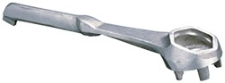

Three (3) glass sampling tubes – approximately ½” I.D. drawn out to ¼” at each end and about 2’6” overall length.

Two (2) metal sampling tubes - approximately 1” I.D. swaged drawn out to ¼” at each end, and with two strong extension wires welded at one end, protruding about ½” below that end to protect the bottom aperture, overall length 2’6”.

One dozen (12) one-gallon sample cans – for taking samples of unusual or unknown products.

Six (6) empty cigarette tins – for grease samples.

Two (2) “Thiefs” or “Tankoscopes”, as illustrated on sketch. [not included]

One set of Enemy Product, in test tubes, clearly marked as to grades, and nine-tenths full. Gasolines should be carried in bottles with ground stoppers, easy to open, but safe.

One dozen (12) empty test tubes – ½: dia. about 6” long.

Six (6) 25 cc glass beakers – for rapid gum determination in gasoline.

One wash bottle of distilled water and

Two (2) 100 cc graduated cylinders – for the checking of alcohol content of certain fuels.

Two (2) – 4” glass filter funnels and coarse filter papers to fit (funnels fluted if possible)

One pint of alcohol – for rapid gum determination in gasoline.

7. The actual procedure, and the allocation of duties between the three members of the team are, of course, a matter for each unit to work out for itself. The following items of procedure are to be carried out, how and in what order being left to the discretion of the chemist in charge.

(a) Rapid check on dump, using barrel keys as a hammer to find out which are filled and which are empty stocks.

(b) Opening of containers – If marking on majority of containers of a given stock is clear, e.g. “Oilo minerale semidense” or “Sondermotoren 01 T”, it will not be necessary to examine each drum or can.

Each container not clearly marked with grade, or from any unusual sources of supply e.g. when Refinery marks, etc. have not been encountered before, must be sampled. When in stocks of apparently identical containers, about five percent of the containers must be opened, sampled and checked. In the case of unusual material, take 1-gallon sample which will be sent back to the base mobile unit. There it will be divided into two equal halves, one for immediate test and one to be forwarded to Petroleum Section, A.F.H.Q.

(c) Sampling and Testing – Lube Oils

The glass sampling tubes are employed; the tube is lowered to the bottom corner of the drum or can, one finger being held tightly over the top of the tube and then removed momentarily to allow the tube to get filled up; the finger is then employed and the sample withdrawn and run into a test tube.

Testing is mostly visual inspection (colour, bloom, etc.) by the feel to ascertain that no drying compound was purposely added to the lube oil by the enemy, and by smell (with a little experience much can be done by means of the nose); also a quick viscosity test can be made by comparing the time of the rise of a bubble of air in the test tube, when reversed, with that in a standard sample of presumably the same grade. If traces of abrasive are suspected, dilute sample with an equal volume of clean gasoline and filter through coarse paper.

Fuels – In cases of bulk or packed FUEL supplies, the metal THIEF (for bulk) or metal tube (for packed) are used to obtain samples which are first identified visually, then re-checked in the laboratory. This check is of particular importance in the case of gas oils, for which a one-gallon sample should always be taken for further analysis. Italian Benzines (yellow)should always be checked for alcohol content, first by the nose, then by dilution with an equal volume of distilled water.

(d) Finally, a count is made of the dump, including that of empty containers in good condition.

8. The count of empty containers, and of filled containers classified by grades, and the disposal advice, are at once forwarded to the HQ Unit responsible, for instance the local Petrol office of the S & T Branch.

Disposal

9. The following information and instructions are to be taken as amplifying and amending those given previously in this section’s “Notes on Testing under Active Service Conditions” and the “Schedule of Equivalent Grades”.

10. As a general rule it is advised that captured enemy fuels and lubricants be utilized for the necessary minimum civilian use, in the captured territory, under the control of AMGOT (Allied Military Government for Occupied Territories) or similar body. Certain specific exceptions are mentioned below. All released for emergency military use will be made by chemical units at their own discretion.

11. Fuels – (German)

The two aviation grades – the green C3 and the blue B4 – have been described in the previous notes referred to in Para 9 above, and suggestions for their disposal is as follows:

(a) Preferred procedure should be to blend the green or blue aviation gasoline with the purple MT German gasoline in the proportions of 60% purple to 40% green or blue fuel, and dispose of the blend either for civilian consumption or for emergency military use in all U.S. or British wheeled transport.

(b) Second best method is to blend the green or blue aviation gasoline with yellow Italian Benzine, providing the latter does not contain alcohol, and providing it does not appear too gummy by visual observation and by smell (characteristic varnish odour). Proportions for blending consist of 33% Benzina to 67% aviation gasoline, and the blend should be used for civilian consumption only.

(c) In last resort, those blue or green aviation gasolines can be blended to a proportion not to exceed 25% with our own motor fuel for use in our military vehicles, in an emergency. It should be noted that the TEL content of these grades of German fuel average about 5.5 cc per imp. gallon, so that blending must be thorough.

The German MT fuel is usually coloured purple and consists of a blend of 33% benzole with 67% Roumanian straight-run distillate, leaded up with about 1 cc to give a 70-72 octane number (Motor Method). Some German MT fuel consists of a Roumanian base with 2 ½ cc TEL per imp. gallon and no benzole, the colour usually a bluish purple.

These grades of German motor fuel can be freely used in civilian vehicles, and in emergency the two purple grades can be used unblended in British wheeled transport. As mentions above, these two purple grades also form a means of disposing of stocks of high lead green or blue aviation gasolines.

German high speed Diesel Fuels may be either for Navy use (containers usually marked “Kriegsmarine Diesel” or "Kriegsmarine Gasol”), for the Army (a small orange or yellow F or flash on the drums) or for the German Air Force (WL-DK1 or WL-K1)

The Navy grade is a clear light brown fuel with a pink hue, or bloom, and phenolic odour. Specific gravity is about 0.85 and the Diesel Index is low, about 40. It is not suitable for military vehicles but can be used on stationary diesel engines or heavy civilian trucks.

The Army grade (D) is a pale yellow straight-run Roumanian distillate of approx. 0.86 specific gravity and 50-56 Diesel Index. In emergency it can be used for military automotive diesels but must not be used on submarines.

The DK1 Luftwaffe grade is a dark brown unstable fuel of 0.86 specific gravity and 45 Diesel Index – it can be used on heavy civilian trucks but would be better as a light fuel e.g. for British field bakeries.

The new Luftwaffe K1 grade is of good quality and can be used as a substitute for automotive diesel fuel in all wheeled vehicles.

Two grades of German Kerosene are known – a white variety (wasch petroleum) evidently used as a degreasing solvent and a red kerosene which is a somewhat heavy burning oil with rather variable flash point. The latter should be issued for civilian use only.

12. Fuels (Italian)

The Italian blue aviation fuel (Avio) corresponds to the German B4 but has no added benzole as is indicated by the lower gravity (0.73) as against 0.75 for the German fuel which contains about 25% benzole). Disposal should be as for the German B4.

The Italian brown MT fuels – Benzina – are without exception unsuitable for military transport and require a careful check on gum content before issue for civilian consumption. The nose usually gives a good indication of high gum content, for there is a characteristic varnish odour. A more accurate approximation of the gum content can be had by filling a 25-cc glass beaker with gasoline and evaporating it to dryness over the hot exhaust pipe of a car; then a few drops of alcohol will dissolve the residual gum. Even when the actual gum is not excessive, the benzina must be used up quickly (within 3 months) as it is apt to be very unstable. Benzinas marked “S.C.1” are normally alcohol blends and have a high octane number (about 90, motor method). The alcohol content averages 45% by volume.

The non-alcohol Italian benzinas can be used as blend stock to dispose of the green or blue aviation grades for civilian consumption as mentions above. Similarly, in real emergency, a non-gummy, non-alcoholic benzina can be blended with the green or blue aviation grades (67% of the aviation grade, 33% benzina) for blending in with red MT 80 octane gasoline for use on military wheeled vehicles.

Italian Diesel Oils are variously marked “Petrolina”, and “Gasolio” and vary very considerably in quality. There is one grade consisting of a 0.855 gravity straight-run Roumanian distillate with a Diesel Index of 54 which can be used on military transport in emergency. However, so much Italian gas oil contains cracked stock that utilization on military vehicles must not be advised until the nature of the material has been checked. A convenient method of approximate checking consists in exposing for 12 hours to the light and heat of the sun a test tube half filled with the Diesel fuel and to examine the amount of precipitated gum*. Much of it is only suitable for dust laying, anti-malarial purposes, or as a light fuel oil (e.g. field bakeries).

* This comes down as a black film on the walls of the tube.

Particulars of German and Italian Fuel Oils are lacking but in general such oils are only suitable for civilian use.

13. Lubricants (German and Italian)

These have been grouped together in tabular form since, with on known exception, they are all non-detergent lubricants and therefore normally unsuitable for use on military motor transport in this theatre (Mediterranean and North Africa). Certain grades are very suitable for railway use, and the remainder as a substitute for various grades in industrial use as indicated below:

Photo 20. German Me-110 refuelling in North Africa 1942

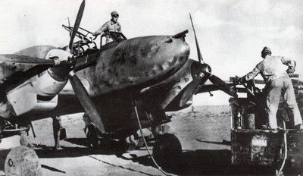

**German and Italian Lubricants**

|  |  |  |  |
| --- | --- | --- | --- |
| Industrial Class | German | Italian | Nearest American or British Grade |
| Light Spindle Oil (about 100 spindle) Vis. Up to 4°E @ 50°C or 260 SSU @ 100°F.  For ice machine oil set point not higher than -25°C | M G Oel  2.5°E @ 50°C or 125 SSU @ 100°F. | Oilo Minerale Incongelabile  2°E @ 50°C or 100 SSU @ 100°F.  and Oilo Minerale Incongelabile Fluido | Rifle Oil or British Oil “A” |
| Motor Oils for civilian use only as motor oils or for industrial movement oils SAE 10 | None | None | - |
| SAE 20 Light Move. Oil e.g. for dynamos and air compressors (Not ice machine) | Kriegsmarine Zd M1 | Oilo Minerale Fluido RA Vis. 122 Red 1 @ 140°F | M-120 Equivalent in Vis. To SAE 20 of 2-104A but without detergent |
| SAE 30 | Kriegsmarine Zd M7 and Motoreinheit | - | M-160 |
| SAE 40 | Motoren Oel T  Sondermotorenol T  Kriegsmarine Zd M2 & 3  Vis. 240 Red 1 @ 140°F | Oilo Semidenso and LEOIL  Vis. 203 Red 1 @ 140°F | M-220 |
| SAE 50-60 | Rotring  Intava Red Band  Aeroshell 100  Kriegsmarine Zd M4 & 6  Vis. 350 Red 1 @ 140°F | Oilo denso  Vis. 350 Red 1 @ 140°F  Oilo Utradenso Diesel Oil FT 45 (the latter being a detergent SAE 60)  Vis. 430 Red 1 @ 140°F | U.S. Navy Symbol 1100 or British M-400.  The German grades can be used as substitutes for M220 on British air cooled engines or as substitute for M-400 in gear boxes. |
| Cylinder Oil for Saturated Steam  Vis. 500 to 1500 Red 1 @ 140°F  Min flash 450°F | Getriebol Vario Rex  Vis. 700 Red 1 @ 140°F  Conradson Carbon may 8% exceed. | Olio 600C (Roman)  Oilo superdenso  Lubrivite  Oilo Interno di Macchine Marine (compound)  Vis. From 500 to 1500 Red 1 @ 140°F  Conradson Carbon below 3% | C-600 or Saturated Steam Cylinder oil such as U.S. Navy Symbol 5150  6135 (compound) |
| Cylinder Oil for Superheated Steam  Vis. 700 to 1000 Red 1 @ 140°F  Min flash 550°F | None Suitable  (Paraffinic stock, identified by lighter gravity for identical viscosity, is preferable to Naphthenic stock. In this case max. gravity to be 0.900 or 24 API.) | | - |
| Locomotive Engine and Car Oils | Use any of the SAE 30 & 40 grades of motor oils described above.  The SAE 50-60 grades can also be used for car journals in hot weather. | | Locomotive Engine and Car Oils |

|  |  |  |  |
| --- | --- | --- | --- |
| Greases | FETT (in large wooden kegs or drums usually without marking)  Can be used in emergency for waterproofing vehicles for amphibious ops., grease slipways, etc.) | Grasso Consistente usually in 7 lb. cans | Grease GP Nos. 1 & 2 |
| Gear Oils  (Mineral Oil type or else compounded mineral grades) | Getriebeole  Getriebeol 18 (mineral gear oil of 90 SAE grade)  Dentoline Getriebeol (compounded gear oil of SAE 80 grade).  Getriebeol Vario Rex SAE 140 grade mineral gear oil | Lubrivite (heavy oil suitable for open gears)  Composto per Combi (SAE 140) (ditto) | M 400 British  No U.S. Equivalent since only hypoid grades are used (with additives). Civilian gear use only.  For use as steam cylinder oil, see above. |

NOTE: The Italian oils may be found in three grades

--- The blue arrow indicated the highest (also indicated by the word “FRECCIA”)

--- The blue strip indicates the second grade.

--- and no special mark for the lowest grade

# Laboratory Methods and Chemists during WWII

Appendix 12. Quarterly Inventory Report

The quarterly inventory report listed each item of laboratory equipment for each test method in use. From this report the test methods in use have been listed below.

The chemists developed new methods to investigate the properties and composition of gasolines.

As discussed earlier, new methods were developed for example, the need for a test method for fuel used in supercharged engines (such as the Rolls Royce Merlin), and the different requirement of the British and U.S. Army Air Force.

Traditionally the British used the U.K. Institute of Petroleum methods (now the Energy Institute), while the U.S. used the American Standard Test Methods (A.S.T.M.). Many were similar indeed ‘joint methods’ for example, Distillation of Petroleum Products A.S.T.M. D86-40 Distillation of Gasoline ‘Standard Test Method for Distillation of Petroleum Products and Liquid Fuels at Atmospheric Pressure’.

There were some U.K. methods which were adopted by the U.S. Army, for example, IPT Gum, existent method I.P. 38/44(T)

Some of the methods were tentative (T) as the chemists established new methods to respond to the changing demands and quality requirements of the petroleum products.

The test methods used by the U.S. Army in this period were as follows:

Test Methods

ASTM D4-27 Determination of Bitumen

ASTM D5-25 Penetration of Bituminous Materials

ASTM D36-26 Softening Point of Bituminous Materials

ASTM D56-36 Flash Point; Tag Closed Cup

ASTM D86-40 Distillation of Gasoline etc.

ASTM D87-37 Melting Point of Paraffin Wax

ASTM D88-38 Saybolt Viscosity

ASTM D90-41T Sulphur (Lamp method)

ASTM D91-40 Precipitation Number of Lube Oils

ASTM D92-33 Flash and Fire; Cleveland Open Cup

ASTM D93-40 Flash Point; Pensky-Martens Closed Cup

ASTM D94-41T Saponification Number

ASTM D95-40 Water in Petroleum Products

ASTM D96-40 Water and Sediment by Centrifuge

ASTM D97-39 Cloud and Pour Points

ASTM D127-30 Melting Point of Petrolatum

ASTM D128-40 Analysis of Grease

ASTM D129-30 Sulphur by Bomb

ASTM D130-30 Free and Corrosive Sulphur

ASTM D158-41 Distillation of Gas and Fuel Oils

ASTM D165-27 Bitumen Soluble in Carbon Tetrachloride

ASTM D188-41T Neutralisation Number

ASTM D189-41 Conradson Carbon Residue

ASTM D216-40 Distillation of Natural Gasoline

ASTM D217-38T Consistency of Grease and Petrolatum

ASTM D243-36 Residue of Specified Penetration

ASTM D270-33 Sampling

ASTM D287-39 API Gravity

ASTM D322-35 Dilution of Crack-Case Oils

ASTM D323-41 Reid Vapor Pressure

ASTM D357-41T Octane Rating

[Waukesha CFR Engine for Motor method with equipment for conversion to 1-C Method ASTM D614-42T]

ASTM D381-36 Gum Content of Gasoline

ASTM D402-36 Distillation of Cut-back Asphalts

ASTM D445-39 Kinematic Viscosity

ASTM D525-41T Gum Stability of Gasoline

ASTM D565-41T Tetra-Ethyl Lead in Gasoline

ASTM D611-41T Aniline Point

IPT 3/42 Aromatic Content

IPT 9/42 Bromine Number

IPT 38/42(T) Existent Gum in Gasoline

IPT 57/42 Smoke Point of Kerosene

# Free French Army - Services des Essences des Armees

In the memorandum by L.C. Jones he describes the French operation from the onset of World War II through to the formation of the Free French First Army and the subsequent various campaigns through the Mediterranean theatre to the liberation of France. [3]

This memorandum covers much of the material listed in a report “History of Service Des Essences” by Capt. Alfred Tibor Services Des Essences, June 1945 HS-AFHQ/696/2[4]. The contents of this report have been combined with the Jones memorandum.

The Jones memorandum is listed below:

Memorandum concerning Services des Essences des Armees.

* Its organisation
* Its liaison with AFHQ
* Its activity during the campaign

Services des Essences des Armees.

Index

1. Definition of the Services des Essences des Armees.

2. Organisation

a. After the Armistice of 1940

b. After the landing of the Allies in North Africa, November 8, 1942

c. Present organisation

3. Liaison and cooperation between the Services des Essences des Armees and the Petroleum Section AFHQ

4. Activity of the Services des Essences des Armees since November 8, 1942.

a. Its task in North Africa during the Campaign of Tunisia and in particular during the years of 1942-43.

b. Campaign of Italy

c. Campaign of Corsica

d. Campaign of France (Landing in Southern France)

e. Campaign of Germany (A special note covering this was to be forwarded at a later date).

## 1. Definition of The Services Des Essences Des Armees. (French Military Gasoline Supply Service).

The Service des Essences is the organisation which has the full responsibility of the supplying and the distributing of petroleum products for ground as well as for air and naval forces. (Excluding naval needs in specifically naval products such as fuel oils and special naval lubricating oils.)

The Service des Essences is directly under the command of the General Chief of Staff. However, its organisation takes care of the needs, in petroleum products, of all military departments.

Its directives are issued by the different G-4 of the corresponding headquarters: Army, Navy and Air Force. [G-4 = U.S. Military General Staff Level office for Logistics]

No other corps or service, either from the Army, Navy or Air Force, is entitled to take any part in the supplying or distributing of petroleum products (Excepting certain specific naval products).

The Service des Essences plans and operates storage depots and requisitions civilian depots and transportation facilities when necessary. The Service owns tank-cars and tank-trucks.

By contrast, use by the Service des Essences can be made of any needed civilian depots or transport facilities.

## 2. Organisation of The Service Des Essences

Before the Armistice of 1940:

During 1939 and 1940 the Service des Essences was attached to the “Direction des Poudres”. When this service became a civilian organization, the Service des Essences was transferred to the Navy Department.

1. After the Armistice of 1940:

(This refers to the surrender to the German forces and the partition of France into Occupied France under German military control and the southern part of France under the Vichy Government (Vichy France, formally French State, French État Français, (July 1940–September 1944), France under the regime of Marshal Philippe Pétain from the Nazi German defeat of France to the Allied liberation in World War II.)

During the earlier part of the war (1939-1940) the Service des Essences was attached to the “Direction des Poudres”. When this service became as civilian organisation, the Service des Essences was transferred to the (French) Navy Department.

After the Armistice of 1940, the Service des Essences became independent and during that period, set up a new organisation liable to meet a new mobilisation of its personnel.

After the discharge of the: “Armistice Army” in France in November 1942, the Service des Essences became “State Gasoline Supply Service” (Service des Essences de l’Etat) and was attached to the Ministry of Industrial Production. Part of the stocks and installations were hidden to keep them out of German control.

The mobilisation, being formed in North Africa so that it could be more easily kept out of German Control, was planned since 1942 and became effective a few months later.

b. After the landing of the Allies in North Africa November 8, 1942. [‘Operation Torch’]

The Service des Essences in North Africa became, after the landing, and as the new French Army was being formed; “Direction Generale du Service des Essences”.

At the same time, four directions were activated covering Algeria, Morocco, Tunisia and West Africa.

In order to meet the requirements of the French Expeditionary Corps which took part in the Campaign of Italy, and afterwards the needs of the French First Army engaged in the Campaign of France, a “Direction of the service des Essences” was set up and attached to the French Expeditionary Corps and later on to the French First Army.

In France, after November 1942, the “Armistice Army” was discharged. The Service des Essences became “State Gasoline Supply Service” (Service des Essence de l’Etat) and was attached to the Ministry of Industrial Production.

Part of its stock and installations were hidden and kept away from German control.

* Present organisation

The present organisation of the Service des Essences is as follows:

- Central Direction

This is one of the “Directions of the French War Office.

- Regional Directions

Regional Direction for Northern France

Regional Direction for Southern France

Regional Direction for Northern Africa

- Gasoline Supply Groups

Gasoline Supply Group for West Africa

Gasoline Supply Group for Libya

- Inside each Army

The representative of the Service des Essences is the head of the Services des Essences of this Army and this officer has several distributing Companies at his disposal to meet the requirements.

## 3. Liaison And Collaboration Between The Services Des Essences And The Petroleum Section A.F.H.Q.

As soon as the Petroleum Section of A.F.H.Q. was activated, early in January 1943, a liaison officer from the Directions du Service des Essences was accredited to represent the Service des Essences.

It seemed indispensable that a permanent contact existed between the Petroleum Section A.F.H.Q. and the Services des Essences for all questions regarding petroleum products for French military needs.

This permanent liaison developed into a complete collaboration between the two services for the best use of all available facilities. Detail of this collaboration will be given under paragraph 4.

a. In Africa:

When Petroleum Section, AFHQ (US Army Air Force HQ), was activated in January, 1943, it seemed essential that a permanent contact exist between the Petroleum Section and the Service for all questions regarding POL for the French military. An officer from the Directions du Service des Essences was accredited to Petroleum Section to represent the Service. A permanent liaison developed between the two services for the best use of all available facilities.

b. In Italy:

An officer of the Service was attached through Petroleum Section to the 5th Army for the invasion of Italy. He landed at Salerno during the first days of the invasion. His special mission was to enter Naples with the first Allies troops and make a quick and complete survey of the petroleum installations. He was ordered particularly to examine the Naples Refinery whose utilization by the Allied Forces was urgently and quickly needed.

c. In France:

When the Allied landings in Southern France were in the planning stage, an officer of the Service des Essences was assigned to the Plans Branch of Petroleum Section. He worked in close collaboration with other Allied officers and prepared all the plans in connection with the needs in petroleum products for this operation.

The Petroleum Section set up its organisation for Southern France at the time, and a mixed staff was formed with American and French Officers and enlisted men. The French contingent was set up with Officers and enlisted men from Directions du Service des Essences.

A complete and friendly collaboration was created which greatly helped in the very difficult and complicated task represented by the supply of petroleum products for the armies advancing rapidly northward and also the French civilian and Territorial Army needs as well as those of Navies and Air Forces.

## 4. Activity of The Service Des Essences Since November 8, 1942.

a. Activity of the Services des Essences I North Africa during the Tunisian Campaign and in particular during the years 1942-1943.

Before 1942

The Services des Essences already had at its disposal the following installations:

MOROCCO

Roches Noires- Casablanca

Meknes – A tank farm under construction

Fez Babftou

ALGERIA

Perregaux

La Chiffa

Colomb-Bechar. A tank farm under construction

Oued Kerberit

TUNISIA

Photo 21. U.S. crew of an M3 Lee tank at Souk el Arba 23 November 1942.

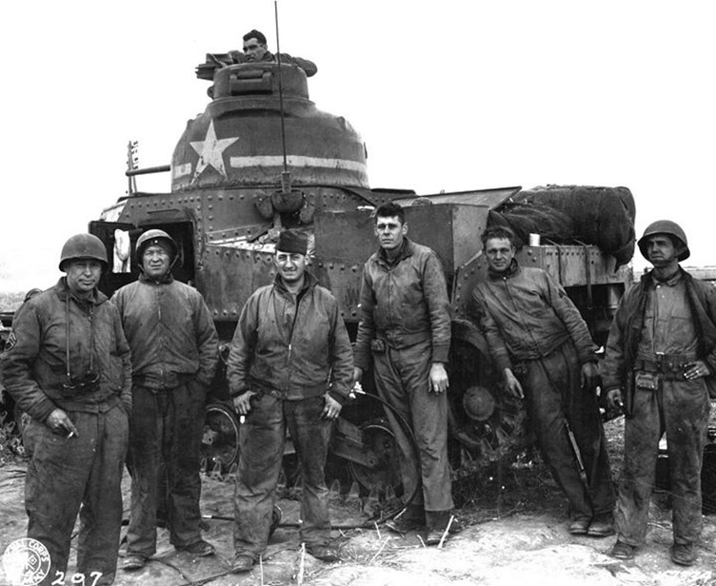

Souk el Arba [The Souk-el-Arba Airfields are a pair of World War II military airfields in Tunisia in 1943, located near what was at the time the village of Souk-el-Arba but since 1966 has been known as Jendouba. The location is approximately 130 km west-southwest of Tunis.

Grombalia

Moreover, the Services des Essences had signed contracts with civilian interests for the use of civilian facilities for the importation of its products.

After November 1942

# French POL Companies

With full aid of civilian firms obtained by requisition on the 18th of November 1942, the Service des Essences built up over the whole of the French Africa Territory installations, and was able, in the fullness of its activity, to handle as much as 150,000 barrels per month. Existing stocks in the Service des Essences depots were turned over to the Allied Forces (in particular those situated in the “Department de Constantine” in Tunisia) and had a large influence in the success of the Tunisian Campaign.

The organisation of a French Army (8 Divisions in North Africa) has caused the Direction of the Service des Essences, created anew at Algiers, to build up this army and of the French military organisation in North Africa.

At the beginning of 1943, the Service des Essences obtained the privilege of mobilising for its own services, all the petroleum technicians in North Africa.

With the help of the above mentioned measures, and the complete collaboration of the petroleum industry, the Service des Essences was able to organise and set up the necessary companies to complete its task.

Nine Companies were created.

Eight of them under Quartermaster Gasoline Supply Company (T.O. 10-77), but the French companies were differently organised.

a. Five companies with four transportation Sections each, instead of two in the T.O. 10-77. In addition, these five companies were activated each with a special section equipped with all the necessary facilities for the operations of bulk installations. They were called: “Compagnies mixtes d’Exploitation et de Ravitaillement” – (Strength 372 men)

b. Three companies with four transportation sections call “Compagnies de Ravitaillement” – (Strength 247 men)

One company, which was activated under the T.O. 5-327 of the Engineer Petroleum Distribution Company.

One of the first companies (704th) also had a special technical Section attached. This section was created with petroleum technicians and the necessary equipment to be used for rehabilitation and repair of bulk petroleum installations and construction of pipe-lines.

Several other territorial companies were activated for the distribution of petroleum products for military needs in North Africa.

A mobile laboratory was also created with necessary equipment obtained from different petroleum laboratories in North Africa.

This laboratory was attached to the French Expeditionary Forces, Services des Essences participating in the Italian Campaign and later, in the Campaign of France and Germany as one of the petroleum laboratories of the 6th Army Group [The Sixth United States Army Group was an Allied Army Group that fought in the European Theatre of Operations during World War II. Made up of field armies from both the United States Army and the French Army, it fought in France, Germany, Austria, and, briefly, Italy. Also referred to as the Southern Group of Armies, it was established in July 1944 and commanded throughout its duration by General Jacob L. Devers.]

The Services des Essences, in order to facilitate the transportation of petroleum products in bulk, organised a special transportation service with tank trucks normally used for the transportation of wine.

By the above measures, the Services des Essences was able to fulfil its tasks:

- During the Tunisian Campaign, with reduced means

- During the Italian Campaign, with four Supply Companies

- Since the landing in France, with nine Supply Companies, one of which being a pipe-line Cy.

During the same period, several of the Services des Essences installations were being used for the Allied Common Pool.

The Services des Essences also managed the Gasoline Supply Transit Centre of Philippeville for the account of the Supply and Transport Division.

In collaboration with Petroleum Section A.F.H.Q. and E.B.S. proceeded to the construction of the bulk terminal at Ouled Rahmoune, during the Tunisian Campaign.

The Service des Essences also sent a technical Section to Tunis for the rehabilitation and repair of bulk installations at Bizerte and Tunis in collaboration with D.S. and T. (Division Supply and Transportation).

b. Italian Campaign

The French Expeditionary Forces participating in the Italian Campaign was first formed with two Divisions. The Direction of the Service des Essences of the Expeditionary Forces had at its disposal at the beginning of the campaign, two companies:

- Company 703 which landed in Italy December 1st 1943,

- Company 704 which landed in Italy December 21st 1943.

Some elements of the Services des Essences attached to Base 901 and whose job was to collaborate very closely with POL Branch of Peninsula Base Section, landed in Italy on the 18th and 19th of December 1943. As soon as they arrived, they immediately started to be operational in supplying the French units upon landing.

First part of the Italian Campaign. Winter 1943-44

During this period of the campaign, the Service des Essences functioned in the following manner:

A. The Direction of the Services des Essences of the French Expeditionary Forces maintained its liaison with the 5th Army, through a petroleum officer attached to the 5th Army. [The 5th Army was led by Lt. General Mark W. Clark]

B. This Section attached to Base 901 had Headquarters at Naples near the Petroleum Officer of P.B.S. and worked in closed cooperation with him.

C. Company 704 was attached to the Base and functioned in P.B.S. territory.

D. Company 703 was attached to the Fifth Army – the French Expeditionary Corps being part of the 5th Army.

E. The technical section of 704 was first used for repairing Naples Refinery tank farm and was later on attached to an American petroleum distribution company to help construct the Naples-Cassino pipe-line.

Second part of the Italian Campaign. Spring and early Summer 1944

(Fall of Rome and offensive which brought the Allies up to Leghorn and Sienna).

The French Expeditionary Forces at the time has a total strength of 4 Divisions. The Service des Essences was also reinforced by the arrival, first of Company 702 and later Company 713.

During this part of the Campaign, companies were attached as follows:

- 5th Army – French Expeditionary Corps

Companies 702 and 703 and later on Company 713

- Peninsula Base Section – Base 901

Company 704

The technical Section attached at that time to Company 713 was used first for the construction of the pipe-line between Piombino and Grosseto and after for the rehabilitation of the Leghorn Refinery storage.

The way the Service des Essences performed its duties during the Italian Campaign can well be illustrated by the following facts:

A. Citation to the Army Corps given by General of the Army Alphonse Juin, commanding the French Expeditionary Forces in Italy, to the Director of Services des Essences of the same forces.

B. Citation awarded to Company 703 by the General commanding the 5th Army for exceptionally meritorious ways in which this Company accomplished its duties in supplying forces of the 5th Army during the battle of Cassino.

C. Letter of congratulations address to the Service des Essences by the General Juin, commanding the French Expeditionary Forces dated Feb. 18, 1944.

c. Corsican Campaign

Aa special survey mission of Directions of the Service des Essences was attached to the Forces which first landed in Corsica. This mission was able to obtain very valuable information in connection with conditions of the POL installations of the island.

Between November 1943 and August 1944 AFHQ Petroleum Sections and Directions of the Services des Essences sent combined representatives on many missions to Corsica to survey, study, develop and inspect POL facilities on the island.

Indeed, a very complete system of POL facilities were developed on the island consisting of bulk terminals, pipe-lines, etc. which enabled Corsica to be used as a very important military base during operations of:

- The defence of the Anzio beachhead

- The liberation of Rome

- The offensive toward Leghorn and Sienna,

- The invasion of Southern France

Director General Service des Essences, through

- His direction in Corsica,

- Company 701 stationed on the island from December 1943 to August 1944,

- Company 720, from August 1944 to January 1945,

greatly contributed to the common effect.

1. Between November 1943 and January 1944, the Service des Essences, and particularly Company 701 was the common pool stock holder of POL products in Corsica until the arrival of NORBS [U.S. Army Northern Base Section].

2. One section of Company 701, reinforced by technicians of the Territorial Army cooperated on the construction of pipe-lines and the construction of bulk terminals at Ajaccio, Calvi and Bastia, and operated the Calvi terminal and the pipe-line between Calvi and Sainte Catherine.

Company 701 operated for the common pool the bulk terminal a of Ajaccio and different package depots on the island in collaboration and under the supervision of Petroleum Officer NORBS from August 1944 to January 1945.

d. Invasion of Southern France

With the French First Army, the Service des Essences engaged during the Campaign of France all its available forces. None gasoline companies activated under the French Rearmament Plan were engaged:

- Companies 701, 703, 704, 705 and 713 (Compagnies mixtes d’exploitation et de Ravitaillement)

- Companies 702, 711, and 712 (Compagnies de Ravitaillement)

- Company 720 (Compagnie de distribution de carburant)

Landing in France of the Services des Essences and its units took place on the following dates:

- Two detachments of Companies 704 and 705 landed in St. Tropez on August 16 (1944) with the First French Units landing on the beaches. At the same date, and with the two detachments, landed also the first elements of the French base.

- Companies 701, 702 and 704, between August 16 and 31.

- Companies 703 and 713 in September and early October.

- Companies 711 and 712 in October.

- Company 702 was transferred from Corsica early in January 1945.

The first month, as far as the Services des Essences was concerned, was a very critical one due to the long line of communications resulting in the quick advances of Allied Forces toward the north.

The Direction of the Service des Essences of the French First Army reached Besançon on September 21, 1944. [Besançon is a city in eastern France, near the border with Switzerland]

Liaison with the American Supply organisation and the U.S. 7th Army was obtained as follows:

1. As long as the French First Divisions were part of the 7th Army, through liaison office of the Service des Essences attached to the 7th Army,

2. After Sixth Army Group was activated with the 7th Army and French First Army, liaison was mainly established through the supply services CONAD and DELTA BASE SECTION. Each American base had a corresponding French base attached to it (Base 901 and Delbase 901) and in each base; the Service des Essences had its own petroleum officer and corresponding organisation.

The French First Army supplied during the whole Campaign of France through the Mediterranean ports and through Petroleum Section A.F.H.Q. (S.F.) [Southern France]

The different gasoline companies during the Campaign of France were distributed as follows:

- Attached to the bases, Companies 711, 712 and later 920 (Company 720 has been operating the pipe-line between Lyon and Macon).

- Attached to the French First Army, Company 703, in the region of Montbéliard and Altkirch, Company 701, in the region of Luxeuil, Plombiere [Plombières-les-Bains] and Remiremont.

The four other companies have been stationed around Besançon where the storage and filling facilities of the French First Army were concentrated.

# POL in Europe[5]

One of the important documents is from the histories of the U.S. Army in the Technical Services - THE QUARTERMASTER CORPS: OPERATIONS IN THE WAR AGAINST GERMANY by William F. Ross and Charles F. Romanus, in particular chapters on Quartermaster Class III A which deals with POL

Chapter VI LIQUID AND SOLID FUELS which covers POL Administration, Rates of Consumption, Decanting Operations, The 5-Gallon Can and Its Army Class III Home, and Solid Fuels.

Chapter XVIII SUPPLY OF FUELS AND LUBRICANTS IN THE ETO (European Theatre Operations) which covers Liquid Fuels, Intermediate POL Depots and New Ports, Consumption Rates, Solid Fuels, and POL in the Final Offensives.

Liquid and Solid Fuels

A plentiful and reliable supply of petroleum products was probably the single most vital factor in establishing Allied logistical superiority over the German Army. In large measure the Allied armies were carried to victory by the internal combustion engine and the fuels with which it operated. The ebb and flow of warfare across the western desert, as the British retreated from Libya to Egypt, and then advanced from El 'Alamein to Tunisia, could be correlated with the relative availability of gasoline supplies to Rommel and Montgomery. More specifically, as the American staff in London began its detailed BOLERO planning, the British War Office notified it that POL had comprised 67 percent of the daily tonnage for the campaigns in Egypt and Libya, a figure verified early in the Tunisian campaign. An American observer aptly summarized the importance of POL with the comment that "without petroleum products the war in North Africa could not be fought." When these statistics and observations are contrasted with the fact that in World War I the number of trucks operated by the entire U.S. Army was only one-third the number of horses and mules used for riding, draft, and pack purposes, the changing nature of modern warfare becomes apparent.

Petroleum Products Laboratories

The assembling of packaged POL reserves for OVERLORD began in the summer of 1943 at the POL depots. Since U.S. units in Britain used bulk gasoline except during manoeuvres, there was little turnover in these canned (jerricans) reserves. The cans therefore had to be checked for gum formation, a service that was at first performed by commercial laboratories. As the workload increased in the fall (Sept-Nov, 1943), the OCQM (Office of the Chief Quartermaster (ETOUSA)) ordered a mobile testing laboratory from Baird & Tatlock, Ltd., a London firm which had already made similar equipment for the U.S. units in the TORCH operation (invasion of North Africa 1942). Initially, this laboratory was manned by casual QM personnel. Meanwhile American equipment for the same purpose was under development, and a T/O&E (Table of Organization and Equipment) for a regular QM unit was authorized on 25th May 1943.

Two such units, minus equipment, arrived in the theatre in January and February 1944 and received training in the British-procured laboratory. In March 1944 these units were reorganized, each being split into a base and a mobile detachment under composite T/O&E 10-500.

Before D-day the U.S. equipment had arrived, and in mid-June the 926th and 927th QM Petroleum Products Laboratories (Mobile) were attached to the U.S. First and Third Armies respectively. These mobile detachments, designated FB teams on the composite T/O, were used in armies and advance sections of COMZ (Communications Zone) to test POL products for accidental contamination or sabotage, and to test captured OL for type and serviceability. The FB detachments, each with a strength of one officer and five enlisted men, were both operationally and administratively subordinate to their respective base detachments, sending POL samples to the latter for detailed analysis.

Base detachments, designated FA's, were used in ports and base sections to check the quality and water content of POL arriving by ship or pipeline, inspect bulk storage facilities, make detailed analyses of any POL product, and provide inspection service for all POL activities. Each FA detachment had a strength of two officers and ten enlisted men. Since the two detachments were often separated by distances of several hundred miles, the arrangement whereby FA detachments controlled FB teams had both administrative and technical disadvantages.

In July 1944 Brig. Gen. Robert M. Littlejohn (Chief, Quartermaster Service) pointed out to The Quartermaster General the advantages of the British-type laboratory. It was a completely mobile, self-contained, nine-man unit, yet capable of performing all the tests made by the standard U.S.-type base detachment. Unfortunately, the British were able to produce only a very limited number of these laboratories. The final U.S. troop basis included six FA and six FB units. After V-E Day, Colonel Talbot recommended that future POL laboratory equipment consist of augmented mobile detachments, able to move anywhere and to serve any headquarters. Experience in the theatre indicated that water contamination was a major problem for POL laboratories. Surprisingly little water was in the gasoline pumped ashore from tankers. Investigation showed that the water used as a seal to combat evaporation in commercial-type storage tanks often entered the pipelines, partly because of the inexperience of the operating personnel, and partly because such storage was not standardized, and even skilled operators needed special instructions on the characteristics of each installation. Rapid distribution of POL made it very difficult to trace such contamination even after it was detected. Rail tank cars and tank trucks were not drained off frequently enough, and spread the contamination. The problem was eventually solved by strict control at the source, including careful instruction of the gaugers at the tank farms. (Gaugers -the person who checks the level of liquid in the tanks)

Photo 22. Ship to Shore Petroleum Line. Tankers at Cherbourg after the Allied occupation were at first unable to tie at the dock.

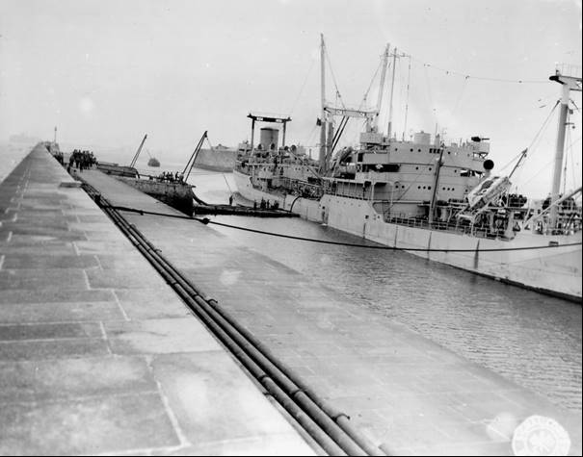

# Epilogue for Chemists of POL in WWII

Their epilogue is that of unsung heroes who kept and maintained the petroleum supplies to the armed services on the ground, on the sea and in the air to ensure an Allied victory over the Axis forces. New test methods were developed; the mobile petroleum laboratory came into existence; and co-operation and collaboration between allies (American, British and French) in ensuring continued supply of quality petroleum products. This would set a bench mark in handling petroleum products for future conflicts and lessons learned in North Africa and Southern France would be applied in the next major conflict Korea.

Recognition should be given to Major Donald D Mossman, Petroleum Section AFHQ of the U.S. Army for his foresight to record in detail the activities of the MTOUSA Mediterranean Theater of Operations, United States Army POL units.

# Index

1

100 octane fuel 39

15th AFSC, Bari 18

1-C (Lean Mixture) rating 13

1-C method 17

1-C Method ASTM D614-42T 48

1st Ind. HQ. NATOUSA 8

2

2032nd. 6

2600th QM 7

2686th 6

2nd Ind. HQ. SOS NATOUSA 8

3

3-C 37

5

5th Army 54, 55

6

6th Army Group 54

7

701-2 EPDU 13

701st 3, 5, 6, 8, 9, 17, 28

701st EPDU 3, 5

702nd 5

702nd EPDU 5, 6, 8, 9, 17, 29

703rd 6, 7

704th 6, 7, 29, 53

705th EPDU 6, 7, 29

785th EPDC 9

7th Army 6, 28, 56

8

80 octane gasoline 13

8th Army 6, 11, 40

9

930 QM PPL (Base) 28

930th 5, 6

931 Q.M. Petroleum Products Laboratory (Bari), APO 512 34

931 QM PPL (Base) 28

931st 5, 7, 9, 11, 12

932 Q.M. Petroleum Products Laboratory (Algiers), APO 497 34

932 QM PPL (Base) 28

932nd Base 7

942 QM PPL (Mobile) 28

942nd 7

942nd. QM Petroleum Products Laboratory (Mobile) 6

943 QM PPL (Mobile) 28

943rd 5, 6, 7

944 QM PPL (Mobile) 29

944th 6, 7

945 QM PPL (Mobile) 29

945th 6

946 QM PPL (Mobile) 29

946th 6, 7

947 QM PPL (Mobile) 29

947th 1, 5, 7, 19, 20

948 QM PPL (Mobile) 29

948th. 5, 7

949th 7

A

A.S.T.M. D86-40 Distillation of Gasoline 47

Abadan Refinery 40

Acceptance Analyses 33, 35

aeration 40

Aeroshell 100 45

Africa 51

ageing process 38, 39

Air Corps 5

Air Corps Service Command 10

Air Force 50, 52

Ajaccio 56

alcohol 43, 44

alcoholic beverages 11

Algeria 5, 29, 50, 52

Algiers 5, 6, 28, 29, 53

alien refugee 11

Allied Common Pool 54

Allied Forces 53

Allied liberation 50

Allies 49, 50

alloys 11

Altkirch 57

American Standard Test Methods (A.S.T.M) 47

AMGOT 42

Ancona, Italy 6

AN-F-28 37

anti-malarial 44

Anzio beachhead 55

appearance 33, 35, 36, 39

Armistice Army 50

Armistice of 1940 49, 50

Army 50

Army grade (D) 43

Army-Navy Petroleum Board 16

ASTM D127-30 Melting Point of Petrolatum 48

ASTM D128-40 Analysis of Grease 48

ASTM D129-30 Sulphur by Bomb 48

ASTM D130-30 Free and Corrosive Sulphur 48

ASTM D158-41 Distillation of Gas and Fuel Oils 48

ASTM D165-27 Bitumen Soluble in Carbon Tetrachloride 48

ASTM D188-41T Neutralisation Number 48

ASTM D189-41 Conradson Carbon Residue 48

ASTM D216-40 Distillation of Natural Gasoline 48

ASTM D217-38T Consistency of Grease and Petrolatum 48

ASTM D243-36 Residue of Specified Penetration 48

ASTM D270-33 Sampling 48

ASTM D287-39 API Gravity 48

ASTM D322-35 Dilution of Crack-Case Oils 48

ASTM D323-41 Reid Vapor Pressure 48

ASTM D357-41T Octane Rating 48

ASTM D36-26 Softening Point of Bituminous Materials 47

ASTM D381-36 Gum Content of Gasoline 48

ASTM D402-36 Distillation of Cut-back Asphalts 48

ASTM D4-27 Determination of Bitumen 47

ASTM D445-39 Kinematic Viscosity 48

ASTM D5-25 Penetration of Bituminous Materials 47

ASTM D525-41T Gum Stability of Gasoline 48

ASTM D525-42T 38

ASTM D565-41T Tetra-Ethyl Lead in Gasoline 48

ASTM D611-41T Aniline Point 48

ASTM D86-40 Distillation of Gasoline etc. 47

ASTM D87-37 Melting Point of Paraffin Wax 47

ASTM D88-38 Saybolt Viscosity 47

ASTM D90-41T Sulphur (Lamp method) 47

ASTM D91-40 Precipitation Number of Lube Oils 47

ASTM D92-33 Flash and Fire; Cleveland Open Cup 47

ASTM D93-40 Flash Point; Pensky-Martens Closed Cup 47

ASTM D94-41T Saponification Number 47

ASTM D95-40 Water in Petroleum Products 47

ASTM D96-40 Water and Sediment by Centrifuge 47

ASTM D97-39 Cloud and Pour Points 47

ASTM distillation 38, 40

auto-catalytic process 40

automotive diesels 43

aviation fuel 37, 38, 39, 40

aviation gasoline 3, 43

Avio 43

B

B4 43

Baird and Tatlock 5, 18, 58

Bari, Italy 5, 6, 12, 28

Barrel Key 41

Base 901 54, 57

Base Lab 3

Base Lab Circulars 12

Base Laboratory 16

Base Section Petroleum Officers 10

Bastia 28, 56

Benzina 43

benzole 43

Besançon 56

Bizerte 28, 29, 54

Bizot 29

Bolero 57

bomb sample chamber 38

Bone 6

Bottoms, Sediment and Water 34

British 43, 59

British Admiralty fuel oil 34

British Army 5, 6

British field bakeries 43

British laboratories 12

British M-400. 45

British Mobile Laboratory 40

British Oil 45

British RASC laboratories, 16

British War Office 57

bulk gasoline 57

bulk petroleum installations 53

bulk storage 58

bulk terminals 55

Bunker C 34

C

C3 43

Cagliari 28

Calvi 56

Camp Claiborne 5

Campaign of Corsica 49

Campaign of France 49, 50, 54, 56, 57

Campaign of Germany 49

Campaign of Italy 49, 50

Campaign of Tunisia 49

Cano 37

Capt. Alfred Tibor 3, 49

Casablanca 5, 6, 28, 29, 52

Cassino 55

centrifuge tubes 23

Cerignola 28

CFR engine 9, 13, 14, 16, 17, 34

chamois 39

Charles F. Romanus 57

Cheltenham 5

Chemical Testing Unit 40

chemicals 11

Cherbourg 59

Chief Laboratory Control Group 3

Chief Quartermaster 57, 58

coke test apparatus 23

Colomb-Bechar 52

Colour 37, 39

commercial laboratories 57

common pool 56

Compagnie de distribution de carburant 56

Compagnies de Ravitaillement 53, 56

Compagnies mixtes d’Exploitation et de Ravitaillement 53, 56

Company 701 56, 57

Company 702 55, 56

Company 703 54, 55, 57

Company 704 54, 55

Company 713 55

Company 720 56

Composite Samples 33

Composto per Combi 46

CONAD 56

construction of pipe-lines 53, 56

contamination 37, 38, 40, 58

corrosion 11, 34, 35, 36, 39

Corsican Campaign 55

cracked stock 44

cracking 38

Cylinder Oil 45, 46

D

Dead storage 33

degreasing solvent 43

Delbase 901 57

Delta Base 6, 56

Department de Constantine 53

depot stocks 10

diesel engines 43

diesel fuel 37, 38, 39, 40

Diesel Index 43

Direction des Poudres 50

Direction Generale du Service des Essences 50

Direction of the Service des Essences 52, 53, 54, 55, 56

Directions of the French War Office 51

distillation 35, 36, 47

Division Supply and Transportation 54

DK1 Luftwaffe grade 43

Drive-Mechanic 17

dusts 11

E

Egypt 6, 57

El 'Alamein 57

Electrically heated still 27

end-point 38, 40

enemy P.O.L. dumps 40

enemy petroleum products 40

Energy Institute 47

engine deposits 12

Engineer Branch, MTOUSA 15

Engineer Depots 15

Engineer Petroleum Distribution Units (EPDU) 5, 53

Engineering Reconnaissance Units 41

Engler distillation 24

EPDU Mobile Laboratories 18

État Français 50

ETOUSA 8, 28

existent gum 38, 39

F

Fall of Rome 55

FB teams 58

Fedala 5

Federal Spec. VV-K-221a 40

Ferryville 29

Fertilia (Italy) 28

FETT 46

Fez Babftou 52

filtration 39

Final Boiling Point 38

flash point 40, 43

Foggia 28, 29

Fono 37

France 11, 49

Freccia 46

Free French Army 3

Free French First Army 49

French Africa Territory 53

French Expeditionary Corps 50, 55

French Expeditionary Forces 54, 55

French First Army 50, 53, 56

French First Divisions 56

French Military Gasoline Supply Service 49

French Morocco 5, 28

French Naval Air Station 5

French Navy Department 50

French Rearmament Plan 56

Fruehauf semi-trailer, Model B-2 17

Fuel Boiler 34

fuel oil 38, 40, 49

G

G.H. Vogel, Colonel, QM 30

gasoline stocks 10

Gasoline Supply Group 51

Gasoline Supply Transit Centre of Philippeville 54

gasolines 40, 41, 47

Gasolio 44

gaugers 58

Gear Oils 46

General Chief of Staff 49

General Jacob L. Devers 54

General of the Army Alphonse Juin 55

generator 13

German Air Force 43

German Army 57

German B4 43

German Control 50

German drums 41

German fuel 43

German gasoline 43

German high speed Diesel Fuel 43

German Kerosene 43

German motor fuel 43

Germany 11, 54

Getriebeole 46

glass sampling tubes 41

Goering 3

Grade 100/130 37

Grasso Consistente 46

gravity 34, 35, 36

Greases 46

Grombalia 53

Grosseto 55

gum content 43

gum formation 40, 57

H

Haifa 13, 40

heavy burning oil 43

I

ice machine 13, 45

initial boiling point 40

Inspect Samples 33

Intava Red Band 45

IPT 3/42 Aromatic Content 48

IPT 38/42(T) Existent Gum in Gasoline 48

IPT 57/42 Smoke Point of Kerosene 48

IPT 9/42 Bromine Number 48

IPT gum determination 37

IPT Gum, existent 34

IPT Gum, Existent 35, 36

IPT Gum, existent method I.P. 38/44(T) 47

IPT residue 38

Italian Benzine 42, 43

Italian blue aviation fuel 43

Italian brown MT fuels 43

Italian campaign 13, 54

Italian Diesel Oils 44

Italy 51

J

Jendouba 53

jerricans 57

Joint Services Petroleum Laboratory Coordinating Committee 16

K

K-19 6

K-19 trailer 17

kerosene 37, 38, 40

Kriegsmarine Diesel 43

Kriegsmarine Gasol 43

Kriegsmarine Zd M1 45

Kriegsmarine Zd M2 & 3 45

Kriegsmarine Zd M4 & 6 45

Kriegsmarine Zd M7 45

L

L.C. Jones 49

L.C. Jones, Lieut. Comdr. USNR 4

La Chiffa 52

laboratory 58

Laboratory Control Group 4, 10, 12, 15, 16, 17

laboratory officers 5

laboratory technicians 5, 17

laboratory van 9, 13, 17

Le Service des Essences des Armees 4

lead compounds 38

Leghorn 29, 55

Leghorn Refinery 55

LEOIL 45

liberation of Rome 55

Libya 57

light ends 38

Light Spindle Oil 45

Locomotive Engine and Car Oils 46

low octane fuel 13

Lt. General Mark W. Clark 54

lube oil 37, 38, 39, 40, 42

Lubricants 44

Lubrivite 46

Luftwaffe 3

Luftwaffe K1 grade 43

Luxeuil 57

Lyon 57

M

M G Oel 45

M-120 Equivalent 45

M-160 45

M-220 45

M3 Lee tank 52

Macon 57

Magdalena 28

Major Donald D Mossman 3, 59

Manfredonia 28

Marrakech 5, 28

Marshal Philippe Pétain 50

Mediterranean 44, 49, 57

Mediterranean Theatre of Operations 5, 59

Meknes 52

metal sampling tubes 41

Middle East motor fuels 40

Ministry of Industrial Production 50

Mobile Lab 703rd EPDU 29

mobile laboratories 4, 5, 7, 9, 10, 13, 14, 16, 17, 18, 41, 53, 59

Molo 37, 38

Montbéliard 57

Montgomery 11, 57

Morocco 50, 52

motor fuel 37, 39, 40, 43

Motor Method 17, 35, 36, 37, 43, 44, 48

Motoreinheit 45

Motoren Oel T 45

MT 80 octane gasoline 44

MTOUSA 3, 5, 9

MTOUSA laboratories 7, 8, 10, 11, 14, 15

N

Naples 6, 12, 15, 28, 29, 51, 54

Naples Refinery 51, 55

Naples-Cassino pipe-line 55

NATOUSA - North African Theatre of Operations, United States Army 8

Nave 37

Navo 37, 39, 40

Navy 5, 43, 50

Nessler tubes 39

non-detergent lubricants 44

North Africa 44, 49, 50, 53, 57, 59

O

Occupied France 50

octane number 37, 44

octane rating 38, 39

odour 39

Oilo denso 45

Oilo Minerale Fluido RA 45

Oilo Minerale Incongelabile 45

Oilo Minerale Incongelabile Fluido 45

Oilo minerale semidense 42

Oilo Semidenso 45

Oilo Utradenso Diesel Oil FT 45 45

Operation Torch 5, 50

Oran 6, 14, 28, 29

Oued Kerberit 52

Ouled Rahmoune 54

OVERLORD 57

oxidation stability 35, 36, 38, 39, 40

P

Palermo (Sicily) 29

Paraffinic stock 46

Patton 3

Peninsula Base Section – Base 901 55

Performance number 37

Perregaux 52

Petrol, Oil, Lubricants 3

petroleum installations 51

Petroleum Officer 8, 9, 12, 15, 30, 31, 54, 56

Petroleum Products Laboratories 57, 58

Petroleum Section (Technical Branch), AFHQ 9

Petroleum Section AFHQ 3, 4, 5, 8, 9, 49, 51, 54, 57, 59

Petroleum Section Engineer, SOS 14

Petroleum Section, AFHQ 7, 8, 42, 51

Petroleum Section, MTOUSA 4, 30, 31

Petrolina 44

phenolic odour 43

Piombino 55

Pipe line Command 10

pipeline 54, 55, 57, 58

Piraeus, Greece 6

Plans Branch 51

Plombiere 57

poisoned candy 11

POL Branch of Peninsula Base Section 54

POL depots 57

POL laboratories 58

POL Section, Engineer Branch SOS, NATOUSA 9

Port du Bouc 28

Port Lyautey 5, 28

Post-Discharge Tests 33, 35

Pour Point – (Diesel Fuels) 34

power generator 9

Power Units 13

precipitation 38

Pre-Issue or Shipment Tests 33, 35

Q

QM Petroleum Products Laboratories 8, 30, 31

QM T/O & E 10-500 7

Quality Control Chart 32, 35

Quartermaster Class III A 57

Quartermaster Corps: Operations 57

Quartermaster Gasoline Supply Company 53

Quartermaster General 58

Quneitra‎‎, al-Qonayṭéra 5

R

Rail tank cars 58

Regional Direction for Northern Africa 51

Regional Direction for Northern France 51

Regional Direction for Southern France 51

Remiremont 57

residue 38

rich-mixture rating 37

Rifle Oil 45

Robert M. Littlejohn 58

Roches Noires 52

Rolls Royce Merlin 47

Rommel 3, 57

Roso 37

Rotring 45

Roumanian straight-run distillate 43

rubber waste 11

S

S & T Branch, AFHQ 12

sabotage 58

SAE 10 37

SAE 140 46

SAE 20 Light Move. Oil 45

SAE 30 45

SAE 40 45

SAE 50-60 45, 46

Sainte Catherine 56

Salerno 51

San Stefano (Italy) 29

saponification flask 26

Sardinia Corsica 28

semi-trailer vans 5

Service des Essence de l’Etat 50

Services des Essences 49, 53, 54, 55, 56

Services des Essences des Armees 49

Shell Company 5

ship 58

Sicily 5, 6, 11

Sienna 55

Sixth Army Group 56

smoke point 40

Socony-Vacuum 6

Sondermotoren 01 T 42

Sondermotorenol T 45

Souk el Arba 53

Southern France 6, 28, 49, 51, 52, 56, 57, 59

Southern Group of Armies 54

Special Grade (Navy Special) 34

special naval lubricating oils 49

Specific gravity 43

Spot Check 33

State Gasoline Supply Service 50

steam cylinder oil 46

Storage Control Tests 33, 35

storage tanks 58

store truck 6, 22

straight-run Roumanian distillate 44

submarines 43

sulphur apparatus 24

Supply and Transport Division 54

Switzerland 56

synthetic plastics 11

T

T/O & E 10-500 8, 9, 16

T/O & E 5-327 8

T/O 10-500 16

T/O&E 58

ASTM D56-36 Flash Point 47

tank farms 58

tank trucks 58

Tankers 59

Tankoscopes 41

Taranto (Italy) 29

Technical Branch Petroleum Section, AFHQ 11, 12

TEL 35, 36, 38, 43

TEL decomposition 39

Telergma (Algeria) 29

Territorial Army 52, 56

Theatre (Area) Petroleum Office 10

Theatre (Area) Petroleum Officer 10, 15, 16, 17

TORCH 58

Transportation Branch, Petroleum Section AFHQ 12

Tunis 29, 53, 54

Tunisia 5, 28, 41, 50, 52, 53, 57

Tunisian Campaign 53, 54

U

U.K. Institute of Petroleum 47

U.S. Army 3, 4, 5, 6, 9, 11, 14, 15, 30, 32, 47, 59

U.S. Army Air Force 47

U.S. Army Northern Base Section 56

U.S. Army Spec. 2-103B 39

U.S. Military General Staff Level office for Logistics 50

U.S. Navy Symbol 1100 45

US Army Air Force HQ 51

US Navy 5

U-tube viscometers 23

V

vapour pressure 35, 36, 38

varnish odour 43, 44

VE Day 12, 15

vegetable (edible) oils 11

Venice 6

Vichy Government 50

viscosity test 42

W

wasch petroleum 43

Water analyses 11

Waukesha CFR Engine 48

Waukesha Company 14

weathering 38

West Africa 50

Western Desert 40

William F. Ross 57

wines 11

WL-DK1 43

WL-K1 43

# References

1. By No 1 Army Film &amp; Photographic Unit, Silverside (Sgt) - http://media.iwm.org.uk/iwm/mediaLib//46/media-46967/large.jpgThis is photograph E 18640 from the collections of the Imperial War Museums., Public Domain, https://commons.wikimedia.org/w/index.php?curid=25353173
2. UK Public Records Office, London Ref: W204/6061 History of MTOUSA Q.M. Petroleum Products Laboratories with Recommendations” by Major Donald D Mossman AFHQ June 1945.
3. UK Public Records Office, London Ref: WO 204/6060 PA/30 June 21, 1945 ‘Memorandum concerning the Services des Essences des Armees.’ Pet. Se. AFHQ (S.F.) APO 772, Pet. Sec. AFHQ APO 512, by L.C. Jones Lieut. Comdr. USNR
4. UK Public Records Office, London Ref: WO 204/6060 “History of Service Des Essences” By Capt. Alfred Tibor Services Des Essences, June 1945 HS-AFHQ/696/2 D. Le Service des Essences des Armees.
5. UNITED STATES ARMY IN WORLD WAR II

   The Technical Services

   THE QUARTERMASTER CORPS: OPERATIONS IN THE WAR AGAINST GERMANY by William F. Ross and Charles F. Romanus

   CENTER OF MILITARY HISTORY

   UNITED STATES ARMY

   WASHINGTON, D.C., 1991

   Library of Congress Catalogue Card Number: 64-60003

   First Printed 1965 CMH Pub 10-15

   <https://history.army.mil/html/books/010/10-15/CMH_Pub_10-15.pdf>

   Accessed Sept 27, 2019