Chapter

7

The Golden Years 1930-1938

Part 2 - Manufacturing Processes

Photo 1. Distillation tower tray showing the bubble caps

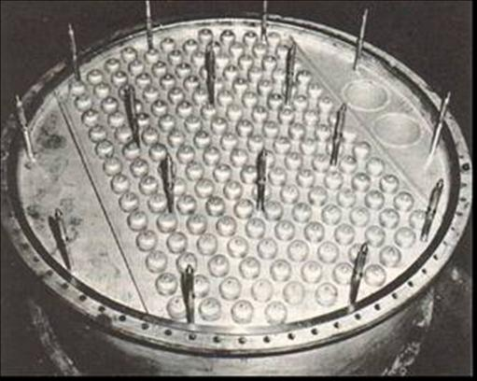

.

Table of Contents

Summary 3

Characteristics Of Aviation Fuels 6

Tetraethyl Lead 7

Research and Experimentation Continues 7

Aviation Gasoline Composition 1930-1938 7

1934 US Aviation Gasoline Specifications 9

1934 French Specifications 12

1935 British Empire Aviation Gasoline Specification 13

Plethora of Grades & Specification Chaos 15

The Fuel Guru’s 19

1930 The Development of 100 Octane Fuel. 19

Manufacturing Process 1930-1938 22

Thermal Cracking 22

Hydrogenated Aviation Gasoline 27

Houdry Catalytic Process 32

Hydrocodimer Process 42

1937 Alkylation Process For Iso-Octane Is Created 43

Oil Companies and Refineries 47

Epilogue For 1938 48

Index 49

References 53

# Summary

1928 Standard Oil Company of New Jersey (SOCNJ) develops Hydrogenation.

1929 SOCNJ made and sold to Ethyl Gasoline Corporation 1,000 US gallons of Di-Isobutylene to be made into Iso-Octane.

1930 Houdry Catalytic Cracking introduced.

1930 Thermal Reforming introduced to produce gasoline of improved octane number.

1932 Hydrogenation Process introduced to remove sulphur.

1932 Coking Process to produce gasoline base stocks.

1933 Solvent Extraction process to improve lubricant viscosity index, of which a by-product would be aromatics.

1934 May US Army buys 1,000 US gallons Iso-Octane from Shell and tests 100 Octane Fuel.

1935 June US Army calls for 1,000,000 US gallons of 100 Octane fuel – supplied by Shell and SOCNJ.

1935 Solvent Dewaxing to improve pour point of lubricating oils, and producing waxes.

1935 Catalytic Polymerization process to improve gasoline yield and octane number.

1937 Catalytic Cracking process to give higher octane gasoline and produce chemical feedstocks.

1937 Industry production of capacity 800 barrels/day Aviation gasoline 100 Octane.

1938 Alkylation largely replaces hydrogenation as method of manufacture of 100 Octane fuel.

1939 Visbreaker Process to reduce viscosity, increased distillate, tar

# The Golden Years of aviation, great advances in refining

The Thirties were the period of new fuels and the development of new processes and fuel research and development.

In the history of aviation gasoline manufacture the decade of the 1930’s would produce nearly all the manufacturing processes which would be used from that time forward. There would be further refinements to the processes in later decades, but it was this decade where the major changes and developments in aviation gasoline occurred. Knock engine tests would become part of all aviation gasoline specifications, as well as other quality control tests such as gum (actual and potential). Higher octane and performance would be achieved by the addition of Tetra Ethyl Lead.

By far the most significant would be the development of 100 Octane Aviation Gasoline.

Aviation gasoline manufacturing methods began to change radically around 1930 owing to the recognition by both of users and manufacturers of the importance of knock (or detonation) in engines caused by fuels of improper quality.

Research work had resulted in the acceptance of several facts in relation to aviation fuels characteristics:

* Tetra Ethyl Lead was a satisfactory anti-knock additive (or ‘dope’) for use in aviation fuels.
* Hydrocarbon structure was extremely important to the anti-knock quality of fuels. Straight chain paraffins in the gasoline boiling range had low anti-knock values, and iso-paraffins had high anti-knock values.
* Fuels which caused knocking gave lower motor efficiencies, than those that did not, and in many cases had destructive effects on motors.

With the requirement of an 87-octane fuel by the US Army Air Force and many commercial users, the refiners directed their attention to manufacturing such fuels. Prior to this time, distillation (as a surrogate for volatility) was the most important characteristic, and the average octane value was approximately 50.

Because of other quality limitations imposed by the government and commercial specifications in regard to freezing point, gum stability, vapour pressure, unsaturation (acid heat test), and maximum TEL content, the production of suitable fuels was limited to certain methods.

These were:

* Production of straight run gasoline of the required properties from selected crudes so that the required octane might be achieved.
* Addition of limited amounts (below 20%) of aromatic stocks (benzol) to a straight run gasoline in order to increase the octane number.
* Fractionation of select naphthas and natural gasolines, and the addition of limited amounts of high vapour pressure hydrocarbons with high octane values.
* Manufacture of pure hydrocarbons or hydrocarbon mixtures with extremely high octane values, and addition of these to a base stock with or without Tetra Ethyl Lead to achieve the correct octane value in the blended fuel.

One of the interesting illustrations of the developments of Avgas in this period was presented in Van Winkle’s excellent book on Aviation Gasoline Manufacture published in 1944, where it showed the increase in 100 Octane usage by the US Army Air Force, and the resultant increase in the average Octane number from 1930 to 1938, and how 100 Octane aviation gasoline would become the dominant grade.

Table . Per Cent Requirements of US Army Air Force for various Octane numbers.[1]

|  |  |  |  |  |  |
| --- | --- | --- | --- | --- | --- |
| Year | Grade 58-65 | Grade 87 | Grade 92 | Grade 100 | Average Octane |
| 1930 | 56.4% | 43.6% |  |  | 70.6 |
| 1931 | 31.6% | 68.4% |  |  | 77.7 |
| 1932 | 16.6% | 83.4% | 0.0% |  | 82.2 |
| 1933 | 6.5% | 50.2% | 43.3% |  | 87.3 |
| 1934 | 5.3% | 0.0% | 94.7% | 0.0% | 90.2 |
| 1935 | 3.9% |  | 91.7% | 4.4% | 91.3 |
| 1936 | 3.5% |  | 77.5% | 19.0% | 92.6 |
| 1937 | 3.0% |  | 68.0% | 29.0% | 93.3 |
| 1938 | 3.0% |  | 7.0% | 90.0% | 98.2 |

Graph . Percentage of Avgas used US Army Air Force by grade 1930-38.[2]



# Characteristics of Aviation Fuels

There is a great difference between aviation fuels and motor spirits used in automobile engines. The remarkable improvement in aircraft engines that took place during the years after World War I could not have been achieved without a correspondingly rapid improvement in the technology of fuel production. During this period the power of the aircraft engine increased by 150% without any increase in cylinder capacity. The brake-mean-effective-pressure increased by 100% and the engine speed by 21%, whilst the fuel consumption at cruising was reduced by 30%.

Although much of the credit for this remarkable performance was due to the skills of the engine designers and metallurgists, the oil industry also met the challenge by producing fuels to meet the demands of the new engine designs.

By this time, it was generally recognised that an aviation petrol usually had a higher knock rating than the average motor spirit, but there are very many important characteristics of an aviation gasoline that vary markedly from those ordinarily used in road transport vehicles. In the previous decade (1920’s) “aviation petrol” was ordinary motor spirit with a small proportion of Benzol (10 to 25%) added to increase the resistance to detonation, but the aviation gasoline marketed in the 1930’s was a highly developed fuel with special characteristics.

These characteristic properties of aviation fuels have a direct influence upon the efficiency and reliability of aircraft engine operation. The most important of these are listed in Table 2.

Table . Aviation Gasoline Properties (1930’s)

|  |  |
| --- | --- |
| Property | Performance |
| Octane Number | Controls resistance to detonation. Maximum power and fuel economy |
| Distillation Range | Controls starting characteristics and distribution of the mixture to the individual cylinders. Also affects tendency to vapour lock (in conjunction with vapour pressure). |
| Vapour Pressure | Controls tendency to vapour lock in the fuel lines and fuel pump |
| Specific Gravity & Calorific Value | Controls the maximum range of the aircraft |
| Sulphur Content | Reduced to insignificant percentage to limit any corrosive action of fuel |
| Gum Content (Actual & Potential) | Controlled to a minimum to prevent gum deposition in fuel lines, manifolds, and valves |

One of the most important characteristics of aviation fuel is, without doubt, the anti-knock quality of the ability to prevent detonation under adverse conditions of load and temperature. Although detonation in automobile engines is not accompanied by immediate engine failure, detonation in aircraft engines is quite disastrous, causing almost instantaneously a rapid temperature rise in the cylinder and piston with the consequent fusing or seizing of the piston. Therefore high-output engines place a considerable demand on the anti-knock quality of the fuels. This quality was greatly increased in this period as a result of intensive research and development work carried out by the oil industry.

Note[3]: Any detonation occurring in automobile engines, in excess of trace amount, will be noticed by the operator, who will normally react by taking action to, at best, eliminate the detonation to trace amount. Therefore, detonation in automobile engines does not often result in engine failure. With aircraft engines, the pilot does not hear any detonation that occurs, and so does not react by taking action to eliminate detonation, often with a cascading of adverse events that result in engine failure.

# Tetraethyl Lead

“Ethyl Fluid”, the trade make of Tetra Ethyl Lead (TEL) was the only anti-knock agent which enjoyed a world-wide distribution from 1925, first in automobile and later in aviation gasolines. It gives the largest increase in octane per unit volume concentration in the fuel, cost less for equal octane number increase than purely organic addition agents.

One early limitation to the concentrations of TEL which could be used in aviation fuels, was the effect it had on valves and spark plugs on the engines of those days. However, by 1938 metallurgists had made considerable progress in producing materials which were not affected by high concentrations of lead, and it appeared (in 1938) that it may be practicable to use aviation fuels with lead contents up to 10 cc/US gallon (2.64 ml/Litre). [This was to prove both uneconomical and resulted in high lead deposits and greater engine maintenance]. It was however feasible to produce unblended fuels up to 90 octane number (ASTM) with 4 cc of lead per US gallon (1.056 ml/Litre); if fuels of a higher octane number were required, a number of petroleum blending agents were commercially available - these were catalytically cracked gasolines, Iso-Octane and Isopropyl Ether.

Lead is discussed in Chapter 36.

# Research and Experimentation Continues

While there was much research and experimentation in the 1920’s, it continued on into the 1930’s. There was an abundance of oil in the US and therefore the search for alternate sources of aviation gasoline was of little interest, however across the Atlantic (in England and Germany), there was interest in producing aviation gasoline from coal. The successful work done by the Germans is described elsewhere, but the British were less successful in their attempts.

Aviation Spirit from British Coal -1933

In 1925 an aviation spirit sample “Coalite” had been produced from coal but this had not been developed. Others would also attempt to produce an economic aviation spirit from coal, and in 1933 The Welbeck Distillation Company using Hucknell Colliery coal attempted to produce aviation spirit. Low temperature carbonizing of cannel coal raised at Welbeck Colliery, produced cracked oil from coal using a retort. (Cannel coal is also considered to be oil shale). The UK Government did not support the project, as the fuel was not of acceptable quality.

Similar approached would be tried at an Australian coal mine during World War II in an attempt to maintain the operation of the mining company. – It was also unsuccessful.

# Aviation Gasoline Composition 1930-1938

In 1930, the composition of aviation gasolines was essentially straight run gasolines from selected crudes which would give the best anti-knock properties. In some cases, particularly in the UK, this would be supplemented with benzol to increase the octane of the blend.

By 1938, the composition of aviation gasolines varied depending on the octane grade. The lowest octane grades (70-74) were unleaded straight run naphthas from naphthenic or aromatic crudes. The higher grades were leaded straight run naphthas, and the highest octane grade (100 Octane) could only be achieved by blends which included iso-octane either as a pure hydrocarbon or mixture of highly branched paraffins similar to iso-octane obtained from alkylation processes. With the cracking processes, a new gasoline blendstock became part of the aviation gasoline “Base Stock”.

Photo 2. De-Havilland DH-89 Dragon Rapide (foreground), De-Havilland DH-82A Tiger Moth (background) - typical aircraft of the 1930’s era using avgas of low octane on display at Duxford, UK (Petroch Services 2005).



Photo 3. Bristol Blenheim– RAF’s fastest frontline bomber of the era, circa 1938. Typical of aircraft using higher octane avgas.

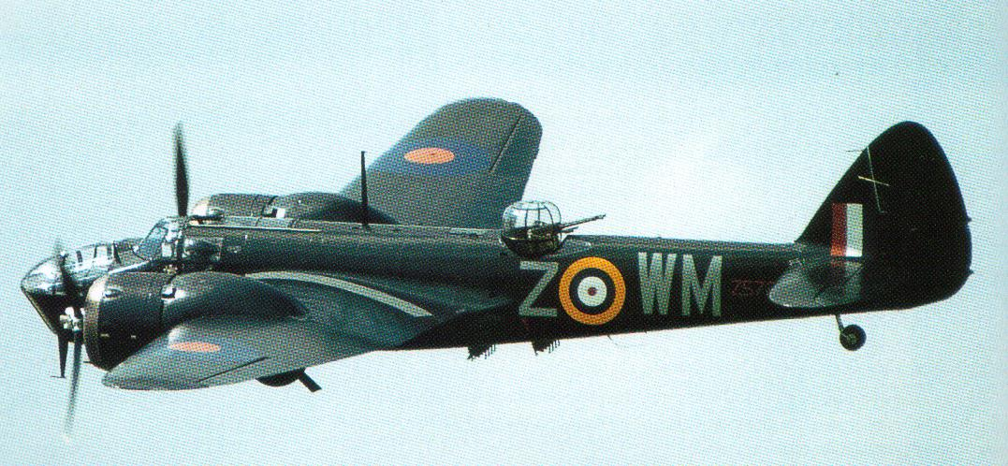Avgas Specifications & Test Methods 1930-1938

[4]By 1929, most avgas manufacturers and consumers recognised that some type of anti-knock rating must be included in the specifications. This would provide a basis to rate the fuel, since the higher anti-knock fuels would allow an increase in usable compression ratio and power. In 1929, the Octane Scale was adopted and by 1930, the first octane number specification appeared.

From 1930 to 1934, the interest in aviation gasoline quality increased greatly. A significant amount of investigation was undertaken on anti-knock test methods and the correlation of performance with laboratory test data. It was also a period of additional tests to increase quality control. These were accelerated ageing test, vapour-pressure test, freezing point test, and acid heat test. The 10% point in the distillation test was established as the point indicating volatility, and in most cases the volume per cent points in the distillation were changed from percent recovered to per cent evaporated. Benzol additions were limited to 20% of less because of its high freezing point, and the amount of treated cracked gasoline allowed in the blend was also limited.

However, the most significant advance in specifications was the inclusion of knock engine testing.

In determining the specification of aviation gasolines, we find the necessary important properties are:

1. Required anti-knock values – Octane Number
2. Correct volatility and vapour pressure.
3. Stability in storage
4. Non-corrosiveness
5. Extremely low freezing point
6. Correct thermal properties (low latent heat of evaporation, high heat of combustion)
7. Minimum water solubility
8. Good lead (TEL) susceptibility

Therefore, these properties must be measurable by suitable test methods or estimated/calculated in order to verify that the fuel indeed meets the desired specification.

Many of these properties are discussed elsewhere in this book. Octane testing is covered in Chapter 37.

# 1934 US Aviation Gasoline Specifications

As a result of work by Graham Edgar and Sam Heron (another great figure in avgas development), in 1930 the US Army specified a minimum octane requirement of 87, and this would require TEL up to 3 cc/US Gal (0.84 gm/l) was permitted. [This is the same as motor spirit pre-1970 in Australia]. The octane test was determined by the Ethyl series 30 Engine.

The development of US specifications led to a variety of grades essentially designated by their octane number. The oil companies were keen to establish strong footholds in this market and so formed strategic alliances to standardise on their supply and distribution networks. One such network was that formed by the Standard Oil Companies called “Stanavo” which was to be their global aviation organisation, as discussed earlier. These grades were marketed under particular “Stanavo” specification numbers. November 1934. Some of the fuels were to meet other national specifications such as British Air Ministry (B.A.M.).

Table 3. STANAVO Aviation Gasoline Specifications 1934[5]

|  |  |  |  |  |  |  |
| --- | --- | --- | --- | --- | --- | --- |
| **Grade Designation** | **74** | **77** | **74** | **80** | **86** | **87** |
| Remarks |  |  | Export - Sale restricted to outside USA |  |  |  |
| Specification Number | Stanavo #2  Nov 1934 | Stanavo #3  Nov 1934  Stanavo Av.Gas | Stanavo #9  Nov 1934  Stanavo Av. Fuel X | Stanavo #11  Nov 1934  Stanavo Ethyl Av.Gas 80 | Stanavo #13  Nov 1934  Stanavo Ethyl Av.Gas  (BAM 87) | Stanavo #14  Nov 1934  Stanavo Ethyl Av.Gas 87 |
| Colour | Clear | Clear | Clear | Blue | Blue | Blue |
| Sulphur (wt.%) Max. | 0.1 | 0.1 | 0.10 | 0.10 | 0.10 | 0.10 |
| Distillation % Rec. | | | | | | |
| Min 50 deg. C Max. 65 deg. C | 5 | 5 |  | 5 | 5 |  |
| Min 60 deg. C Max. 70 deg. C | 10 | 10 |  | 10 | 10 | 10 |
| % Rec. (@ 95 deg. C) Max. | 50 | 50 | 50 | 50 | 50 | 50 |
| % Rec. @ 125 deg. C) Max. | 90 | 90 | 90 | 90 | 90 | 90 |
| % Rec. @ 150 deg. C) Max. | 96 | 96 | 96 | 96 | 96 |  |
| End Point Max deg. C | 165 | 165 | 165 | 165 | 165 |  |
| Loss | 2% | 2% | 2% | 2% | 2% |  |
| Reid Vapour Pressure (@37.8 deg. C) psi Max. (kPa) | 7.0  (49.0) | 7.0  (49.0) | 7.0  (49.0) | 7.0  (49.0) | 7.0  (49.0) | 7.0  (49.0) |
| Freezing Point (deg. C) Max. | -60 | -60 | -60 | -60 | -60 | -60 |
| Knock Rating, CFR Motor Rating Min. | 74 | 77 | 74 | 80 | 87 | 87 |
| Existent Gum (mg/100 ml) Max. | 3 | 3 | 3 | 3 | 3 | 10 |
| Tetra Ethyl Lead Content (cc/USG) Max. |  | 2.5 cc/USG to raise to 87 Octane |  | 0.3 min,  2 Max | 0.3 min,  3 Max | 0.3 min,  3 Max |

Photo 4. Grumman F3F-2 carrier-based fighter (replica) 1938. (Cradle of aviation Museum, New York, 2006).



Note. This aircraft is typical of the US navy carrier-based aircraft up to 1938. It is powered by a Wright R-1820 radial engine favoured by the US Navy and also the US Army Air Corps.

Photo 5. US Army Boeing P-26 ‘Peashooter’ 1933.



# 1934 French Specifications

Many nations had their own specifications, for this was a period of national aviation pride, and the French were no exception. Again, the grades were determined by Octane and Lead content. The specifications for France and its possessions in June 1934 were as follows:

Table 4. French Aviation Gasoline Specifications 1934

|  |  |  |
| --- | --- | --- |
| **Grade Designation** | **70** | **85** |
| Specification Number | (Normes 3401) & 2 Aeronef “A” | (Normes 3401)  & 2 Aeronef “B” |
| Colour | Clear | Clear or Blue if TEL |
| Sulphur (wt.%) Max. | 0.15 | 0.15 |
| Distillation % Rec. + Loss (@ 75 deg. C) Min. | 10-20% | 10-20% |
| % Rec. + Loss (@ 100 deg. C) Min | 50 | 50 |
| % Rec. + Loss (@ 150 deg. C) Min | 90 | 90 |
| Final Boiling Point (deg. C) | 180 | 180 |
| % Rec. Min. | 96% | 96% |
| % Loss | 2% | 2% |
| Specific Gravity (assumed Max.) | 0.78 | 0.78 |
| Reid Vapour Pressure (@ 37.8 deg. C) Max | Note 1.  0.5 kg/cm2 | Note 1.  0.5 kg/cm2 |
| Freezing Point (deg. C) Max | -45 | -45 |
| Knock Rating, Lean mixture CFR Motor Rating. Min. | 70  CFR Modified Motor Method | 85  CFR Modified Motor Method |
| Knock Rating, Rich mixture Supercharge Rating Min. | not applicable | not applicable |
| Potential Gum (mg/100 ml) Max. | (Note 1.) | (Note 1.) |
| Existent Gum (mg/100 ml) Max. | 6 | 6 |
| Tetra Ethyl Lead Content (gm/l). Max. |  | 0.08% vol. |

Note 1. Refer to Stanavo source.

Of particular note is the less severe freezing point specification of minus 45 deg. C compared to other international specifications of minus 60 deg. C.

In addition to the above specification, many other nations also had their own requirements for example.

A.E.F.

Austria

Belgium

Denmark

Finland

Hungary

Italy

Norway

Poland

Portugal, Rio De Oro, Canary Isles

Sweden

Switzerland

Czecoslovakia (Czechoslovakia)

Turkey

Yugoslavia

Greece

# 1935 British Empire Aviation Gasoline Specification

In Britain, the official specification for aviation fuel issued by the British Air Ministry was DTD-134 in June 1930.

It limited cracked spirit to a trace by use of the gum test and required the anti-knock value be equal to 50/50 mixture of Benzene and standard Hexane in a single cylinder engine at 900 rpm. (This was equivalent to 74 Octane Number in an Armstrong Whitworth variable compression engine). The anti-knock properties could be controlled by adding aromatics although Benzol was limited to 20 % because of the freezing in the carburettor jets.

In September 1933, the Air Ministry replaced DTD-134 with DTD-224 raising the Octane to 77 and DTD-230 with an Octane of 87 as tested on the new CFR engine and permitting for the first time the inclusion to TEL up to 4 cc/Imp. Gal. (1.11 gm/l) which was the same as the Americans. The new CFR engine test gave better correlation to the performance of the predominantly British liquid cooled engines, whereas the US Army Method gave better correlation with the US air-cooled engines.

Photo 6. Bristol Bulldog circa 1934 on display at RAF Hendon (2005)

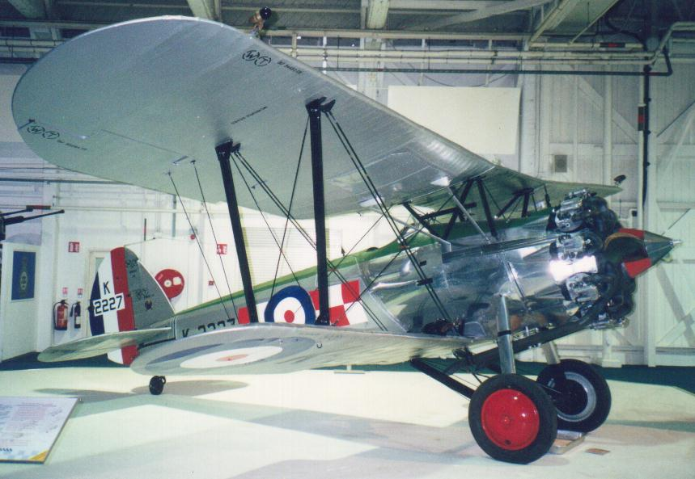

The Bristol Bulldog was a typical example of the British radial engine aircraft of this period. The Bristol fighters, together with the Hawker fighter series with in-line engines (Hardys, Hart, Demon,) were the backbone of the RAF fighter squadrons in the 1930’s.

Photo 7. Hawker Hart (Royal Afghan Air Force) circa 1935, on display at RAF Cosford UK 2005

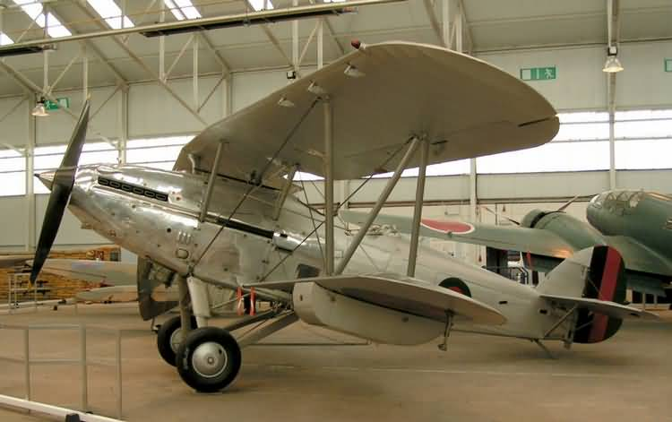

British & Australian (British Empire) Specification DTD-224 October 1933, DTD-230 October 1933.

Table 5. British Aviation Gasoline Specification 1935

|  |  |  |
| --- | --- | --- |
| **Grade Designation** | **77** | **87** |
| General Requirements | Straight Run product from crude oil, coal spirit or mixture thereof | Straight Run product from crude oil, coal spirit or mixture thereof |
| Specification No. | DTD-224 | DTD-230 |
| Colour | Clear | Blue |
| Sulphur (wt.%) Max. | 0.15 | 0.15 |
| Aromatics vol.% Benzol (BTX) Min. | none specified.  Aromatic hydrocarbons may be added | none specified.  Aromatic hydrocarbons may be added |
| Distillation | | |
| Temp. 10% Rec. (deg. C.) Max. | 75 | 75 |
| Temp. 50% Rec. (deg. C.) Max | 100 | 100 |
| Temp. 90% Rec. (deg. C.) Max. | 150 | 150 |
| End Point (deg. C.) Max | 180 | 180 |
| Recovered Minimum | 96% | 96% |
| Loss max. | 2% | 2% |
| Specific Gravity | 0.79 Max | 0.79 Max |
| Reid Vapour Pressure @37.8 deg. C. psi Max.  (kPa) | 7.0  (49.0) | 7.0  (49.0) |
| Freezing Point (deg. C) Max. | -50 | -60 |
| Net Heat of Combustion MJ/kg Min.  (BTU/lb.) | Typical 46.5  20,000 | Typical 46.5  20,000 |
| Knock Rating, Lean mixture CFR Modified Motor Rating Min. (*Aviation method)* | 77 | 87 |
| Potential Gum (16 hr ageing mg/100 ml) Max. | 10 | 10 |
| Existent Gum (mg/100 ml) Max. | 10 | 10 |
| Tetra Ethyl Lead Content (cc/Imp. Gallon) Max. | Unleaded | 4 |

# Plethora of Grades & Specification Chaos

The early part of this decade saw a proliferation of specifications dictated by the military and commercial airlines. By 1935 in the US there were seven aviation fuel specifications based on octane rating. There were two US Army grades, four US Navy grades, and three commercial grades, and some of these were comparable on the basis of octane rating. The 92 octane Army grade was very similar to the 87-octane grade of the Navy and commercial specifications [87 MON corresponds to about 92 octane number with the modified CFR method (1,200 rpm; cylinder 2.625 in.; with jacket temperature 330 deg. F, using the thermal plug to determine maximum knock)].

The number of grades specified showed a lack of agreement among various aviation fuel users as to the qualities necessary in an aviation gasoline. This was due in part to insufficient data on correlation of laboratory tests with actual aircraft engine performance. So, by 1937, this confusion led to the establishment of 14 different aviation fuel specifications in the United States based on octane number, and 11 specifications in other countries in the world.

This required some oil companies to stock up to 14 grades of aviation gasoline, all sufficiently different from on another to prevent substitution. This situation was not conducive to the development from the refiners’ view point.

The principal change in specifications in the US between 1935 and 1937 was the adoption of 100 octane grade by both the US Army and US Navy; and the adoption of 90+ octane grades by a number of commercial users.

In 1937, a paper titled “Aircraft Fuels Specifications – Present and Future” by William H. Hubner, Gustav Egloff, and George B. Murphy was presented at the Second World Petroleum Congress, Paris, France, June 9-14, 1937 and reprinted in the National Petroleum News. It gave details of the American and European military and commercial specifications for aviation gasoline. The paper showed the appalling state of chaos in respect to numerous octane number and volatility requirements.

Table 6. Hubner et. al. shows the various specification in the United States in 1937. Of particular note is the US Army 65 octane grade, which is an unleaded gasoline of higher 90% max. point (330 deg. F) than all other grades and appears to be straight run gasoline.

Dr. Jimmy Doolittle, then Aviation Manager for Shell, was largely responsible for organizing the activity which led to commercial specifications being set by American Society for Testing Materials (A.S.T.M.) which would be accepted by all airlines.

While the great number of octane grades existed, the other properties desired and specified in aviation fuels were generally comparable, for example distillation, vapour pressure.

The Cooperative Fuel Research Committee studied anti-knock methods in relation to fuel performance and through their efforts, conferences between commercial aviation fuel consumers and producers/manufacturers in 1938, it was possible to simplify the specifications to five grades. Refer Table 7. Aviation Fuel Specifications 1939.

In addition, the US Army and US Navy standardized their requirements, specifying six different fuels with four octane grades. There were three distillations requirements all having higher 90% points and three having higher 50% points than were permitted in commercial specifications. This unification of specified types of fuels by both the US Government services and commercial users resulted in overall requirements for essentially five different grades. The US Army and US Navy could use aviation fuels which met the commercial specification, but not the reverse. This consolidation of specifications was a great improvement for the refiners since now there now only five grades had to be stored, not 14 non-interchangeable grades.

To ensure adequate supplies, further simplification in specifications would be needed.

By 1941 principally through the efforts of the CFR Committee the number of commercial aviation fuel grades had been reduced to three; these were 73, 91 and 100 octane grades.

After the standardisation of the commercial specifications, the refining industry was able to concentrate on the processes for the manufacture of high anti-knock fuels, and added impetus to establish larger capacity facilities for aviation gasoline production.

Photo 8. North American Harvard trainer on show at RAAF Pt. Cook, Melbourne 2005. Typical of the US advanced training aircraft of the late 1930’s. This aircraft type would have used Avgas 91. (Note the “Air BP” logos at the rear of the fuselage).

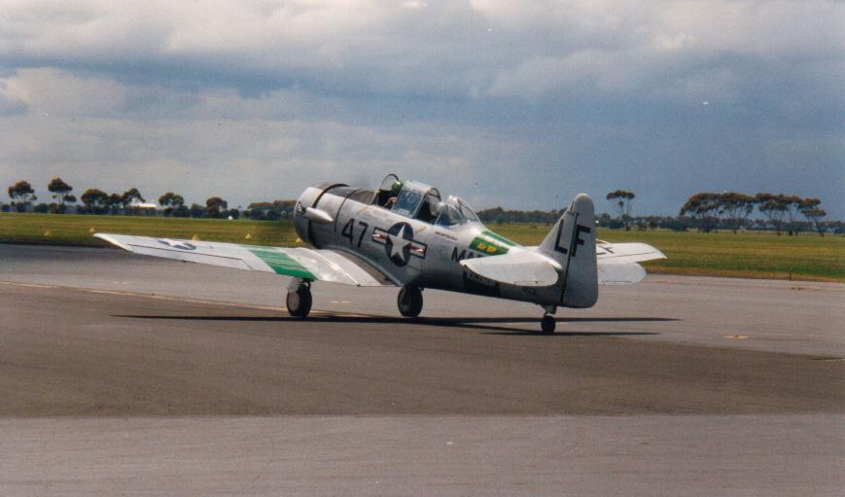

Table 6. Aviation Fuel Specifications 1937[6] as per Hubner et al.

|  |  |  |  |  |  |  |  |  |  |  |  |  |  |  |  |
| --- | --- | --- | --- | --- | --- | --- | --- | --- | --- | --- | --- | --- | --- | --- | --- |
|  | US Army | | | US Navy | | | | | Commercial | | | | | | |
| Grade | 100 | 92 | 65 | 100 | 87 | 83 | 80 | 73 | 95 | 93 | 90 | 87 | 80 | 74 |
| Acid Heat deg. F max. | - | - | - | 20 | 20 | 20 | 20 | 20 | 20-40 Nitration acid heat test | | | | | | |
| Calorific value, BTU/pound, min. | - | - | - | - | - | - | - | - | 20,500 on some 95 & 90 grades | | | | | | |
| Corrosion, copper dish | No corrosion permitted for any fuel | | | | | | | | | | | | | | |
| Distillation |  | | | | | | | | | | | | | | |
| 5%, deg. F., max. | - | - | - | - | - | - | - | - | - | 150 | - | 140-150 | | | |
| 10%, deg. F., max. | 167 | 167 | 158 | 167 | 167 | 167 | 167 | 167 | 167 | 167 | 167 | 150-167 | | | |
| 50%, deg. F., max. | 212 | 212 | 230 | 212 | 212 | 212 | 212 | 212 | 212 | 212 | 212 | 195-221 | | | |
| 95%, deg. F., max. | 275 | 275 | 320 | 275 | 275 | 275 | 275 | 275 | 275 | 266 | 275 | 231-347 | | | |
| 96%, deg. F., max. | - | - | - | - | - | - | - | - | - | 311 | - | 252-275 | | | |
| 10%+50% deg. F., min. | 307 | 307 | 307 | 307 | 307 | 307 | 307 | 307 | 307 | 307 | 307 | 307 | 307 | 307 |
| Recovery, % min. | - | - | - | - | - | - | - | - | - | 96 | - | 96 | 96 | 96 |
| Residue, % max. | 2.0 | 2.0 | 2.0 | 2.0 | 2.0 | 2.0 | 2.0 | 2.0 | 2.0 | 2.0 | 1.0 | 1.0-2.0 | | | |
| Loss, % max. | - | - | - | - | - | - | - | - | - | 2.0 | 2.0 | 2.0 | 2.0 | 2.0 |
| Freezing Point, deg. F., max. | -76 | - | - | - | -76 | - | - | - | - | - | - | - | - | - |
| Gum, accelerated, mg./100 cc., max. | 10.0 | 10.0 | - | 10.0 | 10.0 | 10.0 | 10.0 | 10.0 | 10.0 | 10.0 | 10.0 | 10.0 | 10.0 | 10.0 |
| Octane number (min.) US Army Method | 100 | 92 | 65 | 100 | - | - | - | - | - | - | - | - | - | - |
| Octane number (min.) CFR MON | - | - | - |  | 87 | 83 | 80 | 73 | 95 | 93 | 90 | 87 | 80 | 74 |
| Sulphur, % max. | 0.10 | 0.10 | 0.10 | 0.10 | 0.10 | 0.10 | 0.10 | 0.10 | 0.10 | 0.10 | 0.10 | 0.10 | 0.10 | 0.10 |
| Tetra Ethyl Lead, cc/US gal., max. | 3.0 | 6.0 | 0 | 3.0 | 0.5-3.27 | 2.29 | 1.63 | 0 | 4.0 | 3.0 | 4.0 | 2-3 | 1.1-2 | 0 |
| Vapour Pressure psi, Reid max. | 7.0 | 7.0 | 7.0 | 7.0 | 7.0 | 7.0 | 7.0 | 7.0 | 7.0 | 7.0 | 7.0 | 7.0-7.5 | 7.0-7.5 | 7.5 |

Table 7. Aviation Fuel Specifications 1939 (Commercial)

|  |  |  |  |  |  |
| --- | --- | --- | --- | --- | --- |
| Grade | 95 | 90 | 87 | 80 | 73 |
| Acid Heat deg. F max. | 15 | 15 | 15 | 15 | 15 |
| Calorific value, BTU/pound, min. | 19,000 | 19,000 | 19,000 | 19,000 | 19,000 |
| Distillation |  | | | | |
| 10%, deg. F., max. | 158 | 158 | 158 | 158 | 158 |
| 50%, deg. F., max. | 212 | 212 | 212 | 212 | 212 |
| 95%, deg. F., max. | 275 | 275 | 275 | 275 | 275 |
| 10%+50% deg. F., min. | 307 | 307 | 307 | 307 | 307 |
| Freezing Point, deg. F., max. | -76 | -76 | -76 | -76 | -76 |
| Gum, accelerated, mg./100 cc., max. | 6 | 6 | 6 | 6 | 6 |
| Octane number (min.) CFR MON | 95 | 90 | 87 | 80 | 73 |
| Sulphur, % max. | 0.10 | 0.10 | 0.10 | 0.10 | 0.10 |
| Tetra Ethyl Lead, cc/US gal., max. | 4.0 | 4.0 | 3.0 | 2.0 | 0 |
| Tetra Ethyl Lead, cc/US gal., min. | 3.5 | 3.5 |  |  |  |
| Vapour Pressure psi, Reid max. | 7.0 | 7.0 | 7.0 | 7.0 | 7.0 |

The simplification of the aviation fuel specification also brought a tightening of the Acid Heat limit which would limit the unsaturated hydrocarbon content. There was also a lowering of the 10% distillation point to 158 deg. F. (70 deg. C.)

Photo 9. Douglas DC-3 circa 1937

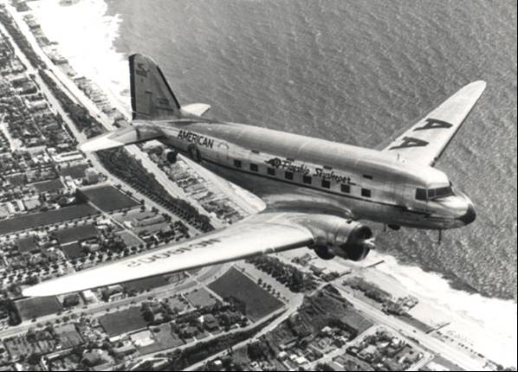

# The Fuel Guru’s

With a better understanding of anti-knock properties, a number of leading people emerged in fuel research on both sides of the Atlantic. People like Sam D. Heron working for the US Army at McCook Field, Dayton Ohio USA, E.L. Bass of the Shell Company (UK) and F.R. Banks of the Associated Ethyl Company in the UK. It would be these people and others who would convince the US Army to adopt 100 Octane fuel, and to also convince the British Government to adopt 100 Octane as the standard operational fuel for the RAF.

# 1930 The Development of 100 Octane Fuel.

In 1930, three US figures took a prominent role, these were James Doolittle who had resigned from the US Army Air Corps in 1930 and joined the Shell Company, Edwin Aldrin who had also left the US Army Air Corps to join Standard Oil Development Company (later Exxon Research & Engineering), and Capt. Frank Klein a test pilot at Wright Field, who was an assistant to Sam Heron, and who was in charge of fuel testing. Doolittle, Aldrin and Klein set their sights on establishing 100 Octane as the standard fuel for the US Army Air Corps and eventually also the airlines.

1934 US Army tests 100 Octane Fuel

Doolittle convinced Shell to build a hydrogenation plant at their St. Louis Refinery, Missouri, USA. Based on Aldrin’s report on the demand for 100 Octane fuel, Standard Oil developed a process which could make this iso-octane. Prior to this the development of this Iso-Octane was done by chemical manufacturers and the cost was about US$7 per litre, by the middle of WW II at the height of production this would be down to 5 cents/litre.

Klein did the experimental work with 100 Octane in a Boeing YP-29 and published a paper “Aircraft Performance with 100 Octane Fuel” in 1934-5. When this Iso-Octane was blended with equal volumes of 68 Octane aviation gasoline and 3 cc/USG (0.84 gm/l) of Lead, 100 Octane aviation fuel was a reality.

Photo 10. Boeing YP-29 circa 1934

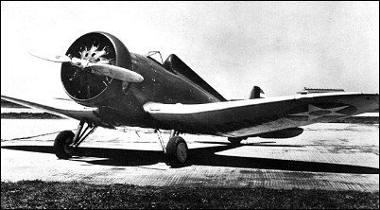

The requirement of the US Army Air Corps for a substantial quantity of 100 Octane gasoline stimulated some of the major oil companies to conduct research in manufacturing iso-octane blending components at a reasonable cost. Shell and Esso were those who took up the challenge most seriously in the early stages. One of the first commercially successful blending agent was “Hydrocodimer”. As stated earlier, this was manufactured from refinery gases in a two-step operation:

(1) the gases iso-butylene and normal butylene were reacted in the presence of Sulphuric or Phosphoric acid to combine (polymerize) to form Trimethyl pentenes, and (2) this was hydrogenated to give a mixture of iso-octane and other forms of iso-octane.

British interest in Avgas 100

Meanwhile back in Britain, this work had not gone unnoticed, and in January 1937 F.R. Banks presented a paper on “Some Problems of Modern High-Duty Aero Engines and their Fuels”[7] and included Klein’s paper. Banks’ paper discussed at length the developments required in engine design - cylinder head and combustion chamber design, valve metallurgy, exhaust pipe metallurgy, spark plugs design, alloy fuel tanks corrosion and leaded fuels, and other issues that would need to be tackled to make use of this new 100 Octane fuel.

E.L. Bass presented a paper in Paris at the Chambre Syndicale des Industries Aéronautiques on the 25th November 1936 titled ‘High Octane Fuels’[8]. He discussed some of the changes in engine design, the use of high octane fuels in civil aviation, the (knock) engine testing of high anti-knock fuels and the discrepancies in the methods. Bass noted that ‘to obtain the maximum advantage from fuels of the order to 100 octane number, which are now commercially available (in 1936), it is clear that new designs of engines will be needed. Additional strength will be required in crankshafts, connecting rods and crankcases, whilst cylinders and heads will require additional fin area to dissipate the increased flow of waste heat. Whilst the development of the internally cooled exhaust valve (Heron) has given new lease of life to the poppet valve engine, it has already been shown that the elimination of hot exhaust valves by use of the sleeve valve has enabled better advantage to be taken of available fuels. The general question of supercharging will need very careful consideration as the power output envisaged by the use of 100 octane fuel may for certain installations require a degree of supercharge which will not be possible with the single stage type in general use today (1936). The need for multi-speed or multi-stage blowers with inter-coolers then becomes necessary’.

The conclusions that Bass presented at this meeting were:

1. In spite of the increased cost of fuels of 100 octane number, their proper utilization in engines for civil aviation can be fully justified on economic grounds.
2. To use 100 octane fuels to the best advantage, new engines of increased strength and possibly modified cylinder design will be necessary. As yet, the reliability of such engines cannot be predicted but it is clearly essential that they must be developed to a stage where reliability and maintenance costs are comparable with those engines using lower octane fuels and which have already proved themselves in commercial airline service.
3. To obtain the maximum benefit from engines using 100 octane fuels, it will be necessary to use some apparatus such as exhaust gas testers to enable the weakest possible mixture strength to be used under cruising conditions, and at the same time to avoid any danger of running with too weak mixture strength. The weight and complication of any such apparatus will mitigate to some extent the advantage of reduced specific weight of the engine itself, but may be avoided by a satisfactory design of an automatic carburettor.
4. The rating of fuels of 100 octane number demands immediate investigation. The CFR engine as it stands at present, when operated under motor method or modified motor method conditions, is totally unsuited for this purpose, and fresh correlation work on high octane fuels will need to be carried out concurrently with the development of operating the CFR engine. This will involve:
5. Investigation into other methods of detecting detonation, both on full-scale engines and the laboratory fuel-testing unit. For this purpose, the electric indicator appears to be the most suitable apparatus.
6. Fuels will have to be rated at least two mixture strengths. i.e., equivalent to cruising and take-off conditions, unless it can be shown by experiment that all fuels will have the same relative rating over the range of mixture strengths involved.

[These points are discussed further in Chapter 36 Lead & Chapter 37 Octane Testing.]

By mid-1937, the British Air Ministry issued its first provisional specification for 100 Octane fuel. It also had the engine and the aircraft that could use it.

Photo 11. Hawker Hurricane 1938 powered by Roll-Royce Merlin Engine.

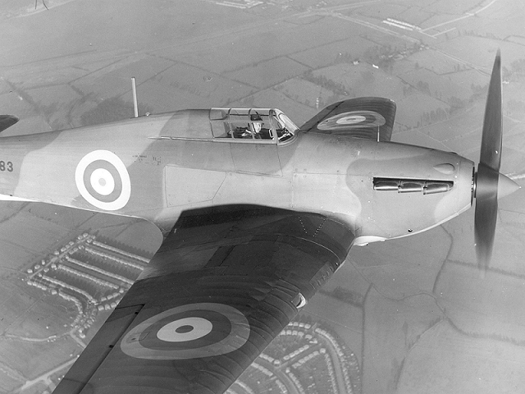

Photo 12. Supermarine K5054 Prototype (Spitfire) 1936 powered by Roll-Royce Merlin Engine.

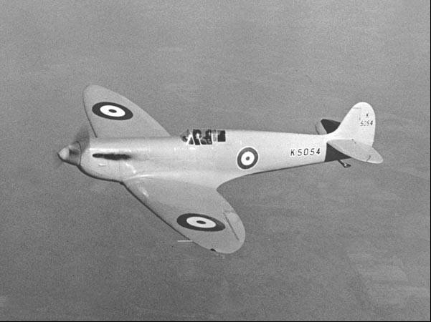

# Manufacturing Process 1930-1938

This was a period of great development in refinery processes with introduction of Hydrogenation, Hydrocodimer, Alkylation and Catalytic Cracking. This was also a period of the expansion of Thermal Cracking processes.

At the start of the decade, aviation gasoline was made from straight run naphtha from selected crudes and perhaps some suitable thermal cracked gasoline, and for the British the addition of aromatic stocks such as Benzole.

[9]In the US, it was:

1. Straight run gasoline from selected crudes,
2. Limited addition of benzol,
3. Fractionation of select naphthas and natural gasolines,
4. Addition of limited high vapour pressure hydrocarbons of high octane values.

Meanwhile intensive research was carried out by many petroleum refining research organisations on the manufacture of pure hydrocarbons and mixtures having extremely high octane values. This research resulted in new methods for the production of Iso-octane, such as polymerization and alkylation, and supplementary processes such as dehydrogenation, hydrogenation and isomerisation.

In another direction, processes were developed for the production of large quantities of high octane base stocks through conversion methods that were suitable for motor gasoline or aviation gasoline. These were thermal cracking, catalytic cracking, hydroforming or aromatization, gas reversion or polyforming, and naphtha isomerisation. Such processes would yield base stocks ranging in octane values from 75 to 85 which normally required some additional treatment before use as aviation fuels and aviation base stocks.

By the end of the decade the composition of aviation gasolines would be dictated by a multitude of ‘chemical processes’ to attain the goal of 100 octane rating – reaching the end of Dr. Edgar’s ‘Octane Scale’. One of the earliest was the Hydrogenation Process in 1933.

# Thermal Cracking

The first thermal cracking method, the Shukhov cracking process, was invented by Vladimir Shukhov - Patent of Russian empire No. 12926 on November 27, 1891.[10] Vladimir Grigorievich Shukhov (1853 - 1939) was a great Russian engineer renowned for his pioneering works on new methods of analysis for civil engineering that led to breakthroughs in industrial design of oil reservoirs, pipelines, boilers, ships and barges.

Shukhov made important contributions to the chemical industry. He designed and built an oil cracking plant. His patents (Shukhov cracking process - patent of Russian empire No. 12926 from November, 27th, 1891) on cracking were used to invalidate Standard Oil's patents (Burton process – Patent of USA No. 1,049,667 on January 7, 1913) on oil refineries.

He designed an original oil pump. Shukhov's pumps revolutionized Baku's oil industry allowing it to increase its oil output; he designed one of the first furnaces that used the residual oil: before his works the residual oil was considered a waste and was discarded, due to his works it became recognized as an important technical product known as a fuel oil.

Photo 13. Vladimir Grigorievich Shukhov (1853-1939)

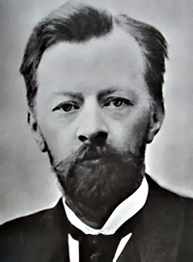

Photo 14. Shukhov cracking process, Baku, USSR, 1934

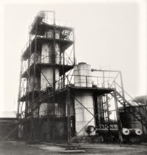

However, in the US, thermal cracking would come into operation in the 1920’s with the Dubbs Process, Burton Process, and others. In fact, thermal cracking continued to slowly grow despite the recession, and it should be noted that at this time most of the cracked gasoline was directed to motor gasoline, not aviation gasoline. However, in the late 1930’s these cracked gasolines would become the ‘base stock’ for aviation gasoline and many of these processes would be diverted to making aviation gasoline in the next decade.

Table 8. US Domestic refinery cracking capacity by process 1929-1941[11]

|  |  |  |  |  |  |  |  |  |
| --- | --- | --- | --- | --- | --- | --- | --- | --- |
| Year | Total cracking capacity MBSD | Burton | Dubbs | Tube & Tank | Holmes-Manley | Cross | Other types | Houdry (catalytic) |
| 1929 | 1,476 | 9.7% | 12.4% | 29.3% | 14.0% | 16.5% | 18.1% |  |
| 1930 | 1,720 | 6.4% | 13.1% | 28.0% | 13.9% | 15.7% | 22.9% |  |
| 1931 | 1,829 | 5.1% | 15.5% | 24.1% | 12.7% | 13.9% | 28.7% |  |
| 1932 | 2,011 | 3.2% | 11.0% | 31.7% | 11.8% | 13.2% | 29.1% |  |
| 1933 | 1,882 | 3.2% | 12.1% | 26.4% | 12.2% | 14.6% | 31.5% |  |
| 1934 | 1,887 | 0.8% | 12.0% | 26.8% | 13.1% | 13.3% | 34.0% |  |
| 1935 | 2,153 | 0.6% | 16.5% | 23.3% | 13.3% | 9.6% | 36.7% |  |
| 1936 | 2,169 | 0.5% | 17.7% | 21.6% | 12.7% | 8.7% | 38.8% |  |
| 1937 | 2,195 |  | 19.2% | 20.9% | 12.9% | 7.1% | 39.8% | 0.1% |
| 1938 | 2,348 |  | 20.5% | 19.6% | 12.5% | 7.4% | 39.4% | 0.6% |
| 1939 | 2,138 |  | 21.3% | 19.3% | 11.6% | 7.8% | 38.9% | 1.1% |
| 1940 | 2,284 |  | 20.5% | 19.1% | 10.8% | 7.3% | 36.7% | 5.6% |
| 1941 | 2,352 |  | 21.4% | 18.1% | 10.2% | 8.1% | 35.6% | 6.6% |

Thermal Cracking Process

[12]In thermal cracking, elevated temperatures (~800 deg. C) and pressures (~700 kPa) are used, a process first developed in the US by William Merriam Burton. An overall process of disproportionation can be observed, where "light", hydrogen-rich products are formed at the expense of heavier molecules which condense and are depleted of hydrogen. The actual reaction is known as homolytic fission and produces alkenes, which are the basis for the economically important production of polymers.

A large number of chemical reactions take place during steam cracking, most of them based on free radicals. Computer simulations aimed at modelling what takes place during steam cracking have included hundreds or even thousands of reactions in their models. The main reactions that take place include:

**Initiation reactions**, where a single molecule breaks apart into two free radicals. Only a small fraction of the feed molecules actually undergo initiation, but these reactions are necessary to produce the free radicals that drive the rest of the reactions. In steam cracking, initiation usually involves breaking a chemical bond between two carbon atoms, rather than the bond between a carbon and a hydrogen atom.

CH3-CH3 → 2 CH3•

**Hydrogen abstraction**, where a free radical removes a hydrogen atom from another molecule, turning the second molecule into a free radical.

CH3• + CH3-CH3 → CH4 + CH3-CH2•

**Radical decomposition**, where a free radical breaks apart into two molecules, one an alkene, the other a free radical. This is the process that results in the alkene products of steam cracking.

CH3-CH2• → CH2=CH2 + H•

**Radical addition**, the reverse of radical decomposition, in which a radical reacts with an alkene to form a single, larger free radical. These processes are involved in forming the aromatic products that result when heavier feedstocks are used.

CH3-CH2• + CH2=CH2 → CH3-CH2-CH2-CH2•

**Termination reactions**, which happen when two free radicals react with each other to produce products that are not free radicals. Two common forms of termination are recombination, where the two radicals combine to form one larger molecule, and disproportionation, where one radical transfers a hydrogen atom to the other, giving an alkene and an alkane.

CH3• + CH3-CH2• → CH3-CH2-CH3

CH3-CH2• + CH3-CH2• → CH2=CH2 + CH3-CH3

Figure . Thermal Reforming Process

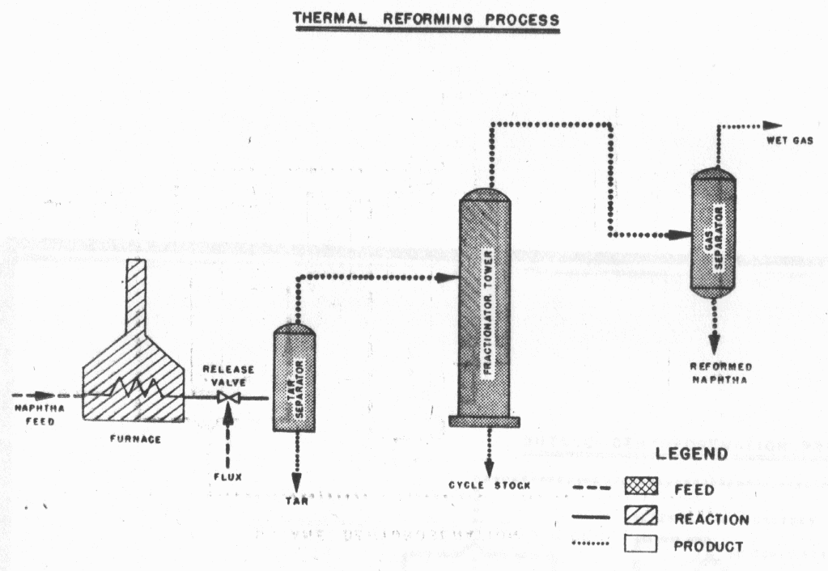

Combination Units

Improvements in cracking, fractionation, heat exchange, and instrumentation led to installations of at least two embryonic combination units as early as 1926 and 1928. Four years later, in 1932 Standard Oil Company of Indiana established a trend with the installation of the first genuine combination unit at its Whiting Refinery, Indiana. This unit was virtually independent of external heat due to exchange of heat generated in processing and with a daily capacity of 20,000 barrels. In turn, this development helped stimulate several new processes involving the use of thermal cracking, notably delayed coking, thermal reforming and thermal polymerisation.

Delayed Coking

In 1929 Standard Indiana filed a patent application and installed at Whiting Refinery a still for delayed coking, in which the thermal conversion of residual oil to naphtha which could be reformed, as carried all the way to coking (petroleum coke).

Thermal Reforming

This process applied thermal cracking to the ‘front end’ of crude oil – a straight run gasoline of boiling range 200-400 deg. F (93-204 deg. C). The straight run gasolines which composed of paraffins and naphthenes are poor in anti-knock quality. Reforming improved the anti-knock characteristics by increasing the olefin and aromatic content. Also, further improvement in octane number came from the resulting shift in boiling range to a greater volatility. The long chain (poor octane) paraffins yield olefins and paraffins of lower boiling points (and higher octane); while the ring-type hydrocarbons naphthenes and aromatics – undergo change, either by dehydrogenation of the naphthenes to form aromatics or by splitting off side chains.

Thermal Polymerisation

The cracking and reforming processes produce additional quantities of gaseous olefins – propylene and butylene which can be polymerized into valuable gasoline blending components of good anti-knock properties – known as polymer gasoline. As early as 1931 Pure Oil installed a unit at its Toledo Refinery in Ohio producing 100 barrel/day of gasoline from refinery gas. In 1934 Phillips Petroleum at its Alamo Refinery, began operating a unit of 1,000 barrels/day charging cracked gasoline either alone or combined with natural gas fractions. Before thermal polymerisation was superseded by catalytic polymerisation, a further application in combination with the thermal reforming of naphtha to improve octane ratings. This was first used by Gulf Oil at its Pittsburgh Refinery in 1936, and became known as ‘Polyforming’

During the mid-1930’s, thermal cracking reached its zenith and in 1934 the largest unit (24,000 barrels/day) combination thermal cracking unit was installed at the Pan-American Texas City Refinery, (a Standard Oil Company of Indiana affiliate). By 1937 a second even larger unit (35,000 barrels/day) was installed, and units of 20,000 BSD were common.

Photo 15. Combination Thermal Cracking Unit (Standard Oil Indiana)

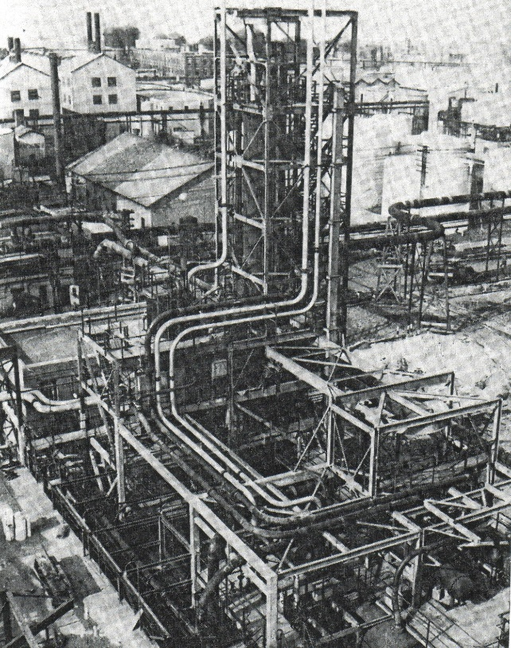

The wide spread use of thermal cracking units to produce motor gasoline of higher octane was evident in 1937 when for the second year the volume of cracked gasoline exceeded that of straight run gasoline.

# Hydrogenated Aviation Gasoline

1933 Hydrogenation process produces high quality avgas – Hydrogenated Aviation Gasoline

Petroleum research in the early 1930’s showed the hydrogenation was the most effective process for converting the heavier fractions of petroleum (kerosines and gas oils) into gasolines of much higher octane than those of raw gasoline from selected crudes. The first gasolines were disappointing because of poor storage stability and disappointing anti-knock performance in supercharged air-cooled engines. However subsequent work led to improved refinery process of hydrocracking using catalysts which provided a highly stable gasoline of relatively high octane. When this was blended with iso-pentane (to provide the volatility at the front end of the distillation) and with 3cc TEL/USG, it gave an excellent aviation gasoline of 92 Octane. Typically, in the 1930, this process was used to produce high quality leaded aviation gasoline of 91 to 95 Octane. This was known as ‘Hydrogenated Aviation Gasoline”. Prior to the application of the hydrogenation process to aviation fuel manufacture, virgin naphthas (straight run naphtha) obtained from only a few selected crudes such as Californian, Rumanian and Borneo crudes were the only feasible sources for the production of satisfactory aviation fuels in large quantities. Hydrogenation represented the first process milestone in the evolution of high octane gasolines. This process was used by Standard Oil Co. of Louisiana. The Process: Gas oil (diesel) (C26-C40) or low grade kerosene (C14-C26) is broken apart to form light gases (C1-C4) [methane to butanes] and gasoline (C5-C12).

Figure . Hydrogenation Process



The steps in the hydrogenation process were firstly to hydrogenate the kerosene or gas oil feedstock. The feedstock was pumped into the high pressure system (3,000 psi or 20,700 kPa) and heated to 650-800OF. (216-427OC.) along with an excess of fresh or recycled hydrogen before passing into the catalyst chamber. Virtually no change occurred in the composition of the oil occurs before it reached the catalyst zone; but when the heated oil and hydrogen reach the catalyst chamber, radical changes occurred in the structure of the feedstock with the larger molecule split into smaller fractions. On emerging from the catalyst chamber the mixture of treated oil and hydrogen was cooled and run through separators, the first separator was to recover the unused hydrogen gas for recycling, the second separator was used to recover the light gases unsuitable for aviation gasoline.

The volume of the hydrogenated oil amounted to 110-115% of the feed entering the unit. Hydrogen required for the process may be generated from materials such as natural gas, refinery gas, oil or coke by reacting them with steam under appropriate conditions.

Figure . Stage I Hydrogenation Process – Conversion

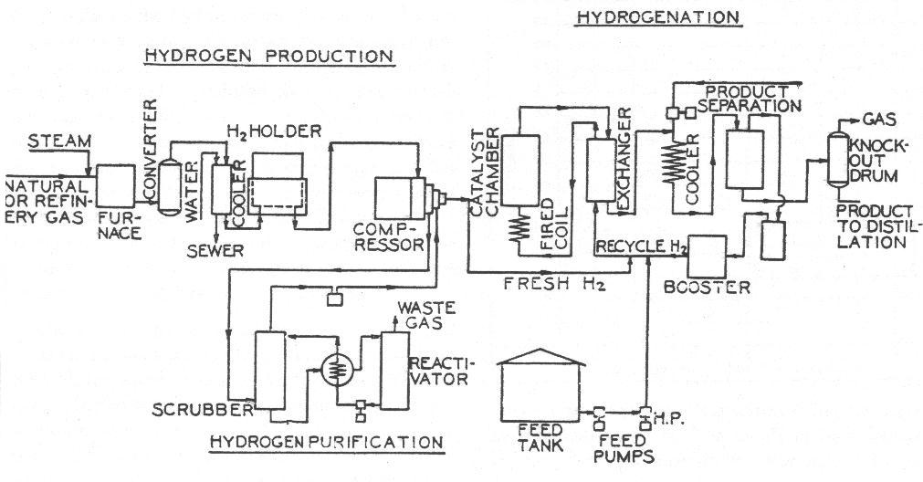

Reactions between the active catalyst and the feedstock and hydrogen resulted in practically a completed conversion. Approximately 60-80% of the hydrogenated product was of a volatility suitable for aviation gasoline. Impurities such as Sulphur and Nitrogen were either totally eliminated or reduced to negligible quantities. Because of the hydrogenation process, olefins and other unstable compounds are eliminated, and hence the aviation gasoline is of extremely high stability and may be stored for long periods without deterioration. The molecular structure of the fractions in the aviation gasoline are such as make them high in anti-knock value, and thus comparable to the best natural gasolines.

The aviation gasoline produced in Stage II is obtained by distillation from the materials coming from the hydrogenation process. In this operation the total hydrogenated overhead product is first debutanised to remove a certain amount of low boiling hydrocarbons (propane C3H8 to pentane C5H12) so that the finished aviation gasoline will have the desired vapour pressure. From the Debutaniser the product goes into a re-run still where the aviation gasoline is taken overhead (distilled off) and the higher boiling point fractions are removed as bottoms (residue).

These bottoms may be either returned to the process for further conversion of feedstock into aviation naphtha, or may be used as a high grade heavy naphtha and heavier distillates in other petroleum products. Again, there are practically no impurities in the hydrogenated product. Hence the only treatment required it caustic treatment to remove trace acidic components to make a completely finished aviation gasoline.

Figure . Stage II Hydrogenation Process - Refining

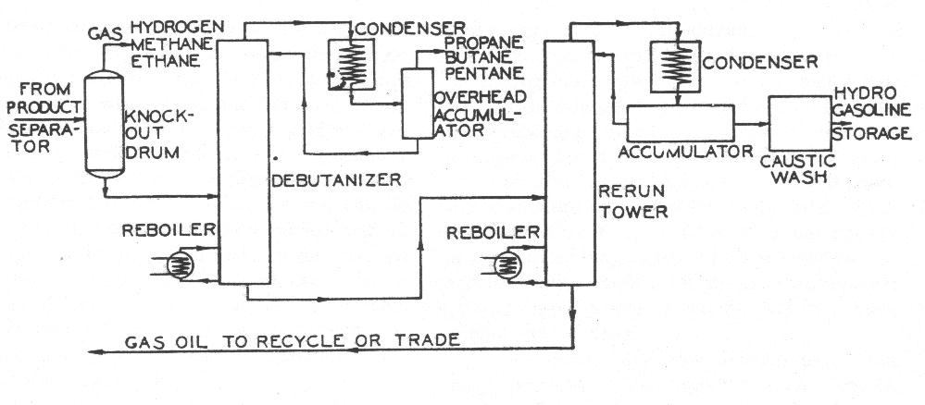

Commercial production of aviation fuels by high pressure hydrogenation was carried out by petroleum refiners particularly in the US. The supply of hydrogenated aviation fuels, produced in this way, materially augmented the available quantities of virgin naphthas, thus assuring increased supplies of high-grade aviation gasoline to meet the needs of the rapidly expanding aviation industry.

Typical test results of hydrogenated aviation gasoline produced from a large-scale operation using kerosene feedstock are listed in Table 9. with similar test results of a straight run naphtha from one of the best crude oil sources. It will be noted that the hydrogenated aviation gasoline was equivalent or superior to virgin naphtha (straight run naphtha) in the following aspects:

1. High stability as indicated by low copper dish gum and high breakdown time (oxygen stability).
2. Satisfactory volatility as shown by distillation and vapour pressure.
3. High clear octane ratings as determined by ASTM – CFR, US Army Air Corps and British Air Ministry tests.
4. Excellent susceptibility to additions of TEL as determined by the various octane number engine test methods.
5. Lower Sulphur level of hydrogenated naphthas adds to better lead susceptibility.

A prime requisite of modern aviation fuels (in 1939) was that they must possess a high degree of stability and to be able to withstand various storage conditions for reasonably long periods of time without change in properties. It was not infrequent that fuels were retained in storage in outlying stations for a year or more before using them in aircraft. In many instances, tropical or semi-tropical weather conditions prevailed during the time the gasoline was stored. Thus, the aviation fuel must possess high chemical stability in order to retain its properties over long storage periods especially in climates where the temperature range was high.

Table 9. Comparison of Aviation Gasolines from Straight Run Naphtha and Hydrogenated Gasoline

|  |  |  |
| --- | --- | --- |
| Test | Straight Run Naphtha | Hydrogenated Aviation Naphtha |
| Specific Gravity | 0.7064 | 0.7154 |
| Colour Saybolt | 30+ | 30+ |
| Doctor Test | Pass | Pass |
| Copper Dish Corrosion | Pass | Pass |
| Copper Dish Gum mg/100cc | 1.5 | 0.1 |
| % Sulphur | 0.025 | 0.005 |
| Breakdown time (hours) | 24+ | 24+ |
| Acid Heat (Temp. Difference) | 2oF. (1.1oC.) | 2oF. (1.1oC.) |
| Bromine No. | 2 | 2 |
| Reid Vapour Pressure @100 oF (37.7oC) psi  Kg/sq.cm | 7.0  0.4921 | 6.9  0.4857 |
| ASTM Distillation | | |
| Initial | 108oF. (42.2oC.) | 109oF. (42.7oC.) |
| % at 167 oF. (75oC.) | 31.0 | 32.0 |
| % at 212oF. (100oC.) | 71.0 | 68.5 |
| Final | 276oF. (135.6oC.) | 272oF. (133.3oC.) |
| % Recovery | 98.0 | 99.0 |
| Sum of 10+50% Distillation Temp | 330oF. (125.5oC.) | 329oF. (125oC.) |
| ASTM- CFR Octane Nos. | | |
| Clear | 74.1 | 76.5 |
| Plus 1 cc/USG (1.2 cc/Imp. Gal.) (0.25 cc/Litre) | 82.9 | 85.3 |
| Plus 3 cc/USG (3.6 cc/Imp. Gal.) (0.79 cc/Litre) | 88.5 | 90.4 |
| Plus 6 cc/USG (7.2 cc/Imp. Gal.) (1.58 cc/Litre) | 93.2 | 95.5 |
| Plus 8 cc/USG (9.6 cc/Imp. Gal.) (2.11 cc/Litre) | 94.9 | 98.0 |
| Plus 10 cc/USG (12.0 cc/Imp. Gal.) (2.64 cc/Litre) | 97.0 | 99.4 |
| US Army Air Corps Octane Nos. | | |
| Clear | 72.8 | 76.0 |
| Plus 1 cc/USG (1.2 cc/Imp. Gal.) (0.25 cc/Litre) | 83.8 | 87.9 |
| Plus 3 cc/USG (3.6 cc/Imp. Gal.) (0.79 cc/Litre) | 90.2 | 92.7 |
| Plus 6 cc/USG (7.2 cc/Imp. Gal.) (1.58 cc/Litre) | 95.5 | 98.0 |
| Plus 8 cc/USG (9.6 cc/Imp. Gal.) (2.11 cc/Litre) | 98.5 | 100.0 |
| Plus 10 cc/USG (12.0 cc/Imp. Gal.) (2.64 cc/Litre) | 99.5 | * |
| British Air Ministry Octane Nos. | | |
| Clear | 74.7 | 76.5 |
| Plus 1 cc/USG (1.2 cc/Imp. Gal.) (0.25 cc/Litre) | 82.6 | 85.9 |
| Plus 2 cc/USG (2.4 cc/Imp. Gal.) (0.52 cc/Litre) | 86.5 | 90.5 |
| Plus 3 cc/USG (3.6 cc/Imp. Gal.) (0.79 cc/Litre) | 88.7 | 92.2 |
| Plus 6 cc/USG (7.2 cc/Imp. Gal.) (1.58 cc/Litre) | 93.7 | 95.7 |

Equal to pure Iso-octane plus 0.07 cc/USG (0.08 cc/Imp. Gal.) (0.018 cc/Litre)

The production of aviation fuel in the 90 to 100 octane range was usually accomplished by blending a suitable base aviation gasoline with a sufficient quantity of high octane blending agent such as Iso-octane, which was then derived from refinery gases in a two-step process [Hydrocodimer Process] – namely polymerisation of isobutylene-normal butylene to form trimethyl substituted pentanes, and then hydrogenation of these substituted pentenes to give commercial Iso-octane.

One of the outstanding features of the hydrogenation process is its flexibility. By changing the catalyst, the unit could be diverted to hydrogenation of the polymers used in aviation blends. Hence the production of both hydrogenated materials which go to manufacture 100 octane aviation fuel could be accomplished with the same process equipment – a major saving in capital equipment costs.

Hydrogenated Gasoline &100 Octane Aviation Gasoline

Hydrogenated aviation gasolines, by virtue of their high octane ratings and TEL susceptibility, require less of the high anti-knock agents such as Iso-Octane for a given octane number than do virgin naphthas (straight run naphthas). The hydrogenated naphthas therefore provide the means of expanding the supply of 100 octane aviation fuel through extending the supplies the use of limited supplies of hydrogenated polymers (iso-octane). This can be realised without the sacrifice in fuel quality as exemplified by stability, Sulphur and gum properties as can be seen in Table 10. This fuel complied with the specifications of the British Air Ministry and the French Air Ministry in all respects, while the octane number is slightly above 100 by the US Army Air Corps test method.

Table 10. Avgas 100 from Hydrogenated Aviation Naphtha and Commercial Iso-Octane

|  |  |
| --- | --- |
| Test | Avgas 100 blend |
| Specific Gravity | 0.7089 |
| Colour | Green |
| Doctor Test | Pass |
| Copper Dish Corrosion | Pass |
| Copper Dish Gum mg/100cc | 0.7 |
| % Sulphur | 0.005 |
| Acid Heat (Temp. Difference) | 2oF. (1.1oC.) |
| Reid Vapour Pressure @100 oF (37.7oC) psi (Kg/sq.cm) | 7.0 (0.4921) |
| ASTM Distillation Initial boiling point | 109oF. (42.8oC.) |
| % at 167 oF. (75oC.) | 26.0 |
| % at 212oF. (100oC.) | 60.0 |
| Final boiling point | 308oF. (153.3oC.) |
| % Recovery | 98.0 |
| % Residue | 0.8 |
| Sum of 10+50% Distillation Temp | 347oF. (175oC.) |
| ASTM-CFR Octane Nos. | |
| Plus 3.33 cc/USG (4.0 cc/Imp. Gal.) (0.99 cc/Litre) | 100.0 |

The same hydrogenation process can be applied to coal, petroleum residues and other carbonaceous materials. This was a significant process used by the Axis powers in WWII, the Germans made their aviation gasoline from coal together with the Fischer-Tropsch process. It was also used by the Japanese to make aviation gasoline from pine root oil. These processes will be discussed later.

Figure . Simplified Catalytic Hydrogenation Process

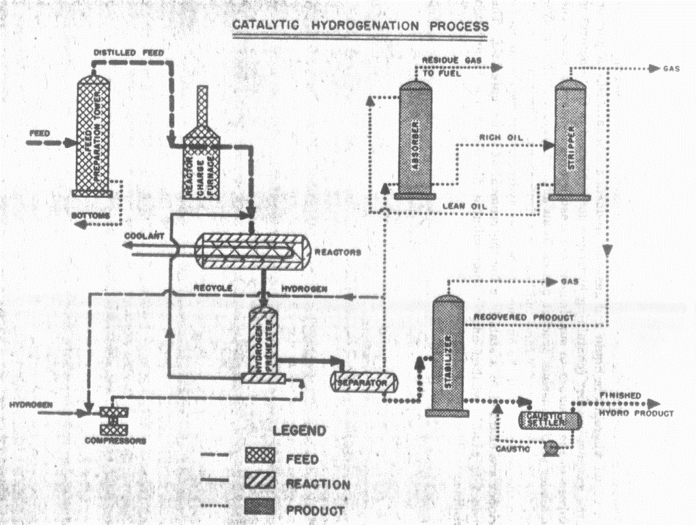

# Houdry Catalytic Process

Catalytic cracking is the process in which a material promotes the breaking of the heavy molecules of crude oil and their rearrangement into more useful lighter molecules (or products) without itself being changed. Houdry Catalytic Process had been under development in the United States for several years, and had been used for the commercial production of aviation gasoline since 1936, however the story started much earlier in France.

The ‘father’ of catalytic cracking was Eugene J. Houdry (1892-1962), who began work in France in 1922. With some support from the French government, Houdry’s work in France continued until 1929. It had shown some encouraging results, but its costs were considered high, and the government withdrew its tentative agreement to continue subsidizing the research. Houdry then approached three major oil companies - Anglo-Persian (later to become British Petroleum), Royal Dutch Shell, and Standard Oil Company of New Jersey (later to become Exxon); he was seeking funds to continue his research work. Each was slow to respond, and in 1930, he turned to the Vacuum Oil Company and obtained support. By October 1930 he had set up a laboratory and pilot plant at Paulsboro on the Delaware River near Philadelphia in New Jersey, USA.

Photo 16. Eugene Houdry in 1953 holding a catalytic converter

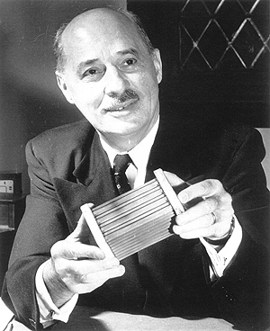

In 1931, the Houdry Process Corporation was formed. The Vacuum Oil Company subsidized one third of the stock, Houdry and his associates the remainder. Vacuum Oil merged with Standard Oil Company of New York to form the Socony-Vacuum Oil Company in 1931.

Before Houdry’s work in catalysis, heavy hydrocarbon fractions were cracked to light fractions by use of heat energy to break up the molecules – Thermal Cracking. The Houdry process was not immediately preferable to thermal cracking; although it produced gasoline with higher octane than thermally cracked gasoline, the yield was lower. The results obtained at the Paulsboro plant were disappointing to Socony-Vacuum. With the deepening economic depression of that time, interest waned, but Houdry remained confident.

In 1933, Houdry sought additional financial support from other oil companies and equipment vendors. Sun Oil Company, a private refiner across the Delaware River at Marcus Hook, purchased a one third interest in the Houdry Process Corporation from Houdry and his associates. With an agreement from Sun to finance further research and development, Houdry moved his apparatus across the river to the Sun Refinery. Work, however continued at the Paulsboro plant, both in the laboratory and in a 10-ton unit within the plant.

By June 1936, both design and operation of the experimental Houdry unit had improved so much that Socony-Vacuum chose to bring the first commercial cracking unit on stream at Paulsboro. Its daily charge was 2,000 barrels of light gas oil was cracked by a natural clay catalyst to produce moderately high octane gasoline.

In April 1937, Sun Oil began operating a unit with a daily charge of more than 12,000 barrels of heavy gas oil at Marcus Hook. These developments set the stage for the introduction of catalytic cracking as a standard secondary processing operation in fuels refineries.

Major investments were now planned in commercial sized units, and the company had to move from development to design engineering. Ten thousand barrel per day units were to be installed at each of Socony-Vacuum refineries - Augusta Refinery in Kansas and Trenton Refinery in Michigan.

Socony-Vacuum formed a small group of engineers led by George Durham to design and build Houdry units – this group would become the Engineering Department of Mobil Research and Development Corporation. In 1937, Sun Oil Company formed a similar group of engineers to build Houdry units in its refineries.

The prototype Houdry units in operation at Paulsboro and Marcus Hook refineries consisted of several insulated cylindrical reactors, referred to as ‘cases’. These were filled with a natural clay catalyst, extruded or pelleted to be ⅛ inch (3.2 mm) diameter and ¼ inch (6.4 mm) long. The catalyst promoted the cracking of heavy gas oil to ‘synthetic crude’, which was then fractionated to produce gasoline, with some fuel oil and recycle oil. Manifolded, vertically mounted, two-inch diameter tubes spaced one foot apart distributed superheated vapourised gas oil into the catalyst bed through shielded orifices. A similar set of tubes collected the synthetic crude.

Carbon or coke built up on the catalyst in the cracking process and decreased its effectiveness and had to be removed at intervals. To regenerate the catalyst, air was blown through the case, using the same tubing, and the carbon burned off. To keep the catalyst at acceptable temperatures during regeneration, a third set of tube circulated water to remove the heat of the burn. During the regeneration process, the pressure in the case rose to about 50 psi (345 KPa).

To achieve good cracking, atmospheric gas oil was 90% vapourised in an oil-fired pre-heater and passed via a Tar Separator to a superheater. At about 900 deg. F (480 deg. C), the gas oil vapour entered the case and was cracked to synthetic crude. When the catalyst became too deactivated by the coke deposits, the case was taken out of operation, purged with steam and vacuum, and readied for catalyst regeneration. With the catalyst reactivated, the case was again purged to be ready to receive the next charge of gas oil vapour.

The challenge for the design engineers was to translate the prototype Houdry unit into a reliable, commercial unit which would operate without any difficulty in the refineries. A number of important mechanical design changes were necessary. Design engineering in the mid-1930’s required a lot of calculations by hand, followed by careful drafting on paper of the mechanical arrangements suggested by the calculations. This was in a time before calculators and computers. A problem in the prototype units that had to be solved was the frequent failure of tube joints, especially in tubes used to transfer the heat during catalyst regeneration. The cyclic operation of the reactor, coupled with the high temperature differential across a tube from hot catalyst and vapour to pressurized hot water, stressed the metal, frequently distorting the case internals. Leaks in the tubing could lead to fires and occasional small explosions in the air and flue gas systems- the rectangular ducts had often been turned into cylindrical ducts. The commercial units had to be designed to avoid these conditions.

Research recommended decreasing the required regeneration time and temperature by limiting reaction to no more than 10 minutes. This operating procedure would also maintain a higher level of catalyst activity because coke lay-down would be lower. A typical four case unit would operate with each case on line for 10 minutes and regenerating for 30 minutes. An electromechanical cycle timer was developed to open and close the many valves on the four reactor units to achieve automatically the complicated reaction-purge-steam out-regeneration-purge-steam out sequence.

A commercial Houdry unit went on stream at the Socony-Vacuum Beaumont Refinery in Texas in March 1939, with all of these design changes. Units at 6 other refineries were soon added.

Photo 17. Houdry Catalytic Cracking Unit, Socony-Vacuum Refinery Beaumont, Texas 1939.

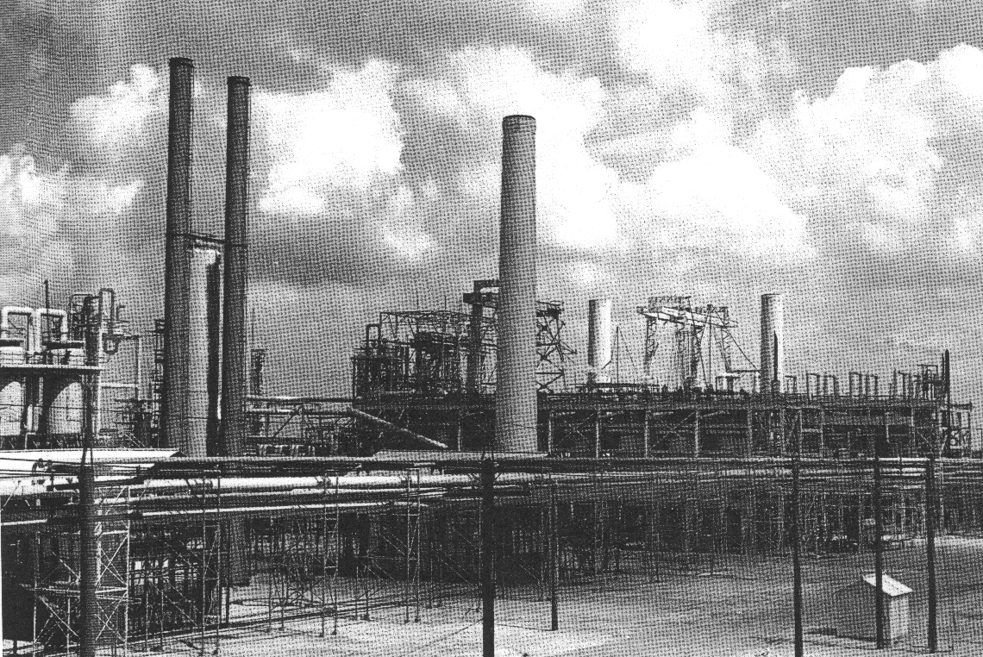

Similar units were being installed at Sun’s refineries and in other companies’ plants under Houdry licences. By 1941, some 29 units were in operation charging a total of 375,000 barrels of gas oil per day. The units are credited with providing 90% of all catalytically cracked aviation gasoline available to the Allies in 1942-43. Without these supplies, aviation fuel would have been limited and the outcome of early battles of World War II in the South Pacific may have been a different story.

1936 Houdry Catalytic process produces high quality Aviation Gasoline blendstock

Within several years the Houdry Catalytic Cracking process was a major part of the refining production of aviation gasoline for both commercial and military use. In 1938 some 7 million US gallons (26.5 million litres) of Houdry aviation gasoline was marketed in the United States, while a further 2 million US gallons (7.5 million litres) were produced and marketed in Europe for military purpose.

The Houdry Process has many applications such as polymerization, gas oil cracking, residual oil cracking, viscosity breaking and reforming, however it is the production of aviation gasoline by the conversion of gas oil which is of interest here.

As of April 1939, there were four Houdry units in operation with a total charge of 35,000 barrels (5.6 million Litres) per day. In addition, 9 units were under construction, the smallest was 10,000 barrels per day, the largest 18,000 barrels per day. One of the principal advantages of the Houdry process was the production of high-octane gasoline having good stability to oxidation and storage tests. These high-octane gasolines were obtained from practically all crudes and only comparatively minor differences occur between crudes.

In the early development of the process it was recognised that aviation gasoline could be produced having a quality equal, and in many cases superior to the straight run aviation naphthas produced from selected crudes. In general, the yield of aviation gasolines was about 20% based on the charge (feedstock) to the catalyst from a single pass operation. Finished aviation gasolines have an A.S.T.M –CFR Motor octane number of 75 to 80, while motor gasolines of 437 deg. F. (225 deg. C.) end point have a motor octane of 76 to 81.

Houdry Catalytic Process

In this Houdry operation, the feedstock (charge) was vapourised in the presence of about 5% steam, and passed through a catalyst chamber maintained at a temperature of 840-870 deg. F. (449-466 deg. C.) and a pressure of 10 to 60 psi (69 to 414 kPa). The charge rate through the catalyst chamber was normally maintained at 1 to 2-liquid volumes of fresh feed per hour per volume of catalyst filled space in the reaction chamber (this is known as space velocity). The catalyst mass consisted of cylindrically shaped pellets of 2 to 4 mm diameter, and 3 to 8 mm long. This mass exerted a strong catalytic action on the vapourised charge oil, converting a substantial proportion of the gas oil charge to gasoline. The products consisted of gas, gasolines (aviation gasoline, heavy naphtha), ‘bottoms’ – gas oils (commonly referred to as ‘first pass recycle oil’) and coke, which remained as a deposit on the catalyst.

Figure . Houdry Catalytic Cracking Process

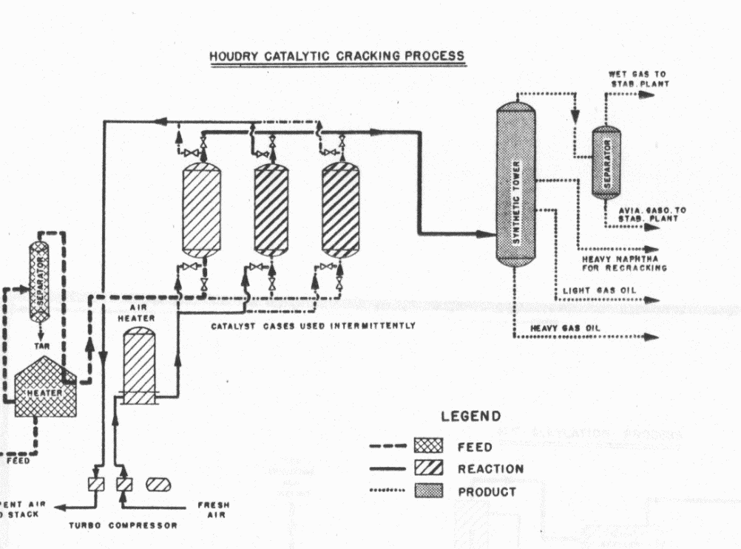

The exact yields from the various charge stocks were dependent upon the charge rate, length of the on-stream phase of the cycle, conversion temperature and pressure; the first two exerting the most decisive effect. The quality of gasolines obtained from a given feedstock, with respect to octane number and other characteristics was to a large extent independent of the yield and operation conditions. For instance, high-octane gasolines were obtained under mild conversion conditions. After the charge oil had been passed through a catalyst case for a predetermined length of time, the catalyst reduces in activity, due to the formation of coke-like substances on its surface, to such an extent that it became necessary to remove the catalyst chamber from stream service and restore its activity by regeneration. Since regeneration of the catalyst was an essential part of the operation, it was necessary to provide two or more catalyst chambers to allow for continuous operation. The commercial units have one or more catalyst chambers on stream while the balance are regenerating. The catalyst regeneration phase of the cycle consists of:

1. Evacuating the case or purging with steam to remove vapours from the catalyst space and lines.
2. Burning the coke deposits from the catalyst surface by using air under atmospheric or elevated pressure.
3. Purging the catalyst space to free it from combustion gases and adjusting the temperature for return to stream service.

The following table shows the yields and the properties of the various products using gas oil as a charging stock.

Table 11. Properties of Products from Houdry Conversion of Gas Oil

|  |  |  |  |  |  |  |  |  |
| --- | --- | --- | --- | --- | --- | --- | --- | --- |
| Property | Charge Stock | | Stabilised Aviation Gasoline | | Heavy Naphtha | | Recycle Gas Oil Bottoms | |
| % Vol. Yield | - | | 22 | | 20 | | 53 | |
| Specific Gravity | 0.8816 | | 0.7275 | | 0.8448 | | 0.8927 | |
| Distillation ASTM | oF. | oC. | oF. | oC. | oF. | oC. | oF. | oC. |
| Initial | 395 | 202 | 105 | 41 | 300 | 149 | 418 | 214 |
| 5% | 433 | 223 | 130 | 54 | 316 | 158 | 444 | 229 |
| 10% | 450 | 232 | 141 | 60 | 320 | 160 | 450 | 232 |
| 20% | 471 | 244 | 154 | 68 | 325 | 163 | 460 | 238 |
| 30% | 488 | 253 | 169 | 76 | 333 | 167 | 468 | 242 |
| 40% | 504 | 262 | 185 | 85 | 339 | 170 | 480 | 249 |
| 50% | 521 | 271 | 202 | 94 | 346 | 174 | 492 | 255 |
| 60% | 538 | 281 | 215 | 102 | 355 | 179 | 505 | 263 |
| 70% | 559 | 292 | 230 | 110 | 364 | 184 | 521 | 271 |
| 80% | 585 | 307 | 244 | 118 | 373 | 189 | 542 | 283 |
| 90% | 637 | 338 | 263 | 127 | 384 | 195 | 581 | 305 |
| End Point | 685 | 362 | 299 | 148 | 410 | 210 | 668 | 353 |
| % Recovery | 98.0 | | 98.0 | | 98.5 | | 98.0 | |
| % Residue | 1.5 | | 1.0 | | 1.0 | | 2.0 | |
| % Loss | 0.5 | | 1.0 | | 0.5 | | 0.0 | |
| Acidity of Residue | - | | Neutral | | - | | - | |
| Colour, Saybolt |  | | 30+ | |  | |  | |
| Reid Vapour Pressure psi, (kg/sq.cm) |  | | 7 (0.492) | |  | |  | |
| Doctor Test |  | | Negative (Pass) | |  | |  | |
| Acid Heat (Temp Difference) |  | | 68oF. (37.8oC.) | |  | |  | |
| Water Tolerance |  | | Pass | |  | |  | |
| Freezing Point |  | | <-76oF. (<-60oC.) | |  | |  | |
| Copper Dish Corrosion |  | | Pass | |  | |  | |
| Copper Dish Gum mg/100cc |  | | 1 | |  | |  | |
| Glass Dish Gum mg/100cc |  | | 1 | |  | |  | |
| Sulphur % Wt. |  | | 0.02 | |  | |  | |
| British Air Ministry Existent Gum |  | | 1 | |  | |  | |
| British Air Ministry Potential Gum |  | | 1 | |  | |  | |
| Octane Number ASTM-CFR |  | | 77.5 | | 75 | |  | |

Note: In making aviation gasoline there is an excess of about 5% volume of light ends consisting mainly of butanes and pentanes, but in making 10 psi RVP motor gasoline only about 1% excess is produced.

Graph . Houdry Distillation Data 1939



As can be seen from the distillation data the Gas Oil Bottoms are similar to the charge feedstock and therefore it was possible to recycle the gas oil bottoms back through the process to obtain more gasoline, however the penalty was increased coke and lower yield than fresh feedstock.

As noted above, the Houdry Process was not limited to certain crude sources as charging stocks, with the result that the available potential supply of aviation gasoline was enormously increased. While the yield of high octane (74-76 MON) straight run aviation gasoline from selected crudes, such as California, Smackover and certain Gulf Coastal crudes, was very low, the Houdry Process based on gas oil charge gave a 20% yield of high octane aviation gasoline. Satisfactory aviation gasolines were produced from a wide variety of sources, nevertheless certain advantages could be gained by using naphthenic type stocks in preference to the more paraffinic types.

This is illustrated by the difference hydrocarbon type analyses of aviation gasolines for the different charging stocks paraffinic and naphthenic.

Table 12. Hydrocarbon analysis from different Houdry Cracker feedstocks [13]

|  |  |  |
| --- | --- | --- |
| Avgas Hydrocarbon type | Paraffinic charge | Naphthenic charge |
| n-paraffins | 17% | 12% |
| Isoparaffins | 63% | 47% |
| Naphthenes | 7% | 25% |
| Aromatics | 9% | 13% |
| Olefins | 4% | 3% |
| Acid Heat | 20 deg. F | 20 deg. F |

Houdry Avgas Treatment

As with any cracking process, those compounds containing Sulphur, Nitrogen and Oxygen atoms are also changed to produce undesirable by-products such as Sulphides, Mercaptans from Sulphur compounds, Amines from the Nitrogen compounds, and Phenols, Cresols from the Oxygen compounds - these need to be removed. The aviation gasoline from the Houdry process was not a ‘finished’ product and required a certain amount of treatment or finishing to meet the aviation gasoline specifications required for commercial and military use. The finishing operations could be any of the following operations:

1. Sweetening or Caustic washing to remove acidic compounds, in particular Sulphur compounds such as Hydrogen Sulphide and Mercaptans in order to pass the Doctor Test.
2. Sulphuric acid treatment followed by redistillation – to pass acid heat or similar tests, such as Bromine Index, and improve the storage stability.
3. Passing over a Houdry catalyst at elevated temperature. This method of treatment achieved the same result as Sulphuric acid treatment. In addition, by the selection of the proper catalyst, the Sulphur content of the finished fuel could be markedly reduced.

While the majority of the aviation gasoline produced had been finished by a combination of methods 1 and 2 above, catalytic treatment was very effective and was used commercially by one refinery. The following table shows the differences in the treatment process on the gasoline, in particular octane number and gum tests.

Table 13. Properties of Treated Aviation Gasolines from Houdry.

|  |  |  |  |  |  |
| --- | --- | --- | --- | --- | --- |
| Property | Untreated Gasoline | Commercial Acid Treated & Re-run | Mildly Acid Treated & Re-run | Houdry Vapour phase treated | Houdry Liquid phase treated |
| % Vol. Yield | - | 84 | 94 | 91.5 | 86** |
| Specific Gravity | 0.7275 | 0.7275 | 0.7283 | 0.7303 | 0.7294 |
| Acidity of Residue | - | Neutral | Neutral | Neutral | Neutral |
| Colour, Saybolt | 30+ | 30+ | 28 | 30+ | 30+ |
| Reid Vapour Pressure psi.  kg/sq.cm | 7  0.492 | 5.7  0.41 | 5.5  0.39 | 6.6  0.46 | 6.2  0.44 |
| Doctor Test | Negative | Negative | Negative | Negative | Negative |
| Acid Heat (Temp Difference) | 68oF. | 14oF. | 48oF. | 21oF. | 9oF. |
| Water Tolerance | Pass | Pass | Pass | Pass | Pass |
| Freezing Point | <-76oF. | <-76oF. | <-76oF. | <-76oF. | <-76oF. |
| Copper Dish Corrosion | Pass | Pass | Pass | Pass | Pass |
| Copper Dish Gum mg/100cc | 1 | 1 | 1 | Below 1 | 1 |
| Glass Dish Gum mg/100cc | 1 | Below 1 | Below 1 | Below 1 | Nil |
| Sulphur % Wt. | 0.02 | 0.01 | 0.01 | 0.02 | 0.01 |
| British Air Ministry Existent Gum | 1 | 1 | 1 | 1 | - |
| British Air Ministry Potential Gum | 1 | 1 | 1 | 1 | - |
| US Army * Accelerated Gum old test 4 hr. mg/100cc | - | 2 | 1 | 2 | 1 |
| US Army * Accel. Gum new test 5 hr. mg/100cc | - | 5 | 1 | *** | - |
| Octane Number ASTM-CFR Clear | 77.5 | 78.0 | 77.7 | 79.2 | 77.4 |
| Plus 1 cc/USG (1.2 cc/Imp. Gal.) (0.25 cc/Litre) | 84.0 | 85.2 | 84.8 | 86.0 | 84.5 |
| Plus 2 cc/USG (2.4 cc/Imp. Gal.) (0.52 cc/Litre) | 86.6 | 88.0 | 87.9 | 88.6 | 87.4 |
| Plus 3 cc/USG (3.6 cc/Imp. Gal.) (0.79 cc/Litre) | 88.5 | 90.1 | 90.0 | 90.6 | 89.3 |

* Former US Army Test was for 4 hours at 212OF. (100OC.) under 100 psi (7.01 Kg/sq.cm) initial oxygen pressure before heating. The new test was similar, but for 5 hours and in the presence of ¼ in. (6.35 mm) diameter plain carbon steel tubing to furnish 35 sq.in. (226 sq.cm) of exposed surface.

** There is produced in addition to the 86% aviation gasoline, 5% Naphtha of 77.9 Octane and end point 414OF. (212OC.), and 8% Gas Oil of SAG. 0.8772.

*** This sample showed only 2 mg/100cc of gum after 8 hours aging in a bomb without carbon steel tubing.

Houdry gasolines showed excellent lead susceptibility as shown in the following graph, which compares Houdry Catalytic Cracked gasoline with straight run gasoline from a selected crude. Two octane engine test methods were used, the ASTM – CFR Motor Method and the US Army Air Corps Method.

Graph 3. ’Ethylizing’ Characteristics of Houdry Catalytic gasolines

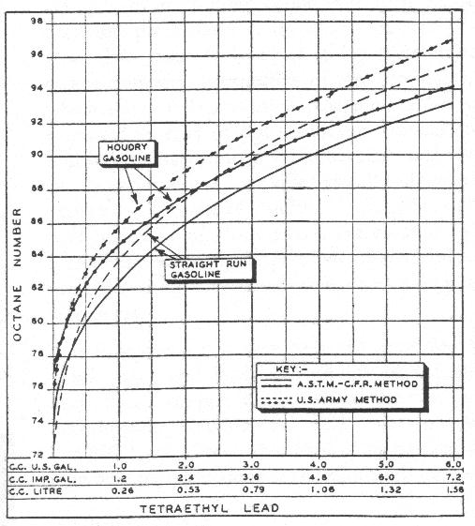

Both of these gasolines have the same volatility, 50% at 203oF. (95oC.), 90% at 258oF. (125.5oC.). While changing the volatility of most straight run gasolines materially affected lead susceptibility, it had much less effect on Houdry gasoline.

This was due to the fact that the distribution of the anti-knock value in the fractions of Houdry aviation gasoline was much more uniform than it was in aviation gasolines produced from straight run fractions normally occurring in suitable crudes. This quality of the gasoline is worthy of consideration. The high initial octane number and good lead susceptibility of Houdry gasoline played an important in the production of 100 Octane gasoline when commercial iso-octane was used. For example, to produce 100 US Army Octane Aviation Gasoline from straight run gasoline of 73 to 75 octane required the addition of 50 to 55% ‘Blending agent’ (75% technical iso-octane plus 25% Isopentane) and 3 cc of Tetraethyl Lead per US gallon (0.79 cc/Litre). Whereas gasoline produced by the Houdry process needed only 35 to 45% blending agent with the same amount of lead.

While the results in Graph 7. above represented the octane numbers obtained by two of the then current [Motor] methods used for the rating of aviation fuels, the limitations of these methods in predicting full-scale engine performance particularly with supercharged engines made it desirable to study the behaviour of fuels by other experimental methods. In 1939 the Ethyl Gasoline Corporation conducted tests on two Houdry gasolines (Commercial Acid treated and Mildly Acid treated) using a supercharged CFR engine at varying test conditions. This was some 3 years before the ASTM-CFR supercharge test method was adopted into aviation gasoline specification, and further naphtha from Michigan crude with ASTM Motor octane of 19 was used as a reference fuel (instead of normal Heptane of ASTM Motor octane of zero), so the results of the Ethyl Gasoline Corporation tests are perhaps somewhat experimental rather than a measurement against a standardised test method. They did show however that anti-knock values by their supercharge test engine, were in order:

Straight Run gasoline< Commercial Acid treated Houdry gasoline < Mildly acid treated Houdry gasoline.

Stability characteristics of the commercial acid-treated and mildly acid-treated fuels were determined by a variety of methods – glass dish, copper dish, British Air Ministry existent and potential gum, and US Army accelerated gum tests. These results are listed in Table 13. above. Actual storage tests in steel barrels were also carried out at atmospheric temperatures and constant elevated temperature (115oF, 46oC). Also, tests were completed on a large quantity of commercial grade gasoline placed in a storage tank for seven months. The overall conclusion of these tests was that Houdry aviation gasoline showed practically no change and that the results were comparable with conventional straight run gasolines.

The Houdry process made possible the production of high-quality aviation gasoline from practically any crude, thus increasing the potential supply. These aviation gasolines were of high octane 76-78, good lead susceptibility equal to conventional straight run gasolines from selected crudes. Storage stability was satisfactory as measured by a variety of test methods both US and British.

# Hydrocodimer Process

The Process: Hydrocodimer was the means of producing Trimethyl Pentane (Edgar’s 100 Octane Standard).

Figure . The Hydrocodimer Process



This process was used extensively throughout the US during WWII with small plants located in Texas and California.

The product produced had a marked stability in storage, a clear octane number of 96.5 (ASTM – CFR Motor Method) and excellent lead susceptibility. Since this material has a boiling range between 188OF to 243OF (86.6OC to 117OC), and a Reid Vapour Pressure of 2.8 psi (19.3 kPa), it is necessary to add another lighter material so as to make a blending agent which, and when added to the aviation naphtha it will produce a fuel of normal characteristics.

Anglo-Iranian Abadan

At the Anglo-Iranian Sunbury Research using a pilot plant at Grangemouth, UK, they had looked at catalytic polymerisation using a cadmium phosphate catalyst. The decision was made to build a catalytic polymerisation unit at Abadan plant, but as the Sunbury catalyst was not ready for commercialization, the order was placed in June 1936 with US process licenced by UOP (Universal Oil Products). The UOP plant was commissioned in May 1938. In 1937 it had been decided to install another polymerisation plant in Abadan for the selective combination of olefins to make Codimers. However, UOP refused to build the plant on the favourable terms of the first plant and so the design went to Kellogg to design a codimer plant at Abadan using a Sunbury catalyst. The new plant was commissioned in June 1939. Anglo-Iranian was also interested in ‘acid polymerisation’ process in which two molecules of olefin isobutene are combined in the presence of sulphuric acid to form di-isobutene (DIB) which has an octane rating around 88. Early in 1935 a pilot plant was built at LLandarcy (Wales, UK) to produce four tons of DIB per day to provide design data for a full-scale plant at Abadan. This plant was commission in September 1937 and had an input of 10,000 gallons/hour of cracker gas, but suffered leaks and mechanical difficulties which were not cured until December 1938. The DIB produced by polymerisation had quite a good octane number, but if treated with hydrogen under pressure using a catalyst would produce iso-octane. A hydrogenation plant at Abadan was commissioned in September 1938 to make iso-octane and also to hydrogenate codimer to make another iso-octane concentrate ‘Hydrocodimer’.

# 1937 Alkylation Process for Iso-Octane Is Created

A major breakthrough in refinery process for the manufacture of iso-octane occurred in 1937 with the advent of the alkylation process. This research groups of Anglo-Iranian (BP), Humble (Exxon), Shell, Standard Oil Development (Esso) and Texas Co. (Texaco) all made important progress towards commercial application of this refining process. The first commercial plant went into production at the Humble Refinery in Baytown, Texas in 1938.

Figure 8. Alkylation Process



By 1938 about 90% of US government avgas purchases were for the 100 Octane grade which had now become the principal fuel used by the US Army Air Corps.

Photo 18. Humble Oil & Refining Co., Alkylation Unit, Baytown, Texas USA (1939) - First commercial unit

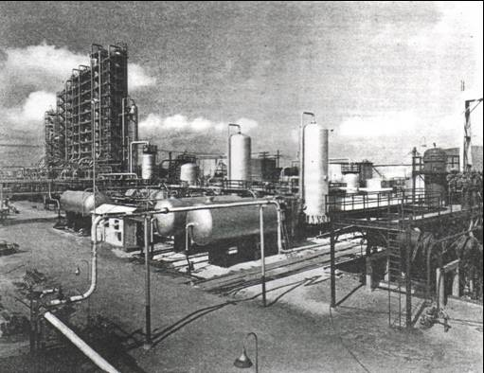

Anglo-Iranian Research

One of the interesting stories regarding the discovery of the alkylation process and its further development to commercialization is that of the work done by Anglo-Iranian Chemical Research Section at Sunbury, UK. This would lead to the battles over patents and royalties. The story is described in the History of British Petroleum[14] in this way: -

The manufacture of iso-octane by the two-stage process of polymerisation and hydrogenation was soon overtaken by the Company’s main research success during this period- the discovery of the Alkylation process enabling 100-octane spirit to be produced from refinery gases by the reaction with sulphuric acid. During 1934 and 1935, the Chemical Research Section under Dr. S.F. Birch concentrated on polymerisation reactions. In July 1936, Dr. T Tait undertook what was intended to be a simple experiment. The unexpected result was described as a ‘fundamental chemical reaction which may prove extremely valuable’, the effective birth of the alkylation process.

It was known that by treatment with about 60% sulphuric acid isobutene molecules would combine to form di-isobutene and Tait’s hope was that with stronger acid (97%) isobutene might also combine with normal butane. In attempting to achieve that reaction, Tait was faced with the problem that butenes are gases at ordinary temperatures. Thinking that he might have a better chance of producing the desired reaction with sulphuric acid if he could keep the butenes in liquid form, he decided to dissolve them in a suitable solvent. Pentane was regarded as chemically unreactive and was chosen. So, Tait put the sulphuric acid and pentane in a 2-litre glass bottle surrounded by ice, set a stirrer going and slowly added his mixture of iso and normal butenes. Some two hours later he separated the acid, distilled away the pentane and measured the liquid product which he had left. There was twice as much as he thought there should have been. Believing he must have made a mistake with his measurements, he repeated the experiment, but again got the same result. Also, the product was paraffinic in nature and not as Tait expected, an olefin (Di-butenes).

Birch was soon informed of Tait’s surprising results and was able to deduce the probable chemistry of the reaction, namely that the pentane which Tait had assumed to be an inert solvent had somehow entered into the reaction. On analysis the pentane used by Tait was found to be largely isopentane, (a branched chain paraffin) which had reacted with the butenes. That was confirmed by further experiments which showed that another branched chain paraffin, isobutane, could also be made to react with butenes. Sunbury reports make no mention of this background and convey the impression that a deliberate (and successful) attempt was made to see if an olefin would react with an isoparaffin. However, interviews with Tait, Howes, Smith and Dr. F.A. Fidler in 1976 all confirmed that the results obtained by Tait was not the prime objective of the experiment.

It was an important discovery. It was known that reactions between isoparaffins and olefins had already been achieved in the USA; but only by means of very drastic treatment. The finding that the reaction could readily take place in the cold using a commonly available reagent sulphuric acid held out exciting prospects. The reaction of greatest interest was that between isobutane and butenes to make iso-octane in a single step and in better yields than the existing 2-stage polymerisation followed by hydrogenation. However before ‘acid condensation’ as the process was originally described could be turned into a refinery process, much data had to be obtained from laboratory trials. This task fell to two junior members of the Chemical Research Section F.B. Pim and Dr. Fidler who worked for months on the reactions of sulphuric acid. By December 1936 sufficient data had been obtained to construct a pilot plant as Sunbury. E. McNeill of the Development Section soon established the importance of recycling unused isobutane stock back into the reaction vessel and of maintaining a high ratio between the recycled material and the olefins in the feed. His findings greatly aided the development of the process, and was duly patented. Action to take to patent the basic reaction from Tait’s discovery was done and the applications is dated 29 July 1936.

The term ‘acid condensation’ remained in use until December 1939 when it gave place to ‘alkylation’ to fall into line with terminology used by other companies.

The company (Anglo- Iranian, later BP) were not alone in 1936 in being interested in isoparaffin-olefin reactions. Royal Dutch-Shell, the Texas Company, Standard Oil (NJ) and UOP were also active in the same field. However, with its patent confirmed in January 1938, the company (BP) were first to publish its findings in the technical journals. Howes felt that a mistake was made in ‘rushing into print too soon’ and that doing so had saved the US oil companies an enormous amount of research effort, leaving the Company (BP) vulnerable to others who were clever at exploiting gaps in patents. Certainly by 1938 a highly confusing patent situation in relation to alkylation reactions had arisen. However, in this as other fields the attraction of co-operation outweighed the appetite for competition. Discussions between the Company (BP) and Standard Oil (NJ) crystallized into an agreement on 17 March 1939, by which time a similar agreement had been reached between Royal Dutch-Shell and The Texas Company. It was only a matter of weeks before those agreements were merged into an overall agreement between the four companies to pool their research efforts and work together to expedite the commercial applications of the process. The Alkylation Agreement, which also included UOP was not finally signed until 11 June 1940, but took effect from 12 April 1939, providing for royalties from licensing the process to be shared between the signatories.

The tense international atmosphere of 1939 provided a weighty distraction to the thoughts of royalty payments.

At this time in Britain, the 87 Octane aviation gasoline was the standard fuel for front line RAF bombers and fighters. There was considerable soul searching on the question that in the event of war whether the engines of the RAF aircraft should be developed to use 100 octane fuel, many authorities maintaining that in the event of war, the 100 octane fuel which was at that time was mostly produced in the US, would be unavailable to Britain. In 1937, Banks argued strongly that the RAF aircraft should take advantage of 100 octane fuel even if the fuel was in short supply, as this may prove decisive in the air.

Photo 19. RAF Spitfire Mk I’s No. 19 Squadron (Duxford) 1938.

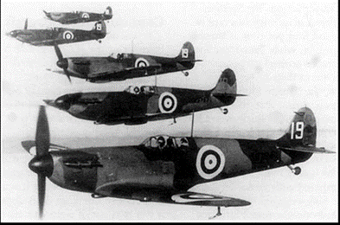

Photo 20. RAF Bristol Blenheim bombers of No. 82 Squadron Bomber Command 1938.

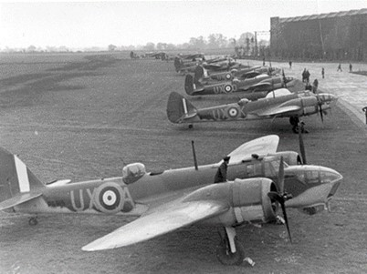

# Oil Companies and Refineries

Esso in Europe

Port Jerome, originally a sandy bank in the Seine river berth, has been built up through a large land recovery program implemented by Napoleon III during the mid- 19th century. The first refinery in Port Jerome was created in 1929 (completed in 1933) by the Bedford Petroleum Company (a company belonging since 1902 to the Standard Oil of New Jersey).

Vacuum Oil in Europe

Vacuum Oil Company crossed the Atlantic to Europe and operated in several countries. In 1929, Mr. Ed Atwood [the first engineer to work for Vacuum Oil Company] was sent to France to build a new refinery for Vacuum’s French affiliate, Raffineries de la Vacuum Oil Company, at Port Jerome, near Gravenchon on the Seine River midway between Le Havre and Rouen. The plant was intended to provide high grade lubricants to France and neighbouring countries, and was also expected to produce a considerable amount of light products such as gasoline and fuel oil from its daily throughput of 5,000 barrels. It was brought on stream in 1934 in the middle years of the Depression and gave employment to 600 people. After several years helping the Gravenchon refinery’s operations, Atwood departed France and moved to Italy, where he helped to build the Naples Refinery. It went on stream in November 1937.

1936 Caltex, Aramco and CPI Joint Ventures Formed[15]

In 1936, Standard Oil Co. of California (Socal) and The Texas Co. (Texaco) formed California Texas Oil Co., Ltd. (Caltex), which was a joint venture combining Socal's Middle Eastern exploration and production rights with those of The Texas Co.'s extensive marketing network in Africa and Asia. The companies also become partners in Bahrain Petroleum Co., formed in 1929. As partners in California Arabian Standard Oil Company (Casoc, later Aramco), they gain exploration rights in Middle East. They also become partners in N.V. Nederlansche Pacific Petroleum Maatschappij (later P.T. Caltex Pacific Indonesia) with exploration rights in Sumatra, Java and New Guinea.

# Epilogue for 1938

In this period 1930 to 1938, the early part of the 30’s was dominated by the “Great Depression” and the public’s avid interest in faster and faster aeroplanes, while the mid to late 30’s saw the “Clouds of War” gathering.

Major developments were made in aircraft design and performance, with the biplanes of the 1920’s giving way to the multi-engine bombers such as the Boeing B-17 bomber and Vickers Wellington, and sleek fighters such as the Supermarine Spitfire and Hawker Hurricane on the military front.

This was also the romantic era of the flying boats and exotic locations which would not survive after the Second World War due to the abundance of land-based airfields.

Photo 21. Imperial Airways (London) Short Empire Class flying boat circa 1935

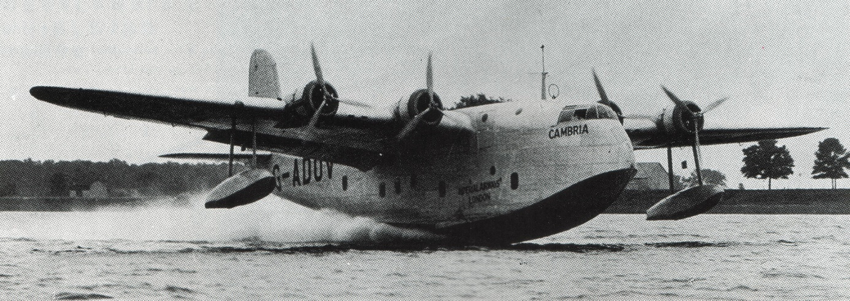

The famous Douglas DC-3 started its career and many other sleek airliners were making their appearance in the world airlines.

The “golden years of aviation” were about to give way to a war dominated by air power and the second world war of that century.

On the technical front, the refining processes of Alkylation and Hydrocodimer had made the dream of “100-Octane gasoline” a reality, and this would be the foundation for all future aviation gasolines.

# Index

1

100 octane 15, 16, 20, 22, 30, 31, 44, 45

100 Octane 3, 4, 7, 19, 20, 21, 41, 42, 43, 48

2

2 Aeronef “A” 12

2 Aeronef “B” 12

6

65 octane 15

68 Octane 19

7

74 Octane 13

8

87 Octane 4, 15, 45

9

92 Octane 15, 27

95 Octane 27

A

Abadan 43

accelerated ageing test 9

accelerated gum 40, 42

acid condensation 45

Acid Heat 17, 18, 30, 31, 37, 39, 40

acid heat test 4, 9, 17

acid polymerisation 43

acidic compounds 39

air-cooled engines 13, 27

aircraft engines 6

Alamo Refinery 26

Aldrin 19

alkane 25

alkene 24, 25

alkylation 3, 22, 43, 44, 45, 48

Alkylation Agreement 45

alkylation process 7, 44

alloy fuel tanks corrosion 20

American Society for Testing Materials 15

Amines 39

Anglo-Iranian 43, 44, 45

Anglo-Persian 32

anti-knock 6, 7, 9, 13, 15, 19, 20, 25, 26, 27, 28, 31, 41, 42

anti-knock additive 4

Aramco 47

Armstrong Whitworth 13

aromatic 3, 4, 7, 14, 22, 25, 39

aromatization 22

Associated Ethyl Company 19

Atwood 47

Augusta Refinery 33

automobile 7

automobile engines 6

aviation base stocks 22

Aviation Fuel Specifications 1939 (Commercial) 18

aviation gasoline 4, 6, 7, 9, 15, 16, 19, 22, 23, 27, 28, 29, 30, 31, 32, 35, 36, 37, 38, 39, 40, 41, 42, 45

aviation naphtha 28, 42

B

Bahrain Petroleum Co. 47

Baku 22, 23

Banks 19, 20, 45

base stock 7, 22, 23

Bass 19, 20, 55

Baytown 43, 44

Beaumont Refinery 34

Bedford Petroleum Company 47

Benzene 13

Benzol 4, 6, 7, 9, 13, 14, 22

Benzole 22

Birch 44, 45

blending agent 41

Boeing B-17 48

Boeing P-26 ‘Peashooter’ 11

Boeing YP-29 19

Borneo 27

brake mean effective pressure 6

Bristol Blenheim 46

Bristol Bulldog 13

British Air Ministry 9, 13, 21, 29, 30, 31, 37, 40, 42

British Aviation Gasoline Specification 14

British Government 19

British Petroleum 32

Bromine Index 39

Bromine No. 30

Burton 24

Burton process 22, 23

butane 27, 37

butenes 45

butylene 26

C

cadmium phosphate catalyst 43

California 27, 38, 42

California Arabian Standard Oil Company 47

California Texas Oil Co., Ltd. 47

Calorific value 6, 17, 18

Caltex 47

Cannel coal 7

carbonaceous materials 31

carburettor 13, 20

catalyst 27, 28, 31, 36

catalytic converter 33

catalytic cracking 3, 22, 32, 33

catalytic polymerisation 3, 26, 43

catalytically cracked aviation gasoline 35

catalytically cracked gasolines 7

caustic treatment 28

Caustic washing 39

CFR engine 13, 20, 41

CFR Modified Motor Method 12

CFR Modified Motor Rating 14

CFR MON 17, 18

CFR Motor 10

CFR Motor Method 40, 42

CFR Motor octane number 36

Chambre Syndicale des Industries Aéronautiques 20

Charge Stock 37

coal 7, 31

coal spirit 14

Coalite 7

Codimers 43

coke 27, 36, 38

Coking Process 3

Colour 10, 12, 14, 31, 37, 40

Colour Saybolt 30

connecting rods 20

Cooperative Fuel Research Committee 15

copper dish 17, 42

Copper Dish Corrosion 30, 31, 37, 40

Copper Dish Gum 29, 30, 31, 37, 40

Corrosion 17

cracked gasoline 23, 26

cracked oil 7

cracking process 7

crankcases 20

crankshafts 20

Cresols 39

Cross 24

D

debutanised 28

Debutaniser 28

dehydrogenation 22, 26

delayed coking 25

Demon 13

Di-butenes 45

diesel 27

di-isobutene 43, 44

Di-Isobutylene 3

distillate 3, 28

distillation 4, 6, 9, 15, 27, 29

Distillation 10, 12, 14, 17, 18, 30, 31, 37

Doctor Test 30, 31, 37, 39, 40

Doolittle 15, 19

dope 4

Douglas DC-3 18, 48

DTD-134 13

DTD-224 13, 14

DTD-230 13, 14

Dubbs 24

Dubbs Process 23

Durham 34

E

Edgar 9, 22, 42

Egloff 15, 55

End Point 10, 14

engine test methods 29

England 7

Esso 19, 43

Ethyl Fluid 7

Ethyl Gasoline Corporation 41

Ethyl series 30 Engine 9

exhaust gas testers 20

exhaust pipe metallurgy 20

Existent Gum 10, 12, 14, 37, 40

Exxon 32, 43

Exxon Research & Engineering 19

F

Fidler 45

Fischer-Tropsch process 31

Freezing Point 4, 10, 12, 14, 17, 18, 37, 40

freezing point test 9

French Air Ministry 31

French Aviation Gasoline Specifications 12

French government 32

fuel oil 47

Fuel X 10

G

gas oil 27

Gas Oil Bottoms 38

gas oil cracking 35

gas reversion 22

gasoline 47

German 31

Germany 7

Glass Dish Gum 37, 40, 42

Grade 100 5

Grade 58-65 5

Grade 87 5

Grade 92 5

Grangemouth 43

Gravenchon 47

Grumman F3F-2 11

Gulf Coast 38

Gulf Oil 26

gum 4, 6, 31, 39, 40

gum stability 4

gum test 13

Gum, accelerated 17, 18

H

Hardys 13

Hawker Hart 13

Hawker Hurricane 21, 48

heat of combustion 9

Heat of Combustion 14

heavy gas oil 34

heavy naphtha 28, 36

Heavy Naphtha 37

Heron 9, 19, 20

Hexane 13

highly branched paraffins 7

Holmes-Manley 24

homolytic fission 24

Houdry 24, 32, 33, 38

Houdry catalytic cracked gasoline 40

Houdry Catalytic Cracking 3, 35, 36

Houdry Catalytic Process 32

Houdry process 38, 39, 41

Houdry Process Corporation 33

Howes 45

Hubner 15, 17, 55

Hucknell Colliery 7

Humble 43

Humble Oil & Refining Co. 44

Humble Refinery 43

Hydrocodimer 20, 22, 42, 43, 48

Hydrocodimer Process 30

hydrocracking 27

hydroforming 22

hydrogen 24, 25, 27, 28, 43

Hydrogen abstraction 24

Hydrogen Sulphide 39

hydrogenated 20

hydrogenated aviation fuels 29

hydrogenated aviation gasoline 27, 29

Hydrogenated Aviation Naphtha 30

hydrogenated naphthas 29, 31

hydrogenated oil 27

hydrogenated polymers 31

hydrogenation 3, 19, 22, 27, 28, 29, 30, 43, 44, 45

Hydrogenation 22

Hydrogenation Process 3, 22, 27, 28, 29, 31, 32

I

inter-coolers 20

internally cooled exhaust valve 20

isobutane 45

isobutene 43, 44

iso-butylene 20, 30

isomerisation 22

iso-octane 3, 7, 19, 20, 22, 30, 31, 41, 43, 44, 45

iso-paraffins 4, 39, 45

iso-pentane 27, 41

Isopropyl Ether 7

J

Japanese 31

Java 47

K

Kellogg 43

kerosene 27, 29

kerosines 27

Klein 19, 20

knock engine testing 9

Knock Rating 10, 12, 14

L

latent heat of evaporation 9

leaded fuels 20

leaded straight run naphtha 7

liquid cooled engines 13

Llandarcy 43

lubricating oils 3

M

Marcus Hook 33

McCook Field 19

McNeill 45

Mercaptans 39

metallurgists 6, 7

methane 27

Michigan 42

Mobil Research and Development Corporation 34

modified CFR method 15

modified motor method 20

motor gasoline 22, 23, 26, 36, 37

motor method 20

motor spirit 9

motor spirits 6

multi-stage blowers 20

Murphy 15, 55

N

N.V. Nederlansche Pacific Petroleum Maatschappij 47

naphtha 4, 25, 26

naphtha isomerisation 22

naphthenes 25, 39

naphthenic 7, 38, 39

Naples Refinery 47

natural clay catalyst 33

natural gas fractions 26

natural gasoline 4, 22, 28

New Guinea 47

Nitrogen 28, 39

No. 19 Squadron 46

No. 82 Squadron 46

non-corrosiveness 9

normal butane 44

normal butenes 44

normal butylene 20, 30

normal Heptane 42

Normes 3401 12

North American Harvard trainer 16

n-paraffins 39

O

octane number 3, 4, 7, 9, 15, 20, 25, 29, 30, 31, 36, 39, 41, 42, 43

Octane Number 6, 9, 17, 18, 37, 40

octane rating 15

octane scale 9, 22

olefin 25, 45

olefins 28, 39, 43, 45

Oxygen 39

oxygen stability 29

P

Pan-American Texas City Refinery 26

paraffinic 38, 39, 45

paraffins 25

Paulsboro 32

pentane 28, 37, 44, 45

pentenes 30

petroleum coke 25

petroleum residues 31

Phenols 39

Phillips Petroleum 26

Phosphoric acid 20

Pim 45

pine root oil 31

Pittsburgh Refinery 26

polyforming 22, 26

polymer gasoline 26

polymerisation 22, 30, 35, 44

polymerize 20

polymers 24

poppet valve engine 20

Port Jerome 47

Potential Gum 12, 14, 37, 40, 42

pour point 3

propane 28

propylene 26

Pure Oil 26

R

Radical addition 24

Radical decomposition 24

Raffineries de la Vacuum Oil Company 47

Recycle Gas Oil Bottoms 37

reforming 25, 35

Reid Vapour Pressure 10, 12, 14, 30, 31, 37, 40, 42

re-run still 28

residual oil 22, 25

residual oil cracking 35

Roll-Royce Merlin Engine 21

Royal Dutch Shell 32

Royal Dutch-Shell 45

Rumania 27

S

S Army 13

Second World Petroleum Congress 15

shale 7

Shell 15, 19, 43

Shell Company 19

Short Empire Class flying boat 48

Shukhov 22

Shukhov cracking process 22, 23

sleeve valve 20

Smackover 38

Smith 45

Socony-Vacuum Oil Company 33

Socony-Vacuum Refinery Beaumont 35

Solvent Dewaxing 3

Solvent Extraction 3

spark plugs 7, 20

specific gravity 6, 12, 14, 30, 31, 37, 40

Spitfire 21, 46

St. Louis Refinery 19

Stabilised Aviation Gasoline 37

stability 9, 27, 28, 29, 31, 39, 42

Stanavo 9, 12

Stanavo #11 10

Stanavo #13 10

Stanavo #14 10

Stanavo #2 10

Stanavo #3 10

Stanavo #9 10

Standard Oil 45

Standard Oil Co. of California 47

Standard Oil Co. of Louisiana 27

Standard Oil Companies 9

Standard Oil Company of Indiana 25, 26

Standard Oil Company of New Jersey 32, 47

Standard Oil Company of New York 33

Standard Oil Development Company 19, 43

steam cracking 24

Straight chain paraffins 4

straight run aviation gasoline 38

straight run aviation naphthas 35

straight run gasoline ..4, 7, 15, 22, 25, 26, 40, 41, 42

straight run naphtha 22, 27, 29, 30, 31

straight run product 14

Sulphur 6, 10, 12, 14, 17, 18, 28, 29, 30, 31, 37, 39

Sulphuric 20

sulphuric acid 43, 44, 45

Sulphuric acid treatment 39

Sumatra 47

Sun Oil Company 33, 34

Sun Refinery 33

Sunbury 43, 44, 45

supercharge 20, 27, 41

Supercharge Rating 12

Supermarine K5054 21

Supermarine Spitfire 48

Sweetening 39

T

Tait 44, 45

tar 3

**Termination reactions** 24

Tetra Ethyl Lead 4, 7, 10, 12, 14, 17, 18

Tetraethyl Lead 41

Texaco 43, 47

Texas 42

Texas Company 45

The Texas Co. 47

thermal cracked gasoline 22

thermal cracking 22, 23, 24, 25, 26, 33

thermal plug 15

thermal polymerisation 25, 26

thermal reforming 3, 25, 26

Toledo Refinery 26

treated cracked gasoline 9

treated oil 27

Trenton Refinery 33

Trimethyl Pentane 42

Trimethyl pentenes 20

trimethyl substituted pentanes 30

Tube & Tank 24

U

UK Government 7

Universal Oil Products 43

unleaded gasoline 15

unleaded straight run naphtha 7

US Army 3, 9, 15, 17, 19, 40, 42

US Army Air Corps 11, 19, 29, 30, 31, 43

US Army Air Corps Method 40

US Army Air Force 4, 5

US Army Method 13

US Government 15, 43

US Navy 11, 15, 17

V

Vacuum Oil Company 32, 33, 47

valve metallurgy 20

valves 6, 7

Van Winkle 4, 55

vapour lock 6

vapour pressure 4, 6, 9, 15, 17, 18, 28, 29

vapour-pressure test 9

Vickers Wellington 48

Visbreaker 3

viscosity breaking 35

viscosity index 3

volatility 4, 9, 15, 25, 27, 28, 29, 41

W

water solubility 9

Water Tolerance 37, 40

waxes 3

Welbeck Distillation Company 7

Whiting Refinery 25

Wright Field 19

Wright R-1820 radial engine 11

# References

1. Aviation Gasoline Manufacture – Matthew Van Winkle, Pennsylvania State College, McGraw-Hill 1944.
2. Aviation Gasoline Manufacture – Matthew Van Winkle, Pennsylvania State College, McGraw-Hill 1944.
3. Personal communication Mr Warren R. Hicks – October 2007
4. Aviation Gasoline Manufacture – Matthew Van Winkle, Pennsylvania State College, McGraw-Hill 1944.
5. Stanavo Aviation Gasoline Specifications Year 1935 Issue
6. Hubner, Egloff, Murphy; National Petroleum News July 28, 1937 (as listed in Aviation Gasoline Manufacture – Van Winkle 1944)
7. Shell Aviation News January 1937 High Duty Aero Engines and their Fuels by F.R. Banks.
8. Shell Aviation News February 1937 High Octane Fuels by E.L. Bass
9. Aviation Gasoline Manufacture – Matthew Van Winkle, Pennsylvania State College, McGraw-Hill 1944.
10. Website <http://en.wikipedia.org/wiki/Cracking_%28chemistry%29> accessed Dec 26, 2006
11. The American Petroleum Industry – The age of energy 1899-1959” by Harold F Williamson et al., Northwestern University Press. Source Chevron Park – San Ramon Technical Library
12. Website <http://en.wikipedia.org/wiki/Cracking_%28chemistry%29#Thermal_Cracking> accessed Dec 26, 2006
13. Aviation Gasoline Manufacture – Matthew Van Winkle, Pennsylvania State College, McGraw-Hill 1944
14. ‘The History of the British Petroleum Company, Vol. 2: The Anglo-Iranian Years, 1928-1954’ by J. H. Bamberg
15. Website <http://www.chevron.com/history/timeline/family_tree.asp> accessed Sept 24, 2005