Chapter

8

Australia – Prelude to War 1936-1941

Photo 1. RAAF frontline fighter of 1936 Hawker Demons of No. 3 Squadron at Richmond, NSW

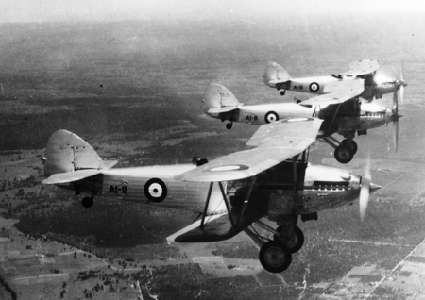

Table of Contents

Summary 3

Recovery From The Depression 1930-1935 4

Prelude To War 8

Avgas Specifications & Test Methods 1936 13

Australian Avgas Stock Position 1938 15

Australian Position 1939 18

Australia Goes To War 20

Australian Avgas Stock Position 1940 21

Oil Companies and Refineries 22

New Commonwealth Tender No. T35259 (1940) 22

Epilogue For 1941 31

Index 32

Research Sources 36

Summary

After the ‘Great Depression’, the world including Australia was recovering. The supply of aviation gasoline in Australia would be dominated by only two oil companies – Shell Company of Australia with its Shell Aviation Services, and Vacuum Oil Company with its INTAVA Aviation Services. Between them they would divide the market, each servicing particular states and areas of Australia. They would be the suppliers to the Australian armed forces into World War II and continue their dominance of the aviation fuel and lubricant market from the 1930’s and into the war years and beyond. However, after successfully winning the supply contracts for the RAAF and RAN in the peacetime years, the demands of these contracts would dramatically change both in increased volumes and in distribution network. With the declaration of war, the demand shifted from the eastern states of NSW and Victoria to the threat in the north and Indian Ocean so the demand was in Northern Australia, and Queensland, and the Indian Ocean area off Western Australia. In addition, there was now a new aviation grade to be supplied for the new aircraft from Britain and the USA. – Avgas 100.

Chronology

1928 Vacuum Oil Company was the first oil company in Australia to appoint an aviation manager. Fred W Haig.

December 4, 1937 “G.S. Walden” brought the first cargo of bulk petrol to Cairns for Standard Vacuum and discharged its cargo at the Kenny St. Depot, Cairns, Queensland, Australia

7 November 1938 Royal Air Force (RAF) Vickers Wellesley bombers arrive at Darwin airport after completing a non-stop, long distance flight from Ismailia Egypt, to Darwin Australia.

November 1936 RAAF commenced using a new aviation fuel – Aviation Gasoline 87 (Avgas 87).

27 March 1939 First Wirraway, A20-3, was test flown by Flight Lieutenant 'Boss' Walker.

3 September 1939 Britain declares war on Germany. World War Two has commenced.

29 November 1940 Tenders close for Schedule T 35259 to supply aviation spirit and lubrication oils to the Commonwealth of Australia for period April 1, 1941 to March 31, 1944.

2 Jan 1941 Shell and V.O.C. are successful tenders for RAAF and RAN.

7 Dec 1941 Japan declares war on the British Empire (including Australia).

Recovery from the Depression 1930-1935

Australia was not isolated from the Great Depression of the 1930’s; industry, Australian families, Australia’s proud armed services, and all of Australian society was affected. But Australia, like all other nations, still made progress, albeit not at the breakneck pace of the 1920’s. The petroleum industry was also developing from the foundations of 1905 when the Shell Transport And Trading Company and the Royal Dutch Petroleum Company established British Imperial Oil Company Limited in Australia as a joint venture. Before that Vacuum Oil Company (Mobil) in 1895, later H.C. Sleigh in 1913; The Texas Company Australasia Limited (TEXACO) in 1918; and in 1920, C.O.R. (Commonwealth Oil Refineries) was formed by the Australian Federal Government and the Anglo-Persian Oil Company as equal partners, later to be sold and become British Petroleum (BP). Others would also pursue their fortunes in Australian aviation such as Atlantic Refining Company of Philadelphia in 1924. And as detailed in earlier chapters, in 1928, the Vacuum Oil Company was the first oil company in Australia to appoint an aviation manager. Fred W Haig.

Photo 2. Vacuum Oil’s Fred Haig with Maj. De Havilland (Sydney circa 1930). Note the Vacuum ‘Plume” brand on the nose of the DH-60 Gypsy Moth

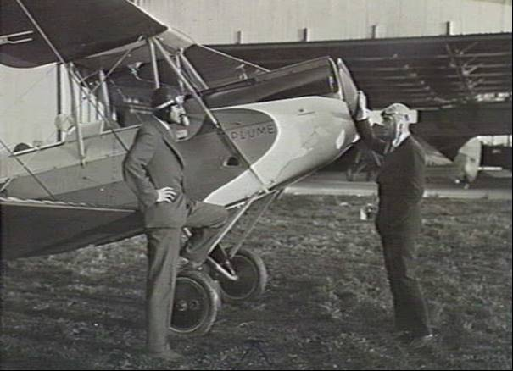

Major de Havilland, D.S.O., Managing Director of de Havilland Aircraft Pty. Ltd., and Mr. F. W. Haig, Chief Aviation Officer of the Vacuum Oil Company Pty. Ltd., Melbourne, beside the latter company's first machine, DH-60 Gipsy Moth VH-UVO, at Mascot Aerodrome, Sydney (circa 1930’ s)[1]

New Oil Companies in Australia

By the 1930’s a number of new oil companies had been established. In 1933 the ALBA Petroleum Company Of Australia Pty. Ltd. was established by P.J. Adams and A.G. Wales. Standard Oil Of New Jersey (later Esso) bought the Atlantic Union Company and continued to use the Atlantic brand name until the early 1960 's. On March 23, 1936 the Australian Motorists Petrol Co. Ltd. was incorporated in New South Wales by William G. Walkley [this was better known as AMPOL]. In 1936, the Texas Company (Australasia) Limited became part of the CALTEX Group.

On December 4, 1937 the tanker “G.S. Walden” brought the first cargo of bulk petrol to Cairns for Standard Vacuum and discharged its cargo at the Kenny St. Depot.[2] (G.S. Walden was the chairman of directors of Standard Vacuum, New York). The vessel was 15,240 tonne dead weight, 30 ft 4 ¼ ins. draft, 75 ft. wide, 485 ft. long. Design speed 12 ½ knots. Fully loaded it carried 4 ½ million gallons (IG) of cargo. It discharged 1 million gallons (Imp. Gallons) of petrol into the new tanks at Cairns, both Super Plume Ethyl and Plume Motor Spirit, and 360,000 IG of VOCO Power Kerosene, 178,000 IG of Laurel Kerosene. Discharge rate was 70-100,000 gallons (IG)/hour, depending on the capacity of the shore lines. It had 36 separate compartments. [Mobil Tank Farm Cairns at Sheridan St. was shutdown circa 1995].

Also in Cairns close by was the Shell Depot - Kenny St. In January 1937 construction began on the No. 1 Tank which was of welded construction and one of four fixed roof tanks.

Earlier in 1930 the Cairns Airport had been opened, and by 1934 Vacuum Oil Company had installed a petrol bowser inside a hangar, but aircraft still had to be filled by 4-gallon tins to refuel aircraft outside because it was not possible to get aircraft close to the bowser.

The military significance of these installations would not be seen until 1942, when they would become a valuable storage depot for aviation gasoline in support of the RAAF and USAAF who were becoming established in the area.

However, with all these new oil companies, only two (or three) would be the suppliers of aviation gasoline. These would be the Shell Company of Australia, and the Vacuum Oil Company. Atlantic Union would have a presence particularly with their connection to Sir Charles Kingsford-Smith, but would be not be a major player in the avgas story which was about to unfold in the next few years.

Avgas & the Navy

While we always associate aviation gasoline with the air force, it must remembered that the navies of the world also had aircraft which needed aviation fuel, and this does not refer to aircraft carriers (which would play a dominant role in the War in the Pacific). This refers to the ‘long-range’ eyes of the HMA Ships – the single-engined (usually amphibian) aircraft such as the Supermarine Seagull (or Walrus) which were aboard capital ships, such as HMAS ‘Canberra’ and HMAS ‘Australia’, or seaplane carriers such as HMAS ‘Albatross’, or armed merchant cruisers such as HMAS ‘Westralia’.

The navy was most likely supplied with aviation gasoline by Shell Company in Sydney, Brisbane, Hobart and Darwin; and by Vacuum Oil Co. in Melbourne, Adelaide, and Fremantle.

Photo 3. RAAF Supermarine Seagull on the top deck of HMAS ‘Albatross’ circa 1930’s[3]

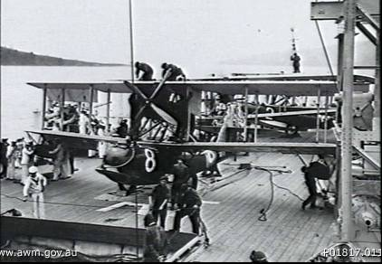

Summary: Australia, 1926-1935. Several Supermarine Seagull III seaplanes of No. 101 Fleet Co-operation Flight RAAF lined up on the top deck of the seaplane carrier HMAS ‘Albatross’. The amphibious aircraft, recently returned from flying missions, have just been hoisted out of the water and aboard the ship by means of the ship's cranes. Sailors are removing the floats from aircraft No. A9-8 in the foreground, while RAAF ground staff prepare to fold its wings back so that it can be stored in the ship's hold. Directly behind is aircraft No. A9-2. A crewman from the seaplane at rear can be seen standing on the aircraft's top wing. This crew member had attached the cable of the crane to the aircraft while it was still in the water, and then rode on the top wing while the seaplane was hoisted aboard the vessel.

Photo 4. Avgas storage on HMAS ‘Westralia’ in Sydney Harbour on March 1940[4]

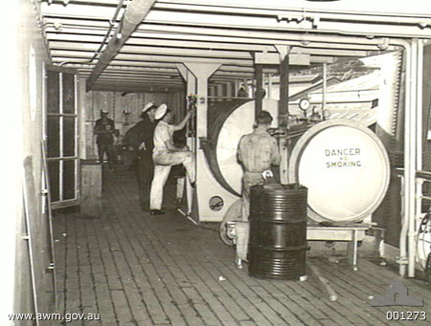

Summary: The storage area for aviation fuel for the Supermarine Walrus amphibian aircraft carried on the Armed Merchant Cruiser HMAS ‘Westralia’.

Photo 5. Supermarine Walrus on launching catapult of HMAS “Canberra” 1939[5]

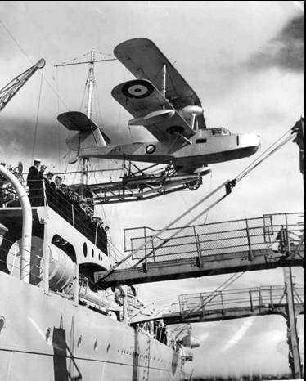

Meantime the British Government was still showing friend and potential foe alike that its air force, the RAF, could reach the distant corners of the British Empire with its bomber force.

Photo 6. Royal Air Force (RAF) Vickers Wellesley bombers, parked at Darwin airport after completing a non-stop, long distance flight from Ismailia Egypt, to Darwin Australia, 7th November 1938[6].

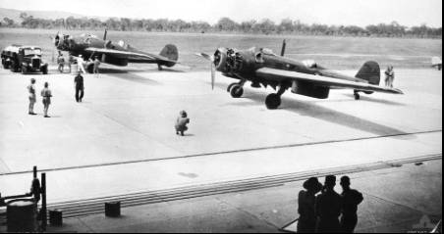

Summary: Two, of a flight of three Royal Air Force (RAF) Vickers Wellesley bombers, parked at Darwin airport after completing a non-stop, long distance flight from Ismailia Egypt, to Darwin Australia. The flight covered a distance of 11,256 kilometres and was completed in just over 48 hours, setting a new world record which was not broken until 1945. These aircraft were piloted by Squadron Leader Kellett and Flight Lieutenant Combe of the long-range flight, RAF. The third aircraft, piloted by Flight Lieutenant Hogan, diverted to Koepang in Timor for fuel, and arrived in Darwin later on the same day. The aircraft in the background is being refuelled from the articulated tanker truck and the engine cowlings of both aircraft have been removed. Credit line: Donor M Minnis

# Prelude to War

During this period there were perhaps two significant developments, firstly in November 1936 the RAAF commenced using a new aviation fuel – Aviation Gasoline 87 (Avgas 87), the other significant development was that the supply of aviation products, in particularly aviation gasoline, was contracted out to only two companies – The Shell Company of Australia (with its Shell Aviation Services) and Vacuum Oil Company (with its INTAVA Aviation Services).

RAAF introduces Avgas 87[7]

There were in fact to be two aviation grades of gasoline to be used by the RAAF, and this was detailed in the memo of November 13, 1936 when the following ‘RAAF HQ Technical Orders - Aircraft Instructions B.8” for the “Octane Numbers of Fuel required for RAAF Aircraft” was issued.

“The RAAF required two grades of fuel

• DTD 224 Octane 77 no Tetra Ethyl Lead - not coloured

• DTD 230 Octane 87 contains Tetra Ethyl Lead - coloured Blue

But as there are other leaded fuels marketed by the oil companies that have a lower octane value than 87, but are also coloured blue, care should be taken when refuelling away from RAAF Stations that the fuel is supplied to RAAF Contract.

The instruction further noted details of the classifications of engines and the fuels to be used.

Classification of Engines - Engines in service fall into three categories.

Category A. - Engines whose power requires the use of 87 octane fuel. These engines are suitably constructed to withstand the effects of leaded fuel and will sustain severe damage if they are run on fuel with a lower octane than required. Engines at present in the service or about to come into the service, fall into these categories are as follows:

Kestrel V in Hawker Demons A1-19 onwards

Cheetah IX in Avro Anson aircraft[8]

Pegasus VI in Supermarine Seagulls A2-13 onwards

Photo 7. RAAF Avro Anson A4-34 (circa 1936)

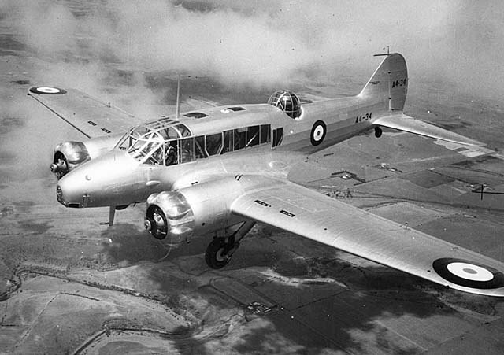

Photo 8. RAAF Seagull (also known as Walrus V) at RAAF Museum Point Cook, Vic.

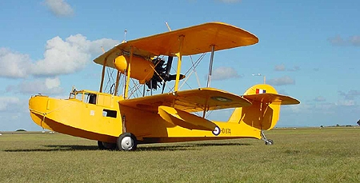

Category B. - Engines that are suitably constructed to withstand the effects of leaded fuel, but whose power output does not require the use of a leaded fuel. These engines may therefore be run on either 87 or 77 octane fuel, but should normally be run on 77 octane fuel unless otherwise ordered. Engines at present in the service or about to come into the service, fall into these categories as follows:

Pegasus II M2 in Supermarine Seagulls Vs A2-1 to A2-12

Kestrel V (derated) in Hawker Demons A1-1 to A1-18

Photo 9. RAAF Hawker Demon A1-8 on display at RAAF Museum Point Cook, Vic.

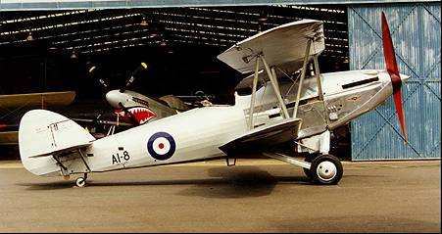

(Note in the background the CAC Mustang in the hangar).

Category C. - Engines not constructed to withstand the effects of leaded fuel. These engines run on 77 octane and must not be run on 87 octane fuel. Engines at present in the service or about to come into the service, fall into these categories as follows: All other aero engines in RAAF. [This would include training and transport aircraft such as DH-82A Tiger Moth].

Photo 10. RAAF DH-82 Tiger Moth A17-711 on display at RAAF point Cook Museum. Vic.

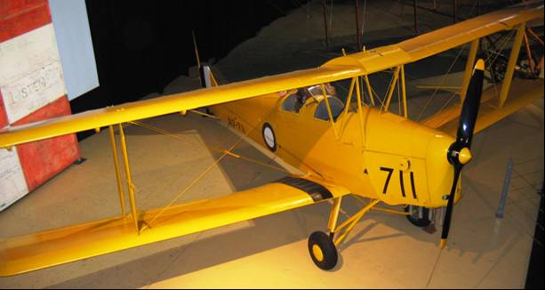

Marking of aircraft to show type of fuel required.

To ensure that only the correct fuel is used in engines the octane number of the fuel required is to be stencilled in figures 1½” high on the aircraft covering adjacent to all fuel tank filler caps (gravity tanks included), and in such a position that it can be read easily by personnel when refuelling.

The figures are to be in the following colours using standard identification marking colours.

87 Blue

77 White

Aircraft in category A are to be stencilled 87, those in Category B 77 and 87, those in category C 77. Applies 13 Nov 1936”

1936 Supply of Avgas 87 to RAAF Begins

Now that the RAAF had introduced the new specifications and issued technical instructions it was up to the contracted oil companies to deliver. The introduction of 87 Octane aviation gasoline would not be without its problems.

So, on the 26th October, 1936 Squadron Leader J F S Murray minuted[9] that:

Arrangements are in hand for supplies of aircraft fuel DTD 230 Octane 87 to be made available to RAAF Stations Laverton and Richmond.

Laverton Fuel installation Service Squadron 6,000 gallons

Fuel installation No. 1 Aircraft Depot (Vacuum) 1,000 gallons

Richmond Fuel installation No. 2 Aircraft Depot (Shell) 6,000 gallons

On the 9th November, 1936 the following was noted:

Minute paper S/Ldr (E2) from D.E. to D.A.I. Aircraft Fuel.

Octane 87 DTD 230 deliveries to RAAF Station Laverton.

*Order A 21074 placed by Sqd. L. J F S Murray (Squadron Leader E2) for 5,000 gallons DTD 230 Rate 1/9½.d NETT 447/18/4 on Vacuum Oil Co. 29 Market St. C1. (undated) [12 Nov 1936]. It was to be supplied to 4,000 gallons No. 1 Squadron Tank, and 1,000 gallons No. 1 A.D. (Aircraft Deport) Tank (at erecting hangar)*

*October 22, 1936 - Order A 21097 was placed by Sqd. L. J F S Murray (Squadron Leader E2) for 2,000 gallons DTD 230 Rate 1/9½.d NETT 179/3/44 Richmond Station has been instructed to place an order with Shell Co. (Shell will not be in a position to deliver until 19 Nov. 1936).*

*November 13, 1936 AS8040 and AS8041 Minute paper 164/1/724 Squadron Leader to A.M.8 asking for guidance regarding ‘consignments’ of untested 87 Octane are to be added; (Fuel installations) will be thrown out of action for at least 2 ½ days while stocks are tested.*

*November 18, 1936 Message from Richmond Station HQ to Air Board - Depot storage for 87 Octane hold is 10, 000 gallons. Deliveries are in 2,000 gallon lots.*

*November 25, 1936 Defence Central 164/1/724 Memo from Group Captain Air Member Supply to Station Richmond.*

“Aircraft Fuel - Octane 87”

“AS8041 is cancelled and the following instructions are substituted:

“It is desired to keep a very careful check on all consignments of 87 Octane fuel entering the service, and to test a sample from every consignment before the fuel is put into use.

On receipt of a consignment of this fuel at your station, you will draw a sample (half gallon) and forward it to No. 1 Aircraft Depot Laverton, address D.A.I., for test, Urgent”, the date of receipt and Order No. of the supply will also be stated.

On completion of the tests you will be notified of the results of the tests by signal. It is to be understood that in the interval until notification is received that it has satisfactorily passed the required test, the refuelling of aircraft for which 87 Octane fuel can be used is to be confined to cases considered by the Station Commander to be essential.

In order that the risk of damage in these cases may be reduced to a minimum, the tank is to be kept well filled so that any untested consignment will form only a small proportion of the total of the tank.”

Group Captain Air Member Supply

A similar memo was sent to No. 1 Flying Training School RAAF Point Cook on November 25, 1936.

Oil Industry Supply Network

The two suppliers of 87 Octane gasoline to the RAAF were Shell and Vacuum, and between them the marketing area was divided into distinct regions as shall be seen later. However supplies of 87 Octane gasoline were sometimes unavailable from one or other of these contracted suppliers; as can be seen from the following:

*Feb 8, 1937 Supplies of aviation fuel - Octane 87 as required for cross country flights.*

*Memo from Group Captain Air Member Supply to Station HQ Laverton, Station HQ Richmond.*

*Advising that Shell Co. is not maintaining stocks of Octane 87 at refuelling points at which, under the “old contract”, it was liable to maintain stocks of aircraft fuel Octane 77 and Oil to DTD-109.*

*It is necessary to advise Shell Co. when supplies of Octane 87 are required at these locations.*

*Current position (8 Feb 1937) - contract arrangements with Shell Co. and Vacuum Oil Co. actually expired 31 Jan 1936, but the companies have agreed to operate under the “old” contract until the new contract is made.*

*Under the old contract there was no obligation to maintain Octane 87 at refuelling points. Shell require notice, Vacuum have arranged for supplies of Octane 87 to be held at most of the refuelling points in the Vacuum supply area.*

*If Shell cannot supply, then draw on Vacuum organisation in the Shell supply area. Vacuum Co. do not at present maintain Octane 87 in NSW at points other than Sydney (7,000 gallons) and Narromine (200 gallons), but quantities shown below (Octane 87) are maintained at points shown:*

Table 1. Vacuum Oil Company Avgas 87 Storage

|  |  |  |
| --- | --- | --- |
| State | Location | Quantities Gallons |
| Queensland | Brisbane | 1,000 |
| Charleville | 500 |
| Maryborough | 50 |
| Roma | 50 |
| Cooktown | 50 |
| Rockhampton | 1,000 |
| Townsville | 1,000 |
| Cairns | 1,000 |
| Darwin | 1,000 |
| Tasmania | Launceston | 4,500 |
| Hobart | 4,500 |

As can be seen from the above table some location such as Roma, Cooktown and Maryborough were stocked with meagre amounts, probably for emergency purposes.

Table 2. Supply areas for Avgas 87 in Australia 1936

The supply areas for Avgas 87 were as follows:

|  |  |
| --- | --- |
| Shell Co. | NSW (except Broken Hill) |
| Queensland |
| North Australia |
| Central Australia (Tennant Creek & Alice Springs) |
| Tasmania |
| Vacuum Oil Co. | Victoria (except Bowser) |
| South Australia (including Farina & Oodnadatta) |
| Western Australia |

# Avgas Specifications & Test Methods 1936

1936 British Empire Aviation Gasoline Specification Apply

Because Australia and New Zealand were still part of the British Empire, the respective air forces followed the British Air Ministry specifications of the day. The RAAF specifications were that of the British RAF from 1933. These would continue into the 1940’s. All aviation gasoline was imported into Australia at this time, and for Shell their sources was the Pladjoe refinery in South East Sumatra which was one of the greatest producers of high octane aviation spirit in the Netherlands East Indies. For Vacuum Oil Company it was the refineries of Palembang. The British Specifications of 1933 would continue for a number of years, indeed this would be the tender specification in 1940.

Table 3. British aviation gasoline specifications 1933

British & Australian (British Empire) Specification DTD 224 October 1933, DTD 230 October 1933

|  |  |  |  |
| --- | --- | --- | --- |
| **Grade Designation** | **73** | **87** | **Method** |
| General Requirements | High grade petrol product from crude oil, coal spirit or mixture thereof | High grade petrol product from crude oil, coal spirit or mixture thereof |  |
| Specification No. | DTD 224 | DTD 230 |  |
| Colour | Clear | Blue |  |
| Sulfur (wt.%) Max. | 0.15 | 0.15 |  |
| Aromatics (vol.% Benzol (BTX) Min. | none specified  Aromatic hydrocarbons permissible | none specified  Aromatic hydrocarbons permissible |  |
| Distillation Temp Rec. (deg. C) Max.  Temp 50% Rec. (deg. C) Max.  Temp 90% Rec. (deg. C) Max.  End Point (deg. C) Max  Recovered Minimum  Loss | 75  100  150  180  96%  2% | 75  100  150  180  96%  2% |  |
| Specific Gravity @ 15C | 0.79 Max | 0.79 Max |  |
| Reid Vapour Pressure (@37.8 deg. C) psi Max  kPa | 7.0  49.0 | 7.0  49.0 |  |
| Freezing Point (deg. C) Max | -50 | -60 |  |
| Net Heat of Combustion MJ/kg Min (BTU/lb.) |  |  |  |
| Knock Rating, Lean mixture CFR Modified Motor Rating Min. (*Aviation method)* | 73  (mixture Temp 260F) | 87  (mixture temp 300F) | ASTM D357-33T |
| Knock Rating, Rich mixture Supercharge Rating Min. | not applicable | not applicable | Not yet in use |
| Copper Strip Corrosion (2 hrs @100 deg. C) Max. | Pass | Pass |  |
| Potential Gum (16 hr aging mg/100 ml) Max | 10 | 10 | Method specified |
| Existent Gum (mg/100 ml) Max. | 10 | 10 |  |
| Tetra Ethyl Lead Content (cc/Imp G) Max  (1T Ethyl Fluid.) | unleaded | 4 |  |

However, if the RAAF were still relying on the DTD Specifications, the oil companies were taking a much more international view, as can be seen from the Shell Technical Department document of 1940 which covered British & Australian (British Empire) and also Holland & Netherlands East Indies. Avgas Specifications & Test Methods 1940

1940 British Empire Aviation Gasoline Specification Apply

In 1940, the Shell Company of Australia Technical Department Aircraft Fuels & Lubricant (Circa 1940) issued the following specification for their Military and Commercial Aviation gasoline Specifications. This was obviously an international specification issued from Shell Head Office since Shell were also supplying the Netherlands East Indies Air Force (which would later become part of the RAAF for the duration of the war), and the RAF in the Far East in particular Singapore (the ‘British Citadel of the Far East’).

British & Australian (British Empire) also Holland & Netherlands East Indies (except CFR Motor Method for 87 & 100).

Table 4. British Air Ministry aviation gasoline specifications 1940

Specification: British Air Ministry DTD 230 (Department of Technical Development)

|  |  |  |  |  |  |
| --- | --- | --- | --- | --- | --- |
| Grade Designation | 73 (Estimated) | 87 | *Typical* | 100 (tentative) | **Method** |
| Specification No. | DTD 224 | DTD 230 |  | Tentative |  |
| Colour |  | Blue |  | Green |  |
| Sulphur (wt.%) Max. | 0.15 | 0.15 |  | 0.15 |  |
| Aromatics (vol.% Benzol (BTX) Min. |  | 25 |  | 25 |  |
| Distillation  Temp 10% Rec. (deg. C) Max.  Temp 50% Rec. (deg. C) Max.  Temp 90% Rec. (deg. C) Max.  End Point (deg. C) Max | 75  100  150  180 | 75  100  150  180 | *67*  *97*  *142*  *175* | 75  100  150  180 |  |
| Specific Gravity |  | 0.79 Max | *0.73-0.75* | 0.79 Max |  |
| Reid Vapour Pressure (@37.8 deg. C) psi Max  kPa | 7.0  49.0 | 7.0  49.0 |  | 7.0  49.0 |  |
| Freezing Point (deg. C) Max | -60 | -60 |  | -60 |  |
| Net Heat of Combustion MJ/kg Min  (BTU/lb.) |  |  | *46.5*  *20,000* |  |  |
| Knock Rating, Lean mixture CFR Modified Motor Rating Min. (*Aviation method)* | *(was 77 reduced to 73* | 87  *88* |  | 100 | ASTM D2700 MON |
| Knock Rating, Rich mixture Supercharge Rating Min.  Note This method was issued by ASTM as a tentative method in June 1941 (ASTM D--41T) | not applic. | not applic. |  | not applic. |  |
| Copper Strip Corrosion (2 hrs @100 deg. C) Max. | Pass | Pass |  | Pass |  |
| Potential Gum (16 hr aging mg/100 ml) Max | 10 | 10 |  | 10 |  |
| Existent Gum (mg/100 ml) Max. | 10 | 10 |  | 10 |  |
| Tetra Ethyl Lead Content (cc/Imp G) Max. | unleaded | 4 |  | 4 |  |

It should be noted that at this time there were no Australian military aircraft requiring the new ‘100-Octane’ fuel. Australia was only at war in Europe and North Africa, and the Spitfires and Hurricanes of the RAF which used 100 octane fuel were fighting the “Battle of Britain” and later the Axis forces in North Africa.

# Australian Avgas Stock Position 1938

Stock Position 1938

With the clouds of war looming in Europe the Australian Government thought it prudent to ascertain their current position with regard to aviation gasoline stocks. The following information has been collated from data obtained from National Archives Australia[10] which indicated the aviation gasoline grades, suppliers and stock position as at 31st November 1938.

The main suppliers were Vacuum Oil Company, Shell Company of Australia, Atlantic Union Oil Co. while the other oil companies of the day Commonwealth Oil Refineries (C.O.R.), Texaco had no stocks of any grade of aviation gasoline. Other oil companies who would later become part of Pool Petroleum Pty. Ltd. were never in the aviation business. [Caltex would market internationally under the Texaco brand].

Graph 1 and Tables 5 & 6 detail the aviation stock position in Australia in 1938 and show there were three grades of aviation gasoline available, Avgas 77, Avgas 80 and Avgas 87.

The aviation gasoline stocks available in November 1938 were:

Avgas 77 [Specification DTD 224] available stock of 2.8 million gallons to be supplied by Shell Oil Company (22%), Vacuum Oil Co. (9%) and Atlantic Union Oil Co. (69%). The stocks were stored 75% in bulk and 25% in drums. It was located mostly in seaboard depots or terminals (90%) and the remainder (10%) at inland depots.

Avgas 80 available stock of 118 thousand gallons was only supplied by Vacuum Oil Co. (100%) comprising 5% in bulk and 95% in drum stock, all of which was located in seaboard depots or terminals.

Avgas 87 [Specification DTD 230] available stock of 771 thousand gallons to be supplied by Shell (79%), Vacuum Oil Co. (21%) with 36% in bulk storage and 64% in drum stock, all of which was located in seaboard depots or terminals.

The distribution of the avgas stocks by state location was as follows

Table 5. Distribution of all avgas stocks by state Nov 1938.

|  |  |  |  |  |  |
| --- | --- | --- | --- | --- | --- |
| % by state | State | Total | Avgas 77 | Avgas 80 | Avgas 87 |
| 12.8% | Queensland | 478,311 | 201,373 | 4,501 | 269,437 |
| 28.8% | New South Wales | 1,067,103 | 1,006,635 | 11,480 | 48,981 |
| 39.8% | Victoria | 1,474,551 | 1,397,223 | 11,695 | 65,633 |
| 4.6% | South Australia | 170,624 | 24,497 |  | 67,854 |
| 4.8% | Western Australia | 178,471 | 44,005 |  | 47,392 |
| 1.0% | Tasmania | 38,168 | 9,525 |  | 21,502 |
| 8.1% | Darwin | 300,173 | 11,377 |  | 250,440 |

Graph 1. Australian Avgas stocks (all grades) by state distribution. Total Stock 3,704,851 Imp. Gal.

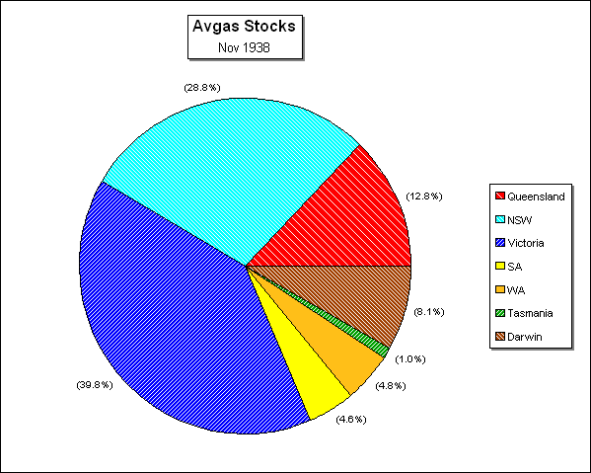

The points to note are that Queensland had 12.8% of the avgas stocks, Darwin 8.1%, but nearly 70% was located in Victoria and New South Wales. This would change dramatically when war came.

There was no Avgas 100 in stock in Australia of any significance, or at least reported in the government records. This was not surprising as the aircraft in service at this time were still biplanes such as Hawker Demon. The Australian designed ‘Wirraway” would not enter service until July 1939. The first Wirraway, A20-3, was test flown by Flight Lieutenant 'Boss' Walker on 27 March 1939, and the first three RAAF Wirraways were accepted in July 1939. By December 1940, seven aircraft were being delivered weekly, and by September 1941, 45 Wirraways per month were coming off the production line.

Table 6. Australian Avgas Stock position as at 31 Nov 1938

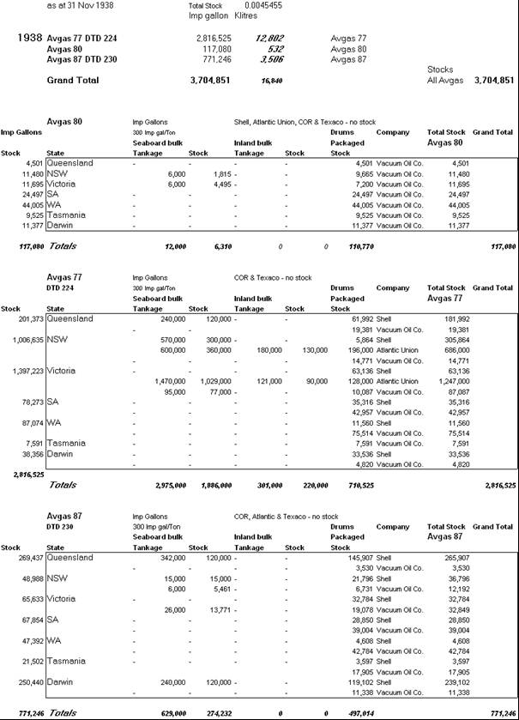

# Australian Position 1939

For training purposes, in aircraft fitted with small engines, Aviation Gasoline 73 Octane Number was generally used. This grade had the same characteristics as Aviation gasoline 87, except that it contained no Tetra Ethyl Lead. Aviation Gasoline 73 was brought over in bulk from refineries in the Netherlands East Indies, and is the basic gasoline used in making the 80 and 87 grades by adding TEL and blue dye for identification.

**Aviation Gasoline 87** (coloured blue) met the British Air Ministry Specification DTD-230 and allowed a maximum TEL concentration of 4 cc/Imperial gallon. The actual grade supplied to the RAAF contained about 3.75 cc of TEL/Imp. gallon, which gave an octane number of approximately 88.

**Aviation Gasoline 100** (coloured green) cannot be made solely from the base stocks used in Aviation Gasoline 73 and even with large quantities of TEL it cannot be raised to 100 octane. It is necessary to use a blending component such as Iso-octane or Isopropyl Ether to be used together with base stock and TEL.

The quality of all aviation grades marketed are guaranteed and tested by the suppliers (Vacuum and Shell). Special precautions were taken to ensure the fuel supplied to aircraft were true to the label and met the specification for each grade. The 87 Octane grade was used mostly in fighting machines. [This was later increased to 91 Octane]. But as it was well known, the latest types of fighting aircraft then in use in England (Spitfires and Hurricanes) required 100 Octane Fuel to give increased speed and power.

In most countries of the British Empire special aerodrome tankers [refuellers], equipped with adequate filtering systems, supplied the requirements in bulk at the more important aerodromes. At many other aerodromes aviation fuel supplies were pumped into the aircraft tanks from underground storage by means of hand operated pumps. At other less important aerodromes supplies were pumped by hand or decanted direct from drums [2- or 4-gallon tins] into the aircraft tanks. In all cases where supplies were taken from drums or tins, special funnels fitted with monel gauze filters and a chamois leather strainer were used to ensure that any impurities, including water were trapped.

*Emergency places*

Whenever an established landing ground exists, aviation fuels were held either in bulk drums or tins. If forced landings were made in remote places away from registered landing fields, aviation gasolines may not be available, although motor gasoline was most likely to be available if there is a township of any size nearby. This was a distinct possibility in the early days of Australian aviation. The advice to the aviator was as follows:

‘Motor gasolines in Australia are different from aviation gasolines, and should be used as a substitute fuel only if aviation grades are not available. In training aircraft, normally running on 73 Octane grade, no serious troubles are likely to occur when running the motor on standard grades, from the knock rating viewpoint. The motor spirit is liable, however to be higher in vapour pressures and thereby cause engine stoppage due to vapour locking, especially if the fuel system is inclined to run on the warm side. Care would be necessary to try to keep the carburettor bowl and fuel system as cold as possible to avoid vapour locking [no advice was given on how this could be achieved]. Any flying done on motor gasoline as an emergency should be kept down to low altitude as far as possible.

In Australia the standard grades of motor gasoline, as marketed by the major companies had an octane number between 70 and 71, and were liable to give detonation trouble if prolonged full throttle running took place. In other respects the motor gasoline would be suitable as an emergency fuel until the aircraft could be brought down at some established centre where aviation gasolines were available.

In fighting aircraft, the engines normally require 87 Octane grade and therefore serious troubles were likely if motor gasolines had to be used for anything but a short emergency period. The most severe factor would be the low knock rating of motor gasoline. The engine should therefore be limited in throttle when taking off to avoid detonation trouble, and the first opportunity should be taken to land and refuel with proper aviation gasoline.

The motor gasoline may be coloured or water-white, and the following colours are at present in use [1939] by the major companies for their standard grades –

SHELL Water-white

VACUUM Water-white or pale gold

COR Pale blue

TEXACO Water-white or yellow

Red is not used by any company at the present time [1939], as this colour was reserved for the leaded super grades conforming to the Ethyl Gasoline standard. Water-white products are 100% petroleum fractions. The coloured grades may contain TEL.

No engine should be run longer the necessary on motor gasoline as the boiling range is higher than for aviation gasoline with a consequent likelihood of dilution occurring in the crankcase oil.’

Photo 11. Ryan STM-S2 and DH-82 Tiger Moth in flight at Temora NSW – typical of the 1930’s aircraft

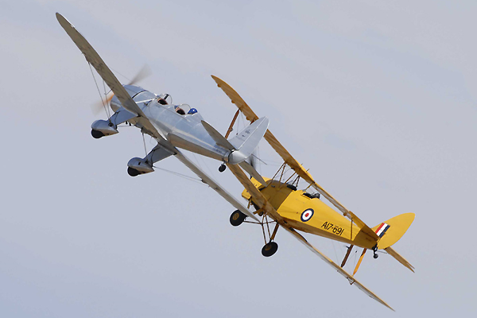

# Australia Goes To War

‘*My* f*ellow Australians, it is my melancholy duty to inform you officially, that in consequence of a persistence by Germany in her invasion of Poland, Great Britain has declared war upon her and that as a result, Australia is also at war.*

Prime Minister Robert Menzies spoke these words in his address to the nation on 3rd September 1939. World War Two had broken out two days earlier when Germany invaded Poland. After Britain and France declared war on Germany, Australia, part of the British Empire, promptly followed suit. It would be six years before Australia, and the world, would be at peace again.

Photo 12. R.G. Menzies announces the Declaration of War to the Australian people September 3, 1939

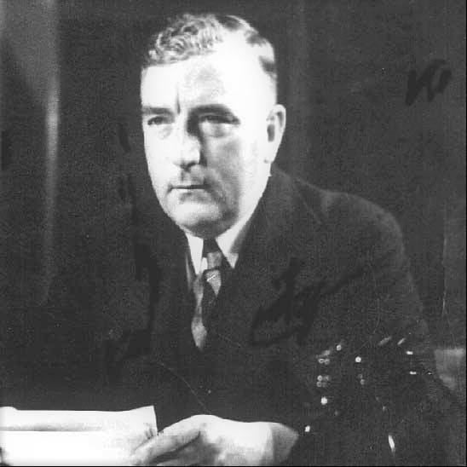

Australian servicemen would once again be shipped overseas to fight on foreign shores, but within a little over a year, many would return home to defend their beloved Australia from the Japanese threat.

Petrol Rationing Introduced

In order to conserve the valuable gasoline stocks, in 1940 the Australian Federal Government introduced petrol rationing as an emergency wartime measure. Petrol rationing would be a way of life for the next 10 years until in 1949 it was finally challenged in a high court case, and the newly elected Menzies’ Government abolished petrol rationing in February 1950.

# Australian Avgas Stock Position 1940

By August 1940, the situation regarding aviation gasoline had changed dramatically. Volumes had doubled and distribution had changed. NSW was the dominant state and Queensland stocks had increased.

Table 7. Distribution of avgas stocks by state 1940.



Graph 2. Australian Avgas stocks (all grades) by state distribution Total Stock 7,451,000 Imp. Gal.



# Oil Companies and Refineries

Within Australia there were no refineries making aviation gasoline – the reasons were two fold; firstly there was already an established aviation gasoline production and supply in the Netherlands East Indies that was meeting Australia’s need, and controlled by the marketing companies of Shell Aviation and Vacuum’s INTAVA; secondly Australia’s two refineries Shell Refinery – Clyde (NSW) and C.O.R. Laverton (Vic) were busy supplying motor gasoline to an Australian market in which only 20% of the demand could be met from local production.

# New Commonwealth Tender No. T35259 (1940)

In 1940 the Commonwealth of Australia called for tenders - Call for tenders: Schedule T 35259 to supply aviation spirit and lubrication oils for period April 1, 1941 to March 31, 1944. Tenders Close 29 November 1940. [11][12]. [For continuity purposes, information related to avgas supply past 1940 has been included in this section].

The requirements for aviation gasoline were as follows:

Table 8. Consumption Estimates RAAF March 1941.

|  |  |  |
| --- | --- | --- |
| Period | Avgas 73 (IG) | Avgas 87 (IG) |
| Apr 1- Dec 31, 1941 | 1,700,000 | 13,800,000 |
| Jan 1-Dec 31, 1942 | 2,000,000 | 16,300,000 |
| Jan 1-Dec 31, 1943 | 2,000,000 | 16,300,000 |
| Total | 5,700,000 | 46,400,000 |

Estimated Consumption from Aug 1940: Anticipated that 11 ¼ Million gallons of aviation spirit and 600,000 gallons of lubricating oil will have been used during 12 months ending 30 April 1941.

Successful Tenders

There were to be two successful tenders and it was described thus in a letter from Secretary to Contract Board summarising the position.

“Shell & Vacuum - only tenders for both oil and aviation spirit, and basically the same as contracts with these two companies which have been operating successfully for a number of years past. Both companies have obviously submitted their tenders in collaboration and are on the same basis of a distribution of territory as under the current contract with certain stipulations to balance sales between the two companies which are acceptable to this Department”.

The following companies were unsuccessful for a variety of reasons, but primarily the inability to provide both aviation spirit and lubricating oil to most of the locations in Australia. Vacuum and Shell - the successful bidders basically carved out their existing distribution territories V.O.C. in Victoria, S.A. W.A, with Shell in NSW, N.T. Qld. and Tas.

Shell Oil Company was notified of successful contract No. 52 on 2nd Jan 1941.

Vacuum Oil Co. was also successful and awarded Contract No 51.

Unsuccessful Tenders

Many of the other oil companies were interested in tendering for this business, however nearly all did not have the developed distribution networks necessary to meet the requirements, and many of the submissions were directed at only parts of the overall tender. Others did not tender at all. The explanations for the unsuccessful tender were thus:

C.O.R. No experience in aviation product distribution, supply uncertain (from the Middle East) (part owned by Anglo-Iranian and Commonwealth Government).

Texas Oil Company Tendered only for oil business.

C.C. Wakefield (Castrol) Tendered only for oil business in Vic & NSW only.

W.B. Dick Tendered only for oil business ex Melbourne store. (London principals).

Australian Motorist Petroleum (AMPOL) informal tender offering 1,000,000 IG Aviation Spirit at a higher price than V.O.C (Vacuum Oil Co.) or Shell, and tender called for 10,000,000 IG storage.

Atlantic Union Oil Co. did not tender.

ALBA Petroleum (Melb.) did not tender (London principals Sternol Lube Oils).

H.C. Sleigh did not tender.

Independent Oil Industries (Glebe) did not tender.

Shell Tender[13][14]

The Shell Company of Australia had been supplying the Commonwealth of Australia with aviation fuels and lubricants since well before 1936. It had an established record as a reliable supplier and it had its ‘Shell Aviation Services’ network. Some of the details of their tender submission were listed in their letter of October 17, 1940 and are as follows:

Shell 17 October 1940

Avgas 90 can be blended from Avgas 73 (straight run spirit) by use of TEL to 5.5 cc TEL/IG (U.S. Specification is 4.8 cc TEL/IG for Avgas 90, but U.S. Army allows 7.2 cc TEL/IG).

All Aviation spirit is supplied 96% from Netherlands East Indies, 4% British.

All aviation lubricating oils are from the USA.

All TEL from USA.

Call for tenders: Commonwealth of Australia Schedule T 35259 to supply aviation spirit and lubrication oils for period April 1, 1941 to March 31, 1944. Tenders Close 29 November 1940.

Shell Contract details for supply of Avgas and Aero Lube oil to the above for a period of 3 years. This follows on from a previous 3 year contract (1939-1941).

List of sites to be supplied are listed in Annex “A”

From Shell Tender Document 29 Nov 1940

“Tender for the supply of Aviation Spirit and Aero Engine Lubrication oils to Department of Air, Department of Civil Aviation and H.M.A. Ships and Naval Establishments during the period 1st April 1941 to 31st. March 1944”:

Octane 90 and 100

“Small stocks of 100 Octane Aviation Gasoline are already on hand at several of our (Shell) installations and supplies of 90 Octane Aviation Gasoline can be produced by blending this grade with stocks of Shell Aviation Gasoline 87” Cost premium Pence/gallon Avgas 87 =1d., Avgas 90 = 2.66d, Avgas 100 = 12.50d

Specifications:

“There is currently no British Air Ministry specification for Avgas 90 but one is under consideration. We (Shell) propose using: D.T.D. 230, except Octane = 90, Lead 4.8 cc TEL/IG maximum.

For 100 Octane Aviation Gasoline: D.T.D. 230, except Octane = 100, Lead 4 cc TEL/IG , Colour Green.

Delivery

Refuelling points also provided with refuelling launches are located at: Sydney, Brisbane, Gladstone, Bowen, Townsville, Karumba, Groote Eylandt, Darwin.

Table 9. Ethyl Mixing Plants

|  |  |
| --- | --- |
| Ethyl Mixing Plants Location | Capacity Gallons mixed/day |
| Melbourne | 141,120 |
| Sydney | 238,500 |
| Brisbane | 112,500 |
| Townsville | 94,080 |
| Adelaide | 94,080 |
| Gladstone | 94,080 |

[Ethyl Mixing Plants were blending facilities where base aviation gasoline stocks were mixed with Tetra Ethyl Lead (TEL) to produce Avgas 87 or Avgas 100.]

[Shell refuelling launches were in regular use since the days of the Empire flying boats and the route from England to Australia.]

Tender Document Specifications

Aviation Spirit Octane No. 73 “Unleaded Petrol” D.T.D 224 Octane 73 in lieu of 77 (“Aviation Spirit Octane No. 73”)

Aviation Spirit Octane No. 87 “Leaded Petrol” D.T.D 230 as amended by RAAF Fuel and Oil Supplement No. 1 Issue No. 2 (“Aviation Spirit Octane No. 87”).

Aviation Spirit Octane Nos. 90 and 100. The Commonwealth of Australia may require Octane 90 and/or 100 (state specification).

Projected usage

Stock can be Avgas 87 or Avgas 73 with lead addition to 4 cc TEL/IG.

Table 10. Projected Usage Avgas 87

|  |  |
| --- | --- |
| Period | Stock IG Avgas 87 |
| 1941 (April 1-June 30) | 7,000,000 |
| 1941 (July 1 - Dec 30) | 9,300,000 |
| 1942 (Jan 1 - June 30) | 9,900,000 |
| 1942 (July 1 - Dec 30) | 10,100,00 |
| 1943 (Jan 1 - June 30) | 10,100,00 |

Photo 13. RAAF Seagull V A2-22 [This aircraft required Avgas 87] circa 1940[15]

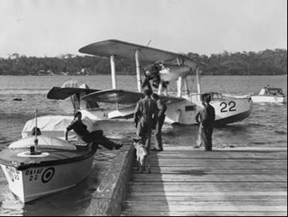

Photo 14. RAAF CAC Wirraway A20-4 circa 1940’s

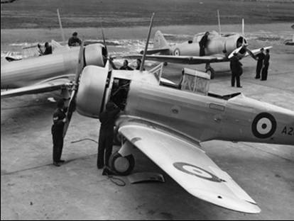

Vacuum Oil Co. Tender - INTAVA Gasoline [16]

Information on the source of supply of Vacuum avgas was not listed in documents on file, however it did contain information on where Vacuum Oil Co. would supply locations with aviation gasoline, and indicated which locations were highest volume users. From a marketing area viewpoint V.O.C. considered parts of southern NSW as part of the Victorian marketing region.

All Refuelling Locations – Schedule “C”

The tender documents contained a Schedule “C” which listed all the refuelling points to be met by the contracts. The following list shows the location and the supplier. V.O.C Supply Locations (those shown in bold were highest user volumes, italics next highest)

Schedule “C” All locations Refuelling Points (from tender documents) Small font indicates those listed in pricing, but not on Schedule C.

Batchelor W.A. was omitted by general agreement. (This however would become an historically significant airfield in 1942).

Victoria (15)

V.O.C. (H.M.A. Ships Melbourne - none) Bairnsdale, Ballarat, Bowser, Benalla, Cressy, Essendon, Geelong, Laverton, Mallacoota, *Mildura*, Nhill, Point Cook, Sale, Fulham, Warrnambool, Yanakie

Shell White Mark (Flinders Island), Currie (King Island)

NSW (22)

V.O.C. Deniliquin, Broken Hill

Shell (H.M.A. Ships in Sydney), Ballina, Cambden, Cootamundra, Dubbo, Evans Head, Hay, Macquaire Grove, Mascot, Narramine, Williamtown (Newcastle), Nyngan, Rathmines, Richmond, Wagga, Moruya, Nowra, Wingham, Bourke, Coffs Harbour

S.A. (10)

V.O.C. (H.M.A. Ships in Adelaide - none) *Ceduna*, Cook, Kimba, Kingscote, Mallala, Maree, Mt. Gambier, Oodnadatta, Parafield, Port Lincoln, Port Pirie, Tintinara

Shell Farina

W.A. (22)

V.O.C. (H.M.A. Ships in Fremantle) Albany, Broome (Military operated), Brassleton, Carnarvon, Cunderdin, Derby (Military operated), Esperance Bay, Fitzroy Crossing, Forrest, Geraldton**,** Halls Creek, Kalgoorlie, Maylands, Onslow, *Pearce,* Port Beadon, Port Hedland, Rawlinna, Tammin, Wyndham.

Shell none

Tas (3)

V.O.C. none

Shell (H.M.A. Ships in Hobart), Hobart, Launceston (Western Junction)

NT (11)

V.O.C. none

Shell Darwin, Katherine, Alice Springs, Brunette Downs, Daly Waters, Tennant Creek, Bathurst Island Mission, Groote Eylandt, Millingimbi Mission, Newcastle Waters, Wave Hill

Qld (22)

V.O.C. none

Shell (H.M.A. Ships in Brisbane), Camooweal, Charleville, Cloncurry, Longreach, Bowen, Bundaberg, Cairns, Coen, Cooktown, Mackay, Maryborough, Rockhampton, Roma, Thursday Island, Gladstone, Karumba, Amberley, Archerfield, Blackall, Townsville, Winton

P.N.G. (4)

Shell Rabaul, Salamaula, Samarai, Port Moresby

While the above listed the locations to be supplied under each contract, there were some variations for example Vacuum supplied Canberra, Douglas aircraft No. 8 Squadron, also into Richmond NSW; and Shell supplied into Laverton

Problems of Storage & State Government Regulations 1939[17]

Problems of Storage - On September 19, 1939 the Shell Co. advised the Commonwealth of Australia Prime Ministers Department that the proposed storage of aircraft fuel and lubricating oils for the RAAF, will be required to store certain quantities in drums in the open. In NSW, this is prohibited under the Inflammables Liquid Act. Action was requested by Shell Co.

Shortly after in a letter from the NSW Premier (Alex Mair) to Prime Minister (Commonwealth of Aust.) A 39/2461 response Sept 29, 1939, the following matter was discussed regarding the storage of RAAF supplies of aviation fuel and compliance with NSW state laws.

Information regarding NSW state law for storage of mineral spirit under “Inflammable Liquids Act, 1915-1931”.

1. Drums to be compounded in a well packed earthen embankment with a capacity of 25% of spirit stored.

2. Stock to be isolated with minimum following distances.

Table 11. Separation Distances for Storage for Inflammable Liquids. (NSW)

|  |  |  |  |
| --- | --- | --- | --- |
| Volume | K. Litres | Separation Distance | metres |
| up to 20,000 Imp. Gal. | 90.9 | 50 ft. | 15.3 |
| 40,000 Imp. Gal. | 181.8 | 75 ft. | 22.9 |
| 80,000 Imp. Gal. | 363.7 | 100 ft. | 30.5 |
| 120,000 Imp. Gal. | 545.5 | 115 ft. | 35 |
| 240, 000 Imp. Gal. | 1,091 | 130 ft. | 39.6 |
| 400,000 Imp. Gal. & over | 1,818 | 150 ft. | 45.7 |

In warmer portions of the state, in the absence of a shelter or shade roof, a temporary tarpaulin is to be stretched on the storage providing for air circulation to mitigate possible expansion in the drums, and that fire protection be ensured with foam extinguishers.

Revisions to the Contracts

As with most contracts, revisions are sometimes necessary due to changed circumstances. The contracts of Shell and Vacuum were also to be varied and by January 1941 there were already changes.

As at 19 Jan 1941 & (16 Dec 1941)

Table 12. Revised Contract details for Annex “A’ supply locations.

|  |  |  |  |
| --- | --- | --- | --- |
| Location Avgas 87 | Company | Tender (‘000 IG) | Revised (‘000 IG) |
| Cooktown | Shell | 5 | 10 |
| Noumea | Shell | 50 | 30 |
| Millingimbi | Shell | 16 | 5 |
| Rabaul | Shell | 60 | 25 |
| Mallacoota | V.O.C. | 10 | 15 |
| Drysdale Mission | V.O.C. | 16 | 5 |
| Coen | Shell | 5 | 10 |
| Daly Waters | Shell | 15 | 30 |
| Kalgoorlie | V.O.C. | 15 | 30 |
| Charleville | Shell | 10 | 20 |
| Cloncurry | Shell | 10 | 20 |
| Alice Springs | Shell |  |  |
| Darwin | Shell |  |  |
| Tennant Creek | Shell |  |  |
| Maree | V.O.C |  |  |
| Katherine | Shell |  |  |
| Esperance | V.O.C |  |  |
| Kalgoorlie | V.O.C |  |  |

Bathurst Island Land plane refuelling

Groote Eylandt Land plane refuelling plus commercial seaplane base (Q.E.A.)

No. 2 SFTS at Wagga usage Oct 1941 estimated at 250,000 IG over 2½. Months.

RAAF Stations at Bundaberg, Kingaroy, Maryborough (2 grades of Avgas), Nowra (12,000 IG Avgas tank)

20 Feb 1941 Comment from Capt. E. Jones (Shell) “100 Octane Base Spirit is not an aviation fuel, but a base spirit from which various grades are produced.”

19 Feb 1941 RAAF to Shell modifying their requirements for Shell to hold 7,000,000 IG Aviation Gasoline Octane No. 73 to 6,000,000 IG Avgas 73 plus 1,000,000 IG Avgas 100 (of which Shell’s share is 600,000 IG Avgas 100).

14 March 1941 Used Aviation Oil proposal to purchase from Shell at 1/- gallon.

15 April 1941 Shell gets approval from London Office to erect “Ethyl Blending Plant” at Darwin (one of the tender conditions). Erection is expected to take 4 months after approval. [Ethyl (Mixing) Blending plants were addition of Tetra Ethyl Lead from drum stock (½ ton drums) blended with Avgas 73 (unleaded petrol) to produce Avgas 87 or Avgas 90. This was done in a mixing tank typically 54,000 IG].

17 April 1941. Estimated consumption of Avgas 100 base spirit, following successful trials of Avgas 90 were:

Table 13. Estimated consumption of Avgas 100 base spirit.

|  |  |
| --- | --- |
| Locations | (‘000 IG) |
| Northern Territory | 75 |
| Queensland | 170 |
| New South Wales | 300 |
| Victoria | 250 |
| South Australia | 50 |
| Western Australia | 150 |
| Total | 995 |

21 Aug 1941 RAAF Reserve stocks Shell plan to send 3,000 x 44-IG drums Avgas 90 to Darwin on M.V. ‘Koolinda’ from Fremantle, also awaiting 450,000 IG Avgas from Netherlands East Indies on tanker “The Augustine” [The M.V. “Koolinda’ would later in November 1941 discover some 31 German mariners in a life boat from the battle between the German raider ‘Kormoran” and the ill-fated HMAS ‘Sydney’ which was lost of the West Australian coast].

Photo 15. M.V. “Koolinda”

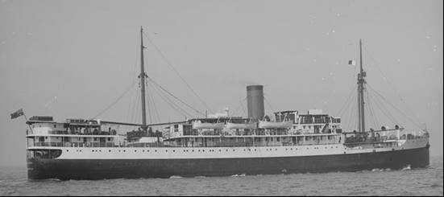

**Lubes:** Aeroshell 120 & 120A required Tri-Butyl Phosphite (0.5%) to added as an additive for service in Bristol Engines with Cadmium-Nickel bearings.

23 Oct 1941 Shell Hobart required

Table 14. Shell Hobart requirements 1941

|  |  |  |  |  |
| --- | --- | --- | --- | --- |
| Shell Hobart | Avgas 73 | Avgas 87 | Aero Oil 100 Sec. | Aero Oil 120 Sec. |
| Operations |  | 20,000 IG |  | 800 IG |
| Training | 10,000 IG |  | 400 IG |  |

7 Oct 1941

Rabaul Stocks Avgas 90 60,016 IG (1,364 x 44-IG drums)

Lae Stocks Avgas 90 minimum stock level 15,000 IG (drums)

20 Nov 1941 Shell supply Avgas to Lae.

23 Nov 1941 Estimated offtake in Northern Territory for 6 months to 30 June 1942 was 624,000 IG (or 340 Tons/month), but earlier it was estimated as 1,600,000 IG over 3 years (or 150 tons/month).

28 Nov 1941 Transfer of Avgas in rail tank cars (Capacity 5,000 IG) to Shell Depots near RAAF. Stations.

**7 Dec 1941** **Japan had declared war on the British Empire (including Australia)**.

Dec 1941 Beaufort Bombers use Avgas 95.

13 Dec 1941 Request to Shell to supply Darwin with 300, 000 IG (plus 4% oil) in 44-IG drums from Netherlands East Indies.

19 Dec 1941 Pool Refuelling Vacuum Oil Co. & Shell Oil Co. at Oodnadatta, Alice Springs (12,000 IG underground Avgas 90 tank), Daly Waters, Cloncurry, Tennant Creek, Charleville. [Pool Petroleum Company will be discussed in the next chapter]

Drysdale Mission 5,000 IG Avgas 87 tank

Mallacoota 15,000 IG Avgas 87 tank

By the start of 1942, the war against Japan was changing all the well-intended plans for the supply of aviation gasoline to the RAAF. Estimates were increasing dramatically, reallocation of supply was becoming a regular occurrence, and the need to protect these valuable fuel supplies was an ever-present worry for the military planners. The need for aviation lubrication oils was also becoming critical since these had to be imported from the United States and that supply route was becoming threatened by the Japanese Imperial Navy. For Australia, everything was moving north and drum stocks was becoming the simplest option.

26 Feb 1942 (RAAF 164/3/89) Shell supply RAAF Stations with underground storage: Bowen, Cairns, Cambridge, Coen, Coffs Harbour, Cooktown, Groote Eylandt, Mackay, Moruya, Nabiac, Rockhampton, Tennant Creek.

10 March 1942 Shell bulk storage at Taree 8,000 IG Avgas emergency stock for Nabiac

14 March 1942 Longreach RAAF Reserve (space for 500 x 44-IG Avgas 100 drums) and 24 x 44-IG drums of aero lube oil.

Thursday Island 200 drums Avgas 100.

# Epilogue for 1941

Australia was at war; but on the other side of the world, Australia had once again sent its young men to fight for the British Empire and to defend ‘Mother Country’ England from the Hun invader.

The aviation gasoline supply contracts were again awarded in 1940 to The Shell Company of Australia with their Shell Aviation Services, and the Vacuum Oil Company with their INTAVA Aviation Services, continuing the relationship established earlier.

RAAF now required 87 Octane aviation fuel, and soon would require 100 Octane fuel as new, modern American and British aircraft entered RAAF service. The next year the US Army Air Force would arrive in Australia and the demand and distribution of aviation gasoline and lubricants would be even greater.

In the Far East the British Empire and its dominions were protected by the ‘fortress of Singapore’ and the British Fleet – but not for long.

Everything changed on December 7, 1941.

Index

1

100 Octane 14, 18, 23, 24, 31

100 Octane Base Spirit 28

7

73 Octane 18

77 octane 9

8

87 Octane 8, 10, 11, 18, 31

9

90 Octane 23

91 Octane 18

A

Adams 5

Adelaide 5, 24

aero lube oil 30

Aero Oil 100 Sec 30

Aero Oil 120 Sec 30

Aeroshell 120 29

aircraft carriers 5

ALBA Petroleum (Melb) 23

ALBA Petroleum Company Of Australia Pty. Ltd. 5

Albany 26

Alice Springs 12, 27, 28, 30

Amberley 27

AMPOL 5

Anglo - Persian Oil Company 4

Anglo-Iranian 23

Archerfield 27

Aromatics 13, 14

ASTM D2700 MON 14

ASTM D357-33T 13

ASTM D--41T 14

Atlantic Refining Company 4

Atlantic Union Company 5

Atlantic Union Oil Co. 15, 23

Australia 20

Australian Federal Government 20

Australian Government 15

Australian Motorist Petroleum (AMPOL) 5, 23

Avgas 100 3, 16, 23, 24, 28, 29, 30

Avgas 73 22, 23, 24, 28, 29, 30

Avgas 77 15

Avgas 80 15

Avgas 87 3, 8, 10, 12, 15, 22, 23, 24, 25, 28, 29, 30

Avgas 90 23, 24, 29, 30

Avgas 95 30

aviation gasoline 5, 18, 22

Aviation Gasoline 100 18

Aviation Gasoline 73 18, 24, 28

Aviation Gasoline 87 3, 8, 18, 24

aviation gasolines 18

Aviation method 13, 14

aviation spirit 3, 13, 22, 23

Avro Anson 8

B

Bairnsdale 26

Ballarat 26

Ballina 26

base aviation gasoline stocks 24

Batchelor W.A. 26

Bathurst Island 28

Bathurst Island Mission 27

Battle of Britain 14

Beaufort Bombers 30

Benalla 26

Benzol 13, 14

Blackall 27

Bourke 26

Bowen 24, 27, 30

Bowser 12, 26

Brassleton 26

Brisbane 5, 12, 24

Bristol Engines 29

Britain 3, 20

British Air Ministry 13, 14, 24

British Empire 3, 7, 13, 14, 18, 20, 30, 31

British Fleet 31

British Government 7

British Imperial Oil Company Limited 4

British Petroleum 4

Broken Hill 12, 26

Broome 26

Brunette Downs 27

Bundaberg 27, 28

C

C.C.Wakefield (Castrol) 23

C.O.R. 4, 23

C.O.R. Laverton (Vic) 22

Cadmium-Nickel bearings 29

Cairns 3, 5, 12, 27, 30, 37

Cairns Airport 5

Caltex 5, 15

Cambden 26

Cambridge 30

Camooweal 27

Canberra 27

carburettor 18

Carnarvon 26

Ceduna 26

CFR Motor Method 14

chamois 18

Charleville 12, 27, 28, 30

Cheetah IX 8

Cloncurry 27, 28, 30

Coen 27, 28, 30

Coffs Harbour 26, 30

Colour 13, 14

Combe 7

Commonwealth Government 23

Commonwealth of Australia 3, 22, 23, 24, 27

Commonwealth Oil Refineries 4, 15

Cook 26

Cooktown 12, 27, 28, 30

Cootamundra, 26

Copper Strip Corrosion 13, 14

COR 19

crankcase oil 19

Cressy 26

Cunderdin 26

Currie (King Island) 26

D

D.T.D. 230 24

Daly Waters 27, 28, 30

Darwin 3, 5, 12, 15, 16, 24, 27, 28, 29, 30

Darwin airport 7

Deniliquin 26

Department of Air 23

Department of Civil Aviation 23

Derby 26

DH-60 Gypsy Moth 4

DH-82 Tiger Moth 9, 10, 19

Distillation 13, 14

Drysdale Mission 30

DTD 224 15

DTD 230 10, 15

DTD-109 11

DTD-224 8, 13, 14

DTD-230 8, 13, 14, 18

Dubbo 26

E

Empire flying boats 24

England 24

Esperance 28

Esperance Bay 26

Essendon 26

Esso 5

Ethyl Blending Plant 28

Ethyl Gasoline 19

Ethyl Mixing Plants 24

Europe 14, 15

Evans Head 26

Existent Gum 13, 14

F

Farina 12, 26

Fitzroy Crossing 26

Forrest 26

France 20

Freezing Point 13, 14

Fremantle 5, 29

Fuel installation No. 1 Aircraft Depot (Vacuum) 10

Fuel installation No. 2 Aircraft Depot (Shell) 10

Fulham 26

G

G.S.Walden 3, 5

Geelong 26

Geraldton 26

German 29

Germany 3, 20

Gladstone 24, 27

Great Britain 20

Great Depression 4

Groote Eylandt 24, 27, 28, 30

H

H.C. Sleigh 4, 23

Haig 3, 4

Halls Creek 26

Hawker Demon 1, 8, 9, 16

Hay 26

HMAS 7

HMAS ‘Albatross’ 5, 6

HMAS ‘Australia’ 5

HMAS ‘Canberra’ 5

HMAS ‘Sydney’ 29

HMAS ‘Westralia’ 5, 6

Hobart 5, 12, 26, 30

Hogan 7

Hurricanes 14, 18

I

Independent Oil Industries 23

Indian Ocean 3

Inflammables Liquid Act 27

INTAVA 22

INTAVA Aviation Services 3, 8, 31

INTAVA Gasoline 26

Ismailia Egypt 3, 7

Iso-octane 18

Isopropyl Ether 18

J

Japan 3, 30

Japanese 20

Japanese Imperial Navy 30

Jones 28

K

Kalgoorlie 26, 28

Karumba 24, 27

Katherine 27, 28

Kellett 7

Kenny St. Depot 3, 5

Kestrel V 8, 9

Kimba 26

Kingaroy 28

Kingscote 26

Kingsford- Smith 5

Koepang 7

Kormoran 29

L

Lae 30

Launceston 12

Launceston (Western Junction) 26

Laurel Kerosene 5

Laverton 10, 26, 27

Lean mixture CFR Modified Motor Rating 13, 14

Longreach 27, 30

lubricating oil 22, 23

lubrication oils 3, 22, 23, 30

M

M.V. ‘Koolinda’ 29

Mackay 27

Macquaire Grove 26

Major de Havilland 4

Mallacoota 26, 28, 30

Mallala 26

Maree 26, 28

Maryborough 12, 27, 28

Mascot 26

Mascot Aerodrome 4

Maylands 26

Melbourne 5, 23, 24

Menzies 20

Menzies’ Government 20

Mildura 26

Millingimbi 27, 28

Mobil 4, 5

monel 18

Moruya 26, 30

motor gasoline 18, 22

Mt. Gambier 26

Murray 10, 11

N

Nabiac 30

Narramine, 26

Narromine 12

navy 5

Net Heat of Combustion 13, 14

Netherlands East Indies 13, 14, 18, 22, 23, 29, 30

Netherlands East Indies Air Force 14

New South Wales 15, 16, 29

Newcastle Waters 27

Nhill 26

No. 1 Aircraft Depot Laverton 11

No. 1 Flying Training School RAAF Point Cook 11

No. 101 Fleet Co-operation Flight RAAF 6

No. 8 Squadron 27

North Africa 14

North Australia 12

Northern Australia 3

Northern Territory 29, 30

Noumea 28

Nowra 26, 28

NSW Premier (Alex Mair) 27

Nyngan 26

O

Octane 87 37

Onslow 26

Oodnadatta 12, 26, 30

P

Palembang 13

Parafield 26

Pearce 26

Pegasus II M2 9

Pegasus VI 8

petrol rationing 20

Pladjoe 13

Plume Motor Spirit 5

Point Cook 26

Poland 20

Pool Petroleum Company 30

Pool Petroleum Pty. Ltd. 15

Port Beadon 26

Port Hedland 26

Port Lincoln 26

Port Moresby 27

Port Pirie 26

Potential Gum 13, 14

Prime Minister 27

Q

Queensland 3, 12, 15, 16, 21, 29

R

RAAF 3, 5, 14

RAAF HQ Technical Orders - Aircraft Instructions B.8 8

RAAF Museum Point Cook 9

Rabaul 27, 28, 30

RAF 3, 7, 14

rail tank cars 30

RAN 3

Rathmines 26

Rawlinna 26

Reid Vapour Pressure 13, 14

Rich mixture Supercharge Rating 13, 14

Richmond 1, 10, 26, 27

Richmond Station 11

Rockhampton 12, 27, 30

Roma 12, 27

Royal Air Force 3, 7

Royal Dutch Petroleum Company 4

Ryan STM-S2 19

S

Salamaula 27

Sale 26

Samarai 27

Schedule 26

Schedule T 35259 3, 22, 23

Seagull 9

Seagull V 25

seaplane carriers 5

Shell 18, 19

Shell Aviation 22

Shell Aviation Gasoline 87 23

Shell Aviation Services 3, 8, 23, 31

Shell Co. 5, 11, 12, 27, 30, 37

Shell Company of Australia 3, 5, 8, 14, 15, 23, 31

Shell Oil Company 15, 22

Shell Refinery – Clyde (NSW) 22

Shell Technical Department 13

Shell Transport And Trading Company 4

Singapore 14, 31

South Australia 12, 15, 29

South East Sumatra 13

Specific Gravity 13, 14

Spitfires 14, 18

Standard Oil Of New Jersey 5

Standard Vacuum 3, 5

Station HQ Laverton 11

Station HQ Richmond 11

Sternol Lube Oils 23

straight run spirit 23

Sulfur 13, 14

Super Plume Ethyl 5

Supermarine Seagull 5, 6, 8

Supermarine Seagulls V 9

Sydney 5, 12, 24

Sydney Harbour 6

T

Tammin 26

Taree 30

Tasmania 12, 15

TEL 23

Temora 19

Tenants Creek 12, 27, 28, 30

Tetra Ethyl Lead 8, 13, 14, 18, 28

Tetra Ethyl Lead (TEL) 24

Texaco 4, 15, 19

Texas Company Australasia Limited 4, 5

Texas Oil Company 23

The Augustine 29

Thursday Island 27, 30

Timor 7

Tintinara 26

Townsville 12, 24, 27

Tri-Butyl Phosphite 29

U

U.S. Army 23

United States 30

US Army Air Force 31

USAAF 5

Used Aviation Oil 28

V

Vacuum 18, 19

Vacuum Plume 4

Vacuum Oil Co. 5, 11, 12, 15, 22, 23, 26, 30

Vacuum Oil Company 3, 4, 5, 8, 12, 13, 15, 31

vapour locking 18

Vickers Wellesley 3, 7

Victoria 12, 15, 16, 29

VOCO Power Kerosene 5

W

W.B.Dick 23

Wagga 26, 28

Wales 5

Walker 3, 16

Walkley 5

Walrus 5, 6, 7

Walrus V 9

Warrnambool 26

Wave Hill 27

West Australian 29

Western Australia 3, 12, 15, 29

White Mark (Flinders Island) 26

Williamtown (Newcastle) 26

Wingham 26

Winton 27

Wirraway 3, 16, 25

Wyndham 26

Y

Yanakie 26

# Research Sources

1. Website accessed Feb 1, 2008 [http://sinpic.slv.vic.gov.au/cgi-bin/Pwebrecon.cgi?Search_Arg=b52555+&Search_Code=FT*&PID=sqGJ1bc_0EuaW8oe0jbbz3RvwTv8&SEQ=20080201190048&CNT=15&HIST=1](http://sinpic.slv.vic.gov.au/cgi-bin/Pwebrecon.cgi?Search_Arg=b52555+&Search_Code=FT*&PID=sqGJ1bc_0EuaW8oe0jbbz3RvwTv8&SEQ=20080201190048&CNT=15&HIST=1)
2. Ref: Historical Society Cairns - Call No. D3741/2
3. AWM Photo ID Number: P01817.011
4. AWM Photo ID Number: 001273
5. State Library of Victoria. Accession Number: H98.105/2458
6. AWM Photo ID Number: P05287.002
7. NAA file: Title Supplies of aviation fuel - Octane 87 requirements. Series Number A705/1. Item Number 164/1/724 Date Range 1936 to 1937
8. Website accessed 3 Feb 2008 <http://users.bigpond.net.au/ctdavies/Jims%20photo%20gallery.htm>
9. NAA file: Defence RAAF 164/2/1716
10. NAA file: Title Import of Fuel, Gas and Lubricating Series Number MP99/3 Item Number 102 Date Range 1939 to 1939 Stock position as at 31 Nov 1938 Australia
11. NAA file: Title Aviation fuel and oils for Dept of Air, Series Number B4601/2, Item Number 35259(PART 1) Date Range 1941 to 1944
12. NAA file: Title Aviation fuel and oils for Dept of Air - unsuccessful tenders Series Number B4601/2 Item Number 35259(PART 3) Date Range 1941 to 1943
13. NAA file: Supply of Aviation Spirit and Lubrication Oil to Depts. of Navy, Air, Civil Aviation, Aircraft Production Commission by Shell Co. of Australia for period 1/4/41 to 31/3/44, Series Number B4601/2, Item Number 35259, Date Range 1940 to 1944
14. NAA file: Supply of Aviation Spirit and Lubrication Oil to Depts. of Navy, Air, Civil Aviation, Aircraft Production Commission by Shell Co. of Australia for period 1/4/41 to 31/3/44 Series Number B4601/2, Item Number 35259, Date Range 1940 to 1944
15. Website accessed Feb 8, 2008 <http://www.raaf.gov.au/raafmuseum/photo_album/h_40.htm#_self>
16. NAA file: Title Maintenance of Stocks of aviation fuel and oils by Shell and Vacuum Oil Co - Monthly advice of prices Series Number B4601/2, Item Number 35259C, Date Range 1940 to 1944
17. NAA file: Title War Records. Commodities. Oil-Storage of for RAAF, Series Number A1608/1, Item Number G52/1/1, Date Range 1939 to 1945