Chapter

9

1939-1940 – The ‘Phoney War’

‘The World is at War’

Photo . Daily Mail London September 1, 1939[1]

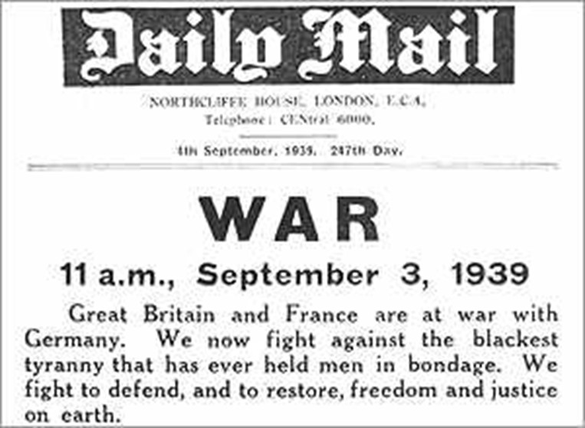

Table of Contents

Summary 3

The “Phoney War” 5

Gasoline Composition 1939 5

Avgas Specifications & Test Methods 1939-1940 5

1940 Military And Commercial Aviation Gasoline Specifications 7

The British Start Planning 12

Petroleum Board 12

Aviation Spirit - British Pre-War Planning 1939. 15

The Demand For 100 On Fuel 18

British Empire 22

British Position August 1939 22

British Position September 1939 23

Benzole 26

Manufacturing Process 1939 26

Houdry Catalytic Reforming 27

Alkylation Processes 27

Alkylation Process For Iso-Octane Gains Acceptance 27

Thermal Alkylation & Neo-Hexane 29

Oil And Refineries 29

1939-40 Aviation Gasoline 32

“The Race For Freedom” – Airspeed Records 32

Epilogue For 1939-1940 33

Index 35

References 37

# Summary

Chronology

1939

March 15 - Hitler occupies rest of Czechoslovakia.

March 28 - Madrid and Valencia surrender to General Franco's Nationalist forces.

March 30 - Piloted by Flugkapitän Hans Dieterle, Heinkel He 100V-8 establishes new world speed record of 746 kph (463 mph) at Oranienburg, Germany.

April 2 - The Spanish Civil War ends.

April 7 - Mussolini invades Albania.

April 26 - Flugkapitän Fritz Wendel, flying Messerschmitt Me 209V1, establishes a new world top speed record of 755 kph (469 mph). This record will not be broken for 30 years.

June 20 - The first flight of the Heinkel He 176 is piloted by Flugkapitän Erich Warsitz at Peenemünde in Germany. This is the first flight of a manned, specifically designed rocket-powered aircraft.

June 28 - Germany and Italy undertake discussions which will lead to "the closest co-operation between German and Italian Air Forces."

Aug. 23 - Germany and the USSR sign non-aggression pact.

August 27 - The Heinkel He 178 makes the first flight of a turbojet powered aircraft. Flugkapitän Erich Warsitz pilots the aircraft from the factory airfield at Rostock-Marienche in Germany.

Photo . Heinkel He 178 the first turbo jet powered aircraft.

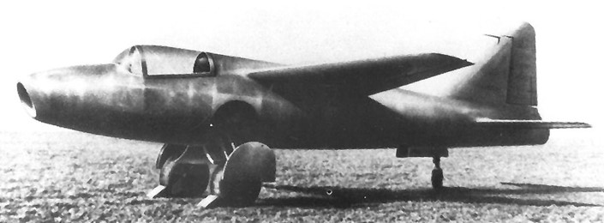

August 30 - A Pan American World Airways flying boat, 'California Clipper' lands at Auckland in New Zealand after a flight from San Francisco. This is intended to be the start of a fortnightly service.

Sept. 1 - Germany invades Poland.

Sept. 3 - Great Britain and France declare war on Germany.

Sept. 17 - Soviet forces invade Poland.

September 28 - Warsaw surrenders.

October 3 - Poland capitulates with Germany. Germany and the Soviet Union partition the country.

November 4 - The United States lifts an arms export embargo, allowing the ‘Cash and Carry’ delivery of weapons. As the Royal Navy has blockaded German ports only the Allies can benefit from this policy.

November 30 - Soviet Union invades Finland and Soviet planes bomb Helsinki and other Finnish towns.

Photo . German Junkers JU-87 ‘Stuka’ dive bombers in action

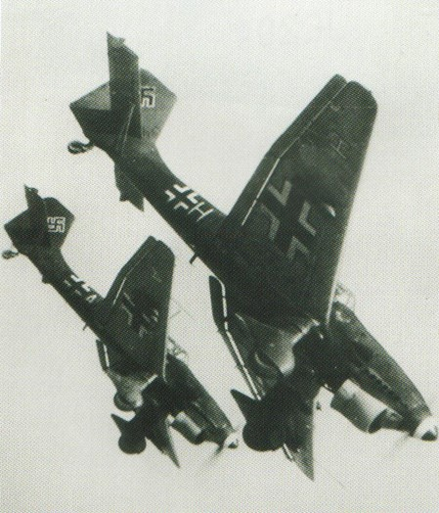

December 2 - General H. (Hap) Arnold, Chief of the United States Army Air Corps (USAAC), has his project for a four-engined bomber with a 2,000 mile radius of action approved. This will lead to the production of the Boeing B-29 Superfortress.

December 28 - Germany's Lufthansa and Russia's Aeroflot agree to resume air services in 1940 between the two capitals Berlin and Moscow.

1940

March 12 - Finland capitulates, signing Treaty of Moscow.

March 25 - United States Army Air Force (USAAC) contractors are authorised to sell to anti-Axis governments modern types of army combat aircraft.

April 9 - Germans begin invasion of Norway includes the use of paratroop assaults on Oslo and Stavanger German forces overrun and occupy Denmark.

May 10 - The German invasion of the Low Countries begins (Netherlands, Belgium, and Luxembourg). There is extensive use of paratroops and airborne troops, and Belgium's Fort Eban Emael, considered impregnable, is quickly and easily overcome by glider-borne assault troops.

May 10 - Winston Churchill becomes prime minister of Great Britain.

# The “Phoney War”

When the Second World War started in August 1939, it was already apparent that aviation would be a vital factor in victory for either side and so there was much activity around the world to develop new processes to manufacture aviation gasoline. In the US, still neutral at this time, there was increased activity in new processes to manufacture this valuable war materiel. New processes such as Catalytic Reforming, Thermal Alkylation, Polymerization and many others would be developed and exploited in the year to come. In Britain plans were underway to build Iso-Octane plants in Britain, Trinidad and Abadan.

# Gasoline Composition 1939

With the advent of war it was important to establish intelligence on the enemy’s petroleum position, its technical capabilities and resources. This would be an important strategic factor later in the war, but for now it was ascertaining the status of the enemy’s technical position. The following is such an example:

In a memo from D.A.C. Dewdren, 27 March 1941[2], the following general description of British and German Fuels made the following observations.

**British** – Over the first year of the war there was a drop in Octane from 100 to 90, and appearance of 5% alcohol. The octane number drop was due to the convenience of distributors, and 5% alcohol was due to carburettor icing troubles.

**Germans** – Up to August 1940 the Germans were using for all types of aircraft on 89-91 ON fuel containing 5.5 cc TEL/IG and consisting of 30-60% hydro-petrol ex bituminous coal or tar, blended with 40-70% straight run petrol spirit which has been obtained from either Rumanian or Venezuelan sources.

About August/Sept 1940, the German appeared to experiment with a variety of fuel brews being aromatics and iso-octanes of various types, as well as hydro-petrol as blending constituents.

A typical German aviation gasoline in 1940 comprised Straight Run Rumanian Base 73 Octane with 10-15% aromatics from coal tar, gas works or coke ovens.

# Avgas Specifications & Test Methods 1939-1940

Even though the oil companies had attempted to standardize the specification for their global distribution aviation organizations, there was still a variety of specifications, some determined by individual countries, others by the aircraft engine manufacturers particularly the US. This luxury would soon disappear with rationalization of supply and pragmatism required by war.

In Britain, the official specification for aviation fuel issued by the Air Ministry was still DTD-234 but the octane reduced from to 77 to 73 MON, and DTD-230 with an Octane of 87. There was a new tentative specification for 100 Octane Aviation Spirit, which required Iso-Octane (or Alkylate) to achieve the desired octane.

Photo . Gloster Gladiator – the last British biplane fighter circa 1938.

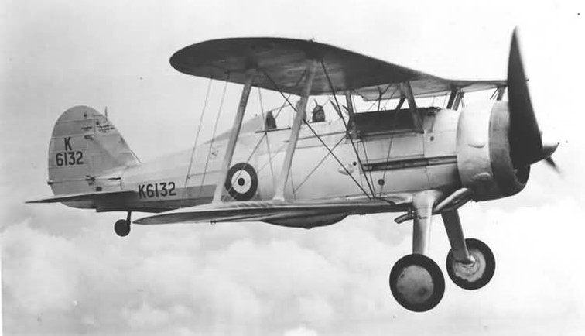

This new 100 Octane gasoline would be required for the new sleek monoplanes such as the Supermarine Spitfire and Hawker Hurricane as the RAF gradually moved out of the biplane era to sleek monoplanes.

Photo . The ‘new breed’ of British fighter – the Hawker Hurricane designed by Sidney Camm (circa 1938)

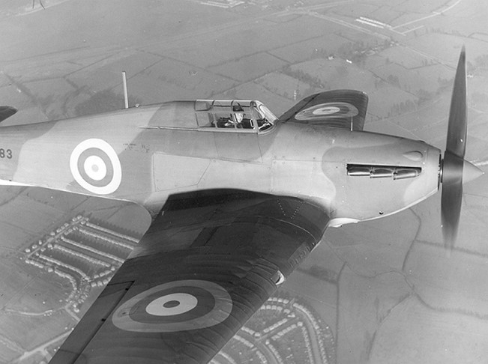

Photo 6. RAF Spitfire Mk V on display at IWM Duxford 2005. The aircraft bears the markings of No. 317 Squadron (Wilno- Polish) flown by Polish pilots during the Battle of Britain.

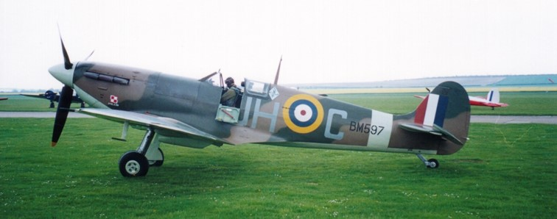

# 1940 Military and Commercial Aviation Gasoline Specifications[3]

1940 British Military and Commercial Aviation Gasoline Specifications

The following specifications were issued by the Shell Co. of Australia Technical Department Aircraft Fuels & Lubricant (circa 1940) for the supply to British & Australian (British Empire) also Holland & Netherlands East Indies (except CFR Motor Method for 87 & 100). The main specification was the British Air Ministry DTD-230 (Department of Technical Development), however there was a tentative specification for ‘100 Octane’ Aviation Spirit (the term ‘Avgas 100/130 would not be used for a year or two until the Rich Mixture Supercharge Rating Method (130 Performance Number) was been adopted in 1941).

Table . British Aviation Gasoline Specifications 1940

|  |  |  |  |  |  |
| --- | --- | --- | --- | --- | --- |
| Grade Designation | 73 (Estimated) | 87 | Typical | 100 (Tentative) | Method |
| Specification No. | DTD-224 | DTD-230 | DTD-230 | Tentative |  |
| Colour |  | Blue |  | Green |  |
| Sulphur (wt.%) Max. | 0.15 | 0.15 |  | 0.15 |  |
| Aromatics (vol. % Benzol (BTX) Min. |  | 25 |  | 25 |  |
| Distillation Temp 10% Rec. (deg. C) Max.  Temp 50% Rec. (deg. C) Max.  Temp 90% Rec. (deg. C) Max.  End Point (deg. C) Max | 75  100  150  180 | 75  100  150  180 | 67  97  142  175 | 75  100  150  180 |  |
| Specific Gravity |  | 0.79 Max | 0.73-0.75 | 0.79 Max |  |
| Reid Vapour Pressure (@37.8 deg. C) psi Max  kPa | 7.0  49.0 | 7.0  49.0 |  | 7.0  49.0 |  |
| Freezing Point (deg. C) Max | -60 | -60 |  | -60 |  |
| Net Heat of Combustion MJ/kg Min  (BTU/lb.) |  |  | 46.5  20,000 |  |  |
| Knock Rating, Lean mixture CFR Modified Motor Rating Min. (Aviation method) | was 77 reduced to 73 | 87  88 |  | 100 | D2700 MON |
| Knock Rating, Rich mixture Supercharge Rating Min.  Note This method was issued by ASTM as a tentative method in June 1941 (ASTM D-41T) | not applicable. | | | | |
| Potential Gum (16 hr aging mg/100 ml) Max | 10 | 10 |  | 10 |  |
| Existent Gum (mg/100 ml) Max. | 10 | 10 |  | 10 |  |
| Tetra Ethyl Lead Content (cc/Imp Gal.) Max. | unleaded | 4 |  | 4 |  |

1940 US Engine Manufacturers Aviation Gasoline Specifications[4]

The foremost US aircraft engine manufacturers were the Wright Aeronautical Corporation and Pratt & Whitney. There appeared to be some consensus between the engine designers on the aviation gasoline grades required. Even though some rationalization of grades had been attempted earlier by the oil industry, it can be seen from the following table that there are five grades, ranging from 87 to 100 octane.

Table . Wright Aeronautical Corporation Aviation Gasoline Specifications 1940

|  |  |  |  |  |  |
| --- | --- | --- | --- | --- | --- |
| Grade Designation | 87 | 90 | 95 | 100 | 100 |
| Specification Number | PWA571-B  Wright 5803-F | PWA812-A  Wright 5804-A | PWA818-A  Wright 5805-B | Wright 5806-A | PWA513-B |
| Color | Blue | Blue | Blue | Blue | Blue |
| Sulfur (wt.%) Max. | 0.10 | 0.10 | 0.10 | 0.10 | 0.10 |
| Distillation  % Rec. + Loss (@ 70 deg. C) Min.  % Rec. + Loss (@100 deg. C) Min  % Rec. + Loss @ 125 deg. C) Min.  10%+50%+90% (deg. C) | 10  50  90  - | 10  50  90  - | 10  50  90  - | 10  50  90  - | 10  50  90  - |
| Specific Gravity | Not stated | Not stated | Not stated | Not stated | Not stated |
| Reid Vapour Pressure (@37.8 deg. C) psi Max  kPa | 7.0  49 | 7.0  49 | 7.0  49 | 7.0  49 | 7.0  49 |
| Acid Heat (Max) | 15 deg. F | 15 deg. F | 15 deg. F | 15 deg. F | 15 deg. F |
| Freezing Point (deg. C) Max | -60 | -60 | -60 | -60 | -60 |
| Knock Rating, Lean mixture  CFR MON Rating Minimum | 87  CFR Motor Method | 90  CFR Motor Method | 95  CFR Motor Method | 100  US Army Method | 100  US Army Method |
| Potential Gum (mg/100 ml) Max | 6 | 6 | 6 | 6 | 6 |
| Tetra Ethyl Lead Content.  (cc/Imp Gallon) Max.  (cc/US Gallon) Max | 3.6  3 | 4.8  4 | 4.8  4 | 4.8  4 | 3.6  3 |

Note: All grades are coloured blue because they contain Tetra Ethyl Lead.

Photo 7. Douglas DC-3 of the era powered by two Pratt & Whitney Twin Wasp S1C3G 14-cylinder radial engines, 1,200 hp

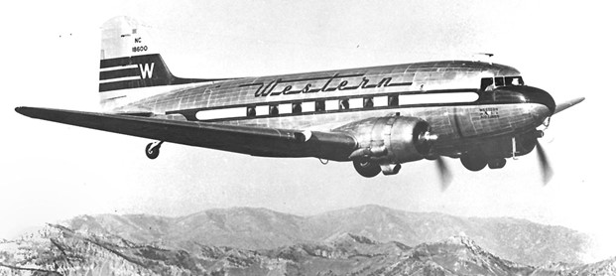

1940 US Military Aviation Gasoline Specifications[5]

The specifications used by the US Army Air Corps were designated Y-3557-F, Y-3557-H, Y3575 and involved a number of different engine test methods, some of which were carried over from the period before the standardization to the CFR Motor Method. Of particular note were the very high levels of Tetra Ethyl Lead (up to 7.2 cc/Imperial Gallon) for Grade 87 and Grade 92 which was allowed by the US military compared to other specifications of 4.0 cc/IG maximum. This may have been to compensate for the poor straight run gasolines (low octane) obtained from the US East Coast crudes.

Table . US Military Specifications for Aviation Gasolines 1940

|  |  |  |  |
| --- | --- | --- | --- |
| Grade Designation | 87 | 92 | 100 |
| Specification Number | Y-3557-F | Y-3557-H | Y-3575 |
| Color | Blue | Blue | Blue |
| Sulfur (wt.%) Max. | 0.10 | 0.10 | 0.10 |
| Distillation  % Rec. (@ 75 deg. C) Min.  % Rec. (@100 deg. C) Min  % Rec. @ 135 deg. C) Min.  10%+50%+90% (deg. C) Min. | 10  50  90  260 | 10  50  90  260 | 10  50  90  - |
| Specific Gravity | Not stated | Not stated | Not stated |
| Reid Vapour Pressure (@37.8 deg. C) psi Max  kPa | 6.5  45.5 | 7.0  49.0 | 7.0  49.0 |
| Freezing Point (deg. C) Max | -60 | -60 | -60 |
| Knock Rating, Lean mixture CFR Motor Rating Min. | 87  Series 30 (190 deg. C Mix Temp) | 92  CFR Motor Method | 100  US Army Method |
| (Existent) Gum (mg/100 ml) Max. | 10 | 10 | 10 |
| Tetra Ethyl Lead Content  (cc/Imp Gallon) Max.  (cc/US Gallon) Max | 7.2  6 | 7.2  6 | 3.6  3.0 |

Note: All grades are coloured blue because they contain Tetra Ethyl Lead.

Photo 8. USAAF Curtiss P-40 Kittyhawks being prepared circa 1939. – America is still at peace.

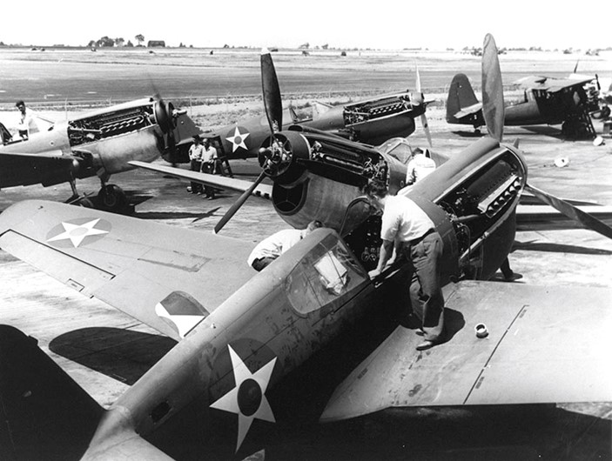

Photo 9. US training aircraft of the era - Stearman PT-17 and US Navy Boeing N2S (Confederate Air Force)

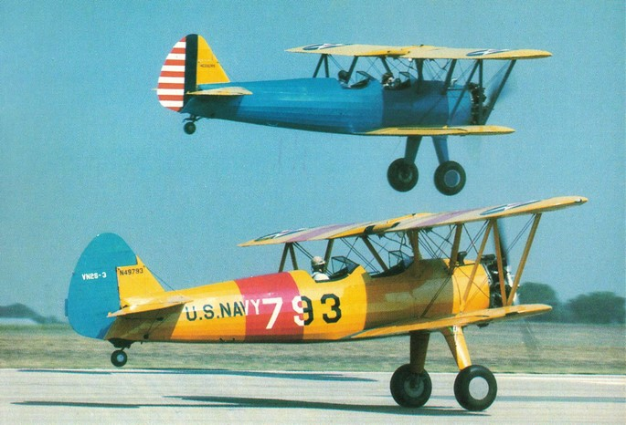

1940 French Military Aviation Gasoline Specification[6]

The specifications used by the French Army & Navy (& French Possessions) were similar to those of other nations. The French aircraft industry had been slowly developing during the 1930’s, but they did have some comparable front-line fighters, but not in the numbers of their enemies, and would not be able to produce sufficient number to defend their beloved France.

Table . French Specifications for Aviation Gasolines 1940

|  |  |  |  |
| --- | --- | --- | --- |
| Grade Designation | 87 | 92 | 100 |
| Specification Number | 3401 Class 2 | 3401 Class 3 | 3401 Class 4 |
| Colour | Blue | Blue | Blue |
| Sulfur (wt.%) Max. | 0.15 | 0.10 | 0.10 |
| Distillation  % Rec. + Loss (@ 75 deg. C) Min.  % Rec. + Loss (@100 deg. C) Min  % Rec. + Loss @ 135 deg. C) Min.  Final Boiling Point (deg. C) | 10-28%  50  90  180 | 10-28%  50  90  180 | 10-28%  50  90  180 |
| Specific Gravity |  |  |  |
| Reid Vapour Pressure (@37.8 deg. C) psi Max  kPa | 7.25  50.8 | 7.25  50.8 | 7.25  50.8 |
| Freezing Point (deg. C) Max | -60 | -60 | -60 |
| Knock Rating, Lean mixture CFR Motor Rating Min. | 87  CFR Modified Motor Method | 92  US Amy Method No. 2-94 | 100  US Amy Method No. 2-94 |
| Potential Gum (mg/100 ml) Max. | 10 | 10 | 10 |
| Existent Gum (mg/100 ml) Max. | 6 | 5 | 5 |
| Tetra Ethyl Lead Content Max. (cc/Imp Gallon) Max. | 4.09 | 4.54 | 3.63 |

Note: All grades are coloured blue because they contain Tetra Ethyl Lead.

Photo 10. French fighter Morane-Saulnier M.S.406, typical of the era.

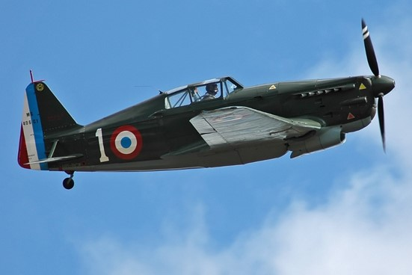

# The British Start Planning[7]

1930’s UK[8]

The situation in Britain before the onset of the Second World War was described by D.J. Payton-Smith in the paper of Aviation Spirit Pre-War Planning[9]. In the mid-1930’s, as with most air forces around the world, there was an increased expansion of the air force (RAF) with emphasis on multi-engined bomber, hence higher fuel supply requirements.

On 30 July 1936, the Committee of Imperial Defence resolved that reserve stocks of aviation spirit equal to 6 months estimated forward consumption in a war against Germany (290,000 tons) should be laid down as soon as possible. Moreover, since world supplies were derived from US, it was considered that in view of political uncertainty, that it was advisable to lay in a stock of Tetra Ethyl Lead (TEL) to meet requirements of British Air Ministry specification DTD-230 for Aviation Spirit. Uncertainty in world supplies of aviation spirit (gasoline) prompted the Oil Board to recommend in June 1938 that authorised reserves be increased to 8 months estimated at 410,000 tons, (by 1941 this was 800,000 tons.)

In the 1930’s, 80% of RAF supplies of Aviation Spirit were derived from Netherlands East Indies (the refineries of Sumatra and Borneo), and the rest from the US. But, the British Admiralty as early as 1926 stated that in the event of a war in the East, communications with Borneo could not be guaranteed and those with Sumatra only after the arrival of the Fleet at Singapore. This was confirmed in 1935.

Moreover in May 1937, the US Neutrality Act was passed. Whilst the supply of Aviation Spirit from the US was not altogether precluded, planning should nevertheless proceed on the assumption that US supplies may not be forthcoming. Thus already the British were looking to other sources of aviation spirit supply. This prompted the later decisions to build plants in Britain and to expand the facilities in the West Indies, such as Trinidad and Curaçao.

# Petroleum Board

While it was generally considered that Britain was unprepared for war with Germany in 1939 following the appeasement policy of the Chamberlain Government, there was one decision that markedly influenced the supply of petroleum products to Britain during the Second World War. Following discussions between leading groups in the oil industry and consultations with the British Mines Ministry and Armed Services in the summer of 1938, the Petroleum board was formed with Government approval during the ‘Munich crisis’. It was a purely voluntary body intended to remain a shadow and planning organization until such time as a national emergency might bring it into active being.

The original Petroleum Board was composed of the four leading distributors:

Anglo-American Oil Company Ltd. (later to be known as Esso)

National Benzole Company Ltd.

Shell-Mex and BP Ltd.

Trinidad Leaseholds Ltd.

In autumn of 1938 a number of committees were set up by the Board. The problems of petroleum distribution under a pooling scheme that would be required in the event of war were examined. The resultant recommendations were made in January 1939 in a series of seven reports with the collective title of “Petroleum Distribution: Emergency Arrangements” covering such topics as pooling of physical resources, pooling of manpower, participation of smaller distributors in the pool, fire-fighting and ARP Air Raid Protection, motor repairs, driving staff, vehicle lighting in the blackout, rail tank cars, field operations, conditions of sale, etc. In short, methods of achieving complete pooling scheme, involving the coordinated use under war conditions of all available facilities and personnel.

In addition, recommendations were for a drastic reduction in the number of grades of petroleum products were made, a rationalization of facilities, and a system of accountancy for the pool was suggested. There were thirteen regions throughout the United Kingdom generally corresponding to the Civil Defence Regions including Northern Ireland. There were some 1,100 installations and depots, and these were to come under the control of the Petroleum Board. With grade reduction alone the working capacity was increased by 20%. The depots were classified as operational, in reserve, or to be closed, ownership was ignored, and efficiency in working and fitness for purpose were the sole factors considered. Yard space, situation in relation to feeding road, rail, or water, office accommodation, risk from bombing, were all taken into consideration in deciding the fate of a depot.

Pool Agreements

The Pool, which the Petroleum Board began to operate immediately hostilities started, was based on three documents: The First Agreement, dated September 22nd. 1938 (a year before the war began); the Second Agreement dated March 8th 1939, both signed by the four companies on behalf of themselves and their associates; and the Supplementary or Independents’ Agreement which was not signed until May 23rd, 1940 although it had been in effectively operating from the moment the Board took over the Pool. Some 32 independent companies known as Additional Members signed the third agreement, all were importers of petroleum products. Affiliated to the original members and the additional members were 57 non-importing oil distributing concerns. These were included either directly or indirectly. The effect of these three agreements was to bring under the control of the Pool, the whole of the British petroleum industry with regard to importation, storage and distribution.

War Starts

On Friday September 1st 1939, the war between Britain and Germany began, by midnight September 3rd (3 days later) the Pool came into operation with a staff of 18,500. Petrol rationing was invoked, and although the Board had no rationing powers whatsoever, it was responsible to ensure that only those officially authorized purchasers were supplied with petroleum products. The Board’s biggest customer was to be the British RAF and the American USAAF. By the end of the war (1945), the amount of fuel delivered to these air forces was to be 50 times the tonnage delivered six years earlier.

Petroleum Board Organisation

The Board comprised a number of committees which were to operate and cooperate in meeting the petroleum demands of a nation now at war. It would be these committees which would decide the supply and distribution of aviation gasoline for Britain’s RAF.

The committees would include the following:

**Overseas Supply Committee** – responsible for purchase, or award under Lend-Lease of the petroleum products needed to meet the vast commitments.

**Tanker Tonnage Committee** responsible in cooperation with the Tanker Division, Ministry of War, for coordinating tanker tonnage over a wide geographical area.

**Management Committee**, Secretariat, Staff Department, Legal Department, Insurance, and Aviation Coordination.

There were three executive departments: Physical and Supplies, General Sales, and Finance and Accounts.

Photo 11. BP- Shell-Mex road tanker now operational as POOL tanker 1940.

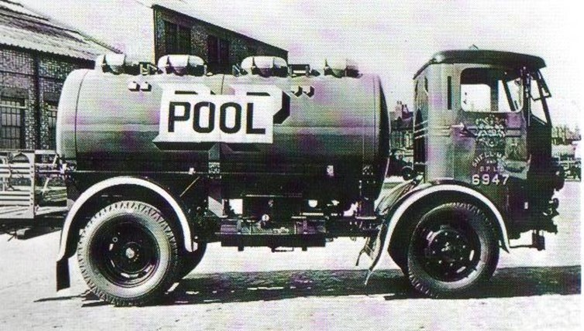

Aviation Coordination

In order to enable the Board to carry out its task of handling the vast fuel needs of the RAF, one of its officials acted as ‘Aviation Coordinator’. This official, for 18 months before the war, had been advising and assisting the Air Ministry with fuel problems and was subsequently appointed by the Ministry their honorary ‘Fuel Adviser’ on Storage and Distribution matters. Coordination of the Board’s complicated work involved in the supply of aviation fuels and lubricating oils entailed the fullest consideration of forward requirements in total, and at a number of different points of RAF (and later USAAF) consumption. Shortages likely to arise in any operational area had to be foreseen and accommodated, and the closest liaison between the Air Ministry and the Petroleum Board’s Aviation Coordination Department was required.

The Petroleum Board was a distributing organization and it did not include refineries. However nearly all the output of the UK refineries, that had been in operation during the war, was on the Petroleum Board or Lubrication Oil Pool account. (The Lubricating Oil Pool did not function as part on the Petroleum Board until October 1939). In the early stages of the war the refineries processing imported crude oil for the production of lubricating oils were closed down in order to economize by importing finished products. Following a world survey however, which indicated that with the USA still on a peacetime basis, there was a danger of a global shortage of lubricating oil refining capacity, the decision was taken in autumn 1941 to re-open those UK refineries in possession of lubrication oil facilities.

Lend-Lease Begins- Refining Department

Early in 1941 the Lend-Lease arrangement was enacted. This meant that all petroleum imports from the USA or dollar-currency suppliers came to Britain not as purchases by individual companies, but as ‘awards’ by America to the British Government. Lend-Lease supplies being subject to various restrictions on their commercial use, the awards of oil to Britain could only be handled by the Government’s appointed agent, the Petroleum Board. In order to deal with Lend-Lease supplies of crude oils for lubricating oil production and other products, the Board set up a Refining Department to make arrangements with the various refiners to process this crude, to coordinate crude oil supplies to the various plants, and the production of the various grades of lubricating oils. Refineries operating in the United Kingdom greatly helped the war effort by supplying specialized products and at times filled the gaps in Britain’s needs. For example, the Manchester Oil Refinery with its specialty products oil refinery, in particular production of transformer oils and cutting oils.

# Aviation Spirit - British Pre-War Planning 1939.[10]

Introduction

Of the many papers, documents and books researched in the preparation of this book on Aviation Gasoline, the work by D. J Payton-Smith titled “Oil History of 2nd World War - A Study of War Time Policy and Administration”[11] is an important record. In addition, he also prepared a paper “Aviation Spirit. Pre-War Planning, D J Payton-Smith.” around 1939 which described the position in Britain.

Effect of introducing British Specification DTD 230 and manufacture of 100 Octane Fuel

With the introduction of the British specification DTD-230 Grade 87 Octane Aviation Spirit as the main RAF aviation fuel for the more powerful engines developed in the 1930’s, there was an increased demand for this grade and also significant interest in the new 100-Octane grade which would be required for the new generation of fighter and bomber aircraft – the Spitfires, Hurricanes and Lancasters. The ramifications of this new 100 Octane aviation fuel were discussed in the paper by Payton-Smith.

Perhaps the greatest single contribution to the relief of this situation (insufficient aviation fuel) was the substitution of leaded spirit of 87 octane number (MON) for ‘unleaded spirit’ of 77 ON as the standard fuel of the RAF.

The 87 Octane spirit was manufactured by distilling a ‘base’ petrol of about 73 MON and blending it with TEL in the ratio of 4 cc ‘Lead’ to each imperial gallon of petrol, whereas 77 ON was produced by blending aromatic products such as benzole with a ‘base’ petrol of a higher octane number than 73.

The new specification not only eliminated the need for aromatics - for which a competitive demand for the manufacture of high explosives was anticipated in time of war - but by virtue of the lower octane number (ON) of the ‘base’ petrol required, enabled a wider variety of the crude oils, and consequently new sources of aviation spirit, to be brought into play.

Another important factor was the development of a process for the manufacture of Iso-Octane from the gases produced during the ‘cracking’ process. The process had been developed in the United States, and by the Spring of 1937 (first quarter 1937), the Shell Group had established a plant at Pernis Holland to manufacture Iso-octane from petroleum components called ‘polymers imported from Curaçao in the Netherlands West Indies. The experiment was watched with great interest by the Oil Board (British), which had in mind a plan to invite the company to transfer its production to the United Kingdom. Iso-octane produced for aviation spirit also greatly increased output in the new areas, which the acceptance of TEL in the Air Ministry specification had permitted to be opened up.

From the point of view of a Western War (European theatre), the most pertinent effect of these developments was that it enabled the Oil Board to consider sources of supply in the Western Hemisphere outside the United States.

At the end of 1936, it made the following tentative estimate of production available by the middle of 1938.

Table . Estimates of expected 1938 Aviation Gasoline 87 Octane Production (made in 1936)

|  |  |  |
| --- | --- | --- |
| Location | Tons | Comments (notations from reference source) |
| Netherlands East Indies | 150,000 | (Query why only 150,000?) |
| Aruba/Curaçao | 100,000 | From Venezuelan Crude. (if tests proceed OK) |
| Trinidad | 120,000 | (42,000 ? and Iso octane plant) |
| Colombia & Peru | 25,000 | (no refinery plant here) |
| Burma | 83,000 |  |
| Total | 478,000 |  |

This total could be increased by the inclusion of the estimated maximum output of the ICI Plant at Billingham (120,000 tons) and by including a token figure of 40,000 tonne for the United States. Billingham was generally discounted as a source of supply, owing to its vulnerability to enemy air attack. [Billingham is located on the north-east coast of England and was within range of German bombers].

The demand anticipated for the first year of a European War was, it will be recalled, 590,000 tons for the Area West of Suez alone. Thus, British demands in the West could be but barely satisfied under the most favourable assumptions; and only by means of a heavy reliance on Eastern sources, which was unsatisfactory from the viewpoint of tanker utilization, and dangerous in the event of an Eastern War. (that is in the Far East).

Problem of 87 ON Supplies - Falmouth Committee Report 1937

The situation of supplies of 87 Octane aviation fuel and Tetra Ethyl Lead (TEL) was reviewed by the Falmouth Committee in its report of November 1937, and various possible remedies were suggested. The (British) Air Ministry specification could be lowered to accept a higher proportion of TEL and the acceptance of a certain amount of ‘cracked’ spirit, suitably inhibited.

A second ‘Billingham’ might be erected, in a less vulnerable area; a stock of crude oil could be accumulated for subsequent home refining, or the authorised reserve of refined spirit could be increased.

In December 1936, a (British) Air Ministry representative had expressed readiness to accept a proportion of ‘cracked’ spirit from Trinidad, but this policy was not ultimately pursued. The stock policy, which implied a long period of pre-war storage, before stocks could be turned over, perhaps inclined opinion against it, though an investigation of the possibilities of re-refining was proposed. The accumulation of crude oil reserves would involve a new refinery which would be as vulnerable as a second ‘Billingham’, while being more wasteful of tanker space.

The Committee itself favoured the idea of another hydrogenation plant, but the Air Ministry preferred to increase the authorised reserve.

Furthermore, the Oil Board encouraged the oil companies to increase their output of aviation spirit by the erection of plants for the manufacture of Iso-octane. The device employed was that of offering a guaranteed market for their output. The response was generally satisfactory at refineries where ‘cracking’ was carried out commercially.

An Iso-octane plant was installed at Aruba in the Netherlands West Indies.

The Shell Company proposed to double their output of ‘polymers’ (Octene in readiness for hydrogenation) at Curaçao and agreed to erect a plant at Stanlow on the Manchester Ship Canal similar to that already in operation at Pernis (Holland). This plant was scheduled to be completed in January 1939, and was to be given first claim on the output from Curaçao. In return for this, the Air Ministry guaranteed an annual purchase of 32,000 tons from Stanlow over five years, and of 25,000 tons from Aruba over 3 years, with the proviso that this should be capable of increase to 50,000 tons in case of emergency.

In the Middle East, the Anglo-Iranian Company needed no inducement to start building two plants, which were considered to be of commercial value. But negotiations with Caltex for a production of Iso-octane at Bahrein came to nothing since the company required more direct financial assistance. It was Trinidad, which formed the centre of attention, however. It was the nearest source of supply to the United Kingdom, apart from the eastern United States. It (Trinidad) was in the British Empire and therefore immune from the kind of political interference which had taken place in Mexico and which, it was feared, might possibly spread to Venezuela; and moreover the Oil Board was not unmindful of the advisability of developing the resources of an entirely British Company such as Trinidad Leaseholds Ltd. Accordingly, in 1938 a thorough survey of the resources of the whole island was undertaken, and Trinidad Leaseholds Ltd. were encouraged by means of a guaranteed off-take of 17,000 tons annually, over a period of five years, to erect a plant for the manufacture of Iso-Octane.

The French, up to the outbreak of war, had made no decision as to the sources from which they would draw their imports. Their standard specification required fuel of 85 ON and this would create no special supply problems, including merely a variation in the proportion of TEL employed. Their needs would, however, constitute an extra drain on British resources. It was not until political events created the Anglo-French Alliance that the British consented to produce a combined program. In June 1939, the position presented itself as follows:

To meet a combined Anglo-French demand of approximately 1,230,000 tons in the West in the year 1939/40:

Table . Estimated Production of 87 ON Aviation Gasoline

|  |  |
| --- | --- |
| Location | Tons per year |
| Aruba | 110,000 |
| Curaçao | 218,000 |
| Trinidad Leaseholds | 94,000 |
| United British Oil Company of Trinidad (UBOT) | 33,600 |
| French Refineries | 300,000 |
| Total | 756,000 |

There was also a supplementary production of 110,000 tons of 100 Octane Aviation Spirit, which will be discussed below and of course, the output of Billingham, now estimated at 100,000 tons a year (1939).

In August 1939, the United British Oil Company of Trinidad (a subsidiary of Shell), was due to increase its output by 36,400 tons; and by the sacrifice of 50,000 tons of 100 Octane fuel at Aruba – (which would be at the expense of stock accumulation) - a further 105,000 tons of 87 ON fuel could be produced. A maximum production of 1,145,000 tonnes from Western sources would thus leave a deficit of 145,000 tons, which would have to be met from the East.

Preparations were made for a domestic production of Ethyl Fluid (TEL) in time of war by the formation in 1936 of a company (Associated Octel Limited) which would undertake the manufacture of TEL within six months of the outbreak (of war). It was expected that output would be sufficient to permit a surplus to be exported for the satisfaction of the requirements in the East.

1938 Review of Avgas sources

With the clouds of war looming the British looked for other potential sources of supply of aviation gasoline as in reality the predictions and estimates of 1936 were below expectations and indicated as follows:

Peru - Standard Oil New Jersey, Talara Refinery, 16,000 tons/year

Columbia - Standard Oil New Jersey, Barrancabermeja Refinery 3,000 tons/year

Both these products were considered unsuitable.

The position in the West Indies was that the Aruba Refinery (processing Venezuela Crude) produced straight run petrol which when leaded up to 4 cc TEL/IG would meet UK Ministry of Air 87 ON Fuel.

In addition a plant for manufacturing mixed octanes by polymerisation and hydrogenation of gases from cracking units was under construction and expected to operate in the autumn of 1938. The estimated output was 38,000 tons/year of mixed octanes.

At Curaçao, the output of aviation fuel from straight run petrol from Lagunillas crude, with not more than 4 cc TEL/IG, was 100,000 tons/year. A polymerisation plant had been installed to treat refinery gases and the Shell Co. originally intended to manufacture the polymer so obtained into mixed octanes at Pernis (Holland). [Events in Europe with Nazi invasion of Holland in May 1940 meant that the Pernis operation would be lost to the Allies war effort]. At Curaçao, the aviation fuel was dependent on petrol from Lagunillas crude oil.

In the UK, the Stanlow plant for mixed octanes was expected to commence in January 1939.

In the Middle East, it was found that crude from Egyptian oil fields was unsuitable for aviation fuel, further that Iran, Iraq and Bahrein crudes were also unsuitable for straight run aviation fuel, however at Abadan Refinery the Anglo-Iranian Oil Co. have undertaken the manufacture of mixed octanes on a progressive scale. The Iso-Octane plant was under construction and being supplemented by a smaller unit expected on-line in September 1939.

# The Demand for 100 ON Fuel

Thus, it appeared that Allied demands in the West, even with a minimum production by French refineries and in the most unfavourable political circumstances - an unfriendly USA and a simultaneous war in the Far East - could be satisfied, if but barely. But the situation proved to be far less satisfactory when the implications of the Air Ministry’s decision in 1938 to adopt aviation spirit of 100-Octane as the standard fuel, came to be examined. This new fuel would permit an improvement of 20% in engine performance. It could improve the performance of all engines, but for the maximum advantage to be gained, it was necessary to employ engines specifically designed to operate on 100 ON fuel. Since, however such engines would be unable to function on a lower grade fuel, it was essential that before the beginning of the new production policy, adequate sources of supply of 100 ON fuel should be guaranteed.

If certainty of supply was the chief characteristic required of these new sources, abundance of output was little less important. The first of the new engines, the Rolls Royce Merlin XII and the Bristol Hercules would be due to come into service by late Spring of 1940 (March/April), but general distribution of 100 ON fuel was not intended until 1941. This meant that demand for the new fuel in its first year of service would be at the rate anticipated for 1941/42, under expansion scheme ‘L’; less the amount consumed by non-operational aircraft, which would still use 87 ON fuel. (The RAF used 73 ON for elementary trainers such as the Tiger Moth. In 1938 some 25% of its aircraft still used 77 ON though its use was declining. It ultimately used 87 ON for training and 90 ON for some operational engines notably Armstrong Siddeley. Engines such as the ‘Wright’ and even the Napier ‘Sabre’ used 90 ON at OTU’s (Operational Training Units). 100 ON was the standard operational fuel.

The demand for 100 ON fuel West of Suez in such circumstances – including requirements for the (British) Fleet Air Arm - was estimated to be 735,000 tons. Moreover, as a result of the decision of CID (Committee of Imperial Defence) on June 23rd 1938, it was intended that 700,000 tons of the reserves of 800,000 tons being laid down, should consist of 100 ON fuel. (It was planned that turnover of these stocks should begin in 1940. At peacetime consumption rate of about 90,000 tons a year, it would take a year to work through the 87 ON stock, and turnover of the 100 ON would coincide with the entry of that grade into consumption.) But if demand was potentially enormous, productive resources were slender. The prospects of supply were estimated as follows, in May 1938.

Table . Estimated Supply of British 100 ON Aviation Gasoline May 1938.

|  |  |  |
| --- | --- | --- |
| Source | Estimated completion date | Capacity - tons per year |
| Aruba | End of 1938 | 50,000 |
| Stanlow/ Curaçao | End of 1938 | 40,000 |
| Trinidad | May 1938 | 20,000 |
| Abadan | August 1938 | 45,000 |
| April 1939 | 30,000 |
| Total | | 185,000 |

This production was only made possible by the development of facilities for the manufacture of Iso-octane as described above, and would be at the expense of a greater production of 87 ON fuel. (Leaded 87 ON blended with Iso-Octane, or unleaded 87 ON (a blend of ‘base’ petrol with Iso-Octane) blended with 4 cc TEL per Imperial gallon produced 100 ON spirit).

Nevertheless the decision to hold stocks of 100 ON petrol created an immediate demand which was partially met by absorption of the guaranteed off-take which stimulated that expansion 77,000 tons a year was procured in this way.

Solution of the Supply Problem – Hydrogenation and Home Production

But there was a limit to the possible output of Iso-Octane which was only about 2% of the throughput of any refinery engaged in its manufacture. The problem created by the large demand anticipated for 1941 could only be resolved by the employment of a new technical process - the manufacture of synthetic ‘base’ petrol and butane gas by the hydrogenation of coal or heavier oils. This process would not only an adequate supply of suitable high grade ‘base’ petrol, but would also relieve the shortage of Iso-Octane, which could be produced in conjunction with the ‘base’ petrol and blended with it.

The process had been developed in the UK by Imperial Chemical Industries Ltd., who in 1934 established a plant at Billingham for the manufacture of petrol by the hydrogenation of Durham coal. For technical reasons, however, early production employed creosote as a raw material, and due to the high price of coal, this method became more important than that for which the plant was originally designed. A potential output of 100,000 tons or more of 87 ON fuel was attributed to Billingham in time of war, though, sited solely with reference to economic convenience, it was regarded as an insecure source because of its vulnerability to attack from the air.

The Air Ministry, which was perhaps at this period inclined to overestimate the threat represented by the enemy bombing force, dissented from the recommendation of the Falmouth Committee in December 1937, that a second ‘Billingham plant’ should be built to supplement the then inadequate supplies of 87 ON fuel; though it had added that the situation created by a future adoption on 100 ON fuel might entail the reconsideration of this decision. Developments in the field of technology meanwhile rendered the process used at Billingham out of date, and justified the caution of the Air Ministry. By the substitution of gas oil for creosote as a feedstock, it was found that approximately twice as much ‘hydropetrol’ could be produced for the employment of an equal amount of hydrogen.

‘Hydropetrol’ possessed a high octane value and the addition of Iso-Octane and the approved quantities of TEL would produce a fuel of 100 ON.

Outcome of Hartley Committee 1938

An Air Ministry committee, under the Chairmanship of Sir Harold Hartley, Chairman of the Fuel Research Board, was set up in 1938 to consider the problem of 100 ON supplies. It reported in December 1938, and its recommendations were accepted by the Committee of Imperial Defence in January 1939. Three new plants were to be erected; they were to combine the production of ‘hydropetrol’ and butane by the hydrogenation of gas oil, with the manufacture of Iso-Octane. Their total estimated output would be 720,000 tons of 100 ON fuel per year.

It was also decided that ICI should erect a pilot plant at Billingham to obtain experience in the early stages of the process for manufacturing Iso-Octane.

The need for certainty of supplies may have contributed to the reversal by the Air Ministry of their former attitude to home production, but even so it was at first a partial surrender; for two of the new plants were to be built in Trinidad and only one in the United Kingdom. The importance and advantages attached to Trinidad have already been described; moreover the need for quantity had dictated the employment of gas oil, imported from Trinidad in preference to home produced creosote, so that the output of the home factory in any case dependent upon the keeping open of the ocean supply lines.

Finally the import of a greater proportion of finished products would economize tanker space. Nevertheless security was reinforced by the decision that the plant in the United Kingdom should be so constructed as to enable it to operate on creosote at half its normal output in case of emergency.

(It was also to be equipped with a plant for manufacturing ‘N’ fuel; a product developed by ICI which had high anti-knock characteristics, and which would supplement production when the hydrogenation plant was running on creosote.)

(Comment: This ‘N’ fuel may have been one of the aromatic amines used as a blending additive)

However, the decisions thus reached proved far from final. In response to objections by the Treasury, the number of plants was reduced to two in June 1939. (But the two factories were to be capable of rapid extension to an output of 360,000 tons if necessary, so there would be no loss in output.)

Conflicting but on the whole unfavourable reports of labour conditions, and the difficulty of recruiting qualified technical staff in Trinidad, as well as the easier pooling of experience in construction research and operations permitted by the working of both undertakings in the United Kingdom, outweighed the advantage on immunity from aerial attack. Plans were changed accordingly and the Air Ministry’s reversal of policy was completed.

Meanwhile preliminary work had begun on the first plant. A site was chosen at Heysham near Lancaster, which combined relative safety from air attack with comparative proximity both to the sources of creosote supply (and the Mersey where imports from Trinidad could be received).

Financing Iso-Octane Production

A variation in policy proved as necessary in the sphere of finance as in that of production. There were three possible ways in which the Government could procure supplies of a product which it was commercially unprofitable to manufacture. It could build its own factory and undertake production for itself; or it could offer a guaranteed and steady market. This last device had proved sufficient to encourage the provision of Iso-Octane plants, but in the case of Heysham, more direct measures were necessary. The Air Ministry accordingly undertook financial responsibility for the construction of the plant which was to operate only in time of war; those three companies which had the widest technical experience of the processes to be employed, contributed their knowledge while acting as sub-contractors to the Ministry. They were Trinidad Leaseholds Ltd., the suppliers of the feedstock (gas oil); Imperial Chemical Industries ICI, the experts on hydrogenation; and the Shell Company which had pioneered in Europe the process for the manufacture of Iso-Octane. The combine was called “Trimpell”, a joint management committee representing the three companies under an independent Chairman, was set up to supervise construction; it was aided by a sub-committee of Air Ministry technical experts, which co-coordinated the design ordering and research.

Before work began on the second plant, however, both the technical and financial methods being employed, were further reconsidered.

Sir Harold Hartley reported that new developments in the USA were likely to render the process used at Heysham out of date. (Comment. Those developments were the alkylation process used to manufacture high octane iso-octanes from olefin gases and isobutane).

The Shell Company came forward with a scheme according to which, with the aid of a Government loan repayable over 10 years, they would undertake the construction of a plant to produce motor spirit in peace time and 350,000 tons a year of 100 ON spirit in time of war. This project would eliminate a wasteful peace time diversion alike of the economic resources of the country, and the financial resources of the Government. It was favourably considered by the Oil Board at the outbreak of war. A scheme proposed by Trinidad Leaseholds Ltd to extend their productive capacity of 100 ON fuel to a maximum of 133,000 tons a year with the aid of a Government loan was also under review; the main issue being the extent to which the company could be persuaded to support a proportion of the financial burden. If these schemes were accepted, the outlook for the production of 100 ON fuel during 1941 (1) could be summarized as follows:

Table . Estimated 1941 Production of 100 Octane Aviation Gasoline

|  |  |
| --- | --- |
| Source | Tons per year |
| Heysham | 345,000 |
| Shell plant | 350,000 |
| Trinidad (Pointe à Pierre) | 133,000 |
| Stanlow/ Curaçao | 42,000 |
| Aruba | 50,000 |
| **Total** | **910,000** |

(1) The new plants would take from 18 months to 2 years to build.

From Western and predominantly British sources of supply; which could fully satisfy British demand for ‘operational’ fuel for the year 1941/42. (If the French adopted 100 ON fuel, it could not satisfy joint Allied operational demands.)

Distribution -The Function of Stocks

The principal reason for accumulating large reserve stocks is to create a cushion either against interruption of the supply routes, or against unforeseen burst of demand as a result of enemy action. But it also performs a useful service in smoothing out those small disharmonies in the rates of consumption and supply which are inevitable when supply is undertaken by irregularly arriving tankers; and demand varies according to the suitability of operational conditions. Stocks are not merely a static heap; they are also in time of war, a moving and flexible supply line. From this point of view, they must be considered not only as contributions to demand, but also as important elements in distribution.

[Comment: This British approach to large reserves was to later cause some friction with the Americans who considered the British requests for aviation gasoline were often inflated.]

# British Empire

It the context of this subject, it is important to appreciate the way in which the British Empire and its Dominions/Colonies were spread across the world particularly from the east of the Suez Canal, and that it was administered from Whitehall (the seat of Colonial Office of the British Government).

Figure 1. The ‘Great British Front’ in 1940 from Sollum to Singapore. (‘East of Suez’)

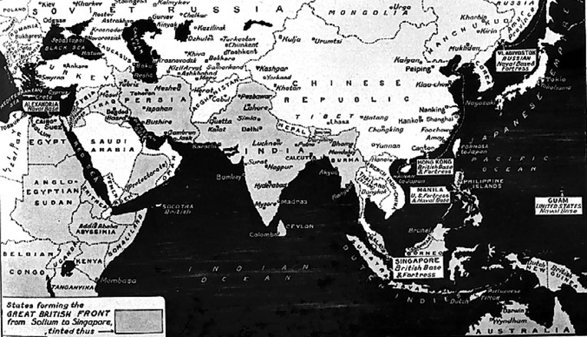

The map above illustrates the vast area covered by Great Britain and its Allies (the United States in Guam and Manila, the Soviets in Vladivostok, the Dutch in New Guinea and East Indies, the French in Indo-China (now Vietnam). For the British this meant a supply network which extended across the world, with the Suez Canal as the focus – the areas were referred to as “East of Suez” and “West of Suez”.

British Position August 1939

The British situation in 1939 was outlined in the 6th Meeting in August 1939 of the Petroleum Products Resources Sub-Committee. For the ‘British Empire’ the world was divided with reference to the British controlled Suez Canal in Egypt. The sources of Aviation gasoline (spirit) were essentially from refineries in the west with Caribbean and Dutch West Indies, and in the east with the Dutch East Indies and British Borneo, with a small amount from Burma (Rangoon) and India (Digboi). The Abadan Refinery in the Middle East was yet to become a major aviation gasoline supplier (a position that would change significantly with Abadan becoming an important supplier to the Soviets later in the war).

Table . Summary of sources of supply (to UK) of 87 Octane Aviation Spirit 1939[12]

|  |  |  |  |
| --- | --- | --- | --- |
| Region | Location | Potential supplies tons/year | Per cent |
| West of Suez | Aruba | 110,000 | 7.3% |
| Curaçao | 218,000 | 14.5% |
| Trinidad | 170,000 | 11.3% |
| Sub Total West |  | 498,000 |  |
| East of Suez | Rangoon & Digboi | 202,000 | 13.5% |
| Abadan | 40,000 | 2.7% |
| Dutch East Indies | 760,000 | 50.7% |
| Sub Total East |  | 1,002,000 |  |
| **Total** |  | **1,500,000** |  |

Exports from USA

There was a significant supply from the US in 1938; total US exports were 391,000 tons. By 1939, it was estimated that the total US exports would be around 590,000 tons. A considerable part of these exports went to Germany and to other countries not expected to be importers in 1940. It should be recognised that the USA was still neutral and its oil companies would be supplying their affiliates in Germany and other countries.

# British Position September 1939

With war declared on Germany by France and Britain on September 3, the aviation gasoline position required immediate reassessment and included the new 100 Octane grade. The British position in 1939 was described in a letter from F. Godber to F.C. Starling Petroleum Department Millbank SW1, London on 12 Sept 1939.

Table . Aviation Gasoline 1939 British Sources

|  |  |  |  |  |  |  |
| --- | --- | --- | --- | --- | --- | --- |
| Refinery Location | Tons/year | Grade (clear) Octane | Aviation Gasoline Octane | TEL cc/IG | Company | Production % |
| Curaçao DWI | 504,000 | 71/73 | 87 | 4 | Asiatic Petroleum Co. & others | 42.1% |
| Brandan DEI | 150,000 | 77 | 87 | 3 | Shell | 12.5% |
| Balikpapan DEI | 312,000 | 73 | 87 | 4 | Standard Vacuum | 26.1% |
| Pernis Holland | 45,000 | 87 | 100 | 4 | Shell | 3.8% |
| Stanlow UK | 50,000 | 87 | 100 | 4 | Shell | 4.2% |
| Pladjoe DEI | 35,000 | 87 | 100 | 4 | Shell | 2.9% |
| Trinidad | 75-100,000 | 71/73 | 87 | 4 |  | 8.4% |
| **Total** | **1,196,000** |  |  |  |  |  |

[DWI= Dutch West Indies, DEI=Dutch East Indies]

The quality (grade) mentioned is the clear (undoped) gasoline produced at the refinery, and when used for service, Tetra Ethyl Lead is added to get the finished aviation gasoline of the required octane. In addition, group sources in the US can produce 110,000 tons of 73 ON aviation gasoline with the addition of TEL can be brought up to 87 ON, plus 95, 000 tons of 100 Octane with the possibility that early in 1940, this will be increased (when various Alkylation plants come into operation) to 350,000 tons/annum of which 250,000 tons/annum we should be able to export. Whilst it may not be possible to increase production of clear basic 73 or 77 Octane aviation gasoline, it is possible to increase production of 100 aviation gasoline by the provision of new facilities in the East.

The British position relied on two sources – the ‘assured’ source of supply from established refineries under British control such as Trinidad, and the ‘non-assured’ source of supply from non-British sources such as the Dutch East Indies, USA and from plants then under construction.

Table . Assured Sources of Supply 1939.

|  |  |  |  |  |  |
| --- | --- | --- | --- | --- | --- |
| Source | 87 ON | % | 100 ON | % | Comments |
| Curaçao (West Indies) | 218,000 | 31.2% | - | - | Venezuelan crude – Asiatic Petroleum Co. |
| UK (possibly Stanlow) | - | - | 42,000 | 35.9% | Produced from Curaçao material (Gas oil) |
| Aruba (West Indies) | 110,000 | 15.8% | 58,000 | 49.6% |  |
| Trinidad | 128,000 | 18.4% | 17,000 | 14.5% |  |
| Abadan (Iran) | 40,000 | 5.7% | - |  | Anglo-Iranian |
| Rangoon & Digboi | 202,000 | 28.9% | - |  |  |
| **Total** | **698,000** |  | **117,000** |  |  |

Burmah Oil Co. advised that the outputs of Digboi Refinery (India) and Syriam Refinery (Rangoon, Burma) could produce 87 ON aviation fuel and do not justify use of extensive cracking for Iso-Octane – it is not economic for refinery product slate.

Table . Non Assured Supply – July 1939.

|  |  |
| --- | --- |
| Source | Quantity tons |
| Dutch East Indies | 760,000 |
| USA | 500,000 |
| Billingham UK | 100,000 |

It was also expected that the French position as of August 1939, would be 300,000 tons/year.

For 1940 planning, the primary sources of British aviation gasoline were expected to be from Trinidad and the Dutch West Indies refineries of Aruba and Curaçao.

Table . British Aviation Gasoline estimations for 1940

|  |  |  |  |  |
| --- | --- | --- | --- | --- |
| Location | Refinery | Crude | 87 Octane at 4 cc Lead | 100 Octane at 4 cc Lead |
| Dutch West Indies | Aruba | Venezuela & Columbia crude | 110,000 | 58,000 |
| Curaçao | Venezuela | 218,000 | - |
| UK | Stanlow | Material ex Curaçao gas oil | - | 42,000 |
| Trinidad | Pointe a Pierre |  | 94,400 | 17,000 |
| Point Fortin |  | 33,600 | - |
| Point Fortin, August 1939 after expansion |  | 75,000 | - |

The supply situation with the new 100-Octane fuel was expected to be met from the following Iso-Octane plants, some of which were nearing completion in 1938-1939.

Table . Supply of 100 Octane Avgas from Iso-Octane plant production (based on 4 cc TEL/Imperial Gallon).

|  |  |  |  |
| --- | --- | --- | --- |
| Plant | Company | Est. Completion Date | Capacity Tons/year |
| Aruba Refinery | Anglo-American | End of 1938 | 10,000 |
| Stanlow Refinery | Shell | End of 1938 | 40,000 |
| Abadan Refinery | Anglo - Iranian | Aug 1938 | 45,000 |
| April 1939 | 30,000 |
| Trinidad | Trinidad Leasehold Ltd. | May 1938 | 20,000 |

Concurrently with the development of production from mixed octanes, the Department had under consideration the manufacture of 100 Octane fuel by use of other anti-knock components. e.g. “N” fuel and ketones, both of which can be made in the UK from indigenous materials.

“N” fuel was at present being produced on an experimental scale by ICI and used by Air Ministry for flight trials and engine tests. The material discovered in the course of research is (blended with benzol), a product of gases derived from the hydrogenation of coal. The benzol, if required, can be stripped of its Toluol content.

In 1938, Borneo and Sumatra were the largest source of supply of (87 ON) Aviation Fuel and petrol particularly rich in natural aromatics. Borneo was the main source of Toluol.

[Toluol is an important chemical in the manufacture of explosives in particular Tri-Nitro Toluene , better known as TNT].

Photo 12. RAF Bristol Blenheim refuelling and rearming circa 1940.

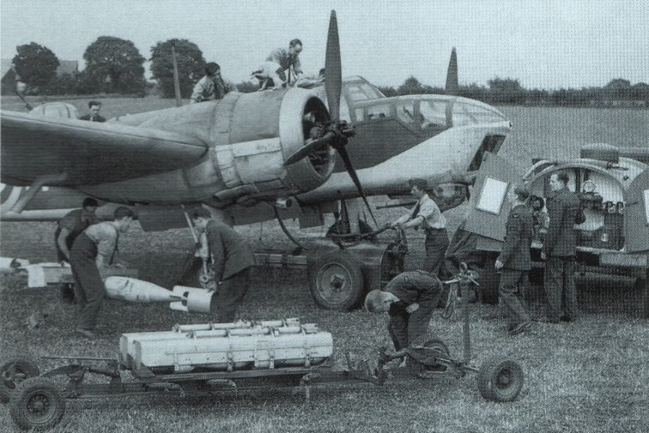

The Bristol Blenheim was the British frontline bomber of the era. On September 3, 1939 a Blenheim from No. 139 Squadron was the first RAF aircraft of WWII to cross the German border, when flying a reconnaissance mission.

# Benzole

The role of Benzole had always been a significant component in British Aviation Spirit, even from the early days of World War I. Again, Benzole was to play an important role however, now there were some limitations due to higher performance requirements such as higher altitudes and colder climatic conditions. The major source of Benzole was still, coal tar, gas works and coke oven at steel works.

From a technical viewpoint, the amount of Benzole which could be added to aviation fuel was limited by two factors:

Freezing point specifications (Benzole has a relative higher freezing point than the other aviation gasoline blendstocks), and

Materials of construction for the aircraft fuel system. Benzole was highly aromatic and therefore an excellent solvent for some rubber components, which was a problem for the American aircraft.

The amount of benzole in aviation gasoline would be dependent its composition and on the other blendstocks used; - for UK Avgas 100/130 from Curaçao the limit of Benzole in aviation spirit was about 10% due to the freezing point. Nearly all refined Benzole would go to motor spirit.[13]

Benzole Composition

The composition of Benzole varied depending on the source, whether it was from the different types of gas works retorts, or steel works coke ovens. The following list the composition from the various British sources. In all cases there was a significant content of Benzene, Toluene and Xylene – all of which give high results in both lean and rich mixture octane ratings.

Source: C.R. Research Dept. Memo 25 Nov 1940.

Table . Composition of Benzole (average of 90 Coke Ovens) 1940

|  |  |
| --- | --- |
| Components (Benzole) % | Average |
| Benzene | 51% |
| Toluene | 13.8% |
| Solvent Naphtha | 7.2% |

Table . Composition of Benzole from Gas Works

|  |  |  |  |
| --- | --- | --- | --- |
| Component % | Horizontal Retort | Inclined Retort | Vertical Retort |
| Benzene | 50.3% | 32.5% | 26.7% |
| Toluene | 16.4% | 18.0% | 11.5% |
| Xylenes | 8.0% | 13.7% | 20.1% |

Manufacturing Process 1939

This was a period of great development in refinery processes with construction of Alkylation and Catalytic Cracking Units in the US and elsewhere around the world. The oil industry turned its attention to any process that would either produce aviation gasoline blendstocks or improve existing gasoline/naphtha blendstocks so that more could be used in aviation gasoline. This would be accelerated in 1942, after the USA had been dramatically drawn into this World War by the attack on US Navy Pacific Fleet at Pearl Harbour, Hawaii by carrier aircraft from the Imperial Japanese Navy.

Aviation gasoline was now developing into the mixture of high octane blendstocks and straight run or catalytic cracked gasolines. The lower grades 73 ON and 87 ON comprised straight run gasolines, while the 100 ON aviation gasoline required iso-octane or a blendstock containing high quantities of iso-octanes from any suitable process, usually alkylation.

# Houdry Catalytic Reforming

Houdry Catalytic Reforming to produce Aviation Gasoline blendstock[14]

Aviation gasoline of 100 Octane comprised Iso-Octane, gasoline base-stocks of sufficient octane, Iso-Pentane/Pentane (to provide sufficient vapour pressure) and Tetra Ethyl Lead. Any process which improved the quality of the gasoline base stocks would increase production by allowing a reduction in the requirement of the valuable and expensive Iso-Octane to reach the 100 Octane target. One such approach was to use the existing Houdry process to catalytically reform straight run gasoline or naphtha. Units for this process were erected in France and the United States – the combined charging capacity which amounted to approximately 25,000 Barrels per day. (4 Million litres/day). (The French unit would be lost to the Germans in 1940).

A Houdry catalytic reforming plant may be used to produce motor gasoline from naphtha, or may be charge gas oil at decreased throughput to produce either aviation gasoline or motor gasoline. This process is described in earlier chapters.

A commercial Houdry unit went on stream at the Socony-Vacuum Beaumont Refinery in Texas in March 1939. [In 1939 the Beaumont Refinery carried the name of Magnolia Oil Co.] Units at 6 other refineries were soon added.

# Alkylation Processes

The union of paraffins with olefins, usually designated as Alkylation was a relatively newcomer in the field of chemical conversion process; it was not until 1935 that experimental demonstrations of the paraffin-olefin union by thermal and catalytic routes were announced, although there were doubts about the thermal route. The published investigations of Frey et al., Ipatieff et al., Dunstan, Birch et al. and Blunck and Carmody showed the versatility of the alkylation reaction, its applicability to many paraffin and olefin reactants, and to cycloparaffins as well. The reaction can occur by heat and pressure alone, and also by catalysts; Boron Fluoride plus Nickel, Aluminium Chloride, Sodium Chloroaluminate, Sulphuric Acid, Phosphoric Acid and Hydrofluoric Acid, and others. The production of Iso-Octane by means of sulphuric acid alkylation rapidly became an important factor in aviation gasoline manufacture. The Alkylation process is described in later chapters.

# Alkylation process for Iso-Octane gains acceptance

Sulphuric Acid Alkylation Plants 1939[15]

The development of the Sulphuric Acid Alkylation process for the manufacture of iso-octane discovered in 1937 continued into 1939. The research groups of Anglo-Iranian (BP), Humble (Exxon), Shell, Standard Oil Development (Esso) and Texas Co. (Texaco) continued with progress towards commercial application of this important refining process.

Even though the first Alkylation process had only come into commercial operation in 1938, by 1939 there were a number Sulphuric Acid Alkylation plants in operation around the world, and more under construction or consideration to increase the production of aviation gasoline.

Operating Plants 1939

Table . Alkylation Plants (Sulphuric Acid type) operating in late 1939

|  |  |  |  |
| --- | --- | --- | --- |
| Company | Location | Aviation Alkylate | |
| Barrels/day | Litres/day |
| Humble Oil & Refining Co. | Baytown, Texas, USA (First commercial plant in 1938) | 1,200 | 191,000 |
| Shell Oil Co. | Dominguez, California, USA | 800 | 127,000 |
| Shell Oil Co. | Martinez, California, USA | 500 | 80,000 |
| The Texas Co. (Texaco) | Port Arthur, Texas, USA | 750 | 119,000 |
| Standard Oil Co. of New Jersey (Esso) | Bayway, New Jersey, USA | 175 | 28,000 |
| Anglo-Iranian Oil Co. (BP) | Abadan, Iran | 100 | 16,000 |

Plants under construction or consideration 1939

Table . Alkylation Plants (Sulphuric Acid type) under construction or consideration in late 1939.

|  |  |  |  |
| --- | --- | --- | --- |
| Company | Location | Aviation Alkylate | |
| Barrels/ day | Litres/day |
| Humble Oil & Refining Co. | Baytown, Texas, USA | 1,500 | 239,000 |
| Shell Oil Co. | Houston, Texas, USA | 1,500 | 239,000 |
| Shell Oil Co. | Wood River, Illinois, USA | 1,500 | 239,000 |
| Standard Oil Co. of Louisiana | Baton Rouge, Louisiana, USA | 1,200 | 191,000 |
| Magnolia Petroleum Co. | Beaumont, Texas, USA | 2,140 | 340,000 |
| Union Oil Co. of California | Wilmington, California, USA | 270 | 43,000 |
| Lago Oil & Transport Co* | Aruba, Netherlands West Indies | 520 | 83,000 |
| NKPM** | Palembang, Sumatra | 560 | 89,000 |

*In 1929, the Lago Oil and Transport Company, a subsidiary of Standard Oil of New Jersey, built a large refinery at the south-eastern tip of the island. The Lago refinery became the largest in the world. (The refinery was sold to Coastal Corporation and is operational today).

** Nederlande Koloniale Petroleum Maatschappij (The Dutch Colonial Company, of which the Standard Oil of New Jersey company had a substantial interest since 1927, and operated the Palembang Refinery. in the Dutch East Indies).

The characteristic four distillation towers of an alkylation plant can be seen in the following examples. The tallest is the De-isobutaniser tower which separates isobutane from the reactor products for recycling in the process.

Photo 13. Texas Company, Alkylation Unit, Port Arthur, Texas USA (1939)

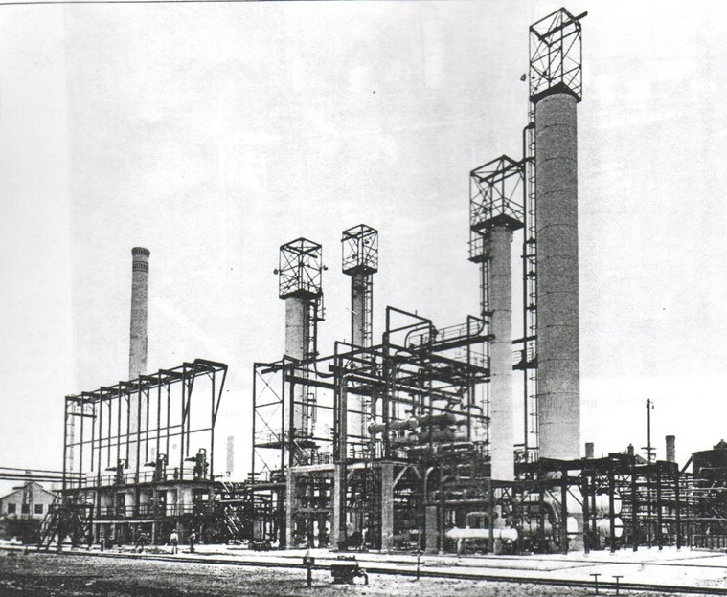

# Thermal Alkylation & Neo-Hexane[16]

Thermal Alkylation

The recently developed (1937) Alkylation process was an addition to the conversion processes applicable to hydrocarbons. While much of the attention was on the catalytic alkylation reaction, it can also be conducted thermally to produce isoparaffinic fuels of high octane number. With non-selected conversion stock such as Ethane, Propane and Butane, motor fuel can be produced in high yields by thermal alkylation in a two stage process in which the lighter part of the stock can be cracked to produce olefins in one stage, which are then reacted with the heavier part of the stock in a second or alkylation stage. This process is described in later chapters.

Neohexane Process

In January 1940, the Phillips Petroleum Company were to commence operation of a plant producing Neohexane, a new aviation fuel blending component, by the reaction of ethylene with isobutane by thermal alkylation. The process consisted of a cracking step wherein an ethane-propane mixture was cracked to ethylene at low pressure and high temperature, and an alkylation step wherein ethylene is reacted with isobutane under high pressure to produce mostly Neohexane which has an octane of 93.4 MON with some other hexanes. This process is described in later chapters.

# Oil and Refineries

The war brought a new dimension to oil companies and their trading. That dimension was foreign country balance of payments. This divided the Allied countries into “Sterling” and “US Dollar” operations, and this would play an important part in British thinking is determining where avgas would be produced and supplied. These ‘Sterling’ operations were British (or Anglo-Dutch) facilities in the West Indies, East Indies and the Middle East. The Axis countries acquired their stocks by seizure as acts of war.

World Production of Crude Oil 1939

The world production of crude oil in 1939 gives some insight to the sources of oil required to fight a war and those countries who were suppliers to eager customers, and those dependant on external supplies.

Table . World Production of Crude Oil 1939[17]

|  |  |  |  |  |
| --- | --- | --- | --- | --- |
| Country | Tons (1939) | % | Allies | Axis |
| USA | 171,053,443 | 60.3% |  |  |
| Venezuela | 30,533,706 | 10.8% |  |  |
| Soviet Union | 29,530,168 | 10.4% |  | Non-aggression pact |
| Iran | 10,367,112 | 3.7% |  |  |
| Netherlands East Indies | 7,948,694 | 2.8% | Overseas |  |
| Rumania | 6,228,047 | 2.2% |  | Europe |
| Mexico | 5,794,215 | 2.0% |  |  |
| Iraq | 4,115,845 | 1.5% |  |  |
| Colombia | 3,067,568 | 1.1% |  |  |
| Trinidad | 2,710,515 | 1.0% | Overseas |  |

Of the 10 top suppliers, the United States had not yet been drawn into the World War, and the major antagonists at this stage were Britain (and its Empire) and France on one side and Germany, Italy, Rumania on the other, none of which have significant crude production except Rumania. However on the Allies side the Netherlands had resources in the Pacific, and the USA would supply the Allies, while on the Axis side, Rumania had joined the Axis powers. The Soviets, who had signed a Non-aggression pact with Nazi Germany in August of 1939, were expanding their influence westward into Finland, Poland, Lithuania, Latvia and Estonia.

While the quantity of crude was important, equally important was the type of crude as this would be a major factor in determining the petroleum products available.

In 1939 the position was as follows:

Netherlands (Dutch) East Indies

The Netherlands East Indies supplied a large proportion of the petroleum products used in Australia; also aviation gasoline for the fighting forces in the United Kingdom. The crudes found in this region are mainly of the aromatic type, and in this respect they yield enormous quantities of gasoline fractions high in anti-knock value, and therefore most suitable for making aviation gasolines. It is from some of these crudes, especially those in Borneo, where the aromatic content is so high, that Toluol could be extracted for the manufacture of high explosives (TNT).

Iraq & Iran

These crudes in the Middle East are mainly of the paraffinic type. They yield a fairly large proportion of gasoline, which is unfortunately low in anti-knock value. [This was discovered in 1919 when RAE tested aviation spirit produced from Abadan – refer to earlier chapters]. It was therefore necessary to use this only for blending purposes, and frequently it was leaded to increase the octane number. Suitable diesel fuels may be obtained from these crudes, although the presence of large proportions of paraffin wax causes the pour point to be somewhat high for handling in cold climates.

Egypt

The crudes found here are of a mixed base, with appreciable proportion of aromatic and asphaltic material in the crude. The more volatile fractions are not very rich in aromatics and therefore the gasoline produced is only moderate in its anti-knock value.

Rumania

Naphthenic base crudes occur in most parts of the country and the gasoline yield is moderate in its anti-knock value, and being low in Sulphur content has a good lead response. These crudes are also very suitable for lubricating oil manufacture, also vital for aircraft operation.

Russia

In the south-west centre the crudes are mainly naphthenic and somewhat similar to those occurring in Rumania. Further north, however the fields produce crudes of mixed base, where the gasoline yield, although not very high is relatively good in octane number.

USA - Pacific Coast

In the western area of USA the crudes found are largely of the aromatic type, producing gasolines of high antiknock value, with considerable asphaltic material in the residues. These were the gasolines that powered the Lindbergh flight to conquer the Atlantic, and those of Kingsford-Smith in bridging the Pacific.

USA - Gulf Coast

The central areas of the USA vary considerably, some are naphthenic, whilst others are largely of a mixed base – where the proportions of the different crudes types are more or less equal. Gasolines produced are medium to low in anti-knock value, and require the addition of TEL to improve their octane.

USA - Atlantic Coast

In the eastern areas of the USA, from the Gulf upwards, the crudes are largely of the paraffinic type. Gasoline yields are relatively high, but low in anti-knock value. The well-known paraffin base crudes from Pennsylvania are used for the production of lubricating oils.

Mexico

Mexican crudes are largely asphaltic, and therefore classified as the aromatic type, producing good yields of gasoline of medium to high octane number.

Venezuela

Crudes from this region vary considerably, some being paraffin base other aromatic and naphthenic. The quantity and quality of gasoline produced varies according to the type of crude. This area produced tremendous quantity of medium to high octane gasoline, much of which was supplied to the United Kingdom from the refineries in the West Indies – Aruba, Curacao (‘Sterling’ refineries). Similar crude oil to this is found in Trinidad, where the asphalt content is particularly high.

From the brief summaries above, it can be seen that the type of crude oil indigenous to the various countries played an important part in the natural fuels that were available. Only the larger producers have been listed, smaller fields, such as those in Spain, Germany and France were not large enough to provide sufficient petroleum products for these countries. However the fact that Germany did have crude oil as a raw material, and with processes such as hydrogenation it was possible to convert low octane gasolines produced from these crudes into high octane gasolines by the use of hydrogen.

# 1939-40 Aviation Gasoline

The production of finished and unfinished aviation gasoline in the US in 1940 was 14,736,000 barrels, estimated to be gain of 40% on 1939 production. Exports of aviation gasoline, including antiknock compounds amounted to 4,649,00 barrels in 1940, this was higher than the 1939 total (4,234,000 barrels) but the figures are not comparable as data on exports of antiknock compounds were not available before Jan 1, 1940.

Up to the time of its collapse France led in the receipts of this product. Shipments to France were 514,000 barrels in the first 6 months of the year compared with 504,000 barrels shipped to the United Kingdom in the same period. The most important shipments for the year (1940) were United Kingdom 1,525,000 barrels, Netherlands Indies 578,000 Bbls, Japan 528,000 Bbls**,** and France 514,000 Bbls.

The total consumption of aviation gasoline by the military air forces of Japan, China, Thailand, Australia, French Indo-China and New Zealand reached 2,509,000 Bbls in 1939. Of this Japan’s aircraft alone accounted for approximately 2,148,000 Bbls (86%), a very sharp rise from the 835,000 Bbls consumed in 1937.[18] Some 9,456,000 Bbls were reported to be consumed by the air forces of Britain, France, the Soviet Union (USSR), and Germany during 1939, only 1,161,000 Bbls came from the United States that year and probably a small amount from the Netherlands West Indies and Iran. It was reported that Great Britain and Germany were able to produce a synthetic fuel of high octane value from coal. France had several refineries which produced aviation fuel from imported crudes, and the USSR was constructing three refineries for the production of iso-octane.

# “The Race for Freedom” – Airspeed Records[19]

Speed and Duration

The gloom of war put paid to the pursuit of air races and this would be the case during the war years, however there was obviously military interest in speed and some records were established in this period by military aircraft, notably German aircraft.

In this year, the (land-based) aircraft achieved the following:

Table . Air Speed Records 1939

|  |  |  |  |  |
| --- | --- | --- | --- | --- |
| Date | Location | Pilot | Aircraft | Official Km/hr |
| 30 March 1939 | Germany, Oranienburg | Hans Dieterle | Heinkel He 100 V8/R (He 112/He 113) | 746.606 (463.9 mph) |
| 26 April 1939 | Germany, Augsburg | Fritz Wendel | Messerschmitt Me 209 VI (Me 109R) (D-INJR) | 755.138 (469.2 mph) |

Photo 14. Messerschmitt Me 209 VI air speed record holder 1939

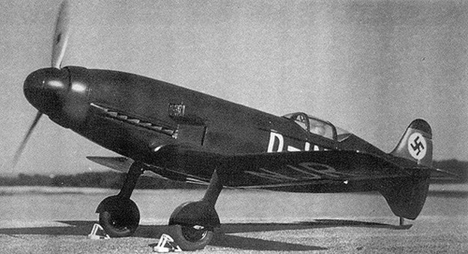

The Nazi Germany’s desire to impress the world of the capability of its fighter aircraft resulted in design of the Messerschmitt Me 209, to be used to establish a new absolute world speed record. With only superficial resemblance to the Bf-109, the Me-209 was tailored around a specially designed Daimler-Benz DB 601 ARJ twelve cylinder inverted liquid cooled engine with a take-off rating of 1,342 kW (1,800 hp), which could be boosted to a peak of 1,715 kW (2,300 hp) for very short periods. This capability proved sufficient for the Me 209 to set a new record, Flugkapitan Fritz Wendel flying the first specially-prepared proto type on 26 April 1939 at an average speed of 755.138 km/h (469.22 mph). This would be the last open record held by a piston engined aircraft – the jets would now take the records.

At this point the German propaganda ministry stepped in, details for ratification submitted to the FAI identifying the record breaking aircraft as the Messerschmitt Me 109R in an attempt to convince other nations that the record had been gained by a variant of the Luftwaffe's new fighter.

# Epilogue for 1939-1940

In this year 1939, the Second World War commenced and all nations were planning for a war where petroleum products in particular fuel oil for the navy, and aviation gasoline and lubricants for the air force were critical important war materiel. The year of 1939 was the year of getting the ‘administrative wheels into motion’ to support a war of then, unknown duration and limited to Europe.

By the spring of 1940, many people had decided that war was never going to happen, and they followed the advice of the newspaper headline which suggested: ‘Forget Hitler – take your holiday’. They stopped carrying their gas-masks. Six million people every night tuned in to listen to ‘Lord Haw-Haw’, the British Nazi who broadcast on the wireless from Germany until, suddenly, on 9 April 1940, Nazi forces attacked Denmark and Norway. On May 10, the Germans invaded the Netherlands, Belgium, and Luxembourg, and 10 days later they were at the English Channel. In June the British Expeditionary Force and its fleeing Allies evacuated from Dunkerque, and by June 14 the triumphant Nazis goose-steeped into France’s beloved Paris.

In June 22, 1940 the German-French armistice was signed, and by July 10, 1940 the Battle of Britain had begun.

Photo 15. RAF pilots scramble to their Hurricanes during the Battle of Britain - 1940.

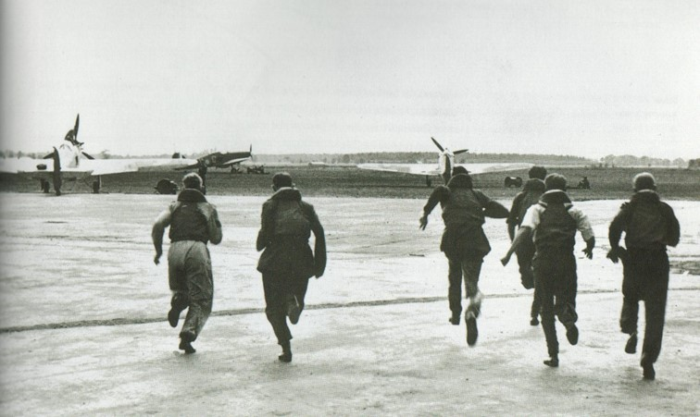

The “Phoney War” was over; it was now a struggle of the democracies of the free world against an evil fascist dictator.

# Index

1

100 Octane Aviation Spirit 5, 17

A

Abadan 5, 19, 23, 24, 25, 28, 30

Abadan Refinery 18, 22

Alkylate 5, 28

Alkylation 21

Anglo-American Oil Company Ltd 12

Anglo-Iranian (BP) 27

Anglo-Iranian Oil Co. 18

Aruba 16, 17, 18, 19, 21, 23, 24, 25, 28, 31

Associated Octel Limited 17

Australia 32

Aviation Coordination 13, 14

B

Bahrein 17

Bahrein crudes 18

Balikpapan 23

Barrancabermeja Refinery 18

Battle of Britain 34

Billingham 16, 17, 19, 20, 24

Borneo 12, 22, 25, 30

Brandan 23

Bristol Hercules 18

British Military and Commercial Aviation Gasoline Specifications 7

Burma 16, 22

Burmah Oil Co 24

C

Caltex 17

Catalytic Reforming 5, 27, 38

China 32

Colombia 16, 30

cracked’ spirit 16

Curaçao 12, 15, 16, 17, 18, 19, 21, 23, 24, 26

Curtiss P-40 Kittyhawks 10

D

Daimler-Benz DB 601 ARJ 33

Dewdren 5, 38

Dieterle 32

Digboi 22

Digboi Refinery 24

Douglas DC-3 8

DTD-224 7

DTD-230 5, 7, 12, 15

DTD-234 5

Durham coal 19

Dutch East Indies 22, 23, 24, 28

Dutch West Indies 22, 24

E

Egypt 31

Egyptian oil fields 18

Estonia 30

Ethyl Fluid 17

F

Falmouth Committee 16, 19

Finland 30

France 27, 32

French Indo-China 32

French Military Aviation Gasoline Specification 11

G

Germany 32

Gloster Gladiator 6

H

Hartley Committee 20

Hawker Hurricane 6

Heinkel He 100 32

Heysham 20, 21

Houdry 27

Humble 27

hydrogenation 19, 21

hydro-petrol 5

I

Imperial Chemical Industries 19, 21

Iran 18, 24, 28, 30, 32

Iraq 18, 30

Iso-Octane 5, 15, 17, 18, 19, 20, 21, 24, 25, 27

J

Japan 32

L

Lago Oil and Transport Company 28

Lagunillas petrol 18

Latvia 30

Lend-Lease 13, 14

Lithuania 30

Lord Haw-Haw 34

M

Magnolia Petroleum Co. 28

Manchester Oil Refinery 14

Messerschmitt Me 109R 33

Messerschmitt Me 209 32, 33

Mexico 17, 30, 31

mixed octanes 18, 25

Morane-Saulnier M.S.406 11

Munich crisis 12

N

National Benzole Company Ltd 12

Nederlande Koloniale Petroleum Maatschappij 28

Neohexane Process 29

Netherlands East Indies 16, 30

Netherlands Indies 32

Netherlands West Indies 15, 16, 32

New Zealand 32

No. 317 Squadron (Wilno- Polish) 6

Non-aggression pact 30

O

Octene 16

P

Payton-Smith 12, 15, 38

Pernis 15, 17, 18, 23

Peru 16

Petrol rationing 13

Petroleum Board 12, 13, 14

Petroleum Products Resources Sub-Committee 22

Phillips Petroleum Company 29

Pladjoe 23

Poland 30

Polymerization 5

Pool 13

Pratt & Whitney 8

R

Rolls Royce Merlin XII 18

Rumania 5, 30, 31

Russia 31

S

Shell Co. of Australia 7, 38

Shell Company 21

Shell-Mex and BP Ltd 12

Socony-Vacuum Beaumont Refinery 27

Soviet Union 30, 32

Spitfire Mk V 6

Standard Oil Co. of Louisiana 28

Standard Oil Development (Esso) 27

Standard Oil New Jersey 18

Stanlow 16, 17, 18, 19, 21, 23

Stanlow Refinery 25

straight run 5, 9, 18, 27

Sumatra 12, 25, 28

Syriam Refinery 24

T

Talara Refinery 18

Texaco 27, 28

Texas Company 29

Thailand 32

Thermal Alkylation 5, 29, 38

Toluol 30

Trimpell 21

Trinidad 5, 12, 16, 17, 19, 20, 21, 23, 24, 25, 30, 31

Trinidad Leaseholds Ltd 12, 17, 21

1

U

Union Oil Co. of California 28

unleaded spirit 15

US Army Air Corps 9

US East Coast crudes 9

US Military Aviation Gasoline Specifications 9

US Neutrality Act 12

USSR 32

V

Venezuela 5, 16, 24, 30, 31

W

Wendel 33

West Indies 12, 18, 24, 28, 30, 31

Wright Aeronautical Corporation 8

# References

1. Website <http://history.acusd.edu/gen/WW2Index/picindex5.html> Accessed Sept 26, 2005
2. UK Public Records Office, Kew, London, File S 1372/A.1.9. (L) Memo from D A C Dewdren, 27 March 1941, General Description of Fuels British & German
3. “Aircraft Fuels and Lubricants” Shell Co. of Australia Limited - Technical Department (Circa 1940)
4. “Aircraft Fuels and Lubricants” Shell Co. of Australia Limited - Technical Department (Circa 1940)
5. “Aircraft Fuels and Lubricants” Shell Co. of Australia Limited - Technical Department (Circa 1940)
6. “Aircraft Fuels and Lubricants” Shell Co. of Australia Limited - Technical Department (Circa 1940)
7. “Petroleum At War” reprinted from “The Petroleum Times” September 29, October 13, 27 and November 10, 24, 1945 sources from American Petroleum Institute.
8. UK Public Records Office, Kew, London File: CAB 102/549 Aviation Spirit. Pre-War Planning, D J Payton-Smith.
9. UK Public Records Office, Kew, London, File: CAB 102/549 Aviation Spirit. Pre-War Planning, D J Payton-Smith.
10. UK Public Records Office, Kew, London, File: CAB 102/549 Aviation Spirit. Pre-War Planning, D J Payton-Smith.
11. Imperial War Museum, “Oil History of 2nd World War A Study of War Time Policy and Administration” by D. J Payton-Smith
12. UK Public Records Office, Kew, London File: POWE 33/579 British Sources of Supply of Aviation Spirit 1939 Petroleum Products Resources Sub-Committee 6th. Meeting August 1939
13. UK Public Records Office, Kew, London, File: POWE 33/1814 Ref PE 9/13/42 (13 Sept 1942)
14. American Petroleum Institute 20th Annual Meeting Chicago Illinois November 9-17, 1939 Group Session – Refining “Catalytic Reforming for the Production of Aviation Gasoline” by A.G. Peterkin, J.R. Bates, H.P. Broom
15. American Petroleum Institute 20th Annual Meeting Chicago Illinois November 9-17, 1939 Group Session – Refining “High Octane Aviation Fuel by Sulfuric Acid Alkylation Process”
16. American Petroleum Institute 20th Annual Meeting Chicago Illinois November 9-17, 1939 Group Session – Refining “Thermal Alkylation and NeoHexane” by G.G. Oberfell, F.E. Frey
17. “Aircraft Fuels and Lubricants” Shell Co. of Australia Limited - Technical Department (Circa 1940)
18. “Netherlands Indies to Produce Aviation Fuel for Far East” by Ellen van Zyll de Jong, Far Eastern Survey, Vol. 9, No. 10 (May 8 1940) pp 116-117
19. “World Speed Record Aircraft” by Ferdinand Kasman F.C.W. -Cologne - June 1990. Leicestershire Library (UK) Call No. 639.1334.