Chapter

10

1940-1945

The War Continues – ‘We need more Avgas’

Photo 1. USAAF B-17 Bombers on a mission over Germany April 1945[1]

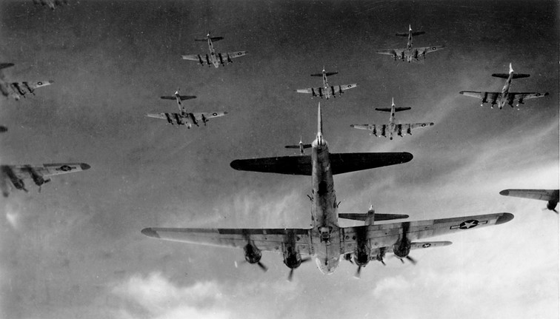

B-17 Flying Fortresses from the 398th Bombardment Group fly a bombing run to Neumunster, Germany, on April 13, 1945. On May 8, Germany surrendered, and Victory in Europe Day was declared.

Table of Contents

Summary 4

More Avgas For Our Flyers 4

Composition Of Avgas Components – API Project No. 6 6

Manufacturing Process 1941-1943 6

Catalytic Cracking Processes 6

Thermofor Catalytic Cracking (TCC) 8

Fluid Catalytic Cracking (FCC) 12

Houdry Catalytic Cracking Process 16

General Refinery Operations 18

Alkylation Process 20

Alkylation Process For Iso-Octane 20

Hydrocodimer Process 27

Dimer & Trimer Process 29

Blendstock Properties And Their Importance 30

Thermal Alkylation 37

Neohexane Process 39

Butane Dehydrogenation Process 42

Isomerization 42

Thermal Reforming 43

Low Pressure Catalytic Hydrogenation 44

The Problem Of Location Of Refining Capacity 45

Production Of Aviation Gasoline 46

1940 US Statistics 48

1941 US Statistics 48

1942 US Statistics 50

1943 US Statistics 50

1944 US Statistics 51

1945 US Statistics 51

Epilogue For 1945 51

Index 52

Research Sources 59

# Summary

### Chronology

1938 First commercial Alkylation plant built at Humble Oil & Refining Co. Baytown, Texas,

1939 Commercial Alkylation plant built at the Texaco Port Arthur Refinery, Texas.

1942 (circa) First operational Thermofor Catalytic Cracking (TCC) unit on stream at the Socony-Vacuum Olean Refinery, New York

1942 First Fluidised Catalytic Cracking (FCC) unit on stream at the Standard Oil Company of New Jersey, Baton Rouge Refinery, New Jersey, USA .

1943 First commercial Thermofor Catalytic Cracking (TCC) unit on stream at the Socony-Vacuum Refinery Beaumont, Texas, USA

# More Avgas for our Flyers

The years of increased understanding of Avgas composition.

At the start of 1941 with the world in turmoil Europe, the forces of Britain (and its empire) were struggling against the Axis forces in Mediterranean and North Africa; and by the end of 1941, the Pacific and East Asia would also be theatres of war. Aviation gasoline was in demand and there were fears that there would not be sufficient stocks to keep the British supplied in Europe, Africa and the Pacific.

By 1945, every continent (except Antarctica), and every sea would be touched by this World War, but the avgas kept coming.

Photo 2. American and Australian soldiers refuelling a U.S. Army B-17 Flying Fortress at the Alice Springs Aerodrome, 1945.

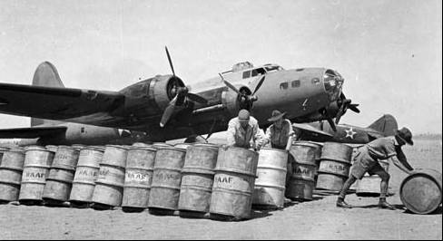

Note the drums are marked ‘RAAF’ and would have been part of the supply system to airfields used by the US Army Air Force and RAAF in Australia and the Pacific.

Photo 3. US Army Air Force refuelling a Brewster F2A-3 Buffalo in Hawaii, 1942.

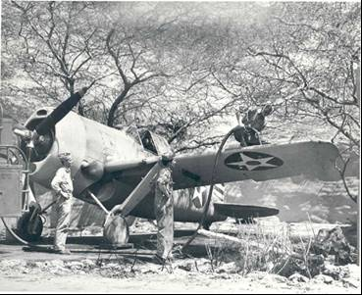

Photo 4. USAAF C-47 ‘Skytrains’ over southern France 1944.

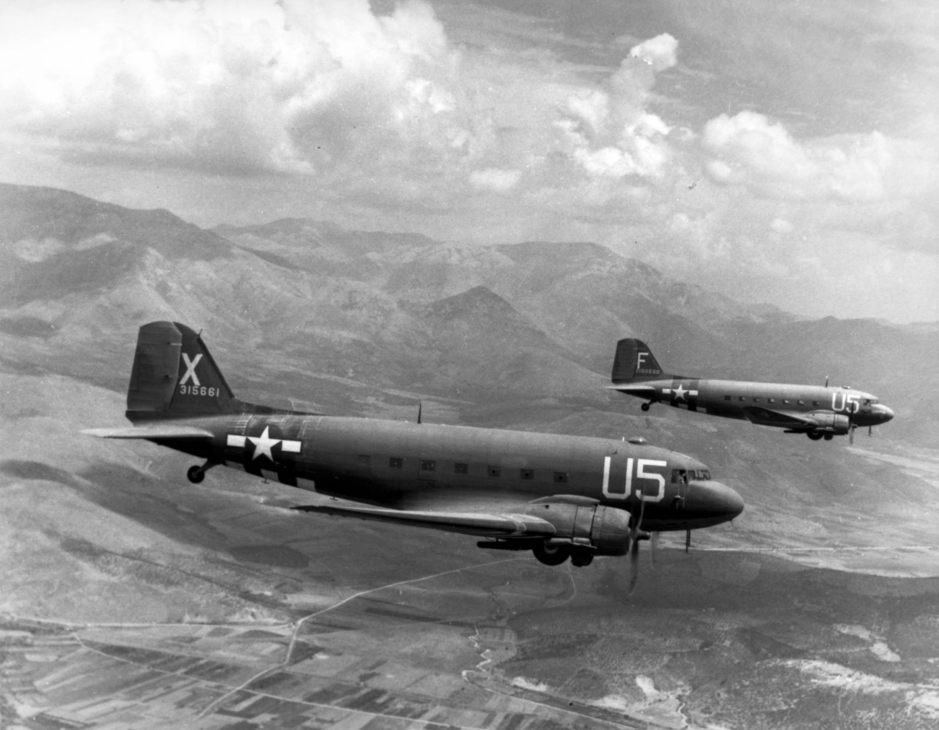

# Composition of Avgas components – API Project No. 6[2]

The work on this project focused mainly on the perfecting the laboratory analytical methods and not much further progress was made on identifying the components of gasoline. However, as part of the war research program, API Project No. 6 was called upon by the Technical Advisory Committee of the Petroleum Industry War Council and the National Advisory Committee for Aeronautics, to determine the hydrocarbon components in a number of representative alkylates and hydrocodimers. This work was reported in 1946.[3], and is listed later.

Alkylates & Hydrocodimers

(1942-1945)

The work of API Research Project No. 6 was to analyse some 20 different alkylates and 8 hydrocodimers including samples from Sulphuric Acid Alkylation, Hydrofluoric Acid Alkylation, Sulphuric Acid Hydrocodimers, and Phosphoric Acid Hydrocodimers. The analysis was done using the same approach of fractional distillation with subsequent analytical and chemical analysis to identify the hydrocarbons.

# Manufacturing Process 1941-1943

This was a period of great activity in refinery processes with construction of new alkylation and catalytic cracking units in the US and elsewhere around the world. The oil industry turned its attention to any process that would either produce aviation gasoline blendstocks or improve existing gasoline/naphtha blendstocks, so that more could be used in aviation gasoline.

New Processes 1942-1943 comprised:

* Modern Isomerisation units.
* Alkylation units - specialised hydrocarbons for synthetic rubber and aviation gasoline.
* Cumene units - components for super aviation gasoline (Avgas 100).
* Dehydrogenation Units - components for synthetic rubber.
* Hydrogenation units.
* Toluene units - for components for TNT explosives.
* Super-fractionation equipment.
* Hydrocarbon extraction units - for purification of synthetic hydrocarbons.

# Catalytic Cracking Processes

New Molecules from Old

While Alkylate was a critical component to produce 100 Octane aviation gasoline, the less of this valuable blendstock that was required, it would permit more aviation gasoline to be produced, however this required more of other blendstocks – namely Base Stock, and the higher the volume and quality of this base stock, the more aviation gasoline that could be produced. The base stock was generally catalytically cracked gasoline, and there were essentially two main cracking processes – Thermofor Catalytic Cracker (TCC) and Fluidized Catalytic Cracker (FCC). They also provided feedstocks for the alkylation process.

In addition, there was the older Houdry Cracking and Thermal Reforming/Cracking processes.[4] During World War II, the US Government financed some 10 FCC plants, 3 TCC plants, 1 Houdry Cracker Unit and 5 Thermal Reformer plants.

In 1941 in the US the refinery cracking capacity was 2,352,000 barrels/day which comprised Burton Process (none), Dubbs Process (21.4%), Tube and Tank Process (18.2%), Holmes-Manley Process (10.2%), Cross Process (8.1%), other thermal processes (35.5%), Houdry (Catalytic) Process (6.6%).

It was no easy task to obtain a rapid build-up of catalytic cracking capacity. Of the three processes only the Houdry process was in limited commercial production prior to 1941. The FCC process was announced in 1941 and not put into production until 1942, it was followed by the TCC process in 1943.

The problem of building up cracking facilities was further complicated by the fact that unlike much of the wartime construction in other industries, no two catalytic cracking plants were identical as to design, equipment, or operating conditions. Knowledge gained from operation of the pioneer plants of each type were incorporated in the design of later plants. The rapid build-up of cracking capacity is shown in the following table

*Table 1. Summary of US cracking capacity by type 1941-1946 (MBSD)*[5]

|  |  |  |  |  |
| --- | --- | --- | --- | --- |
| Year | Total Cracking capacity MBSD | Reformed | Thermal | Catalytic |
| 1941 | 1,103.0 | 187.5 | 859.1 | 56.4 |
| 1942 | 1,193.7 | 225.4 | 902.7 | 65.6 |
| 1943 | 1,189.4 | 275.6 | 829.9 | 83.9 |
| 1944 | 1,286.4 | 281.9 | 811.6 | 192.9 |
| 1945 | 1,487.9 | 313.8 | 820.6 | 353.5 |
| 1946 | 1,499.8 | 274.9 | 836.1 | 388.8 |

Photo 5. Dubbs Thermal Cracking Unit Lloyd Refinery, Port Credit, Toronto 1936.

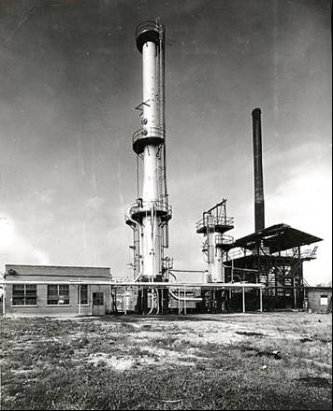

# Thermofor Catalytic Cracking (TCC)

Refinery units work most easily and reliably when their operations are continuous. Immediately following the successful demonstration of Houdry units at Beaumont, Texas, Socony-Vacuum research was underway and Lou Evans was assigned to build a bench-scale continuous catalytic cracking reactor. The Evan’s process included the introduction of catalyst granules at the top of a heated vertically mounted reactor tube and removing them from the bottom through star valves. Superheated, vapourised light gas oil was then fed to the bottom of the tube and synthetic crude (a wide range of hydrocarbons produced from the cracking process) withdrawn from the top. Coke deposited on the catalyst was burned off in a regenerator tube, mounted parallel to the reactor tube, through which catalyst passed on its way back to the top of the reactor.

The results were sufficiently promising that, within months, in the early days on 1940, the design of TCC-1X began. It was to be a semi-commercial unit, the first experimental Thermofor Catalytic Cracking (TCC) Unit. The regeneration of the catalyst would be modified by the use of a kiln mounted above the reactor. The first operational unit was installed at Olean Refinery. Later versions would be installed at Socony-Vacuum refineries at Paulsboro (New Jersey), Beaumont (Texas), and Buffalo (New York).[6]

The facilities and techniques required for the operation of the Thermofor catalytic cracking process are shown in simplified form in the adjoining diagram (Fig. 1.) In this process, feedstock is heated, partially fractionated to remove tar, and then is further heated prior to introduction into the reactor. In the reactor, cracking is accomplished by contacting the ascending oil vapours with descending zeolite clay catalyst in the form of small pellets or beads. The inactive catalyst removed from the bottom of the reactor is lifted by elevators to the top of the regenerator, or Thermofor kiln. As the catalyst descends in the regenerator, carbonaceous deposits are burn off with air restoring catalyst activity. Regenerated catalyst removed from the bottom of the kiln is conveyed by a second elevator to the top of the reactor to complete the cycle of catalyst handling.

The hydrocarbon stream leaving the reactor and containing cracked products and unconverted gas oil is charged to a fractionator for separation into various grades of naphtha, gas oil, and gas containing the light hydrocarbons. The gas constitutes the source of butylene and isobutane whereas the light naphtha is further processed for use in aviation gasoline. [The butylene and isobutane are valuable feedstocks for the alkylation process, and butyl rubber production].

This operation yields aviation base stocks having leaded (4 ml TEL/USG) octane ratings from 94 to 97 depending on the nature of the gas oil charge stock. The aviation base stocks require little or no finishing treatment to meet gum, colour and sulphur specifications.

Thermofor Catalytic Cracking (TCC) was favoured by Socony-Vacuum Oil Co. – it was to also be this Paulsboro plant where TCC developments and research for Socony-Vacuum (later Mobil), would be done.

There would be many modifications to the design; the ‘star valves’ would be replaced by the ‘seal leg’.

Then first commercial TCC was built at Beaumont Refinery in 1943, the reactor was 11.5 feet (3.5 metres) in diameter; it stood 200 feet (61 metres) high with two bucket elevators, each carrying 150 tons of catalyst per hour, one to the catalyst hopper above the reactor, and the other to the top of the regeneration kiln. With a nominal capacity of 10,000 barrels per day, it was the first of 35 units erected in the next five years by Socony-Vacuum, Sun Oil and other refiners under licence. In 1944 and 1945, the TCC units based on Houdry’s experimental work and designed by Socony-Vacuum engineers, contributed to the gasoline essential to the Allied Forces in World War II.

Photo 6. The first commercial TCC unit Socony-Vacuum Refinery Beaumont, Texas 1943

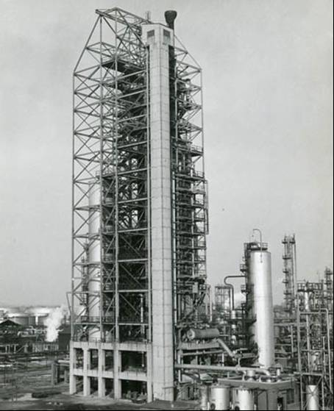

In 1943 there were significant development in equipment and also catalysts. These were:

* Invention of the bead catalyst
* Application of improved processing techniques in the treating step.
* Extension of TCC processing to include a wide variety of charging stocks, other than gas oils, well suited for aviation production.

Figure 1. TCC Process

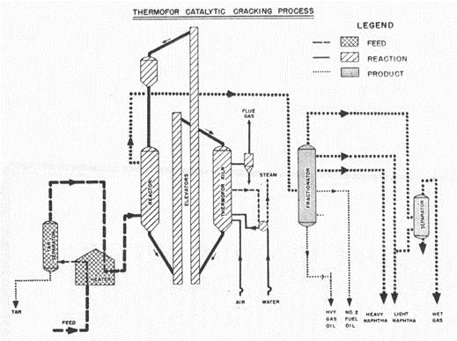

The other significant feature of this TCC process was the production of light hydrocarbon gases in particular, olefins such as Propylene and Butenes which were essential for the alkylation process.

While the major feedstock was gas oil, developmental work showed that other charge stocks could be used. The most interesting of these were light and heavy naphthas. Catalytic reforming of these stocks in TCC units over bead catalysts produced exceptionally high yields of aviation base stocks with leaded octane ratings of 98 to 100 (Aviation Motor Method 1-C). The products had well balance boiling ranges and met all other aviation gasoline specifications, hence may be considered as excellent aviation fuels by themselves, being equal to or superior to Alkylate and similar synthetic fuels in many respects. Thus, the TCC process opened up another field of processing which could be done more effectively by catalytic than by conventional thermal means. TCC processing could also be extended to a variety of processed naphthas - these included products obtained by thermal reforming, polyforming and hydroforming of virgin naphthas to yield high quality aviation base stocks.

In 1943 the TCC process was in operation or under construction at the following major oil companies:

Magnolia Petroleum Company

Gulf Oil Corporation

The Pure Oil Company

Sinclair Refining Company

General Petroleum Corporation

Continental Oil Company

Crown Central Petroleum Corporation

Ashland Oil & Refining Company

Socony-Vacuum Lubrite Division

Richfield Oil Company

Union Oil Company of California

Socony-Vacuum Oil Company, Inc. (Mobil)

Standard Oil Company of California (Chevron)

Tide Water Oil Company

Sun Oil Company

Quality of TCC Gasoline[7]

The motor gasolines range from 77 to 84 octane number (Research Method), have good stability characteristics, and have fairly good lead susceptibilities. The following table shows the approximate range of properties of aviation gasoline made from this process (2-pass TCC operation).

Table 2. Properties of TCC aviation gasoline (two pass operation)

|  |  |
| --- | --- |
| Acid Heat deg. F. | 10 to 25 |
| Aromatics % | 20 to 30 |
| Gum Accelerated mg/100 cc | 3 to 5 |
| Octane Number (AFD 1-C) Clear | 77 to 80 |
| Octane Number +3 cc TEL/USG | 92 to 95 |
| Octane Number +4 cc TEL/USG | 94 to 97 |
| % volume of alkylate to make 100 octane number | 22 to 45 |
| Reid Vapour Pressure (psi) | 7.0 |

Photo 7. Typical Thermofor Catalytic Cracker (Mobil Altona Refinery – Melbourne Australia, former Standard Vacuum Refinery. TCC constructed in 1954 – shutdown 1997)

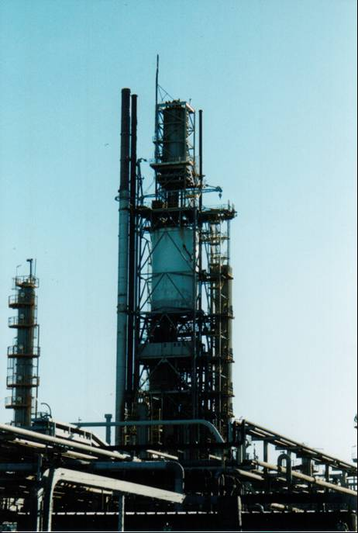

The TCC is easily recognised by its tall structure required to lift the catalyst to the Surge Separator (at the top of the TCC) which then feeds catalyst to the reactor. To the left of the photo is the Alkylation Unit Re-Run Tower. Refineries with FCC or TCC Units typically had an Alkylation Unit as part of the refinery process because the gasses produced from the cracking process were the feedstock for the Alkylation process. This Altona TCC never made aviation gasoline blendstock, however the feed for the alkylation unit was used to make alkylate for 100 octane avgas from 1956 to 1997. [The first Australian refinery to make aviation gasoline].

# Fluid Catalytic Cracking

Fluid Catalytic Cracking (FCC) was favoured by Standard Oil companies. A number of large-scale Fluid Catalytic Cracking plants were in operation producing highly aromatic aviation base stock, and feedstock for alkylation plants, synthetic rubber and Toluene. By 1943 more than 30 FCC plants were brought to completion in the US and foreign refining centres. The main designs were by M.W. Kellogg Company and Universal Oil Products Company (UOP) with a significant contribution by the Standard Oil Development Company.

The first commercial plant was at the Baton Rouge Refinery of Standard Oil of New Jersey and commenced in 1942 producing motor gasolines using natural clay catalysts, however after a brief shutdown and changing to synthetic catalysts, it resumed operation producing butylenes for rubber and alkylation, in addition to light paraffinic and heavy aromatic aviation gasoline components. Two other FCC units of similar design were in operation: one at Humble Oil and Refining Company refinery at Baytown Texas, and the other at Standard Oil Company of New Jersey at Bayway, New Jersey – both producing alkylate feedstocks and aviation gasoline. The Bayway plant was operated to produce a higher quality aviation gasoline by subjecting the catalytically cracked gasoline to further FCC processing (re-running the naphtha through the FCC process – a two stage process). Higher yields were also obtained by using hydrogenation to eliminate the olefinic components of the gasoline product which occurred mainly in the fraction up to 107 deg. C.

The basic principles of the fluid catalytic cracking process are illustrated in the accompanying simplified flow diagram (Fig. 2.). In the operation of this process, gas oil feed stocks, shown by the heavy line near the bottom of the diagram, are admixed with hot, finely divided catalyst from the regenerator at the inlet to the reactor. In the reactor, cracking occurs upon contact of the feed with the finely divided catalyst. Mechanical separators in the top section of the reactor enable the discharge of reaction products and the retention of the catalyst. During the course of the cracking operation the catalyst becomes inactive because of the deposition of carbonaceous by-product. In order to restore catalyst activity, catalyst is continuously withdrawn, from the bottom of the reactor and by means of air injection is forced upward into the regenerator, the large vessel in the centre of the diagram, In the regenerator carbonaceous deposits are removed by air burning; the resulting flue gas is discarded after recovery of heat for the production of steam, and after recovery of essentially all entrained catalyst.

Reactor products consist of a mixture of light hydrocarbons naphtha, and unconverted gas oil. These mixed products pass to a fractionator wherein separation into the various components is made as indicated on the diagram. The gas stream is subsequently processed in other facilities for segregation of butylenes, and isobutane. The naphtha produced is subsequently processed for inclusion in aviation gasoline.

Quality of FCC Gasoline[8]

Under normal operation the following products were recovered: light and heavy fuel oils, a motor gasoline fraction boiling from 300-400 deg. F (149-204 deg. C), and aviation gasoline fraction 100-300 deg. F (38-149 deg. C), a light fraction containing C3, C4 and C5 hydrocarbons, and gas containing C1 and C2 hydrocarbons. The aviation gasoline cut at 4 cc TEL/USG was 92 to 97 octane. The C3 to C5 fraction contained propane, propylene, butane, isobutane, butene, isobutene and isopentane, and most of these are suitable for charge materials to polymerisation and alkylation processes.

Photo 8. The first commercial FCC unit Standard Oil of New Jersey Refinery, Baton Rouge, Louisiana 1942.

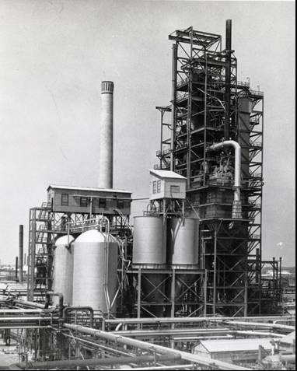

Figure 2. FCC Process

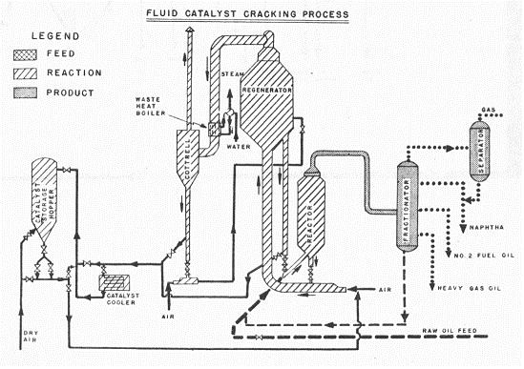

The President of Humble Oil Mr. H.C. Weiss noted at the annual stockholders meeting and in their publication “Our Second War Year - Humble Oil & Refining Co. (Feb 1944)”, that from their refineries at Baytown Refinery, Texas (near Houston) and Ingleside Refinery, Texas (near Corpus Christi):

Output of critical war products (in 1943) increased by 1/3 over 1942.

Baytown Ordnance Works production of Toluene (for explosives) - this plant produced the bulk of a basic material during a period when no alternative was available.

Baytown - Government butadiene plant one of the first large units (30,000 tons/year) in operation completed August 1943. Completion of Butyl Rubber plant (30,000 tons) expected in mid-1944.

Baytown - 1st. FCC was completed in early 1943, and 2nd. FCC completed to produce 1,800 BSD Isobutane for (alkylation) Avgas blendstock.

Ingleside Refinery converted refinery facilities and equipment to operate a Government plant 12,500 tons/year Butadiene

100 Octane aviation gasoline. Humble produced twice the volume in 1943 compared to 1942.

Humble accounted for 10% of US Avgas 100 production in 1943.

Humble produced very large quantities of 91 Octane Avgas and 80 Octane all-purpose gasoline, aviation and other lubricants for military use.

Refinery throughputs in 1943 averaged 192,000 BSD, in 1942 165,000 BSD (all Humble Oil refineries). At the end of 1943, crude runs were 225,000 BSD.

In 1943 those major oil companies involved with the FCC process were:

Standard Oil Company (New Jersey) - (Esso)

Standard Oil Company (Indiana)

Standard Oil Company (Louisiana)

Anglo-Iranian Oil Company Ltd. - (BP)

Humble Oil & Refining Company

Shell Oil Company Inc.

The Texas Company - (Texaco)

Engineering firms involved were:

M.W. Kellogg

Universal Oil Products (UOP)

Three FCC units were in operation in March 1943, and 28 more were under construction. These were distributed among 20 companies.

Photo 9. Typical Fluidized Catalytic Cracker (FCC) (Mobil Altona Refinery – Melbourne Australia, FCC constructed in 1997)

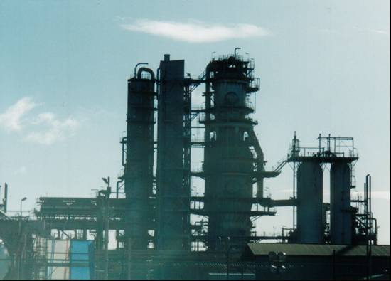

FCC units are characterised by the large squat reactor vessels and their lower profile compared to the TCC units. The FCC process is also favoured over the TCC process due to its better yields of gasoline (Light & Heavy Naphthas) and diesel blendstocks (No. 2 Fuel oil) and lower fuel oil production (Heavy Gas Oil).

One application of a FCC in an integrated refinery operation for aviation fuel production, is shown in Figure 3. below. The feedstock is a typical heavy paraffinic gas oil. Butylenes and Amylenes which are produced are alkylated with isobutane, the light catalytic naphtha is severely acid treated with sulphuric acid to remove the olefins and thereby improve the lean octane ratings. The catalytic heavy aromatic fraction which is of a high octane is blended directly into the final gasoline. The blend of alkylate and naphthas from the catalytic operation is substantially higher in octane number than the specification requires, and so straight run naphthas, which are comparatively low in octane, are blended in such the final blend meets specification and thereby increase the volume of the aviation gasoline produced. In this operation, additional isobutane is necessary to supplement the isobutane produced in the catalytic cracking. Normal butane is isomerised to isobutane. For every barrel of gas oil feed 66.3% becomes 100-Octane avgas which includes 12.2% straight run naphthas from the crude units.

Figure 3. Aviation Gasoline by Fluid Catalytic Cracking (1939)[9]

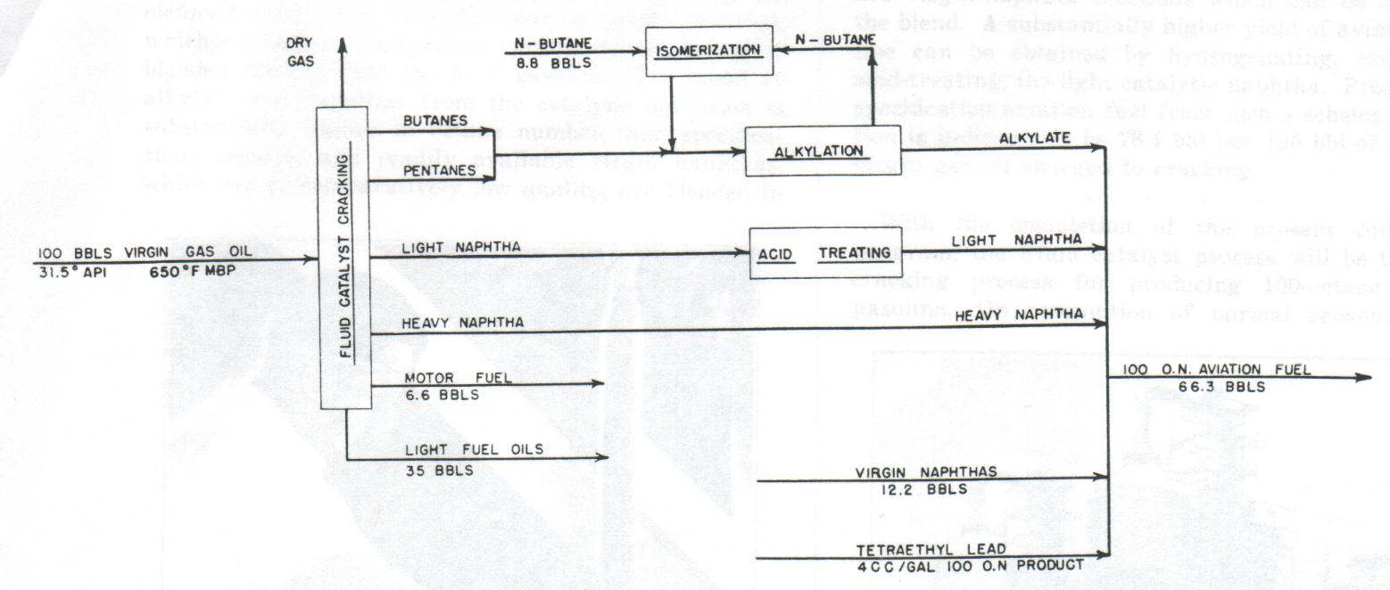

A substantially higher yield of avgas can be obtained by hydrotreating the light catalytic naphtha rather than acid-treating. This would increase the output to 78.4%.

# Houdry Catalytic Cracking Process

In 1937, the catalytic cracker was introduced, increasing the quality and yield of gasoline from crude oil. It was brought to the US by Eugene Houdry of France. The operation of the Houdry catalytic-cracking process is shown diagrammatically on the accompanying flow sheet (Fig. 4.).

The feedstock is heated, vapourized, and after elimination of tar, is reheated and introduced into one of three reactors, or catalyst cases where the cracking operation is performed. In this matter, oil vapours ascend through a stationary bed of solid catalyst pellets and cracking accompanies contact between oil and catalyst. During cracking, certain reactions occur which lead to the deposition of carbon on the catalyst, thereby rendering the catalyst inactive. Burning off the carbon with air, after completion of the cracking period, restores the activity of the catalyst. The time required for completing the regeneration and associated operations is about twice the optimum cracking period and, as a result, three or more catalyst cases are required to maintain continuity of operation. Switching the service of the catalyst cases is accomplished by the use of an automatic electric timing device.

The cracked products from the cracking reactor are charged to the synthetic tower, a fractionating tower wherein separation into the desired products is achieved by fractionation. The overhead product from the fractionator is processed for the recovery of butylenes and isobutane and aviation gasoline stocks. A heavy naphtha stream from the synthetic tower is accumulated in storage and is subsequently reprocessed through the Houdry catalytic cracking unit to improve its quality in a manner analogous to the above described operation on gas oil charge stocks.

Figure 4. Houdry Catalytic Cracking Process

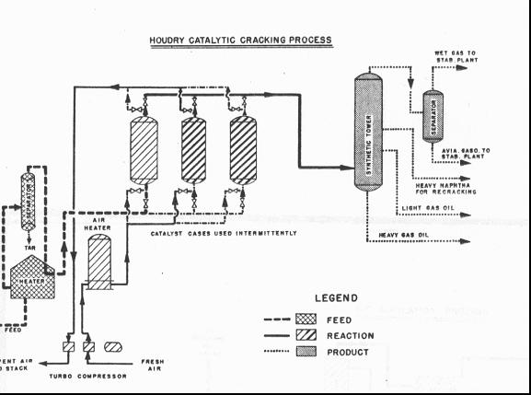

Yield and Quality of Houdry Gasoline[10]

The yield and type of gasoline are interdependent variables. For a 400 deg. F (204 deg. C) end point gasoline of 70 octane number, the yield is correspondingly higher than that for a gasoline of 300 deg. F (149 deg. C) and 80 octane number. Aviation fuels yields from 60 to 80 per cent when naphthas are used as charging stocks, and 35 to 40 per cent when gas oils are charged.

Table 3. Properties of typical Houdry Aviation gasoline[11]

|  |  |  |  |  |  |  |  |  |
| --- | --- | --- | --- | --- | --- | --- | --- | --- |
| **Property** | **Houdry Avgas 1** | | **Houdry Avgas 2** | | **Houdry Avgas 3** | | **Houdry Avgas 4** | |
| Gravity API | 63.6 | | 62.9 | | 60.1 | | 60.0 | |
| Specific Gravity | 0.725 | | 0.728 | | 0.739 | | 0.739 | |
| Distillation ASTM | oF. | oC. | oF. | oC. | oF. | oC. | oF. | oC. |
| Initial | 111 | 44 | 115 | 46 | 104 | 40 | 104 | 40 |
| 50% | 196 | 91 | 204 | 96 | 212 | 100 | 198 | 92 |
| 90% | 288 | 142 | 285 | 141 | 276 | 136 | 288 | 142 |
| End Point | 336 | 169 | 344 | 173 | 328 | 164 | 334 | 168 |
| Acid Heat (Temp Difference) | 40 deg. F | | 28 deg. F | | 13.5 deg. F | | 24 deg. F | |
| Motor Octane Number (ASTM) | 80.6 | | 80.1 | | 77.6 | | 77.7 | |
| MON+3 cc TEL/USG | 91.1 | | 92.2 | | 90.5 | | 92.5 | |
| Reid Vapour Pressure psi | 6.4 | | 6.7 | | 7.0 | | 7.0 | |

These gasolines had a good lead susceptibility and when used as base stock for 100 octane aviation gasoline did not require a high percentage of iso-octane to be blended with them.

In March 1943 there were 16 Houdry units in operation, and 10 were being built. These would be operated by 10 different companies.

Photo 10. Houdry Cracking Unit Socony-Vacuum Refinery, Brooklyn, New York 1939.

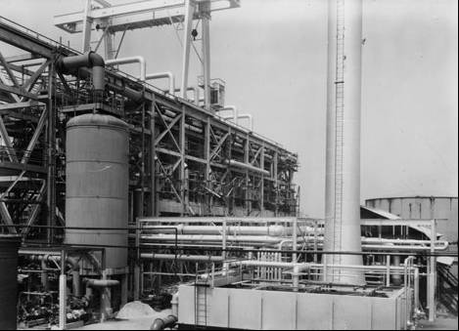

Note the five overhead pipes from the reactors.

# General Refinery Operations

The catalytic cracking process must be considered in combination with other refinery processes, particularly alkylation, because catalytic cracking is essentially the source of alkylate as well as of premium aviation base stock. Therefore, whenever a catalytic cracking unit was constructed, there would invariably also be an alkylation unit constructed as part of an integrated refinery operation. This is shown in Figure 5. Typical Refinery and War Plants.

The typical refinery & war plants of 1944 were operated to produce a variety of products to meet the on the Allied war effort.

Input:Crude Oil, Imported Naphtha to Toluene Unit, “Field Streams” to fractionation units for toluene production.

Products: Fuel Gas, Propane, Toluene, Copolymer, 100 Octane Aviation Fuel, Motor Gasoline, Solvents, Kerosene, Tractor Fuel, Trade Gas Oil, Paraffin Distillate, Heating Oil, Lubes, Navy Fuel Oil, General Grade Fuel Oil, Asphalt.

Figure 5. Typical refinery and War Plants 1944[12]

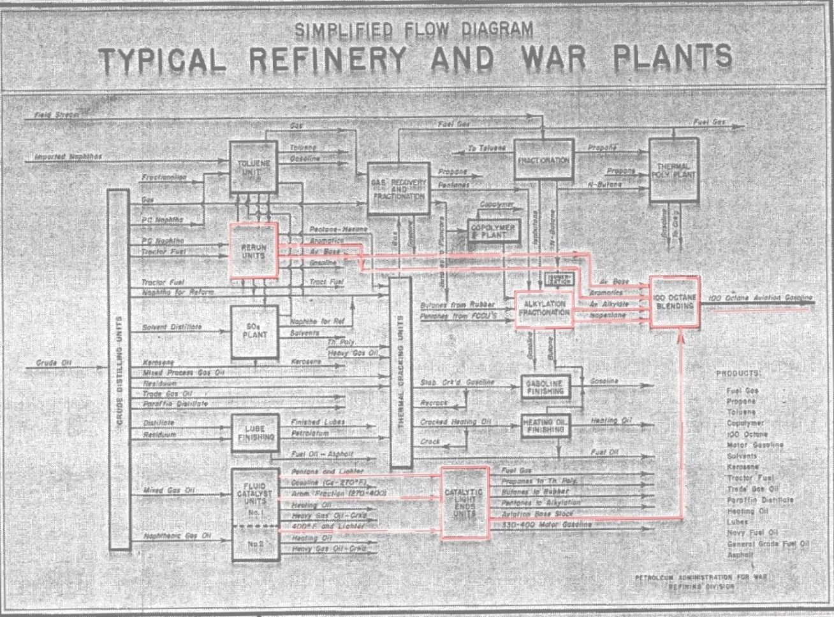

From this figure, it can be seen that the US aviation gasoline was comprised of:

Alkylate

Catalytically Cracked Light Naphtha (after acid treatment)

Catalytically Cracked Heavy Naphtha

Virgin Naphtha

Butane and Pentanes (to achieve the correct vapour pressure)

Tetra Ethyl Lead (4. ml/USG to achieve 100 Octane)

The general composition of Aviation gasoline was as follows:

Aviation base stock from FCC

Pentane & lighter

Aromatic fraction 270-400 deg. F (132.2-204.4 deg. C)

FCC Gasoline <400 F (<204.4 deg. C)

Isopentane from fractionation of FCC Pentanes and Natural Gasoline Butanes & Pentanes

Alkylate from alkylation of Butylenes & Isobutane

Isobutane from isomerisation of Butanes

Aviation Fuel (87 Octane)

60% Base Stock

10% Isopentane

30% Alkylate

Aviation Super Fuel (100 Octane)

18% Base Stock

15% Isopentane

67% Alkylate

# Alkylation Process

The alkylation process utilizes isobutane and butylenes, pentylenes or propylene as the raw stocks for the manufacture of alkylate, a material which constitutes the principal high-octane blending agent used in the production of 100-octane aviation gasoline. In this process isobutane unites with the other hydrocarbons, all of which are gases under normal conditions of temperature and pressure, to form a liquid in the aviation-gasoline boiling range having a high octane number. Isobutane is obtained from various including thermal and catalytic cracking, crude oil distillation, recovery at natural gasoline plants, and the isomerization of normal butane. Butylenes, pentylenes, and propylene are produced by cracking and other refining operations.

There are two different alkylation processes in use, one utilizing Hydrofluoric Acid (HF) and the other using Sulphuric Acid (H2SO4) as the catalyst. During World War II the US Government financed hydrofluoric acid units at 17 plants and sulphuric acid units at two plants. The majority of privately owned alkylation units were of the sulphuric acid type. The essential features of each of these processes are shown in greatly simplified form is described later.

# Alkylation process for Iso-Octane

Sulphuric Acid Alkylation Plants 1942-1945

In. the sulphuric acid process, the feed stock, consisting of a mixture of isobutane and olefins and recycled isobutane, passes through a pump where the isobutane and olefins are thoroughly mixed with acid and then through a cooler to remove the heat of reaction by refrigeration. The material is then charged to a reactor where concentrated sulphuric acid acts as a catalyst to bring about the reaction that produces alkylate. Process temperatures are controlled by circulation of a large portion of the reactor liquid through the refrigerated cooler. The settler and washing system serve to remove the acid from the mixture, after which the hydrocarbon stream passes to fractionating equipment for the separation of alkylate from butanes and for the recovery of aviation alkylate from the total alkylate. Fractionation equipment, serves to recover unconverted isobutane for recycling and to remove propane from the recycle isobutane.

There were two main types of the Sulphuric Acid (H2SO4) Alkylation units for the manufacture of iso-octane - the M.W. Kellogg design and the Universal Oil Products (UOP) design. Many plants would be built and operated during the period of 1942 and 1945. Production would be significantly improved through the efforts of the sub-committee described above.

Figure 6. Sulphuric Acid Alkylation Process

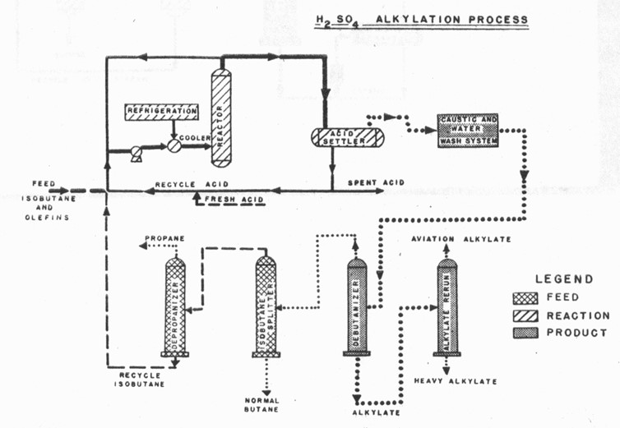

Table 4. Alkylation Plants (Sulphuric Acid type) operating in 1942-1945[13]

|  |  |
| --- | --- |
| Company | Location |
| Humble Oil & Refining Co. | Baytown, Texas, USA (First commercial plant in 1938) |
| Shell Oil Co. | Dominguez, California, USA |
| Shell Oil Co. | Martinez, California, USA |
| The Texas Co. (Texaco) | Port Arthur, Texas, USA (Alkylation Unit No. 1 was completed in 1939) (refer below) |
| Standard Oil Co. of New Jersey (Esso) | Bayway, New Jersey, USA |
| Anglo-Iranian Oil Co. (BP) | Abadan, Iran |
| Atlantic Refining Co. | Atlantic had refineries in Philadelphia and Port Arthur, Texas. |
| Standard Oil Co. of Ohio | Cleveland, Ohio, USA |
| Standard Oil Co. of Louisiana | Baton Rouge, Louisiana, USA |
| Sinclair Refining Co. | Wyoming, USA |
| The Pure Oil Company | Smiths Bluff, Texas, USA |
| Utah Oil Refining Co. | Salt Lake City, Utah, USA |
| Cities Service Oil Co. | East Chicago, Indiana, USA |

The composition of (H2SO4) Alkylates obtained from these processes is listed in Table 6. Analyses of Propylene Alkylates and Mixed Propylene/Butene Alkylate.

In the years 1942-1943, the Texaco Port Arthur Refinery Polymerization Unit No. 1 was converted to manufacture Cumene for aviation gasoline and the Isomerization Unit was completed. Alkylation Unit No. 2 started operations in April 1943. Unseen corrosion on Alkylation Unit No. 2 caused an explosion and fire on December 28, 1943. Three men were fatally burned. Alkylation Unit No. 3 was started up in October 1943. It operated throughout the war period without incident.[14]

Hydrofluoric Acid Alkylation Plants 1942-1945

While the sulphuric acid catalyst was an essential requirement for the alkylation process, it was not the only catalyst used. Hydrofluoric acid (HF) was also found to a suitable alternative catalyst, and many alkylation units were operated using this HF catalyst. The HF Alkylation process was favoured by the Sinclair Refining Company. The composition of HF alkylates obtained from these processes is listed in Table 6. Analyses of Propylene Alkylates and Mixed Propylene/Butene Alkylate

In the hydrofluoric acid process, the feedstock consisting of a mixture of isobutane and olefins (propylene, butenes, amylenes, etc.) is passed through a drier to remove small amounts of water and is then charged to the reactor with unconverted isobutane recovered from the reactor product. In the reactor a circulating pump produces an intimate mixture or an emulsion of hydrocarbon and hydrofluoric acid. The hydrofluoric acid serves as a catalyst to bring about the reaction that produces alkylate. Process temperatures are controlled by water cooling exchangers to remove the heat liberated during reaction. The material passes from the reactor to a settler where the hydrocarbon and acid are largely separated. The hydrocarbon material from the separator is processed in an acid recovery system for removal and purification of the entrained acid, after which the hydrocarbon mixture is fractionated to remove propane and normal butane, and to recover unconverted isobutane for reuse in the process. The remaining alkylate is fractionated to yield a product in the aviation gasoline boiling range, designated as aviation alkylate, and a small amount of heavy alkylate not suitable for aviation purposes.

Figure 7. Hydrofluoric Acid Alkylation Process

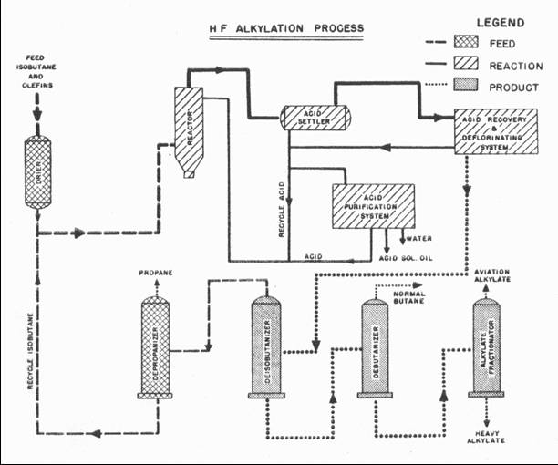

Table 5. Alkylation Plants (Hydrofluoric Acid type) operating in 1942-1945

|  |  |
| --- | --- |
| Company | Location |
| Magnolia Petroleum Co. | Sweeney, Texas, USA |
| Ashland Oil & Refining Co. | Catlettsburg, Kentucky, USA |
| Associated Refiners Inc. | Beckett, Oklahoma, USA |
| Cooperative Refining Co. | Coffeyville, Kansas, USA |
| Continental Oil Co. | Ponca City, Oklahoma, USA |
| Crown Central Petroleum Corp. | Pasadena, Texas, USA |
| Eastern States Petroleum Co. Inc. | Houston, Texas, USA |
| The Frontier Refining Co. | Cheyenne, Wyoming, USA |
| Great Southern Corp. | Corpus Christi, Texas, USA |
| Mohawk Petroleum Corp. | Bakersfield, California, USA |
| The Pennzoil Company | Oil City, Pennsylvania, USA |
| Premier Oil Refining Co. | Cotton Valley Louisiana, USA |
| Republic Oil Refining Co. | Texas City, Texas, USA |
| Root Petroleum Co. | El Dorado, Arkansas, USA |
| Southport Petroleum Company | Texas City, Texas, USA |
| Standard Oil Company of California (Chevron) | Richmond, California, USA |
| Wiltshire Oil Co. Inc. | Norwalk, California, USA |
| Champlin Refining Co. | Enid Oklahoma, USA |
| Sinclair Refining Co. | Wyoming, USA |
|  |  |

Feedstocks - Olefins C3 to C5

The feedstock for alkylation plants ranged from Propylene, Propylene/Butene mix, Butene, Butene/Pentene mix, and Pentenes; when combined with Isobutane they produced a range of highly branched paraffins from C6 to C10 with boiling range from 58 to 190 deg. C. including the valuable Iso-Octane. The following tables illustrate the composition from the various feedstocks and processes.

Propylene Alkylates while not abundant in Iso-Octane, did contain substantial amounts of 2,3 Dimethyl Pentane and 2,4 Dimethyl Pentane. These have Motor Octane Numbers (MON - Unleaded) of 88.5 and 83.8 respectively; and when leaded to 3 cc TEL/US Gallon have MON of 103.4 and 99.1 respectively.

Propylene Alkylates

Table 6. Analyses of Propylene Alkylates and Mixed Propylene/Butene Alkylate

|  |  |  |  |  |  |
| --- | --- | --- | --- | --- | --- |
| API Project No. 6 Sample No. | | | 20 | 17 | 16 |
| Date | | | April 1944 | Dec 1943 | April 1944 |
| Feedstock & Process Type | | | Propylene Alkylate (H2SO4) | Propylene Alkylate (HF) | Mixed C3/C4 Alkylate (HF) |
| Sourced from Company | | | Shell Oil Co. | Sinclair Refining | Sinclair Refining |
| RON Clear | | | 88.7 | 87.5 | 87.9 |
| F-3 with 4cc/USG TEL | | | 103.3 | 102.7 | 102.5 |
| F-4 with 4cc/USG TEL Est. | | | 129 | 127 | 127 |
| Component ID | Other Names | CAS No. | Vol. % (above pentane) | | |
| Total | | | 100 | 100 | 100 |
| 2,2 Dimethyl Butane | Neohexane | 75-83-2 | Trace | Trace | Trace |
| 2,3 Dimethyl Butane |  | 79-29-8 | 3.5 | 2.9 | 1.4 |
| 2 Methyl Pentane | Isohexane | 107-83-5 | 1.7 | 1.4 | 0.4 |
| 3 Methyl Pentane |  | 96-14-0 | 0.1 | 0.7 | 0.5 |
| 2,2,3 Trimethyl Butane | Triptane | 464-06-2 | Trace | Trace | Trace |
| 2,2 Dimethyl Pentane |  | 590-35-2 | 1.1 | 0.8 | 0.7 |
| 2,3 Dimethyl Pentane |  | 565-59-3 | 36.1 | 21.1 | 4.5 |
| 2,4 Dimethyl Pentane |  | 108-08-7 | 26.2 | 18.2 | 4.2 |
| 2 Methyl Hexane | Isoheptane | 591-76-4 | 1.2 | 0.7 | 0.4 |
| 3 Methyl Hexane | (+)- | 6131-24-4 | 1.1 | 0.6 | 0.4 |
| 2,2,3 Trimethyl Pentane | 2-tert-Butyl Butane | 564-02-3 | 0.8 | 1.1 | 2.3 |
| 2,2,4 Trimethyl Pentane | Iso-Octane | 540-84-1 | 7.8 | 16.3 | 30.04 |
| 2,3,3 Trimethyl Pentane |  | 560-21-4 | 3.2 | 3.9 | 6.7 |
| 2,3,4 Trimethyl Pentane |  | 565-75-3 | 2.5 | 3.4 | 6.8 |
| 2,3 Dimethyl Hexane |  | 584-94-1 | 1.2 | 0.9 | 4.0 |
| 2,4 Dimethyl Hexane |  | 589-43-5 | 1.2 | 2.0 | 4.0 |
| 2,5 Dimethyl Hexane |  | 592-13-2 | 1.3 | 2.0 | 5.1 |
| 2,2,5 Trimethyl Hexane |  | 3522-94-9 | 1.4 | 4.5 | 8.2 |
| 2,3,5 Trimethyl Hexane |  | 1069-53-0 | 1.83 |
| Toluene |  | 108-88-3 |  |  | 0.06 |
| Isoparaffins 115.6-124.1C |  |  |  |  | 1.3 |
| Isononanes 126-143C |  |  | 0.8 | 2.4 |  |
| Isononanes 133-143C |  |  |  |  | 1.53 |
| Isoparaffins >143C |  |  |  |  | 15.5 |
| Isoparaffins 143-151C |  |  | 2.2 | 3.3 |  |
| Isoparaffins 151-160C |  |  | 1.5 | 2.2 |  |
| Isoparaffins >160C |  |  | 5.1 |  |  |
| Isoparaffins 160-175C |  |  |  | 7.7 |  |
| Isoparaffins >175C |  |  |  | 3.7 |  |
| Aromatics 125-133C | Xylenes? |  |  |  | 0.07 |
| Aromatics 133-149C | Xylenes? |  |  |  | 0.07 |
| Olefins 99-109C |  |  |  | 0.2 |  |

Butene Alkylates

Butene Alkylates were of particular importance because of the abundance of 2,2,4 Trimethyl Pentane (Iso-Octane). This isomer is the standard on the Octane Scale and equals 100 for all motor tests.

Table 7. Analyses of Butene Alkylates

|  |  |  |  |  |  |  |  |  |
| --- | --- | --- | --- | --- | --- | --- | --- | --- |
| API Project No. 6 Sample No. | | 1 | 2 | 9 | 10 | 24 | 27 | 13 |
| Date | | Oct 31, 1942 | Nov 10, 1942 | Nov 30, 1943 | Dec 18, 1943 | Nov 30, 1943 | Oct 1944 | Nov 30, 1943 |
| Feedstock & Process Type | | Butene Alkylates (H2SO4) | | | | | | Butene Alkylates (HF) |
| Sourced from Company | | Std. Oil NJ | Texas Oil Co. | Atlantic Ref. Co. | Atlantic Ref. Co. | Std. Oil Ohio | Std. Oil Louisiana | Sinclair Ref. |
| F-2 MON Clear | |  |  |  |  | 96.7 |  |  |
| RON Clear | |  |  | 91.9 | 92.3 | 96.7 | 92.2 | 91.1 |
| F-3 with 4cc/USG TEL | |  |  | 104.3 | 105.5 | 108 |  | 105.2 |
| F-4 with 4cc/USG TEL est. | |  |  | 142 | 143 | >162 |  | 138 |
| F-4 with 4.6cc TEL | |  |  |  |  | 181 |  |  |
| Component ID | Other names | Vol.% above Pentane | | | | | | |
| Total | | 100 | 100 | 100 | 100 | 100 | 100 | 100 |
| 2,2 Dimethyl Butane | Neohexane | 0.6 | 0.5 |  |  |  |  |  |
| 2,3 Dimethyl Butane |  | 5.5 | 8.1 | 6.5 | 7.0 | 0.7 | 5.2 | 0.7 |
| 2,2,3 Trimethyl Butane | Triptane |  |  |  |  |  | 0.2 |  |
| 2 Methyl Pentane | Isohexane | 1.8 | 3.2 | 0.9 | 1.2 | 0.7 | 1.2 | 0.7 |
| 3 Methyl Pentane |  | 0.9 | 0.7 | 0.9 | 1.2 | 0.7 | 0.4 | 0.7 |
| 2,2 Dimethyl Pentane |  |  | 0.7 | 0.5 | 0.8 | 0.6 | 0.2 | 1.3 |
| 2,3 Dimethyl Pentane |  | 2.2 | 3.4 | 2.1 | 2.5 | 0.3 | 2.6 | 0.6 |
| 2,4 Dimethyl Pentane |  | 3.6 | 5.5 | 4.2 | 3.9 | 0.6 | 3.7 | 1.3 |
| 2 Methyl Hexane | Isoheptane | 0.5 | 0.9 | 0.4 | 0.3 | 0.3 | 0.2 | 0.6 |
| 3 Methyl Hexane | (+)- | 0.5 | 0.9 | 0.4 | 0.3 | 0.4 | 0.2 | 0.6 |
| 2,2 Dimethyl Hexane |  |  |  |  |  |  | 0.3 |  |
| 2,4 Dimethyl Hexane |  | 4.1 | 5.2 | 4.0 | 4.2 | 1.7 | 3.6 | 6.7 |
| 2,5 Dimethyl Hexane |  | 4.1 | 5.2 | 4.0 | 4.2 | 1.7 | 3.6 | 6.7 |
| 2,2,3 Trimethyl Pentane | 2-tert-Butyl Butane | 1.8 | 1.9 | 1.7 | 1.6 | 2.0 | 1.3 | 2.9 |
| 2,2,4 Trimethyl Pentane | Iso-Octane | 30.1 | 22.4 | 25.9 | 26.8 | 35.5 | 26.7 | 41.7 |
| 2,3,3 Trimethyl Pentane |  | 14.5 | 10.4 | 12.1 | 14.9 | 25.2 | 13.5 | 10.0 |
| 2,3,4 Trimethyl Pentane |  | 9.3 | 15.3 | 16.4 | 19.2 | 24.0 | 14.3 | 9.4 |
| 2,3 Dimethyl Hexane |  | 3.7 | 3.4 | 4.2 | 2.3 | 2.4 | 3.3 | 6.2 |
| 3,4 Dimethyl Hexane |  |  |  |  |  |  | 0.4 |  |
| 2,2,5 Trimethyl Hexane |  | 12.7 | 8.8 | 4.9 | 6.3 |  | 4.9 | 3.4 |
| 2,3,5 Trimethyl Hexane |  | 1.9 | 1.9 |  |  |  | 1.0 |  |
| Unsaturated 100-109C |  |  | 0.1 |  |  |  |  |  |
| Isoparaffins 115.6-124.1C |  |  |  |  |  | 3.3 |  |  |
| Isononanes 126-143C |  |  |  | 2.3 | 2.0 |  |  | 6.4 |
| Isoparaffins >131.4C |  | 2.4 | 1.7 |  |  |  |  |  |
| Isononanes 133-143C |  |  |  |  |  |  | 0.5 |  |
| Isoparaffins >143C |  |  |  |  | 1.5 |  |  |  |
| Isoparaffins 143-160C |  |  |  | 2.9 |  |  | 2.5 |  |
| Isoparaffins 160-180C |  |  |  | 3.8 |  |  | 3.0 |  |
| Isoparaffins >180C |  |  |  | 2.1 |  |  | 7.3 |  |

Pentene Alkylates

Pentene Alkylates were also important because they contained significant amounts of 2,2,4 Trimethyl Pentane (Iso-Octane). As can be seen in the analyses of Pentene Alkylates in Table 8.

Table 8. Analyses of Pentene Alkylates and Mixed Butene/Pentene Alkylate

|  |  |  |  |  |  |  |  |  |
| --- | --- | --- | --- | --- | --- | --- | --- | --- |
| API Project No. 6 Sample No | | 7 | 12 | 22 | 23 | 14 | 15 | 11 |
| Date | | May 22, 1943 | Dec 6, 1943 | May 13, 1944 | May 20, 1944 | Dec 6, 1943 | Dec 18, 1943 | Dec 11, 1943 |
| Feedstock & Process Type | | PenteneAlkylates (H2SO4) | | | | Pentene Alkylate (HF) | C4-C5 Alkylates (HF) | |
| Sourced from Company | | Standard Oil of New Jersey | Atlantic Refining Co. | Shell Oil Co. | Shell Oil Co. | Sinclair Refining Co. | Sinclair Refining Co. | Atlantic Refining Co. |
| RON Clear | | - | 87.7 | 92.1 | 90.7 | 87.1 | 88.6 | 90.5 |
| F-3 with 4cc/USG TEL | | - | 102.9 | 105.4 | 104.8 | 102.5 | 102.9 | 103.4 |
| F-4 with 4cc/USG TEL (Est.) | | - | 117 | 147 | 138 | 121 | 127 | 135 |
| Component ID | Other Names | Vol.% above Pentane | | | | | | |
| Total | | 100 | 100 | 100 | 100 | 100 | 100 | 100 |
| C5 Cyclopentane |  |  | 0.5 |  | 0.5 |  |  | 0.3 |
| 2,2 Dimethyl Butane | Neohexane |  | 0.2 |  | 0.1 |  |  | 0.3 |
| 2,3 Dimethyl Butane |  | 2.6 | 2.7 | 1.1 | 2.1 | 0.6 | 0.5 | 2.8 |
| 2 Methyl Pentane | Isohexane | 2.1 | 2.0 | 1.1 | 1.8 | 0.5 | 0.5 | 1.4 |
| 3 Methyl Pentane |  | 1.1 | 1.1 | 1.0 | 0.4 | 0.5 | 0.5 | 0.5 |
| 2,2,3 Trimethyl Butane | Triptane | Trace | Trace | Trace | Trace | Trace | Trace | Trace |
| 2.2 Dimethyl Pentane |  | 0.9 | 1.1 | 0.8 | 0.9 | 0.7 | 0.9 | 1.2 |
| 2,3 Dimethyl Pentane |  | 0.6 | 0.6 | 0.3 | 1.0 | 0.6 | 0.6 |  |
| 2,4 Dimethyl Pentane |  | 0.9 | 1.0 | 0.7 | 0.8 | 0.7 | 0.9 | 1.1 |
| 2 Methyl Hexane | Isoheptane | 0.5 | 0.5 | 0.3 | 0.3 | 0.6 | 0.6 | 1.1 |
| 3 Methyl Hexane | (+)- | 0.6 | 0.6 | 0.3 | 0.2 | 0.6 | 0.6 | 0.8 |
| 2,2 Dimethyl Hexane |  | Trace | Trace | Trace | Trace | Trace | Trace | Trace |
| 2,3 Dimethyl Hexane |  | 1.1 | 0.2 | 0.9 | 0.9 | 1.2 | 4.5 | 1.7 |
| 2,4 Dimethyl Hexane |  | 2.1 | 2.0 | 1.8 | 1.9 | 1.9 | 5.0 | 2.6 |
| 2,5 Dimethyl Hexane |  | 2.2 | 2.1 | 1.9 | 2.0 | 2.0 | 5.1 | 2.7 |
| 3,4 Dimethyl Hexane |  | Trace | Trace | Trace | Trace | Trace | Trace | Trace |
| 2,2,3 Trimethyl Pentane | 2-tert-Butyl Butane | 0.9 | 0.7 | 0.7 | 0.8 | 0.7 | 2.1 | 0.8 |
| 2,2,4 Trimethyl Pentane | Iso-Octane | 13.1 | 12.4 | 21.7 | 17.2 | 24.2 | 33.3 | 20.1 |
| 2,3,3 Trimethyl Pentane |  | 4.5 | 7.0 | 9.5 | 7.1 | 4.2 | 8.1 | 10.2 |
| 2,3,4 Trimethyl Pentane |  | 6.6 | 4.2 | 9.4 | 6.4 | 5.4 | 7.1 | 11.6 |
| 2,2,5 Trimethyl Hexane |  | 34.2 | 35.5 | 29.5 | 29.4 | 29.3 | 13.4 | 24.0 |
| 2,3,5 Trimethyl Hexane |  | 6.6 | 8.8 | 6.5 | 5.6 | 5.5 | 2.7 | 5.8 |
| Isoparaffins >131.4C |  |  |  | 12.5 |  |  |  |  |
| Isononanes 133-143C |  | 4.4 | 5.2 |  | 5.2 | 6.2 | 4.7 | 3.5 |
| Isoparaffins 143-151C |  |  | 5.6 |  | 3.8 | 2.9 | 1.5 | 3.0 |
| Isoparaffins 143-168C |  | 8.9 |  |  |  |  |  |  |
| Isoparaffins 151-160C |  |  | 3.7 |  | 2.2 | 5.0 | 1.2 | 1.3 |
| Isoparaffins >160C |  |  | 2.3 |  | 9.4 | 6.6 | 6.3 | 3.2 |
| Isoparaffins 160-189C |  | 3.1 |  |  |  |  |  |  |
| Isoparaffins >189C |  | 2.8 |  |  |  |  |  |  |
| Olefins >144 to >189C |  | 0.2 |  |  |  |  |  |  |

# Hydrocodimer Process

This process remained in favour during the war years and many plants were built in the United States particularly in the Mid-West and South-West.

Table 9. Companies operation Hydrocodimer Plants

|  |  |  |
| --- | --- | --- |
| Company | Location | Catalyst Type |
| Standard Oil Co. of Indiana |  | Solid Phosphoric acid |
| Shell Oil Co. |  | Hot acid |
| The Texas Co. (Texaco) | Tulsa, Oklahoma |  |
| The Texas Co. (Texaco) | Lawrenceville |  |
| Standard Oil Co. of New Jersey (Esso) |  | Phosphoric acid |
| Standard Oil Co. of Ohio | Lima 6 |  |
| Standard Oil Co. of Ohio | Lima 7 |  |
| Trimpell Ltd. | West Indies | (HSO-1684) |
| Trimpell Ltd. | Heysham UK |  |

The catalysts used in this process were either Sulphuric acid (H2SO4), or Phosphoric acid (H3PO4)

Hydrocodimers Analyses

Some Hydrocodimer processes yielded significant amounts of 2,2,4 Tri Methyl Pentane (Iso-Octane), while others produced 2,3,4 Tri Methyl Pentane which has a MON of 96 (unleaded).

Table 10. Analyses of Hydrocodimers 1942-1945

|  |  |  |  |  |  |  |  |  |
| --- | --- | --- | --- | --- | --- | --- | --- | --- |
| API Project 6 Sample No. | 35 | 4 | 33 | 36 | 37 | 41 | 42 | 44 |
| Date | Jan 31, 1944 | Dec 19, 1942 | Oct 31, 1944 | May 15, 1945 | May 31, 1945 | June 15, 1945 | Sept 15, 1945 | June 30, 1945 |
| Feedstock & Process Type | Hot Acid | Solid H3PO4 | H3PO4 |  |  |  |  |  |
| Sourced from Company | Shell Oil Co. | Standard Oil Co. Indiana. | Standard Oil New Jersey | Texas Oil Co. | Texas Oil Co. | Standard Oil Ohio | Standard Oil Ohio | Trimpell Ltd. |
| Location |  |  |  | Lawrenceville | Tulsa | Lima 6 | Lima 7 | HSO-1684 |
| RON Clear |  | 93.8 |  | 92 | 89.5 | 92.5 | 91 | 95 |
| F-3 @ 4cc/USG TEL |  | 103.2 |  | 104 | 103.4 | 104.5 | 103.6 | 107.5 est. |
| F-4 @ 4cc/USG TEL |  | 177 |  | 155 |  | 162 | 148 | 133 |
| Component ID | % Vol. (above Pentane) | | | | | | | |
| Total | 100 | 100 | 100 | 100 | 100 | 100 | 99.85 | 99.2 |
| C5 Cyclopentane |  |  | 0.1 |  | 0.2 |  |  |  |
| 2,2 Dimethyl Butane | 0.2 | 0.7 | 0.1 | 0.8 | 2.6 | 0.5 | 0.5 |  |
| 2,3 Dimethyl Butane |  |
| 2 Methyl Pentane | 1.4 |  |
| 3 Methyl Pentane |  |
| n-Hexane |  |  |
| C6 Methyl Cyclopentane |  |  |  |  | 0.2 |  |  |  |
| Benzene (contamination) |  |  |  |  | 0.03 |  |  |  |
| 2,2 Dimethyl Pentane |  | 1.2 | 0.9 | 1 | 3.6 | 0.6 | 0.7 | 2.4 |
| 2,4 Dimethyl Pentane |  |
| 2,3 Dimethyl Pentane |  | 1.1 | 1.7 | 15 | 1.4 | 1.3 | 7.4 |
| 2 Methyl Hexane |  | 0.2 |  | 0.6 |  | 0.1 |  |
| 3 Methyl Hexane |  | 0.2 |  | 0.6 |  |  |
| Heptanes | 1.0 |  |  |  |  |  |  |  |
| 2,2,4 Trimethyl Pentane | 35.4 | 9.9 | 12.1 | 6.6 | 7.2 | 11.2 | 5.2 | 27.4 |
| 2,2 Dimethyl Hexane | 4.0 | 1.2 | 2.7 | 2.3 | 1.8 | 2.1 | 1.8 | 0.9 |
| 2,5 Dimethyl Hexane | 0.9 | 6.7 | 2.9 | 4.8 | 2.4 | 1.8 | 7.4 | 2.2 |
| 2,4 Dimethyl Hexane |
| 2,2,3 Trimethyl Pentane | 26 | 9.2 | 11.8 | 10.6 | 8.5 | 14.8 | 10.0 | 7.9 |
| Toluene (contamination) |  |  |  |  | 0.05 |  |  |  |
| 2,3,4 Trimethyl Pentane | 19.0 | 43.9 | 43.4 | 43.9 | 34.9 | 39.3 | 37.3 | 28.3 |
| 2,3,3 Trimethyl Pentane | 7.0 | 8.6 | 15 | 6.1 | 5.2 | 7.2 | 4.6 | 3.1 |
| 2,3 Dimethyl Hexane | 1.4 | 5.6 | 4.3 | 6.5 | 4.8 | 4.3 | 7.4 | 1.9 |
| 3,4 Dimethyl Hexane |  |  |  | 2.9 | 5.3 | 4.6 | 3.9 | 1.1 |
| Aromatics 125-133C |  |  |  | 2.6 |  |  |  |  |
| Isoparaffins 115.6-124.1C | 2.9 | 1.9 | 5.3 |  |  |  |  |  |
| Isononanes 126-143C |  | 2 |  | 2.9 | 2.4 | 2.4 | 2.6 | 2.6 |
| Isoparaffins >131.4C |  |  |  |  | 4.5 | 3.1 | 5.5 |  |
| Aromatics 133-149C |  | 3.6 |  |  | 0.05 | 0.07 | 0.15 |  |
| Isoparaffins >143C |  |  |  | 7.1 |  | 6.5 | 11 |  |
| Isoparaffins 143-168C |  |  |  |  |  |  |  | 1.3 |
| Isoparaffins 160-175C |  |  |  |  |  |  |  | 2.9 |
| Isoparaffins >175C |  |  |  |  |  |  |  | 7.3 |
| Olefins >49 to >132C | 2.2 | 4 |  | 0.2 | 0.1 | 0.17 | 0.4 | 2.5 |

# Dimer & Trimer Process

This process was a variation of the hydrocodimer process and was also used in the US and elsewhere in the world.

Table 11. Companies operating Dimer & Trimer Plants

|  |  |  |
| --- | --- | --- |
| Company | Location | Type/Catalyst |
| Shell Oil Co. |  | Dimer/Hot acid/Sulphuric acid |
| Shell Oil Co. |  | Trimer/Cold acid/Sulphuric acid |
| The Pure Oil Co. |  | Trimer/Hot acid/Sulphuric acid |

The catalysts used in this process were Sulphuric acid (H2SO4), either as cold acid or hot acid.

Analyses of Dimer & Trimer Alkylates

The Dimers and Trimers were rich in three of the Trimethyl Pentane isomers, particularly 2,3,3 Trimethyl Pentane whose octane numbers (MON 99 (Unleaded) with F-4 Supercharger Performance Numbers @ 4.6 cc TEL/USG of 237 estimated) were equal or better than Iso-Octane. (MON (Unleaded) of 100 with F-4 @ 4.6 cc TEL/USG of 157).

Table 12. Analyses of Dimer & Trimer Alkylates 1944-1945

|  |  |  |  |  |
| --- | --- | --- | --- | --- |
| API Project No. 6 Sample No. | | 34 | 21 | 43 |
| Date | | Oct 15, 1944 | May 6, 1944 | June 15, 1945 |
| Feedstock | | Dimer (Hot Acid) | Trimer (Hot Acid) | Timer (Cold Acid) |
| Sourced from Company | | Shell Oil Co. | Shell Oil Co. | The Pure Oil Co. |
| RON Clear | | 95 | 93.2 | 93.1 |
| F-3 with 4cc/USG TEL | | 108.1 | 105.4 | 105.8 |
| F-4 with 4cc/USG TEL Est. | | 154 | 149 | 150 |
| Component ID | Other names | % Vol. (above Pentane) | | |
| Total | | 100 | 100 | 100 |
| 2,2 Dimethyl Butane | Neohexane | Trace | Trace | Trace |
| 2,3 Dimethyl Butane |  | 3.4 | 4.2 | 6.6 |
| 2 Methyl Pentane | Isohexane | 1.1 | 0.9 | 1.3 |
| 3 Methyl Pentane |  | 0.4 | 0.8 | 0.5 |
| 2,2 Dimethyl Pentane |  | 0.3 | 0.3 | 0.5 |
| 2,4 Dimethyl Pentane |  | 2.6 | 4.6 | 4.5 |
| 2,2,3 Trimethyl Butane | Triptane | Trace | Trace | Trace |
| 3,3 Dimethyl Pentane |  |  |  |  |
| 2,3 Dimethyl Pentane |  | 0.5 | 2.6 | 3.2 |
| 2 Methyl Hexane | Isoheptane | 0.5 | 0.2 | 0.2 |
| 3 Methyl Hexane |  | 0.4 | 0.1 | 0.2 |
| 2,2,4 Trimethyl Pentane | Isooctane | 35.6 | 30.5 | 31.4 |
| 2,2 Dimethyl Hexane |  | Trace | Trace | Trace |
| 2,5 Dimethyl Hexane |  | 3.6 | 4.2 | 4.2 |
| 2,4 Dimethyl Hexane |  | 3.6 | 4.2 | 4.1 |
| 2,2,3 Trimethyl Pentane | 2-tert-Butyl Butane | 1.8 | 2.5 | 1.1 |
| 2,3,4 Trimethyl Pentane |  | 15.7 | 10.4 | 14.9 |
| 2,3,3 Trimethyl Pentane |  | 16.9 | 11.9 | 12.5 |
| 2,3 Dimethyl Hexane |  | 2.8 | 2.3 | 1.9 |
| 3,4 Dimethyl Hexane |  | Trace | Trace | 0.7 |
| 2,2,5 Trimethyl Hexane |  | 2.4 | 4.4 | 3.4 |
| Isononanes 127-143C |  | 0.6 | 1.6 | 1.1 |
| Isoparaffins 143-151C |  |  | 0.6 |  |
| Isoparaffins 143-160C |  | 1.1 |  |  |
| Isoparaffins 147-152C |  |  |  | 2.3 |
| Isoparaffins 151-160C |  |  | 0.4 |  |
| Isoparaffins >152C |  |  |  | 5.4 |
| Isoparaffins 160-175C |  | 1.8 | 1.5 |  |
| Isoparaffins >175C |  | 4.9 | 11.8 |  |

# Blendstock Properties and their importance[15]

It should be emphasized that throughout the World War II aviation gasoline production never consistently exceeded the demand for this essential fuel. It should also be stated that the Allies war effort was never compromised by lack of aviation fuel, as was the case with the Axis powers.

Nevertheless, there was always pressure on the petroleum operators and technologists to produce either greater volumes of the same quality of blending stocks, or the same volume of improved quality; because either way, the total volume of finished blended aviation fuel could be increased.

The blending of aviation gasolines during the early years of the war were characterised by many discrepancies. Two grades of combat fuel were required; one for the US Forces (and those using the American specification AN-100), and the other for the British specification (BAM-100).

The American AN-100 specified only a single octane number (lean mixture octane rating) viz., the 1-C (later to become F-3 Aviation Motor Method); whereas the British Air Ministry (BAM-100) specification also required this, and a rich mixture supercharged rating – which was subsequently adopted by both allied air forces, and was approximately standardised as the 3-C (later the F-4 Supercharge Performance Number or Index).

In blending to meet these two specifications, it was noticed that the preferred blending agent for meeting the British requirement was hydropolymer gasoline; whereas alkylate was as good, or possibly somewhat better, than hydropolymers for meeting the American specification. Yet, so far as the petroleum technologists were concerned, both types of gasoline plants produced “iso-octane”.

To understand the differences in the gasoline blendstocks it is useful to note the approximate anti-knock values of certain key components of aviation gasoline blending agents. Refer Table 13.

Table 13. Anti-knock Values of Trimethyl Pentanes

|  |  |  |
| --- | --- | --- |
| Component | F-3  (4 cc TEL/USG) | F-4  (Performance Index) |
| 2,2,3 Trimethyl Pentane | 114 | 238 |
| 2,2,4 Trimethyl Pentane | 113 | 154 |
| 2,3,3 Trimethyl Pentane | 112 | 234 |
| 2,3,4 Trimethyl Pentane | 108 | 193 |

A brief outline of the chemical formula for each of these isomers is shown below

Figure 8. Trimethyl Pentane formulae

F3 @4cc/USG = 114, F4=238 F3 @4cc/USG = 113, F4=154

F3 @4cc/USG = 112, F4=234 F3 @4cc/USG = 108, F4=193

Alkylates vs. Hydropolymer

Comparison of the analysis of a typical Sulphuric-Acid Alkylate with that of a typical hydrogenated codimer from a Phosphoric-Acid catalytic polymerisation plant shows the marked difference in the two outputs. The comparison is confined to Trimethyl Pentane (TMP) content and its various isomers, and illustrates the difference in the blending characteristics of the two materials. The predominant high-octane component of alkylate was 2,2,4 Trimethyl Pentane (Iso-Octane); but the predominant component of hydropolymer was of a different isomer 2,3,4 Trimethyl Pentane which has a lower lean mixture octane (F-3), but substantially better in rich mixture supercharge index (F-4), than 2,2,4 Trimethyl Pentane. In addition, the hydropolymer gasoline component contains substantial quantities of 2,2,3 Trimethyl Pentane which is extremely good in both F-3 and F-4 test methods.

Table 14. Alkylate vs. Hydropolymer - Trimethyl Pentane Content

|  |  |  |
| --- | --- | --- |
| API Project No. 6 Sample No. | 1 | 4 |
| Type | H2SO4 - C4 Alkylate | C4 Hydropolymer |
| 2,2,4 TMP % | 30.7 | 9.9 |
| 2,2,3 TMP % | 1.6 | 9.2 |
| 2,3,4 TMP % | 9.0 | 43.9 |
| 2,3,3 TMP % | 14.5 | 8.6 |
| **Total TMP %** | **55.8** | **71.6** |
| **Octane No.s** | | |
| F-3 (4 cc TEL/USG) | 106.4 | 103.2 |
| F-4 (Perf. Index) | 140 | 177 |

The outstanding good characteristics of the hydropolymer gasoline component gave added impetus to the drive to produce large volumes of codimer by conversion of idle or standby refinery facilities to polymer plants, and ultimately a large share of the volumetric burden of the aviation gasoline program was being carried by such plants which shipped their polymer gasolines to several large hydrogenation plants for finishing. This approach of shipping components to other plants with excess capacity was to characterise the great strides made in producing the massive amount of aviation gasoline from the US refineries. This will be discussed later.

As an aside, the production of 2,2,3 Trimethyl Pentane was quite a challenge to the petroleum technologists engaged in developing alkylation processes, but up to the end of the war there was no data which showed alkylates with greater than 4.0% of this component (2,2,3 TMP). Apparently, the mechanism of isobutane-butene alkylation produces this isomer only as an incidental by-product.

The initial British production and testing of 100 Octane aviation gasoline was based on hydrocodimer blendstocks from Trimpell Ltd. at Heysham, UK and this to some extent influenced British expectations from this new fuel. Thus, when the American aviation gasolines made from alkylates arrived, they initially did not perform as well in supercharged (rich mixture) conditions for liquid cooled engines as had been achieved with the British 100 Octane gasoline from Hydrocodimer, and this was to be the genesis for the F-4 Supercharge Performance Index.

Alkylation Variables

As stated previously, the alkylation reaction is not simply the combination of one butylene molecule (or propylene) with one molecule of isobutane to make one molecule of an eight (or seven) carbon hydrocarbon. If the reaction were so simple, only iso-octane or iso-heptane would be formed. However, analysis of a typical alkylate shows that many isomers with different numbers of carbon atoms formed. (Refer to Tables 6, 7 & 8). Beside the main reaction of desired condensation of the two molecules, the formed molecules then undergo rearrangement and undergo secondary reactions. The situation is further complicated by the fact, that in parallel to the alkylation reaction, some olefins also polymerise. The consequence of all these reaction possibilities is that control of the operating conditions is essential to suppress polymerisation, to produce a high quality alkylate containing the most iso-octane.

The key operating variables for the Alkylation Process are:

* Isobutane concentration - Increased isobutane concentration in the reactor increases alkylate yield and octane number, and decreases acid consumption. Consequently, efforts are made to maintain a high isobutane concentration by maximising the isobutane recycling to the reactor. This can be expressed as isobutane content in the reactor effluent. The target is usually 50% minimum isobutane in the reactor effluent.
* Butylene and Propylene Content of the Reactor Feedstock - Propylene consumes three times as much sulphuric acid as butylene, and the propylene alkylate F-4 Performance number is 21 PN lower than that of butylene alkylate produced under the same operating conditions.
* Acid Strength (Sulphuric Acid) - The sulphuric acid concentration in the reactor must be kept between 91 and 93% because at lower concentrations the polymerisation reaction will become predominant. At its worst the polymerisation reaction would continue to produce not a clear, light hydrocarbon liquid, but a sticky, gluey, black rubbery mass which would shut the plant down.
* Reactor Temperature - The temperature of the reactor must be kept between 35- and 45-degrees F (1.7 to 7.2 deg. C) in order to suppress polymerisation. At temperatures lower than 35 deg. F, the sulphuric acid becomes too viscous to achieve good mixing.

As the demand for aviation gasolines mounted rapidly during the war, existing alkylation plants were pushed above their designed capacity to meet this demand because construction progress was slow and new plants were delayed in getting on stream. (This delay in construction was due to competing demands for war materials in particular steel, simply put, the Government of the day had to decide between more ships, tanks or more chemical plants).

In the case of the alkylation plants operating above design capacity, while there was increased production of alkylate, the octane blending value was showing a marked decrease, in spite of plant modifications (increased refrigeration capacity to maintain low reactor temperatures). Clearly, something was happening at these high rates, which was deleterious to the alkylation reaction. Table 15. compares the analyses of three sulphuric-acid alkylates from plants operating at different effective production rates. The lower octane values of both F-3 and F-4, for the higher plant rates (lower per cent Isobutane in reactor effluent) is quite marked.

Table 15. Butene Alkylates (Sulphuric Acid type) – Trimethyl Pentane

|  |  |  |  |
| --- | --- | --- | --- |
| **API Project No.6 Sample No.** | **9** | **10** | **24** |
| 2,2,4 TMP % | 25.9 | 26.8 | 35.5 |
| 2,2,3 TMP % | 1.7 | 1.6 | 2.0 |
| 2,3,4 TMP % | 16.4 | 19.2 | 24.0 |
| 2,3,3 TMP % | 12.1 | 14.9 | 25.2 |
| **Total TMP %** | **56.1** | **62.5** | **86.7** |
| **Octane No.s** | | | |
| F-3 (4 cc TEL/USG) | 104.3 | 105.6 | 108.0 |
| F-4 (Perf. Index) | 142 | 143 | 179 |
| Temperature deg. F. (deg. C) | 45 F (7 C) | 45 F (7 C) | 39 F (4 C) |
| Spent Sulphuric Acid % | 90.2 | 90 | 94.6 |
| % Isobutane (in Reactor Effluent) | 45.7 | 59.0 | 81.3 |

An examination of the Trimethyl Pentane content of these alkylates gave immediate clues to what improvements could be sought for the overburdened plants. It can be seen that under high capacity conditions, the alkylation plants produced alkylates having essentially the same relative distributions of the four Trimethyl Pentanes (TMP), but the total TMP content dropped significantly. An examination of the complete analytical data for these samples showed that the side reactions of high capacity operation produced large proportions of Dimethyl Hexanes which from an anti-knock standpoint, are poor and account for the sharp drop in total alkylate anti-knock quality.

Table 16. Anti-knock Values of Dimethyl Hexanes

|  |  |  |
| --- | --- | --- |
| Component | F-3  (4 cc TEL/USG) | F-4  (Performance Index) |
| 2,2 Dimethyl Hexane | 101 | 120 |
| 2,3 Dimethyl Hexane | 99 | 102 |
| 2,4 Dimethyl Hexane | 94 | 80 |
| 2,5 Dimethyl Hexane | 80 | 44 |
| 3,3 Dimethyl Hexane | 100 | 102 |
| 3,4 Dimethyl Hexane | N/A | N/A |

The F-4 Performance Indices indicate the blending value that the component would adopt in a blend.

The understanding of the process variables of the alkylation process led to improved isobutane fractionation operation, which resulted in improved quality or still further increases in plant capacity.

Alkylation – Sulphuric or Hydrofluoric Acid

The first alkylation plants in the US used sulphuric acid (initial feed 98% Sulphuric Acid) as the catalyst; but as the war program developed, alkylation plants using Hydrofluoric Acid (HF) came on stream in increasing numbers. This was due largely to the self-contained feature of HF plants in which catalyst regeneration was an in-built operation, which appealed to refineries which did not have sulphuric acid regeneration facilities. In addition, HF Alkylation plants operated at higher temperatures, requiring little or no refrigeration, which was also attractive because of the existing compressor shortage.

Initially it was thought there was little difference in the results from either process, however it soon became apparent that a somewhat different chemistry was involved, as the octane values from HF alkylates were lower the those obtained from sulphuric acid alkylation. This difference is illustrated in Table 17 where it shows that HF alkylation is run at lower effective capacity (i.e. higher isobutane in the reactor effluent) in order to match the sulphuric acid alkylate F-3 octane quality; and even then, it falls somewhat short in F-4 quality. Comparison of the TMP distribution gives the reason for this difference.

The analyses indicated that HF alkylation was more specific and that 2,2,4 Trimethyl Pentane (Iso-Octane) is more predominant than in sulphuric acid alkylation. Chemically, this characterises HF as a better alkylation catalyst (fewer side reactions), but from the standpoint of F-4 octane requirements, which were critical throughout the war years, the HF plants were slightly disappointing in their response to increased throughputs in isobutane-butene alkylation. However, HF alkylation plants did show benefits in processing of other olefins such as Pentene, which made their operation a very valuable part of the Allies petroleum industry war program.

Table 17. Butene Alkylates (Sulphuric Acid vs. HF) – Trimethyl Pentane

|  |  |  |  |
| --- | --- | --- | --- |
| **API Project No.6 Sample No.** | **9** | **10** | **13** |
| Catalyst | Sulphuric Acid | | Hydrofluoric Acid |
| 2,2,4 TMP % | 25.9 | 26.8 | 41.7 |
| 2,2,3 TMP % | 1.7 | 1.6 | 2.9 |
| 2,3,4 TMP % | 16.4 | 19.2 | 9.4 |
| 2,3,3 TMP % | 12.1 | 14.9 | 10.0 |
| **Total TMP %** | **56.1** | **62.5** | **64.0** |
| **Octane No.s** | | | |
| F-3 (4 cc TEL/USG) | 104.3 | 105.6 | 105.2 |
| F-4 (Perf. Index) | 142 | 143 | 138.0 |
| Temperature deg. F. (deg. C) | 45 F (7 C) | 45 F (7 C) | 100 F (38 C) |
| % Isobutane (in Reactor Effluent) | 45.7 | 59.0 | 69.5 |

Marginal Olefin Alkylation

As the aviation gasoline program expanded and new facilities were put into operation, the light hydrocarbon balance in most refineries wandered quite far from the original design plans. The butane isomerisation plants and the catalytic cracking units were producing larger quantities of isobutane than expected; the extensive operation of polymer plants for the production of codimer were consuming larger quantities of butenes than planned; Pentene and Propylene were being brought into the alkylation process.

Some sulphuric acid alkylation plants started charging Pentenes as marginal olefin feed with considerable success – showing little if any drop in alkylate quality. Other sulphuric acid alkylation plants reported very poor results, particularly in F-4 rich mixture performance quality. The following Table 18. shows the analysis of the various alkylates and this led the way to utilisation of the various olefin feedstocks with the most appropriate alkylation process.

Table 18. Butene Alkylates (Sulphuric Acid vs. HF) – Trimethyl Pentane

|  |  |  |  |  |  |
| --- | --- | --- | --- | --- | --- |
| **API Project No.6 Sample No.** | **9** | **7** | **23** | **22** | **14** |
| Catalyst | Sulphuric Acid | | | | Hydrofluoric Acid |
| **Olefin** | **Butene** | **Pentene** | **Pentene** | **Light Pentene (1)** | **Pentene** |
| 2,2,4 TMP % | 25.9 | 13.1 | 17.2 | 21.7 | 24.2 |
| 2,2,3 TMP % | 1.7 | 0.9 | 0.8 | 0.7 | 0.7 |
| 2,3,4 TMP % | 16.4 | 6.6 | 6.4 | 9.4 | 5.4 |
| 2,3,3 TMP % | 12.1 | 4.5 | 7.1 | 9.5 | 4.2 |
| **Total TMP %** | **56.1** | **25.1** | **31.5** | **41.3** | **34.5** |
| **Octane No.s** | | | | | |
| F-3 (4 cc TEL/USG) | 104.3 | 103.2 | 104.8 | 105.4 | 102.5 |
| F-4 (Perf. Index) | 142 | 132 | 138 | 147 | 121 |
| Temperature deg. F. | 45 F | 50 | 50 | 50 | 102 |
| % Isobutane (in Reactor Effluent) | 45.7 | 45.0 | 66.0 | 70.3 | 49.5 |
| 2,2,5 TMH % | 4.9 | 34.2 | 29.4 | 29.5 | 29.3 |
| 2,3,5 TMH % | - | 6.6 | 5.6 | 6.5 | 5.5 |
| **Total TMH %** | **4.9** | **40.8** | **35.0** | **36.0** | **34.8** |

Note 1. Light Pentenes from prefractionation of Pentene feed. This resulted in higher content of 3-Methyl-1-butene, (Iso-amylene) which boils at 19 deg. C, whereas the straight-chained compound 1-Pentene boils at 30 deg. C. Therefore, the lighter fraction should produce a superior feed.

Samples 7 and 23 showed the effect of using full boiling range pentenes into an alkylation plant as an additional olefin feed. This resulted in a drop in F-4 values, and as expected the total Trimethyl Pentane content was displaced by Trimethyl Hexanes, however the distribution of the TMP is similar to that from butene alkylation. Again, increasing the isobutane content of the reactor effluent improved the situation as shown in sample 23. But it was sample 24 (Light pentenes feedstock) which highlighted the real improvement. This was to spearhead the prefractionation of pentene olefin feedstock for practically all the sulphuric acid alkylation plants in the U.S.

By contrast, sample 14 showed that pentenes should not be used as marginal olefin feed in HF alkylation plants. However, comparison of samples 9, 20 (Sulphuric Acid Alkylates) and 17 (HF Alkylate) showed that on a marginal olefin basis, the HF plants were better for alkylating Propylene wherever this olefin could not be used for the production of Cumene. Further there was better utilisation of sulphuric acid alkylation plant capacity because there was less need for higher % isobutane in the reactor effluent when processing Propylene (compared to Butenes).

Thus, these findings set the pattern for marginal olefin feeds wherein pentenes were used by Sulphuric Acid Alkylation plants, and Propylene was used by HF Alkylation plants.

Table 19. Anti-knock Values of Trimethyl Hexanes

|  |  |  |
| --- | --- | --- |
| **Component** | **F-3 (4 cc TEL/USG)** | **F-4 (Performance Index)** |
| 2,2,3 Trimethyl Hexane | - | - |
| 2,2,4 Trimethyl Hexane | - | - |
| 2,2,5 Trimethyl Hexane | 108 | 150 |
| 2,3,3 Trimethyl Hexane | - | - |
| 2,3,4 Trimethyl Hexane | - | - |
| 2,3,5 Trimethyl Hexane | 104 | 120 |
| 2,4,4 Trimethyl Hexane | - | - |
| 2,4,5 Trimethyl Hexane | - | - |
| 3,3,4 Trimethyl Hexane | - | - |

Use of Butadiene By-products

With much of the natural rubber plantations in Malaya and west Pacific, either destroyed or in the hands of the Japanese enemy, the US (and Germany) developed synthetic rubber products. The petroleum source butadiene plants built as part of the Allies wartime synthetic rubber program were producing as by-product material, mixtures of di-isobutylene and tri-isobutylene in significant quantities. These highly branches olefins from the sulphuric acid polymerisation units, operated as part of the butadiene purification plants, were given prompt attention as possible sources of aviation blending agents. The first idea was to hydrogenate these materials, but the substantial quantity of trimer present in the material ended up as C12 paraffins hydrocarbons (dodecanes), which have boiling points too high for aviation gasolines. The next thought was to take these olefinic materials and use them as feed for the sulphuric acid alkylation units as marginal olefin feedstock. The results were extremely interesting and gratifying. The process apparently did not recognise that polymers were being charged, the outlet showing no apparent difference from charging all the olefins as monomer.

Analysis of alkylate samples produced from test operations on dimer (Sample 21) and trimer feed stocks (Samples 43 and 34) showed that the results were characteristic of butene alkylation in all respects, including the relative amounts of the various trimethyl pentanes, whether dimers or trimers were charged to the plants. By contrast, the hydrogenation of the dimer gave a trimethyl pentanes distribution unlike that produced by alkylation of the same type of olefin. – the difference was particularly noticeable in the production of 2,2,3 TMP.

The outcome of this review was that isobutylene polymers containing trimers should be charged to sulphuric acid alkylation plants for optimum results. If, however only dimers were present, the material could be charged either to alkylation or to hydrogenation with about equal results as far as octane number contribution to the aviation gasoline program was concerned – the choice would be dependent on other factors such as available capacity, transportation, iso-butane availability, etc.

# Thermal Alkylation[16]

Thermal Alkylation

The recently developed (1937) Alkylation process was an addition to the conversion processes applicable to hydrocarbons. While much of the attention was on the catalytic alkylation reaction, it can also be conducted thermally to produce isoparaffinic fuels of high octane number. With non-selected conversion stock such as Ethane, Propane and Butane, motor fuel can be produced in high yields by thermal alkylation in a two stage process in which the lighter part of the stock can be cracked to produce olefins in one stage, which are then reacted with the heavier part of the stock in a second or alkylation stage.

The thermal alkylation reaction occurs by subjecting a mixture of paraffins and olefins to a temperature bordering on the ‘cracking range’, approximately 500 deg. C. at high pressure 3,000 to 5,000 psi (207 to 345 bar), the high pressure being required to reverse the cracking tendency. Olefins readily are polymerised by themselves under such conditions, but by maintaining the concentration of olefin low and paraffin high during the reaction, polymerisation of the olefins is held back and the union of paraffin and olefin becomes the dominating reaction.

Sulphuric acid alkylation bears a general resemblance to thermal alkylation – except that the acid acting as a catalyst brings about reaction at ordinary temperatures and low pressures. The two types of alkylation are markedly different in the way different paraffins and olefins respond. As to the olefins, acid alkylation reacts isobutylene, normal butenes and propylenes readily, and ethylene with difficulty. Thermal alkylation, on the contrary, reacts isobutylene with difficulty, normal butenes and propylene more readily, and ethylene most readily of all. As to the paraffins, acid alkylation is selective and limited to isoparaffins, the simplest of which are isobutane and isopentane; whereas thermal alkylation reacts these isoparaffins and normal paraffins with equal ease, normal pentane and normal butane reacting readily as well as propane. Ethane and methane, however react with difficulty. Another noticeable difference is that catalytic alkylation often yields an isomer or rearranged form of the expected molecular union, while thermal alkylation in many instances yields primarily those products formed by the joining of the reactants without rearranging the carbon structure. For example; Ethylene and Isobutane under thermal alkylation yields 2,2 Dimethyl Butane, whereas catalytic alkylation yields 2,3 Dimethyl Butane.

In its application to gas polymerisation, thermal alkylation provides a route for converting ethane, propane, and butane into motor fuel; ethane can be cracked or dehydrogenated to ethylene, which can be used to alkylate propane and butane in a second step. Propane and butane can serve also as an olefin source through cracking or catalytic dehydrogenation.

By the selection of individual paraffins and olefins for thermal alkylation, primary reaction products result from the union of one molecule of each, accompanied by secondary products. Table 20 shows the products formed by interaction, while Table 21 shows the composition of the liquid product - Alkylate.

Table 20. Alkylation product from Olefin and Paraffin feed stock

|  |  |  |
| --- | --- | --- |
| Olefin feed | Paraffin feed | Product |
| Ethylene | Propane | Isopentane, some normal pentane |
| Ethylene | Normal butane | 3 Methyl pentane |
| Ethylene | Isobutane | Neohexane (2,2 Dimethyl butane) |
| Propylene | Propane | 2,3 Dimethyl butane, 2 Methyl pentane |
| Ethylene | Cyclohexane | Ethyl Cyclohexane |

Table 21. Reaction products formed under Thermal Alkylation conditions

|  |  |  |  |  |  |  |  |
| --- | --- | --- | --- | --- | --- | --- | --- |
| **Test** | **1** | **2** | **3** | **4** | **5** | **6** | **7** |
| Reactants wt. % | C2H4, 8.9%  C3H8, 91.1% | C2H4, 25%  C3H8, 75% | C3H6, 12.8%  C3H8, 87.2% | C2H4, 11.8%  i-C4H10, 88.2% | C2H4, 25.6%  i-C4H10, 74.4% | i-C4H8, 8.2%  i-C4H10, 91.8% | C2H4, 12.5%  Cyclo C6, 87.5% |
| Pressure psi | 4,500 | 4,500 | 6,300 | 4,500 | 4,500 | 8,000 | 4,500 |
| Temperature deg. C | 510 | 510 | 506 | 515 | 505 | 486 | 495 |
| Total Reaction time Mins. | 4.1 | 5.6 | 7.4 | 2.2 | 4 | 3.2 | 3.9 |
| Number of Olefin additions | 20 | 10 | 10 | 14 | 10 | 10 | 10 |
| Gasoline yield wt.% | 11.2 | 32.8 | 20.5 | 14.8 | 35.4 | 2.9 | 22.5 |
| **Product Analysis %wt.** | | | | | | | |
| Hydrogen H2 | 0.004 | 2.29 | 1.59 | 0.55 | 0.84 | 0.12 | 0.06 |
| Methane CH4 | 0.716 |
| Ethylene C2H4 | 1.23 | 0.69 | 0.09 | 1.72 | 2.30 | 0.05 | 2.51 |
| Ethane C2H6 | 0.53 | 4.10 | 2.64 | 0.71 | 1.44 | 0.04 | 0.37 |
| Propylene C3H6 | 0.16 | 0.88 | 2.05 | 0.60 | 0.63 | 0.19 | 0.04 |
| Propane C3H8 | 84.40 | 54.17 | 69.29 | 0.76 | 2.04 | 0.05 | 0.04 |
| Isobutene C4H8 | 0.21 | 1.92 | 0.89 | 2.04 | 0.98 | 4.10 | 0.13 |
| n-Butene C4H8 | 0.80 | 0.85 |
| Isobutane C4H10 | 0.70 | 3.17 | 2.09 | 78.77 | 56.37 | 92.36 | 0.38 |
| n-Butane C4H10 |
| Pentene C5H10 | 0.29 | 1.24 | 1.01 | 0.29 | 0.78 | 0.20 | 2.68 |
| Isopentane C5H12 | 6.20 | 9.38 | 1.36 | 0.73 | 1.11 | 0.11 |
| n-Pentane C5H12 | 1.82 | 4.22 | 1.79 | 0.97 |
| Hexene C6H12 | 0.22 | 0.80 | 0.82 | 0.77 | 0.95 | 0.05 |
| 2,2 Dimethyl Butane | 0.81 | 3.67 | 0.56 | 6.26 | 11.10 | 0.08 |
| 2,3 Dimethyl Butane | 3.67 | 2.60 |
| 2 Methyl Pentane | 3.54 | 3.49 |
| n-Hexane C6H14 | 1.07 |
| Heptene C7H14 | 0.20 | 0.76 | 0.54 | 0.36 | 0.71 | 0.10 | Cyclo-C6, 73.96 |
| Heptanes C7H16 | 1.12 | 3.60 | 1.74 | 0.61 | 1.45 | 1.13 | C8, 0.73 |
| Octenes C8H16 | 0.12 | 0.62 | 0.50 | 0.47 | 1.03 | 1.01 | Ethyl Cyclo-C6, 10.15 |
| Octanes C8H18 | 0.37 | 1.95 | 1.23 | 1.89 | 4.84 | 1.05 | 140-180C, 2.80 |
| C9+ to 200 deg. C | 0.10 | 3.46 | 2.68 | 0.72 | 6.14 | 0.36 | 180-210C, 4.07 |
| Above 200 deg. C | 3.08 | 0.15 | 2.83 | Heavier, 2.08 |
| **Total** | **100.00** | **100.00** | **100.00** | **100.00** | **100.00** | **100.00** | **100.00** |

Table 22. Liquid products formed under Thermal Alkylation conditions

|  |  |  |  |  |  |  |  |
| --- | --- | --- | --- | --- | --- | --- | --- |
| **Test** | **1** | **2** | **3** | **4** | **5** | **6** | **7** |
| Reactants wt. % | C2H4, 8.9%  C3H8, 91.1% | C2H4, 25%  C3H8, 75% | C3H6, 12.8%  C3H8, 87.2% | C2H4, 11.8%  i-C4H10, 88.2% | C2H4, 25.6%  i-C4H10, 74.4% | i-C4H8, 8.2%  i-C4H10, 91.8% | C2H4, 12.5%  Cyclo C6, 87.5% |
| **Product Analysis %wt.** | | | | | | | |
| Pentene C5H10 | 2.6 | 3.7 | 5.1 | 1.9 | 2.2 | 6.5 | 2.8 |
| Isopentane C5H12 | 55.1 | 28.6 | 6.7 | 5.0 | 3.1 | 3.6 |
| n-Pentane C5H12 | 16.2 | 12.9 | 8.8 | 2.7 |
| Hexene C6H12 | 1.9 | 2.4 | 4.4 | 5.2 | 2.7 | 1.6 |
| 2,2 Dimethyl Butane | 7.1 | 11.2 | 2.7 | 42.1 | 31.3 | 2.6 |
| 2,3 Dimethyl Butane | 18.0 | 17.5 |
| 2 Methyl Pentane | 17.7 | 9.9 |
| n-Hexane C6H14 | 5.4 |
| Heptene C7H14 | 1.8 | 2.3 | 2.4 | 2.4 | 2.0 | 3.2 | Cyclo-C6, 76.7 |
| Heptanes C7H16 | 10.0 | 11.0 | 7.9 | 4.1 | 4.1 | 4.2 | C8, 0.8 |
| Octenes C8H16 | 1.0 | 1.9 | 2.4 | 3.2 | 2.9 | 32.7 | Ethyl Cyclo-C6, 10.5 |
| Octanes C8H18 | 3.3 | 6.0 | 6.2 | 12.7 | 13.7 | 34.0 | 140-180 deg. C, 2.9 |
| C9+ to 200 deg. C | 1.0 | 10.6 | 12.3 | 4.8 | 17.4 | 11.6 | 180-210 deg. C, 4.2 |
| Above 200 deg. C | 9.4 | 1.1 | 8.0 | Heavier, 2.1 |
| **Total** | **100.00** | **100.00** | **100.00** | **100.00** | **100.00** | **100.00** | **100.00** |

# Neohexane Process[17]

In January 1940, the Phillips Petroleum Company were to commence operation of a plant producing ‘Neohexane’, a new aviation fuel blending component, by the reaction of ethylene with isobutane by thermal alkylation. The process consisted of a cracking step wherein an ethane-propane mixture was cracked to ethylene at low pressure (less than 1 bar) and high temperature (775 deg. C), and an alkylation step wherein ethylene is reacted with isobutane under high pressure (over 200 bar) to produce mostly Neohexane (2,2 Dimethyl Butane) which has an octane of 93.4 MON, together with some other hexanes (such as 2,3 Dimethyl Butane 94.3 MON, 2 Methyl Pentane 73.5 MON and normal Hexane 26 MON), plus lesser quantities of higher boiling hydrocarbons in the Heptane, Octane, Nonane range up to 200 deg. C and beyond.

Neohexane is only one of five possible isomers of hexane.

Figure 9. Hexane Isomers

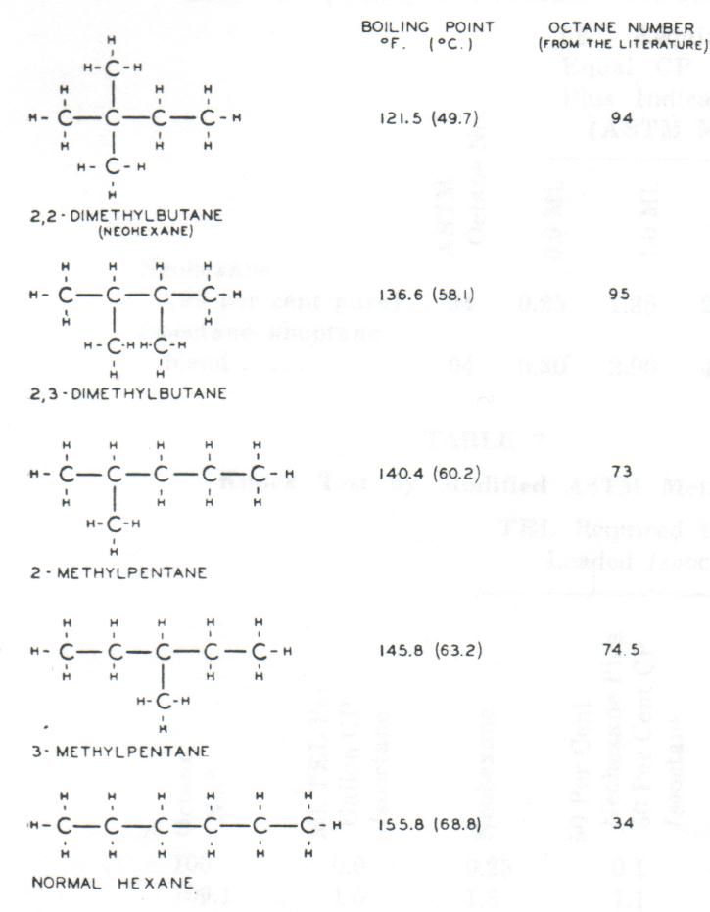

All but Neohexane have been known for some years to occur in natural gasoline. Figure 9. shows that only two of the hexanes (Neohexane and 2,3 Dimethyl Butane) have octane numbers over 90; as aviation fuel components these two isomers are comparable to iso-octane, and because of their higher volatility they can be used to provide flexibility in blending high octane rating aviation fuels

Neohexane is the most volatile (lowest boiling point) of all the hexanes, and therefore can be separated by fractional distillation from the other hexanes which have poor octane ratings – particularly normal hexane.

Figure 10. Neohexane Process

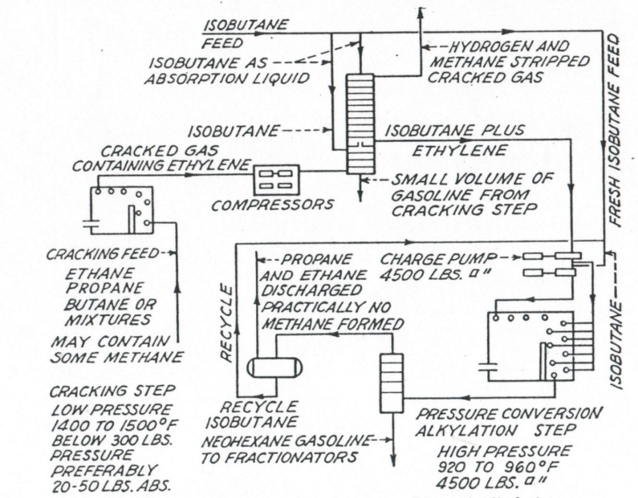

By selecting Ethylene and Isobutane as reactants, thermal alkylation at high pressures will produce Neohexane, an isoparaffin of high octane number suitable for aviation fuel, but higher in volatility than Iso-Octane. Neohexane has high lead susceptibility, for example at 3.0 ml TEL/USG (0.792 ml TEL per litre) it is comparable in anti-knock rating to chemically pure Iso-Octane with 3 ml TEL/USG.

When the aviation gasoline ordinarily used in blending to high octane number fuels is replaced by suitable mixtures of Neohexane and Iso-octane, finished aviation gasolines of balanced volatility with much higher octane numbers can be produced.

For example – for the same 50% distillation point 95OC and a vapour pressure of 7psi, the theoretical blends show that inclusion of Neohexane has a marked impact on the octane rating. Isopentane is primarily present to achieve the desired vapour pressure

Table 23. Neohexane theoretical blends – Blend 1(0% neoC6), Blend 2 (0% Naphtha)

|  |  |  |  |
| --- | --- | --- | --- |
| Component | MON | Blend 1 | Blend 2 |
| Isopentane (balance) | 90 | 21.3% | 15.6% |
| Neohexane | 94 | 0.0% | 25.8% |
| Straight Run Naphtha | 75 | 53.2% | 0.0% |
| Iso-Octane (2,2,4 TMP) | 94 | 25.5% | 58.6% |
| Octane Number MON Clear | | **82.8** | **93.4** |

Initially some criticism was made of the practical vapourisation characteristics of such blends since they are essentially a three-component mixture and the ASTM distillation may not adequately represent the conditions expected in engine tests. Some preliminary engine test work was undertaken and the initial findings indicated that the conventional volatility specifications for aviation gasoline were applicable even to the three component blends.

# Butane Dehydrogenation Process

Butylenes are important raw materials in the manufacture of aviation gasoline, butadiene, and butyl rubber. The major portion of the butylene supplies is obtained from catalytic and thermal cracking operations; but these supplies have been supplemented by the dehydrogenation of normal butane.

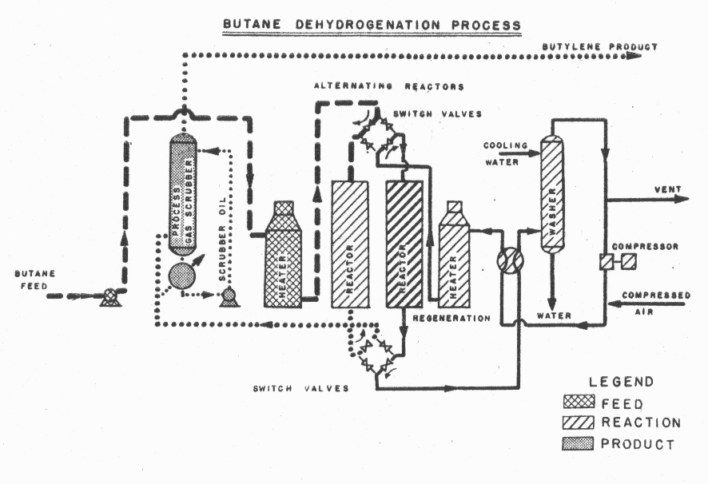Figure 11. Butane Dehydrogenation Process

In this process, normal butane is heated to a temperature in the range of 1,000 to 1,100 deg. F. (537 to 593 deg. C.) and is fed to the reactors consisting of a large number of parallel tubes filled with catalyst. Substantial quantities of heat are absorbed during reaction, and the proper temperature is maintained by circulating hot flue gas around the exterior of the catalyst tubes. Since the catalyst becomes inactive with use because of the formation of carbonaceous deposits on, the catalyst, it is periodically regenerated by burning with a properly controlled air-flue gas mixture. Reactors in multiple groups of two are provided in order that one may be on-stream while the other is being regenerated. Electrical timing devices automatically control the sequence of operations in the reactors. The hydrocarbon mixture leaving the reactors is cooled and compressed prior to delivery to a purification system wherein hydrogen and undesirable reaction products are removed.

The butylene molecule contains two less hydrogen atom than does the butane molecule. In essence this process therefore converts butane to butylene by removing two hydrogen atoms from each butane molecule.

The butylenes in the product are used to make alkylate or copolymer for use in aviation gasoline. The hydrogen obtained as a by-product in about 80 per seat purity is suitable for many hydrogenation purposes, such as the hydrogenation of copolymer.

# Isomerization

The isomerization process was used principally for converting normal butane to isobutane, a material which was an essential raw stock in the manufacture of alkylates for the high octane gasoline program. Isobutane produced by isomerization with both Government and privately owned facilities accounted for about one-fourth of the total used for alkylation. Normal butane and isobutane differ only it the arrangement of the carbon and hydrogen atoms. Isomerization serves to change the arrangement of the normal butane molecule. This equipment was necessary in order to provide additional supplies of isobutane above the quantities that could be obtained from normal operations and from privately owned isomerization equipment. During World War II the US Government financed Butane Isomerization units at 13 plants with only Pentane Isomerization unit at one plant.

Figure 12. Butane Isomerisation Process

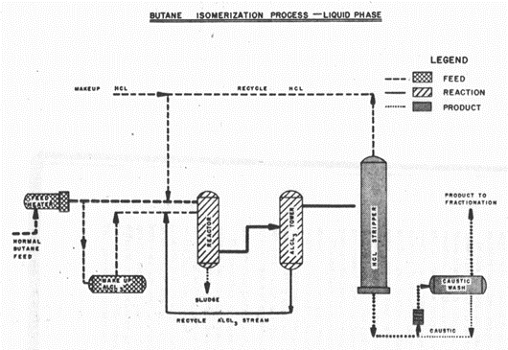

The liquid-phase process needs in most defence plants charges, part of the normal butane feed directly to the reactor and part to an Aluminium Chloride saturator wherein this portion of the feed dissolves the desired amount of Aluminium Chloride (AlCl3) before it reaches the reactor. Anhydrous hydrochloric acid (HCl) is introduced into the reactor and serves as a promoter to expedite the reaction. Sludge formed in the reactor is settled out to the bottom and the rest of the material is passed to a tower for removal of Aluminium Chloride for recycling to the reactor. The product stream from this operation passes to an HCl stripper, for separation of HCl which is recycled in the desired amount and a bottoms product consisting of an iso/normal butane mixture. After caustic washing to remove residual HCl the mixed butane product is charged to other fractionation facilities for recovery of the isobutane produced.

Processes quite similar to the liquid-phase isomerization process described above were employed for the production of isopentane from normal pentane, and isomerized naphthas from light virgin naphthas.

# Thermal Reforming

Thermal reforming is used primarily to improve the octane quality of heavy virgin naphthas. The process has the further advantage that the yield of butylenes, required for the high octane program, is appreciably higher than usually obtained in other thermal-cracking operations. Although the actual designs of thermal-reforming installations vary widely, the basic principles may be set forth rather simply as shown in the accompanying flow diagram.

The feed stock for this equipment is a heavy naphtha obtained in the distillation of crude oil. The feed charged to a furnace and heated to high temperatures so that extensive reforming or cracking occurs. As the material leaves the furnace, pressure is released and a heavy oil is introduced for partial quenching and reduction in temperature. The tar separator serves to remove the heavier fractions. The overhead products from the separator pass to a fractionating tower where the heavier portion of the material is segregated as a recycling stock. The lighter material then passes through a gas separator, at which point the reformed naphtha is recovered. The wet gas from the separator is subjected to further processing for the recovery of butylenes and other light hydrocarbons.

# Low Pressure Catalytic Hydrogenation

The naphthas produced by catalytic cracking of gas oils are generally not suitable for direct inclusion in 100 octane either because of a tendency to form gummy substances or because of low octane and hence the necessity for further processing arises. One of the methods employed for this purpose, particularly on the light fractions of the catalytic naphthas, is hydrogenation. The hydrogenation process accomplishes the conversion of olefinic constituents to paraffinic constituents by reaction with hydrogen. Copolymers produced from butylenes are also charged to hydrogenation plants for conversion to high quality blending agents for use in 100-octane manufacture. A number of different hydrogenation processes are employed for this purpose. However, the two Government owned plants employed a relatively low-pressure process. This process is illustrated in simplified form in the accompanying diagram.

Figure 13. Catalytic Hydrogenation Process

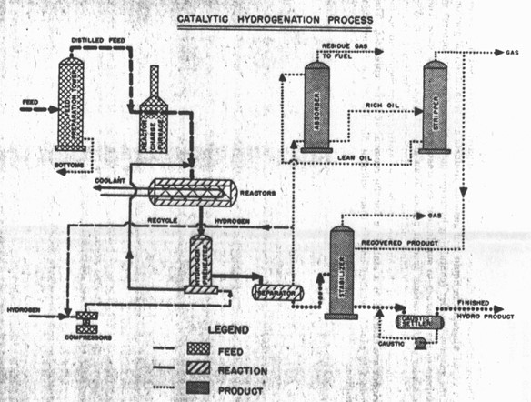

In the operation of this process, feed stock consisting of light catalytically cracked naphtha and/or copolymer is charged to a feed preparation tower where a relatively small amount of heavy material is removed. The distilled feed stock is vapourized in a furnace and, together with hydrogen-bearing gases that have been heated to the proper temperature, is charged at a pressure in the range of 200-300 pounds per square inch (1,378 to 2,068 kilopascals) to a number of reactors operating in series. These reactors are packed with a suitable catalyst in pellet form. A large amount at heat is liberated during the reaction and as the reaction temperature must be carefully controlled, the heat is removed by circulating a cooling liquid through tubes located in the catalyst beds.

The mixture leaving the reactor, is cooled and partially condensed and passes to a vessel wherein the liquid and gaseous products are separated. A portion of the gaseous product (containing hydrogen not consumed in the reactors) is returned to the reactors to supplement the fresh hydrogen-bearing gas. The remainder of the gaseous product passes to an absorption and stripping system for the recovery of butane and header hydrocarbons. The liquid product from the separator and the butane and heavier hydrocarbons recovered at the stripper are charged to a stabilizer for the removal of light materials. The product is caustic washed and is then suitable for direct use in aviation gasoline.

# The Problem of Location of Refining Capacity[18]

When measured by crude oil runs to stills, the US industry’s total operating refining capacity in 1941 was divided among the major refinery districts as follows:

Texas-Gulf 34%,

Indiana-Illinois-Kentucky 18%,

US East Coast 15%,

US West Coast 15%,

Oklahoma-Kansas-Missouri 9%.

With processing facilities far in excess of demand in their district, Gulf-Texas refiners shipped a large portion of their output, principally by tanker, to the East Coast, where demand exceeded refining capacity (due to large shipments of petroleum products to Britain). Thus, when the German U-boats began sinking tankers, there was a serious decline in the quantity of refined products, as well as crude, reaching the Atlantic seaboard particularly during 1942 -43. Given the shortage of strategic materials for the construction of new refining capacity, the problem of supplying the East Coast (District 1) was partly solved by the construction of a pipeline (“Big Inch”) to deliver crude to these east coast refiners. The supply problem was finally solved by the construction of a second pipeline (“Little Big Inch”) for refined products.

Big Inch and Little Big Inch Crude Pipelines

In 1941, a time when oil was transported mostly by tankers and railcars, the threat of German submarines along the east coast of the United States created the need for a more efficient and safer means of transporting United States oil. Following considerable debate among high-ranking defence and administration officials, the famous 300-Mbpd, 24-inch Big Inch and the 190-Mbpd, 20-inch Little Big Inch War Emergency Pipelines were programmed for construction by the government in June 1942. They were to be built to meet the urgent need for Gulf Coast and East Texas crude on the Eastern Seaboard and thereby eliminate the submarine menace to coastal operations.

Willbros, one of the few contractors with the experience required for lines this size, was named principal construction contractor for the Big Inch and Little Big Inch pipelines. The pipelines were 2,897 km (1,800 miles) long, extending from the Texas and Louisiana oil fields, and were capable of bringing 250,000 barrels per day to the East Coast— considerably more than the estimates of the daily shortage. Willbros laid approximately 966 km (600 miles) of crude oil pipeline and constructed 15 pump stations. Willbros also installed all the river crossings from Texas to New Jersey because of the company’s previous experience installing pipeline river crossings on nearly every major river in North America.

Photo 24. Welder at work on the construction of Big Inch pipeline 1942

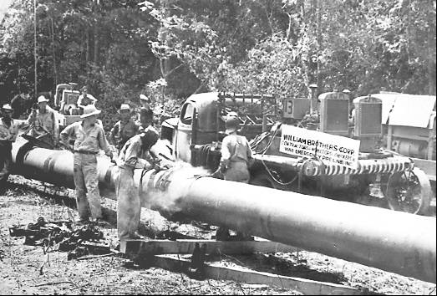

Oil began flowing out of the pipeline in December 1942 at Norris City, Illinois, at substantial savings over tanker or rail transport. A few months later, the final extension to Pennsylvania and New York was completed.

After the war, Willbros was appointed custodian of both the Big Inch and the Little Big Inch pipelines. As an agent of the government, the company later converted these lines to natural gas and, until their eventual sale, operated them while they were under lease to a private company.

Change of Refinery Product Mix

With the outbreak of war, a major change was required in the refined product output of refineries. Conversion by refiners from a basis of producing motor fuel for cars as their principal output to the production larger proportions of fuel oils for ships, high octane gasoline for aviation fuel, butadiene for rubber, and aromatics for toluene, Cumene, and styrene; and to the construction of alcohol plants for the manufacture of rubber and explosives. The changes required entirely new sections of some refineries, whereas others had to be used with minimum changes because of material shortages.

# Production of Aviation Gasoline

The production of aviation gasoline is discussed in Chapter 11 U.S. Petroleum Administration for War, however a summary of the situation over the next nine years can be summarised by excerpts from the reports in the Minerals Yearbook, Reviews from the years 1940 to 1948 [19]

While the number of US refineries declined due to the shutdown of plants of small capacity, however the overall capacity increased due to new construction and expansion of existing plants.

Graph 1. The number of US Refineries from 1940 to 1948



Graph 2. Capacity of US refineries 1940 to 1948.

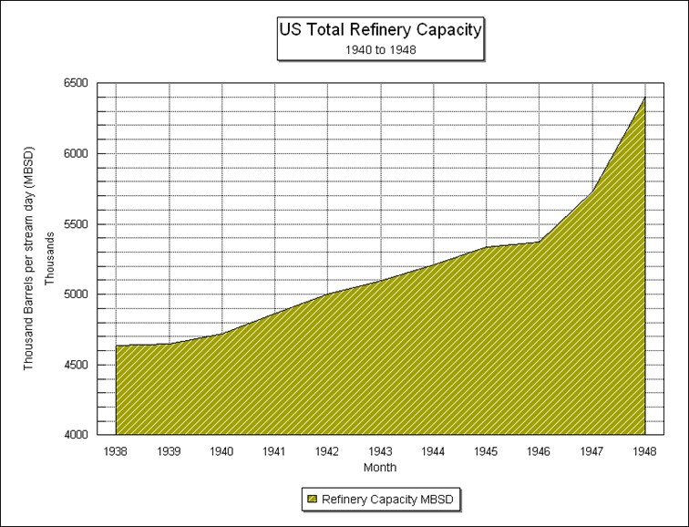

# 1940 US Statistics

1940 Aviation Gasoline Production

The production of finished and unfinished aviation gasoline in 1940 was 14,736,000 barrels (2,343 MLitres), estimated to be gain of 40% on 1939 production.

Exports of aviation gasoline, including antiknock compounds amounted to 4,649,000 barrels (739 MLitres) in 1940, this was higher than the 1939 total (4,234,000 barrels) (673 MLitres), but the figures are not comparable as data on exports of antiknock compounds were not available before Jan 1, 1940.

Up to the time of its collapse France led in the receipts of this product. Shipments to France were 514,000 barrels (82 MLitres) in the first 6 months of the year compared with 504,000 barrels (82 MLitres) shipped to the United Kingdom in the same period.

The most important shipments for the year (1940) were United Kingdom 1,525,000 barrels (243 MLitres), Netherlands Indies 578,000 barrels (92 MLitres), **Japan 528,000 Bbls** (84 MLitres), and France 514,000 barrels (82 MLitres). [Note Japan was stockpiling petroleum products particularly aviation gasoline for its forthcoming war with the United States.]

# 1941 US Statistics

1941 Refinery Capacity

A huge program of refinery construction was initiated in 1941, but little of it was destined to increase crude oil capacity, as it was mostly ear marked for the production of such special commodities as butadiene, aviation gasoline, and toluene. Only one new plant of 4,000 Bbls (BSD) crude oil capacity was being built on Jan 1, 1942 and additional crude oil capacity of 39,400 Bbls was under construction at existing refineries.

1941 Crude Capacity

Total number of (US) refineries dropped from 562 to 523, their daily capacity rose from 4,860,194 Bbls to 4,999,999 due largely to elimination of shutdown plants of small capacity, which declined in number from 136 to 92 and additional capacity completed for existing plants. The number of operating plants increased from 420 to 430 and their daily capacity rose from 4,180,588 to 4,496,843 Bbls (BSD). The largest increases in capacity were in the Texas Gulf Coast, California and Indiana, Illinois, Kentucky, etc., districts where the gains were 163,000, 157,000 and 149,000 Bbls respectively.

1941 Cracking Capacity

Cracking capacity rose from 1,151,193 Bbls of gasoline output (BSD) on Jan 1, 1941 to 1,222,684 BSD on Jan 1, 1942. A decline in both capacity shut-down and that under construction made the operating capacity 1,144,594 BSD compared with 1,021,006 BSD on Jan 1, 1941. Emphasis in refinery construction during 1941 centred on aviation gasoline refineries, but interest in synthetic rubber plants developed at the end of the year. These included catalytic cracking plants, polymerisation plants, alkylation plants, isobutane and isopentane plants and aviation-base stocks plants.

1941 Aviation Gasoline Production

Production of high octane blending agents by the alkylation method was rapidly supplanting the method of polymerising butane to iso-octene followed by hydrogenation of the codimer obtained. The principal reason was that the alkylation process required less investment and ran at lower operating costs.

In addition to the thermal alkylation and low-temperature sulphuric acid catalytic methods, a patent was granted late in 1941 covering alkylation method using hydrofluoric acid as a catalyst. One of the advantages claimed for this method was the ability to use propane (?) *(propene was probably intended)* as well as butane (?) *(butene was probably intended)* for the charging stock in addition to the advantage of operating at normal temperatures, thus eliminating the need for refrigeration.

One plant planned to be completed early in 1942 will produce a new aviation gasoline blending agent – Cumene or isopropyl benzene.

The increase in production of 100-Octane aviation gasoline from 40,000 BSD to 120,000 BSD was one of the most important defence projects initiated in 1941. Efforts in this direction included concentration of crude oils yielding high-octane gasoline, increasing the production of butane, diversion of butane from other uses to serve as a source of iso-octane, isomerisation of butane, and raising the tolerance of tetra-ethyl lead from 3 cc to 4 cc per US gallon.

The high boiling range of iso-octane (blend) 225-263 deg. F (107-128 deg. C) necessitated blending with other agents to produce an aviation fuel of required volatility. These blending agents usually were a light gravity cut of straight run gasoline of high octane or a catalytically cracked gasoline with isopentane. The naphthenic-base crude oils, which traditionally have been considered less desirable because of their low gasoline content, make the highest octane gasoline, although the cut suitable for use as an aviation fuel blending agent usually is very small. Texas, California, and Louisiana are the sources of most crude oils of this type.

The need for increasing the production of butane was most essential both for the production of 100-Octane gasoline and for the synthesis of rubber. Greater efficiency in its recovery and the use of more absorber oil should supply a quantity that heretofore has been wasted, estimated by one authority at 15,000 BSD compared with 40,000 BSD used. An addition amount probably will have to be produced from the cracking of oils.

Tetraethyl Lead (TEL)

Although the US Navy had permitted the TEL content as much as 6 cc/US Gallon (7.21 cc/Imp. Gallon, 1.58 cc/L) to be used in its aviation fuel, specifications for all military gasoline in the recent past had been set to a limit of 3 cc/US Gallon (3.6 cc/Imp. Gallon, 0.79 cc/L). In December 1941, the maximum lead level was raised to 4 cc/US Gallon (4.8 cc/Imp. Gallon 1.06 cc/L).

Hydroforming

Several hydroforming plants for the aromatisation of the non-aromatic constituents of naphtha were either put in operation or were under construction in 1941. One such plant was designed to produce a new solvent claimed to be superior in many ways to present solvents. Hydroforming, though, is of even more immediate importance in the production of toluene, essential in the manufacture of explosives. The proportion obtainable through aromatisation of crude oil is very small, and the aromatic naphtha produced by the hydroforming process must go through several highly complicated operations for separation and purification of the toluene.

It was estimated that war needs would require about 1,500,00 Bbls/year of toluene. Although production from coking operations amounted to approximately 700,000 Bbls in 1941, most of this was required in the chemical industry and could be diverted only at a serious loss. The hydroforming plants under construction probably would be able to supply the needs for this product, although not all of these plants have provided for production of toluene.

Synthetic Rubber

The synthetic rubber industry competed with 100-Octane gasoline for the supply of butane. Because almost all natural rubber came for the East Indies, Japan’s declaration of war precipitated a problem that had previously been considered only as a long term project – that of manufacturing rubber. Of all the major countries at war, the United States was best situated to meet this problem. Although Germany and Russia had more experience in producing synthetic rubber for practical use, they particularly Germany, did not have the petroleum resources available in the US.

# 1942 US Statistics

1942 Aviation Gasoline

The program for the production of aviation gasoline launched in 1941 was well under way by the end of 1942, when approximately 16 times as much 100-Octane gasoline was being produced as at the beginning of 1941. With the largest part of the proposed plants yet unfinished, however, that production was still considerably short of the goal of 250,000 BSD.

In 1942 the following companies across the USA were manufacturing 100 Octane gasoline[20]

Continental Oil Company

Gulf Refining Company

Humble Oil and Refining Company

Magnolia Refining Company

Phillips Petroleum Company

Richfield Oil Company

Shell Eastern Petroleum Company

Shell Union Oil Company

Sinclair Refining Company

Standard Oil Company of California

Standard Oil Company of New Jersey

Standard Oil Company of Indiana

Standard Oil Company of Louisiana

Standard Oil Company of Ohio

The Texas Company

Union Oil Company of California

# 1943 US Statistics

1943 Aviation Gasoline

The continued upward revision of estimated requirements necessitated construction of new plants and the use of short-cut methods of expanding the output of essential constituents. Even with new plants coming into operation, it was necessary to relax the specifications early in 1944 to obtain enough high octane aviation fuel. TEL content was increased from 4 cc/USG (4.8 cc/IG, 1.06 cc/L) to 4.6 cc/USG (5.22 cc/IG, 1.22 cc/L). On January 5, 1944, distillation points also were raised to expand production. Thirty-two (32) of the new aviation gasoline plants were supplying 100-Octane gasoline by the end of 1943, and 40 more were scheduled for completion early in 1944. War requirements necessitated a double octane index to describe the antiknock quality of aviation fuel; a rich mixture (3-C) rating in addition to the lean mixture (1-C) rating previously in use. The rich mixture rating described the superior quality of the fuel for take-offs, climbing, sudden loads, and similar circumstances extremely important under combat conditions and not indicated by the ordinary octane rating. The rich-mixture rating is determined in a supercharged knock test engine by comparing the fuel to be tested with a standard reference fuel. Thus a 130 rich mixture number indicates that the fuel is 30% better than the reference fuel. Specifications for the two upper grades of aviation fuel were 100/130 and 91/96.

Cumene

Cumene, first produced for aviation fuel blending in 1942 has been the principal rich mixture additive. It was being manufactured in substantial quantities in 18 plants in 1943. Other additives about five times as potent as Cumene came into used during 1943, and together made possible a surplus rich-mixture fuel, with the result that by the end of 1943 the emphasis was on the production of lean-mixture rather than rich-mixture fuel.

# 1944 US Statistics

1944 Aviation Gasoline

In 1943 and 1944 the production of all grades of aviation gasoline in the United States expanded rapidly and according to published estimates materially exceeded an average of 500,000 barrels daily in 1944. The production of 100-Octane gasoline or above constituted to about two thirds of the total in 1944. The expansion in the production of aviation gasoline was so great in 1944 as to offset the war decline in the civilian consumption of motor fuel and to raise the total production and demand for motor fuel to new record levels.

In 1942 a program for the construction of new plants initiated by the Petroleum Administration for War, and the objectives of that program as to quantity and quality continued to rise throughout 1944.

# 1945 US Statistics

1945 Aviation Gasoline

The wartime expansion in the production and use of aviation gasoline was much greater than the increase in demand for other petroleum products because of the growth of the use of air power in war. The total demand for aviation gasoline (domestic plus exports) rose daily from an average of 49,000 barrels in 1941 to a peak of 701,000 barrels daily in April 1945. Since the requirements follow wartime use pattern, it is necessary to divide the months on 1945 into two parts to get a picture of the changes within the year. Total demand dropped from a daily average of 560,000 barrels for the first 8 months to 123,000 barrels for the last 4 months, with 37,000 barrels daily in December 1945.

The production of all aviation grades increased from an average of 58,000 barrels daily in 1941 to an average of 537,000 barrels daily in 1944 and 620,000 barrels daily in the peak month of March 1945. The average production for the first 8 months of 1945 was 578,000 barrels daily compared with 99,000 barrels daily for the last 4 months. The greatest monthly decrease came between the August daily average production of 425,000 barrels and the 133,000 barrels average in September. As a result of the abrupt curtailment of military demand in the last 4 months of 1945, the total quantity of aviation gasoline including components, transferred to other products was abnormally large, amounting to 57% of production compared with 3% in the first 8 months. There was a substantial drop in stocks from 15 million barrels on August 31 to 5 million barrels at the end of the year.

Exports of all grades of aviation gasoline averaged 135,000 barrels daily in the first 8 months of 1945 with 244,000 barrels daily in April, and dropped to an average of 7,000 barrels in the last 4 months of the year, with a low of only 2,000 barrels daily in September (1% of the April demand). Almost all the wartime exports went to other Allied Nations.

The production of 100-Octane gasoline or above constituted about 85% of the total produced in the first 8 months of 1945.

# Epilogue for 1945

The need for more and more avgas for the war effort saw new technical and process achievements by the refiners focused on two objectives – More avgas, higher octane. However, when the war was won by the Allies and peace returned, the attention of the refiners would turn to motor gasoline.

# Index

1

100 Octane 18, 19, 49

100 octane avgas 10

100 Octane Aviation Fuel 17

100 Octane aviation gasoline 5, 13, 16, 31

100/130 49

100-Octane aviation gasoline 19, 48, 49, 50

100-octane manufacture 43

1-C 29

1-Pentene 34

2

2 Methyl Hexane 23, 24, 25, 27, 28

2 Methyl Pentane 23, 24, 25, 27, 28, 37, 38

2,2 Dimethyl Butane 23, 24, 25, 27, 28, 36, 37, 38

2,2 Dimethyl Hexane 24, 25, 27, 28, 32

2,2 Dimethyl Pentane 23, 24, 27, 28

2,2,3 Trimethyl Butane 23, 24, 25, 28

2,2,3 Trimethyl Hexane 35

2,2,3 Trimethyl Pentane 23, 24, 25, 27, 28, 29, 30, 31

2,2,4 Trimethyl Hexane 35

2,2,4 Trimethyl Pentane 23, 24, 25, 26, 27, 28, 29, 30, 33

2,2,5 Trimethyl Hexane 23, 24, 25, 28, 35

2,3 Dimethyl Butane 24, 25, 27, 28, 36, 37, 38, 39

2,3 Dimethyl Hexane 23, 24, 25, 27, 28, 32

2,3 Dimethyl Pentane 23, 24, 25, 27, 28

2,3,3 Trimethyl Hexane 35

2,3,3 Trimethyl Pentane 23, 24, 25, 27, 28, 29

2,3,4 Trimethyl Hexane 35

2,3,4 Trimethyl Pentane 23, 24, 25, 26, 27, 28, 29, 30

2,3,5 Trimethyl Hexane 23, 24, 26, 35

2,4 Dimethyl Hexane 23, 24, 25, 27, 28, 32

2,4 Dimethyl Pentane 23, 24, 25, 27, 28

2,4,4 Trimethyl Hexane 35

2,4,5 Trimethyl Hexane 35

2,5 Dimethyl Hexane 23, 24, 25, 27, 28, 32

2.2 Dimethyl Pentane 25

2-tert-Butyl Butane 23, 28

3

3 Methyl Hexane 23, 24, 25, 27, 28

3 Methyl Pentane 23, 24, 25, 27, 28, 37

3,3 Dimethyl Hexane 32

3,3,4 Trimethyl Hexane 35

3,4 Dimethyl Hexane 24, 25, 27, 28, 32

398th Bombardment Group 1

3-C 29

3-Methyl-1-butene 34

8

80 Octane all-purpose gasoline 13

87 Octane 18

9

91 Octane Avgas 13

91/96 49

A

Abadan, Iran 20

absorber oil 48

Acid Heat 10, 16

Acid Strength (Sulphuric Acid) 31

acid treated 15

acid treatment 18

acid-treating 15

air power 50

alcohol plants 45

Alice Springs Aerodrome 3

alkylate 5, 9, 15, 17, 18, 19, 29

alkylates 5, 31, 34, 41

alkylation 5, 17, 38

alkylation method 47

Alkylation plant 3, 47

alkylation process 7, 9, 10, 47

alkylation unit 10, 17, 20

Alkylation Unit Re-Run Tower 10

allied air forces 29

Allies 29, 33, 50

Allies wartime synthetic rubber program 35

Aluminium Chloride 42

American specification AN-100 29

amylenes 14, 21

Anglo-Iranian Oil Company Ltd 14

antiknock compounds 47

API Project No. 6 5, 23, 24, 25

aromatic aviation base stock 11

aromatic naphtha 48

aromatics 23, 27, 45

aromatisation 48

Ashland Oil & Refining Company 9, 22

Asphalt 17

Associated Refiners Inc. 22

ASTM distillation 40

Atlantic Refining Co. 20, 25

Atlantic seaboard 44

Australia 3

Avgas 100 5, 13

aviation alkylate 21

aviation base stock 9, 17

aviation blending agent 35

aviation fuel 48

aviation fuel blending component 38

aviation gasoline 3, 7, 10, 11, 15, 18, 20, 29, 35, 40, 41, 44, 45, 47, 49, 50

aviation gasoline blending agents 29

aviation gasoline blendstock 5, 10

aviation gasoline program 30, 33, 35

aviation gasoline specifications 9

aviation gasoline stocks 15

Aviation Motor Method 1-C 9

aviation-base stocks plants 47

Axis forces 3

Axis powers 29

B

B-17 Flying Fortress 1, 3

Bakersfield, California 22

Base Stock 5, 18, 19

Baton Rouge Refinery 11

Baton Rouge, Louisiana 20

Baytown Ordnance Works 13

Baytown Refinery, Texas 13

Baytown, Texas 11, 20

Bayway, New Jersey 11, 20

bead catalyst 8

Beaumont Refinery 7

Beaumont, Texas 7

Beckett, Oklahoma 22

Benzene 27

Big Inch 44, 45

Big Inch pipeline 45

BP 14, 20

branched paraffins 22

Brewster F2A-3 Buffalo 4

Britain 3, 44

British specification (BAM-100) 29

Buffalo, New York 7

Burton Process 6

butadiene 41, 45, 47

butadiene plant 13, 35

butadiene purification plants 35

Butane 11, 18, 23, 24, 25, 36, 41, 44, 47, 48

Butane Dehydrogenation 41

Butane Isomerisation 33, 42

Butene 11, 22, 34, 48

Butene Alkylates 24

Butene alkylation 34, 35

Butene/Pentene mix 22

Butenes 9, 21, 33, 34

Butyl rubber 7, 13, 41

Butylene 7, 31, 41

butylene alkylate 31

Butylenes 11, 14, 15, 18, 19, 42, 43

C

C4 Hydropolymer 30

C-47 ‘Skytrains’ 4

C4-C5 Alkylates (HF) 25

California 47, 48

carbon 15, 42

catalyst granules 7

catalytic alkylation 36

catalytic cracking 43

catalytic cracking capacity 6

catalytic cracking plants 47

catalytic cracking process 17

catalytic cracking unit 17, 33

catalytic dehydrogenation 36

catalytic heavy aromatic fraction 15

Catalytic Hydrogenation Process 43

catalytic naphthas 43

Catalytic reforming 9

catalytically cracked gasoline 11, 48

Catalytically Cracked Heavy Naphtha 18

Catalytically Cracked Light Naphtha 18

Catlettsburg, Kentucky 22

caustic washed 44

caustic washing 42

Champlin Refining Co. 22

chemical industry 48

Chevron 9, 22, 58

Cheyenne, Wyoming 22

Cities Service Oil Co. 20

clay catalyst 7

codimer 30, 33, 47

Coffeyville, Kansas 22

Coke 7

coking operations 48

cold acid 28

colour 7

combat fuel 29

Continental Oil Company 9, 22, 49

Cooperative Refining Co. 22

Copolymer 17, 43

Corpus Christi, Texas 22

Cotton Valley Louisiana 22

cracked products 7, 15

Cracking capacity 47

cracking range 36

Cross Process 6

Crown Central Petroleum Corporation 9, 22

crude 44

crude oil 15, 17, 42, 48

crude oil capacity 47

crude oil pipeline 44

Cumene 5, 20, 34, 45, 48, 49

Cyclo-C6 37

Cyclohexane 37

Cyclopentane 25, 27

D

declaration of war 49

dehydrogenated 36

Dehydrogenation 5, 41

di-isobutylene 35

Dimer 28, 35

Dimer/Hot acid/Sulphuric acid 28

Dimethyl Hexanes 32

distillation 42

Distillation ASTM 16

distillation point 40, 49

dodecanes 35

Dominguez, California 20

Dubbs Process 6

Dubbs Thermal Cracking Unit Lloyd Refinery, Port Credit, Toronto 6

E

East Asia 3

East Chicago, Indiana 20

East Coast 44

East Coast (District 1) 44

east coast refiners 44

East Indies 48

East Texas crude 44

Eastern Seaboard 44

Eastern States Petroleum Co. Inc. 22

El Dorado, Arkansas 22

Enid Oklahoma 22

Esso 14, 20, 26

Ethane 36, 37

ethane-propane mixture 38

Ethyl Cyclo-C6 37

Ethyl Cyclohexane 37

Ethylene 36, 37, 38, 40

Eugene Houdry 15

explosives 45, 48

Exports 47, 50

F

F-3 Aviation Motor Method 29

F-4 Supercharge Performance Index 31

F-4 Supercharge Performance Number 28, 29

FCC Gasoline 11, 18

feed preparation tower 43

Fluidised Catalytic Cracking (FCC) 3, 5, 11, 14

fractional distillation 5, 39

fractionating tower 43

fractionation 15, 17, 18, 42

fractionator 7, 11, 15

France 4, 15, 47

Fuel Gas 17

fuel oils 45

G

gas oil 7, 8, 9, 11, 15, 16, 43

gas polymerisation 36

gas separator 43

gasoline 15

gasoline blendstocks 29

General Grade Fuel Oil 17

General Petroleum Corporation 9

German U-boats 44

Germany 35, 49

Gravity API 16

Great Southern Corp. 22

Gulf Coast 44

Gulf Oil Corporation 9

Gulf Refining Company 49

gum 7

Gum Accelerated 10

gummy substances 43

H

H.C. Weiss 13

H2SO4 - C4 Alkylate 30

Heating Oil 17

heavy alkylate 21

heavy aromatic aviation gasoline components 11

heavy fuel oils 11

Heavy Gas Oil 14

heavy naphtha 9, 14, 15, 42

heavy oil 43

heavy paraffinic gas oil 14

heavy virgin naphthas 42

Heptane 27, 37, 38

Heptene 37, 38

Hexene 37, 38

Heysham, UK 26, 31

HF alkylates 21, 33, 34

HF alkylation 33, 34

HF Alkylation process 21

high octane blending agents 47

high octane gasoline 41, 45, 48

Holmes-Manley Process 6

hot acid 28

Houdry (Catalytic) Process 6

Houdry catalytic cracking unit 15, 17

Houdry Cracking 6, 7, 16

Houston, Texas 22

Humble Oil & Refining Co. 3, 11, 13, 14, 20, 49

Hydrocarbon extraction 5

hydrochloric acid 42

hydrocodimer blendstocks 31

Hydrocodimer process 26

hydrocodimers 5

Hydrofluoric Acid 19, 21, 33, 34, 48

hydroforming 9, 48

hydrogen 37, 41, 42, 43, 44

hydrogenate 35

hydrogenated codimer 30

hydrogenation 5, 11, 31, 35, 41, 43, 47

hydropolymer gasoline 29, 30

hydrotreating 15

I

Illinois 47

Indiana 47

Indiana-Illinois-Kentucky 44

Ingleside Refinery, Texas 13

iso/normal butane mixture 42

Iso-amylene 34

isobutane 7, 11, 13, 15, 18, 19, 21, 22, 31, 32, 33, 34, 35, 36, 37, 38, 41, 42, 47

isobutane fractionation 32

isobutane-butene alkylation 31, 33

isobutene 11, 36, 37

isobutylene polymers 35

Isoheptane 23, 24, 25, 28, 31

Isohexane 23, 24, 25, 28

isomerisation 5, 19, 20, 41, 42, 48

isomerized naphthas 42

Isononanes 23, 24, 26, 27, 29

Iso-octane 16, 19, 22, 25, 29, 31, 39, 40, 48

iso-octene 47

isoparaffinic fuels 36

Isoparaffins 23, 24, 26, 27, 29

Isopentane 11, 18, 19, 36, 37, 38, 40, 42, 47, 48

isopropyl benzene 48

J

Japan 47, 49

Japanese 35

K

Kentucky 47

Kerosene 17

L

Lawrenceville 26, 27

lead susceptibility 16, 40

lean mixture (1-C) 49

lean mixture octane (F-3) 30

lean mixture octane rating 29

light catalytic naphtha 15

light catalytically cracked naphtha 43

light gas oil 7

light gravity cut 48

light hydrocarbons 7

light naphtha 7

Light Pentene 34

light virgin naphthas 42

Lima 6 26, 27

Lima 7 26, 27

Little Big Inch 44, 45

Little Big Inch War Emergency Pipeline 44

Lou Evans 7

Louisiana 48

Louisiana oil fields 44

low-temperature sulphuric acid catalytic methods 48

Lubes 17

M

M.W.Kellogg 11, 14, 19

Magnolia Petroleum Company 9, 22

Magnolia Refining Company 49

Malaya 35

Martinez, California 20

Mediterranean 3

Methane 36, 37

Methyl Cyclopentane 27

Minerals Yearbook 45

Mixed Butene/Pentene Alkylate 25

Mixed C3/C4 Alkylate (HF) 23

Mixed Propylene/Butene Alkylate 23

Mobil 7, 9, 58

Mobil Altona Refinery 10, 14

Mohawk Petroleum Corp. 22

monomer 35

motor fuel 36, 45

motor gasoline 10, 11, 17, 50

Motor Octane Number 16, 23

N

naphtha 5, 7, 11,15, 16, 17, 48

naphthenic-base crude oils 48

National Advisory Committee for Aeronautics, 5

natural clay catalysts 11

natural gas 45

natural gasoline 18, 39

natural rubber 48

natural rubber plantations 35

Navy Fuel Oil 17

n-Butane 37

n-Butene 37

Neohexane 23, 24, 25, 28, 37, 38, 39, 40

Neohexane Process 40

Netherlands Indies 47

Neumunster, Germany 1

n-Hexane 27, 37, 38

No. 2 Fuel oil 14

Nonane 38

normal butane 19, 15, 21, 36, 37, 41, 42

normal butenes 36

normal hexane 38, 39

normal pentane 36, 37, 42

Norris City, Illinois 45

North Africa 3

Norwalk, California 22

n-Pentane 37, 38

O

Octane 37, 38

Octane Number MON 40

Octenes 37, 38

Oil City, Pennsylvania 22

Oklahoma-Kansas-Missouri 44

Olean Refinery 7

olefin feed 34

olefinic 11, 43

olefins 9, 15, 19, 21, 23, 26, 27, 31, 33, , 34, 35, 36

P

Pacific 3

Paraffin Distillate 17

paraffinic 43

paraffins 36

Pasadena, Texas 22

Paulsboro 7

Pentane Isomerization unit 42

Pentanes 18

Pentene 33, 34, 37, 38

Pentene Alkylate 25

Pentenes 22, 34

pentylenes 19

Petroleum Administration for War 50

Petroleum Industry War Council 5

Philadelphia 20

Phillips Petroleum Company 38, 49

Phosphoric acid 26

Phosphoric Acid Hydrocodimers 5

Phosphoric-Acid catalytic polymerisation 30

pipeline 44

polyforming 9

polymer gasolines 30

polymer plants 30, 33

polymerisation 11, 20, 31, 36, 47

Ponca City, Oklahoma 22

Port Arthur, Texas 20

prefractionation 34

Premier Oil Refining Co. 22

propane 11, 19, 21, 36, 48

Propane 17, 36, 37

propylene 11, 19, 21, 31

Propylene 9, 22, 31, 33, 34, 36, 37

propylene alkylate 20, 21, 23, 31

Propylene/Butene mix 22

pump stations 44

R

RAAF 3

reformed naphtha 43

Reid Vapour Pressure 10, 16

Republic Oil Refining Co. 22

Research Method 10

rich mixture (3-C) 49

rich mixture additive 49

rich mixture supercharge index (F-4) 30

rich mixture supercharged rating 29

Richfield Oil Company 9, 49

Richmond, California 22

Root Petroleum Co. 22

rubber 11, 45, 48

Russia 49

S

Salt Lake City, Utah 20

Shell Eastern Petroleum Company 49

Shell Oil Co. 14, 20, 23, 25, 26, 27, 28

Shell Union Oil Company 49

Sinclair Refining Company 9, 20, 21, 22, 23, 25, 49

Smiths Bluff, Texas 20

Socony-Vacuum Lubrite Division 9

Socony-Vacuum Oil Co. 7, 9

Socony-Vacuum Olean Refinery, New York 3

Socony-Vacuum Refinery Beaumont, Texas 3, 8

Socony-Vacuum Refinery, Brooklyn, New York 17

solid catalyst pellets 15

solvent 17, 48

Southport Petroleum Company 22

Specific Gravity 16

stabilizer 44

Standard Oil Company (Indiana) 14, 26, 27, 49

Standard Oil Company (Louisiana) 14, 20, 49

Standard Oil Company (New Jersey) 3, 11, 12, 14, 27, 49

Standard Oil Company of California 9, 22, 49

Standard Oil Company of Ohio 20, 26, 27, 49

Standard Oil Development Company 11

straight run gasoline 48

straight run naphthas 15, 40

stripper 44

styrene 45

sulphur 7

sulphuric acid 15, 19, 21, 26, 28, 31, 33, 34

sulphuric acid alkylate 30, 33, 34

Sulphuric acid alkylation 5, 19, 20, 34, 35, 36

Sulphuric Acid Hydrocodimers 5

sulphuric acid polymerisation 35

sulphuric-acid alkylates 32

Sun Oil Company 7, 9

supercharged knock test engine 49

Super-fractionation 5

Surge Separator 10

Sweeney, Texas 22

synthetic catalysts 11

synthetic crude 7

synthetic hydrocarbons 5

synthetic rubber 5, 11, 35, 47, 48, 49

synthetic tower 15

T

tar 7, 15

tar separator 43

TCC aviation gasoline 10

TCC Process 9

TCC-1X 7

Technical Advisory Committee 5

TEL content 48, 49

Tetra Ethyl Lead 18, 48

Texaco Port Arthur Refinery 3, 20

Texas 48

Texas City 22

Texas Gulf Coast 47

Texas-Gulf 44

The Frontier Refining Co. 22

The Pennzoil Company 22

The Pure Oil Company 9, 20, 28

The Texas Company - (Texaco) 14, 20, 26, 27, 49

thermal alkylation 36, 38, 40, 48

Thermal Reformer plants 6

thermal reforming 9, 42

Thermal Reforming/Cracking 6

thermal-cracking operations 42

Thermofor Catalytic Cracker 3, 5, 7, 10

Tide Water Oil Company 9

TNT explosives 5

Toluene 5, 11, 13, 17, 23, 27, 45, 47, 48

total alkylate 19, 32

Tractor Fuel 17

Trade Gas Oil 17

triisobutylene 35

Trimer 28, 35

Trimer/Cold acid/Sulphuric acid 28

Trimer/Hot acid/Sulphuric acid 28

Trimethyl Hexanes 34

Trimethyl Pentane 29, 30, 32, 34, 35

Trimpell Ltd. 26, 27, 31

Triptane 23, 24, 25, 28

Tube and Tank Process 6

Tulsa 26, 27

U

U.S. Petroleum Administration for War 45

Union Oil Company of California 9, 49

United Kingdom 47

Universal Oil Products Company (UOP) 11, 14, 19

US Army Air Force 3, 4

US East Coast 44

US Navy 48

US West Coast 44

Utah Oil Refining Co. 20

V

Van Winkle 58

vapour pressure 40

virgin naphthas 9, 18

volatility 48

volatility specification 40

W

West Indies 26

Willbros 44, 45

Wiltshire Oil Co. Inc. 22

Wyoming, 20, 22

X

Xylenes 23

Z

zeolite 7

# Research Sources

1. Website USAF <http://www.af.mil/photos/index.asp?galleryID=161&page=2> accessed Dec 20, 2006
2. American Petroleum Institute 22nd Annual Meeting San Francisco California November 3-7, 1941 Division – Refining “Method For Analyzing The Gasoline Fraction Of Petroleum, With Preliminary Results On East Texas And Oklahoma Crudes”– API Research Project 6 by Frederick D. Rossini, et al.
3. American Petroleum Institute 26th Annual Meeting, Chicago Illinois November 11-14, 1946 Division of Refining “Analysis of Alkylates and Hydrocodimers” – API Research Project 6 by Frederick D. Rossini, et al.
4. Description of Principal Refining Processes from: “Aviation Gasoline Plants and Facilities” - Report of the Surplus Property Administration to the (U.S.) Congress Jan 14, 1946 - Institute of Aeronautical Science
5. The American Petroleum Industry – The age of energy 1899-1959” by Harold F Williamson et al., Northwestern University Press. Source Chevron Park – San Ramon Technical Library.
6. “The Story of Engineering at Mobil” Mobil Research & Development Corporation, Princeton New Jersey Published 1989
7. Aviation Gasoline Manufacture – Matthew Van Winkle, Pennsylvania State College, McGraw-Hill 1944.
8. Aviation Gasoline Manufacture – Matthew Van Winkle, Pennsylvania State College, McGraw-Hill 1944.
9. American Petroleum Institute 24th Annual Meeting Division of Refining Vol. 24 [III] (1943) “FCC Catalyst Cracking for Premium Fuels” by E.V. Murphee et al.
10. Aviation Gasoline Manufacture – Matthew Van Winkle, Pennsylvania State College, McGraw-Hill 1944.
11. Aviation Gasoline Manufacture – Matthew Van Winkle, Pennsylvania State College, McGraw-Hill 1944.
12. A History of the Petroleum Administration for War, 1941-1945 Administration For War Petroleum Administration for War, Published by University Press of the Pacific, United States (2005) ISBN 10: 1410221954 ISBN 13: 9781410221957
13. Aviation Gasoline Plants and Facilities. Report of the Surplus Property Administration to the Congress, January 14, 1946, Institute of Aeronautical Sciences.
14. Website <http://www.texacohistory.com/History/index.htm> accessed Oct 27, 2007 “History Of The Texas Company and Port Arthur Works Refinery” by Elton N. Gish
15. American Petroleum Institute 26th Annual Meeting Chicago Illinois November 11-14, 1946 Division of Refining “Project 6 Spotlights AVGAS Progress” by H.W. Field and D.W. Gould
16. American Petroleum Institute 20th Annual Meeting Chicago Illinois November 9-17, 1939 Group Session – Refining “Thermal Alkylation and NeoHexane” by G.G. Oberfell, F.E. Frey
17. American Petroleum Institute 20th Annual Meeting Chicago Illinois November 9-17, 1939 Group Session – Refining “Thermal Alkylation and NeoHexane” by G.G. Oberfell, F.E. Frey
18. The American Petroleum Industry – The age of energy 1899-1959” by Harold F. Williamson et al., Northwestern University Press. Source Chevron Park – San Ramon Technical Library.
19. Reference: Minerals Yearbook, Review of 1940, 1941, 1942, 1943, 1944, 1945, 1946, 1947, 1948 - Source San Francisco Public Library Accessed May 2000.
20. “Background data on 100 octane gasoline. History of its Development, Its Manufacture, Its Potentialities for War and Peace, Economic and Strategic Choices Related To It.” - Prepared by the Standard Oil Company (NJ) 30 Rockefeller Plaza, New York City. April 1943. Source: US Library of Congress Call Number: TP692.2 .S8