Chapter

122

1942-1945 Technical Issues

The War Continues – ‘We’ve got problems with your Avgas!’

Photo 1. Drop tank for Republic P-47 Thunderbolt (RAF Hendon )

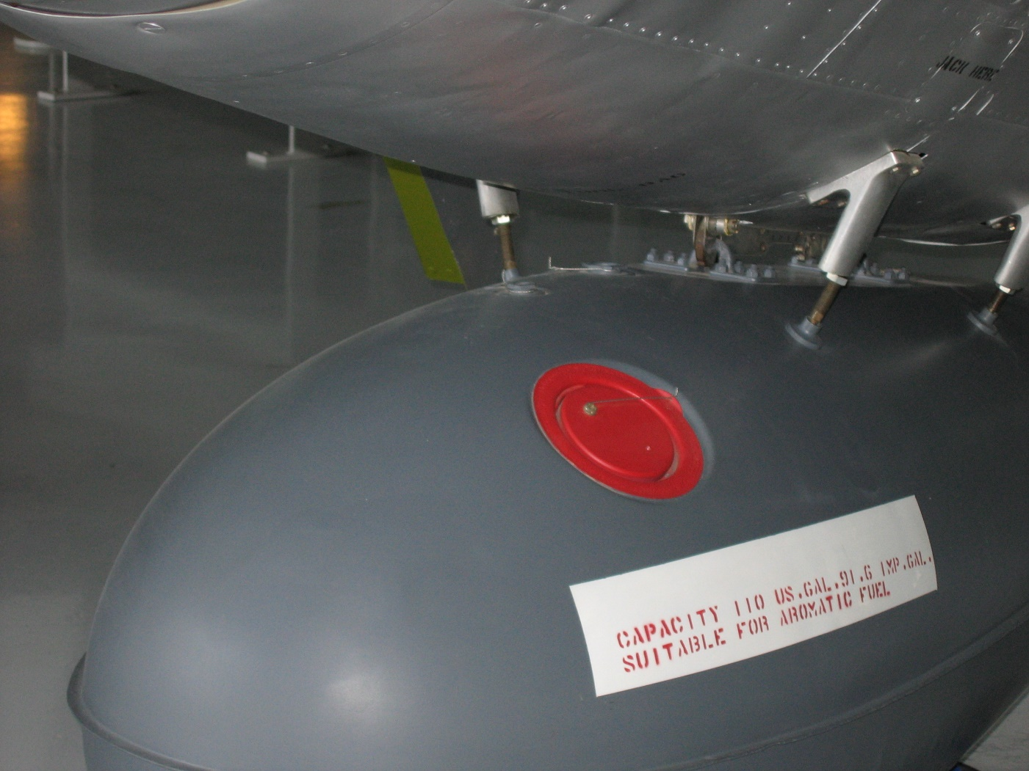

Table of Contents

Avgas Markings 3

Avgas & Aromatics – Problem For The Americans 6

Index 10

# Avgas Markings

The differences in Avgas composition becomes a problem for US and British aircraft.

As aircraft developed and different grades of avgas became available it became important to let the pilot, and more importantly those refuelling the aircraft, which fuel was suitable for which aircraft. Not only was the grade and specification important, but also if the aircraft fuel system (including tanks) was suitable for the fuel. To deal with this problem, it was simply a matter of marking the aircraft and its fuel fill points with the appropriate information. This general system was adopted well before the War and continued by both Allies and Axis, and can be seen in the following examples. The British tended to also add the fuel specification as well.

Photo 2. Hawker Cygnet circa 1930s on display at R.A.F. Hendon Museum, London U.K. 2000

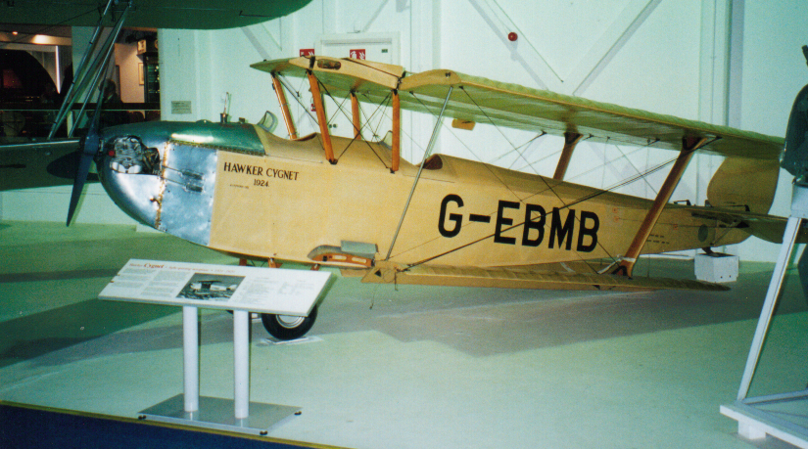

Photo 3. Fuel fill points of Hawker Cygnet. Note the avgas grade and oil grades required.

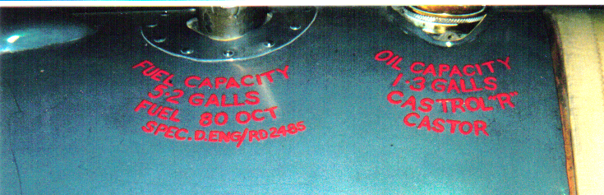

Of note is that both the fuel grade “FUEL 80 OCT” and specification “SPEC D.ENG/RD 2485” are listed. Also note the use of “CASTROL ‘R’ CASTOR’ oil. (Refer to previous chapters on the ‘perils of castor oil’ for a pilot).

Photo 4. Gloster Gladiator Mk II N5628 on display at RAF Hendon Museum, London U.K. (2000) Museum Accession Number 72/A/472

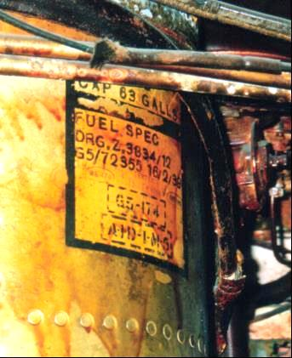

This aircraft was retrieved from a watery grave in Norway and preserved at R.A.F. Hendon Museum, London. Note the avgas specifications marked on the fuel tank in Feb 1939. ‘FUEL SPEC DRG. Z.3834/12 G5/72355 16/2/39’

Photo 5. Gloster Gladiator Mk II N5628 at R.A.F. Hendon Museum, UK (2000)

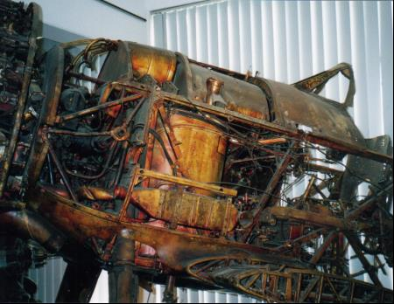

The Axis (Germans & Italians) opted for a triangle and identification number sometimes the grade ‘B4’, or the Octane number ‘87’.

Photo 6. German Me-109 fuel fill point ‘87’ Octane triangle (on display at NASM Washington (2001)

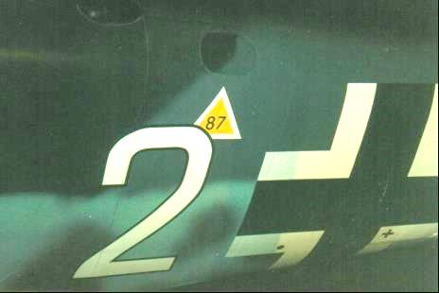

Photo 7. Italian Macchi C202 on display at NASM Washington (2001) – suspended above a P-51 Mustang

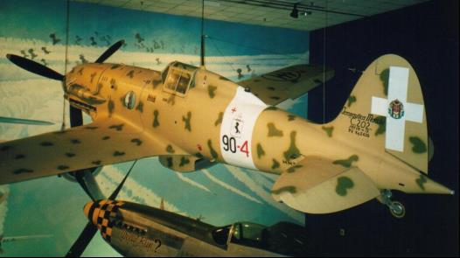

Photo 8. Italian Macchi C202 cockpit, note the triangle under the fuel fill point (NASM 2001)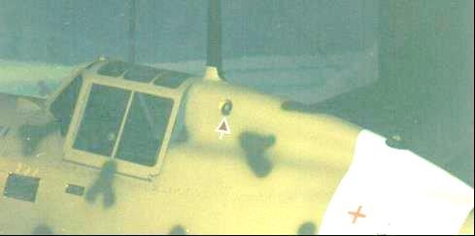

# Avgas & Aromatics – Problem for the Americans

Avgas Properties

In general terms gasoline is a refined petroleum distillate, normally boiling within the limits of 30 deg. C to 220 deg. C, which by its composition is suitable for use as a fuel in spark ignition internal combustion engines. Aviation gasolines are prepared from specially blended grades of gasoline suitable for use in aircraft engines. The fuels have high anti-knock ratings, high stability, low freezing point and high overall volatility, the normal boiling range is about 40 deg. C to 170 deg. C.

The five most significant properties of aviation gasoline which influence engine design are, in order of their relative importance:

1. Anti-knock value
2. Volatility
3. Vapour locking tendency
4. Stability
5. Solvent and corrosion properties

The problems of undesirable ‘solvent’ properties have been discussed in previous chapters.

Undesirable Solvent Properties

As early as World War I, one of the features which distinguished American aviation gasolines from those of the Europeans – British and German, was the level of aromatic hydrocarbons in their aviation fuels and the type of rubber components used in their aircraft. The early laboratory chemists knew that unsaturated hydrocarbons and in particular aromatic hydrocarbons are powerful solvents of rubber and some rubber-like compounds, indeed Benzene was a common laboratory solvent up until the 1970’s. The aromatic hydrocarbons (particularly Benzene) caused swelling of rubber with resultant blocking of fuel lines (internally), leakage from fuel lines due loose fittings, etc. The Americans had developed their aircraft on low aromatic fuels and after several disasters following the use of high aromatic fuels there were limits placed on the aromatic content. At one time, aromatics were not allowed in aviation gasolines. However, in order to keep up the supply of high grade aviation gasoline it became necessary to include aromatics in increasing quantities and to redesign the fuel systems so as to resist the solvency effect of the aromatics. This change was made in the U.S.A. much later than in the U.K. Hence, there were considerable difficulties in the interim period where ‘aromatic fuels’ were used in fuel systems unsuitable for them.

There could also be a problem if non-aromatic fuels were used because with some rubber components a small amount of swelling was expected with aromatic fuels and this ensured good sealing of the fuel system.

The difficulty was resolved during WWII, and all aircraft and equipment could be used with high grade fuel containing aromatics. However, in 1948, there was still caution as it was noted that the fuel systems of light aircraft running on low grade fuels may not be suitable for aromatics and old airfield equipment (post-WWII), particularly of American origin may also not be suitable.

There was one World War II story of Australian built Beaufort bombers, on their way from the Government Aircraft Factory at Fisherman’s Bend (Victoria) to Darwin, being grounded part way through the flight because the fuel lines were leaking so badly as a result of rubber shrinkage – the aircraft components were designed for British aromatic fuels, but the aircraft were operated on American low aromatic aviation gasoline. Later the avgas 115/145 would have a minimum 5% aromatic requirement to ensure this shrinkage problem was controlled.

‘Suitable for Aromatic Fuels’

This was such an important matter that all American aircraft were marked with their fuel requirements. These markings were usually located under the pilot’s window and listed the aircraft designation, serial number (which included the year of manufacture), and the fuel requirements. This became standard practice on all American aircraft. For British aircraft the markings were usually limited to the avgas grade and this was located at the fuel tank fill point. Below are some examples of these markings.

Photo 9. U.S. Army Boeing B-17G ‘Mary Alice” Serial Number 42-31983 Duxford U.K. Museum (2002)

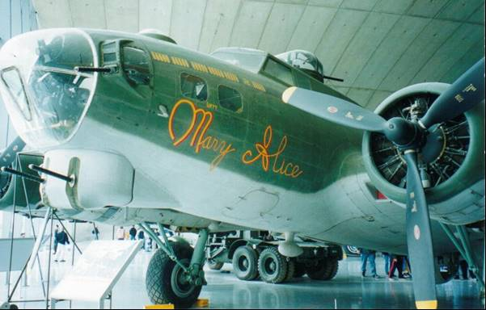

Photo 10. Boeing B-17G-35-BO “Mary Alice” Fuel markings.

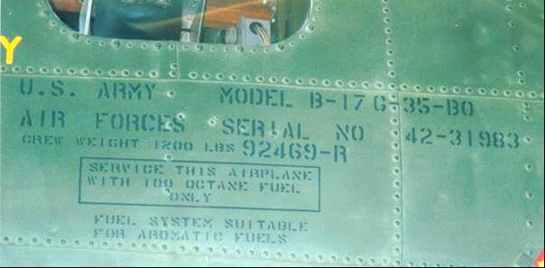

The notation states “SERVICE THIS AIRPLANE WITH 100 OCTANE FUEL ONLY” “FUEL SYSTEM SUITABLE FOR AROMATIC FUELS”. The markings are located just above the aircraft nose art “Mary Alice”. This aircraft was built in 1942.

Photo . U.S. Army Liberator B-24 5FO markings

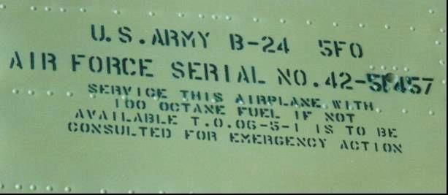

This notation states “SERVICE THIS AIRPLANE WITH 100 OCTANE FUEL IF NOT AVAILABLE T.O. 06-5-1 IS TO BE CONSULTED FOR EMERGENCY ACTION”. The reference to T.O. 06-5-1 is U.S. Army Air Force Technical Order 06-5-1 which details the conditions under which other grades of aviation gasoline may be used.

The problem of suitability of aromatic aviation gasoline fuels extended to all components of the aviation fuel system – from the fuel tanks, delivery lines through to the engine. Consequently, all components in the fuel system were marked to indicate their suitability.

Photo . P-51 Mustang

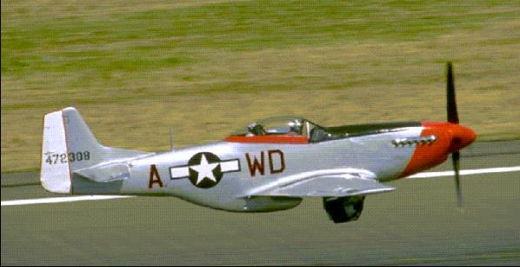

The fuel tanks which are mounted in the wing of this aircraft are self-sealing (i.e. in case of damage from bullets or shrapnel there is some capability to minimise gross leakage of highly inflammable fuel).

Photo . P-51 Mustang wing fuel tank (on display at Caboolture Warplane Museum, Qld, Australia 2002)

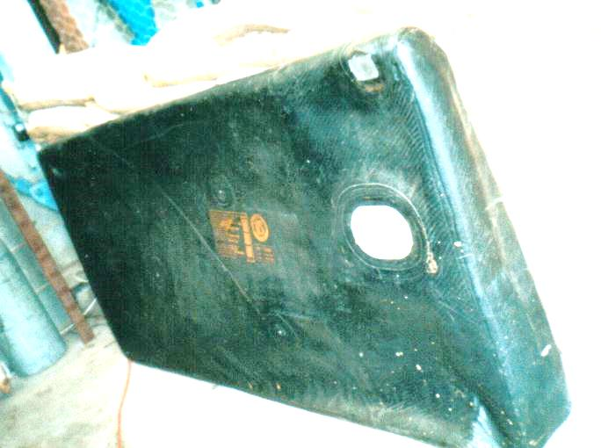

Label

The orange label states ‘NORTH AMERICAN P-51 WING FUEL TANK’ ‘TANK, FUEL, SELF-SEALING …..‘SUITABLE FOR AROMATIC FUEL’. This particular fuel tank was made by the United States Rubber Company in 1944.

Photo . Label on wing fuel tanks of P-51 Mustang. Note ‘Suitable For Aromatic Fuel’

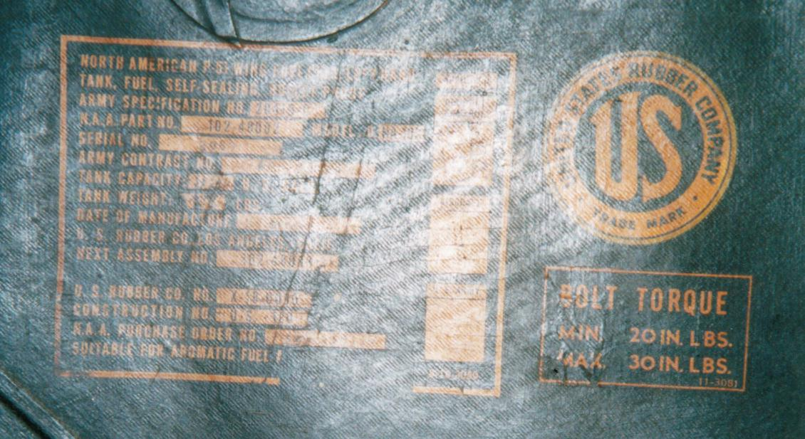

# Index

1

100 OCTANE FUEL ONLY 7

A

aircraft fuel system 3

Allies 3

American 6

anti-knock rating 6

Anti-knock value 6

aromatic aviation gasoline fuel 8

aromatic fuel 6, 9

aromatic hydrocarbons 6

Australian 6

avgas 115/145 7

aviation fuel system 8

aviation gasoline 6

Axis 3, 4

B

B4 4

Beaufort bombers 6

Benzene 6

Boeing B-17G 7

boiling range 6

British 3, 6

C

Caboolture Warplane Museum 9

CASTROL ‘R’ CASTOR 3

corrosion properties 6

D

Darwin 6

Duxford U.K. 7

F

Fisherman’s Bend (Victoria) 6

freezing point 6

FUEL 80 OCT 3

fuel lines 6

FUEL SPEC DRG. Z.3834/12 G5/72355 16/2/39’ 4

G

German 4, 6

German Me-109 5

Gloster Gladiator 4

Government Aircraft Factory 6

H

Hawker Cygnet 3

Hendon 3

Hendon 4

high aromatic fuels 6

I

Italian 4

L

laboratory solvent 6

leakage 6, 8

Liberator B-24 8

light aircraft 6

low aromatic 6, 7

low grade fuels 6

M

Macchi C202 5

N

NASM Washington 5

non-aromatic fuels 6

Norway 4

O

Octane number 87 4

P

P-47 Thunderbolt 1

P-51 Mustang 5, 8, 9

R

rubber 6

rubber components 6

rubber shrinkage 6

S

self-sealing 8, 9

solvency effect 6

Solvent 6

SPEC D.ENG/RD 2485 3

specification 3

Stability 6

SUITABLE FOR AROMATIC FUEL 9

swelling 6

T

Technical Order 06-5-1 8

U

United States Rubber Company 9

unsaturated hydrocarbons 6

V

Vapour locking tendency 6

Volatility 6

W

wing fuel tank 9