Chapter

14

Caribbean & West Indies 1940-1945

The World is at War

Photo . Curaçao Refinery (circa 1970)

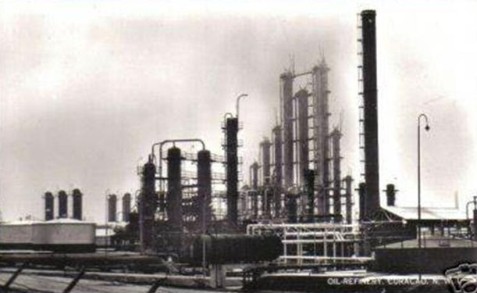

Table of Contents

The Oil Industry Gets Organised 3

Oil Companies And Refineries 3

Caribbean Refining Operations 4

Curaçao 5

Trinidad 6

Aruba 8

US Dollars And British Crude Purchases 9

US Government & UK Treasury Memos 10

Arrangements For Lend-Lease Crudes 10

Gasoline Off-Take From Trinidad Leasehold Limited 13

Other Trinidad Projects 14

Overseas Supply 14

Epilogue For Caribbean War Effort 15

Index 16

Research Sources 18

Caribbean & West Indies contribution to Avgas production

The period of diversified avgas production.

As the clouds of war were looming in Europe the British knew that relying on America as the sole source of aviation gasoline supplies may not be prudent, and so in the late 1930’s plans were under consideration for the production of aviation gasoline in the U.K., and also in the British and Dutch controlled refineries both in the West Indies and East Indies. The closest overseas supply of aviation gasoline, after the U.S., was that from the Caribbean and West Indies. Here the refineries were close to the vast crude supplies of Venezuela (a neutral country), and there was no threat of air attack, although attacks on shipping were to be a major threat.

# The Oil Industry gets organised

As discussed in previous chapters the British Government and oil industry developed plans for the supply of petroleum products in the event of war with Germany. This also included plans for the British controlled operations in the Caribbean and West Indies region. These activities continued on the British side throughout 1939 to 1941 until the Americans were drawn into the World War, at which time the Americans formed their own organizations such as the Petroleum Administration for War (PAW).

From 1942 onwards the Allies, through the various petroleum committees, cooperated to supply the Allied armed forces with the petroleum products they required. This is described in the chapter on PAW. Part of their work was to support the production of overseas refining operations in particular those controlled by American interests, however it extended to other Allied facilities. This support entailed organisation and delivery of specialised refinery equipment, scheduling of crude and finished product tankers to deliver crude and load the petroleum products.

# Oil Companies and Refineries

The war brought a new dimension to oil companies and their trading. That dimension was foreign country balance of payments. This divided the Allied countries into “Sterling” and “US Dollar” operations, and as detailed earlier would play an important part in British thinking is determining where avgas would be produced and supplied.

Table 1. Aviation gasoline and Blendstocks from British controlled refineries in 1945.

|  |  |  |  |  |  |
| --- | --- | --- | --- | --- | --- |
| Product Estimated Bbls/day 1945 | Abadan | Curaçao | TLL Trinidad | UBOT Trinidad | U.K. |
| Avgas 100/130 | 27,700 | 11,600 | 4,800 | - | 11,850 |
| Avgas 91/96 | - | - | - | - | - |
| Avgas 87 | 4,500 | 1,200 | 200 | 70 | - |
| Polymers |  | 900 |  |  |  |
| Super AVARO/Butene |  | 500 |  |  |  |
| AVARO |  | 1,900 |  |  |  |

UBOT was United British Oilfields of Trinidad (UBOT) established in 1913.

TLL was Trinidad Leaseholds Ltd., also in stablished 1913.

Figure . Caribbean Sea showing location of Curaçao, Aruba and Trinidad

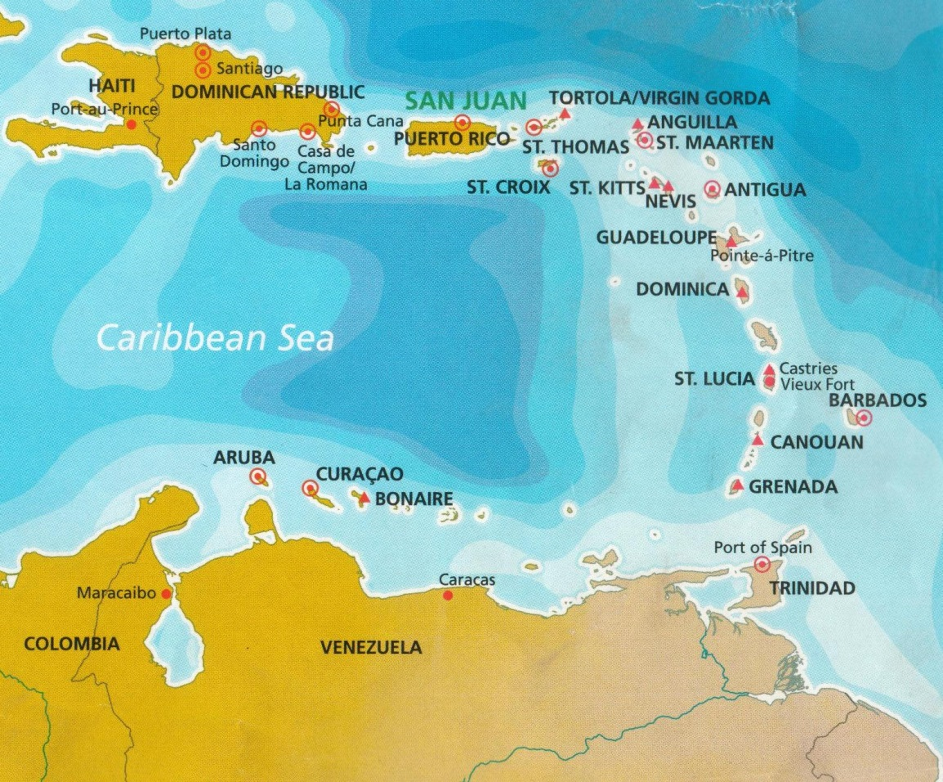

# Caribbean Refining Operations[1]

Following the first submarine attack against Allied shipping in the Caribbean, accompanied by the shelling of shore installations at Aruba in February 1942 and the continued loss of shipping early in 1942 from attacks by German submarines, plans for making the most effective use of Caribbean refineries were brought forward. As a result, in June a formal plan of action was developed which in turn led to the formal establishment of the Caribbean Area Petroleum Committee (CAPC) on November 1942. This was followed by the formation of a subcommittee on refining for the purpose of further unifying the operations of the various companies so that they, for all practical purposes, operated as a single company.

While this arrangement was in place, the British controlled refineries were operated in such a way as to produce the maximum possible quantity of critically needed war products such as aviation gasoline and high-octane gasoline for motor vehicles. There was also a financial concern by the British to maximise production from British controlled operations or specifically ‘Sterling’ refineries in order to minimize the currency imbalance caused by purchasing ‘US Dollar’ product.

There were three main regions in the Caribbean and West Indies where petroleum products and in particular aviation gasoline were produced. These were:

**Curaçao,** which had a large refinery and was close to the Venezuela crude supplies. It was operated by the British-Dutch Shell Company.

**Aruba** which had a large refinery operated by Standard Oil Company of New Jersey.

**Trinidad** which had a number of facilities operated by the British controlled Trinidad Leasehold Limited. (TLL).

# Curaçao

CURAÇAO, the largest of the five islands comprising the Netherlands Antilles, lies in the Caribbean Sea 60 km off the Venezuelan coast at a latitude of 12°N, outside the hurricane belt. It is 65 km long and 11 km at its widest, with an area of 448 square km.

Thornton Project - Curaçao[2].

Only two wartime projects in the Caribbean area provided for increased crude oil distillation capacity. One was the plant improvements at Caripito to increase the crude processing capacity and produce more Navy Special Fuel Oil. The other was at Curaçao, called the “Thornton Scheme” which was the re-erection of equipment, which had been dismantled early in the war and transferred to Curaçao from the partially completed Shell Company refinery at Thornton, England. The cracking and distillation plants transferred from Thornton (U.K.) did not function until May 1945, and permitted and increased the refinery’s crude processing capacity by 18,000 BSD. Originally recommended on the basis of a potential increase in production of 80-Octane gasoline (10,800 BSD), the flexibility of the new units was such that their operating program as finally developed resulted in a 2,200 BSD increment of 100-Octane gasoline production, with 34,500 BSD increase in crude throughput.

Aviation Project- Curaçao

Three main aviation gasoline projects were undertaken at Curaçao. The first two were an alkylation-isomerization plant, and a Cumene plant. Construction was completed in the second quarter of 1944, and raised the total output of 100-Octane gasoline at Curaçao to approximately 10,000 BSD (1.6 million Litres/day). Because of defective materials the Cumene plant worked well below its rated capacity of 50,000 tons/year and was shut down in the later months of 1944. It did not reach full output until the spring of 1945 (April-June).

The third major project was the Curaçao so-called Alkylation III, made possible an increase of 6,700 BSD (1 million Litres/day) in output of 100-Octane gasoline. It was completed near the end of 1945.

The refinery at Curaçao was operated by Shell. The aviation gasoline output is listed in Table 1.

Table 2. Aviation Gasoline Output from Curaçao

|  |  |  |
| --- | --- | --- |
| Year | Thousand tons | Million Litres |
| 1942 | 57 | 59 |
| 1943 | 99 | 102 |
| 1944 | 230 | 238 |
| Sept 1944 - June 1945 | 306 | 317 |

In addition to the manufacture of aviation gasoline, the refinery at Curaçao was also a supplier of feedstock for other installations; in 1941 the Shell Stanlow Refinery in the U.K. manufactured 32,000 tons/year of iso-octane by hydrogenating octylenes shipped from Curaçao.

The situation at Curaçao in 1945 was as follows:

Avgas 100 included Cumene, but no “AVARO”

Alkylation III commencing operation 1st. March 1946

Avgas 100/130 reduced to 5,000 tons/month

The Cumene Plant at Curaçao was expected to produce 50,000 tons/year. It required 40,000 tons of pure or 1oBenzole, its operation was increased and avgas production was expected to be 164,000 tons/year. The highest quality benzole was obtained by re-running motor spirit benzole at Stanlow, U.K.

Cumene was also manufactured at Abadan from Benzole shipped from India 4,000 tons/year and Australia where availability was 20,000 tons/year, part of which was shipped to California. Benzole was also shipped from Soviet Union.

‘AVARO’’

One aviation gasoline blendstock which appeared to only have been produced at Curaçao, was “AVARO” which was described as a highly aromatic extract produced in surplus quantities at Curaçao, and transferred to Trinidad and Aruba. ‘Avaro’ had a high rich mixture response and enabled refineries to stretch out their supply of alkylates for Avgas 100.

The ‘Avaro’ process is a two-pass or severe single pass thermal reforming operation. The product is generally heavily acid-treated for removal of olefins. The redistilled product had an aromatic content of 70 to 95%, an octane number of 85-95 and a high rich mixture rating.

Problems with different specifications

In June 1945, Memo No. 33/45 from Dr. F. B. Thole of Ministry of Fuel and Power, Petroleum Division to the Petroleum Products London Assignment Committee discussed the subject of manufacturing specifications to which Curaçao should work. This matter was raised directly with the Asiatic (Esso oil company). Asiatic had instructed Curaçao to manufacture in future 100/139 Grade to meet AN-Y-28 specification. It is however, somewhat unfortunate that this decision had been taken, and it would seem that the differences between the two Specifications AN-F-28 and D.E.D. 2475 should have been satisfactorily settled right at the very beginning rather than expect Curaçao to produce aviation gasoline at several different specifications.

# Trinidad[3]

In 1913, former sugar estates in the area were purchased for plans to build a refinery by Trinidad Leaseholds Ltd, a British subsidiary of Central Mining Company headquartered in the United Kingdom. In 1917, the refinery was built and began production at 75,000 barrels of oil per day. Its first upgrade occurred in 1928 with the construction of the No 3 and 4 Topping plants. During World War II the refinery was identified as an asset to be "protected at all cost" as a major supplier of aircraft fuel for the Allied forces. By 1940, the refinery went through another expansion, a top-secret project known as Project 1234 and by May 1942, the first Catalytic Cracking Unit came on stream where refining capacity in Trinidad and Tobago was recorded at 28.5 million barrels per year. At the end of World War II, the refinery was recognized as the largest in the British Empire.

The old refinery consisted of Topping Units, two Vacuum Units, a Dubbs Thermal Cracking Unit, a Fluidised Catalytic Cracking Unit (FCCU), an Alkylation Unit with an associated Isomerisation Unit and a Sulphuric Acid Plant and a Sulphur Production Plant. The area where the FCCU, the Alkyl and Isom Units were located was known as the Eastern Refinery. It was built by the British War Department in 1941 as a means of providing high octane gasoline for the Royal Air Force during World War II. Of the four Alkylation units of that design built at that time, only the Pointe-a-Pierre Refinery unit survived, to be shut down for replacement recently. The other three were said to have burned to the ground. The sulphuric acid plant provided sulphuric acid which was used in the alkylation process.[4] The sulphur production unit was to convert the sour gases hydrogen sulphide into elemental sulphur.

In 1956, Trinidad Leaseholds Ltd was acquired by Texaco where by April 1960, the No 8 Topping Unit came on stream along with a lubricating oil plant, canning plant and a paraffins plant with production increasing and peaking to 360,000 barrels per day by 1970. Following the unrest of the 1970 Black Power Revolution, throughput was down to 183,000 barrels per day yet the refinery continued to be viable. By late 1984, Texaco assets including the refinery was acquired by the State and placed under the state company Trintoc, which itself was merged to form Petrotrin in 1993. By 1997, upgrades to infrastructure, instrumentation, and environmental systems were completed. This was done to improve product quality by reducing the sulphur content and increasing the octane of gasoline blendstocks, and increasing production from 90,000 to 160,000 barrels per day. More upgrades were done on the plants as recent as 2011. By being the only refinery in operation in the Caribbean, Trinidad & Tobago became the supplier of refined petroleum products to the rest of the region.

The refinery had a capacity of 190 thousand barrels per day (30,000 m3/d) and it was the only refinery in the world that operated alongside a wildlife park.

Petrotrin became the embodiment of poor corporate governance, expressed in bad policy decisions, wastage, corruption and nepotism across governments. The Oilfield Workers’ Trade Union’s power over the company due to consolidation of past state oil companies made it even more difficult for management to institute changes. On 28 August 2018, it was announced by Prime Minister Dr Keith Rowley that Petrotrin would have to be shut down because of the company's inability to generate a profit during a period of low oil prices where TT$8 billion was lost over five years. Also cited by the government was lack of competitiveness, declining production, TT$12 billion in debt, and the loss of foreign exchange due to the importation of oil to be used, together with locally produced oil to keep the refinery in operation. A cash injection of $25 billion would be required to refresh its infrastructure and repay its debt. On 30 November 2018, Petrotrin was shut down with the country's largest refinery officially closed after 101 years in operation. Approximately 5,500 permanent and temporary/casual employees lost their jobs.

Photo 2. Trinidad Refinery

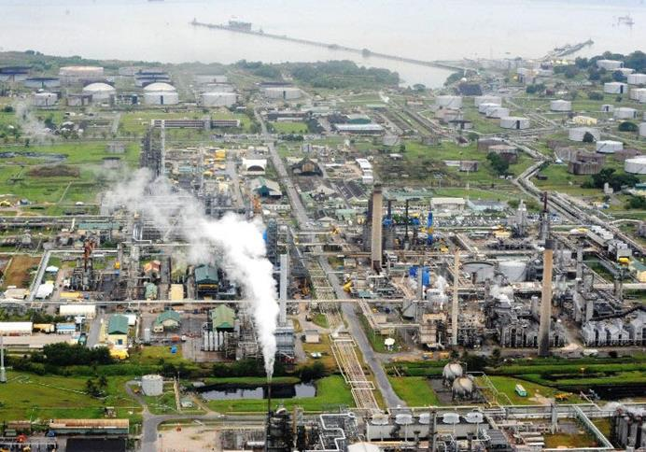

# Aruba

Photo 3. Dutch soldier guarding refinery, Lago Oil and Transport Co. Ltd., Aruba.

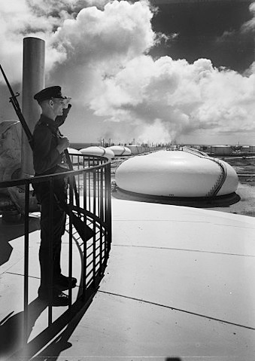

In 1929, the Lago Oil and Transport Company, a subsidiary of Standard Oil Company of New Jersey, built a large refinery at the south-eastern tip of the island. The Lago Refinery became the largest in the world, assuring Aruba its place as one of the most prosperous islands in the Caribbean. The refinery was sold to Coastal Corporation and is operational today (2000).

In 1928, Royal Dutch Shell built the Eagle Oil Refinery and this was immediately followed by a refinery built by Lago Oil and Transport Company Ltd. in San Nicolas. Royal Dutch Shell ceased its operations in 1953, after serving as a depot for both refineries during the Second World War. In 1932, the Standard Oil Company of New Jersey (Esso) took over the Lago Refinery. The refinery employed well over 8,000 people, 16% of Aruba’s population, and up until the 1970’s was one of the largest in the world.

In 1948 biggest refinery in the world was in Aruba - Netherland West Indies, this was the Lago Oil & Transport Refinery 400,000 BSD with a 200,000 BSD Cracker.

On Tuesday, February 16, 1942 the German submarine U-156[5] shelled the oil refinery on Aruba. The attack was unsuccessful and the result was a dent in a large storage tank and a hole in a house.

[*Aruba attack - during its second patrol, U-156 participated in ‘Operation Neuland’, which intended to disrupt traffic in the Caribbean; and included an attack on the oil refinery at Aruba island, ordered by Captain Hartenstein. At the beginning of the attack on the Lago Oil and Transport Company, San Nicolas refinery, the deck gun exploded because the cap or tampion in the muzzle of the gun, which prevented water from entering the barrel, was not removed before firing. This accident saved what was at the time the world’s largest refinery. As a result of the accident, Matrosengefreiter (equivalent to Able Seaman or Leading Seaman) Heinrich Bussinger was killed, and Gunnery Officer Dietrich von dem Borne lost his right leg in the explosion. He was taken below and the boat submerged and left the waters off the coast of Aruba. Von dem Borne was put ashore on the island of Martinique for medical treatment and survived the war. The stop at Martinique, at the time part of Vichy France contributed to the worsening of diplomatic relations between the USA and Vichy France.]*

Photo 4. Aruba refinery under attack from German U-boat 1942.

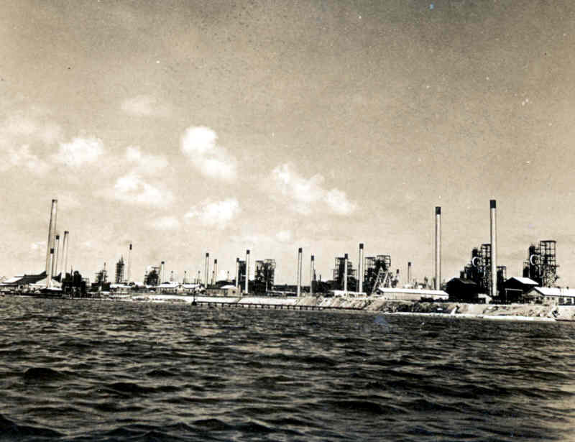

Aviation Gasoline Projects - Aruba

Two major aviation gasoline projects were built at Aruba. The first provided for a gas recovery plant and alkylation plant; the second was a complete aviation facility including isomerization and alkylation units and a catalytic cracking plant. Aruba Refinery was operated by Standard Oil Company of New Jersey (Esso, later known as Exxon). In 1942 two alkylation units and a catalytic cracking unit were under construction with a total capacity 550,000 tons/year of Avgas 100. Construction was completed and in operation in spring (March-May) 1944. All of these facilities, plus isomerization units, were in operation early in 1944, bringing Aruba’s 100-Octane gasoline output to approximately 13,500 BSD (over 2 million Litres/day). The first alkylation plant was installed in 1939. The aviation gasoline output during the war years is listed in Table 2.

Table 3. Lago on Aruba -Aviation Gasoline Output

|  |  |  |
| --- | --- | --- |
| Year | Thousand tons | Million Litres |
| 1943 | 302 | 312 |
| 1944 | 505 | 522 |
| July 1944 - June 1945 | 502 | 519 |

# US Dollars and British Crude Purchases

In a memo from the British Embassy in Washington the following outlines some of the issues with the British purchasing crude in US dollars. [6]

*Washington to Ministry of Fuel and Power from Earl of Halifax 24th April 1946*

*For Butler from LeButt (British Embassy)*

*Your telegram No. 163*

*Shell’s draft affidavits and declarations discussed with (US) State Department. Generally the statements appear satisfactory. Bud Howard wishes to give them a little further study in order to avoid any hold-up with G.A.O. and he has promised a quick reply.*

*2. It was a bit of a nuisance that reference to the Arend refinery at Aruba had to be introduced in the affidavits as all our calculations are based on Curaçao refinery operations and offtakes. In answer to enquiries I explained that inclusion of Arend, no doubt, related broadly to the Shell’s general refinery operations and that for our purpose we had assumed that all the dollar crudes had been refined at Curaçao or pre-treated at San Lorenzo. The Americans seemed fairly satisfied at this point and I breathe again. Actually I understand that while all the straight dollar purchase crudes are processed at Curaçao the royalty crudes bought from the Venezuelan production and are shipped either to Curaçao or Arend.*

*3. What is the position of dollar affidavits in respect of Trinidad and Bahrein? Are we right in assuming you are fixing these in London?*

*4. You will remember I gave you a copy of the final clause of the statement we have to sign which certifies that crude to the value of 30 million dollars was paid in dollars by His Majesty’s Government from our point of view, the form of words was unsuitable and the Americans are therefore anxious to know as soon as possible what alternative clause you suggest. Please advise.*

*5. Your telegram No. 164. The role of Oliver Twist at this late hour was not a particularly happy one, but the American reception was not unfavourable, and judging from preliminary soundings the prospects of getting another million dollars are pretty fair. I am dealing with this matter in a separate telegram.*

# US Government & UK Treasury memos

The following memo discusses the arrangements between the US and UK governments regarding output of petroleum products and payments in the allied war effort.[7]

*United Kingdom Treasury Delegation*

*Box 680 Benjamin Franklin Station Washington D.C.*

*(from Frank G. Lee, cc LeButt British Embassy to Ernest Rowe-Dutton)*

*April 5th 1946*

*Mr. Ernest Rowe-Dutton, C.B. H.M. Treasury*

*The Government of the United States reaffirms the arrangement made in 1944 in connection with the combined decision of the Governments of the United Kingdom and of the Unites States to expand the output of petroleum products in Curaçao, Trinidad and Bahrein for use in the Allied war effort, and will complete the payments due to the Government of the United Kingdom when the amounts are determined. (estimated at $38 million).*

*British companies (Asiatic Petroleum Company Limited, Anglo-Saxon Petroleum Company Limited bought crude through American intermediaries Asiatic Petroleum Corporation, Caribbean Petroleum Incorporated, Colon Development Limited and Venezuelan Oil and Concession Limited.*

# Arrangements for Lend-Lease Crudes

The following memo illustrates the arrangements regarding crude purchases from various sources in South America under Lend-Lease.[8]

*Office of The British Petroleum Representative in the U.S.A.*

*August 10th 1945*

*No. 108*

*M.R. Bridgeman, Esq., Ministry of Fuel and Power Petroleum Division, Dean Stanley Street, London S.W.1*

***Lend-Lease Crudes for Curaçao Trinidad and Bahrein***

*As we informed you in Elfunocop 726 we have at last after much discussion, submitted requisitions in respect of the above as follows:*

***CURAÇAO***

|  |  |  |
| --- | --- | --- |
| *Shell’s straight dollar purchase of light Venezuelan Crude Oil From 1st December 1944 to 15th June 1945.* | *8,812,235 Bbls* | *$10,263,160* |
| *Royalty payment of 16 2/3 % to Venezuelan Government on Shell’s production during Dec 1944/March 1945.* | *3,773,529 Bbls* | *$2,618,447* |

***TRINIDAD***

|  |  |  |
| --- | --- | --- |
| *Jusepin Crude purchased by Trinidad Leaseholds from 13 Feb to 16 May 1945* | *979,331 Bbls* | *$1,075,460* |

***BAHREIN***

|  |  |  |
| --- | --- | --- |
| *Saudi Arabian Crude purchased by Bahrein Petroleum Company from 1st Dec (1944) to 30th April 1945* | *6,060,563 Bbls* | *$6,358,603* |

*As regards (1) and (3) we claimed that these crudes were purchased solely to produce products which were shipped 100% to Lend-Lease and Reciprocal Aid areas. With regard to (2) we calculated that 77% of Curaçao offtake went to Lend-Lease and Reciprocal Aid destinations and therefore claimed that percentage of the dollar expenditure involved. As regards (4) we claimed shipments to commercial areas were more than met from the production of Bahrein crude and therefore all the Saudi Arabian crude was eligible for Lend-Lease.*

*From 1st December (1944) Curaçao processed twenty different types of crude and Officina crude for instance is partly Shell’s own production and partly bought for dollars and not identifiable in the crude tanks nor in the refinery reports.*

*In addition, the Shell purchase-*

*North Venezuelan Petroleum Company’s share of Cumerabo Royalty Crude*

*British Controlled Oilfields’ Royalty Crude*

*[comments on crude type demand for Curaçao and availability of crudes to East Coast US Refineries.]*

*Cumarebo and Netick Crude Oils for the Curaçao Refinery (Light Eastern Venezuelan Crude)*

*Curaçao also process Shell’s own light crude oil fields, e.g. La Paz*

*Heavy Mene Grande and Light-Medium Mene Grande Crudes for the San Lorenzo Refinery (Argentina)*

*Trinidad Leasehold 10,000 barrels per day of Jusepin Crude under lend-lease.*

***Curaçao***

|  |  |  |  |  |  |
| --- | --- | --- | --- | --- | --- |
| *Product* | *Officina* | *Netick* | *Cumarebo* | *Heavy Mene Grande* | *Light Medium Mene Grande* |
| *Avgas & “All Purpose” Gasoline components* | *19.9* | *14.6* | *36.9* | *8.0* | *11.2* |
| *US Navy Special Fuel Oil components* | *71.6* | *77.5* | *50.7* | *85.5* | *81.2* |
| *Refinery Fuel and Loss* | *8.5* | *7.9* | *12.4* | *6.5* | *7.6* |

*Yield of aviation and “All Purpose” Gasoline components derivable from the fourth quarter 1944 dollar crude purchases would have been around 20% of about 3,250,000 barrels of such crude of about 650,000 barrels. This compares with total shipments of aviation and “All Purpose” gasolines during the same period of about 2,500,000 barrels.*

*Details of Actual Offtake October – December 1944*

*No aviation gasoline to Australia or New Zealand*

*Total Offtake 100 Octane 710,000 barrels, 90/ 91 Octane 3,000 barrels, 87 Octane 219,100 barrels. (Total 923,100 barrels)*

*(Comment: As can be seen the majority of aviation gasoline was 100-octane (76.2%), 87-octane (0.3%) and 90-octane (23.5%)*

*Leaded “Bara” Australia 322,500 Barrels*

*Details of Actual Offtake January, February, with March (estimate) 1945*

*No aviation gasoline to Australia or New Zealand*

*Total Offtake 100 Octane 870,000 barrels, 90/ 91 Octane 3,000 barrels, 87 Octane 124,100 barrels. (Total 997,100 barrels).*

*(Comment: As can be seen the majority of aviation gasoline was 100-octane (87.3%), 87-octane (0.3%) and 90-octane (12.4%)*

*Leaded “Bara” Australia 221,000 Barrels*

Photo 5. Trinidad Refinery

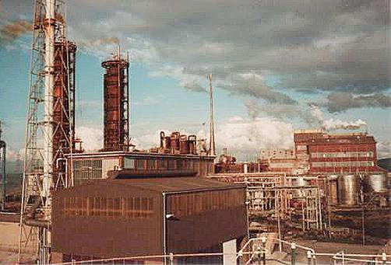

# Gasoline Off-take from Trinidad Leasehold Limited

The following lists the gasoline off-take to the various destinations from the British owned facilities -Trinidad Leasehold Limited (TLL) during 1944 and 1945. These are the various grades of aviation gasoline, motor gasoline and blending agents.

*Trinidad Leasehold Limited Actual Offtake by Destination 1st March-31st August 1944*

*Barrels (42 US Gallons) Table 4. Gasoline Off-take 1944*

|  |  |  |  |  |  |
| --- | --- | --- | --- | --- | --- |
| *Destination* | *Aviation Gasoline* | | | *Motor gasoline* | *Blending diluent* |
| *100 Octane* | *91 Octane* | *73/87 Octane* |
| *United Kingdom (Direct)* | *67,483* |  |  | *832,686* |  |
| *Halifax Storage* |  |  |  | *73,949* |  |
| *British Armed Forces* |  |  |  | *327* |  |
| *U.S. Armed Forces* | *551,299* | *6,771* | *688* | *60,184* | *50,613* |
| *Brazil* |  |  |  | *789,168* |  |
| *Freetown West Africa* |  |  |  |  |  |
| *Curaçao - N.W.I.* |  |  |  |  |  |
| *Guianas - British, French, Dutch* |  |  |  | *23,970* |  |
| *Islands - Caribbean Area* | *17,045* | *5,813* | *7,695* |  |  |
| *Commercial Bunkers* |  |  |  | *51,699* |  |
| *Local Consumption* |  |  |  |  |  |
| *U.B.O.T. Refinery, Trinidad* |  |  |  | *96,569* |  |
| ***Total*** | ***635,827*** | ***12,584*** | ***8,383*** | ***1,928,552*** | ***50,613*** |

*Trinidad Leasehold Limited Actual Offtake by Destination 1st March-31st August 1945*

*Barrels (42 US Gallons) Table 5. Gasoline Off-take 1945*

|  |  |  |  |  |  |
| --- | --- | --- | --- | --- | --- |
| *Destination* | *Aviation Gasoline* | | | *Motor gasoline* | *Blending diluent* |
| *100 Octane* | *91 Octane* | *73/87 Octane* |
| *United Kingdom (Direct)* | *32,012* |  |  | *195,225* |  |
| *Halifax Storage* |  |  |  | *100,646* |  |
| *British Armed Forces* |  |  |  | *759* |  |
| *Allied Forces H.Q. and Caserta* | *134,368* |  |  | *103,012* |  |
| *U.S. Armed Forces* | *837,242* | *1,650* | *172* |  |  |
| *Brazil* |  |  |  |  |  |
| *Freetown West Africa* |  |  |  |  |  |
| *Curaçao - N.W.I.* |  |  |  |  | *41,497* |
| *Guianas - British, French, Dutch* |  |  |  | *28,532* |  |
| *Islands - Caribbean Area* |  |  |  | *56,082* |  |
| *Commercial Bunkers* |  |  |  |  |  |
| *Local Consumption* | *13,366* | *9,982* | *6,830* | *108,029* |  |
| ***Total*** | ***1,016,988*** | ***11,632*** | ***7,002*** | ***592,285*** | ***41,497*** |

The following lists the various crudes and products from the British owned facilities -Trinidad Leasehold Limited (TLL) refinery program in 1945.

*Trinidad Leasehold limited Refinery Programme Jan 5, 1945*

*Barrels per day Table 6. TLL Refinery Programme*

|  |  |  |
| --- | --- | --- |
| ***Refinery input*** | ***Without Jusepin*** | ***With Jusepin*** |
| *Trinidad Crude* | *34,533* | *34,533* |
| *Jusepin Crude* | *-* | *10,000* |
| *Quiritops ex Caripito* | *593* | *940* |
| *Jusendee ex Caripito* | *1,947* | *-* |
| *P.D. blend ex Caripito* | *1,940* | *2,175* |
| *E.N.D. ex U.B.O.T.* | *1,400* | *1,400* |
| *Apex Casinghead (Gasoline)* | *243* | *243* |
| *Avaro ex Curaçao* | *400* | *400* |
| *Butane ex Curaçao* | *77* | *77* |
| *91 Octane ex U.B.O.T.* | *117* | *117* |
| ***Total*** | ***41,250*** | ***49,885*** |

*Table 7. TLL Refinery Production*

|  |  |  |
| --- | --- | --- |
| ***Products*** | ***Without Jusepin*** | ***With Jusepin*** |
| *Aviation 100 Octane* | *4,747* | *4,793* |
| *Aviation 87/91 Octane* | *117* | *117* |
| *Motor Gasoline "All purpose"* | *2,700* | *3,333* |
| *Motor Gasoline other* | *8,167* | *7,333* |
| *Burning Kerosene* | *360* | *360* |
| *U.S. Navy Diesel Oil (45 Cetane)* | *-* | *3,333* |
| *Gas Oil* | *667* | *986* |
| *Marine Diesel Oil* | *500* | *500* |
| *Navy Special Fuel Oil* | *18,270* | *22,842* |
| *Surplus Fuel Diluent* | *1,370* | *637* |
| *Plant Fuel* | *800* | *800* |
| *Gas and Loss* | *3,552* | *4,851* |
| ***Total*** | ***41,250*** | ***49,885*** |

# Other Trinidad Projects

Aside from these major projects above, priority was also obtained for several smaller additions of equipment as a part of the aviation gasoline program. At Pointe-a-Pierre, Trinidad.

# Overseas supply

New Zealand supply

The British delegation was responsible for supply to the dominions of the British Empire. This included New Zealand. The situation in 1943 was as follows:

New Zealand 1st. March 1943, the stock of 100 Octane aviation gasoline was 194,000 Bbls which was equal to 34 months consumption; this was due to shipment by U.S. Navy. The stock of 87 Octane aviation gasoline was 152,000 Bbls equal to 7½ months consumption. Supply source not stated.

However, the supply position could alter if and when Abadan had surplus supplies (Abadan was a ‘Sterling’ refinery). This was considered outside the usual supply requirements, but it was not included in British supply position as it was assumed America will supply avgas to New Zealand as this was part of the South West Pacific (SWP) area in which the U.S. Navy and U.S. Army were operating.

Australian supply

While the majority of supply to Australia was from the West Coast of U.S.A. There were occasionally shipments from the Gulf region of the U.S.A., and also from the Caribbean, however those from the ‘Sterling’ refineries were to be balanced by an allocation or exchange between U.S.A. and U.K. - the ‘Sterling’ U.K. controlled’ vs ‘Dollar-U.S. controlled’ dilemma.

Aviation Spirit was shipped from Curaçao to Australia as a direct allocation or exchange for U.S.A. to U.K. This was noted in the following cables[9]:

25 April 1944 Aviation supplies to Commonwealth of Australia ex NWI (predicted)

1944 349,000 tons

1945 424,000 tons to be met from Aruba/Curaçao and the balance from USA.

Curaçao (Sterling source), Aruba (Lend Lease source).

Nearly 50% of Australia requirement could be met from Curaçao, but would lead to reduction in UK requirements.

17 July 1944 Cable NY to Ministry of Fuel & Power No. 999

July 1944 61,000 Bbls Avgas 100 ex Curaçao to Australia. During March and April 1944 lifting from US Gulf for shipment to Australia/India.

August 1944 Avgas 100 Octane from Curaçao for New Guinea (arrived half to Shell Co. and half to Standard Vacuum Oil Co.). As noted earlier the two companies supplying aviation products in Australia were the Standard-Vacuum Oil Co. and the Shell Company. These companies also supplied the armed forces in New Guinea.

*October 1944 Supply 100,000 Bbls Avgas 91/96 from Trinidad to Australia*

*24 Dec 1944 Cable 873 from Ministry of Fuel & Power to Washington Airboard Melb. SWP Group I Australia.*

*The main source of supply is USA as in the case of Middle East I etc. it seems likely that some supplies may be drawn from Curaçao and at a later stage possible Abadan.*

*Australia comes under APPLAC* (Aviation Petroleum Production London Assignment Committee)*.*

*27 Dec 1944 Cable from Washington to UK Ministry of Fuel & Power - Earl of Halifax*

*Avgas requirements of South West Pacific and South Pacific theatres supplied from U.S. controlled sources. British Admiralty some Avgas supplies from SWP (South West Pacific) and SP (South Pacific) theatres may be drawn and indeed have been drawn from Curaçao (Sept 1944), it interferes with the Latin American distribution/allocation.* [The Latin American distribution/allocation was part of the PAW role for the world petroleum allocation.]

# Epilogue for Caribbean War Effort

The Caribbean and West Indies provided invaluable support to the 100-Octane program with substantial supplies at a time when the Allies were critically short. Perhaps more importantly for Britain, it protected to some extent, their U.S. currency reserves because they could make avgas at ‘Sterling’ refineries and not expend valuable American dollars in this war effort.

# Index

1

100 Octane 12, 13, 14, 15

100 Octane program 15

100/139 Grade 6

100-Octane gasoline 5, 9

1oBenzole 6

7

73/87 Octane 13

8

80-Octane gasoline 5

87 Octane 12, 14

87/91 Octane 14

9

90/91 Octane 12

91 Octane 13, 14

A

Abadan 3, 6, 15

acid-treated 6

Airboard Melb. SWP Group I 15

alkylate 6

Alkylation III 5

alkylation plant 9

Alkylation Unit 6, 9

alkylation-isomerization plant 5

All Purpose Gasoline 12

America 15

AN-F-28 6

Anglo-Saxon Petroleum Company Limited 10

AN-Y-28 6

Apex Casinghead 14

APPLAC 15

Arend refinery 10

Aruba 4, 6, 8, 9, 10, 15

Aruba island 9

Aruba Refinery 9

Asiatic 6

Asiatic Petroleum Company Limited, 10

Asiatic Petroleum Corporation 10

Australia 6, 12, 15

Avaro 6, 14

AVARO 3, 5, 6

avgas 3, 12, 15

Avgas 100 5, 6, 9, 15

Avgas 100/130 3, 5

Avgas 87 3

Avgas 91/96 3, 15

aviation gasoline 4, 5, 12, 13, 14

aviation gasoline program 14

aviation gasoline supplies 3

Aviation Petroleum Production London Assignment Committee 15

Aviation Spirit 15

B

Bahrein 10, 11

Bahrein crude 11

Bahrein Petroleum Company 11

Bara 12

Benzole 6

Black Power Revolution 7

blending agents 13

Blending diluent 13

Brazil 13

Bridgeman 11

Britain 15

British 3, 13, 15

British Admiralty 15

British Armed Forces 13

British controlled refineries 4

British Embassy 9, 10

British Empire 6, 14

British Government 3

British Petroleum 11

British War Department 6

British-Dutch Shell Company 4

Bunkers 13

Burning Kerosene 14

Bussinger 9

Butane 14

Butene 3

Butler 10

C

California 6

canning plant 7

Caribbean 3, 4, 8, 15

Caribbean Area Petroleum Committee (CAPC) 4

Caribbean Petroleum Incorporated 10

Caribbean Sea 5

Caripito 5

Caserta 13

catalytic cracking plant 9

Catalytic Cracking Unit 6, 9

Central Mining Company 6

Cetane 14

Coastal Corporation 8

Colon Development Limited 10

Cracker 8

cracking 5

crude oil distillation 5

Cumarebo 11, 12

Cumene 5, 6

Cumene Plant 5, 6

Cumerabo Royalty Crude 11

Curaçao 3, 4, 5, 6, 10, 11, 13, 15

Curaçao Refinery 1, 10, 11

D

D.E.D. 2475 6

distillation plants 5

dollar 12, 15

Dubbs Thermal Cracking Unit 6

Dutch 3, 8, 13

E

Eagle Oil Refinery 8

Earl of Halifax 10, 15

East Coast US Refineries 11

East Indies 3

Eastern Refinery 6

Esso 6, 9

Exxon 9

F

Fluidised Catalytic Cracking Unit (FCCU) 6

Freetown West Africa 13

French 13

Fuel Diluent 14

Fuel Oil 12

G

Gas Oil 14

gas recovery plant 9

gasoline 13, 14

gasoline blendstocks 7

German submarine U-156 9

German submarines 4

Germany 3

Government of the United Kingdom 10

Government of the United States 10

Guianas 13

Gulf region 15

H

Halifax Storage 13

Hartenstein 9

Heavy Mene Grande 11, 12

high octane gasoline 4, 6

highly aromatic extract 6

His Majesty’s Government 10

Howard 10

hydrogen sulphide 7

hydrogenating 5

I

India 6, 15

Isomerisation Unit 6, 9

isomerization 9

iso-octane 5

J

Jusendee ex Caripito 14

Jusepin Crude 11, 14

L

La Paz 11

Lago Oil & Transport Refinery 8

Lago Oil and Transport Company 8, 9

Lago Refinery 8

Latin American 15

LeButt 10

Lee 10

Lend-Lease 11, 15

Light Eastern Venezuelan Crude 11

Light Medium Mene Grande 11, 12

London 10

lubricating oil plant 7

M

Marine Diesel Oil 14

Martinique 9

Middle East I 15

Ministry of Fuel and Power 6, 10, 15

motor gasoline 13, 14

motor spirit 6

motor vehicles 4

N

Navy Special Fuel Oil 5, 14

Netherland West Indies 8

Netherlands Antilles 5

Netick 11, 12

New Guinea 15

New Zealand 12, 14

North Venezuelan Petroleum Company 11

O

octane number 6

octylenes 5

Officina 11, 12

Oilfield Workers’ Trade Union 7

olefins 6

Operation Neuland 9

P

paraffins plant 7

PAW 15

Petroleum Administration for War (PAW) 3

Petroleum Products London Assignment Committee 6

Petrotrin 7

Pointe-a-Pierre Refinery 6

Pointe-a-Pierre, Trinidad 14

Polymers 3

Project 1234 6

Q

Quiritops ex Caripito 14

R

Reciprocal Aid 11

refineries 3, 4

refinery 5, 8

Refinery Fuel 12

rich mixture rating 6

rich mixture response 6

Rowe-Dutton 10

Rowley 7

Royal Air Force 6

Royal Dutch Shell 8

S

San Lorenzo 10

San Lorenzo Refinery 11

San Nicolas 8, 9

Saudi Arabian Crude 11

Shell 5, 10, 11

Shell Company 5, 15

Shell Stanlow Refinery 5

South Pacific 15

South West Pacific 15

Soviet Union 6

Standard Oil Company of New Jersey 4, 8, 9

Standard Vacuum Oil Co. 15

Stanlow, U.K. 6

State Department 10

Sterling 3, 4, 15

submarine attack 4

sulphur 7

Sulphur Production Plant 6

Sulphuric Acid Plant 6

T

Texaco 7

thermal reforming 6

Thole 6

Thornton Project 5

Thornton Scheme 5

TLL 3

TLL Trinidad 3

Tobago 6

Topping plants 6

Trinidad 4, 6, 10, 11, 13, 15

Trinidad Crude 14

Trinidad Leaseholds Ltd 3, 4, 6, 7, 11, 13, 14,

Trinidad Refinery 7

Trintoc 7

U

U.B.O.T. 3, 14

U.B.O.T. Refinery 13

U.S. Armed Forces 13

U.S. Army 15

U.S. Navy 14

U.S. Navy Diesel Oil 14

U.S.A. 15

United British Oilfields of Trinidad (UBOT) 3

United Kingdom 13

United Kingdom Treasury Delegation 10

US Dollar 3, 4, 9

US Gulf 15

V

Vacuum Units 6

Venezuela 3, 4

Venezuelan 5, 10

Venezuelan Crude Oil 11

Venezuelan Government 11

Venezuelan Oil and Concession Limited 10

Vichy France 9

von dem Borne 9

W

Washington 9, 10, 15

West Coast 15

West Indies 3, 4, 15

# Research Sources

1. “A History of The Petroleum Administration for War 1941-1945” United States Government Printing Office Washington 1946 prepared by John W. Frey and H. Chandler Ide. Sourced from API Library Washington D.C. U.S.A.
2. UK Public Records Office, Kew, London Ref: UK PRO CAB 102/549 Aviation Spirit. Pre-War Planning, D J Payton-Smith.
3. Website <https://en.wikipedia.org/wiki/Petrotrin>
4. Memories of Pointe-a-Pierre by Tony Beaubrun, Chairman, ANSA Technologies Limited.
5. Website <https://en.wikipedia.org/wiki/German_submarine_U-156_(1941)>
6. UK Public Records Office, Kew, London Ref UK PRO POWE 33-803 British Production & Caribbean 1945-46.
7. UK Public Records Office, Kew, London Ref UK PRO POWE 33-803 British Production & Caribbean 1945-46.
8. UK Public Records Office, Kew, London Ref UK PRO POWE 33-803 British Production & Caribbean 1945-46.
9. UK Public Records Office, Kew, London Ref: UK PRO POWE 33/866