Chapter

16

Britain 1941-1944

Photo 1. Short Stirling Mk I. Bomber refuelling with avgas 100/130.

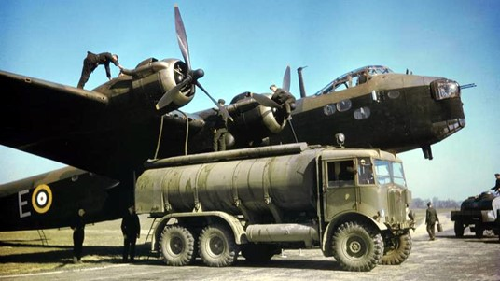

Table of Contents

Summary 3

This Is ‘Total War’ 4

The British Oil Industry Gets Organized 4

The Uk Avgas Distribution Network 5

Manufacturing Process In UK 12

Coal Tar Benzole 14

Benzole 14

Epilogue For 1941-1944 14

Index 15

Research Sources 17

Photo 2. Air Chief Marshall Sir Arthur ‘Bomber’ Harris – Head of R.A.F. Bomber Command, 1942

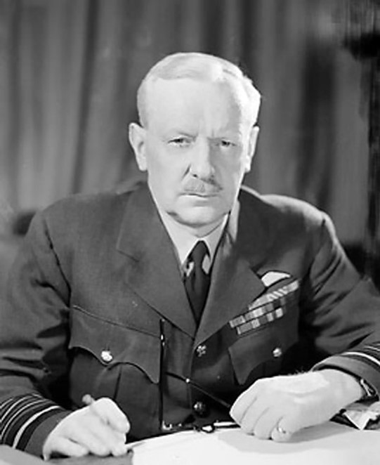

# Summary

During the period 1941 to 1944 the air war in Europe became one of a bomber offensive with the RAF bombing German occupied installations at night with their Lancaster, Halifax, Stirling and Wellington bombers. The U.S. Army Air Force ‘Mighty’ 8th Air Force conducted daylight bombing raids with their Boeing B-17 Flying Fortress and Consolidated B-24 Liberator bombers. This would require large volumes of aviation gasoline to sustain these operations; most of these supplies would come from America with a lesser contribution from four refineries in the UK and the West Indies. The supply of aviation fuel was under the control of the U.K. Petroleum Board. Eventually by 1944, as a prelude to the June 6 Normandy landings, the Allied air forces based in England had achieved air superiority over the German Luftwaffe who by now were running out of aircraft, pilots and fuel supplies.

**Chronology**

**1941**

1 August - The United States bans the export of aviation fuel, except to the United Kingdom and unoccupied nations. This comes as severe blow to the Japanese and their continuing war in China.

20 July - Ferry Command is formed to bring aircraft from the factories to the air forces, later to be renamed Transport Command.

24 December - The Avro Lancaster enters service with the R.A.F.

**1942**

22 February - The first United States Army Air Force (USAAF) headquarters in Europe are established in the United Kingdom with Brigadier General Ira C. Eaker commanding.

30 May - Over 1,000 R.A.F. bombers set out to raid Cologne, severely damaging the city – The first of the 1,000 bomber raids.

18 June - Major General Carl Spaatz is appointed to command the 8th United States Army Air Force (USAAF) in the United Kingdom.

25 June - Around 1,000 R.A.F. bombers set out to raid Bremen, severely damaging the city and successfully bombing the Focke-Wulf aircraft factory.

1 July - The first Boeing B-17 Flying Fortress for the 8th United States Army Air Force (USAAF) lands at Prestwick in Scotland.

17 August - The United States Army Air Force (USAAF) makes its first European heavy bomber raid of the Second World War. Boeing B-17 Flying Fortresses of the 97th Bombardment Group attack Rouen-Scotteville marshalling yards in occupied France.

21 October - The United States Army Air Force (USAAF) 8th Bomber Command flies its first operation, attacking German submarine bases in occupied France.

**1943**

14-23 January - The Casablanca Conference in Morocco. Churchill, Roosevelt and their Chiefs of Staff reach an important decision to step up round-the-clock bombing of targets in Germany and also to begin an invasion of Sicily, the 'soft underbelly' of Europe. A cross-Channel invasion is deferred until 1944.

27 January - The first United States Army Air Force (USAAF) heavy bomber attack on Germany. Boeing B-17 Flying Fortresses of the 1st Bombardment Wing, 8th USAAF attack Emden and Wilhelmshaven.

15 February - Major General Ira C. Eaker is appointed as Commanding General of the 8th United States Army Air Force (USAAF) in the United Kingdom, in succession to Major General Carl Spaatz.

5 March - In an effort to decimate the German industrial base, R.A.F. Bomber Command begins bombing the Ruhr region.

16 May - Aircraft of No. 617 Squadron set out on “Operation Chastise”, commonly known as the Dam busters Raid. The Mohne and Eder dams are breached.

2 November - The newly formed 15th United States Army Air Force (USAAF) takes on its first mission, when twelve heavy bombers attack aircraft factories at Wiener Neustadt in Austria.

18 November - This is the first night of a four-month bombing campaign against Berlin by R.A.F. bombers.

13 December - The 8th United States Army Air Force (USAAF) begins long-range fighter escort missions.

**1944**

1 January - United States Strategic Air Forces in Europe is activated.

6 January - Lieutenant General Carl Spaatz assumes command of the United States Strategic Air Forces in Europe and Major General James H. Doolittle takes command of the 8th United States Army Air Force (USAAF) in the United Kingdom.

6 June - The Allied invasion of Normandy begins. The amphibious landings, which are the largest in history, are preceded by airdrops. The whole operation is supported by massive air operations, with the allied air forces flying 14,674 sorties in the 24 hours up to midnight on the 6 June.

# This is ‘Total War’

Demand for Avgas in the UK for Strategic Bombing is critical.

With the ‘Battle of Britain’ air war over, the Allies strategic bombing campaign against Axis Germany was underway. With America drawn into the World War and the decision (pressed by Churchill) to defeat the Axis in Europe first, and with the Western Front not yet open, the focus was on an air war – an air war with bombers against Germany in Europe.

To achieve this, the last country in Europe not under Nazi tyranny was Britain; surrounded by the sea with its sea lanes attacked by German U-boats in the Battle for the Atlantic, Britain was to be used as a giant land-based aircraft carrier to launch the air assault against Germany’s industry and military forces.

Meanwhile in North Africa the Allies were locked in mortal combat with the Axis forces in the desert. The Russians were fighting the Germans on the Eastern Front, while the Japanese Imperial Forces ravaged the Pacific region, and were about to threaten Australia.

# The British Oil Industry Gets Organized[1]

Avgas Demand

With the UK Petroleum Board now established (in 1939) and later the Lend-Lease arrangements enacted (1941), the task for the Board was to distribute the aviation gasoline imported from America, Caribbean and elsewhere to the air fields scattered throughout Britain particularly in the south.

Not only did the Board have to supply the R.A.F. but also the U.S.A.A.F. (U.S. Army Air Force) [The U.S. air forces were divided into essentially two groups – aircraft operated by the U.S. Navy (USN) for example their carrier based aircraft, while all land based aircraft were part of the U.S. Army under the U.S. Army Air Force (U.S.A.A.F.) The U.S. Air Force (U.S.A.F.) would not be established as an independent service until 1947 under President Harry Truman – it was the first racially integrated U.S. military service].

The Battle of Britain in 1940 gave the Board its first opportunity of showing what it could do under active service conditions. Deliveries to the R.A.F. which had previously been a routine job, became a matter of life and death. Their reports noted – ‘*on many occasions deliveries of aviation fuel were made to aerodromes actually under air attack, and at times drivers and their vehicles were machined-gunned at the approaches to airfields’*. Aerodromes often had to be evacuated and their squadrons transferred to other stations, where demands for fuel were greatly increased at the shortest possible notice.

To appreciate the magnitude of their overall effort, the UK White Paper on the ‘War Effort of the United Kingdom’ showed that in the first 4¾ years of the war 102,600 aircraft of all types were built in the United Kingdom. The Petroleum Board supplied fuel and oil for all of these while on the bench and during test flights. Moreover, the Board must have fuelled a very large proportion of these aircraft while on repeated operations. In addition, there were a number of aircraft for the R.A.F. built overseas and then flown across the Atlantic to Britain, plus the huge fleets of the American air forces such as the Mighty 8th Air Force.

A single big bombing raid over the German Reich might mean the consumption of an entire tanker cargo or some 3 million gallons of aviation fuel. With day bombing by the U.S.A.A.F. and night bombing by the R.A.F., the Board’s commitment was to refill the aerodrome storage tanks within a period of operationally necessary. This commitment was essential, as without the assurance that fuel stocks would be replenished as required, the Allied air forces would be unable to plan for periods of round-the-clock bombing covering days without a break. The need becomes clearer when it is realized that on any one aerodrome petrol stocks might be reduced by more than two-thirds as a result of a single mission.

Approximately 94% of the R.A.F. and U.S.A.A.F. aviation fuel was delivered to the airfields by Petroleum Board road tank wagons.

# The UK Avgas Distribution Network

The distribution of aviation gasoline in particular Avgas Grade 100/130 was described in a Combined Chiefs of Staff Memo Ref 456/6 “Assignment of Grade 100/130 Aviation Fuel June 1944” as follows:

The airfields exceeded 675 in number and the daily operation load at each varied in relation to the war situation and effort maintained by the air forces.

The off-take at airfields was irregular. The average holding at bomber airfields did not exceed 2-3 days consumption at the usage rates during May 1944.

Minimum amounts of aviation fuel in the distribution system required to be maintained were as follows:

Marine Terminals 3,150,000 Bbls (less than 1 months feed to system)

At Depots near airfields 1,350,000 Bbls

In transit & pipeline 1,800,000 Bbls

At 23 System outlying storages having a regular local demand 2,250,000 Bbls

Packed stock 900,000 Bbls

Total 9,450,000 Bbls

The marine terminals were Thames Haven (in the east near London), Stanlow (near Liverpool in the North West), Avon mouth (in the south west on the Bristol Channel), and Southampton in the south of England.

May 1944 Consumption in the European theatre was 4,050,000 Bbls (450,000 Tons)

The trans-Atlantic Convoy took about 15 days to reach Britain and re-supply the distribution system.

Avgas Distributing Depots in UK

The distribution regions were divided into areas which were the same as the air forces operational areas. In each of these areas an Aviation Fuel Distributing Depot (AFDD) was responsible for deliveries to a group of airfields. In addition, there were Aviation Fuel Reserve Depots (AFRD), some of which were active and functioned as a distribution depot.

These depots were supplied either by rail or by the Aviation Circuit of the great UK Pipeline System. It should be noted that only a very small percentage of the airfields drew supplies directly from the pipeline, about 94% of airfield off-take went by road tanker from the depot (AFDD) – generally a 2,000-gallon tanker.

To distribute petroleum products throughout England an extensive pipeline system was used. The pipeline extended from Stanlow, where not only was aviation gasoline cargoes received from the U.S. and Caribbean, but also Shell operated a refinery producing Avgas 100/130.

Photo 3. The connection of hoses to distribute fuel to various locations (commonly known in the oil industry as “Spaghetti junction”)

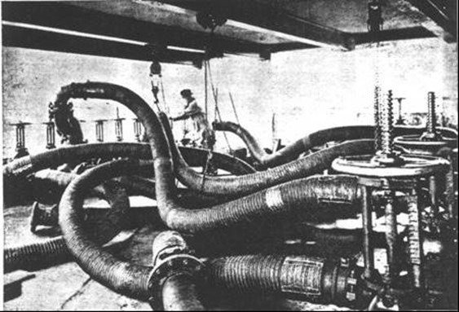

Figure 1. UK Pipeline system used to transport Aviation Gasoline across the country (Circa 1943) 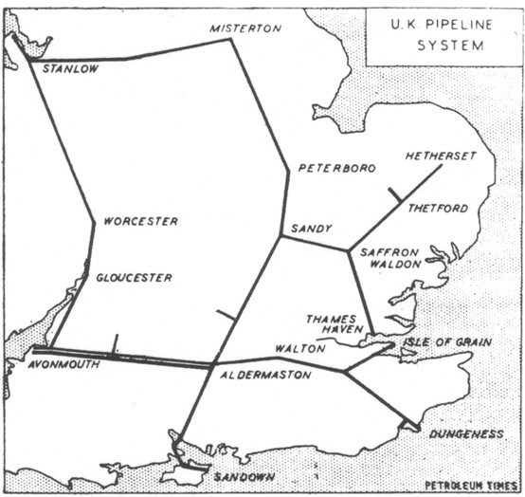

Rail Delivery

One of the main supply methods to the storage and distribution depots was via the famous British Rail system. Aviation gasoline was transported across the country from the west and southern ports to the much needed areas on the east and south-east depots which supplied the airfields. Such ‘gasoline trains’ and the ports from which they were supplied were a favourite target for Axis air attacks.

Photo 4 Aviation gasoline rail tankers somewhere in England (circa 1944)

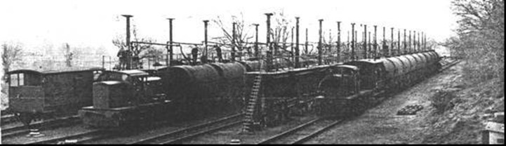

Road Delivery

The next stage of the distribution system was the tanker delivery to the airfield storage tanks, either as bulk fuel or in some cases as 44-gallon drums (200 Litres). The road tankers (2,000 gallons) were typically top-loaded from a gantry.

Photo 5. Gasoline loading gantry 1944 UK

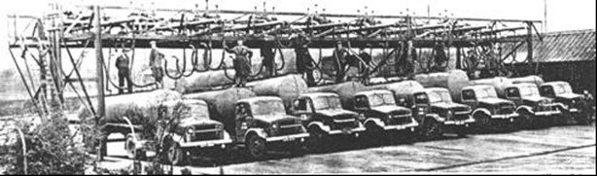

Photo 6. Atkinson Aviation Fuel Tanker 2,000-gallon (circa 1942)

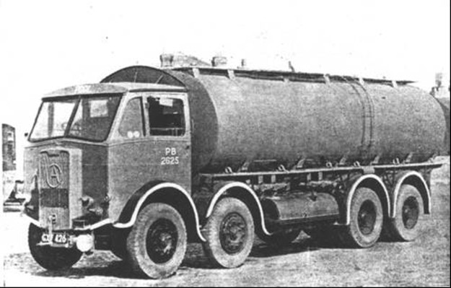

Photo 7. Storage tank fill for road tankers circa 1944

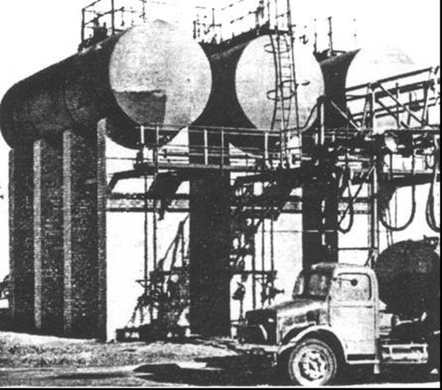

Airfield supply

The final stage of the distribution network was the airfield storage where the aviation gasoline would be delivered to the aircraft by various refueller such as tankers, trailers and even 44-gallon drums using hand pumps. Battlefields are never stationary and fuel supply lines are a critical factor in maintaining the fighting force, so while there is a need for fuel storage depots the essential requirement for aircraft (and other military vehicles) is to get the fuel into the fuel tanks – usually by the fastest, most expedient method. This in an ideal situation is via dedicated refueller tankers, in reality it is anywhere the aviation fuel can be obtained and delivered to the aircraft (including for the Axis , captured fuel). The following show some of the refueller and activities involved.

Photo 8. Aviation Fuel Tanker used to refuel aircraft circa 1942 (restored tanker UK Imperial War Museum, Duxford, UK).

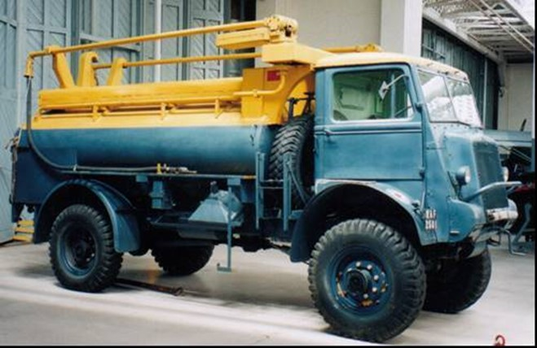

Photo 9. Aircraft refueller trailer Scammel Trailer drawn by tractor (restored tanker UK Imperial War Museum, Duxford, UK)

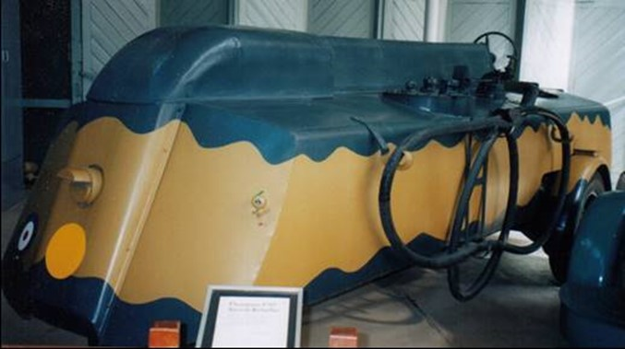

Photo 10. Refuelling a Spitfire Mark Vb from a tanker (circa 1942-43)

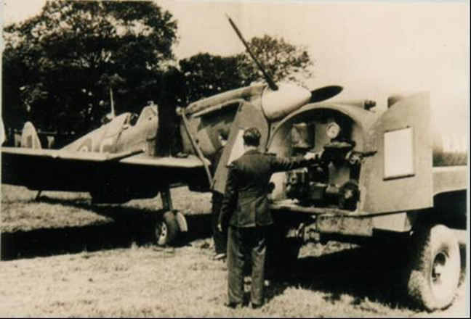

Photo 11. Refuelling a Spitfire Mark Vb from No. 350 (Belgian) Squadron RAF in England (circa 1942)[2]

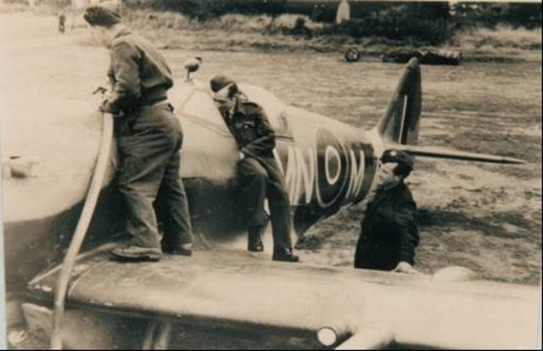

For the navy, and where locations were remote, other refuelling methods were used as can be seen in the refuelling of this British Fleet Air Arm Fairy Swordfish aircraft (this time land-based). Hand pumping from 44-gallon drums (200 litre) through the filter chamois into the aircraft fuel tank.

Photo 12. Refuelling a British Fairy Swordfish (circa 1940)

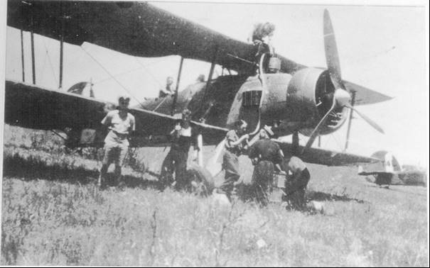

The chamois filter was required to remove water and ‘dirt’ from the aviation fuel. This technique had been in use since the beginning of aviation gasoline; for the failure of an engine in a motor car due to water or dirt was an inconvenience, such an engine failure in an aircraft was a matter of life or death.

Photo 13. Refuelling a Spitfire (circa 1941).

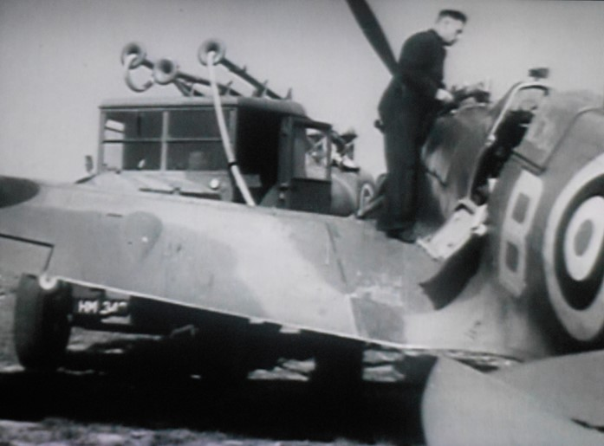

# Manufacturing Process in UK

Aviation gasoline production in Britain was limited to essentially four locations, Heysham (Lancashire), Billingham (Durham), Thornton (South Gloustershire) and Stanlow Refinery (Ellesmere Port, Cheshire) [3]

Figure 2. Location of Counties in Britain

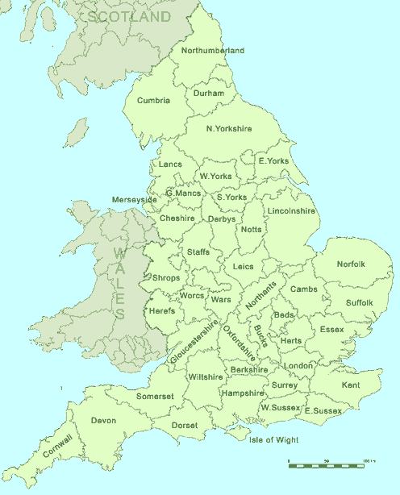

In the UK the expansion program for avgas production did not provide for any new construction. However, its greatest value was after the middle of 1943 when the UK plants were then in the main theatre of air operations. In the later years of the war, the level of 100-Octane production in Britain ceased to be determined by the supply of high octane blending agents (imported from the US in small quantities, had ceased). One reason was the increase in TEL concentration from 4.8 cc/IG to 5.5 cc/IG in autumn 1943.

Billingham (Stockton-on-Tees)

The Billingham Works were operated by Imperial Chemical Industries (ICI). It included a hydrogenation plant manufacturing Iso-octane. In 1939, it produced 30,000 tons of Iso-octane but in 1940 & 1941 it was used to manufacture motor gasoline as an import saving measure. However, from May 1942 Billingham was switched to 100-Octane spirit instead of motor spirit.

Heysham (Lancashire)

Heysham is located on the East Coast of Britain. It was a wartime refinery[4] constructed around 1939. This plant was to produce aviation fuel from gasoline and explosives. It was owned by Government having invested £10 million and was a joint venture with Trinidad Lake Asphalt, Shell and ICI, jointly called Trimpell and was operated by them from October 1943.

The general operations were:

Gasoline imported from Trinidad,

Shell operated the oil refining including gas oil to produce aviation spirit

ICI operated high pressure technology to make Ammonium Nitrate explosives

Memo from L. N. Refell to K. L. Stock Ministry of Fuel & Power

24 April 1947

The plant was jointly operated by ICI, Shell, Trinidad Leaseholds. It was the largest U.K. producer and operated by the Trimpell Management Committee under the control of the British Ministry of Aircraft Production. Trimpell Management Committee eventually supervised avgas production for all 3 plants until the end of 1943.

Heysham came into operation in August 1941

This plant was expected to require about 450,000 tons per year of gas oil feed stock to produce 350,000 tons of product.

Heysham ‘base’ spirit rating was improved by mixing it with Benzole. Later, better results were obtained by mixing the Benzole with the gas oil feedstock and hydrogenating the mixture. This ‘hydrobenzoling’ began at the start of 1943. The U.S. was supplying the gas oil feed stock for Heysham.

There were limitations; the refinery could only work on imported fuel oil or creosote[5]. It was uneconomic; the cost of producing aviation fuel at Heysham was only 4 pence more than imported aviation fuel before payment of duty, whereas corresponding differential at Billingham was 13 pence. Heysham had other uses than refining, notably production of ammonia. Apparently, it burns 80,000 tons of coal per annum.

Heysham problems were also complicated by the extravagant promises which the Air Ministry gave to the Trimpell Company in 1939, and upon whose interpretation it has been so difficult to reach, that the agreement under which Trimpell’s operated Heysham during the war was never actually concluded.

After the war the refinery and chemical works closed from 1945-48 with Heysham closing in July 1946, it was bought from Government by Shell and ICI. Shell would process crude oil from Middle East to produce fuel oil, gas oil, gasoline and butane. ICI would manufacture methanol and ammonia. Port facilities at Heysham were poor and could not accommodate the large, modern tankers which were now in use, in addition both companies had better sites and it was considered a poor investment. After the 1973 international fuel crisis, the site was scaled down and finally the refinery was demolished in 1979.

ICI remained at the site, but methanol production ceased in 1977 and nitrate production continued until 1986.

Stanlow Refinery

The Shell Stanlow Refinery is located at Ellesmere Port, South Wirral, near Chester on the west coast of England. Stanlow Refinery UK manufactured 32,000 tons/year of Iso-octane by hydrogenating octylenes from Curaçao (Dutch West Indies) (Caribbean). The Shell hydrogenation plant was built to its own design with the aid of a government loan. In peace-time it was expected to make motor gasoline. It was technically more advanced than the Heysham plant.

Thornton (South Gloustershire)

The Thornton plant was located not far from Stanlow, and was larger than Heysham, it lay half built and was abandoned. This was planned to distil 800,000 tons per year of crude oil to produce 400,000 tons of petrol using a catalytic cracking process a by-product of which would be 200,000 tons of petroleum coke

Table 1. Gasoline Production from Thornton Plant

|  |  |  |
| --- | --- | --- |
| UK | 000 tons | M.Litres |
| 1942 | 184 | 190 |
| 1943 | 345 | 357 |
| 1944 | 549 | 568 |
| July 1944 - June 1945 | 513 | 531 |

1942-1944 Imports to UK from US of aviation blending components (iso-octane) was less than 80,000 tons.

# Coal Tar Benzole

The gas and coke industries in Britain made a modest contribution to the aviation gasoline production drive. Benzene, which is the main raw material for the production of Cumene, is in fact the chief chemical constituent of coal tar benzole. During the middle years of World War 2, the Americans who needed benzole for the production of synthetic rubber as well as aviation gasoline, pressed their Allies for supplies. They received Australia’s total exportable surplus of some 12,000 tons/year and, from the autumn of 1942 all of Britain’s surplus as well.

In the autumn of 1941, the British Government had published orders compelling all gas producers with benzole recovery plants to scrub their gas for benzole. (“Benzole Recovery Plant Order 1941 No. 1715”. These orders were published to obtain more Toluene for the manufacture of explosives).

By 1943 the output of 90% of coal that was being carbonized in Britain was being treated for maximum benzole recovery, and the amount of crude benzole recovered from gas works was 85% greater than in 1940. Output declined later in the war as the loss of younger workers caused standards of work and maintenance to decrease, especially when plants were overdue for renewal. Meanwhile more of what Benzole was produced was being diverted away from the US into the “sterling refineries” of the Caribbean to make Cumene for 100-octane spirit production.

# Benzole

Cumene Plant at Curaçao produced 50,000 tons/year of Benzole. This plant is discussed in detail in Chapter 14 Caribbean West Indies. The plant required 40,000 tons of pure or 1o Benzole, its operation increased avgas production 164,000 tons/year. The highest quality benzole was obtained by re-running motor spirit benzole at Stanlow.

# Epilogue for 1941-1944

Perhaps the best tribute to their efforts that can be made, is that there was not one single example of an aircraft failing to leave the ground because of lack of aviation fuel.

# Index

1

100-Octane 12, 14

1st Bombardment Wing 4

8

8th Air Force 3, 5

8th United States Army Air Force 3

9

97th Bombardment Group 3

A

Air Chief Marshall Sir Arthur ‘Bomber’ Harris 2

Air Ministry 13

America 5

ammonia 13

Ammonium Nitrate 13

Atkinson Aviation Fuel Tanker 8

Atlantic 4, 5

Australia 4

Austria 4

avgas 100/130 1

Avgas 100/130 6

Avgas Grade 100/130 5

avgas production 14

Aviation Circuit 6

aviation fuel 5, 11, 13, 14

Aviation Fuel Distributing Depot 6

Aviation Fuel Reserve Depots 6

Aviation Fuel Tanker 9

aviation gasoline 5, 6, 7

aviation spirit 13

Avonmouth 6

Axis 4, 7, 9

B

Battle of Britain 4, 5

Benzene 14

Benzole 13, 14

Benzole Recovery Plant Order 1941 No. 1715 14

Berlin 4

Billingham 12, 13

Boeing B-17 Flying Fortress 3

Bremen 3

Brigadier General Ira C. Eaker 3

Bristol Channel 6

Britain 5, 6

British Fleet Air Arm 10

British Ministry of Aircraft Production 13

British Rail 7

butane 13

C

Caribbean 5, 6, 14

Casablanca Conference 3

catalytic cracking process 14

chamois 10, 11

Chester 13

Churchill 3, 4

coal 13, 14

coal tar benzole 14

Cologne 3

Combined Chiefs of Staff 5

Consolidated B-24 Liberator 3

creosote 13

crude oil 13, 14

Cumene 14

Curaçao 14

D

Dambusters Raid 4

Doolittle 4

Durham 12

Dutch West Indies 14

E

Eder 4

Ellesmere Port 12, 13

Emden 4

F

Fairey Swordfish 10

Ferry Command 3

fuel oil 13

G

gantry 8

gas oil 13

gasoline 13

German Luftwaffe 3

German Reich 5

German U-boats 4

Germany 4

H

Halifax 3

Heysham 12, 13, 14, 17

high octane blending agents 12

hydrobenzoling 13

hydrogenating 13, 14

hydrogenation 12, 14

I

ICI 13

Imperial Chemical Industries 12

Iso-octane 12, 14

J

Japanese Imperial Forces 4

L

Lancashire 12

Lancaster 3, 17

Lend-Lease 4

Liverpool 6

M

marine terminals 5, 6

methanol 13

Middle East 13

Ministry of Fuel & Power 13

Mohne 4

motor gasoline 12, 14

motor spirit 14

N

navy 10

nitrate production 13

No. 350 (Belgian) Squadron RAF 10

Normandy 4

North Africa 4

O

octylenes 14

Operation Chastise 4

P

Pacific 4

petrol 14

Petroleum Board 5

petroleum coke 14

pipeline 6

R

R.A.F. Bomber Command 2, 4

Refell 13

road tank wagons 5

road tanker 6

Roosevelt 3

Rouen-Scotteville 3

Ruhr 4

Russians 4

S

Scammel Trailer 9

Shell 6, 13

Sicily 3

South Gloustershire 12

South Wirral 13

Southampton 6

Spaatz 3, 4

Spitfire Mark Vb 10

Stanlow 6, 12, 13, 14

sterling refineries 14

Stirling i, 3

Stock 13

strategic bombing 4

T

TEL 12

Thames Haven 6

Thornton 12, 14

Toluene 14

trans-Atlantic Convoy 6

Transport Command 3

Trimpell 13

Trinidad 13

Trinidad Lake Asphalt 13

Trinidad Leaseholds 13

Truman 5

U

U.K. Petroleum Board 3

U.S. Air Force 5

U.S. Army Air Force 3, 5

U.S. Navy 5

UK Imperial War Museum 9

UK Petroleum Board 4

UK Pipeline System 6

United Kingdom 5

United States Army Air Force 3, 4

United States Strategic Air Forces 4

W

Wellington 3

Wiener Neustadt 4

Wilhelmshaven 4

# Research Sources

1. “Petroleum At War” reprinted from “The Petroleum Times” September 29, October 13, 27 and November 10, 24, 1945 sources from American Petroleum Institute.
2. Aircraft identification from Web Site <http://www.spitfiresociety.demon.co.uk/squadron.htm>, accessed July 14, 2003
3. “Oil” History of 2nd. World War - A Study of War Time Policy and Administration” D.J. Payton –Smith Imperial War Museum Library Published by Her Majesty’ Stationery Office 1971
4. Department of Environmental Science Lancaster University “Development of Middleton Wood” website accessed June 2002.
5. UK Public Record Office File T37/01 Oil Refining in the UK & Disposal of Heysham Aviation Fuel Plant. Memo to R W B Clarke 5 March 1947.